**REMOTE WORK AND WORK FLEXIBILITY ON EMPLOYEE COMMITMENT IN SMALL AND MEDIUM SIZE ENTERPRISES: A STUDY IN THE CONTEXT OF THE SOCIOPOLITICAL CRISIS IN CAMEROON**

**Abstract**

Small and medium size enterprises in Cameroon are gaining wide spread acceptance as viable drivers of economic growth. Organizational remote work therefore constitutes the cornerstone in human resource management to enhance organizational commitment as well as retain employees in Cameroonian organizations particularly during the time of the socio-political crisis. This paper examines the influence of remote work on employee commitment in SMEs during the sociopolitical crisis in Cameroon. In this research, a descriptive research design was used. This study targeted 150 small and medium size organisations in the North West and south west region of Cameroon. To analyze the collected data the descriptive statistics and regression analysis were used, the data collected were analyzed by means of the principal component analysis and the OLS method using SPSS version 20. This research established that remote work strategy and work flexibility positively affects the commitment of employees of SMEs in Cameroon with regard to the prevailing socio-political crisis. This study reveals that the effectiveness of flexible work schedules has a positive impact to commitment of employees during crisis. We thus suggested that managerial teams should employ optimal remote work and flexible work policy in the enterprises, in an attempt to create a satisfactory business climate.

**Key words:** Remote work, Work Flexibility, Employee Commitment, Small and Medium Size Enterprise and Socio-Political Crisis.

1. **Introduction**

The Anglophone regions of Cameroon have since late 2016 experienced some sociopolitical crisis which has continued to worsen, escalate to armed forces confrontations, loss of lives and property, internal displacement and increased fear and uncertainty. Human right watch (2021) revealed that the acts that have been committed during these attacks resulting from confrontation between government forces and Non-State Armed Groups has targets regions where the employee works and operates. Facilities have been stormed by armed personnel on a recurring basis or repeatedly, and sadly, this has lasted to cost lives and even deeply embarrassingly traumatize many an employee or even employer. Most NSAGs targeting the government embraced the boycott, disruption strategy on economic activities starting from 2017. This was coupled with Monday ‘ghost towns’ and other arbitrary social media generated calls for ‘lockdowns’, or more especially on commemorated national days, occasionally extending for several days. This strategy of boycott and disruption of economic activities has affected severely employee’s flexibility and work commitment (Human right watch, 2021). The major economic activity in the Anglophone region is farming; They are famous for coffee, bananas, cocoa, and rice farming within the region, and contribute about 20 per cent to the country’s GDP, (Nembot *et al.,* 2023) .The two regions of northwest and southwest (Industrial services declined by more than 30% in 2017, export by 5.3%, consumption by 3.4% and investment by 10.2% with reference to the pre-crisis level according to Nembot, 2023). Awareness of these dynamics would be important for performing an extensive research on remote work and work flexibility on employee commitment in SMEs. This crisis has brought political instabilities, economic insecurity and social tensions which poses as a difficult environment for business to run, which affects work flexibility and employee commitment to work, (crisis group, 2017). Such disruptions may make it hard for SMEs to facilitate work flexibility and enhance employee’s commitments and access to resources. Moreover, employees’ stress, job and personal insecurities, safety issues may reduce their organisational commitment. Many of these challenges can be only understood and solved under the conditions of the sociopolitical crisis in Cameroon to which the SMEs have to adapt in order to create appropriate working environment and manage the workforce.

**Problem Statement**

The current volatility has resulted in a volatile business landscape that makes it difficult for organizations to run efficiently, and, although large organizations have been affected, the effects have impacted SMEs most harshly. In Cameroon, and indeed most countries across the globe, SMEs drive economic growth, infrastructure development, and have become a source of employment, the survival and growth of these. The sociopolitical crisis in Cameroon has affected many sections of society and the business sector in general and more so on SMEs. The shutdown has impacted the Cameroonian economy’s advancement with an estimated loss of Franc CFA 499 billion (US$ 846 million). Limitations of doing business through weekly so-called ‘ghost towns’, restrictions on mobility, and insecurity slow bulk, passenger, and service exchange. Those businesses and transport vehicles that have continued to defy the “ghost town” status have been threatened and attacked. (Mboumien, 2018). Kindzeka (2019) stated that the security forces have also been accused of vandal- ising and burning business premises and markets. Thus, hundreds of companies have been shut down in this area. Insecurity has made production and operational activities of some of the largest companies in the region such as the Cameroon Tea Estate, the Upper Nun Valley Development Authority and the Cameroon Development Corporation to scale down. Banana, palm oil, coffee and rice production as the major products from the region also declined sharply. For instance, the Cameroon Development Corporation cut down its functionality at under 26 per cent, and posted a net loss of Franc CFA 32 billion ($55.3 million) in the 2018 financial year. This has immense implication for employment since the Cameroon Development Cooperation located at the foot of Mount Cameroon has been one of Cameroon’s largest employers with diverse employees from all parts of the country. According to Mbodiam (2020), Unemployment has escalated in the region meaning that the crisis has caused dismissal of more than 30,000 people. Employers’ Association of Cameroon calculated that the formal economy of the region had lost about 6434jobs by July 2018 and fsarther 8000 jobs were expected to be lost. The unemployment rate in Buea the regional capital of the South West Region, for instance—rose to 70 per cent. Custom department of the North West Region revealed that its revenue base lost Franc CFA 200, 000, 000 (about USD 362,000) for the FY 2018 while overall losses to Cameroonian economy during the same FY was estimated to be Franc CFA 269, 000,000,000 (about USD 489,000,000). Some road contractors have been attacked and threatened and their equipment vandalized/destroyed and many of them have stopped/abandoned projects. Indeed, over three-quarter of the public contracts entered in the Anglophone region for the fiscal year 2017/2018 were not implemented (ICG, 2019 and APF,2018). As pointed out by Nsom (2017), This crisis is rooted in Anglophone and Francophone hostilities over social and political affairs, which culminated to protesting, fighting, and dismantling of structures. But the crisis has impacted SMEs’ operations in a very strategic and crucial manner. An area highly affected by emerging conditions and essential in establishing competitiveness in a world economy has been work flexibility that has been significantly affected by issues such as disrupted supply chain, security threats, and regulatory ambiguity. This rigidity stifles SME’s capacity to respond quickly to market demand and restricts their prospects for new development. Employee commitment in the SMEs has continued to be another area that has been negatively impacted on by the crisis. The volatile situation increases anticipations among the workers, which subsequently reduces morale, productivity and employee loyalty. It is common for the employees to develop job insecurity because of the existing economic challenges and operation difficulties of their employers. This reduced loyalty can even exacerbate some of the above mentioned difficulties which hound SMEs in areas such as human capital management, corporate culture, and profitability.

It is important hence to get an appreciation of the background to the sociopolitical crisis in Cameroon as a way of appreciating the many facets of the crisis within the SMEs. Through recognizing these complexities, the stakeholders can pinpoint the areas that have to be addressed and that can help to reduce the effects of the crisis on work flexibility, and the levels of commitment of the employees involved in SMEs occurrence so that they can sustain and bounce back after the occurrence of a crisis effectively.

Although work flexibility and employee commitment in the improvement of organisational performance are advantages, sociopolitical crisis in Cameroon SME challenges arise. Consequently, the purpose of this study is to analyse the effects that remote work and work flexibility. Through such dynamics, this research aims at discovering the impact of remote work and Work flexibility on employees’ commitment and how remote work options can be used to overcome the crisis and maintain a committed and productive workforce.

### Literature Review and Research Hypotheses development

Remote work and Flexible work schedule practices have gained popularity in business organization throughout the world (McNall *et al.,* 2010). For example, Families and Work Institute in the USA with data derived from telephone surveys say that the proportion of employers that offer flexible work arrangement to least some of the employees increased from 68% in 1998 to 81% in 2014(Galinsky *et al.,* 2005; Matos and Galinsky, 2014). Moreover, similar tendency was noted in Europe as well: According to Plantenga and Remery’s 2009 European Commission review, more than 60% of employees can access flexible working hours.

Yet, the employees called for the new focus on life before the crisis even occurred. Organizations and specifically their workplaces were already enduring constant change pre-crisis and this will continue. In her article published on Gallup website, Mullen O’Keefe wrote that, flexibility will not be the same in every workplace because culture is as individual as genes. There are some positions in for which it is mandatory to be physically present at workplace. Therefore, this particular situation which we are experiencing now allows reconsidering the flexibility for the company and its policies in general.

This led to discussion on how the labor market will appear after the crisis, and what response should the employees provide to the situation when remote working is not required anymore. In the same post, Mullen O’Keefe said in addressing the “when,” managers should also think about whether the “where” for workers can also shift. That’s why full-time remote work is not the only possible solution. From the recent Gartner poll as mentioned by Cheremond one of the future work trend post crisis was that remote working will increase because while 30% of the employees decided to work remotely after crisis 48% of them wanted to do so before the crisis.009) showed that over 60% of employees have access to flexible working schedules.

However, before the crisis, employees were already demanding a new focus on life. Workplaces faced constant change prior to the crisis, and there will be more to come. In her article published on Gallup website, Mullen O’Keefe argued that, “Flexibility will look different in each workplace because culture is as unique to an organization as DNA is to a person.” Certain jobs require employees to be physically present. Thus, this particular situation which we are facing, offers the opportunity of revisiting the company policies in order to better incorporate flexibility overall.

There has been a debate on how the labor market will look after the crisis, and an answer needed to be given of whether employees will continue working from home when restrictions are no longer necessary. According to Mullen O’Keefe, in addition to the “when,” managers should consider if the “where” for workers can change too. Full-time remote work is not the only solution. According to Cheremond, the main findings of the recent Gartner poll revealed that one of the future work trends post crisis refers to the increase of remote working, stipulating that 48% of employees most likely will decide to work remotely at least part of the time after crisis compared with only 30% of them before the crisis; flexible working will be a new normal after the crisis couple with the complex working environment in the crisis affected regions in Cameroon. Measures of ghost towns were targeting employees’ absence from work and undermining any economic activities. As for the professional activities’ development, the flexibility at work was implemented, for instance, telecommuting, distance education, congestion prevention, and minimization, and the shut down of unnecessary facilities and services (Adriana *et al.,* 2020).

The socio-political crisis most affected the NWSW, as the largest number of employees switched to a home working mode, which became the new trend. The effects of crisis on the labor market vary from one country to the other. The situation in Germany is quite clear: ordinary employees have a clearly defined short-term work schedule and should not be affected by a crisis. At the national level, effects are uneven and thus increase social disparities. Non-traditional workers as well as those with other non-standard employment and occupations involving a small fraction of their work from home report having their hours cuts, layoffs or voluntary turnover, and declines in earnings. This kind of employment can be helpful for IT employees and other employees, but there are always employees for whom the home employment is not possible, even in a crisis situation, which can considerably affect the employee’s commitment toward the work (Adriana *et al.,* 2020). The socio-political crisis has impacted on training thereby making retraining difficult. Most of these effects could have been controlled at initial stages if organizations had planned well in advance or if the employees were well conversant with such strategies which compel organizations to adopt work flexibility in a bid to improve employee commitment. Thus, we can deduce the main research hypothesis as follows: This paper also reveals that work flexibility has an impact on their commitment levels in the SMEs in view of the sociopolitical crisis of Cameroon.

**3.1 Structural Framework on Work Flexibility and Employee Commitment**

**3.1.1 Remote Work and Flexible Work Schedule**

Employability flexibility is defined as the ability of employers to make changes on where, when and the total amount of time that employees can devote or spend on work-related activities (Hill, 2018). This definition indicates that work schedule flexibility gives the management the schedule arrangement paradigm as human resource strategy they use to motivate, attract and retain their skilled and experienced employees. Employer has the discretion on how to structure and coordinate working environment in order to ask for, and get, high levels of commitment from the worker. According to Grzywacz *et al.,* (2016) work schedule flexibility is defined as the extent to which employers are capable to make choices to organize and arrange the key feature of jobs in an organization. In their 2017 work Pruchno and al define work schedule flexibility as a model of working in which the workers are able to have control over hours they wish to work within a given time. The definition can be deduced in the sense that it is both organisation and employee oriented because it offers a chance to the employees to improve their commitment to work through rearranging and organizing their work schedule the time they make spend at work to complete the assigned work which in result propels both personal and organisational achievement. Again, work schedule flexibility is the reciprocal self-serving contract between the employer and the employees as a way of enhancing commitment towards organizational objectives and goals. Flexi-time is thus a working arrangement between the employer and the employee in which the employer and the employee agree to schedule their work with a view of attaining benefits for both. From the study conducted by Coenen and Kok (2014) it was determined that flexi-time has a positive significant relationship toward employees and organizations through enhancement of the job satisfaction and reduction on turnover intention in the related organization. In flexi-time schedule arrangement, the employer offers an alternative time that the employees can choose for their working day, and a certain number of hours that the employee is expected to work. Compressed work week may be defined as that scheduling arrangement in which the time needed to complete a particular task is significantly slashed. This implies that instead of timing that may extend to one week, tasks are compacted to two or three days (Wheatley, 2016).

**Employees’ Commitment**

Meyer & Allen 1991 while defining the commitment said that it is a state of being involved in a relationship with an organization. This relationship determines the action of the employee, whether to either remain or quit the company. This is the operational definition for this study. The feature falls in a working relationship context whereby relationships, for example that between the employee and the line manager, may impact on commitment (Randall, 1990). In some literature it has been argued that this working relationship can either enhanced or drained organizational commitment. Hence it is important as variable to be considered when studying employee commitment in the work- place. That there are other definitions of organisational Commitment; Porter *et al.,* (1991) defined it as a state wherein the employee feel that he /she belong to the organisation and would want to remain with the employer, he/she has an identification with the employer’s vision and values of the organisation, there is want to invest extra effort. According to O’Reilly (1989), employee commitment can be defined as an individual’s psychological bond with a firm; this includes job identification, organizational allegiance and organisational citizenship.

In general, there are several forms of employee commitment.

**Affective Commitment**

Specifically, affective commitment had always been the most preferred type of commitment and the main focus when analyzing the commitment of employees to organizational results (Meyer *et al.,* 2002). Meyer and Allen (1991) have described affective commitment as the state where the employee has an emotional loyalty to the organisation he or she feels a personal identification with the organisation, and is also involved with the organisation. As Meyer and Allen (1991) assert, this term can be found mainly in the article by Mowday et al. (1979). Ketchand and Strawser (2001) who states that most of the employee will have affective commitment to the employer on realization of common goal and willingness to help the employer to achieve those goals. This is a kind of love that is thought to be unique for the relationship, which exists between the employees and their employers; affection is usually formed when people commit and offer a continuing support to guarantee value to the organizational, according to Meyer and Herscovitch, (2001).

**Continuance Commitment**

Meyer and Allen in their work of 1991 described continuance commitment in these words: “an awareness of the costs related with leaving the organisation”. On the other, Becker (1960) went on detail on how an employee would invest in side-bets by betting on continued employment in an organization, and would cut off those side-bets as he decides to quit the organization. Some examples of side-bets are time, status, pensions to be received, employee benefits, special skills, and years of service with the organization, and others (Reichers, 1985). Meyer and Herscovitch, (2001) noted that the employees that side bet a tremendous amount in an organization to realize strong continuance commitment.

**Normative Commitment**

According to Meyer and Allen (1991) normative commitment can be described as having a degree of understanding that the employee has to remain in the job. Unlike the other two components of commitment, there is little consideration of this nor- mative commitment component among many scholars Johnson et al, (2010). Normative commitment or the feelings of obligation does not create perceived_Ends of Centralido, vol 42, no.1, pp. 171-185 day, 2009 Meyer and Allen (1997), suggest that while affective commitment or the emotions of dedication does not create perceived involvement in the organizations. In other words, normative commitment is defined as the perceived commitment from the employee and his/her commitment to on being employed in that organization (Johnson et al 2010.).

**3.1.2 Employee Commitment**

Due to the identified vitale problem, commitment is one of the big challenges that SMEs face in the competitive en- vironment most especially during a crisis. In this sense managers are gradually assured that having a competent employee pool goes beyond offering the high remunerations in the market. Therefore, the plan of how to attract and retain the employees leads to better utilisation of employee capital which subsequently ensure higher performance. The following figure illustrates antecedents of/or reasons for commitment by the employees in the figure, the following completes the figure and adds subtitles to the parts of it marked IX:

Figure 1. Determinants of Employee commitment

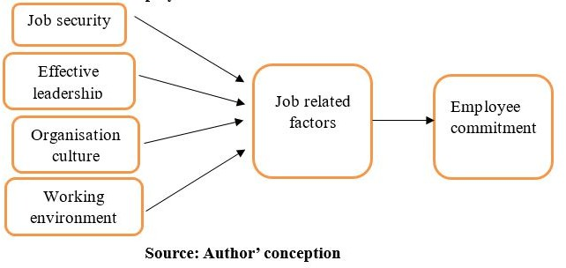

The level at which employees can be attracted to stay committed in the organization can therefore be determined by attributes which are derived from the types of employee commitment: affective, continuance and normative commitment: Regulation working environment, management leadership, job security and organizational culture. Job security is one with the strategies which encourage employees to retain their job within their organization and assist in boosting right employee behavior like self-esteem, which enable them contribute to the organizational objectives. In the case of hrlineup (2024) it was identified that leadership initiatives are central to the triumphs of organizational commitment among the employees. When employees trust their leaders, are reassured by their management, and observe ‘openness and honesty’ they build more commitment to the organization in question.

The following paper aims at identifying the consequences that are likely to be realized when employees show commitment.

According to Asiedu and al (2014) employee commitment has been a focal area of study in the last decade. It discovers that the cause for this is due to the influence and added values that the employee commitment has borne concerning employee per- formance and organizational revenues on the organization. In a world that has been described as competiti- ve, Lesabe and Nkosi (2007) pointed out that no organisation can operate at optimum if all organisational entities are not committed towards its objectives and strategic plans. Given organizations today experiencing higher levels of competition and volatility, there emerged a need to train and develop obedient employees since it would bring forth guaranteed returns to the firm. From their observation, Visagie and Steyn (2011) found out that highly affective committed employees will continu- ally stay with the organization due to their desire. This type of commitment is evident when employee’s work experiences match their expectations and needs. As the level of normative commitment increases on the part of the employees they will remain with the organization because they are bound to. Such employees may apply considerable amount of working effort in his/her organization if he/ she feels that he/she has to work hard to ensure that the employee is not let go by the organization. Finally, continuance commitment typically results from investments like with close working relationships with others, for other employees, for retirement and career investments. These differences have to be taken into consideration since they show how some behaviors can be expected of an employee. It also shows the kind of work which the employee can undergo and the impact which is thereafter formed on the commitment which is later displayed.

In the study looking at employee commitment, Becker *et al.,* (1996) established that employees are committed to their managers and organization. This was an important finding because it means that employees fix their stare at different aspects when observing commitment. Becker *et al*., (1996) also stated the commitment towards line manager was positive and significantly associated with performance. Their view post conducting the research was that researchers going forward should shift from the studies revealing the commitment to the organization. Finally, Becker et al (1996) endeavoured to replicate the current study to help change the perspective taken by both theoreticians and professionals, in the future, regarding this type of commitment referring to the employee. This is a different angle concerning employees’ commitment and confirms the idea and the various outlooks and aspects concerning employees’ commitment.

3.2 Theoritical Frame Work of Work Flexibility and Employee Commitment

Literatures have developed a good number of theories regarding work flexibility and employee commitment and these will assist in our study to elaborate or bring more light to our concern.

**3.2.1 Job Enrichment Theory**

This study draws its conceptual framework from job enrichment theory popularized in the work of Hackman & Oldham, (1976) The theory posits that the primary manner through which job enrichment is done is through the job characteristics that are known to bring about motivation, satisfaction, commitment as well as involvement, performance quality and withdrawal behaviours including absence and turnover are hypothesized to be a direct function the three critical psychological states namely the meaningfulness, the responsibility Job enrichment theory postulates that jobs should exhibit specific attributes which lead to high work motivation, satisfaction, performance involvement and commitment. It determines the tasks Geschoepfungszustand in which an individual is expected to thrive in their job. In the theory, management is equipped with knowledge that for job enrichment organizational goals with high levels of key characteristics can be achieved and ensure that employees with equated personal attributes work on the jobs (Hackman & Oldham, 1976). According to job enrichment theory, the work flexibility and organizational employee commitment could be analysed since while an interesting job feature, such as the flexible work time is introduced by the management it could affect commitment in an insecure climate to enhance organizational performance. Therefore, according to the job enrichment theory, the improvement of content and design of job is possibly to improve commitment. Through use of job enrichment principles in the study, it will assist researchers to understand the extent to which flexibility workplaces where employees count on for greater autonomy and control over their job can enhance their job especially during the era of socio-political crisis in Cameroon.

* + 1. **Tri-Dimensional Organizational Commitment Theory**

It is recognized that there is a limited number of well-developed theories, including the focal Tri-Dimensional Organizational Commitment Theory proposed and developed by Meyer and Herscovitch in 2001. Thus, Meyer and Allens (1997) prominently introduced tri-dimensional theory to explain the organizational commitments such as affective commitment, continuance commitment and finally normative commitment. These dimensions explain how the organizational commitment can be developed and what this means for the behaviour of the employees. This theory of commitment has been used by researchers in the following ways to predict; important employee outcomes such as turnover and citizenship behaviours, job performance, absenteeism and tardiness (Meyer *et al.,* 2002). Empirical research done in organization using Tri-Dimensional Organizational Commitment Theory supports that affective and normative commitment positively correlates and continuance commitment is inversely linked with positive organizational phenomena like performance and organizational citizenship behavior (Hackett *et al.,* 1994; Shore and Wayne, 1993). Other research also indicates that affective commitment to work, job and career was positively related to continuance and normative commitment (Cohen, 1996). Ayeni and Phopoola (2007) postulated that Continuance commitment costs that involves the concerns of how she can leave the organization and normative commitment involves perceived obligation to stay in the organization is relevant to the continuing participation of the individual in the organization. According to Kim (2005) the level of commitment in SMEs depends with the employees’ attitude, identification and involvement towards SMEs. Likewise, Romzek (1990) discovered that, employee commitment is rooted in affective attachment to work organization.

##### 3.3 EMPIRICAL REVIEW ON REMOTE WORK AND WORK

##### FLEXIBILITY AND EMPLOYEE COMMITEMENT

In Nganga (2010) study on the international non-governmental organizations in the health sector in Kenya, the author recommends the organizations to embrace quality WLB practice. Some of the WLB initiatives suggested here are compressed work schedules, alternative work schedules, job sharing, childcare facilities, wellness programmes and teleworking. The study observed that motivation and productivity of the employees in organizations that have adopted the WLB initiatives were relatively high. Schedules also founds that flexible working arrangements have a positive impact to the produc- tivity of the Judiciary. Flexible work hours are intended to help maintain employees’ engagement in performance in a growing tough and demanding business environment. They allow workers to choose their start and ending time in the working day as long as the exact number of hours are met. Ommends the adoption of quality WLB practices. The proposed WLB initiatives include compressed work schedules, alternative work schedules, job sharing, childcare facilities, wellness programmes and telecommuting. The study noted an increase in employee motivation and productivity in the organizations that adopted these WLB initiatives. Flexible working schedules positively influence employee produc- tivity at the Judiciary. Flexible work hours are designed to keep employees motivated in a competitive business environment. The flexible schedules permit workers to vary their start and finish times provided a certain number of hours are worked. It can let them fulfill family or personal commitments/emergencies (give the workers the chance to perform their family and individual roles as well as attend to unexpected events occurring during the day) in the morning or in the evening, or just have shorter driving time coming to work or leaving early in the morning or late in the evening. If flex- ible works schedules is designed with both employer and employee perspective in mind the results are improved efficiency, focused work, and individual affective management of working time as highlighted by Wulfert (2010).

Fletcher (2015) posited that desired em- ployee commitment is brought by flexible work scheduling. Yet, this only happens when employees view the flexible working scheduling in a positive manner. According to Fletcher (2015), it is noteworthy that in assuming that making options of a flexi- ble working schedule accessible to an employee will adequately meet the goals of the employer’s expectations. Fletcher (2015) also notes that organisations interact with employees and clarify how they care about commitment at the job and in the organisation. Finally, in relation to managers, Fletcher (2015) proposed making the employment circumstance of employees who frequently utilize this benefit even more secure. That is going to enhance commitment as well as performance, according to him.

Njiru (2016), on his study on the influence of flexible work practices on employee performance in Public sector: A case of ministry of interior and coordination of National Government, Embu County Ministry of Interior and Coordination of National Government, Embu County. The study therefore confirmed that the institution did have flexible work practices policy in place. The research also found out that though compressed work hours affected employee performance, job satisfaction and improve staff morale per ratio, it was a very small percentage. But job sharing and flexi time were among those which were implemented by majority and had positive impact on employee performance, job satisfaction, staff moral, reduced rate of absenteeism, cost control and efficiency in percentageages. According to the study, the Institution should offer other flexible work arrangements hence the Institution should consider offering shift, part-time and weekend work. To on his study about: The impact of flexible work arrangement on organization performance in the banking sector in Kenya.

Mullins (2009) consider employee commitment to embrace aspects of putting in a full self at the place of work. They also say that commitment for employees means how one manages time, paying dues and going of extra-mileage. The current world employees are so sure of their importance to their employers, and thus would deliberately join organizations that satisfy the above on workplace expectations. The research recommended that organizations that are perceived to be employee friendly and those that show employees a lot of consideration will capture the desired workforce and there- by emerge winners of the battle for the workforce share (Madigan *et al.,* 2009).

Authors Dixit and Bhati (2012) pointed out that it is the commitment of employees that is deemed relevant because it serves as a tool that may be used to forecast on the likely performance, and even absence, of the employee. There is evidence that using organizational commitment affects employee’s behavior and attitude in workplace. That high organizational commitment leads to low turnover intention, improves em- ployees’ punctuality and enhances their willingness to demonstrate behavioural methods that are related with change in attitude towards organizational change and performance (Mququlwa, 2008). It has been argued that employee’s commitment provides him with the attitude to adopt the objectives of the organization and align efforts towards strategic directions and values of the firm (Meyer *et al.,* 2010). Thus, the firms are challenged by the necessity to enhance the introduction of organizational integration flexibility and quality service. Employee competence and commitment is hence determinants of any organization to compete in quality and in the same comply with change by embracing it. The firm therefore has to call, sieze, and nurture and maintain appropriate personnel to tackle these emerging demands (Amadi, 20144 Small and medium size businesses in Cameroonional non-governmental organizations in the health sector in Kenya which recommends the adoption of quality WLB practices. The proposed WLB initiatives include compressed work schedules, alternative work schedules, job sharing, childcare facilities, wellness programmes and telecommuting. The study noted an increase in employee motivation and productivity in the organizations that adopted these WLB initiatives. Flexible working schedules positively influence employee produc- tivity at the Judiciary. Flexible work hours are designed to keep employees motivated in a competitive business environment. The flexible schedules permit workers to vary their start and finish times provided a certain number of hours are worked. This can allow them to meet family or personal commitments/ emergencies (enable employees to respond to both predictable and unpredictable circumstances), during the day or to reduce their commuting time by starting and ending work before or after the rush hour. When im- plemented with both employer and employee interests in mind, flexible works schedules can increase efficiency, work focus, and empower individuals to self-manage work time (Wulfert, 2010).

According to Fletcher’s (2015), flexible work scheduling can lead to desired em- ployee commitment. However, this only occurs when employees perceive the flexible working scheduling in a positive light. Fletcher (2015) states that simply making flexi- ble working schedule available to employees may not yield the results which the employer seeks. Fletcher’s (2015) study also suggests that organisations engage with employees and explore how they experience commitment in their job and organisation. Lastly, Fletcher (2015) suggests that managers should also look at making the employment situation more secure for employees who regularly take up the benefit. He states that this will increase commitment and performance.

Njiru (2016), on his study on the influence of flexible work practices on employee performance in Public sector: A case of ministry of interior and coordination of National Government, Embu County. The study established that the institution did have flexible work practices policy in place. The study further revealed that compressed work hours influenced employee performance, job satisfaction and enhanced staff morale in a very small percentage. However, job sharing and flexi time were being used by majority and influenced employee performance, job satisfaction, staff morale, reduced absenteeism and contributed to cost effectiveness and efficiency in a big percentage. The study recommends that the Institution should provide other forms of flexible practices, for instance, shift, part-time and weekend work. On his study on influence of flexible work arrangement on organization performance in the banking industry in Kenya.

Mullins (2009) view employee commitment as encapsulating by giving all of one-self while at work. They also state that employee commitment entails using time constructively, attention to detail and making that extra effort. Employees today are increasingly self- assured of their value to employers, and would consciously choose to work for those organizations that meet the above workplace expectations. Organizations that demon- strate commitment to employees will attract and retain the desired workforce and will ultimately win the battle for the workforce share (Madigan *et al.,* 2009).

Dixit and Bhati (2012) stated that the commitment of employees is an important issue because it may be used to predict employee’s performance, absenteeism and other be- havior. Organizational commitment plays an important role in its influence on employee’s attitudes and behaviors in the workplace. High organizational commitment reduces em- ployees’ intention to leave the organization, improves employee punctuality, and promotes organizational citizenship behaviors and attitudes towards organizational change and per- formance (Mququlwa, 2008). Employees with higher levels of organizational commitment internalize strategic goals and values of the organization and direct their efforts towards organizational objectives (Meyer et al., 2010). With changing times, firms are faced with need to maximize on organizational integration, flexibility and quality service. Employee competence and commitment is therefore of decisive importance for any organization to be able to compete in quality and go along with changing times by adapting to these changes. The firm therefore must attract, select, train and retain qualified people to meet these changing needs (Amadi, 2014

**3.4 Small and Medium Size Businesses in Cameroon**

Under the Law N° 2010/001 of April 13, 2010 defining an SME, an SME is a set of Very Small Enterprises that adopt not more than five people and an annual turnover of about Twenty-five Thousand Euros or Fifteen Million FCFA. Further, small firms are Very Small Enterprises categorized by employment base of between 6 and 20 staff and an average turnover per year of between 25,000EUR and 175,000EUR. (World Bank 2013). However, in Cameroon SMEs are incorporated into the Growth and Employment in a Structural Christmas plan a (the GESP), (Tamungang and al., 2018). These SMEs depend with over 90% of the country’s economic sector while allegedly contributing a 36% of the national GDP, (World Bank 2013). Similar work made by Isoh and al (2020) established that Cameroonian small and medium enterprises were submitting oltre del 30% of the local government taxes. The SME’s have the proportions to play an influential role in the progress of an economy, as concluded by Ariyo in his work in 2005.

Cameroonian Small and Medium-sized Enterprises (SMEs) dominate the country’s enterprises’ profile. With other accompanying measures for a level playing ground already developed, the SMEs, as recommended by the statistics from the Ministry of Small and Medium-sized Enterprises, Social Economy and Handicraft (MINPMEESA), represent 95 percent of Cameroon enterprises. The sectors involved are; change, agri- business, retail, building and civil engineering and most recently the Information and Communication Technologies (ICTs) sectors. According to Camer-cap-parc research and Analysis Centre on the Economic and social policies of Cameroon, 61,366 SMEs were developed in Cameroon in the period between 2010 and 2016, from which 59,200 were local and 2,166 foreign the taxation department database showed that 72.24per cent of the enterprises were determined to be focused at Camer-cap-parc as at May 2016.

Cameroonian SMEs regarded as the main driver of the growth of the economy account for only 36 percent of the GDP based on the ministry of Small and Medium-sized Enterprises, Social Economy and Handicraft ministry annual statistic of 2016. «It is said that if SMEs were contributing 50 per cent to GDP, it would already be an emerging country. Therefore, SMEs must therefore pull their socks and ensure that their contribution to the national economy rises to at least the 50 per cent level. The SMEs are often found wanting in technical materials of production and therefore cannot cope with demand and compete with their foreign counterparts more so due to the coming of Economic Partnership Agreement with the European Union which was established last year. These small or medium enterprises, which can also be considered as family businesses, applied unsuitable management, plus lack of training and professional associations to control actors. These difficulties including fiscal constraints, personnel shortage, and technical production requirements among others which causes retention were highlighted in the 2016 Statistic Year Book of the tutelage ministry.

1. **Methodology**

This study adopts the Hypothetico-deduc-tive method and the survey design and analysis entail only the primary data collected from the respondent. The primary data was gathered through an em- pirical structured questionnaire from respon- dents from enterprises situated in the North West of Cameroon. The instrument utilized in data generation is the Likert response alternative questionnaire adopted by Likert (1932) in his study. Small and medium size enterprises were selected from the North West region of Cameroon using a non-probabilistic sampling technique depending on the respective enterprise and its sector of activity. As for Data analysis method, we employed Statistical and Econometric model. The study employed a Research Methods comprises of examining work flexibility by using Principal Component Analysis (PCA) and the relationship between work flexibility and employee commitment in SMEs in Cameroon in the context of socio-political crisis is based on the Ordinary Least Square (OLS) Regression model to test hypothesis and to show which of the work flexibility is positively and significantly related to employee commitment. The data was regressed by SPSS software version 20. The data exploited in the scope of our study was gotten through a self-developed questionnaire administered among the workers and managers respectively from 150 Small and medium size enterprises randomly chosen all over the North West regions of Cameroon. In the context of our research, the population of study is that of the set of persons (workers and managers) working in small and medium size enterprises in the North West regions of the country. North West region was selected since it hosts a high number of SMEs and they have been impacted by the so - political crisis in Cameroon. The target population in this study incorporates SMEs located in the North West and south west regions of Cameroon. The sample source in our study was done using non-probability sampling technique specifically convenience sampling the north west regions of Cameroon was chosen because access is easy. A total of 150 questionnaire were distributed to SMEs in the north west and south west region of Cameroon. According to the information collected from the field, raw data collection was accomplished, filtering, proof reading and coding to achieve the intended quality, accuracy and completeness of the information collected. Discrete measures were operationalised and recorded on the statistical package for social sciences (SPSS) and analysed. Mugenda *et al.,* (2003) concluded that in any research it is recommended to use the computer in data analysis to enhance efficiency of result admission. The analysis was done by use of charts, percentages and frequency tables. Multiple regression analysis was also applied so as to find out the coefficient of relationship between the variables (the dependent and independent variables). The independent variable is work flexibility which is flexi-time, compressed work weeks, job share, home-based remote working option, center-based remote working option, mobile telework remote working option and home-based telecommuting within SMEs while the dependent variable is the employee commit, affective commitment, normative commitment and continuance commitment. The Likert scale questions were summed total in order to arrive at means for all the variables were computed and then regression was conducted. The data was analyzed using the formulated research questions. The Pearson Correlation coefficient was used to test the relationship between the study variable. The Regression analysis was used to determine the relationship of study variables on the dependent variable as combined effect. The data was collected from the field by the researchers through administering of questionnaires, which was later coded in to the computer using SPSS version 20.In this research works, the charts and tables were used in order to present the profile of the respondents of the study and to answer the research question one in which we investigate the type of work flexibility most used for employee committing.Work flexibility was measured in relation with efficiency and the reduction of the dimension of the

Extraction is the process of constructing the PCs as linear composites of the observed indicators as we have done with all our other methods.

⇒ *PC*1 = *b*11*X*1 + *b*21*X*2 + *. . .* + *bk*1*Xk* (1)

Where PC refers to principal component and Xki refers to the set of variables that make up a principal component.

###### Results

**4.1 Analysing the response rate**

The study sought to gather information from workers and managers working on selected SMEs in Cameroon in the North West (Bamenda). A total of 175 questionnaires were distributed to selected SMEs and 150 were collected having been filled completely. This made a response rate of 85.72% which was sufficient for data analysis.

**Table 1 : Response Rate**

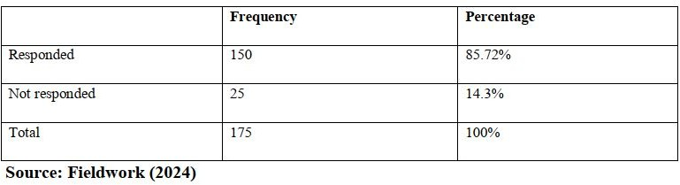

4.2 The legal status of the enterprise

The respondents were requested to provide information about the type of their legal status. The results are shown in Table 2 below

**Table 2: The Legal Status of the Enterprise**

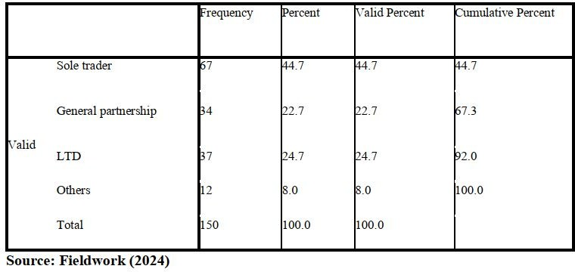

With regard to their legal status, the results of Survey 5 are tabulated in the table below: The analysis of the data demonstrates that sole traders are in largest number among the respondents, exactly 44.7%. After it, the second most common form is the limited liability companies (LTD) making up 24.7 percent of the interviewed enterprises. The study sample comprises of general partnerships accounting to 22.7%, and 8% falls in the ‘others category’. These results offer information on the distribution of legal structures within the population of businesses under consideration; the greatest share of the enterprises in the survey is represented by sole propriety organizations. This study found out that the legal statuses of the surveyed businesses are numerous and can be attributed to the fact that business enterprises are of diverse types in the region.

4.3 The branch of activity of the enterprise

Fig. 2: Results on the Estimated Annual Turnover.

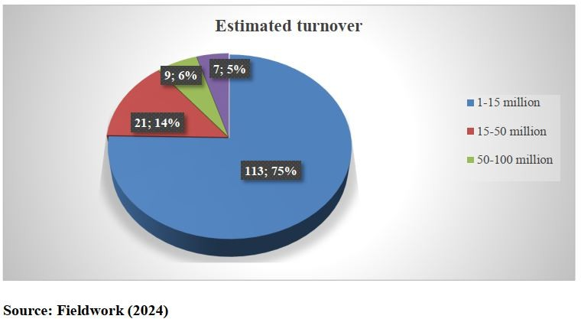

In the Figure above, we have illustrated the estimated annual turnover of respondents according to 4 groups. The largest group responding to the survey fell under the category of an annual turnover of between 1 and 15 million Euros and totaled 113. The major category consists of 35% (51 respondents) indicating turnovers less than 15 million the second major category comprises 14% (21 respondents) with turnovers between 15-50million the third category is 6% (9respondents) in the 50-100 million categories the least preferential category is 5% (7 respondents) with turnovers above 100 million. The matter laid down by the study shows that the greater part of the surveyed business has relatively lower turnovers during the year, with three-fourths of them being in the lowest bracket. The result also shows that only a small percentage of business have turnovers more than fifty million supporting the fact that most of the sample businesses are small to medium enterprises. This distribution helps in making a perception of the economic magnitude of the businesses under consideration in this study.

Results on the Branch of Activity of the Enterprise by Town, the number of employees, and the duration of the existence of the enterprise

**Table 3: Activiteis by Branch** 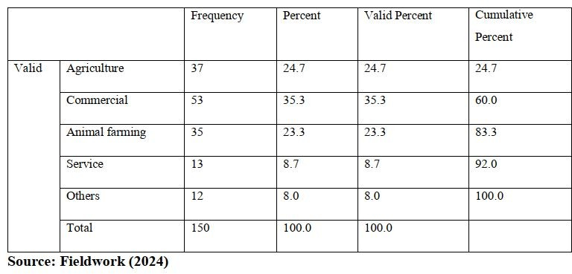

According to the responses of the respondents, the questionnaire called for identification of the branch of activity in which the various regions function in. The table above shows distribution of enterprise activities across sectors that the respondents were sampled from. The second most chosen answer is the commercial activities, by 35.3% (53) of the respondents. Coming at a distant second is agriculture with 24.7% (37 respondents). As for the specialization, animal farming is also significa nt – 23.3% of the respondents are experienced in this sphere and 35 individuals. The service sector contributes only 8.7 percent with thirteen respondents, while twelve respondents are from “Others”. From this distribution one is able to determine the economic endowments of the region; business and commerce and agriculture are the major economic activities; animal farming is also recognized as being of significant importance. According to the data, the economic activity appears to be rather heterogeneous with the traditional industries as the main drivers of the local economy but the services and other sectors as containing a considerable share as well.

**4.4 The Number of Employees**

The objective of the study was therefore to determine the number of workers in each enterprise. His results are summarized in the figure that follows.

**Table 4: The Number of Employees**

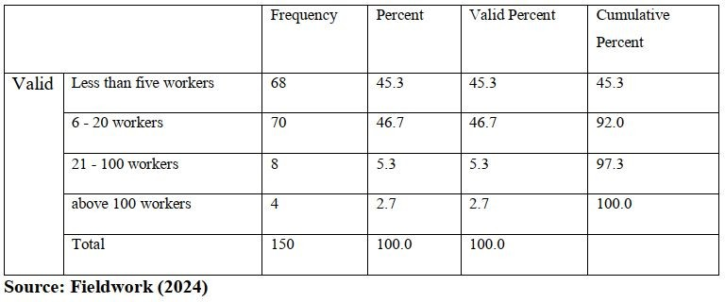

The table above shows the number of enterprises by their employees’ size class. As for the number of employees, most respondents are employing less people at the workplace, 70 out 150, stated that they have 6-20 workers, and 68 out of 150 employ less than five workers. Small to medium enterprises with 21-100 workers were identified by 8 respon- dents; they represented 5.3% of the sample. The largest number of respondents, 43, or 2.7%, are large businesses with over 100 employees. From the above data, it can be seen that small business have the largest representation within the sample since more than 90 percent of the firms have less than 20 employees. The high proportion of MSEs comes to the fact that the business environment is likely to be occupied by many firms of relatively small size, and few medium to big firms. Such an employee distribution gives an understanding of the organization structure of the local economy and about the job creation process in the region.

**4.5 The Duration or Existence of the Enterprise**

The research aimed at identifying the duration of business operations of the business firm. The findings are summarized in the following table.

**Table 5: Experience of Enterprises**

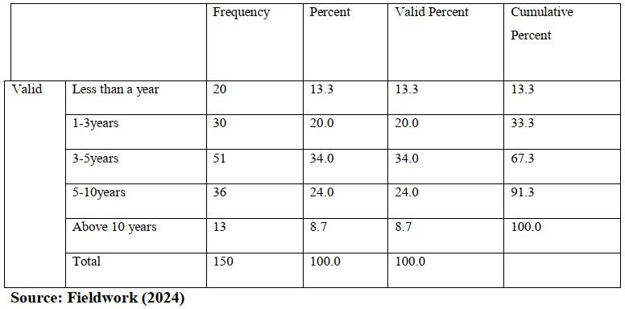

In the table above, we find operational duration of the surveyed enterprises as follows: The biggest share, of 34%, or 51 respondents, labels their businesses as having an operating period of 3-5 years. This implies enterprises in the 5–10-year range which constituted 24 percent of the respondents sampled as shown in the following table. SMEs in the study were grouped by their years of operation and the following break down was established: • SMEs that have been in operation for 1-3 years = 20% (30 respondents) Respondents that have been in operation for less than one year = 13.3% (20 respondents). The least is business owners operating business for more than 10 years with only 13(8.7%). This distribution implies which there is an active business environment with many new and existing firms, with the majority of the firms established in the 3-10 years ‘range. The results reveal a reasonable ratio of the firms that started their activity very recently and those that have been continually operating for several years, which may signify tendencies of economic development in the region.

**4.6 Organizational work flexibility in the condition of crisis**

The interaction effect of flexi-time improves the satisfaction of employees together with the reduction of the turnover intention in the organization.

**Table 6: Work Flexibility in the Crisis Context**

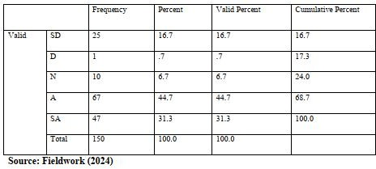

In the table above, the examined employees expressed their views about flexi-time’s influence on job satisfaction and turnover intention, and significant agreement with these positive effects was observed. Across the multiple-choice questions that were administered, 76% of the respondents agreed with ‘Yes’ options on the positive impact of flexi- time to both employee and organization through improved job satisfaction and reduced turnover intentions where ‘Yes strongly’ made 44.7% of the respondents while the remaining 31.3% selected the ‘Yes’ option. On the other hand, only 17.4% of respondents said that they disagreed this statement, out of whom, 16.7% strongly disagreed and 0.7% merely disagreed; 6.7% were neutral about it. These results support the idea that flexi-time is mostly welcome by employees, a fact that may help sustain a satisfied and loyal labor force. Based on the above findings on positive and negative attitudes towards the working conditions, the high percentage of agreement on the usefulness of flexible working hours suggest that such aspects of work arrangements such as flexi-time are a valued working condition, all the same, the low percentage of the disagreeing opinion to flexi-time show that the potential benefits might not positively affect everyone. These findings are consistent with the assumption that flexible work arrangements, particularly flexi-time, yield benefits for both, the employees and the organisations.

Stressing such a positive aspect of work as flexibility. However, the different responses also show that the extent that flexi-time is implemented and utilized also shows that the mode that is preferred in every establishment and situations also varies. These findings will benefit managers and policymakers in SMEs, especially in such a competitive environment caused by the sociopolitical crisis in Cameroon; it is recommended that, to increase employees’ satisfaction and retention, managers can adopt the practice of flexi-time.

**4.7 Examining flexi-time**

**Table 7: Having A Relaxed Flexi-Time Gives Me the Opportunity to Schedule My Personal Responsibilities and Cope with the Instability in the Region**

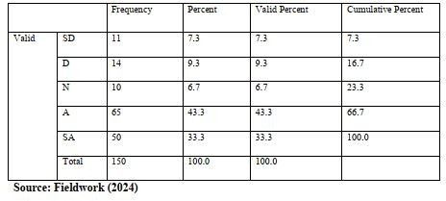

Essential information that can be drawn from the data presented bove relates to the extent to which; flexi time enables emploees to attend to other commitments and deal with regional insecurity. It is clear that respondents agreed with this statement 43.3% (65) with strong agreement 33.3% (50) giving general and strong agreement an impressive 76.6%. This high level of agreement implies that members of the organization see flexi-time as a useful mechanism of responding to work–life balance issues given the current regional volatile environ- ment. On the other hand, respondents who disagreed with the statement amounted to 16.6%: strongly disagreeing 7.3% (11); disagreeing 9.3% (14). A third of the respondents, 6.7%, were neutral about the issue. This evidence suggests that for the clear preponderance of the workforce, flexibility in work schedules, specifically, flexi-time is perceived as a viable way of attending to personal needs while responding to the Organizations is facing due to regional volatility. The high agreement level indicates that flexible work arrangements are significantly important in en- abling employees to manage the challenges of their lives in an environment of unpredictability. However, it would be wrong to think of this as a universal experience because there are always those who hold another opinion, probably owing to one reason or the other, or owing to the nature of their jobs. In aggregate, these results highlight work flexibility options as critical organizational practices that enable employee well-being and work-life performance especially considering sociopolitical factors in regions and offer practical evidence to organizations interested in improving employee satisfaction and retention through flexible work options.

**4.8 Effect of Work Flexibility on the Levels of Employee Commitment**

To establish the relationship between work flexibility and the commitment of employees in the small and medium size enterprises in view of the sociopolitical crises, correlation and regression tests were carried out.

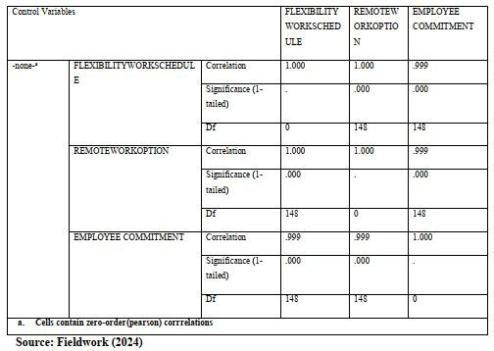**Table 8: The Pearson Correlations Coefficient**

The following table provides the correlation analysis that was also performed to ex-tend the look at the nature of the connections between Flexible Work Scheduling, Remote Work Options, and Employee Commitment. These findings give a clear support to the research hypotheses drawn in this study. Analysis of the mean scores revealed that results for Flexible Work Scheduling were highly positively correlated with results for Employee Commitment, that is, r = 0.999, p < 0.001, and even if adjusted for Remote Work Options the correlation coefficient was still significant, partial r = 0.665, p < 0.001. As with Employee Engagement, Remote Work Options also shared a highly significant and positive correlation with Employee Commitment (r = 0.999, p < 0.001); this correlation remained significant when partialling out Flexible Work Scheduling (partial r = 0.665, p < 0.001). As highlighted in the research data above, both work flexibility elements have a professional link to higher organizational commitment among employees in SMEs in Cameroon.

As it turns out, Flexible Work Scheduling and Remote Work Options also had perfect positive link with each other (r = 1.000, p < 0.001), meaning that these two may be tapping two very similar or possibly different aspects of the same construct in this research. Though this strong correlation is suggestive of a positive connection between these different work flexibility measures, it also raises a note of caution about the problem of multicollinearity, which might explain the very high R-squared figure noted in the regression model. These correlation results combined with the regression results support the hypotheses stated that Flexible Work Scheduling and Remote Work Options positively affect Employee Commitment. However, due to the very high correlation levels between all the variables, caution has to be taken when using regression results. Future research might also consider testing for multicolli- nearity and refining measures to ensure reasonable confidence that the constructs being compared are quite different Future research might test for multicollinearity and refine measures to be certain the variables being compared are actually quite different Nevertheless, the study maintains that work flexibility measures have a positive relationship with employee commitment in SMEs Cameroon in view of the current sociopolitical crisis.

###### 4.9 Results on the Chi-square test between work flexibility and employee commitment and on the OLS regression.

The Chi-square test between work flexibility and employee commitment

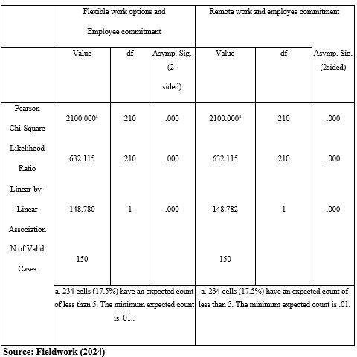**Table 9: Chi-Square Tests**

The table above illustrates the Chi-square test which was conducted to examine the relationships between work flexibility and employee commitment, as well as between remote work and employee commitment. The results, presented in Table 7, reveal sta- tistically significant associations in both cases. For flexible work options and employee commitment, the Pearson Chi-Square value is 2100.000 (df = 210, p < 0.001). Identical results were obtained for remote work and employee commitment. The Likelihood Ratio (632*.*115*, df* = 210*, p <* 0*.*001) and Linear-by-Linear Association (148*.*780*, df* = 1*, p <* 0*.*001) further support these findings. Importantly, the assumption of expected cell fre- quencies was met, with only 17.5% of cells having an expected count less than 5, which is within the acceptable range for reliable Chi-square analysis. These results strongly suggest that flexible work options are significantly associated with employee commitment. The consistent p-values of 0.000 across all test statistics provide robust evidence against the null hypothesis of no association.

**4.10 Model summary**

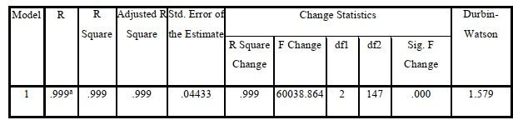**Table 10: Model Summary**

**Source: Field Work (2024)**

The findings of the regression analysis that was carried out with the intentions of offering convincing evidence of positive correlation between work flexibility options and employee commitment are presented in the table above. Remote work, options and flexible working schedules were used in the model and the level of prediction that this model achieves is exceptionally high. In terms of R-value the model obtained was 0.999 showing a high level of association between the predictors and consequently the level of commitment among the employees. The results indicate that the R Square value is 0.999 for the flexibility measures which mean that 99.9% of the variability of the employee commitment can be accounted for by these measures, which is a very high percentage indeed. The Adjusted R Square, being 0.999, is again evidence of the model’s high capacity to predict even with consideration of the number of predictor variables. A low standard error of estimate (0.04433) shows high accuracy of the developed models. Since F Change statistic of (60038.864) at the significance level of 0.000, if df1 = 2 & df2 = 147, it demonstrates that overall the model has statistical significance, therefore indicating that aggregated both remote work options and flexible work schedule together has a significant impact on the employee commitment. An important assumption of regression analysis has been pass tested by the Durbin Watson statistic of 1.579 which is close 2, indicating no auto correlation in the residuals. Even though these findings point quite clearly to the fact that flexible work arrangements are highly heralded and that predictivet power is high in both the steps, the R Square value is disproportionately high. This evidently shows a very strong correlation of the two which might require that further study be done to establish whether multicolli- nearity or some other factors may be having an effect on this very strong correlation. However, these results offer significant statistical evidence for the relation between work flexibility options and employee commitment to the organizations under analysis.

**4.11 Analysis of Variance**

ANOVA is used to compare differences of means among more than two groups. It does this by looking at variation in the data and where the variation is found. ANOVA compares the variation between groups with the amount of variation within groups. The result of the study is illustrated on the table below.

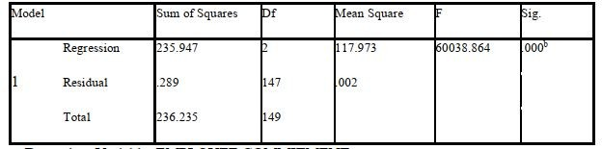**Table 11: Analysis of variance (ANOVA)**

**Source: Field Work (2024)**

The clear and strong positive correlation between work flexibility measures and employee com- mitment is especially rewarding given the sociopolitical crisis in Cameroon. According to Adriana AnaMaria davidescu and al (2020), in order to stop individuals from attending the workplace and paralyse other operational activities the numerous measures include “ghost towns”. In this context, that is, managing through tight resources, our results imply that offering adaptable work schedules, particularly telecommuting, could be fundamental to SMEs ‘keeping employees’ loyalty during the difficult period.

1. **Conclusion**

The purpose of this work was to assess the effect of remote work and work flexibility on employee commitment of SMEs given the socio-political crisis in Cameroon. From the discussion above, this study established that the purpose of work flexibility by demonstrating the need for its proper implementation in enhancing employee commitment in small and medium enterprises in Cameroon is vital. The issues that most managers encountered facing to cherry-pick skill and committed staff despite the fact that the literature was also considered. As noted despite the fact that due to funding constraints small scale enterprises cannot offer the best work flexibility policies so as to retain committed employees, it was established that some small and medium size employers have developed methods that help in providing flexibility to the workers to enable them remain committed to their workplace, hence the adaption work flexibility plays a humongous role in enhancing employee commitment of SMEs especially in the context of the crisis.

We also have evidence to suggest that SMEs enhance employee commitment through better work flexibility strategies by the managers. It also deduced that co-ercive work arrangements in most SMEs in Cameroon could be a strong force in economic commitment more so in hard conditions. In this case, work flexibility is central in management of people required to achieve the level of commitment among employees in the organization. The results that have been obtained established that there is a positive significance between work flexibility and commitment of employees of SMEs in the backdrop of the crisis in Cameroon. It should be noted that it is not only work flexibility incentives that influences employee commitment of small and medium enterprises in crisis situation in Cameroon, there are other factors that are endogenous or external to employee commitment and they can include: conditions such as environmental influence motivation working environment, organizational culture, acknowledging and rewards leadership style, etc.

**5.1 Limitation of the Study and Suggestion for Future Research**

The research is conducted on the employees and the managers of SMEs in the North West Region, Cameroon with the main purpose of examining the role of work flexibility in relation to the level of commitment The sample is considered to be small (150). Therefore, the findings of this research may not be applied across all SMEs operating in Cameroon. This is so because it is still necessary to consider other criteria or other elements. Al Though our results are proven to be stable, it is still important to be cautious concerning the exceptionally high calculated R Square value 0.999. It might be beneficial to look into other variables and whether there is multicollinearity between these substantial variables in order to explain this rather powerful positive relationship. In our case, the mediating or moderating variables we chose appear to provide insights into how work flexibility affects employee commitment during sociopolitical crises; however, there are other variables that may prove fruitful for future research.

**5.2 Recommendation**

It is also apparent that flexibility at work during crisis can make big production of enterprise. The management should also try in some ways to foster the feelings of organizational collectivism among the employees and this will in a way improve their level of flexibility as well as employee’s commitment. Consequently, the employees of SMEs sector of Cameroon are advised to engage in continuous training which enables them to make recommendation on continuously changing tough business environment. The employees should also contribute towards effort towards creating a culture of confidence and submissiveness in order to allow the management of this sector factor in their needs in the running of the enterprise.

**References**

Johnson, A., & Noble, K. (2011). Business impacts of flexibility: An imperative for expansion. Corporate Voices for Working Families.

Culture on Organizational Commitment: A Comparative Study of Public and Private Organizations. Research Journal of Recent Sciences, 2(5), 15-20.

Amarakoon, A. & Wickramasinghe, V. (2010). Impact of Work-Life Balance on Em- ployee Engagement an Empirical Study on Sri Lankan Employees, Conference proceedings of 4th international research conference on management and finance held in University of Colombo, Sri Lanka, 661-671.

Asiedu, M., Sarfo, J., & Adjei. (2014). Organisational commitment and citizenship Behaviour: Tools to improve employee performance: An internal marketing approach. European Scientific Journal, 10(4), 288-305.

Bakker, A & Demerouti, E. (2008). Towards a model of work engagement. Career Development International, 13(3), 209-223.

Becker, H.S. (1960). Notes on the concept of commitment. The American Journal of Sociology. 66, 32-40. <http://dx.doi.org/10.1086/222820>

Beyers, W. B., & Lindahl, D. P. (1999). Workplace flexibilities in the producer services. The Services Industries Journal, 19(1), 3560.

Boushnak, E., Rageb, A., Ragab, A. and Sakr, M. (2018) Factors Influencing Credit Decision for Lending SMEs: A Case Study on National Bank of Egypt. Open Access Library Journal, 5, e4996.

Crossroad Causes of the Anglophone Crisis. Retrieved from https:/[/www.crisisgroup.org/africa/central-](http://www.crisisgroup.org/africa/central-) africa/cameroon/305-cameroon-addressing-root-causes-anglophone-crisis.

International Labour Organization (ILO). (2020). Rapid evaluation of the impact of COVID-19 on employment and the labor market in Cameroon.

Africa Renewal –the united nations (2018 December). Crisis worsen in Cameroon. Akhtar, S., Naseer, Z., Haider, M., & Sana, R. (2013). Impact of Organizational

Allen, T. D., & Shockley, K. (2006, March 22). Flexible work arrangements: Help or hype? Paper presented at the BYU Families and Work Research Conference, Provo, UT.

Business news daily. (2023, October 24). Current and future trends in remote work.

Crisis group. (2017, August 2) retrieved Cameroon’s Anglophone Crisis at the

International Crisis Group. (2023, January 19). Cameroon: Addressing the Root Causes of the Anglophone

Crisis. Retrieved from https:/[/www.crisisgroup.org/africa/central-](http://www.crisisgroup.org/africa/central-) africa/cameroon/305-cameroon-addressing-root-causes-anglophone-crisis.

Isoh, A., Joelle, M. and Esowe, S. (2020) Modeling Critical Survival Factors of Small and Medium Size Enterprises in Cameroon. International Journal of Science and Business, 4, 201-212.

Jasmine, L., Nasina, M., & Muhammad, H. (2016). Flexible Working Arrangement towards Organizational Commitment and Work Life Conflict, Studies in Asian Social Sciences, 3(1), 21-36.

Jooss S., McDonnell A., Conroy K (2020). Flexible global working arrangements: An integrative review and future research agenda. Human Resource Management Review. 2020 doi: 10.1016/j.hrmr.2020.100780. [CrossRef] [Google Scholar]

Kindzeka E. Cameroon’s (2019). Second largest employer crippled by separatist conflict. [Google Scholar]

Leke, N. V. (2020). The Anglophone Crisis in Cameroon: Impact on Children’s Access to Education and Learning. Journal of Conflict and Violence, 15(3), 245-261. Retrieved from h[ttps://www.ncbi.nlm.nih.g](http://www.ncbi.nlm.nih.g/)

Lesabe, R. A. F., & Nkosi, J. (2007). A qualitative exploration of employees’ views on organisational commitment. SA Journal of Human Resource, 5(1), 35-44.

Likert, (1932). —A technique for the measurement of altitude. Journal for altitude structure vol.17, no140, pp117-182

Marcie PittCatsouphes to the Senate Special Committee on Aging February 28, 2007.

Mbodiam B. CDC expected to partially resume activities in Q3, 2019. 2020. [Google Scholar]

Mbodiam B. CDC expected to partially resume activities in Q3, 2019. 2020. [Google Scholar]

Mboumien E. Assessing the socio-economic internet shut down in the English speak- ing regions of Cameroon from a multistakeholder and multisector perspective. 2018. [Google Scholar]

Meyer, J. P., Allen, N. J. (1991). A three-component conceptualization of organi- zational commitment. Human Resource Management Review, 1, 61-89.

Meyer, J. P., Allen, N. J. (1991). A three-component conceptualization of organi- sational commitment. Human Resource Management Review, 1, 61-89.

Meyer, J. P., Allen, N. J. (1997). Commitment in the workplace: Theory, research, and application. Newbury Park, CA: Sage.

Meyer, J. P., Herscovitch, L. (2001). Commitment in the workplace: Toward a general model. Human Resource Management Review, 11, 299-326. <http://dx.doi.org/10.1016/S1053-> 4822(00)00053-X

Meyer, J. P., Paunonen, S. V., Gellatly, I. R., GoYn, R. D., Jackson, D. N. (1989). Organizational commitment and job performance: It’s the nature of the commitment that counts. Journal of Applied Psychology, 74, 152-156. <http://dx.doi.org/10.1037/0021-> 9010.74.1.152

Meyer, J. P., Stanley, D. J., Herscovitch, L., Topolnytsky, L. (2002). Affective, continuance, and normative commitment to the organization: A meta-analysis of antecedents, correlates, and consequences. Journal of Vocational Behavior, 61, 20-52. <http://dx.doi.org/10.1006/jvbe.2001.1842>

Meyer, J., Allen, N. (1984). Testing the side-bet theory of organizational commit- ment: Some methodological considerations. Journal of Applied Psychology, 69, 372-378. Meyer, J., Allen, N. (1997). Commitment in the Workplace. Thousand Oaks, CA: SAGE Publications.

Meyer, P., Elyse, R. (2010). Employees Commitment and Well-Being: A Critical Review,

Meyer, P., Stanley, J., Herscovitch, L., Topolnytsky, L. (2002). Theoretical Framework and Research Agenda. Journal of Vocational Behaviour, 77, 323-337. Affective, continuance, and normative commitment to the organization: A meta-analysis of an- tecedents, correlates, and consequences. Journal of Vocational Behavior, 61, 20-52

Mququlwa, N. (2008). The relationship between organizational Commitment and Work Performance in an Agricultural Company. Unpublished Master Thesis University of South Africa.

Muchiti, M., (2015). Influence of Work Life Balance on Employment Productivity in Kenya. A Case of Milimani Law Courts Nairobi. The Strategic Journal of Business and Change Management, 2(48), 1-20

Mukete, B., Sun, Y., Etongo, D., Sajjad, S., Ngoe, M. and Tamungang, R. (2018) Cameroon Must Focus on SDGs in Its Economic Development Plans. Environment: Sci- ence and Policy for Sustainable Development, 60, 25-32.

Mungania, K., Wangithi, W., Kihoro, M. (2016). Influence of flexible Work Ar- rangement on Organizational Performance in the Banking Industry in Kenya. Interna- tional Journal of Academic Research in Bsiness and Social Sciences, 6(7), 159-172.

Mutiria, M. (2017) Factors Influencing Small and Medium Size Enterprises Access to Financing: A Case of Kiambu County, Kenya. MBA Dissertation, United States International University, Nairobi.

Mutoko, W. and Kapunda, M. (2017) Factors Influencing Small Medium and Micro- Sized Enterprises Borrowing from Banks: The Case of the Botswana Manufacturing Sec- tor. Independent Research Journal in the Management Sciences, 17, Article No. a426.

Nkengafac V. Leke. (2020). The Anglophone Crisis in Cameroon: Impact on Edu- cation and Poverty. Journal of Conflict Studies, 25(4), 567-583.

Nsom Y. Biya (2017). Orders creation of common law depts at Supreme Court, ENAM. [Google Scholar]

Okemwa, O., (2016). Relationship between Flexible Work-Arrangement and Com- mitment of Nurses in Public Hospitals in Kenya. International Journal of Academic Research in Accounting, Finance and Management Sciences, 6(3), 255-261.

Pierce, J. L., Newstrom, J. W. (1982). Employee responses to flexible work sched- ules: an inter-organisation, intersystem comparison. Journal of Management, 8(1), 9-25.

Richman, A. L., Civian, J. T., Shannon, L.L., Hill, E.J., Brennan, R. T. (2008). The relationship of perceived flexibility, supportive work-life policies, and use of formal flexible arrangements and occasional flexibility to employee engagement and expected retention. Community, work and family, 11(2), 183-197. Richman,

Rothmann. S. (2003). Burnout and Engagement: A South African Perspective. SA Journal of Industrial Psychology, 29(4), 16-25.

Saks, A.M., 2006, “Antecedents and Consequences of Employee Engagement,” Jour- nal of Managerial Psychology, 21(7), 600-19.

Schaufeli, W. B., Bakker, A. B., Salanova, M. (2006). The measurement of work engagement with a short questionnaire: a cross-national study. Educational and Psycho logical Measurement, 66(4), 701-716.

Schaufeli, W. B., Bakker, A. B., Salanova, M. (2010). The measurement of work engagement with a short questionnaire. New York: Psychology Press.

Schaufeli, W., Salanova, M., Gonzalez-Roma, V., Bakker, A. (2001). The measure- ment of engagement and burnout: A two sample confirmatory factor analytic approach. Netherlands: Kluwer Academic Publishers.

Schaufeli, W.B., and M. Salanova. (2007). Work Engagement: An Emerging Psychological Concept and Its Implications for Organizations. Research in Social Issues in Management: Managing Social and Ethical Issues in Organizations. Vol. 5. Greenwich, CT: Information Age Publishers.

Sharma M., Luthra S., Joshi S., Kumar A. Developing a framework for enhancing survivability of sustainable supply chains during and post-COVID-19 pandemic. Inter- national Journal of Logistics Research and Applications. 2022;25(4–5):433–453. [Google Scholar]

Shore, M. Wayne, J. (1993). Commitment and employee behavior: Comparison of affective commitment and continuance commitment with perceived organizational sup- port. Journal of Applied Psychology, 774-780.

St-Pierre, J., Foleu, L., Abdulnour, G., Nomo, S. and Fouda, M. (2015) Small Medium Enterprise Development Challenges in Cameroon: An Entrepreneurial Ecosystem Perspective. Transnational Corporations Review, 7, 441-462.

Swarnalatha, C., Prasanna, A. (2012). Employee engagement and job satisfaction. International Journal of Scientific Research, 3(5), 339-340.

Syed, A. Nadeem, A. (2014). Influence of Work Life Balance and Job Satisfaction on Organizational Commitment of Healthcare Employees in India. International Journal of Human Resource Studies, 4(2), 18-24

The Center on Aging Work (n.d.) Website. Retrieved May 23, 2007, from [http://agingandwork.b](http://agingandwork.b/) Center*onAgingandW orkF lexAndOlderWorkers.pdf* 152*E.J.Hilletal.*

The Center on Aging Work at Boston College. (2007). Testimony given by Dr.

United Nations Development Programme (UNDP). (2020). Impact of the Anglo- phone Crisis on the Economy of Cameroon.

United Nations Economic and Social Commission for Asia and the Pacific (2012) Contributions, Challenges and Prospects of SMEs.

United Nations Office for the Coordination of Humanitarian Affairs (OCHA). (2023, March 15). Cameroon: Humanitarian Needs Overview 2023.

United Nations. (2023, March 20). Secretary-General’s remarks to the Security Council on the situation in Central Africa.

Visagie, C., Steyn, C. (2011). Organisational commitment and responses to planned organisational change: An exploratory study. Southern African Business Review, 15(3), 98-121.

Voydanoff, P. (2002). Linkages between the workfamily interface and work, family, and individual outcomes: An integrative model. Journal of Family Issues, 23(1), 138164. Voydanoff, P. (2007). Work, family, and community: Exploring interconnections. Mah- wah, NJ: Lawrence Erlbaum Associates.

Waithira, M. (2015). Factors Influencing Commitment and Engagement of Health- care Workers at Kenyatta National Hospital. Unpublished Master Thesis University of Nairobi.

Wang B., Liu Y., Qian J., Parker S.K. Achieving effective remote working during the COVID-19 pandemic: A work design perspective. Applied Psychology. 2021;70(1):16–59. doi: 10.1111/apps.12290. [PMC free article] [PubMed] [CrossRef] [Google Scholar]

Wijewantha, P., Sangarandeniya, Y. (2014). Impact of Perceived Work-Life benefit Usefulness on Organizational Citizenship Behaviour (OCB): The mediating Role of PEer- ceived Organizational Support. 11th International Conference on Business Management.

World Bank (2013) Competitive Small and Medium Size Enterprises: A Diagnostic to Help Design Smart SME Policies.

World Bank. (2014) Doing Business 2014: Understanding Regulations for Small and Medium-Size Enterprises. Washington DC, World Bank Group.

World Bank. (2020). Cameroon Economic Update: Navigating the Economic and Social Impacts of the COVID-19 Crisis.

Wulfert, S. (2010). If Time Does Not Matter: Flextime and Trust-Based Working Time and their Relation to Job Satisfaction, Affective Organizational Commitment, Work- Home Interference and Job Autonomy