*Case report*

Gastric perforation secondary to trichobezoar: a case report

.

ABSTRACT

|  |
| --- |
| **Introduction: B**ezoars are collections of indigestible materials in the gastrointestinal tract they can be formed by hair (trichobezoars) milk (phytobezoars) milk (lactobezoars) and other materials.  **Presentation of the Case:** Our patient is a 17 year old female, with no history of mental illness, presenting to the emergency room with generalized abdominal pain with physical examination finding a tender abdomen, CT scan showed pneumoperitoneum, a trichobezoar in the stomach with gastric solution of continuity, the patient was operated on, a gastrotomy was performed with extraction of the trichobezoar, the perforation and gastrotomy were sutured, and a peritoneal lavage was done, the post operative course was uneventful, and the patient was discharged on the fifth day  **Discussion:** Trichobezoar is the accumulation of hair in GI tract forming a mass, the natural course is growth which can lead to perforation, the standard surgical approach is laparotomy, although in literature the laparoscopic approach has been described.  **Conclusion:** Trichobezoar is a treatable affection, the complications of which can be lethal, it requires a multidisciplinary approach to avoid recurrence. |

*Keywords: Trichobezoar, Acute abdomen, Case report, gastric perforation.*

1. INTRODUCTION

Bezoars are collections of indigestible materials in the gastro intestinal tract, they can be formed by hair (trichobezoars), milk (lactobezoars), cellulose (phytobezoars) and other materials. They are usually associated with mental illness, and are more frequent in young females [1], Gastric perforation due to a trichobezoar is rare, but has been reported in adolescents, typically in the context of Rapunzel syndrome [2], we present here a case of a gastric trichobezoar causing a perforation and subsequent peritonitis in a young girl with no history of psychiatric disorders.

2. Presentation of the case

We present the case of a 17-year-old female, with no psychiatric history, presenting with generalized abdominal pain evolving for 2 days, She denied any history of vomiting, weight loss, gastrointestinal bleeding, or foreign body ingestion. and neither the patient nor her family reported hair-pulling or ingestion behavior. Physical examination found a stable patient, with generalized tenderness in the abdomen.

The patient came to the emergency room with a CT scan done in another medical center showing pneumoperitoneum, a large gastric bezoar and a solution of continuity in the front side of the stomach, measuring 2cm.

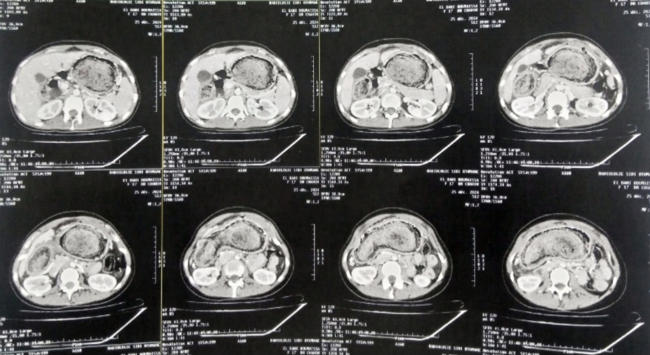

Figure1: CT Scan showing the bezoar and pneumoperitoneum.

The patient was admitted urgently to the operating room, and a laparotomy was performed, we have found gastric fluid in the peritoneal cavity, with a 2cm perforation in the gastric fundus, we then proceeded with a transverse gastrotomy and the extraction of a large trichobezoar occupying the whole lumen of the stomach, primary suture of the perforation and the gastrotomy was performed, with a subsequent peritoneal lavage and drainage.

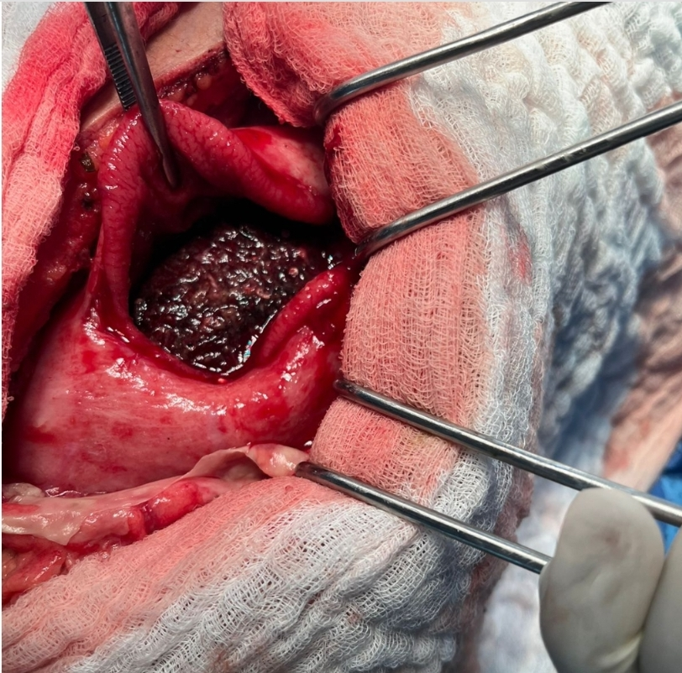

Figure 2: transverse gastrotomy showing the trichobezoar

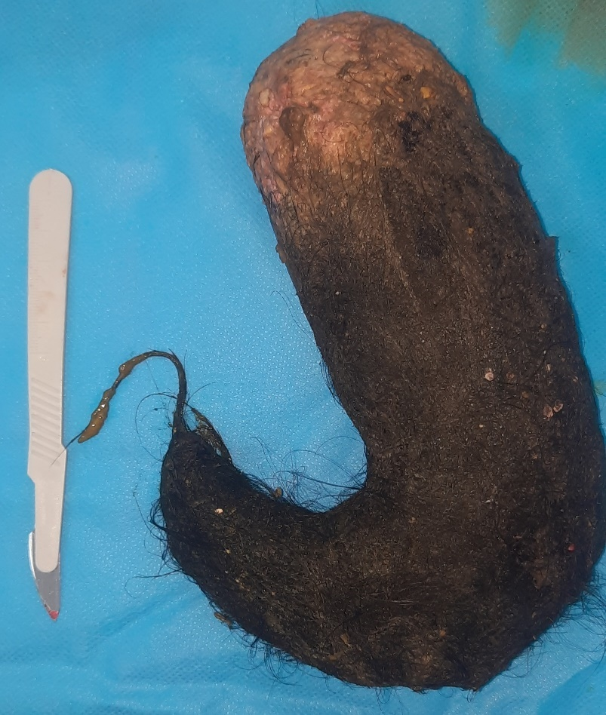

Figure 3: trichobezoar after extraction

The post operative course was uneventful, and the patient was discharged on the fifth day.

A psychiatric consultation was done pre discharge, no diagnostic criteria were met for trichotillomania, obsessive-compulsive disorder, anxiety, or depression. She was advised to follow up regularly with out patient psychiatric services.

3. discussion

Trichobezoar which is the accumulation of indigestible hair in the digestive tract is usually found in young girls with psychiatric or social problems [3,4], even though in some cases like ours, the patient is not known to have any psychiatric history. The most common complications are perforation, followed by intussusception, pancreatitis and cholangitis [5,6]. As the trichobezoar grows, blood supply the mucosa is hampered, leading to ulceration and perforation [7,8].

While most trichobezoars are confined to the stomach, larger masses may extend into the small intestine, forming what is known as Rapunzel syndrome [9]. Although no intestinal extension was found in our case, the bezoar was of sufficient size and density to cause gastric wall compromise. Surgical intervention remains the mainstay of treatment in complicated cases, especially when perforation or obstruction is present.

Trichobezoars of the gastro intestinal tract can remain asymptomatic, and incidentally discovered on routine radiography, or they can be diagnosed during the complications cited above [10]. Our patient stayed asymptomatic for years, the trichobezoar eventually grew in size causing the perforation and peritonitis

Although laparoscopy is feasible in certain cases, the standard procedure is laparotomy due the usually extreme size of the bezoar [11]

Clinicians should maintain a high index of suspicion for bezoars in adolescents presenting with unexplained abdominal symptoms, weight loss, or gastrointestinal obstruction even in the absence of psychiatric history. Early recognition and treatment are essential to preventing severe complications such as hemorrhage, obstruction, or perforation.

The absence of psychiatric history is unusual but not unheard of. Several studies report that psychiatric or behavioral signs may remain subclinical or unrecognized by the patient or family [12]. This underscores the necessity of formal psychiatric evaluation in all such cases.

4. Conclusion

Trichobezoar is a treatable affection, the consequences of which could be deadly, to avoid recurrence, a multidisciplinary approach involving surgeons, pediatricians, psychiatrists and gastroenterologists is needed.

Consent (where ever applicable)

All authors declare that written informed consent was obtained from the patient (or other approved parties) for publication of this case report and accompanying images. A copy of the written consent is available for review by the Editorial office/Chief Editor/Editorial Board members of this journal.

Ethical approval (where ever applicable)

All authors declare that ‘written informed consent was obtained from the patient (or other approved parties) for publication of this case report and accompanying images. A copy of the written consent is available for review by the Editorial office/Chief Editor/Editorial Board members of this journal.

References

1. Chisholm EM, Leong HT, Chung SC, Li AK. Phytobezoar: an uncommon cause of small bowel obstruction. Ann R Coll Surg Engl. 1992 Sep;74(5):342-4. PMID: 1416706; PMCID: PMC2497638.

2. Hennessy MM, Ivanovski I, Ó Súilleabháin CB. Gastric ulceration and perforation secondary to large trichobezoar - A case report describing the role of magnetic resonance imaging in diagnosis. Int J Surg Case Rep. 2018;43:25-28. doi: 10.1016/j.ijscr.2018.01.004. Epub 2018 Feb 10. PMID: 29438853; PMCID: PMC5814371.

3. Ahmad Z, Sharma A, Ahmed M, Vatti V. Trichobezoar Causing Gastric Perforation: A Case Report. Iran J Med Sci. 2016 Jan;41(1):67-70. PMID: 26722149; PMCID: PMC4691274.3. Bulut OB, Rasmussen C, Fischer A. Acute surgical treatment of complicated peptic ulcers with special reference to the elderly. World J Surg. 1996;20:574–7. doi: 10.1007/s002689900089.

4.  Bouwer C, Stein DJ. Trichobezoars in trichotillomania: case report and literature overview. Psychosom Med. 1998;60(5):658–660

5. Santos Valenciano J, Nonose R, Bragattini Cruz R, Tiemi Sato D, Monteiro Fernandes F, Fabricio Nascimento E, et al. Tricholithobezoar causing gastric perforation. Case Rep Gastroenterol. 2012;6:26–32. doi: 10.1159/000336203000336203.

6. Phillips MR, Zaheer S, Drugas GT. Gastric trichobezoar: case report and literature review. Mayo Clin Proc. 1998;73(7):653–656.

7. Gonuguntla V, Joshi DD. Rapunzel syndrome: a comprehensive review of an unusual case of trichobezoar. Clin Med Res. 2009;7:99–102. doi: 10.3121/cmr.2009.822.

8. Gonçalves R, Andrade P, Carvalho J, Rodrigues S, Macedo G. Trichobezoar: a rare cause of gastrointestinal obstruction. Rev Esp Enferm Dig. 2012;104(9):473–476.

9. Ventura DE, Herbella FA, Schettini ST, Delmonte C. Rapunzel syndrome with a fatal outcome in a neglected child. J Pediatr Surg. 2005;40(10):1665–1667

10. Gorter RR, Kneepkens CM, Mattens EC, Aronson DC, Heij HA. Management of trichobezoar: case report and literature review. Pediatr Surg Int. 2010;26:457–63. doi: 10.1007/s00383-010-2570-0

11. Cintolo J, Telem DA, Divino CM, Chin EH, Midulla P. Laparoscopic removal of a large gastric trichobezoar in a 4-year-old girl. JSLS. 2009 Oct-Dec;13(4):608-11. doi: 10.4293/108680809X12589999538110. PMID: 20202404; PMCID: PMC3030801.

12.Ramaswamy P, Natarajan M, Balasubramaniam G. Gastric perforation secondary to trichobezoar in a 13-year-old girl. *J Pediatr Surg*. 2013;48(5):e13–e15.