Case report

Brain MRI in Gougerot–Sjögren syndrome: A Case Report with diagnostic approach and imaging review

ABSTRACT
We report here the case of a 35-year-old patient who was followed for Gougerot's disease and who had headaches for several weeks.
Gougerot-Sjögren's disease is a systemic autoimmune disease characterized by impaired specific glands (notably the lachrymal and salivary glands), which presents various systemic symptoms that may affect multiple organs [1]. Besides, this condition may develop neurological symptoms. An MRI of the brain is therefore useful in these instances to evaluate dual pathology.
Key words:
MRI, Sjögren's syndrome, Aseptic meningitis, T2 hypersignal.

INTRODUCTION
Sjögren's syndrome is an uncommon condition impacting about one in 10,000 persons [1]. Women are affected 10 times more than men, and the disease most often sets in around the age of 50[2].
However, it can occur much earlier in life, between the ages of 20 and 30 [2]. These forms affecting young people are often more severe.
Sjögren syndrome (SGS) is characterized by lymphocyte infiltration of exocrine glands, including the salivary and lacrimal glands, resulting in dry eye. Although often seen as a restricted disorder, SGS can also bring systemic implications, involving various organs, including the central nervous system.[3].
Here we present a rare case of a 35-year-old female patient followed for Gougerot-Sjögren syndrome and the role of MRI in the diagnosis.

CASE PRESENTATION
Our patient is a 35-year-old woman who is being monitored for Gougerot-Sjögren syndrome and is currently under observation. She reports persistent headaches for several weeks, despite symptomatic medical treatment. The clinical examination revealed that the patient was stable and afebrile, with a thorough neurological assessment showing no abnormalities.
The patient underwent a brain MRI (Fig. 1):
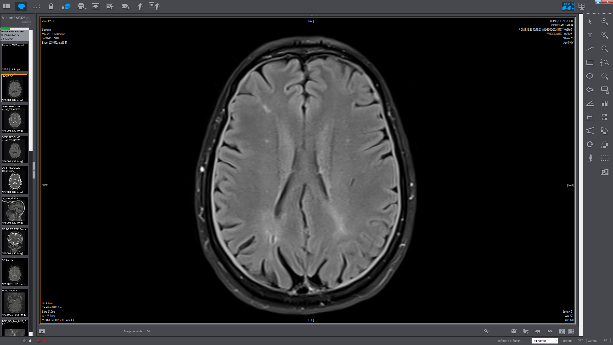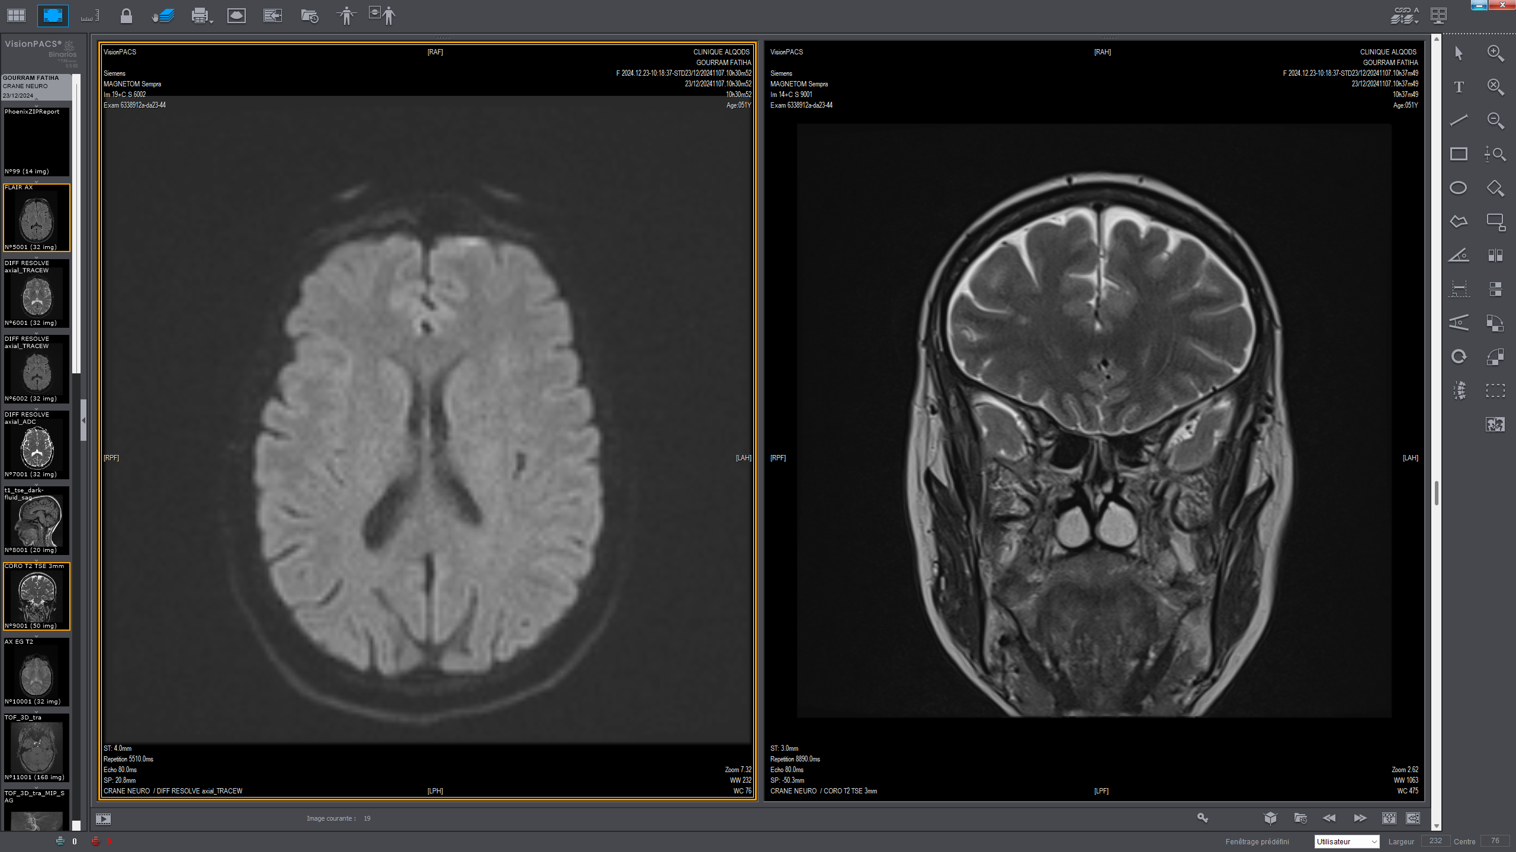
B
A
FLAIR
Diffusion
T2
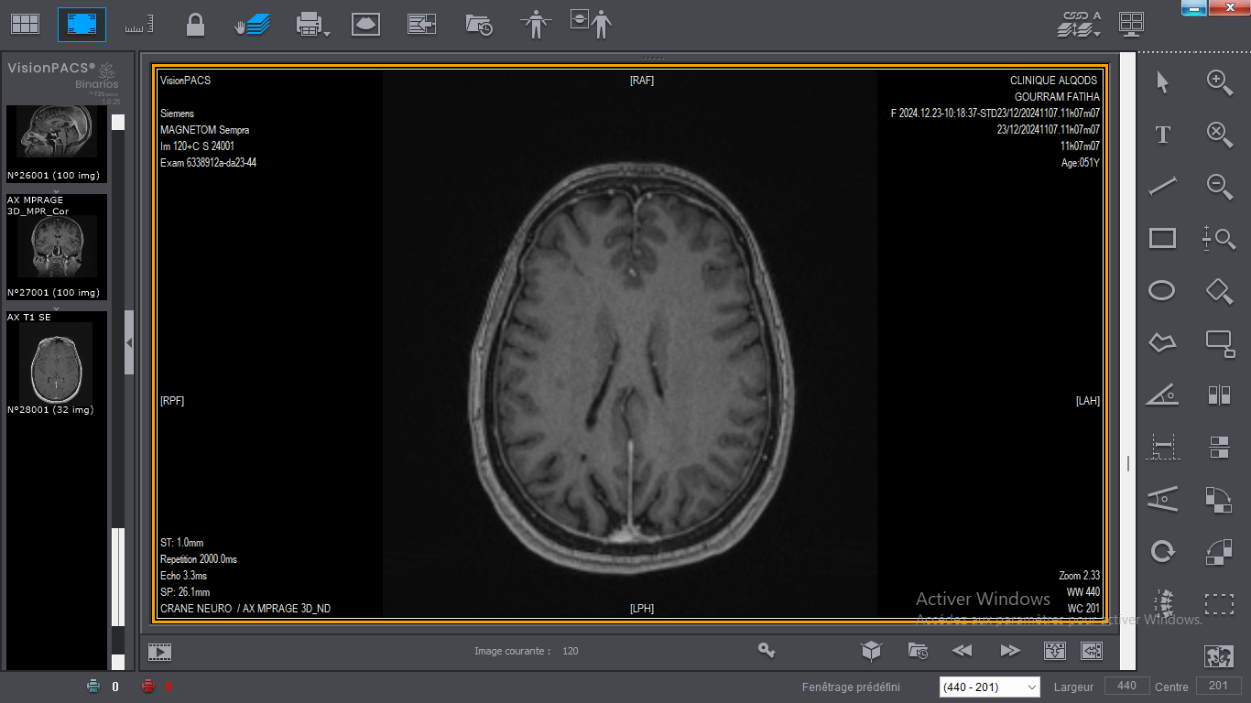
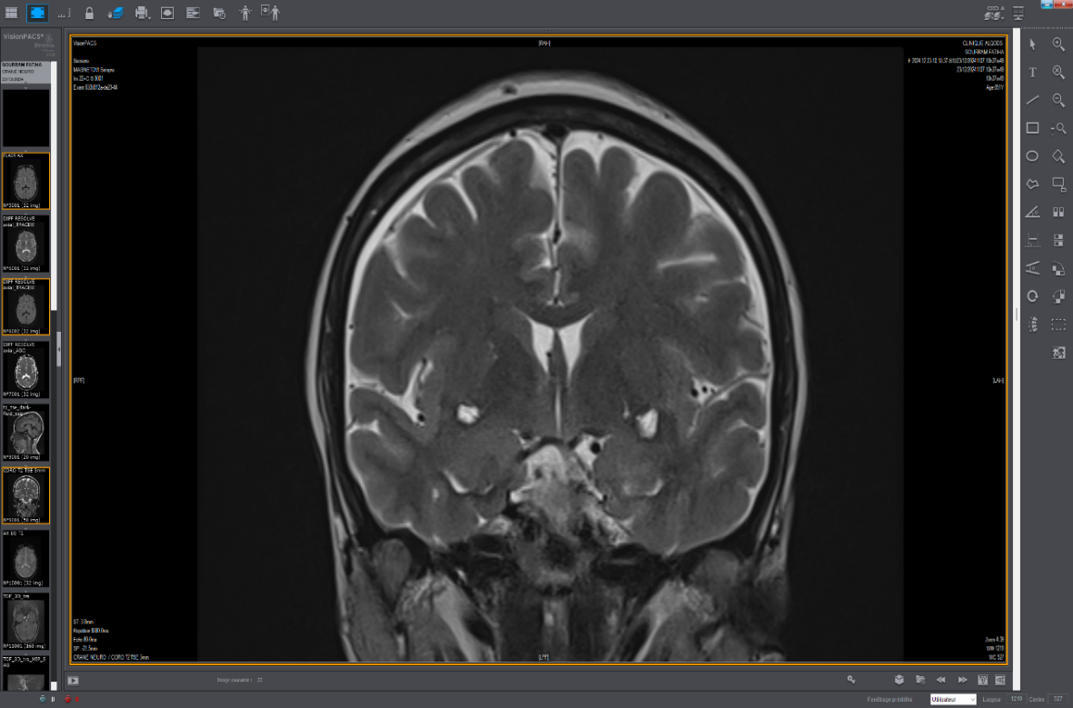
D
C
T1 c+
T2

Fig.1: Axial FLAIR (A), Axial diffusion (B), Coronal T2 (C), Axial T1 post-contrast (D): The images reveal the presence of white matter lesions, characterized by hyperintensities on T2 and FLAIR sequences, as well as thickening and enhancement of the meninges, described as hyperintensities on T2.
DISCUSSION:
The foundations of SS were established in the early 20th century. In 1925, Gougerot described a clinical picture associating dryness of the eyes, mouth, nose, and larynx, suggesting the disease’s systemic dimension [1]. In 1933, Henrik Sjögren expanded upon these observations, linking dryness with chronic arthritis in women, thereby confirming the autoimmune nature of SS [4].
The etiology of SS remains incompletely understood and differs from related autoimmune diseases such as systemic lupus erythematosus (SLE). Multiple factors contribute to its pathogenesis, including genetic, hormonal, immunologic, and viral components [5]. The disease is characterized by autoimmune infiltration of the exocrine glands, leading to their progressive destruction [6]. Autoantibodies targeting nuclear and glandular structures exacerbate tissue damage via chronic inflammation. Dendritic cells and macrophages play a central role in this immune dysregulation [6].
In addition to ocular and oral involvement, SS affects multiple organ systems, confirming its systemic nature. Joint manifestations such as pain, morning stiffness, and swelling are common. Cutaneous findings include dryness, rash, or vasculitis. Pulmonary involvement may present as recurrent infections, chronic cough, or dyspnea. Renal complications include glomerulonephritis and tubular disorders [7]. Vascular phenomena such as Raynaud’s syndrome or systemic vasculitis have also been described [8][9].
Sjögren’s syndrome may give rise to a wide spectrum of neurological symptoms. Lymphocytic infiltration of the nervous system, combined with the production of autoantibodies against neuronal antigens, leads to chronic inflammation, neuronal damage, and vascular injury, potentially resulting in infarctions or hemorrhages [6][7]. Clinically, neurological involvement may manifest as headaches, cognitive dysfunction, peripheral neuropathies, or dysautonomia.
Brain MRI is an essential and irreplaceable tool for investigating neurological manifestations in SS. It enables the detection of structural lesions not evident upon clinical examination and allows for the assessment of lesion extent and activity. T2-weighted and FLAIR sequences are particularly sensitive in detecting hyperintensities in the subcortical and periventricular white matter, often mimicking lesions observed in multiple sclerosis (MS) [10][11][12]. Gadolinium-enhanced T1-weighted imaging reveals areas of active inflammation, indicative of ongoing autoimmune processes.
Specific findings such as corpus callosum atrophy, basal ganglia abnormalities, and brainstem lesions have also been reported, suggesting widespread and deep central nervous system involvement. Assessment of cerebral atrophy, especially in the temporal and parietal lobes, offers insight into disease chronicity and severity [11]. In some cases, MRI demonstrates lymphocytic meningitis, visible as meningeal thickening and contrast enhancement, often associated with symptoms like persistent headaches or cognitive decline.
Spinal cord involvement, including transverse myelitis, typically appears as T2 hyperintensities in the cervical cord. These lesions can be distinguished from other etiologies based on their topography, longitudinal extent, and gadolinium enhancement profile [13]. Thus, MRI not only facilitates accurate diagnosis but also guides therapeutic decisions and longitudinal monitoring.
The presence of specific autoantibodies (anti-SSA, anti-SSB) and salivary gland biopsy confirming lymphocytic infiltration support the diagnosis. Cerebrospinal fluid (CSF) analysis frequently shows elevated IgG index and oligoclonal bands, also found in MS, necessitating a strict correlation with MRI findings [14].
In our case, a female patient was initially evaluated for chronic headaches. Brain MRI revealed aseptic meningitis and white matter hyperintensities, consistent with SS-related neurological involvement. This presentation warranted close radiological monitoring and regular neurocognitive testing to adjust therapeutic strategy. The patient initially responded well to corticosteroid therapy, but was lost to follow-up. Upon returning several months later, she presented in a severely deteriorated condition, with memory impairment, spatial-temporal disorientation, diffuse paresthesia, and moderate ataxia. Immunosuppressive therapy was initiated, resulting in notable clinical improvement [15].
CONCLUSION:
Magnetic resonance imaging (MRI) plays a pivotal role in the identification and monitoring of neurological complications associated with Sjögren’s syndrome. Beyond detecting clinically silent abnormalities, MRI enables the differentiation of SS-related central nervous system lesions from other demyelinating disorders, particularly multiple sclerosis. Specific radiological findings, such as periventricular hyperintensities, corpus callosum atrophy, or meningeal enhancement, may serve as imaging biomarkers of disease activity or chronicity.
A multidisciplinary diagnostic approach integrating clinical, serological, and radiological data is essential to improve diagnostic accuracy, guide immunosuppressive therapy, and monitor disease progression. A deeper understanding of SS-specific imaging patterns could contribute to earlier diagnosis and more individualized treatment strategies.

CONSENT
All authors declare that ‘written informed consent was obtained from the patient family for publication of this case report and accompanying images’.

ETHICAL APPROVAL
All authors hereby declare that all experiments have been examined and approved by the
appropriate ethics committee and have therefore been performed in accordance with the ethical standards laid down in the 1964 Declaration of Helsinki.

DISCLAIMER (ARTIFICIAL INTELLIGENCE)
Author(s) hereby declares that NO generative AI technologies such as Large Language Models (ChatGPT, COPILOT, etc.) and text-to-image generators have been used during the writing or editing of this manuscript.

REFERENCES:
- R. I. Fox, M. Stern, et P. Michelson, « Update in Sjögren syndrome », Current Opinion in Rheumatology, vol. 12, no 5, p. 391-398, sept. 2000.
- Shiboski CH, Shiboski SC, Seror R, et al: 2016 American College of Rheumatology/European League Against Rheumatism classification criteria for primary Sjögren's syndrome: A consensus and data-driven methodology involving three international patient cohorts. Arthritis Rheumatol 69(1):35–45, 2017. doi:10.1002/art.39859
- Payet J, Belkhir R, Gottenberg JE, Bergé E, Desmoulins F, Meyer O, Mariette X, Seror R. « ACPA-positive primary Sjögren's syndrome: true primary or rheumatoid arthritis-associated Sjögren's syndrome? RMD Open. 2015 Apr 30;1(1):e000066. doi: 10.1136/rmdopen-2015-000066. eCollection 2015.
- 3. Narbutt J. Sjogen's Syndrome. http://www.emedicine.com/derm/topic846.htm. (accessed January 1,2006)
- Noah Scheinfeld «Sjögren syndrome and systemic lupus erythematosus are distinct conditions ». Dermatology Online Journal 12 (1): Department of Dermatology, St Lukes Roosevelt Hospital Center, New York NY. (2006). https://doi.org/10.5070/D30jp529zq
- C. Martel, M.-O. Jauberteau, E. Vidal, et A.-L. Fauchais, « Physiopathologie du syndrome de Gougerot-Sjögren primitif », La Revue de Médecine Interne, vol. 35, no 8, p. 524-530, août 2014, Doi: 10.1016/j.revmed.2013.12.0
- A. Bordron, A. Charras, C. Le Dantec, et Y. Renaudineau, « Épigénome et syndrome de Gougerot-Sjögren », La Revue de Médecine Interne, vol. 39, no 5, p. 346-351, mai 2018, Doi: 10.1016/j.revmed.2017.09.003.
- Scofield RH. Vasculitis in Sjögren's Syndrome. Curr Rheumatol Rep. 2011 Dec;13(6):482-8. doi: 10.1007/s11926-011-0207-5. PMID: 21870104; PMCID: PMC5278618.
- Y.-T. Huang, T.-H. Lu, P.-L. Chou, et M.-Y. Weng, « Diagnostic Delay in Patients with Primary Sjögren’s Syndrome: A Population-Based Cohort Study in Taiwan », Healthcare, vol. 9, no 3, p. 363, mars 2021, Doi: 10.3390/healthcare9030363.
- Fan W, Par-Young J, Li K, Zhang Y, Xiao P, Hua L, Leng L, Chen X, Bucala R « Clinical features and high-risk indicators of central nervous system involvement in primary Sjögren's syndrome.». Clin Rheumatol. 2023 Feb;42(2):443-451. doi: 10.1007/s10067-022-06448-w. Epub 2022 Nov 19. PMID: 3640106
- László V Módis , Zsófia Aradi , Ildikó Fanny Horváth , János Bencze , Tamás Papp , Miklós Emri , Ervin Berényi , Antal Bugán , Antónia Szántó. « Central Nervous System Involvement in Primary Sjögren’s Syndrome: Narrative Review of MRI Findings » ( doi: 10.3390/diagnostics13010014) 2022 Dec 21;13(1):14. [PMC free article] [PubMed]
- Barsottini OGP, Moraes MPM, Fraiman PHA, Marussi VHR, Souza AWS, Braga Neto P, Spitz M. « Sjogren's syndrome: a neurological perspective ». Arq Neuropsiquiatr. 2023 Dec;81(12):1077-1083. doi: 10.1055/s-0043-1777105. Epub 2023 Dec 29. PMID: 38157875; PMCID: PMC10756846.
- Veenbergen S, Kozmar A, van Daele P LA, Schreurs M WJ. « Autoantibodies in Sjögren's syndrome and its classification criteria ». J Transl Autoimmun. 2021;5:100138. doi: 10.1016/j.jtauto.2021.100138.
- Perzyńska-Mazan J, Maślińska M, Gasik R. Termedia Publishing House Ltd. «Neurological manifestations of primary sjögren's syndrome»; 2018. Vol. 56, Reumatologia; pp. 99–105.
- R. Goulabchand, E. Castille, S. Navucet, D. Etchecopar-Etchart, A. Maria, L. Partouche, A. Le Quellec, B. Maréchal, E. Le Bars, A. Gabelle, N. Menjot De Champfleur, P. Guilpain, « IRM cérébrales au cours du syndrome de Gougerot–Sjögren : résultats préliminaires et aspects anatomo-cliniques » ,La Revue de Médecine Interne,Volume 40, Supplement 1,2019,Page A55,ISSN 0248-8663, https://doi.org/10.1016/j.revmed.2019.03.021.

