**Original Research Article**

**Isolation, Characterization, Probiotic Potential and Safety Evaluation of Lactic Acid Bacteria from Curd**

**Abstract**

Lactic Acid Bacteria (LAB) are widely recognized as beneficial microorganisms that play a crucial role in the production of various fermented foods. They contribute to improving food flavor and inhibiting the growth of pathogenic and spoilage microorganisms in these products. This study focused on isolating, characterizing, and identifying LAB from diverse products collected in Chennai, followed by evaluating their in vitro antimicrobial activity against pathogenic bacteria. Five *Lactobacillus* strains were isolated from curd and identified through biochemical and physiological tests. Preliminary classification suggested these isolates belonged to the *Lactobacillus* genus, which was further confirmed by genus-specific PCR and 16S rDNA sequencing. The identified strains included *Lactiplantibacillus plantarum*, *Lactobacillus acidophilus*, *Limosilactobacillus fermentum*, *Lacticaseibacillus rhamnosus* and *Lactobacillus acidophilus*. The isolates’ survival was tested under simulated gastrointestinal conditions, including low pH and bile salt exposure. All strains demonstrated growth at pH 3 and in the presence of bile salts. Hemolytic activity assays on sheep blood agar revealed   
γ-hemolysis in all isolates, indicating non-hemolytic behavior. The antimicrobial activity of the strains was evaluated against *Escherichia coli* (ATCC 25922) and *Staphylococcus aureus* (ATCC 25923) using the agar well diffusion method, where all isolates showed clear zones of inhibition. In conclusion, these findings indicate that the isolated LAB strains possess probiotic potential.

**Key words:** *Lactic acid bacteria, acid and bile tolerance, haemolytic activity antimicrobial activity, curd*

**Introduction:**

Traditionally, individuals have consumed lactic acid bacteria (LAB), present in numerous fermented foods such as dairy items. LAB are extensively studied worldwide because of their essential role in most fermented foods. They are greatly appreciated for their ability to generate numerous antimicrobial substances 1, anticancer effects 2, suppress harmful species 3, boost the immune system 4. Bacteriocins produced by lactic acid bacteria (LAB) have attracted considerable interest as safe alternatives to traditional food preservatives in commercial applications. LAB have been used as preservatives in food and animal feed for centuries, and LAB that generate bacteriocins might act as alternatives to chemical preservatives to prevent bacterial spoilage and harmful bacterial growth in food products 5. This study aimed to isolate, characterize, and identify Lactobacillus strains from dairy and dairy products to examine their probiotic properties (such as non-hemolytic assay, acid tolerance, bile tolerance, and antimicrobial activity against pathogens) and the potential of these isolated lactic acid bacteria (LABs) to function as viable probiotic organisms.

**Materials and Methods**

**Sample collection**

The research sought to isolate strains of lactic acid bacteria (LAB) from different curd samples. To accomplish this, samples were gathered from different areas of Chennai. Also, the following cultures were received from Department of Dairy Microbiology, Verghese Kurien Institute of Dairy and Food Technology, Mannuthy for comparing the probiotic potential of isolated lactic acid bacteria shown in table.1.

**Table. 1. List of Lactic Acid Bacteria**

|  |  |  |
| --- | --- | --- |
| **S. No** | **Name of the probiotic culture** | **Gene Bank Number** |
| 1. | *Lactobacillus delbrueckii ssp. bulgaricus* | MK765016 |
| 2. | *Lactobacillus rhamnosus* | MT180552 |
| 3. | *Limosilactobacillus fermentum* | MT176500 |
| 4. | *Lactiplantibacillus plantarum* | MT211513 |
| 5. | *Lacticaseibacillus casei* | MK793581 |
| 6. | *Lactobacillus fermentum* | KY379153 |
| 7. | *Lactobacillus helveticus* | MH191154 |

**Isolation, purification, and screening of lactic acid bacteria**

Microbiological techniques were utilized to analyze the samples, which involved streaking them onto MRS agar (de Man, Rogosa, and Sharpe) from HiMedia, India, and incubating in anaerobic conditions at 37◦C for 24 to 48 hours. The LAB colonies that displayed distinct characteristics were carefully selected, sub-cultured, and grown in MRS broth. The colonies were evaluated based on morphological traits, including Gram staining, colony morphology, as well as morphological attributes such as colony color, shape and size. The findings were then compared with the Bergey’s Manual of Determinative Bacteriology 6 for further examination. The biochemical test was carried out for the isolates using Hi-Media carbo kit to identify the organism based on sugar fermentation. The most promising isolates, which demonstrated growth during sub-culturing, were chosen for further research. The bacterial culture was then preserved in an MRS agar slant and stored at 4◦C for future studies.

**Identification and Molecular characterization of Isolates by 16S rRNA Gene Sequencing**

The identification of LAB isolates was achieved through a blend of morphological and phenotypic assessments, which encompassed biochemical and physiological characteristics. To validate the identity of the isolates further, 16S rDNA sequencing was employed. Its quality was evaluated on 1.0 % agarose gel, a single band of high-molecular weight DNA has been observed. Fragment of 16S rRNA gene was amplified by 16SrRNA-F and 16SrRNA-R primers. A single discrete PCR amplicon band of 1500 bp was observed when resolved on agarose gel. The PCR amplicon was purified to remove contaminants. Forward and reverse DNA sequencing reaction of PCR amplicon was carried out with 16SrRNA-F and 16SrRNA-R primers using BDT v3.1 Cycle sequencing kit on ABI 3730xl Genetic Analyzer. Consensus sequence of 16S rRNA gene was generated from forward and reverse sequence data using aligner software. The 16S rRNA gene sequence was used to carry out BLAST-N with the ‘nr’ database of NCBI GenBank database. Based on maximum identity score first ten sequences were selected and aligned using multiple alignment software program Clustal W. Distance matrix and phylogenetic tree was constructed was constructed using MEGA 11.

The evolutionary history was inferred by using the Maximum Likelihood method and Tamura-Nei model 7. The tree with the highest log likelihood (-2201.38) is shown. Initial tree(s) for the heuristic search were obtained automatically by applying Neighbor-Join and BioNJ algorithms to a matrix of pairwise distances estimated using the Tamura-Nei model, and then selecting the topology with superior log likelihood value. This analysis involved 11 nucleotide sequences. Codon positions included were 1st + 2nd + 3rd + Noncoding. There were a total of 1531 positions in the final dataset. Evolutionary analyses were conducted in MEGA118.

**Acid tolerance and Bile tolerance test**

The MRS broth was modified to a pH of 3 using 1N HCl, and freshly cultured bacteria were introduced into the corresponding MRS broth within test tubes. The tubes were then incubated for 90 minutes at a temperature of 42°C and colonies were counted at dilutions of 107 using the pour plate method after an incubation period of 24 hours at 42°C. The negative control, which contained only the media, did not exhibit any growth 9.

The ability of the isolates to tolerate bile salt was assessed using MRS broth that was enriched with bile salt at concentrations of 0.2, 0.4, 0.6, 0.8, and 1.0 percent. The cultures were incubated at 37°C, and samples were collected after 24 hours. The negative control, consisting solely of the media, exhibited no signs of growth 9.

**Antimicrobial activity**

The antimicrobial activity of the isolates was tested using culture-free supernatants, the antimicrobial activity of the isolates was tested against the indicator bacteria *Staphylococcus aureus* (ATCC 25923) and *Escherichia coli* (ATCC 25922). The conventional agar well diffusion method was employed to evaluate this activity on Nutrient Agar plates. All supernatants were adjusted to a pH of 6.5 to counteract the inhibitory effects of lactic acid. After a 24-hour incubation at 37°C, the zone of inhibition was recorded 9.

**Hemolytic activity**

Using a blood agar medium containing 5% (w/v) sheep blood, the hemolytic activity of the isolates was assessed. The plates were incubated for 48 hours at 37°C, following which the hemolytic activity of the isolated cultures was evaluated and categorized based on the degree of red blood cell lysis observed in the surrounding medium. The presence of clear zones around the colonies indicated α-hemolysis, while green zones suggested β-hemolysis, and the lack of any zones around the colonies on the blood agar plates pointed to γ-hemolysis. Strains were considered safe only if they exhibited γ-hemolysis 10, 11.

**Results and Discussions**

**Isolation, purification and screening of lactic acid bacteria**

Five bacterial colonies were isolated from dairy products and purified using MRS medium. All isolates exhibited characteristic small, pointed colonies and were Gram-positive, consistent with the typical morphology of lactic acid bacteria (Figure 1). These isolates were randomly selected and preserved in 35% glycerol for future experiments.

|  |  |
| --- | --- |
|  |  |
| 1. Colony morphology | 1. Gram staining of the isolated strain |

**Fig. 1. Colony and Gram staining of isolates**

The biochemical characteristics of the isolates are presented in Table 2. All lactic acid bacteria (LAB) isolates were able to utilize galactose, maltose, glucose, fructose, mannose and lactose as primary fermentable sugars. These results are largely consistent with previous phenotypic identifications of LAB species from traditional African fermented products such as Ititu/Ergo 12 and Laban Zeer from Egypt 13.

**Table. 2. Biochemical characterization of the isolated lactic acid bacteria**

|  |  |  |  |  |  |
| --- | --- | --- | --- | --- | --- |
| **Name of the sugar** | **Sample code** | | | | |
| **Strain 1** | **Strain 2** | **Strain 3** | **Strain 4** | **Strain 5** |
| Arabinose | V | - | V | - | - |
| Cellobiose | + | + | V | - | + |
| Fructose | + | + | + | + | + |
| Galactose | + | W | + | + | W |
| Lactose | + | + | + | + | + |
| Maltose | + | - | + | + | - |
| Mannitol | + | + | + | + | + |
| Mannose | + | + | - | + | + |
| Melibiose | + | - | + | - | - |
| Raffinose | + | + | + | + | + |
| Rhamnose | - | + | - | + | + |
| Salicin | + | + | - | + | + |
| Sorbitol | + | - | - | - | - |
| Sucrose | + | + | + | + | + |
| Trehalose | + | - | V | - | - |
| Xylose | V | + | V | + | + |

+ = able to ferment sugar; – = not able to ferment sugar; v = variable fermentation;

w = weak fermentation

**Identification and Molecular characterization of Isolates**

To identify the five selected isolates, partial 16S rRNA gene sequencing was performed following phenotypic characterization, using two universal primers. Each isolate produced a PCR amplicon of approximately 1500 bp (Figure 2). The PCR products were purified using the QI Aquick PCR Purification Kit, and the purified DNA was sequenced. Sequence similarity searches were conducted using the GenBank database via BLAST analysis, which clearly confirmed the identities of the isolates. The strains were molecularly identified as *Lactiplantibacillus plantarum*, *Lactobacillus acidophilus*, *Limosilactobacillus fermentum* and *Lacticaseibacillus rhamnosus*.

In a previous study 14, isolated and identified 50 LAB strains from Oggtt samples using phenotypic and biotyping methods. Among these, 30% were identified as *Lactobacillus casei*, 22% as *Lactobacillus acidophilus*, 16% as *Enterococcus faecium*, 14% as *Lactobacillus plantarum*, 12% as *Lactobacillus lactis* and 6% as *Lactobacillus fermentum*. The phylogenetic tree of *Lacticaseibacillus rhamnosus* is presented in Figure 3. Differences in LAB composition between studies may be due to variations in milk type, curd preparation methods, seasonal factors and storage conditions.

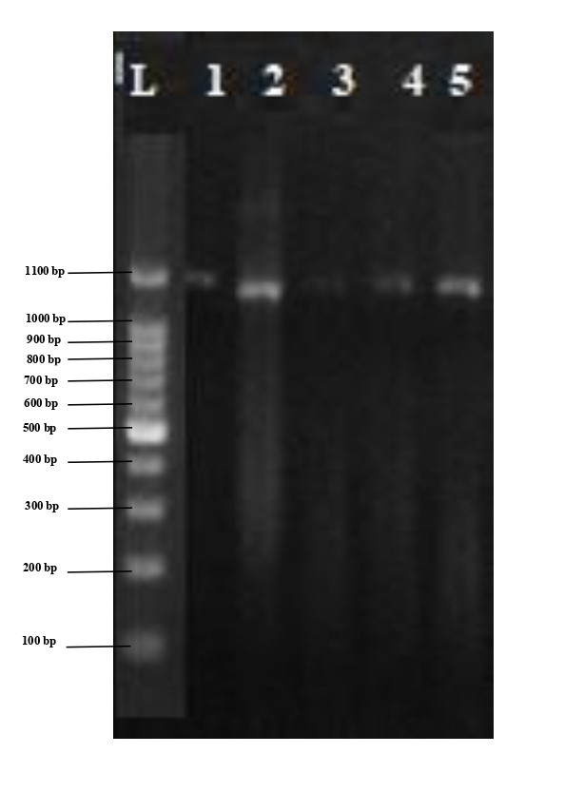

**Fig. 2. Electrophoresis results after PCR with primers**

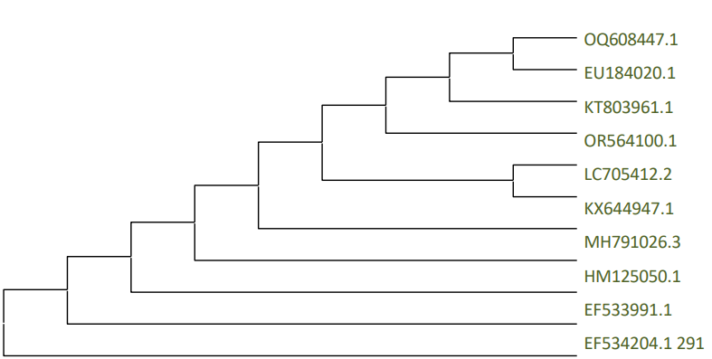

**Fig.3.** **Phylogenetic tree of *Lacticaseibacillus rhamnosus***

**Acid and Bile Tolerance Test**

As shown in Table 3, all LAB strains demonstrated the ability to survive in bile salt concentrations of 0.2%, 0.4%, 0.6%, 0.8%, and 1.0% (v/v), indicating both acid and bile tolerance. Additionally, all strains were able to withstand acidic conditions at pH 3.0. In the bile tolerance assay, a gradual decline in viable cell counts was observed with increasing bile salt concentrations.

**Table 3. Acid and Bile tolerance test of the isolates**

|  |  |  |  |  |  |  |  |
| --- | --- | --- | --- | --- | --- | --- | --- |
| **S. No** | **Name of the probiotic culture** | **Bile resistance**  **(bile salt %)** | | | | | **Acid tolerance**  **(pH 3.0)** |
| **0.2** | **0.4** | **0.6** | **0.8** | **1.0** |
| 1. | *Lactobacillus delbrueckii ssp. bulgaricus* | + | + | + | + | + | + |
| 2. | *Lactobacillus rhamnosus* | + | + | + | + | + | + |
| 3. | *Limosilactobacillus fermentum* | + | + | + | + | + | + |
| 4. | *Lactiplantibacillus plantarum* | + | + | + | + | + | + |
| 5. | *Lacticaseibacillus casei* | + | + | + | + | + | + |
| 6. | *Lactobacillus fermentum* | + | + | + | + | + | + |
| 7. | *Lactobacillus helveticus* | + | + | + | + | + | + |
| 8. | Strain 1 | + | + | + | + | + | + |
| 9. | Strain 2 | + | + | + | + | + | + |
| 10. | Strain 3 | + | + | + | + | + | + |
| 11. | Strain 4 | + | + | + | + | + | + |
| 12. | Strain 5 | + | + | + | + | + | + |

+ - growth

Because probiotics are commonly consumed orally, they must be able to survive passage through the acidic environments of the stomach and small intestine. Therefore, tolerance to the low pH of gastric juice is considered a crucial trait of probiotic bacteria 15. The results of this study are consistent with previous findings, which reported that lactic acid bacteria species generally exhibit strong acid resistance at pH levels of 2.0 and 3.0—conditions similar to those found in gastric juice—although their survival tends to decrease at even lower pH levels 16.

**Antimicrobial activity**

This study investigated the antimicrobial properties of the isolated strains in comparison to other bacterial species. As presented in Table 4, the isolates exhibited notably stronger antimicrobial activity, highlighting their potential as probiotic candidates. These results are supported by evidence that the strains produce a range of antimicrobial compounds, including bacteriocins, biosurfactants, hydrogen peroxide (H₂O₂), and organic acids, which contribute to their inhibitory effects 17. Our findings align with previous studies by 18, 19 which reported that lactic acid bacteria isolated from poultry possess broad-spectrum antagonistic activity against various pathogenic microorganisms.

**Table 4. Antimicrobial activity of the lactic acid bacteria and isolated strains**

|  |  |  |  |
| --- | --- | --- | --- |
| **S. No** | **Organism** | **Zone of inhibition** | |
| ***E.coli*** | ***S. aureus*** |
| 1. | *Lactobacillus delbrueckii ssp. bulgaricus* | + | + |
| 2. | *Lactobacillus rhamnosus* | + | + |
| 3. | *Limosilactobacillus fermentum* | + | + |
| 4. | *Lactiplantibacillus plantarum* | + | + |
| 5. | *Lacticaseibacillus casei* | + | + |
| 6. | *Lactobacillus fermentum* | + | + |
| 7. | *Lactobacillus helveticus* | + | + |
| 8. | Strain 1 | + | + |
| 9. | Strain 2 | + | + |
| 10. | Strain 3 | + | + |
| 11. | Strain 4 | + | + |
| 12. | Strain 5 | + | + |

This study resulted in the identification of five probiotic species, which were subsequently characterized and genotypically confirmed as members of the *Lactobacillus* genus. These indigenous probiotic strains possess distinctive traits that may hold potential for applications in the pharmaceutical, cosmetic and food industries. The findings underscore the value of oral and dietary sources as promising reservoirs for the discovery of novel probiotics with beneficial functional properties.

**Hemolytic activity**

The Food and Agriculture Organization (FAO) emphasizes that probiotics, defined as beneficial microbial strains, must be safe for their intended host20. Ensuring this safety involves selecting strains that lack hemolytic activity, as the absence of such activity is indicative of non-virulent properties. In the current study, all lactic acid bacteria (LAB) strains evaluated for hemolytic activity were found to be non-hemolytic, supporting their potential suitability for probiotic applications. These findings are in agreement with previous reports 10,11.

**Conclusion**

Recent research has increasingly focused on the probiotic potential of *Lactobacillus* species due to their diverse health benefits. Commonly found in fermented foods such as yogurt, kefir, and sourdough, *Lactobacillus* species have been shown to improve digestive health, enhance immune function, and reduce the risk of various diseases. This study involved isolating *Lactobacillus* strains from local sources of both fermented and non-fermented foods, followed by evaluating their tolerance to stress conditions including high salinity and acidic pH. Results demonstrated that the isolated strains were capable of withstanding these adverse environments, indicating their potential to survive passage through the gastrointestinal tract. Furthermore, the absence of major virulence factors and hemolytic activity, along with their sensitivity to commonly used antibiotics, supports the suitability of these isolates for application in functional food products.

**References**

1. Temmerman, R., Pot, B., Huys, G. and Swings, J. (2002). Identification and antibiotic susceptibility of bacterial isolates from probiotic products. Int J Food Microbiol 81,   
1–10.

2. Hilde, M., Ostile Merete Helland, H. and Judith Narvhus, A. (2003). Growth and metabolism of selected strains of probiotic bacteria in milk. Int J Food Microbiol 87, 17–27.

3. Salminen, S., Ouwehand, A.C. and Isolauri, E. (1998). Clinical applications of probiotic bacteria. Int Dairy J 8, 563–572.

4. Isolauri E, Sütas Y, Kankaanpää P, Arvilommi H, Salminen S. Probiotics: effects on immunity. Am J Clin Nutr. 2001 Feb;73(2 Suppl):444S-450S. doi: 10.1093/ajcn/73.2.444s. PMID: 11157355.

5. Daeschel, M.A. (1989). Antimicrobial substances from lactic acid bacteria for use as food preservatives. *Food Technol.,* 43: 164-167.

6. Holt, J.G., Krieg, N.R., Sneath, P.H.A., Stanley, J.T. and William, S.T. (1994) Bergey’s Manual of Determinative Bacteriology. Williams and Wilikins, Baltimore, 786-788.

7. Kimura M. (1980). A simple method for estimating evolutionary rate of base substitutions through comparative studies of nucleotide sequences. Journal of Molecular Evolution 16:111-120.

8. Kumar S., Stecher G., Li M., Knyaz C., and Tamura K. (2018). MEGA X: Molecular Evolutionary Genetics Analysis across computing platforms. *Molecular Biology and Evolution* 35:1547-1549.

9. Chen, Z., Leng, X., Zhou, F., Shen, W., Zhang, H., Yu, Q. (2022). Screening and identification of probiotic Lactobacilli from the infant gut microbiota to alleviate lead toxicity. Probiot. Antimicrob. Proteins 21, 9895.

10. Asadi, A., Lohrasbi, V., Abdi, M., Mirkalantari, S., Esghaei, M., Kashanian, M. (2022). The probiotic properties and potential of vaginal Lactobacillus spp. isolated from healthy women against some vaginal pathogens. Lett. Appl. Microbiol. 74, 752–764.

11. Wei, C., Luo, K., Wang, M., Li, Y., Pan, M., Xie, Y., et al. (2022). Evaluation of potential probiotic properties of a strain of Lactobacillus plantarum for shrimp farming: From beneficial functions to safety assessment. Front. Microbiol. 13, 854131.

12. Gonfa A, Foster HA, Holzapfel WH. Field survey and literature review on traditional fermented milk products of Ethiopia. Int J Food Microbiol. 2001 Sep 1;68(3):173-86. doi: 10.1016/s0168-1605(01)00492-5. PMID: 11529440.

13. Saleh FA, (2013) Isolation and identification of microorganisms and antibacterial activity of Laban Zeer, an Egyptiantraditional fermented milk product. Food and Nutrition Sciences Dep. College of Agriculture and Food Science, KingFaisal University, Saudi Arabia 2:31–42.

14. Al-Hindi, R. R., Abd El Ghani, S., & Assem, F. (2015). Physicochemical composition and microbiological quality of Oggtt: Saudi Arabian traditional dried fermented milk. American Journal of Food Technology, 10(5), 195–205. <https://doi.org/10.3923/ajft.2015.195.205>

15. Yin, Q. and Zheng, Q. (2005). Isolation and identification of the dominant Lactobacillus in gut and feces of pig using carbohydrate fermentation and 16S rDNA analysis. J. Biosci. Bioeng., 99: 68–67.

16. Chang, Y.C. ; Wang Y.C. , Wang I.K. ; Lin C.F. ; Chuang, H.L. ; Wu, Y.Y. ; Chung, T.C. and Chen, T.H. (2012). Ciprofloxacin and tetracycline susceptibility of lactobacilli isolated from indigenous children's feces. Afr J Microbiol Res., 6: 245–50.

17. Lashani, E., Davoodabadi, A., and Soltan Dallal, M. M. (2020). Some probiotic properties of Lactobacillus species isolated from honey and their antimicrobial activity against foodborne pathogens. Vet. Res. Forum. 11, 121–126. doi: 10.30466/vrf.2018.90418.2188

18. García-Hernández, Y., Pérez-Sánchez, T., Boucourt, R., Balcázar, J. L., Nicoli, J. R., Moreira-Silva, J., et al. (2016). Isolation, characterization and evaluation of probiotic lactic acid bacteria for potential use in animal production. Res. Vet. Sci. 108, 125–132. doi: 10.1016/j.rvsc.2016.08.009

19. Oyewole, O. F., Maria, C. O., Tope, P. S., and Funmi, O. O. (2018). In vitro study of potential probiotic lactic acid bacteria isolated from the gut of chickens in Abeokuta, Nigeria. Alexandria J. Vet. Sci. 58, 73–73. doi: 10.5455/ajvs.290499

20. Hou F., Tang J., Liu Y., Tan Y., Wang Y., Zheng L., et al. (2023). Safety evaluation and probiotic potency screening of *Akkermansia muciniphila* strains isolated from human feces and breast milk. Microbiol. Spectr. 22, e0336122. 10.1128/spectrum.03361-22