**Original Research Article**

**Jowar price forecasting using different time series model in Ballari district of Karnataka**

**ABSTRACT**

Sorghum (*Jowar*) plays a critical role as a staple food and fodder crop in semi-arid regions of India, especially in Karnataka. This study focuses on forecasting the wholesale prices of Jowar in the Ballari market using monthly data spanning 2002 to 2024. To capture seasonality and complex patterns in the data, different time series models such as ARIMA, SARIMA, BATS, and TBATS—were evaluated. Accuracy of models were performed by using RMSE and MAPE metrics. Among the models, the BATS model exhibited superior forecasting accuracy with the lowest error values. Descriptive statistics and seasonal indices highlighted July and August as peak pricing months, aligning with demand-supply dynamics. The findings underscore the value of advanced forecasting methods in supporting informed decision-making for farmers, traders, and policymakers in the region.

**Keywords:** Sorghum, ARIMA, SARIMA, BATS, TBATS

1. **INTRODUCTION**

Sorghum (Jowar) is an important cereal crop cultivated in semi-arid regions of India (central and south India). It serves as both a staple food and vital source of fodder. It is grown in both the Kharif and Rabi. However, the share of Kharif is higher in terms of area as well as production. It is the third most important food crop with respect to area and production after Rice and Wheat. It requires areas with less than 100 cm rainfall and temperature ranging from 20 to 320 C for its growth. The soil requires for the cultivation is usually black cotton soil or regur soil with clayey and alluvium properties. It requires higher rainfall during the peak growth stage of the crop and crop maturity happens in cold weather conditions. India is the third largest producer of Jowar in the world and the highest Jowar producing states are Maharashtra, Karnataka, Telangana and Madhya Pradesh. Karnataka is the second largest producer of Jowar after Maharashtra. Vijayapura, Kalaburagi, Bagalkot, Raichur, Belagavi, Bidar and Ballari are the major producing districts in Karnataka.

As a staple food grain and fodder source, its price trends directly impact both farmers’ incomes and regional food security. Given the increasing volatility in agricultural markets due to climatic, policy and global economic influences, accurate price forecasting has become essential for informed decision making by farmers, traders and policymakers.

Price forecasting in agriculture has been an active area of research, especially in the context of improving market efficiency and supporting farmer decision making. Various statistical and machine learning models have been employed to predict agricultural commodity prices. The time series forecasting models provide powerful tools for understanding and predicting future price behavior. Among these, the Autoregressive Integrated Moving Average (ARIMA) model, Seasonal ARIMA (SARIMA) model, BATS (Box-Cox transformation, ARMA errors, Trend and Seasonal components) and TBATS (Trigonometric seasonality, Box-Cox transformation, ARMA errors, Trend and Seasonal components) have recognized as powerful tools for modelling and forecasting complex seasonal time series data. BATS and TBATS models extend traditional exponential smoothing techniques by incorporating advanced components such as Box-Cox transformations for variance stabilization, ARMA errors for autocorrelation modeling and multiple seasonal cycles, critical features for real world data which often exhibit multiple and non-integer seasonality. The TBATS models leverages trigonometric representations of seasonality, making it effective in handling high frequency and multiple seasonal data such as hourly or daily prices. The goal is to evaluate their effectiveness in capturing seasonal patterns, trends, and noise in the data and to assess their forecasting accuracy in comparison to more conventional models. By analyzing past patterns and trends in historical data, these models offer a statistically grounded methods for anticipating future price movements.

Santosha *et. al.,* (2018) has analyzed and forecasted the oilseed production of India using artificial intelligence techniques like Time Delay Neural Network (TDNN) and Non-Linear Support Vector Regression (NLSVR) and compare these models with ARIMA model. Monika Ray *et. al.,* (2022) has employed BATS and TBATS models for modelling and forecasting meteorological factors for the Keonjhar district of Orissa. The study reveals that BATS model was best for maximum temperature, morning and evening relative humidity based on the error estimation. For minimum temperature both BATS and TBATS model performed significantly at par. Vinay H T *et. al*., (2024) applied time series models such as Exponential Smoothing, ARIMA, SARIMA, BATS and TBATS models to forecast tomato prices in Kolar market of Karnataka using monthly wholesale price data, among the applied models, BATS showed superior performance. G. Mohan Naidu *et. al.,* (2024) analyzed the trends in the area, production and yield of mango using different non-linear and ARIMA models. Kozuch *et. al.,* (2023) analysed timber price using different traditional time series tools (ARIMA, SARIMA, BATS and TBATS model) and also ANN models for forecasting timber price. Vinay H T *et al*. (2024) evaluated ARIMA, SARIMA, BATS, and TBATS models to predict onion prices in Karnataka. Their analysis revealed that the TBATS model outperformed the others, and it was subsequently employed for forecasting future onion prices.

1. **MATERIALS AND METHODS**

This study is focused on the Jowar prices of Ballari market in the Kalyana Karnataka region of Karnataka state. The secondary data on monthly price of Jowar (sorghum) crop of Ballari district was collected for a period of 23 years (from January 2002 to December 2024) from [www.krishimaratavahini.co.in](http://www.krishimaratavahini.co.in) , Department of Agricultural Marketing, Government of Karnataka. The forecasting model details are as follows

**2.1 AUTOREGRESSIVE INTEGRATED MOVING AVERAGE (ARIMA) MODEL**

The ARIMA model is a classical statistical method used for analyzing and forecasting univariate time series data. It combines following three components

1. Autoregressive (AR): A regression of the variable on its own lagged values

2. Integrated (I): Differencing the data to make it stationary.

3. Moving Average (MA): A regression of the variable on lagged forecast errors.

In general, an ARIMA model is characterized by the notation ARIMA (*p, d, q*) where, *p, d* and *q* denote orders of autoregression, integration (differencing) and moving average respectively. In this model, time series is a linear function of past actual values and random shocks. For a time series {Yt}, a first order autoregressive process is denoted by ARIMA (1, 0, 0) or simply AR (1) and the equation of the model is given below.

$$Y_{t}= μ+ φ_{1}Y_{t-1}+ ε_{t}$$

and a first order moving average process is denoted by ARIMA (0, 0, 1) or simply MA (1) and is given by

$$Y_{t}= μ- θ_{1}ε_{t-1}+ ε_{t}$$

Alternatively, the model ultimately derived, may be a mixture of these processes and of higher orders as well. Thus, a stationary ARIMA (p, q) process is defined by the equation

$$Y_{t}=φ_{1}Y_{t-1}+φ_{2}Y_{t-2}+ .. . . . . . . + φ_{p}Y_{t-p} {- θ_{1}ε_{t-1}-- θ_{2}ε_{t-2}- . . . . . . -- θ_{q}ε_{t-q}+ε}_{t}$$

Where $ε_{t}'$ s is independently and normally distributed with mean zero and constant variance σ2 for t= 1, 2, 3, . . . . . . n. where p and q are autoregressive and moving average operators respectively.

**2.2 Seasonal autoregressive integrated moving average (SARIMA)**

Identification of relevant models and inclusion of suitable seasonal variables are necessary for seasonal modeling and their application. If time series data have seasonal components, then the SARIMA model is more useful. The seasonal period is mentioned using an S term at the end of the Seasonal ARIMA model. ARIMA (*p, d, q*) (P, D, Q) s.

The Seasonal ARIMA i.e., ARIMA (*p, d, q*) (P, D, Q)s model is represented by the equation

$$\left(1- φ_{p}B\right)\left(1- ϕ_{p}B^{s}\right)\left(1-B\right)\left(1-B^{s}\right){ y}_{t}= \left(1- θ_{q}B\right)\left(1- Θ_{Q}B^{s}\right) ε_{t}$$

Where, B is the backshift operator, S is the seasonal lag, $ε_{t}$ is the sequence of error ~ N (0, σ2), and represent the seasonal and non-seasonal autoregressive parameters respectively. $Θ$ and $θ$ represent the seasonal and non-seasonal moving average parameters.

**2.3 BATS (B: BOX-COX TRANSFORMATION A: ARIMA ERRORS T: TREND S: SEASONAL COMPONENTS) MODEL**

Box-Cox transformation is a power transformation that helps make the series stationary, by stabilizing the variance and mean over time. BATS model is developed by extension of Double-Seasonal Holt-Winter’s (DSHW) method with Box-Cox transformation, ARMA errors, Trend, and multiple seasonal patterns (De Livera, 2012).

$$Y_{t}^{\left(ω\right)}= \left\{\begin{aligned}\frac{Y_{t}^{ω}-1}{ω}; ω≠0 \\ \log{Y_{t} ω=0}\end{aligned}\right.$$

Where,

$$Y_{t}^{\left(ω\right)}= l_{t-1}+ ∅ b_{t-1}+ \sum_{i=1}^{T}{S_{t-m_{i}}^{\left(i\right)}}+ d_{t}$$

$$l_{t}= l_{t-1}+ ∅ b_{t-1}+ ∝d_{t}$$

$$b_{t}=\left(1-∅\right)b+ ∅ b_{t-1}+ βd_{t}$$

$${S_{t}^{\left(i\right)}= S}_{t-m_{i}}^{\left(i\right)}+ γ_{i}d_{t}$$

$$d_{t}= \sum_{i=1}^{p}{φ_{i}d_{t-i}+ \sum_{i=1}^{q}{θ_{i}ε_{t-i}+ ε_{i}} }$$

Where, $Y_{t}^{\left(ω\right)}$ represents Box-Cox transformed observations with a parameter $ω$ at time *t*, *m1, m2 … , mT* denote the seasonal periods, $l_{t}$ is the local level at time t, b is the long run trend and $b_{t}$ is the short-run trend at time t, $S_{t}^{\left(i\right)}$ indicates the *i*th seasonal component at time *t*, $d_{t}$ represents an ARMA (*p, q*) process, $ε_{i}$ is a Gaussian white noise process with zero mean and constant variance σ2, and the smoothing parameters are given by α, β, and $γ_{i}$ for *i*=1, …, *T*. The model was represented by BATS ( , (*p, q*), , *m1, m2 …, mT*), where, $ω$ is the Box-Cox transformed value, (*p, q*) is ARMA components, $∅$ dampening parameter, *mi* represents *i*th season.

**2.4 TBATS (T: TRIGONOMETRIC B: BOX-COX TRANSFORMATION A: ARIMA ERRORS T: TREND S: SEASONAL COMPONENTS) MODEL**

For high frequency and non-integer seasonality BATS model are not efficient, therefore, to overcome this, TBATS was introduced as an extension of BATS model by adapting the following equations (De Livera *et al*. 2011)

$$S_{t}^{\left(i\right)}= \sum_{j=1}^{k_{i}}{S_{j, t}^{\left(i\right)}}$$

$$S_{j, t}^{\left(i\right)}= S_{j, t-1}^{\left(i\right)}\cos{λ_{j}^{\left(i\right)}+ S_{j, t-1}^{*\left(i\right)}\sin{λ_{j}^{\left(i\right)}+ γ_{1}^{\left(i\right)}d_{t}}}$$

$S_{j, t}^{*\left(i\right)}= - S_{j, t-1} \sin{λ_{j}^{\left(i\right)}+ S_{j, t-1}^{*\left(i\right)}\cos{λ_{j}^{\left(i\right)}+ γ_{2}^{\left(i\right)}d_{t}}}$

Where, $γ_{1}^{\left(i\right)}$ and $γ_{2}^{\left(i\right)}$ are the smoothing parameters,

$λ_{j}^{\left(i\right)}= \frac{2πj}{m_{i}}$, $S_{j, t}^{\left(i\right)}$ describe the stochastic level of the *i*th seasonal component, *ki* is the number of harmonics required for the *i*th seasonal component, $k_{i}=\frac{m_{i}}{2}$ for even values of $m_{i}$, and $k_{i}=\frac{(m_{i}-1)}{2}$ for odd values of $m_{i}$.

**2.1.1 MODEL EVALUATION CRITERIA**

**2.1.1.1. ROOT MEAN SQUARE ERROR (RMSE)**

The root mean square error (RMSE) or root mean square deviation is a frequently used measure of the differences between values predicted by a model or an estimator and the values observed. The RMSE represents the sample standard deviation of the differences between predicted values and observed values. The RMSE of predicted values ${\hat{y}}_{i}$ for times *i* of a regression’s dependent variable $y_{i}$ is computed for n different predictions as the square root of the mean of the squares of the deviations:

* + - 1. **MEAN ABSOLUTE PERCENTAGE ERROR (MAPE)**

Mean absolute percentage error measures the average magnitude of error produced by a model or how far off predictions are on average.

$$MAPE= \frac{1}{n}\sum{\frac{\left|y- \hat{y}\right|}{y}} × 100$$

Where, *y* is the actual values, $\hat{y}$ is the predicted values, n is the number of observations.

**3. RESULTS AND DISCUSSION**

To analyse the trend and to forecast the monthly price data of Jowar crop in Ballari district, the monthly price data was collected for a period of 23 years (January 2002 to December 2024) from [www.krishimaratavahini.co.in](http://www.krishimaratavahini.co.in) which was divided into training (80 per cent of the data) and testing (20 per cent) data set. Out of 263 observations, the training set consists of 210 observations which was used for model building and testing data set consists of 53 observations it was used for evaluating the model performance using Root Mean Square Error (RMSE) and Mean Absolute Percent Error (MAPE)

**3.1 DESCRIPTIVE STATISTICS RESULTS**

The descriptive statistics for monthly Jowar price data of Ballari market were tabulated in Table 1, which is consists of 263 observations. The average price of jowar was observed to be ₹ 1301.922 per quintal with ranging from ₹ 470.680 (Minimum value) to ₹ 3163.762 (Maximum value) per quintal. This data had a variation of about 46.84 per cent with Standard Deviation of 609.821. Skewness and kurtosis for this data was found to be 0.015 and 0.612 indicating that the data was positively skewed and platykurtic in nature respectively.

Figure 1 depicts the average monthly price of Jowar crop in Ballari market shows the seasonality, indicating the highest price during the month of July while the lowest price during May and October months.

**Table 1: Descriptive Statistics for jowar price data of Ballari district**

|  |  |
| --- | --- |
| Mean | 1301.922 |
| Median | 1307.727 |
| Mode | 643.250 |
| S.D. | 609.821 |
| CV | 46.84% |
| Kurtosis | 0.015 |
| Skewness | 0.612 |
| Minimum | 470.680 |
| Maximum | 3163.762 |
| Count | 263 |

**Fig 1: Average Monthly Price of Jowar in Ballari Market**

**Table 2: Seasonal Indices of Jowar price data in Ballari district.**

|  |  |
| --- | --- |
| **Months** | **Seasonal Index** |
| January | 0.97 |
| February | 0.96 |
| March | 0.98 |
| April | 0.98 |
| May | 0.96 |
| June | 0.99 |
| July | 1.05 |
| August | 1.03 |
| September | 1.02 |
| October | 0.98 |
| November | 1.03 |
| December | 1.03 |
|  |  |

**SEASONAL INDICES**

Seasonal indices for jowar price were tabulated in Table 2. This table can help in understanding the seasonal patterns of Jowar prices in Ballari market, aiding in better planning and decision-making, also provide the seasonal pattern in the time series data. It helps in understanding how much variation in data can be attributed to seasonal factors. The months which are having the index values more than 1 experiences the seasonality within the year (Midathana *et. al.,* 2024). Seasonal index values were ranging from 0.96 to 1.05, as the index value was high during the month of July experiences the higher demand or lower supply. The lowest price was observed during the month of February and May with the index value 0.96 indicating lower demand or higher supply.

**3.3 JOWAR PRICE DATA MODELLING**

The stationarity of the series was tested by using Augmented Dickey Fuller (ADF test) and the result was tabulated in Table 3. Null hypothesis for ADF test was rejected as the p-value was less than 0.05 (0.015) hence the series was found to stationary at the given level of significance.

The parameter estimates of ARIMA (1, 1, 1) model were tabulated in table 4. The AR1 and MA1 estimates were found to be statistically significant at 0.01 and 0.001 level of significance with the estimated values of -0.6319 and 0.7359 respectively, meaning if the value was high in the previous period, it is likely to be lower in the current period, and vice versa. Positive MA1 indicates that the time series has a positive correlation with the noise in the previous period. A positive noise component in the previous period tends to increase the current value of the series.

Seasonality of jowar price data was tested by using Kruskal-Walli’s test, which suggest that there is a seasonality in the data as the p-value (0.00019) is very much less than the 0.05; hence SARIMA model was used. ARIMA (0,1,0) (2,0,2) [12] model was found to be the best model and the parameter estimates for this model were tabulated in table 5 Jadhav *et. al.,* (2017) employed ARIMA models for agricultural crop price forecasting. The estimates SAR1, SMA1 and SMA2 were found to be statistically significant at 0.001 and 0.01 level of significance respectively Divisekara *et al* (2020).

Further, BATS and TBATS model were employed to for capturing complex seasonal patterns and multiple seasonality in time series data. The BATS and TBATS model’s parameter estimates were depicted in Table 6. BATS model was found to be the best model with lower AIC and Standard deviation value of 3410.846 and 0.0694 respectively. Therefore, BATS model was used to forecast the future values of the Jowar price in Ballari market. For other values of lambda, the transformation adjusts the data to reduce non-linearity and heteroscedasticity (unequal variance).

**3.4 MODEL ACCURACY MEASURES**

Performance of the fitted models were evaluated by considering Root Mean Squared Error (RMSE) and Mean Absolute Percent Error (MAPE) values. Therefore, the RMSE and MAPE values for training and testing data set of the fitted models were presented in Table 7. From this table we can conclude that the BATS model was found be best with lower RMSE (87.1809 for training and 105.8676 for testing data set) and MAPE value (5.0855 for training and 5.9085 for testing data set). Randomness of residuals in the BATS model was tested by employing Ljung-Box test and the results were depicted in Table 8. BATS model appears to have adequately captured the patterns in the time series data, as indicated by the p-value. This suggests that the model's residuals are approximately white noise, which is a good indication of model fit.

**3.5 MONTHLY JOWAR PRICE FORECASTING BY BATS MODEL**

BATS model was found to be the best fitted model when compared to other models. Hence this model was used to forecast the future wholesale price of Jowar in Ballari market and the forecasted values were tabulated in Table 9, from this table it was evident that the price of jowar was maximum during the month of August followed by July.

**Table 3: Stationarity test results for Jowar price data in Ballari market**

|  |  |  |  |
| --- | --- | --- | --- |
| **Test** | **Test Statistic** | **Lag order** | **p-value** |
| ADF test | -3.869 | 6 | 0.015 |

**Table 4: Estimated parameters of ARIMA (1, 1, 1) Model**

|  |  |  |  |
| --- | --- | --- | --- |
| **Parameters** | **Estimate** | **Standard Error** | **P-value** |
| AR1 | -0.6319 | 0.22952 | 0.00589 ** |
| MA1 | 0.7359 | 0.19985 | 0.00023 *** |

Significance codes: ‘***’ 0.001 ‘**’ 0.01 ‘*’ 0.05

|  |  |  |  |
| --- | --- | --- | --- |
| **Parameters** | **Estimate** | **Standard Error** | **P-value** |
| MA1 | 0.080174 | 0.069579 | 0.2492109 |
| SAR1 | 1.048881 | 0.281751 | 0.0001971 *** |
| SMA1 | 1.076957 | 0.256720 | -2.728e-05 *** |
| SMA2 | 0.566981 | 0.214461 | 0.0081995 ** |

**Table 5: Estimated parameters of ARIMA (0,1,0) (2,0,2) [12] Model**

Significance codes: ‘***’ 0.001 ‘**’ 0.01 ‘*’ 0.05

**Table 6: Model accuracy results**

|  |  |  |  |  |
| --- | --- | --- | --- | --- |
| **Model** | **RMSE** | | **MAPE** | |
| Training set | Testing set | Training set | Testing set |
| ARIMA | 93.4546 | 1069.4223 | 5.4478 | 204.2418 |
| SARIMA | 93.4546 | 1023.3079 | 5.4478 | 195.4138 |
| **BATS** | **87.1809** | **105.8676** | **5.0855** | **5.9085** |
| TBATS | 88.2149 | 445.8642 | 5.1676 | 22.6665 |

Table 07: Parameter estimates of BATS and TBATS model

|  |  |  |  |  |  |  |  |
| --- | --- | --- | --- | --- | --- | --- | --- |
| **Model** | **Lambda** | **Smoothing parameter** | | | **Phi** | **Prediction error** | |
| **Alpha** | **Beta** | **Gamma** | **Sigma** | **AIC** |
| BATS (0.001, {0,0}, -, {12}) | 0.0014 | 1.1085 | - | -0.0291 | - | 0.0694 | 3410.846 |
| TBATS (0.009, {0,0}, -, {<12,5>}) | 0.0092 | 1.0985 | - | Gamma-1 0.0028 | - | 0.0743 | 3416.025 |
| Gamma-2  0.0013 |

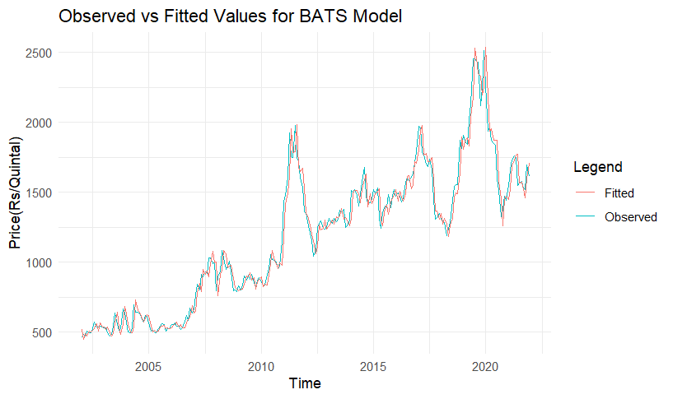**Fig. 2: Plot showing observed vs fitted values by BATS model**

**3.6 RESIDUAL DIAGNOSTICS**

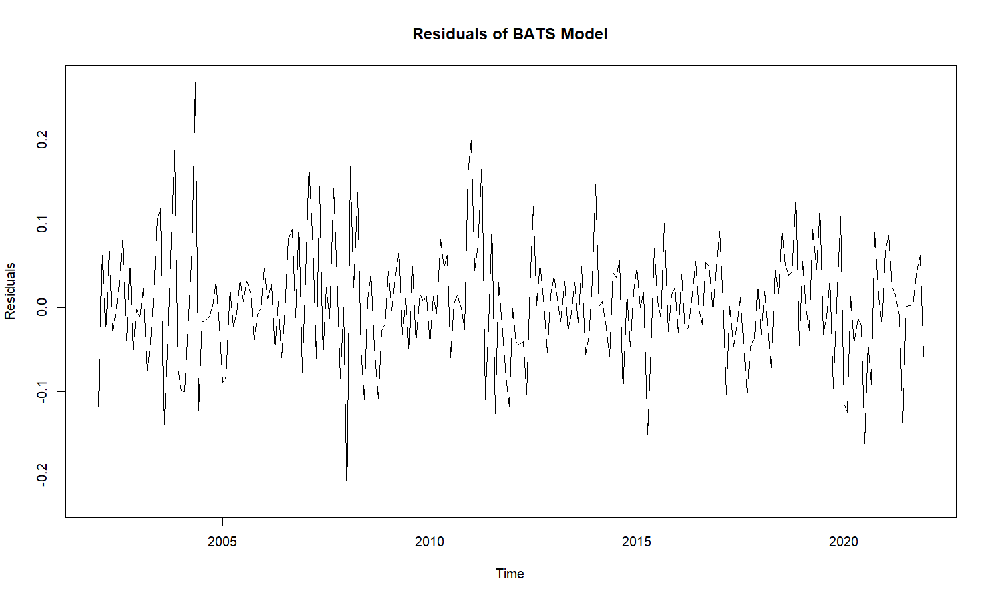BATS model was observed to be the best model hence the residual diagnostic check was conducted by using Ljung-Box test. This test results revealed that the residuals were random in nature as the p-value (0.07147) is greater than the level of significance (0.05). Figure 3 represents residual

plot for the BATS model. From this plot we can infer that the residuals oscillate around the zero line, indicating the differences between observed values and those predicted by the BATS model. Residuals close to zero suggest that the model predictions are accurate.

**Fig. 3: Residual diagnostic plot of BATS model**

**Table 08: Residual diagnosis by Ljung – Box test of BATS model**

|  |  |  |
| --- | --- | --- |
| **Ljung-Box test** | | |
| Model | Test statistic | p-value |
| BATS | 29.901 | 0.07147 |

**Table 9: Monthly forecasted wholesale prices of Jowar in Ballari market by using BATS model.**

|  |  |
| --- | --- |
| **Months** | **Forecasted price** |
| January-2025 | 1607.31 |
| February-2025 | 1569.96 |
| March-2025 | 1588.73 |
| April-2025 | 1584.19 |
| May-2025 | 1590.40 |
| June-2025 | 1619.70 |
| **July-2025** | **1656.74** |
| **August-2025** | **1662.69** |
| September-2025 | 1604.76 |
| October-2025 | 1531.25 |
| November-2025 | 1600.19 |
| December-2025 | 1605.84 |

1. **CONCLUSION**

Jowar price in the Ballari district was forecasted using advanced time series models highlights the importance of robust analytical techniques in agricultural market analysis. Among the models evaluated—ARIMA, SARIMA, BATS, and TBATS—the BATS model delivered superior accuracy with the lowest RMSE and MAPE values, making it the most reliable choice for predicting monthly wholesale prices. Seasonal indices confirmed peak prices during July and August, aligning with observed demand-supply dynamics. These insights offer valuable guidance for farmers, traders, and policymakers to make informed decisions related to production, marketing, and pricing strategies. As agricultural markets grow increasingly volatile, integrating advanced statistical forecasting tools becomes not only beneficial but essential for ensuring food security and economic stability in the region.

COMPETING INTERESTS DISCLAIMER:

Authors have declared that they have no known competing financial interests OR non-financial interests OR personal relationships that could have appeared to influence the work reported in this paper.

1. **REFERENCE**
2. De Liver, A.M., Hyndman, R.J. and Snyder, R.D. (2011). Forecasting time series with complex seasonal patterns using exponential smoothing. *Journal of the American Statistical Association*, 106, 1513-1527.
3. De Livera, A. M., (2012), Automatic forecasting with a modified exponential smoothing state space framework*. Monash Econometrics and Business Statistics Working Papers*, 10, 1-6.
4. Jadhav, V.; Reddy, V.C.; Gaddi, G.M (2017). Application of ARIMA Model for Forecasting Agricultural Prices. *Journal of Agricultural Sciences and Technology,* 19, 981–992.
5. Santosha Rathod, K. N. Singh, S G Patil, Ravindrakumar H Naik, Mrinmoy Ray and Vikram Singh Meena (2018). Modelling and forecasting of oilseed production of India through artificial intelligence techniques. *Indian Journal of Agricultural Sciences*. 88(1): 22-27
6. Alibuhtto, M. C., and Ariyarathna, H. R. (2019). Forecasting weekly temperature using the ARIMA model: a case study for Trincomalee in Sri Lanka. *International Journal of Science, Environment and Technology*, 8(1), 124–131.
7. Divisekara, R. W., Jayasinghe, G. J. M. S. R., & Kumari, K. W. S. N. (2020). Forecasting the red lentils commodity market price using SARIMA models. *Springer Nature Business & Economics*, *1*(1), 20.
8. Meena. S., Peram, N., Sharma, A. and Surliya, V. (2022). Price forecasting of tomato by using moving average forecasting model, weighted moving average forecasting model, simple exponential smoothing forecasting model and ARIMA model*. Journal of applied management and entrepreneurship*, 16, 25-37.
9. Monika Ray, K C Sahoo, Mostafa Abotaleb, Soumik Ray, P. K. Sahu, Pradeep Mishra, Abdullah Mohammad Ghazi Al Khatib, S S Das, Vikas Jain and Ritisha Balloo (2022). Modelling and forecasting meteorological factors using BATS and TBATS models for the Keonjhar district of Orissa. Mausam. 73 (3): 555-564.
10. Kozuch, A., Cywicka, D. and Adamowicz, K. (2023). A Comparison of Artificial Neural Network and Time Series Models for Timber Price Forecasting. Forests, 14, 177
11. Kumar, M.A., Ghosh, A., Vinay, H.T., Poddar, P. and Reza, M.W., (2024), Forecasting Green Chilli Prices: Using Data Analytics to Gain Market Understanding*. Journal of Scientific Research and Reports*, 30(10):671-679.
12. Vinay H T., Pradip Basak, Arunava Ghosh, Sankalpa Ojha and Chowa Ram Sahu (2024), Forecasting of Tomato Price in Karnataka using BATS Model. *Journal of the Indian Society of Agricultural Statistics,* 78(2): 107-113.