Phenotypic and Molecular Characterization of Plant Growth Promoting Bacteria of Wild Cotton Rhizosphere and its Seed Priming Effect on Cotton Seedling Growth

ABSTRACT
The present investigation was undertaken to explore the untapped potential of the rhizospheric bacteria associated with wild cotton, Gossypium aridum. All the 13 isolated rhizospheric bacterial isolates were screened for ten parameters comprising plant growth promoting (potash, phosphorus and zinc solubilization; IAA and GA₃ production) and plant protection (chitinase, cellulase, and protease production; siderophore and HCN production). Four rhizospheric bacteria viz., NAU-RPM-4, NAU-RPM-9, NAU-RPM-1 and NAU-RPM-11 of wild cotton species recorded statistically significant plant growth and protection activities and thus chosen to study their seed priming effect on early cotton seedling growth of cultivated cotton (G. hirsutum). Bacterial isolate NAU-RPM-1 and NAU-RPM-11 significantly improved the growth parameters such as germination percent, shoot length, root length, fresh weight of shoot, dry weight of shoot, fresh weight of root, dry weight of root and root-shoot ratio as compared to absolute control. However, seed biopriming with NAU-RPM-4 and NAU-RPM-9 isolates also improved the early seedling growth parameters but it was found on par with the control. Therefore, NAU-RPM-1 and NAU-RPM-11 were further characterized using 16S rDNA technique and preliminary identified as Enterobacter mori NAU-RPM-1 and Bacillus cereus NAU-RPM-11, respectively. Our results highlight the importance of rhizosphere bacteria isolated from wild cotton species (G. aridum) in improving the growth and resilience of cultivated cotton, especially in the context of utilizing PGPR for long-term sustainable agricultural practices.

Keywords: PGPR, Wild Cotton Rhizosphere, Seed Priming, Seedling growth, Gossypium aridum and Gossypium hirsutum

INTRODUCTION
Gossypium aridum (Rose & Standl.) Skovst is a wild cotton species known for its tolerance to arid conditions and resistance to certain nematodes (Baez-Gonzalez et al., 2022); and may act as reservoir of the most favorable attributes required under climate change scenario. In addition to that, the rhizosphere of cotton known to harbor the diverse group of microbes with multifarious plant growth promoting traits like phytohormone production, mineral solubilisation along with plant protection activities like lytic enzyme and antimicrobial traits. These multifarious activities of microbes directly or indirectly support plant growth under normal and stressed condition (Hakim et al., 2021). Qiao et al. (2017) reported that Acidobacteria, Actinobacteria, Bacteroidetes, Planctomycetes, Proteobacteria, and Verrucomicrobia are the six bacterial phyla dominantly found in cotton rhizosphere. However, soil of the wild cotton plant rhizosphere and its PGP activities are rarely studied. Thus, present study aimed to isolate bacteria from cotton rhizosphere of wild cotton Gossypium aridum.
Frequent and injudicious use of chemicals (fertilizers, insecticides, and pesticides) for plant growth, development and protection in agriculture not only affected the soil health, nutrient utilization and microbiome but also heavily impacted the environment. Wide range of rhizospheric bacteria known to solubilised varied minerals, produce phytohormones like auxins, cytokinine, gibberellic acid, Indole-3-acetic acid etc., that play a key role in plant growth and development (Olenska et al., 2020). Fahimi et al. (2014) reported that bacterial strains viz., Bacillus amyloliquefacians and other Bacillus species can promote and protect the cotton plant due to its phosphate solubilisation, phytohormones, siderophore and nitrogen fixation ability. Rhizosphere bacteria-derived bio-molecules like siderophores, hydrogen cyanide (HCN) and enzymes (chitinase, cellulase, protease and ACC deaminase) can directly or indirectly protect the plant against varied pest, insects along with biotic and abiotic stress. Plant growth-promoting rhizobacteria (PGPR) can also induce systemic resistance (ISR) against pathogen infections (Zhu et al., 2022). Thus, harnessing the biologicals or microbes presents an eco-friendly and effective approach to enhancing plant growth and protection. Perhaps, application of these potentials microbes is a difficult task in agriculture. Among varied methods used to apply the biologicals, seed biopriming is one of the simple and eco-friendly approaches used to improve seed germination, seedling vigor, abiotic stress as well as biotic stress management (Fahsi et al., 2021; Ahmad et al., 2021). The present study implies to isolate and identify the bacteria from the soil of wild cotton rhizosphere and screen for plant growth and protecting traits; and study effect of potent PGP rhizobacterial strains on early seedling growth of cultivated species of cotton was attempted thorough seed priming.

MATERIAL AND METHODS
Isolation of Rhizospheric Bacteria
Rhizospheric soil sample of wild cotton species (Gossypium aridum) was collected from the nursery of Main Cotton Research Station, Navsari Agricultural University, Surat, Gujarat, India (latitude 21º10’11.3”N and longitude 72º48’17.7”E). Rhizospheric soil was collected as a composite sample by mixing of rhizospheric soil samples around the root and surface of the root from the depth of 5.0 cm from the ground soil. The samples were labeled properly, placed into sterile polythene bags and kept at 4ºC until used for further investigation. The bacterial colonies were isolated by serial dilution and spread plate technique on sterile nutrient agar plate.
Plant Growth Promoting (PGP) Activities
The present study assessed each of the rhizospheric bacterial colonies for its plant growth promoting (mineral solubilization and phytohormone production). Plate assay was performed to detect the zinc, potassium and phosphate solubilization of the bacteria as per Di Simine et al. (1998), Parmar and Sindhu, (2013) and Pikovskaya (1948), respectively.
Indole-3-acetic acid (IAA) production was performed by the method of Bric et al. (1991). Quantitative assay of gibberellic acid production was carried out using the protocol of Graham and Henderson et al. (1961).
Plant Protecting Activities
Detection of hydrolytic enzymes viz., chitinase, protease and cellulase was performed by spot inoculation of bacterial culture on chitin agar plate, skim milk agar plate and CMC agar plates as per method described by Kuddus and Ahmad (2013), Patel et al. (2005) and Ferbiyanto et al. (2015), respectively. Qualitative screening of rhizospheric bacterial isolates for HCN production was performed as per method of Lorck (1948). Quantitative determination of bacterial siderophore production was performed as per method of Schwyn and Neilands (1987).

Bacterial Seed priming and its effect on germination and Early Seedling Growth of Cotton Plant
The biopriming of cotton seeds was carried out by using potent rhizospheric PGP bacteria as per method suggested by Meena et al (2020). For that, cotton seeds were surface sterilized (Musson et al.,1995) followed by inoculation in bacterial suspension (10⁸ cfu ml⁻¹) with 1.0 % aqueous carboxymehtyl cellulose (CMC) as binding agent and seeds were dried under aseptic condition. The seeds treated only with CMC acted as control; while seeds without CMC and bacteria as absolute control. Each of the bioprimed cotton seeds, absolute control and control cotton seeds were aseptically transferred to half MS medium in PTC bottles (five seeds/bottle) in triplicates. Bottles were kept in a growth room at 25±2°C to 16 hrs photoperiod. The germination percentage of cotton seedling was recorded at 7th day of incubation; while other morphological parameters were recorded at 15th day of incubation. Five seedlings from each treatment (Bioprimed seeds, absolute control and control seeds) were selected in order to measure the morphological characters viz., Shoot and Root length (cm), Fresh Shoot and Root Weight (g), Dry Shoot and Root Weight (g) and Root: Shoot ratio.
Microbial and Molecular Characterization of Potent PGP Rhizobacteria
Identification of the bacteria was carried out using microbial and molecular attributes. The KB002 Hi-Assorted Biochemical test kit was used for biochemical characterization of bacteria; while gram reaction and nutrient media were used to identify the morphology and cultural characteristics of the bacteria.
Molecular identification was performed through 16S-rDNA sequence analysis. Bacterial genomic DNA was extracted, purified and was confirmed through agarose gel electrophoresis Bacterial 16S rDNA gene was amplified using primers 357F (CCTACGGGAGGCAGCAG) and 1391R (GACGGGCGGTGWGTRCA) (Weisburg et al., 1991) and column purified amplicon was sequenced. Consensus sequence of 16S rDNA gene was generated and used to carry out BLAST with the database of NCBI Genbank. The evolutionary history was inferred using the Neighbor-Joining method (Saitou and Nei, 1987). The evolutionary distances were computed using the Maximum Composite Likelihood method (Nei and Kumar, 2000) and evolutionary analyses were conducted in programme MEGA11 (Tamura et al., 2021).
Statistical Analysis
Data analysis was done using Completely Randomized Design (CRD) in three replications. The critical difference (CD) among the variance was calculated at P≤0.05 (Panse and Sukhatme, 1961). The results are expressed as mean with standard deviation (mean±SD) or standard error (mean±SE). During the statistical analysis, percentage data has been transformed using arc sign transformation and other parameter transformed using square root transformation. The results were graphically presented using Microsoft Excel.

RESULTS AND DISCUSSION
The wild cotton species, G. aridum was known to have better biotic and abiotic stress resistance in comparison to their cultivated varieties. Further, it was speculated that the cause was due to its complex microbial community which may prove to be beneficial to plant growth and protection. In particular, the PGPR found in the rhizosphere is of great focus for this study as they play a pivotal role in enhancing plant nutrition and resistance to stress. Therefore rhizospheric soil of G. aridum was chosen for the present study.

Isolation and characterization of Rhizospheric Bacteria
A total of 13 rhizospheric bacteria based on its distinct colonial characters were isolated and purified using four flame method after incubation of 24-48 hrs at room temperature. Further, it was noted that the population size of bacteria was 5.8 × 10² CFU ml⁻¹g⁻¹ of soil sample and the purified bacterial isolates were coded as NAU-RPM-1 to NAU-RPM-13. Earlier, Patel and Minocheherhomji (2020) also reported 81 diversified bacterial communities from rhizospheric soil of American cotton (rhizosphere, rhizoplane, and endorhizosphere). While, Parmar et al. (2024) reported isolation of 19 endophytic bacteria from the root, leaf, stem and boll samples of the desi cotton.
Plant Growth Promoting (PGP) Activities
One of the primary reasons for screening for PGP traits is to identify bacteria that can promote plant growth and increase crop yields in an environmentally sustainable manner. PGPR promote plant growth either by solubilizing and assisting nutrient acquisition or by releasing phytohormones or biocontrol agents to protect plant from various pathogens (Glick, 2012). PGP traits such as mineral solubilization (phosphate, potash, and zinc) and phytohormone production (e.g., IAA, GA₃) directly influence plant growth by improving nutrient availability and promoting root and shoot development.
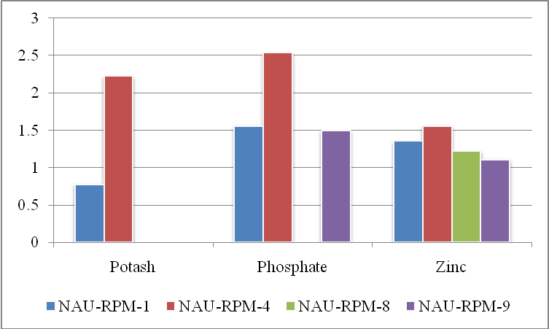 | 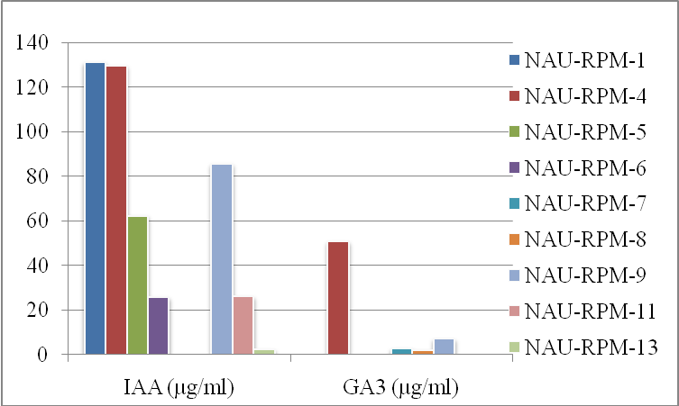
(a) | (b)
Fig.1 Plant growth promoting activities of rhizospheric bacterial isolates of G. aridum
The 13 pure rhizobacteria isolates were screened for their potent PGPR traits under in vitro conditions (Fig.1). The plate assays for mineral solubilization revealed that NAU-RPM-4 (2.23) followed by NAU-RPM-1 (0.78) showed maximum solubilization index for potash; NAU-RPM-4 (2.53), NAU-RPM-1 (1.56), and NAU-RPM-9 (1.50) showed maximum SI for phosphate; while NAU-RPM-4 (1.56), NAU-RPM-1 (1.36) showed the highest ability of zinc solubilization followed by NAU-RPM-8 (1.22) and NAU-RPM-9 (1.11) at 72 h (Fig.1 (a)). Recently, Zhao et al. (2024) also isolated and characterized potassium-solubilizing rhizobacteria (KSR) from cotton; and they reported strain the A10 (Pseudomonas aeruginosa) with potassium highest solubilization capacity (21.8 ppm). Shah et al. (2022) reported 17 thermo-tolerant phosphate solubilizing bacteria (PSB) from the rhizosphere of cotton. Dhaked et al. (2017) reported three bacterial isolates named ZnSB-1 and ZnSB-3 as zinc solubilizers. Further, Parmar et al. (2024) reported solubilization index for zinc and potash of 0.58 and 0.76, respectively by potent root endophyte of desi cotton (NAU-G27E-PR1).
Indole-3-Acetic Acid (IAA) is one of the most common and essential naturally occurring plant hormone, classified as auxin that know to promotes cell elongation, root initiation, fruit development, and facilitates nutrient uptake. Gibbberellic acid (GA) is also a plant hormone belonging to the gibberellin group and it regulates cell elongation and division, leading to increased shoot length, leaf expansion, and root development. Thus, identification of IAA and GA producing strains and optimization to maximize IAA and GA production could promote sustainable agriculture. Phytohormone production viz., IAA and gibberellic acid revealed that seven isolates viz., NAU-RPM-1 (131.00 µg ml⁻¹), NAU-RPM-4 (129.51 µg ml⁻¹), NAU-RPM-9 (85.54 µg ml⁻¹), NAU-RPM-5 (62.25 µg ml⁻¹), NAU-RPM-11 (26.12 µg ml⁻¹), NAU-RPM-6 (25.70 µg ml⁻¹) and NAU-RPM-13 (2.24 µg ml⁻¹) produced IAA. Whereas, four isolates viz., NAU-RPM-4 (50.73 µg ml⁻¹), NAU-RPM-9 (7.06 µg ml⁻¹), NAU-RPM-7 (2.65 µg ml⁻¹) and NAU-RPM-8 (2.10 µg ml⁻¹) recorded GA₃ production (Fig.1 (b)). Similar range of IAA production ( 0.070 – 0.317 ug ml⁻¹) and GA₃ production (0.001- 0.364 μg ml⁻¹) was reported by Patel and Desai (2015) among 67 bacteria of rhizosphere of cotton plant (Gossypium hirsutum), Shaikh et al. (2017) reported seven cotton endophytes (EB3, EB13, EB8, EB11, EB15, EB2 and EB17) as IAA producers in the range of 15-28 µg ml⁻¹ at 72 h. Recently, Parmar et al. (2024) reported IAA production (19.97 ± 0.14 µg ml⁻¹) and gibberellic acid production (33.03 ± 0.60 µg ml⁻¹) in desi cotton root endophyte.
Plant Protection Activities
PGPR can also promote plant growth through the suppression of pathogen growth by production of siderophores, antibiotics, HCN and cell wall degrading enzymes like chitinase, protease, and cellulase (Soltani et al., 2010). Many bacterial species like B. subtilis, B. cereus, B. subtilis, B. thuringiensis, and S. marcescens etc. are shown to synthesize such enzymes that can affect the cell wall integrity of the pathogens and inhibit those (Panicker and Sayyed, 2022).
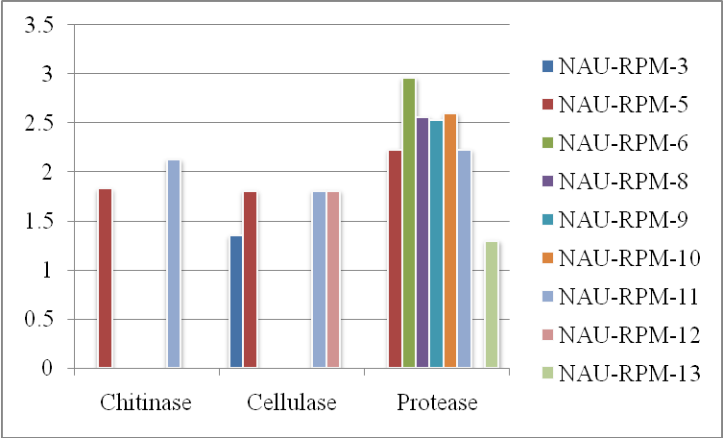 | 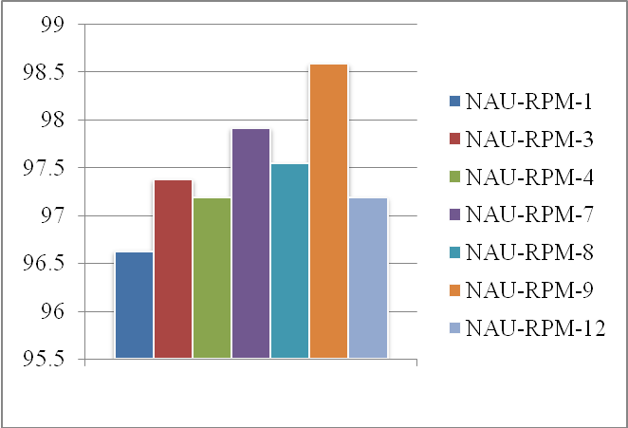
(a) | (b)
Fig 2 : Plant protection activities of rhizospheric bacterial isolates of G. aridum
The plant protection traits like production of hydrolytic enzymes (chitinase, cellulase and protease) and biomolecules (HCN and siderophore) production were studied. Two isolates NAU-RPM-11 (2.13) and NAU-RPM-5 (1.83) were chitinase producers; four isolates viz., NAU-RPM-11 (1.81), NAU-RPM-12 (1.81), NAU-RPM-5 (1.81), and NAU-RPM-3 (1.35) were potent cellulase producers; and eight isolates were protease producers viz., NAU-RPM-6 (2.96), NAU-RPM-2 (2.63), NAU-RPM-10 (2.60), NAU-RPM-8 (2.56) NAU-RPM-9 (2.53), NAU-RPM-5 (2.23), NAU-RPM-11 (2.23) and NAU-RPM-13 (1.30) (Fig.2(a)). Further, three isolates showed HCN production NAU-RPM-2 (orange), NAU-RPM-7 (orange) and NAU-RPM-11 (light orange) and seven showed siderophore production NAU-RPM-9 (98.56 %), NAU-RPM-7 (97.92 %), NAU-RPM-8 (97.55 %), NAU-RPM-3 (97.38 %), NAU-RPM-4 (97.19 %), NAU-RPM-12 (97.19 %) and NAU-RPM-1 (96.63 %) (Fig. 2(b)). Recently, Parmar et al. (2024) reported zone index for chitinase (0.51), protease (0.39) and siderophohre production by root endophytic bacteria from desi cotton variety, G.27. Afrin et al. (2024) characterized protease-producing bacterial strains and they reported seven bacterial strains (S1, S2, S3, S4, S5, S6, and S7) for protease activity using skimmed milk agar and gelatin hydrolysis methods. HCN and siderophore production of cotton flora was reported by Shahid et al. (2017).
Based on the data generated on 10 parameters comprising plant growth promoting and plant protection across 13 rhizobacterial strains, six parameters each found statistically significant in NAU-RPM-4 (potash, phosphate and zinc solubilization; IAA and GA₃ production; and siderophore production), NAU-RPM-9 (phosphate and zinc solubilization; IAA and GA₃ production; protease activity and siderophore production); and NAU-RPM-11 (IAA and GA₃ production; Chitinase, cellulase and protease activity ; and HCN production), while five statistically significant parameters recorded in NAU-RPM-1 (potash, phosphate and zinc solubilization; IAA production; and siderophore production). Therefore, these four rhizospheric bacteria of wild cotton species were used for seed priming study.
In vitro Study of Effect of Bacterial Seed Priming on Germination and Early Seedling Growth of Cotton Plant
Seed priming is a very simple and powerful technique to enhance the seed performance as well as plant growth and development that supports sustainable agriculture by reducing dependency on chemical fertilizers offering a cost-effective and eco-friendly solution for improving cotton productivity.
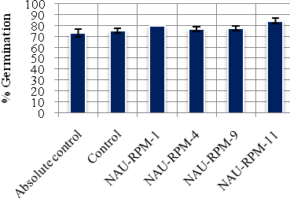 | 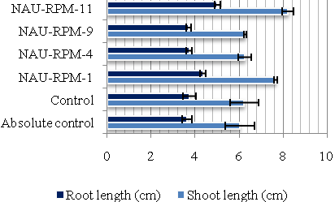
(a) | (b)
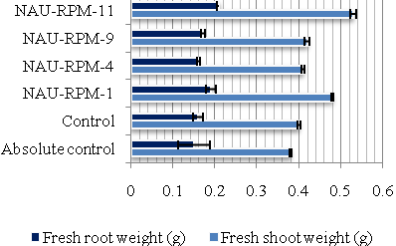 | 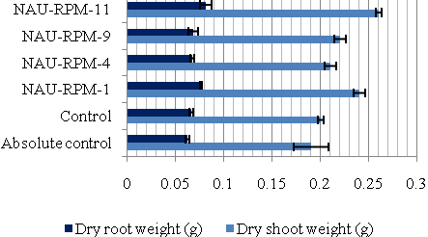
(c) | (d)
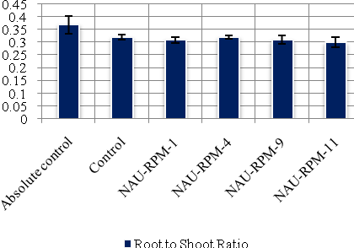
(e)
Fig.3: Effect of seed biopriming on seedling growth parameters (a) Percent Germination; (b) Root and Shoot length (cm); (c) Fresh root and shoot weight (g); (d) Dry root and shoot weight (g) and (e) Root to Shoot ratio
The study of seed biopriming of cultivated cotton (G. Cot. 40) with the potential four rhizobacterial isolates revealed that the isolate NAU-RPM-1 significantly improved the growth parameters such as germination percent, shoot length, root length, fresh and dry weight of shoot and root and root-shoot ratio to an extent of 9.09 %, 27.24 %, 19.83 %, 26.31 %, 26.31%, 26.66 %, 22.58 % and 16.21 %, respectively in comparison to absolute control. Data are shown in Fig.3. Similarly, seed bioprimed with isolate NAU-RPM-11 also recorded significantly improved growth parameters such as germination percent, shoot length, root length, fresh and dry weight of shoot and root and root-shoot ratio to an extent of 15.15 %, 36.00 %, 38.01 %, 39.47 %, 36.84 %, 40.00 %, 30.64 % and 18.91 %, respectively as compared to absolute control. Data regarding the biopriming with NAU-RPM-4 and NAU-RPM-9 also improved the early seedling growth parameters but it was found on par with the absolute control. Earlier, Nehra et al. (2016) reported significantly improved shoot (hypocotyl) length (75 %), root length (84 %), fresh root weight (129%) and dry root weight (135%) in cotton seeds bioprimed with the PGPR Brevibacillus brevis than control. Ragadevi et al. (2021) also reported maximum shoot length (12 cm) and root length (6 cm) with an increase of 24.4 % and 42.8 % respectively, in cotton seeds treated with PGPR Azospirillum sp7 strain.
Higher shoot and root length, higher fresh/dry weight of root and shoot in bioprimed cotton plants indicates the positive impact of PGPR in developing the better root system that can support the overall plant resilience and growth. Further, Ma et al. (2024) was also of opinion that reduced root-shoot ratio enhances photosynthetic activity, boll formation and biomass restoration, ultimately leading to better cotton yield. Similar trend was also reported in the present study that establishes the importance of PGPR (NAU-RPM-1 and NAU-RPM-11) in biomass accumulation. Therefore, NAU-RPM-1 and NAU-RPM-11 were further characterized at microbiological and molecular level for precise identification.
Microbial and Molecular Characterization of Potent PGP Rhizobacteria
Microbial Characterization
Microbiological characterization revealed that NAU-RPM-1 was gram negative, short rod shaped forming single colonies; while NAU-RPM-11 was gram positive long rods occurred in short chain. Further, cultural characterization revealed that NAU-RPM-1 was small, round, smooth, transparent, glistening and non-pigmented colonies; while NAU-RPM-11 was large, round, rough, opaque and off white color colonies on nutrient agar plates. Arunachalam and Gayathri (2010) also reported the variation for cultural characterization of endophytic bacteria. Shaikh et al. (2017) also characterized 19 bacterial leaf endophytes of G. hirsusutm and reported ten as gram positive and nine as gram negative rods.
Biochemically, isolate NAU-RPM-1 NAU-RPM-11 both showed positive results for urease, citrate utilization, esculin hydrolysis, arabinose, xylose, and glucose; while both isolates showed negative results for lysine utilization, ornithine utilization, phenylalanine deamination, H₂S production, Voges Proskauer’s, methyl red, indole, raffinose, trehalose, lactose and oxidase. Further, NAU-RPM-1 showed positive results for ONPG, nitrate reduction, malonate utilization, rhamnose and saccharose, while negative results for, adonitol, cellobiose, melibiose. On the contrary NAU-RPM-11 showed positive results for adonitol and melibiose, while negative results for ONPG, nitrate reduction, malonate utilization, rhamnose, mellobiose, and saccharose. Recently, Parmar et al. (2024) also microbiologically characterized endophyte of desi cotton NAU-G27E-PR1 as gram positive rods with short chains and large, irregular, entire, smooth, opaque and white colonies on nutrient agar; while biochemically the endophyte recorded positive for nitrate reduction, methyl red, Vogus-Proskaurer’s (VP), oxidase, escluline, saccharose, glucose, xylose, maltose, dextrose, galactose, sucrose, insulin and sorbitol tests. They reported NAU-G27E-PR1 belongs to genus Bacillus based on microbial characters.
Molecular Characterization
The 16S rDNA sequencing was employed to assess the molecular identity of potential PGPR. The 16S rDNA bacterial genes of NAU-RPM-1 and NAU-RPM-11 were successfully amplified using PCR with universal primers for species identification. The sequences obtained were then searched for homology using BLAST in NCBI GenBank. Further, homology analysis indicated that the sequence for 16S rDNA gene of NAU-RPM-1 and NAU-RPM-11 showed a high sequence similarity to the genus Enterobacter mori (81 %) and Bacillus cereus (100 %), respectively. Finally, the phylogenetic tree constructed using neighbour-joining method in MEGA 11 software for NAU-RPM-1 and NAU-RPM-11 (PQ410308) (Fig. 4 (a) and (b)). Although the BLAST analysis of NAU-RPM-1 showed a 82.01 % sequence similarity to Enterobacter species suggesting that the isolate is related to the identified species but it may represent a distinct or less characterized strain or species. However, its plant growth-promoting traits and biochemical properties may contribute to distinct mechanisms for plant-microbe interactions.
Fig 4: Phylogenetic tree based on 16S rDNA sequence of a) NAU-RPM-1(Enterobacter mori) and b) NAU-RPM-11 (Bacillus cereus)
Majority of the biochemical tests of NAU-RPM-1 and NAU-RPM-11 were same as Enterobacter mori and Bacillus cereus, respectively. Thus, isolates NAU-RPM-1 and NAU-RPJ-11 identified as Enterobacter mori NAU-RPM-1 and Bacillus cereus NAU-RPM-11. The study conducted by Ibrahim et al. (2020) also revealed that Bacillus was the most prevalent genus, constituting 92 % of the bacterial isolates in the Bt cotton rhizosphere and 88 % in the non-Bt cotton rhizosphere, with Bacillus cereus being the most common species. Recently, Parmar et al. (2024) reported root endophyte of desi cotton, NAU-G27E-PR1 as Bacillus halotolerans based on 16S rRNA gene sequence, which showed 99.93 % similarity.
CONCLUSION
The present study results implicated that rhizospheric bacteria isolated from wild cotton species exhibited significant plant growth promoting (potash, phosphorus and zinc solubilization: IAA and GA₃ production) and plant protection (chitinase, cellulase, protease, siderophore and HCN production) activities. Further, seed biopriming with identified two potent rhizobacteria Enterobacter mori NAU-RPM-1 and Bacillus cereus NAU-RPM-11 showed promising improvement in early seedling growth parameters like germination percent, shoot length, root length, fresh and dry weight of shoot and root and root-shoot ratio in cultivated cotton. Thus, it can be concluded that the seed biopriming with potential rhizobacteria identified improved the early seedling growth but still comprehensive understanding and studies are required to explore it in agriculture practices.

COMPETING INTERESTS DISCLAIMER:
Authors have declared that they have no known competing financial interests OR non-financial interests OR personal relationships that could have appeared to influence the work reported in this paper.

REFERENCES
Afrin, S., Tamanna, T., Shahajadi, U. F., Bhowmik, B., Jui, A. H., Miah, M. A. S. & Bhuiyan, M. N. I. (2024). Characterization of protease-producing bacteria from garden soil and antagonistic activity against pathogenic bacteria. The Microbe, 4, 100123.
Ahmad, I; Ahmad, M; Hussain, A. & Jamil, M. (2021). Integrated use of phosphate-solubilizing Bacillus subtilis strain IA6 and zinc-solubilizing Bacillus sp. strain IA16: a promising approach for improving cotton growth. Folia Microbiol (Praha)., 66(1),115-125
Arunachalam, C. & Gayathri, P. (2010). Studies on bioprospecting of endophytic bacteria from the medicinal plant of Andrographis paniculata for their antimicrobial activity and antibiotic susceptibility pattern. International Journal of Pharmaceutical Sciences and Research, 2(4), 63-68.
Baez-Gonzalez, A. D., Melgoza-Castillo, A., Royo-Marquez, M. H., Kiniry, J. R. & Meki, M. N. (2022). Modeling the Distribution of Wild Cotton Gossypium aridum in Mexico Using Flowering Growing Degree Days & Annual Available Soil Water. Sustainability, 14(11), 6383.
Bric, J. M; Bostock, R. M. & Silverstone, S. E. (1991). Rapid in situ assay for indoleacetic Acid production by bacteria immobilized on a nitrocellulose membrane. Applied Environmental Microbiology, 57(2): 535-8.
Dhaked, B. S., Triveni, S., Reddy, R. S. & Padmaja, G. (2017). Isolation and screening of potassium and zinc solubilizing bacteria from different rhizosphere soil. International Journal of Current Microbiology and Applied Sciences. 6(8), 1271-1281.
Di Simine, C. D; Sayer, J. A. & Gadd, G. M. (1998). Solubilization of zinc phosphate by a strain of Pseudomonas fluorescens isolated from a forest soil. BioFertilizer and Soils, 28, 87-94.
Fahimi, A., Ashouri, A., Ahmadzadeh, M., Hoseini Naveh, V., Asgharzadeh, A., Maleki, F. & Felton, G. W. (2014). Effect of PGPR on population growth parameters of cotton aphid. Archives of Phytopathology and Plant Protection, 47, 1274–1285.
Fahsi, N, Mahdi, I, Mesfioui, A, Biskri, L. & Allaoui, A. (2021). Plant growth-promoting rhizobacteria isolated from the jujube (Ziziphus lotus) plant enhance wheat growth, Zn uptake, and heavy metal tolerance. Agriculture, 11, 316.
Ferbiyanto, A; Rusmana, I. & Raffiudin, R. (2015). Characterization & identification of cellulolytic bacteria from gut of worker Macrotermes gilvus. Hayati Journal of Biological Sciences., 22(4), 197-200.
Glick, B. R. (2012). Plant growth promoting bacteria: mechanisms and applications. Scientifica, 2012(1), 963401.
Graham, H. D. & Henderson, J. H. M. (1961). Reaction of gibberellic acid & gibberellins with Folin-Wu phosphomolybdic acid reagent & its use for quantitative assay. Plant Physiology, 36(4), 405.
Hakim, S., Naqqash, T., Nawaz, M. S., Laraib, I., Siddique, M. J., Zia, R. & Imran, A. (2021). Rhizosphere engineering with plant growth-promoting microorganisms for agriculture and ecological sustainability. Frontiers in Sustainable Food Systems, 5, 617157.
Ibrahim, M., Ahmad, F., Nawaz, H., Aslam, M. & Shad, M. A. (2020). Studies on correlations between soil chemistry and bacterial population in rhizosphere of Bt and non-Bt cotton and characterization of rhizobacteria. Journal of Taibah University for Science, 14(1), 1463-1474.
Kuddus, S. M. & Ahmad, R. I. Z. (2013). Isolation of novel chitinolytic bacteria and production optimization of extracellular chitinase. Journal of Genetic Engineering and Biotechnology, 11: 39-46.
Lorck, H. (1948). Production of hydrocyanic acid by bacteria. Physiologia Plantarum, 1(2), 142-146.
Ma, Z., Liu, J., Wen, Y., Zhang, J., Yin, F., Guo, L., Li, W., He, J., Ma, J., Liang, Y.& Wang, Z. (2024). Optimizing cotton yield through appropriate irrigation water salinity: Coordinating above-and below-ground growth and enhancing photosynthetic capacity. European Journal of Agronomy, 154, 127095.
Meena KK, Bitla UM, Sorty AM, Singh DP, Gupta VK, Wakchaure GC & Kumar S (2020) Mitigation of salinity stress in wheat seedlings due to the application of phytohormone-rich culture filtrate extract of methylotrophic Actinobacterium Nocardioides sp. NIMMe6. Frontiers in Microbiology. 11:2091.
Nehra,V, Saharan, B. S. & Choudhary, M. (2016). Evaluation of Brevibacillus brevis as a potential plant growth promoting rhizobacteria for cotton (Gossypium hirsutum) crop. Springerplus, 5, 1-10.
Nei, M. & Kumar, S. (2000). Evolutionary change of amino acid sequences. Molecular Evolution and Phylogenetics, 17-32.
Olenska, E., Małek, W., Wójcik, M., Swiecicka, I., Thijs, S. & Vangronsveld, J. (2020). Beneficial features of plant growth-promoting rhizobacteria for improving plant growth and health in challenging conditions: a methodical review. Science of the Total Environment, 743,140682.
Panicker, S. & Sayyed, R. Z. (2022). Hydrolytic enzymes from PGPR against plant fungal pathogens. In Antifungal Metabolites Rhizobacteria Sustain. Agriculture, (pp. 211-238).
Panse, Y. G. & Sukhatme, P. V. (1961). Statistical methods of agricultural workers. New Delhi: ICAR., (pp. 12–87).
Parmar, P. & Sindhu, S. S. (2013). Potassium solubilization by rhizosphere bacteria: influence of nutritional and environmental conditions. Journal of Microbiological Research, 3(1), 25-31.
Parmar, P. R., Rajkumar, B. K., Desai, H. R., Patel, R. D., Patel, D. H. & Patel, M. C. (2024). Identification of multifaceted endophytic bacteria from Gossypium arboreum (CV. G. 27). Plant archives, 24(2), 2486-2492.
Patel T S & Desai P B. 2015. Isolation and screening of PGPR from rhizospheric and nonrhizospheric soil of Bt-cotton. Indo-American Journal Agriculture and Veterinary Sciences 3(1): 1- 17.
Patel, R., Dodia, M. & Singh, S.P. (2005). Extracellular alkaline protease from a newly isolated haloalkaliphilic Bacillus sp.: Production and optimization. Process Biochemistry, 40(11), 3569-3575.
Patel, T. M. & Minocheherhomji, F. P. (2020). Isolation and screening of phytohormones producing PGPR from cotton plant rhizospheric soil. Journal Advances in Scientific Research., 11(04), 148-154.
Pikovskaya, R. I. (1948). Mobilization of phosphorus in soil in connection with the vital activity of some microbial species. Mikrobiologiya., 17: 362–370.
Qiao, Q; Wang, F; & Zhang, J. et al. (2017). The variation in the rhizosphere microbiome of cotton with soil type, genotype and developmental Stage. Scientific Reports, 7, 3940.
Ragadevi, K, Jeyakumar, P, Djanaguiraman, M, Kalaiselvi, T, Arul, L, Mahalingam, Ravichandran, V. & Anandakumar, S. (2021). Influence of Microbial Priming on Germination and Seedling Growth Traits of Compact Cotton CO17. International Journal of Plant and Soil Science., 33(24). pp. 530-540.
Saitou, N. & Nei, M. (1987). The neighbor-joining method: a new method for reconstructing phylogenetic trees. Molecular Biology and Evolution, 4(4), 406-425.
Schwyn & Neilands, B. J. (1987). Universal chemical assay for the detection and determination of siderophores. Annals of Biochemistry., 160(1): 47–56.
Shah, S. H., Hussain, M. B., Zahir, Z. A., Haq, T. U. & Matloob, A. (2022). Thermal plasticity and cotton production enhancing attributes of phosphate-solubilizing bacteria from cotton rhizosphere. Journal of Soil Science and Plant Nutrition, 22(3), 3885-3900.
Shahid, I., Rizwan M., Baig D.N., Saleem R.S., Malik K.A. & Mehnaz S. (2017). Secondary Metabolites production and plant growth promotion by Pseudomonas chlororaphis and P. aurantiaca strains isolated from Cactus, Cotton and Para Grass. Journal of Microbiology and Biotechnology, 27(3), 480-491.
Shaikh, A. A., Parmar, P., Rajkumar, B., Patel, D., Desai, H. & Solanki, B. (2017). Bioprospecting potential of endophytic bacteria from leaves of Gossypium hirsutum. International Journal of Current Microbiology and Applied Sciences, 6, 1718-1730.
Soltani, A. A., Khavazi, K., Asadi-Rahmani, H., Omidvari, M., Dahaji, P. A. & Mirhoseyni, H. (2010). Plant growth promoting characteristics in some Flavobacterium spp. isolated from soils of Iran. Journal of Agricultural Sciences, 2(4), 106.
Tamura K, Stecher G, & Kumar S (2021). MEGA11: Molecular Evolutionary Genetics Analysis Version 11. Molecular Biology Evolution, 38(7):3022-3027.
Weisburg, W G, S M Barns, D A Pelletier, & D J Lane. 1991. 16s Ribosomal DNA Amplification for Phylogenetic Study. Journal of Bacteriology, 173 (2): 697–703.
Zhao, Y., Liang, H., Zhang, J., Chen, Y., Dhital, Y. P., Zhao, T. & Wang, Z. (2024). Isolation and characterization of potassium-solubilizing rhizobacteria (ksr) promoting cotton growth in saline–sodic regions. Microorganisms, 12(7), 1474.
Zhu, L., Huang, J., Lu, X. & Zhou, C. (2022). Development of plant systemic resistance by beneficial rhizobacteria: Recognition, initiation, elicitation and regulation. Frontiers in Plant Science, 13, 95239.

