**Original Research Article**

**Manipulation of root growth in carrot cv. Nantes through foliar application of GA3**

**Abstract**

Thin roots with uniform size from top to bottom are preferred for slicing and canning throughout the world. Nantes-type carrots are characterized by their cylindrical shape and nearly same diameter from end to end. The ability of GA3 to alter root diameter and hence increase its suitability for slicing was studied in carrot cv. Nantes over the course of two consecutive growing seasons. Three concentrations of GA3 i.e. 100, 150 and 200 ppm were sprayed onto 6 week old carrot seedlings. GA3 sprays applied to carrot plants stimulated shoot growth and inhibited root growth. Maximum reduction in root diameter and root weight was observed in carrot plants sprayed with 200 ppm GA3 but the reduction in root size was up to a point where they were still suitable for processing and slicing.

**Keywords:** Root diameter, Root weight, Shoot length, Slicing, Xylem, *Daucus carota*, gibberellic acid,

**Introduction**

Carrot (*Daucus carota*), a member of family Umbelliferae is cultivated throughout the world for its nutritious edible taproot. The size and shape of carrot roots are the primary determinants not only of yield, but also their harvestability, post-harvest handling and marketability (Banga, 1957; Simon et al., 2008). Carrot roots are sold into different markets as a fresh product, for storage or for processing. For example, processing industries (e.g. canning, dehydrating, freezing, or juicing) prefer to purchase large bulky roots while fresh market use, on the other hand, typically requires long slender roots. Carrots are generally cut into slices before dehydration and canning. Similarly, carrots used in salad or cooked as vegetable are also sliced into uniform pieces. For this purpose, roots that are thin and uniform in size from top to bottom are preferred. Thick roots with broad shoulders and pointing tips do not cut into slices of similar size and are therefore not picked. Nantes-type carrots are favoured for their excellent taste and delightful crispness and are characterized by their cylindrical shape and blunt and rounded top and tip. Their nearly same diameter from end to end makes them an excellent choice for slicing. Scarlet Nantes, Little Finger, Nantes, Bolero and Nantes are some Nantes-type carrots grown throughout the world. Out of these, Nantes is the most common Nantes-type temperate carrot variety grown in India. It is perfectly crunchy, mildly sweet and excellent to be eaten raw.

Gibberellins (GAs) are growth hormones strongly involved in a diverse range of physiological activities. GAs can stimulate seed dormancy and germination, stem and root elongation, leaf expansion, flowering and fruit senescence (Hedden and Sponsel, 2015). Previous studies on GAs focused on plant parts grown above the ground because the root was not considered economically important. However, underground parts some vegetable crops, such as potato, yam, carrot, radish, beetroot etc., need intensive attention. GA is known to stimulate shoot and foliage development and inhibit the growth of roots in carrot (Michel-Wolwertz and Sironval, 1963). Application of GAs is known to decrease root diameter and weight in carrot (Wang et al., 2015; Pethybridge et al., 2023). This feature of GAs can be used to manipulate carrot root size as per our requirements. Therefore, this research was aimed to study the effect of foliar application of GA3 on root diameter and other root traits suitable for slicing and processing.

**Materials and methods**

Seeds of carrot cv. Nantes were sown with a spacing of 10 cm between plants and 30 cm between rows in randomized complete block design (RCBD) at the experimental farm of the Department of Seed Science and Technology, Dr. Yashwant Singh Parmar University of Horticulture and Forestry, Nauni, Solan, Himachal Pradesh, India (77°11’30” East longitude and 30°52’30” North latitude) during the years 2021-22 and 2022-23.

Six weeks after seedling emergence, solutions of 100 ppm, 150 ppm, and 200 ppm GA3 were sprayed onto different plots before sunrise using a hand sprayer. These solutions were made by first preparing a 1000 ppm stock solution by dissolving 1g of GA3 in small quantity (50ml) of acetone and making the final volume to 1 litre by adding distilled water. Subsequently, spray solutions of 100 ppm, 150 ppm, and 200 ppm were prepared using this stock solution. Treatment without any GA3 application was taken as control and each treatment was replicated thrice. The observations recorded were as follows:

**Root length (cm)**

At the time of harvestable maturity, 10 roots were taken randomly from each plot and their length was measured in centimeters (cm) using a meter scale. The measurements were taken from the point of attachment of the leaves to the tip of the root.

**Root diameter (cm)**

At harvestable maturity, 10 roots were taken randomly from each plot and their diameter was measured just below the crown with the help of digital vernier calliper. The average diameter was expressed in centimeters (cm).

**Root weight (g)**

10 roots were taken randomly from each plot at the time of harvest and their weight was recorded in grams (g). Average root weight was carefully calculated.

**Shoot length (cm)**

After pulling the roots out from soil, shoot length of randomly taken 10 carrot plants was measured with a meter rod and the average shoot length was computed in centimetres.

**Results and Discussion**

To determine the involvement of gibberellins in carrot root growth, 6 week old seedlings were sprayed with different concentration of GA3. The effect of exogenous application of GA3 was observed after 10 weeks. The pooled data of both the trials conducted during the *rabi* season of 2021-22 and 2022-23 indicated that GA3 significantly increased shoot length but significantly decreased root diameter and root weight. There was no significant change in root length (Table 1). In general, GA3 application increased the growth of carrot foliage while decreasing the root growth.

**Table 1:** Effect of various concentrations of GA3 on root length, root diameter, root weight and shoot length

|  |  |  |  |  |  |  |  |  |  |  |  |  |  |
| --- | --- | --- | --- | --- | --- | --- | --- | --- | --- | --- | --- | --- | --- |
| **T** | **GA3 (ppm)** | **Root length (cm)** | | | **Root diameter (cm)** | | | **Root weight (g)** | | | **Shoot length (cm)** | | |
|  |  | **2021-22** | **2022-23** | **Pooled** | **2021-22** | **2022-23** | **Pooled** | **2021-22** | **2022-23** | **Pooled** | **2021-22** | **2022-23** | **Pooled** |
| **F0** | 0 | 15.64 | 15.61 | 15.62 | 2.87 | 2.85 | 2.86 | 43.10 | 43.44 | 43.27 | 19.59 | 20.51 | 20.05 |
| **F1** | 100 | 15.85 | 15.67 | 15.79 | 2.61 | 2.64 | 2.63 | 36.97 | 37.06 | 37.01 | 24.26 | 25.14 | 24.70 |
| **F2** | 150 | 15.82 | 15.98 | 15.89 | 2.49 | 2.51 | 2.50 | 33.91 | 33.94 | 33.93 | 27.06 | 28.11 | 27.58 |
| **F3** | 200 | 15.84 | 15.75 | 15.79 | 2.12 | 2.14 | 2.13 | 29.21 | 29.38 | 29.30 | 30.05 | 31.08 | 30.57 |
| **CD0.05** |  | **NS** | **NS** | **NS** | **0.08** | **0.09** | **0.06** | **0.47** | **0.36** | **0.30** | **1.22** | **1.27** | **0.78** |

Shoot length increased with an increase in concentration of GA3. Plants sprayed with 200 ppm GA3 were 34.41 % taller than the unsprayed ones (control) at the time of marketable maturity of roots. Control showed the shortest shoot length (20.05 cm) followed by treatments F1 (24.70cm), F2 (27.58 cm) and F3 (30.57 cm), respectively. Inversely, root diameter decreased with an increase in GA3 concentration suggesting an inverse relationship between the two. Pooled analysis of data revealed that maximum root diameter (2.86 cm) was observed in control and minimum (2.13 cm) in F3 (foliar application of GA3 @ 200 ppm). Root weight was also significantly reduced in GA3 treated carrot plants. Pooled analysis of data revealed that maximum root weight (43.27 g) was noted in treatment F0 (control) and minimum (29.30 g) in F3 (foliar application of GA3 @ 200 ppm). Root length remained unaltered at the end of the experiment. The changes in root and shoot characteristics were consistent across the years.

Altering plant growth, stature and productivity has been a desirable objective in the fields of agronomy and horticulture. Plant growth regulators are natural chemicals synthesized within plants that impact physiological processes. Their synthetic counterparts initiate a wide range of biochemical and physiological processes that play a role in plant growth and development. GAs promote seed germination, initiate transitions from meristem to shoot growth and vegetative to flowering stage, controls sex expression and seed development (Gupta and Chakrabarty, 2013). Their ability to alter carrot root growth was studied in the present research. Earlier, it was believed that GAs promoted root growth. However, the effect of GAs on rooting responses was found to be highly dependent on the species under study (Castro-Camba et al., 2022). Linser and Zeid (1975), Neumann and Schwab (1975) and Arafa et al. (1977) remarked that the application of GA3 promoted leaf growth and inhibited root growth. In other words, foliar growth in carrot was enhanced sufficiently at the expense of root biomass after GA3 application (Santos et al., 2000; Abbas et al., 2011; Pethybridge et al, 2023). Increase in shoot length may be due to the effect of GA3 on the cell division and cell enlargement, along with the stimulated the growth and expansion of cells through an increase in wall plasticity of cells (Saleh, 1990). Impairment in carrot root development was also observed in the present study which was in confirmation with the results obtained by Wang et al. (2015) and Pethybridge et al. (2023). GA3 is known to increase the number of vascular bundles in petioles, which might have contributed to influxes of nutrients and water towards the leaves thereby encouraging their development. It also influences transcriptional regulatory networks of hormones which lead to inhibition of root growth (Wang et al., 2015). These changes in sink-source relationships might have reflected as reductions in root weight and diameter (Morgan and Mees, 1958; Currah and Thomas, 1979). In both trials, there was proof of a GA3-induced shift in source-sink relationship which most likely resulted from changes in hormone directed transport (Barnes 1979; Patrick and Woolley 1973) and assimilates sink competition (Barnes 1979; Hooley 1994).

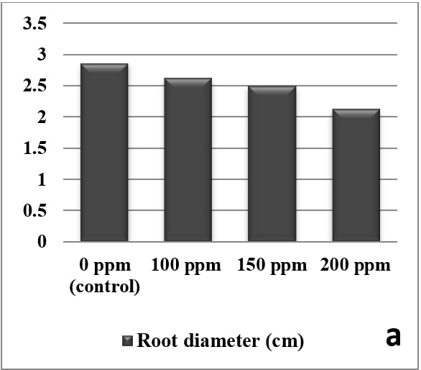 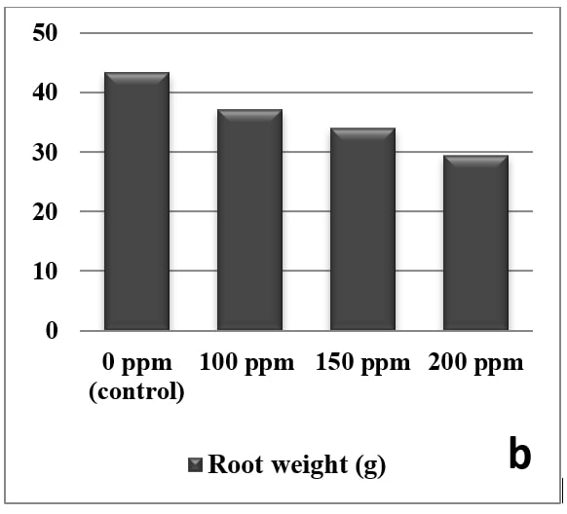

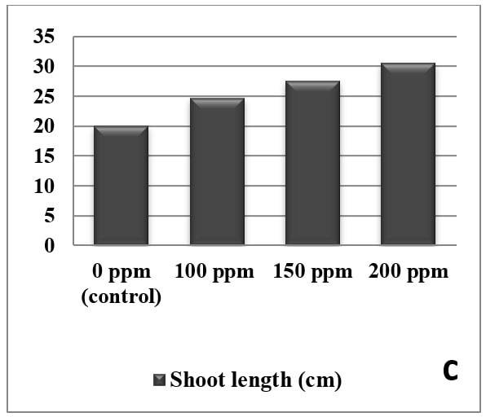 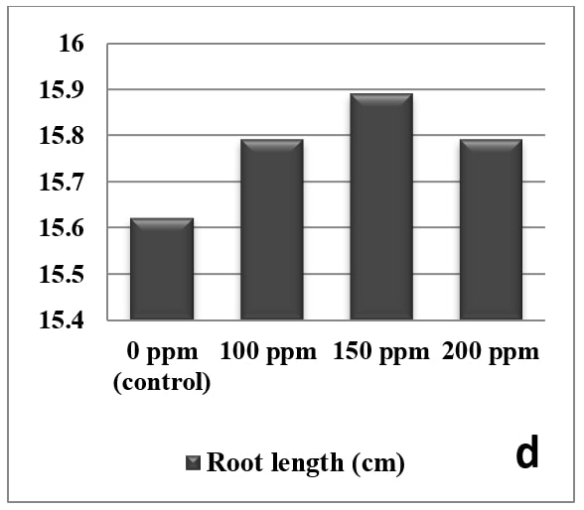

**Figure 1**: Effect of foliar application of GA3 on carrot root diameter (a), root weight (b), shoot length (c) and root length (d)

Xylem is responsible for water and solute transport in higher plants (Demura et al., 2010). Interestingly, the phloem tissue in carrot root provides more nutrients and metabolites than the xylem tissue (Arscott and Tanumihardjo, 2010). Therefore, an appropriate phloem/xylem ratio is essential in a carrot root. GA3 has been found to promote the development of secondary xylem and decrease secondary phloem production (McKee and Morris, 1986) and enhance lignifications. Wang et al. (2015) noticed a thickened xylem region in roots and increased area of vascular bundles in petioles of plants treated with GA3 and suggested that this change could potentially be the reason for poor development of carrot roots and enhanced shoot growth. The role of GAs in enhancement of internode elongation has been previously reported in different species (Suge and Rappaport, 1968; Salisbury and Ross, 1992). Additionally, Nieuwhof (1984) stated that the effect of GA3 on leaf and shoot growth was more evident with higher concentration. Several researchers obtained similar results in other crops whose underground parts are of economic importance. In a study conducted by Jabir et al., (2017) on radish, application of paclobutrazol, an inhibitor of GA, significantly increased taproot weight and diameter and decreased shoot length. Moreover, these results have been supported by the findings of Bidadi et al. (2010) in Arabidopsis and Mariana and Hamdani (2016) in potato.

A problem encountered during cultivation of Nantes-type carrots is that they have a weak brittle top which makes pulling difficult. The ability to GA3 to increase shoot length and foliar biomass can also be brought to use in this case as longer shoots facilitate easy manual and mechanical top pulling harvest (Pethybridge et al., 2023). The concentration of GA3 is an important factor that determines the marketability of roots. Concentrations of GA3 higher than 250 ppm may severely reduce root size (Santos, 2000) making them unfit for further use. However, even the highest the concentration of GA3 used in the present study (200 ppm) reduced root size to a point where they were still suitable for processing and slicing.

**Conclusion**

Results of this study confirmed the response of carrot cv. Nantes to GA3 in enhancing the shoot growth and inhibiting root growth. GA3 application showed a significant increase in shoot length and decrease in root diameter and root weight. These outcomes suggest the application of GA3 as a potential tool to alter carrot root size as per the market requirements. One spray of GA3 was found to be enough to alter root morphology as per our requirements and the results were consistent across the years.

COMPETING INTERESTS DISCLAIMER:

Authors have declared that they have no known competing financial interests OR non-financial interests OR personal relationships that could have appeared to influence the work reported in this paper.

**References**

Abbas, E.D., 2011. Effect of GA3 on growth and some physiological characters in carrot plant (*Daucus carota* L.). Ibn al-Haitham j. pure appl. sci. 24(3): 52-57.

Arafa, A.E., El Sahar, K.F., Said, M.S., 1977. Induction of flowering in *Daucus carota* L. with gibberellin and its effect on different characters of plant. Agric. Res. Rev. 55: 135-142.

Arscott, S.A., Tanumihardjo, S.A., 2010. Carrots of many colors provide basic nutrition and bioavailable phytochemicals acting as a functional food. Compr Rev Food Sci Food Saf. 9(2): 223-239.

Banga, O., 1957. Origin of the European cultivated carrot. Instituut voor de Veredeling van Tuinbouwgewassen

Barnes, A., 1979. Vegetable plant part relationships. II. A quantitative hypothesis for shoot/storage root development. Ann Bot. 43: 487–499.

Bidadi, H., Yamaguchi, S., Asahina, M., Satoh, S., 2010. Effects of shootapplied gibberellin/gibberellin-biosynthesis inhibitors on root growth and expression of gibberellin biosynthesis genes in *Arabidopsis thaliana*. Plant Root. 4: 4‒11.

Castro-Camba, R., Sánchez, C., Vidal, N., Vielba, J.M., 2022. Plant Development and Crop Yield: The Role of Gibberellins. Plants (Basel). 11(19), 2650. doi: 10.3390/plants11192650.

Currah, I.E., Thomas, T.H., 1979. Vegetable plant part relationships. III. Modification of carrot (Daucus carota L.) root and shoot weights by gibberellic acid and daminozide. *Ann Bot*. 43: 501–511

Demura, T., Ye, Z.H., 2010. Regulation of plant biomass production. Curr Opin Plant Biol. 13(3): 298–303.

Gupta, R., Chakrabarty, S.K., 2013. Gibberellic acid in plant: still a mystery unresolved. Plant Signal Behav 8(9), e25504. doi: 10.4161/psb.25504.

Hedden, P., Sponsel, V., 2015. A Century of Gibberellin Research. *J. Plant Growth Regul.*, *34*: 740–760.

Hooley, R., 1994. Gibberellins: Perception, transduction, and responses. *Plant Mol Biol*. 26: 1529–1555.

Jabir, B.M.O., Kinuthia K.B., Faroug M.A., NureldinAwad F., Muleke E.M., Ahmadzai Z., Liu, L., 2017. Effects of gibberellin and gibberellin biosynthesis inhibitor (paclobutrazol) applications on radish (Raphanus sativus) taproot expansion and the presence of authentic hormones. Int. J. Agric. Biol. 19: 779‒786.

Linser, H., Zeid, F.A., 1975. Reinprotein, Chlorophyll, Carotin und Kohlenhydrate bei Daucus carota im Verlauf der Vegetationsperiode des ersten Jahres unter dem Einflusz von Wachstumsregulatorem Z. Pflanzenernaehr. Bodenkd. 181-196.

Mariana, M., Hamdani J.S., 2016. Growth and Yield of Solanum Tuberosum at Medium Plain with Application of Paclobutrazol and Paranet Shade. Agric. Agric. Sci. Proced. 9: 26‒30.

McKee, J.M.T., Morris, G.E.L., 1986. Effects of gibberellic acid and chlormequat chloride on the proportion of phloem and xylem parenchyma in the storage root of carrot (*Daucus carota* L.). Plant Growth Regulat. 4: 203–211.

Michel-Wolwertz, M.R., Sironval, C., 1963. Inhibition of growth and accumulation of β-carotene in carrot roots by gibberellic acid. Phytochemi. 2(2): 183–187.

Morgan, D.G., Mees, G.C., 1958. Gibberellic acid and the growth of crop plants. J Agric Sci. 50: 49–59.

Neumann, K.H., Schwab, B., 1975. Untersuchungen fiber den Einflusz von Gibberellins~urespritzungen auf den Ertrag, die Anatomie der Wurzel und die Karotinverteilung bei Karotten. Z. Pflanzenernaehr. Bodenkd., pp. 19—23

Nieuwhof, M., 1984. Effect of gibberellic acid on bolting and flowering of carrot (*Daucus carota* L.). Sci. Hortic. 24: 211–219. doi:10.1016/0304-4238(84)90104-3

Santos, P., 2000. Influence of Gibberellic Acid on Carrot Growth and Severity of Alternaria Leaf Blight. Plant Dis. 84(5): 555-558

Patrick, J.W., Woolley, D.J., 1973. Auxin physiology of decapitated stems of Phaseolus vulgaris L. treated with indol-3yl-acetic acid. J Expt Bot. 24: 949–957.

Pethybridge, S. J., Murphy, S. P., Kikkert, J. R. 2023. Growth Manipulation of Slicer Carrots by Foliar-applied Gibberellic Acid in New York. Hort Technology, 33(4): 325-332. Retrieved Jun 24, 2023, from <https://doi.org/10.21273/HORTTECH05231-23>

Saleh, M.M.S., 1990. Physiology of plants growth hormones. 1st edition. Ministry ofhigher education – Salahaden University – Iraq. (From Arabic)

Salisbury, F.B., Ross C.W., 1992. Plant Physiology. Wadsworth, Belmont. California, USA

Santos, P., Nunez, J.J., Davis, R.M., 2000. Influence of gibberellic acid on carrot growth and severity of Alternaria leaf blight.  Plant Dis. 84, 555–558. <https://doi.org/10.1094/PDIS.2000.84.5.555>.

Simon, P.W., Freeman, R.E., Vieira, J.V., Boiteux, L., Briard, M., Nothnagel, T., Michalik, B., Kwon, Y., 2008. Carrot - vegetables ii: Fabaceae, Liliaceae, Solanaceae, and Umbelliferae. In: Prohens, J., Nuez, F., editors. *Springer.* New York: New York, NY. pp. 327–357.

Suge, H., Rappaport, L., 1968. Role of gibberellins in stem elongation and flowering in radish. Plant Physiol., 43: 1208‒1214.

Wang, G.L., Que, F., Xu, Z.S., Wang, F., Xiong, A.S., 2015.  Exogenous gibberellin altered morphology, anatomic and transcriptional regulatory networks of hormones in carrot root and shoot. BMC Plant Biol 15, 290 <https://doi.org/10.1186/s12870-015-0679-y>