**Enhancing Value and Agricultural Use of Shiitake Mushroom Byproducts: Investigating Biodegradable Active Compounds**

**Abstract:**

The cultivated edible fungus Shiitake mushroom (*Lentinus edodes*) maintains substantial economic worth as well as nutritional value throughout the globe while maintaining particular importance across Asian countries especially Japan China and Korea because individuals have used Shiitake mushrooms for centuries both as food ingredients and medical treatments. The majority of global mushroom production originates from China since they create 22% of the worldwide mushroom output. The Shiitake mushroom attracts more attention across India because of its unique taste and nutrient value along with its potential health benefits. The mushroom cultivation methodology results in significant by-products that include spent mushroom substrate (SMS) plus stipes together with non-commercial mushrooms. Analysis shows that SMS waste stream contains substantial amounts of cellulose, hemicellulose as well as lignin since each kilogram of mushrooms creates 5 kg of waste. By-product materials obtained during mushroom production contain beneficial substances including polysaccharides, proteins and antimicrobial, antioxidant and immunomodulatory bioactive molecules. When the food industry incorporates SMS into nutritional supplements it becomes possible to sustain mushroom cultivation and delivers a productive waste management system. The organic and inorganic content of spent mushroom substrate makes it useful for creating biogas and biochar products for increasing soil quality and capturing carbon dioxide from the atmosphere. The examination details how Shiitake mushroom waste materials serve different agricultural and industrial purposes while maintaining their essential function in sustainable waste management and resource recovery.

**Introduction:**

Shiitake mushroom *Lentinus edodes* is named for the fungus found on the “shii” tree (*Castanopsis* *cuspidate Schottky*) is the Japanese term for mushroom, and taken the word for it. *L. edodes*, commonly referred to as the flower mushroom, Shiitake, winter mushroom, golden oak mushroom, emperor mushroom, and Chinese black mushroom, has been grown for millennia. The shiitake mushroom *Lentinus edodes* ranks as the second most cultivated edible mushroom, witnessing a rise in both production and consumption in recent years. Japan is the world leader in producing this variety of mushroom, In China *L. edodes* is names as ''ko-ko'' or ''hoang-mo'. Far Eastern nations like China, Korea, and Japan have been using these mushrooms as food and medicine for thousands of years. More than 93% of shiitake is grown in China and Japan using sawdust or oak log and bed preparation method but mostly people prefer bed preparation method as it has shorter production periods. Shiitake are renowned for their excellent nutritional content and ability to be eaten Forms that are raw or dry. Nutritionally, shiitake mushrooms are very important.and has essential amino acids*, L. edodes* are recognized to possess substantial nutritional value. Due to their culinary applications, health advantages, and rising interest in plant-based and sustainable food sources, shiitake mushrooms are becoming more and more in demand worldwide.

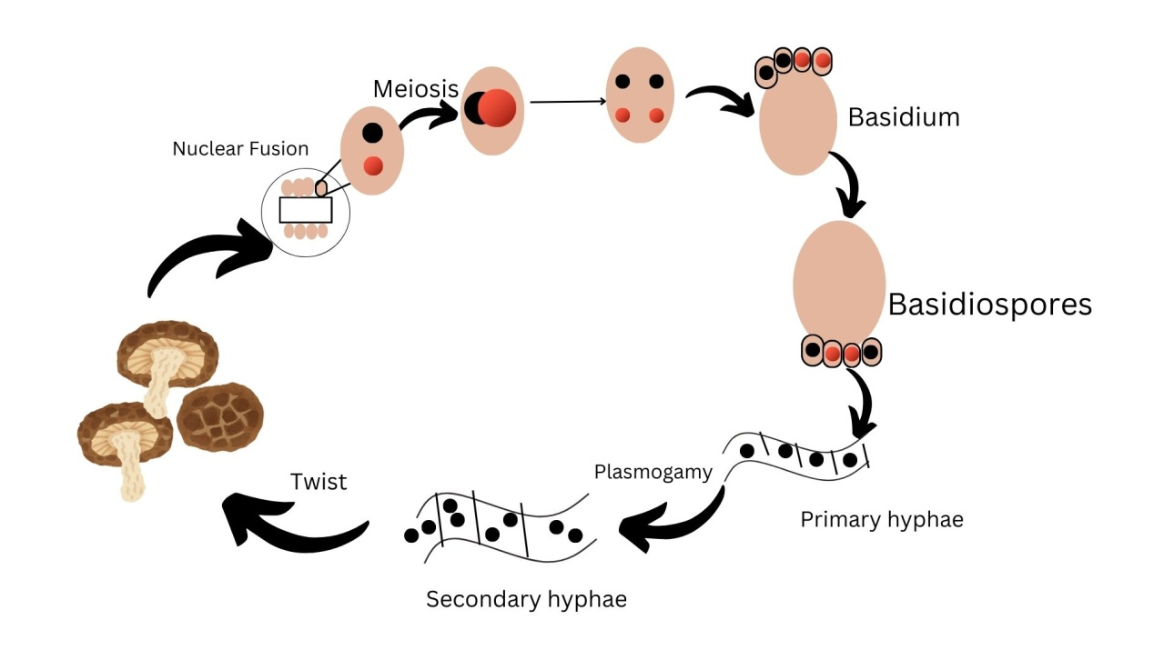

**FIG 1: Life cycle of Shiitake Mushroom**

**Global Market:**

An examination of FAOSTAT reveals that Asia, Europe, and the Americas together contribute to 99% of global mushroom production. Among these, Asia represents 76% of the total. According to FAOSTAT, China and Japan have historically been the primary mushroom producers in Asia. In 1970, these two countries were responsible for 98% of Asia's mushroom output. Even in 2016, China and Japan together accounted for 96% of the production (FAOSTAT) (Singh et al., 2018). China is the largest producer of farmed, edible mushrooms. Lentinus edodes has become the most widely cultivated edible mushroom globally, accounting for approximately 22% of the total supply worldwide **(**Royse et al., 2017**)**. Japan, which held a 15% share in mushroom production in Asia during the 1970s, has declined to merely 1% by the year 2016 **(**FAOSTAT).The production of mushrooms has increased in several Asian nations, including Taiwan, Vietnam, Korea, Indonesia, and India. In China According to information from the Chinese Edible Fungi Association (CEFA) in year 2016-18 the production of *L. edodes* was(8983,9865,10432 thousand tones) (Singh et al.,2021) Mainly grown in Asian nations (Japan, South Korea, Taiwan, China), shiitake, have begun to appear on roads in Europe, America, Canada, and Australia.Six mushrooms predominate in the world's production and sale, includingshiitake mushrooms(26%),Button (11%), Flammulina (7%), paddy straw mushroom (1%), oyster mushroom (21%), black earmushroom (21%), and various mushrooms (13%).

**Indian Market:**

In India, where the mushroom business is dominated by the production and consumption of white button mushrooms, the shiitake mushroom is making inroads. The production of mushroom in India is only 0.13 million tons (Sharma et al., 2017). Shiitake, commonly referred to as golden oak mushroom, is the most popular edible fungus in the world and is widely grown in India because of its distinct flavor and nutritional value (Singh et al., 2021). According to recent production statistics, shiitake mushrooms accounted for more than 1% of overall mushroom production in the country. Shiitake mushroom cultivation has become a significant source of income in a few areas of the North Eastern states, as well as a viable source of income in Himalayan states (Sharma *et a*l., 2020). According to a 2020 A study conducted by the Federation of Indian Chambers of Commerce and Industry, urban consumers are increasingly looking for mushrooms because of their high protein content and health advantages. Shiitake mushrooms are especially after because of their antioxidant content and immune-boosting qualities.

**By-products of shiitake mushrooms**:

There are many by-products produced during the mushroom production process, which have a negative influence on the environment and increase industry management expenses. Spent mushroom substrate (SMS), caps, stipes, and mushrooms that don't meet commercial specifications for size, shape, or caliber are examples of by-products. SMS is made up of leftover lignocellulosic substrates, extracellular enzymes released by mushrooms for substance breakdown, and fungal mycelium (Antunes *et al*., 2020). Growing mushroom production in recent decades has produced enormous post-cultivation wastes, approximately 5 kg of wasted substrate are left over after every kilogram of mushrooms, which adds up to 10–50 million metric tons yearly on average. Without any previous treatment, these wastes are haphazardly disposed off. The holo-celluloses found in spent mushroom substrate are abundant since shiitake mushrooms typically eat just Starting substrates include 15%, 56%, and 23% of the hemicellulose, cellulose, and lignin contents, respectively. Since SMS contains a sizable quantity of carbohydrates and protein, researchers have encouraged its usage in the production of biofuels, particularly biogas( Kumar *et a*l., 2020). Shiitake mycelium consists 25-30% protein, One of the most abundant necessary fatty acids found in shiitake mycelium is linoleic acid. The usual substrate composition for shiitake cultivation is 80% hardwood sawdust and 20% additive mixture (Atila et al., 2019). In fresh shiitake mushrooms, ergosterol levels are highest in the gills, followed by the cap and stalk, with the gills containing twice the ergosterol concentration of the cap. When exposed to UV-B radiation, the gills also produce more vitamin D2—up to four times more than the cap, with 22.8 μg/g DM in the gills compared to 5.2 μg/g DM in the cap (Cardwell et al., 2018). The nutritional profile of shiitake mushroom stipes, which are the stems left over during processing, shows they are quite nutrient-dense. These stipes contain a significant amount of fiber (82.94 g/kg) and carbohydrates (439.56 g/kg), making them a promising addition to functional foods. Their high fiber content and carbohydrate levels suggest they could be used to enhance the nutritional value of various food products (Li et al., 2018). Shiitake stipes are plentiful and contain high amounts of bioactive compounds known for their strong antioxidant properties. The main components of SMS are cellulose, lignin, and hemicelluloses found in plant cell walls, together with leftover fungal mycelium. Minerals, proteins, and non-cell-wall carbohydrates are also included. The significant organic content found in shiitake byproducts makes them suitable for anaerobic digestion, allowing for biogas production. This process serves as an efficient way to convert waste into energy, minimizing environmental waste while creating renewable energy.

**Agriculture and industry use of Byproducts**:

Mushroom farming has the potential to convert substantial amounts of ligno-cellulosic waste into different edible options or therapeutic foods, aiding in environmental preservation and rehabilitation. Furthermore, mushroom farming can promote equitable economic development, which has already positively impacted communities, nations, and regions. Edible mushrooms are among the easiest and most affordable types to grow commercially, as they are well-known for their capacity to transform agricultural waste into nutritious food protein significant levels of nitrates may be present in discarded mushroom substrates (SMS), which might contaminate surface and groundwater. This concerning matter prompted the European Union (EU) to introduce the “Nitrate Directive” in 1991, aimed at protecting this vital resource for life (EEA, 2022).The production of shiitake mushrooms generates large amounts of spent mushroom substrate (SMS), a form of solid waste that necessitates proper handling. One of the several suggested uses for spent mushroom compost is to reincorporate SMS by adding nutritional supplements to support further mushroom cultivation, providing an effective approach to managing this significant waste material (Carrasco et al., 2018). Mushrooms are capable of producing a variety of hydrolytic and oxidative enzymes. The idea of reusing spent mushroom substrate (SMS) in subsequent growth cycles relies on the different enzymatic activities of various mushroom species, which underscores the significance of their sequence of introduction. After Shitake mushroom production the substrate was recycled, sterilixed and reuse in the cultivation of *P. ostreatus*, *P. eryngii* and *Grifola frondosa* cultivation (Stamets et al., 2016). *L. edodes* SMS contains 151.6 mg of provitamin D2 ergosterol per 100 g (Wang et al., 2018). Its high nutritional value makes it a preferred choice in the meals consisting of monogastric animals, ruminants, poultry,fish and edible insects. Similarly, when given L. edodes SMS, weaned pigs had enhanced intestinal barriers, immunity, and gut bacterial diversity. (Qi and Peng et al., 2020). Active enzymes made by the mycelium of white-rot fungus continually break down lignin in the substrate throughout the growth of edible mushrooms, increasing the nutritious elements like crude protein and enhancing the in vivo dry matter digestibility (IVDMD) of lignocellulosic materials (Leong et al.,2022). Using *L. edodes* as SMS-based biocontrol agents has shown remarkable efficacy in promoting significant changes in plant development as well as reducing the symptoms of a variety of plant diseases. The intensity of the bacterial spot was reduced by a polysaccharide extract from *P. ostreatus* and leftover *L. edodes* mushrooms. *Xanthomonas gardneri* in tomatoes by 50% (Martin et al., 2023). Spent mushroom substrate (SMS) from shiitake cultivation, rich in organic and inorganic matter, is effective for biogas production. A 50:50 SMS and cow dung mix yielded the highest biogas (8834 mL, 61% methane) and showed the greatest reduction in slurry parameters after 21 days. The resulting digestate also improved soil nutrients, benefiting tomato growth (Kumar et al., 2022). The unique properties of spent mushroom substrate (SMS), such as its lignocellulosic structure, rich nutrients, and organic content (40-45%), make it an ideal material for biochar production. Biochar from SMS enhances soil fertility, boosts water retention, supports beneficial microbes, and helps sequester carbon, offering a sustainable solution for improving agricultural systems and combating climate change (Aiduang et al., 2025) Bioactive molecules derived from SMS hold significant promise for various applications across multiple sectors, including pharmaceuticals, biomedicine, animal feed, and the food industry. The versatility of these molecules presents a unique opportunity to enhance product efficacy and safety in these fields.

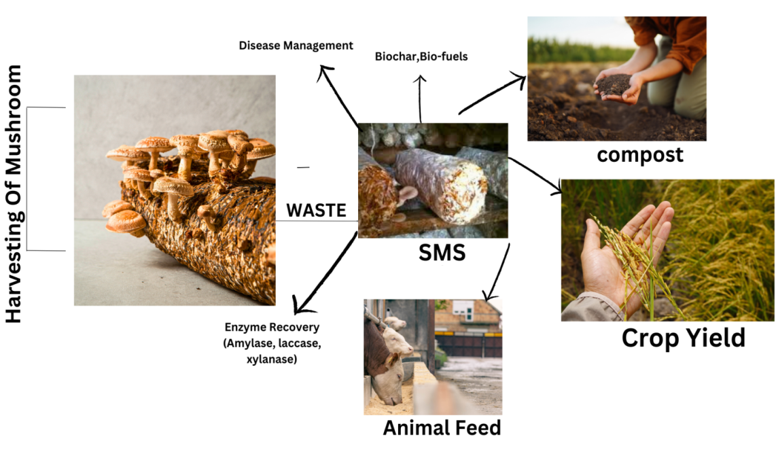

**FIG 2: Potential Applications of SMW in Various Fields of Agriculture and Others.**

**Bio-active compound in Shiitake mushroom:**

Secondary metabolites are bioactive chemicals found in high molecular weight substances containing peptides and polysaccharides. Mushrooms contain bioactive compounds that show promise for treating and preventing various illnesses. Proteins, peptides, terpenoids, polyphenols, polysaccharides, vitamins, and mineral elements are among the many physiologically active chemicals that are present and are thought to have a variety of effects, including immunomodulatory, anti-inflammatory, antioxidant, hypocholesterolemic, and hypoglycemic ones(zang et *a*l., 2020).The wood-cultured fungus had more terpenoids and phenolic components, as well as greater hypoglycemic and antioxidant potential, than the sack-cultured Shiitake *Lentinula edodes* when the functional traits and chemical composition of the two cultures were compared(sobota et al., 2020). Like other mushroom species, edible shiitake fruit bodies, especially those from group B, are an excellent source of vitamins. Their size is greater than eggs and their vitamin B1 level is comparable to cereal grains. Compared to veggies, vitamin B2 is more readily available. The fruiting bodies have comparatively low lipid content, ranging from 4.8 to 8.0% of the dry weight. Fatty acids, mono-, di-, and triglycerides, phospholipids, and sterols are among the fats found there (Muszyńska et al., 2017). The basic repeating units of β-glucan polysaccharides derived from edible shiitake *Lentinula edodes* mushrooms consist of two branches of 1-6-β-glucopyranoside and five (1→3)-β-glucose residues connected in a linear pattern. The β-glucan content varied significantly between cultivars, with the stipe of the fruiting bodies showing greater amounts than the pileus. The discovered β-glucan levels ranged from 20.06% to 44.21% in the pileus parts and from 29.74% to 56.47% in the stipe section. (Friedman, 2016). The extract derived from this fungus contains several biologically active compounds with potent antimicrobial effects. These include erythritol isomers (1,2-and 3,4-butanetetrol), sesquiterpenes, steroids, anthraquinones, benzoic acid derivatives, and quinolones. Additionally, it contains bathing acid, a metabolite of sesquiterpene, as well as carvacrol, an aromatic monoterpene found in shiitake oil extract (Avinash et al., 2016). Mushroom protein is rich in important amino acids such as glutamic acid, aspartic acid, and arginine (PUIA et al., 2018). Shiitake *Lentinula edodes* have the most protein more than 20% (Chaturvedi et al., 2018). Key bioactive proteins in fungi include lectins, immunomodulatory proteins, and enzymes like nucleases, ribonucleases, laccase, and ergotionein. Lectins help increase insulin secretion, lower blood sugar, boost the immune system, and even offer chemo-preventive effects against cancers, such as hepatocellular carcinoma (Sousa et al., 2023). Shiitake mushrooms are packed with antioxidant-rich phenolic compounds, including p-hydroxybenzoic acid, protocatechuic acid, and trans-cinnamic acid. They also have higher calcium levels than many other mushrooms, along with significant amounts of potassium, magnesium, sodium, zinc, and phosphorus. Mushrooms, including shiitake, contain phenolic compounds that have powerful antioxidant effects. Shiitake mushrooms, in particular, have a total phenolic content of 13 µmol GAE/mg (Sharpe et al., 2021). The presence of polyunsaturated fatty acids, like linoleic acid, adds to their value in nutraceuticals. Moreover, fatty acids from Shiitake mycelium and spent substrates show promising antibacterial and antifungal effects. Shiitake consists series of waste materials these byproducts contain a wealth of complex organic compounds that can be utilized for sustainable purposes. It is important to understand the chemical makeup of shiitake mushroom waste to evaluate its biodegradability, potential for reuse, and environmental effects. The major components of this waste consist of cellulose, hemicellulose, lignin, proteins, amino acids, and trace minerals, all of which play a role in its capacity for recycling or repurposing.

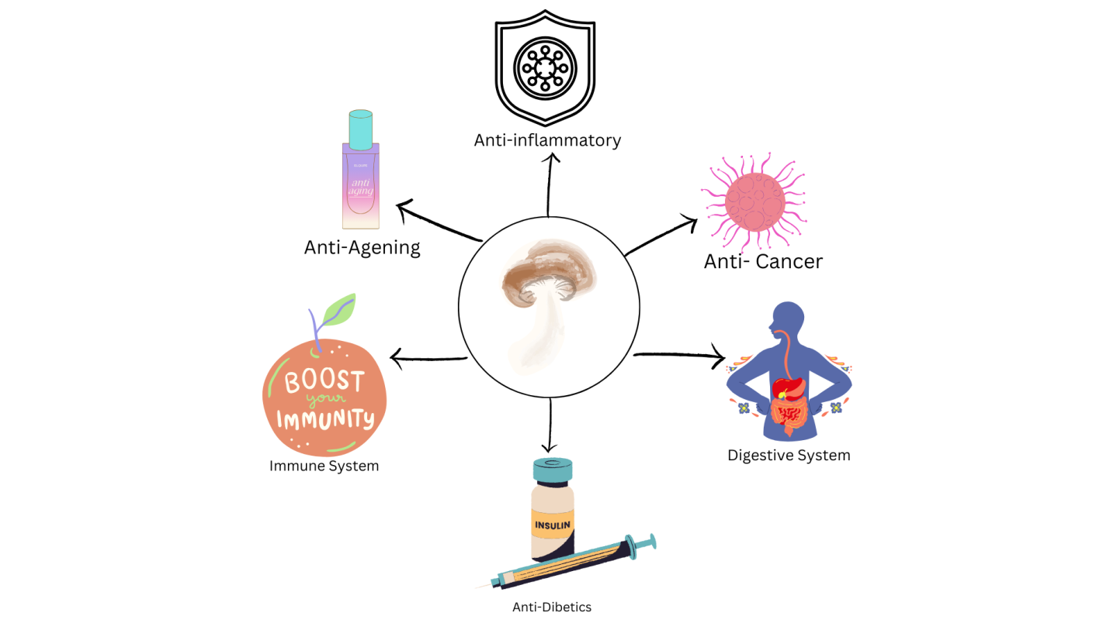

**FIG 3: Bio-activity of shiitake mushroom byproducts**

**TABLE 1. Bioloical activity and different bio-active compounds of shiitake mushroom byproducts:**

|  |  |  |
| --- | --- | --- |
| **Bioactive Compound** | **Biological Activity** | **Reference** |
| Polysaccharides (e.g., Î²-glucans, lentinan) | Anticancer, immunomodulatory, antioxidant, antitumor and cholesterol-lowering activities | (Chaipoot et al., 2023; Łysakowska et al., 2023) |
| Phenolic compounds | Antioxidant, antimicrobial and anti-inflammatory properties | (Chaipoot et al., 2023; Kumar et al., 2022) |
| Ergosterol | Antioxidant and precursor to vitamin D synthesis | (Chaipoot et al., 2023; Antunes et al., 2020) |
| Triterpenoids | Antitumor and anti-inflammatory effects | (Antunes et al., 2020; Łysakowska et al., 2023) |
| Proteins and peptides | Antimicrobial and immunomodulatory effects | (Antunes et al., 2020) |
| Polysaccharide-protein complexes | Enhances immunity and exhibits antitumor activity | (Antunes et al., 2023; Łysakowska et al., 2023) |
| Flavonoids | Antioxidant and protective effects | (Antunes et al., 2023; Kumar et al., 2020) |
| Trace elements (e.g., Fe, Zn, Mg) | Supports enzymatic functions and antioxidant defense systems | (Kumar et al., 2020) |

**Medicinal and Nutritional Value of Shiitake Byproducts:**

Shiitake mushrooms are known for their high concentration of biologically active compounds, such as (1,3)(1,6)-β-D-glucans, which are a form of dietary fiber, along with triterpenes, phenolic compounds, and sterols. Due to their low fat content, they are a low-calorie food and are considered a functional food. These mushrooms support overall health and enhance nutritional levels, offering a range of benefits for the body (Łysakowska et al., 2023) Shiitake mushrooms are celebrated for their therapeutic properties and high oral bioavailability, which has contributed to their widespread consumption around the world. For thousands of years, they have been an essential part of traditional Chinese medicine, valued for their health benefits and medicinal qualities (Wang et al., 2019). Shiitake mushrooms are an excellent source of the vitamin B complex. Lentinula edodes contains approximately 58-60% carbohydrates, 20-23% protein, 9-10% fiber, 3-4% fat, and 4-5% ash (Sheng et al., 2021). *Lentinus edodes* has been utilized to boost vitality, energy levels, and in an effort to fight aging Lentinus species-derived lentinan sulfate inhibits HIV. In addition to strengthening the immune system and reducing the negative effects of radiation and chemotherapy, the *lentinula edodes* polysaccharides have strong antiviral, anticancer, and antibacterial characteristics. The *Lentinula edodes* by its anti-inflammatory attributes, and research has indicated that the incorporation of the anti-inflammatory properties of L. edodes mycelial extracts were enhanced by Cu, Zn, or Se, suggesting that the mycelium of Lentinula edodes may serve as a prospective ingredient in natural anti-inflammatory dietary supplements. (Muszyńska et al., 2020). Strains of *Lentinula edodes*, especially the one called Shenxiang 18, showed a favorable amino acid composition and high protein quality.Free amino acid levels spanning from 0. 06 to 730 ^mol/g dry matter in 113 different species of mushrooms; L. edodes contained 128mol/g. Consuming L. edodes for four weeks led to a significant rise in the ex vivo proliferation of γδ-T cells (60% increase, p < 0.0001) and NK-T cells (a two-fold increase, p < 0.0001). These cell types also exhibited greater expression of activation receptors, indicating that mushroom consumption enhanced cell effector function (Dai et al., 2015). Mycelia from shiitake (L. edodes) mushrooms bioprocessed with elm tree (Ulmus parvifolia) bark may be able to prevent and/or cure allergic asthma (Kim et al., 2016). Fresh shiitake mushrooms have lower content of total acids (0.16%) compared with dried mushrooms from the variant M1 (0.48%). The acetone extract derived from shiitake mushrooms exhibits greater antimicrobial properties compared to the water extract. Additionally, the acetone extract displayed no cytotoxic effects at the concentrations that demonstrated antimicrobial activity. Based on these findings, shiitake mushrooms may aid in the prevention and treatment of periodontitis (Jeon et al., 2022). Fresh Lentinula edodes fruting bodies contain 88-92% water. Their calorific value is 387- 392 kcal per 100 g of dry matter. Shiitake byproducts are also rich in dietary fiber, which contributes to better digestive health and may play a role in regulating blood glucose levels. The fiber content in shiitake stems has been reported to be significant, with both soluble and insoluble fibers present.

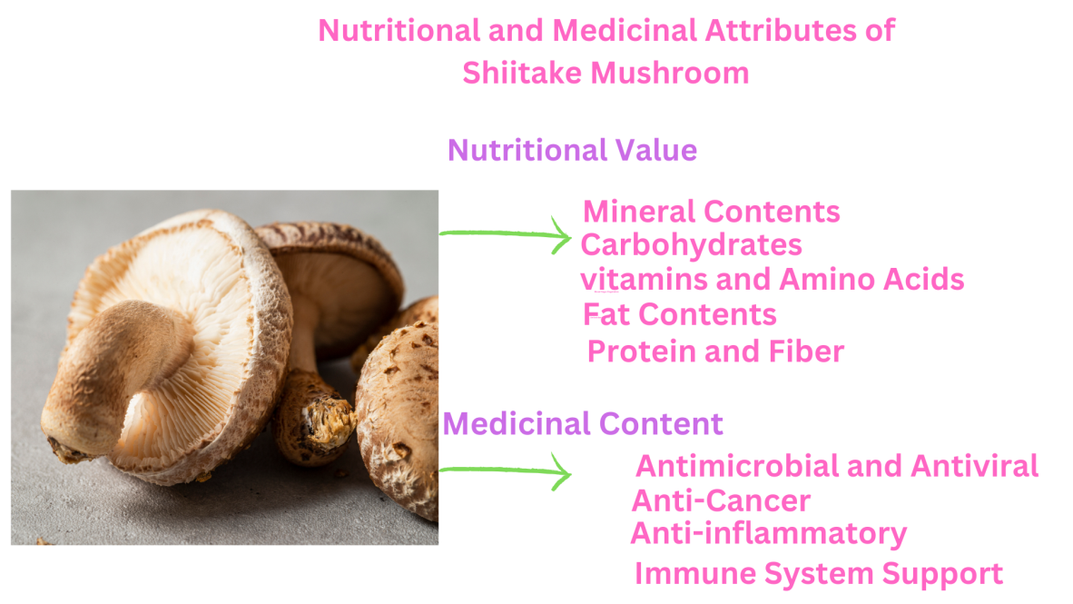 **Fig 3: Medicinal and Nutritional Content in Shiitake Mushroom.**

**TABLE 2. Nutritional Value of Shiitake Mushrooms (Per 100g Dried):**

|  |  |
| --- | --- |
| **Nutrient** | **Amount per 100g** |
| **Energy** | 296 kcal |
| **Carbohydrates** | 75.4 g |
| **Dietary Fiber** | 11.5 g |
| **Sugars** | 2.2 g |
| **Protein** | 9.6 g |
| **Total Fat** | 1.0 g |
| **Saturated Fat** | 0.2 g |
| **Monounsaturated Fat** | 0.2 g |
| **Polyunsaturated Fat** | 0.4 g |
| **Vitamin D** | 3.9 µg |
| **Vitamin B2 (Riboflavin)** | 1.27 mg |
| **Vitamin B3 (Niacin)** | 14.1 mg |
| **Vitamin B5 (Pantothenic Acid)** | 3.6 mg |
| **Vitamin B6** | 0.29 mg |
| **Folate** | 163 µg |
| **Vitamin C** | 3.5 mg |
| **Vitamin A** | 2 µg |
| **Vitamin E** | 0.5 mg |
| **Vitamin K** | 1.7 µg |
| **Calcium** | 11 mg |
| **Iron** | 1.7 mg |
| **Magnesium** | 60 mg |
| **Phosphorus** | 294 mg |
| **Potassium** | 1534 mg |
| **Sodium** | 13 mg |
| **Zinc** | 2.0 mg |
| **Copper** | 5.2 mg |
| **Manganese** | 0.5 mg |
| **Selenium** | 46.1 µg |

*Percent Daily Values are based on a 2,000-calorie diet* (Smith, 2023)

**Biodegradation mechanisms of shiitake mushroom byproducts:**

The enzymes that break down lignin are produced by *L. edodes.* Therefore, in nature, they may grow on straw and wood trunks. Above all, they may be adapted to a variety of commercial substrates, including forestry, agro-industrial, and agricultural waste, and use biodegradation and biotransformation to recycle them into biomass that is high in protein. To prevent hygienic risks, SMS contains phytotoxic substances that must weather for one to two years before being used in commercial soil (Hu et al., 2019). The mycelium of *L. edodes* generates enzymes that have oxidative properties, potentially breaking down xenobiotics. White rot fungi are capable of altering persistent pollutants like polycyclic aromatic hydrocarbons. Such characteristics may also be utilized for cleaning soil that has been contaminated with petroleum (Muszyńska et al., 2018). Mushrooms generate extracellular peroxidases, ligninases, cellulases, pectinases, xylanases, and oxidases. Multiple (hemi)cellulolytic enzymes, such as xylanase, endoglucanases (GH12), and cellobiohydrolases (GH6 and GH7), along with enzymes that contribute to lignin breakdown (laccases and MnP), have been biochemically analyzed in *L. edodes* (Cai Y, et al.,2017). Various enzymes, including ligninolytic, cellulolytic, and hemicellulolytic, can be used to break down lignocelluloses (Vasco et al., 2016). Sethese enzymes decompose nonpolymeric, resistant contaminants such nitrotoluenes, organic and synthetic colors, and pentachlorophenol. Mushroom is biosorption, In terms of biosorption, dead mushroom biomass has several benefits over living cells. Dead mushroom biomass may be collected from industry as a byproduct from fermentation operations (Kulshreshtha et al., 2014). White-rot fungi, known for breaking down lignocellulosic materials, can also degrade shiitake mushroom byproducts. Shiitake mycelium itself is capable of decomposing lignocellulose too. These fungi effectively break down lignin in shiitake waste, turning it into humus-like material useful as soil conditioner (Zhang et al., 2017). Bacteria are strong producers of cellulase, which they release in large quantities. Cellulase plays a key role in breaking down lignocellulose by targeting and hydrolyzing the β-1, 4 glycosidic bonds in cellulose (Malik et al., 2021). Chitin, found in the mycelium of shiitake mushrooms, can be broken down by chitinases.Chitin degradation is crucial for mycelial waste treatment and recycling. The chemical composition of the shiitake byproducts, such as the proportion of cellulose, hemicellulose, lignin, and chitin, influences the degradation rate. Lignocellulosic-rich substrates tend to degrade more slowly compared to mycelium-based substrates.

**Shitake byproduct as composting and organic fertilizers:**

Composting is the process of turning organic waste into a more degraded product. Composting's main objective is to make it easier for nutrients found in straw and supplements to be released.   
Changing them into a form that will provide the best nourishment for mushrooms. The management and disposal of SMC present significant environmental hazards as they emit greenhouse gases into the atmosphere due to natural anaerobic digestion, which frequently takes place in the mounds formed during temporary storage. This process also leads to unpleasant odors and leachate drainage, which pollutes and enriches water bodies, resulting in the depletion of dissolved oxygen (Martín et al., 2023). Pure SMC, lacking any compost, exhibits the highest bulk density, which diminishes with the inclusion of other materials. For an optimal growth substrate, the ideal bulk density should be 0.4 g/cm3, serving as a reliable indicator of porosity that facilitates unrestricted gas exchange throughout the medium. This suggests that the desired water-holding capacity and total pore space fall within the ranges of 50–60% and 70–90%, respectively (Thakur et al., 2020). SMC generally has a nutrient ratio of 1.9:0.4:2.4% NPK, and after a period of 8 to 16 months of exposure to the elements, it usually has a nutrient ratio of 1.9:0.6:1.0% NPK. Although potassium is more soluble than nitrogen and phosphorus, it experiences a notable reduction in its content due to weathering. SMC is not classified as hazardous waste, as it contains far fewer heavy metals compared to sewage sludge (Becher et al., 2021). Spent Mushroom Substrate (SMS) is generally has low in water content and has week acidic PH. *L.edodes* substrate is used as mulching. SMC derived from shiitake *Lentinula edodes* was tested against F. oxysporum f. sp cepae, which causes basal rot disease in shallots. The results showed that the SMC notably reduced the disease severity by 44–76.8 %. (Yusidah et al., 2018). Where the residues of Shiitake mushrooms supplied 50% of the nitrogen, and chemical fertilizers accounted for the remaining 50% of the nitrogen; and ABR50 (Tang et al., 2024). Shiitake mushroom waste (SMW) improves soil aeration, boosting plant growth. It's rich in essential minerals like nitrogen (1.3–4.2%), phosphorus (0.1–0.4%), and potassium (0.5–1.8%), along with calcium (0.2–0.4%) and sodium (0.05–0.2%). It also contains micronutrients such as copper, iron, manganese, zinc, boron, in varying amounts, supporting healthy plant development (Jasinksa et al., 2018). Spent Mushroom Waste derived from Lentinus edodes serves as a superior alternative for mulch due to its enhanced physicochemical properties and its biological effect on pesticide breakdown (Gao et al., 2015).

**Innovative Biotechnological Approaches for Enhancing By-product Utilization**:

Shiitake mushrooms (Lentinula edodes) are among the most cultivated edible mushrooms in the world, valued both for their culinary attributes and medicinal properties. Apart from their direct consumption, they are an essential resource for the biotechnology sector, as their cultivation results in significant byproducts, primarily in the form of spent mushroom substrate (SMS), which is often discarded or used as animal feed. However, recent developments in biotechnological approaches have opened new pathways for utilizing these byproducts, leading to the production of value-added, biodegradable compounds with significant applications in various industries, such as agriculture, medicine, food, and bioplastics.

* **Biodegradable Packaging from Shiitake Mushroom Byproducts**:

Recent findings from Salesforce indicate that digital sales surged by 71% in the second quarter of 2020 and by 55% in the third quarter. This significant increase has led to a rise in the demand for packages and packaging materials, which are likely to end up in landfills, incineration facilities, or even worse, in water bodies and the natural environment. The recyclability of packaging materials such as polystyrene and polypropylene is frequently overstated, with estimates suggesting that less than 14% of the nearly 86 million tons of plastic packaging produced annually is actually recycled. Instead of being recycled, a significant amount of the generated packaging waste ends up in landfills or is incinerated. Additionally, some of it may find its way into the environment, including our water bodies and oceans, where it poses a threat to marine life (Ellen MacArthur Foundation,2017). Research on fungi-based packaging made from mushroom mycelium has been thoroughly conducted and documented over the last ten years. Mycelium foams created from agricultural byproducts or substances such as sawdust can be seen as a cost-effective substitute that shares similar characteristics with traditional Styrofoam. Mycelium develops around materials such as sawdust or coir pith by binding them, resulting in a compostable product that serves as an eco-friendly alternative to expanded polystyrene and other plastics used for cushioning packaged items. However, it remains to be determined whether they can effectively compete with synthetic materials as a protective packaging solution based on cost and performance (Ellen MacArthur Foundation, 2017). Ecovative Design is a biotech firm located in New York that specializes in the production of foam made from mushrooms. They have made significant advancements in optimizing the manufacturing process while preserving the essential qualities of the material. Companies like Dell have been early adopters, announcing their choice to utilize environmentally friendly foam made from fungal mycelium for shipping their servers in their packaging. They have thoroughly examined these materials in their laboratories to confirm that they offer the same level of protection for their products as traditional expanded polystyrene foam (Rajendran, 2022). During the 1980s, Japanese scientist Shigeru Yamanka noted the adhesive capabilities of mycelium as beneficial in the paper industry and in the production of construction materials. (Mojumdar et al., 2021).

* **Development of Functional Foods and Nutraceuticals:**

Shiitake mushrooms (*Lentinula edodes*) have been valued for their cooking and health benefits for a long time. Nevertheless, recent studies have put more emphasis on creating functional foods and nutraceuticals from the byproducts of shiitake mushroom farming, including spent substrate, stems, and mycelium. These often overlooked byproducts contain a wealth of bioactive compounds that could be useful in developing health-enhancing food products. The shiitake mushroom possesses a distinctive umami taste and a variety of rich non-volatile flavor compounds, making it a focal point in the advancement of natural seasonings. Research has shown that the by-products of shiitake mushrooms can be converted into a flavor enhancer, which might aid in creating low-salt meat products (França et al., 2022). The tasty compounds found in shiitake mushrooms include soluble sugars, free amino acids, 5'-nucleotides, organic acids, and smaller substances like flavorful peptides, which all significantly contribute to how we perceive taste (Sun et al., 2020). Blanched and centrifuged shiitake broths contain high levels of polysaccharides, total phenols, ergothioneine, essential minerals, and flavor compounds, while being low in fat and sodium. This suggests that the blanching water from shiitake mushrooms is not just flavorful but also offers health advantages (Chen et al., 2023). *L. edodes* showed the greatest NADPH levels during the transformation of acetaldehyde into ethanol (Takemoto et al.,2024). L. edodes serve as a readily available nitrogen source in the alcoholic fermentation process because of their significant protein content (Chen et al., 2022). Various quantities of L. edodes powder, celebrated for its deep umami taste and health benefits, and were added to the fermentation process of Huangjiu, a type of traditional Chinese rice wine. The powder from shiitake mushrooms was blended with Jiuku wheat and water to start fermentation, and the effects of the mushrooms on the microbial dynamics and volatile compounds during the fermentation process were examined (Geng et al., 2024). *Lentinula edodes* powder, a staple in Japanese cooking, was combined with potato tubers, leading to the quick release of saccharides observed under heterogeneous solid-state conditions (Tatsumi et al., 2016)

**Conclusion:**

Shiitake mushroom farms produce three types of byproducts consisting of SMS and stipes with non-commercial mushrooms which present management difficulties yet contain economic value. The use of SMS through nutritional supplements allows for mushroom cultivation expansion while forming an efficient waste management method. The organic and inorganic contents of SMS allow for effective biogas creation along with biochar production that boosts soil quality while helping capture atmospheric carbon. Bioactive molecules from SMS show extensive practical potential throughout the pharmaceuticals sector as well as biomedicine and animal feed production and the food industry. These molecules demonstrate versatility which creates an exceptional opportunity to improve both efficiency and safety measures of products within these industries. The nutritional quality of animal feed improves due to L. edodes SMS's presence of 151.6 mg per 100 g of provitamin D2 ergosterol. The active lignin-degrading enzymes produced by white-rot fungus mycelium function constantly throughout edible mushroom growth stages to increase nutrient proteins and promote lignocellulosic material digestion by livestock. Spent mushroom substrate (SMS) demonstrates three main characteristics which make it suitable for biochar production: its lignocellulosic framework and its dual nutritive value and its organic substance content. The biochar derived from SMS strengthens soil nutrients while retaining moisture and promoting microbial communities while trapping carbon which provides environmentally friendly answers to farming system development and climate change reduction. Future studies need to develop optimal approaches for retrieving bioactive compounds while utilizing SMS effectively to establish sustainable economic solutions.

**Acknowledgements**

I would like to express my great appreciation and gratitude to all the authors for providing their assistance and their contribution for valuable and constructive suggestions.

Conflict of interest statement

The authors declare that they have no known competing financial interests or personal relationships that could have appeared to influence the work reported in this article.

Competing interests

Authors have declared that no competing interests exist.

COMPETING INTERESTS DISCLAIMER:

Authors have declared that they have no known competing financial interests or non-financial interests or personal relationships that could have appeared to influence the work reported in this paper.

**References:**

Aiduang, W., Jatuwong, K., Kiatsiriroat, T., Kamopas, W., Tiyayon, P., Jawana, R., Xayyavong, O., & Lumyong, S. (2025). Spent Mushroom Substrate-Derived Biochar and Its Applications in Modern Agricultural Systems: An Extensive Overview. Life, 15(2), 317. <https://doi.org/10.3390/life15020317>

Antunes, F., Marçal, S., Taofiq, O., M. M. B. Morais, A., Freitas, A. C., C. F. R. Ferreira, I., & Pintado, M. (2020). Valorization of Mushroom By-Products as a Source of Value-Added Compounds and Potential Applications. Molecules, 25(11), 2672. <https://doi.org/10.3390/molecules25112672>

Atila, F. Compositional changes in lignocellulosic content of some agro-wastes during the production cycle of shiitake mushroom. *Sci. Hortic.* 2019, *245*, 263–268.

Avinash J, Vinay S, Jha K, Das D, Goutham BS, Kumar G. The Unexplored Anticaries Potential of Shiitake Mushroom. Pharmacogn Rev. 2016 Jul-Dec;10(20):100-104. doi: 10.4103/0973-7847.194039. PMID: 28082791; PMCID: PMC5214552.

Becher, M., Banach-Szott, M., & Godlewska, A. (2021). Organic Matter Properties of Spent Button Mushroom Substrate in the Context of Soil Organic Matter Reproduction. Agronomy, 11(2), 204. <https://doi.org/10.3390/agronomy11020204>

Cai, Y.; Gong, Y.; Liu, W.; Hu, Y.; Chen, L.; Yan, L.; Zhou, Y.; Bian, Y. Comparative secretomic analysis of lignocellulose degradation by *Lentinula edodes* grown on microcrystalline cellulose, lignosulfonate and glucose. *J. Proteom.* **2017**, *163*, 92–101

Cardwell, G., Bornman, J. F., James, A. P., & Black, L. J. (2018). A Review of Mushrooms as a Potential Source of Dietary Vitamin D. Nutrients, 10(10), 1498. https://doi.org/10.3390/nu10101498

Carrasco, J., Zied, D. C., Pardo, J. E., Preston, G. M., & Pardo-Giménez, A. (2018). Supplementation in mushroom crops and its impact on yield and quality. *AMB Express*, *8*, 1-9.

Chaipoot, S., Wiriyacharee, P., Phongphisutthinant, R., Buadoktoom, S., Srisuwun, A., Somjai, C., & Srinuanpan, S. (2023). Changes in physicochemical characteristics and antioxidant activities of dried shiitake mushroom in dry-moist-heat aging process. *Foods*, *12*(14), 2714.

Chaturvedi, V. K., Agarwal, S., Gupta, K. K., Ramteke, P. W., & Singh, M. P. (2018). Medicinal mushroom: boon for therapeutic applications. *3 Biotech*, *8*, 1-20.

Chen, F.; Xiong, S.; Gandla, M.L.; Stagge, S.; Martín, C. Spent mushroom substrates for ethanol production—Effect of chemical and structural factors on enzymatic saccharification and ethanolic fermentation of *Lentinula edodes*-pretreated hardwood. *Bioresour. Technol.* **2022**, *347*, 126381.

Chen, S.-Y., Tseng, J., Wu, C.-R., & Lin, S.-D. (2023). Quality Evaluation of Shiitake Blanched and Centrifuged Broths as Functional Instant Drinks. Foods, 12(15), 2925. <https://doi.org/10.3390/foods12152925>

Dai, X., Stanilka, J. M., Rowe, C. A., Esteves, E. A., Nieves, C., Jr, Spaiser, S. J., Christman, M. C., Langkamp-Henken, B., & Percival, S. S. (2015). Consuming Lentinula edodes (Shiitake) Mushrooms Daily Improves Human Immunity: A Randomized Dietary Intervention in Healthy Young Adults. *Journal of the American College of Nutrition*, *34*(6), 478–487. <https://doi.org/10.1080/07315724.2014.950391>

EEA European Environment Agency. Nitrate Directive. 2022. Available online: [**https://www.eea.europa.eu/archived/archived-content-water-topic/water-pollution/prevention-strategies/nitrate-directive**](https://www.eea.europa.eu/archived/archived-content-water-topic/water-pollution/prevention-strategies/nitrate-directive) (accessed on 3 May 2022).

Ellen MacArthur Foundation (2017) The new plastics economy: Rethinking the future of plasticsand catalysing action. <http://www.ellenmacarthurfoundation.org/publications>

França, F., dos Santos Harada-Padermo, S., Frasceto, R. A., Saldana, E., Lorenzo, J. M., de Souza Vieira, T. M. F., & Selani, M. M. (2022). Umami ingredient from shiitake (Lentinula edodes) by-products as a flavor enhancer in low-salt beef burgers: Effects on physicochemical and technological properties. *LWT*, *154*, 112724

Friedman, M. (2016). Mushroom Polysaccharides: Chemistry and Antiobesity, Antidiabetes, Anticancer, and Antibiotic Properties in Cells, Rodents, and Humans. Foods, 5(4), 80. <https://doi.org/10.3390/foods5040080>

Gao, W., Liang, J., Pizzul, L., Feng, X.M., Zhang, K., del Pilar Castillo, M., 2015. Evaluation of spent mushroom substrate as substitute of peat in Chinese biobeds. Int. Biodeterior. Biodegrad. 98, 107–112

Geng, J.; He, S.; Zhang, S.; Tian, H.; Jin, W. Impact of incorporating shiitake mushrooms (*Lentinula edodes*) on microbial community and flavor volatiles in traditional Jiuqu. *Foods* **2024**, *13*, 1019.

Hu, T., Wang, X., Zhen, L., Gu, J., Zhang, K., Wang, Q., ... & Zhao, W. (2019). Effects of inoculating with lignocellulose-degrading consortium on cellulose-degrading genes and fungal community during co-composting of spent mushroom substrate with swine manure. *Bioresource technology*, *291*, 121876.

Jasinksa, A., 2018. Spent mushroom compost (SMC)—retrieved added value product closing loop in agricultural production. Acta Agrar. Debr. 150, 185 –2020. https://doi.org/10.341010/actaagrar/150/171

Jeon, Y. M. (2022). Effects of Shiitake mushroom extract on antimicrobial activity against periodontopathogens and inflammatory condition of human gingival fibroblast. *Journal of Dental Rehabilitation and Applied Science*, *38*(2), 90-96.

Kim, S. P., Lee, S. J., Nam, S. H., & Friedman, M. (2016). Turmeric (Curcuma longa) bioprocessed with mycelia of shiitake (Lentinus edodes) mushrooms: Composition and mechanism of protection against salmonellosis in mice. *Int. J. Med. Mushrooms*.

Kulshreshtha S, Mathur N, Bhatnagar P. Mushroom as a product and their role in mycoremediation. AMB Express. 2014 Apr 1;4:29. doi: 10.1186/s13568-014-0029-8. PMID: 24949264; PMCID: PMC4052754.

Kumar, P., Eid, E. M., Taher, M. A., El-Morsy, M. H. E., Osman, H. E. M., Al-Bakre, D. A., Adelodun, B., Abou Fayssal, S., Goala, M., Mioč, B., Držaić,V., Ajibade, F. O., Choi, K. S., Kumar, V., & Širić, I. (2022). Biotransforming the Spent Substrate of Shiitake Mushroom (*Lentinula edodes* Berk.): A Synergistic Approach to Biogas Production and Tomato (*Solanum lycopersicum* L.) Fertilization. Horticulturae, 8(6), 479. <https://doi.org/10.3390/horticulturae8060479>

Leong, Y.K.; Ma, T.W.; Chang, J.S.; Yang, F.C. Recent Advances and Future Directions on the Valorization of Spent Mushroom Substrate (SMS): A Review. *Bioresour. Technol.* **2022**, *344*, 126157

Li, S., Wang, A., Liu, L. *et al.* Evaluation of nutritional values of shiitake mushroom (*Lentinus edodes*) stipes. *Food Measure* **12**, 2012–2019 (2018). https://doi.org/10.1007/s11694-018-9816-2

Łysakowska, P., Sobota, A., & Wirkijowska, A. (2023). Medicinal Mushrooms: Their Bioactive Components, Nutritional Value and Application in Functional Food Production—A Review. Molecules, 28(14), 5393. <https://doi.org/10.3390/molecules28145393>

Malik, W. A., & Javed, S. (2021). Biochemical Characterization of Cellulase From *Bacillus subtilis* Strain and its Effect on Digestibility and Structural Modifications of Lignocellulose Rich Biomass. *Frontiers in bioengineering and biotechnology*, *9*, 800265. https://doi.org/10.3389/fbioe.2021.800265

Martín, C., Zervakis, G. I., Xiong, S., Koutrotsios, G., & Strætkvern, K. O. (2023). Spent substrate from mushroom cultivation: exploitation potential toward various applications and value-added products. *Bioengineered*, *14*(1). <https://doi.org/10.1080/21655979.2023.2252138>

Martín, C., Zervakis, G. I., Xiong, S., Koutrotsios, G., & Strætkvern, K. O. (2023). Spent substrate from mushroom cultivation: exploitation potential toward various applications and value-added products. *Bioengineered*, *14*(1). https://doi.org/10.1080/21655979.2023.2252138

Mojumdar A, Behera HT, Ray L (2021) Mushroom mycelia-based material: an environmental friendly alternative to synthetic packaging. In: Vaishnav A, Choudhary DK (eds) Microbial polymers. Springer, Singapore, pp 131–141. <https://doi.org/10.1007/978-981-16-0045-6_6>

Muszyńska, B., Kała, K., Włodarczyk, A., Krakowska, A., Ostachowicz, B., Gdula-Argasińska, J., & Suchocki, P. (2020). Lentinula edodes as a Source of Bioelements Released into Artificial Digestive Juices and Potential Anti-inflammatory Material. *Biological trace element research*, *194*(2), 603–613. <https://doi.org/10.1007/s12011-019-01782-8>

Muszyńska, B., Pazdur, P., Lazur, J., & Sułkowska-Ziaja, K. (2017). Lentinula edodes (Shiitake)–biological activity. *Medicina Internacia Revuo*, *28*(108), 189-195.

Muszyńska, B., Żmudzki, P., Lazur, J. *et al.* Analysis of the biodegradation of synthetic testosterone and 17α-ethynylestradiol using the edible mushroom *Lentinula edodes*. *3 Biotech***8**, 424 (2018). <https://doi.org/10.1007/s13205-018-1458-x>

Mwangi, R.W., Mustafa, M., Kappel, N. *et al.* Practical applications of spent mushroom compost in cultivation and disease control of selected vegetables species. *J Mater Cycles Waste Manag* **26**, 1918–1933 (2024). <https://doi.org/10.1007/s10163-024-01969-9>

Ponnusamy C, Uddandrao V. V. S, Pudhupalayam S. P, Singaravel S, Periyasamy T, Ponnusamy P, Prabhu P, Sasikumar V, Ganapathy S. Lentinula Edodes (Edible Mushroom) as a Nutraceutical: A Review. Biosci Biotech Res Asia 2022;19(1

PUIA, I. C., Aida, P. U. I. A., CHEDEA, V. S., LEOPOLD, N., BOCSAN, I. C., & BUZOIANU, A. D. (2018). Characterization of Trametes versicolor: Medicinal mushroom with important health benefits. *Notulae Botanicae Horti Agrobotanici Cluj-Napoca*, *46*(2), 343-349.

Qi Q, Peng Q, Tang M, et al. Microbiome analysisinvestigating the impacts of fermented spent mushroom substrates on the composition of micro-biota in weaned piglets hindgut. Front Vet Sci.2020 volume 7 <https://doi.org/10.3389/fvets.2020.584243>

Raghoonundon, B., Gonkhom, D., Phonemany, M., Luangharn, T., & Thongklang, N. (2021). Nutritional content, nutraceutical properties, cultivation methods and economical importance of Lentinula: a review. *Fungal Biotec*, *1*, 88-100.

Rajendran, R. C. (2022). Packaging applications of fungal mycelium-based biodegradable composites. In *Fungal Biopolymers and Biocomposites: Prospects and Avenues* (pp. 189-208). Singapore: Springer Nature Singapore

Royse, D. J., Baars, J., & Tan, Q. (2017). Current overview of mushroom production in the world. *Edible and medicinal mushrooms: technology and applications*, 5-13.

Sharma, V. P., Annepu, S. K., Barh, A., & Kumar, S. (2020). Adoption and competitiveness of new strains of shiitake mushroom in India. *Mushroom Research*, *29*(1).

Sharpe, E., Farragher-Gnadt, A. P., Igbanugo, M., Huber, T., Michelotti, J. C., Milenkowic, A., & Bou-Abdallah, F. (2021). Comparison of antioxidant activity and extraction techniques for commercially and laboratory prepared extracts from six mushroom species. *Journal of agriculture and food research*, *4*, 100130.

Sheng K, Wang C, Chen B, Kang M, Wang M, Liu K, et al. Recent advances in polysaccharides from Lentinus edodes (Berk.): Isolation, structures and bioactivities. Food chemistry. 2021 Oct 1;358:129883.

Singh, M., Kamal, S. and Sharma, V.P. 2021. Status and trends in world mushroom production-III-World Production of Different Mushroom Species in 21st Century. Mushroom Res., 29(2): 75-111.

Singh, M., Kamal, S., & Sharma, V. P. (2018). Status and trends in world mushroom production-II -Mushroom production in Japan and China. *Mushroom Research*, *27*(1).

Smith, J., & Brown, R. (2023). *Nutritional and medicinal properties of Shiitake mushrooms: A comprehensive review.* Journal of Food Science and Nutrition, 12(4), 567-582.

Song, T.; Zhang, Z.; Liu, S.; Chen, J.; Cai, W. Effect of Cultured Substrates on the Chemical Composition and Biological Activities of Lingzhi or Reishi Medicinal Mushroom, Ganoderma lucidum (*Agaricomycetes*). *Int. J. Med. Mushrooms* **2020**, *22*, 1183–1190

Sousa, A. S., Araújo-Rodrigues, H., & Pintado, M. E. (2023). The health-promoting potential of edible mushroom proteins. *Current Pharmaceutical Design*, *29*(11), 804-823.

Stamets, P. (2011). *Growing gourmet and medicinal mushrooms*. Ten speed press.

Sun, L. B., Zhang, Z. Y., Xin, G., Sun, B. X., Bao, X. J., Wei, Y. Y., ... & Xu, H. R. (2020). Advances in umami taste and aroma of edible mushrooms. *Trends in Food Science & Technology*, *96*, 176-187.

Takemoto, N.; Sameshima, Y.; Matsui, T. Study of alcohol dehydrogenase involved in alcohol fermentation by Basidiomycetes. *J. Nutr. Sci.* **2024**, *12*, 7–12

Tang, Q., Liu, W., Huang, H., Peng, Z., & Deng, L. (2024). Responses of Crop Yield, Soil Fertility, and Heavy Metals to Spent Mushroom Residues Application. Plants, 13(5), 663. <https://doi.org/10.3390/plants13050663>

Tatsumi, E.; Konishi, Y.; Tsujiyama, S. Application of residual polysaccharide-degrading enzymes in dried shiitake mushrooms as an enzyme preparation in food processing. *Biotechnol. Lett.* **2016**, *38*, 1923–1928

Thakur, M.P. Advances in mushroom production: key to food, nutritional and employment security: A review. *Indian Phytopathology* **73**, 377–395 (2020). <https://doi.org/10.1007/s42360-020-00244-9>

Vasco-Correa, J.; Ge, X.; Li, Y. Biological pretreatment of lignocellulosic biomass. In Biomass Fractionation Technologies for aLignocellulosic Feedstock Based Bioreﬁnery; Elsevier: Amsterdam, The Netherlands, 2016; pp. 561–585

Wang Q, Cheng J, Wang L, et al. Valorization of spentshiitake substrate for recovery of antitumor fungalsterols by ultrasound-assisted extraction. J FoodBiochem. 2018;42(5):e12602

Wang T, He H, Liu X, Liu C, Liang Y, Mei Y. Mycelial polysaccharides of Lentinus edodes (shiitake mushroom) in submerged culture exert immunoenhancing effect on macrophage cells via MAPK pathway. International journal of biological macromolecules. 2019 Jun 1;130:745-754.

Wasser, S.P.; Weis, A.L. Medicinal Mushrooms. Lentinus edodes (Berk.) Singer ; Nevo, E., Ed.; Peledfus Publ. House: Haifa, Israel, 2019; 95

Yusidah I, Istifadah N, Biosci IJ (2018) The abilities of spent mushroom substrate to suppress basal rot disease (Fusarium oxysporum f. sp cepae) in shallot. Int J Biosci 13:440–448. <https://doi.org/10.12692/ijb/13.1.440-448>

Zhang, Y., Yang, Z., & Wang, Q. (2017). Degradation of lignocellulosic compounds from shiitake mushroom byproducts by white-rot fungi. Fungal Ecology, 27, 65-73.

# 