Pharmacological potential of Tetilla dactyloidea: Anthelmintic, thrombolytic, anti-inflammatory, and antipyretic activities through in vitro, in vivo, and in silico approaches

Abstract
Tetilla dactyloidea, a marine sponge predominantly found along the eastern coast of Bangladesh, was examined for its anthelmintic, thrombolytic, anti-inflammatory, and antipyretic properties. The pharmacological potential of acetone extracts from Tetilla dactyloidea was investigated using integrated in vitro, in vivo, and in silico approaches. Anthelmintic activity was assessed against Tubifex tubifex, by recording the time to paralysis and death. Thrombolytic effect was examined through a clot lysis assay employing human blood samples. Anti-inflammatory effect was evaluated by Protein denaturation assay of egg albumin, whereas antipyretic effect was tested via Brewer's Yeast-Induced Pyrexia method. Chemical constituents were identified through gas chromatography–mass spectrometry (GC–MS). Computational approaches included bioactivity prediction via PASS online, ADME/T profiling, and molecular docking to explore interactions between major compounds and selected target proteins. In vitro studies, including anthelmintic testing on the aquarium worm Tubifex tubifex, demonstrated that the sponge extract exhibited dose-dependent anthelmintic effects. The extract also showed moderate thrombolytic activity, performing better than the control but lower than streptokinase in a dose-dependent manner. Anti-inflammatory potential was confirmed through a protein denaturation assay, where the sponge extracts inhibited egg albumin denaturation by 81.30% at 125 μg/mL. Additionally, the sponge extract exhibited significant antipyretic activity at doses of 200 mg/kg and 400 mg/kg in Brewer’s yeast-induced pyrexia (p < 0.05). Molecular docking studies indicated that compounds from T. dactyloidea extracts had strong binding affinities to key drug targets associated with anthelmintic, thrombolytic, anti-inflammatory, and antipyretic activities. These results highlight the potential of T. dactyloidea for therapeutic applications, warranting further research.
Keywords: Tetilla dactyloidea, Sponge, Anthelmintic, Thrombolytic, Anti-inflammatory, Antipyretic.

1 INTRODUCTION
Infections with parasitic worms continue to pose a serious threat to world health, especially in underdeveloped nations with limited access to efficient treatments. The rising concern over resistance of drugs to conventional anti-parasitic therapies has accelerated the quest for new anthelmintic medicines in recent years (Risi et al., 2024). Thrombosis is another major cause of many fatalities in affluent countries. Venous thrombosis, as well as thrombosis of deep veins and thromboembolism, is an inevitable consequence of the contemporary way of life (Ramzan et al., 2025). Acute myocardial infarction and cerebral hemorrhage, which can be fatal, are coronary blood abnormalities that blood clots can exacerbate (Emon et al., 2020). Intravenous heparin is the first-choice drug for thrombus therapy due to its survivability, safety, and potency. (Prasad et al., 2006). Streptokinase and urokinase are often preferred for their lower cost compared to other thrombolytic drugs. However, they carry risks, including the potential to cause severe bleeding, re-occlusion, and re-infarction (Emon et al., 2021). Inflammation is the response of living tissues to injury, involving a complex interaction of enzyme activation, mediator release, cell movement, fluid leakage, tissue breakdown, and repair (Labu et al., 2025). The indications include redness, pain, and swelling (L. Chen et al., 2017). It is essential to manage these symptoms in order to improve patient outcomes. As it is not regulated, it may damage the body's functions (Woranam et al., 2020). Prolonged inflammation will eventually result in arthritis (Tatiya et al., 2017). Fever, also known as pyrexia, is frequently brought on by infections, tissue injury, inflammation, graft rejection, cancer, or other illnesses. In order to produce an environment in which damaged tissue or infectious pathogens cannot live, the body's natural defensive mechanism elevates the temperature. Pro-inflammatory mediators, such as cytokines like interleukin 1 β, α, β, and TNF-α, are typically produced in greater amounts by infected or injured tissue. These mediators then promote the synthesis of prostaglandin E2 (PGE2) close to the preoptic hypothalamus region, which causes the hypothalamus to raise body temperature (Saper & Breder, 1994). Non-steroidal anti-inflammatory medications (NSAIDs) are often prescribed because of their efficacy in treating rheumatic illnesses, pain, fever, and inflammation. Their consumption, however, has been connected to a negative effect on the digestive system, which can range from peptic ulcers, gastrointestinal erosions, and dyspeptic symptoms to more serious issues including bleeding or perforation (Hossain et al., 2012). Therefore, generating new medications with fewer adverse effects is still essential. The use of computer-aided drug design (CADD) has become essential in contemporary drug discovery procedure. CADD uses computational methods to expedite the process of finding and refining promising candidates for drugs (Niazi & Mariam, 2023). CADD implies researchers to computationally screen vast libraries of chemicals, predict how they will interact with physiological targets, and enhance their qualities before expensive and laborious laboratory testing are conducted. This approach increases the chances of success, reduces the time and expense of development, and facilitates the creation of more specific and effective medicines.
Since the ocean covers up more than 70% of the planet's surface and is home to a diverse array of life, it is an excellent location for research on natural goods (Kiran et al., 2018). From river to nautical, shoreline to deep sea, sponge habitats are found all over the planet and they are an integral part of the benthic zone (Pang et al., 2018). Often referred to as "gold mines" or "chemical factories," these are thought to be among the most valuable sources of bioactive molecules(Barzkar et al., 2024). Many of the bioactive substances produced by these sessile invertebrates have shown great promise for use in medicine. Marine sponges are a focus for the development of new medications because of the distinctive metabolic mechanisms they use to produce these secondary metabolites, especially when it comes to treating illnesses for which there are few or no effective treatments available. Bactericidal antiviral, antimalarial, antifungal, nematicidal, immune suppressors, muscle relaxant, and anti-inflammatory properties have all been found in bioactive compounds produced from sponges. Numerous substances derived from sponges are currently undergoing clinical studies as anti-inflammatory, anticancer, and antimicrobial medicines (Anjum et al., 2016).
A coastal sponge that is primarily found on Bangladesh's east coast, Tetilla dactyloidea, commonly called golf ball sponge, is a member of the Tetillidae family. It has a faint greenish-gray appearance when it is alive. It is almost identical, with a single, tiny osculum leading to a central hollow (Siddiqui et al., 2007). According to reports, the Tetillidae family has a wide range of medicinal potential (Nurhayati et al., 2015). However, there is scarcity of specific studies on Tetilla dactyloidea. In terms of pharmaceutical interest, investigation into Tetilla dactyloidea could reveal novel secondary metabolites that may have pharmacological significance, especially given the chemical diversity observed in marine sponges of similar genera. By systematically evaluating its phytochemical composition, anthelmintic, thrombolytic, antipyretic, and anti-inflammatory activities, this research aims to contribute valuable insights into the bioactive compounds of T. dactyloidea and their potential role in drug development.

2 MATERIAL AND METHOD
2.1 Collection and preparation of extract fraction
Samples of the marine sponge Tetilla dactyloidea were obtained from the Gotivangha River, situated between Moheshkhali and Sonadia Island. After collection, the sponges were thoroughly rinsed with seawater to remove any attached sediments, microorganisms, or organic debris.
The cleaned samples were then left to dry under shade for approximately 4–5 days until they reached a stable weight, indicating complete desiccation. Once fully dried, the sponge material was coarsely powdered using a mechanical grinder and stored in an airtight container to avoid moisture contamination.
For the extraction process, 750 grams of the powdered sponge were immersed in 5 liter of acetone (analytical grade) and kept at room temperature (25–28°C) for 14 days. The mixture was stirred occasionally to facilitate optimal interaction between the solvent and sponge particles. After the extraction period, the solution was filtered through What
0man No. 1 filter paper to separate the acetone extract from the sponge residue.
To ensure maximum yield, the residual sponge material was subjected to two additional extractions using fresh acetone (5 liter each) under the same conditions. All resulting filtrates were combined and evaporated under reduced pressure at 40°C using a rotary evaporator to remove the solvent. The concentrated crude acetone extract was then collected and stored at 4°C in an airtight container until further use in phytochemical and pharmacological analyses.

2.2 Identification of sample
The marine sponge was identified by Dr. M Shah Nawaz Chowdhury, Associate Professor, Institute of Marine Science, University of Chittagong. The specimen number DP/CU/2021/01, deposited and preserved in department of Pharmacy and Applied Chemistry & Chemical Engineering department. The identified marine sponge is Tetilla dactyloidea.
2.3 Preliminary phytochemical screening
2.3.1 Phytochemical screening
Preliminary qualitative phytochemicals and secondary metabolites functional groups like alkaloids, flavonoid, tannin, glycosides, phenolic content, saponin content screening was carried out with the following standard protocols (Shaikh & Patil, 2020).

2.3.2 GCMS analysis
The marine sponge extract of Tetilla dactyloidea was analyzed using a gas chromatograph (GC-17A, Shimadzu Corporation, Japan) with a silica capillary column (Rxi-5 ms, 0.25 m, 30 m length, 0.32 mm internal diameter) coated with DB-1 (J & W). Helium gas was used as the mobile phase, and the temperature program started at 70 °C (0 min) and increased to 150 °C at a rate of 10 °C/sec, holding for 10 minutes. The inlet temperature was set to 260 °C, with a pressure of 90 kPa, and a 1 μL injection volume at a flow rate of 0.6 mL/min. The mass spectrometer (MS, TQ 8040, Shimadzu Corporation) was operated with a temperature interface set at 280 °C between the GC and MS. The MS scan mode covered a range of 40 to 350 amu. Compound identification was performed at the Institute of National Analytical Research and Service (INARS, ISO/IEC 17025:2017 accredited laboratory), BCSIR, Dhaka, Bangladesh, using the NIST GC-MS library (version 08-S).
2.4 Anthelmintic activity
The procedure employed by Paul et. al (Paul et al., 2018) to ascertain the anthelmintic activity of crude extracts was somewhat altered. Due to its comparable anatomy, the aquarium worm Tubifex tubifex, which is a member of the intestinal worm family, was tested for anthelmintic potential in this study. The sludge worms used in this experiment were purchased from an aquarium supply store in Chittagong. Three groups participated in the trial: the test group received varying amounts of crude extracts (5, 8, and 10 mg/mL), the positive control group received the standard prescription Albendazole (1 μg/mL), and the negative control group received distilled water. The Petri dish was then filled with 3 mL of each group's various concentrations. The starting, paralyzed, and dying times of the worms were meticulously monitored and documented to evaluate the anthelmintic activity through the verification of its movement. The worm's paralysis and death times could not be observed by shaking it wildly or submerging it in slightly warm water.
2.5 Thrombolytic activity
The In vitro thrombolytic study's experimental design was carried out earlier and is recorded in references (Fathima et al., 2015). Healthy individuals gave consent to have their venous blood drawn, and 500 μL was placed into sterile, pre-weighed Eppendorf tubes. The tubes were then all kept in an incubator for forty-five minutes at 37 ºC. The serum was cautiously aspirated without disrupting the established clot after clot formation had taken place. We next reweighed each tube containing a clot (Clot weight = weight of tube with clot – weight of tube alone). Each eppendorf tube holding clot was properly labeled, and then the clots were treated by different concentrations of sponge extract (20, 10, 5 and 2.5 mg/mL respectively). After that, the tubes were incubated for ninety minutes at 37 ºC.
The thrombolytic potential of the Marine Sponge Extract (MSE) was assessed across six treatment groups, with each group comprising eight samples (n = 8). Group I, the negative control, received 0.9% NaCl solution, whereas Group II, serving as the positive control, was administered Streptokinase (30,000 I.U), a well-established thrombolytic agent. Groups III through VI were treated with MSE at varying concentrations of 20 mg/mL, 10 mg/mL, 5 mg/mL, and 2.5 mg/mL, respectively. The extent of blood clot lysis was calculated for all groups and presented as mean ± standard deviation. Comparative analysis between the treatment groups and the controls was performed to determine the dose-dependent thrombolytic effectiveness of the extract. The percentage of clot lysis was calculated as follows.

Percent clot lysis= (Weight after clot lysis/ Weight of clot before lysis) ×100

2.6 Evaluation of In vitro anti-inflammatory activity
2..6.1 Protein denaturation method
The egg albumin denaturation assay was performed following the method described by Mizushima and Kobayashi (Mizushima & Kobayashi, 1968), with slight modifications. A 5 mL reaction mixture was prepared, consisting of 0.2 mL of egg albumin (isolated from a fresh hen’s egg), 2.8 mL of phosphate-buffered saline (PBS, pH 6.4), and 2 mL of sponge extract at final concentrations of 31.25, 62.5, and 125.0 μg/mL. An equal volume of double-distilled water served as the control. The mixtures were incubated at (37 ± 2) °C for 15 minutes, followed by heating at 70 °C for 5 minutes. After cooling, absorbance at 660 nm was recorded using a spectrophotometer, with the vehicle as a blank. Viscosity was determined using an Ostwald viscometer. Diclofenac sodium, at concentrations of 31.25, 62.5, and 125.0 μg/mL, was used as a reference and subjected to the same procedure for absorbance and viscosity assessment. The percentage inhibition of protein denaturation was determined using the following formula. (Chandra et al., 2012a):
% inhibition = 100 × (V_{t} / V_{c} - 1)
Where, V_{t} = absorbance of test sample, V_{c} = absorbance of control.

2.7 Antipyretic activity
2.7.1 Brewer’s yeast-induced pyrexia method
In this experiment, mice were divided into six groups, each containing five animals. Before inducing fever, the baseline body temperature of each mouse was measured using a digital thermometer. Pyrexia (fever) was then induced by subcutaneous injection of a 20% aqueous suspension of Brewer’s yeast at a dose of 10 ml/kg. After 18 hours of fasting (with free access to water), rectal temperatures were recorded.
Only those mice that exhibited an increase in body temperature of at least 0.5°C were included in the study; those with a smaller temperature rise were excluded. Group I served as the negative control and received saline (10 ml/kg), while Group II was administered paracetamol (150 mg/kg) as the standard antipyretic drug. Groups III and IV received the acetone extract of the fruit at doses of 200 mg/kg and 400 mg/kg, respectively.
Rectal temperatures were again measured at 1, 2, 3, and 4 hours after treatment. The antipyretic effect was assessed by calculating the percentage reduction in fever using the following formula (Gunarti et al., 2024)
Percentage reduction of pyrexia = [(B – C) / (B – A)] × 100
Where-
A = Normal body temperature before yeast injection
B = Body temperature after pyrexia induction
C = Body temperature at each time point (1, 2, 3, or 4 hours) after treatment

2.8 In silico investigation
2.8.1 Ligand preparation
10 small molecules were identified from the GC-MS analysis of the acetone extract of T. dactyloidea marine sponge. These compounds were acquired from the PubChem database in 3D SDF format for docking purposes. If the 3D SDF format was unavailable, the 2D SDF format was downloaded and converted to 3D SDF using Open Babel software (O’Boyle et al., 2011). Before docking simulation, all ligands were minimized and saved as pdbqt format using AutoDock Tools (version 1.5.6) (Xue et al., 2022).

2.8.2 Protein preparation
For studies on anthelmintic, thrombolytic, anti-inflammatory, and antipyretic effects, the proteins tubulin (PDB ID: 1SA0) (Ravelli et al., 2004), human two-chain tissue plasminogen activator (PDB ID: 1A5H) (Renatus et al., 1997), TNF-alpha (He et al., 2005), and microsomal prostaglandin E synthase-1 (mPGES-1) (Luz et al., 2015) were obtained from the RCSB Protein Data Bank (https://www.rcsb.org/structure) in PDB format. Using Discovery Studio 2021 (Studio, 2008), the structures were prepared by removing water molecules and other heteroatoms. These proteins were then subjected to energy minimization through both the steepest descent and conjugate gradient methods in Swiss-PDB Viewer (Version 4.1.0) (Guex & Peitsch, 1997). The PDB files were converted to pdbqt format using AutoDock Tools (version 1.5.6), and the final files were saved in this format.

2.8.3 Molecular docking analysis
The docking of the selected proteins with seaweed ligands was performed using PyRx AutoDock Vina (Dallakyan & Olson, 2015; Eberhardt et al., 2021). A semi-flexible docking system was used for this analysis where the protein was rigid and ligands were flexible. AutoDock specified the parameters defining the box type as well as forming the grid box. The grid box was centered around the active site. Moreover, BIOVIA Discovery Studio Visualizer 2021 was employed to construct two and three-dimensional docking interactions.

2.9 ADME/T investigations
The pharmacokinetic properties (ADME) as well as toxicological attributes of the compounds were assessed using two online servers, SwissADME (Daina et al., 2017) and Pkcsm (Pires et al., 2015). Lipinski's Rule of Five (X. Chen et al., 2020) was considered for evaluating the positive drug-like attributes of the compounds.

2.10 Statistical analysis
Data were analyzed as mean ± standard error of the mean (SEM). Statistical evaluations were conducted using one-way ANOVA followed by Dunnett's t-test. Differences from the control group were considered statistically significant at p < .001, p < .01, and p < .05. GraphPad Prism software (version 5.2) was used for all statistical analyses.

3 RESULT
3.1 Phytochemicals screening
3.1.1 Preliminary phytochemical screening
According to the outcomes of preliminary qualitative phytochemical screening of marine sponge extract of Tetilla dactyloidea possesses a substantial quantity of important phytochemicals that may have potential health benefits. Glycosides, flavonoids, steroids, saponins, cholesterol, protein, and amino acids are just a few of the components that may be found within marine sponge Tetilla dactyloidea all the phytochemicals’ tests and results are tabulated in Table 1.
TABLE 1. Preliminary phytochemicals screening results
Secondary Metabolite | Name of the test | Results
Alkaloids | Wagner's test | --
Glycosides | General test | ++
Cardiac glycosides | 1. Legals test | --
 | 2. Baljet's test | --
Triterpenes | Salkowsky test | --
Carbohydrate | Molisch's test | --
Reducing Sugar | Benedict's test | --
Flavonoids | 1. General test | ++
 | 2. Specific test | ++
Steroids | Libermann- Burchard's test | ++
Tannins | FeCl₃ test | --
Saponins | Frothing test | ++
Cholesterol | GCMS analysis | ++
Proteins and Amino acid | Millon's test | ++

3.1.2 GCMS analysis:
All compounds given are identified by name as they showed 42%-96% similarity when compared to the reference library. There were 10 compounds detected in the marine sponge extract of Tetilla dactyloidea. The major compounds are 9-Octadecene, (E)-; 2,6-Dimethyl-6-nitro-2-hepten-4-one; Hexanoic acid, heptadecyl ester [1,1'-Bicyclopropyl]-2-octanoic acid, 2'-hexyl-, methyl ester; 1,37-Octatriacontadiene (2R,3R,4aR,5S,8aS)-2-Hydroxy-4a,5-dimethyl-3-(prop-1-en-2-yl)octahydronaphthalen-1(2H)-one; Cholesterol; Ergost-5,8(14)-dien-3-ol; Pregn-5-en-20-one, 3,17-dihydroxy-, 3-acetate; .beta.-Sitosterol; Spirost-8-en-11-one, 3-hydroxy-, (3.beta.,5.alpha.,14.beta.,20.beta.,22.beta.,25R)-

3.2. Anthelmintic activity
To evaluate the anthelmintic activity, two key parameters were assessed: the time to paralysis and the time to death of the worm’s following treatment with the marine sponge extract. The experimental results are summarized in Table 2 and Figure 1. The In silico molecular docking also proves the anthelmintic activity of marine sponge extract. Molecular docking results are as Table 5 and Figure 2.

TABLE 2. Anthelmintic effect of marine sponge extract

Paralysis Time |  |  |  |  | Death Time
Conc. | 10 mg/mL | 8 mg/mL | 5 mg/mL |  |  | 10 mg/mL | 8 mg/mL | 5 mg/mL
 | 44 | 61 | 78 |  |  | 78 | 97.2 | 128
Time | 46 | 60 | 78 |  | Time | 79 | 98.1 | 128.1
 | 43 | 63 | 75 |  |  | 80.3 | 99.3 | 129.3
Mean | 44.33333 | 61.33333 | 77 |  | Mean | 79.1 | 98.2 | 128.4667
SEM | 0.881917 | 0.881917 | 1 |  | SEM | 0.665833 | 0.608276 | 0.417665
SD | 1.527525 | 1.527525 | 1.732051 |  | SD | 1.153256 | 1.053565 | 0.723418
Standard | Albendazole |  | 20 ± 0.577350 |  |  | Albendazole |  | 49 ± 0.577350

FIGURE 1. Graphical Exposition of Anthelmintic Effect of Marine Sponge Extract

(a1)  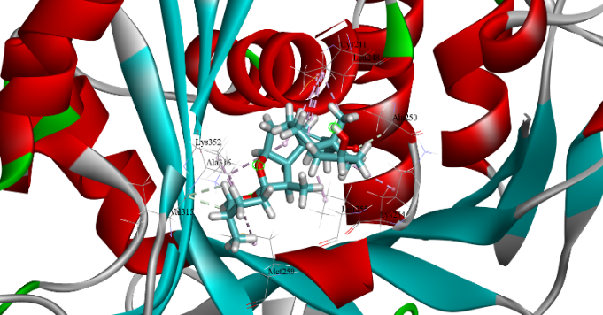 | 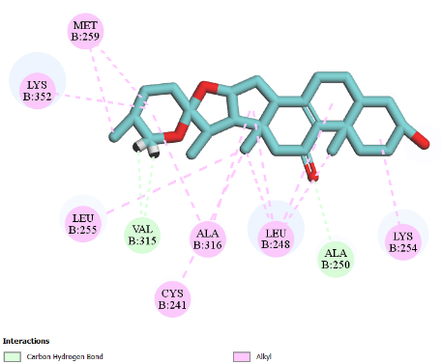
(a2)  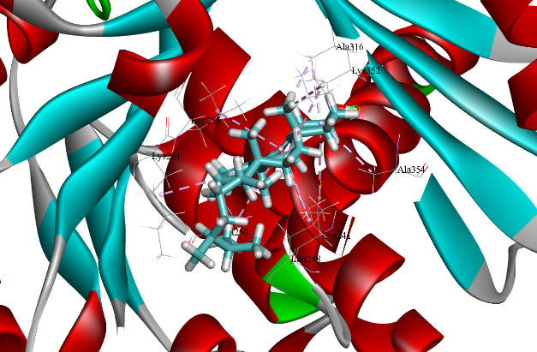 | 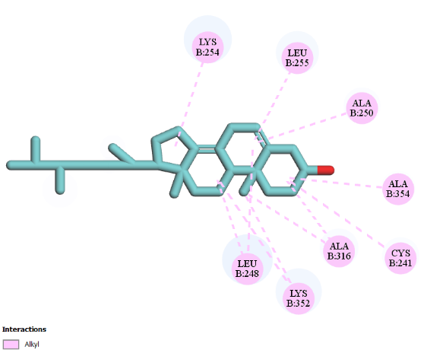
(a3)  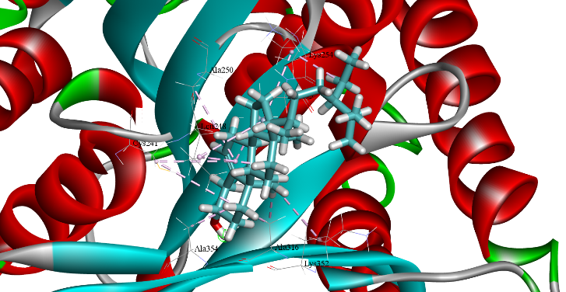 | 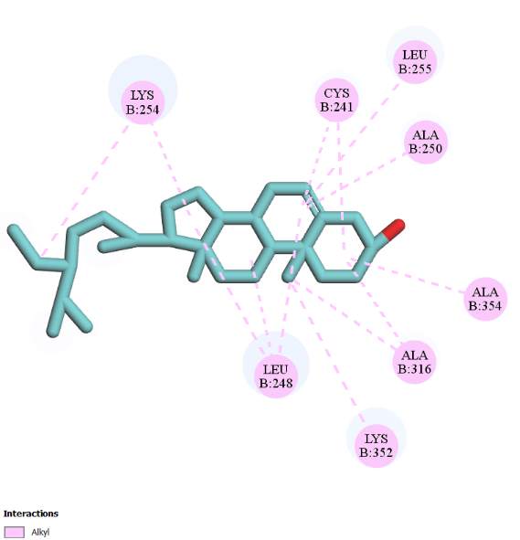
(a4)  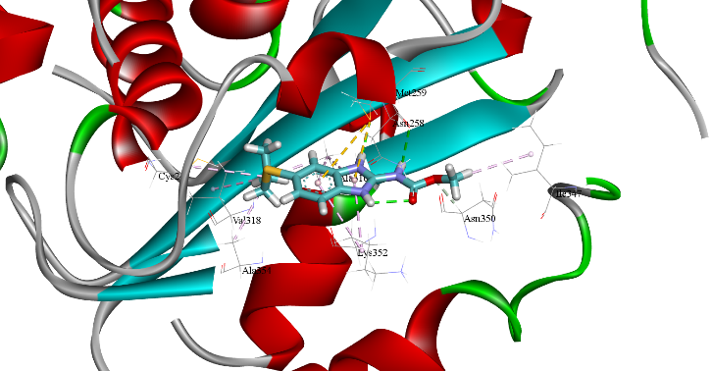 | 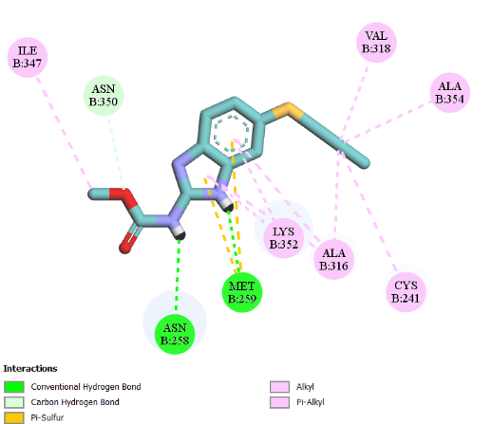

FIGURE 2. Molecular docking interaction of compounds against Tubulin (PDB ID: 1SA0): (a1) Spirost-8-en-11-one, 3-hydroxy-, (3.beta.,5.alpha); (a2) Ergost-5,8(14)-dien-3-ol; (a3) beta .- Sitosterol; (a4) Albendazole (Standard)
3.3. Thrombolytic activity
The thrombolytic activity of marine sponge extract on blood clot lysis of human blood In vitro (mean± SEM). The clots were treated by different concentrations of extract (20, 10, 5 and 2.5 mg/mL respectively). At the dose of 10 mg/mL, 5 mg/mL, 2.5 mg/mL sponge extract show moderate thrombolytic activity (P<0.05) with 43.03%, 20.63%, 23.03%, 11.18% clot lysis while the standard thrombolytic drug streptokinase (30000 I.U.) showed 71.26 % clot lysis. The extract induced significant (P< 0.001) clot lysis of human blood with 43.03% at 20 mg/mL compared to control (normal saline). All experimental data showed in Table 3 and Figure 3. In silico molecular docking and visualization are represented in Table 5 and Figure 4.
TABLE 3. % Blood Clot lysis Data of Marine Sponge Extract (MSE)
Treatment Group | n | % Blood clot lysis
0.9% NaCl Solution | 8 | 23.23 ± 3.93
Streptokinase (30,000, I.U) | 8 | 71.26 ± 12.36
MSE 20.0 mg/mL | 8 | 43.03 ± 14.30
MSE 10.0 mg/mL | 8 | 20.63 ± 2.43
MSE 5.0 mg/mL | 8 | 23.03 ± 4.79
MSE 2.5 mg/mL | 8 | 11.18 ± 3.69

FIGURE 3. Graphical comparison % Blood clot lysis data of marine sponge extract (MSE)

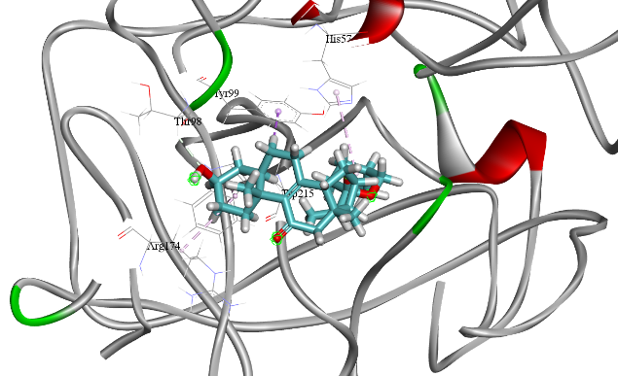  (a1) | 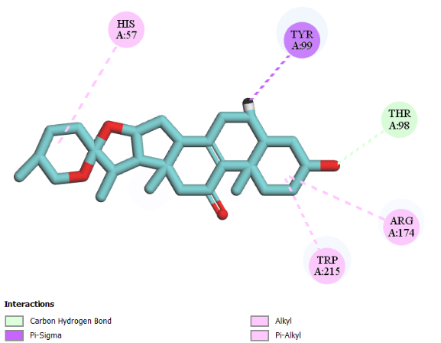
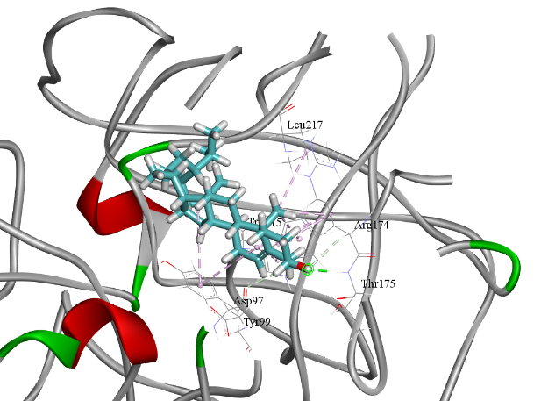  (a2) | 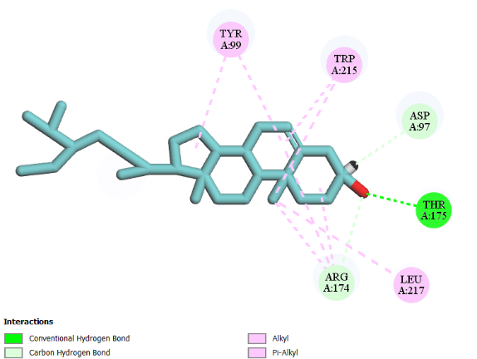
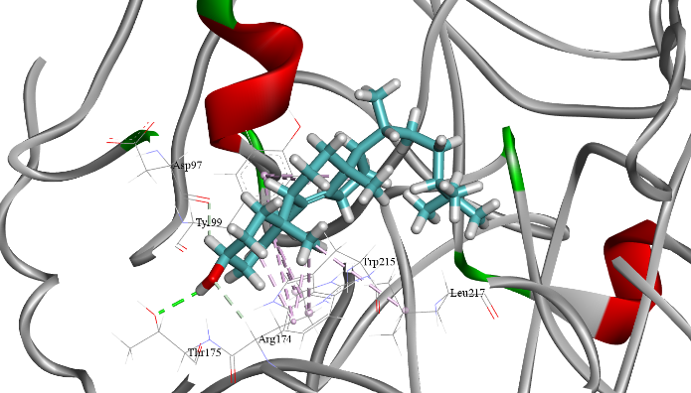  (a3) | 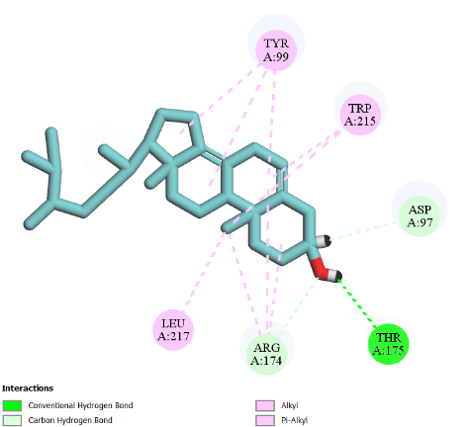
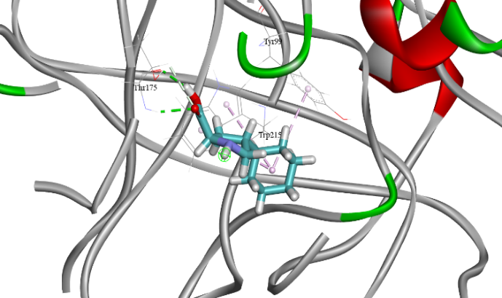  (a4) | 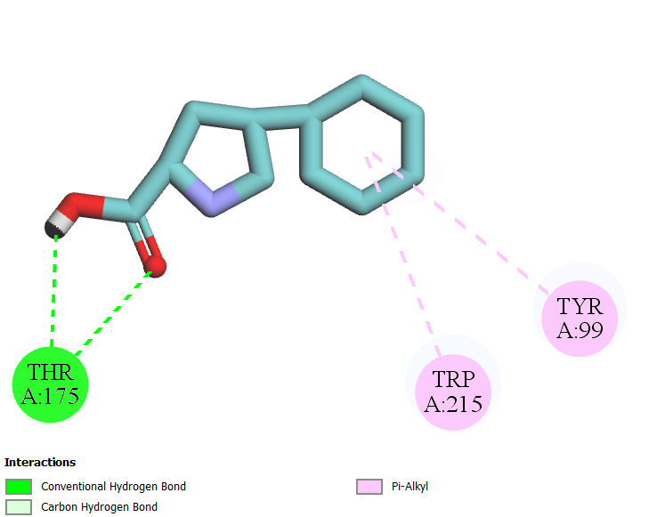
FIGURE 4. Molecular docking interaction of compounds against human two-chain tissue plasminogen activator (PDB ID: 1A5H): (a1) Spirost-8-en-11-one, 3-hydroxy-, (3.beta.,5.alpha); (a2) beta-Sitosterol; (a3) Ergost-5,8(14)-dien-3-ol; and (a4) Streptokinase (Standard).

3.4 Assessment of the anti-inflammatory potential: In vitro assays.
3.4.1 Protein denaturation assay
Marine sponge inhibited egg albumin denaturation in a dose-dependent manner, achieving 81.30% inhibition at 125 μg/mL. Its activity was comparable to Diclofenac sodium, which showed 82.83% inhibition at the same concentration (Figure 5). In silico molecular docking and visualization are represented in Table 5 and Figure 6.

FIGURE 5. Graphical comparison % inhibition of marine sponge extract (MSE) with standard.

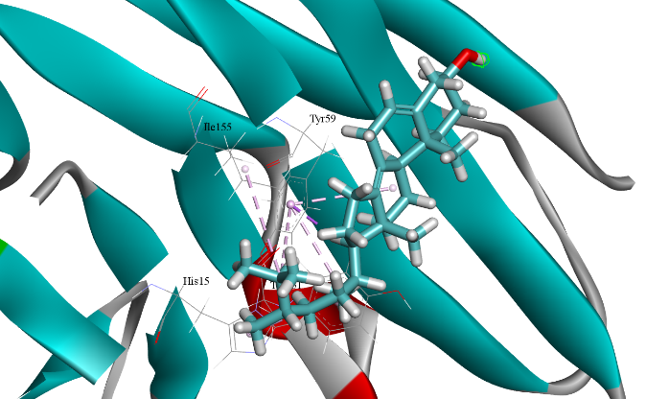  (a1) | 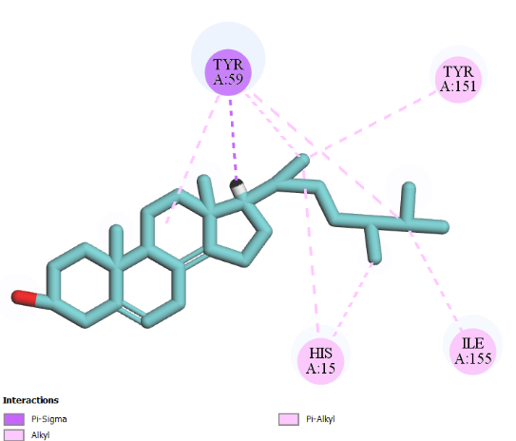
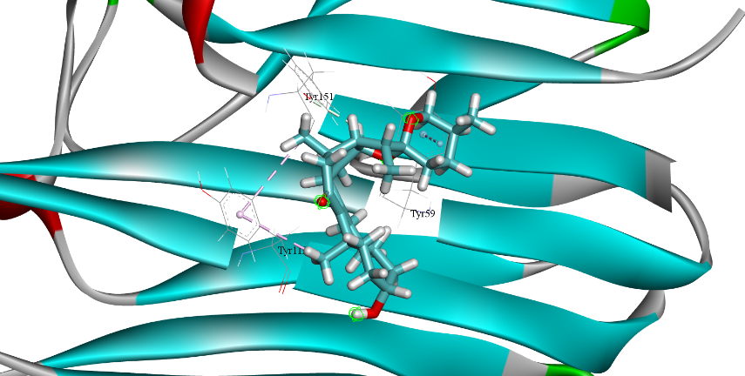  (a2) | 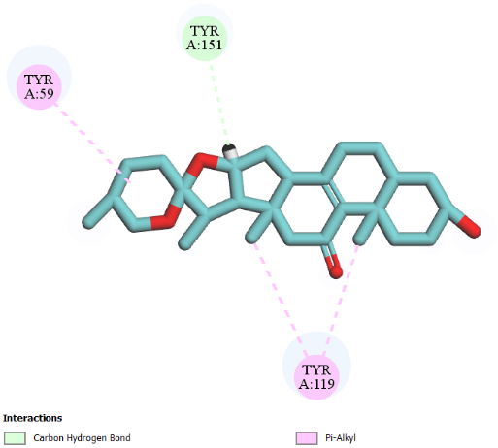
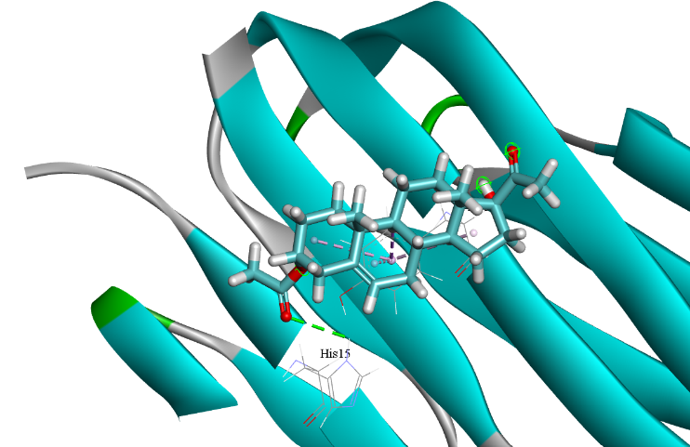  (a3) | 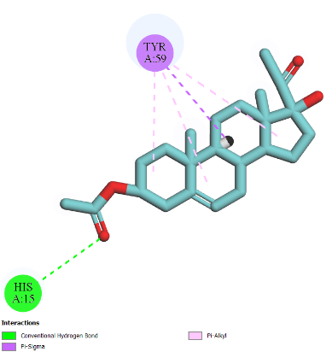
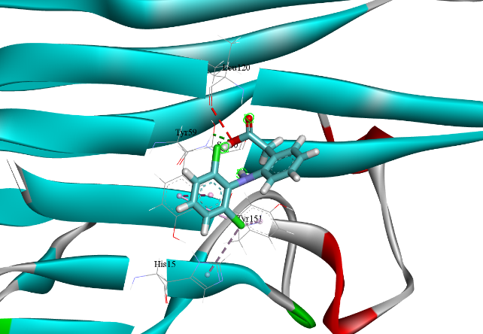  (a4) | 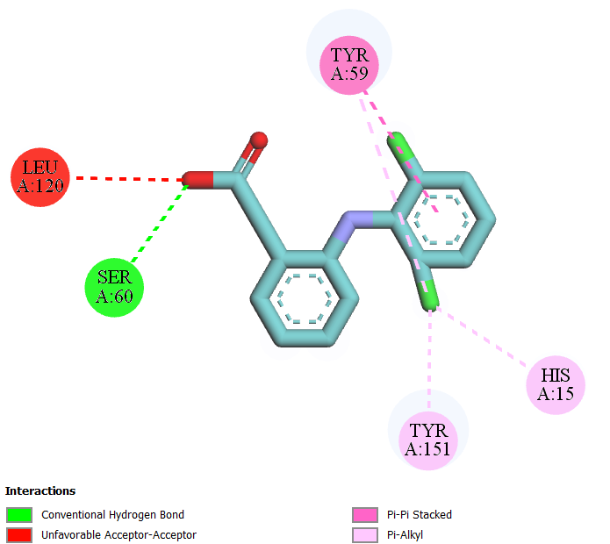
FIGURE 6. Molecular docking interaction of compounds against TNF-alpha (PDB ID: 2AZ5): (a1) Ergost-5,8(14)-dien-3-ol; (a2) Spirost-8-en-11-one, 3-hydroxy-, (3.beta.,5.alpha); (a3) Pregn-5-en-20-one, 3,17-dihydroxy-, 3-acetate; and (a4) Diclofenac (Standard).

3.5 Antipyretic activity
3.5.1 Brewer's yeast-induced pyrexia
Table 4 presents the effect of marine sponge extracts of T. dactyloidea on rectal temperature in mice. Subcutaneous administration of the yeast suspension significantly increased rectal temperature after 18 hours. However, treatment with the extract demonstrated significant antipyretic activity (P < 0.05; P < 0.001) compared to the control. In silico molecular docking and visualization are represented in Table 5 and Figure 7.
TABLE 4. Effect of the marine sponge extracts of T. dactyloidea on yeast-induced pyrexia in mice

Treatment | 0h | 18h | 19h | 20h | 21h | 22h
Control | 98.74 ± 0.43 | 98.62 ± 0.58 | 98.40 ± 0.32 | 98.46 ± 0.37 | 97.62 ± 0.41 | 98.84 ± 0.31
Paracetamol (Standard) | 98.52 ± 0.19 | 100.5 ± 0.40* | 100.10 ± 0.48** | 99.5 ± 0.36* | 98.90 ± 0.34* | 98.68 ± 0.55
Sponge 200 | 98.18 ± 0.11 | 100.62 ± 0.48* | 100.36 ± 0.17** | 100.24 ± 0.32** | 99.10 ± 0.34** | 98.42 ± 0.21
Sponge 400 | 98.26 ± 0.09 | 101.62 ± 0.58** | 100.70 ± 0.43*** | 100.14 ± 0.32** | 99.34 ± 0.16** | 98.70 ± 0.09

Note: Results are expressed as mean ± SEM (n = 5) and statistically analyzed using ANOVA followed by Dunnett’s comparison test. ***p < 0.001, **p < 0.01, & *p < 0.05 when compared with control (n = 5).
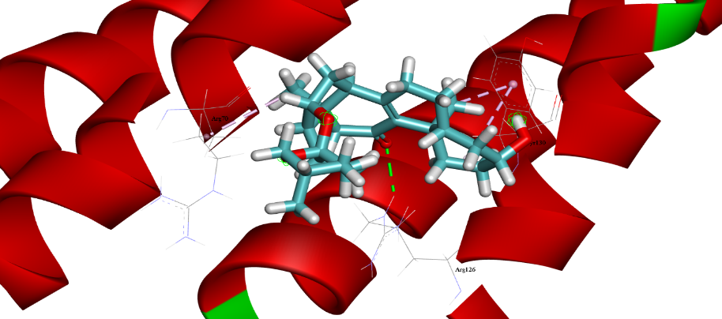  (a1) | 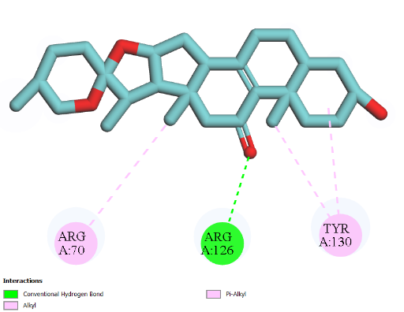
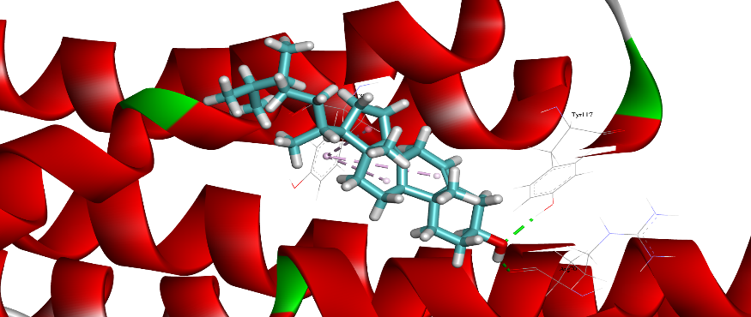  (a2) | 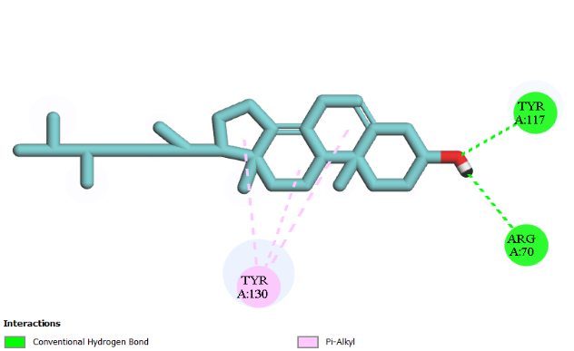
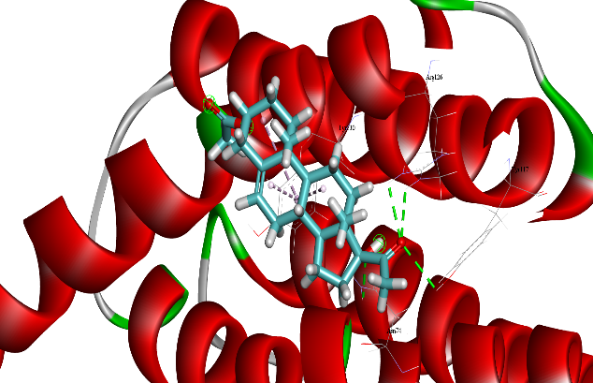  (a3) | 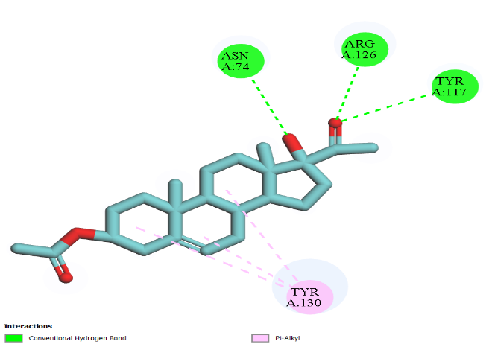
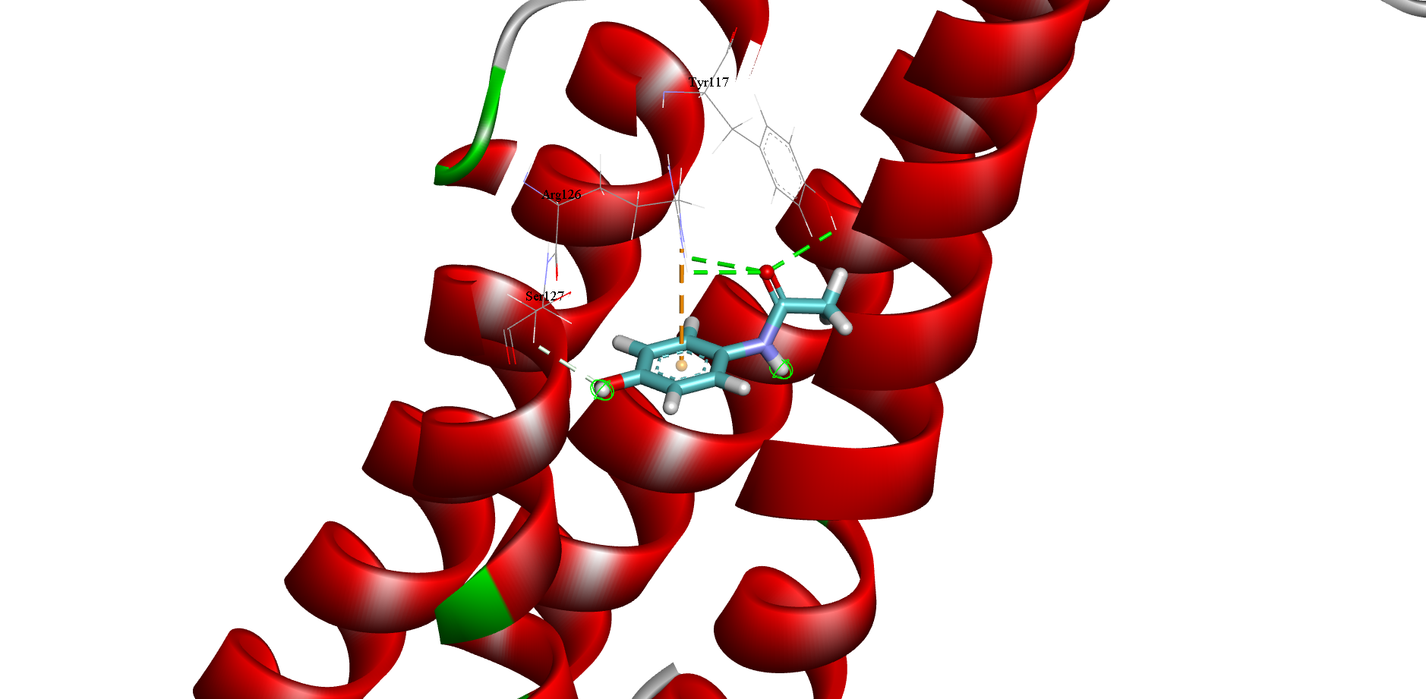  (a4) | 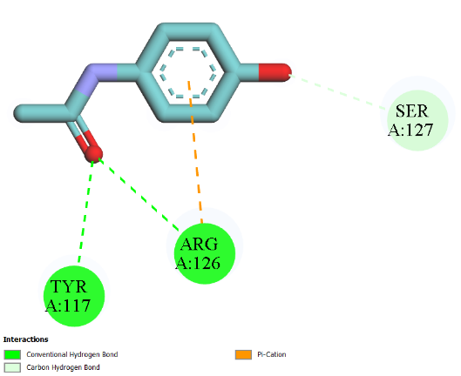
FIGURE 7. Molecular docking interaction of compounds against mPGES-1 (PDB ID: 4YK5): (a1) Spirost-8-en-11-one, 3-hydroxy-, (3.beta.,5.alpha.,14.beta.,20.beta.,22.beta.,25R)-; (a2) Ergost-5,8(14)-dien-3-ol; (a3) Pregn-5-en-20-one, 3,17-dihydroxy-, 3-acetate; and (a4) Paracetamol (Standard).

3.7. Molecular docking study
Compound name | PubChem ID | Binding Affinity
 |  | Anthelmintic activity (PDB ID: 1SA0) | Thrombolytic activity (PDB ID: 1A5H) | Anti-inflammatory activity (PDB ID: 2AZ5) | Antipyretic activity (PDB ID: 4YK5)
9-Octadecene, (E)- | 5364599 | -4.7 | -5.4 | -4.1 | -3.7
2,6-Dimethyl-6-nitro-2-hepten-4-one | 557916 | -4.8 | -5.1 | -4.4 | -4.8
Hexanoic acid, heptadecyl ester | 575857 | -4.6 | -5.5 | -3.6 | -3.5
[1,1'-Bicyclopropyl]-2-octanoic acid, 2'-hexyl-, methyl ester | 552098 | -5.6 | -6.6 | -4.5 | -3.9
1,37-Octatriacontadiene | 543714 | -5.6 | -4.6 | -3.3 | -2.9
(2R,3R,4aR,5S,8aS)-2-Hydroxy-4a,5-dimethyl-3-(prop-1-en-2-yl)octahydronaphthalen-1(2H)-one | 75953512 | -7.0 | -6.4 | -5.4 | -5.1
Ergost-5,8(14)-dien-3-ol | 22213470 | -7.5 | -7.7 | -6.8 | -5.7
Pregn-5-en-20-one, 3,17-dihydroxy-, 3-acetate | 18667388 | -7.4 | -7.5 | -6.5 | -5.6
.beta.-Sitosterol | 222284 | -7.5 | -7.9 | -6.5 | -5.5
Spirost-8-en-11-one, 3-hydroxy-, (3.beta.,5.alpha.,14.beta.,20.beta.,22.beta.,25R)- | 628694 | -7.9 | -8.9 | -6.8 | -6.2
Standard (Albendazole/Streptokinase/ Diclofenac/Paracetamol) | 2082/ 9815560/ 3033/1983 | -6.3 | -6.5 | -5.8 | -4.0
Table 5 provides a summarized overview of the molecular docking analysis of compounds from T. dactyloidea against four key drug target proteins. The top-ranking compound for each protein is illustrated in Figures 2, 4, 6, and 7.
TABLE 5. Molecular docking study of bioactive compounds from marine sponge extract of T. dactyloidea for anthelmintic, thrombolytic, anti-inflammatory, and antipyretic activities.

3.8 Assessment of pharmacokinetic profiles of sponge compounds: Pharmacokinetics results of GCMS scanned compounds are as Table 6.
TABLE 6. Assessment of pharmacokinetic profiles of sponge compounds
Compound name | Solubility | GI absorption | BBB permeability | P-gp substrate | CYP1A2 inhibitor | CYP2C19 inhibitor | CYP2C9 inhibitor | CYP2D6 inhibitor | CYP3A4 inhibitor | Log Kp (skin permeation) | PAINS | Synthetic accessibility | Total Clearance  (log ml/min/kg) | AMES Toxicity | Hepatotoxicity
9-octadecene, (E) |  |  |  |  |  |  |  |  |  |  |  |  | 1.983 | No | No
2,6-dimethyl-6-nitro-2-hepten-4-one | Soluble | High | Yes | No | No | No | No | No | No | -6.21 cm/s | 0 alert | 2.6 | 0.653 | No | No
Hexanoic acid, heptadecyl ester | Poorly soluble | Low | No | No | Yes | No | No | No | No | -1.15 cm/s | 0 alert | 3.4 | 2.064 | No | No
[1,1'-Bicyclopropyl]-2-octanoic acid, 2'-hexyl- | Poorly soluble | High | No | No | Yes | No | Yes | No | No | -2.57 cm/s | 0 alert | 3.95 | 1.436 | No | No
(2R,3R,4aR,5S,8aS)-2-hydroxy-4a,5-dimethyl | Soluble | High | Yes | No | No | No | No | No | No | -5.35 cm/s | 0 alert | 4.45 | 2.495 | No | No
Cholesterol | Poorly soluble | Low | No | No | No | No | Yes | No | No | -2.47 cm/s | 0 alert | 5.98 | 1.19 | No | No
Ergost-5,8(14)-dien-3-ol | Poorly soluble | Low | No | No | No | No | No | No | No | -3.29 cm/s | 0 alert | 6.06 | 0.577 | No | No
Pregn-5-en-20-one,3,17-dihydroxy-,3-acetate | Moderately soluble | High | Yes | No | No | No | No | No | No | -6.11 cm/s | 0 alert | 5.18 | 0.623 | No | No
beta-Sitosterol | Poorly soluble | Low | No | No | No | No | No | No | No | -2.20 cm/s | 0 alert | 6.3 | 0.628 | No | No
Spirost-8-en-11-one,3-hydroxy-, (3 beta,5 alpha) | Moderately soluble | High | Yes | No | No | No | No | No | No | -5.94 cm/s | 0 alert | 6.7 | 0.256 | No | No

3.9 PASS prediction of GCMS scanned compound: PASS prediction results are presented in Table 7.
TABLE 7. PASS prediction of GCMS scanned compound
Compounds | Biological Activity
 | Antioxidant |  | Antidiabetic |  | Antibacterial |  | Anthelmintic |  | Thrombolytic |  | Antiarthritic
 | Pa | Pi | Pa | Pi | Pa | Pi | Pa | Pi | Pa | Pi | Pa | Pi
2,6-dimethyl-6-nitro-2-hepten-4-one | 0.285 | 0.026 | 0.249 | 0.076 | 0.378 | 0.036 | 0.292 | 0,059 | 0,230 | 0,039 | - | -
Hexanoic acid, heptadecyl ester | 0.210 | 0.050 | 0.190 | 0.177 | 0.168 | 0.034 | 0.483 | 0,017 | 0,258 | 0,021 | - | -
[1,1'-Bicyclopropyl]-2-octanoic acid, 2'-hexyl- | 0.140 | 0.115 | 0.144 | 0.062 | 0.218 | 0.103 | 0.203 | 0,096 | 0,273 | 0,016 | - | -
(2R,3R,4aR,5S,8aS)-2-hydroxy-4a,5-dimethyl | 0.162 | 0.088 | - | - | 0.455 | 0.021 | 0.264 | 0,069 | - | - | - | -
Cholesterol | 0.198 | 0.056 | 0.131 | 0.092 | 0.267 | 0.074 | - | - | 0,166 | 0,124 | - | -
Ergost-5,8(14)-dien-3-ol | 0.174 | 0.075 | - | - | 0.184 | 0.133 | - | - | - | - | - | -
Pregn-5-en-20-one,3,17-dihydroxy-,3-acetate | 0.203 | 0.053 | 0.138 | 0.075 | 0.202 | 0.115 | - | - | - | - | - | 0,342
Beta-Sitosterol | 0.178 | 0.072 | - | - | 0.283 | 0.066 | - | - | - | - | - | 0,241
Spirost-8-en-11-one,3-hydroxy-, (3 beta,5 alpha) | 0.244 | 0.038 | - | - | 0.442 | 0.023 | 0.202 | 0,096 | - | - | - | 0,411

3.10 Assessment of drug likeness characteristics of sponge compounds
TABLE 8. Assessment of drug likeness characteristics of sponge compounds
Compound name | Molecular weight | No. H-bond acceptors | No. H-bond donors | Log P_{o/w} | No. of rotatable bonds | TPSA | Lipinski rule of five | Veber rule
2,6-dimethyl-6-nitro-2-hepten-4-one | 185.22 g/mol | 3 | 0 | 1.25 | 4 | 62.89 Å² | Yes | Yes
Hexanoic acid, heptadecyl ester | 354.61 g/mol | 2 | 0 | 7.74 | 21 | 26.30 Å² | Yes | No
[1,1'-Bicyclopropyl]-2-octanoic acid, 2'-hexyl- | 322.53 g/mol | 2 | 0 | 6.01 | 15 | 26.30 Å² | Yes | No
(2R,3R,4aR,5S,8aS)-2-hydroxy-4a,5-dimethyl | 234.33 g/mol | 2 | 1 | 2.75 | 1 | 37.30 Å² | Yes | Yes
Cholesterol | 386.65 g/mol | 1 | 1 | 6.75 | 5 | 20.23 Å² | Yes | Yes
Ergost-5,8(14)-dien-3-ol | 398.66 g/mol | 1 | 1 | 6.74 | 5 | 20.23 Å² | Yes | Yes
Pregn-5-en-20-one,3,17-dihydroxy-,3-acetate | 374.51 g/mol | 4 | 1 | 3.65 | 3 | 63.60 Å² | Yes | Yes
beta-Sitosterol | 414.71 g/mol | 1 | 1 | 7.24 | 6 | 20.23 Å² | Yes | Yes
Spirost-8-en-11-one,3-hydroxy-, (3 beta,5 alpha) | 428.60 g/mol | 4 | 1 | 4.3 | 0 | 55.76 Å² | Yes | Yes

Note: Lipinski’s Rule of Five includes a guideline about log P, which refers to a compound’s lipophilicity (its ability to dissolve in fats versus water). According to the rule, a drug-like compound should have a log P value of 5 or less. This indicates that the compound is not excessively lipophilic, which helps ensure better water solubility and, in turn, improves its chances of being well absorbed when taken orally. A log P value higher than 5 may lead to poor absorption and limited effectiveness as an oral medication.
4 DISCUSSION
This research aimed to evaluate the potential bioactivity of Tetilla dactyloidea, a marine sponge, and its role in various biological activities. To achieve this, a phytochemical analysis was conducted to identify the presence of phytoconstituents in the crude sponge extract. Implementing phytochemical screening at the initial stages could accelerate the identification of potent phytochemicals, facilitating the development of novel pharmaceutical treatments (Nath et al., 2025). Additionally, it enables the quantitative determination and qualitative differentiation of pharmacologically relevant phytochemicals (Parivuguna, 2008). The initial results of this study on the marine sponge extract of Tetilla dactyloidea indicate that Tetilla dactyloidea contain bioactive compounds such as glycoside, flavonoids, Saponins, and Proteins and Amino acid (Table 1). These bioactive compounds offer a range of health benefits, including antioxidant, antimicrobial, anti-inflammatory, cancer-preventive, antidiabetic, and antihypertensive properties (Sangeetha & Vidhya, 2016). The medicinal properties of these substances are attributed to their phytochemicals and other chemical components. For instance, saponins exhibit hypotensive and cardiodepressive effects (Olaleye, 2007). Similarly, glycosides are naturally occurring drugs that are used in treating congestive heart failure and cardiac arrhythmias (Sangeetha & Vidhya, 2016).
The extract from the marine sponge T. dactyloidea demonstrated significant dose-dependent anthelmintic activity against Tubifex tubifex, comparable to the standard drug albendazole (Table 2, Figure 1). At the highest concentration tested (10 mg/mL), the mean paralysis and death times were 44.33 minutes and 79.1 minutes, respectively. In comparison, at the lowest concentration (5 mg/mL), the corresponding times were 77.00 minutes and 128.47 minutes. This clear dose–response relationship highlights a marked enhancement in efficacy with increasing extract concentration. Although the standard drug Albendazole exhibited greater potency—inducing paralysis and death at 20.00 and 49.00 minutes, respectively—the sponge extract at 10 mg/mL still showed considerable anthelmintic activity. These results indicate that T. dactyloidea may contain pharmacologically active constituents with notable anthelmintic potential. This is supported by previous phytochemical reports identifying bioactive compounds in marine sponges—such as alkaloids, tannins, terpenoids, flavonoids, and phenolic compounds (Doughari, 2006; Salhan et al., 2011). Additionally, in silico molecular docking studies reinforced the experimental outcomes, showing strong binding affinities between sponge-derived compounds and helminthic protein targets (Table 5, Figure 2). These computational findings provide additional insight into the extract's potential mechanisms of action and further support its anthelmintic efficacy.
The primary cause of vascular obstruction in the systemic circulation is thrombus formation, which can sometimes result in patient fatality. Several thrombolytic drugs, including tissue plasminogen activator, streptokinase, and urokinase, are currently utilized to dissolve thrombi. However, these medications pose a risk of bleeding and adverse reactions due to their lack of specificity. As a result, extensive research is underway worldwide to develop newer and more targeted thrombolytic agents (Harun-Or-Rashid et al., 2023). The extract from the marine sponge T. dactyloidea demonstrated moderate thrombolytic activity compared to streptokinase but significantly higher than the control in a dose dependent manner (Table 3, Figure 3). The highest percentage of blood clot lysis is 43.03% suggesting thrombolytic activity. The identification of flavonoids in the T. dactyloidea marine sponge extract strengthens the evidence of its thrombolytic activity (Rashid et al., 2023).
This study employed the protein denaturation bioassay to evaluate the anti-inflammatory potential of the marine sponge Tetilla dactyloidea extract In vitro. Protein denaturation is a well-established factor in inflammatory and arthritic diseases, as it may lead to the production of autoantigens in certain conditions (Chandra et al., 2012b). Therefore, substances capable of preventing protein denaturation could be valuable in the development of anti-inflammatory drugs. Phytochemical analysis of marine sponge Tetilla dactyloidea extracts in this study confirmed the presence of diverse bioactive compounds (Sangeetha & Vidhya, 2016). Results indicated an increase in anti-inflammatory activity with higher concentrations (Figure 5), likely due to the presence of active compounds such as flavonoids (Sangeetha & Vidhya, 2016). With its promising bioactivity, Tetilla dactyloidea holds potential as a natural candidate for the development of anti-inflammatory agents, potentially providing a safer and more effective alternative to conventional synthetic drugs used in treating inflammatory disorders.
The induction of fever following subcutaneous brewer’s yeast injection is attributed to elevated prostaglandin synthesis, establishing it as a key In vivo assay for antipyretic evaluation (Muhammad et al., 2012; Rauf, Uddin, Latif, et al., 2014; Rauf, Uddin, Siddiqui, et al., 2014; Wan et al., 2013). The extract from the marine sponge T. dactyloidea demonstrated antipyretic activity in a dose dependent manner (Table 4). Pathogenic fever induced by yeast may result from prostaglandin production. The antipyretic effect, similar to paracetamol, is potentially linked to the inhibition of prostaglandin synthesis, which occurs by obstructing cyclooxygenase enzyme activity (Igbe et al., 2009; Moltz, 1993). It is commonly acknowledged that antipyretic agents work by inhibiting cyclooxygenase enzyme activity, ultimately leading to a decline in PGE2 levels within the hypothalamus (Vasundra & Divya, 2013). Hence, the fever-reducing effect of the marine sponge Tetilla dactyloidea extract might be likely attributed to the suppression of prostaglandin synthesis in the hypothalamus.
The integration of computer-aided drug design (CADD) has significantly contributed to the challenging process of identifying novel bioactive molecules. Notably, molecular docking is a prominent approach used to predict ligand-receptor interactions (Ali et al., 2024). Tubulin, human two-chain tissue plasminogen activator, TNF-alpha, and microsomal prostaglandin E synthase-1 (mPGES-1) receptor were identified as drug targets to evaluate anthelmintic, thrombolytic, anti-inflammatory, and antipyretic activities. Inhibitors that interfere with tubulin polymerization into microtubules have consistently demonstrated anthelmintic effects (Fennell et al., 2008).
The compound Spirost-8-en-11-one, 3-hydroxy-, (3.beta.,5.alpha.,14.beta.,20.beta.,22.beta.,25R)-, identified in the sponge extract of T. dactyloidea, exhibited a significant binding affinity of −7.9 kcal/mol, indicating its potential as an anthelmintic agent. Streptokinase is used in thrombosis treatment by activating plasminogen (Kunamneni et al., 2007). Compounds derived from the marine sponge T. dactyloidea demonstrated strong binding affinities to human two-chain tissue plasminogen activator, highlighting their potential thrombolytic properties. Molecular docking analysis revealed that compounds such as Spirost-8-en-11-one, 3-hydroxy-, (3.beta.,5.alpha.,14.beta.,20.beta.,22.beta.,25R)-, beta.-Sitosterol, and Ergost-5,8(14)-dien-3-ol, exhibited higher binding affinities than streptokinase (-6.5 kcal/mol). his suggests their potential as novel thrombolytic agents, contributing to the observed thrombolytic activity of T. dactyloidea extract. Additionally, as tumor necrosis factor-alpha (TNF-α) is a key mediator of inflammation, TNF-α antagonists may offer therapeutic benefits for inflammatory disorders (Esposito & Cuzzocrea, 2009). According to our molecular docking study, compounds like Spirost-8-en-11-one, 3-hydroxy-, (3.beta.,5.alpha.,14.beta.,20.beta.,22.beta.,25R)-, Ergost-5,8(14)-dien-3-ol, .beta.-Sitosterol, demonstrate a strong binding affinity to TNF-alpha, which may help alleviate inflammation and exert anti-inflammatory effects. As a central mediator of immune-induced fever, mPGES-1 represents an important target for the treatment of fever (Engblom et al., 2003). According to our molecular docking analysis, compounds such as Spirost-8-en-11-one, 3-hydroxy-, (3.beta.,5.alpha.,14.beta.,20.beta.,22.beta.,25R)-, Ergost-5,8(14)-dien-3-ol, Pregn-5-en-20-one, 3,17-dihydroxy-, 3-acetate, show strong binding interactions with mPGES-1, indicating their potential for fever reduction and antipyretic effects. Besides molecular docking studies, ADME/T analysis is a crucial method for predicting the pharmacokinetic as well as toxicity profiles of bioactivemolecules. The ADMET evaluation of the ten identified bioactive molecules showed that all compounds possessed a safe toxicity profile.

5 CONCLUSION
In conclusion, the marine sponge extract of T. dactyloidea exhibited significant anthelmintic, thrombolytic, anti-inflammatory, and antipyretic properties. Furthermore, several identified compounds showed strong binding affinities to drug target proteins, aligning with In vitro and In vivo findings. However, unidentified molecules might also contribute to these effects. Despite these uncertainties, the study highlights the therapeutic potential of T. dactyloidea and provides a foundation for further exploration. Therefore, additional experimental validation is necessary to clarify its mechanism of action and assess its safety profile.
Highlights:
- The extract possessed anthelmintic potential in a dose-dependent manner.
- Inhibiting protein denaturation, the extract exhibits promising anti-inflammatory effects.
- The In vivo study confirmed the extract’s ability to reduce fever.
- Molecular docking analysis reinforces the findings of In vivo and In vitro studies, further validating the pharmacological potential of the extract.
The ADME/T analysis verified the safety of the identified compounds, suggesting the extract’s suitability for safe pharmaceutical use.

ETHICS APPROVAL AND CONSENT TO PARTICIPATE
The human body was not involved in any testing. Instead, Swiss albino mice and rats were used for the in vivo experiments, conducted in compliance with the guidelines of the Faculty of Biological Science's Animal Ethics Review Board (Reference No. CMC/MATS/2022/011).
DECLARATION OF GENERATIVE AI AND AI-ASSISTED TECHNOLOGIES IN THE WRITING PROCESS
Throughout the process of writing this article, AI or AI-assisted tools were solely employed for grammar correction and sentence simplification. The authors have thoroughly reviewed and revised the content, taking full responsibility for its quality and precision.
DATA AVAILABILITY
Data will be made available on request.
REFERENCES
Ali, M. L., Meem, J. N., Hoque, N., Jalil, M. A., Chowdhury, S. H., Khastagir, S., Rashed, M., Hoque, F., Alarfaj, A. A., & Ansari, M. J. (2024). GC‐MS Analysis, Neuropharmacological and Antidiarrheal Activities of the Acetone Extract of Najas gracillima Seaweed: In Vivo and In Silico Study. Chemistry & Biodiversity, e202402303.
Anjum, K., Abbas, S. Q., Shah, S. A. A., Akhter, N., Batool, S., & ul Hassan, S. S. (2016). Marine sponges as a drug treasure. Biomolecules & Therapeutics, 24(4), 347.
Barzkar, N., Sukhikh, S., & Babich, O. (2024). A comprehensive review of marine sponge metabolites, with emphasis on Neopetrosia sp. International Journal of Biological Macromolecules, 135823.
Chandra, S., Chatterjee, P., Dey, P., & Bhattacharya, S. (2012a). Evaluation of in vitro anti-inflammatory activity of coffee against the denaturation of protein. Asian Pacific Journal of Tropical Biomedicine, 2(1), S178–S180. https://doi.org/10.1016/S2221-1691(12)60154-3
Chandra, S., Chatterjee, P., Dey, P., & Bhattacharya, S. (2012b). Evaluation of in vitro anti-inflammatory activity of coffee against the denaturation of protein. Asian Pacific Journal of Tropical Biomedicine, 2(1), S178–S180.
Chen, L., Deng, H., Cui, H., Fang, J., Zuo, Z., Deng, J., Li, Y., Wang, X., & Zhao, L. (2017). Inflammatory responses and inflammation-associated diseases in organs. Oncotarget, 9(6), 7204.
Chen, X., Li, H., Tian, L., Li, Q., Luo, J., & Zhang, Y. (2020). Analysis of the physicochemical properties of acaricides based on Lipinski’s rule of five. Journal of Computational Biology, 27(9), 1397–1406.
Daina, A., Michielin, O., & Zoete, V. (2017). SwissADME: a free web tool to evaluate pharmacokinetics, drug-likeness and medicinal chemistry friendliness of small molecules. Scientific Reports, 7(1), 42717.
Dallakyan, S., & Olson, A. J. (2015). Small-molecule library screening by docking with PyRx. Chemical Biology: Methods and Protocols, 243–250.
Doughari, J. H. (2006). Antimicrobial activity of Tamarindus indica Linn. Tropical Journal of Pharmaceutical Research, 5(2), 597–603.
Eberhardt, J., Santos-Martins, D., Tillack, A. F., & Forli, S. (2021). AutoDock Vina 1.2. 0: New docking methods, expanded force field, and python bindings. Journal of Chemical Information and Modeling, 61(8), 3891–3898.
Emon, N. U., Alam, S., Rudra, S., Riya, S. R., Paul, A., Hossen, S. M. M., Kulsum, U., & Ganguly, A. (2021). Antidepressant, anxiolytic, antipyretic, and thrombolytic profiling of methanol extract of the aerial part of Piper nigrum: In vivo, in vitro, and in silico approaches. Food Science & Nutrition, 9(2), 833–846.
Emon, N. U., Jahan, I., & Sayeed, M. A. (2020). Investigation of antinociceptive, anti-inflammatory and thrombolytic activity of Caesalpinia digyna (Rottl.) leaves by experimental and computational approaches. Advances in Traditional Medicine, 20, 451–459.
Engblom, D., Saha, S., Engström, L., Westman, M., Audoly, L. P., Jakobsson, P.-J., & Blomqvist, A. (2003). Microsomal prostaglandin E synthase-1 is the central switch during immune-induced pyresis. Nature Neuroscience, 6(11), 1137–1138.
Esposito, E., & Cuzzocrea, S. (2009). TNF-alpha as a therapeutic target in inflammatory diseases, ischemia-reperfusion injury and trauma. Current Medicinal Chemistry, 16(24), 3152–3167.
Fathima, S. N., Ahmad, S. V., & Kumar, B. R. (2015). Evaluation of in vitro thrombolytic activity of ethanolic extract of Curcuma caesia rhizomes. International Journal of Pharma Research & Review, 4(11), 50–54.
Fennell, B. J., Naughton, J. A., Barlow, J., Brennan, G., Fairweather, I., Hoey, E., McFerran, N., Trudgett, A., & Bell, A. (2008). Microtubules as antiparasitic drug targets. Expert Opinion on Drug Discovery, 3(5), 501–518.
Guex, N., & Peitsch, M. C. (1997). SWISS‐MODEL and the Swiss‐Pdb Viewer: an environment for comparative protein modeling. Electrophoresis, 18(15), 2714–2723.
Gunarti, N. S., Alkandahri, M. Y., Wahyuningsih, E. S., Agustina, P., Mursal, I. L. P., Hidayah, H., & Nurviana, V. (2024). Evaluation of Antipyretic and Antioxidant Activities of Ten Indigenous Medicinal Plants of Tirtajaya, Karawang Regency, West Java, Indonesia. Indian Journal of Pharmaceutical Education and Research, 59(1), 252–263.
Harun-Or-Rashid, M., Akter, S., Habiba, U., Laboni, F. R., Uddin, J., Labu, Z. K., Mim, F., & Reza, M. S. (2023). Antioxidant, antibacterial, cytotoxic and thrombolytic activities of flowers of Mirabilis jalapa L: possible role of phenolics and flavonoids. Journal of Agriculture and Food Research, 14, 100893.
He, M. M., Smith, A. S., Oslob, J. D., Flanagan, W. M., Braisted, A. C., Whitty, A., Cancilla, M. T., Wang, J., Lugovskoy, A. A., & Yoburn, J. C. (2005). Small-molecule inhibition of TNF-α. Science, 310(5750), 1022–1025.
Hossain, H., Shahid-Ud-Daula, A. F. M., Hasan, K., Mansur, A. A., & Haq, M. M. (2012). Anti-inflammatory activity, total flavonoids and tannins content from the ethanolic extract of Spilanthes paniculata leaf growing in Bangladesh. Int J Pharm, 2(2), 271–277.
Igbe, I., Ozolua, R. I., Okpo, S. O., & Obasuyi, O. (2009). Antipyretic and analgesic effects of the aqueous extract of the fruit pulp of Hunteria umbellata K Schum (Apocynaceae). Tropical Journal of Pharmaceutical Research, 8(4).
Kiran, G. S., Sekar, S., Ramasamy, P., Thinesh, T., Hassan, S., Lipton, A. N., Ninawe, A. S., & Selvin, J. (2018). Marine sponge microbial association: Towards disclosing unique symbiotic interactions. Marine Environmental Research, 140, 169–179.
Kunamneni, A., Abdelghani, T. T. A., & Ellaiah, P. (2007). Streptokinase—the drug of choice for thrombolytic therapy. Journal of Thrombosis and Thrombolysis, 23, 9–23.
Labu, Z. K., Karim, S., Rahman, M. T., Hossain, M. I., Arifuzzaman, S., & Shakil, M. (2025). Assessment of phytochemical screening, antibacterial, analgesic, and antipyretic potentials of Litsea glutinosa (L.) leaves extracts in a mice model. PloS One, 20(1), e0309857.
Luz, J. G., Antonysamy, S., Kuklish, S. L., Condon, B., Lee, M. R., Allison, D., Yu, X.-P., Chandrasekhar, S., Backer, R., & Zhang, A. (2015). Crystal structures of mPGES-1 inhibitor complexes form a basis for the rational design of potent analgesic and anti-inflammatory therapeutics. Journal of Medicinal Chemistry, 58(11), 4727–4737.
Mizushima, Y., & Kobayashi, Mjj. (1968). Interaction of anti-inflammatory drugs with serum proteins, especially with some biologically active proteins. Journal of Pharmacy and Pharmacology, 20(3), 169–173.
Moltz, H. (1993). Fever: causes and consequences. Neuroscience & Biobehavioral Reviews, 17(3), 237–269.
Muhammad, N., Saeed, M., & Khan, H. (2012). Antipyretic, analgesic and anti-inflammatory activity of Viola betonicifolia whole plant. BMC Complementary and Alternative Medicine, 12, 1–8.
Nath, A. K., Alam, S. S., Ara, J., Chowdhury, M. M., Nisat, U. T., Uddin, M. J., Chowdhury, M. T., Khan, S., & Dutta, M. (2025). Evaluation of In Vitro and In Vivo Pharmacological Activity of Elatostema sessile With In Silico Approaches. Food Science & Nutrition, 13(3), e70052.
Niazi, S. K., & Mariam, Z. (2023). Computer-aided drug design and drug discovery: a prospective analysis. Pharmaceuticals, 17(1), 22.
Nurhayati, A. P. D., Pratiwi, R., Wahyuono, S., Istriyati, I., & de Voogt, N. J. (2015). The anticancer activity of marine sponge cinachyrella sp.(Family Tetillidae). IPTEK The Journal for Technology and Science, 25(3).
O’Boyle, N. M., Banck, M., James, C. A., Morley, C., Vandermeersch, T., & Hutchison, G. R. (2011). Open Babel: An open chemical toolbox. Journal of Cheminformatics, 3, 1–14.
Olaleye, M. T. (2007). Cytotoxicity and antibacterial activity of methanolic extract of Hibiscus sabdariffa. Journal of Medicinal Plants Research, 1(1), 9–13.
Pang, X., Lin, X., Wang, J., Liang, R., Tian, Y., Salendra, L., Luo, X., Zhou, X., Yang, B., & Tu, Z. (2018). Three new highly oxygenated sterols and one new dihydroisocoumarin from the marine sponge-derived fungus Cladosporium sp. SCSIO41007. Steroids, 129, 41–46.
Parivuguna, V. (2008). Antimicrobial Properties and Phytochemical Constituents of Rheo discolor Hance. Ethnobotanical Leaflets, 2008(1), 114.
Paul, A., Adnan, M., Majumder, M., Kar, N., Meem, M., Rahman, M. S., Rauniyar, A. K., Rahman, N., Chy, M. N. U., & Kabir, M. S. H. (2018). Anthelmintic activity of Piper sylvaticum Roxb.(family: Piperaceae): In vitro and in silico studies. Clinical Phytoscience, 4, 1–7.
Pires, D. E. V, Blundell, T. L., & Ascher, D. B. (2015). pkCSM: predicting small-molecule pharmacokinetic and toxicity properties using graph-based signatures. Journal of Medicinal Chemistry, 58(9), 4066–4072.
Prasad, S., Kashyap, R. S., Deopujari, J. Y., Purohit, H. J., Taori, G. M., & Daginawala, H. F. (2006). Development of an in vitro model to study clot lysis activity of thrombolytic drugs. Thrombosis Journal, 4, 1–4.
Ramzan, A., Tajammal, A., Khan, S. G., Batool, M., Verpoort, F., Khan, M. A., Munawar, M. A., & Basra, M. A. R. (2025). Synthesis, characterization and thrombolytic activity evaluation of novel pyrazolo [3, 4-b] pyridine-4-carbohydrazide derivatives. Journal of Molecular Structure, 1320, 139618.
Rashid, M. H.-O., Akter, M., Uddin, J., Islam, S., Rahman, M., Jahan, K., Sarker, M. M. R., & Sadik, G. (2023). Antioxidant, cytotoxic, antibacterial and thrombolytic activities of Centella asiatica L.: possible role of phenolics and flavonoids. Clinical Phytoscience, 9(1), 1–9.
Rauf, A., Uddin, G., Latif, A., & Muhammad, N. (2014). Pistagremic acid, a novel antimicrobial and antioxidant isolated from Pistacia integerrima. Chemistry of Natural Compounds, 50, 97–99.
Rauf, A., Uddin, G., Siddiqui, B. S., Muhammad, N., & Khan, H. (2014). Antipyretic and antinociceptive activity of Diospyros lotus L. in animals. Asian Pacific Journal of Tropical Biomedicine, 4, S382–S386.
Ravelli, R. B. G., Gigant, B., Curmi, P. A., Jourdain, I., Lachkar, S., Sobel, A., & Knossow, M. (2004). Insight into tubulin regulation from a complex with colchicine and a stathmin-like domain. Nature, 428(6979), 198–202.
Renatus, M., Bode, W., Huber, R., Stürzebecher, J., Prasa, D., Fischer, S., Kohnert, U., & Stubbs, M. T. (1997). Structural mapping of the active site specificity determinants of human tissue-type plasminogen activator: implications for the design of low molecular weight substrates and inhibitors. Journal of Biological Chemistry, 272(35), 21713–21719.
Risi, G., Liu, M., Vairoletti, F., Quinn, R. J., & Salinas, G. (2024). A Screening of 10,240 NatureBank Fractions Identifies Nematicidal Activity in Agelasine-Containing Extracts from Sponges. Journal of Natural Products, 87(6), 1532–1539.
Salhan, M., Kumar, B., Tiwari, P., Sharma, P., Sandhar, H. K., & Gautam, M. (2011). Comparative anthelmintic activity of aqueous and ethanolic leaf extracts of Clitoria ternatea. Int J Drug Dev Res, 3(1), 62–69.
Sangeetha, G., & Vidhya, R. (2016). In vitro anti-inflammatory activity of different parts of Pedalium murex (L.). Inflammation, 4(3), 31–36.
Saper, C. B., & Breder, C. D. (1994). The neurologic basis of fever. New England Journal of Medicine, 330(26), 1880–1886.
Shaikh, J. R., & Patil, M. (2020). Qualitative tests for preliminary phytochemical screening: An overview. International Journal of Chemical Studies, 8(2), 603–608.
Siddiqui, K. U., Islam, M. A., & Ahmed, Z. (2007). Encyclopedia of flora and fauna of Bangladesh. (No Title).
Studio, D. (2008). Discovery studio. Accelrys [2.1].
Tatiya, A. U., Saluja, A. K., Kalaskar, M. G., Surana, S. J., & Patil, P. H. (2017). Evaluation of analgesic and anti-inflammatory activity of Bridelia retusa (Spreng) bark. Journal of Traditional and Complementary Medicine, 7(4), 441–451.
Vasundra, D. P. A., & Divya, P. S. (2013). Antipyretic activity of ethanol and aqueous extract of root of Asparagus racemosus in yeast induced pyrexia. Asian Journal of Pharmaceutical and Clinical Research, 6(3), 190–193.
Wan, J., Gong, X., Jiang, R., Zhang, Z., & Zhang, L. (2013). Antipyretic and anti‐inflammatory effects of asiaticoside in lipopolysaccharide‐treated rat through up‐regulation of heme oxygenase‐1. Phytotherapy Research, 27(8), 1136–1142.
Woranam, K., Senawong, G., Utaiwat, S., Yunchalard, S., Sattayasai, J., & Senawong, T. (2020). Anti-inflammatory activity of the dietary supplement Houttuynia cordata fermentation product in RAW264. 7 cells and Wistar rats. PloS One, 15(3), e0230645.
Xue, Q., Liu, X., Russell, P., Li, J., Pan, W., Fu, J., & Zhang, A. (2022). Evaluation of the binding performance of flavonoids to estrogen receptor alpha by Autodock, Autodock Vina and Surflex-Dock. Ecotoxicology and Environmental Safety, 233, 113323.

