**Participatory approaches and local economic development in Cameroon**

***Abstract***

*The objective of this study is to analyze the effects of participatory approaches on local economic development in Cameroon using data from the Survey on the Capitalization of Acquis du PNDP (ECA-PNDP 2021) in 141 Cameroonian municipalities. The question is what is the effect of participatory approaches on local economic development in Cameroon? The controversies surrounding the subject and its mixed effect on the results of the different authors remain our theoretical basis. Given the censored nature of the dependent variable, the provision of basic infrastructure, we opted for the Tobit estimation method, developed by James Tobin in 1958. The results of this regression reveal that participatory approaches have a significant positive effect on the provision of basic infrastructure and, consequently, on local development. Our conclusions remain robust even when using alternative estimation methods. In order to maximize this positive impact, we recommend encouraging and supporting participatory organizations by stimulating their creation and effective operation. It is crucial to provide resources and training to build the capacities of community leaders and citizens in participatory processes. In addition, it is essential to promote transparency and accountability in local decision-making processes to strengthen citizen trust and engagement.*

**Keywords** : Participatory Approaches, Local Development; Participation Bodies

1. **Introduction**

Local development in Cameroon is hampered by several major challenges despite efforts to foster inclusiveness and sustainability. The persistent centralization of decisions, with only 15% of the national budget allocated to local governments in 2019, is a significant obstacle (World Bank, 2020). Regional disparities are marked, with a poverty rate of 77% in the Far North compared to 4% in Yaoundé (INS Cameroon, 2018). Local institutional capacities are limited, with only 30% of municipalities having a formalized development plan in 2020 (Ministry of Territorial Administration and Decentralization, 2020). Financing for local projects is insufficient, with state transfers representing only 5% of the total budget of local governments in 2020 (World Bank, 2020). Citizen participation is low, with only 25% of local projects having benefited from formal public consultation in 2018 (UNDP, 2018). In addition, road infrastructure and access to electricity remain unevenly developed between urban and rural areas (Ministry of Public Works, 2020). Overcoming these challenges requires an integrated approach that combines effective decentralization and enhanced participation. Participatory approaches and their role in local development have been the subject of intense and complex academic debate, spanning the disciplines of social sciences, community development, and public policy.

Studies on citizen participation in built environment development, although extensively explored, are still subject to debate. One of the main controversies concerns the place of citizens in the planning and implementation of development projects. According to Ambe (2010), critics of citizen participation (CP) point out that citizens' lack of planning expertise can make their involvement counterproductive, incurring additional costs and disrupting the normal functioning of planning institutions. Moses (1997a, 1997b) and Cleaver (1999), based on experiences in sub-Saharan Africa and southern India, show that communities often struggle to sustain participatory development projects due to insufficient material resources, thus highlighting the crucial role of aid agencies and the state after the implementation of the projects.

Rao and Ibanez (2001), using an example from Jamaica, demonstrate that participatory processes can strengthen the capacity of individuals to act collectively, but this impact is more pronounced among the most educated and well-connected individuals. Similarly, Ambe (2010) examines citizen participation in public infrastructure development in rural Cameroon and notes that, although rural councils play a crucial role as coordinating authorities, interference from national authorities and a lack of skilled labour limit the effectiveness of this participation.

However, Chambers (1984) and advocates of participatory approaches emphasize the potential of these approaches to transform social dynamics by valuing citizens' rights and influence in decision-making processes. Gaventa (2004) goes further, arguing that community participation is essential to promote participatory democracy and realize fundamental human rights. Similarly, Moynihan (2003) argues that participation improves public efficiency by optimizing the allocation of resources. It also helps to better identify and understand citizens' needs (Roberts, 2008), improves local planning and budgeting (Lu and Xue , 2011), and facilitates the implementation of decisions ( Gerston , 2002; Yang and Pandey , 2011). Citizen participation produces equity-based decisions and promotes inclusive development (Adams, Bell & Brown, 2002; Mohanty , 2010; Venugopal & Yilmaz, 2009). Katz and Sara (1997) note that in communities where residents can influence the implementation of infrastructure, the quality of services is often better.

However, these approaches have also attracted much criticism. Barber (1984), in " Strong Democracy ", warns of the risk that participatory processes are manipulated by elites to serve their interests, creating a form of "tyranny of the majority". Platteau and Abraham (2002) corroborate this perspective by showing how a local leader in sub-Saharan Africa diverted funds from an NGO for his own interests, despite his role as a representative of local communities. We can also cite the free-rider theory ( Olson , 1965) which illustrates the problem when individuals benefit from social infrastructure without contributing to it ( Ostrom , 1990). This behavior is exacerbated when citizens do not feel involved in the management of transferred skills, making them indifferent to local development projects ( Devas and Grant, 2003; Ngoran and Mougoue , 2021).

Thus, in the face of these controversies and the mixed effect of participatory approaches on local development, our question is "What is the real effect of participatory approaches on local development in Cameroon?" This study aims to analyze the effect of participatory approaches on local development in Cameroon. Given the censored nature of the dependent variable, the provision of basic infrastructure, we opted for the Tobit estimation method, developed by James Tobin in 1958 on data collected by the National Participatory Development Program (PNDP) from 141 municipalities, as part of its capitalization survey carried out in 2021.

The article is structured in five sections. After the first one devoted to the introduction, the second revisits the literature. The third section presents the methodological approach while the fourth focuses on the presentation and discussion of the results. Section five is devoted to the conclusion.

1. **Brief literature review**

The literature on the effects of participatory approaches on local development is abundant and reveals mixed effects. On the one hand, participatory approaches have demonstrated significant benefits in several aspects of local development. Ambe J. (2010) highlights the effectiveness of citizen participation in the field of infrastructure in Cameroon, despite government interference, by emphasizing that the contribution of citizens to projects that they perceive as their own strengthens their commitment. Subsequently, he will conclude at the end of his study that the willingness of citizens to contribute in kind or financially to any given self-help infrastructure project depends on the extent to which they perceive the project as truly theirs.

This article examines whether the use of participatory budgeting in Brazilian municipalities between 1990 and 2004 had an impact on the structure of municipal expenditures and living conditions. It shows that municipalities that used participatory budgeting promoted an allocation of public expenditures that closely matched popular preferences and devoted a greater share of their budgets to investments in sanitation and health services.

Similarly, Adesida and Okunlola (2015) on a sample of 144 respondents in Nigeria, show that involving community members in project management enhances their sense of ownership, which promotes sustainability. Explicitly they examined the effects of rural household participation on the sustainability of infrastructure developments in Ondo State. The results were analyzed using frequency counts, percentages, Likert scale and Pearson product moment correlation. Thus the study concludes that involving community members in the above areas has fostered sense of ownership among stakeholders and it has become a strong factor in project sustainability as they are more willing to ensure that the projects are adequately carried out and maintained. Similarly, Masiya and Yul (2019) concluded that close collaboration between local communities and municipal authorities during policy implementation can strengthen citizen-centred service delivery. Their qualitative study conducted in Nyanja, a township in Cape Town, involved 12 focus group discussions with community leaders and municipal officials from the water and related services sector.

In a study in Thailand, Nuntachart et al. (2008) demonstrate that stakeholder participation improves the quality of infrastructure, such as cycle paths. The example of Glasgow shows that even with low citizen participation, projects can evolve through data engagement for the improvement of public services ( Przeybilovic et al., 2022). Furthermore, community participation in initiatives such as Smart Solar Charging in Utrecht can align public and private interests to produce sustainable outcomes ( Przeybilovic et al., 2022).

One of the major contributions of participatory practice is the improvement of local governance and transparency. Mansuri and Rao (2013), in their analysis of participatory development programs in low-income countries, observed that these programs promote transparency and accountability in local governments. Their study, which covers hundreds of communities in South Asia, Africa, and Latin America, shows that populations with an active voice in local decisions perceive less corruption and more efficiency in the management of public resources ( Mansuri and Rao, 2013).

In the environmental field Bernadett Baiser et al (2021) qualitatively and transversally analyze the current forms and implications of citizen participation in nature-based solutions. Case studies conducted in 21 cities in light of support for broader sustainability. In their system of production researchers (Glaser and Strauss, 1967); The methodology used in this study is a comparative inter-case and cross-case analysis of citizen participation in 58 stakeholders on nature-based solutions in 21 cities. The results show that there is no correlation between the types of participation and that environmental sustainability sustainability at the social level is more remarkable there is a mobilization of knowledge through social learning and an increased sense of belonging and greater motivation for better environmental management.

In another context, Berkes (2007), in " Linking Social and Ecological Systems ", examines how participatory approaches to coastal natural resource management enhance social resilience. The study highlights that when local communities are actively involved in resource management decision-making, they develop more effective and adaptive governance mechanisms. These participatory processes foster better communication, increase mutual trust, and facilitate close collaboration among community members, thereby reducing conflicts over resource use. Aker et al. (2017) analyzed the effectiveness of participatory methods in resolving land conflicts in Liberia, using logistic regression models to assess the impact of community mediation and local leader engagement on the success of land dispute resolutions. Their results showed that participatory approaches significantly increase the likelihood of successful conflict resolution, particularly when community leaders are involved and mediation processes are used, contributing to sustainable and mutually acceptable resolutions.

Finally, older people's participation in community assets, as observed by Mugford et al. (2019), is associated with improved quality of life and reduced care costs. The authors estimate the effects of community asset participation on quality of life and care costs in a longitudinal cohort study of older people in England, specifically in the Salford area (a city in the north-west).

However, participatory approaches are not without challenges. Some work is less conclusive. White et al. (2018) shows that participatory processes can sometimes reinforce social inequalities, being dominated by local elites who marginalize vulnerable groups. Moreover, as Touchton , Sugiyama , and Wampler (2021) point out, implementing these approaches can be costly and complex, requiring substantial resources that are often lacking in low-development contexts. In Afghanistan, Beath , et al. (2015) reveal that the benefits of participatory projects may not be sustainable without ongoing support and strong local institutions. Heterogeneous communities may also face challenges in cooperation and project management, as observed by Bardhan and Daytosssn -Johnson (2002) in their studies of water management. Finally, Gugerty and Kremer (1999) note that the arrival of external funds in participatory projects can change community dynamics, often in favor of the more educated and affluent members, which can harm the fairness of the process. In sum, although citizen participation can improve the governance and sustainability of projects, it requires careful management to avoid the pitfalls of inequality and social exclusion.

1. **Empirical analysis**
   1. **Study data**

The data used come from secondary sources of the Survey on the Capitalization of Acquis du PNDP (ECA-PNDP) is an operation carried out from January 25 to February 14, 2021, through questionnaires administered in 141 Cameroonian municipalities. The objective of this survey was to evaluate the activities and achievements of the PNDP since its establishment. This investigation provides valuable information on the decentralization process, the construction of infrastructure, the improvement of the living conditions of the populations, as well as on the mechanisms for involving the population in local governance. The collection and processing of data were carried out in accordance with the procedures of the National Institute of Statistics (INS). The secondary data, for their part, were extracted from the PNDP archives, in particular from the 2020 Guichet Performance Report . This report presents an assessment of the municipalities on various criteria defined by the PNDP, aimed at measuring progress in terms of governance, budgetary management and the adoption of participatory planning practices. These criteria encourage healthy competition between municipalities through performance comparisons. However, the data available for this performance window cover the years 2017, 2018 and 2019. For the purposes of this study, we have retained the most recent information, namely that of the year 2019.

* + 1. **Dependent variable**

The main dependent variable of this study is local development, measured from the supply of basic infrastructure.

In Cameroon, basic infrastructure is developed in various sectors, such as education, health, water supply, electrification, trade facilitation and sanitation, among others. For each type of measure, a code of 1 is assigned if the infrastructure brings a significant change, and 0 otherwise.

In order to take into account this multidimensionality linked to the contribution of infrastructure to the development of communities and the improvement of the well-being of the population, we have constructed an indicator of infrastructure achievement at the municipal level, by aggregating the different types of infrastructure. Concretely, to obtain the community development variable, we added the total number of types of infrastructure available for each municipality and divided this total by 7. Thus, a municipality where the 7 types of infrastructure are present obtains a score of 1, which corresponds to the highest level of local development.

* + 1. **Variable of interest**

The variable of interest is the participatory approach, for this captured by the participation bodies at the municipal level. Several authors and institutions raise its importance for a more sustainable and inclusive development. Roberbs Chambers, a fervent defender of participatory practice, emphasizes the essential role of participatory approaches in improving the living conditions of African populations, because they give them the capacity to analyze and articulate their own needs as well as to participate in efforts to meet those of the communities benefiting from the project (Ambe, 2010). In Cameroon, there are several participation bodies at the municipal level: village assemblies; consultation committees, steering committees, COMES, complaint management mechanisms, citizen control of public action and many others. These organizations are coded 1 if they are functional and/or if local elected officials use them in their localities to involve the population in the management of municipal affairs, and 0 otherwise. As with the dependent variable, to obtain the participatory approach variable subtitled Approche_particip we will take the average of the different instances of participation to have an average.

* + 1. **Control variables**

Considering the influence that external variables play during scientific experiments, we integrate so-called control variables into our analysis. Considering the literature, we have chosen:

Number of villages per commune. The number of villages in a commune measures the extent of geographical dispersion of populations. A commune with a greater number of villages may face additional challenges in terms of resource management and infrastructure implementation.

Population involvement in the resource mobilization stage of local planning. This variable provides information on the participation of populations in the resource mobilization stage.

Proportion of projects completed with funding **requested by a partner** . This variable measures the proportion of infrastructure projects that were completed with the help of external partners (NGOs, donors, elites, etc.). External partnerships can provide additional resources, technical expertise and logistical support.

The variable assessment made of local planning in the establishment of coordination bodies. SS

Problems related to technical difficulties in the execution of contractors. This variable assesses problems encountered during the execution of infrastructure projects due to technical difficulties or poor performance of contractors. These difficulties may include delays, cost overruns, or poor quality of work.

* 1. **Model Specification**

Participatory approaches have become an essential component of local development. It is crucial to take into account the aspirations of the population in defining development objectives. Drawing on stakeholder theory ( Alkhafaji , 1989 ; Noto and Noto , 2019) and bottom-up approaches, the relationship between citizen participation and development can be modeled as follows:

$$DL=f\left(APP, NV, ITM, PP,PT\right)$$

$${DL}_{it}=α_{0}+α_{1}{APP}_{it}+α_{2}{NV}_{it}+α_{3}{ITM}_{it}++α_{4}{PP}_{it}+α_{5}{PT}_{it}+α 5AFi+tε_{it}$$

Or :

* ${DL}_{it}$ Represents the local development indicator;
* f is the function relating the local development to the different variables;
* ${APP}_{it}$ Refers to participatory approaches;
* ${NV}_{it}$ Corresponds to the number of villages per municipality;
* ${ITM}_{it}$ Refers to intervention in the resource mobilization stage;
* *AFit* is the assessment made of local planning in the establishment of participation bodies;
* ${PP}_{it}$ Indicates the proportion of projects carried out by partners;
* ${PT}_{it}$ Concerns issues related to technical difficulties in the execution of service providers.
* $ε_{it}$ The error term.

1. **Statistical analysis**

Table 1 below presents the descriptive statistics of the effect of participatory approaches on local development according to the literature according to different variables by presenting the number of observations, the mean, the standard deviation, the minimum and the maximum of each variable of the model in the different columns of the table. The characteristics of central tendency and dispersion of the different variables reveal the following information:

On average, out of the 141 municipalities studied, 65% of residents are satisfied with the infrastructure built in their localities as part of the promotion of local development. This satisfaction is captured by the variable "Local Development" which is a binary variable, indicating the presence or absence of satisfaction with an average value of 0.65.

##### Table 1: Descriptive statistics

|  |  |  |  |  |  |
| --- | --- | --- | --- | --- | --- |
| Variable | Obs | Mean | Std. Dev. | Min | Max |
| Local Development | 141 | 0.65 | 0.205 | 0 | 1 |
| Approach participate | 141 | 0.639 | 0.26 | 0 | 1 |
| Number of village | 129 | 80,527 | 265.177 | 3 | 3000 |
| Intervention_MR | 141 | 0.872 | 0.335 | 0 | 1 |
| Intervention_Follow-up | 141 | 0.057 | 0.232 | 0 | 1 |
| Appreciation_MPIC | 141 | 1,603 | 0.559 | 0 | 2 |
| Project_completed | 141 | 51,794 | 28,097 | 1 | 100 |
| Technical_problem | 141 | 0.39 | 0.49 | 0 | 1 |
|  |  |  |  |  |  |

Source: author from stata

## Correlation matrix

The following Table 2 summarizes the results of the correlation test between the variables. It is observed that there is a positive relationship between participatory approaches and the construction of infrastructure.

##### Table 2: Correlation matrix

|  |  |  |  |  |  |  |  |  |
| --- | --- | --- | --- | --- | --- | --- | --- | --- |
| Variables | (1) | (2) | (3) | (4) | (5) | (6) | (7) | (8) |
| (1) Local_development | 1,000 |
| (2) Participatory approach | 0.255 | 1,000 |
| (3) Village_number | -0.149 | 0.010 | 1,000 |
| (4) Intervention_MR | 0.233 | 0.245 | 0.048 | 1,000 |
| (5) Intervention_Follow-up | 0.239 | 0.191 | -0.032 | 0.082 | 1,000 |
| (6) Appreciation_MPIC | 0.242 | 0.175 | 0.061 | 0.121 | 0.114 | 1,000 |
| (7) Project_completed | 0.128 | -0.010 | -0.104 | 0.097 | -0.088 | -0.126 | 1,000 |
| (8) Technical_problem | 0.211 | 0.076 | -0.072 | -0.112 | 0.243 | -0.036 | -0.034 | 1,000 |

Source: Author

## Graphical illustration of correlations

This figure showing the relationship between participatory approaches and the provision of basic infrastructure which is a de facto measure of local development confirms the results of the correlation matrix. This graph shows a positive relationship between the approaches and the provision of basic infrastructure, hence the positive slope.

###### Chart 1: Scatter plot with trend

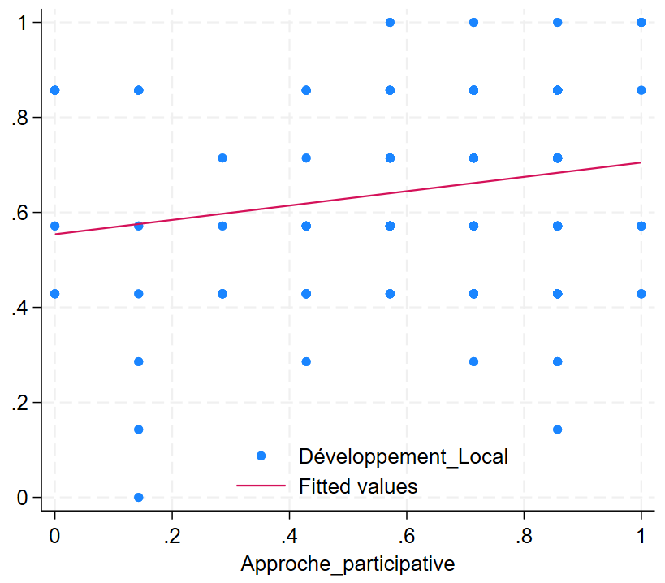

Source: Author

* 1. **Estimation technique**

The Tobit model, introduced by James Tobin in 1958, is an econometric technique designed to deal with censored data, lying halfway between linear regression models for fully observable continuous variables and models with categorical variables ( Wooldridge , 2002 ). Originally used to analyze consumer spending on durable goods, where values cannot be negative, this model is also known as a censored or truncated regression model. In a Tobit model, the dependent variable is continuous but observable only within a certain interval, unlike a censored model where all observations of the explanatory variables are available, even if the dependent variable is partially observable. Conversely, a truncated model excludes all observations of the explanatory variables and the dependent variable that do not fall within a certain interval. The Tobit model models the probability that observations fall within the lower or upper bounds of the defined interval, as well as the probability of values falling between these bounds. This allows data dynamics to be captured more accurately when data is naturally restricted to a certain range of values, providing a valuable tool for economic analysis and other areas where data censorship is common.

To illustrate this, let us imagine a latent random variable $Y_{it}^{*}$, which represents the true value of the observation without censoring. Standard Tobit regression then establishes a linear relationship on this latent scale, specified by the following equation:

$Y_{it}^{*}=β_{i}^{*}X_{it}^{'}+ε_{it}$ (2) $ε_{it}\sim \left(0, { δ}^{2}\right)$

Where denotes the municipality and t denotes the time is a vector of regression coefficients associated with the vector of covariates , which includes community participation and subsets of other covariates . Furthermore, it is assumed that we can only observe the realizations of for a given range s and that values ​​less than l or greater than u are censored at l and u, respectively. Therefore, the limited observed dependent variable is obtained as follows:

$$Y_{it}=\left\{\begin{aligned}1 for Y_{it}^{*}≤1 \\ Y_{it}^{*} for 1 <u \\ u for Y_{it}^{*} ≥u\end{aligned}\right.$$

When a dependent variable is limited on one side, only a lower or upper bound is needed to define censoring (Wang and Griswold , 2017). In this case, the probability associated with such a one-sided Tobit model can be expressed as:

* 1. **Smart PLS (Partial Least Squares Equation Modeling)**

Smart PLS (Partial Least Squares Structural Equation Modeling ) is a statistical tool designed for complex multivariate analyses , particularly useful for modeling latent variables, which are not directly observed but inferred from other variables. Developed by Christian Ringle , Sven Wende, and Jan-Michael Becker, Smart PLS offers robust features for path modeling, assessing the reliability and validity of the measurement model, and analyzing the explanatory power of the structural model. SmartPLS allows for in-depth assessment of measurement reliability and validity ( Fornell & Larcker , 1981), robust estimation of structural relationships, robust significance testing via bootstrapping ( Preacher & Hayes, 2008), and comparison of group differences (Henseler et al., 2009). By combining these various features, SmartPLS helps to strengthen the rigor and robustness of the conclusions drawn from PLS-SEM analyses, making them particularly suitable for exploratory contexts where theory is still developing (Kline, 2015). In addition, Smart-PLS allows the analysis of complex models with multiple latent variables, thus providing increased flexibility and analytical depth ( Ringle et al., 2012).

1. **Basic results**

In general, the overall significance of the model varies between 5% and 1%, so the model can be recommended for forecasting purposes. As for the econometric interpretation we have:

In the first column of Table 3, it is observed that participatory approaches have a positive and significant influence that varies from 5% to 10% on infrastructure supply. An increase of 5% to 10% of participatory approaches improves infrastructure supply by 0.151 to 0.125 respectively . This indicates that the engagement of local communities in decision-making processes has a significant positive effect on local development, particularly on the availability of basic infrastructure. Moreover, the chi-square test shows that the model is statistically significant at a confidence level of 5%. Mansuri and Rao (2013) found that involving communities in decision-making processes often leads to more effective and sustainable development outcomes. In practice, regularly organizing village assemblies and consultation committee meetings can enhance the positive impact on local development. Policies should encourage the training and empowerment of these participatory bodies so that they can play a more active and influential role in the development process. The work of Ika and Donnelly (2020), who also highlights the importance of community involvement for the success of development projects. Recent work corroborating these findings includes that of Mansuri and Rao (2012 **)** , who show that development projects that integrate community participation tend to have better results in terms of performance and sustainability. Cleaver (2001) , in his critical analysis, also highlights the importance of local dynamics and intervention management for sustainable impact.

In column 2, the integration of the variable " Number_village " reveals a negative coefficient and significant at 10%. This suggests that an increase in the number of villages per commune is associated with a slight negative impact on local development, probably due to the dispersion of resources and attention in areas with a high density of villages. In parallel, the coefficient of the participatory approach increases to 0.234, becoming even more significant at 1%. This means that the positive effect of participatory approaches through local authorities is reinforced when the number of villages is taken into account. Thus, these results suggest that the impact of participatory approaches is amplified in a context where the number of villages per commune is taken into consideration. In addition, the chi-square test confirms that the addition of this variable significantly improves the overall quality of the model (Table 3). Chattopadhyay and Duflo (2004) also showed in their study in India that municipalities with more dispersed villages may have higher infrastructure needs but also more difficulty in meeting them equitably.

Adding the intervention in local planning in the third column at the resource mobilization level ( Intervention_MR ) shows a positive and significant coefficient of 0.133 on local development at a 5% threshold. Although the effect of the participatory approach decreases slightly to 19.2%, it remains statistically significant at the 5% threshold, highlighting its continued importance for local development. This result highlights the crucial importance of integrating local communities from the early stages of resource mobilization of development projects, which can significantly improve the quality and success of initiatives. The introduction of this variable in planning significantly improves the overall quality of the model (Table 3). Smoke (2015) highlights the importance of support in resource mobilization for strengthening the financial capacity of local governments.

In column 4, the intervention in monitoring and evaluation ( Intervention_Monitoring-Evaluation ) presents a significant coefficient at 5% (0.157), which indicates that the continued involvement of communities in the monitoring and evaluation of PCD projects has a positive impact on local development. Although the coefficient of the participatory approach decreases to 0.161, it remains significant, highlighting that the effect of participatory approaches remains relevant even with the integration of this new variable. The model continues to improve with this addition (Table 3). The study S oransora , DT (2021) also found that the continued involvement of communities in these activities has a significant and positive effect on local development.

In the fifth column, the variable appreciation variable Apprécia_MPIC , representing the assessment made of local planning in the establishment of coordination bodies, has a positive and significant influence at 5% (0.069) on local development. The coefficient of the Participative_Approach decreases slightly to 0.138 with 10% significance but remains significant. The significance of the model improves even more (table 3).

The variable measuring the proportion of projects implemented in the case of funding requested by a development partner in column 6 shows a positive coefficient of 0.001 (significant at 10%), indicating a slightly positive effect. Although each additional project has a small marginal impact, it remains positive. Despite a slight decrease to 0.138 (significant at 10%) for Participatory_Approach , it remains significant. This suggests that engagement with development partners for funding is beneficial, but that the focus should be not only on the quantity of projects implemented but also on their quality and real impact (Table 3). Mohapatra and Mishra 's (2022) research indicates a slightly positive effect on project implementation of external financing on projects.

The addition of the variable Problem_C , representing the technical difficulties encountered during the implementation of PCDs by providers, shows a coefficient of 0.079 (significant at 5%). This suggests that these challenges can have a positive effect on local development, potentially stimulating innovative solutions or strengthening the resilience of providers. Although the Participative_Approach decreases slightly to 0.125 at a threshold of 10%, it remains significant, although less strong than before. This finding implies that development projects must anticipate and plan to overcome technical obstacles. Technical difficulties should be seen as opportunities for learning and improving practices (Table 3) which is contrary to the study of Flyvbjerg et al. (2003) who highlight technical problems and poor performance of providers as major causes of failure of infrastructure projects, often leading to delays and additional costs.

**Table 3** : Effect of participatory approaches on local development: estimation by Tobit

|  |  |  |  |  |  |  |  |
| --- | --- | --- | --- | --- | --- | --- | --- |
| VARIABLES | Local_Development | | | | | | |
| 1 | 2 | 3 | 4 | 5 | 6 | 7 |
| Participate_approach | 0.151** | 0.234*** | 0.192** | 0.161** | 0.138* | 0.138* | 0.125* |
|  | (0.065) | (0.077) | (0.077) | (0.077) | (0.076) | (0.076) | (0.074) |
| Village_number | | -0.000* | -0.000* | -0.000* | -0.000** | -0.000* | -0.000* |
|  |  | (0.000) | (0.000) | (0.000) | (0.000) | (0.000) | (0.000) |
| Intervention_MR | |  | 0.133** | 0.128** | 0.118** | 0.105* | 0.124** |
|  |  |  | (0.060) | (0.059) | (0.058) | (0.058) | (0.057) |
| Intervention_Monitoring-evaluation | | |  | 0.157** | 0.144** | 0.155** | 0.115* |
|  |  |  |  | (0.070) | (0.069) | (0.069) | (0.069) |
| Apprecia_MPIC | |  |  |  | 0.069** | 0.075** | 0.079*** |
|  |  |  |  |  | (0.030) | (0.030) | (0.029) |
| Project_realized_partner | |  |  |  |  | 0.001* | 0.001* |
|  |  |  |  |  |  | (0.001) | (0.001) |
| Problem_C |  |  |  |  |  |  | 0.079** |
|  |  |  |  |  |  |  | (0.033) |
| Constant | 0.554*** | 0.501*** | 0.409*** | 0.424*** | 0.339*** | 0.282*** | 0.236*** |
|  | (0.045) | (0.054) | (0.068) | (0.067) | (0.075) | (0.081) | (0.082) |
| var( e.Local_Development ) | 0.040*** | 0.038*** | 0.037*** | 0.036*** | 0.034*** | 0.033*** | 0.032*** |
|  | (0.005) | (0.005) | (0.005) | (0.004) | (0.004) | (0.004) | (0.004) |
| Observations | 141 | 129 | 129 | 129 | 129 | 129 | 129 |
| LR chi2(7) | 5.251 | 11.92 | 16.73 | 21.65 | 26.81 | 29.88 | 35.36 |
| Prob > chi2 | 0.0219 | 0.0026 | 0.0008 | 0.0002 | 0.0001 | 0.0000 | 0.0000 |

Source: Author; Standard errors in parentheses ; ***p<0.01, **p<0.05, *p<0.1

***Robustness by SMART-PLS***

**Figure 1: Simple representation of the model with smart pls**

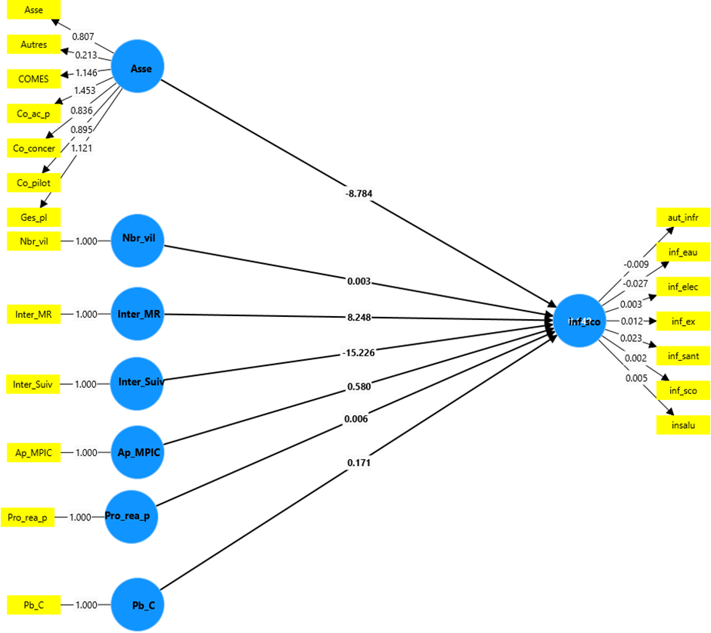

SmartPLS regression shows relationships between various latent variables and infrastructure. The Asse variable representing participatory approaches positively influences infrastructure supply, which is consistent with the results obtained previously. The Inter_Suiv variable has a negative influence (-15.226) on infrastructure supply , while Inter_MR has a positive influence (8.248). This suggests that follow-up interventions can have a significant negative impact, unlike MR interventions that significantly improve infrastructure. The other variables, Ap _ MPICet Pb_C , show moderate positive influences.

**Figure 2: Representation with transmission channels**

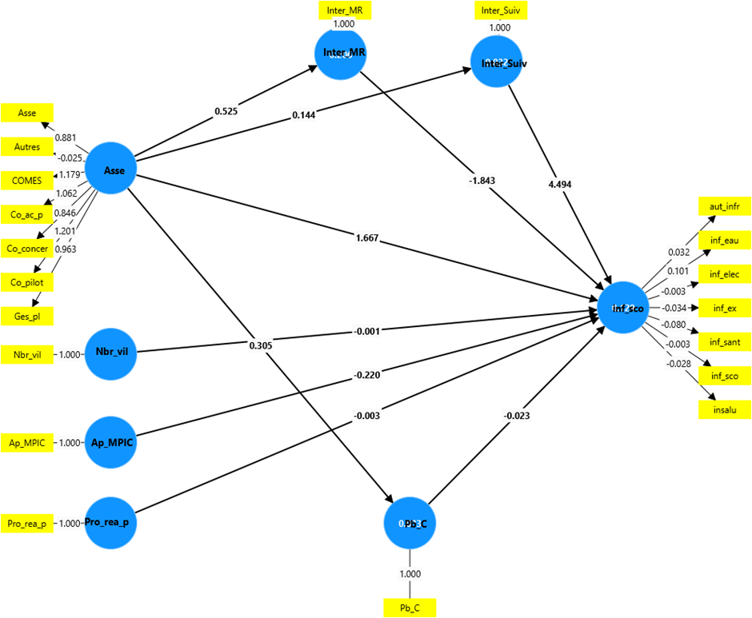

Author : made from smart PLS

The figure presented illustrates that participatory approaches have a positive influence on local development, which confirms the results of the regression made with the Tobit. We also observe the presence of three transmission channels: the first concerns the intervention in the mobilization of resources, which is not a good channel; the second concerns the technical difficulties of execution by the providers, which is also less effective by Compared with the previous channels, the intervention in monitoring and evaluation is a good channel through which participatory approaches can influence local development.

1. **Conclusion**

The objective of this was to analyze the effects of participatory approaches on local development. The methodology adopted for this purpose is based on a Tobit model applied to ECA-PNDP data (2021). At the end of the investigations, it clearly appears that participatory approaches, through its participatory bodies at the municipal level, are positively linked to local development. This finding underlines the crucial importance of strengthening these participatory bodies in our country, Cameroon, in order to enable populations benefiting from development initiatives to actively participate at all levels of decision-making. Increased citizen engagement in these participatory processes can not only promote better ownership of development projects, but also enrich local democracy by strengthening the transparency and legitimacy of decision-making processes. From an academic point of view, this study will help educate young people on the decentralization and local development diptych, and explore new avenues of research on the multiplier effects of local economic development.

Based on the results indicating a positive effect of participatory approaches on local development in the communes of Cameroon, we formulate the following practical economic policy recommendations:

**Strengthening citizen participation** : Establish formal mechanisms to encourage and support active and ongoing citizen participation in local decision-making. This can be done by adopting transparency and accountability policies, holding regular public consultations, and involving communities in the development and implementation of local development projects.

**Invest in capacity building for local actors** : Establish training and capacity building programs for local actors, including local elected officials, municipal officials, civil society organizations and citizens. This will improve their skills in planning, resource management and decision-making, and strengthen their ability to collaborate effectively to implement local development projects.

**Promote intersectoral collaboration and policy coordination** : Encourage collaboration between different government sectors involved in local development, such as education, health, agriculture and land use planning. Establish effective coordination mechanisms to ensure a coherent and integrated approach to local development, promoting the complementarity of sectoral policies and programmes.

**Promote economic diversification and local job creation** : Encourage the diversification of the local economy by supporting the development of various economic sectors, such as agriculture, crafts, tourism and services. Implement policies to promote local entrepreneurship, support small and medium-sized enterprises and create employment opportunities for young people and women in the municipalities.

As a limitation of our work, we could broaden our sample to all 360 communes and deepen the indicators of decentralization and local development in Cameroon.

**References**

Adesida , IE and Okunlola , JO (2015). Effects of community participation on sustainability of rural infrastructure in Ondo State, Nigeria. *Asian Journal of Agricultural Extension, Economics and Sociology* , *7* (1), 1-9.

French Development Agency (AFD). (2018). “Micro-Projects and Local Development: The Impact of PNDP in Cameroon.”

Amemiya , T. (1973). Regression analysis when the dependent variable is truncated normal. *Econometrica : Journal of the Econometric Society* , 997-1016.

Bank worldwide . (2004). "Participation in Development Projects: A Practical Guide for Effective Implementation.

Bank worldwide . (2014). “Participatory Planning in Cameroon: The Role of the PNDP.”

Becker, GS (1994). *Human Capital: A Theoretical and Empirical Analysis with Special Reference to Education* . University of Chicago Press.

Friedmann , J. (1992). *Empowerment: The politics of alternative development* . John Wiley & Sons.

Heckman, J. J. (1979). Sample selection bias as a specification error. *Econometrica : Journal of the econometric society* , 153-161.

Henseler, J., Ringle , C.M., & Sarstedt , M. (2009). Testing measurement invariance of composites using partial least squares. *International Marketing Review* , 26(4/5), 443–456.

Kline, R.B. (2015). *Principles and practice of structural equation modeling* (4th ed .). Guilford Press .

Mansuri G., Rao V., 2012, Localizing development . Does participation work? World Bank Policy Report, Washington, DC, World Bank

Mansuri , G., & Rao , V. (2013). *Localizing Development: Does Participation Work?* The World Bank.

Masiya , Tyanai , Adrino Mazenda , and Yul Derek Davids . "Effective public participation in municipal service delivery ." *Administration publication* 27.3 (2019): 27-47.

Moser, CO (1998). The asset vulnerability framework: Reassessing urban poverty reduction strategies. *World Development, 26* (1), 1-19.

Munford, L.A., Wilding, A., Bower, P., & Sutton, M. (2020). Effects of participating in community assets on quality of life and costs of care: longitudinal cohort study of older people in England. *BMJ open* , *10* (2), e033186.

Preacher , K.J., & Hayes, A.F. (2008). Asymptotic and resampling strategies for assessing and comparing indirect effects in multiple mediators models . *Behavior Research Methods* , 40(3), 879–891.

Przeybilovicz , E., Cunha, MA, Geertman , S., Leleux , C., Michels , A., Tomor , Z. , ... & Meijer, A. (2022). Citizen participation in the smart city: findings from an international comparative study. *Local government studies* , *48* (1), 23-47.

Mohapatra , R., & Mishra, A. (2022). Community Participation and External Funding in Development Projects: Evidence from Odisha , India. Journal of Development Effectiveness, 14(2), 203-221.

Ringle , C.M., Wende, S., & Becker, J.-M. (2015). *SmartPLS 3* . Retrieved from https://www.smartpls.com

Ringle , C.M., Wende, S., & Will, A. (2005). *SmartPLS 2.0 (beta)* . Retrieved from https://www.smartpls.com

Soransora , D.T. (2021). Influence of Community Participatory Monitoring and Evaluation on Performance of Development Project: A Case of Ewaso Ng’iro North Development Authority, Isiolo County. University of Nairobi Repository.