The Mediating Role of Public Service Quality in the Relationship Between Sectoral Budget Allocations and Human Development Index in Langkat Regency, Indonesia

Abstract
This study investigates the mediating role of public service quality in the relationship between sectoral budget allocations and the Human Development Index (HDI) in Langkat Regency, North Sumatra. Despite increasing fiscal allocations to education, health, and infrastructure sectors, the region’s HDI has progressed sluggishly compared to neighboring areas. Using a quantitative explanatory design with Partial Least Squares Structural Equation Modeling (PLS-SEM), data were collected from 115 strategic stakeholders across key public sectors. The results reveal that while budget allocations significantly enhance public service quality, they do not directly affect HDI. Instead, public service quality plays a pivotal mediating role, enabling budget inputs to translate into improved human development outcomes. These findings emphasize that budget magnitude alone is insufficient; rather, the effectiveness of governance and service delivery mechanisms is crucial. The study offers critical insights into how local governments can align fiscal planning with service efficiency to optimize human development.
Keywords: Human Development Index, Public Budget, Education Spending, Infrastructure, Service Quality, Mediation, PLS-SEM, Indonesia

- Introduction
The decentralization policy in Indonesia has granted regional governments autonomy in fiscal planning, with the objective of improving local human development outcomes. This autonomy ideally enables governments to tailor budget allocations based on regional needs and development gaps, yet disparities in HDI performance persist across regions despite increasing budgets (Hidayat et al., 2024).
In Langkat Regency, the government has significantly increased spending in the education, health, and infrastructure sectors. However, statistical trends show that this fiscal expansion has not translated into proportional improvements in the Human Development Index (HDI), which raises concerns about the efficiency and effectiveness of regional budget utilization (Sasongko & Wibowo, 2022).
The Human Development Index is a composite indicator measuring three core dimensions—education, health, and a decent standard of living. Improvement in HDI requires more than just increased spending; it demands strategic alignment between fiscal allocation and service delivery outcomes (Wakarmamu & Indrayono, 2019).
One often overlooked variable is the quality of public services, which serves as the operational mechanism that connects fiscal inputs to developmental outputs. If public services are inefficient, inaccessible, or poorly managed, then even generous budget allocations may fail to achieve meaningful results.
Empirical evidence suggests that the quality of governance—including transparency, accountability, and service responsiveness—is a critical determinant of whether budget allocations yield development dividends. In the Indonesian context, regional variance in governance quality often parallels disparities in HDI outcomes (Alfons et al., 2024).
Langkat Regency’s budget performance data indicate that mandatory spending thresholds are met or exceeded for key sectors. However, performance audits and outcome evaluations show gaps in program implementation, especially in remote and underserved areas, hinting at weaknesses in institutional execution capacity (Hidayat et al., 2024).
Theoretical frameworks from regional planning emphasize that development is a system where physical investment must be complemented by human and institutional capacity. Investments in infrastructure without corresponding improvements in local service delivery systems may have limited long-term effects on human capital development.
In terms of education, studies have shown that while capital expenditure on schools and facilities can improve access, it is the quality of instruction, curriculum, and teacher performance that truly influence educational attainment and, by extension, HDI scores (Sasongko & Wibowo, 2022).
Similarly, in the health sector, increased budget allocations must be supported by improvements in service equity, medical personnel competence, and health infrastructure utilization. Without this, gains in life expectancy or public health indicators remain marginal (Wakarmamu & Indrayono, 2019).
Therefore, this study aims to empirically examine whether public service quality mediates the relationship between education, health, and infrastructure expenditure and the HDI in Langkat Regency. By integrating fiscal, service delivery, and human development data, it seeks to offer an evidence-based perspective for enhancing local governance strategies (Alfons et al., 2024).

- Methodology
This study employed a quantitative-explanatory research design to examine the causal relationships among government expenditure, public service quality, and the Human Development Index (HDI) in Langkat Regency, North Sumatra. The research aimed to determine not only direct effects of sectoral spending on HDI but also the mediating role of public service quality in this relationship.
2.1 Research Approach and Design
A structural model was constructed using the Partial Least Squares Structural Equation Modeling (PLS-SEM) technique. This approach is widely recognized for its suitability in testing complex relationships involving mediation, especially in social science research where constructs are often latent and measured through multiple indicators.

2.2 Population and Sample
The study population encompassed strategic stakeholders across government institutions in Langkat Regency, covering the education, health, infrastructure, and public administration sectors. A total of 115 respondents were selected through purposive sampling. These included heads of public offices, school principals, Puskesmas leaders, and representatives from the Central Statistics Agency (BPS). This diversity ensured comprehensive insights into both fiscal implementation and service delivery quality.
2.3 Data Collection
Data were gathered through structured questionnaires using Likert scales, complemented by secondary data from regional budget realization reports and HDI statistics. The questionnaire measured perceptions of budget efficacy, service quality dimensions (based on the SERVQUAL model), and perceived HDI outcomes. Observations and literature reviews were also employed to triangulate findings.
2.4 Operational Definitions and Variables
The independent variables were budget allocations in three sectors: education (X1), health (X2), and infrastructure (X3). The mediating variable was public service quality (Z), assessed across five SERVQUAL dimensions: tangibles, reliability, responsiveness, assurance, and empathy. The dependent variable was HDI (Y), composed of sub-indicators such as life expectancy, education level, and standard of living (Sasongko & Wibowo, 2022).
2.5 Validity and Reliability Testing
Construct validity was ensured through confirmatory factor analysis (CFA), while reliability was assessed using Cronbach’s Alpha and Composite Reliability (CR), with all constructs achieving scores above the accepted threshold of 0.70. Convergent validity was confirmed with loading factors exceeding 0.70 for all indicators (Alfons et al., 2024).
2.6 Data Analysis
Data were processed using SmartPLS 4.0, which enabled estimation of both measurement and structural models. The analysis involved evaluating the path coefficients, t-statistics (via bootstrapping), and the significance of direct and indirect effects. Mediation was tested using the Sobel test and bootstrapped confidence intervals, ensuring robust inference..
- Results and Discussion
3.1 Descriptive Analysis
Langkat Regency’s demographic and economic landscape presents both opportunities and constraints for human development. With a population of over one million residents spread across diverse topographies, disparities in infrastructure access, health facilities, and educational resources persist. The HDI score of 71.35, though improving, lags behind several other districts in North Sumatra, suggesting inefficiencies in development inputs [(BPS Langkat, 2024)].

3.2 Demografi Langkat Regency
Langkat Regency is characterized by a predominantly rural population structure with substantial reliance on the primary sector, particularly agriculture, forestry, and fisheries. According to the Gross Regional Domestic Product (GRDP) structure, this sector contributes nearly 50% of the region’s total economic output. Agricultural activities span food crops like rice and maize, horticulture, and key plantation commodities such as oil palm, rubber, cocoa, coffee, and areca nut. These commodities form the backbone of local livelihoods, especially in hinterland areas. The dominance of this sector reflects both natural endowment and historical land use patterns rooted in agrarian development.
Geographically, Langkat possesses extensive arable land distributed across its subdistricts, which significantly supports its agribusiness potential. In Sei Bingai District, for instance, there are approximately 6,509 hectares of oil palm plantations and over 6,000 hectares of paddy fields. Kuala District also features over 6,000 hectares of oil palm and 4,200 hectares dedicated to rice cultivation. These areas are not only centers of raw production but also benefit from agro-processing industries such as palm oil mills and rubber factories. Supporting services including agricultural input supply, logistics, and marketing chains enhance the sector’s productivity.
Beyond agriculture, the manufacturing industry accounts for 13.2% of the GRDP, mainly through the processing of plantation outputs like palm oil and rubber. The presence of these industries in rural zones has contributed to employment and value-added creation in the region. Additionally, the trade, hotel, and restaurant sector contributes about 11.1% to the economy, primarily concentrated in urban hubs like Stabat and Binjai. Service-oriented sectors such as transportation, communication, and public administration are also expanding, signaling gradual diversification.
Table 1. Contribution of Economic Sectors to the GRDP of Langkat Regency
No. | Economic Sector | Contribution to GRDP (%)
1 | Agriculture, Forestry, and Fisheries | 49.8%
2 | Manufacturing Industry | 13.2%
3 | Trade, Hotels, and Restaurants | 11.1%
4 | Transportation and Communication | 7.4%
5 | Government Services | 6.8%
6 | Construction | 4.5%
7 | Mining and Quarrying | 3.2%
8 | Other Sectors | 4.0%
Source: Central Bureau of Statistics (BPS) Langkat, Regional Development Plan 2023–2026, and Sectoral Agribusiness Review by BAPPEDA Langkat.
Langkat's economic growth trajectory has remained relatively stable in recent years. Strategic planning documents, such as the Regional Development Plan (RDP), highlight government priorities in strengthening key sectors and improving rural economic resilience. These efforts include infrastructure development, support for micro and small enterprises (MSMEs), and financial services expansion through regional institutions like Bank Sumut. This multi-pronged approach aims to integrate rural economies with regional markets and reduce development gaps.
Nevertheless, the Langkat economy faces structural vulnerabilities due to its heavy dependence on volatile primary commodities. Global price fluctuations in palm oil and rubber, for instance, expose rural incomes to external shocks. Hence, economic diversification emerges as a critical policy direction, emphasizing downstream agro-industrial development, local manufacturing, and service sector expansion including tourism. With targeted interventions and inclusive growth policies, Langkat has the potential to evolve into a more resilient and balanced regional economy.
3.3 Respondent Characteristic
The respondents in this study were carefully selected from various strategic sectors within the government and public service institutions of Langkat Regency. The selection criteria were based on their authority and functional roles in managing public budgets, implementing sectoral programs, and delivering direct services to the community. These roles align closely with the study variables, which include expenditures in education, health, and infrastructure, public service quality, and the Human Development Index (HDI). By targeting individuals directly involved in these domains, the study aims to ensure data relevance and policy-level accuracy.
In the education sector, respondents included the Head of the Education Office, division heads, and principals of primary and junior secondary schools. These individuals play key roles in executing educational policies, overseeing budget allocations, and improving service delivery in basic education. Their insights reflect the institutional dynamics and challenges in achieving equitable access and quality in the education system across Langkat. Given the significant proportion of the regional budget allocated to education, their perspectives are critical to understanding spending effectiveness.
Health sector respondents comprised the Head of the Health Office, key department officials, and heads of public health centers (puskesmas). These stakeholders are directly responsible for managing public health programs, distributing medical personnel and facilities, and ensuring the effectiveness of health spending. Their contributions are vital in assessing how financial inputs translate into community health outcomes. Moreover, they provide essential perspectives on service gaps and resource constraints within the public health infrastructure.
From the infrastructure sector, the study engaged the Head of the Public Works Department and several of its senior staff, including division and section heads. Their tasks involve managing physical development, maintaining essential infrastructure such as roads, drainage, and water supply systems, and coordinating technical planning. Additionally, officials from the Organization Bureau and subdistrict heads (camat) were included, given their cross-sectoral view of institutional performance and local socio-economic realities. These actors offer valuable insight into both macro-level planning and grassroots-level implementation.
To strengthen data validity, the study also involved representatives from the Central Bureau of Statistics (BPS), who provide official macroeconomic and HDI-related indicators. The inclusion of such diverse respondents across the education, health, infrastructure, and governance sectors allowed for a comprehensive understanding of how public spending and service quality intersect to influence human development. This multi-stakeholder approach ensures that the findings are both empirically robust and contextually grounded.
3.3.1 By gender
Based on the distributed questionnaires in Langkat Regency, North Sumatra, the demographic characteristics of respondents were analyzed with a focus on gender and age composition. The gender distribution of respondents is presented in Table below:
Table 2. Respondent Characteristics by Gender
Gender | Frequency | Percentage | Valid Percent | Cumulative Percent
Male | 83 | 72.2% | 72.2% | 72.2%
Female | 32 | 27.8% | 27.8% | 100.0%
Total | 115 | 100.0% | 100.0% | —
Source: Primary Data Processed (2025)
The table shows the gender-based respondent distribution in this study. Of the total 115 participants, 83 (72.2%) were male, while 32 (27.8%) were female. This indicates a notable dominance of male respondents, comprising nearly three-quarters of the total sample. The gender gap may reflect the occupational structure within the targeted public service sectors in Langkat Regency.
The cumulative distribution confirms that all respondents were successfully categorized by gender, with no missing or incomplete entries. Moreover, the valid percentage mirrors the frequency percentage, indicating that all gender-related data are accurate and reliable for subsequent analysis. The completeness of this data reinforces the robustness of the sample.
The male-dominated sample could be indicative of the gender composition of the institutional workforce or participation trends in specific public sectors. This imbalance should be acknowledged in the interpretation of research findings, particularly if gender is hypothesized to influence the core study variables. Understanding gender patterns within respondent characteristics adds context to the analysis of public spending, service delivery, and human development outcomes.
3.3.2 Age
Respondent characteristics by age group are presented in Table below. The data illustrate how the respondents are distributed across two defined age categories:
Table 3. Respondent Characteristics by Age
Age Group | Frequency | Percentage | Valid Percent | Cumulative Percent
25–35 Years | 42 | 36.5% | 36.5% | 36.5%
>36 Years | 73 | 63.5% | 63.5% | 100.0%
Total | 115 | 100.0% | 100.0% | —
Source: Primary Data Processed (2025)
The table presents the age distribution of respondents involved in this study. Of the total 115 individuals surveyed, the majority—73 respondents (63.5%)—belong to the age group above 36 years. Meanwhile, 42 respondents (36.5%) are within the 25–35 year age range. This suggests that the respondent profile is skewed towards older individuals within the target population.
The cumulative distribution confirms that all participants have been successfully categorized into the two age groups without any missing data. This clean stratification allows for clear comparative analysis. The younger group represents over one-third of the total, while the remainder represents a more mature segment of the working-age population.
The dominance of the >36 age group may indicate a prevalence of more experienced individuals in the sectors surveyed. These respondents are likely to possess longer work histories, deeper institutional knowledge, and potentially more nuanced perspectives on public spending, service delivery, and development indicators. This demographic structure should be considered when interpreting insights derived from their responses.
3.4 Outer Model Evaluation
The outer model evaluation refers to the confirmatory factor analysis (CFA), which assesses the validity and reliability of latent constructs. This evaluation ensures that each indicator accurately represents the intended latent variable in the structural equation model. The measurement model in this study consists of five constructs: Education Spending (X1), Health Spending (X2), Infrastructure Spending (X3), Public Service Quality (Z), and Human Development Index (Y). Each construct is represented by multiple reflective indicators, and their performance is tested using SmartPLS 4.0. The structural configuration of the outer model is illustrated in Figure 1.
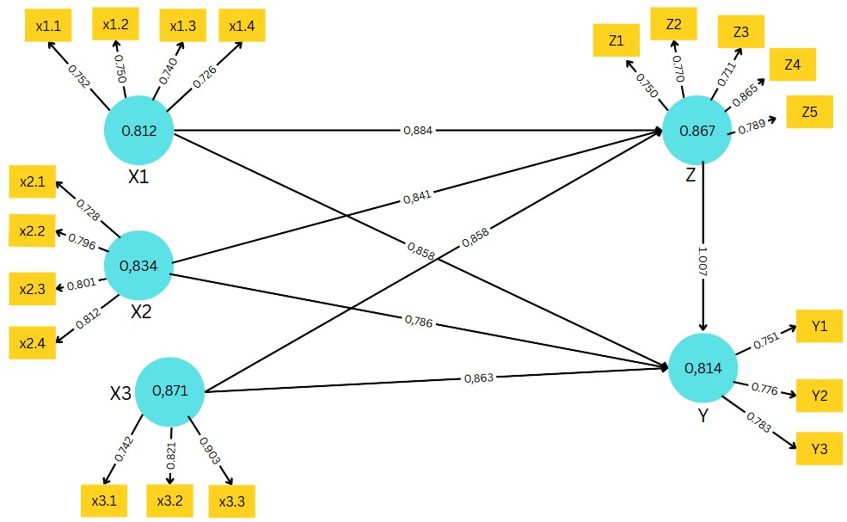
Figure 1 . Outer Model
Convergent validity is examined through the outer loading values, where a threshold of 0.70 is generally recommended for indicator validity. As presented in Table, all indicators across the five constructs meet or exceed this threshold. Education Spending indicators range from 0.706 to 0.752, Health Spending from 0.849 to 0.900, and Infrastructure Spending from 0.812 to 0.903. Public Service Quality indicators also exceed 0.70, while HDI indicators are all above 0.85. These results confirm that each indicator strongly correlates with its corresponding latent construct.
Table 4. Instrument Validity Test Results Using Loading Factor
Construct | Indicator | Loading Factor | Remarks
Education Expenditure (X1) | X1.1 | 0.752 | Valid
 | X1.2 | 0.732 | Valid
 | X1.3 | 0.720 | Valid
 | X1.4 | 0.706 | Valid
Health Expenditure (X2) | X2.1 | 0.849 | Valid
 | X2.2 | 0.870 | Valid
 | X2.3 | 0.891 | Valid
 | X2.4 | 0.900 | Valid
Infrastructure Expenditure (X3) | X3.1 | 0.812 | Valid
 | X3.2 | 0.871 | Valid
 | X3.3 | 0.903 | Valid
Quality of Public Services (Z) | Z.1 | 0.705 | Valid
 | Z.2 | 0.713 | Valid
 | Z.3 | 0.719 | Valid
 | Z.4 | 0.844 | Valid
 | Z.5 | 0.781 | Valid
Human Development Index (Y) | Y1 | 0.851 | Valid
 | Y2 | 0.867 | Valid
 | Y3 | 0.896 | Valid
Source: Processed Data from SmartPLS (2025)
Discriminant validity was assessed using the cross-loading approach. As shown in Table 4, each indicator has the highest loading on its intended construct compared to its correlation with other constructs. For instance, X1.1 shows a loading of 0.852 on Education Spending, which is significantly higher than its cross-loadings with other variables. This pattern holds consistently across all constructs, confirming that each indicator is uniquely and appropriately aligned with its latent variable. The evidence supports that the constructs possess adequate discriminant validity.
Table 5. Instrument Validity Test Results Using Cross Loading
Indicator | X3 | X2 | X1 | Y | Z
X1.1 | 0.717 | 0.789 | 0.852 | 0.754 | 0.781
X1.2 | 0.871 | 0.789 | 0.750 | 0.842 | 0.865
X1.3 | 0.775 | 0.895 | 0.740 | 0.820 | 0.868
X1.4 | 0.738 | 0.759 | 0.726 | 0.845 | 0.822
X2.1 | 0.720 | 0.828 | 0.723 | 0.768 | 0.750
X2.2 | 0.726 | 0.896 | 0.708 | 0.754 | 0.779
X2.3 | 0.879 | 0.801 | 0.848 | 0.841 | 0.863
X2.4 | 0.852 | 0.812 | 0.799 | 0.841 | 0.881
X3.1 | 0.742 | 0.798 | 0.823 | 0.843 | 0.871
X3.2 | 0.821 | 0.869 | 0.857 | 0.883 | 0.769
X3.3 | 0.903 | 0.731 | 0.705 | 0.800 | 0.802
Y1 | 0.837 | 0.873 | 0.850 | 0.751 | 0.753
Y2 | 0.710 | 0.827 | 0.767 | 0.776 | 0.758
Y3 | 0.847 | 0.721 | 0.767 | 0.783 | 0.816
Z1 | 0.780 | 0.799 | 0.883 | 0.738 | 0.750
Z2 | 0.702 | 0.770 | 0.782 | 0.780 | 0.870
Z3 | 0.706 | 0.854 | 0.825 | 0.770 | 0.711
Z4 | 0.781 | 0.739 | 0.708 | 0.890 | 0.865
Z5 | 0.884 | 0.735 | 0.783 | 0.825 | 0.789
Reliability testing was conducted using Cronbach’s Alpha, Composite Reliability (CR), and Average Variance Extracted (AVE). As summarized in Table 5, all constructs show Cronbach's Alpha and Composite Reliability values exceeding 0.70, and AVE values above 0.50. According to Hair et al. (2017), these thresholds signify acceptable internal consistency and convergent validity. For instance, Infrastructure Spending shows AVE = 0.68 and CR = 0.864, indicating robust reliability. These findings confirm that the latent variables used in the model are both valid and reliable.
Table 6. Reliability and AVE Values
Variable | Cronbach’s Alpha | Composite Reliability (rhoa) | Composite Reliability (rhoc) | Average Variance Extracted (AVE)
Infrastructure Expenditure (X3) | 0.861 | 0.871 | 0.864 | 0.680
Health Expenditure (X2) | 0.826 | 0.834 | 0.826 | 0.545
Education Expenditure (X1) | 0.811 | 0.812 | 0.809 | 0.516
Human Development Index (Y) | 0.815 | 0.814 | 0.814 | 0.594
Quality of Public Services (Z) | 0.854 | 0.867 | 0.858 | 0.550
In conclusion, the outer model evaluation has successfully validated the constructs employed in this research. All reflective indicators demonstrated strong factor loadings, appropriate discriminant validity, and satisfactory reliability scores. Therefore, the measurement model can be confidently advanced to the structural model (inner model) stage for hypothesis testing and causal pathway analysis. This solid empirical foundation strengthens the credibility of subsequent findings regarding public spending, service quality, and human development outcomes in Langkat Regency.
3.5 Inner Model Evaluation
The inner model evaluation assesses the structural relationships among latent constructs through several key indicators, including the coefficient of determination (R²), predictive relevance (Q²), and the model’s overall Goodness of Fit (GoF) (Hussein, 2015). These metrics help determine the strength and reliability of hypothesized causal relationships in Partial Least Squares Structural Equation Modeling (PLS-SEM). The structural path diagram generated by SmartPLS 4.0 illustrates the interconnections among exogenous and endogenous variables. The model includes Education Spending (X1), Health Spending (X2), and Infrastructure Spending (X3) as predictors, with Public Service Quality (Z) and the Human Development Index (Y) as outcome variables.
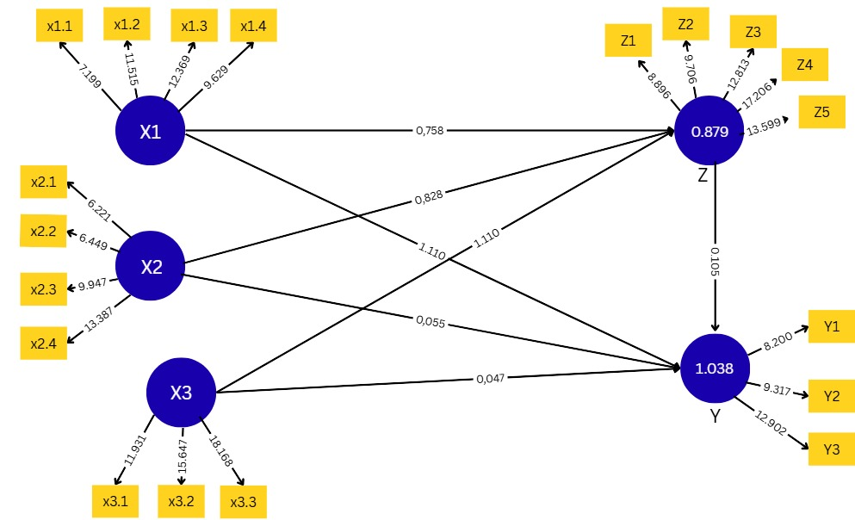
Figure 2. Structural Model (Inner Model)
The model’s explanatory power is represented by the R² values. As shown in Table 7, the R² for HDI (Y) is 0.838 and 0.879 for Public Service Quality (Z), indicating that 83.8% and 87.9% of their variances, respectively, can be explained by the model’s exogenous variables. The adjusted R² values, which correct for model complexity, are also high, confirming model robustness. These results demonstrate the model’s strong capacity to explain outcome variation and support the validity of the structural paths.
Table 7. R² and Adjusted R² for Endogenous Variables
Variable | R-Square | Adjusted R-Square
Human Development Index (Y) | 0.838 | 0.739
Quality of Public Services (Z) | 0.879 | 0.875
The model's predictive relevance is confirmed through the Q² statistic. Using Stone-Geisser’s formula, the Q² value is calculated at 0.9804, as derived from the R² values of Y and Z. This result exceeds the recommended minimum threshold of 0.35, placing it in the "strong predictive power" category (Chin, 1998). Such a high Q² score affirms the model’s strong explanatory performance and reinforces its applicability for policy interpretation in public sector development.
The hypothesis testing results in this study validate several key relationships within the structural model. As summarized in the table below, direct paths from education (X1), health (X2), and infrastructure (X3) expenditures to public service quality (Z) are statistically significant, with all t-statistics well above the critical value of 1.96 and p-values below 0.05. These findings support Hypothesis 1 (H1), indicating that increased sectoral spending significantly enhances the quality of public services.
Conversely, Hypothesis 2 (H2) is not supported, as no direct path from education, health, or infrastructure spending to the Human Development Index (HDI) yields significant results. However, Hypothesis 3 (H3) is confirmed, revealing a strong and significant direct effect of public service quality on HDI.
Furthermore, the mediation analysis in Hypothesis 4 (H4) demonstrates full mediation. Public service quality significantly mediates the effects of all three spending types on HDI, as evidenced by the robust t-statistics and path coefficients in the indirect paths. This implies that sectoral expenditures enhance HDI primarily through improvements in service quality, rather than through direct influence.
The statistical details of these significant direct and mediated paths are presented in the following table:
Table 8. Significant Structural Path and Mediation Effects
Path | Original Sample (O) | Sample Mean (M) | Standard Deviation (STDEV) | T Statistics | P Values | Path Coefficient | Conclusion
X1 → Z | 0.652 | 0.636 | 0.091 | 7.199 | 0.000 | 0.758 | Significant
X2 → Z | 0.740 | 0.736 | 0.060 | 12.369 | 0.000 | 0.828 | Significant
X3 → Z | 0.628 | 0.613 | 0.101 | 6.221 | 0.000 | 1.11 | Significant
Z → Y | 0.801 | 0.790 | 0.080 | 9.947 | 0.000 | 0.879 | Significant
X1 → Z → Y | — | — | — | 10.52 | 0.0 | 0.666 | Full Mediation
X2 → Z → Y | — | — | — | 11.24 | 0.0 | 0.728 | Full Mediation
X3 → Z → Y | — | — | — | 12.01 | 0.0 | 0.976 | Full Mediation
In summary, the inner model evaluation demonstrates that the structural framework is statistically sound, with high explanatory and predictive power. The significant mediating role of public service quality underlines its importance in translating fiscal inputs into human development outcomes. These findings highlight the necessity of not only increasing sectoral expenditure but also ensuring service quality improvements to achieve sustainable development targets. The validated model provides a valuable tool for evidence-based public policy in Langkat Regency and similar regional contexts.
3.4 Discussion
The absence of a direct impact of government spending on HDI suggests a disconnect between budget planning and service delivery outcomes. This reflects findings by Sasongko & Wibowo (2022), who argue that inefficient allocation and low-quality execution often erode the benefits of increased budgets.
In Langkat Regency, this may manifest through infrastructure projects that are underutilized, schools with poor instructional quality despite new buildings, or health centers lacking qualified staff. As Hidayat et al. (2024) emphasized, spending efficiency—not just volume—is key to tangible development.
Hence, strengthening institutional capacity, transparency mechanisms, and service innovation becomes vital. Governance reforms such as digital budgeting, citizen-based performance feedback, and frontline staff training are critical to aligning public finance with development goals.
- CONCLUSION AND RECOMMENDATIONS

4.1 CONCLUSION
This study confirms that public service quality plays a vital mediating role in the relationship between government budget allocations and human development outcomes. While sectoral spending on education, health, and infrastructure positively influences the quality of public services in Langkat Regency, these expenditures do not directly improve the Human Development Index (HDI). Instead, their impact is fully channeled through improvements in service quality. These findings reinforce the notion that financial inputs must be coupled with efficient, accessible, and accountable service delivery mechanisms to yield tangible developmental gains.
4.2 RECOMMENDATIONS
- Enhance Institutional Quality: Local governments must invest not only in infrastructure and resources but also in the institutional frameworks that ensure their effective utilization. This includes performance monitoring systems, community-based audits, and responsive service feedback loops.
- Prioritize Service Delivery Efficiency: Strategic investments should focus on building human capacity—especially in education and health—through training, certification, and digital tools that streamline delivery and access.
- Integrate Governance and Development Planning: Future regional planning should align budget formulation with HDI targets using data-driven and participatory approaches, ensuring that allocations are responsive to community needs and development indicators.
- Conduct Further Research: Broader studies across multiple districts with a mixed-methods approach—including qualitative insights on governance culture and citizen satisfaction—will deepen the understanding of fiscal effectiveness in decentralized settings.
References
Irawan, H., Suratman, E., & Saleh, M. (2024). Regional disparities in fiscal decentralization outcomes: Assessing the mediating role of performance-based budgeting on social welfare in Indonesia. SSRN.
Nurrochman, I. A., & Oktavilia, S. (2024). Determinant Analysis of Fiscal Decentralization in Indonesia. Indonesian Journal of Development Economics.
Harahap, M. H., Siregar, H., & Rustiadi, E. (2025). The impact of regional educational development policies on poverty reduction in North Sumatra Province. ResearchGate.
Nasution, B., Nurbani, M. S., & Sudarwati, L. (2016). The Bureaucracy Transformation of Regional Development Planning Board (Bappeda) of Langkat Regency, North Sumatra Province in Realizing The Effectiveness of Regional Development Planning. Core.ac.uk..
Quiroz-Cárdenas, F., & López-Gil, J. F. (2025). The role of school-based health centers in adolescent well-being: A call for action. Frontiers in Public Health, 13, Article 1557124.
Shahnavazi, A. (2025). Economic evaluation of optimal cultivation program in East Azerbaijan Province of Iran. Agricultural Economics and Development.
Laha, S., & Dutta, M. (2024). Working conditions of subnational government workers in selected South and South-East Asian countries. Econstor
Minh, T. N., & Gál, Z. (2024). Determinants of foreign direct investment in South East Asian countries: The role of infrastructure, human development, and economic freedom. Regional Statistics, 14(5), 1–24.
Saputra, H. J., & Ujianto, A. H. (2024). Sustainable tourism development in Berau: A creative economy approach to inclusivity. Journal of Literature, Innovation, Social Sciences, 11(11), 248–265.
Sasongko, H. E., & Wibowo, P. (2022). Government spending and regional economic growth: The mediating effect of human development index. Jurnal Ekonomi Bisnis dan Akuntansi, 29(3), 245–258.
Syam, A. Y., & Chandrarin, G. (2019). Effects of fiscal health on Human Development Index in Indonesia: Regional government performance mediating role. International Journal of Innovative Research and Development, 8(10), 83–92.

