**The Role of Road Infrastructure in Regional Economic Development: Evidence from Simalungun Regency, Indonesia**

**Abstract**

This study investigates the relationship between land transport infrastructure and regional economic development in Simalungun Regency, Indonesia, from 2010 to 2022. Using a quantitative correlational method, the research examines the impact of road length and vehicle volume on three economic indicators: regional income (PDRB), employment rates, and the growth of micro, small, and medium enterprises (MSMEs). Spearman's rho test was employed due to non-normal data distribution, revealing that road length has a very strong and statistically significant correlation with employment (ρ = 0.851; p = 0.032), and a strong but non-significant relationship with PDRB and MSMEs. Conversely, vehicle volume showed weak and statistically insignificant correlations across all indicators. These findings suggest that physical infrastructure—especially road availability—plays a more pivotal role in facilitating regional labor mobility and economic distribution than vehicle accumulation. The study recommends an integrated, spatially targeted infrastructure policy emphasizing road development in high-potential but under-connected regions, aligned with Indonesia’s current fiscal efficiency agenda.

**Keywords:** Road infrastructure, Regional economic development, Employment, MSMEs (Micro, Small, and Medium Enterprises), Indonesia

1. **INTRODUCTION**

Infrastructure development plays a pivotal role in fostering regional economic performance by reducing transportation costs, improving accessibility, and increasing productivity (Bawole & Sutanto, 2025). In developing countries, especially in Southeast Asia, transport infrastructure is widely regarded as a catalyst for spatial integration and inclusive growth (Milewski & Załoga, 2019). However, the magnitude and distribution of its impact often depend on contextual factors such as location, road quality, and institutional capacity (Crawford, 2006).

Indonesia’s regional disparities in infrastructure remain pronounced, with rural areas such as Simalungun Regency often lacking equitable access to economic opportunities (Franatha et al., 2025). The government has invested substantially in road development to unlock local economic potential, especially after the COVID-19 pandemic’s economic disruptions (Widodo et al., 2025). Yet, recent studies suggest that physical access alone is insufficient without complementary policies that empower local enterprises and workers (Iqbal, 2022).

Earlier research primarily focused on the impact of infrastructure on aggregate economic indicators such as GDP or PDRB (Nugroho, 2023). While these studies confirm a positive association between infrastructure and economic growth, they often overlook micro-level outcomes such as employment generation and the development of MSMEs (Silalahi et al., 2016). Addressing these dimensions is crucial in evaluating the true social and economic value of public investment in transport.

Micro, Small, and Medium Enterprises (MSMEs) form the backbone of Indonesia's economy, contributing over 60% to GDP and absorbing nearly 97% of the labor force (Handoko et al., 2023). However, MSMEs in rural regions often struggle due to inadequate logistics infrastructure, which restricts their market access and scalability (Fardani et al., 2024). Improved road infrastructure can lower distribution costs, enhance customer reach, and facilitate supply chain efficiency (Ahmad, 2022).

Likewise, road access has a strong influence on labor mobility and employment patterns, especially in regions where public transport alternatives are limited (Junaidi, 2021). Improved transport connectivity not only reduces commuting time but also expands the geographic scope of job opportunities (Serang, 2022). This relationship becomes particularly important in post-pandemic recovery efforts where local employment growth is a priority.

Despite its importance, the number of empirical studies examining infrastructure’s effect on employment and MSME growth in a unified framework remains limited. Most existing works isolate PDRB as the primary economic indicator, failing to capture the multidimensional nature of regional development (Sun et al., 2018). This research gap is especially pertinent in rural economies where economic complexity is influenced by both formal and informal sectors.

This study aims to fill that gap by analyzing the relationship between two main components of land transport infrastructure—road length and vehicle volume—and three development indicators: PDRB, employment, and MSME growth. It adopts a non-parametric correlational approach using Spearman’s rho to account for data characteristics common in regional statistics (Purba, 2022). The analysis uses 13 years of secondary data from 2010 to 2022.

The theoretical framework is grounded in spatial development and economic accessibility theories, which posit that infrastructure shapes regional economic performance through increased connectivity, reduced isolation, and enhanced capital flows (Hall, 2003). These mechanisms are especially relevant to developing countries facing fiscal constraints and uneven spatial growth (Widodo et al., 2025).

Ultimately, this research provides a more nuanced understanding of infrastructure’s role beyond GDP-centric metrics. By incorporating employment and MSME development into the analysis, it supports a policy agenda that views roads not merely as physical outputs, but as enablers of inclusive and sustainable development, particularly in underdeveloped areas like Simalungun Regency (Zukari & Aryanto, 2025).

**II.METHODS**

**2.1 Research Design**

This study adopts a **quantitative correlational research design**, suitable for analyzing the strength and direction of association between transportation infrastructure variables (e.g., road length and vehicle volume) and regional economic indicators (e.g., GRDP, employment, and MSME growth). Unlike regression which assumes causal pathways, correlation analysis is preferred when relationships are explored descriptively and without strict assumptions on causality [(Creswell, 2014)](https://www.sciencedirect.com/science/article/abs/pii/S1877042815006741). \

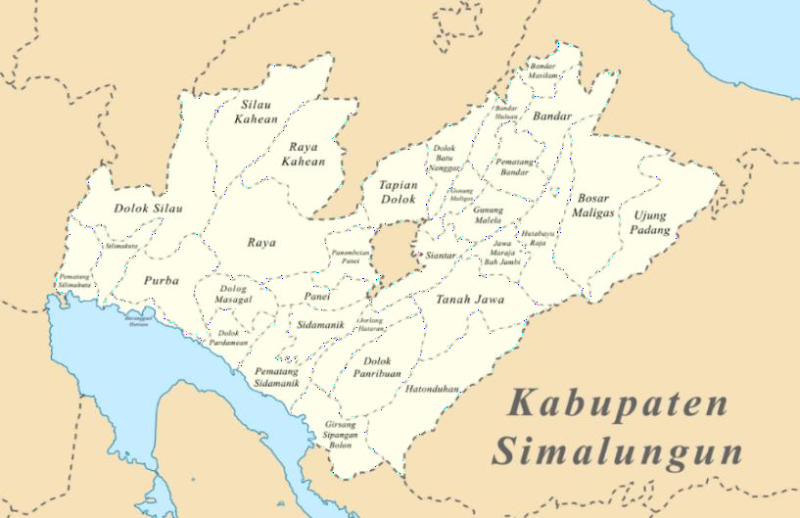This study was conducted in Simalungun Regency, a region in North Sumatra Province, Indonesia, characterized by its diverse topography, agricultural economy, and evolving infrastructure landscape. Simalungun is strategically positioned as a transit corridor between major economic zones, making it a pertinent case for assessing the role of transportation infrastructure in regional economic dynamics.

**Figure 1.** Research Location

The selection of Simalungun was based on its unique infrastructural challenges and opportunities. Despite ongoing investment in provincial road development, the regency continues to face spatial inequality in access, limited urban-rural connectivity, and uneven MSME growth. These characteristics provide a rich empirical ground to analyze how road infrastructure (as physical capital) correlates with economic indicators such as Gross Regional Domestic Product (GRDP), employment levels, and micro-enterprise activity.

Data were collected specifically from major provincial road segments across multiple districts within the regency, including urban hubs and rural peripheries. This allowed for comparative analysis of infrastructure influence across varying economic contexts. The inclusion of peripheral districts ensured the study captured both the direct and spillover effects of transportation infrastructure on local development outcomes.

Simalungun’s demographic and economic structure—dominated by agriculture, trade, and microenterprises—offered a representative microcosm for examining land transport impacts on rural-based economies. Additionally, its inclusion in national strategic infrastructure plans under the Indonesian government's long-term development agenda further reinforced its relevance as a focal point for this study

**2.2 Data Sources and Variable Construction**

The research utilizes time-series secondary data spanning from 2010 to 2022, obtained from Badan Pusat Statistik (BPS) of Simalungun Regency. The study focuses on two sets of variables:

* Independent Variables:
  + Road Length (in kilometers), adjusted by condition-based weights
  + Number of Vehicles, converted to Satuan Mobil Penumpang (SMP)
* Dependent Variables:
  + Gross Regional Domestic Product (GRDP) at constant prices (IDR)
  + Employment (number of employed persons)
  + MSME Growth (number of active business units)

**2.3 Standardization Techniques**

2.3.1 Road Quality Index (RQI)

To reflect infrastructure effectiveness, the study introduces a Road Quality Index (RQI) calculated as:

Where:

* Li ​ = Length of road segment iii
* Wi = Weight assigned to condition of road iii (see Table 1)

**2.3.2 Vehicle Standardization to SMP**

Vehicle types are converted to **Passenger Car Units (SMP)** using the Indonesian Highway Capacity Manual (IHCM) standards:

Where:

* Nj ​ = Number of vehicles type jjj
* Cj ​ = Conversion factor (see Table 2)

Tables supporting these standardizations are displayed above.

**2.4 Analytical Procedure**

2.4.1 Descriptive Analysis

Statistical descriptions (mean, standard deviation, and trends) are used to summarize the characteristics and temporal patterns of all variables.

2.4.2 Correlation Analysis

To measure the relationship between transportation infrastructure and economic indicators:

* Pearson’s correlation (r) is applied when data are normally distributed and continuous:

* Spearman’s rank correlation (ρ) is used when data violate normality assumptions or are ordinal:

Where:

* d= Difference in ranks
* n= Number of data pairs

**2.4.3 Interpretation via Guilford Scale**

Correlation strengths are interpreted using Guilford’s classification:

* Very High: r>0.90r > 0.90r>0.90
* High: 0.71≤r≤0.900.71 \leq r \leq 0.900.71≤r≤0.90
* Moderate: 0.41≤r≤0.700.41 \leq r \leq 0.700.41≤r≤0.70
* Low: 0.21≤r≤0.400.21 \leq r \leq 0.400.21≤r≤0.40
* Negligible: r<0.20r < 0.20r<0.20

**2.5 Analytical Flowchart**

The overall workflow is summarized as:

1. Data Collection → 2. Variable Standardization (RQI, SMP) → 3. Descriptive Statistics → 4. Correlation Testing → 5. Policy Interpretation

**III. RESULTS AND DISCUSSION**

**3.1 Key Findings**

This study evaluated the correlation between land transport infrastructure (road length and vehicle volume) and economic development indicators in Simalungun Regency. The analysis used Spearman's rho correlation due to the ordinal and non-parametric nature of the data collected over a 13-year period (2010–2022). Figure 2 illustrates the correlation strength for six hypothesis tests, distinguishing between significant and non-significant relationships.

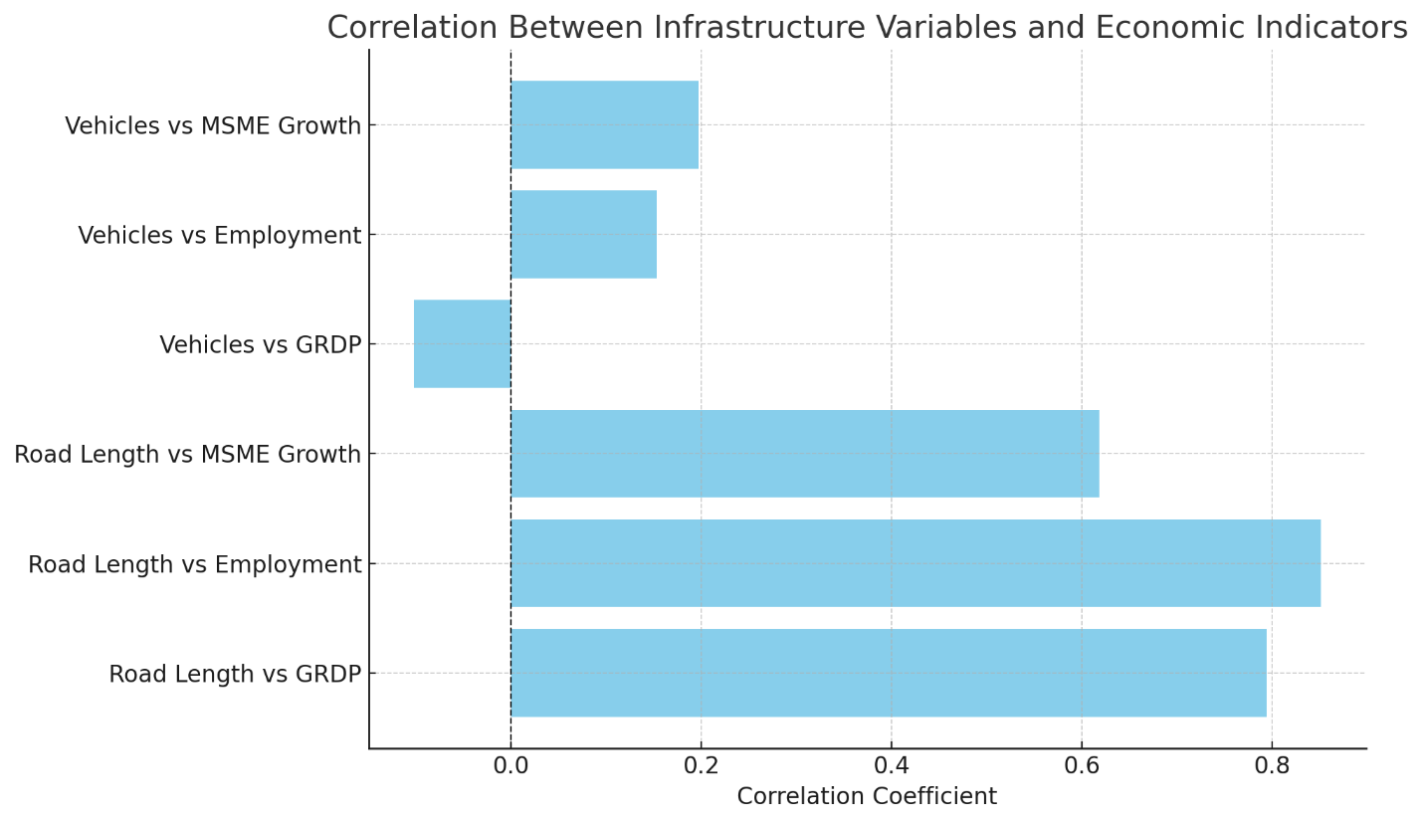**Figure 2.** Correlation Between Infrastructure Variables and Economic Indicators

The analysis revealed a **very strong positive correlation** between road length and employment opportunities (r = 0.851, p = 0.032), suggesting that better road access enhances labor mobility and supports job creation. This supports previous findings indicating that infrastructure development directly reduces geographical barriers to employment (Iqbal, 2022).

In terms of GRDP, road length also showed a high correlation (r = 0.794) but narrowly missed statistical significance (p = 0.059). This may indicate that while infrastructure contributes to regional output, the lagged effect of economic returns from road investment could extend beyond the observation window (Syadullah & Setyawan, 2021).

The moderate correlation between road length and MSME growth (r = 0.618), though not statistically significant (p = 0.191), reflects infrastructure's partial role in supporting small enterprises. Improved road conditions lower logistics costs and enhance market access, yet non-infrastructure barriers such as capital access and digital literacy may inhibit full benefits (Fardani et al., 2024).

**Table 1.** Correlation Results Summary

|  |  |  |  |
| --- | --- | --- | --- |
| **Hypothesis** | **Spearman's rho** | **p-value** | **Significance** |
| Road Length vs GRDP | 0.794 | 0.059 | Not significant |
| Road Length vs Employment | 0.851 | 0.032 | Significant |
| Road Length vs MSME Growth | 0.618 | 0.191 | Not significant |
| Vehicle Volume vs GRDP | -0.102 | >0.05 | Not significant |
| Vehicle Volume vs Employment | 0.153 | >0.05 | Not significant |
| Vehicle Volume vs MSME Growth | 0.197 | >0.05 | Not significant |

In contrast, the correlation between vehicle volume and economic indicators was weak or even negative. Vehicle count was negatively correlated with GRDP (r = -0.102), and weakly correlated with employment (r = 0.153) and MSME growth (r = 0.197). These outcomes suggest that higher vehicle volumes alone do not signify greater productivity, and may instead lead to congestion or increased maintenance costs without commensurate economic output (Nasution et al., 2019).

This dichotomy highlights the importance of differentiating infrastructure stock (road length) from infrastructure usage or load (vehicle volume). While the former creates enabling environments for growth, the latter may stress public assets without economic returns, especially in regions lacking supporting systems like traffic management or freight consolidation (Handayani et al., 2020).

**3.2 Integration with Literature**

Our findings are consistent with regional and international studies. The role of transportation infrastructure in stimulating economic activity is well-established in urban planning literature (Hall, 2003), and recent Indonesian studies affirm this at the provincial and municipal levels (Nugroho, 2023; Serang, 2022).

The significant association between road length and employment mirrors findings from Kalimantan and Aceh provinces, where rural road improvement led to increased workforce participation and spatial labor reallocation (Junaidi, 2021; Iqbal, 2022).

However, our results depart from some earlier findings that emphasized vehicle ownership as a proxy for economic dynamism. In contrast, our data suggest that in a district like Simalungun, vehicle proliferation may not equate to productivity, particularly if mobility is impaired by inadequate road maintenance or urban congestion.

Moreover, our use of weighted road quality index adds nuance not seen in prior studies. Unlike traditional binary road length data, our index captures road condition and accessibility, ensuring a more accurate representation of infrastructure functionality.

**3.3 External Shocks and Contextual Factors**

An important moderating factor during the study period was the Covid-19 pandemic. The economic shock from 2020–2021 severely impacted MSMEs and informal labor sectors, diminishing the apparent economic returns from infrastructure. Even as road access improved, market closures, movement restrictions, and demand contractions reduced its effective utility (Handoko et al., 2023).

This disconnect explains why certain hypotheses failed significance thresholds despite having moderately strong correlations. It also underscores the need for multi-sectoral resilience planning in future infrastructure evaluations.

**3.4 Trend Analysis of Economic and Infrastructure Growth (2016–2022)**

150%

100%

Road Length (X1)

50%

0%

2016 2017 2018 2019 2020 2021 2022

Vehicle Growth (X2)

GRDP (Y1)

Employment Growth (Y2)

MSME Growth (Y3)

-50%

-100%

**Figure 3**. Trend Growth Data Chart (in Percent) Source: Processed by Researchers (2025)

Figure 3 presents the percentage-based growth trends of five key variables—UMKM Business, Employment, Gross Regional Domestic Product (GRDP), Vehicle Volume, and Road Length—from 2016 to 2022. These variables are central to assessing the influence of land transportation on regional economic development in Simalungun.  
  
1. **Peak Growth (2020)**:

The year 2020 marked a significant peak, notably for UMKM business growth, which soared by 115.40%. Similar trends were observed in Employment and Road Length, suggesting either an economic stimulus effect or resilience during early pandemic phases.  
  
2. **Lowest Decline (2022)**:

Conversely, 2022 witnessed a sharp decline, especially in Vehicle Volume which dropped by -73%, while GRDP and Road Length also experienced notable contractions. These trends may be attributed to post-pandemic supply chain disruptions or budget reallocation.  
  
3. **Pattern Discrepancies**:

Not all variables followed identical growth trajectories:  
 - GRDP and Road Length showed consistent growth until 2021 before declining.  
 - UMKM and Employment experienced explosive growth in 2020 but declined sharply afterward.  
 - Vehicle Volume showed the most volatility, peaking in 2018 and plummeting in 2022.  
  
These findings reinforce earlier statistical insights, particularly the strong correlation between road length and employment. The visual analysis complements the correlation data, emphasizing infrastructure’s enabling but non-linear relationship with economic metrics. While 2020 was a turning point for some indicators, the following years highlight structural vulnerabilities and the need for integrated policy responses post-COVID-19.

**3.5 Theoretical and Practical Implications**

Theoretically, the findings validate the enabling role of infrastructure, particularly in developing regional economies with latent potential. Roads act not only as connectors but also as catalysts for structural transformation—shifting labor from subsistence to semi-formal activities, especially where market linkages are previously weak.

Practically, these results call for greater integration between physical and economic planning. Infrastructure projects should be synchronized with workforce development, MSME support programs, and financial inclusion initiatives to maximize impact.

Additionally, the ineffectiveness of vehicle volume as an economic lever invites reconsideration of transport metrics in policy planning. Rather than counting vehicles, planners might benefit from mobility efficiency indicators such as average travel time or logistics cost per ton-km.

The study also points to the value of spatial targeting. Infrastructure investments in economically marginalized subdistricts with high employment elasticity may yield better returns than blanket development.

The findings arrive at a critical juncture for Indonesian fiscal policy. The new Prabowo–Gibran administration has announced aggressive budget rationalization under Inpres No. 1/2025, including a massive cut to the PUPR budget.

This makes our evidence especially relevant. It suggests that future road spending must emphasize maintenance and utility optimization, not merely physical expansion. Road quality, connectivity, and economic linkage should be prioritized.

Furthermore, the study advocates for Public-Private Partnerships (PPP) as a funding strategy. With proper oversight, PPPs can ensure infrastructure continuity while reducing fiscal pressure, especially in districts like Simalungun where resource constraints are acute.

**IV. Conclusion and Recommendations**

This study explored the relationship between land transportation infrastructure and regional economic development in Simalungun Regency, focusing on two primary indicators: road length and vehicle volume. Among six tested hypotheses, only the correlation between road length and employment proved statistically significant, highlighting the direct role of physical connectivity in enhancing labor mobility and job opportunities. Although road length also demonstrated strong correlations with GRDP and MSME growth, these effects were not statistically robust, possibly due to latent effects or intervening socioeconomic variables.

In contrast, the volume of vehicles displayed weak and sometimes negative correlations with economic development indicators, suggesting that increased mobility alone is insufficient and may even detract from productivity due to congestion, externalities, and unsustainable transport trends. These results align with recent literature cautioning against equating motorization with progress, especially in the absence of regulatory and spatial planning controls. Therefore, road infrastructure appears to be more consequential for enabling access and economic participation than vehicle ownership or density.

Given these findings, strategic policy responses are essential. Infrastructure investment should prioritize economically strategic but underserved areas, with planning guided by data and spatial equity. Moreover, roads must function as enablers for broader development agendas, necessitating integrated policies involving MSME support, labor training, and digital inclusion. Without such complementarities, the economic potential of infrastructure will remain underutilized, particularly in post-pandemic recovery contexts.

To ensure efficient and impactful outcomes, regional development policies must be synchronized with national budgetary strategies like the Prabowo–Gibran administration’s fiscal rationalization. The adoption of transport analytics, GIS, and outcome-based performance indicators can further refine investment choices. Ultimately, roads should be seen not only as physical assets but as strategic instruments to facilitate inclusive, sustainable, and regionally balanced economic growth

**References**

Creswell, J. W. (2014). Research design: Qualitative, quantitative, and mixed methods approaches (4th ed.). SAGE Publications.

Sugiyono. (2019). Quantitative, Qualitative, and R&D Research Methods. Alfabeta.

Siburian, G. (2016). Analysis of the Influence of Land Transportation on Economic Growth in Indonesia. Diponegoro University.

Nugroho, R. (2023). The relationship between road infrastructure and regional economic growth in Central Java Province. Journal of Economics, 17(2), 102–117.

Kurniadi, A. (2014). The role of roads in regional development: A case study of West Sumatra. Journal of Regional Transportation, 3(1), 55–69.

Fardani, A., Fajri, F. N., Muhsoni, R., Hidayat, F. R., & Nugraha, Y. A. (2024). The impact of UMKM growth and road infrastructure on economic growth in the village of Karang Mukti. KENTAL: Jurnal Kewirausahaan dan Bisnis Digital, 1(1), 24–36.

Handoko, M., Febriansha, A., & Mafaza, M. S. (2023). The impact of the COVID-19 pandemic on the income of UMKM in Indonesia. Jurnal Ekonomi Indonesia, 15(1), 33–48.

Syadullah, M., & Setyawan, D. (2021). Time-lag effects of infrastructure investment on economic growth in Indonesia. Economic Journal of Development Studies, 9(4), 89–105.

CNN Indonesia. (2025). Prabowo's government cuts PUPR Ministry budget by 70 percent. Retrieved from <https://www.cnnindonesia.com/ekonomi/2025>

Antaranews. (2025). Economist: PU budget cuts are President Prabowo's rational move. Retrieved from <https://www.antaranews.com/berita/4624641>