OPTIMIZED BIOGAS PRODUCTION FROM BIOLOGICALLY PRETREATED RICE STRAW CODIGESTED WITH ANIMAL MANURE IN A BATCH SYSTEM BIOREACTOR

ABSTRACT

The Presence of lignin in lignocellulosic substrates greatly limits anaerobic digestion for production of biogas. The need for initial pretreatment to sufficiently remove it became inevitable .Bacterial pretreatment method was used to pretreat rice straw samples for application in biogas production in a batch bioreactor. Bacterial spp isolated from termite gut were identified by 16S rRNA gene sequencing and a lignolytic isolate identified as *Morgenela morganii* strain S4L2C (MH745964) was used for biological pretreatment of the substrate. The pretreated rice straw was co-digested with 1:1, 2:1 and 3:1 ratios of cow dung, pig waste and poultry droppings respectively, as amendments. Proximate composition, lignin, cellulose and hemicellulose content of the feedstock were determined by standard methods. Results obtained revealed that lignin concentration reduced from 17.4% to 7.3% after bacteria pretreatment. The 16S RNA gene analysis of bacterial consortium from termite gut indicated the presence of *Escherichia coli* and *Morgenela morganii* strain S4L2C (MH745964), with 100% and 98.6% similarity, respectively. There was a significant difference (*P* ≤ 0.05) in biogas yield in all Bacteria pretreated rice straw (BPRS) amended with animal manure compared to untreated rice straw (URS) alone. Bacterial pretreated rice straw (BPRS/CD) 1:1 ratio of rice straw to cow dung showed the highest yield of biogas followed by bacteria pretreated Rice Straw codigested with poultry dropping (BPRS/PD ) 2:1 with a cumulative biogas yield of 27.05dm3 and 22.47dm3 respectively. Composition of components gases in biogas produced by rice straw/ cow dung 1:1 which produced highest volume of biogas in this study, were CO 1.15%, CO2 33.56% and CH4 64.96%. Findings from this study have shown that biological pretreatment of lignocellulosic waste (Rice Straw) using *Morgenela morganii* strain S4L2C (MH745964) enhanced biogas production.

Keywords: Bacteria pretreatment, Lignocellulosic waste, animal manure and Biogas.

**Introduction**

Rice straw is the main agro-waste in many countries in which rice is a major crop (Sun et al. 2008). Rice straw is a lignocellulosic waste and lignocellulose is one of the most complex organic compounds that exist naturally and abundantly in plant biomass. Being considered a renewable resource, rice straw can be converted to biofuel through the application of biotechnology.

Biogas production Produced from the decomposition of wastes .A by-product of the cleaning up of waste from the environment. Biogas consists of 30 - 40% CO2 and 45- 75% CH4.

Rice straw is a lignocellulosic waste and lignocellulose is one of the most complex organic compounds that exist naturally and abundantly in plant biomass. These wastes are disposed indiscriminately in drainages and road sides which results to environmental pollution and greenhouse gas emission. The issue of waste disposal and environmental problems in addition to high cost of fossil fuel has made biogas production from bio waste a better option thus the need to trap the large amount of gas for beneficial purposes which will in turn produce a safer environment using recalcitrant agro wastes, such as rice straw will also aid environmental cleanup. The product is energy for all and a safer environment for all. Thus, the need to produce biogas from biologically pretreated rice co digested with animal manure in a batch bioreactor.

**Materials and Methods**

The lignocellulosic wastes used in this study to produce biogas were rice straw. Other substrates include the nitrogenous wastes: cow dung, pig waste and poultry droppings, Isolate from termite gut, cow rumen waste, measuring cylinder and fabricated digesters.

**Sample Preparation and Pretreatment**

Rice straw was sun dried, then milled and sieved to the size range of (0.25-0.42mm) then stored in sterile containers for use.Lignolytic bacteria from the termite gut was isolated and used to pretreat the substrate for a period of 30days within which the cellulose, hemicellulose and lignin content of the substrate were determined in the course of pretreatment so as to determine the pretreatment efficiency.

**Collection, Isolation and Molecular Identification of Lignolytic Bacteria from termite Gut**

Red headed termites were collected from old and decaying woods with containers and taken to the laboratory for analysis. The termites were washed with sterile distilled water dried on a filter paper and sterilized with 70% ethanol, thereafter their guts were accessed by removing singly, the heads and legs such that what is left is the gut which was then squashed with mortar and pestle. A 10 fold serial dilution was done, where 1 gram of the squashed termites gut was put in 9 mls of maximum recovery diluent (MRD) and left to stand for 30 mins – 1 hour. Then 0.1 ml was collected from the maximum recovery diluent and dropped on an enriched medium (containing 2% w/v saw dust powder,0.05% w/v glucose,5% v/v stock salt solution, 0.02 % v/v Hunter’s trace element and 1.5% w/v agar) and incubated at ambient temperature for 15 days.

**Bacterial Pretreatment of Substrate Rice Straw and Water Hyacinth**

The method described by Girisha *et al.* (2017) was adopted with modifications. The bacterial isolates from the gut of termites were used to pre-treat Rice Straw for 30 days. Nutrient broth was prepared and 500 ml of the freshly prepared nutrient broth was poured into a bowl containing 100 grams of sample. The contents of the bowl were properly mixed by gentle turning to form slurry. The contents of the bowl were left for biomass cellulose degradation. Samples were drawn from the bowl to determine lignin, hemicellulose and cellulose content on Day 0, Day 15 and Day 30 respectively.

**Co- digestion of Substrates with Nitrogenenous Sources (Amendment) for biogas production.**

Cow dung, pig waste and poultry droppings which were sun-dried, were mixed in three ratios of 1:1, 2:1 and 3:1 with each of the primary substrates. The composites were loaded into the digesters after thorough mixing with water. Then 1.6 liters of freshly strained cow rumen waste which was used as source of inoculum was added to each composite and properly mixed. Each of these inoculated composites was charged into the bio digester for biogas production.

**Determination of Lignin,Cellulose,Hemicellulose Contents of Rice Straw**

Lignin, cellulose and hemicellulose contents of each substrate were measured before , during and after pretreatment at 3 intervals (i.e. before pretreatment, after 15 days and after 30 days of pretreatment). These were done according to methods described by Lin (2010)

**Results**

Results from this study showed that production of biogas from biologically pretreated rice straw and co digestion with the different nitrogenous animal wastes increased the volume and composition of biogas produced as well as the quality of the resultant digestate

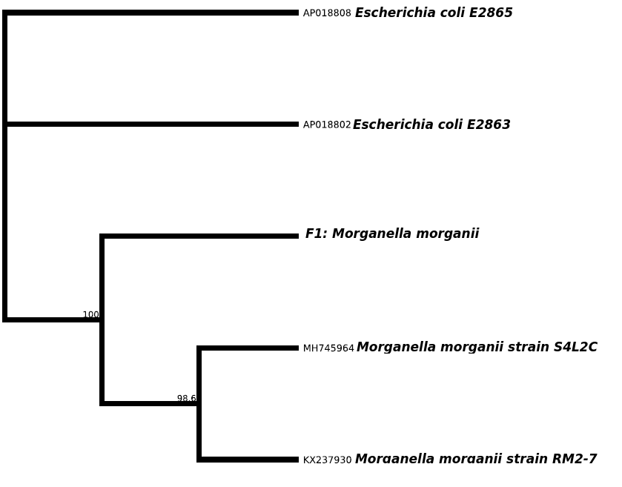

Fig1 : Phylogenetic tree showing the evolutionary distance between the bacterial isolate

B1 L B2 B3

16S rRNA gene band

1000bp

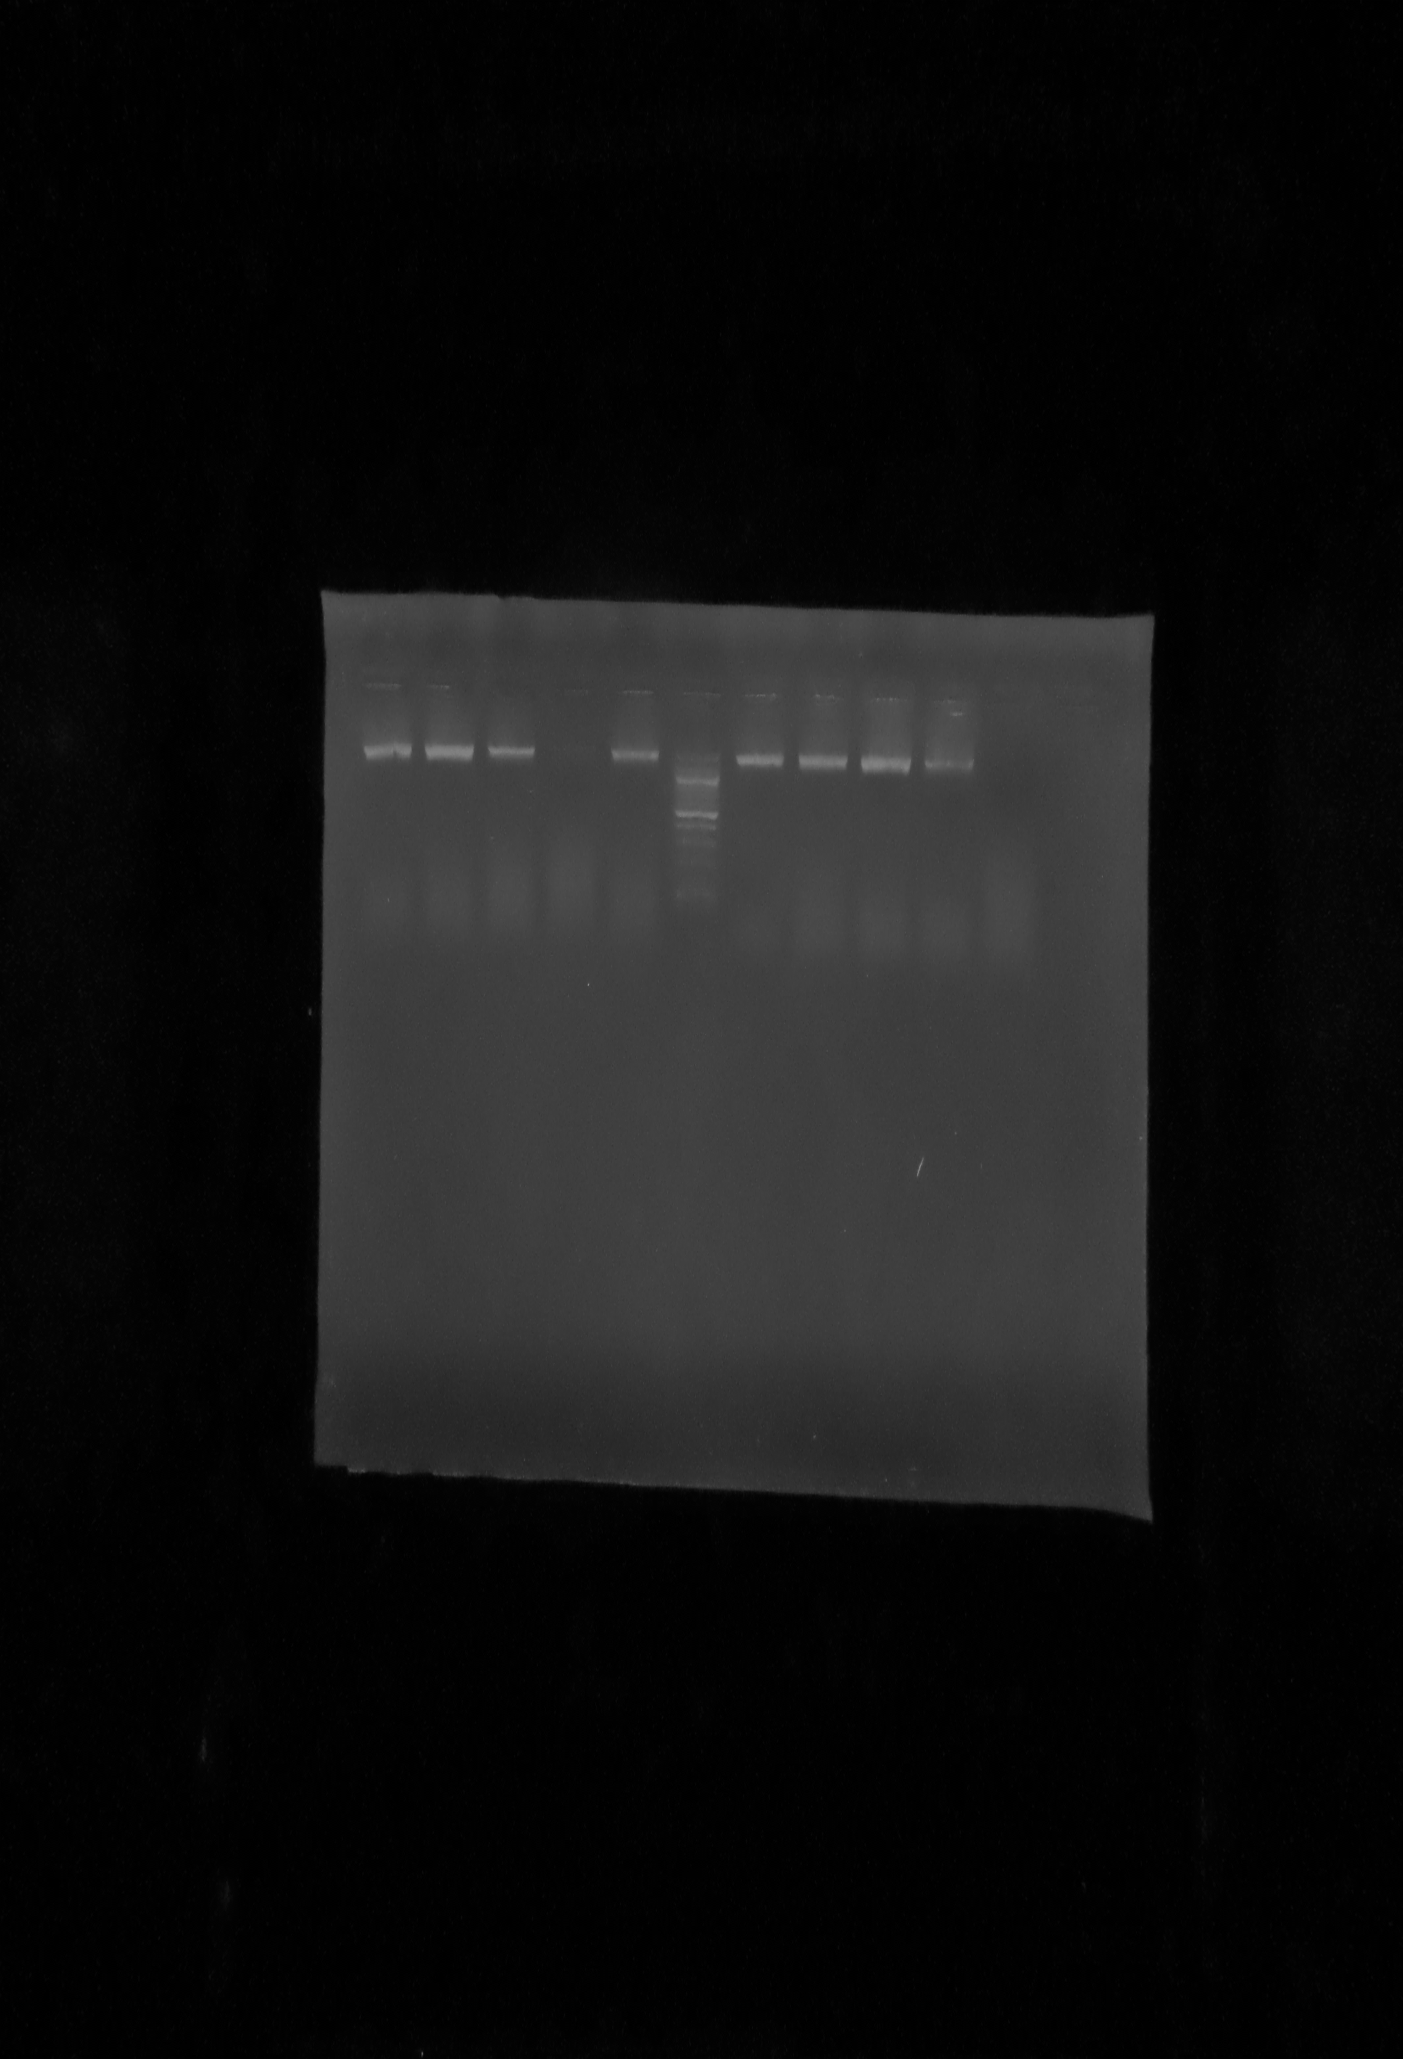.

Figure 2:Agarose gel electrophoresis of the 16S rRNA gene of some selected bacterial isolates. Lanes B1, B2, B3 represent the 16SrRNA gene bands (1500bp), lane L represents the 100bp molecular ladder.

**Table 1: Chemical composition of Rice Straw following pretreatment with bacteria isolated from termite gut.**

|  |
| --- |
|  |

Anaerobic Digestion(days) Lignin (%) Hemicellulose (%) Cellulose (%)

|  |
| --- |
|  |

0 17.439 10.278 57.709

15 11.259 14.369 33.552

30 7.299 8.908 38.860

|  |
| --- |
|  |

**Table 2: Maximum Cumulative Biogas Yield from the Biologically Pretreated**

**Feedstock and Amendments**

|  |
| --- |
|  |

Treatments Biogas Yield (dm3)

|  |
| --- |
|  |

BPRS/CD 1:1 27.31

BPRS/CD 2:1 12.28

BPRS/CD 3:1 13.90

BPRS/PD 1:1 19.55

BPRS/PD 2:1 22.47

BPRS/PD 3:1 18.26

BPRS/PW 1:1 18.13

BPRS/PW 2:1 19.03

BPRS/PW 3:1 14.60

|  |
| --- |
|  |

BPRS = Biologically Pretreated Rice Straw

Table 3: % composition of produced biogas

|  |
| --- |
|  |

Component gas %composition

|  |
| --- |
|  |

CO 1.15

CO2  33.56

CH4  64.96

|  |
| --- |
|  |

# 

Figure 3 :The main effects plot for the production of methane (ppm) following Bacterial pretreatment of the substrate

# 

Figure 4: Interaction plot for Methane (ppm) production following Bacterial pretreatment of the substrate

# 

Figure 5: Surface Plot of Methane (ppm) vs Amendment, HRT after Baterial pretreatment of the substrate

# 

Figure 6: Surface Plot of Methane (ppm) vs Amendment, Substrate following Bacterial pretreatment of the substrate



Figure 7: Surface Plot of Methane (ppm) vs HRT, substrate following Bacterial pretreatment of the substrate



Figure 8: Optimization Plots for Methane Production after Bacterial pretreatment of the substrate

**Discussion**

# Biogas production and optimization

It has been well documented that several factors affect the yield of biogas in a bioreactor (Sarker et al. 2019). In order to determine the optimal conditions required for the production of biogas, we decided to optimize several factors that are critical in stages of the production line. These include the substrate, the amendments, and the Hydraulic Retention Time (HRT). The substrate is the most important component of any bioreactor other than the microorganisms (Sarker et al. 2019). The substrates in this study, rice straw is rich in cellulose which is documented to be the most abundant substrate on earth. We therefore sought to obtain the high energy that is stored in these substrate and harness it for biogas production. To achieve this, we carried out biological pretreatment. Pretreatment is necessary because ordinarily, this substrate could take between weeks to months to undergo degradation into simple sugars needed for biogas production (Steffen, Szolar, and Braun 1998). A combination of thermal and chemical pretreatment have been adopted as strategy for chemical pretreatment using alkaline. This is becoming popular recently (C. Li et al. 2016; X. Liu et al. 2019;BoladoRodriguez et al. 2016). On the other hand, thermal and biological pretreatment was adopted and will be referred to as biological pretreatment. Thermal pretreatment have been reported to be very effective as a strategy to hydrolyse polymers into simple sugars that can be harnessed for biogas production. This overall increased the degradation kinetics, increased surface area for chemical, microbial and enzymatic activities, and most importantly, biogas yield (Ennouri et al. 2016; Kor-Bicakci and Eskicioglu 2019; Ennouri et al. 2016). Biological pretreatment is much slower than the chemical pretreatment and is usually used alongside the inoculum in order to obtain a synergistic activity where one community of microorganisms degrade the waste and another community ferment the sugars to produce gas (Amin et al. 2017).

Despite adopting both pretreatment strategies, it took approximately 7-10days to begin biogas production. This is because a little time is required for the microbial community to acclimatize to its new substrate where activities like enzyme production, biomass production, etc are occurring. On the other hand, the rich source of inoculum can be a key player in determining the duration of the lag phase (Gu et al. 2014). A low inoculum source can be a source result in slower and incomplete substrate digestion while a high inoculum size to substrate ratio will increase the hydraulic retention time (HRT) of the bioreactor. This implies that the feed to inoculum ratio plays an important role in determining increased biogas yield (G. Liu et al. 2009). In addition, A previous research has reported that the biogas yield from water hyacinth was independent of the particulate size but dependent on the amendment (Nitrogen source) and inoculum volume (Moorhead and Nordstedt 1993). To this regard, we sought to investigate the optimum inoculum size, feed-stock concentration and also the hydraulic retention time (HRT) that would produce maximum yield of biogas.

To achieve this, we adopted the one variable at a time (OVAT) method to determine what Substrate and amendment concentration produced the highest volume of biogas measured as a cumulative volume of biogas produced. Bacterial pre-treated substrate, rice straw were amended with cow dung, piggery waste and poultry waste in 1:1, 2:1 and 3:1 combination. Importantly, results provided evidence that codigestion is vital for increased yield of biogas. For instance, the combination of rice straw and pig waste, poultry drop, or cow dung, produced more volume of methane than when they were digested individually. Mono-digestion of lignocellulosic materials often results in a slow process and low methane yield (Sawatdeenarunat, Surendra, et al. 2015; Sawatdeenarunat, Nguyen, et al. 2016; Surendra et al. 2015). However, this drawback can be overcome by using a co-substrate, such as animal manure to supplement lignocellulosic materials with macro- and micronutrients and buffering capacity (Mata-Alvarez et al. 2014). Co-digestion has been investigated for other cellulolytic substrates such as pulpy straw and chicken manure (Bayrakdar et al. 2017), rice straw with kitchen waste and pig manure (Ye et al. 2013) and oat straw with cattle manure (Lehtom¨aki, Huttunen, and Rintala 2007). These studies report higher methane yields (approximately 200-400 mL/g VS) compared with when using straw alone ( 120-200 mL/g VS), as a consequence of the higher energy content of the co-digestion materials and their complementary properties. In short, most recent attempts to optimize the breakdown of cellulolytic feedstock are predominantly engineered through co-digestion(Ai et al. 2020; Miryahyaei et al. 2020; Zhong et al. 2020; Almomani and Bhosale 2020)

Results from OVAT had it that the Rice straw/ cow dung 2:1 combination had the best yield in the chemically pre-treated Rice straw with an 5580 ml day 15, an average of 22,510 ml of gas at day 35; and also the Rice straw/cow dung 1:1 combination produced an average of 8,950 ml on day 15; and on day 35, it had produced 27,050 ml of gas.. These result is in agreement with previous research as cow dung and poultry droppings are good sources of natural inoculum for bio-digesters(Ona et al. 2019; Olatunji, Alo, and Akadiri 2020; Aniekan, Akhihiero, and Esekhaigbe 2020) and have been strongly reviewed (Caruso et al. 2019; Putatunda et al. 2020; Putatunda et al. 2020; Ghosh et al. 2020; Kapoor et al. 2020). Therefore, a BoxBenken design was done to accommodate the range of feed-stock concentration, amendment and also the hydraulic retention time (HRT).

The results showed that an increase in substrate concentration led to an increase in methane production. An increase in Organic Loading Rate (OLR) usually results in an increase in total methane yield, however, if a certain OLR value is exceeded, the process can be unstable and process failure may even occur (Mata-Alvarez et al. 2014; Astals et al. 2014; Dhar et al. 2016; RomeroGu¨iza et al. 2016). Also, HRT between 15 – 30 days, there was a continuous methane production. This corresponds with reports from Mao (Mao et al. 2015; Lochyn´ska and Frankowski 2018) and Braun (Braun et al. 2010) who opined that a typical HRT is 15-30 days under mesophilic conditions and slightly shorter under thermophilic conditions. Also, a long HRT is required in anaerobic digestion of lignocellulosic wastes. However, a shorter HRT is desirable, in order to reduce the capital cost and increase the efficiency of the process (Shi et al. 2017; Issah, Kabera, and Kemausuor 2020). This shows that HRT and substrate concentration are important parameters for biogas production from both alkaline and biological pretreatment methods.

Therefore, we sought to investigate what the optimum conditions are for the HRT, Substarte concentration and the amendments. The Results show that for the Bacterial pretreated substrate show that the optimum conditions for methane production are substrate concentration of 520, HRT of 30 days and amendment of 520. At these conditions, the maximum yield that will be achieved will have a response of 27.31dm3.

**Conclusion**

The results of this study have shown that Morgenela morganii strain S4L2C (MH745964) could be used in the pretreatment of lignocellulosic wastes (Rice straw) for improved biogas yield even in large scale production process

**References**

Abbasi, T., Tauseef, S. M. & Abbasi, S. A. (2012).Anaerobic digestion for global warming control and energy generation-An overview. *Renewed Sustainable Energy Review, 16* :228-3242

Adeyanju, A.A. (2008). Effect of seeding of wood-ash on biogas production using pig waste and cassava peels. *Journal of Engineering and Applied Science 3*: 242 – 245.

Barakat, A., De Vries, H. & Rouau, X. (2013). Dry Fractionation process as an important step in current and future lignocellulose biorefineries: a review *Bioresource.Technology*, *134*: 362-373.

Ben‑lin, D., Xu‑jing, G., Dong‑hai, Y.& Ji‑ming, X. (2018).Comparison of different pretreatments of rice straw substrate to improve biogas production.*Waste Biomass Valorization. 9*(1) :1503-1512

Lin, l.,Yan, R., Liu, Y. & Jiang, W. (2010). In-depth investigation of enzymatic hydrolysis of biomass wastes based on three major components: Cellulose, hemicellulose and lignin. *Bioresource Technology, 101*(21): 8217-8223.

Xia, A., Cheng, J., Song, W., Yu, C., Zhou, J. & Cen, K. (2013).Enhancing enzymatic saccharification of water hyacinth through microwave heating with dilute acid pretreatment for biomass energy utilization. *Energy, 61*: 158-166.

Zhang, Y.H.P. (2008)Reviving the carbohydrate economy via multi‐product lignocellulose biorefineries*. Journal of Industrial Microbiology and Biotechnology,* *35*:367‐375

Ziganshin, A.M., Liebetrau, J., Proter, J. & Kleinsteuber, S. (2013).Microbial community structure and dynamics during anaerobic digestion of various agricultural waste materials. *Applied Microbiology and Biotechnology, 97*(11): 5161-5174.