*Original Research Article*

**Efficacy of Limited Cyclophotocoagulation in Glaucoma Therapy Among Adult Patients with Refractory Glaucoma at KCMC Eye Department 2023-2024**

**Abstract**

**Background: Refractory glaucoma possess a therapeutic challenge due to poor response to standard medical and surgical treatments. Cyclophotocoagulation (CPC) is an alternative method for lowering intraocular pressure (IOP) in such cases, however its use is often limited to advanced disease due to variable outcomes and complications after destructive procedure on the ciliary body.**

**Objective: To assess the efficacy of limited CPC in reducing IOP among adult patients with refractory glaucoma at Kilimanjaro Cristian Medical Center, Eye department between 2023 and 2024.**

**Methodology: A prospective study was conducted involving 74 patients who underwent transscleral CPC. Laser was applied to the inferior** 180° of the ciliary body with 10 burns per quadrant at 2000 mW for 2 seconds per burn. Treatment success was defined as achieving an IOP ≤ 21 mmHg and ≥ a 20% reduction from baseline at three months with or without treatment.

**Results:** At three months, 36 patients (48.6%) achieved target IOP (≤ 21mmHg and ≥ 20% reduction), while 63 (85.1%) had at least 20% reduction in IOP. The median baseline IOP decreased from 46.5 mmHg (IQR 39-56) to 25mmHg (IQR 18-38). Lower pre-treatment IOP (AHR=0.95; 95% CI: 0.91-0.99; P= 0.015) and optic disc notching were positively associated with treatment success, while ocular comorbidities were negatively associated (AHR = 0.33; 95% CI: 0.14-0.74; P=0.007). The most common complications were transient uveitis (10.8%) and cystoid macular edema (8.1%).

**Conclusion:** Limited CPC showed moderate effectiveness in lowering IOP after a single session, with minimal complications. However, nearly half of the patients required a repeat procedure to achieve target IOP at three months.

**Key words:** Refractory glaucoma, Limited cyclophotocoagulation, Transscleral CPC, Intraocular Pressure Reduction, Laser Therapy Complications.

**Introduction**

Glaucoma refers to a group of progressive optic neuropathies characterized by the degeneration of retinal ganglion cells and their axons, leading to optic disc cupping and irreversible visual field loss. If left untreated, the disease invariably results in permanent blindness (1). Although the etiology of glaucoma is multifactorial, elevated intraocular pressure (IOP) remains the only modifiable risk factor and the main target of current treatment approaches. While age related lens enlargement is a contributing factor, genetic and environmental components also influence disease onset and progression (2).

Globally, glaucoma affects approximately 2.4% of the population, though prevalence varies geographically. Sub Saharan Africa is the most affected region with a prevalence of 4.0% compared to 2.4% in North America, 2.3% in Europe, 2.1% in Asia and 1.8% in South America (3). In Tanzania among individuals aged 40 years and above, the estimated prevalence is 4.2%, similar to figures observed in African American populations in the United States. However, it is lower than the 5.3% reported in South Africa and the 7.1% reported in African Caribbean populations (4)

Glaucoma is the second leading cause of blindness worldwide and the leading cause of irreversible blindness. In 2020, 76 million people were affected and this number is expected to reach approximately 111.8 million by 2040 (5). Despite improvements in treatment, about 10% of glaucoma patients still progress to permanent vision loss(6).

The primary goal of glaucoma treatment is to preserve functional vision by controlling IOP, thereby preventing further damage to the optic nerve. Treatment modalities include medical therapy with eye drops, surgery or laser therapies (7).

Among the laser-based options, transscleral cyclophotocoagulation (TSCPC) is increasingly used for managing refractory glaucoma. This procedure involves the application of laser energy to the pigmented epithelium of the ciliary body, which is responsible for aqueous humor production. Destroying this tissue reduces aqueous production, thus lowering IOP(8). While TSCPC has shown promising results, it is generally reserved for cases where conventional treatments have failed due to the risk of complications such as post operative inflammation, hypotony, phthisis bulbi, cystoid macular edema and inconsistent pressure lowering effects(9).

Despite its growing use in clinical practice, there is paucity of data concerning the efficacy and safety of limited TSCPC, particularly within Sub Saharan Africa. Some studies from countries such as Ghana, Cameroon, Malawi and Tanzania have explored its application often with varying indications and outcomes. Most reported that TSCPC is relatively safe with mild associated complications. A study from Nigeria demonstrated that, TSCPC could be safe and effective for patients with good vision, suggesting it as a viable alternative to other interventions.

Given the high prevalence of refractory glaucoma and limited resources in many African eye care settings, further investigations on the effectiveness of TSCPC is needed. This study aims to evaluate the efficacy of limited TSCPC in patients with refractory glaucoma at KCMC Eye Department.

## 

**Methods.**

**Study design and setting**  
A prospective cohort study of 74 participants aged 18 years and above was conducted at the Ophthalmology Department of Kilimanjaro Christian Medical Centre (KCMC), Moshi, Northern Tanzania, from August 2023 to June 2024. KCMC is one of five consultant hospitals in Tanzania, serving the northern regions and receiving referrals nationally and from neighboring countries. It also serves as a training center and ophthalmology and allied eye care professionals is one of the trainings offered at KCMC. Glaucoma constitutes about 10% of total patients managed in the Eye Department annually.

**Study population and Eligibility criteria**  
The study enrolled adult patients aged 18 years and above with refractory glaucoma treated with transscleral cyclophotocoagulation (TSCPC) during the study period. Eligible patients had an intraocular pressure (IOP) ≥30 mmHg despite maximal medical therapy. Timolol and Latanoprost are most frequently available and affordable drugs for glaucoma at KCMC.   
Patients with prior cyclodestructive procedures, active ocular inflammation or recent intraocular surgery in the treatment eye were excluded.

**Sample Size determination**  
Between August 2023 and June 2024, a total of 114 patients were treated with (TS-CPC). Of these patients, 74 met the inclusion criteria and enrolled in the study. **Figure 1** summarizes the enrollment of the study participants.

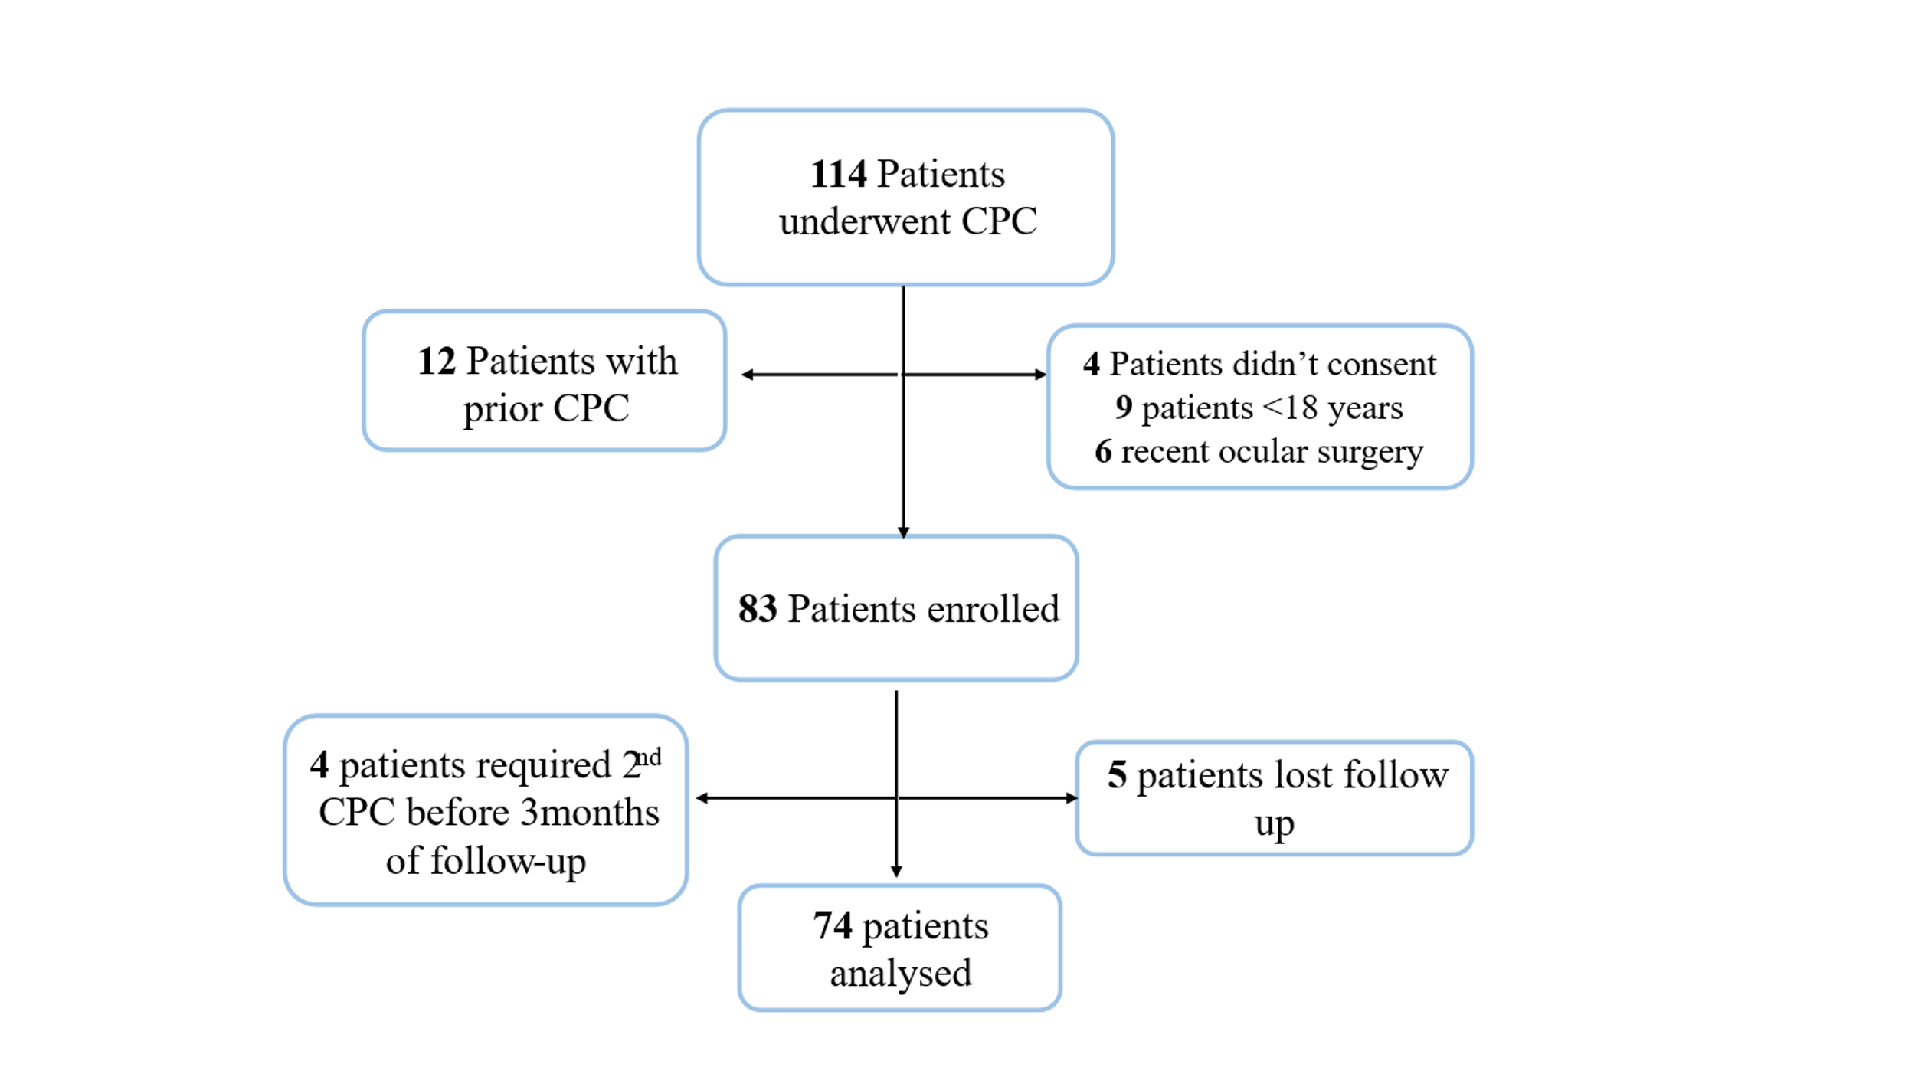

**Figure 1:** Flow chart showing selection of participant enrolled in the study.

**Study variables**

The outcome variable for this study was success which was defined as IOP ≤ 21mmHg or 20% reduction from the initial IOP (“Success” “Failure”)

The Independent variables Included, Participant’s age in years (“≤60” “>60”), sex of the participant (“Male” “Female”), initial IOP in mmHg (Median (IQR)), Vertical CDR (Median (IQR)), Disc notching (“Yes” “No”), Optic disc hemorrhage (“Yes” “No”), Type of glaucoma (“Primary glaucoma” “Secondary glaucoma”) and Associated comorbidities (“Systemic diseases” “Ocular diseases”)

**Data Collection Procedures**  
After obtaining informed consent from patients who met the inclusion criteria, demographic and clinical characteristics were recorded. Visual acuity was assessed using the Snellen’s chart or the tumbling E chart basing on the level of literacy of the participant. Slit lamp examination of the anterior segment, Goldman applanation tonometry, and Optic disc assessment were performed.

For patients with functional vision, the procedure was performed under general anesthesia, and for patients with poor vision a retrobulbar or peribulbar anesthesia of 3mls (lignocaine 4%, adrenaline 1%, and hyaluronidase 1500IU) was used. TSCPC was performed using G-probe of the Iris medical diode, (OcuLihgt SLx) 810nm Laser (IRIS Medical Instruments, Inc 340 Pioneer Way, California, and USA). Laser was applied over the inferior 180°, sparing the 3 and 9 o’clock positions, with up to 10 burns per quadrant. Each burn lasted 2 seconds at 2000 mW, totaling 120 J per session.

Postoperatively, patients received topical dexamethasone and chloramphenicol combination for 2 weeks, oral acetazolamide and Ibuprofen for three days. IOP and anterior segment assessments were conducted on day one, then at two weeks, six weeks, and three months by an independent examiner. OCT was performed at the final follow up to detect macular edema. If IOP was not significantly reduced at two weeks, timolol 0.5% was added and for patients requiring further intervention, a second CPC session was performed at six weeks targeting the superior 180°, using the same settings. Treatment success was defined as IOP ≤ 21mmHg and reduction by 20% or more from the baseline with or without medications at 3months follow up. Ethical approval (No.PG 88/2023) was obtained from the College Research Ethics Review Committee of Kilimanjaro Christian Medical University College, Moshi, Tanzania. The study adhered to the tenets of the Declaration of Helsinki.

**Data Management and Analysis**  
Data was analyzed using STATA version 17(Stata Corp LLC, college Station, Texas, USA). Numerical variables were summarized using medians with interquartile ranges (IQR), while frequencies with percentages were used to summarize categorical variables.

A non-parametric test, Wilcoxon signed-rank test was used to compare changes in IOP from the initial, over time. Significant change was determined at p-value of <0.05.

Cox regression was performed to assess factors associated with treatment success while stepwise regression was used for variable selection in adjusted analysis. Variables with a p-value <0.05 were considered statistically significant associated with treatment success in both, crude and adjusted analysis.

**RESULTS**

Of the 74 enrolled participants the median age was 64 years (IQR 55-70 years) with 45(60.8%) aging >60 years and 39(52.7%) were males.

The median IOP before TSCPC was 46.5mmHg (IQR 39-56mmHg) while median cup to disc ratio (CDR)was 0.9(0.8-1). Of these participants, 4(5.4%) had normal VA while majority 63(85%) were blind according to WHO classification and 41(55.4%) had Cup disc Notching. There were 40(54.1%) who had primary open angle glaucoma, while 8 (10.8%) had Optic disc hemorrhage and more than half of the participants 45 (60.8%) had associated systemic diseases.

## **Table 1: Participant’s social demographic and clinical characteristics (N=74)**

|  |  |  |
| --- | --- | --- |
| **Characteristics** | **Frequency** | **Percentage** |
| **Patients Age** |  |  |
| ≤60 | 29 | 39.2 |
| >60 | 45 | 60.8 |
| *Median (IQR)* | *64(55-70)* |  |
| **Patient Gender** |  |  |
| Male | 39 | 52.7 |
| Female | 35 | 47.3 |
| **Initial IOP** |  |  |
| *Median (IQR)* | *46.5(39-56)* |  |
| **Vertical CDR** |  |  |
| *Median (IQR)* | *9(8-10)* |  |
| **Participant’s VA** |  |  |
| Normal vision | 4 | 5.4 |
| Mild VI | 1 | 1.3 |
| Moderate VI | 3 | 4.1 |
| Severe VI | 3 | 4.1 |
| Blind | 63 | 85.1 |
| **Cup Disc Notching** |  |  |
| Yes | 41 | 55.4 |
| No | 33 | 44.6 |
| **Type of glaucoma** |  |  |
| Primary open angle | 40 | 54.1 |
| Secondary glaucoma | 34 | 45.9 |
| **Optic Disc Hemorrhage** |  |  |
| Yes | 8 | 10.8 |
| No | 66 | 89.2 |
| **Associated comorbidities disease** |  |  |
| Systemic Disease | 45 | 60.8 |
| Ocular Disease | 29 | 39.2 |

### 

**VI=Visual Impairment.**

**Incidence rate of CPC success and change of IOP following limited CPC in refractory glaucoma patients treated at KCMC hospital Ophthalmology Department (N=74)**

The overall incidence rate of CPC success was 15.54 per 100 person-months (95%CI: 11.21-21.54) with 36 events occurring during the follow up. The median follow- up time was 3.29 months (IQR=3.09-3.52).

**Figure 2** is a Nelson-Aalen curve estimator showing how individuals achieve success over time. The cumulative hazard of achieving CPC success increases steadily approximately around 2.9 months and accelerates sharply after 3 months.

**Figure 3** shows the median change in intraocular pressure (IOP) before and after CPC. There was a significant median IOP decrease (P-value<0.05) from the initial IOP during the follow up time. The IOP varied with time in individual eyes, going both up and down from one visit to another.

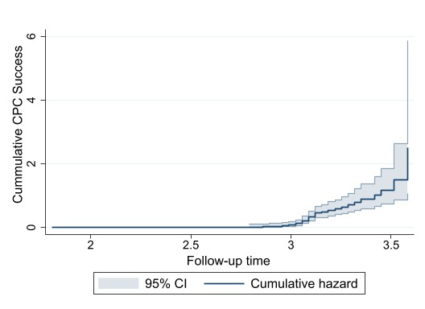

**Figure 2:** **Nelson Aalen estimator curve in contest of participant achieving success overtime.**

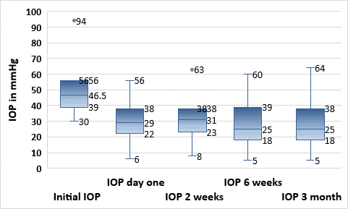

**Figure 3: Illustration of IOP change from initial to 3 months follow-up time (N-74)**

**Complications following limited CPC in refractory glaucoma patients treated at KCMC Ophthalmology Department.**

During follow up, post CPC uveitis was the most observed complication in 8 (10.8%) patients, followed by cystoid macular edema observed in 6(8.1%) and only 2(2.7%) experienced IOP of less than 6mmHg.

## 

**Factors associated with the change in intraocular pressure (IOP) following limited Cyclophotocoagulation (CPC)**

**Table 2** summarizes factors associated with CPC success in both crude and adjusted analysis. In crude analysis pre-operative IOP, cup disk notching and associated commodities were factors that significantly associated with CPC success.

Stepwise regression retained pre-operative IOP, cup disk notching and associated commodities, whereas age and sex were retained prior as potential confounders. Hence, the final model was adjusted for Age, sex, pre-operative IOP, cup disk notching and associated commodities. Variables that remained significant associated with CPC success in adjusted analysis were pre-operative IOP, cup disk notching and associated commodities.

Participants were 7% significant less likely to have CPC success [AHR=0.93; 95%CI (0.89-0.97)] after every 1 mmHg increase in IOP. Individuals with cup disk notching were approximately 2.4 times significant more likely of having CPC success compared to those with no cup disk notching [AHR=2.39; 95%CI (1.10-5.19)], while compared to systemic diseases, Participants with ocular disease were 66% significant less likely of having CPC success [AHR=0.34; 95%CI (0.15-0.79)]

**Table 2: Factors associated with CPC success**

|  |  |  |  |  |
| --- | --- | --- | --- | --- |
| **Variable** | **CHR (95%CI)** | **P-value** | **AHR (95%CI)** | **P-value** |
| **Patients Age** |  |  |  |  |
| ≤60 | Ref |  | Ref |  |
| >60 | 1.30(0.65-2.62) | 0.459 | 1.40(0.65-2.98) | 0.388 |
| **Patient Gender** |  |  |  |  |
| Male | Ref |  | Ref |  |
| Female | 1.58(0.81-3.08) | 0.181 | 2.11(0.99-4.47) | 0.051 |
| **Initial IOP** | 0.94(0.91-0.98) | 0.003 | 0.93(0.89-0.97) | 0.001 |
| **Vertical CDR** | 0.94(0.77-1.16) | 0.573 | - | - |
| **Fundoscopy Cup Disc Notching** |  |  |  |  |
| Yes | 2.19(1.07-4.50) | 0.032 | 2.39(1.10-5.19) | 0.028 |
| No | Ref |  | Ref |  |
| **Optic Disc Hemorrhage** |  |  | - | - |
| Yes | Ref |  | - | - |
| No | 0.78(0.27-2.23) | 0.643 | - | - |
| **Type of glaucoma** |  |  | - | - |
| Primary glaucoma | Ref |  | - | - |
| Secondary glaucoma | 0.48(0.23-1.01) | 0.052 | - | - |
| **Associated Comorbidities disease** |  |  | - | - |
| Systemic Disease (HTN/DM/ETC) | Ref |  | Ref |  |
| Ocular Disease | 0.39(0.18-0.83) | 0.015 | 0.34(0.15-0.79) | 0.012 |

## **Discussion**

This study evaluated the efficacy of limited TSCPC in lowering IOP among adult patients with refractory glaucoma treated at KCMC Eye department. Although traditionally it is reserved for advanced disease or palliative care, CPC is increasingly being reconsidered for broader use due to improvement in technique and understanding of its safety profile.

Our findings demonstrate that limited CPC significantly reduces IOP in patients with refractory glaucoma. A single treatment session led to an average IOP reduction of 46.2% from the baseline at 3 months, with nearly half (48.6%) of patients achieving the target IOP of ≤ 21mmHg. These results align with widely reported success rates in global studies ranging between 40% and 60%, such as those by(10) and (11) who reported success rates of approximately 50% . Similarly, (12) in Serbia reported a 45% success rate at 6months, increasing to 55% at 12 months, while (13) in Turkey also reported a comparable cumulative success rate of 46.6% at one year post treatment. These consistent results across diverse populations support CPC’s general effectiveness.

Comparable findings have also been reported in Sub Saharan Africa. In Malawi, (14) observed a 50% success rate at 3months post CPC and 50% of participants required retreatment. In South Africa,(15) documented success rates ranging from 40% to 60% highlighting the role of treatment parameters such as laser power and the extent of ciliary body coverage. Similarly(16) in retrospective study conducted in Tanzania, reported success rates between 43% and 53% following TSCPC.

Some studies have reported higher success rates, for example, (17) in Nigeria observed a 73% success rate after 12 months of follow up. In another prospective study, (18) evaluated CW-TSCPC in patients with different types of glaucoma and reported success rates between 55% and 65%. (19) similarly reported a 65% success rate. These higher outcomes may be attributed to the use of individualized treatment protocols, optimized laser energy settings, careful patient selection and intraoperative adjustments tailored to patient specific ocular characteristics.

In exploring predictors of treatment success, our study found that pre operative IOP and the presence of ocular comorbidities significantly influenced CPC outcomes. Patients presenting with lower baseline IOP were more likely to achieve successful pressure reduction, a finding supported by (10), (11) and (20), who similarly highlighted the predictive value of baseline IOP. The inverse correlation between higher baseline IOP and treatment success may reflect more advanced disease or reduced responsiveness of the ciliary body to laser ablation.

The presence of ocular comorbidities significantly reduced the likelihood of achieving IOP control by 67%. Conditions like corneal opacity, uveitis, exfoliation syndrome and trauma related changes can interfere with laser delivery or alter ocular anatomy, making treatment less effective. Corneal edema, commonly observed in patients with advanced disease, can obscure visualization during CPC, scatter or absorb laser energy and hinder precise application of treatment leading to suboptimal ablation and diminished pressure reduction. Our findings align with other studies like those by(11) and (20), which linked conditions like exfoliation syndrome and prior cyclodestruction with poor outcomes. On the contrary,(10) and (17) reported no significant association of patient specific characteristics like age, sex and comorbidities with the treatment success, highlighting the diversity of outcomes across different populations.

Moreover, the optic disc notching was found to correlate with better outcomes compared to fully cupped optic nerve disc. This might be explained by the fact that notching typically indicates localized damage, whereas full cupping suggests more advanced and diffuse nerve fiber loss. Patients with notching may thus retain some functional nerve tissue capable of responding to IOP lowering therapy. However this result contrast with (10) who associated notching with poorer outcomes, reflecting the complexity and variability in glaucomatous progression and treatment response.

Complications were generally mild and manageable. The most common observed complication was post CPC uveitis, seen in 10.8% of the patients and resolved with topical corticosteroids. This aligns with findings from (15), (20) and (11), all of whom reported transient inflammatory responses following CPC.

Cystoid macular edema (CME), particularly in patients with diabetic retinopathy or prior retinal treatment was the second most prevalent, affecting 8.1% of the patients. A few patients required intravitreal steroids, and two experienced persistent edemas with subsequent vision loss. These findings necessitate the importance of pre operative screening and risk assessment particularly in patients with known macular vulnerabilities.

Hypotony occurred in 2.7% of patients but was transient with no cases of phthisis bulbi at three months. Continued follow up is warranted to monitor for long term sequelae. These complications align with those reported by (10), (17) and (15), who noted transient hypotony as a potential but relatively uncommon consequence of CPC.

This study findings reinforce the efficacy of limited CPC in reducing IOP among patients with refractory glaucoma, while also highlighting the role of baseline characteristics and comorbidities in determining outcomes. The treatment success rates, complications and predictive factors observed in this Tanzanian cohort are broadly consistent with those documented in other geographic and clinical settings, adding to the growing body of evidence supporting CPC as a practical option in glaucoma management. However, careful patient selection, standardized technique and vigilant post procedure monitoring remain essential to maximize efficacy and minimize risks.

## **Conclusion**

This study demonstrates that limited TSCPC applied to 180° of the ciliary body, offers a moderate but clinically meaningful reduction of IOP among patients with refractory glaucoma. The procedure was generally safe with a low incidence of significant complications, the most common being transient uveitis.

A success rate of 48.6% was observed, with efficacy closely linked to baseline IOP and the presence of optic disc notching. Conversely, patients with ocular comorbidities or advanced optic disc cupping showed reduced treatment success.

**Recommendations**

Based on the findings of this study, limited TSCPC can be considered as a viable treatment option for patients with refractory glaucoma, particularly when conventional therapies have failed. Performing TSCPC over 180° is recommended as a safer alternative to more extensive treatment especially in patients at higher risk for complications. Future research should focus on optimizing laser parameters such as energy settings, pulse duration and number of burns to improve efficacy while reducing adverse effects. Long term follow-up studies are also essential to evaluate sustained IOP control, retreatment rates and late onset complications.

COMPETING INTERESTS DISCLAIMER:

Authors have declared that they have no known competing financial interests OR non-financial interests OR personal relationships that could have appeared to influence the work reported in this paper.

REFERENCES

1. Wagner I V., Stewart MW, Dorairaj SK. Updates on the Diagnosis and Management of Glaucoma. Mayo Clin Proc Innov Qual Outcomes [Internet]. 2022;6(6):618–35. Available from: https://doi.org/10.1016/j.mayocpiqo.2022.09.007

2. Adebayo A, Laroche D. Unfulfilled Needs in the Detection, Diagnosis, Monitoring, Treatment, and Understanding of Glaucoma in Blacks Globally. J Racial Ethn Heal Disparities [Internet]. 2023;(0123456789):1–6. Available from: https://doi.org/10.1007/s40615-023-01679-2

3. Zhang N, Wang J, Li Y, Jiang B. Prevalence of primary open angle glaucoma in the last 20 years: a meta-analysis and systematic review. Sci Rep [Internet]. 2021;11(1):1–12. Available from: https://doi.org/10.1038/s41598-021-92971-w

4. Kyari F, Abdull MM, Bastawrous A, Gilbert CE, Faal H. Epidemiology of glaucoma in Sub-Saharan Africa: Prevalence, incidence and risk factors. Middle East Afr J Ophthalmol. 2013;20(2):111–25.

5. Smith AF, Negretti G, Mascaro A, Bokre D, Baker H, Dhalla K, et al. Glaucoma Control Strategies in Sub-Saharan Africa: A Review of the Clinical and Health Economic Evidence. Ophthalmic Epidemiol. 2018;25(5–6):419–35.

6. Allison K, Patel D, Alabi O. Epidemiology of Glaucoma: The Past, Present, and Predictions for the Future. Cureus. 2020;12(11).

7. Ting NS, Li Yim JFT, Ng JY. Different strategies and cost-effectiveness in the treatment of primary open angle glaucoma. Clin Outcomes Res [Internet]. 2014;6:523–30. Available from: https://doi.org/10.2147/CEOR.S30697

8. Boboev SA. STAGES OF ETIOLOGY , PATHOGENESIS , DIAGNOSIS , TREATMENT OF REFRACTER GLUCOMAS. 2022;(May):166–72.

9. Jammal AA, Costa DC, Vasconcellos JPC, Costa VP. Prospective evaluation of micropulse transscleral diode cyclophotocoagulation in refractory glaucoma: 1 year results. Arq Bras Oftalmol. 2019;82(5):381–8.

10. Quigley HA. Improved Outcomes for Transscleral Cyclophotocoagulation Through Optimized Treatment Parameters. J Glaucoma. 2018;27(8):674–81.

11. Souissi S, Baudouin C, Labbé A, Hamard P. Micropulse transscleral cyclophotocoagulation using a standard protocol in patients with refractory glaucoma naive of cyclodestruction. Eur J Ophthalmol. 2021;31(1):112–9.

12. Miljković A, Babić N, Čanadanović V, Davidović S, Ljikar J, Vasin M. Efficacy of cyclocryotherapy and transscleral diode laser cyclophotocoagulation in the management of refractory glaucoma. Acta Clin Croat. 2021;60(2):171–7.

13. Aygün FB, Mocan MC, Kocabeyoğlu S, İrkeç M. Efficacy of 180° cyclodiode transscleral photocoagulation for refractory glaucoma. Turkish J Ophthalmol. 2018;48(6):299–303.

14. Schulze Schwering M, Kayange P, Klauss V, Kalua K, Spitzer MS. Low-dose transscleral diode laser cyclophotocoagulation (TSCPC) as a potential single treatment for primary open-angle glaucoma (POAG) in Malawi? Graefe’s Arch Clin Exp Ophthalmol. 2013;251(10):2389–93.

15. Thomas JP. The Efficacy and Safety of Diode Laser Cycloablation in the Treatment of Refractory Glaucoma in a South African Population. 2022;(April).

16. Mavrakanas N, Dhalla K, Kapesa I, Alibhai A, Murdoch I. Diode laser transscleral cyclophotocoagulation for the treatment of glaucoma in East Africa. Eye. 2013;27(3):453–4.

17. Abdull MM, Broadway DC, Evans J, Kyari F, Muazu F, Gilbert C. Safety and effectiveness of primary transscleral diode laser cyclophotoablation for glaucoma in Nigeria. Clin Exp Ophthalmol. 2018;46(9):1041–7.

18. Aquino MCD, Barton K, Tan AMWT, Sng C, Li X, Loon SC, et al. Micropulse versus continuous wave transscleral diode cyclophotocoagulation in refractory glaucoma: A randomized exploratory study. Clin Exp Ophthalmol. 2015;43(1):40–6.

19. Shah P, Bhakta A, Vanner EA, Kishor KS, Greenfield DS, Maharaj ASR. Safety and efficacy of diode laser transscleral cyclophotocoagulation in eyes with good visual acuity. J Glaucoma. 2018;27(10):874–9.

20. Ariga M, Nivean, Nivean PD, Madanagopalan VG, Mohan S. Micropulse trans-scleral diode laser cyclophotocoagulation in refractory glaucoma: an initial experience in Indian eyes. Int Ophthalmol [Internet]. 2021;41(8):2639–45. Available from: https://doi.org/10.1007/s10792-021-01697-1