**Study of the microbiological quality of cowpea dishes sold at the Abdou Moumouni University (UAM), Niamey, Niger**

**ABSTRACT**

In urban areas, cowpea artisanal processing is mainly focused on cowpea fritters (Kossay in Hausa and kaikaina in zarma) and cowpea-based soup, also known as Doungouri Harri Harri (DHH). The overall objective of this study is to contribute to the improvement of the hygienic quality of cowpea-based products. To do this, six contamination indicators were searched (Total Mesophilic Aerobic Flora (TMAF), total coliforms (TC), fecal coliforms (FC), *Escherichia coli*, yeasts and molds (LM) and *Salmonella*) according to the ISO methods appropriate to each contamination indicator. The results show high levels of contamination in FAMT, CT, FC and LM respectively 1.40 ± 1.37.107, 2.12 ± 2.54.106, 2.18 ± 2.46.106, 2.50 ± 3.54.103 CFU/g of product. Samples of cowpea soup with ingredients are more contaminated than samples of soup without ingredients and doughnut samples. Only three (3) samples were contaminated with E. coli. Three (3) significant differences were recorded between the indicators of contamination and type of products. One concerns the TMAF (P-value = 0.047) and the other total coliforms (TC) (P-value = 0.029) and fecal coliforms (CF) (P-value = 0.048). Indeed, the contamination indicator loads recorded are mostly higher than the standards. As a result, the sanitary quality of these products is low. It is therefore necessary to make sellers aware of the strict compliance with good hygiene practices for a healthy product, as well as the risks and diseases to which they expose consumers in the event of non-compliance with these rules of good practice.

**Keywords:** cowpea dishes, microbiological quality, contamination, risks.

**INTRODUCTION**

Cowpea, also known as the "black-eyed bean", is a plant in the *Fabaceae* and gender *Vigna* (*Vigna unguiculata* L. Walp.) native to tropical Africa, several subspecies of which are grown as food plants that offer, as a legume, a valuable source of high-quality vegetable protein. It is grown for its seeds, pods, and leaves for food and livestock (HCI3N, 2022). It plays an important role in human nutrition, food security, and income generation for farmers and food vendors in the region (IITA, 2017). Niger is one of the major producers of cowpeas in West Africa. Its production is second only to that of Nigeria, which produces 75% of the total in West Africa (NIPN, 2021). According to data from the Directorate of Agricultural Statistics, the production of grain cowpea in Niger during the 2020 season is about 2.6 million tons. From 2010 to 2020, production grew at an average annual rate of 7% (RECA, 2022). Cowpea has become one of the main agricultural export products after the decline of groundnuts. It is an alternative crop on which producers base their hope even in the event of poor rainfall or a late agricultural season, as it generally manages to complete the production cycle, which is rarely the case for cereals (SNV, 2013). Under these conditions, it offers producers the opportunity to obtain income, food products and livestock feed through the use of haulms (SNV, 2013). The quantity of cowpea consumed per capita is traditionally quite low in Niger. In contrast, it is estimated that 50% to 75% of Niger's cowpea production is exported mostly informally (NIPN, 2021). In Niger, most cowpea products are consumed, but the forms of consumption vary according to the region and the time of year. Cowpea consumption habits mean that some forms predominate over others, with notable differences between rural and urban areas (HCI3N, 2022). Raw products (grains, leaves, young pods) and those of primary processing (flour, semolina, broken pieces, dough) are more the prerogative of rural families, while urban households are fond of snacks (doughnuts, pancakes) and cooked or uncooked novelties (cowpea macaroni, Béroua, couscous, etc.). The present study concerns two cowpea products: cowpea fritter and cowpea soup. The cowpea fritter (Kossay in Hausa and kaikaina in Zarma) and the cowpea-based soup commonly known as Doungourri Harri Harri (DHH) are flagship products in the artisanal processing of cowpeas in urban areas. The overall objective of this study is to contribute to the improvement of the microbiological quality of cowpea-based doughnuts and soups sold at the Abdou Moumouni University in Niamey.

**MATERIALS AND METHODS**

**Study area**

Our study was carried out at the Abdou Moumouni University of Niamey (UAM), located on the right bank of the Niger River in the communal district of Niamey. Sampling was carried out by the simple random method in the university areas and the samples were taken from the university halls of residence, the front of the faculties and the CHU.

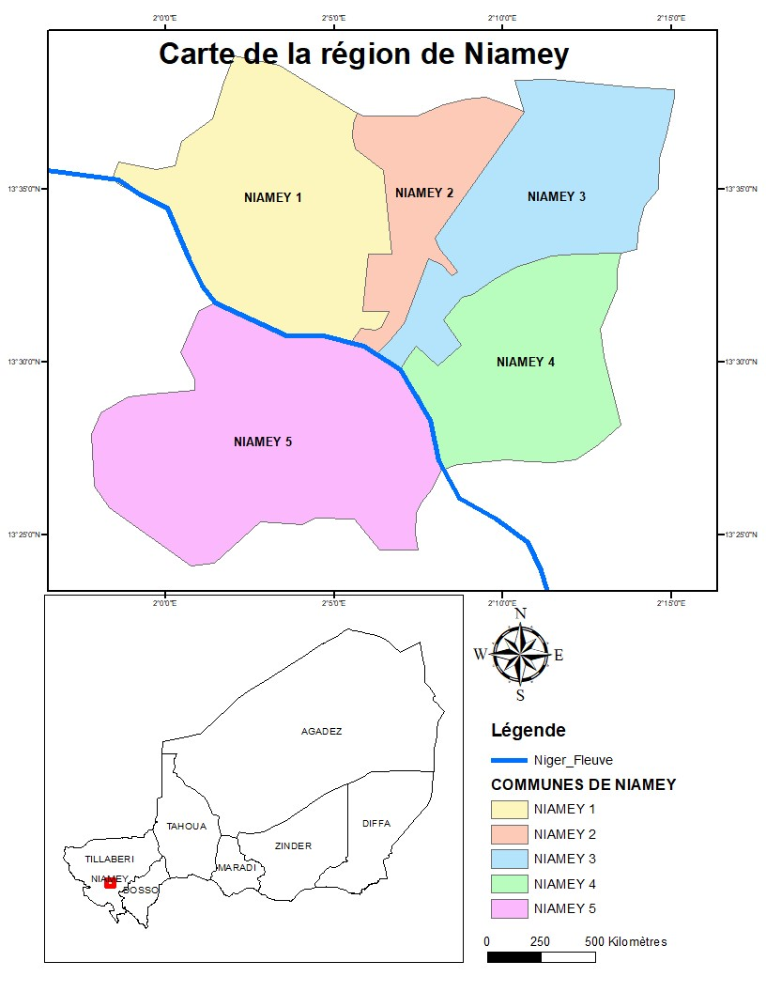

* UAM

Figure 1. Mapping the study area

**Bacteriological analysis**

***Preparation of culture media***

The preparation of culture media consists of diluting the appropriate amount of each lyophilized medium in 1 L of distilled water, then placing these solutions on a hot plate until boiling. Subsequently, the solutions are sterilized in an autoclave at 121°C for a period of 15 minutes.

***Preparation of stock solutions***: ISO 6887-V08-010-6 (**2013**) was used for the preparation of stock solutions. Thus, 10 g of each cowpea fritter sample or soup was weighed and poured into a vial containing 90 ml of buffered peptone water (BPW) after grinding. The filtrate obtained is homogenized for 45 minutes under magnetic agitation. This stock suspension solution was used to achieve a series of decimal dilutions. For this purpose, 1 mL of the stock suspension was introduced into a test tube containing 9 mL of sterile buffered peptone water, using a sterile graduated pipette to obtain a 10-2 solution. Then, 1 mL of this test tube was introduced into another test tube containing 9 mL of the diluent, and so on until a 10-4 solution was obtained.

* The TMAF enumeration was carried out according to the ISO V08-051(1992) / ISO 4833 standard on PCA (Plat Count Agar) agar. Incubation was done at 37° C for 24 hours in the oven. All colonies that have grown on the surface have been counted.
* Total and faecal coliform counts were performed according to the standard (ISO V 08-015 (1991) / ISO 4832 and ISO V 08-017 (**1996**)) on Mac Conkey agar. The boxes were incubated at 37 °C (total coliforms) and 44°C (faeces) for 24 hours. Bright red to pinkish colonies were counted.
* *Escherichia coli* is a member of the *Enterobacteriaceae family*. It is considered a good indicator of fecal contamination. The search for *E.coli* was carried out on EMB (Eosine Methylene Blue) medium according to the ISO 3811 method. The incubation of the petri dishes was done at 37°C for 24 hours. Blue colonies with metallic reflections were counted.
* Yeasts and moulds have been counted according to the NF **V08 059: (2002) standard on Sabouraud chloramphenicol agar.** The seeded dishes were incubated at 37°C for 72 hours. The colonies (lenticular, round, deep in the agar, generally white for yeasts and filamentous colonies, downy on the surface for moulds) were observed and counted.

The search for *Salmonella* was carried out in two stages: enrichment on liquid selective medium (Rappaport Vassiliadis), and isolation on SS solid selective medium (Salmonella-Shigella).

* Enrichment: 0.1 mL of the sample already pre-enriched in peptone water was introduced into a sterile test tube containing 10 mL of Rappaport Vassiliadis. The mixture was homogenized and incubated for 24 hours at 42°C.
* Isolation: Cultures in Rappaport Vassiliadis medium were inoculated on the surface of SS (Salmonella-Shigella) solid selective medium using a platinum loop. The boxes were turned over and incubated for 18 to 24 hours at 37°C.

***Reading and Interpretation***

According to the French standard V 08-011, each box retained must contain a maximum of 300 colonies and at least 15 colonies. The number of microorganisms per gram of the sample was calculated from the boxes retained at the level of two successive dilutions by applying the formula below:

N = $\frac{\sum{C}}{v(n1+n2*0,1)d}$

* Σc = Total number of colonies counted in the boxes with a number of colonies between 15 and 300.
* n1 = number of boxes counted from the first dilution;
* n2 = number of boxes counted from the second dilution;
* v = volume inoculated, generally 0.1ml;
* D = dilution factor from which the 1st counts were made.

**Statistical analysis**

The data were subjected to frequency, mean and standard deviation calculations using IBM SPSS Statistics 23 software. Then, the non-parametric Kruskal-Walis tests were performed to test not only the variability between the different samples. The differences are considered significant for *P-value<0.05 values*. Finally, Microsoft Excel software was used to generate the tables and graphs. The document was developed on Microsoft Word and the arc Gis software was used for the design of the geographical map of the study area.

**RESULTS**

Table **I** shows the average loads of TMAF and *E. coli* from the doughnut samples and cowpea soup (locally referred to as DHH). The results show that the loads in TMAF range from 1.08 ± 1.31.105 to 1.26 ± 0.97.107 CFU/g of doughnuts and those of soup from 6.50 ± 4.95.104 to 1.40 ± 1.37.107 CFU/g of soup. The recorded loads are high and above the reference criteria with the exception of the samples (Ev1b1, Ev3b1, Ev1H1 and Ev2H1). The one-way analysis of variance (ANOVA) divides the samples into three (3) distinct groups. The difference is significant between the expenses (P-value = 0.047). For *E. coli* loads, only three (3) samples are loaded (Ev2b1, Ev1b2 and Ev2H2 respectively 1.25 ± 1.77.104; 1.15 ± 1.20.104 and 2.50 ± 3.54.102 CFU/g of product). All these charges are above the standards. The difference is not significant between these expenses (P-value = 0.120).

**Table I. Contamination levels of cowpea doughnut and cowpea soup samples in FAMT and *E. coli***

|  |  |  |
| --- | --- | --- |
|  | **Mean ± standard deviation** | |
| **FAMT** | ***E. coli*** |
| Ev1b1 | 1.20 ± 1.13.105c | 0 |
| Ev2b1 | 3.98 ± 0.67.105bc | 1.25 ± 1.77.104a |
| Ev3b1 | 1.08 ± 1.31.105c | 0 |
| Ev1b2 | 4.07 ± 2.80.106ab | 1.15 ± 1.20.104a |
| Ev2b2 | 1.26 ± 0.97.107a | 0 |
| Ev3b2 | 3.24 ± 1.44.106ab | 0 |
| Ev1H1 | 6.50 ± 4.95.104c | 0 |
| Ev2H1 | 2.15 ±1.91.105c | 0 |
| Ev1H2 | 1.40 ± 1.37.107a | 0 |
| Ev2H2 | 6.19 ± 4.40.106a | 2.50 ± 3.54.102a |
| Norm | 1.0. 103cd | 1.0. 10a |
| P-value | 0,047 | 0,120 |

Table **II** shows the levels of contamination of cowpea doughnut and cowpea soup samples in total and faecal coliforms. No total and fecal coliform germs were detected in sample Ev3b1. All the loads obtained are higher than the standards defined by AFNOR. Loads range from 7.00 ± 2.83.103 to 2.12 ±2.54.106a CFU/g for total coliforms and 1.00 ± 1.41.103cd to 2.18 ±2.46.106a CFU/g for fecal coliforms. It was found that E2V1DHH (2.12±2.54.106 CFU/g), with ingredients (maggi, mayonnaise, oil and chili), were more contaminated than samples without E1V2DHH ingredients (7.00±2.83.103 CFU/g). The differences are significant differences between total and fecal coliform loads (P-value = 0.029 and P-value = 0.048 respectively).

**Table II. Contamination levels of cowpea doughnut and soup samples in Total Coliforms (TC) and Feces (FA)**

|  |  |  |
| --- | --- | --- |
| **Name** | **Mean ± standard deviation** | |
| **CT** | **CF** |
| E1V1B | 0 | 5.00 ± 7.07.103cd |
| E1V2B | 1.31 ± 0.09.105bc | 1.58 ± 0.81.104bc |
| E1V3B | 0 | 0 |
| E2V1B | 7.96 ± 3.73.105a | 5.55 ± 0.49.105ab |
| E2V2B | 1.84 ± 1.93.106a | 1.40 ± 0.79.106a |
| E2V3B | 1.86 ± 1.62.105b | 2.00 ± 0.00.104bc |
| E1V1DHH | 1.63 ± 0.53.104bcd | 1.55 ± 2.06.105bc |
| E1V2DHH | 7.00 ± 2.83.103de | 1.00 ± 1.41.103cd |
| E2V1DHH | 2.12 ± 2.54.106a | 2.18 ± 2.46.106a |
| E2V2DHH | 1.42 ± 0.67.106a | 1.88 ± 2.49.106ab |
| Norm | 104 | 103cd |
| P-value | 0,029 | 0,048 |

Table III shows the levels of yeast and mould contamination in cowpea fritter and soup samples. All recorded loads except for sample E2V1B (0.75 ±1.06.103CFU/g), are above the microbiological reference criterion for cowpea products. The E1V2DHH and E2V2DHH samples were more contaminated with loads of 2.03 to 2.79.104 CFU/g and 1.25 ± 1.77.104a CFU/g respectively. It has been observed that cowpea soup samples are more contaminated than doughnuts, regardless of its condition (with or without ingredients). The difference is non-significant (P-value = 0.982).

**Table III. Contamination levels of cowpea doughnut and soup samples in Yeasts and Molds (LM)**

|  |  |  |
| --- | --- | --- |
| **Average sample load in LM (CFU/g)** | | |
| **NAME** | **Mean ± standard deviation** | **P-value** |
| E1V1B | 5.25 ± 6.72.103a | 0,982 |
| E1V2B | 1.75 ±2.47.103a |
| E1V3B | 2.50 ± 3.54.103a |
| E2V1B | 0.75. ± 1.06.103a |
| E2V2B | 3.25 ± 2.47.103a |
| E2V3B | 2.75 ± 3.89.103a |
| E1V1DHH | 2.50 ± 3.54.103a |
| E1V2DHH | 2.03 ± 2.79.104a |
| E2V1DHH | 2.03 ± 2.79.104a |
| E2V2DHH | 1.25 ± 1.77.104a |
| **Norm** | 1,0. 103 | |

* + - 1. **Presence of pathogen (*Salmonella spp*) in some samples**

Figure 2 shows the level of salmonella contamination of cowpea doughnut and soup samples. It is apparent from this figure that 50% of the doughnut samples are contaminated with Salmonella and 25% of the soup samples.

**Figure 2. Results of Pathogen germ (*Salmonella spp*)**

**DISCUSSION**

The objective of this study is to analyze the quality of cowpea-based products (in particular cowpea fritter and soup) sold at the Abdou Moumouni University of Niamey. The results highlighted a significant risk to public health associated with the consumption of cowpea products. The high level of contamination by hygienic indicator and pathogenic microorganisms shows a failure in hygiene practices.

The TMAF provides an indication of the degree of general contamination of the food for its acceptability for consumption. It is also called food spoilage flora (Kasse et *al.,* 2014). The study highlighted the presence of TMAF in cowpea doughnut and cowpea soup samples. The recorded TMAF loadings range from 6,50,104 to 1,40,107 CFU/g. Only three (3) samples (Ev1b1, Ev3b1, Ev1H1 and Ev2H1) have loads below the microbiological standards for cowpea products. In contrast to our results, Sare *et al*., (2023) recorded below-standard loads in TMAF in samples from Toubani, a traditional African delicacy made from cowpeas. This high load of TMAF could be explained on the one hand by the overload of the sales environment with microorganisms and on the other hand by the sick or healthy carrier staff who handle the products. A low-skilled workforce, traditional and unsatisfactory processing methods do not allow staff to work in good hygienic conditions (Aboubacar et *al.,* 2013).

Total and faecal coliforms give an idea of the hygienic conditions during the manufacture and storage of the product. They are indicators of the hygiene of the processing and its environment. All the recorded loads are higher than the standards defined by AFNOR. The high presence of these germs could be explained by their ubiquitous nature. These bacteria, which are widespread in the environment and are saprophytic to humans and warm-blooded animals, are found in meals during processing (N'goran-Aw *et al.,* 2018).

*Escherichia coli* is a coliform that indicates faecal contamination of human origin and therefore a sign of the hygiene of the processor. It also provides an indication of the presence of possible enteric pathogenic strains (Kasse *et al*. 2014). Some samples of cowpea fritters and soup are free of *Escherichia coli*. However, the samples Ev2b1, Ev1bé and Ev2H2 are contaminated with *Escherichia coli* and all above the standards.

For all the indicators of contamination sought, the high contaminations are recorded in the cowpea soup samples. In addition, samples with ingredients are more contaminated than samples without ingredients. Price and Schweigert (1971) noted that unless spices are used to reduce microbial load, they can also be a source of a large number of germs in the product to which they are added.

The high level of microorganisms recorded in this survey may be related to inadequate hygiene measures taken during production. In addition, street food is often prepared in a traditional and manual way with household equipment. Materials used in direct contact with these foods can contaminate them. Contamination can also come from the environment in which the food is handled. It is possible that the methods of preparing, storing and preserving these foods are the main source of contamination. Indeed, it is crucial to control the relationship between temperature and time when preparing food. It is necessary to respect certain conditions for the preservation of food. Thus, Igene et *al.* (2016) stated that critical control point analysis significantly improves the microbiological quality, sensory attributes and storage stability of food.

**CONCLUSION**

This study evaluated the microbiological quality of cowpea fritter and soup samples produced and sold at Abdou Moumouni University. The results revealed that the people selling these cowpea products are usually uneducated and do not have a sales license or a medical certificate. Hygiene standards are not respected at the time of sale of these foods. Most of the samples have bioloads above the AFNOR standards for cowpea-based products. The presence of hygienic indicator and pathogenic microorganisms, indicating a low level of hygiene at the time of processing and sale of these products. It would be important to raise awareness and train the actors of the sector on the application of good hygiene practices.

**References**

**1. AFNOR (1996). Microbiological Analysis: Horizontal Methods. Paris: French Association for Standardization (AFNOR): 1,521 pages**

**2. AFNOR (1988). "Quality Control of Food Products: Sensory Analysis." Paris: French Association for Standardization (AFNOR); 222 pages**

**3. HCI3N (2022): Prospective Analysis of the Cowpea Value Chain in Niger 2021-2030. SOFRECO-HCI3N. EU. p. 135.**

**4. IITA / CGIAR (2017): Guide to Cowpea Production in West Africa, p. 61.**

**5. INS, National Institute of Statistics, Niamey Regional Directorate (2015). Regional Statistical Yearbook 2010-2014. 82 pages.**

**6. INS, National Institute of Statistics, Niamey Regional Directorate., (2022). Niamey in Figures. Leaflet, 2022 edition. 1 p.**

**7. PNIN (2021). National Nutrition Information Platform, Volume 2: Identification of Foods for Mass Consumption for Their Micronutrient Fortification, PNIN, Niger, 2021). Available at: https://pnin-niger.org**

**8. RECA (2022). Prospective Analysis of the Cowpea Value Chain in Niger 2021-2030. Available at: https://reca-niger.org/IMG/pdf/l4_etude_niebe.pdf**

**9. SNV (2013): Market Study of Cowpea Processing Products. P70**

**10. Aboubacar AM. (2023). "Hygienic Quality Control of Street Food Sold in Schools in Niamey (Niger)." Dissertation for the Master's Degree in Nutrition, Food, and Food Science (NASA): Faculty of Science and Technology, Abdou Moumouni University, Niamey. P75**

**11. Igene U., Ebabhamiegbebho E. (2016). Shelf-Life Stability Studies of Kilichi Product from the University of Benin (Uniben), Prof. Asian Journal of Science and Technology, 7: 2268-2274.**

**12. Price JF., Schweigert BS. (1971). The Science of Meat and Meat Products. New York: W.H. Freeman and Company.**

**13. N'goran-Aw EBZ., Coulibaly JK., Assidjo EN., N'gatta C. (2018). Microbiological Quality of Corn Flour Sold in the Markets of Abidjan (2018). Moroccan Journal of Agronomic and Veterinary Sciences 6(4): 476-482.**

**14. Kasse M., Cissé M., Touré A., Ducamp-Collin A., Guisse A., (2014). Microbiological Quality of Mango Slices (Mangifera indica L.) Sold in Dakar, Senegal. International Journal of Biological and Chemical Sciences 8(4): 1611-1619.**