Biochemical Characterization of *Escherichia coli* and Other *Enterobacteriaceae* from Smoked and Dried Fish in Chad

.

ABSTRACT

|  |
| --- |
| **Aims:** To assess the microbiological safety of smoked and dried fish by detecting and characterizing Escherichia coli strains and other members of the Enterobacteriaceae family.  **Study design:** Cross-sectional descriptive udy  **Place and Duration of Study:** Conducted at the Laboratory for Research in Food Science and Nutrition (LaRSAN), University of N’Djamena in Chad, and the Laboratory of Biochemistry and Applied Immunology (LaBIA), Joseph KI-ZERBO University in Burkina Faso, between March 2024 and October 2024.  **Methodology:** A total of 150 samples of smoked and dried fish were collected from various processing sites around Lake Fitri, Chad. Samples were analyzed for microbial contamination. Bacterial isolation was performed on selective media, and 25 bacterial strains were obtained. Biochemical identification of isolates was conducted using the API 20E system. Identification focused on *Escherichia coli* and other Enterobacteriaceae.  **Results:** The analysis revealed a significant diversity within the Enterobacteriaceae family, including 19 Escherichia coli strains and 6 strains distributed among Serratia spp., Enterobacter sakazakii, Enterobacter aerogenes, Stenotrophomonas maltophilia, and Raoultella ornithinolytica. The presence of hygiene indicator bacteria and potential pathogens highlights a health risk for consumers. These findings indicate significant microbial contamination in smoked and dried fish, necessitating urgent improvements in processing and storage hygiene.  **Conclusion:** The study demonstrates that smoked and dried fish from Lake Fitri present a potential public health risk due to contamination by pathogenic microorganisms. Strengthening hygienic practices during processing and storage is essential to ensure the microbiological safety of these products and to protect consumers' health. |

*Keywords: Microbiological safety, Enterobacteriaceae, Escherichia coli, smoked fish, dried fish, Chad.*

1. INTRODUCTION

Fish is an essential and accessible source of animal protein for a significant portion of the global population (Koranteng et al., 2014). Over the past 50 years, the global supply of fish for human consumption has grown at a rate surpassing population growth. Between 1961 and 2013, fish production increased by an average of 3.2% per year, nearly twice the rate of global population growth, leading to a notable rise in per capita fish availability (Griliopoulos, 2014; Jackson et al., 2016). In 2014, global capture fisheries and aquaculture produced 167.2 million tonnes of fish, with 93.4% originating from capture fisheries and 76% of freshwater fish production coming from aquaculture (FAO, 2018). Estimates suggest that over 90% of global fish production is destined for human consumption (Guny et al., 2014; FAO, 2018).

Africa contributed approximately 9.7 million tonnes to global fisheries production in 2012, accounting for nearly 6% of total output (FAO, 2016). Over the past decade, the continent’s contribution has increased from 1.2% to 2.2%, driven largely by the expansion of freshwater aquaculture in sub-Saharan Africa (FAO, 2018). Despite its significant potential, aquaculture in Africa remains underexploited, with less than 5% of its capacity utilized. Smoked fish constitutes 14% of global processed fish production, a proportion higher than the world average. While domestic fish catches have declined by 0.3 million tonnes in Asia, they have increased by 0.1 million tonnes across African countries (Kolging et al., 2016).

In developing countries such as Chad, processed fish products are often overlooked by governmental regulatory bodies. Many fish-producing regions lack technical assistance and quality control measures, despite the increasing prevalence of smoked and dried fish consumption in the Sahelian zone (Kolding et al., 2016; Gamane, 2017). In Chad, dried and smoked fish are the most commonly consumed forms (Gamane et al., 2017). Traditional preservation methods such as salting, drying, and smoking play a crucial role in extending shelf life and maintaining fish availability (Koranteng et al., 2014; Singleton et al., 2017). However, these techniques, along with inadequate processing and storage conditions, can compromise the microbiological safety of the final products, posing health risks to consumers.

This study investigates microbial contamination in smoked and dried fish to improve understanding of its microbial profile. The findings provide insights into microbial hazards, supporting efforts to strengthen fish safety and protect consumer health.

2. material and methods

**2.1 Study Area and Sampling**

The study was conducted on four islands of Lake Fitri (Doumrou, Maguiti, Birguimi, and Moudou) as well as at Yao market, where smoked and dried fish are sold. Lake Fitri is located in the Batha region in central Chad, between 12°50'N and 17°30'E (Figure 1).

Sample collection took place between March 2024 and October 2024. A total of 150 smoked and dried fish samples were randomly collected from fish processors and fishermen. The samples were collected under aseptic conditions, transported to the laboratory under refrigeration at 4°C, and stored at this temperature until further analysis.

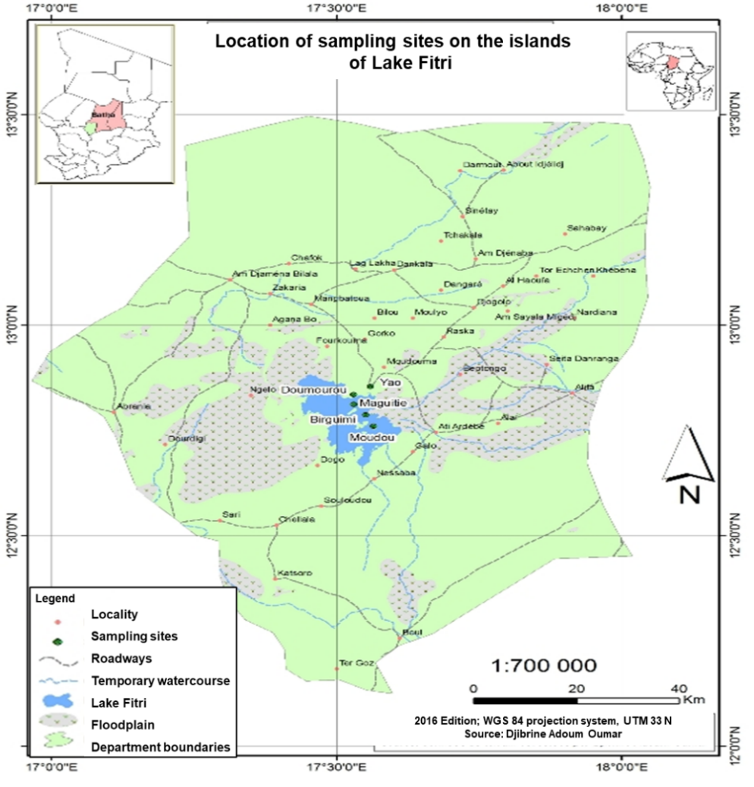

**Fig. 1. Map of the study area**

**2.2 Isolation of *E. coli* and Other Enterobacteria**

The isolation of enteropathogenic Escherichia coli and other Enterobacteria was performed using Eosin Methylene Blue (EMB) agar, following the NF ISO 4833 (2006) standard. Petri dishes containing EMB agar were inoculated with the fish sample suspensions and incubated at 37°C for 24 hours. Colonies exhibiting a metallic green sheen were selected and subcultured onto Mueller-Hinton (MH) agar for biochemical identification of enteropathogenic *E. coli.*

**2.3 Characterization of Isolated Strains**

Suspected colonies (E. coli and the others Enterobacteria) were subcultured on Mueller-Hinton (MH) agar (Liofilchem, Italy) and incubated at 37°C for 24 hours. After incubation, the presumptive E. coli colonies were selected and subjected to biochemical testing using API 20E and minimal biochemical tests.

**2.3.1 Minimal Biochemical Tests**

Suspected colonies were subcultured and confirmed using minimal biochemical tests. Kligler medium (BioMérieux, France) was used to assess glucose and lactose fermentation, as well as H₂S and gas production. Mannitol-motility medium was used to determine mannitol fermentation and bacterial motility, while citrate medium was used to evaluate citrate utilization. Urease-indole reagent was applied to detect urease activity and indole production (Colin, 2002).

**2.3.2 API 20E Identification**

The API 20E system was used to assess various enzymatic activities, including β-galactosidase (ONPG), arginine dihydrolase (ADH), lysine decarboxylase (LDC), ornithine decarboxylase (ODC), Simmons citrate utilization (Cit), hydrogen sulfide (H₂S) production, urease activity, tryptophan deaminase (TDA), indole production, acetoin production (VP test), gelatin hydrolysis (GEL), cytochrome oxidase activity, nitrite formation (Nit), and catalase activity. The system also evaluated carbohydrate fermentation, including glucose (GLU), mannitol (MAN), inositol (INO), sorbitol (SOR), rhamnose (RHA), sucrose (SAC), melibiose (MEL), amygdalin (AMY), arabinose (ARA), and lactose (L).

The API 20E system consists of 20 microtubes containing dehydrated substrates and colorimetric indicators. The tests were inoculated with a bacterial suspension adjusted to 0.5 McFarland, allowing the media to be reconstituted, and incubated at 37°C for 18 to 24 hours. The results were interpreted based on spontaneous color changes or revealed by the addition of reagents such as VP1, VP2, Nit1, and Nit2. Following reagent addition, the strain’s numerical profile was generated and compared against the API 20E analytical database (BioMérieux, ref. 20190) for species identification.

**2.4 Data Processing**

Data were analyzed using Microsoft Excel 2013, and figures were processed with Paint.net version 4.0.6.

3. results and discussion

**3.1 Results**

**3.1.1 Characteristics of the Isolated Strains**

Among the 25 strains isolated, 19 were confirmed as *Escherichia coli* and 6 were classified as other members of the Enterobacteriaceae family. The detailed results of the characterization of the isolated bacteria are summarized below.

**Table 1. Biochemical characteristics of the isolated bacteria**

|  |  |  |
| --- | --- | --- |
| **Strain codes** | **Identification by Minimal gallery** | **Identification by API 20E gallery** |
| 001 | *E. coli* | *E. coli* |
| 002 | *E. coli* | *E. coli* |
| 003 | *E. coli* | *E. coli* |
| 004 | *E. coli* | *E. coli* |
| 005 | *E. coli* | *E. coli* |
| 006 | *E. coli* | *E. coli* |
| 007 | *E. coli* | *E. coli* |
| 008 | *E. coli* | *E. coli* |
| 009 | *E. coli* | *E. coli* |
| 010 | *E. coli* | *E. coli* |
| 011 | *E. coli* | *E. coli* |
| 012 | *E. coli* | *E. coli* |
| 013 | *E. coli* | *E. coli* |
| 014 | *E. coli* | *E. coli* |
| 015 | *E. coli* | *E. coli* |
| 016 | *E. coli* | *E. coli* |
| 017 | *E. coli* | *E. coli* |
| 018 | *E. coli* | *E. coli* |
| 019 | *Enterobacter aerogenes* | -- |
| 020 | *Serratia spp* | *Serratia ficaria* |
| 021 | *E. coli* | *E. coli* |
| 022 | *Raoultella omniphinolytica* | *Raoultella omniphinolytica* |
| 023 | *Enterobacter sakazakii* | *Enterobacter sakazakii* |
| 024 | *Serratia spp* | *Serratia rubidcaea* |
| 025 | *Stenotrophomonas maltophilia* | *Stenotrophomonas maltophilia* |

**3.1.2 Biochemical characterization**

*3.1.2.1 Escherichia coli*

Biochemical analysis of the E. coli strains revealed the following profile: citrate (−), H₂S (−), glucose (+), lactose (+), gas (+), motility (+), urease (+), indole (+), and tryptophan deaminase (TDA) (+). While the production of urease, indole, and TDA is atypical for E. coli, identification using the API 20E system confirmed the classification as *Escherichia coli* as shown below (Figure 2).

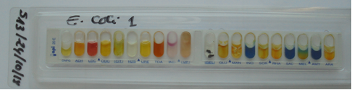

**Fig. 2. API 20E profile of *Escherichia coli***

*3.1.2.2 Enterobacter sakazakii*

This strain exhibited the following biochemical characteristics: citrate (+), H₂S (-), glucose (+), lactose (+), gas (+), motility (+), urease (-), indole (-), TDA (-). The API 20E system confirmed its classification as Enterobacter sakazakii as shown below (Figure 3).

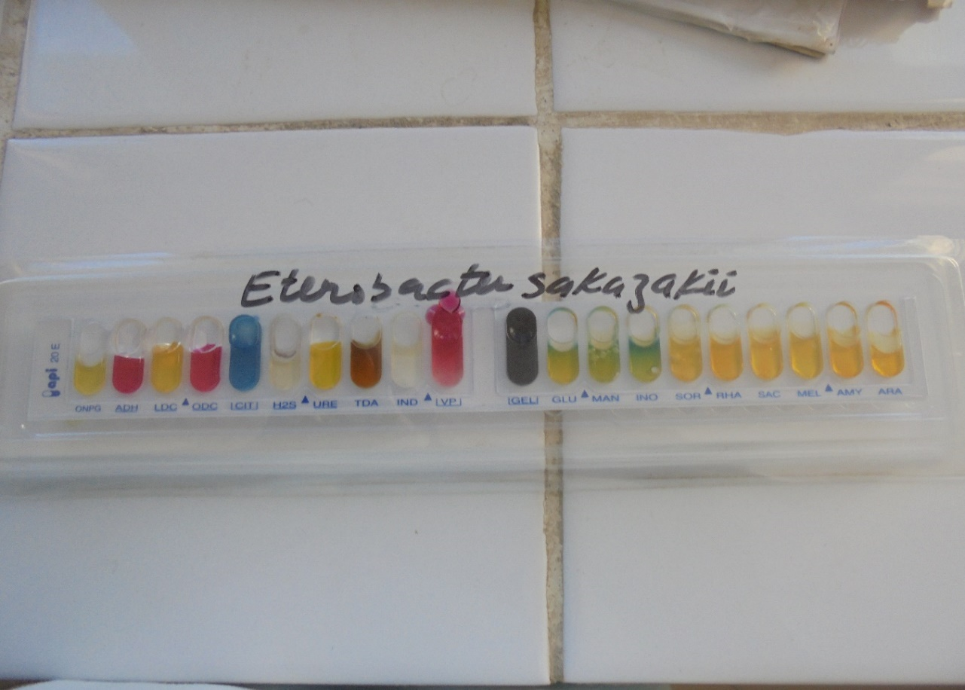

**Fig. 3. API 20E profile of *Enterobacter sakazakii***

*3.1.2.3 Serratia spp*

Biochemical testing showed the following profile: citrate (−), H₂S (+), glucose (+), lactose (−), gas (−), motility (−), urease (−), indole (−), and TDA (−). Based on the API 20E system, the strain was identified as Serratia spp. as shown below (figure 4).

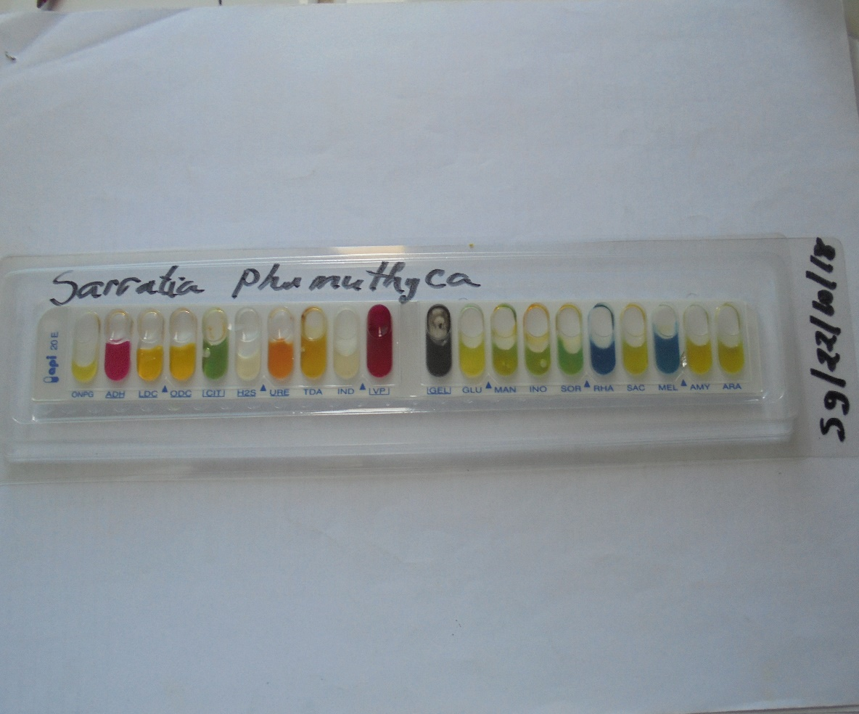

**Fig. 4. API 20E profile of *Serratia phumuthica***

*3.1.2.4 Enterobacter aerogenes*

This strain exhibited the following characteristics: citrate (+), H₂S (-), glucose (+), lactose (+), gas (+), motility (-), urease (-), indole (-), TDA (-). Identification using API 20E confirmed the strain as *Enterobacter aerogenes* given by figure 5.

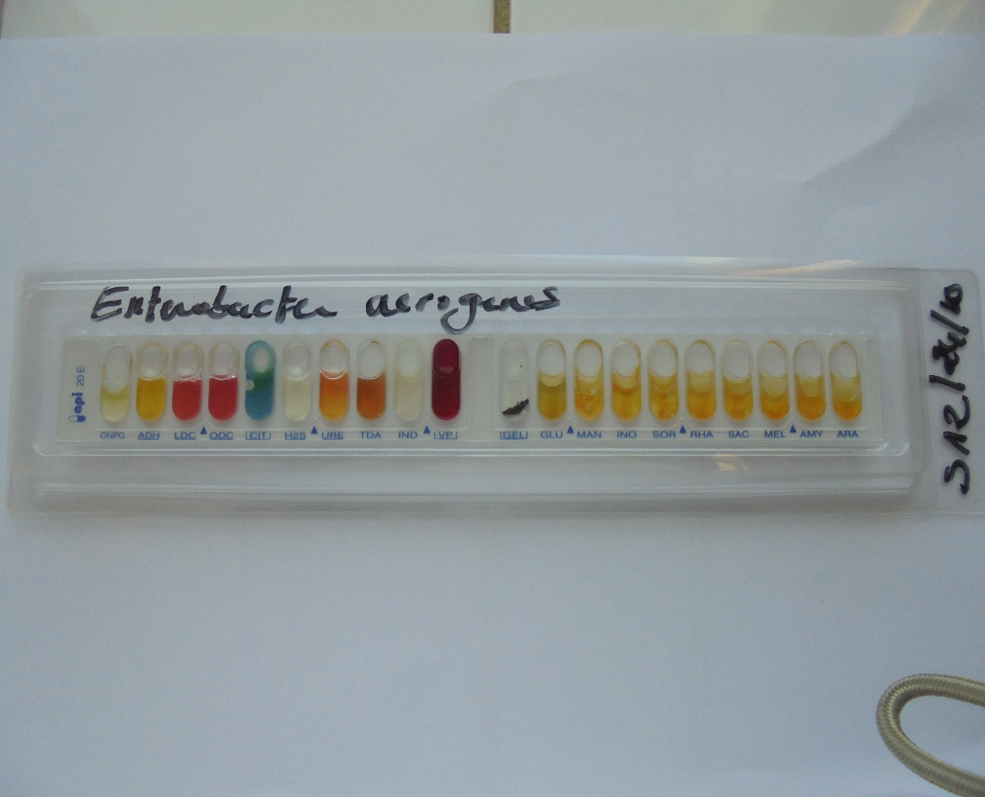

**Fig. 5. API 20E profile of *Enterobacter aerogenes***

*3.1.2.5 Stenotrophomonas maltophilia*

The biochemical profile of this strain was as follows: citrate (−), H₂S (−), glucose (−), lactose (−), gas (+), motility (−), urease (−), indole (−), and TDA (−). API 20E analysis confirmed the identification as *Stenotrophomonas maltophilia* (Figure 6).

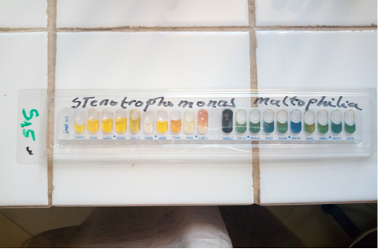

**Fig. 6. API 20E profile of *Stenotrophomonas maltophilia***

*3.1.2.6 Raoultella ornithinolytica*

This strain displayed the following biochemical characteristics: citrate (+), H₂S (−), glucose (+), lactose (+), gas (−), motility (−), urease (+), indole (+), and TDA (−). API 20E system results confirmed the strain as Raoultella ornithinolytica (see figure 7).

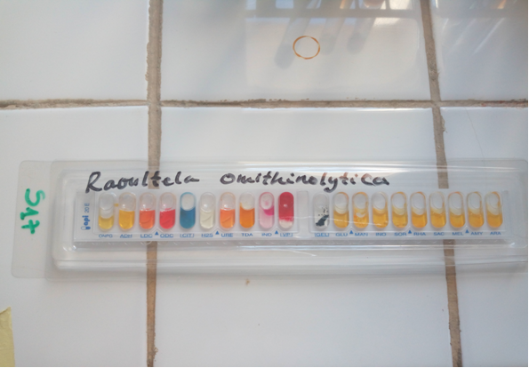

**Fig. 7. API 20E profile of *Raoultella ornithinolytica***

**3.2 Discussion**

**3.2.1 Microbial Diversity**

The results of this study confirm a significant microbial diversity in smoked and dried fish samples, including Escherichia coli and various opportunistic Enterobacteriaceae species. This diversity aligns with previous research on traditionally processed fish across Africa (Anihouvi et al., 2021; Yusuf & Hamid, 2017). The detection of Enterobacter sakazakii supports findings by Ekundayo et al. (2024), who reported these species in powdered infant formula, emphasizing its role in foodborne infections. Additionally, Serratia spp. has been linked to nosocomial infections and respiratory complications (Samonis et al., 2011), while Enterobacter aerogenes is recognized as an opportunistic pathogen associated with neonatal infections (Andrianarivel et al., 2010).

**3.2.2 Clinical Relevance of the Identified Microorganisms**

The microorganisms identified in this study carry notable clinical implications. Stenotrophomonas maltophilia is commonly associated with respiratory infections in immunocompromised patients (Brooke, 2021; Izydorczyk et al., 2023). Raoultella ornithinolytica, a histamine-producing bacterium, has been implicated in foodborne poisoning cases (Hajjar et al., 2029; Hwang et al., 2020).

Enterobacter sakazakii (now Cronobacter sakazakii) is particularly concerning due to its association with severe neonatal infections, especially from contaminated infant formula (Ekundayo et al., 2024). Enterobacter aerogenes, another opportunistic pathogen, is known for producing extended-spectrum beta-lactamases (ESBL), contributing to hospital-acquired infections (Andrianarivel et al., 2010).

The presence of E. coli in fish products is also concerning, as certain pathogenic strains can cause gastrointestinal infections in humans (Anihouvi et al., 2019). Studies have reported that foodborne outbreaks associated with E. coli contamination in fish products often stem from cross-contamination and poor hygiene during processing (Ayeloja et al., 2018).

The presence of E. coli, a well-known hygiene indicator and potential pathogen, is alarming, particularly because pathogenic strains can cause serious gastrointestinal illness. Contamination is often linked to poor hygiene and cross-contamination during processing (Ayeloja et al., 2018). Additionally, reports of antibiotic resistance among Enterobacteriaceae strains in this study echo findings from Amoah et al. (2024), emphasizing the growing threat of antimicrobial-resistant foodborne bacteria.

**3.2.3 Potential Sources of Microbial Contamination**

Contamination in smoked and dried fish may stem from several sources including unhygienic processing conditions, as traditional open-air drying and smoking techniques allow for microbial exposure and proliferation (Anihouvi et al., 2021; Alshevskaya et al., 2024); inadequate storage and packaging, where poorly sealed packaging and exposure to humidity foster microbial growth and spoilage (Chu et al., 2024); and cross-contamination, which involves the transfer of pathogens via contaminated hands, surfaces, and equipment, a common issue in fish handling and transportation (Ibrahim et al., 2024).

These findings are consistent with those of Somda et al. (2018) and Bonkoungou et al. (2011), who linked E. coli contamination to poor hygiene practices. While traditional processing methods remain important for food preservation, they must be coupled with improved sanitary practices. Implementing Good Manufacturing Practices (GMP) and Hazard Analysis and Critical Control Points (HACCP) systems is critical for reducing microbial risks (Geraldo et al., 2024).

**3.2.4 Health Risks Associated with Microbial Contamination**

This study highlights significant concerns about bacterial contamination in smoked and dried fish. With regards to bacterial infections, the consumption of contaminated fish can lead to gastroenteritis, septicemia, and urinary tract infections, particularly in immunocompromised individuals (Amoah et al., 2024). The presence of Raoultella ornithinolytica raises concerns about scombroid poisoning, which manifests as flushing, headaches, and nausea (Hwang et al., 2019).

The co-occurrence of bacterial pathogens in smoked and dried fish calls for urgent improvements in food safety controls. These include routine microbial surveillance, enhanced drying and packaging technologies, and stricter enforcement of hygiene regulations (Ouédraogo et al., 2023; Amoah et al., 2023).

4. Conclusion

This study successfully isolated, identified, and characterized bacterial strains present in smoked and dried fish products. Biochemical (API 20E) analyses revealed a high prevalence of Enterobacteriaceae (including E. coli), and other potentially harmful bacterial species. Several of the identified bacteria are known pathogens, and some exhibit antimicrobial resistance, posing a significant health risk to consumers. Improving hygiene practices, refining traditional processing methods, and enhancing storage conditions are essential steps toward ensuring the microbiological safety of smoked and dried fish in Chad.

AcknowledgEments

The authors express their gratitude to the University of N’Djamena and the LaRSAN, LaBIA, and LaBESTA laboratories at the University Joseph Ki-Zerbo for their technical support. Special thanks are extended to fish processors and fishermen from Lake Fitri for their collaboration, which made this study possible.

Competing interests

“Authors have declared that no competing interests exist.”.

Authors’ Contributions

All authors contributed significantly to the conception and design of the study. Data collection, analysis, and interpretation were carried out collaboratively. The manuscript was drafted and critically revised by all authors, with each contributing to its intellectual content. All authors have reviewed and approved the final version of the manuscript and agree to its submission for publication.

References

Bedah, L., Jessica, T., Sophie, L., Annick, C., Pierre-Yves, B., Harriet, C. (2017). Stenotrophomonas maltophilia: A marker of lung disease severity. Journal of Pediatric Pulmonology, 53(6), 426-430.

Bonkoungou, I. J. O., Lienemann, T., Martikainen, O., Dembélé R, Sanou. I, Traoré, A. S., et al. (2012). Detection of diarrhoeagenic Escherichia coli by 16-plex PCR from young children in urban and rural Burkina Faso. Clinical Microbiology and Infection, 18(3), 901-906.

Colin, M. (2002). Fiche de description de danger transmissible par les aliments: Salmonella spp. AFSSA, 46 pp.

Corin, V. W., Brian JD, Robert JB, Michael AH. (2019). A Stenotrophomonas maltophilia strain evades a major Caenorhabditis elegans defense pathway. Infection and Immunity, 84(2), 524-536.

Arvanitoyannis, I. S., Kotsanopoulos, K. V. (2012). Smoking of fish and seafood: History, methods and effects on physical, nutritional and microbiological properties. Food and Bioprocess Technology, 5, 831-853

Gamane, A. (2007). Évaluation physique des pertes post-capture des produits de la pêche avec les communautés de Mitteriné lac Tchad. Mémoire de licence professionnelle, Institut AVD-Tchad, 63 pp.

Sabah MH, Al-Shatty AA, Gahffr ARSA. (2014). Study of microbial and chemical characteristics for dried carp (Cyprinus carpio) fish by local manufactured vacuum solar dryer. Journal of the University Zighar of Agricultural Sciences, 2(1): 1–18.

Griliopoulos, D. (2014). New fish-drying method in Burundi boosts quality and incomes. https://www.theguardian.com/global-development/2014/dec/31/new-fish-drying-method-in-burundi-boosts-quality-and-incomes. Implementación práctica del enfoque ecosistémico a la pesca y la acuicultura del camarón en los países del Sistema de Integración Centroamericana (SICA/OSPESCA). FAO/OSPESCA Workshop Report, San Salvador, FAO, Rome, 45 pp.

Hattie, C., Tami, D. L., Sara, O. V., Kelly, B. F., Alexander, J. M., Gregory, P. P, Roy K. (2017). Global and local selection acting on the pathogen Stenotrophomonas maltophilia in the human lung. Nature Communications, 8, 14078.

Jackson, A., Newton, R. W. (2016). Project to model the use of fisheries by-products in the production of marine ingredients with special reference to omega-3 fatty acids EPA and DHA. Institute of Aquaculture, University of Stirling and IFFO, the Marine Ingredients Organisation, 240 pp.

Kolding, J., van Zwieten, P., Marttin, F., Poulain F. (2016). La pêche dans les zones arides d’Afrique subsaharienne. « Le poisson vient avec la pluie ». FAO Circular on Fisheries and Aquaculture No. 1118, FAO, Rome, 147 pp.

Koranteng, K. A., Vasconcellos, M. C., Satia, B. P. (2014). Preparation of management plans for selected fisheries in Africa-Baseline reports. FAO EAF-Nansen Project Report No. 23, FAO, Rome, 60 pp.

Kevin, E., Ashelford, J., Fry, C., Mark, J. B., Martin, J. (2002). Characterization of Serratia isolates from soil: Ecological implications and transfer of Serratia proteamaculans subsp. quinovora Grimont to Serratia quinivorans corrig. sp. International Journal of Systematic and Evolutionary Microbiology, 52(4), 2281-2289.

Mohammed MJ, Mohammed KS, Abdul K, Abbas M, Bayan HH, Allaa M, Aenab SKS. (2015). Detection of Enterobacter sakazakii from commercial children's dry milk. Journal of Environmental Protection, 6, 610-1043.

Samonis G, Vouloumanou EK, Christofaki M, Dimopoulou D, Maraki S, Triantafyllou E, Kofteridis DP, Falagas ME. (2011). Serratia infections in a general hospital: Characteristics and outcomes. European Journal of Clinical Microbiology and Infectious Diseases, 30(5), 653-660.

Singleton, R. L., Allison, E. H., Le Billon, P., Sumaila, U. R. (2017). Conservation and the right to fish: International conservation NGOs and the implementation of the Voluntary Guidelines for Securing Sustainable Small-Scale Fisheries. Marine Policy, 84: 22–32.

Somda, N. S. (2018). Antibiorésistance et typage moléculaire des souches de Salmonella Typhi et paratyphi et les pathovars de Escherichia coli d’origine humaine et alimentaire responsable de diarrhées au Burkina Faso. Ph.D. Thesis, Université Ouaga I Pr Joseph Ki-Zerbo, UFR-SVT, Département de Biochimie et Microbiologie, Burkina Faso, 205 pp.

FAO. (2018). La situation mondiale de la pêche et de l’aquaculture : Atteindre les objectifs de développement durable. FAO, Rome, 254 pp