# ***Review Article***

# BLACK SOLDIER FLY CULTURE: A SUSTAINABLE PROTEIN SOURCE IN ANIMAL FEED

Abstract

The increasing demand for sustainable and cost-effective protein sources in animal feed has necessitated the exploration of alternative solutions. Black Soldier Fly (*Hermetia illucens*) larvae have emerged as a viable high-protein feed ingredient with significant environmental and economic benefits. This review evaluated the effectiveness of BSF culture as a sustainable protein source for livestock nutrition. Key aspects include protein composition, waste bioconversion efficiency, environmental impact, economic feasibility and challenges for large- scale adoption. Although BSF larvae exhibit high digestibility and essential amino acid profiles, challenges such as regulatory acceptance, production scalability and biosecurity risks remain. Future research should focus on optimizing production, addressing market barriers and enhancing farmer adoption to establish BSF meals as a mainstream feed ingredient.

**Keywords:** Black soldier fly larvae; Organic waste; Alternative protein source; Nutrient recycling; Nutritional composition; Sustainable protein source.

Introduction

The global demand for protein in animal feed is steadily increasing, presenting significant challenges in terms of sustainability, cost and resource availability. Conventional protein sources, such as soybean meal and fishmeal, which are widely used, contribute to environmental concerns, including deforestation and overfishing. Additionally, the rising costs of these traditional protein sources make livestock feed production more expensive, necessitating the search for alternative sustainable protein sources.

Among emerging alternatives, Black Soldier Fly (BSF) larvae have gained considerable attention as a nutrient-rich and environmentally sustainable feed ingredient. With protein content ranging from 40% to 50% and an abundance of essential nutrients, BSF larvae offer a promising solution for livestock and aquaculture nutrition. One of the most significant advantages of BSF farming is its ability to upcycle organic waste into high-quality protein and fat, thereby contributing to waste management and fostering a circular economy (González-Lara et al., 2025). This ability not only reduces the dependency on conventional feed sources but also minimizes the environmental footprint of feed production (Lai‐Foenander et al., 2024).

The significance of BSF culture extends beyond its nutritional value, as it holds the potential for large-scale commercialization and sustainable feed production worldwide. Internationally, BSF are the preferred insect species for commercial insect protein production. In Europe, 95% of insect farming focuses on BSF and yellow mealworms (Fitches, 2019), with approximately 80% of EU insect-producing companies based on BSF, as of 2018 (Halloran et al., 2018; cited in Cadinu et al., 2020). The adaptability of BSF to diverse organic waste materials makes it a scalable and resource-efficient alternative, positioning it as a transformative solution for sustainable animal feed production in the future.

According to Halloran et al. (2018), soybean production is responsible for large-scale deforestation in South America. In this context, BSF larvae are a promising sustainable protein alternative for livestock and aquaculture feed. BSF farming supports a circular economy by utilizing organic waste to produce high-quality protein and fat, thereby reducing reliance on conventional feed ingredients. Nyakeri et al. (2016) demonstrated that BSF larvae effectively convert food waste into biomass, reducing the environmental impact while generating valuable feed ingredients.

This review article explores the growing importance of BSF larvae in animal feed, highlighting their nutritional benefits, environmental impact and potential to revolutionize livestock and aquaculture industries.

# Importance of Protein in Livestock Feeds

Proteins are crucial nutrients for livestock growth, reproduction and overall health. It plays an essential role in muscle formation, tissue repair and reproductive performance and supports hormone production and milk yield. Salahuddin et al. (2024) highlighted that BSF larvae contain essential amino acids such as lysine and methionine, which are vital for optimal livestock growth. Additionally, proteins enhance disease resistance by facilitating antibody production and immune functions. The efficiency of feed conversion in livestock is also influenced by the availability of high-quality protein, which ultimately improves livestock productivity and economic viability for farmers. Makkar et al. (2014) suggested that insect-based protein sources, such as BSF larvae, can replace up to 50% of conventional protein sources without compromising livestock performance.

## List 1 Protein Requirement (Crude Protein %) for Different Livestock

|  |  |  |  |  |
| --- | --- | --- | --- | --- |
| **Animal** | **Maintenance (%)** | **Growth (%)** | **Lactation (%)** | **Finishing (%)** |
| **Goat** (Adult) | 9-10% | 12-14% | 14-16% | 10-12% |
| **Cattle** (Adult) | 8-10% | 12-14% | 14-16% | 10-12% |
| **Buffalo** (Adult) | 8-10% | 12-14% | 14-16% | 10-12% |
| **Poultry (Broilers)** | - | 20-23% (Starter) | 18-20% (Grower) | 16-18%  (Finisher) |
| **Poultry (Layers)** | 16-18% | - | 18-20% | - |

Ref :- National Dairy Development Board (NDDB). Animal Nutrition Booklet.(2012)

# Challenges in Meeting Protein Demands

The increasing global protein demand for livestock feed has been constrained by several factors. Overfishing continues to deplete marine biodiversity and disrupt ecosystems, whereas large-scale soybean farming contributes to habitat destruction, deforestation and climate change. Soisontes et al. (2024) projected that global soybean demand will continue to rise, exacerbating environmental concerns. In addition, competition between livestock feed production and the human food supply exacerbates food insecurity. The fluctuating prices of conventional protein sources owing to economic and climatic factors further complicate feed affordability. Furthermore, some conventional protein sources lack essential amino acids, leading to nutritional imbalances that can affect livestock growth and productivity. Fukuda et al. (2022) confirmed that replacing fishmeal with BSF larvae could alleviate these challenges while maintaining optimal livestock performance.

# Overview of Black Soldier Fly Culture

BSF larvae are rich in proteins, containing approximately 40-50%, making them a suitable substitute for fishmeal and soybean meal. The BSF life cycle consists of four stages: eggs, larvae, pupae and adults. Ghughuskar et al. (2023) reported that BSF larvae reared on organic waste exhibited high growth rates and protein content, making them ideal for commercial feed production. Eggs hatch within four days, followed by the larval stage, where they efficiently convert organic waste into biomass over a period of 14-21 days. The pupae then transform into adults within 7-10 days and the adult flies, which have a short lifespan of 5-8 days, are primarily responsible for reproduction. Adult BSFs resemble wasps, are either blue or black and have two translucent "windows" on the abdomen's first section. The length of an adult BSF is between 15 and 20 mm.

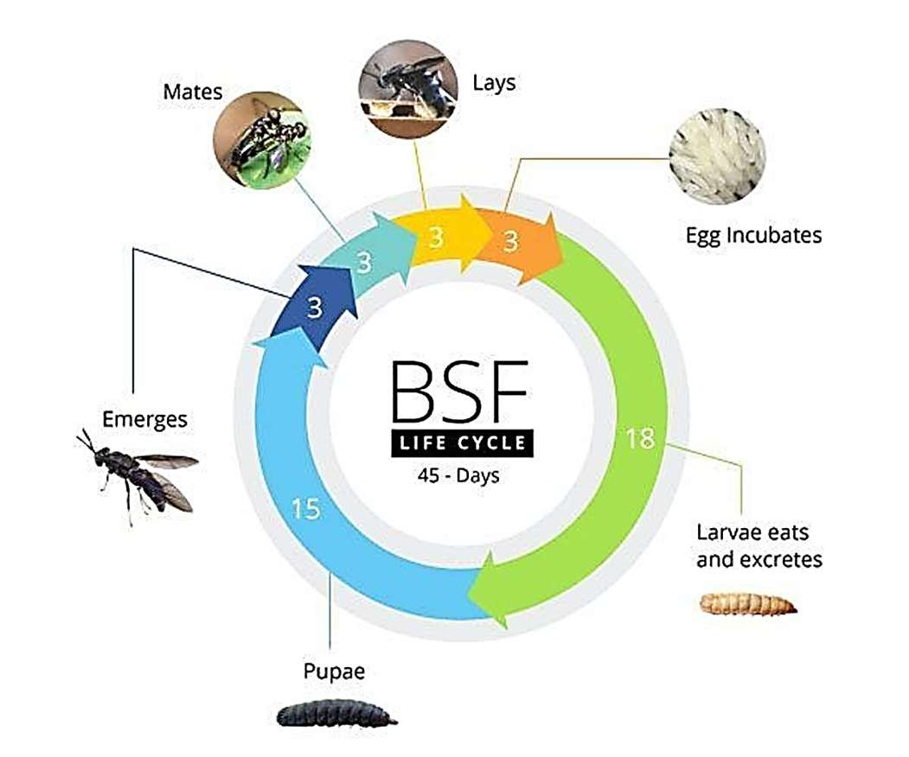

(Compost

Fig .1 Life cycle of Black Soldier Fly

# Black Soldier Fly Larvae Chemical Composition and Nutritive Value

Black soldier fly larvae (BSFL) are found in the manure of cattle, pigs and poultry, yet they can also develop on various organic waste materials, including coffee bean pulp and vegetables.

Various researchers have noted distinct nutrients in feeds produced from BSF larvae (Table 1). Typically, BSFL comprise DM (27.40%), CP (56.10%), CF (23.20%) and ash (9.85%), Ca

(2.14%), P (1.15%), Mg (0.39%), K (1.35%), Zn (13.10 mg/kg), Cu (11.20 mg/kg), Mn (23.20

mg/kg) and Fe (20.40 mg/kg) based on dry matter (DM). BSFL (often referred to as feed) BSF larvae, BSF prepoppy feed and BSF worm feed are utilized directly or are dehydrated, diced and pulverized into forms. The DM content in fresh BSFL is significantly greater (34.9% to 44.9%), making BSFL simpler and more affordable than alternative fresh goods (Shah et al. (2022). Typically, BSFL is composed of 41.1% to 43.6% CP, 15.0% to 34.8% EE, 7.0% to 10% CF, ash 5.9% to 8.1% and 5,278.49 kcal/kg GE, calculated on a dry matter basis [De Marco et al. (2015) Jayanegara et al. (2017)]. BSFL Larvae contain significant levels of Ca (5% to 8%) and P (0.6% to 1.5%). Coat Additionally, the mineral composition includes Cu (6.0 mg/kg), Fe (0.14% to 14%), Mn (246 mg/kg), Mg (0.39%), Na (sodium, 0.13%), K (0.69%) and Zn (108 mg/kg) (Makkar et al. 2014).

Table 1. Chemical composition and nutritive value of Black soldier fly larvae

|  |  |
| --- | --- |
| Chemical composition and nutritive value | Percentage (%) |
| DM | 27.40 |
| CP | 56.10 |
| CF | 23..20 |
| Ash | 9.85 |
| Ca | 2.14 |
| P | 1.15 |
| Mg | 0.39 |

|  |  |
| --- | --- |
| K | 1.35 |
| Na | 0.13 |

DM, dry matter; CP, crude protein; CF, crude fiber; Ash; Ca, calcium; P, phosphorous; Mg, magnesium; K, potassium; Na, sodium; Zn, zinc; Cu, copper; Mn, manganese; Fe, iron.

BSF larvae provide a well-balanced amino acid profile, including lysine, methionine and valine, which are essential for livestock growth. Salahuddin et al. (2024) found that BSF larvae-based feed improved poultry growth rates and meat quality. They also contain a high fat content (30- 35%), including beneficial lauric acid, known for its antimicrobial properties. Additionally, BSF larvae are rich in minerals such as calcium and phosphorus, which are critical for bone development and metabolic processes. Fukuda et al. (2022) demonstrated that BSF larvae improve digestibility and nutrient absorption in cattle, further validating their role in animal nutrition.

# Sustainability and Circular Economy

Sustainability and the circular economy emphasize reducing waste, reusing resources and minimizing environmental impact. One innovative approach is utilizing Black Soldier Fly (*Hermetia illucens*) larvae to efficiently process organic waste and produce high-value by- products. Widyastuti et al. (2021) studied the chemical composition of compost produced by BSF larvae and found that it contains 18.37% organic carbon, 1.45% nitrogen and 1.58% phosphorus, with a balanced pH of 6.8, meeting national and international compost standards. Similarly, Myers et al. (2008) examined the ability of BSF larvae to reduce dairy manure waste by 33–58%, while also decreasing phosphorus (P) and nitrogen (N) content by 30–70%, demonstrating their potential to minimize pollution and improve waste management.

In addition to waste decomposition, BSF larvae serve as a sustainable protein source for animal feed. Pradabphetrat et al. (2024) analyzed the nutritional value of BSF larvae reared on organic waste and found that they contain 9.25–10.69% protein and 3.29–15.90% fat, making them a viable alternative to conventional feed ingredients like soybean meal and fish meal. Furthermore, the residue from BSF larvae, known as frass, is a rich organic fertilizer. It was found to contain 2.46% nitrogen, 2.77% phosphorus and 3.14% potassium, which enhances soil fertility and reduces the need for chemical fertilizers. Compared to traditional composting methods, BSF- based waste decomposition produces lower levels of methane and ammonia emissions, contributing to a reduction in greenhouse gases and environmental pollution. Feeding black soldier fly larvae with a diet made of wastes containing desirable omega-3 fatty acids is therefore a way to enrich the final biomass (St-Hilaire et al., 2007).

The use of BSF larvae aligns with the principles of the circular economy, as they efficiently convert organic waste into nutrient-rich compost and high-protein animal feed, creating a closed- loop system that supports sustainable agriculture and waste management. Their rapid decomposition capabilities significantly shorten composting time compared to conventional methods, further increasing their economic and environmental benefits. Given these advantages, BSF larvae offer a promising eco-friendly solution for tackling organic waste, improving soil health and providing a renewable protein source for livestock production.

BSF farming plays a crucial role in sustainability by converting organic waste into high-quality protein, thereby reducing food waste accumulation. WWF-UK and Tesco (2021) reported that large-scale BSF production could significantly reduce greenhouse gas emissions compared to conventional feed sources. Compared to conventional feed sources, BSF farming generates lower greenhouse gas emissions, making it a more environmentally friendly option. Furthermore, BSF frass, a by-product of the larvae, serves as a nutrient-rich organic fertilizer, enhancing soil fertility and supporting sustainable agricultural practices. Nyakeri et al. (2016) noted that BSF frass enhances soil microbial activity, making it an effective bio-fertilizer.

Cortes-Ortiz et al.(2016) highlighted that its efficiency in converting organic waste into high- protein and high-fat biomass for animal feed while also reducing pathogens like *E. coli* and *Salmonella spp.* The larvae can self-harvest, making large-scale production cost-effective.

**Fig .2 : Frass/BSF Compost**

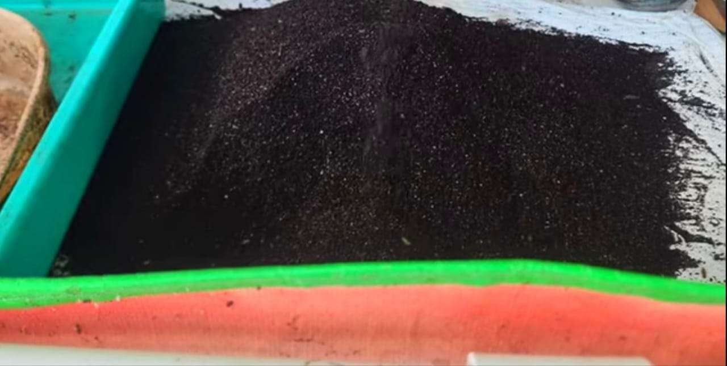

**Table 2. Nutrient Composition of Frass/Compost Produced by Black Soldier Fly (BSF) Larvae**

|  |  |  |
| --- | --- | --- |
| **Sr. No.** | **Parameters** | **Compost BSF** |
| **1.** | pH | 6.8 |
| **2.** | C-Organic(%) | 18.37 |
| **3.** | N-Total (%) | 1.45 |
| **4.** | P-Total (%) | 1.58 |
| **5.** | C/N Ratio | 12.66 |

Source : Widyastuti et al. (2021)

Ghughuskar M.M., et al.(2022) studied and found that BSF larvae efficiently convert organic waste into high-protein (42%) and fat-rich (35%) biomass, making them a viable replacement for fishmeal and soybean meal in aquaculture and livestock feed. The larvae also help reduce organic waste by 50% while lowering harmful bacteria and housefly populations.

# Applications in Animal Nutrition

BSF larvae have diverse applications in animal nutrition. Fukuda et al. (2022) showed that replacing traditional feed with BSF larvae in poultry diets improved feed efficiency and overall health. In aquaculture, BSF larvae improve feed conversion ratios and contribute to a higher omega-3 fatty acid composition in fish. Salahuddin et al. (2024) demonstrated that BSF larvae- fed fish exhibited improved growth performance and survival rates. In livestock, they serve as a sustainable energy and protein source, reducing dependence on traditional feed ingredients. Ruminants also benefit from BSF larvae meal, as it provides essential amino acids and minerals necessary for muscle development and milk production. The study by Jayanegara et al. investigates Black Soldier Fly Larvae (BSFL) as an alternative protein source for Friesian Holstein cattle, comparing its effects with soybean meal (SBM). While BSFL has higher fiber content (NDF & ADF), leading to lower dry matter (DM) and organic matter (OM) digestibility, its total volatile fatty acid (VFA) concentrations remain comparable to SBM, indicating effective rumen fermentation.

A key benefit is reduced methane (CH₄) emissions, as insect-based feeds produce less hydrogen (H₂), a precursor for methanogenesis. However, ammonia (NH₃) formation varies, depending on protein degradation dynamics. Despite lower digestibility, BSFL offers sustainability benefits, particularly in reducing greenhouse gas emissions

# Economic Feasibility of BSF Farming

The economic advantages of BSF farming are significant. The larvae thrive on food waste and agricultural residues, reducing feed costs. Soisontes et al. (2024) estimated that BSF meal could lower feed costs by 20-30% compared to soybean meal. Their high feed conversion efficiency ensures a greater protein yield per unit of input, making them a cost-effective alternative to traditional protein sources. The growing market demand for sustainable feed ingredients further enhances the profitability of BSF farming. Additionally, the by-product frass provides an additional revenue stream as an organic fertilizer.

# Challenges and Solutions in BSF-Based Feed Adoption

Several challenges hinder the widespread adoption of BSF-based feed. Regulatory approvals vary across regions, necessitating collaboration with policymakers to establish safety guidelines. Nyakeri et al. (2016) emphasized that standardized regulations are necessary to ensure BSF larvae meal meets safety and quality standards. Processing optimization through improved drying and oil extraction methods can enhance product quality and storage stability. Scaling up

production requires investment in automation and sustainable farming practices to reduce operational costs.

# Future Prospects and Conclusion

Black Soldier Fly larvae offer a nutrient-rich, sustainable and cost-effective alternative to conventional protein sources in animal feed. Their ability to efficiently convert organic waste into high-quality protein supports environmental sustainability and circular economy principles. As global demand for protein continues to rise, BSF meal presents a viable solution to reducing reliance on fishmeal and soybean meal, helping to alleviate the environmental and economic pressures associated with conventional feed production.

The global adoption of BSF-based feed is expected to expand due to technological innovations, policy support and market acceptance. Advances in genetic improvements and automated farming systems will enhance production efficiency. Government incentives promoting sustainable feed alternatives will facilitate wider adoption. Increasing consumer awareness of sustainable practices is also expected to drive market demand. BSF larvae present a transformative solution to sustainable protein production. Overcoming regulatory and technological barriers will be crucial in facilitating its widespread adoption. Continued research, investment and policy changes will ensure that BSF farming contributes to a more sustainable and resilient livestock industry, reducing environmental impact while ensuring global food security.

Highlights

Black Soldier Fly (BSF) larvae provide a high-protein sustainable alternative to conventional livestock feed.

BSF-based feeds offer environmental benefits, including waste recycling and reduced greenhouse gas emissions.

Challenges include regulatory barriers, consumer perceptions and large-scale commercialization. Future research should focus on optimizing the rearing conditions, nutritional balance and integration into existing feed systems.

# Ethics Statement

As this manuscript is a **review article**, it does not involve any experiments on animals or human participants. Therefore, ethical approval was not required. The authors confirm that the information and references used in the manuscript are properly cited and sourced from published literature.

**Abbreviations:** ADF, acid detergent fibre; BW, body weight; DM, dry matter; TMR, totally mixed ration; NDF, neutral detergent fibre; CP, crude protein; CF, crude fibre; EE, ether extract; SBM, soyabean meal; BSF, black soldier fly.

**References**

Cadinu et al. (2020). Insect rearing: Potential, challenges and circularity for sustainable food production. *Animals*, 10(4), 1-20.

J.A. Cortes Ortiz, A.T. Ruiz, J.A. Morales-Ramos, M. Thomas, M.G. Rojas, J.K. Tomberlin,

L. Yi, R. Han, L. Giroud, R.L. Jullien, Insect Mass Production Technologies, in: A.T. Dossey, J.A. Morales-Ramos, M.G. Rojas (Eds.), Insects as Sustainable Food Ingredients: Production, Processing and Food Applications, Academic Press, San Diego, 2016, pp.173- 176.

Cullere et al. (2016). Black soldier fly as a dietary protein source for broiler quails: Apparent digestibility, excreta microbial load, feed choice, performance, carcass and meat traits. *Animal, 10*, 1923-1930. https://doi.org/10.1017/S1751731116001270

De Marco et al. (2015). Nutritional value of two insect larval meals (*Tenebrio molitor* and *Hermetia illucens*) for broiler chickens: Apparent nutrient digestibility, apparent ileal amino acid digestibility and apparent metabolizable energy. *Animal Feed Science and Technology*, 209, 211-218. https://doi.org/10.1016/j.anifeedsci.2015.08.006

Fitches, E. (2019). Insect protein for animal feed: Opportunities and regulatory challenges.

*Journal of Insects as Food and Feed*, 5(1), 1-9.

Fukuda et al. (2022). Evaluation of Black Soldier Fly larvae as a protein supplement for beef steers consuming low-quality forage. *Translational Animal Science*, 6(1), 1–6. https://doi.org/10.1093/tas/txac018

Ghughuskar et al. (2023). Culture of wild strain of Black Soldier Fly (*Hermetia illucens* L.) of Sindhudurg district and its potential for bioconversion of organic waste into protein-rich food source for replacement of fishmeal. *Journal of Experimental Zoology India*. Vol. 23, Supplement 1, pp. 793-797. https://[www.researchgate.net/publication/376808886.](http://www.researchgate.net/publication/376808886)

Halloran A., et al. (2016). Life cycle assessment of edible insects for food protein: a review. *Agron Sustain Dev*. 2016 ; 36 (4) :57. Doi: 10.1007/s13593-016-0392-8. Epub 2016 Sep 29. PMID: 32010238; PMCID: PMC6961468.

Jayanegara et al. (2017). Evaluation of some insects as potential feed ingredients for ruminants: Chemical composition, in vitro rumen fermentation and methane emissions. *Journal of Indonesian Tropical Animal Agriculture*,42,247-254. https://doi.org/10.14710/jitaa.42.4.247-254.

Makkar, et al. (2014). State of the art on use of insects as animal feed. *Animal Feed Science and Technology*, *197*, 1–33. https://doi.org/10.1016/j.anifeedsci.2014.07.008

Nyakeri, E., et al. (2016). An open system for farming black soldier fly larvae as a source of proteins for small-scale poultry and fish production. *Journal of Insects as Food and Feed*, 3(1), 51–56.

Pexas et al. (2023). The future of protein sources in livestock feeds: Implications for sustainability and food safety. *Frontiers in Sustainable Food Systems*, 7, 1188467. https://doi.org/10.3389/fsufs.2023.1188467

Salahuddin, M., et al. (2024). Flight toward sustainability in poultry nutrition with black soldier fly larvae. *Animals*, 14(510). https://doi.org/10.3390/ani14030510

Shah et al. (2022). Nutritional composition of various insects and potential uses as alternative protein sources in animal diets. *Animal Bioscience*, 35(2), 317-331. https://doi.org/10.5713/ab.21.0447

St-Hilaire et al. (2007). Fly prepupae as a feedstuff for rainbow trout (*Oncorhynchus mykiss*). *Journal of the World Aquaculture Society, 38*, 59-67. https://doi.org/10.1111/j.1749- 7345.2006.00073.x

Soisontes, S., et al. (2024). The future of protein feed: A case study of sustainable substitutes in the German livestock industry*.* Environment, Development and Sustainability, 26(10), 25199–25226. https://doi.org/10.1007/s10668-023-03676-1

WWF-UK & Tesco. (2021). Driven to waste: The global impact of food loss and waste on farms*.* WWF-UK. Retrieved from https://[www.wwf.org.uk](http://www.wwf.org.uk/)

Widyastuti, U., et al.(2021). Chemical content of waste composting by black soldier fly (*Hermetia illucens)*. IOP Conference Series: Earth and Environmental Science, 739, 012003. <https://doi.org/10.1088/1755-1315/739/1/012003>

González-Lara, H., Parra-Pacheco, B., Rico-García, E., Aguirre-Becerra, H., Feregrino-Pérez, A. A., & García-Trejo, J. F. (2025). Black Soldier Fly Culture as a Source of Chitin and Chitosan for Its Potential Use in Concrete: An Overview. Polymers, 17(6), 717.

Lai‐Foenander, A. S., Kuppusamy, G., Manogoran, J., Xu, T., Chen, Y., Tang, S. Y., ... & Goh, B. H. (2024). Black soldier fly (Hermetia illucens L.): A potential small mighty giant in the field of cosmeceuticals. *Health Science Reports*, *7*(6), e2120.