*Original Research Article*

A STUDY OF STAKEHOLDERS AND THEIR LINKAGE IN ANDHRA PRADESH COMMUNITY MANAGED NATURAL FARMING PROJECT

.

ABSTRACT

|  |
| --- |
| The Andhra Pradesh Community-Managed Natural Farming (APCNF) programme represents a paradigm shift in agricultural extension by emphasizing decentralized governance, community participation, and agroecological transformation. This study was undertaken to analyze the roles, actions, types, and nature of linkages among key stakeholders in the APCNF innovation system, with a focus on understanding how learning processes are shaped within this decentralized extension framework.  The research was conducted in Anantapur district, a drought-prone region with high adoption of natural farming, during the period 2023–2024. An exploratory research design was employed to investigate the stakeholder dynamics within the agricultural innovation system. Three mandals—Kalyandurg, Rapthadu, and Gooty—were purposively selected, and data were collected from 80 respondents representing seven key stakeholder categories including Department of Agriculture (DoA), Rythu Sadhikarika Samstha (RySS), Self-Help Groups (SHGs), Panchayati Raj Institutions (PRIs), Farmer Producer Organizations (FPOs), Community Resource Persons (CRPs), and natural farming farmers. Data collection involved structured interviews, focus group discussions, and use of an actor linkage matrix to map relationships and associated learning types.  The findings reveal that the APCNF model operates through a dense network of formal and informal linkages. DoA maintains a contractual relationship with RySS, promoting "learning by imitating and mastering," while grassroots actors engage through partnerships, networks, and alliances, facilitating "interactive learning" and "learning by doing." CRPs and SHGs emerged as vital knowledge intermediaries, and social media served as a key enabler for real-time, low-cost information exchange.  In conclusion, APCNF illustrates a robust, participatory innovation system where learning is collaborative, experiential, and rooted in local contexts. Strengthening multi-stakeholder linkages, investing in grassroots capacity, and expanding digital engagement are essential for sustaining and scaling agroecological transitions. |

*Keywords: Agricultural Innovation Systems, Stakeholder Analysis, Roles of Stakeholders, Actions of Stakeholders, Linkages between stakeholders*

1. INTRODUCTION

India’s agricultural progress since the Green Revolution has significantly improved food security and rural incomes, yet many smallholder farmers—especially in remote and economically disconnected regions—still lack access to credit, inputs, markets, and extension services. Fragmented landholdings, degraded resources, and climate variability further increase their vulnerability. As noted by the Planning Commission (2011), agricultural systems are now facing technology fatigue, ineffective service delivery, and weak localized planning. Public sector innovations often fail to reflect the socio-economic and agro-ecological realities of farmers, while extension systems remain outdated and overstretched. At the same time, farmers are expected to adapt to climate change, add value to their produce, and manage sustainable inputs—demands that require a more dynamic and inclusive extension ecosystem.

In response, the Andhra Pradesh Community-Managed Natural Farming (APCNF) programme has emerged as a grassroots-led, agroecological alternative to input-intensive agriculture (FAO,2020). Launched in 2016 by Rythu Sadhikara Samstha (RySS), APCNF builds on two decades of community mobilization through the CMSA initiative and the SHG network. By promoting low-cost, chemical-free, and locally adapted practices, particularly among women and marginalized farmers, APCNF now spans over 9.6 lakh farmers and one million acres. It marks a shift from conventional top-down approaches to a collaborative, multi-stakeholder innovation system where farmers are empowered as knowledge creators and agents of change (FAO,2021).

The evolving complexity of agriculture demands that farmers receive multifaceted support—ranging from organizational and technological to financial and entrepreneurial. However, the current agricultural extension systems remain narrowly focused on technology dissemination and are poorly equipped to address the diverse and localized needs of farmers (Sulaiman & Hall, 2004). Despite the growing awareness of the need to broaden extension's mandate, there is a lack of practical insights and empirical evidence on how to operationalize this shift. This should ideally emerge from assessing innovative extension models and drawing insights from research-based learning initiatives. The study examined key actors and their roles within the innovation system to generate empirical evidence on interaction patterns and enrich agricultural extension practices.

The roles and significance of actors within an innovation system are dynamic, shifting throughout the innovation process as circumstances evolve and learning occurs. Actors can adopt multiple roles, including serving as sources of knowledge, seekers of knowledge, and coordinators facilitating linkages among other participants in the system (Hall *et al*., 2006).

The influential actors can shape network structures within innovation systems by providing financial resources or creating supportive legislative frameworks. These actors play a key role in fostering collaboration, driving policy alignment, and enabling networks to grow and innovate effectively (Hermans *et al*., 2012).

The significance of actors in the innovation system, emphasizing their roles, activities, and the diverse knowledge they contribute. The roles stakeholders play is crucial for fostering collaboration and driving innovation within the system. They actively engage in various activities, such as generating, sharing, and applying knowledge, while their expertise enriches the system's capacity to address challenges and explore opportunities (Sulaiman, 2015)

The Actor Linkage Matrix is a valuable tool for mapping relationships between stakeholders and identifying critical institutional connections that a project should engage with or reinforce to meet its objectives. This method is particularly effective for recognizing strengths and opportunities within a specific institutional context and for developing relevant indicators to measure change (Matsaert, 2002)

This study aims to analyze the roles, actions, nature and type of linkage among stakeholders within agricultural innovation systems, with a focus on innovative extension arrangements. By mapping actor linkages and understanding how learning takes place through these systems. The findings are expected to provide empirical evidence for rethinking and strengthening extension’s role as a facilitator and connector across multiple service domains.

2. methodology

2.1 Locale of the Study

The present study was conducted in Anantapur district of Andhra Pradesh. Anantapur is one of the key districts where natural farming has been actively promoted due to its drought-prone conditions, strong institutional presence of RySS, and significant farmer participation (Khan & Sreeja, 2022). Within the district, a few mandals with high levels of natural farming adoption were selected after consultations with district-level functionaries and RySS coordinators.

**2.2 Sampling Procedure**

The selection of respondents for the study on the Andhra Pradesh Community-Managed Natural Farming (APCNF) programme was carried out in a structured manner to ensure comprehensive representation of key stakeholders across implementation and community levels. For extension personnel, three mandals—Kalyandurg, Rapthadu, and Gooty—were purposively selected based on their consistent engagement with natural farming activities, including community outreach, farmer training, and program implementation. These mandals were chosen to reflect agro-ecological diversity and operational depth. All officials directly working on APCNF within these mandals were included using total enumeration sampling. This comprised eight Department of Agriculture (DoA) officials, including Mandal Agriculture Officers (MAOs) and Agricultural Extension Officers (AEOs), who facilitate convergence and deliver frontline services, and six field-level coordinators and cluster staff from Rythu Sadhikara Samstha (RySS), responsible for capacity building, monitoring, and technical guidance.

For community stakeholders, criterion-based and purposive sampling methods were used. A total of 18 women farmers from Self-Help Groups (SHGs) were selected for their active engagement in natural farming, particularly those trained in bio-input preparation and involved in peer-to-peer learning. Six representatives from Panchayati Raj Institutions (PRIs), such as Sarpanchs and Ward Members, were also included based on their role in convergence, community mobilization, and local resource allocation for natural farming. Additionally, six members from Farmer Producer Organizations (FPOs), including CEOs and Board Directors involved in natural farming-based seed and produce aggregation, were selected to represent the collective enterprise aspect of the model. Six Community Resource Persons (CRPs), identified by RySS district staff for their outstanding grassroots-level mobilization and outreach, were also purposively included in the study.

Furthermore, a sample of 30 farmers practicing natural farming across the three selected mandals was drawn using criterion-based sampling. Farmers were chosen based on their minimum two years of experience with natural farming, active participation in APCNF trainings, and regular use of bio-inputs. Care was taken to ensure diversity in terms of social backgrounds and farm sizes. The selection process was conducted in consultation with CRPs and AEOs to ensure a balanced and inclusive representation. Overall, this multi-tiered sampling approach enabled the study to capture a holistic and nuanced understanding of the APCNF programme from various stakeholder perspectives.

**2.3 Selection of Research Design**

The literature indicates a lack of prior research on innovations in agricultural extension approaches with a focus on the agricultural innovation system (AIS) framework. The AIS approach is still in its nascent stages in the context of agriculture in developing countries (Spielman et al., 2010). Therefore, an exploratory research design was chosen for this study. This flexible design is capable of addressing diverse research questions (such as why, who, and how) and is particularly useful for gathering foundational information on a research topic (de Vaus & de Vaus, 2001). It is especially suited for investigating new problems where little or no prior research exists (Brown, 2006)

2.4 Development and Administration of Interview Schedule

A structured and pre-tested interview schedule was developed to gather data on stakeholder roles, actions, nature and type of linkage within the innovation systems. The schedule was prepared in consultation with an advisory committee and subject experts from agricultural extension and social sciences to ensure its relevance and validity.

Possible stakeholder roles, actions and type of linkages were outlined through a combination of literature review and exploratory interviews, and were quantified using frequency and percentage. An actor linkage matrix was employed to assess the nature of linkage between stakeholders, highlighting key institutional connections and gaps. The types of linkages between actors were examined to differentiate the relationships among them. Additionally, the nature of learning was investigated to understand how these interactions contribute to the innovation system. Both the types of linkages and learning were analysed based on the framework established by hall *et al*, 2006b.

Information on nature and type of linkage was gathered through focused group discussions and individual interviews. Before final administration, the schedule was pre-tested with 30 stakeholders from a non-sample area. After following these steps, the finalized interview schedule was used to collect primary data collection.

2.5 Data Collection and Analysis

The data was collected from 80 respondents from seven stakeholder organizations i.e., Department of Agriculture officials (8), Field coordinators of RySS (6), Self Help Groups (18), Panchayat Raj Institution (6), Farmer Producer Organisations (6), Community resource persons (6), Natural farming farmers (30). Frequency was used to calculate roles and actions of each stakeholder organisation; Mean was used to calculate the nature of linkage among different stakeholder organizations. Stakeholder organizations were categorized as no linkage, poor linkage, fair linkage, good linkage, very good linkage based on mean values.

2.7 Operational definitions of Roles, Actions, Type of Linkages and Learning

The concept of a role has been operationally defined as the position an individual or organization voluntarily assumes based on their abilities and capacities. Various roles were defined to capture the diversity of stakeholder functions. Facilitation refers to making tasks easier for others or helping them understand and achieve objectives, while a communicator plays the role of transmitting, sharing, or disseminating relevant information among stakeholders. Technology transfer is the process of sharing new or improved technologies with other actors in the system. Research is understood as formal efforts to expand the knowledge base relevant to innovation. Funding entails providing financial resources to ensure smooth functioning of innovation activities. Policy formulation involves designing effective and acceptable strategies to create a supportive environment for innovation, whereas policy implementation refers to translating these strategies into actionable programs. Collaboration is defined as the joint effort of stakeholders to achieve common goals, and networking is the ongoing process of building and leveraging relationships to enhance knowledge exchange, coordination, and problem-solving. Market linkage involves supporting farmers to gain effective access to markets, and awareness creation refers to increasing understanding, consciousness, and knowledge about the innovation among stakeholders.

The term action is defined as the process of executing tasks that influence other stakeholders within the innovation system, either positively or negatively. Various stakeholder actions were operationally classified to better understand their functional contributions. Brokering refers to the act of creating linkages between different actors, thereby enabling coordination and flow of resources or information. Convening involves bringing stakeholders together to enhance mutual interaction and collective understanding. Negotiating is defined as initiating discussions to help actors resolve conflicts or reach agreements. Facilitating is understood as providing assistance to other stakeholders to help them achieve their goals more effectively. Advocating refers to supporting actors through suitable policies, institutional backing, or influence. Coaching is the act of equipping stakeholders with knowledge and skills required to sustain innovation processes. Disseminating involves sharing critical information among actors to support decision-making and performance. Lastly, mediating is the act of easing tensions and fostering consensus among stakeholders, thereby contributing to smoother collaboration within the innovation ecosystem (Sulaiman *et al*, 2010).

The type of linkages among stakeholders in innovation systems can take various forms, each supporting distinct patterns of interaction and learning. A partnership is characterized by collaborative efforts where stakeholders work together to achieve shared interests. In contrast, a paternalistic linkage represents a more hierarchical relationship where one actor exerts control over another, often directing actions and decisions. A formal contract denotes a structured linkage with clearly defined objectives, roles, and governance mechanisms, ensuring accountability and predictability. Networks are dynamic connections where stakeholders interact to pursue either individual or collective goals, fostering flexibility and information sharing. Advocacy linkages are formed to influence and shape policy environments within innovation systems, while an alliance involves a deeper collaboration aimed at achieving common outcomes through coordinated action. Information exchange—whether formal or informal—is a fundamental form of linkage, enabling the flow of knowledge across the system.

These linkages support various learning types that enhance innovation capacity. Interactive learning occurs when stakeholders engage in sustained, knowledge-rich interactions, promoting mutual understanding and co-creation. Learning by training is often seen in paternalistic relationships, where information is unidirectionally imparted by a dominant stakeholder. Learning by doing, typically supported by alliances, emphasizes hands-on engagement and collective problem-solving. Lastly, learning by imitating and mastering arises in structured linkages with focused goals, where one stakeholder adopts and refines practices based on another’s experiences. Collectively, these linkages and learning modes are essential for building adaptive and resilient agricultural innovation systems

3. results and discussion

This section presents and evaluates the study’s findings related to the roles, actions, and nature of linkages among stakeholders involved in the APCNF project. The data from figures 1 and 2 provide insights into the various roles undertaken and actions performed by different stakeholder groups. Meanwhile, table 1 illustrates the nature of linkages among these stakeholders. The findings are discussed in the following subsections, which are organized into three key areas: roles of stakeholders, actions of stakeholders, and the nature of linkages within the innovation system.

3.1 Roles of Stakeholders

Drawing from the findings presented in the figure 1, the APCNF project reveals a well-coordinated, multi-stakeholder innovation system wherein each actor assumes complementary roles. The department of agriculture plays a foundational role in policy formulation, funding, and fostering inter-departmental collaboration, setting the strategic direction for the programme. Rythu sadhikarika samstha (RySS) acts as the central facilitator, translating policy into action through implementation, technology transfer, research collaboration, and extensive networking. Self-help groups (SHGs) and community resource persons (CRPs) serve as grassroots agents of communication, technology dissemination, and awareness creation, particularly empowering women and smallholder farmers. Panchayati raj institutions (PRIs) support policy implementation, local convergence, and awareness generation, while farmer producer organizations (FPOs) strengthen market linkages, enabling value addition, branding, and economic sustainability. Farmers play dual roles as recipients and generators of knowledge, actively contributing to innovation refinement. Social media platforms enhance real-time communication, foster peer learning, and expand networking beyond geographical limits. The APCNF model’s inclusive, decentralized, and adaptive structure anchored in community institutions, supported by convergence with schemes, and guided by evidence-based practices demonstrates how multi-actor innovation systems can foster agroecological transformation, enhance resilience, and support sustainable livelihoods at scale.

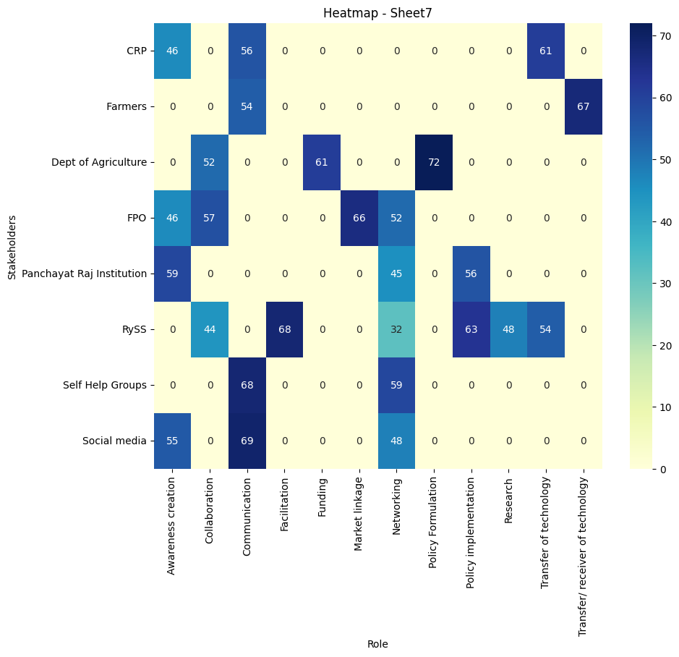

Figure 1. Role-Frequency matrix of APCNF Innovation system

3.2 Actions of Stakeholders

The analysis of stakeholder actions within the APCNF project, based on figure 2, highlights a multi-tiered, participatory implementation model. The department of agriculture and RySS emerge as key institutional drivers, taking on roles of facilitating, convening, and brokering—ensuring convergence across departments, smooth fund flows, and alignment with policy. RySS additionally leads in advocacy and coaching, enabling scale and capacity building at the grassroots. Community actors like SHGs, PRIs, and FPOs undertake crucial intermediary functions negotiating, disseminating, and mediating, to ensure that the programme remains responsive to farmers’ needs. CRPs play a pivotal field-level role in coaching, resolving issues, and spreading practices. Meanwhile, farmers contribute to informal scaling through passive dissemination, and social media platforms act as dynamic tools for information flow, feedback, and digital training. Overall, the action–frequency matrix reveals a decentralized, role-differentiated system that strengthens stakeholder synergy, builds institutional trust, and enhances the effectiveness and resilience of agroecological extension under APCNF.

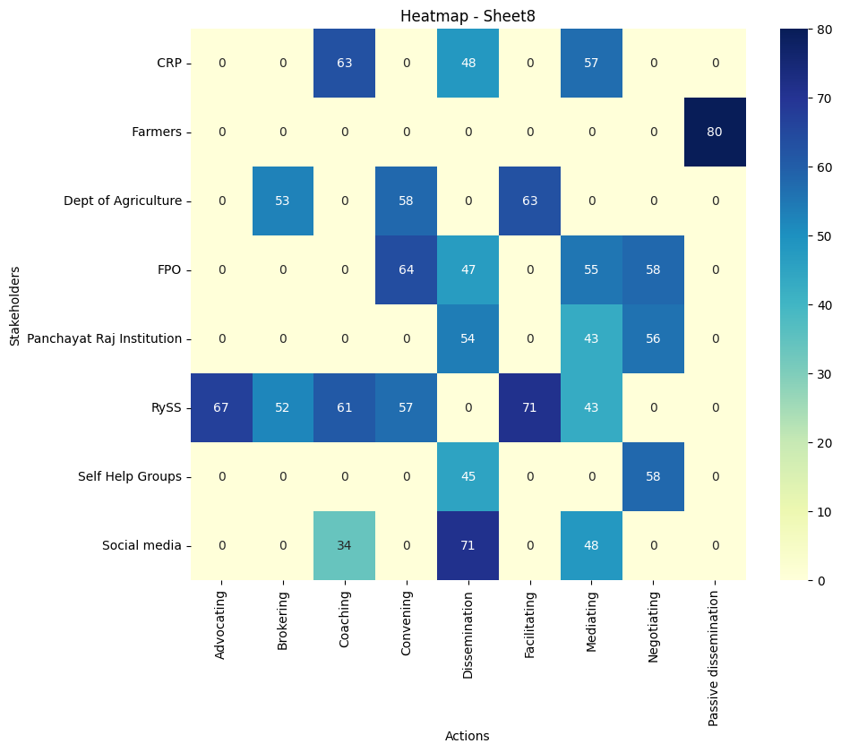

Figure 2. Action-Frequency matrix of APCNF Innovation system

3.3 Nature of Linkage Between Stakeholders

Based on the results illustrated in the table 1, the actor linkage matrix for the APCNF system reveals a deeply collaborative network, with the Department of Agriculture (DoA) and Rythu Sadhikara Samstha (RySS) emerging as the central pillars of convergence. The DoA maintains very strong relationships with RySS (4.52), Community Resource Persons (CRPs) (4.10), and farmers (4.25), which reflects its key role in policy coordination, program implementation, and extension support. Similarly, the DoA’s strong ties with social media (4.15) indicate its commitment to modern outreach mechanisms for farmer education, while its solid linkages with Self-Help Groups (SHGs) (3.23), PRIs (3.10), and FPOs (3.75) demonstrate a wide institutional footprint. RySS, the nodal implementing agency of the APCNF model, exhibits very strong institutional coordination, particularly with CRPs (4.92), who serve as the backbone of the field-level implementation. Its strong connections with SHGs (4.4) and social media (4.18) reflect its dual focus on community mobilization and digital information dissemination. The moderately strong linkage with FPOs (2.57) highlights the need for greater integration between natural farming promotion and collectivized market strategies, which is an area still developing in the APCNF model.

Community Resource Persons (CRPs), being the direct agents of change on the ground, maintain very strong mutual linkages with nearly all stakeholders, especially with RySS (4.92), FPOs (4.53), and farmers (4.37). Their consistent and trusted presence in villages is vital for facilitating behavioral shifts toward natural farming practices. Their strong links with social media (4.35) also reflect their role in content creation and real-time farmer feedback loops. Farmers in the APCNF network show strong reciprocal relationships with the DoA (4.13), RySS (4.25), CRPs (4.37), and FPOs (4.25). These robust linkages underscore the farmer-centricity of the model. Notably, farmers also share very good ties with PRIs (4.37) and SHGs (3.75), showing the value of community-based structures in accessing resources, support, and information. Farmers’ good relationship with social media (3.75) reinforces the increasing relevance of mobile-based advisories and awareness campaigns. SHGs, critical for mobilizing women and creating savings-based self-reliance, have strong ties with CRPs (4.38) and farmers (4.63), showing their grassroots integration. Their moderate engagement with the DoA (3.23), RySS (3.25), and social media (3.06) reflects their emerging but essential role in promoting household-level adoption of natural inputs and cost-saving practices.

PRIs, though administrative units, show good linkage with farmers (4.37) and CRPs (3.77), indicating their function in beneficiary selection, grievance redressal, and scheme facilitation. Their moderate ties with DoA (3.10) and SHGs (2.25) reveal their indirect but enabling presence in program delivery. FPOs act as market-facing institutions and show very good relationships with farmers (4.92) and CRPs (4.53), enabling collective procurement and marketing of naturally grown produce. Their relatively moderate connection with RySS (2.57) and social media (3.5) suggests evolving engagement with institutional and digital marketing frameworks. Social media has emerged as a powerful connective force across stakeholders, especially with CRPs (4.35), DoA (4.15), RySS (4.18), and farmers (3.75). It plays a pivotal role in spreading awareness, documenting success stories, and facilitating peer learning across geographies.

In essence, the APCNF implementation network reveals a highly participatory, decentralized, and digitally enabled ecosystem, anchored by RySS and the Department of Agriculture, and powered by grassroots actors like CRPs, SHGs, and FPOs. The presence of strong horizontal linkages between community-level actors like farmers, CRPs, and SHGs, along with vertical support from RySS and DoA, reflects the program’s strength in convergence and collaboration. These dense and complementary relationships are foundational to scaling the principles of natural farming across Andhra Pradesh in an inclusive, sustainable, and farmer-led manner.

**Table 1 Actor-Linkage Matrix of stakeholders in APCNF Innovation system**

|  |  |  |  |  |  |  |  |  |
| --- | --- | --- | --- | --- | --- | --- | --- | --- |
|  | **Dept of Ag** | **RySS** | **SHG** | **PRI** | **FPO** | **CRP** | **Farmers** | **Social media** |
| **Dept of Ag** | _ | 4.52 | 3.23 | 3.10 | 3.75 | 4.10 | 4.25 | 4.15 |
| **RySS** | 4.53 | _ | 4.4 | 3.33 | 2.57 | 4.92 | 3.75 | 4.18 |
| **SHG** | 2.43 | 3.25 | _ | 2.25 | 2.875 | 4.38 | 4.63 | 3.06 |
| **PRI** | 3.33 | 2.43 | 2.25 | _ | 2.5 | 3.77 | 4.53 | 2.75 |
| **FPO** | 3.5 | 4.25 | 3.75 | 3.75 | _ | 4.53 | 4.92 | 3.5 |
| **CRP** | 4.25 | 4.92 | 4.5 | 3.75 | 4.53 | _ | 4.5 | 4.35 |
| **Farmers** | 4.13 | 4.25 | 3.75 | 4.37 | 4.25 | 4.37 | _ | 3.75 |
| **Social media** | 4.15 | 4.18 | 3.06 | 2.75 | 3.5 | 4.35 | 3.75 | _ |

(0=no relation; 0.1-1=poor; 1.1-2=fair; 2.1-3=good; 3.1-4=very good; blank cells=don’t know)

**3.4 Type of Linkage and Type of Learning between Stakeholders**

According to the Table 2. It could be observed that, the implementation model of APCNF is deeply rooted in decentralized governance and social capital, reflected in the diverse, trust-based relationships among stakeholders and the types of learning they support. The Department of Agriculture (DoA) maintains a formal, contractual linkage with Rythu Sadhikarika Samstha (RySS), leading to a "learning by imitating and mastering" dynamic. In contrast, its interactions with grassroots actors—SHGs, PRIs, CRPs, FPOs, and farmers—are characterized by networks, partnerships, and alliances, promoting "interactive learning" through two-way knowledge exchange on natural farming practices.

RySS, the nodal agency, plays a dual role—implementing APCNF while advocating within the DoA to shape policy convergence. Its strong partnerships and alliances with SHGs and CRPs facilitate "learning by doing" via field demonstrations and community trainings. PRIs and FPOs primarily engage through information exchange and coordination, enabling dialogue-driven learning. SHGs and CRPs, being community-embedded, foster vibrant networks and peer-based interactive learning, with SHGs supporting input production and CRPs serving as knowledge intermediaries.

PRIs legitimize local implementation and promote scheme convergence, while FPOs support aggregation and market linkages—though their direct linkages with CRPs and RySS remain limited. Farmers, at the center of the model, maintain dynamic, horizontal relationships with multiple stakeholders, learning primarily through interaction and peer engagement. Social media further amplifies this, enabling real-time, low-cost information sharing and feedback, especially among farmers and CRPs.

In summary, APCNF exemplifies a participatory, horizontally integrated innovation system where formal contracts are minimal, and learning is largely experiential, collaborative, and socially embedded—essential for sustaining agroecological transitions at scale.

**Table 2. Type of linkage and Type of learning between stakeholders**

|  |  |  |  |
| --- | --- | --- | --- |
| **Stakeholders** | | **Type of Linkage** | **Type of learning** |
| Dept of Agriculture | RySS | Formal contract | Learning by imitating and mastering |
| SHG | Alliance; Network | Learning by interacting |
| PRI | Partnership | Learning by interacting |
| FPO | Networks | Learning by interacting |
| CRP | Partnership; Alliance | Learning by interacting |
| Farmers | Networks | Learning by interacting |
|  | Social media | Information Exchange | Learning by interacting |
| RySS | Dept of Agriculture | Advocacy linkage | Learning by interacting |
| SHG | Alliance; Networks | Learning by doing |
| PRI | Information exchange | Learning by interacting |
| FPO | Networks | Learning by interacting |
| CRP | Partnership | Learning by interacting |
| Farmers | Networks | Learning by interacting |
| Social media | Information exchange | Learning by interacting |
| SHG | Dept of Agriculture | Alliance; Networks | Learning by interacting |
| RySS | Alliance | Learning by doing |
| PRI | Networks | Learning by interacting |
| FPO | Networks | Learning by interacting |
| CRP | Partnership; Networks | Learning by interacting |
| Farmers | Information Exchange; Networks | Learning by interacting |
| Social media | Information Exchange | Learning by interacting |
| PRI | Dept of Agriculture | Partnership; Alliance | Learning by doing |
| RySS | Information Exchange | Learning by interacting |
| SHG | Information Exchange | Learning by interacting |
| FPO | Networks | Learning by interacting |
| CRP | Networks | Learning by interacting |
| Farmers | Networks; Information Exchange | Learning by interacting |
| Social media | Information Exchange | Learning by interacting |
| FPO | Dept of Agriculture | Networks | Learning by interacting |
| RySS | None | None |
| SHG | Information Exchange | Learning by interacting |
| PRI | Information Exchange; Networks | Learning by interacting |
| CRP | None | None |
| Farmers | Information Exchange; Networks | Learning by interacting |
| Social media | Information Exchange | Learning by interacting |
| CRP | Dept of Agriculture | Partnership/Alliance | Learning by interacting |
| RySS | Partnership | Learning by interacting |
| SHG | Networks | Learning by interacting |
| PRI | Information exchange | Learning by interacting |
| FPO | None | None |
| Farmers | Networks; Information exchange | Learning by interacting |
| Social media | Information exchange | Learning by interacting |
| Farmers | Dept of Agriculture | Networks | Learning by interacting |
| RySS | Alliance | Learning by doing |
| SHG | Partnership | Learning by interacting |
| PRI | Networks | Learning by interacting |
| FPO | Partnership | Learning by interacting |
| CRP | Networks; Information exchange | Learning by interacting |
| Social media | Information exchange | Learning by interacting |

4. Conclusion

The findings of this study underscore the strength, complexity, and community-centric architecture of the stakeholder ecosystem driving the Andhra Pradesh Community-Managed Natural Farming (APCNF) programme. Through the integrated lens of roles, actions, and inter-actor linkages, APCNF emerges not as a conventional, top-down agricultural intervention, but as a decentralized, socially embedded innovation system rooted in participatory governance and collective learning.

Key institutional actors such as the Department of Agriculture and Rythu Sadhikara Samstha (RySS) form the backbone of policy formulation, funding, convergence, and facilitation. RySS, in particular, plays a dual role—not only implementing but also advocating for agroecological transition within the government structure. In contrast, grassroots actors like Self-Help Groups (SHGs), Community Resource Persons (CRPs), Panchayati Raj Institutions (PRIs), and Farmer Producer Organizations (FPOs) operationalize the program on the ground through capacity building, peer-led training, market linkages, and trust-based knowledge exchange.

The implementation model of APCNF is deeply anchored in decentralized governance and local social capital. While the Department of Agriculture maintains a formal contractual linkage with RySS—characterized by "learning by imitating and mastering"—its interactions with grassroots stakeholders operate through partnerships, alliances, and networks that facilitate "interactive learning" and dynamic two-way information flow. RySS’s close collaboration with SHGs and CRPs promotes "learning by doing," empowering farmers through field demonstrations, seasonal campaigns, and participatory experimentation.

PRIs serve as institutional anchors, ensuring scheme convergence and facilitating awareness at the village level, while FPOs enhance farmers’ market access and economic viability, albeit with scope for stronger linkages with CRPs and RySS. Farmers themselves lie at the core of the system, engaging in horizontal, trust-based relationships that promote peer-to-peer learning and adaptive practice. Social media platforms have further enriched the ecosystem by enabling real-time, low-cost dissemination, feedback, and problem-solving—especially for CRPs and farmers.

Overall, the APCNF innovation system exemplifies a robust, horizontally integrated, and community-led approach to agricultural extension. It highlights how reimagined extension—when embedded within grassroots institutions and supported by a facilitative state—can drive ecological, economic, and social transformation. For the continued success and scalability of this model, it will be critical to strengthen inter-institutional linkages, invest in continuous capacity building, leverage digital platforms, and nurture local leadership as catalysts of change.

Competing interests

No competing interests exist.

References

**Planning Commission of India.** (2011). *Report of the working group on agricultural development for the twelfth five-year plan (2012–17)*. New Delhi: Government of India.

**FAO. (2020).** Impact Assessment of Andhra Pradesh Community Managed Natural Farming (APCNF): Kharif 2019-2020. <https://www.fao.org/agroecology/database/detail/en/c/1381186/>

FAO (2021). Andhra Pradesh Community Managed Natural Farming: A Transformative Agroecology Approach. Food and Agriculture Organization of the United Nations.  
<https://www.fao.org/agroecology/database/detail/en/c/1381186>

Sulaiman, R. V., & Hall, A. (2004). Towards Extension Plus: Opportunities and Challenges. Policy Brief 11, National Centre for Agricultural Economics and Policy Research, Indian Council of Agricultural Research (ICAR), New Delhi.

**Hall, A., Janssen, W., Pehu, E., & Rajalahti, R.** **(2006).** *Enhancing agricultural innovation: How to go beyond the strengthening of research systems*. Washington, DC: The World Bank.

**Hermans, F., Apeldoorn, D., Stuiver, M. and Kok, K (2012).** Niches and networks: Explaining network evolution through niche formation processes. *Research Policy*. 2798. 1-11.

**Sulaiman, R.V. (2015).** Agricultural Innovation Systems. Note 13. GFRAS Good Practice Notes for Extension and Advisory Services. GFRAS: Lindau, Switzerland.

**Matsaert, H. 2002.** “Socio-economic Methodologies for Natural Resource Research Best Practice Guidelines.” Natural Resources Institute, University of Greenwich. Accessed june 6, 2023. <http://www.nri.org/publications/bpg/bpg11.pdf>.

Khan, M.M., & Sreeja, T. (2022) Microeconomic Comparison of Natural and Conventional Farming in Andhra Pradesh. Journal of fundamental & comparative research, 3(29), 136-141.

**Spielman, D. J., Davis, K. E., Negash, M. and Ayele, G. (2010).** Rural innovation systems and networks: Findings from a study of Ethiopian smallholders. *Agriculture and Human Values*, 28(2):195-212.

**de Vaus, D. A., & de Vaus, C. (2001).** Research design in social research. London: SAGE Publications.

**Brown, J. (2008).** Research in Agricultural Innovation Systems: Case Study Methodologies*.* *International Journal of Agricultural Development*, 23(4), 345–361.

**Hall, A., Janssen, W., Pehu, E., & Rajalahti, R.** (2006b). *Enhancing agricultural innovation: How to go beyond the strengthening of research systems*. Washington, DC: The World Bank.

**Sulaiman, R. V., Hall, A., Vamsidhar, R., & Clark, N.** (2010). Necessary but not sufficient: Information and communication technology and its role in putting research into use. *RIU Discussion Paper 2010-02*. Research Into Use (RIU) Programme.