***Original Research Article***

**Evaluation of Paddy Crop Characteristics in the NEH Region for Mechanized Harvesting**

**Abstract**

Engineering properties of crop plants play a vital role in the design and optimization of efficient harvesting machinery. This study investigates the morphological and physical characteristics of the PR-126 paddy variety (*Oryza sativa L.*) cultivated in the North Eastern Hill (NEH) region of India, aimed at providing essential data for harvester design. Fifty paddy samples were randomly collected from the field and analyzed for plant height, panicle height, stem diameter, crop spacing, density, and moisture content using standard instruments such as a digital Vernier Caliper, measuring tape, and an infrared moisture analyzer. The average plant height and panicle height were found to be 904 ± 74 mm and 506 ± 74 mm, respectively, with a mean stem diameter of 7.62 ± 0.81 mm. The crop exhibited a row spacing of 200 ± 10 mm and a plant density of 24 hills m-2. Moisture content measured post-harvest was 21.74 ± 0.74% (w.b.) for grain and 40.46 ± 3.81% (w.b.) for straw. Most parameters followed normal or near-normal distributions, indicating uniform growth conditions. These characteristics provide critical input for determining appropriate cutting height, blade specifications, and conveying mechanisms for harvesting equipment adapted to hilly terrains.

**Keywords:** Paddy, Morphological Characteristics, Physical Characteristics, Moisture Content, Hill Agriculture

1. **Introduction**

Paddy (Oryza sativa L.) is a major cereal crop and staple food for a large portion of the global population, particularly in Asia, which accounts for over 90% of both the cultivation area and production. India and China together hold nearly half of the global paddy area and contribute significantly to global rice consumption (Anonymous, 2023a; Anonymous, 2023b). India ranks as the world’s second-largest producer of paddy, accounting for approximately 25.27% of global output, and also plays a key role in the export of cereal crops, supported by increasing international demand (Sahu *et al.,* 2025; Hensh *et al.*, 2024; Guru *et al.,* 2025).

Cereal crops such as wheat, paddy, maize, sorghum, barley, and millets are central to Indian agriculture. As per estimates from the Ministry of Agriculture for the year 2020–21, the production of paddy, maize, and bajra in India was reported at 102.36, 19.88, and 9.23 million tonnes, respectively (Choudhary and Machavaram, 2022). During 2022–23, India’s total cereal exports were valued at ₹111,062.37 crore (13,857.95 million USD), with paddy contributing around 80% of the total cereal exports, indicating its economic importance (Anonymous, 2024).

In the North Eastern Hill (NEH) region, including Sikkim, paddy is one of the most important food crops. It is cultivated under two major land conditions terraced and valley lands depending on the topography. Despite challenging terrain and high cultivation costs, paddy remains integral to food security in the region (Gogoi *et al.,* 2025; Debnath and Chauhan, 2020; Komatineni *et al.,* 2024). According to recent reports, paddy cultivation in Sikkim during 2021–22 covered 8,700 hs with a total production of 16,190 tonnes, achieving an average productivity of 1860.61 kg ha⁻¹. Productivity has steadily increased from 1437.00 kg ha⁻¹ in 2003, primarily due to the gradual introduction of mechanization in field operations (Komatineni *et al.,* 2023; Hensh and Raheman, 2022).

However, full-scale adoption of mechanized harvesting technologies remains limited in the NEH region due to fragmented fields, undulating terrain, and the absence of crop-specific data for machinery design. Under such conditions, the effective design of harvesting equipment requires precise information on crop characteristics. Morphological and physical properties such as plant height, panicle height, stem diameter, hill diameter, and moisture content directly influence the functional performance of harvesting units. These parameters are essential for determining suitable cutter bar height, blade dimensions, and conveying system configurations, especially for use in small, terraced fields and sloped landscapes.

Therefore, evaluating the engineering properties of paddy crops grown under NEH conditions is critical to ensure compatibility between the crop and machine design. Such data not only improve the efficiency and reliability of harvesting operations but also reduce post-harvest losses and dependence on manual labor. In this context, the present study aims to assess the morphological and physical characteristics of the PR-126 paddy variety cultivated in Sikkim. The outcomes of this study will contribute valuable input data for the development of location-specific harvesting machinery suitable for the agro-climatic and topographic conditions of the NEH region.

1. **Materials and Methods**
   1. **Experimental setup**

The field experiment was conducted at the experimental farm of the ICAR Research Complex for the North Eastern Hill (NEH) Region, Sikkim Centre, located at Tadong, Gangtok, Sikkim. The objective of the study was to assess the engineering properties of the paddy variety PR-126, which is widely cultivated across the NEH region, for the purpose of designing and developing suitable harvesting machinery. A total of 50 paddy plant samples were randomly selected from different locations within the field to ensure representative data collection. Key morphological and physical parameters influencing harvester design were measured using appropriate instruments, as detailed in the subsequent sections. Additionally, row-to-row spacing was recorded to estimate the effective cutting width required for the harvester's cutter bar and shown in Fig. 1.

* + 1. **Plant height**

Plant height is a key factor affecting reel positioning, cutter bar clearance, and overall harvester geometry (Yuan *et al.,* 2023). It was measured as the vertical distance from the soil surface to the tip of the highest leaf. A measuring tape with a least count of 1 mm was used for this purpose. Measurements were recorded for each of the 50 sampled plants and expressed in millimetres

* + 1. **Panicle height**

Panicle height, which affects crop top flexibility and cutter bar design, was measured from the base of the panicle (point of emergence from the flag leaf sheath) to the panicle tip. Measurements were taken using a measuring tape/scale with a least count of 1 mm and recorded in millimetres. This parameter is essential in assessing lodging potential and for positioning the cutting unit to avoid grain losses (Sun *et al.,* 2019)

* + 1. **Stem diameter**

Stem diameter determines the resistance offered during cutting and affects blade selection in harvester design (Xin *et al.,* 2022). It was measured at the first internode (above ground level) using a digital Vernier caliper with a least count of 0.01 mm. The values were recorded for all samples and expressed in millimeters. Consistent measurement at the same internodal position ensured uniformity and repeatability.

* + 1. **Number of productive stems per hill**

This parameter provides insights into the crop stand density and biomass load, influencing the design of the feed mechanism. The number of stems bearing panicles was counted manually per hill for each of the 50 sampled hills. Hills were uprooted carefully to avoid loss. The average number of productive stems per hill was calculated (Modak and Raheman, 2022).

* + 1. **Hill diameter**

Hill diameter represents the lateral spread of the basal portion of the crop and influences the design of gripping and conveying mechanisms. It was measured across the widest point of the hill using a Vernier caliper and recorded in millimeters. This parameter helps assess the required clearance and gripping width for crop holding units (Sahoo and Raheman, 2020).

* + 1. **Grain and straw moisture content (% w.b.)**

Moisture content is a critical parameter influencing the cutting, threshing, and conveying efficiency during the harvesting of paddy crops. In this study, moisture content was determined for both grains and straw of the selected paddy variety. A total of 50 samples were randomly collected from various locations across the experimental field. The measurements were conducted using an Infrared Moisture Analyzer (Brand: Mettler Toledo, Model: HC 103), which offers high precision with a readability of 1 mg and a moisture resolution of 0.01%. Approximately 5 g of each grain and straw sample was placed in the analyzer and subjected to thermal drying at 105 °C. The analyzer provided real-time drying curves, aiding in the accurate determination of moisture content. The initial weight and final dry weight of the samples were recorded to compute the moisture content using the standard gravimetric method. The following formula was used for both grain and straw moisture determination (Sahay and Singh, 1994; Komatineni *et al.,* 2025)

$M_{C}=\frac{W_{w}}{W_{d}}×100$…. (1)

Where,

*MC* = Moisture content, %; $W_{W}$ = Weight of the water removed from crop, g and $W_{d}$ = Weight of the dry crop, g

* + 1. **Crop density**

Crop density plays a critical role in determining the volume of biomass encountered per unit cutter bar width and hence affects the throughput capacity of the harvester. To measure it, a 1 m² quadrant made of square iron rods was randomly placed at 50 different spots across the experimental field. The number of hills within each quadrant was manually counted, and the average hill density per square meter was computed (Li *et al.,* 2022; Komatineni *et al.,* 2023 ).

|  |  |  |  |
| --- | --- | --- | --- |
|  |  |  |  |
| a. Measurement of plant height | b. Measurement of stem diameter | c. Measurement of plant density | d. Measurement of moisture content |

**Fig. 1. Determination of properties of paddy crops related to harvesting**

1. **Results and Discussion**

Crop growth parameters of the randomly selected 50 samples of paddy crop were measured using suitable instruments, which were mentioned in the above section. The various crop growth properties measured are presented and discussed in the following subsections and given in Table 1.

* 1. **Plant height**

The average plant height was recorded as 904 ± 74 mm, based on 50 test samples. The measured values ranged from a minimum of 780 mm to a maximum of 1046 mm, indicating a moderately wide distribution. Most of the observations fall between 850 mm and 950 mm, suggesting a symmetrical pattern centered around the mean and shown in Fig. 2.

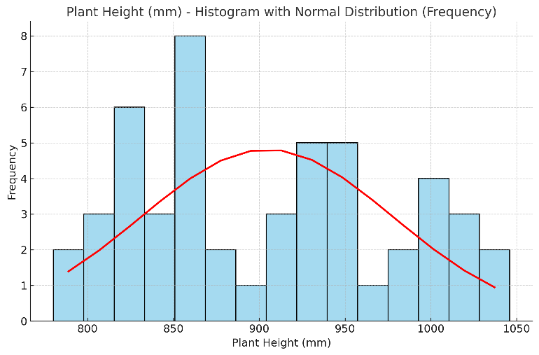

**Fig. 2**. Distribution in plant height of PR-126 paddy variety

* 1. **Panicle height**

The average panicle height was recorded as 506 ± 74 mm, calculated over 50 test samples. The values ranged between 416 mm to 690 mm, showing a considerable spread. The data appears to follow a relatively symmetrical distribution, with the majority of values lying between 450 and 550 mm, indicating consistent growth across the samples as shown in Fig. 3.

**Fig. 3**. Distribution in panicle height of PR-126 paddy variety

* 1. **Stem diameter**

The average stem diameter was recorded as 7.62 ± 0.81 mm and measured for the 50 samples. The range of stem diameter varied between 5.82 to 9.62 mm. The maximum numbers of observations fall between 7.00 to 8.50 mm and is shown in Fig. 4.

**Fig. 4**. Distribution of stem diameters of PR-126 paddy variety

* 1. **No. of stems per hill**

The average number of stems per hill was recorded as 9 ± 2, based on 50 test samples. The values ranged from a minimum of 6 stems to a maximum of 13 stems, indicating a moderately narrow distribution. Most of the observations fall within the range of 8 to 11 stems per hill, suggesting a consistent tillering pattern across the field and a distribution closely centered around the mean and shown in Fig. 5.

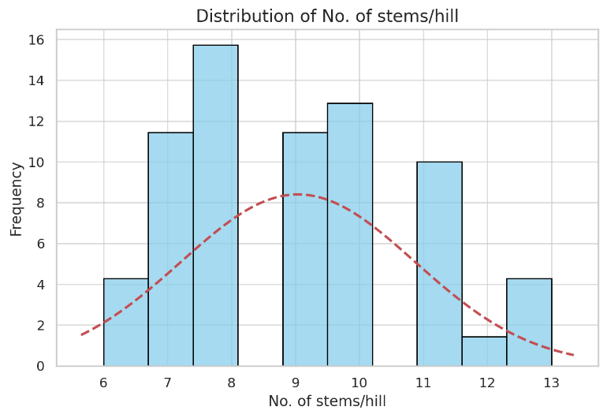

**Fig. 5**. Distribution of the number of stems per hill of PR-126 paddy variety

* 1. **Hill diameter**

The average hill diameter was recorded as 65.34 ± 17.58 mm, based on 50 test samples. The measured values ranged from a minimum of 39.80 mm to a maximum of 102.70 mm, indicating a relatively wide variability among the hills. The data appears to be moderately dispersed, with most observations clustering between 55 mm and 75 mm, suggesting a slightly right-skewed distribution due to a few high values above 95 mm, as shown in Fig. 6.

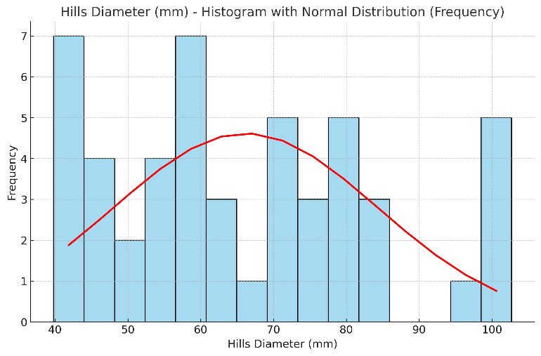

**Fig. 6**. Distribution of hills diameter of the PR-126 paddy variety

* 1. **Moisture content of paddy grain**

The average moisture content of paddy grain (w.b.) was 21.74 ± 0.74% measured for the 50 samples. The range of moisture content varied between 19.98% to 23.05%. The recorded data shows that the moisture content data follow a normal distribution. This range suggests controlled and consistent drying or harvesting conditions. Most values are close to the mean, indicating high uniformity among the test samples, as shown in Fig. 7.

**Fig. 7**. Distribution in grain moisture content of PR-126 paddy variety

* 1. **Moisture content of paddy straw**

The average values of moisture content of paddy straw (w.b.) were 40.46% ± 3.81% measured for the 50 samples. The range of moisture content varied between 33.61% to 48.17%. showing a spread of approximately 15%, the field recorded data shows that the moisture content data also follows a normal distribution as above. The maximum number of observations falls between 36% to 44%. Overall, the results indicate that while the majority of the straw samples had moisture levels suitable for harvesting, safe storage, some may require additional drying to prevent spoilage or microbial growth, as shown in Fig. 8.

**Fig. 8**. Distribution of straw moisture content of PR-126 paddy variety

* 1. **Plant density**

The average plant density of the paddy field at the time of maturity of the crop was found as 25 hills m-2, as measured for the 50 samples. The range of plant density varied between 21 to 28 hills m-2. It was measured by a 1×1 m2 iron square block. The maximum number of observations falls in the range of 21 to 26 hills m-2. The values are tightly clustered, indicating uniform planting practices and density management across the test plots as shown in Fig. 9.

**Fig. 9**. Distribution in plant density of PR-126 paddy variety

**Table 1.** Descriptive statistics of measured crop growth parameters of paddy plants

|  |  |  |  |  |  |  |  |  |
| --- | --- | --- | --- | --- | --- | --- | --- | --- |
|  | **Plant Height, mm** | **Panicle Height, mm** | **Stem Diameter, mm** | **No. of stems Per hill, no.** | **Hills Diameter, mm** | **Grain Moisture, %** | **Straw Moisture, %** | **Plant Density, hills m-2** |
| **Mean** | 904 | 506 | 7.62 | 9 | 66.18 | 21.74 | 40.46 | 24 |
| **Standard Error** | 10 | 10.5 | 0.11 | 0.26 | 2.59 | 0.1 | 0.54 | 0.23 |
| **Median** | 901 | 482.5 | 7.67 | 9 | 61.67 | 21.93 | 40.18 | 24 |
| **Mode** | 825 | 480 | 6.92 | 8 | #N/A | 21.75 | 44.62 | 25 |
| **Standard Deviation** | 74 | 74.26 | 0.81 | 1.83 | 18.31 | 0.74 | 3.81 | 1.66 |
| **Sample Variance** | 5508.86 | 5514.87 | 0.65 | 3.37 | 335.21 | 0.54 | 14.51 | 2.76 |
| **Kurtosis** | -1.14 | 0.01 | 0.37 | -0.46 | -0.69 | 0.32 | -0.86 | -0.72 |
| **Skewness** | 0.24 | 0.97 | 0.06 | 0.4 | 0.46 | -0.89 | 0.4 | 0.15 |
| **Range** | 266 | 274 | 3.8 | 7 | 62.9 | 3.07 | 14.56 | 7 |
| **Minimum** | 780 | 416 | 5.82 | 6 | 39.8 | 19.98 | 33.61 | 21 |
| **Maximum** | 1046 | 690 | 9.62 | 13 | 102.7 | 23.05 | 48.17 | 28 |
| **Sum** | 45230 | 25303 | 381.11 | 451 | 3309.11 | 1086.99 | 2023.02 | 1217 |
| **Count** | 50 | 50 | 50 | 50 | 50 | 50 | 50 | 50 |
| **Confidence Level (95.0%)** | 21.09 | 21.11 | 0.23 | 0.52 | 5.2 | 0.21 | 1.08 | 0.47 |

1. **Conclusion**

The study evaluated the morphological and physical characteristics of the PR-126 paddy crop to support the development of harvesting machinery for the NEH Region. The average plant height (904 ± 74 mm), panicle height (506 ± 74 mm), and stem diameter (7.62 ± 0.81 mm) indicated uniform and robust plant growth. Consistent row spacing of 200 ± 10 mm contributed to a stable plant density of 24 hills m-2. Post-harvest moisture content averaged 21.74 ± 0.74% (w.b.) for grain and 40.46 ± 3.81% (w.b.) for straw.

**References**

Anonymous. (2023a). FAOSTAT Food and Agriculture organization of United Nation, 2019. [http://www.fao.org/faostat/en/#country/100.](http://www.fao.org/faostat/en/#country/100. Acessed on 02.03.2023)

Anonymous. (2023b). Department of Agriculture, Government of Sikkim. <https://agri.sikkim.gov.in/Department/AgriSubMenuDetails?ContID=19&SubContID=9>

Anonymous. (2024). Agricultural and Processed Food Products Export Development Authority <https://apeda.gov.in/apedawebsite/six_head_product/cereal.htm>.

Choudhary, V., & Machavaram, R. (2022). Need of automation in paddy nurseries for raising paddy seedlings in India: A Review. *Journal of Biosystems Engineering*, *47*(2), 209-222.

Debnath, A., and Chauhan, N.S. (2020). Field Performance and Economic Feasibility of Self-Propelled Vertical Conveyor Reaper (VCR) for Harvesting of Rice in West Sikkim and A Technological Strategy for Mitigation of Air Pollution through Crop Residue Burning in India. *Nature Environment and Pollution Technology,* 19:521-538.

Gogoi, N., Pathak, B., Rehman, R., Upadhyaya, S., Mahanta, P., Borah, A., & Bhuyan, K. (2025). Rice yield responses to climate variability in Northeast India using machine learning approach. *Theoretical and Applied Climatology*, *156*(4), 1-17.

Guru, P. K., Shrivastava, A. K., Khandai, S., Yahaya, R., Singh, S., Kumar, V., ... & Kumar, M. (2025). Development and Performance Evaluation of a Precision Seeder for Sustainable Rice Cultivation. *Results in Engineering*, 104059.

Hensh, S., & Raheman, H. (2022). An unmanned wetland paddy seeder with mechatronic seed metering mechanism for precise seeding. Computers and Electronics in Agriculture, 203, 107463.

Hensh, S., Raheman, H., Upadhyay, G., & Bera, S. (2024). Comparative analysis of a remotely-controlled wetland paddy seeder and conventional drum seeder. *Sādhanā*, *49*(4), 260.

Komatineni, B. K., Makam, S., & Meena, S. S. (2024). A comprehensive review of the functionality and applications of unmanned aerial vehicles (UAVs) in the realm of agriculture. *Journal of Electrical Systems and Information Technology*, *11*(1), 1-28.

Komatineni, B. K., Satpathy, S. K., Naik, M. A., Dwivedi, U., & Lahre, J. (2024). An Unmanned rice seeder with WiFi based mobile-control system for drudgery reduction. *Smart Agricultural Technology*, *8*, 100471.

Komatineni, B. K., Satpathy, S. K., Reddy, K. K. V., Sukdeva, B., Dwivedi, U., & Lahre, J. (2023). Development and evaluation of bluetooth based remote controlled battery powered drum seeder. *e-Prime-Advances in Electrical Engineering, Electronics and Energy*, *6*, 100333.

Komatineni, B.K., Manjula, B., Meena, S.S. *et al.* Development and evaluation of punching mechanism for de-seeding of ber fruit. *Discov Agric* **3**, 18 (2025). <https://doi.org/10.1007/s44279-025-00168-w>

Li, C., Tang, Y., McHugh, A. D., Wu, X., Liu, M., Li, M., & Huang, Y. (2022). Development and performance evaluation of a wet-resistant strip-till seeder for sowing wheat following rice. *biosystems engineering*, *220*, 146-158.

Sonawane, S., Mehta, A. K., Nalawade, R. D., Sonawane, S. P., Kumar, M., & Rahimi, M. (2025). Design, development and performance evaluation of henna harvester. *Scientific Reports*, *15*(1), 13716.

Modak, S., & Raheman, H. (2022). Effects of various machine parameters on cutting performance for high-speed cutting of paddy crop. *Journal of Biosystems Engineering*, *47*(2), 181-196.

Sahay K.M. and Singh K.K., 1994**.** Unit Operations of Agricultural Processing. Vikas House Pvt. Press, New Delhi, India.

Sahoo, A. U., & Raheman, H. (2020). Power requirement estimation for cutting paddy crop using a standard cutter bar. *Journal of The Institution of Engineers (India): Series A*, *101*, 477-484.

Sahu, N., Kesharwani, R., Das, P., Kumar, A., Varun, A., Saini, A., & Mishra, M. M. (2025). Spatiotemporal dynamics of rice cultivation in India. *Tropical Ecology*, *66*(1), 152-167.