Original Research Article
Influence of spacing and fertilizer levels on yield, cost economic returns, leaf nutrient composition and soil nutrient status in Daisy (Aster amellus L.) cv. Purple Multipetal

Abstract: Investigations were carried out at the Department of Floriculture and Landscaping, Kittur Rani Channamma College of Horticulture, Arabhavi, under the University of Horticultural Sciences, Bagalkot, during the year 2023–24. The experiment was laid out in a factorial randomized complete block design (RCBD) with three replications and included three spacing levels (30 × 20 cm, 30 × 30 cm, and 40 × 30 cm) and three fertilizer levels: F1 (105:131.25:112.5 NPK kg/ha), F2 (140:175:150 NPK kg/ha), and F3 (175:218.75:187.5 NPK kg/ha). The highest fertilizer level (F3) recorded the maximum values for yield parameters, available soil nutrients, and leaf nutrient status (N, P₂O₅, and K₂O). Among the spacing levels, the optimum spacing (S3: 40 × 30 cm) resulted in the highest yield per plant and per hectare, along with better available soil and leaf nutrient status. In terms of treatment combinations, the S3F3 treatment (40 × 30 cm spacing with 175:218.75:187.5 NPK kg/ha) recorded the highest yield per plant and per hectare, as well as improved soil and leaf nutrient levels, whereas the highest yield per plot was recorded in the S1F3 combination. The highest gross and net returns, along with the maximum benefit-cost ratio of 2.54, were also obtained in the S3F3 treatment combination.
Keywords: Daisy, Aster amellus, spacing, fertilizers, interactions.

Introduction

Daisy (Aster amellus L.), commonly known as the Italian aster, is a promising perennial filler flower native to Europe and parts of Asia, belonging to the Asteraceae family. It features upright, branched stems with dark green foliage and obovate, petiolated basal leaves. The plant is widely cultivated for use in floral arrangements and as filler material, and it has become increasingly popular in India, particularly near urban areas, due to its decorative appeal and adaptability. Its flowering season, which spans from July to October, coincides with market demand, making it commercially viable. Daisy thrives in full sunlight and a variety of soil types, demonstrating notable tolerance to heat, drought, and common pests and diseases. Its perennial habit and consistent flowering ability make it a suitable alternative to seasonal flowers, offering continuous harvest potential and steady market supply.
In floriculture, effective nutrient management and proper plant spacing are essential for successful cultivation. The macronutrients nitrogen (N), phosphorus (P), and potassium (K) are vital for healthy plant growth and maximum productivity. Nitrogen enhances vegetative growth and leaf color by promoting photosynthesis and protein formation; phosphorus supports early root growth, flower initiation, and seed development; and potassium contributes to stronger stems, better stress resistance, and overall plant vigor. An optimal NPK balance improves not only growth but also flowering quality, flower yield, and overall productivity.
Plant spacing also plays a crucial role in determining plant performance. Wider spacing facilitates better air circulation, improved light penetration, and root development, which lead to healthier plants and superior flower quality. Conversely, closer spacing can increase the number of flowers per area but may limit individual plant growth due to competition for resources. Therefore, achieving an ideal balance between spacing and nutrient supply is necessary to maximize both yield and quality.
Recognizing the importance of both spacing and fertilizer management in influencing the growth, flowering, and overall productivity of Daisy, an experiment was conducted to assess their combined effects. The goal of the study was to identify the most effective spacing and fertilizer combination for maximizing the performance of Aster amellus cv. Purple Multipetal. This research offers valuable insights for improving commercial Daisy production and is supported by earlier findings such as those by Siddappa et al. (2018). Successful crop production depends on various factors, including soil fertility, irrigation, plant population, and pest management. Among these, nutrient application and spacing are particularly important for achieving high productivity. Appropriate spacing ensures adequate nutrient uptake, light exposure, and aeration, allowing plants to perform optimally in terms of yield and quality. Nitrogen, phosphorus, and potassium are especially critical and must be supplied in adequate quantities to support healthy growth and flowering. Additionally, analyzing cost and returns across different production practices helps identify favorable regions for year-round cultivation. Understanding crop nutrient requirements, uptake patterns, and post-harvest soil and plant nutrient status is essential for formulating suitable fertilizer recommendations for a given agroclimatic region. With these considerations in mind, the present study titled “Influence of spacing and fertilizer levels on yield, cost economic returns, leaf nutrient composition and soil nutrient status in Daisy (Aster amellus L.) cv. Purple Multipetal” was undertaken.
.

Materials and methods

The present investigation was conducted at the Department of Floriculture and Landscaping, Kittur Rani Channamma College of Horticulture, Arabhavi, to examine the effect of various spacing and fertilizer levels on the vegetative growth of Daisy (Aster amellus L.) cv. Purple Multipetal. The experiment followed a factorial randomized block design (FRBD), incorporating two factors—spacing and fertilizer—each with three replications and randomly allocated treatments. The spacing treatments included S1 (30 × 20 cm), S2 (30 × 30 cm), and S3 (40 × 30 cm), while the fertilizer treatments consisted of F1 (105:131.25:112.5 NPK kg/ha), F2 (140:175:150 NPK kg/ha), and F3 (175:218.75:187.5 NPK kg/ha). Suckers of the Purple Multipetal variety were planted according to the assigned spacing and fertilized with the corresponding nutrient levels. Before transplanting, the plots were enriched with well-decomposed farmyard manure (FYM). A basal dose comprising the full quantity of phosphorus and potassium, along with half of the nitrogen, was applied during planting. The remaining half of the nitrogen was administered as a top dressing 30 days after transplanting. Uniform cultural practices were maintained across all treatments, and the data collected were subjected to appropriate statistical analysis.
For the evaluation of yield attributes, five plants were randomly selected from each treatment to measure flower yield per plant and per hectare. Flower stems were harvested periodically, and the total yield was recorded. To assess the soil nutrient status (N, P₂O₅, and K₂O), soil samples were initially collected from a depth of 15–30 cm in a zigzag manner across the experimental field. After treatment application, soil samples were taken separately from each plot to determine final nutrient levels. Additionally, the 3rd and 4th leaves from the apex were sampled from each treatment to analyze leaf nutrient content (N, P₂O₅, and K₂O). The benefit-cost ratio was calculated following standard procedures, with nitrogen measured using the Micro-Kjeldahl method, phosphorus by the Vanadomolybdate method, and potassium using a flame photometer.

Table 1: Initial available nutrient status of soil (before treatment imposition)
Sl. No. | Particulars | Characterization | Method employed
I. | Physical properties
a. | Soil structure  Sand (%)  Silt (%)  Clay (%) | 49.50  17.50  32.00 | Hydrometer method  (Piper, 1966)
b. | Soil texture | Sandy clay loam
c. | Soil colour | Black
d. | Bulk density (g cc⁻¹ ) | 2 | Majumder and Singh, 2012
II. | Chemical properties
a. | Soil pH | 8.32 | pH meter (Jackson, 1973)
b. | Soil EC | 1.28 dSm⁻¹ | Conductivity meter (Jackson, 1973)
c. | Soil organic carbon | 0.84 per cent | (Walkey and Black,1934)
d. | Available nitrogen | 138.35 kg ha⁻¹ | Modified Kjeldahl method (Subbaiah and Asija, 1956)
e. | Available phosphorus | 8.77 kg ha⁻¹ | Olsen’s method (Olsen’s et al. 1954)
f. | Available potassium | 146.05 kg ha⁻¹ | Flame Photometry (Jackson, 1973)

Results and discussion
Influence of different spacings and fertilizer levels on yield parameters of Daisy (Aster amellus L.) cv. Purple Multipetal

Yield parameters
Number of Spikes per Plant
The number of spikes per plant in daisy was significantly affected by different spacing levels, fertilizer doses, and their interaction. The recorded data is presented in Table 2.
Effect of Spacing
Spacing had a notable influence on the number of spikes per plant. The widest spacing (S3: 40 × 30 cm) resulted in the highest number of spikes per plant (5.04), while the closest spacing (S1: 30 × 20 cm) produced the lowest (3.53). The increase in the number of spikes per plant with wider spacing can be attributed to better light penetration and aeration, which promote more branching and ultimately lead to increased spike production. These findings are in agreement with those reported in gladiolus by Kumar et al. (2016), and in carnation by Karthikeyan and Jawaharlal (2013).
Effect of Fertilizer
Fertilizer application also showed a significant effect on the number of spikes per plant. The highest number of spikes (5.62) was observed with the highest fertilizer dose (F3: 175:218.75:187.5 NPK kg/ha), while the lowest number (3.10) was recorded with the lowest dose (F1: 105:131.25:112.5 NPK kg/ha). This suggests that increasing nutrient availability supports better vegetative growth and spike development. These findings are consistent with previous studies by Ganyandev (2006) and Monish et al. (2008) in China aster.
Interaction of Spacing and Fertilizer
The interaction between spacing and fertilizer levels significantly influenced spike production per plant. The highest number of spikes per plant (6.12) was recorded in the treatment combination S3F3 (40 × 30 cm and 175:218.75:187.5 NPK kg/ha), whereas the lowest number (2.54) was noted in S1F1 (30 × 20 cm and 105:131.25:112.5 NPK kg/ha). The enhanced spike
Table 2. number of spikes/plant and yield of spikes/ha (lakh/ha) of daisy (Aster amellus L.) cv. Purple Multipetal as influenced by different spacing and fertilizer levels
Treatments | Number of spikes/plants | Yield of spikes (lakh/ ha)
Factor I – Spacing levels
S₁ | 3.53 | 5.49
S₂ | 4.39 | 4.69
S₃ | 5.04 | 3.86
S.Em± | 0.05 | 0.058
C.D. @ 5% | 0.16 | 0.17
Factor II – Fertilizer levels
F₁ | 3.10 | 4.02
F₂ | 4.25 | 4.78
F₃ | 5.62 | 5.25
S.Em± | 0.05 | 0.05
C.D. @ 5% | 0.16 | 0.17
Interaction (S × F)
S₁F₁ | 2.54 | 4.46
S₁F₂ | 2.98 | 5.73
S₁F₃ | 3.77 | 6.28
S₂F₁ | 3.16 | 4.02
S₂F₂ | 4.35 | 4.81
S₂F₃ | 5.24 | 5.24
S₃F₁ | 4.90 | 3.47
S₃F₂ | 5.84 | 3.80
S₃F₃ | 6.12 | 4.22
S.Em± | 0.10 | 0.10
C.D. @ 5% | 0.28 | 0.29

Spacing levels: Fertilizer levels:
S₁- 30 × 20 cm F₁- 105:131.25:112.5 NPK kg/ha
S₂- 30 × 30 cm F₂- 140:175:150 NPK kg/ha
S₃- 40 × 30 cm F₃- 175:218.75:187.5 NPK kg/ha

production in S3F3 is likely due to the combination of sufficient nutrient supply and ample space, which collectively support vigorous plant growth.
4.2.4 Yield of Spikes per Hectare (lakh/ha)
Spike yield per hectare was significantly influenced by spacing, fertilizer levels, and their interaction, as shown in Table 2.
Effect of Spacing
Closer spacing (S1: 30 × 20 cm) resulted in the highest spike yield per hectare (5.49 lakh/ha), while the widest spacing (S3: 40 × 30 cm) gave the lowest yield (3.86 lakh/ha). Despite fewer spikes per plant at closer spacing, the higher plant population per unit area contributed to greater overall yield. This outcome is in line with the findings on chrysanthemum, ageratum, and marigold by Beniwal et al. (2003), Jena et al. (2021) and Balachandra et al. (2004).
Effect of Fertilizer
Fertilizer application significantly affected spike yield per hectare. The highest yield (5.25 lakh/ha) was obtained with F3 (175:218.75:187.5 NPK kg/ha), while the lowest (4.02 lakh/ha) was recorded with F1 (105:131.25:112.5 NPK kg/ha). The improved yield with higher fertilizer doses can be attributed to better nutrient availability, which enhances nutrient uptake and photosynthesis, ultimately leading to increased biomass and spike production. These findings corroborate those of Shilpa et al. (2011) in golden rod, Karetha et al. (2011) in gaillardia, and Chandel et al. (2020) in chrysanthemum.
Interaction of Spacing and Fertilizer
The interaction of spacing and fertilizer levels had a marked impact on spike yield per hectare. The highest yield (6.28 lakh/ha) was observed in S1F3 (30 × 20 cm and 175:218.75:187.5 NPK kg/ha), while the lowest (3.47 lakh/ha) was recorded in S3F1 (40 × 30 cm and 105:131.25:112.5 NPK kg/ha). Although wider spacing with high fertilizer doses (S3F3) enhanced the number of spikes per plant, the maximum yield per hectare was achieved with closer spacing and higher fertilizer application. This was due to the increased plant density compensating for the lower spike count per plant, thereby maximizing total yield per unit area.
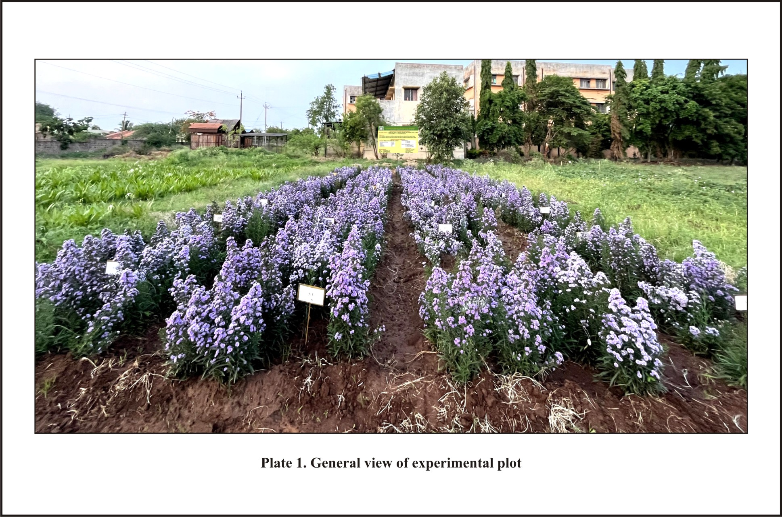
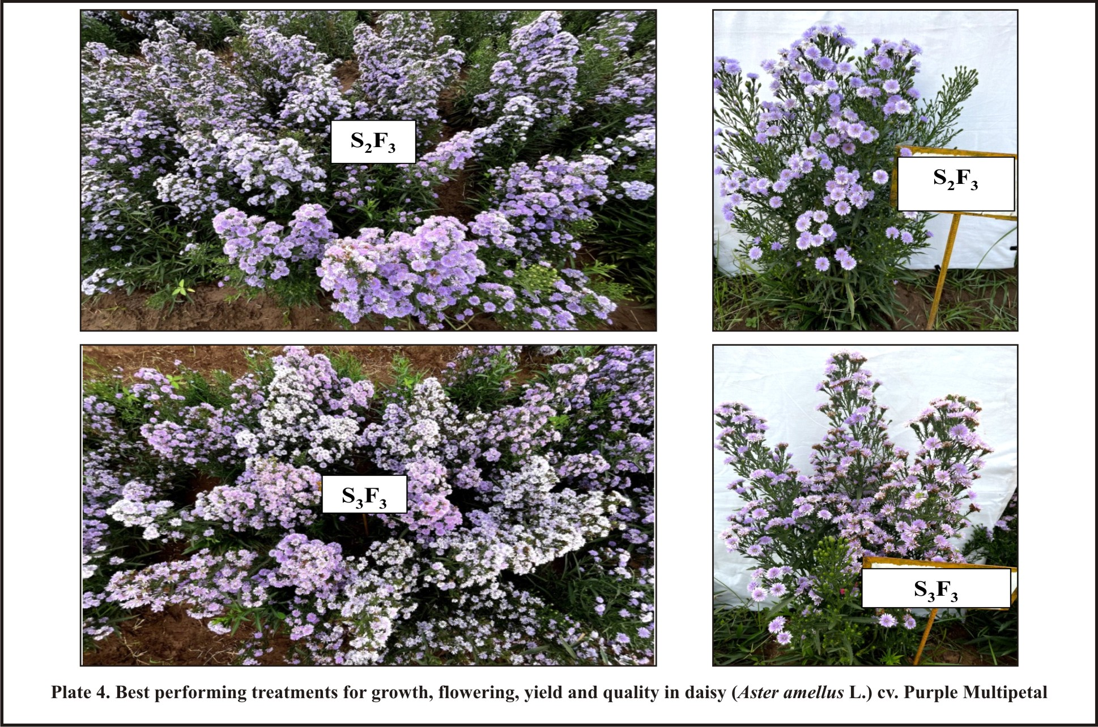
Plate 2. Best performing treatment for yield parameters in Daisy (Aster amellus L.) cv. Purple Multipetal

The superior performance of the S1F3 combination is attributed to the synergistic effect of optimal nutrient supply and higher plant population. Similar interactions have been reported in a range of floricultural crops, including marigold by Rolaniya et al. (2017). Additional supportive findings have been noted in studies on nerium, heliconia, and gomphrena by Manjula (2021), Patil et al. (2022), and Duggani et al. (2023), respectively.
Influence of different spacings and fertilizer levels on soil parameters of Daisy (Aster amellus L.) cv. Purple Multipetal
Soil Parameters
The study investigated various soil parameters, including pH, electrical conductivity (EC), organic carbon (OC), and the availability of nitrogen, phosphorus, and potassium before and after the harvest of daisy under different spacing and fertilizer treatments, as detailed in Table 3.
Soil pH
Post-harvest observations on soil pH revealed that different spacing and fertilizer levels did not significantly affect soil pH. Among the spacing treatments, the highest pH value (8.29) was observed with the closest spacing, S1 (30 × 20 cm), while the lowest pH (8.10) occurred in S3 (40 × 30 cm). Regarding fertilizer application, the highest pH (8.27) was recorded with F1 (105:131.25:112.5 NPK kg/ha), and the lowest (8.14) with F3 (175:218.75:187.5 NPK kg/ha). Interaction between spacing and fertilizer was also non-significant, but the highest pH (8.34) was found in S1F1, and the lowest (8.02) in S3F3.
Electrical Conductivity (EC)
Soil EC significantly varied with both spacing and fertilizer levels. The closest spacing, S1 (30 × 20 cm), resulted in the highest EC (1.42 dS m⁻¹), while the widest spacing, S3 (40 × 30 cm), recorded the lowest (1.17 dS m⁻¹). Among fertilizer treatments, F1 led to the highest EC value (1.33 dS m⁻¹), and F3 to the lowest (1.25 dS m⁻¹). Notably, the interaction between spacing and fertilizers significantly influenced EC, with the maximum EC (1.45 dS m⁻¹) in S1F1 and the minimum (1.12 dS m⁻¹) in S3F3.
Organic Carbon (OC)
Soil organic carbon content showed significant differences due to both spacing and fertilizer application. The highest OC (0.75%) was recorded under S1, and the lowest (0.55%) under S3. Fertilizer F1 increased OC content to 0.76%, whereas F3 reduced it to 0.59%. Interaction effects were also significant, with the highest OC (0.87%) found in S1F1 and the lowest (0.51%) in S3F3.
Available Nitrogen
Available nitrogen in the soil was significantly affected by spacing, fertilizer levels, and their interaction. The maximum nitrogen content (157.40 kg/ha) was found under S1 spacing, while the minimum (106.69 kg/ha) occurred under S3. Among fertilizers, F1 treatment resulted in the highest available nitrogen (143.88 kg/ha), and F3 the lowest (119.60 kg/ha). Interaction effects showed the highest nitrogen (165.47 kg/ha) in S1F1 and the lowest (100.10 kg/ha) in S3F3.
Available Phosphorus
Available phosphorus content in soil varied significantly across different spacing and fertilizer treatments. S1 yielded the highest phosphorus content (9.68 kg/ha), whereas S3 had the lowest (6.86 kg/ha). F1 fertilizer application led to the maximum phosphorus content (8.86 kg/ha), and F3 the minimum (7.55 kg/ha). The S1F1 combination recorded the highest phosphorus level (10.32 kg/ha), while the lowest (6.72 kg/ha) was found in S3F3.
Available Potassium
Soil potassium content was significantly influenced by spacing, fertilizer application, and their interaction. S1 spacing resulted in the highest available potassium (159.09 kg/ha), whereas S3 had the lowest (149.93 kg/ha). Among fertilizer treatments, F1 had the highest (149.93 kg/ha) and F3 the lowest potassium content (131.52 kg/ha). The combination treatment S1F1 showed the maximum potassium (166.65 kg/ha), while S3F3 recorded the minimum (118.79 kg/ha).
The post-harvest soil analysis revealed that soil pH ranged between 8.10 and 8.29, EC between 1.17 and 1.42 dS m⁻¹, and organic carbon between 0.55% and 0.78% across various treatments. A significant variation was observed in the soil NPK content. The
Table 3. Soil parameters from the experimental plot at harvest stage as influenced by different spacing and fertilizer levels
Treatments | pH | EC  (dSm⁻¹) | OC (%) | N (kg/ha) | P (kg/ha) | K (kg/ha)
Factor I – Spacing levels
S₁ | 8.29 | 1.42 | 0.75 | 157.40 | 9.68 | 159.09
S₂ | 8.22 | 1.28 | 0.68 | 130.17 | 8.23 | 137.86
S₃ | 8.10 | 1.17 | 0.55 | 106.69 | 6.86 | 122.88
S.Em± | 0.11 | 0.01 | 0.01 | 1.91 | 0.10 | 1.63
C.D. @ 5% | NS | 0.03 | 0.03 | 5.74 | 0.30 | 4.90
Factor II – Fertilizer levels
F₁ | 8.27 | 1.33 | 0.76 | 143.88 | 8.86 | 149.93
F₂ | 8.20 | 1.29 | 0.64 | 130.78 | 8.36 | 138.37
F₃ | 8.14 | 1.25 | 0.59 | 119.60 | 7.55 | 131.52
S.Em± | 0.11 | 0.01 | 0.01 | 1.91 | 0.10 | 1.63
C.D. @ 5% | NS | 0.03 | 0.03 | 5.74 | 0.30 | 4.90
Interaction (S × F)
S₁F₁ | 8.34 | 1.40 | 0.87 | 165.47 | 10.32 | 166.65
S₁F₂ | 8.29 | 1.45 | 0.72 | 160.63 | 9.70 | 157.93
S₁F₃ | 8.25 | 1.39 | 0.67 | 146.10 | 9.02 | 152.68
S₂F₁ | 8.27 | 1.35 | 0.82 | 148.84 | 9.24 | 154.00
S₂F₂ | 8.23 | 1.28 | 0.64 | 129.07 | 8.56 | 136.47
S₂F₃ | 8.16 | 1.21 | 0.58 | 112.59 | 6.90 | 123.10
S₃F₁ | 8.20 | 1.23 | 0.61 | 117.33 | 7.03 | 129.14
S₃F₂ | 8.09 | 1.15 | 0.55 | 102.63 | 6.83 | 120.71
S₃F₃ | 8.02 | 1.12 | 0.51 | 100.10 | 6.72 | 118.79
S.Em± | 0.21 | 0.02 | 0.02 | 3.32 | 0.18 | 2.83
C.D. @ 5% | NS | 0.06 | 0.05 | 9.95 | 0.53 | 8.49

Spacing levels: Fertilizer levels:
S₁- 30 × 20 cm F₁- 105:131.25:112.5 NPK kg/ha
S₂- 30 × 30 cm F₂- 140:175:150 NPK kg/ha
S₃- 40 × 30 cm F₃- 175:218.75:187.5 NPK kg/ha

treatment combination S1F1 resulted in the highest levels of available nitrogen (141.42 kg/ha), phosphorus (9.79 kg/ha), and potassium (151.67 kg/ha), whereas the lowest NPK values—108.22, 7.23, and 117.13 kg/ha, respectively—were found in S3F3. These results suggest that vigorous plant growth under optimal spacing and nutrient supply led to higher nutrient uptake, as reflected in the increased number of cut spikes per plant. These findings are consistent with earlier studies by Airadevi (2012) in annual chrysanthemum, Priyanka (2015) in crossandra, and Manjula et al. (2021) in Nerium.
Influence of different spacings and fertilizer levels on Nutrient Content in Plant of Daisy (Aster amellus L.) cv. Purple Multipetal
Nutrient Content in Plant
The nutrient content of daisy plants at harvest was significantly influenced by spacing, fertilizer levels, and their interaction, as shown in Table 4. Among the spacing treatments, wider spacing (S3: 40 × 30 cm) resulted in the highest concentrations of nitrogen (3.28%), phosphorus (0.33%), and potassium (1.96%) in plant tissues. In contrast, the closest spacing (S1: 30 × 20 cm) recorded the lowest values for nitrogen (1.36%), phosphorus (0.20%), and potassium (0.72%). Fertilizer levels also had a marked effect, with the highest nutrient concentrations observed in plants treated with the highest dose, F3 (175:218.75:187.5 NPK kg/ha), resulting in nitrogen, phosphorus, and potassium contents of 2.88%, 0.30%, and 1.72%, respectively. Conversely, the lowest fertilizer dose, F1 (105:131.25:112.5 NPK kg/ha), resulted in the least nutrient accumulation—1.73% nitrogen, 0.21% phosphorus, and 1.00% potassium.
The interaction between spacing and fertilizer levels showed significant effects as well. The S3F3 treatment combination (widest spacing with highest fertilizer dose) yielded the highest nutrient contents in the leaves: 3.82% nitrogen, 0.37% phosphorus, and 2.16% potassium. On the other hand, the S1F1 combination (closest spacing with lowest fertilizer dose) recorded the lowest values: 1.03% nitrogen, 0.17% phosphorus, and 0.41% potassium. These variations can be attributed to increased nutrient uptake facilitated by the wider plant spacing and higher fertilizer availability, which enhanced nutrient absorption and ultimately improved plant growth and yield. These findings are consistent with previous studies
Table 4. Plant nutrient content at harvest stage as influenced by different spacing and fertilizer levels
Treatments | Leaf nitrogen (%) | Leaf phosphorus (%) | Leaf potassium (%)
Factor I- Spacing levels
S₁ | 1.36 | 0.20 | 0.72
S₂ | 2.17 | 0.25 | 1.42
S₃ | 3.28 | 0.33 | 1.96
S.Em± | 0.03 | 0.003 | 0.01
C.D. @ 5% | 0.09 | 0.01 | 0.05
Factor II – Fertilizer levels
F₁ | 1.73 | 0.21 | 1.00
F₂ | 2.20 | 0.26 | 1.37
F₃ | 2.88 | 0.30 | 1.72
S.Em± | 0.03 | 0.003 | 0.01
C.D. @ 5% | 0.09 | 0.01 | 0.05
Interaction (S × F)
S₁F₁ | 1.03 | 0.17 | 0.41
S₁F₂ | 1.21 | 0.19 | 0.68
S₁F₃ | 1.85 | 0.23 | 1.06
S₂F₁ | 1.50 | 0.20 | 0.89
S₂F₂ | 2.04 | 0.26 | 1.42
S₂F₃ | 2.98 | 0.30 | 1.94
S₃F₁ | 2.67 | 0.27 | 1.70
S₃F₂ | 3.34 | 0.34 | 2.01
S₃F₃ | 3.82 | 0.37 | 2.16
S.Em± | 0.05 | 0.01 | 0.03
C.D. @ 5% | 0.16 | 0.01 | 0.09

Spacing levels: Fertilizer levels:
S₁- 30 × 20 cm F₁- 105:131.25:112.5 NPK kg/ha
S₂- 30 × 30 cm F₂- 140:175:150 NPK kg/ha
S₃- 40 × 30 cm F₃- 175:218.75:187.5 NPK kg/ha
Influence of different spacings and fertilizer levels on economics of Daisy (Aster amellus L.) cv. Purple Multipetal
conducted by Airadevi (2012) in annual chrysanthemum and Lalhruaitluangi (2022) in asparagus, both of which reported similar positive correlations between nutrient application and plant nutrient content.
Economics
Economic evaluation of daisy (Aster amellus L. cv. Purple Multipetal) cultivation under field conditions revealed significant differences due to spacing, fertilizer levels, and their interactions. The total cost of cultivation was highest with the closest spacing, S1 (30 × 20 cm), at ₹968,863.97 per hectare, primarily due to the greater requirement of planting materials in denser planting. This was followed by S2 (30 × 30 cm), while the lowest cost was incurred under S3 (40 × 30 cm) at ₹515,315.93 per hectare. Among fertilizer levels, the highest cost of cultivation (₹719,292.01 per hectare) was observed with F3 (175:218.75:187.5 NPK kg/ha), followed closely by F2, and the lowest cost (₹715,343.71) was seen in F1 (105:131.25:112.5 NPK kg/ha). Regarding interactions, the combination S1F3 resulted in the highest cost of cultivation (₹970,838.12), whereas S3F1 had the lowest (₹513,341.78 per hectare).
Gross returns were also significantly influenced by these factors. S1 spacing produced the highest gross income (₹1,648,920.00 per hectare), followed by S2, while S3 recorded the least (₹1,157,646.10). For fertilizer treatments, F3 yielded the highest gross returns (₹1,575,445.10), followed by F2, and the lowest was seen in F1 (₹1,204,106.70). The maximum gross return (₹1,885,200.00 per hectare) among interaction combinations was obtained from S1F3, while the lowest (₹1,062,812.17) was from S3F1.
Net returns, however, were highest in S2 (₹741,308.97 per hectare), despite S1 yielding the highest gross return. This suggests that moderate spacing may offer better profitability due to balanced input costs and yield. The lowest net return was noted in S3 (₹642,330.18 per hectare). Among fertilizer levels, F3 resulted in the highest net return (₹856,153.11 per hectare), whereas F1 showed the lowest (₹488,763.01). In terms of interaction, S1F3 again recorded the highest net return (₹914,361.88), followed by S2F3. The lowest net profit (₹373,870.18) came from S1F1.

Table 5. Economics of cultivation of daisy (Aster amellus L.) cv. Purple Multipetal per hectare as influenced by different spacing and fertilizer levels
Treatments | Cost of cultivation (Rs.) | Gross returns (Rs.) | Net returns (Rs.) | B:C ratio
Factor I – Spacing
S₁ | 968863.97 | 1648920.0 | 680056.03 | 1.69
S₂ | 667773.69 | 1409082.7 | 741308.97 | 2.15
S₃ | 515315.93 | 1157646.1 | 642330.18 | 2.23
Factor II – Fertilizer
F₁ | 715343.71 | 1204106.7 | 488763.01 | 1.70
F₂ | 717317.86 | 1436096.9 | 718779.08 | 2.11
F₃ | 719292.01 | 1575445.1 | 856153.11 | 2.24
Interaction (S × F)
S₁F₁ | 966889.82 | 1340760.00 | 373870.18 | 1.38
S₁F₂ | 968863.97 | 1720800.00 | 751936.03 | 1.77
S₁F₃ | 970838.12 | 1885200.00 | 914361.88 | 1.94
S₂F₁ | 665799.54 | 1208748.00 | 542948.45 | 1.81
S₂F₂ | 667773.69 | 1444500.00 | 776726.31 | 2.16
S₂F₃ | 669747.84 | 1574000.01 | 904252.16 | 2.35
S₃F₁ | 513341.78 | 1062812.17 | 549470.39 | 2.07
S₃F₂ | 515315.93 | 1142990.82 | 627674.89 | 2.21
S₃F₃ | 517290.08 | 1267135.35 | 749845.27 | 2.44

Spacing levels: Fertilizer levels:
S₁- 30 × 20 cm F₁- 105:131.25:112.5 NPK kg/ha
S₂- 30 × 30 cm F₂- 140:175:150 NPK kg/ha
S₃- 40 × 30 cm F₃- 175:218.75:187.5 NPK kg/ha

The benefit-cost (B:C) ratio further highlighted the economic efficiency of treatments. A wider spacing of S3 recorded the highest B:C ratio of 2.23, followed by S2 (2.15), whereas the lowest B:C ratio of 1.69 was observed with S1. Similarly, among fertilizer levels, F3 provided the best economic return with a B:C ratio of 2.24, followed by F2 (2.11), and the lowest in F1 (1.70). Notably, the interaction treatment S3F3 exhibited the highest B:C ratio of 2.44, indicating maximum return per unit investment, while S1F1 showed the least (1.38).
These results suggest that wider spacing and balanced fertilizer application, especially in the S3F3 treatment, led to optimum nutrient uptake, better plant development, and consequently higher spike yield and economic return. The findings align with previous research by Rao (2005) in cut flowers, Manjula (2021) in nerium, Balagamsetty et al. (2018) in Oncidium orchids, and Singh et al. (2018) in gladiolus, all of which confirm the economic advantage of integrating appropriate spacing and fertilization strategies in floriculture.

Conclusion

In the experimental study, it was finally concluded that the combination of optimum spacing S3 (40 × 30 cm) with F3 (175:218.75:187.5 NPK kg/ha) was identified as beneficial for achieving a superior quality of flower with maximum yield of flower per plant and per ha along with higher available soil and leaf nutrient status. The treatment combination of S3F3 (40 x 30 cm, 175:218:187.5 kg NPK/year) recorded the maximum yield of flower per plant and per ha, with the highest gross returns, net returns and benefit-cost ratio in Daisy.

Reference

Airadevi P. A., 2012, Integrated nutrient management studies in garland chrysanthemum. Asian J. Soil Sci., 7(1): 93-97.
Balachandra R. A., Deshpande V. K. and Shekhargouda M., 2004, Effect of growth regulators on seed yield and quality of ageratum. Karnataka J. Agric. Sci., 17(1): 110-111.
Balagamsetty R., Ganga M., Kannan M. and Arulmozhiselvan K., 2018, Influence of nutrients and growth regulators on the vegetative growth parameters of oncidium orchid (Oncidium goldiana) Proc. Nation, Symp. Adv. in Flori Urban Hort., BCKV, West Bengal, 168.
Beniwal B. S., Ahlawat V. P. and Singh S., 2003, Effects of spacing and pinching on growth and yield of chrysanthemum cv. Flirt. Haryana J. Hort. Sci., 32(3-4): 228-229.
Chandel A., Gupta Y. C. and Bhatia S., 2020, Effect of integrated nutrient management on growth, flowering and yield parameters in annual chrysanthemum [Glebionis coronaria (L.) Spach]. Int. J. Curr. Microbiol. Appl. Sci., 9(2):577-583.
Duggani S. M., Shirol A. M., Kulkarni B. S. and Krishnamurthy G. H., 2023, Standardization of spacing and fertilizer for high yield, quality and nutrient status in bachelor’s button cv. AGS-5. J. Pharma Innov., 2023; 12(5): 905-909.
Gnyandev B., 2006, Effect of pinching, plant nutrition and growth retardants on seed yield, quality and storage studies in China aster (Callistephus chinensis L. Nees). M. Sc. (Agri.) Thesis. Univ. of Agric. Sci., Bangalore.
Jackson, M. L., 1967, Soil chemical analysis. Prentice Hall of India Pvt. Ltd., New Delhi.pp.183-192.
Jena S., Mohanty C. R. and Dash R. M., 2021, Effect of pinching on growth and flowering of annual chrysanthemum (Chrysanthemum coronarium L.). J. pharmacogn. Phytochem., 10(2): 1042-1045.
Karetha K. M., Giriraj Jat G. J., Virendra Singh V. S. and Gajipara, N. N., 2011, Effect of different levels of NPK on growth, yield and yield attributes of gaillardia (Gaillardia pulchella) cv. Local Double. Asian J. Hortic., 6(2):344-347.
Karthikeyan S. and Jawaharlal M., 2013, Optimization of planting density in carnation. Hort. Flora Res. Spectrum, 2(2): 121-125.
Kumar K., Singh C. N., Beniwal V. S. and Pinder R., 2016, Effect of spacing on growth, flowering and corm production of gladiolus (Gladiolus sp.) cv. American Beauty. Int. J. Environ. Agric. Biotech., 1(3): 2456-1878.
Laihruaithuangi H., 2022, Standardisation of planting density and nutrition in asparagus (Asparagus densiflorus 'Sprengeri' L.) under shade house conditions. M.sc (Hort.) Thesis, Univ. Hort. Sci., Bagalkot (India).
Manjula B. S., 2021,, Evaluation of genotypes, standardization of spacing and nutrition in nerium (Nerium oleander L.) under eastern dry zone of Karnataka. M.sc (Hort.) Thesis, Univ. Hort. Sci., Bagalkot (India).
Monish M., Umrao V. K., Tyagi A. K. and Meena A. M., 2008, Effect of nitrogen and phosphorus levels on growth, flowering and yield of China aster. Agric. Sci. Digest., 28(2): 97-100.
Olsen S. R ., Cole C. V., Watanabe F. S. and Dean F. S., 1954, Estimation of available phosphorus in soils by extraction with sodium bicarbonate. US Dept. Agric. Circ., 19: 939.
Patil L., Biradar M. S., Patil V. S., Math K. K. and Patil H. Y., 2022, Influence of growing condition, spacing and nutrition on growth and yield of Heliconia genotypes. J. Pharm. Innov., 11(12): 1706-1710.
Piper C. S., 1966, Soil and plant analysis: Inter –Science Publications, Inc., New York.
Priyanka, 2015, Varietal evaluation, spacing and nutritional studies in crossandra (Crossandra undulaefolia salisb.). M.sc (Hort.) Thesis, Univ. Horti. Sci., Bagalkot (India).
Rolaniya M. K., Khandelwal S. K., Koodi S., Sepat S. R. and Choudhary A., 2017, Effect of NPK, biofertilizers and plant spacings on growth and yield of African marigold (Tagetes erecta Linn.). Chem. Sci. Rev. Lett., 6(21): 54-58.
Shilpa K., Neha C. and Seema T., 2011, Effect of nitrogen and potassium on growth, flower yield and quality of golden rod. J. Asian Hortic., 6(2): 327-330.
Siddappa B., Nayak H., Prashanth P. and Naik S., 2018, Effect of different plant spacing’s on growth performance of selected daisy (Aster amellus L.) cultivars in southern zone of Telangana. Int. J. Chem. Stud., 6(5): 2740-2743.
Singh D., Singh B. and Singh S., 2018, Effect of different levels of NPK and spacing on growth and flowering of gladiolus (Gladiolus hybridus L.) cv. Candyman. Proc. Nation. Symp. Adv. in Flori. Urban Hort., BCKV, West Bengal, 139.
Subbaiah B. V. and Asija G. L., 1956, A rapid procedure for estimation of available nitrogen in soil. Curr. Sci., 25: 259-260.
Walkley A. and Black I. A., 1934, An examination of the degtjareff method for determining soil organic matter and a proposed modification of the chromic id titration method. Soil Sci., 37: 29-38.

