**Molecular identification and antimicrobial resistance profiling of *Acinetobacter* spp. isolated from retail meat samples in Chennai**

**ABSTRACT**

The foodborne diseases caused by ESKAPE pathogens are mainly linked to animal or plant-origin foods such as milk, meat, poultry and vegetables or instigated from the food-related environment. Among ESKAPE pathogens over the past ten years, *Acinetobacter spp.* has universally emerged as an exceedingly worrying nosocomial pathogen with foodborne implications. The present study was carried out to screen the meat sold in Chennai for the presence of *Acinetobacter* spp. and to elucidate antimicrobial resistance. Atotal of 300 meat samples comprising 75 each of chicken, mutton, beef and pork respectively were collected from retail meat outlets in Chennai and subjected to standard bacteriological methods. The overall occurrence of *Acinetobacter* spp. was 2.67 %, which included 2 from mutton samples (2.67 %), 4 from beef samples (5.33 %) and 2 from pork samples (2.67 %). Further, all the isolates were confirmed as *Acinetobacter* spp. through morphological and biochemical tests such as Gram’s staining (negative), oxidase (negative) and catalase test (positive). Molecular confirmation of all the isolates was carried out by polymerase chain reaction targeting genus specific 16S rRNA gene of *Acinetobacter* spp. The isolates were subjected to antibiotic sensitivity test by disc diffusion method using selective antibiotics and the results revealed that all the isolates (100 %) were sensitive to gatifloxacin and minocycline, followed by piperacillin/tazobactam (87.50 %), imipenem (87.50 %), levofloxacin (87.50 %) and co-trimoxazole (87.50 %). Efflux pump activity in *Acinetobacter* spp. was assessed by ethidium bromide agar cartwheel method which revealed that all the isolates produced fluorescence on the agar plates with varying EtBr concentrations (0.0 to 2.5 mg/l) indicating no active efflux activity. The findings of this study underscore the potential of meat as an important medium for this opportunistic pathogen. This study underscores the need to monitor antimicrobial resistance in foodborne *Acinetobacter* spp. and to enforce improved hygiene and antimicrobial stewardship across the food chain to reduce transmission risks to humans.

**Key words:** *Acinetobacter*, meat, 16S rRNA, efflux pump

**1. INTRODUCTION**

Antimicrobial resistance (AMR) is a serious global health concern caused by the inappropriate and overuse of antibiotics across multiple sectors, which promotes the development of resistant microbes (Ahmed *et al*., 2024). AMR in the food chain has far-reaching consequences that go beyond reduced productivity and food safety, leading to increased food insecurity, economic burdens at both national and global levels and a worsening impact on climate change (Founou *et al*., 2021).

World Health Organization (WHO) has published a list of “ESKAPE” pathogens (*Enterococcus faecium, Staphylococcus aureus, Klebsiella pneumoniae, Acinetobacter baumannii, Pseudomonas aeruginosa,* and *Enterobacter spp*.), which have the ability to bypass currently available antibiotics resulting in severe infections in human (Tacconelli *et al*., 2018). Most of the foodborne diseases caused by ESKAPE pathogens are mainly linked to animal or plant-origin foods such as milk, meat, poultry and vegetables or instigated from the food-related environment such as agricultural land, food industry, hospitals, kitchen, etc. (Patil *et al.,* 2021). Among ESKAPE pathogens over the past ten years, *Acinetobacter spp.* has universally emerged as an exceedingly worrying nosocomial pathogen with foodborne implications.

*Acinetobacter* spp. is non-motile, non-fermentative, non-sporulating, non-fastidious, gram-negative, catalase positive, oxidase negative, strictly aerobic coccobacilli with a G+C content between 39 and 47%.They have been recovered from a variety of food products such as vegetables, fruit, meat, fish, milk, cheese, and drinking water (Valizade *et al*., 2014; Carvalheira *et al*., 2017; Veress *et al*., 2020).A wide range of human infections caused by *Acinetobacter* spp. includes meningitis, pneumonia, endocarditis, bacteraemia, skin and urinary tract infections in immunocompromised patients and associated with high rates of morbidity and mortality (Munoz-Price *et al.,* 2018; Morris *et al.,* 2019).Most reported infections are associated with the species *A. baumannii*, followed by A. *calcoaceticus* and A. *lwoffii.* Other species, such as A. *haemolyticus*, A. *johnsonii*, A. *junii*, A. *nosocomialis*, A. *pittii*, A. *schindleri* and A. *ursingii* have occasionally been reported (Wong *et al*., 2017).

The capacity of *Acinetobacter* spp. to survive for long periods on both dry surfaces and in water to form biofilms and to resist disinfectants facilitate long-term persistence in the environment (Carvalheira *et al.,* 2021). Resistance of these organisms to several antimicrobials, including carbapenems and polymyxin, the last-resort drugs to treat infections caused by multidrug-resistant *Acinetobacter* spp.represent an additional concern (Thacharodi *et al.,* 2024). This emphasizes the importance of assessing the role of foods in the occurrence of infections and transmission of these bacteria into the community and hospital environments which is an important step to design and evaluate strategies to control the spread of multidrug-resistant strains, as well as, to prevent *Acinetobacter* spp. infection.

Considering the above facts, this work was carried out to screen the meat sold in Chennai for the presence of *Acinetobacter* spp. and to elucidate its antimicrobial resistance status.

**2. MATERIAL AND METHODS**

**2.1 Collection of meat samples**

Atotal of 300 meat samples comprising 75 each of chicken, mutton, beef and pork were collected from retail outlets in and around Chennai. Around 20 g of each individual fresh raw meat samples were collected in sterile pouches under aseptic conditions. The samples were transferred immediately onto ice packs and transported to Department of Veterinary Public Health and Epidemiology, Madras Veterinary College, Chennai and were processed on the same day.

**2.2 Isolation of *Acinetobacter* spp.**

About 10 g of meat sample was homogenized using mortar and pestle. One ml of homogenate was mixed with 9 ml Brain Heart Infusion (BHI) broth for enrichment and incubated at 37ºC for 24 h. The enriched samples were streaked on Leeds Acinetobacter Agar and incubated at 37ºC for 24 h. The pink mucoid colonies with pink color diffused into the medium were picked up on BHI agar slant and stored at 4°C for further characterization.

**2.3 Morphological and biochemical characterization**

**2.3.1 Gram’s staining**

The heat fixed smears of 18 h old broth culture of presumptive isolates were made on a clean glass slide. The smear was flooded with crystal violet and allowed it to act for 1-2 min. Stain was poured off and washed with water. Then gram’s iodine was added to the smear and allowed to act for 1-2 mins. After washing with water, the smear was treated with methanol for about 15-20 sec to remove the excess crystal violet. Finally, the smear was counter stained with carbol fuchsin for 1 min, washed with water, dried and examined under oil immersion objective. Gram positive cells appear as violet coloured, while Gram negative cells as pink coloured.

**2.3.2 Oxidase test**

A single colony of *Acinetobacter* waspropagated in BHI broth and incubated at 37°C for 24 h. From the overnight culture, a drop was placed on the Oxidase discs and observed for colour change. A deep purple colour development on the disc within 10-15 seconds indicates a positive reaction.

**2.3.3 Catalase test**

A few suspected colonies were smeared on a clean, dry slide. A drop of 3% H2O2 was added and mixed. A positive reaction is indicated by active, copious amount of effervescence production.

**2.4 Molecular identification of *Acinetobacter* spp.**

**2.4.1 DNA Isolation**

The DNA extraction was performed using boiling and snap chilling method as described earlier by Porteen *et al.* (2006) with slight modifications. Briefly, 1.5 ml of broth culture was centrifuged at 5000 rpm for 5 min. The pellet was resuspended in 100 μl of PBS and washed thrice in a microcentrifuge tube. Further, the resulting pellet was mixed with 100 μl of PBS and kept in a boiling water bath for 10 min. After heat treatment, it was kept onto ice immediately for 10 min. Then it was centrifuged at 5000 rpm for 5 min and the supernatant was collected which was used as template DNA. The DNA extracted fromthe isolates were stored at -20OC till further use.

**2.4.1 Polymerase Chain Reaction (PCR) amplification**

*Acinetobacter* spp. isolates confirmed by morphological and biochemical tests were subjected to PCR using genus specific primers targeting 16S rRNA gene (*Ac* gene) to identify *Acinetobacter* spp.as described by Vanbroekhoven *et al.* (2004) (Table 1). PCR amplification was performed using DLAB TC1000 – S thermocycler. PCR was carried out with final volume of 25 μl (Template DNA - 4.0 μl; Forward Primer (10 pmole/μl) - 1.0 μl; Reverse Primer (10 pmole/μl) -1.0 μl; 2X PCR master mix - 12.5 μl; Nuclease free water 6.5 μl). Optimization of PCR was carried out using reference strain *A. baumannii* (MCC 2366) obtained from National Centre for Microbial Resource, Pune, India. On completion of PCR, 10 μl of each PCR product was electrophoresed through 1% agarose gel as described previously (Sambrook and Russell, 2001). Running buffer system consisted of 1X TAE and electrical field strength was 5 V/cm. Finally, after the completion of the run, gels with embedded products were visualized under UV transillumination in a gel documentation system (Bio-Rad) and photographed for further analysis and reference.

**Table 1: Primer used in the study**

|  |  |  |  |  |  |
| --- | --- | --- | --- | --- | --- |
| **Gene** | **Primer sequence** | **Condition** | | **Cycles** | **Product Size (bp)** |
| **PCR Step** | **Temp. & Time** |
| 16s rRNA *(Ac* gene*)* | Ac436-F- TTTAAGCGAGGAGGAGG  Ac676-R- ATTCTACCATCCTCTCCC | Initial denaturation | 950C - 15 sec |  | 280 |
| Denaturation | 950C - 3 sec | 50 |
| Annealing | 580C - 10 sec |
| Extension | 740C - 30 sec |
| Final Extension | 740C - 2 min |  |

**2.5 Screening of the isolates for the presence of antimicrobial resistance**

Antibiotic resistance pattern of each *Acinetobacter* spp. isolate was studied by Kirby-Bauer disc diffusion method (Bauer *et al.,* 1966) against a panel of 8 antibiotics namely Piperacillin/tazobactam (100/10 μg), Ticarcillin/clavulanate (75/10 μg), Ceftriaxone (30 μg), Imipenem (10 μg), Gatifloxacin (5μg), Levofloxacin (5μg), Minocycline (30μg) and Co-trimoxazole (1.25/23.75μg). Test isolates were propagated in BHI broth at 37°C overnight. Thereafter, the concentration of the broth was adjusted to 0.5 Mc Farland standard. A swab suspension was taken from each broth and spread on the surface of Mueller- Hinton agar plates. The plates were allowed to dry for few minutes. The antibiotic discs were gently placed onto the Mueller- Hinton agar plates and were incubated at 37°C for 24 h. Based on the zone of inhibition, the isolates were graded as sensitive, intermediate and resistant as per Clinical and Laboratory Standards Institute (CLSI) guidelines (CLSI, 2024).

**2.6 Identification of efflux pump - mediated multidrug resistance**

Efflux pump-mediated multi-drug resistance of *Acinetobacter* isolates were done by the ethidium bromide agar cartwheel method as described by Martins *et al.* (2013). Trypticase Soy Agar (TSA) plates with varying concentrations of ethidium bromide ranging from 0.0 to 2.5 mg/l were prepared and each plate were then divided into twelve sectors by radial lines resembling a cartwheel pattern. Overnight grown bacterial culture adjusted to 0.5 McFarland standard were swabbed onto the plates from center to margin and incubated at 37ºC for 16 h. After the period of incubation, the plates were examined using a gel-imaging system or UV transilluminator to assess the fluorescence.

**3. RESULTS AND DISCUSSION**

*Acinetobacter* spp. are opportunistic pathogens increasingly recognized for their role in multidrug resistant bacterial infections. While traditionally associated with nosocomial infections, growing evidence suggests their presence and persistence throughout the food chain, raising public health concerns. In this study, a total of 300 meat samples comprising 75 each of chicken, mutton, pork and beef were examined for the presence of *Acinetobacter* spp. by employing standard bacteriological methods. About 8 samples comprising of 2 mutton samples (2.67 %), 4 beef samples (5.33 %) and 2 pork samples (2.67 %) produced pink mucoid colonies with pink color diffused into the medium which was confirmative for *Acinetobacter* spp. (Fig.1). The overall occurrence of *Acinetobacter* spp. isolated from meat samples was 2.67 %. All the obtained isolates when examined for their morphological and biochemical characters revealed that they were Gram negative, coccobacilli, catalase positive and oxidase negative. PCR amplification by targeting the 16S rRNA gene (280 bp) confirmed all the 8 isolates as *Acinetobacter* spp. (Fig. 2).

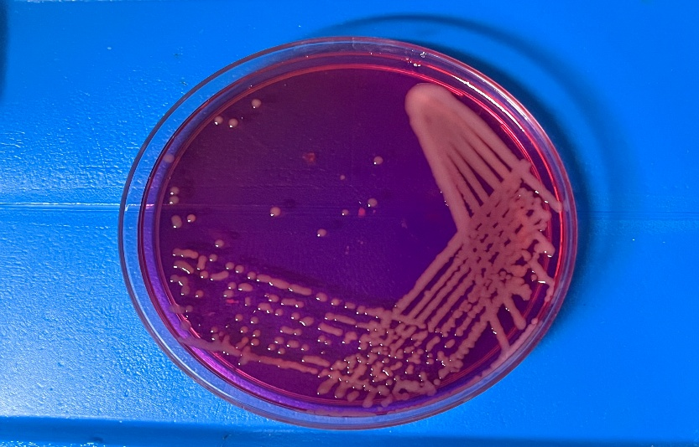

**Fig.1** *Acinetobacter* spp. in Leeds Acinetobacter Agar

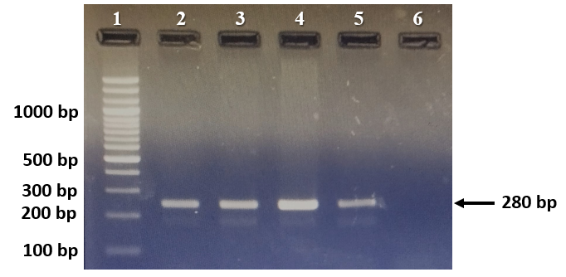

1 – 100 bp ladder; 2, 3, 4 – *Acinetobacter* spp. positive isolates (280 bp); 5 – Positive control (*A. baumannii* - MCC 2366); 6 – No template control

**Fig.2** PCR amplification of 16S rRNA gene of *Acinetobacter* spp.

Cha *et al.* (2021) reported 32 *Acinetobacter* spp. (38.6%) from beef and 22 (26.5%) from pork in Korea, which was higher than our report. Similarly, Puente *et al.* (2025) reported 17 *Acinetobacter* spp. (74 %) from chicken, 20 (74 %) from pork and 14 (61 %) from beef in Spain. Further Bhargavi *et al.* (2024) identified 24 *Acinetobacter* spp. (18.18 %) from Chicken in Meghalaya. The prevalence of *Acinetobacter* spp. observed in the present study (2.67%) is notably lower than several reports from other regions, suggesting possible geographical and methodological differences in contamination rates and detection efficiency (Wajid *et al.,* 2021). These variations could be attributed to differences in sampling sources, processing and hygiene standards, environmental conditions and laboratory methodologies, including enrichment protocols and molecular tools employed. The comparatively lower prevalence in our study might reflect the differences in microbial ecology in the retail environments studied.

On the other hand, the presence of *Acinetobacter* spp. in meat may reflect contamination during slaughter, processing, or handling, and suggests that meat could serve as a vehicle for transmission of these organisms to humans, particularly if proper cooking or hygiene practices are not followed and warrants attention toward food safety standards across the meat supply chain.

*Acinetobacter* spp. is increasingly associated with difficult-to-treat infections due to their ability to resist multiple classes of antibiotics. While some strains may remain susceptible to selected antimicrobials, the emergence of multidrug-resistant (MDR), extensively drug-resistant (XDR) and pan-drug-resistant (PDR) strains poses a serious clinical and public health challenge (Lee *et al*., 2011). All the obtained isolates in this study were subjected to antibiotic sensitivity test by disc diffusion method and the results were interpretated according to CLSI guidelines, 2024 (Fig. 3). The results revealed that all the isolates (100 %) were sensitive to gatifloxacin and minocycline, followed by piperacillin/tazobactam (87.50 %), imipenem (87.50 %), levofloxacin (87.50 %) and co-trimoxazole (87.50 %). Intermediate resistance was observed towards ceftriaxone (100 %) and ticarcillin/clavulanate (50 %). Further only one isolate was found to be resistant to ticarcillin/clavulanate (12.5 %), levofloxacin (12.5 %) and co-trimoxazole (12.5 %).

Carvalheira *et al*. (2017) identified *Acinetobacter* spp. isolates from retail meat in Portugal were resistant to piperacillin-tazobactam (64.9 %), co-trimoxazole (23.2 %), imipenem (1.2 %) and minocycline (1.2 %). Cha *et al.* (2021) studied the antimicrobial resistance profile of *Acinetobacter* spp. from retail meat in Korea and reported that 10 isolates (17.24 %) were resistant to co-trimoxazole. Puente *et al.* (2025) revealed that *Acinetobacter* spp. isolates from retail meat in Spain were resistant to ceftriaxone (9.1 %), piperacillin-tazobactam (6.1 %), trimethoprim-sulfamethoxazole (3 %) and ticarcillin-clavulanic acid (3 %). All these reports showed greater resistance of *Acinetobacter* spp. to different antibiotics when compared to the resistance pattern obtained in our study. These comparatively lower resistance levels suggest possible regional differences in antimicrobial use in livestock and the food production environment, as well as variations in bacterial ecology and selective pressures. The findings underscore the necessity of continued surveillance of foodborne *Acinetobacter* spp., not only to monitor emerging resistance patterns but also to understand their role in the broader context of antimicrobial resistance dissemination from food sources to humans.

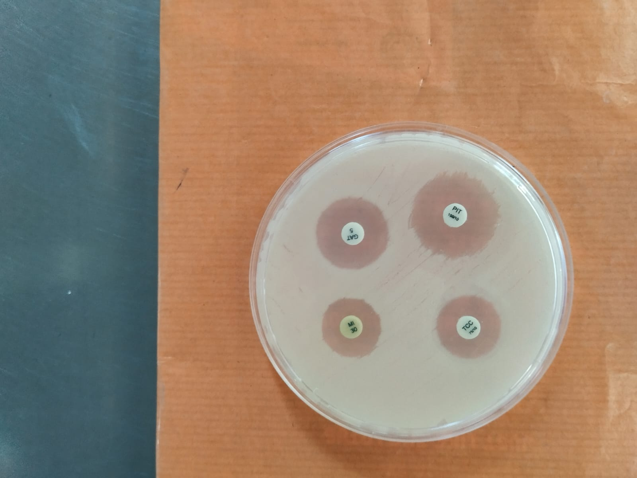 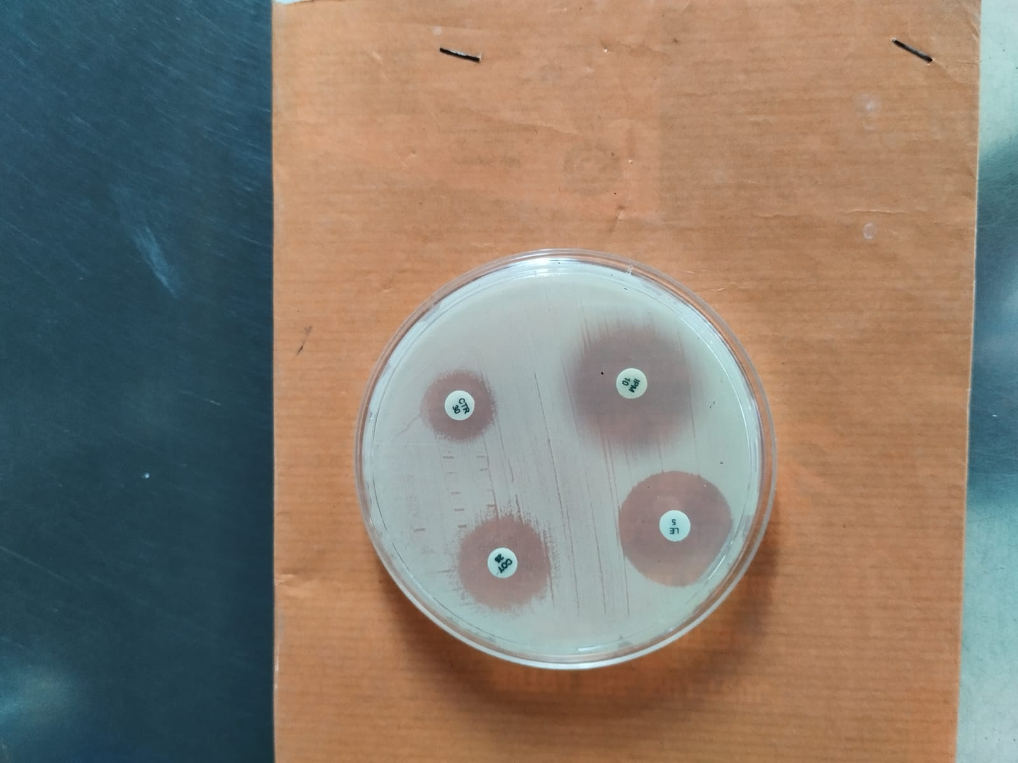

**(A)** GAT – Gaifloxacin, MI – Minoycline, PIT – Pippracillin/tazobactum, TCC – Ticarcillin/clavulanate

**(B)** CTR – Ceftriaxone, COT – Co-trimoxazole, IPM – Imipenem, LE - Levofloxacin

**Fig. 3** Antibiotic sensitivity test

One of the major mechanisms contributing to the MDR phenotype in *Acinetobacter* spp. is the overexpression of efflux pump systems. These are membrane-bound transport proteins that actively extrude a wide array of structurally unrelated antimicrobial agents out of the bacterial cell, thereby lowering their intracellular concentrations and rendering the antibiotics ineffective (Zack *et al*., 2024). In the present study, efflux pump activity in *Acinetobacter* spp. was assessed by ethidium bromide agar cartwheel method (Martins *et al*., 2013). The results revealed that all the isolates produced fluorescence on the agar plates with varying EtBr concentrations (0.0 to 2.5 mg/l) indicating no active efflux activity (Fig. 4). Interestingly, despite the apparent lack of active efflux, the isolates displayed resistance to certain antibiotics, suggesting that other mechanisms may be contributing to their MDR phenotype. These could include enzymatic degradation (e.g., β-lactamases), target site modifications, or altered membrane permeability (Muteeb *et al*., 2023). The absence of efflux activity further highlights the complexity of resistance in *Acinetobacter* spp. and underscores the multifactorial nature of MDR in these organisms.

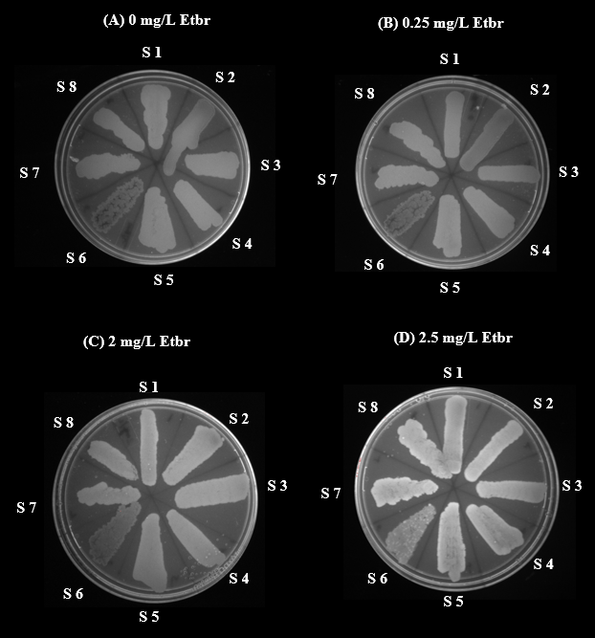

**Fig.4** Efflux pump activity in *Acinetobacter* spp.

**4. CONCLUSION**

The findings of this study underscore the potential of meat as a reservoir for this opportunistic pathogen. Although the prevalence was relatively low, the detection of *Acinetobacter* spp. in retail meat intended for human consumption raises concerns regarding food safety and public health. Also, this study highlights the importance of monitoring antimicrobial resistance patterns in foodborne *Acinetobacter* spp. and calls for the implementation of better hygiene and antimicrobial stewardship practices throughout the food production and distribution chain to mitigate the risk of transmission of resistant bacteria to humans.

**REFERENCES**

1. Ahmed, S. K., Husein, S., Qurbani, K., Ibrahim, R. H., Fareeq, A., Mahmood, K. A., & Mohamed, M. G. (2024). Antimicrobial resistance: Impacts, challenges, and future prospects. *Journal of Medicine Surgery and Public Health*, 2(100081), 100081–100081.
2. Bauer, A. W., Kirby, W. M., Sherris, J. C., & Turck, M. (1966). Antibiotic susceptibility testing by a standardized single disk method. *American Journal of Clinical Pathology*, 45(4), 493–496.
3. Bhargavi, D., Ghatak, S., Srinivas, K., Angappan, M., Das, S., Milton, A.A.P., & Prasad, C.B. (2024). Prevalence and molecular characterization of *Acinetobacter* species in retail chicken meat: implications for food safety and antimicrobial resistance. *International Journal of Advances in Biochemistry Research*, 8(12), 387-390.
4. Carvalheira, A., Casquete, R., Silva, J., & Teixeira, P. (2017). Prevalence and antimicrobial susceptibility of *Acinetobacter* spp. isolated from meat. *International Journal of Food Microbiology*, 243, 58-63.
5. Carvalheira, A., Silva, J., & Teixeira, P. (2021). *Acinetobacter* spp. in food and drinking water–A review. *Food Microbiology*, 95, 103675.
6. Cha, M. H., Kim, S. H., Kim, S., Lee, W., Kwak, H. S., Chi, Y. M., & Woo, G. J. (2021). Antimicrobial resistance profile of *Acinetobacter* spp. isolates from retail meat samples under Campylobacter-selective conditions. *Journal of Microbiology and Biotechnology*, 31(5), 733.
7. CLSI, 2024. *Performance Standards for Antimicrobial Susceptibility Testing* (34th ed, pp 88-89). Clinical and Laboratory Standards Institute, PA.
8. Founou, L. L., Founou, R. C., & Essack, S. Y. (2021). Antimicrobial resistance in the farm-to-plate continuum: more than a food safety issue. *Future science* OA, 7(5), FSO692.
9. Lee, K., Yong, D., Jeong, S. H., & Chong, Y. (2011). Multidrug-resistant *Acinetobacter* spp.: increasingly problematic nosocomial pathogens. *Yonsei Medical Journal*, 52(6), 879-891.
10. Martins, M., McCusker, M. P., Viveiros, M., Couto, I., Fanning, S., Pagès, J. M., & Amaral, L. (2013). A simple method for assessment of MDR bacteria for over-expressed efflux pumps. *The Open Microbiology Journal*, 7, 72.
11. Morris, F. C., Dexter, C., Kostoulias, X., Uddin, M. I., & Peleg, A. Y. (2019). The mechanisms of disease caused by *Acinetobacter baumannii*. *Frontiers in Microbiology*, 10, 1601.
12. Munoz-Price, L. S., & Weinstein, R. A. (2008). Acinetobacter infection. *New England Journal of Medicine*, 358(12), 1271-1281.
13. Muteeb, G., Rehman, M. T., Shahwan, M., & Aatif, M. (2023). Origin of antibiotics and antibiotic resistance, and their impacts on drug development: A narrative review. *Pharmaceuticals*, 16(11), 1615.
14. Patil, A., Banerji, R., Kanojiya, P., & Saroj, S. D. (2021). Foodborne ESKAPE biofilms and antimicrobial resistance: Lessons learned from clinical isolates. *Pathogens and Global Health*, 115(6), 339-356.
15. Porteen, K., Agarwal, R. K., & Bhilegaonkar, K. N. (2006). PCR-Based detection of *Aeromonas* from milk samples. *Journal of Food Technology,* 4, 111-115.
16. Puente, A., Cobo-Díaz, J. F., Oliveira, M., Cordero-García, R., Grosso, F., Asnicar, F., ... & Álvarez-Ordonez, A. (2025). Diverse *Acinetobacter* in retail meat: a hidden vector of novel species and antimicrobial resistance genes, including plasmid-borne *bla*OXA-58, *mcr*-4.3 and *tet* (X3). *International Journal of Food Microbiology*, 111313.
17. Sambrook, J. and Russell, D. (2001). Molecular cloning: a laboratory manual. CHSL Press. 2: 2344.
18. Tacconelli, E., Carrara, E., Savoldi, A., Harbarth, S., Mendelson, M., (2018). Discovery, research, and development of new antibiotics: the WHO priority list of antibiotic-resistant bacteria and tuberculosis. *The Lancet Infectious Diseases*, 18(3), 318-327.
19. Thacharodi, A., Vithlani, A., Hassan, S., Alqahtani, A., & Pugazhendhi, A. (2024). Carbapenem-resistant *Acinetobacter baumannii* raises global alarm for new antibiotic regimens. *Iscience*, 27(12), 111367.
20. Valizade, K.M., Rezazad, B.M., Mehrnoosh, F., & Alizade K.A.M. (2014). A research on existence and special activities of *Acinetobacter* in different cheese. *International journal of Advanced Biological and Biomedical Research*, 2(2), 517-525.
21. Vanbroekhoven, K., Ryngaert, A., Wattiau, P., De Mot, R., & Springael, D. (2004). *Acinetobacter* diversity in environmental samples assessed by 16S rRNA gene PCR–DGGE fingerprinting. *FEMS Microbiology Ecology*, 50(1), 37-50.
22. Veress, A., Nagy, T., Wilk, T., Komüves, J., Olasz, F., & Kiss, J. (2020). Abundance of mobile genetic elements in an *Acinetobacter lwoffii* strain isolated from Transylvanian honey sample. *Scientific Reports*, 10(1), 2969.
23. Wajid, M., Gonti, P., Mallamgunta, S., & Naaz, S. (2021). A Study on Acinetobacter spp isolated from various clinical samples and analysis of their susceptibility pattern at a tertiary care centre. *Tropical Journal of Pathology and Microbiology*, 7(6), 313-319.
24. Wong, D., Nielsen, T.B., Bonomo, R.A., Pantapalangkoor, P., Luna, B., & Spellberg, B. Clinical and Pathophysiological Overview of *Acinetobacter* Infections: a Century of Challenges*. Clinical Microbiology Reviews*, 30(1), 409-447.
25. Zack, K. M., Sorenson, T., & Joshi, S. G. (2024). Types and mechanisms of Efflux Pump Systems and the potential of Efflux Pump Inhibitors in the restoration of antimicrobial susceptibility, with a special reference to *Acinetobacter baumannii*. *Pathogens*, 13(3), 197.