ARTIFICIAL INTELLIGENCE FOR AGROFORESTRY: A REVIEW

**ABSTRACT**

Agroforestry is an intensive and interactive land usage strategy that maximizes biotic and abiotic resources by deliberately combining trees and/or shrubs with agricultural crops and/or animals in temporal and spatial patterns on the same plot of land. Agroforestry is a self-sustaining green and smart technology that will transform the future of Indian agriculture. AI-powered agroforestry plays a critical role in data collecting, processing, assessment, interpretation, knowledge acquisition, and solution provision to improve overall production and efficiency. Thus, AI-enabled solutions are extremely valuable in crop cultivation, risk management, crop management, crop protection, crop advice, soil and crop health monitoring and management, crop feeding, automated irrigation, autonomous crop harvesting, crop grading, and even marketing. It will transform contemporary agroforestry methods by enhancing efficiency through accurate real-time monitoring and projections of increased food yields. Thus, the combination of AI, robotics, machine learning, and ancestral knowledge is the path to a transformational technological period that will renew agriculture and agroforestry throughout the world by encompassing varied crops and livestock species. This is also known as Smart Farming, Green Farming, Modern Farming, or Technical Farming.

**Keywords:** Agroforestry, Artificial Intelligence, Robots, Transforming, Smart Farming, Green Farming

**Introduction**

The introduction of artificial intelligence (AI) is constantly transforming the present age of agroforestry. In the discipline of Agroforestry, which blends agricultural and agroforestry processes to generate more diversified, productive, sustainable, and resource-efficient land-use systems, AI is becoming an essential tool. When AI is properly incorporated into agroforestry techniques, it has the ability to increase output, improve crop health, minimize environmental impact, and optimize resource management. This detailed tutorial digs into how AI may be used effectively in the field of agroforestry, providing explanations and vivid examples for each issue.

Agroforestry is defined as an intensive and interactive land utilization system that optimizes resource utilization patterns and mutual benefits from the interactions of biotic components such as the intentional use of trees and/or shrubs in combination with agricultural crops and/or livestock in temporal and spatial arrangements on the same piece of land (Lundgren and Raintree, 1982). Agroforestry is a self-sustaining green technique that will transform the future of Indian agriculture (Montes et al., 2020). Indian agriculture is the backbone of the country's economy, providing a living and income for 60% of the people, both directly and indirectly. Agroforestry is a rapidly expanding science that addresses the issues of climate change, global warming, and carbon sequestration. Artificial Intelligence (AI) has been used into a number of farming practices, from planting to harvesting, as part of the modernization of agriculture. In order to solve the issues of labour, cost, time, and accuracy or precision farming, agroforestry now requires the use of AI-based technology. The use of machine intelligence and AI-based technologies in agroforestry farming represents a paradigm change from conventional, antiquated farming methods. Because of the fast growth of technology and its many applications, artificial intelligence has quickly become a major topic of computer science study.

AI-powered Agroforestry plays a pivotal role in data collection, processing, evaluation, interpreting, acquiring knowledge and providing solutions to enhance the overall efficiency and productivity.

It is very essential to understand the complexity of Agroforestry system, cropping patterns, succession, stratification, productivity and biodiversity on the land. However, a larger workforce is required to increase the farm productivity which also enables with employment opportunity and smart work in a reconnection with nature. Thus, AI and robotics in agriculture will not only observe a paradigm shift in agricultural production but also provide additional employment opportunities. Thus, the integration of AI, robotics, machine and ancestral wisdom is the way of a transformative technological era to regenerate agriculture and Agroforestry across the globe through encompassing diverse crops and livestock animals. This transformation will have a profound influence on mitigation of climate change effect, biodiversity conservation, global food security, soil health and nutritional health of humans by envisioning the future.

**Development And Current Application Of AI**

Artificial intelligence (AI) is a vast and multi‐facetted technology developed by the computer and engineering sciences. The goal of AI is to develop machines capable of performing tasks traditionally requiring human intelligence. Among the first applications in forest research were applications of rule‐based reasoning for tree species identification, diagnosing disorders in trees, and silvicultural decision making (Gadow 1988). *Autonomous systems*, like a delivery robot in a restaurant or a tree harvesting machine, can independently plan and carry out sequences of steps to achieve a specific goal. *Machine Learning, Supervised Learning* or *Deep Learning* (using multilayer neural networks) are particular applications of AI enabling computers to develop new knowledge based on experience and/or extensive datasets.

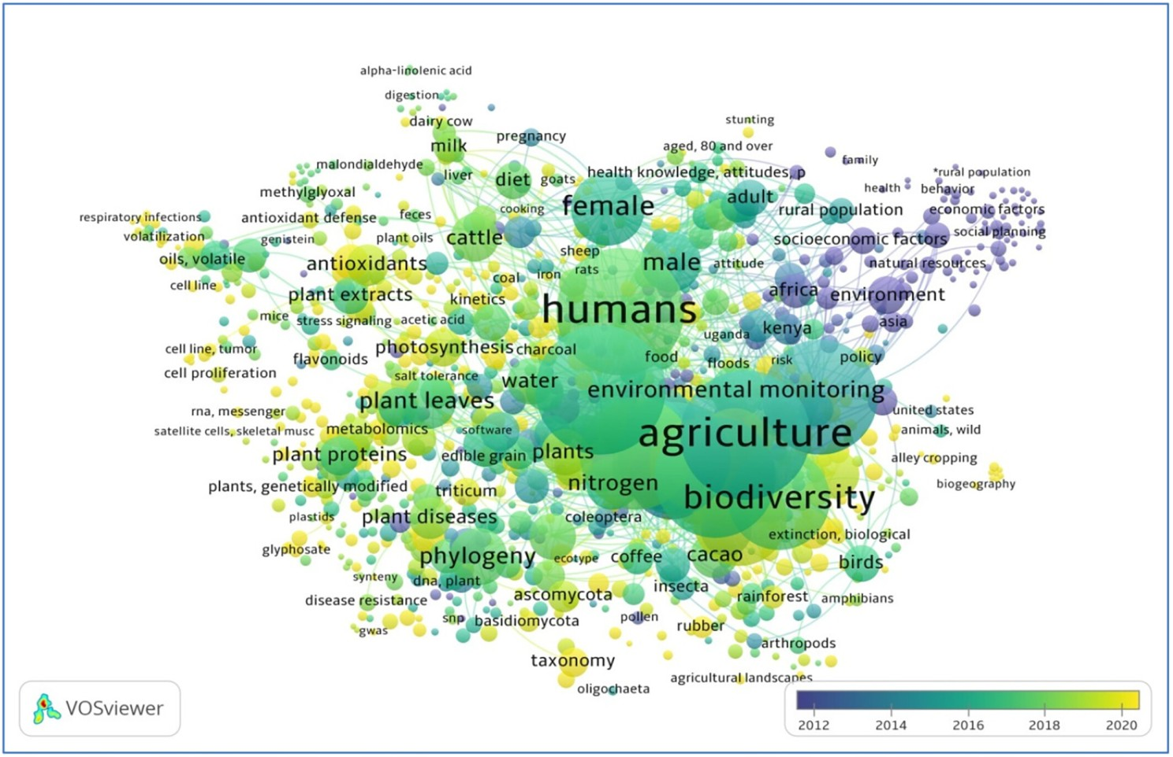

**Image 1 : Network map of keywords, for the most central keywords of articles published between 2012 and 2020 in agroforestry related articles. Source: Ghimire et al., 2024**

**Monitoring and Assessment.**

A majority of current applications of AI in Agroforestry are focused on assisting data analyses for monitoring Agroforestry productivity and health, detecting changes in land cover and land use, and assessing tree density and species distribution. For instance, machine learning and deep learning have been employed to process vast amounts of remote sensing imagery (e.g. Landsat) and text (e.g. LiDAR) data, to map global forest cover (Hansen et al. 2013). To study those forest characteristics that are difficult or infeasible to quantify with remote sensing data, researchers further utilize *in situ* information such as forest inventory data. For example, based on a multitude of forest inventory and remote sensing data, researchers used machine learning to map forest productivity (Liang et al. 2016), tree density (Crowther et al. 2015), and forest tree species diversity (Liang et al. 2022), across the global forest range. These high‐resolution wall‐to‐wall global maps are invaluable for understanding the current state of forests and identifying areas in need of intervention.

**Estimating Growth and Yield.**

Since the dawn of Agroforestry, people have consistently turned to sustainable growth and yield models for forecasting the productivity and future condition of forest stands. These models are especially crucial when considering various management approaches or their absence. Over time, an impressive array of forest growth and yield models has emerged, ranging from early yield tables to contemporary, computer‐based forest growth simulators. However, unlike other essential tools of Agroforestry, such as axes and chainsaws, forest growth and yield models are notably expensive to build. This is primarily due to their labor‐intensive nature, and the need for specialized expertise encompassing forest ecology, forest management, biometrics, and modeling. For instance, the Forest Vegetation Simulator, the predominant growth and yield model in the United States, relies on an annual budget of approximately $300 million through the Forest Monitoring Program of the USDA Forest Service (USDA Forest Service 2023). As a result of these steep costs, more than eighty percent of developing countries worldwide lack access to a single forest growth and yield model to support their Agroforestry and conservation efforts. Recent strides in this field have introduced machine learning techniques (Ma et al. 2020), and self‐learning systems (Pukkala et al. 2021), aiming to make forest growth and yield models more economically viable. However, these enhanced models still necessitate close human supervision, thus limiting their applicability to a broader spectrum of forest types. Addressing this challenge, the Forest Advanced Computing and Artificial Intelligence Laboratory at Purdue University (FACAI), in collaboration with the World Resources Institute and the Food and Agriculture Organization of the United Nations (FAO), is currently engaged in the development of MATRIX – an artificial intelligence‐based forest growth model. MATRIX‘s objective is to project stand level forest dynamics across the global forest range under various forest management and climate change scenarios, presenting a promising solution to the cost and accessibility barriers associated with traditional forest growth and yield models.

**Precision Forestry.**

AI can optimize logging operations by pinpointing individual trees to cut in a pre‐designed harvest schedule that aims to minimize logging cost or maximizes net present value (Liu et al. 2021). AI‐driven equipment can make precise cuts to reduce waste and environmental impact, enhancing resource efficiency and promoting sustainable forestry practices. Furthermore, AI systems can streamline inventory management by automating or augmenting forest inventory surveys that are very labour intensive. This increases forest inventory capacity, reduces errors, enhances transparency, and helps combat illegal logging, especially for the developing countries (Dalla Corte et al. 2020, Hamedianfar et al. 2022).

**Carbon Stock Monitoring.**

Managing, conserving, and restoring forests have great potential for climate change mitigation, but such a task requires precise quantification of global forest carbon accumulation rates. Due to inconsistent data, methods, and assumptions employed in existing forest carbon monitoring systems (Harris et al. 2021), large uncertainties in the magnitude and direction of the response of the terrestrial carbon cycle to climate change still remain unquantified (Pugh et al. 2020). More specifically, existing global‐scale map products either assumed linear growth rates (e.g. Cook‐ Patton et al. 2020) or a simple non‐linear model, such as the Chapman‐Richards growth function (e.g. Bukoski et al. 2022). These assumptions are insufficient for precise quantification of the complex species‐specific forest growth rates. Furthermore, little is known about how much local forest carbon accumulation rates are attributable to upgrowth, regeneration, and mortality, and how sensitive these key components of forest growth are to changes in climate and land‐use patterns. AI has great potential, such as through the AI‐based forest growth models described above, to help monitor and predict carbon stocks in forests, assisting researchers in understanding the role of forests in the global carbon cycle.

**Artificial Intelligence (AI) And Machine LEARNING (ML)**

Artificial intelligence is powerful technology that encompasses computers and machines to simulate the intelligence of human to solve specific problem on the basis of logical reasoning and fast experiences. As a field of computer science, AI enables machine learning and deep learning. These two disciplines involve to develop AI algorithms, then models after the decision-making processes of the human brain or intellectual which is ‘learn’ from existing data and make progressively very high accurate simulations, classifications or predictions over time. Digital assistants, autonomous vehicles, GPS guidance and generative AI tools such as Chat GPT, Open AI are some examples of Artificial Intelligence in our daily lives and the daily news.

**Types of AI: Weak AI And Strong AI**

**Weak AI:** This AI is trained and very much focused to accomplish a specific task. It is also known as *artificial narrow intelligence (ANI) or narrow AI*.

**Strong AI:** It is a theoretical form of Artificial Intelligence where a machine would have an intelligence equal to a human such as self-awareness with a consciousness that would have the ability to solve problems, learn, understand and plan with a solution for the prediction of future. It is made up of *artificial general intelligence (AGI)* and *artificial (ASI)*. ASI is also known as super intelligence would surpass the intelligence, consciousness and ability of the human brain.

**Deep Learning and Machine Learning**

Both machine learning and deep learning are sub-disciplines of Artificial Intelligence. Deep learning is a sub-discipline of machine learning. These learning algorithms are mainly used the neural networks to ‘learn’ from huge amounts of existing data to programme structure of model after the decision-making processes of the human brain. They consist different layers of interconnected nodes at each level that extract features and specifications from the existing data and make predictions of future on the basis of simulations.

**Applications of Artificial Intelligence in Agroforestry**

In Indian economy, Agriculture is the backbone of the country where sixty percentage of Indian population are mainly depended on agriculture whether directly or indirectly. Agroforestry system has the potential capacity to achieve big goals such as social, economic, and environmental goals through optimizing and improving the land productivity. In recent time, advances have been made in green faming such as Smart Agriculture, Robotic Agriculture, Precision farming, Regenerative Agriculture, Satellite based Agriculture, Artificial Intelligence enabled Agriculture etc. to meet out the productivity and sustainability challenges.

The large information available on internet which is generated by soil water content sensor, ph sensor, soil moisture content sensor, weed seeker sensor, soil electrical conductivity sensor, temperature sensor, and wind speed sensor. Internet of Things (IoTs) adopts various enabling techniques viz., wireless sensor networks, big data analysis, cloud computing, security protocols, embedded systems, communication protocols, architectures and web services. Additionally, AI enables automated agricultural operations and systems requiring minimum supervision and control with drones or ground based autonomous vehicles and use of robotics in agriculture and Agroforestry (Eli-Chukwu, 2019). The various applications of AI in Agroforestry have been describing in following ways:

**Weather Forecasting System:** AI-enabled weather forecasting system is analysed fast year data and present weather conditions to predict the future rainfall, temperature, humidity etc. On the basis of forecasted weather, farmer can choose the suitable suggested agricultural crop, forest crops and livestock, and also the optimal time of seed sowing. suggested decisions based on real-time weather data.

**Monitoring of Soil Health:** AI-driven technologies can detect the nutrient status, deficiency of nutrients and provide information regarding to use the fertilizer in which quantity.

**Monitoring and Control of Crop Health:** AI-enabled techniques used to detect and control insect-pest attack and its management using drones or autonomous tractors (Fig.2). AI systems utilize satellite imageries, fast historical data and employing algorithms to detect and control insect pest attack. Farmers can receive real-time alerts and pest control measures on their smartphones.

**Optimizing Automated Irrigation Systems:** AI based irrigation system used sensor data i.e., monitor soil moisture levels and weather conditions and algorithms can decide and prove in real-time solution how much water is required for irrigation in the crop. Therefore, an automated crop irrigation system has been designed to conserve soil water and provide irritation in real time.

**Yield Mapping and Predictive Analytics:** Yield mapping of crop uses ML algorithms to analyse large datasets in real time and this is used to understand the patterns and yield of the crops which allowing a farmer for better planning and management. By combining machines and robots predict the crop yield for a specific crop. Data is collected on multiple drone flights in the field, enabling increasingly the levels of precise analysis with the use of various algorithms to predict very precise yield (Fig. 1).

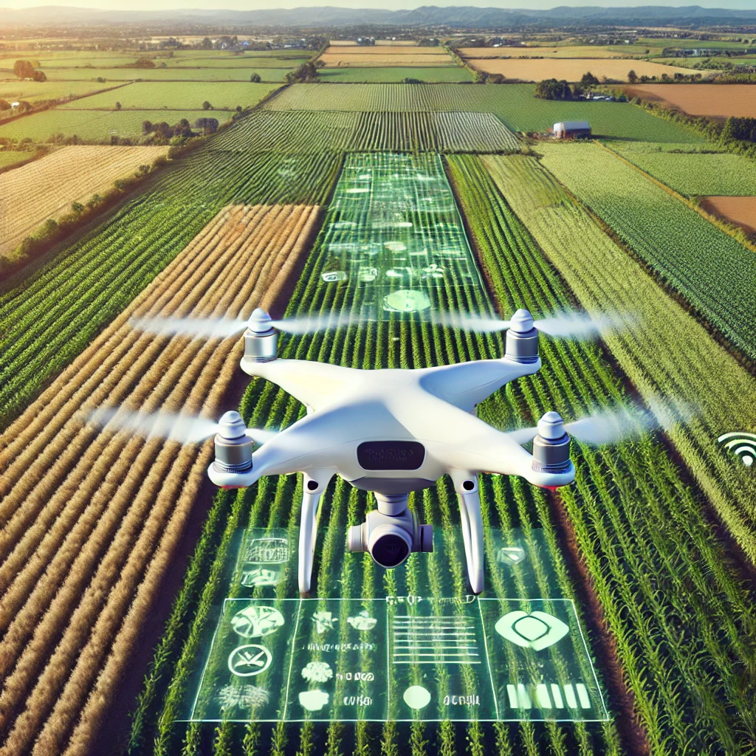

**Fig. 1: Crop yield mapping using drone technology**

**Automated Weeding:** When AI combined with machine learning, the computer software analyses all the data regarding to the size, shape, and colour of leaves to distinguish weeds and invasive plant species from crops and provide the solutions which can be used to program a robot that carry out the robotic process automation (RPA) tasks which is also called as automatic weeding.

**Automatic Harvesting:** Similar to the AI-enabled technologies used for detect insect-pests and diseases, weeds etc. can also be used to detect and harvest the crop. In fact, the crop harvesting robot has already been used effectively in developed countries. As these AI-driven technologies become more accessible for harvesting of the crops in real time.

**Smart Grading of Harvested Produce:** AI-enabled technologies are not only useful for identifying and detecting potential problems with crops while they are growing to sort and grade the harvested produce more accurately.

**Agricultural Marketplace:** Recently, Smart Agricultural Marketplace which is enabled with AI-technologies such as blockchain to optimize and regulate the supply and demand agricultural products. This innovative solution can also be integrating with agricultural products, e-marketplace services and blockchain to collect information and data at various stages of the supply chain which enhancing transparency and efficiency.

**Surveillance and Security of the Farm:** Security is very important part of the farm management. Farms are common targets for animals and birds and even humans which is hard for farmers to monitor their fields all around the clock. When AI combined with video surveillance systems, mobile, computer software and ML can quickly identify security breaks and issue the alert. Where some automated security systems are even well-advanced enough to distinguish regular employees from unauthorized persons.

**The Future of AI in Agroforestry Transformation**

AI is definitely playing an increasingly huge role in agriculture as well as Agroforestry and food security with sustainability over the upcoming years. AI-enabled technologies have always been at the forefront of agriculture and Agroforestry such as from primitive tools and implementations to irrigation to tractors to drones to robots to AI. This is also called as Smart Farming (Charania and Li, 2020). Every development of technology and its advancement has increased efficiency with accuracy while reducing the challenges of green farming all around the world (Fig. 2). AI has the modern tools to address various challenges posed by climate change, global warming, environmental issues, and an increasing demand for food and nutrition. It will revolutionize modern agriculture and Agroforestry by improving efficiency with accuracy, sustainability, management, resource allocation on top of real-time monitoring and predictions for healthier and higher-quality food produce.

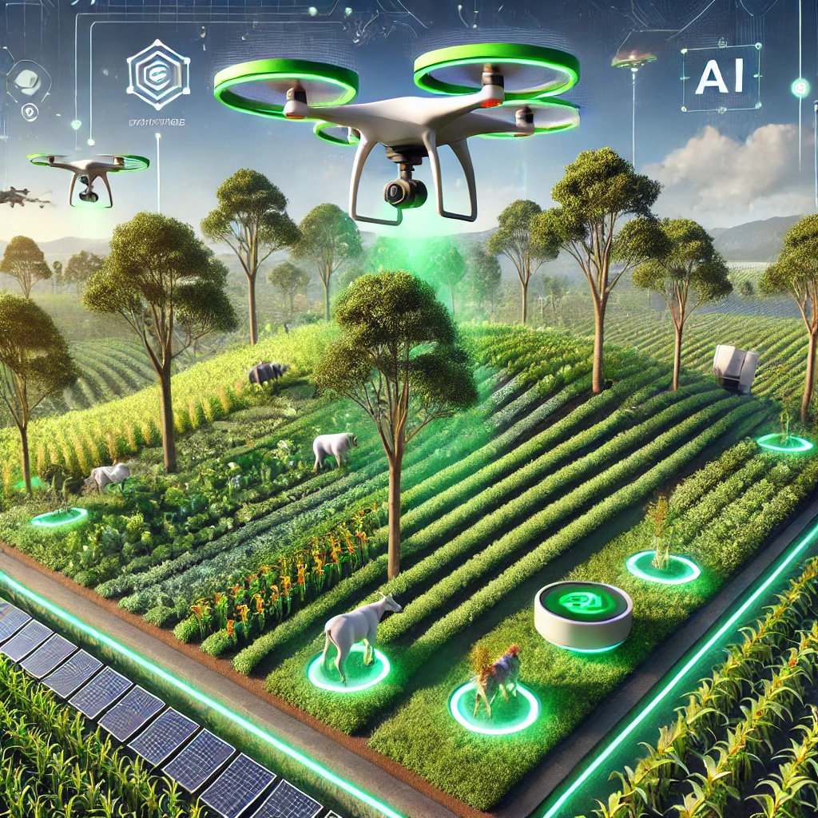

**Fig. 2: AI Based futuristic agroforestry landscape where AI and drones monitor crops and trees, creating a sustainable, tech-integrated environment.**

**Conclusion**

The AI-enabled technologies are very useful from the growing of a crop, its risk management, crop management, crop protection, crop advise, soil and crop health analysis and management, crop feeding, automated irrigation, automatic crop harvesting and finally crop grading and even marketing. Thus, these various applications can be utilized in Agroforestry. It will revolutionize modern Agroforestry practices by increasing efficiency with accuracy in real-time monitoring and predictions for higher yield of food produce. It is widely accepted that any deviation from Holocene standards will present human societies with great challenges. Stabilizing forest productivity and resilience at multiple scales is such a challenge. Evidence from different forest regions shows that forested landscapes with *asynchronous stands* are more stable than homogenous landscapes (Lin et al. 2022, Qiao et al. 2023), and local stands that include *asynchronous species* are more resilient than biologically homogenous communities (Yue et al. 2022). This evidence presents new challenges for AI research that go well beyond the measurement of tree crowns, heights and timber volumes. A particular challenge are intelligent systems for reliable identification of tree species in the field and the further development and extension of databases that contain tree species traits. Traits are inherent attributes of a plant species. Examples of traits are wood density; maximum height; seed mass; growth form (tree, shrub, climber); or the life expectancy of a tree. Important response traits are plant tolerance to frost, drought, or shading. Traits may change according to tree development stage (certain oak species are shade tolerant only at a very young age).

Traits may be modified by site: maximum tree height may be severely reduced on windswept sites. Response traits also determine the capacity of a tree species to stablish itself and survive in harsh environments, at high altitudes, in deserts or salty marshes. Trait‐based approaches provide a useful framework for evaluating ecosystem functioning under intensifying global change. However, the current focus of trait‐functioning relationships relies mainly on aboveground traits (e.g. leaf traits), and there is a lack of consideration for belowground traits (e.g. absorptive root traits), even though these traits provide important plant functions. The use of AI in forest research and management, like in any other field, raises several ethical considerations that need to be carefully addressed. First, AI tools and applications, such as LLM and drones, can have profound environmental impacts. For example, the electricity consumption of GPT‐3 or similar LLM can be significant due to the computational resources required for their operation. The use of drones for data collection may disturb wildlife or damage sensitive ecosystems. Secondly, AI systems often rely on large datasets, which may include sensitive information about landowners, forest ecosystems, or even indigenous communities. It’s crucial to ensure data privacy, protect personal information, and obtain informed consent when collecting and using data. Thirdly, AI algorithms can inherit biases present in training data, which can result in unfair or discriminatory outcomes. Furthermore, as indigenous and rural communities have less access to Internet and other technologies, it is especially important to prioritize the benefits to under‐represented and under‐privileged communities in the design of AI tools and applications. AI systems should be developed and deployed with consideration for local communities, indigenous knowledge, and historically marginalized groups. Finally, we believe that a sound theoretical framework is a useful basis for guiding the development of specific technical applications of artificial intelligence.

**DISCLAIMER (ARTIFICIAL INTELLIGENCE)**

The authors hereby attest to the usage of generative AI technologies, including large language models, in the composition or editing of works. The name, version, model, and source of the generative AI technology will all be covered in this discussion, along with all of the input prompts that the system uses.

**Details of the AI usage are given below:**

The Keyword Co-Occurrence Network on Agroforestry and Diagnosis Research is being generated using VOS viewer software version 1.6.20.

**Reference**

Bukoski, J. J., S. C. Cook‐Patton, C. Melikov, H. Ban, J. L. Chen, E. D. Goldman, N. L. Harris, and M. D. Potts. 2022. Rates and drivers of aboveground carbon accumulation in global monoculture plantation forests. Nature communications 13:1‐13.

Cook‐Patton, S. C., S. M. Leavitt, D. Gibbs, N. L. Harris, K. Lister, K. J. Anderson‐Teixeira, R. D. Briggs, R. L. Chazdon, T. W. Crowther, and P. W. Ellis. 2020. Mapping carbon accumulation potential from global natural forest regrowth. Nature 585:545‐550.

Crowther, T., H. Glick, K. Covey, C. Bettigole, D. Maynard, S. Thomas, J. Smith, G. Hintler, M. Duguid, and G. Amatulli. 2015. Mapping tree density at a global scale. Nature 525:201‐205.

Dalla Corte, A. P., D. V. Souza, F. E. Rex, C. R. Sanquetta, M. Mohan, C. A. Silva, A. M. A. Zambrano, G. Prata, D. R. A. de Almeida, and J. W. Trautenmüller. 2020. Forest inventory with highdensity UAV‐Lidar: Machine learning approaches for predicting individual tree attributes. Computers and Electronics in Agriculture 179:105815.

Charania, I. and Li, X. (2020). Smart farming: Agriculture's shift from a labor intensive to technology native industry. Internet of Things, 9, p.100142.

Eli-Chukwu, N.C. (2019). Applications of artificial intelligence in agriculture: A review. Engineering, Technology & Applied Science Research, 9(4).

Gadow, K. v. 1988. Building Agroforestry rule systems.South African Journal of Philosophy7:132‐137.

Ghimire, M., Khanal, A., Bhatt, D., Dahal, D., & Giri, S. (2024). Agroforestry systems in Nepal: Enhancing food security and rural livelihoods – a comprehensive review. Food and Energy Security, 13, e524. https://doi.org/10.1002/fes3.524

Hamedianfar, A., C. Mohamedou, A. Kangas, and J. Vauhkonen. 2022. Deep learning for forest inventory and planning: a critical review on the remote sensing approaches so far and prospects for further applications. Agroforestry 95:451‐465.

Hansen, M. C., P. V. Potapov, R. Moore, M. Hancher, S. Turubanova, A. Tyukavina, D. Thau, S. Stehman, S. Goetz, and T. Loveland. 2013. High‐resolution global maps of 21st‐century forest cover change. Science 342:850‐853.

Harris, N. L., D. A. Gibbs, A. Baccini, R. A. Birdsey, S. de Bruin, M. Farina, L. Fatoyinbo, M. C. Hansen, M. Herold, R. A. Houghton, P. V. Potapov, D. R. Suarez, R. M. Roman‐Cuesta, S. S. Saatchi, C. M. Slay, S. A. Turubanova, and A. Tyukavina. 2021. Global maps of twenty‐first century forest carbon fluxes. Nature Climate Change 11:234‐240.

He, K., C. Fan, M. Zhong, F. Cao, G. Wang, and L. Cao. 2023. Evaluation of Habitat Suitability for Asian Elephants in Sipsongpanna under Climate Change by Coupling Multi‐Source Remote Sensing Products with MaxEnt Model. Remote Sensing 15:1047.

Liang, J., T. W. Crowther, N. Picard, S. Wiser, M. Zhou, G. Alberti, E. D. Schulze, A. D. McGuire, F. Bozzato, H. Pretzsch, S. de‐Miguel, A. Paquette, B. Herault, M. Scherer‐Lorenzen, C. B. Barrett, Lin, S., C. Fan, C. Zhang, X. Zhao, and K. von Gadow. 2022. Anthropogenic disturbance mediates soil water effect on diversity‐productivity relationships in a temperate forest region. Forest Ecology and Management 525:120544.

Liu, T., Y. Sun, C. Wang, Y. Zhang, Z. Qiu, W. Gong, S. Lei, X. Tong, and X. Duan. 2021. Unmanned aerial vehicle and artificial intelligence revolutionizing efficient and precision sustainable forest management. Journal of Cleaner Production 311:127546.

Lundgren, B. and Raintree, J.B. (1982). Sustained Agroforestry In: Nestel, B. (ed.). Agricultural Research for development; Potentials and Challenges in Asia. ISNAR, The Hague. Pp: 37- 49.

Ma, W., G. Lin, and J. Liang. 2020. Estimating dynamics of central hardwood forests using random forests. Ecological Modelling 419:108947.

Montes, O., Castro, R., Uribe, M., Villanueva, C. and Pérez, M. (2020). Agroforestry 4.0 Interventions for Indian Agroforestry Policy. In: Proceedings of Proceedings of Two Days International Conference on Emerging Trends in Sustainable Agriculture and Biotechnology (ICETSAB 2020) on 5-6, September, 2020. Pp: 35-47.

Mporas, I., I. Perikos, V. Kelefouras, and M. Paraskevas. 2020. Illegal logging detection based on acoustic surveillance of forest. Applied Sciences 10:7379.

Pérez‐Rodríguez, L. A., C. Quintano, E. Marcos, S. Suarez‐Seoane, L. Calvo, and A. Fernández‐ Manso. 2020. Evaluation of prescribed fires from unmanned aerial vehicles (UAVs) imagery and machine learning algorithms. Remote Sensing 12:1295.

Pijanowski, B. C., D. G. Brown, B. A. Shellito, and G. A. Manik. 2002. Using neural networks and GIS to forecast land use changes: a Land Transformation Model. Computers, Environment and Urban Systems 26:553‐575.

Pugh, T. A. M., T. Rademacher, S. L. Shafer, J. Steinkamp, J. Barichivich, B. Beckage, V. Haverd, A. Harper, J. Heinke, K. Nishina, A. Rammig, H. Sato, A. Arneth, S. Hantson, T. Conference Series: Earth and Environmental Science. IOP Publishing.

Qiao, X., Y. Hautier, Y. Geng, S. Wang, J. Wang, N. Zhang, Z. Zhang, C. Zhang, X. Zhao, and K. von Gadow. 2023. Biodiversity contributes to stabilizing ecosystem productivity across spatial scales as much as environmental heterogeneity in a large temperate forest region. Forest Ecology and Management 529:120695.

Stephenson, P. 2020. Technological advances in biodiversity monitoring: Applicability, opportunities and challenges. Current Opinion in Environmental Sustainability 45:36‐41.

USDA Forest Service. 2023. Fiscal year 2024 Budget Justification. USDA Forest Service, Washington D.C.

Wang, Y., B. Chao, P. Dong, D. Zhang, W. Yu, W. Hu, Z. Ma, G. Chen, Z. Liu, and B. Chen. 2021. Simulating spatial change of mangrove habitat under the impact of coastal land use: Coupling MaxEnt and Dyna‐CLUE models. Science of The Total Environment 788:147914.

Yue, Q., Y. Geng, K. von Gadow, C. Fan, C. Zhang, and X. Zhao. 2022. Effects of neighborhood interaction on tree growth in a temperate forest following selection harvesting. Ecological Indicators 136:108663.

Zhang, Y., P. Geng, C. Sivaparthipan, and B. A. Muthu. 2021. Big data and artificial intelligence based early risk warning system of fire hazard for smart cities. Sustainable Energy Technologies and Assessments 45:100986.