**Global Food Security and Environmental Challenges in the face of Climate Change**

ABSTRACT

Climate change poses a severe threat to global food security, with rising temperatures, unpredictable weather patterns, soil degradation, and water scarcity leading to diminished agricultural productivity. Climate-Smart Agriculture (CSA) emerges as a strategic approach to mitigate these challenges by enhancing agricultural resilience, reducing greenhouse gas emissions, and ensuring sustainable food production. This review examines the principles of CSA, including sustainable intensification, climate-resilient practices, and greenhouse gas mitigation techniques. Additionally, it explores the socio-economic and technological barriers hindering CSA adoption and proposes policy frameworks to facilitate widespread implementation. By integrating innovative farming practices, such as agroforestry, water conservation, and precision agriculture, CSA can ensure long-term food security in the face of climate change. Ultimately, transitioning to climate-smart agricultural systems is imperative for sustaining global food production while addressing environmental sustainability and economic viability.

**Keywords**: Climate-Smart Agriculture, food security, greenhouse gas mitigation, agroforestry, agricultural resilience, policy frameworks.

1. INTRODUCTION

Climate crisis affects productive capacity, which results in intensified uncertainty of agricultural production. The disruption affects the worldwide food stock chain , exacerbates food shortage threats. Key problems such as loss of soil, pest infestation and shortage of water exacerbated by climate change significantly reduce agricultural productivity and threaten global food security (Laderach *et al.,* 2017; Arora, 2019; Zizinga *et al.,* 2022; Miron *et al.,* 2023). The global population is projected at the global organization at 9.71 billion in 2050s and agriculture needs to be raised by 70% to satisfy demand (United Nations, 2021). The solution is in pragmatic measures with the potential to forestall the hostile effects of the shifting environment and increase strength and adaptability of smallholder agricultural systems. The systems must be protected from rapidly adjusting to consequences, which destabilizes farming production and food method or raises the exposure and uncertainty of policymakers and farmers. Climate change has certainly played a role in creating grave concerns regarding global food security, and the concerns are likely to get worse in the future. Drivers of this trend include urbanization, population dynamics, economic development, and an increase in natural disasters such as floods, droughts, and intense heat. By 2050, 9 billion people are projected to be living in more challenging circumstances, with a large number of them experiencing food shortages and rising hunger and poverty rates (Amoroso, 2018; Kebeda *et al.,* 2015).

Global organizations like the Food and Agriculture Organization (FAO., 2021) and the World Bank are collaborating to develop agricultural systems that can enhance food production on both a local and international level. Different stakeholders, such as researchers, policymakers, investors, and public, private, and civil society representatives, have generally acknowledged and embraced the implementation of climate-smart agriculture (CSA) as part of these programs (Taylor, 2018).Food insecurity may also be undermined by climate-related disasters like storms, droughts, and floods through the devastation of food webs, infrastructure, crops, and livestock. CSA refers to a purposeful technique of sustainable development that leverages utilizing of farming to respond to safety of food facing the consequences (Godde *et al.,* 2021). Approach is centered on three main goals: agro-ecological productivity income, modification to climate change and improving of boosting against it, elimination of carbon emissions where possible (FAO., 2021). CSA provides a means to reorganize farming systems to guarantee food security amidst the novel challenges brought about by climate change. Food insecurity can also be threatened by climate-related disasters such as storms, droughts, and floods through the destruction of food webs, infrastructure, crops, and livestock (Godde *et al.,* 2021). Climate smart agriculture (CSA), as defined by the Food and Agriculture Organisation (FAO), refers to a purposeful method of sustainable development that leverages the potential of agriculture to respond to food security in the face of global heating (Godde *et al.,* 2021). The reduction in agricultural production induced by increasing temperatures, unpredictable weather, loss of soil, and water scarcity has raised food and nutritional vulnerability. There will be an estimated 9.7 billion people on earth by 2050, and to cope with the increasing demand, food production would need to rise by 70%.(FAO).

CSA is a sustainable option since it improves the productivity of resources, lowers greenhouse gas emissions, and improves the resilience of agricultural systems .World Bank and Food and Agriculture Organization (FAO) emphasize that CSA is a necessary strategy for safeguarding food systems and addressing environmental concerns over climate change. Climate-Smart Agriculture is not only a positive choice; it is an inevitable response to the urgent challenges of food security and environmental sustainability in an era increasingly defined by climate change. It will be the emphasis on CSA that enables us to take the step toward a more resilient agricultural future capable of supporting an increasingly larger population while safeguarding the precious resources of our world.

1. UNDERSTANDING HOW CLIMATE CHANGE AFFECTS FOOD SECURITY
   1. The relationship between food security and climate crisis

Climate crisis is a crucial threat to farming because of heightened occurrence, intensity of catastrophic weather like cyclones, frosts, etc. Extreme weather events may cause widespread damage to livestock, infrastructure, and agriculture, and the food supply chain and increase food insecurity (Atadoga *et al.,* 2024). Greenhouse gases emitted as a result of these activities retain heat and lead to the alteration of the planetart climate(Kumar *et al.,* 2021). Climatic models currently forecast more warming in the world and alteration of the rain pattern with local heterogeneity that is extreme (Zhang *et al.,* 2021). Climate change poses a risk to food security by the negative impact on crop yield, higher prices of food, and lower overall production. Sustainable farm management and adaptation strategies must be adopted right away to control these effects (Bibi & Rahman, 2023).

|  |  |  |  |
| --- | --- | --- | --- |
| Factor | Impact of Climate Change | Effect on Food Security | Reference |
| Extreme Weather Events | Increased frequency of cyclones, hurricanes, heatwaves, frosts | Damage to crops, livestock, and infrastructure | Atadoga et al., 2024 |
| Temperature Rise | Higher global mean temperatures | Reduced crop yield, heat stress on livestock | Kumar et al., 2021 |
| Changes in Rainfall Patterns | Altered precipitation, more droughts or floods | Water scarcity, loss of arable land | Zhang et al., 2021 |
| Greenhouse Gas Emissions | Increased CO₂ levels from fossil fuels, deforestation | Changes in soil fertility, higher pest infestations | Kumar et al., 2021 |
| Food Price Increase | Supply chain disruptions, lower agricultural productivity | Higher food costs, reduced affordability | Bibi & Rahman, 2023 |
| Crop Yield Reduction | Stressed plant growth, lower productivity | Food shortages, malnutrition risks | Bibi & Rahman, 2023 |
| Mitigation Strategies | Sustainable farming, adaptation techniques | Improved resilience, food system stability | IPCC, 2021 |

**Table 1** This shows how climate change affects food security.

* 1. Addressing the Food Security Challenges Linked to Climate Change

Climate change affects all components of the food chain adversely, affecting food availability, access, and utilization from production to consumption (Godde *et al.,* 2021). Temperature and precipitation changes can affect agricultural production and result in reduced crop yields, livestock production, and fishery stocks. Effects at any point in the food system, either production, transport, or storage, can result in increased food insecurity. In the developing world, threats to food systems is especially severe; climatic change conditions—like drought or floods—mean decreased food availability. Additionally, in developing countries, smallholder farmers tend to operate under financial constraints that act counter to their generation of sufficient earnings to sustain themselves and purchase basic agriculture inputs such as fertilizers (USDA, <https://www.usda.gov/oce/energy-and-environment/food-security>).

2.3The Significance of Modifying Agricultural Practices to tackle these problems

It is critical to modify farming methods in order to manage the difficulties that climate crisis poses for agriculture. Climate crisis fundamentally changes agriculture, leading to risks like extreme weather events, water shortages, and soil degradation. Farmers can increase their resilience to climate change and variability, minimize risks, and sustain productivity by modifying farming practices and implementing climate-smart agriculture. Such adaptation measures address short-term challenges while also ensuring long-term sustainability and profitability as climate conditions change (USDA Climate Hubs, <https://www.climatehubs.usda.gov/agricultural-adaptation-changing-climate>).

2.4 The Importance of Utilizing Adaptation Methods in Agriculture  
  
Cultivation adaptation is important in alleviating climatic uncertainty effects, including unpredictable weather, flooding, drought, and loss of infestation.  
Farmers can combat climate change impacts at enhancing strength of agricultural systems by adjustment (Grigorieva *et al.,* 2023). Climate crisis adaptation enhances ecologically sound ways of preserving natural resources, environmental conservation, and long-term agricultural production sustainability. Adjustment to climate crisis ensures economic sustainability into business by stabilizing farm production, Diminishing volatilities of yields, and ensuring farmers' incomes. By ensuring farm production and reducing the vulnerabilities based on food environment systems shocks, adaptation represent a pivotal part to preserve foodstuffs safely (Grigorieva *et al.,* 2023).

1. ESSENTIALS AND PRINCIPLES

This strategic initiative plan to reduce the issues introduced by environment change by a modification of farming practices. CSA integrates climate aspects into agriculture planning by choosing appropriate technology and practice through site-specific assessment. CSA seeks to build climate-resilient and sustainable agricultural systems by combining climate-responsive policy with sustainable development goals. The coordination of several stakeholders is required for successful implementation in a bid to adopt evidence-based practices that encourage innovation and drive the agricultural industry towards enhanced climate resilience (Verhagen *et al.,* 2014).

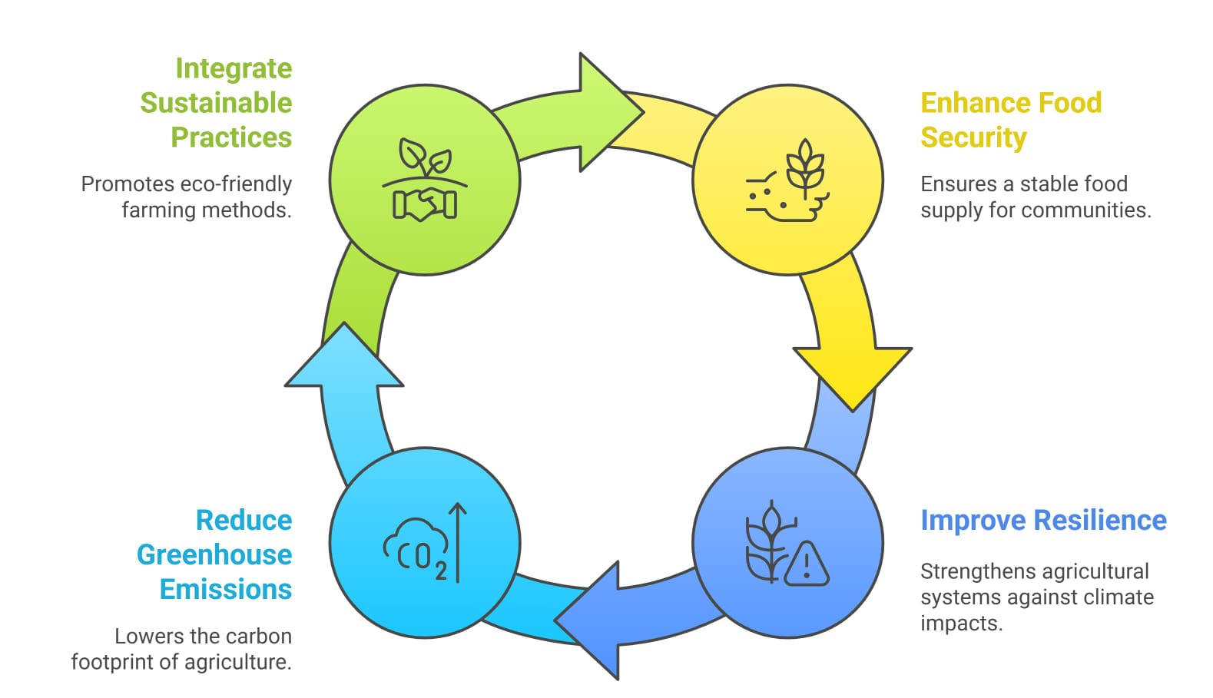

**Figure 1** Cycle of Climate Smart Agriculture

3.1 Sustainable Agricultural Intensification

Sustainable intensification is a crucial concept in agriculture that aims to boost productivity while ensuring the sustainability of natural resources and minimizing environmental impacts. This approach focuses on increasing yields per unit area to secure food availability without harming the environment (Donovan, 2022). Sustainable intensification seeks to meet the rising food demand while enhancing environmental health and food production efficiency. Strategies employed include crop diversification, reduced tillage, improved crop varieties, and conservation agriculture practices, all aimed at achieving higher yields and profitability for farmers (Donovan, 2022).

3.2 Climate Change Adaptation Techniques

Climate change adaptation is an essential slice of Climate Resilient Farming, which aims mitigate carbon emissions, improve adaptation and increase agricultural productivity. For reducing the vulnerability of agri-food systems, CSA utilizes an assortment of adaptation methods at different scales. These strategies consist of afforestation, the utilisation of resilient crop varieties, climate-resilient practices, as well as other strategies to decrease the impacts of climate crisis (Okoronkwo *et al.,* 2024).

In Nigeria, climate change has led to reversal of fortunes, mainly because of its detrimental effects on agricultural productivity. There is a need for the adaptation of CSA in order to boost the sustainability and resilience of agriculture due to climate change. CSA, through its adaptive sustainable and climate-smart approaches, has been observed to be a probable solution to the effects of climate variability. (Grigorieva *et al.,* 2023). Global climate negotiations are centered on projecting the rise in production as a result of emerging farming methods while underplaying the substantial contribution of traditional knowledge towards adaptation. Shifting away from conventional to modern farming has reduced crop diversity in rural areas. Therefore, it is important to find and incorporate regenerative agriculture once again and blend them with contemporary methods (Asian Development Bank, 2023; Grigorieva *et al.,* 2023).

* 1. Greenhouse Gas Emissions Reduction

Climate Smart Agriculture (CSA) guarantees the mitigation of greenhouse gas emissions and environmental degradation from farm activities. Greenhouse gases emitted from farm activities, including carbon dioxide (CO2), methane (CH4), and nitrous oxide (N2O), are mainly responsible for global warming. To address this challenge, CSA advocates for adopting practices that reduce emissions and enhance carbon sequestration in agriculture (Zaman *et al.,* 2021). One of the best ways to decrease greenhouse gas emissions in Climate Smart Agriculture (CSA) is to use nitrification and urease inhibitors, which decelerate the process of nitrification and lower N2O emissions. In addition, conservation tillage, cover crops, and applying synthetic and organic manures with proper judgment have been proven as good practices of mitigating emissions and enhancing agricultural carbon sequestration in soil. These practices reduce greenhouse gas emissions while augmenting agricultural stability and production (United States Department of Agriculture, 2021). Climate Smart Agriculture also supports enhancement of nutrient management to provide highest possible uptake by crops of nitrogen and least amount of loss to the air, both of which are vital for reducing greenhouse gas emissions from farming activities. Climate-smart agriculture and enhancing the use efficiency of nutrients can conserve emissions while keeping or even growing productivity and environment change resilience to allow farmers (Christ., <https://extension.psu.edu/climate-smart-agriculture-and-conservation-practices>).

|  |  |  |  |  |
| --- | --- | --- | --- | --- |
| Practice | GHG Reduced | Impact on Environment | Additional Benefits | Reference |
| Nitrification & Urease Inhibitors | ↓ N₂O by 30-70% | Improves nitrogen efficiency | Improves nitrogen efficiency, enhances crop yields | Zaman et al., 2021 |
| Conservation Tillage | Sequesters 0.5 t C/ha/yr | Reduces soil disturbance | Reduces erosion, improves soil structure | USDA, 2021 |
| Cover Crops | ↓ N₂O by 40% | Enhances soil organic carbon | Improves water retention, prevents erosion | USDA, 2021 |
| Nutrient Management | ↑ Efficiency by 30-60% | Minimizes nitrogen losses | Enhances crop uptake, lowers input costs | FAO, 2020 |
| Carbon Sequestration in Soil | Sequesters 1.2–3.0 t CO₂/ha/yr | Stores carbon in soil | Improves soil organic matter and fertility | Zaman et al., 2021 |
| Agroforestry | Sequesters 2–4 t CO₂/ha/yr | Increases carbon storage in trees and soil | Provides additional income sources (timber, fruits) | USDA, 2021 |
| Precision Agriculture | ↓ GHG emissions by 10-30% | Reduces input waste (fertilizer, water, pesticides) | Enhances efficiency and productivity | FAO, 2020 |
| Manure Management | ↓ CH₄ emissions by 30-80% | Captures methane from livestock waste | Converts waste to bioenergy, reduces water contamination | USDA, 2021 |
| Improved Rice Cultivation | ↓ CH₄ by 20-50% | Reduces methane emissions from flooded fields | Enhances water use efficiency, improves yields | Zaman et al., 2021 |
| Biochar Application | Sequesters 2-4 t CO₂/ha/yr | Enhances soil carbon storages emissions | Improves soil fertility, increases crop yields | USDA, 2021 |

**Table 2** Climate-Smart Strategies for Lowering Agricultural Emissions (↓=Lowering, ↑= Enhancing)

3.4 Emergence of Resilience

Addressing the challenges climate change presents to agricultural systems requires the application of CSA in order to improve resilience. An essential element of CSA is to promote innovation and adopt farming practices that respond to and alleviate climate change, all while enhancing productivity sustainably (Union of Comoros, <https://www.adaptation-undp.org/projects/strengthening-resilience-climate-smart-agricultural-systems-and-value-chains-union-comoros>). CSA encourages practice of climate-resilient techniques among small-scale farmers and value chain actors and crop varieties. CSA projects provide smallholder farmers with support and tools to undertake climate-resilient agricultural practices, and as a result, they become even less vulnerable to climate change. Among these resources are crop calendars, agricultural land use plans, advisory sheets for suitable varieties and practices, and agroforestry practices such as hedging. Farmers can enhance the environment strength of farming systems through CSA practices that increase soil health. For example, enhancing the handling of crop residues is central to enhancing the well-being of soils and stability of agriculture systems (Dougill *et al.,* 2021). There is a need to invest in climate-resilient agricultural practices and technologies that enhance the sector's resilience. Farmers can similarly adjust to droughts through climate-resilient management strategies and crops that have the ability to avoid crop yield loss or enhance crop yields, which can positively impact their earnings (Samuel *et al.,* 2024).

4. IMPROVING AGRICULTURAL PRODUCTIVITY IN SUSTAINABLE WAY  
The strategy emphasizes the consideration of global warming issues in eco-agriculture so as to enhance resilience and efficiency in resource use in terms of farm product. By coordinating collective action among various stakeholders like farmers, policy-makers, private sector actors, and scientists. CSA promotes resilient pathways. In contrast with conventional strategies, CSA targets the need for adaptable, context-led solutions supported through innovative finance and policy arrangements (Ali *et al.,* 2023). CSA targets to solve the coupled challenges of expanding farm productivity sustainably, developing resilience to climate change impacts, and minimizing greenhouses gases emission. By increasing the vulnerability of agricultural production systems and rural livelihoods to risk, CSA seeks to alleviate risk of hunger both now and in the long term. By using sustainable farming practices, CSA aims to achieve balanced gains in income and enhance climate change boost at various levels from local to global (Ali *et al.,* 2023). In Ethiopia and Mali, among other nations where agriculture is a significant sector in the economy and rural communities' livelihoods, the use of farming practices that are climate-smart has had promising impact on poverty alleviation and food security. Techniques like management of integrated soil fertility, conservation agriculture, diversification of crops, and irrigation on a small scale have played a vital part in improving food safety, boosting crop productivity, decreasing household vulnerability to climate alteration. Those initiatives not just help attain Sustainable Development Goals linked to poverty alleviation, hunger eradication, and climate action but also underscore the importance of scaling up CSA practices through enhanced access to resources, education, and financing mechanisms (Traore *et al.,* 2021).

4.1 Enhanced Food Production and Agricultural Productivity  
The world is facing an unprecedented increase in its population and demand for food. The demand will have to be met with a rise in the production of food, and more agricultural productivity will be needed for this. Growing productivity is very important in keeping economic growth and poverty reduction in check as well as ensuring availability of food (Hemathilake & Gunathilake, 2022). Technological changes in equipment, process technology, animal genetics, and plant genetics have all pushed the forty-year improvement in the aggregate agricultural productivity to yield fantastic growth rates for crop output as well as for overall output (Hemathilake & Gunathilake, 2022). Among the largest drivers of increased agricultural productivity is the enhanced use of new farm practices and technology that seek to optimize productivity and efficiency. Irrigation, precision agriculture, and high-yielding varieties are some of the technologies that have revolutionized farm practices and enabled farmers to produce more from previously cultivated lands without accessing additional natural resources. Besides this, insofar as agriculture negatively impacts the environment and causes climate change is concerned, transitioning towards sustainable agriculture not only promotes increasing production but also environmental preservation (OECD., <https://www.oecd.org/agriculture/topics/agricultural-productivity-and-innovation>).  
Agricultural productivity development is not so much a matter of expanding the quantity of food output but also about making food systems sustainable. Agriculture can meet the ever-increasing demand for food and become more productive and less resource-intensive, hence increasing farmers' incomes and poverty reduction. The farming sector can increase productivity, enhance food production, and construct more sustainable food systems for the future by making an investment in research, sharing best practices, and ongoing neuerung (Ritchie *et al.,* 2023).

|  |  |  |  |
| --- | --- | --- | --- |
| Category | Description | Key Benefits | Reference |
| Precision Agriculture | Use of technology (GPS, sensors, AI) to optimize farm management | Increases efficiency, reduces input waste, enhances yields | Hemathilake & Gunathilake, 2022 |
| High-Yielding Crop Varieties | Development of genetically improved crops with better resistance and productivity | Boosts food supply, improves resilience to pests and climate | Hemathilake & Gunathilake, 2022 |
| Mechanization & Process Technology | Modern farming equipment and automation for increased efficiency | Saves labor, improves precision in planting and harvesting | Hemathilake & Gunathilake, 2022 |
| Animal Genetics & Breeding | Genetic improvements for livestock to increase productivity and disease resistance | Enhances meat/milk output, improves animal health | Hemathilake & Gunathilake, 2022 |
| Research & Development | Investment in agricultural innovation and knowledge sharing | Drives technological advancements, increases long-term productivity | Ritchie et al., 2023 |
| Food System Sustainability | Practices that balance production and environmental conservation | Protects natural resources, supports food security | Ritchie et al., 2023 |
| Digital Agriculture & Smart Farming | Use of big data, IoT, and blockchain in agriculture | Enhances traceability, improves decision-making | Hemathilake & Gunathilake, 2022 |

**Table 3** Strategies for Enhancing Agricultural Productivity

4.2 Improved Resilience of Agricultural Systems  
One of the most significant qualities of CSA is enhancing resilience in agricultural systems to reduce the gloomy effects of environment crisis to safeguard food supply. Resilience development for CSA encompasses climate-resilient management systems and crops, including drought-tolerant plants and effective irrigation systems with optimal water utilization. These enable farmers to respond to climatic stresses better, minimize loss of yields, and maintain their income level. Investment in policy and technology in climate-smart agriculture is crucial in the innovation of sustainable agriculture practice, particularly for drylands, whose agriculture and food security are significantly jeopardized by climate risks (Union of Comoros., , <https://www.adaptation-undp.org/projects/strengthening-resilience-climate-smart-agricultural-systems-and-value-chains-union-comoros>). CSA also acknowledges that information sharing and capacity building are essential to building the resilience of agricultural actors. This includes enhancing access to information on climate risks, farming practices, and market opportunities and enhancing the ability of local institutions to function as institutions in the context of incorporate environmental decarbonization objectives into farm operations (Samuel *et al.,* 2024).Additionally, CSA advocates for the use of nuclear techniques to cause variability in crops, improve to generate variation in crops, enhance the productivity of animals, keep an eye on insect pests and animal ailments, and offer essential information for the creation of forecasting models. These methods can greatly improve agricultural resilience and adaptation to climate change, especially regarding global food security (Resilience and adaptation to climate change, <https://www.iaea.org/topics/resilience-and-adaptation-to-climate-change> ).

* 1. Availability of Nutritious Food

Availability of good nutrition is a fundamental aspect of addressing climate change, food and nutrition insecurity poses very major challenges towards achieving this vision. CSA is an integrated landscape management approach addressing linkage between climate change, food and nutrition insecurity. CSA aims to achieve a "triple win" by improved productivity, strengthening resilience and greenhouse gas emissions mitigation in the agrifood system (Beattie & Sallu, 2021). CSA also considers the synergies and trade-offs between output, adjustment, alleviation, with various approaches and technologies suited to particular agroecological contexts and socio-economic situations. Through such practice, there are possible triple-win advantages comprising productivity gain, enhanced resilience, and greenhouse gas reduction for agrifood system (Owino *et al.,* 2022).

1. METHODS AND NEW DEVELOPMENTS IN CLIMATE-SMART AGRICULTURE

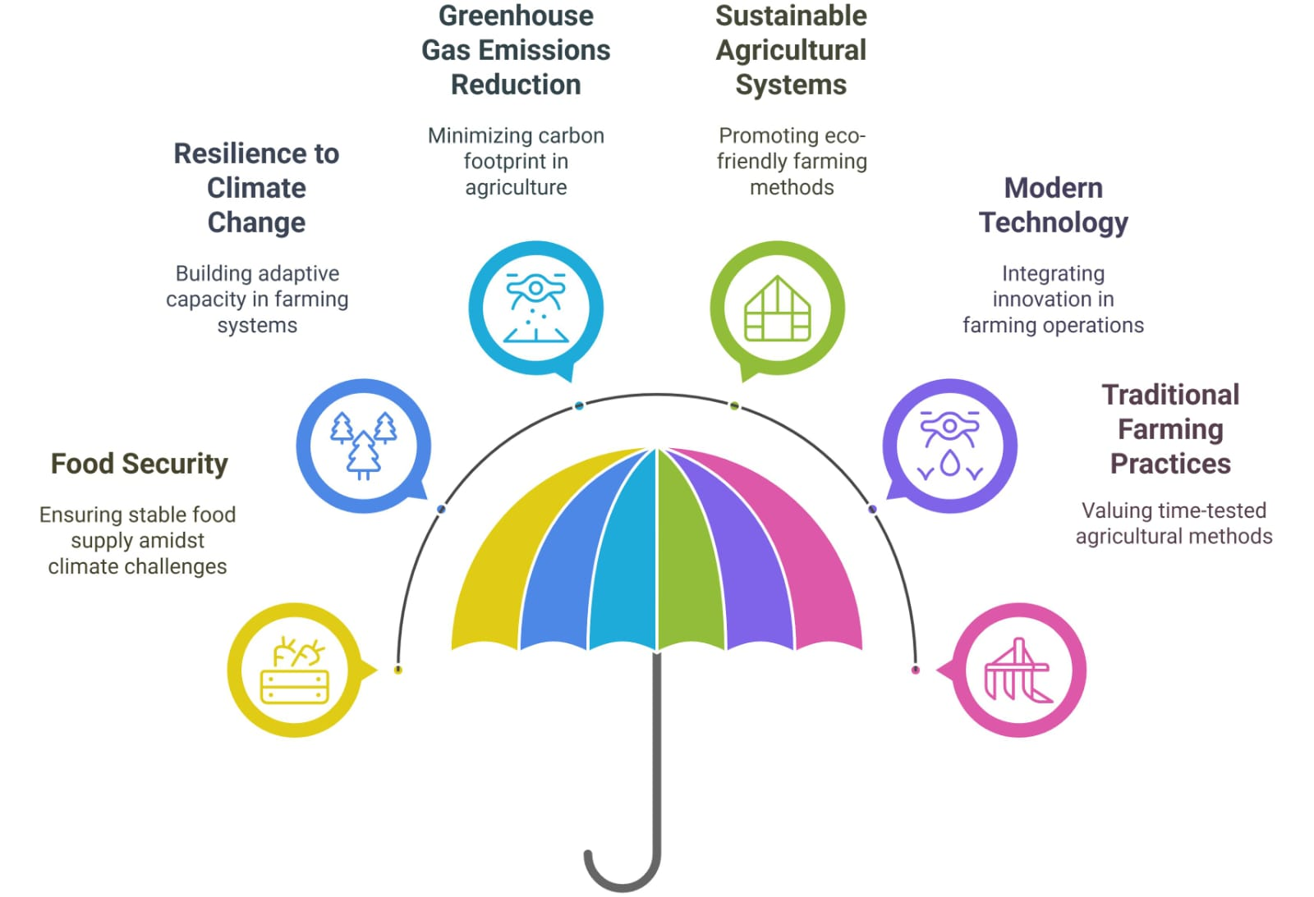

**Figure 2** Components of Climate Smart Agriculture

* 1. Crop Diversification and Rotation Strategies

Crop diversification and rotation are two important principles of this concept, since they encourage better nutrient cycling, soil health, and weed and insect management. Crop rotation means the cultivation of a sequence of different crops in the same land over a period. For instance, the corn-growing farmer, which takes nitrogen from the soil, may plant beans after it, which are great at fixing nitrogen. Rotational systems may be simple (consisting of two to three crops) or complex (with a dozen or more). The ubiquitous practice of monoculture in conventional farming presents numerous sustainability issues (Rodale Institute, 2020). Various crops require specific nutrients and different levels of susceptibility to disease and pests. Continued monoculture drains the soil of particular nutrients needed by the planted species. Also, depending on one crop provides a stable habitat to pests and diseases, and thus their higher incidence. Consequently, crop levels need often to be sustained through a significant increase in using chemical fertilizers and pesticides as measures of defence against these biological stresses. Crop rotation replenishes nutrients in the soil without the requirement of artificial additives, breaks disease and pest cycles, enhances soil health through biomass augmentation due to the varied root systems of crops, and encourages farm biodiversity (Rodale Institute, 2020). Crop rotation and diversification are essential for the encouragement of food security and minimization of risk of crop failure due to unfavorable weather conditions. By promoting both intra- and inter-specific diversity over time and space—through practices such as intercropping, utilizing crop variety mixtures, and implementing crop rotations—farmers can achieve greater stability in crop yields. Specifically designed crop associations and rotations aimed at particular adaptation goals often incorporate cover crops to partially or completely replace mechanical soil tillage (Okoronkwo *et al.,* 2024).

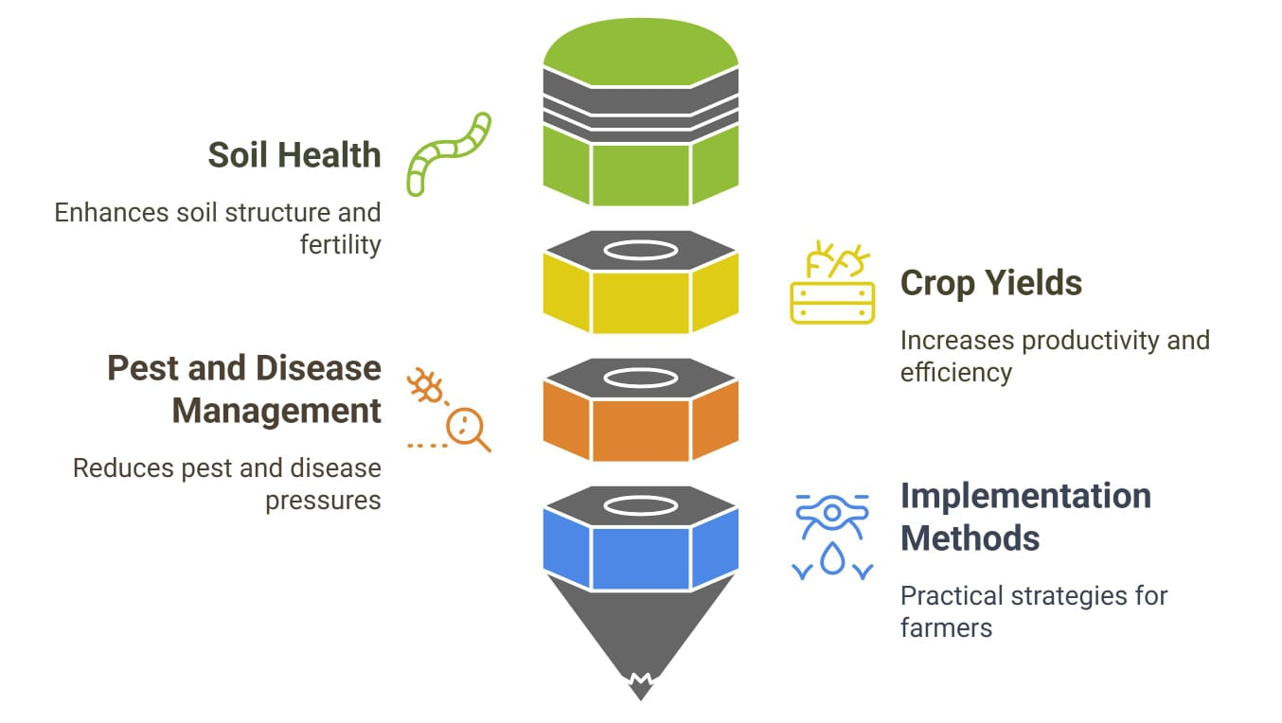

**Figure 3** Optimizing Agriculture with Diversification and Rotation

* 1. Agroforestry

Agroforestry is an essential element of CSA, the practice utilizes benefits from trees and also agricultural crops in order to obtain various ecological, economic, and social functions, such as soil improvement, reduction of erosion, provision of wildlife habitats, provision of water quality, and promotion of carbon sequestration (Sileshi *et al.,* 2023).  
The trees in such systems contribute to carbon sequestration and greenhouse gas emission mitigation, hence serving as efficient climate change mitigation tools. Agroforestry systems also have several advantages, such as enhanced water quality, soil erosion prevention, increased organic carbon and nutrient retention, and biodiversity conservation support (Agroforestry's critical role in Climate-Smart Farming, 2023). Successful agroforestry systems worldwide provide examples of the beneficial effects of agroforestry on agricultural sustainability and resilience. Indonesia, for instance, introduced a national agroforestry program to combat deforestation and promote sustainable use of land with ecological and economic gains for smallholder farmers. Smallholder farmers in Malawi who used agroforestry saw higher yields, higher diversity of crops, and higher income compared to their counterparts who didn't use agroforestry. Likewise, coffee producers in Costa Rica improved soil quality, minimized erosion, and increased biodiversity by integrating agroforestry into their coffee production (Quandt *et al.,* 2023). Agroforestry offers numerous advantages as a component of climate-smart agriculture. It contributes to carbon sequestration, enhances crop yields, promotes economic development, generates new employment opportunities, enhances water quality, reduces soil erosion, and promotes biodiversity conservation. Through the incorporation of trees into farming landscapes, agroforestry systems provide a sustainable and integrated farm practice that addresses the challenges posed by climate change while promoting environmental sustainability, economic profitability (Ntawuruhunga *et al*., 2023).

5.3 Strategies for management of water

Water governance strategies play a crucial function in Climate-Smart Agriculture, as climate change increasingly impacts water availability and quality, resulting in challenges for agricultural productivity, food security, and environmental sustainability. Below are several important water management strategies relevant to CSA: Climate-Smart Water Use and Management: This approach focuses on optimizing irrigation to grow crops profitably while minimizing water waste. It involves methods like deficit irrigation, which gives only sufficient water during sensitive drought stages of growth, matching water consumption with the potential yield according to different levels of soil fertility, and using responsive crop varieties and practices. Reduction of the water footprint, increasing the water productivity, and mitigation of the effects of climate extremes are the objectives. Water Saving and Collection: This method incorporates a range of conservation practices that ensure maximum capacity for saving in-situ water. Apart from offering guidelines regarding appropriate cropping system diversification for water-deficit regions, it entails investigation of the safe reuse of treated wastewater to boost production of feed, forage, and trees. It also aims at alternative sources of power to support off-grid water circulation (ICARDA., . <https://www.icarda.org/research/sustainable-land-soil-and-water-management/climate-smart-water-use-and-management> ). The primary goals of water-smart cropping are to increase the water-holding capacity of the soil, establish water-harvesting and storage facilities, and utilize climate-resilient cropping systems with water-saving technology. It is a holistic strategy that increases long-term sustainable food production. Water Management Options for Enhancing Adaptation and Building Resilience. Water Management and Climate Change Mitigation: This is the application of water management in agriculture towards the mitigation of greenhouse gas emissions. This includes minimizing irrigation water use, expanding water conservation, and improving the efficiency of water use (Frimpong *et al.,* 2023).

* 1. Practices for Livestock Management

One of the principal components of CSA aiming to reduce CO2 gas emissions, enhance productivity in agriculture, and support adaptation to climate change, is Climate-Smart Livestock Production (CSLP). CSLP aims to reduce environmental burden from livestock farming, increase resilience, and achieve better resource utilization (FAO., <https://www.fao.org/climate-smart-agriculture-sourcebook/production-resources/module-b2-livestock/chapter-b2-3/en>). CSLP entails several practices, approaches. Silvo pasture systems for managing and restoring grasslands are utilized, where pasture and trees are integrated in order to promote productivity, resilience, and diversity. Manure recycling and bio-digesting can result in emission savings as well as the generation of energy. Crop livestock integration is a term employed to describe a spot where crop and livestock production are integrated for the aim of enhanced resilience, productivity, and efficiency in the utilization of resources. By reducing livestock disease and mortality, enhancing animal productivity and household income, and providing sufficient nutrition, CSLP also promotes climate change adaptation. Nonetheless, the adoption of CSLP can be confronted with several challenges such as constrained access to technology, insufficiency of finance, and information unavailability. They are overcome through policy interventions collectively, extension, and financial tools, including initiatives for improving credit access by livestock producers and payment of environmental services (Shahbaz *et al.,* 2022).

1. THE CHALLENGE OF INNOVATION AND POLICY EFFECTS

These strategies involve methods such as climate-smart agriculture, water resource management using sustainable strategies, recycling and waste management practices, climate and flood protection strategies, and advanced machinery for the study of climate conditions in agricultural operations. FITs are also being seen more and more as a solution to these issues (Hotte & Jung, 2022). Food Innovation Technologies (FITs) mainly specialize in food and new food product development, manufacturing, and processing using innovative technologies to enhance the quality, safety, and security of food. FITs fall into two categories: climate change mitigation technologies and adaptation technologies. Mitigation technologies are geared toward minimizing and avoiding greenhouse gas (GHG) emissions and their drivers. Adaptation technologies, on the other hand, are intended to transform the processes, practices and structures of food systems to reduce the potential effects of climate change, as well as identify possibilities that can come with these changes (Balan *et al.,* 2020; Gouvea *et al.,* 2022). The tools enable farmers to analyze the well-being of plants and animals and enhance engagement between agricultural stakeholders, such as farmers and consumers. Applications of machine learning can, for example, forecast the demand for and supply of food in certain areas, while IoT-equipped sensors and drones can evaluate crop health rapidly using high-res images (Klerkx *et al.,* 2019). Agriculture 5.0: This concept encompasses AI and deep learning systems that help farmers recognize diseases, pests, and nutritional deficiencies on their farms. Sensors may collect field information, for instance, the occurrence of pests and suggest suitable herbicides using local knowledge and types of cr1ops. The solutions are affordable and accessible to farmers, especially smallholder farmers with a low income level (Ahmad & Nabi, 2021). Blockchain technology provides enhanced traceability of the food supply chain, making it possible for farmers to utilize data collected by smart agricultural systems in an efficient and secure manner (Rogerson & Parry, 2020). In Vertical Farming, plants are grown in vertical levels. Vertical Farming often employs controlled environment agriculture, have potential to decrease the negative impacts of climate change on agricultural output (Kalantari *et al.,* 2018).

|  |  |  |  |
| --- | --- | --- | --- |
| Technology | Description | Key Benefits | Reference |
| Climate-Smart Agriculture (CSA) | Sustainable farming approach to adapt to and mitigate climate change | Reduces GHG emissions, improves soil health, enhances resilience | Hotte & Jung, 2022 |
| Food Innovation Technologies (FITs) | Advanced food production, processing, and safety technologies | Improves food security, enhances quality and safety | Balan et al., 2020; Gouvea et al., 2022 |
| Mitigation Technologies | Technologies aimed at reducing GHG emissions | Lowers carbon footprint, promotes energy efficiency | Balan et al., 2020 |
| Adaptation Technologies | Modifies food systems to adapt to climate change | Enhances sustainability, increases resilience to climate change | Klerkx et al., 2019 |
| Agriculture 5.0 | AI and deep learning-based farming solutions | Detects diseases, pests, and nutrient deficiencies | Ahmad & Nabi, 2021 |
| IoT & Drones in Agriculture | Sensors and drones for monitoring soil, crops, and livestock | Improves crop health, reduces input waste | Klerkx et al., 2019 |
| Blockchain in Agriculture | Secure, transparent data management in food supply chains | Enhances traceability, reduces fraud | Rogerson & Parry, 2020 |
| Vertical Farming | Growing crops in vertically stacked layers with controlled environments | Saves space, reduces water use, minimizes climate change impact | Kalantari et al., 2018 |

**Table 4** Key Technologies and Strategies for Climate-Smart Agriculture and Food Innovation

1. DIFFICULTIES IN ADOPTING CLIMATE-SMART AGRICULTURE

It provides a viable option for building a climate-resilient agri-food system amidst mounting climate change effects. A number of critical challenges, however, stand in the way of its uptake, such as policy and regulatory, social and cultural, high front-end costs, and low knowledge and awareness. Policy and regulatory challenges can stand in the way of farmers' ability to undertake climate-smart approaches. There could be limitations on the application of specific technologies or practices, and the absence of support from government agencies in terms of funding or technical support can make things even more difficult. Social and cultural aspects also pose serious challenges; farmers might not want to use new technologies or techniques that go against traditional practices or that they are not used to. In addition, they can also face resistance from their communities as they try to adopt climate-smart agriculture strategies that are perceived as new or threatening traditional ways of living (Silva *et al.,* 2024). The adoption of some climate-smart approaches tends to demand considerable initial monetary outlays. These expenses can include spending on new technology, required infrastructure upgrades, or worker training programs. For most farmers, the cost of these requirements is prohibitive, and this keeps them from becoming widely adopted. However, financing climate-smart agriculture can ultimately make farmers maximize their crop yields in the long term (IFAD, <https://www.ifad.org/en/web/latest/-/story/opportunities-challenges-and-limitations-of-climate-smart-agriculture-the-case-of-egypt>). Limited information and awareness is a significant disincentive towards the uptake of climate smart agriculture. In order to encourage farmer uptake on a large scale, it is therefore important to be able to clearly communicate information concerning climate-smart practices and install capacity-building mechanisms. Nonetheless, a key challenge persists, particularly for resource-poor farmers in developing nations, who might not be able to switch to these practices even if they are eager to embrace them (IFAD, <https://www.ifad.org/en/web/latest/-/story/opportunities-challenges-and-limitations-of-climate-smart-agriculture-the-case-of-egypt>). To properly address the challenges to embracing climate-smart agriculture (CSA), a holistic approach must be undertaken. While government assistance is vital, it must be complemented with the creation of a robust and resilient agricultural value chain. This combined approach supports long-term sustainability in the agricultural industry. Market-oriented initiatives that serve agricultural businesses of all sizes can ensure that financial support is available regardless of the size or type of entity that requires it. Moreover, the evidence base for CSA needs to be expanded since it can address technical skill gaps and human resource gaps while yielding useful information for designing effective training programs that enable informed decision-making. Offering economic incentives to farmers adopting CSA practices—e.g., grants, tax credits, or access to low-interest loans—is also important. Introducing a premium price strategy for climate-smart agricultural commodities, coupled with corporate participation, can establish a carbon inset market mechanism. This market-driven mechanism rewards farmers for embracing CSA practices, thereby mitigating greenhouse gas emissions and offsetting initial financial outlays and potential economic losses from sustainable agriculture. Also, establishing market platforms that bring consumers and retailers into contact with CSA producers and policy frameworks conducive to such implementation can facilitate the effective implementation of CSA (ORF 2019.,<https://www.orfonline.org/expert-speak/towards-climate-smart-agriculture-csa-strategies-obstacles-and-visions-for-a-sustainable-fut>

CONCLUSION

The impacts of climate change on agriculture necessitate urgent and strategic interventions to safeguard global food security. Climate-Smart Agriculture (CSA) represents a comprehensive and sustainable approach to addressing these challenges by integrating climate adaptation, mitigation, and productivity enhancement strategies. The implementation of CSA practices, such as sustainable intensification, agroforestry, efficient water management, and advanced technological solutions, can bolster agricultural resilience and ensure long-term food availability. However, the widespread adoption of CSA faces obstacles, including financial constraints, lack of awareness, and policy limitations. Addressing these barriers through supportive policies, education, and financial incentives is crucial for scaling up CSA initiatives globally. The future of agriculture depends on a transition towards climate-smart practices that not only enhance productivity but also contribute to environmental sustainability and socio-economic stability. A collaborative effort among policymakers, researchers, farmers, and international organizations is essential to achieve a resilient agricultural system capable of feeding a growing global population amidst climate uncertainties.

**References**

1. Laderach, P., Ramirez-Villegas, J., Navarro-Racines, C., *et al*. (2017). Climate change adaptation of coffee production in space and time. *Climatic Change, 141*(1), 47–62. <https://doi.org/10.1007/s10584-016-1788-9>
2. Arora, N. K. (2019). Impact of climate change on agriculture production and its sustainable solutions. *Environmental Sustainability, 2*(2), 95–96. <https://doi.org/10.1007/s42398-019-00078-w>
3. Zizinga, A., Mwanjalolo, J.-G. M., Tietjen, B., *et al*. (2022). Climate change and maize productivity in Uganda: Simulating the impacts and alleviation with climate-smart agriculture practices. *Agricultural Systems, 199*, 103407. <https://doi.org/10.1016/j.agsy.2022.103407>
4. Miron, I. J., Linares, C., & Díaz, J. (2023). The influence of climate change on food production and food safety. *Environmental Research, 216*, 114674. <https://doi.org/10.1016/j.envres.2022.114674>
5. United Nations. (2021). Economic and social council: Population, food security, nutrition and sustainable development. *Oxford Handbook of the United Nations*, 1-20. <https://www.un.org/development/desa/pd/sites/www.un.org.development.desa.pd/files/undesa_pd_2021_e_cn.9_2021_2_advanceunedited.pdf>
6. Amoroso, L. (2018). Post-2015 Agenda and Sustainable Development Goals: Where are we now? Global opportunities to address malnutrition in all its forms, including hidden hunger. In *Hidden Hunger: Strategies to Improve Nutrition Quality* (pp. 45-56).
7. Kebeda, B. T., Abdisa, T. O., & Berkessa, A. J. (2015). Review on the expected role of climate-smart agriculture on food systems in Ethiopia.
8. Taylor, M. (2018). Climate-smart agriculture: What is it good for? *Journal of Peasant Studies, 45*(1), 89–107. <https://doi.org/10.1080/03066150.2017.1363652>
9. Godde, C. M., Mason-D’Croz, D., Mayberry, D. E., Thornton, P. K., & Herrero, M. (2021). Impacts of climate change on the livestock food supply chain: A review of the evidence. *Global Food Security, 28*, 100488. <https://doi.org/10.1016/j.gfs.2021.100488>
10. Food and Agriculture Organization of the United Nations. *Climate-smart agriculture*. Retrieved from (2021). <https://www.fao.org/climate-smart-agriculture/en/>
11. Atadoga, A., Awonuga, K. F., Ibeh, C. V., Ike, C. U., Olu-lawal, K. A., & Usman, F. O. (2024). Harnessing data analytics for sustainable business growth in the US renewable energy sector. *Engineering Science & Technology Journal, 5*(2), 460-470.
12. Kumar, V., Ranjan, D., & Verma, K. (2021). Global climate change: The loop between cause and impact. In *Global Climate Change* (pp. 187-211). Elsevier.
13. Zhang, W., Furtado, K., Wu, P., Zhou, T., Chadwick, R., Marzin, C., Rostron, J., & Sexton, D. (2021). Increasing precipitation variability on daily-to-multiyear time scales in a warmer world. *Science Advances, 7*(31), eabf8021.
14. Bibi, F., & Rahman, A. (2023). An overview of climate change impacts on agriculture and their mitigation strategies. *Agriculture*. <https://doi.org/10.3390/agriculture13081508>
15. Godde, C. M., Mason-D’Croz, D., Mayberry, D. E., Thornton, P. K., & Herrero, M. (2021). Impacts of climate change on the livestock food supply chain: A review of the evidence. *Global Food Security, 28*, 100488. <https://doi.org/10.1016/j.gfs.2021.100488>
16. U.S. Department of Agriculture (USDA). Climate change, global food security, and the U.S. food system. Retrieved from <https://www.usda.gov/oce/energy-and-environment/food-security>
17. U.S. Department of Agriculture (USDA) Climate Hubs. Agricultural adaptation in a changing climate. Retrieved from <https://www.climatehubs.usda.gov/agricultural-adaptation-changing-climate>
18. Grigorieva, E. A., Livenets, A., & Stelmakh, E. (2023). Adaptation of agriculture to climate change: A scoping review. *Climate, 11*(10), 202. <https://doi.org/10.3390/cli11100202>
19. Verhagen, A., Schaap, B., Pulleman, M., Hengsdijk, H., & Achterbosch, T. (2014). Climate-smart agriculture as a guiding principle for agricultural transformation. *Research@WUR*. <https://research.wur.nl/en/publications/climate-smart-agriculture-as-a-guiding-principle-for-agricultural>
20. Donovan, M. (2022, June 2). What is sustainable intensification? CIMMYT. Retrieved from <https://www.cimmyt.org/news/what-is-sustainable-intensification>
21. Okoronkwo, D. J., Ozioko, R. I., Ugwoke, R. U., Nwagbo, U. V., Nwobodo, C. E., Ugwu, C. H., Okoro, G. G., & Mbah, E. C. (2024). Climate smart agriculture? Adaptation strategies of traditional agriculture to climate change in sub-Saharan Africa. *Frontiers in Climate, 6*. <https://doi.org/10.3389/fclim.2024.1272320>
22. Bank, A. D. (2023, October 27). Climate-Smart Agriculture: adoption, impacts, and implications for sustainable development. Asian Development Bank. Retrieved from <https://www.adb.org/news/events/climate-smart-agriculture-adoption-impacts-and-implications-for-sustainable-development>
23. Grigorieva, E. A., Livenets, A., & Stelmakh, E. (2023). Adaptation of agriculture to climate change: A scoping review. *Climate, 11*(10), 202. <https://doi.org/10.3390/cli11100202>
24. Zaman, M., Kleineidam, K., Bakken, L. R., Berendt, J., Bracken, C., Butterbach‐Bahl, K., Cai, Z., Chang, S. X., Clough, T. J., Dawar, K., Ding, W., Dorsch, P., Martins, M. D. R., Eckhardt, C., Fiedler, S., Frosch, T., Goopy, J. P., Gorres, C., Gupta, A., Müller, C. (2021). Climate-Smart Agriculture Practices for mitigating greenhouse gas emissions. In *Springer eBooks* (pp. 303–328). <https://doi.org/10.1007/978-3-030-55396-8_8>
25. United States Department of Agriculture. (2021, October 25). Climate-Smart Agriculture and Forestry Resources. Farmers.gov. Retrieved from <https://www.farmers.gov/conservation/climate-smart>
26. Christ, G. Climate smart agriculture and conservation practices. Retrieved from <https://extension.psu.edu/climate-smart-agriculture-and-conservation-practices>
27. Strengthening the resilience of Climate-Smart agricultural systems and value chains in the Union of Comoros | Climate Change Adaptation. Retrieved from <https://www.adaptation-undp.org/projects/strengthening-resilience-climate-smart-agricultural-systems-and-value-chains-union-comoros>
28. Dougill, A. J., Hermans, T., Eze, S., Antwi‐Agyei, P., & Sallu, S. M. (2021). Evaluating Climate-Smart Agriculture as a route to building climate resilience in African food systems. *Sustainability, 13*(17), 9909. <https://doi.org/10.3390/su13179909>
29. Samuel, J., Rao, C. A. R., Pushpanjali, Beevi, C. A., Raju, B., Reddy, A. A. A., Kumar, R., Reddy, A. G. K., Singh, V., Prabhakar, M., Siva, G. S., & Teggelli, R. (2024). Enhancing farm income resilience through climate smart agriculture in drought-prone regions of India. *Frontiers in Water, 6*. <https://doi.org/10.3389/frwa.2024.1327651>
30. Ali, H., Menza, M., Hagos, F., & Haileslassie, A. (2023). Impact of climate-smart agriculture adoption on food security and multidimensional poverty of rural farm households in the Central Rift Valley of Ethiopia. *Agriculture & Food Security, 11*(1). <https://doi.org/10.1186/s40066-022-00401-5>
31. Traore, B., Zemadim, B., Sangare, S., Gumma, M. K., Tabo, R., & Whitbread, A. (2021). Contribution of Climate-Smart Agriculture Technologies to food Self-Sufficiency of smallholder households in Mali. *Sustainability, 13*(14), 7757. <https://doi.org/10.3390/su13147757>
32. Hemathilake, D., & Gunathilake, D. M. C. C. (2022). Agricultural productivity and food supply to meet increased demands. In *Elsevier eBooks* (pp. 539–553). <https://doi.org/10.1016/b978-0-323-91001-9.00016-5>
33. Agricultural productivity and Innovation. OECD. Retrieved from <https://www.oecd.org/agriculture/topics/agricultural-productivity-and-innovation>
34. Ritchie, H., Rosado, P., & Roser, M. (2023). Agricultural production. *Our World in Data*. Retrieved from <https://ourworldindata.org/agricultural-production>
35. Strengthening the resilience of Climate-Smart agricultural systems and value chains in the Union of Comoros | Climate Change Adaptation. Retrieved from <https://www.adaptation-undp.org/projects/strengthening-resilience-climate-smart-agricultural-systems-and-value-chains-union-comoros>
36. Resilience and adaptation to climate change. Retrieved from <https://www.iaea.org/topics/resilience-and-adaptation-to-climate-change>
37. Climate-smart agriculture. Lutheran World Relief. Retrieved from <https://lwr.org/climate-smart-agriculture>
38. Beattie, S., & Sallu, S. M. (2021). How does nutrition feature in Climate-Smart Agricultural Policy in Southern Africa? A Systematic Policy review. *Sustainability, 13*(5), 2785. <https://doi.org/10.3390/su13052785>
39. Rodale Institute. (2020, December 15). Crop Rotations - Rodale Institute. Retrieved from <https://rodaleinstitute.org/why-organic/organic-farming-practices/crop-rotations>
40. Sileshi, G. W., Dagar, J. C., Nath, A. J., & Kuntashula, E. (2023). Agroforestry as a Climate-Smart Agriculture: Strategic Interventions, current practices and policies. In *Sustainability Sciences in Asia and Africa* (pp. 589–640). <https://doi.org/10.1007/978-981-19-4602-8_18>
41. Quandt, A., Neufeldt, H., & Gorman, K. (2023). Climate change adaptation through agroforestry: opportunities and gaps. *Current Opinion in Environmental Sustainability, 60*, 101244. <https://doi.org/10.1016/j.cosust.2022.101244>
42. Ntawuruhunga, D., Ngowi, E. E., Mangi, H. O., Salanga, R. J., & Shikuku, K. M. (2023). Climate-smart agroforestry systems and practices: A systematic review of what works, what doesn’t work, and why. *Forest Policy and Economics, 150*, 102937. <https://doi.org/10.1016/j.forpol.2023.102937>
43. Climate-Smart Water Use and Management | ICARDA. ICARDA. <https://www.icarda.org/research/sustainable-land-soil-and-water-management/climate-smart-water-use-and-management>
44. Frimpong, F., Asante, M. D., Peprah, C. O., Amankwaa-Yeboah, P., Danquah, E. O., Ribeiro, P. F., Aidoo, A. K., Agyeman, K., Asante, M. O. O., Keteku, A., & Botey, H. M. (2023). Water-smart farming: review of strategies, technologies, and practices for sustainable agricultural water management in a changing climate in West Africa. *Frontiers in Sustainable Food Systems, 7*. <https://doi.org/10.3389/fsufs.2023.1110179>
45. Climate-smart livestock production systems in practice | Climate Smart Agriculture Sourcebook | Food and Agriculture Organization of the United Nations. <https://www.fao.org/climate-smart-agriculture-sourcebook/production-resources/module-b2-livestock/chapter-b2-3/en>
46. Shahbaz, P., Abbas, A., Aziz, B., Alotaibi, B. A., & Traore, A. (2022). Nexus between Climate-Smart Livestock Production Practices and Farmers’ Nutritional Security in Pakistan: Exploring Level, Linkages, and Determinants. *International Journal of Environmental Research and Public Health, 19*(9), 5340. <https://doi.org/10.3390/ijerph19095340>
47. Silva, M. F. E., Van Schoubroeck, S., Cools, J., & Van Passel, S. (2024). A systematic review identifying the drivers and barriers to the adoption of climate-smart agriculture by smallholder farmers in Africa. *Frontiers in Environmental Economics, 3*. <https://doi.org/10.3389/frevc.2024.1356335>
48. Opportunities, challenges and limitations of climate-smart agriculture - The case of Egypt. IFAD.<https://www.ifad.org/en/web/latest/-/story/opportunities-challenges-and-limitations-of-climate-smart-agriculture-the-case-of-egypt>
49. Towards Climate-Smart Agriculture (CSA): Strategies, obstacles, and visions for a sustainable future. ORF Online. <https://www.orfonline.org/expert-speak/towards-climate-smart-agriculture-csa-strategies-obstacles-and-visions-for-a-sustainable-fut>
50. Hotte, K., & Jung, S. (2022). Knowledge for a warmer world: A patent analysis of climate change adaptation technologies. *Technological Forecasting and Social Change, 183*, 121879.
51. Balan, I. M., Popescu, A. C., Iancu, T., Popescu, G., & Tulcan C. (2020). Food Safety Versus Food Security in a World of Famine. *Journal of Advanced Research in Social Sciences and Humanities, 5*, 20–30.
52. Gouvea, R., Kapelianis, D., Li, S., & Terra, B. (2022). Innovation, ICT & food security. *Global Food Security, 35*, 100653.
53. Klerkx, L., Jakku, E., & Labarthe, P. (2019). A review of social science on digital agriculture, smart farming and agriculture 4.0: New contributions and a future research agenda. *NJAS - Wageningen Journal of Life Sciences, 90*, 100315.
54. Ahmad, L., & Nabi, F. (2021). *Agriculture 5.0: Artificial Intelligence, IoT and Machine Learning*. Taylor & Francis Group: Abingdon, UK; CRC Press: Boca Raton, FL, USA.
55. Rogerson, M., & Parry, G. C. (2020). Blockchain: Case studies in food supply chain visibility. *Supply Chain Management, 25*, 601–614.
56. Kalantari, F., D'Amico, S., & Mazzocchi, C. (2018). The impact of vertical farming on climate change mitigation. *Journal of Cleaner Production*, 198, 1234-1245. <https://doi.org/10.1016/j.jclepro.2018.06.123>