**A statistical and analytical approach for discriminating formulation variability in Nepafenac ophthalmic suspension via In-vitro dissolution.**

**Abstract**

Dissolution plays an important role as an in-vitro release test for any pharmaceutical product life cycle. Discriminatory dissolution profiles are highly desirable for differentiation between products having differences in their pharmaceutical attributes (formulation and/or manufacturing processes differences) that may reflect corresponding differences in vivo. Substantial changes in CPPs and CMAs for any drug product would not be detected if a dissolution method will not be discriminatory and batches will pass the test which are not bioequivalent. This study demonstrates discriminatory power of dissolution method for Nepafenac ophthalmic suspension, a BCS Class 4 drug. Excipient which were identified critical for the product characteristics, were altered and eight different formulations were developed for evaluation. Due to change of excipients quantities characteristics of formulations changes like, particle size of drug substances, osmolality, pH, and viscosity. Dissolution profiles were obtained utilizing a GF/D membrane filter, STF pH 7.4 as the dissolution medium, Apparatus IV (open loop), and 0.5g of sample with a medium flow rate of 10 mL/minute. A developed high-performance liquid chromatographic method was used to assess the drug release. The dissolution profiles of all eight samples were compared using the similarity factor (f2) and statistical analysis i.e. Paired T-Test and One-way Annova with the help of Minitab software. A clear change in dissolution profiles was observed to distinguish change in excipient concentration in the formulation which was further statistically proved that all the formulations are not similar. Hence it can be concluded that developed method has significant discrimination capability. Since no monograph is available for the Nepafenac ophthalmic suspension formulation, the suggested dissolution technique can be used for quality control and comparing the dissolution profiles of various R&D and commercial formulations.

**Keywords:**

In vitro release test, BCS class 4 drug, Nepafenac, Ophthalmic suspension, USP apparatus IV, dissolution, discrimination, simulated tear fluid, in-vitro in-vivo correlation (IVIVC), bioavailability, critical material attributes and critical product attributes, statistical analysis, Paired T-test, One-way Annova.

**INTRODUCTION:**

Dissolution also known as in vitro release test for a drug plays an important role for the evaluation of drug product quality (1) This testing is a procedure to measure that how quickly a drug dissolves in dissolution medium (2) It is a very important tool to evaluate the rate of release from a dosage form, to predict in-vitro in-vivo correlation (IVIVC) (3)

A "discriminatory dissolution method" in drug development refers to a dissolution test specifically developed to distinctly distinguish between formulations or variations in processes that may affect drug release and bioavailability. This signifies that the technique must be sensitive enough to identify significant alterations in the drug product, guaranteeing that the dissolution profile truly represents possible variations in in vivo performance (4–6)

In the advanced phases of clinical development, proving the discriminatory ability of a dissolution method is very much essential for guaranteeing the quality control of pharmaceutical drug products before their release. It's a key part of pharmaceutical development (7,8)

To show discrimination of a dissolution method, a frequently used approach involves three steps. First step is to carrying out a risk assessment to determine the factors that could have a considerable affect over dissolution profiles by assessing various conditions for each factor. Second step is to prepare deviated formulations with particular parameter adjustments according to the understanding of the drug product. The dissolution data profiles should show discrimination or a meaningful change when there is a change in critical material attributes (CMAs) and critical product properties (CPPs)(9). Third and last step is to perform dissolution testing for the deviated formulations and executing dissimilarity analysis(10–12).

Dissolution discrimination testing is commonly employed in quality control and research and development. Regulatory authorities globally anticipate evidence of the method's ability to differentiate drug product with change in the drug product quality (13–15)

Nepafenac is a nonsteroidal anti-inflammatory drugs (NSAIDs) class of drug. It is a class 4 drug that means drug is poorly soluble and poorly permeable. It is a prodrug, chemically known as 2-amino-3- benzoylbenzeneacetamide. Nepafenac is yellow crystalline powder in nature. It is having molar mass- 254.28g/mol (16,17)

Doctors recommend ophthalmic suspension of nepafenac for patients after cataract surgery to relieve the symptoms such as swelling, redness, and eye pain. This procedure intended to address lens cloudiness in the eye (18) Next to administration, nepafenac infiltrates to the cornea and is swiftly converted to amfenac by hydrolases. Nepafenac and amfenac both function by effectively blocking COX-1 and COX-2 enzymes (19)

There were no compendial methods are available for the dissolution (invitro release test) of nepafenac ophthalmic suspension (20). There is a dissolution method reported for the determination of nepafenac in ophthalmic formulation however this method does not discuss about discriminatory power of reported method to distinguish the change in formulation (21).

The objective of this study was to evaluate the discriminatory capability of the developed dissolution method using USP type IV apparatus for nepafenac ophthalmic suspension formulation. For this purpose, first a simple, straight forward HPLC method was developed and followed by discriminatory dissolution tests prformed for quantitative analysis of nepafenac in Nepafenac ophthalmic formulation. The dissolution profiles of altered nepafenac ophthalmic formulations were compared with control formulation using the similarity factor (f2) and dissolution efficiency of the discriminatory dissolution method(22). Also, dissolution profiles of altered formulation were evaluated for statistical analysis with the help of Minitab software. For statistical evaluation of data two hypothesis were used i.e. Paired T-Test and One-way Annova.

**MATERIALS AND METHODS:**

## Chemicals and reagents:

The Nepafenac API was received from Deccan Nutraceuticals Pvt. Ltd. Methanol, acetonitrile, distilled water, and all other solvents employed were of HPLC grade quality, and the reagents were of analytical purity.

## Instrumentation and chromatographic conditions:

### Dissolution testing (In-vitro release test):

Sotax CE7 USP apparatus IV (Sotax corporation, USA) open loop system was used for dissolution. Dissolution method was developed and finalized with 0.5g sample, 22.6 mm sample cell, simulated tear fluid pH 7.4, flow rate 10.0 mL/min. GF/D was used as a filter membrane in between the glass beads. Samples aliquots were collected at different time intervals in 1, 2, 3, 4, 5, 6, 7, 8, 9 and 10 minutes. These sample aliquots were injected into HPLC system (23).

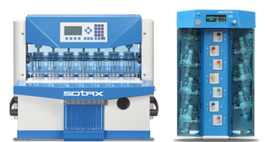

*Figure 1: USP apparatus IV dissolution*

### High performance liquid chromatography (HPLC)

Determination of Nepafenac was performed by using an HPLC system (Alliance HPLC System - Waters Corporation, USA) equipped with a degasser, a quaternary solvent pump, an autosampler, a thermostatic column compartment and a UV-VIS/PDA detector. Empower 3.0 software was used to process and quantify the samples (23).

**ASSESSMENT OF DISCRIMINATORY CAPABILITY OF THE DEVELOPED DISSOLUTION METHOD**

**1. Risk assessment**

Discriminatory power of a dissolution method is an important aspect to ensure the quality control of any drug product. To test the method performance to discriminate different formulations, a comprehensive assessment of risk for dissolution method was done. In this assessment various factors were evaluated like manufacturing process, API physiochemical properties, excipients and dissolution method parameters. Further assessed and found that factor from API properties which mostly affect the dissolution profile for an ophthalmic formulation is particle size of API. Also, excipients quantity has direct impact on dissolution profile. Due to the change in excipient quantities drug formulation properties were also observed changed.

As an ophthalmic formulation, manufacturing process and dissolution method parameters were kept constant for this study. For identification of discriminatory power one change in factor was made at a time with the formulation to identify the clear root cause for the deviation of dissolution profile.

**2. Formulation Preparation**

Seven different formulation of Nepafenac ophthalmic suspension were prepared using the altered quantities of excipients, Carbopol, Tyloxapol, Sodium chloride, Mannitol, Edetate disodium, Benzalkonium chloride. Control formulation was labeled as formulation-A and other altered lab formulations were prepared as follows.

Formulation A-Control formulation

Formulation B-Un-milled API used in formulation (High particle size)

Formulation C-High concentration of NaCl

Formulation D- Low concentration of NaCl

Formulation E-High quantity of Carbopol (150%)

Formulation F-Low quantity of Tyloxapol (50%)

Formulation G- Low pH formulation

Formulation H- High pH formulation

**Characterization of prepared formulations.**

**a. Particle Size Analysis**

Particle Size Analysis for Nepafenac was performed to determine the determine particle size distribution for the formulations (Formulation A (Control) and formulation B). Particle size distribution was performed by laser diffraction technique using Malvern Mastersizer® 3000 - Hydro MS module. Refer figure 2 and table 1 for the data of formulation A and figure 3 and table 2 for the data of formulation B.

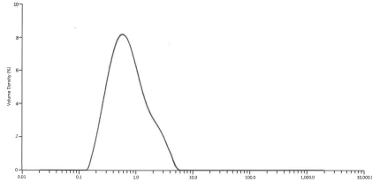

*Figure 2: Milled API particle size histogram in Control formulation (A)*

Table 1: Particle size data of milled API

|  |  |  |  |
| --- | --- | --- | --- |
| **Measurement** | **D10 (µm)** | **D50 (µm)** | **D90 (µm)** |
| **1** | 0.287 | 0.675 | 2.09 |
| **2** | 0.287 | 0.673 | 2.10 |
| **3** | 0.287 | 0.673 | 2.09 |
| **Mean** | **0.287** | **0.674** | **2.09** |
| **Std dev** | **0.000151** | **0.00144** | **0.00436** |
| **RSD (%)** | **0.0527** | **0.214** | **0.208** |

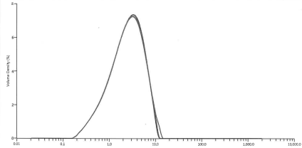

*Figure 3: Un-milled API particle size histogram in formulation (B)*

|  |  |  |  |
| --- | --- | --- | --- |
| **Measurement** | **D10 (µm)** | **D50 (µm)** | **D90 (µm)** |
| **1** | 0.701 | 2.53 | 6.22 |
| **2** | 0.701 | 2.53 | 6.31 |
| **3** | 0.703 | 2.55 | 6.51 |
| **Mean** | **0.702** | **2.54** | **6.35** |
| **Std dev** | **0.00147** | **0.0122** | **0.14** |
| **RSD (%)** | **0.209** | **0.482** | **2.33** |

Table 2: Particle size data of un-milled API

**b. Osmolality Analysis**

Osmolality analysis for Nepafenac was performed to determine osmolality of formulations (Formulation A, Formulation C and Formulation D) using Gonotec® OSMOMAT 3000. Results of osmolality for the formulations are mentioned below in the table 3.

Table 3: Osmolality data for the formulations

|  |  |  |  |
| --- | --- | --- | --- |
| **Formulations** | **Formulation-A**  **(Control)** | **Formulation-E**  **(High NaCl)** | **Formulation-F**  **(Low NaCl)** |
| **Osmolality (mOsm/kg)** | 294 | 320 | 275 |

**c. pH analysis**

pH analysis was performed to determine the pH of formulations (Formulation A, Formulation G and Formulation H) by using Thermo Orion Star pH meter. Results of pH for the formulations are mentioned below in the table 4.

Table 4: pH analysis data for the formulations

|  |  |  |  |
| --- | --- | --- | --- |
| **Formulations** | **Formulation-A**  **(Control)** | **Formulation-G**  **(Low pH)** | **Formulation-H**  **(High pH)** |
| **pH** | 7.29 | 6.82 | 7.85 |

**d. Viscosity analysis**

A Brookfield viscometer (Model LVDV2T Cone/Plate) operating at 25°C was used to determine the viscosity of the different formulations. It was connected to a water bath maintained at 25°C. Spindle used for the analysis was CPA-52Z at 30 rpm.

Table 5: Viscosity data for the formulations

|  |  |  |
| --- | --- | --- |
| **Formulations** | **Formulation-A**  **(Control)** | **Formulation-E**  **(High Carbomer)** |
| **Viscosity (cps)** | 152.2 | 289.5 |

**3. Sample Analysis**

These altered formulation dissolution samples were analyzed by using Waters alliance HPLC system equipped with a degasser, a thermostatic column compartment, a quaternary solvent pump, an autosampler, and UV detector (Waters Corporation, USA). Separation was achieved at 40°C column oven temperature using Inertsil ODS 3 (150x4.6) mm, 5µm as a column. A mixture of Buffer (10 mM phosphate buffer pH 3.5) and methanol in the ratio of 40:60 % v/v was used for Mobile phase. Flow rate used to 1.0 mL/min, 25 µL injection volume and 240 nm wavelength for UV detection. Nepafenac peak areas were integrated using a software program Empower 3.0 (Waters Corporation, USA).

**RESULTS AND DISCUSSION**

Most of the global regulatory agencies ask discriminatory dissolution methods for the quality control of the pharmaceutical products (24). If both profiles are the same, then f2=100When the average difference across all time points is 10%, the f2 value will be 50. A f2 value between 50 and 100 has been established by the FDA as a standard to show that two dissolution profiles are similar(25). f2 value calculated on the basis of below mentioned formula.

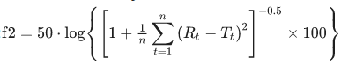

where the reference and test products' respective dissolution values at time t are denoted by Rt and Tt, and n is the number of time points.

Results are given in table-6 and Figure 4. As anticipated, the dissolution rate of the formulation (B) with un-milled API (higher particle size i.e. about 6µm) was slower compared to control formulation (A) and f2 observed of 45 which is lower than the acceptance limit of 50.

Osmolality, or the concentration of solute particles in a solution, significantly impacts ophthalmic formulations. Ideally, ophthalmic solutions should be isotonic to prevent irritation and discomfort. Hyperosmolality (high osmolality) can cause cell shrinkage and increased viscosity, while hypoosmolality can lead to cell swelling, potentially causing pain and discomfort (26). To check discrimination between the formulation due to change in osmolality, formulation C (high osmolality) and formulation D (Low osmolality) were tested. On comparison with control formulation (A), it was observed that formulation C with higher NaCl content has f2 of 49 which is below the acceptance criteria of 50 however formulation D with lower NaCl content has passing f2 of 53.

Increased Carbopol concentration in the formulation E, decreases dissolution profile drastically when compared with the control formulation (A). Observed f2 value for this formulation was 24. This was attributed by the increase in gelling nature of Carbopol (27).

Tyloxapol as a surfactant has been widely used for many years as a wetting agent or stabilizer, in suspension products in Pharmaceutical industries(28). For Formulation F with decreased concentration of Tyloxapol, decreased in the dissolution profile observed. Observed f2 value for this formulation was 46. It was quite anticipated as decrease in tyloxapol concentration decreases the stability of suspended nepafenac particles in the ophthalmic suspension formulation and dissolution method was able to discriminate it.

On the other hand, the change in manufacturing process did not affect the dissolution rate significantly, though dissolution method was above to detect the change in pH of the formulations. To evaluate it two more formulation G (low pH) and formulation H (High pH) were tested against control formulation (A). f2 value were observed pass for both the formulation i.e. 68 and 50 respectively for formulation G and formulation H. however slight decrease in release profile was observed for formulation H. The slower profile might be observed due to pH dependent characteristic of carbomer.

Table 6: Result comparison table for f2 value

|  |  |  |  |  |  |  |  |  |
| --- | --- | --- | --- | --- | --- | --- | --- | --- |
| **Formulation** | **A** | **B** | **C** | **D** | **E** | **F** | **G** | **H** |
| **Time**  **(min)** | **Control** | **Un-milled** | **High osmolality** | **Low osmolality** | **High Carbopol** | **Low**  **Tyloxapol** | **Low pH** | **High pH** |
| 1 | 15.7 | 10.3 | 10.2 | 12.1 | 4.4 | 13.2 | 12.2 | 13.2 |
| 2 | 32.5 | 21.5 | 21.5 | 25.6 | 8.5 | 22.1 | 26.4 | 25.4 |
| 3 | 47 | 31 | 32.5 | 36.3 | 12.2 | 30.9 | 39.7 | 35.5 |
| 4 | 57.6 | 40.1 | 42.3 | 45.2 | 16.4 | 39.7 | 50.7 | 43.2 |
| 5 | 65.2 | 47.7 | 51.1 | 52.5 | 19.2 | 48.3 | 60.2 | 50.5 |
| 6 | 70.6 | 54.2 | 57.7 | 58.5 | 22.0 | 55.6 | 68.1 | 56.4 |
| 7 | 74.5 | 59.2 | 62.8 | 62.7 | 24.4 | 61.2 | 74.4 | 61.4 |
| 8 | 77.2 | 63.8 | 67.1 | 66.4 | 27.2 | 65.3 | 78.5 | 65.6 |
| 9 | 79.1 | 66.8 | 70.5 | 70.2 | 29.2 | 68.1 | 81.7 | 69.3 |
| 10 | 80.3 | 68.1 | 72.0 | 73.5 | 30.8 | 69.6 | 84.1 | 72.1 |
| **f2 Value** | | **45** | **49** | **53** | **24** | **46** | **68** | **50** |
| **Results** | | Fail | Fail | Pass | Fail | Fail | Pass | Pass |

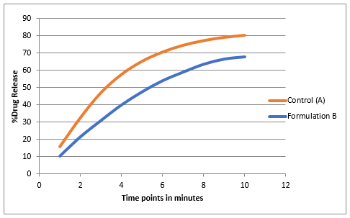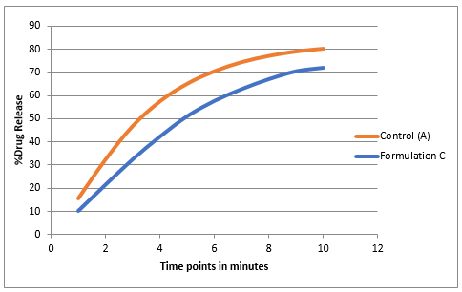

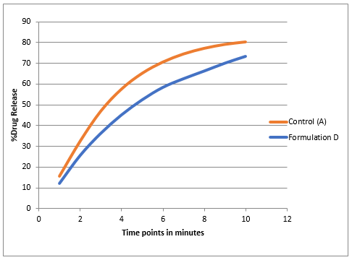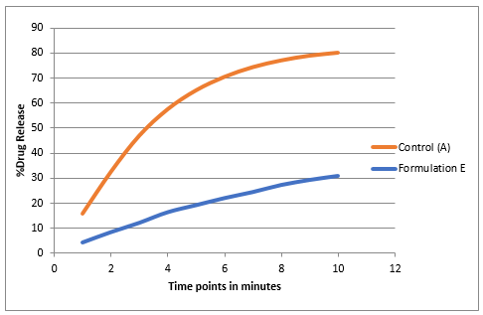

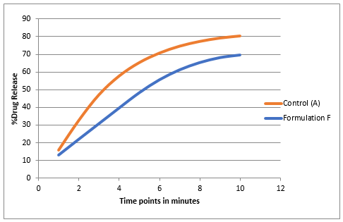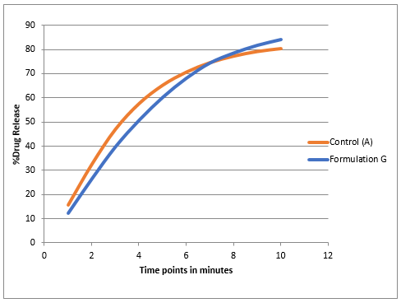

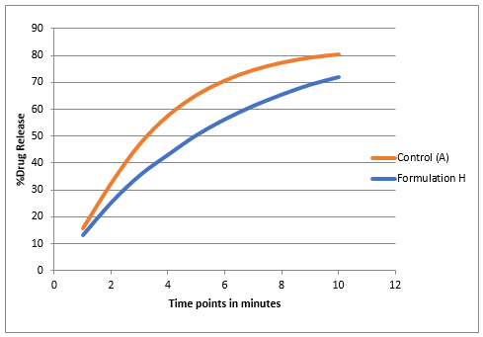

***Figure 4: Comparative Dissolution profile graphs (Formulations B-H)***

Statistical analysis of dissolution profiles:

The below-mentioned results are subjected to inferential statistics i.e. Hypothesis testing. Paired T test and One-way Annova is applied to the above data set to determine the difference in the mean of % release of Nepafenac among these different formulations (Formulations A-H).

**Hypothesis testing**

**Null hypothesis (H0):** There is no statistical difference in the mean % release of Control sample Relative to the mean % release of another sample at 95% confidence interval.

**Alternative Hypothesis (Ha):** There is a statistical difference in the mean % release of Control sample Relative to the mean % release of another sample at 95% confidence interval.

**Results inference:** If the P value is higher than the 0.05, then accept the null hypothesis, If P value is lower than 0.05 then failed to accept the null hypothesis.

1. **Paired T -Test results:**

In Paired T- Test, each formulation B to H (each condition) is compared against the Control sample- Formulation-A (individual condition).

Table 7: Six Unit %release data at 10 minutes

|  |  |  |  |  |  |  |  |  |
| --- | --- | --- | --- | --- | --- | --- | --- | --- |
| **Formulation** | **A** | **B** | **C** | **D** | **E** | **F** | **G** | **H** |
| **Units** | **Control** | **Un-milled** | **High osmolality** | **Low osmolality** | **High Carbopol** | **Low**  **Tyloxapol** | **Low pH** | **High pH** |
| 1 | 80.6 | 64.8 | 77.1 | 71.2 | 32.1 | 65.2 | 83.3 | 72.5 |
| 2 | 79.8 | 70.5 | 72.6 | 73.6 | 27.2 | 70.2 | 81.7 | 75.8 |
| 3 | 78.3 | 61.9 | 69.9 | 71.9 | 25.5 | 63.4 | 82.3 | 70.9 |
| 4 | 79.5 | 63.7 | 70.7 | 75.0 | 36.7 | 73.9 | 87.5 | 71.6 |
| 5 | 83.1 | 72.2 | 65.9 | 73.1 | 29.6 | 75.1 | 84.1 | 68.4 |
| 6 | 80.7 | 75.6 | 75.8 | 76.2 | 33.8 | 69.8 | 85.7 | 73.5 |
| AVG | **80.3** | **68.1** | **72.0** | **73.5** | **30.8** | **69.6** | **84.1** | **72.1** |
| SD | 1.61 | 5.43 | 4.10 | 1.87 | 4.19 | 4.62 | 2.18 | 2.50 |
| %RSD | 2.01 | 7.97 | 5.70 | 2.55 | 13.61 | 6.64 | 2.59 | 3.46 |
| P-Value  (Paired T-Test) | | 0.001 | 0.004 | 0.000 | 0.000 | 0.001 | 0.993 | 0.001 |
| Inference compared to control formulation | | Not similar | Not similar | Not similar | Not similar | Not similar | Similar | Not similar |

1. **One-way Annova results:**

In the one-way Annova hypothesis, mean of % release of all the different samples (Formulations A to H) are compared all together in a single test.

**Method**

|  |  |
| --- | --- |
| Null hypothesis | All means are equal |
| Alternative hypothesis | Not all means are equal |
| Significance level | α = 0.05 |

*Equal variances were assumed for the analysis.*

**Factor Information**

|  |  |  |
| --- | --- | --- |
| **Factor** | **Levels** | **Values** |
| Factor | 8 | Control, Un-milled, High osmolality, Low osmolality, High Carbopol, Low Tyloxapol, Low pH, High pH |

**Analysis of Variance**

|  |  |  |  |  |  |
| --- | --- | --- | --- | --- | --- |
| **Source** | **DF** | **Adj SS** | **Adj MS** | **F-Value** | **P-Value** |
| Factor | 7 | 11125.6 | 1589.38 | 124.16 | 0.000 |
| Error | 40 | 512.0 | 12.80 |  |  |
| Total | 47 | 11637.7 |  |  |  |

**Model Summary**

|  |  |  |  |
| --- | --- | --- | --- |
| **S** | **R-sq** | **R-sq(adj)** | **R-sq(pred)** |
| 3.57784 | 95.60% | 94.83% | 93.66% |

**Means**

|  |  |  |  |  |
| --- | --- | --- | --- | --- |
| **Factor** | **N** | **Mean** | **StDev** | **95% CI** |
| Control | 6 | 80.333 | 1.611 | (77.381, 83.285) |
| Un-milled | 6 | 68.12 | 5.43 | (65.16, 71.07) |
| High osmolality | 6 | 72.00 | 4.10 | (69.05, 74.95) |
| Low osmolality | 6 | 73.500 | 1.874 | (70.548, 76.452) |
| High Carbopol | 6 | 30.82 | 4.19 | (27.86, 33.77) |
| Low Tyloxapol | 6 | 69.60 | 4.62 | (66.65, 72.55) |
| Low pH | 6 | 84.100 | 2.180 | (81.148, 87.052) |
| High pH | 6 | 72.12 | 2.50 | (69.16, 75.07) |

*Pooled StDev = 3.57784*

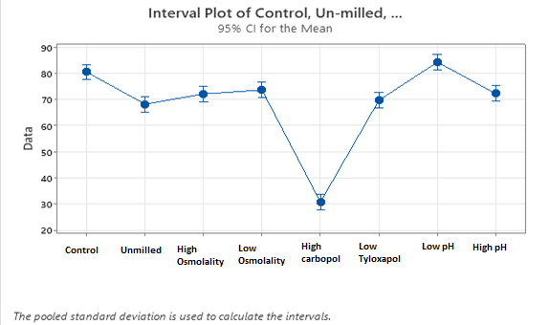

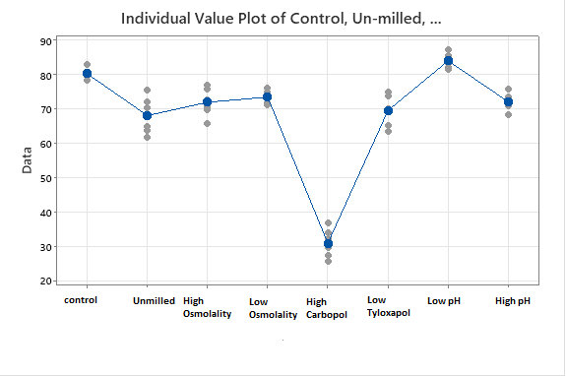

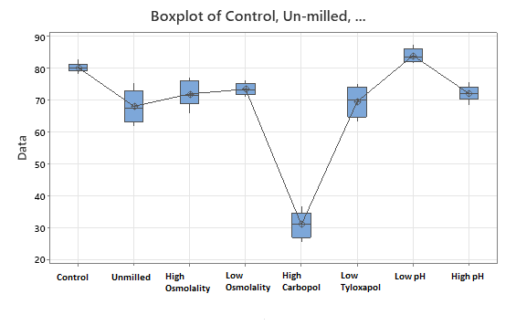

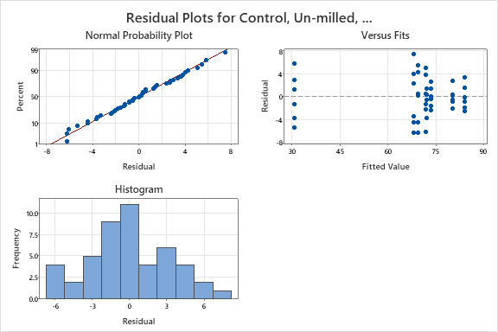

**CONCLUSION**

From above obtained results of f2 calculation, graphs and statistical analysis among all the formulations in the section of results and discussion, it is evident that the developed method is significantly sensitive to the changes in the formulation. Although f2 value found pass for three formulation that are low osmolality, low pH and high pH conditions of the formulation but all the formulation found dissimilar statistically compared to control formulation except low pH formulation. P value for dissimilar formulation were found below 0.05. P-value for low pH formulation was found greater that 0.05 (i.e. P= 0.993). One possible explanation is that the pH change was insufficient to drastically alter the formulation. However, the slight increase in dissolution rate and profile was observed compared to control formulation. Hence it can be concluded that developed method suitably demonstrates the discriminatory nature of the dissolution method. No monograph is available for this pharmaceutical formulation, hence the dissolution method proposed can be considered suitable for quality control and dissolution profile comparison of different R&D and commercial formulations.

**References:**

1. Shen J, Burgess DJ. In Vitro Dissolution Testing Strategies for Nanoparticulate Drug Delivery Systems: Recent Developments and Challenges. Drug Deliv Transl Res. 2013 Oct 1;3(5):409–15.

2. Grady H, Elder D, Webster GK, Mao Y, Lin Y, Flanagan T, et al. Industry’s view on using quality control, biorelevant, and clinically relevant dissolution tests for pharmaceutical development, registration, and commercialization. J Pharm Sci. 2018 Jan 1;107(1):34–41.

3. Shen J, Burgess DJ. In Vitro-In Vivo Correlation for Complex Non-Oral Drug Products: Where Do We Stand? J Control Release [Internet]. 2015 Dec 10 [cited 2025 Mar 14];219:644. Available from: https://pmc.ncbi.nlm.nih.gov/articles/PMC4739855/

4. Ashokraj Y, Daroi A, Gupta R, Khanolkar A, Kulkarni A, Laud S, et al. Discriminatory dissolution method development and validation of etoricoxib tablets. Dissolution Technol. 2016 May 1;23(2):30–4.

5. Gray VA. Power of the dissolution test in distinguishing a change in dosage form critical quality attributes. AAPS PharmSciTech. 2018 Nov 1;19(8):3328–32.

6. Bhatt S, Roy D, Kumar M, Saharan R, Malik A, Saini V. Development and Validation of In Vitro Discriminatory Dissolution Testing Method for Fast Dispersible Tablets of BCS Class II Drug. Turk J Pharm Sci [Internet]. 2020 [cited 2025 Mar 14];17(1):74. Available from: https://pmc.ncbi.nlm.nih.gov/articles/PMC7227868/

7. Chen H, Wang R, McElderry JD. Discriminative Dissolution Method Development Through an aQbD Approach. AAPS PharmSciTech [Internet]. 2023 Dec 1 [cited 2025 Mar 14];24(8):1–11. Available from: https://link.springer.com/article/10.1208/s12249-023-02692-8

8. Dickinson PA, Lee WW, Stott PW, Townsend AI, Smart JP, Ghahramani P, et al. Clinical relevance of dissolution testing in quality by design. AAPS J. 2008 Jun;10(2):380–90.

9. Kuril AK, Saravanan K. Method Development and Validation for the determination of Higher Molecular Weight species of Calcitonin Salmon in Calcitonin Salmon injection by High Performance Size Exclusion Chromatography. International Journal of Pharmaceutical Sciences and Drug Research. 2024 Mar 30;260–6.

10. da Silva AS, da Rosa Silva CE, Paula FR, da Silva FEB. Discriminative dissolution method for benzoyl metronidazole oral suspension. AAPS PharmSciTech. 2016 Jun 1;17(3):778–86.

11. Machado JC, Lange AD, Todeschini V, Volpato NM. Development and validation of a discriminative dissolution method for atorvastatin calcium tablets using in vivo data by lc and uv methods. AAPS PharmSciTech. 2014 Feb;15(1):189–97.

12. Amer AM, Allam AN, Abdallah OY. Evaluation of the discriminatory power of usp dissolution method for candesartan cilexetil tablets through testing of marketed products in Egypt. Dissolution Technol. 2018 Nov 1;25(4):40–6.

13. Suarez-Sharp S, Abend A, Hoffelder T, Leblond D, Delvadia P, Kovacs E, et al. In vitro dissolution profiles similarity assessment in support of drug product quality: what, how, when-workshop summary report. AAPS J. 2020 Jul 1;22(4):74.

14. Limberg J, Potthast H. Regulatory status on the role of in vitro dissolution testing in quality control and biopharmaceutics in Europe. Biopharm Drug Dispos. 2013 Jul;34(5):247–53.

15. Kuril AK, Manchuri KM, Anand SP. Emerging Protein and Peptide Therapeutics for Osteoporosis: Advances in Anabolic and Catabolic Treatments. J Pharm Res Int. 2024 Oct 17;36(11):85–102.

16. https://go.drugbank.com/drugs/DB06802.

17. Kuril AK. Exploring the versatility of mass spectrometry: Applications across diverse scientific disciplines. European Journal of Mass Spectrometry. 2024 Dec 24;30(5–6):209–20.

18. Yüksel B, Karti Ö, Kusbeci T. Topical nepafenac for prevention of post-cataract surgery macular edema in diabetic patients: patient selection and perspectives. Clin Ophthalmol. 2017;11:2183–90.

19. New drug: Nepafenac for cataract surgery. Aust Prescr. 2017 Dec 4;40(6):246–7.

20. https://www.accessdata.fda.gov/scripts/cder/dissolution/index.cfm.

21. Gupta PK, Pancholi SS, Das P. In Vitro Drug Release Testing Method For Nepafenac Ophthalmic Suspension. J Pharm Sci. 2024 Apr 1;113(4):1061–7.

22. Abend AM, Hoffelder T, Cohen MJ, Van Alstine L, Diaz DA, Fredro-Kumbaradzi E, et al. Dissolution Profile Similarity Assessment—Best Practices, Decision Trees and Global Harmonization. AAPS Journal. 2023 May 1;25(3).

23. Singh V, Saravanan K. Development and validation of in vitro release test for a BCS class 4 drug nepafenac ophthalmic suspension using USP apparatus IV. International Journal of Research in Pharmaceutical Sciences. 2025 Mar 11;16(1):103–10.

24. Anand O, Yu LX, Conner DP, Davit BM. Dissolution Testing for Generic Drugs: An FDA Perspective. AAPS J. 2011 Sep 9;13(3):328.

25. Shah VP, Tsong Y, Sathe P, Williams RL. Dissolution Profile Comparison Using Similarity Factor, f2. Dissolut Technol. 1999;6(3):15–15.

26. Arbelaez-Camargo D, Roig-Carreras M, García-Montoya E, Pérez-Lozano P, Miñarro-Carmona M, Ticó-Grau JR, et al. Osmolality predictive models of different polymers as tools in parenteral and ophthalmic formulation development. Int J Pharm. 2018 May;543(1–2):190–200.

27. Safitri FI, Nawangsari D, Febrina D. Overview: Application of Carbopol 940 in Gel. In: Proceedings of the International Conference on Health and Medical Sciences (AHMS 2020). Paris, France: Atlantis Press; 2021.

28. Siekmann B, Westesen K. P234 solid lipid nanoparticles stabilized by tyloxapol. European Journal of Pharmaceutical Sciences [Internet]. 1994 Sep 1 [cited 2025 Jun 22];2(1–2):177. Available from: https://www.sciencedirect.com/science/article/abs/pii/0928098794904073