Case report

**Intracranial hemorrhage with ventricular exhaustion: A case report**

**ABSTRACT:**

Intracranial hemorrhage is one of the most devastating illnesses with the greatest mortality rates. As there are no clinically proven therapies, the treatment is generally supportive. Due to the poor prognosis, many families limit or withdraw care from the hospital, which poses a significant health risk to the patient. In this case report, we presented a case of a 72-year-old man suffering from intracranial hemorrhage with ventricular exhaustion. Following his examination and diagnosis, he was advised to have craniotomy surgery.

**KEYWORDS:**

Intracranial hemorrhage, Blood pressure, Craniotomy, Stroke, Intracranial pressure.

**INTRODUCTION:**

Intracranial hemorrhage is defined as any bleeding within the intracranial space, including the brain parenchyma and surrounding meningeal spaces. Generally, ICH is a life-threatening disease if prompt treatment has not been given, with an incidence of 24.6 per 100,000 people (1). ICH has four broad types, such as epidural hemorrhage, subdural hemorrhage, subarachnoid hemorrhage, and intraparenchymal hemorrhage, which may occur due to any blunt trauma in the head, skull fracture, cerebral aneurysm, hypertension, tumor, vasculitis, etc (2). In recent decades, the incidence and mortality of ICH have increased in Asia, Europe, America, and other regions. Generally, the ICH has different risk factors, such as alcoholism, smoking, previous medical problems, antithrombotic medication, and the involvement of different sites of bleeding, which may have a different impact on the general prognosis of the patient (3). Generally, there are no proven medical treatments for ICH present; therefore, the patients are frequently referred to surgery. But the roles of different surgical methods and the timings remain controversial (4). In this study, we report a case of a 72-year-old man who presented with weakness of the right side of the body, which was sudden onset and gradually progressing.

**CASE REPORT:**

A 72-year-old male was admitted to the neurosurgery department on February 2025 with the complaint of right-side hemiparesis, which was gradually increasing. On initial examination, the patient complained of mild generalized pain, which was present with weakness and an inability to sit for long durations. However, the patient had a long history of smoking for 25 years, had hypertension, and was suspected of having COPD. There were no signs of tingling or numbness of the limbs. CVS: S1 S2 positive, P/A: soft and nontender, HMF: intact, CN: intact, and GCS: E4 V4 M6. Furthermore, the patient did not have a history of falls or previous episodes of vomiting or any other comorbidities. Relevant investigations were done on the arrival of the patient. Hematology results show HB%: 12.4 g/dl, RBC count: 4.50 million/cumm, total WBC count: 10170 cells/cumm, neutrophils: 92%, lymphocytes: 05%, monocytes: 03%, eosinophils: 0%, and basophils: 0%. 2D echo shows rhythm abnormalities, mild MR, and mild concave LVH. However, there was adequate LV systolic function, which was 50%. Furthermore, a CT brain reveals hyperdensity of hemorrhagic attenuation with surrounding edema measuring 2.79x2.99x2.71 cm (APxTRxCC) in the left thalamus, corona radiata causing a mass. effect in form compression and displacement of left lateral ventricle, third ventricle, midline shift of 5.6 mm to the right, and there is an extension of bleeding into left lateral ventricle. Furthermore, there was a suspicious rounded hyperdense lesion in the anterior interhemispheric fissure along the course of the ACA with a suspected thrombosed aneurysm.

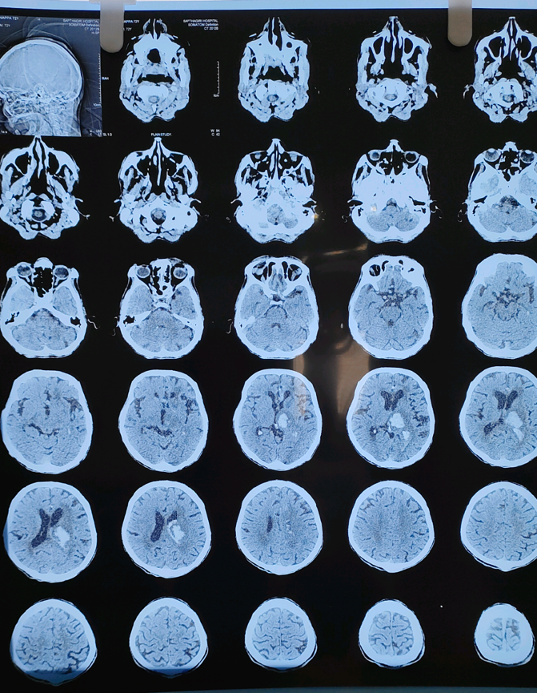 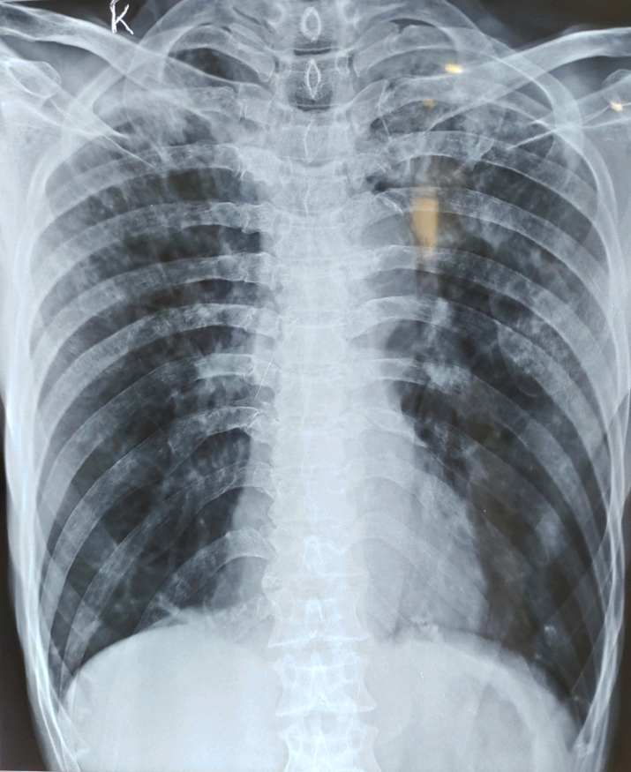

Figure 1: Intraparenchymal bleed in left Figure 2: Right lower lobe consolidation.

thalamus with mass effect

**THERAPEUTIC INTERVENTION:**

After the confirmation of intracranial hemorrhage, the patient was advised for decompression surgery, and all the pre-operative procedures were done. Furthermore, the patient was prescribed inj Xone 1g IV x BD, Inj pan 40 mg IV X OD, Inj emeset 4 mg IV X BD, Inj labetalol 20 mg IV SOS, Inj mannitol 100 ml infusion X TDS, Tab telma 40 mg x BD, Inj hydrocort 100 mg IV stat. Also, it was advised to perform intubation SOS in case of any drop in GCS score or respiratory arrest.

**DISCUSSION:**

Intracranial hemorrhage is a medical emergency and should be managed accordingly according to AHA/ASA guidelines. Initial management should focus on airway patency, breathing and circulation, neuroimaging proof, use of standardized assessment scales such as the National Institute of Health Stroke Scale (NIHSS) and Glasgow Coma Scale (GCS), blood pressure management, coagulopathy reversal, and surgical intervention along with frequent neurological examinations with the signs of intracranial pressure (ICP) (5). Surgery, such as craniotomy, is a more common treatment approach for spontaneous intracranial bleeding. Although the role of open surgery has remained controversial for decades, as open craniotomy is not without risks and complications. Therefore, the application of alternative approaches has been tested, such as minimally invasive techniques (6). Recently, a pilot randomized controlled trial showed that ICES (Intraoperative Computed Tomography–guided Endoscopic Surgery for Brain Hemorrhage) has shown promising safety and effectiveness. of CT-guided endoscopic drainage of ICH (7). In our case, the patient was a chronic smoker with a history of smoking for more than 25 years; therefore, there was a strong link between hypertension and cerebral hemorrhage, which is commonly known as hypertensive cerebral hemorrhage. The incidence has increased recently among the younger population with higher mortality rates (8). Nurses play a very crucial role in managing the patients in the intensive care unit, where they will be constantly checking patients’ conscious level, maintaining vital signs, cardiac activity, any alteration of hydroelectric imbalance, seizures, hygiene, mobilization, etc. In this case, the patient was advised for surgical corrections, but suddenly he started having seizures. However, after the conservative treatment, the patient's vitals and all the other parameters were stable, and there was no sign of any infection.

**CONCLUSION:**

Intracranial hemorrhage is an important cause of global burden, accounting for 10 to 15% of strokes in high-income countries and 20 to 50% in developing countries. The clinicians need to diagnose ICH properly with the proper diagnostic criteria. Furthermore, it is also important to provide information on the most probable outcome of the patient, which may align with what is medically feasible and what the patient or family members want so it can improve clinical care.

**REFERENCE:**

1. Caceres, J. A., & Goldstein, J. N. (2012). Intracranial hemorrhage. Emergency medicine clinics of North America, 30(3), 771–794. <https://doi.org/10.1016/j.emc.2012.06.003>

2. enny S, Thorell W. Intracranial Hemorrhage. [Updated 2024 Feb 17]. In: StatPearls [Internet]. Treasure Island (FL): StatPearls Publishing; 2025 Jan-. Available from: <https://www.ncbi.nlm.nih.gov/books/NBK470242/>

3. Wang, S., Zou, X., Wu, L., Zhou, H., Xiao, L., Yao, T., Zhang, Y., Ma, J., Zeng, Y., & Zhang, L. (2022). Epidemiology of intracerebral hemorrhage: A systematic review and meta-analysis. *Frontiers in Neurology*, *13*. https://doi.org/10.3389/fneur.2022.915813

**4.** McGurgan, I. J., Ziai, W. C., Werring, D. J., Salman, R. A., & Parry-Jones, A. R. (2020). Acute intracerebral haemorrhage: diagnosis and management. *Practical Neurology*, *21*(2), 128–136. https://doi.org/10.1136/practneurol-2020-002763

**5.** De Oliveira Manoel, A. L., Goffi, A., Zampieri, F. G., Turkel-Parrella, D., Duggal, A., Marotta, T. R., Macdonald, R. L., & Abrahamson, S. (2016). The critical care management of spontaneous intracranial hemorrhage: a contemporary review. *Critical Care*, *20*(1). <https://doi.org/10.1186/s13054-016-1432-0>

**6.** De Oliveira Manoel, A. L. (2020). Surgery for spontaneous intracerebral hemorrhage. *Critical Care*, *24*(1). <https://doi.org/10.1186/s13054-020-2749-2>

**7.** Vespa, P., Hanley, D., Betz, J., Hoffer, A., Engh, J., Carter, R., Nakaji, P., Ogilvy, C., Jallo, J., Selman, W., Bistran-Hall, A., Lane, K., McBee, N., Saver, J., Thompson, R. E., & Martin, N. (2016). ICES (Intraoperative Stereotactic Computed Tomography-Guided endoscopic surgery) for brain hemorrhage. *Stroke*, *47*(11), 2749–2755. <https://doi.org/10.1161/strokeaha.116.013837>

**8.** Wang, W., Zhou, N., & Wang, C. (2017). Minimally Invasive Surgery for Patients with Hypertensive Intracerebral Hemorrhage with Large Hematoma Volume: A Retrospective Study. *World Neurosurgery*, *105*, 348–358. https://doi.org/10.1016/j.wneu.2017.05.158