***Original Research Article***

The geographical analysis of malaria Pf prevalence longitudinal trend and hotspot hyper- endemic region in association with environmental determinants

### ABSTRACT

Malaria remains a significant public health burden in the state of Tripura, North-Eastern India, where environmental condition has been perpetuated its endemic situation over the several decades. The longitudinal trends of malaria Pf prevalence was analyzed in association with environmental determinants in the hotspot hyper-endemic regions. Tripura’s environmental landscape featuring dense forests, extensive paddy cultivation, high soil moisture, and abundant surface water bodies along with a humid tropical climate, creates optimal conditions for malaria transmission throughout the year. The integrated remote sensing and GIS, was applied to analyze the environmental factors including the Normalized Difference Vegetation Index (NDVI), Normalized Difference Water Index (NDWI), and Normalized Difference Moisture Index (NDMI) associated with long-term precipitation. A significant correlation was observed between malaria incidence and climatic variables, particularly precipitation and the Normalized Difference Vegetation Index (NDVI), which indicates the density and health of vegetation closely linked to mosquito habitats. The Normalized Difference Water Index (NDWI) was employed to detect surface water bodies, serving as breeding sites for malaria vectors. The Normalized Difference Moisture Index (NDMI) was used to assess surface soil moisture, reflecting areas where water surfaces favor vector breeding. High soil moisture content, persistent humidity, and wet topographic features were found to favorable conditions for mosquito breeding and thereby sustaining active malaria transmission throughout the year. Land Use and Land Cover (LULC) categories are spatially associated with malaria Pf prevalence. Targeted interventions based on environmental risk profiling could significantly enhance malaria control in Tripura.

**Keywords**: Malaria Pf prevalence, hotspot endemic region, environmental determinants, longitudinal trends, NDVI, NDWI, NDMI, land use and land cover, remote sensing and GIS

**Introduction**

One of India's most enduring public health issues is malaria, which disproportionately affects underprivileged groups in rural and especially, in tribal areas [1-5]. In tropical and subtropical areas of the world, malaria parasites continue to pose a major hazard to public health despite the use of numerous control strategies to limit their transmission to humans. India is known for malaria endemic; however, the registered malaria Pf cases have been declining, since 2000 [6]. The 2021 malaria report states that India has been responsible for almost 4.2 million cases and 7341 fatalities. Eleven states in the eastern (Odisha, Jharkhand, and West Bengal), western (Maharashtra, Gujarat), central (Chhattisgarh, Madhya Pradesh), northern (Uttar Pradesh), and northeastern (Mizoram, Tripura, and Meghalaya) regions account for the majority of malaria cases (95%) in India [1-6]. Malaria, which is caused by *Plasmodium* parasites and spread by the bite of an infected female *Anopheles* genus mosquito [6-9], affects people's health directly as well as having broader socioeconomic repercussions. A sizable percentage of malaria infections in Southeast Asia, particularly, still occur in India[7], despite the country's notable progress in lowering the disease burden in recent decades [6]. Because mosquitoes thrive in states with deep woods, mountainous terrain, and little access to healthcare, malaria is more common in the state [1-6,10]. One of the high-risk areas among these is the state of Tripura [1-6, 10].

Tripura, a small state bordered by Bangladesh on three sides, has long struggled with malaria outbreaks, especially in its tribal and forested areas[ [1-7,10]. The state's geography and climate provide a conducing environment for malaria vector mosquito breeding, and many of its remote regions lack robust healthcare infrastructure. *Anopheles minimus* and *Anopheles dirus* are the main malaria vectors in Tripura [1-6,10]. They breed in humid, wooded areas with clean, slow-moving water. Depending on the weather, the state's malaria transmission is both erratic and seasonal, peaking between May and September [1-6]. Tripura tribal communities rely heavily on the Jhum cultivation for their livelihood, and numerous studies have identified Jhum as a significant malaria risk factor [10]. Tribal communities living in hilly, forested areas are particularly vulnerable due to limited awareness, poor sanitation, and inadequate access to prevention and treatment services. Malaria cases have historically increased as a result of seasonal epidemics, especially during and after the monsoon. In the state, some districts and subdivisions have consistently displayed hyper- endemic traits, with persistently high rates of transmission. Deploying efficient vector control strategies, allocating resources, and implementing health interventions all depend on locating and charting these hotspot areas.

Furthermore, it has been demonstrated that environmental factors including temperature, precipitation, and relative humidity collectively have a major impact on the dynamics of malaria transmission [7-9]. Variations in these factors may have an impact on human-vector interactions, parasite growth, and mosquito breeding cycles. These links can be clarified and possible epidemic periods can be predicted with the use of a longitudinal analysis of malaria trends in relation to climatic data [7]. This will help to improve early warning systems and direct prompt public health interventions. The current study is to map Tripura's malaria hotspot and hyper-endemic areas over a certain time period and examine the longitudinal patterns of malaria prevalence in relation to important environmental factors [3,9-11]. Dhalai and South Tripura districts have been routinely reported high incidence rates of malaria. The study is designed to give a thorough grasp of the spatial variability of malaria transmission throughout the state by employing spatial and temporal analysis using GIS-based methods and analysis of malaria and environmental determinants [12-16]. With location-based insights, (like malaria cases) to location (specific places on Earth), which makes it easier to see patterns. GIS allows for spatial modeling to predict how things spread, what factors contribute, or where risks are emerging. Under the GIS umbrella, satellite images, epidemiological data, environmental, elevation, and land use / land cover are analyzed that improves our capacity to monitor, forecast, and manage malaria, and its incorporation into malaria prevention initiatives is crucial for focused on public health initiatives [12-16].

**1.2. Background of the study**

Over the past few decades, India has achieved great strides in the fight against malaria due to government programs including the National Vector Borne Disease Control Programme (NVBDCP, 2022), insecticide-treated nets; indoor residual spraying and better case management. Nonetheless, a disproportionately high number of cases are reported in northeastern states like Tripura, where malaria continues to be a persistent public health concern. Due to its tropical and subtropical temperature, mountainous terrain and dense forest cover, the Northeastern part of India, including Tripura is known for malaria endemic. Due to its socio- economic difficulties, occupational exposure and limited access to healthcare, and migration and cross border transmission are especially vulnerable. *Plasmodium falciparum* (Pf) and *Plasmodium vivax* (Pv) are the main parasites that cause malaria in Tripura, with Plasmodium falciparum causing severe and potentially fatal cases. The present study intends to provide evidence based advice for public health authorities and policymakers by mapping malaria hotspots and examining the association to reduce the malaria burden in Tripura and environment based predictive model strengthen malaria surveillance systems march towards the long term malaria control and management.

**1.3. Study Area**

Tripura is the third smallest state in North-East India after Sikkim. Tripura is located Southwestern periphery of the region, and these state borders with surroundings through Bangladesh in the North, South, and West and in the East through Assam (Karimganj district) and Mizoram (Mamit district ) ;thus it is land locked. The study area extends between 22⁰ 56′ and 24⁰ 32′ N latitudes, and longitudes between 91⁰ 09′E and 92⁰ 20′ E. It has a geographical area of 10,491.69Square Kilometers. Tripura is administratively divided into eight districts and thirty sub divisions. Districts and Sub-divisions are delimited based on geomorphic features viz: hill ranges (Muras), hills (Tillas), rivers (Nadis or Gang), and streams (charras) (Meena and Das (Pan), 2012. Tripura state is situated at the western fringe of Purvanchal ranges (basically atypical ridge valleys, which consist of five hill ranges successively increasing height towards the east relief ranges from 15 meters to 939 meters (Mazumdar, 1984). Tectonically Tripura lies in five Seismic Zone. The Topography of Tripura is immature. Geographically, it represents late Tertiary fold mountain belt, commonly known as Indo-Burman ranges. The ten major Rain- fed Rivers originated from the hills of Tripura and flow towards Bangladesh. All the rivers have catchments areas of over 9400 hectors, and are namely; Juri, Longai, Deo, Manu, Dhalai, Khowai, Howrah, Gomati, Muhuri, and Fenni.

The Tropic of Cancer (23 ½oN) crosses over the state and it mainly touches Udaipur and partially Sonamura, Amarpur and Gandacherra subdivisions. The climate of Tripura is under the influence of South-West Monsoon for which there is an extreme climate condition gold and hot during the winter and summer respectively, and the climate of the state is tropical monsoon in nature and generally warm and humid. Tripura has a tropical savanna climate (Aw) as per the koppen classification of climate of India. The summer temperature in the state ranges from 17.8⁰ C to 35.6⁰ C, whereas in winters the temperature ranges from 5.2⁰ C to 26.9⁰ C. The average annual rainfall varies from 1900mm to 2800mm. Conducive temperatures for most parts of the year and a long and wet monsoon season makes the state suitable for transmission of malaria throughout the year. However, majority of the malaria cases reported during the monsoon season from May to September.

Fig.1 Study area–Tripura, Northeastern state of India

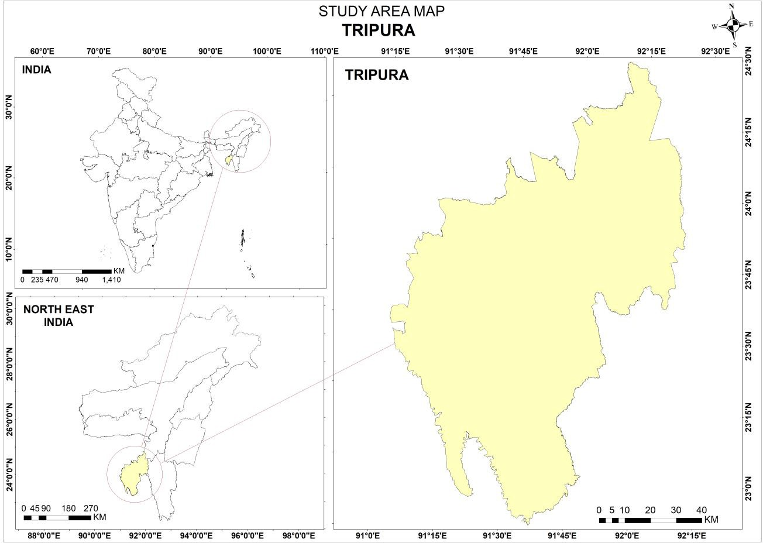

**1.4. Objectives**

1. To delineate the malaria hotspot hyper-endemic region in the Tripura state
2. To analyze the longitudinal trend of malaria Pf prevalence in Tripura for the period of 15 years (2010-2024)
3. To analyze the association between environmental determinants, vector proficiency and malaria transmission Pf cases in the state

### Climate seasons

Tripura is located in the northeastern region of India with a tropical climate, marked by distinct seasons. The environmental conditions play an important role in malaria transmission, due to their effect on mosquito‘s behavior and breeding patterns. The summer months (March-May) are marked by high temperatures and rather dry weather. Following the monsoon rains, the post monsoon season (October-November) is characterized by higher humidity and water stagnation but also comparatively lower temperatures than the hottest summer months. The high temperatures in Tripura during the summer months range from 28⁰C to 35⁰C.Despite being moderate, the humidity rises in the second half season, particularly when there are sporadic pre- monsoon showers.

1. **Materials and Methods**

Data on district-by-district malaria Pf cases is collected from the state government vector-borne illness control program of Tripura (2010-2024) in order to comprehend the malaria epidemiology. The epidemiological data include confirmed monthly incidences of *Plasmodium falciparum and Plasmodium vivax* malaria, malaria-related fatalities. Data collection for the analysis of longitudinal trend of malaria cases are analyzed to observe temporal variations, seasonal patterns, and potential outbreak periods. Microsoft Excel is used for organizing the data, performing descriptive statistical analysis, and generating graphs to identify trends and fluctuations over time.

To examine the geo-environmental determinants associated with malaria transmission, satellite imagery from Landsat missions is utilized. Landsat5 TM8 Operational Land Imager (OLI) images are acquired for different year‘s corresponding to the malaria data timeline. ArcGIS is utilized to integrate and analyze the satellite-derived environmental parameters with malaria prevalence data. The environmental variables are analyzed seasonally and annually to detect changes in land cover, water availability, and vegetation health, which could influence malaria transmission dynamics. Spatial analysis tools are used to identify correlations between environmental factors and malaria hotspots. The derived indices (NDVI, NDWI, NDMI, PCA and LU/LC) are overlapped with malaria Pf prevalence cases to examine the relationship between environmental variables and vector breeding habitat suitability. Maps showing the spatial distribution patterns of key environmental factors are generated to visualize high-risk areas for malaria vector breeding.

1. **Results and Discussions**

A time series analysis was carried out; it shows the malaria Pf cases during 2010-2024 which shows the general declining trend over a period. The result shows that a significant fluctuation, the highest peaks in recent years and the lowest cases are observed in the beginning of the study period. The use of a logarithmic y-axis indicates that the number of cases varies widely, and some years’ experience sharp drops or spikes in reported Pf cases. The linear trend shows that 7.6 % declining, and it has statistically high significance during the recent years a drop in malaria Pf cases recorded less than 100 cases and even recorded 1 case in the recent year.

Fig.2. The longitudinal trend of Malaria Pf prevalence (2010-2024)

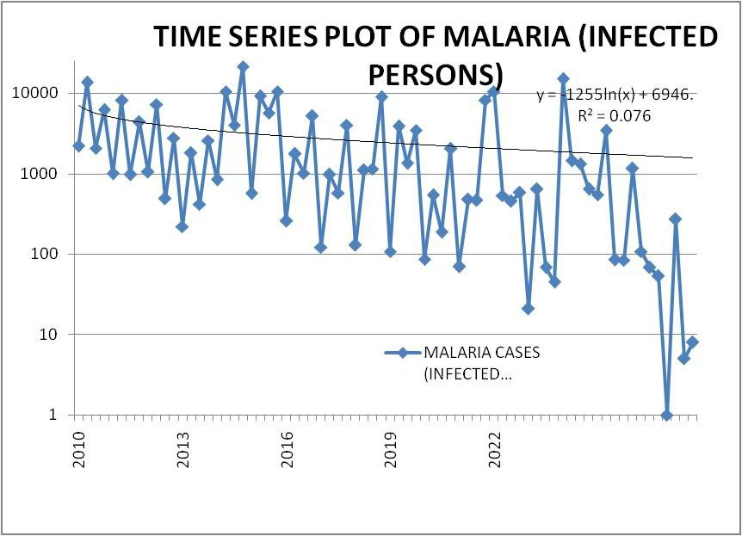

1. **Hotspot Map (2024)**

A spatial hotspots or patterns malaria Pf cases map is created using QGIS platform that graphically depicts in the data is known as an Analytical Mapping Product (AMP). It's a useful tool for researchers, urban planners, health officials, and decision-makers to rapidly analyze geographical trends. For example, a malaria hotspot AMP would show regions with higher concentrations of malaria cases or mosquito breeding grounds than other regions. Health authorities could be used AMPs to identify high-risk regions, strategically use indoor residual spraying and insecticide-treated nets, create campaigns for community health, and concentrate on managing larval sources in certain areas. Hotspot analysis, a geo-statistical method that finds and displays regions with noticeably greater or lower values for a specific occurrence, produces an analytical map product known as a hotspot AMP. Hotspot AMPs specifically aid in the detection and prediction of transmission of malaria Pf incidence, and allowing authorities to respond more efficiently to control outbreaks (Fig.3).

Fig.3 Malaria hotspot during 2024

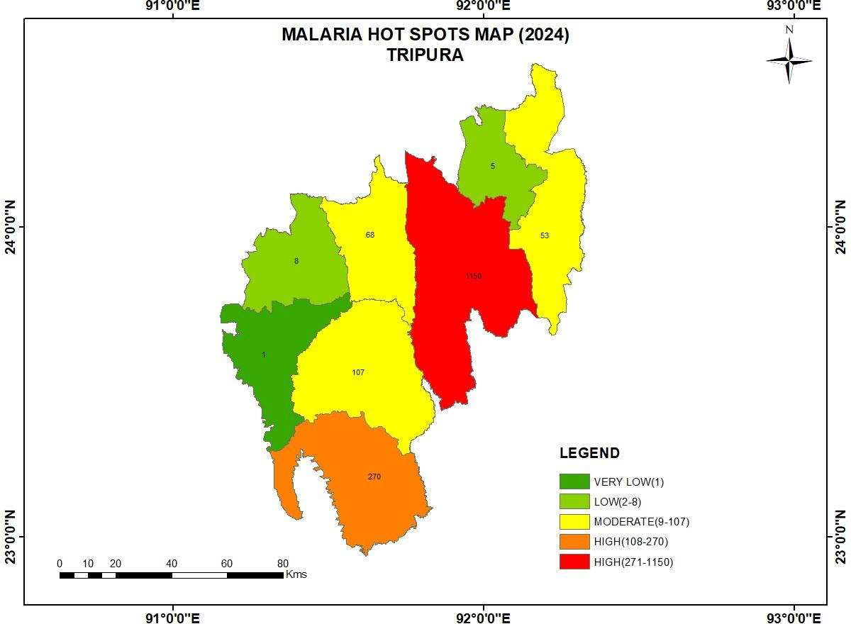

Central and southern parts of Tripura exhibit the highest malaria intensity, and has contiguous stretch depicted as high risk red zones, particularly, malaria Pf cases minimum of 1150, and maximum of 799 cases (presumably representing total case numbers per unit area), and highlight significant malaria hotspots. An orange zone in the southern part recorded 270 cases is also considerable malaria risk zone. A belt of yellow regions surrounds the high-risk core, especially towards the central and north-central parts, is a considerable number of Pf cases registered minimum 9, and maximum 107 cases, and it is lying in between high-risk and low-risk zones. The western and north-eastern borders of Tripura show very low to low malaria incidence, and it is depicted dark green patches (1 case) and light green patches (2–8 cases), and it indicates either effective control measures, lower vector habitats, or less suitable environmental conditions for malaria transmission.

1. **Environmental Variables and Malaria**

The temporal trends of declining vegetation moisture in Tripura, shown through NDMI, suggest that malaria prevalence shift over period of time. Initially, regions with abundant moisture likely had higher malaria risk, but as high moisture zones contract and dry zones expand, new malaria hotspots may emerge in areas with fragmented water bodies. NDVI trend shows that the areas with dense vegetation consistently associated with malaria hotspots. Dense vegetation offers ideal breeding conditions for Anopheles vector mosquitoes. NDMI and NDWI trends indicate that moisture levels in these regions remain conducive throughout much of the year, especially during pre-monsoon and monsoon periods. High NDWI values correlate with the presence of standing water bodies are favorable for mosquito larvae development, while NDMI reflects vegetation moisture content, indirectly suggesting habitat suitability for mosquitoes. Seasonal variability in NDVI, NDMI, and NDWI, and further, elucidates the temporal patterns of malaria incidence. Peak malaria cases often follow periods of increased moisture availability, confirming that water availability is a critical factor in vector population dynamics. The spatial synchronization between high NDVI-NDMI zones and malaria hotspots also supports the hypothesis that ecological niches shaped by forest and semi-urban fringe areas contribute significantly to disease transmission. The PCA provides the variance and underscore vegetation density, surface moisture, elevation, and land cover type as principal environmental determinants. PCA loadings also reaffirm that malaria hotspots are positively correlated with higher vegetation and moisture indices and negatively correlated with highly urban or barren areas, and it high significant correlation with increased surface water, agricultural variability, vegetation losses are favorable conditions for malaria vectors fecundity. Malaria prevalence strongly correlates with LULC changes in Tripura. High-risk districts like Dhalai, Gomati, and South Tripura are most affected due to loss of forests, cropland intensification, and seasonal surface water. Urban areas like West Tripura show lower risk, but urban sprawl have been take place without proper planning may still pose local threats. The LULC map analysis reveals that malaria hotspots predominantly fall within mixed forest, open forest, and agricultural mosaics with scattered human settlements. These transitional zones between forested areas and human habitations facilitate vector-human contact and maintain transmission cycles.

* 1. **Normalized Difference Vegetation Index (NDVI)**

The central and south-western region of Tripura has dense vegetation. These areas are likely covered by forests, plantations, and undisturbed natural vegetation. Dense green cover areas often associated with favorable conditions for mosquito breeding, and hence, higher malaria Pf incidence, which includes the central, south-central, and eastern Tripura. The land /land cover categories of the regions are classified as agricultural land, open scrubland, or mixed land use, lakes, rivers, wetlands, and other water sources, scattered across central-west, south-west, and north-east regions. The water bodies are important ecological features making potential ground for malaria vector mosquito fecundity. The high density of vegetation in central and southern Tripura contributes to ecological richness but also plays a role in the spatial distribution of malaria Pf cases. The presence of water bodies interspersed with dense forest cover creates an environment favorable for *Anopheles* genus malaria vector mosquito breeding, and has statistically significant correlation with high malaria incidence. The sparse vegetation areas, mostly agricultural and mixed land use, typically lower malaria incidence (Fig.4a and b).

* 1. **The Normalized Difference Water Index (NDWI)**

The darkest blue areas on the map represent wetlands. These are concentrated in specific pockets, more pronounced in the northern and southern parts of Tripura. These regions have a higher presence of surface water, indicating permanent or semi-permanent wetlands. The north of nearby Dhalai River basins and adjacent forested valleys, and the south of nearby Gomati and Muhuri river basins possess ecosystems where surface water persists for longer durations even during the post monsoon. Dry areas are shown in the lightest shade, are widespread throughout Tripura, covering most of the central and western parts of the state, and have little or no surface water presence. By October, the southwest monsoon typically begins to retreat from Tripura, and central and western regions which feature undulating hills, higher elevations, urban areas (Agartala), and well-drained soils dry out rapidly after rains diminish. The analysis of NDWI reveals higher malaria prevalence is expected in wetland areas with high moisture retention (central and northern Tripura), as these regions provide stable environments for mosquito breeding year-round. Moderate malaria prevalence may occur in shallow water zones (southern Tripura) due to seasonal water accumulation, which creates temporary breeding grounds. Lower malaria prevalence is likely in dry areas (western and central highlands, urban regions), where water retention is limited and mosquito breeding is also reduced to less fecundity (Fig.5a and b).

* 1. **Normalized Difference Moisture Index (NDMI)**

The Normalized Difference Moisture Index (NDMI) of Tripura was generated, and a comprehensive depiction of the spatial variation in vegetation moisture content across the region. The NDMI values, ranging from -0.28 to 0.36, have been categorized into four classes: Dry Areas (-0.28 to 0.09), Low Vegetation Water Content (0.09 to 0.16), Moderate Vegetation Water Content (0.16 to 0.20), and High Vegetation Water Content (0.20 to 0.36). The analysis provides that the central and eastern parts of Tripura remain dominated by high moisture content zones, as represented by extensive blue shades, attributable to dense forest cover and moisture- rich valleys. In contrast, the southwestern and northwestern regions exhibit a notable increase in very dry areas, shown by red shades, suggesting heightened moisture stress and possible land degradation in these zones. The areas of low vegetation water content are dispersed throughout the state, predominantly along transitional landscapes and agricultural regions. The persistence of moderate vegetation water content is observed around forest edges and in mixed land-use areas, and indicates a discernible expansion of dry patches, particularly in peripheral and southern parts of Tripura, likely reflecting environmental pressures, land use changes due to seasonal climatic influences. The NDMI values in Tripura provide a strong environmental framework for understanding malaria transmission dynamics. High vegetation moisture content zones, particularly in central and eastern regions, likely correlate with higher malaria prevalence, while areas with lower moisture content are likely to experience a reduced amount of malaria risk (Fig.6a and b).

* 1. **Principal Component Analysis (PCA)**

A strong statistical method for dimensionality reduction, data compression, and pattern detection is principal component analysis (PCA). While retaining as much variability (information) as feasible from the original data, it reduces big, complicated datasets with lots of variables into a smaller set of new variables known as principle components. Particularly when working with high-dimensional data, such as satellite images, medical records, financial markets, or environmental monitoring, PCA helps to simplify data, making it simpler to view, comprehend, and analyze. PCA provides the comprised response of individual data set, and makes patterns on the surface and combines correlated between the dataset of band pixel values, and to arrive the percentage of each surface features (Fig.7a and b). PC-1 (65.01%) provides the total area with agriculture cropland. This component captures 65.01% of the total variance slightly less (78.66%), but still represents the major portion of landscape variability (Band-1). In May 2024 with seasonal transitions (pre-monsoon), most of Tripura‘s agricultural land would again show mixed reflectance with ploughed fields, standing Kharif, and leftover dry vegetation. PC-2 (27.95%) shows the water features via visible blue. A strong 27.95% of total variance is explained, and is suggesting that in May 2024 water features or wet areas are more pronounced. Reflectance from Band-2 (Visible Blue) highlights open water, wetlands, and saturated soils. PC-3 (6.33%) is the response of thick vegetation (Visible Green) 6.33% of variance. Highlights dense vegetative cover (Band-3) have thick forest canopies, groves, and plantations, common in Tripura‘s hilly and forested tracts, and patches of cropland with dense green cover or agricultural crop lands. PC-4 (0.37%) shows Built- up Areas and Mixed Transitions Very small variance (0.37%), typical for a predominantly rural, vegetated region like Tripura. Reflectance via Visible Red (Band-4) isolates settlements, infrastructure, and bare urban surfaces.PC-5 and PC6 (≤ 0.25%) shows the subtle variations. B-5 (NIR) and B-6 (SWIR) contribute marginally. The result shows that extensive agriculture and expanding water bodies, especially in low-lying or flood-prone areas, seasonal croplands or abandoned/fallow areas that trap water and support larval habitats of high malaria prevalence districts (Dhalai, Gomati, parts of South Tripura). Lower-risk districts (West Tripura, urban Agartala) are associated with more built-up land and less agricultural stagnation, especially during the post-monsoon.

* 1. **Land Use/Land Cover (LU/LC)**

Land use /land cover are classified in to six fold categories, such as; agriculture (croplands, plantations, and current fallow lands), residential areas, industrial zones, recreation parks, transportation networks, water bodies (lakes, pools, tanks, rivers and streams), and waste lands (gullied or barren lands, rocky exposures, sandy lands). Deforestation, desertification, wetland loss, urban sprawl, and biodiversity changes are all monitored throughout the study period with LULC data (Food Security and Agriculture Planning for food production), evaluating drought, and managing lands are all aided by mapping croplands (Regional and Urban Planning-LULC) used by city planners to oversee zoning, transportation systems, green spaces, and infrastructure development, by comprehending how land changes impact water cycles, LULC analysis aids in managing watersheds, forecasting flood risks, and evaluating the health of water bodies, because land cover can be used to map mosquito habitats (such as marshes, rice fields, or stagnant water), LULC data can identify regions that are susceptible to vector-borne illnesses like malaria (Fig.8).

Dark green shows the dense vegetation which is spatially distributed in central, northeastern and southern zones. These areas are ideal breeding grounds for *Anopheles* genus malaria vector mosquitoes, especially *An. dirus* and *An. minimus*, which are primary malaria vectors in forested Northeast India. Dense vegetation is covering much of the state, especially in the hilly region where the population density is very low. Purple shows the urban areas noticeably clustered in the west, southwest, and pockets in the east. *An. stephensi* may breed in urban settings with poor drainage or water storage containers and overhead tanks, cement tanks, etc., The areas under transition including fallow lands and minor construction activities, shows moderate to high, depending on seasonal water retention and human activities are most ubiquitous, and these transition zones often become malaria hotspots due to changing land use and poor environmental management. Light green shows active croplands and fields which distributed especially around built up and accessible areas. Agricultural lands are mostly spreader throughout the valleys and lower elevations region. Yellow colour represents major roads and highways. Irrigated agriculture, paddy fields in particular, can support *Anopheles culicifacies*, a major rural malaria vector. Blue represent the water bodies, such as; rivers, lakes and reservoirs scattered, with prominent patches in central southern areas, where static or slow-moving water bodies provide breeding habitats for malaria vectors.

Water bodies, such as; rivers, lakes, ponds, and reservoirs which are concentrated in the central-south and eastern parts, and are high in the surrounding areas, especially, where agriculture or settlements surrounded by water bodies. Dark green shows forested areas dominant throughout Tripura-especially dense in the central, northeast and southern zones. In forest areas, malaria vector mosquitoes *An. dirus* and *An. minimus*, are most common efficient carriers of *Plasmodium falciparum*. The tribal communities in the forest-fringe areas often higher exposure, and are most victimized. Agricultural land is interspersed within forested regions and along accessible plain areas. The irrigation practice (e.g., paddy fields) provides ideal ground for mosquito breeding habitats. Workers in the fields are exposed to vector biting during agricultural field activities, and especially, the people who are sleeping at night time their house which are located 2.5 Km from the source of vector breeding sites. Yellowish tan shows exposed sandy areas along rivers, very limited noticeable along major river systems, and low to moderate, seasonal risk of malaria transmission depending on moisture retention and rainfall occurrence. Red represents urban and developed zones, concentrated around key towns and cities noticeable clusters, particularly, in and around the Agartala (west-central Tripura) city. Built-up areas appear limited but visibly expanding, likely around urban centers. Urban malaria is typically less intense but poor drainage, stagnant water tanks, drinking water storage overhead tank, and construction zones are making conducing environment for malaria vectors, and *An. stephensi* in urban water storage systems. The progressive drying trend in Tripura, reflected by a reduction in wetlands and shallow water zones, and the increase in dry areas, may lead to mixed effects on malaria prevalence while some areas have been reduced mosquito breeding sources due to reduced standing water, the fragmentation of water bodies and shifts in land use was created new habitats provides sustain increase of malaria transmission in specific region in Tripura.

1. **Conclusion**

The spatial-temporal patterns of malaria incidence and the environmental factors influencing disease dynamics in this ecologically sensitive area is obtained by combining climatic data with spatial epidemiology research. The results shows that malaria prevalence are not evenly distributed throughout Tripura, but it is concentrated in specific hotspots, which are primarily found in the hilly, forested, and border-adjacent districts of Dhalai, Gomati, and South Tripura. The longitudinal analysis of malaria incidence associated with seasonal climatic variations and the malaria hotspots in Tripura, and are integrated with remote sensing based derived indices, such as; NDVI (Normalized Difference Vegetation Index), NDWI (Normalized Difference Water Index), NDMI (Normalized Difference Moisture Index), PCA (Principal Component Analysis), and Land Use Land Cover (LULC) categories. The relationship between environmental variables and malaria transmission dynamics has significantly associated with space and time. Persistent high-risk areas are identified by the hotspot analysis and are primarily found in the hilly and forested areas of Dhalai, Gomati, and portions of South Tripura districts where high levels of vegetation cover, moderate to high levels of moisture availability, and generally stable ecological conditions make suitable environment for vector breeding, survival and fecundity. The study confirms that the environmental variables are playing important role in malaria endemic situation and dynamic malaria transmission in Tripura.

**Disclaimer**

Author(s) hereby declare that NO generative AI technologies such as Large Language Models (ChatGPT, COPILOT, etc.) and text-to-image generators have been used during the writing or editing of this manuscript.

## References

1. Dev, V., (2016), Persistent Malaria Transmission in Tribal and Forested Areas of Tripura State, Northeast India: Challenges and Future Directions.‖ *Indian Journal of Medical Research*, vol. (143), no. 3, <https://doi.org/10.4103/0971-5916.187104>.
2. Dhiman, Sunil, Reji Gopalakrishnan, Diganta Goswami, Bipul Rabha, Indra Baruah, and Lokendra Singh. (2011), Malaria Incidence among Paramilitary Personnel in an Endemic Area of Tripura, India. *The Indian Journal of Medical Research*, vol. (133), no. 6, [https://doi.org/10.4103/0971-](https://doi.org/10.4103/0971-5916.92194) [5916.92194.](https://doi.org/10.4103/0971-5916.92194)
3. Kumar, A., (2021), Environmental Correlates of Malaria Incidence in Northeast India: A Multi-Year Analysis.‖ *Parasitology International*, vol. (80), Article 102241.
4. Ghosh, Sujit K. (2024), Forecasting Malaria in Indian States: A Time Series Approach with R Shiny Integration.‖ *arXiv preprint*, arXiv:2412.20121, [https://arxiv.org/abs/2412.20121.](https://arxiv.org/abs/2412.20121)
5. Bhowmick, I. P.,( 2021), Dry Post Wintertime Mass Surveillance Unearths a Huge Burden of *P. vivax*, and Mixed Infection with *P. vivax* and *P. falciparum*, a Threat to Malaria Elimination, in Dhalai, Tripura, India.‖ *Pathogens*, vol. (10), no. 10, <https://doi.org/10.3390/pathogens10101259>[.](https://www.mdpi.com/2076-0817/10/10/1259?utm_source=chatgpt.com)
6. National Vector Borne Disease Control Program, New Delhi, 2022 (NVBDCP, 2022)
7. M.Palaniyandi, (2021), “The environmental risk factors significant to *Anopheles* species vector mosquito profusion, *Plasmodium falciparum, Plasmodium vivax* parasite development, and malaria transmission, using remote sensing and GIS”, *Indian Journal of Public Health Research and Development*, 2021; 12(4):162-171. p-ISSN:0976-0245 | e-ISSN: 0976-5506 (e-Open access), <https://doi.org/10.37506/ijphrd.v12i4.16539>
8. M. Palaniyandi, P Manivel, T Sharmila, and P Thirumalai, (2021), “The use of Multispectral (MSS) and Synthetic Aperture Radar (SAR) microwave remote sensing data to study environment variables, land use / land cover changes, and recurrent weather condition for forecast malaria: A review”,  *Applied Ecology and Environmental Sciences*, 2021; 9(4): 490-501. p- ISSN: 2328-3912 | e-ISSN: 2328-3920 <https://doi.org/10.12691/aees-9-4-10>
9. M.Palaniyandi, T Marriappan, and PK Das, (2016), “Mapping of land use / land cover and mosquitogenic condition, and linking with malaria epidemic transmission, using remote sensing and GIS”, *J Entomol Zool Stud*, 2016; 4(2): 40-47. p-ISSN: 2349-6800 | e-ISSN: 2320-7078 <http://dx.doi.org/10.22271/j.ento>
10. M.Palaniyandi, (2014), “Red and Infrared remote sensing data for mapping and assessing the malaria and JE vectors”, *J of Remote Sensing and GIS*, 2014; 3(3): 1-4. <https://doi.org/10.4172/2169-0049.1000126> ISSN: 2469-4134 (e-Open access)
11. Nizamuddin, M., et al. "Modeling and Forecasting Malaria in Tripura, India Using NOAA/AVHRR-Based Vegetation Health Indices." *TRP ENVIS Centre*, Ministry of Environment, Forest & Climate Change, Government of India. [https://trpenvis.nic.in/test/doc_files/modeling_and_forecasting_malaria_in_Tripura.pdf.](https://trpenvis.nic.in/test/doc_files/modeling_and_forecasting_malaria_in_Tripura.pdf)
12. Soma Sarkar, Poonam Singh, Mercy Aparna L. Lingala, Preeti Verma, Ramesh C. Dhiman, (2019), Malaria risk map for India based on climate, ecology and geographical modeling, *Geospatial Health*, 2019; Vol. 14 (2): <https://doi.org/10.4081/gh.2019.767>
13. M.Palaniyandi, (2021), “Spatial and temporal analysis of vector borne disease epidemics for mapping the hotspot region, risk assessment, and control,” *Indian Journal Public Health Research and Development*, 2021; 12 (4): 151-161. P-ISSN: 0976-0245 | e-ISSN: 0976-5506 (e-Open access). <https://doi.org/10.37506/ijphrd.v12i4.16537>
14. Aimone, Ashley Mariko, and NanditaPerumal. (2013), The Use of GIS for Malaria and Anemia Surveillance in Low- and Middle-Income Countries: Mapping, Modeling, and Public Health Planning.‖ *International Journal of Health Geographics*, vol. (12), no. 1, <https://doi.org/10.1186/1476-072X-12-36>.
15. Ogunsakin, R., Babalola, B., Okpeku, M., & Adebayo, A. (2024), "GIS-Based Spatiotemporal Mapping of Malaria Prevalence and Exploration of Environmental Inequalities." *Parasitology Research*, vol. (123), no. 7, [https://doi.org/10.1007/s00436-024-](https://doi.org/10.1007/s00436-024-08276-0) [08276-0.](https://doi.org/10.1007/s00436-024-08276-0)
16. M.Palaniyandi, (2012). The role of Remote Sensing and GIS for Spatial Prediction of Vector Borne Disease Transmission - A systematic review. *J Vector Borne Dis*., 2012; 49 (4): 197-204. ISSN: 0972-9062. PMID: 23428518. https://doi.org/[10.4103/0972-9062.213498](http://dx.doi.org/10.4103/0972-9062.213498)

Fig.4a Normalized Difference Vegetation Index during Rabi season

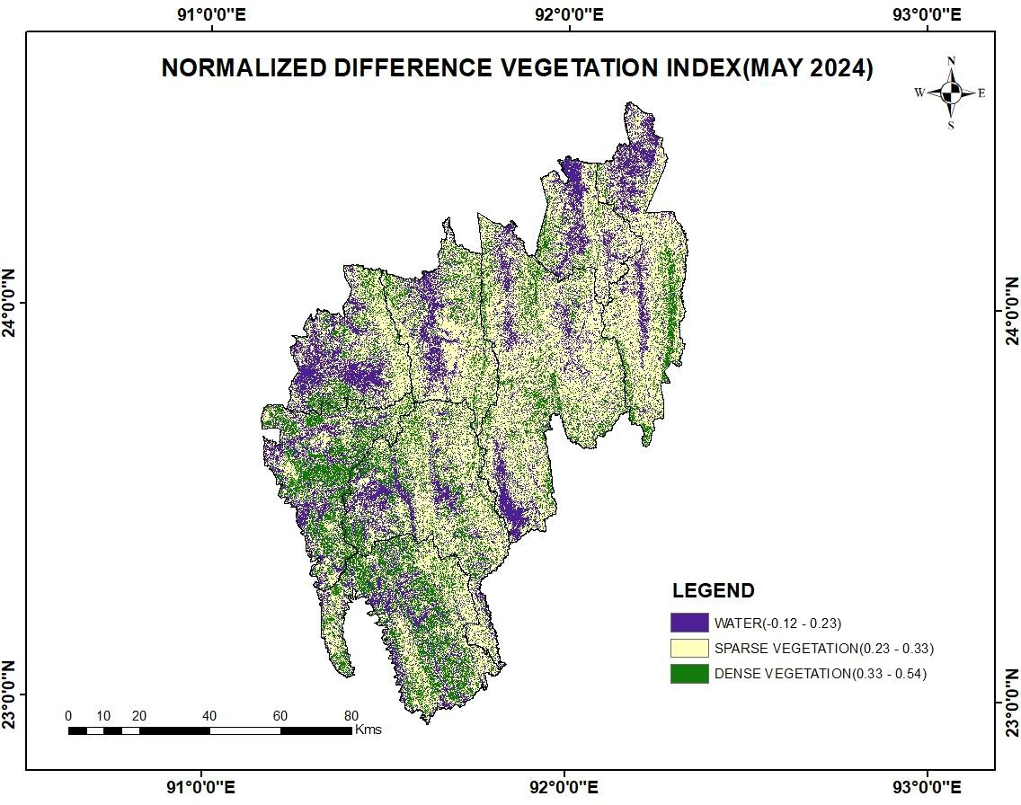

Fig.4b Normalized Difference Vegetation Index during Kharif season

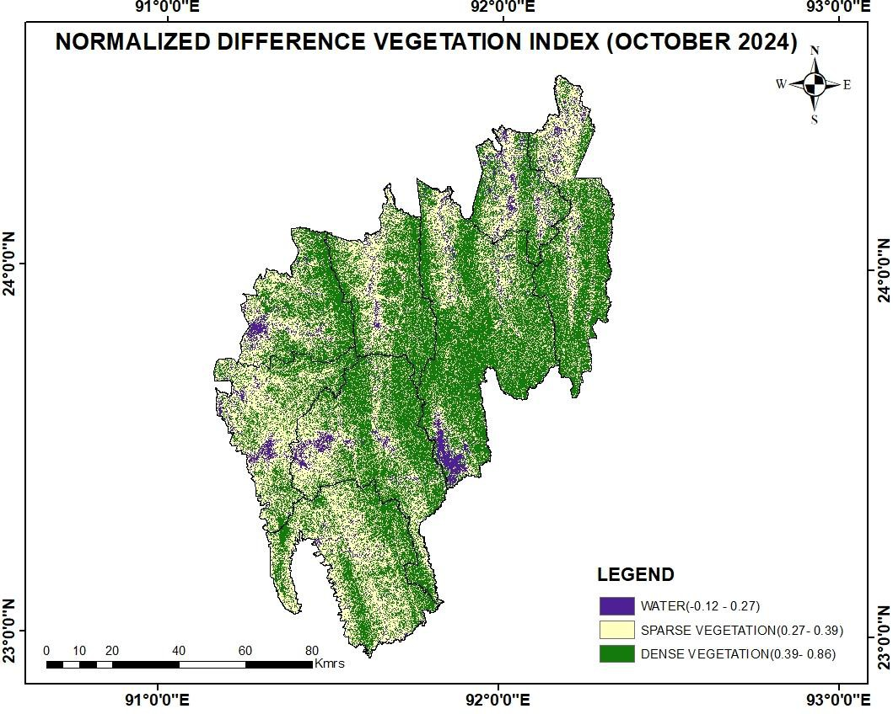

Fig.5b Normalized Difference Water Index during Kharif season

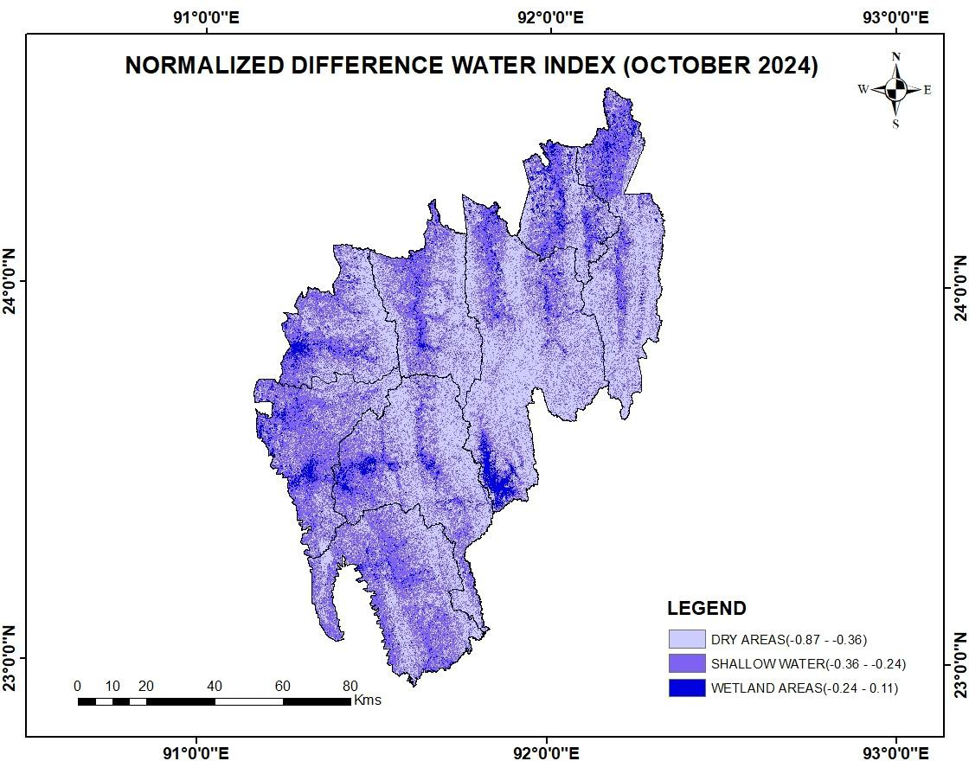

Fig.5a Normalized Difference Water Index during Rabi season

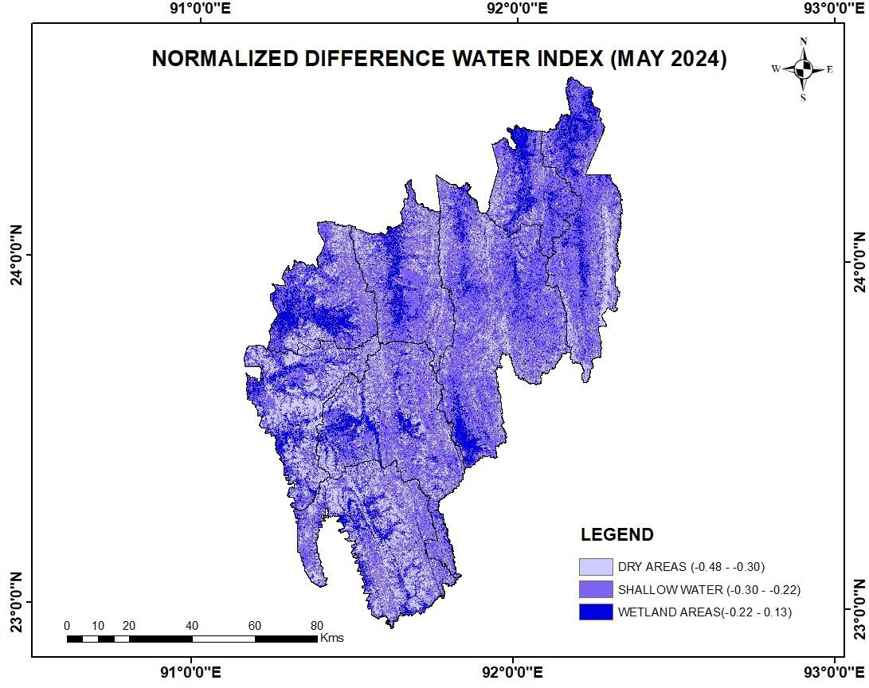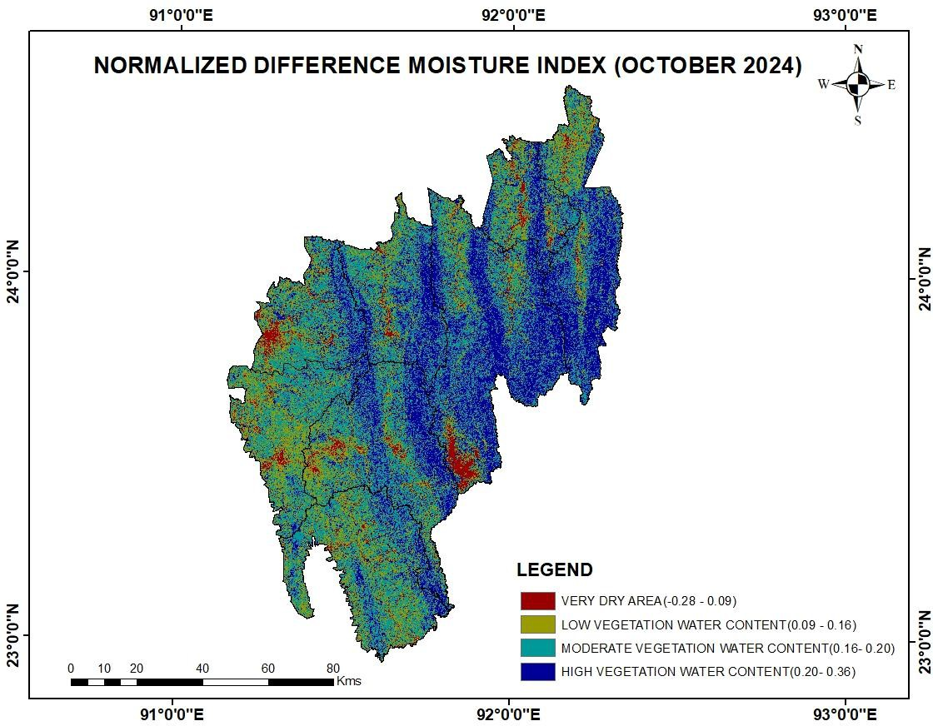

Fig.6b Normalized Difference Moisture Index during Kharif season

Fig.6a Normalized Difference Moisture Index during Rabi season

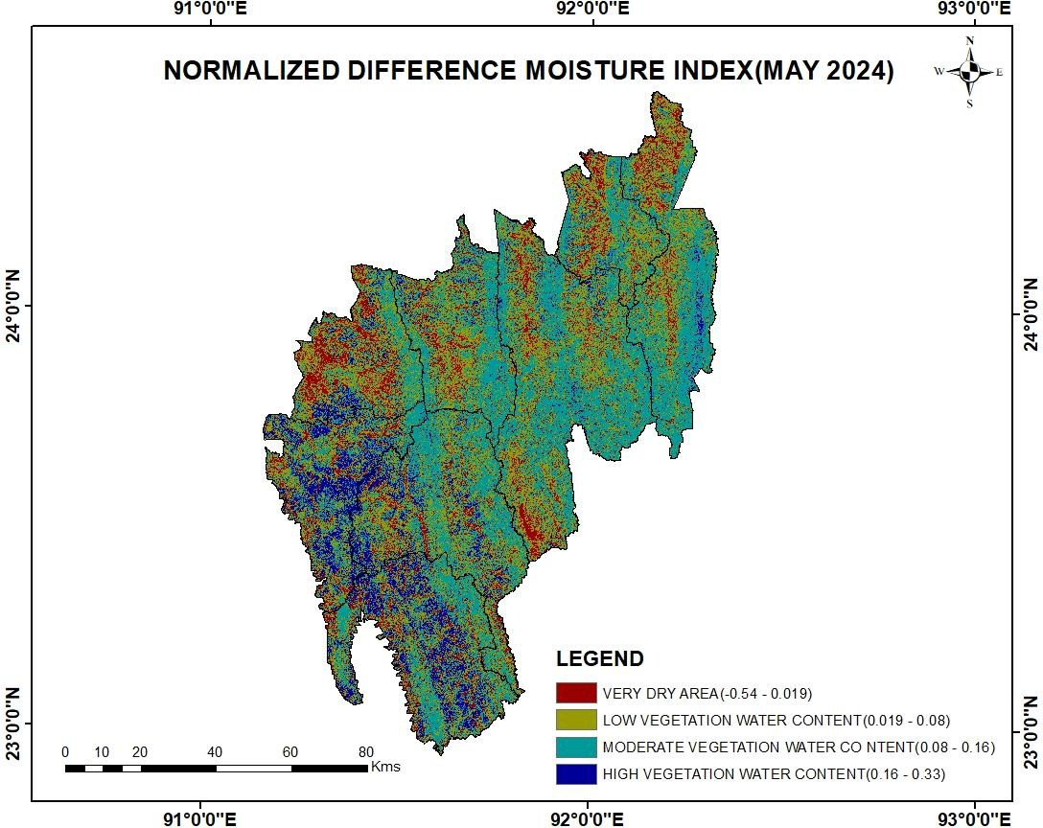

Fig.7b Principal Component Analysis, Kharif season

Fig.7a Principal Component Analysis, Rabi season

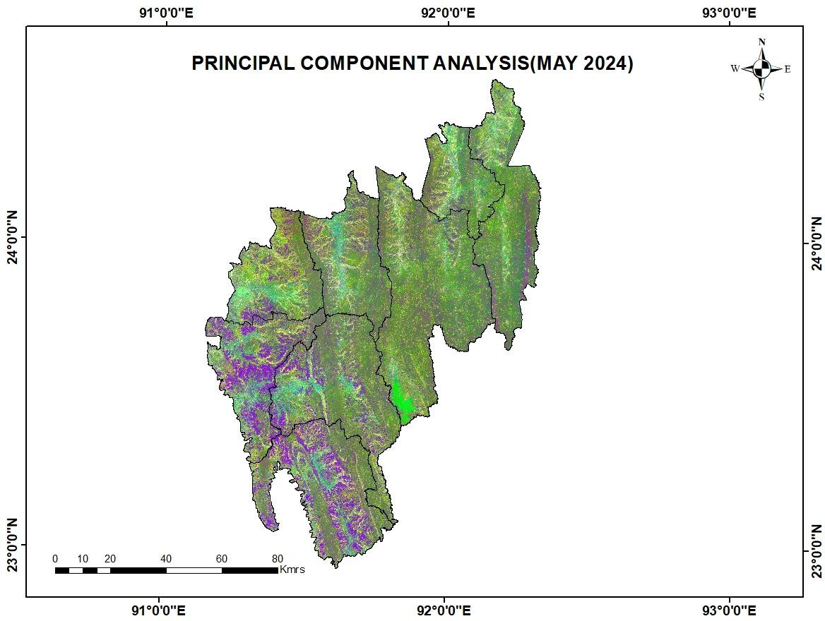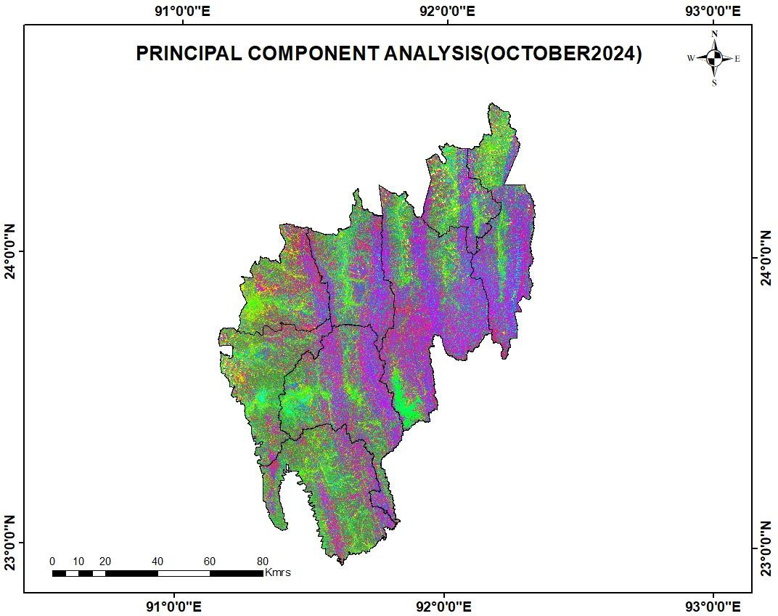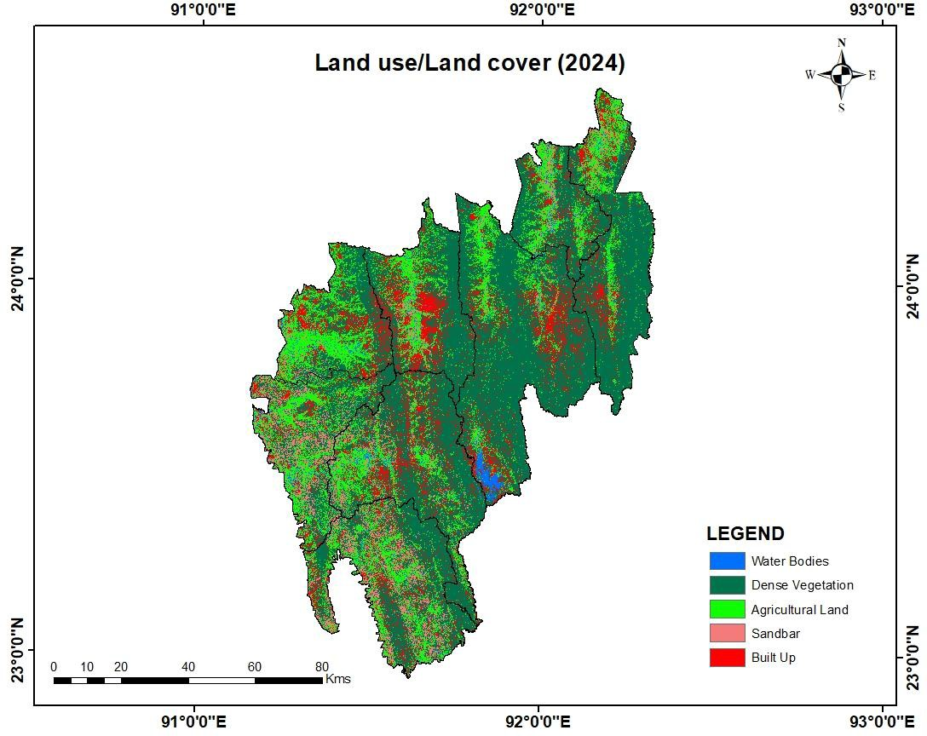

Fig.8 Land Use / Land Cover Classification