**Ichthyofaunal Diversity in the Riverine Ecosystems of Meghalaya, Northeast India**

# ABSTRACT

The present study focused on evaluating the species richness, distribution, conservation status, and economic value of fish in these Umiam, Umngot, and Kynshi rivers based on a field survey of six months duration between October 2024 and March 2025. Using a combination of traditional and modern fishing techniques, a total of 67 fish species were recorded, spanning 45 genera, 22 families, and 8 taxonomic orders. Among these, the order *Cypriniformes* was the most species-rich, with the family *Cyprinidae* alone accounting for over half of all identified species. The Umngot river, with its clear water and minimal anthropogenic disturbance, had the maximum species diversity, while the Kynshi river showed lower diversity, which could be related to mining-induced pollution. The fact that species were considered near threatened and vulnerable in the IUCN’s official catalog of species conservation status highlights the need for immediate conservation action. Interestingly, a number of high-value ornamental species were reported, which is an indication of both the natural richness and economic value of the region's ichthyofauna. The research emphasizes the twofold importance of freshwater fish as indicators of ecosystem health and as important livelihood resources. It recommends an integrated conservation strategy that involves community participation, responsible fishing practices, and the protection of natural habitats to ensure the continued health of fish populations and their surrounding ecosystems.

**Keywords**: Conservation, Richness, Livelihood, Biodiversity and Ichthyofaunal

**Introduction:**

Meghalaya is a state located in northeast India and is universally known for having an impressive aquatic biodiversity. Its scenery, which consists of a river network, streams, and lakes, supports a diverse range of freshwater fish species, most of which are native and play a major role in both the ecological balance and local communities' economic livelihood. Situated in two of the largest global biodiversity hotspotsthe Indo-Burma and the Himalayan regions—northeast India and, more so, Meghalaya is centrally positioned to provide support for sustaining ichthyofaunal diversity (**Das *et al*., 2021**). Ichthyofaunal diversity speaks to the composition and richness of fish species found in a particular aquatic environment. It is regarded as one of the principal indicators of the health of aquatic ecosystems and the biological richness of rivers, lakes, or coastal areas (Basan ta K. Das *et al*., 2021). In the Meghalaya context, such diversity is determined by the state's geographical and hydrological conditions. Positioned within the geographic range of 25.1° to 26.7° North latitude and 89.50° to 92.48° East longitude, the zone is a fossil zone of the ancient Indian plateau and is cut by a profuse network of rivers and streams depicting complex drainage patterns. With nearly 5,600 kilometers of rivers and canals, Meghalaya has the longest river system in northeast India, beating Assam by nearly 4,820 kilometers of such water bodies (**Gurumayum *et al*., 2007**).

The state has twelve districts and three main tribal groups—the Khasi, Jaintia, and Garo. The groups are strongly attached to the rivers of the region, which are essential sources of agriculture, fishing, and household water supply. Meghalaya is drained by two large drainage basins: the Brahmaputra and the Barak-Meghna systems, with rivers either flowing northward or southward depending on where they are. These aquatic systems are known to support a rich diversity of fish, with over 190 species documented across 11 taxonomic orders and 32 families (**Vaiphei & Gupta, 2016**). Previous research reported 104 species (**Sen *et al*., 1984**), subsequently revised to 152 species (**Sen *et al*., 1995**), and up to 165 by 2000 (**Sen *et al*., 2000**), demonstrating a steady rise in fish diversity identification via continued research. Major rivers such as the Umiam, Umngot, and Kynshi flow from different regions of the state, including the Khasi and Jaintia Hills. The Umiam River, which is created by the union of the Wah Umkhrah and Umshyrpi rivers in proximity to Shillong Peak, is famous for its ecological diversity and sustains various flora and fauna species. It supplies necessary resources to the local population via agriculture, fisheries, and tourism (**CIFRI, 2013**).

Likewise, the Umngot River or Dawki river is found in the East Khasi Hills and is popular for its very clear water. The river hosts a range of fish including mahseer, trout, catfish, and eel. The river is the focus of traditional fishing practices and helps to sustain the livelihood of the native Khasi and Jaintia communities. Its aesthetic and ecological qualities make it a hub for eco-tourism, contributing significantly to the local economy (**Swaddle, 2013**). The Kynshi River, which originates in the Eastern-West and West Khasi Hills, also has a central role to play in local livelihoods. The Kynshi river basin has high forest resource endowments, both timber and non-timber forest products. Nonetheless, the Kynshi has also seen growing concerns regarding pollution, which impacts aquatic life and community health (**The Highland Post, 2024**). All the same, the river still sustains agriculture, fishing, and eco-tourism activities in the area.

**MATERIALS AND METHODS:**

**Study areas:**

The current research was carried out for six months, from October 2024 to March 2025, with the objective of evaluating fish species diversity in three Meghalaya rivers. The chosen rivers were Umiam, Kynshi, and Umngot, each situated in a different district of the state. The Umiam river was the first location surveyed. It is located in East Khasi Hills district, about 19.1 kilometers from Shillong. The geographic location of the Umiam River is 25.6517° N latitude and 91.8841° E longitude. After the Umiam survey, the second river surveyed was the Kynshi River, which is situated near the town of Mairang, at a distance of approximately 15 kilometers. This river occurs at about 25.3211°N latitude and 91.0891°E longitude. The Umiam River and the Kynshi River are separated by a distance of approximately 57.6 kilometers. The final site surveyed was the Umngot River, situated at approximately 25.2010°N latitude and 92.0186°E longitude. This river lies around 76.8 kilometers away from the nearest town, Khliehriat. It is about 103.5 kilometers from the Kynshi River to the Umngot River. These three rivers were chosen for their ecological importance and accessibility, constituting the central study sites for assessing ichthyofaunal diversity in Meghalaya.

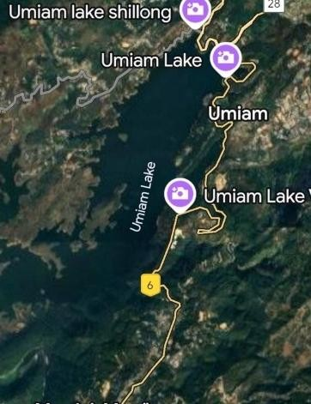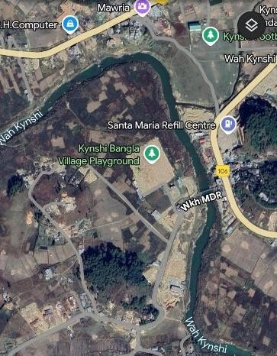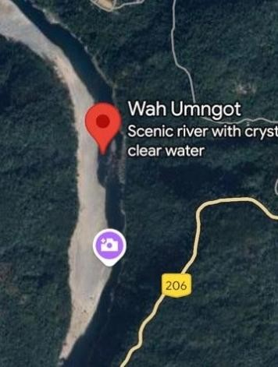

**Plate 1:** Umiam river **Plate 2**: Kynshi river **Plate 3**: Umngot

**Sampling and Data Collection**:

Fish species were sampled from the Umiam, Umngot, and Kynshi rivers by employing diverse fishing gears, such as scoop nets, cast nets, indigenous fish traps, and fishing rods. Specimens collected were photographed and fixed in 10% formalin in labeled containers. Sampling was done with the help of local people and the Directorate of Fisheries, Shillong, staff. Some of the species were documented and released on site, while unidentified specimens were stored and transported to the Directorate for further examination. Data collected included IUCN conservation status, habitat, feeding habits, and economic value. Identification of species was confirmed using Fish Base (www.fishbase.org), and conservation status was verified using the conservation status list published by IUCN ([www.iucnredlist.org)](http://www.iucnredlist.org/).

# Result and Discussion

The fish fauna significantly contributes to the fishery potential of aquatic ecosystems. The current study results were show that, Cypriniformes was identified as the predominant order, comprising a total of 38 recorded species. Within this order, the family Cyprinidae was notably abundant, comprising 30 species. Cypriniformes particularly carps and minnows were the most species-rich group in the Wah Umngot and Umiam rivers during the survey, likely due to their broad ecological adaptability and economic importance. Although less diverse, orders such as Cyprinidontiformes, Beloniformes and Tetraodontiformes were also recorded and are ecologically significant. The present data was presented in table no 1 and 2 and fig. no1. The fish diversity of all three rivers showed the significant result in terms of fish availability. The siluriformes family had the maximum family (8) with 15 fish species but cyriniformes had only 5 family but these families have maximum no of fish species that was 38. The beloniformes order has minimum fish family (1) and fish species also one. This research evaluated fish diversity in three major rivers of Meghalaya Umiam, Umngot, and Kynshi—emphasizing their ecological and economic importance in the region. There were 67 species collected with considerable variation in distribution patterns. The Umngot river, less affected by pollution and having higher habitat complexity, recorded the greatest species richness, followed by the Umiam River, more disturbed by human activities, with lower diversity. The occurrence of Near Threatened, Vulnerable, and Endangered species indicates the continuing challenges for conservation. Economically, the local food security and trade depend on various species, although reduced catches indicate exploitative pressures that are unsustainable. Freshwater fish are both economic and ecological indicators. The results indicated high ichthyofaunal richness dominated by Cypriniformes, in agreement with previous research in Northeast India (**Deka *et al*., 2021; Goswami *et al*., 2012**). Economically valuable species such as *Neolissochilus hexagonolepis*, *Tor putitora*, and *Channa striata* were abundant, contributing to local diets and livelihoods (**Sen & Khynriam, 2014; Nath & Dey, 2000**). The Cyprinidae family was most distributed across all rivers, replicating trends cited in previous studies (**Jayaram, 2010; Snaitang *et al*., 2023).** Past surveys indicated an increase in reported fish species from 152 in 1995 to 190 by the year 2016, indicating Meghalaya's diversity (**Sen, 1995; Sen & Khynriam, 2014; Vaiphei & Gupta *et al*., 2016**). Amongst the rivers, Umngot carried the highest fish diversity, probably because it contained clear water and had little human influence. This conforms with the findings of **Mawa *et al*. (2024)**, who stressed the requirement for conservation in view of escalating tourism. Contrarily, the Kynshi River revealed lower diversity, which was caused by pollution and runoff from mining, as further documented by **Highland Post (2024)** and **Swer & Singh (2003).** These trends lend support to the argument that water quality is pivotal in maintaining fish populations. Some of them, such as *Tor tor* and *Bagarius bagarius,* are listed as Near Threatened or Vulnerable (**Lakra *et al*., 2010**), necessitating urgent conservation. This corroborates international conservation literature emphasizing habitat-specific threats (**Dahanukar *et al*., 2012; Vishwanath, 2017**). A total of 67 fish species were identified, spanning 45 genera, 22 families, and 8 taxonomic orders, with Cypriniformes accounting for approximately 60% of the diversity observed. Cyprinidae alone contained 30 species, further solidifying its dominance. Other families that were prominently represented were Channidae, Nemacheilidae, and Bagridae. Many of Meghalaya’s freshwater fish are also prized for ornamental value. **Mahapatra *et al*. (2003)** found that 89% of the 155 recorded species had ornamental traits, with many already traded internationally (**Singh & Ahmed, 2005; Jayasankar, 1988**). About 30 ornamental species were noted in this survey, consistent with **Ghosh & Lipton (1982)** and Biswas *et al*. (2015). Omitting conservation of native and ornamental species is critical from both ecological and economic perspectives (**Kar *et al*., 2006**). Despite that, constant hazards including pollution, siltation, overfishing, and invasive species continue to affect biodiversity (**Kar, 1995; 2005**). Areas under protection like Nongkhyllem sanctuary, act as habitats for rare species (**Khynriam *et al*., 2016**). Some species, such as Mystus tengara and *Puntius sophore*, are central to local fisheries and are under threat from overfishing and destructive practices (**Mahapatra *et al*., 2003; Kar *et al*., 2006**). Local communities' dependency on fishing calls for sustainable, community-based conservation (**Baruah & Biswas, 2002; Goswami *et al*., 2012**). Since the smaller rivers may harbor endemic but under-documented species (**Sen, 2003; Ramanujam *et al*., 2010**), inclusive conservation approaches are critical. Recommendations are to enhance regulations, encourage responsible fishing, and engage locals in river monitoring (**Lakra *et al*., 2010**).

# Conclusion

This research investigated the diversity of fish species in three river systems, evaluated their conservation status in terms of IUCN categories, and analyzed their economic importance to local communities. There were 67 species collected with considerable variation in distribution patterns. The Umngot river, less affected by pollution and having higher habitat complexity, recorded the greatest species richness, followed by the Umiam river, more disturbed by human activities, with lower diversity. The occurrence of Near Threatened, Vulnerable, and Endangered species indicates the continuing challenges for conservation. Economically, the local food security and trade depend on various species, although reduced catches indicate exploitative pressures that were unsustainable. Freshwater fish were both economic and ecological indicators. Their preservation is essential in harmony with human utilization.

**Disclaimer (Artificial Intelligence)**

Author(s) hereby declare that NO generative AI technologies such as Large Language Models (ChatGPT, COPILOT, etc.) and text-to-image generators have been used during the writing or editing of this manuscript.

# References

* **Basan ta K. Das, R., Kharumnuid, T., & Sharma, A. (2021)**. Ichthyofaunal diversity as an indicator of ecosystem health in northeastern India. *Journal of Biodiversity and Endangered Species,* 9(2), 1–6.
* **Biswas, S. P., et al. (2015).** Conservation and management of ornamental fish resources of North East India. *Journal of Aquaculture Research & Development, 6*(310), 1–7.
* **Boruah, S., & Biswas, S. P. (2002).** Ecohydrology and fisheries of the upper Brahmaputra basin. *Environmentalist*, *22*, 119-131.
* **Central Inland Fisheries Research Institute (CIFRI). (2013).** Report on inland water biodiversity and fishery resources in Meghalaya. ICAR-CIFRI.
* **Central Inland Fisheries Research Institute. (2019).** *Cage culture in Umiam Reservoir, Meghalaya under TSP*. Indian Council of Agricultural Research.
* **Dahanukar, N., Paingankar, M., Raut, R. N., & Kharat, S. S. (2012).** CEPF Western Ghats Special Series: Fish fauna of Indrayani River, northern Western Ghats, India. *Journal of Threatened Taxa*, 2310-2317.
* **Dahanukar, N., Raghavan, R., Ali, A., Abraham, R., & Shaji, C. P. (2011).** *Pethia shalynius*. The IUCN Red List of Threatened Species 2011: e.T168471A6510063.
* **Dey, S. C., & Kar, D. (2005).** *Fish fauna of Assam and Meghalaya*. Zoological Survey of India.
* **Gurumayum, S. D., & Choudhury, M. (2007).** Fish diversity and aquatic resources of northeast India. *Aquaculture Asia Magazine*, 12(4), 9–11.
* **Lakra, W. S., & Sarkar, U. K. (2011).** *Neolissochilus hexagonolepis (McClelland, 1839): Status, distribution and conservation needs*. National Bureau of Fish Genetic Resources (NBFGR), ICAR.
* **Lakra, W. S., Sarkar, U. K., & Gopalakrishnan, A. (2010).** Threatened freshwater fishes and their conservation in India. *Journal of Threatened Taxa, 2*(6), 1093–1103.
* **Mawa, D., Papang, H., Saxena, S., & Kher, D. (2024).** Ichthyofaunal diversity in the rivers of Meghalaya. *Biological Forum – An International Journal, 16*(7), 285–291.
* **Sen, N. (1984).** A review of the fish fauna of Meghalaya. *Records of the Zoological Survey of India*, 81(1-4), 85–92.
* **Sen, N. (1995).** Fish fauna of Meghalaya, India. Records of the Zoological Survey of India, Occasional Paper No. 162, 1–48.
* **Sen, N. (2000).** Updated checklist of fishes of Meghalaya. Zoological Survey of India.
* **Sharma, L., & Lyngdoh, D. (2015).** Ichthyofaunal diversity of Umngot River in Meghalaya. *International Journal of Fauna and Biological Studies, 2*(2), 23–28.
* **Snaitang, B., Saxena, S., Papang, H., & Yadav, M. K. (2023).** A study on fish diversity of Meghalaya. *Biological Forum – An International Journal, 15*(10), 212–216.
* **Snaitang, B., Saxena, S., Papang, H., & Yadav, M. K. (2023).** A study on fish diversity of Meghalaya. *Biological Forum – An International Journal, 15*(10), 212–216.
* **The Highland Post. (2024).** Pollution threatens Kynshi River ecosystem and health of residents.
* **The Swaddle. (2013).** Umngot River: Northeast India’s transparent treasure.
* **Vaiphei, K. T., & Gupta, B. B. P. (2016).** *Fish diversity in Meghalaya*. AkiNik Publications.
* **Vaiphei, Y., & Gupta, S. (2016).** Diversity and distribution of freshwater fishes of Meghalaya, India. Journal of Threatened Taxa, 8(3), 8569–8579.
* **Vishwanath, W. (2017).** Diversity and conservation status of freshwater fishes of the major rivers of northeast India. *Aquatic Ecosystem Health & Management, 20*(1–2), 86–101.

**Table 1: Calculating the order of families and species during the research period.**

|  |  |  |
| --- | --- | --- |
| **Order** | **Number of Families** | **Number of Species** |
| **Siluriformes** | 8 | 15 |
| **Cypriniformes** | 5 | 38 |
| **Perciformes** | 3 | 3 |
| **Anabantiformes** | 2 | 6 |
| **Cyprinodontiformes** | 1 | 1 |
| **Mugiliformes** | 1 | 2 |
| **Beloniformes** | 1 | 1 |

# Table 2: Diversification of fish species in the three rivers

|  |  |  |  |  |  |  |  |  |
| --- | --- | --- | --- | --- | --- | --- | --- | --- |
| **S.No** | **Orders** | **Families** | **Common Name** | **Scientific Name** | **Umiam** | **Kynshi** | **Umngot** | **IUCN Status** |
| 1 | Cypriniformes | Cyprinidae | *Labeo* | *Labeo*  *gonius* | **+** | **+** | **+** | LC |
| *Labeo calbasu* | **+** | **-** | **+** | LC |
| *Labeo pangusia* | **-** | **-** | **+** | VU |
| *Labeo rohita* | **+** | **-** | **+** | LC |
| *Labeo dero* | **+** | **-** | **-** | DD |
| *Labeo catla* | **+** | **-** | **-** | LC |
| *Pethia* | *Pethia gelius* | **-** | **+** | **-** | EN |
| *Puntius* | *Puntius*  *chola* | **+** | **+** | **+** | LC |
| *Puntius*  *shalynius* | **+** | **+** | **-** | LC |
| *Puntius*  *sophore* | **-** | **+** | **+** | VU |
| *Puntius*  *sarana* | **-** | **-** | **+** | LC |
| Tor | *Neolissocheilius hexagonalepis* | **+** | **+** | **+** | DD |
| *Tor tor* | **+** | **+** | **+** | LC |
| *Tor putitora* | **+** | **+** | **+** | EN |
| *Danio* | *Danio*  *rerio* | **+** | **+** | **+** | LC |
| *Danio*  *dangila* | **+** | **-** | **+** | NT |
| *Devario* | *aequipinnatus* | **-** | **-** | **+** | LC |
| *mola* | *Amblyphayngodon*  *mola* | **+** | **-** | **+** | LC |
| Common Carp | *Cyprinus Carpio* | **+** | **-** | **-** | LC |
| *Garra* | *Garra*  *gotyla* | **+** | **-** | **-** | LC |
| *Garra*  *lamta* | **-** | **+** | **-** | LC |
| *Garra*  *mullya* | **+** | **+** | **+** | NT |
| *Barilius* | *Barilius*  *bendelisis* | **+** | **+** | **-** | LC |
| Grass Crap | *Ctenopharyngodon*  *idella* | **-** | **+** | **+** | NT |
| *Cirrhinus* | *Cirrhinus*  *reha* | **-** | **-** | **+** | LC |
| *Cirrhinus mrigala* | **+** | **+** | **+** | LC |
| minnow and Chela | *Salmostoma*  *bacaila* | **+** | **+** | **+** | NT |
| *Chela*  *laubuca* | **+** | **+** | **+** | LC |
| *Esomus danricus* | **+** | **+** | **+** | LC |
| Silver carp | *Hypophthalmicthys*  *molitrix* | **+** | **-** | **+** | LC |
| 2 |  | Psilorhynchidae | *stone carp* | *Psilorhynchus sucatio* | **-** | **-** | **+** | VU |
| 3 |  | Nemacheilidae | ray-finned fish | *Schistura multifasciata* | **+** | **-** | **+** | LC |
| *Schistura*  *reticulofasciata* | **+** | **-** | **-** | LC |
| *Schistura* *beavani* | **+** | **-** | **-** | LC |
| *Acanthocobitis* *botia* | **-** | **+** | **-** | NT |
| 4 |  | Balitoridae | Gray's stone loach | *Balitora*  *brucei* | **+** | **+** | **+** | LC |
| Cobitidae | Bengal Loach | *Botia dario* | **+** | **+** | **-** | LC |
| Queen Loach | *Lepidocephalus*  *guntea* | **-** | **+** | **+** | LC |
| 5 | Cyprinidontiform  es | Poecilidae | *Guppy* | *Poecilia reticulata* | **-** | **-** | **+** | LC |
| 6 | Mugiliformes | Ambassidae | Bengal Loach | *Chanda nama* | **+** | **+** | **+** | LC |
| *Parambasis baculis* | **+** | **+** | **+** | NT |
| 7 | Perciformes | Badidae | *Badis*  *badis* | **+** | **+** | **+** | LC |
| Belontidae | *Colisa*  *fasciatus* | **+** | **+** | **+** | NT |
| Gobidae | *Glossogobius*  *giuris* | **+** | **-** | **+** | LC |
| 8 | Anabantiformes | Channidae | *Channa* | *Channa*  *gachua* | **-** | **-** | **+** | LC |
| *Channa*  *punctatus* | **+** | **-** | **+** | NT |
| *Channa*  *striatus* | **+** | **-** | **-** | LC |
| *Channa*  *stewartii* | **+** | **-** | **-** | LC |
| *Channa*  *orientalis* | **-** | **+** | **-** | LC |
| Anabantidae | *Anabas* | *testudineus* | **+** | **+** | **+** | VU |
| 9 | Beloniformes | Belonidae | *Xenentodon*  *cancila* | **+** | **+** | **-** | LC |
| 10 | Siluriformes | heteropneustid  ae |  | *Heteroneustes*  *fossilis* | **-** | **+** | **+** | LC |
| Clariidae | *Clarius batrachus* | **-** | **-** | **+** | LC |
| *Clarius gariepinus* | **+** | **+** | **+** | NT |
| Loricariidae | *Hypostomus* | *Hypostomus plecostomus* | **+** | **+** | **+** | LC |
| Sisoridae | *Glyptothorax* | *Glyptothorax*  *telchitta* | **+** | **+** | **+** | LC |
| *Parachiloglanis hodgarti* | **+** | **+** | **+** | LC |
| *Gagata*  *cenia* | **+** | **-** | **+** | LC |
| Bagridae | *Mystus* | *Mystus*  *cavasius* | **-** | **-** | **+** | LC |
| *Mystus*  *bleekeri* | **+** | **-** | **+** | NT |
| *Mystus*  *tengara* | **+** | **-** | **-** | LC |
| *Batasio*  *batasio* | **+** | **-** | **-** | NT |
| Siluridae | *Ompak* | *Ompak pabo* | **-** | **+** | **-** | LC |
|  | *Wallago* | *Ompak attu* | **+** | **+** | **+** | LC |
| Olyridae | *Olyra* | *Olyra*  *longicaudata* | **+** | **+** | **-** | NT |
| Amblycipitida  e | *Amblyceps* | *Amblyceps apangi* | **-** | **+** | **+** | LC |
| Tetradontiformes | Tetradontidae | *Tetratodon* | *Tetratodon*  *cutcutia* | **-** | **-** | **+** | LC |
| Beloniformes | Belonidae | *Xenentodon* | *Xenentodon*  *cancila* | **+** | **+** | **+** | LC |

The (+) sign indicates the presence of the species, and the (-) sign indicates the absence of the species.

# Abbreviation: LC: Least Concern; NT: Near Threatened; VU: Vulnerable; EN: Endangered; DD: Data Deficient; Or: Ornamental

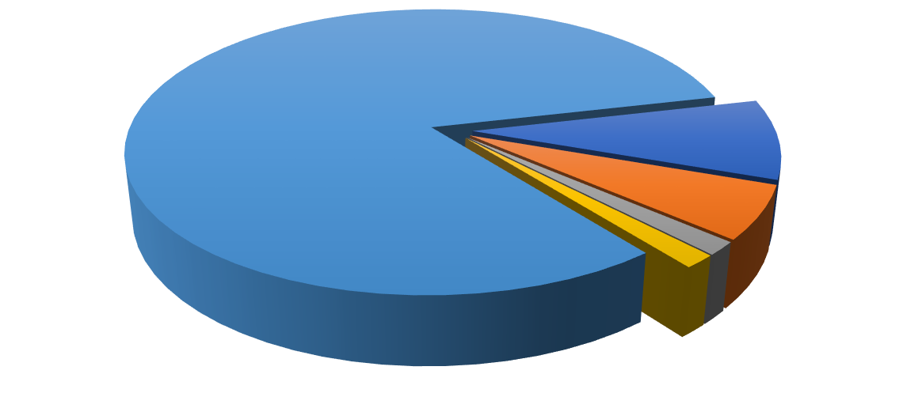

9

%

6

%

2

%

1

%

82

%

**Conservational Status of the Species caught**



Near threatened



Vulnerable



Endangered



Data deficient



Least concern

**Fig 1**: Distribution of fish species based on their conservation status