Spatial distribution of cerebrovascular women patients in the selected five districts in Tripura-A Geographical Appraisal

**Abstract**

Geographical review of clinically registered 273 cerebrovascular female patients in the selected five districts of Tripura from December 2022 to December 2024 shows a unique geographical distribution, spatial pattern and demographic variation. West Tripura is the main hotspot with 89% of cases particularly found in metropolitan areas like Agartala Municipal Corporation while other districts namely, Sepahijala, Gomati, South Tripura, and Khowai recorded with low percentage. The women ages group between 51 and 80 are most prevalent, with the highest incidence occurred in the age group of 61–80 shows the susceptibility for the obvious risk of incidence and 82% of cases were normal Cerebrovascular Accidents (CVAs or strokes), with less 18% frequent CVA-related hypertensive intracranial bleeding. IGM Hospital treated about 50% of the patients, and the others 50% needed just one day of hospitalization, pointing to timely interventions or mild severity, and were referred to GBP Hospital and AGMC. The prevalence of cerebrovascular illness found in females age wise variation during 2022-2024 (χ² = 21.71, p-value < 0.0001), cerebrovascular (CV) disorders affected varied age groups of female patients equally during 2022-2023, (χ² =, p-value < 0.01), and it was revealed statistically significance (χ² =, and p-value < 0.001) during 2023-24. In preventive care, women between the ages of 51 and 80, particularly those between the ages of 51 and 60, must be given priority. The pattern of geographical distribution of cluster patients indicates underlying factors such as population density, expensive to healthcare, socio-economic inequalities, environmental aspects, or lifestyle behaviours that require further examination to prevent the cerebrovascular accidents among the women in Tripura.

Key words: Cerebrovascular Accidents (CVA), risk factors, spatial distribution, cluster pattern, random distribution, geographical appraisal

* 1. **Introduction**

Disruptions in the blood supply to the brain are due to cerebrovascular events, also referred to as strokes, which result in neurological impairment. These events may be caused by haemorrhage, bleeding or ischemic blockages, and risk factors include obesity, diabetes, high blood pressure, and unhealthy lifestyle choices, including smoking and unhealthy food habits. Because of their extended life expectancy, pregnancy-related difficulties, and hormonal changes, women, especially postmenopausal women, are more susceptible to strokes. Stroke is still a major cause of death and disability globally, despite medical breakthroughs. Thus, studies on its occurrence and its effect in relation to gender are crucial.

In India, a considerable percentage of mortality from non-communicable diseases is caused by cerebrovascular incidents, which has been increasing every year. Due to socioeconomic impediments to healthcare access, delayed diagnosis, and a lack of awareness, women in India confront additional challenges. The incidence of stroke in Indian women is frequently underreported, and cultural considerations also affect prompt medical attention. According to studies, rural women are more vulnerable because of inadequate medical facilities and treatment deferrals, especially in the developing nations. The impact of stroke on women is especially alarming in the North-eastern region of India, where the healthcare system is not developed up to the benchmark than the other region. Increased morbidity and death among impacted women are caused by a lack of stroke awareness initiatives, financial limitations, and restricted access to specialised care.

The prevalence of cerebrovascular accidents among women is a rising public health challenging issue in the state of Tripura. Access to healthcare is a major problem in a largely rural area, which causes stroke treatment to be delayed. An ageing female population, diabetes, and high blood pressure are risk factors that also contribute to the rising rates of stroke. Furthermore, women may be prevented from obtaining prompt medical attention due to conventional socio-cultural standards, which would worsen the long-term effects of strokes. Improving stroke awareness, implementing focused healthcare policies, and improving access to early diagnosis and rehabilitation treatments for female patients in the state are all necessary to address these problems.

* 1. **Background of the Study**

Stroke continues to be one of the main causes of death and long-term disability in India, with its occurrence and frequency rising much faster than in wealthy countries. Recent research has shown important differences by region, with cities and states like Goa, Kerala, and several in the North-East (including Tripura) showing a higher number of stroke cases (Behera, *et al.*, 2024; Kalita, *et al.*, 2023). Studies consistently point out that uncontrolled high blood pressure, diabetes, and different types of tobacco use, especially smokeless tobacco and being around second-hand smoke, are the main changeable risk factors that contribute to the burden of this disease (Gupta and Xavier, 2018; Roy, 2021). Moreover, delays in getting to the hospital, low public awareness of stroke signs, and economic challenges have been connected to higher death rates (Carvalho, *et al.*, 2024).

The high-quality specialist stroke care and secondary prevention strategies are importance of generating high-quality epidemiological data ensuring complete and accurate coding of deaths in the entire population. The limited and inconsistent spatial epidemiology of strokes occurred in India, the detailed stroke prevalence. Significant regional differences in stroke prevalence are found throughout India, according to the data, highlighting the necessity of specialised public health initiatives to address regional issues (Behera, *et al.*, 2024). This study highlights the urgent need for better healthcare accessibility and focused interventions in the region by offering important insights into the stroke burden in North-Eastern States of India (Kalita, *et al.*, 2023). Increased mortality and poor functional outcomes were closely linked to higher NIHSS scores, underscoring the significance of early intervention in settings with limited resources (Carvalho, *et al.*, 2024). Strong anti-tobacco laws could significantly lower the incidence of strokes, according to the study, which highlights the large effects of second-hand smoke and smokeless tobacco on the burden of strokes (Roy, *et al.*, 2021).

The varied incidence of stroke in Indian states is revealed by this systematic study, suggesting that region-specific approaches are essential to lowering death and disability, India State-Level Disease Burden Initiative Stroke Collaborators, 2018. The results show that socioeconomic disparities and modifiable risk factors both contribute to the prevalence of stroke in India, making comprehensive preventative strategies necessary (Das & Banerjee, *et al*., 2008). It is clear from 50 years of study that focused public health initiatives are necessary to reduce India's rising stroke rate (Banerjee and Das, *et al*., 2016). One of the main risk factors for stroke is hypertension, and controlling blood pressure effectively may significantly lower the incidence of stroke in India (Gupta and Xavier, *et al*., 2018).

A changing demographic profile and a rising incidence of stroke in younger populations are revealed by our data, necessitating prompt preventive action. The study highlights the need for early risk factor management in India by identifying sedentary lifestyles and uncontrolled hypertension as key factors in acute stroke (Ram, *et al.*, 2021). New molecular targets for stroke treatment present encouraging opportunities for enhanced patient outcomes and future therapeutic approaches. According to the study, improving risk factor management and changing one's lifestyle could significantly lower the incidence of stroke in India (Kaul, *et al.*, 2009). The three main risk factors for stroke are found to be hypertension, diabetes, and tobacco use, with notable geographical differences throughout India (Ramachandran, *et al.*, 2019). There is still a significant gap in stroke care in rural areas, despite improvements in metropolitan areas, which calls for immediate legislative and infrastructure changes. Reducing door-to-needle time is paramount for improving acute stroke outcomes, yet systemic delays continue to hamper treatment efficacy (Kumar and Gupta, *et al*., 2020). Although access is still unequal throughout the nation, sustained rehabilitation efforts are essential to improving stroke patients' long-term functional recovery.

The study's significant pre-hospital delays highlight how urgently India's emergency medical services and public education need to be improved. This indicates that stroke has a significant financial impact, underscoring the need for legislative actions to reduce patients' out-of-pocket costs. To enhance recovery and quality of life for stroke survivors throughout India, it is imperative to provide access to reasonably priced stroke rehabilitation therapies (Joshi and Kaur, *et al*., 2022). The comprehensive lifestyle intervention programmes are a successful way to lower the risk of stroke in Indians (Babu Kurup, *et al*., 2019). Stroke results in urban and rural areas differ significantly, with rural patients experiencing delays and having less access to high-quality care (Patel, *et al.*, 2015). According to the national analysis, stroke mortality is still frighteningly high, particularly in areas with little resources, even with advancements in acute care. Trends over time show that the number of strokes has increased in recent decades due to both unfavourable lifestyle changes and demographic shifts (Gupta, *et al.*, 2021). The need for subtype-specific management methods is highlighted by the prevalence of ischaemic strokes with notable regional variations (Kapoor, *et al.*, 2020). The frequency of strokes among young adults in India is alarmingly on the rise, which calls for specific preventive measures for this demographic (Mondal, *et al*., 2022).

**1.3. Study Area**

The study area is Tripura state in the north-eastern region of India, and it is geographically located between 22°56′ N to 24°32′ N latitudes and 91°09′ E to 92°21′ E longitudes. Geomorphological setup of the state has a sequence of low altitude hills that run mostly from north to south, along with rich valleys and flat land. Tripura has a humid subtropical climate with hot, mild rain in summers, and dry in winters. The annual rainfall is high, usually between 2000 mm and 2500 mm, mostly occurring during the June to September monsoon season. Temperatures can drop to around 10°C in winter and rise above 35°C during the hottest part of summer. The state’s population is over 3.5 million, with West Tripura being one of the most populated districts. The capital city, Agartala, which is home to the Indira Gandhi Memorial (IGM) Hospital, serves as the main administrative and economic hub of the region (Fig.1).

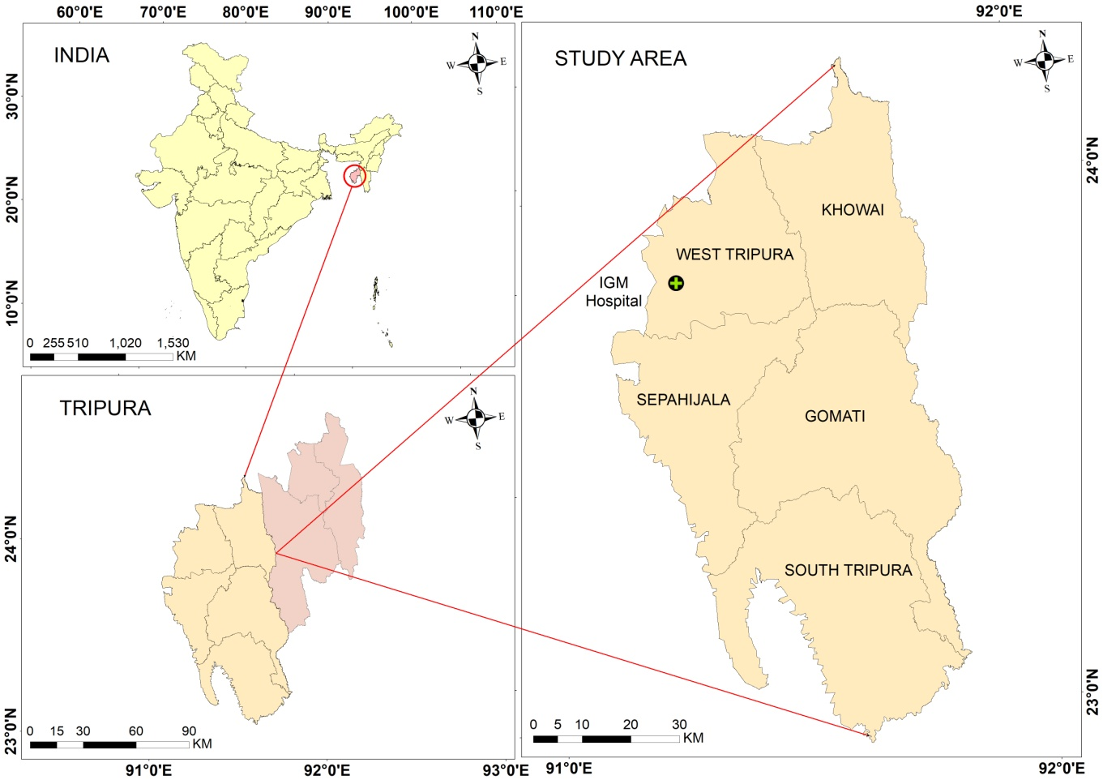

Fig.1 Study Area – IGM Hospital

**1.3. Objectives**

1. To mapping the spatial distribution of the cerebrovascular incidents (CVIs) in Tripura, India
2. To analyse the spatial distribution of cerebrovascular incidents (CVIs) in Tripura, India, using GIS.
3. To examine the temporal trends of stroke cases over two years (December, 2022 - November, 2023 and December, 2023 – December 2024).

**2. Materials and Methods**

The materials used in this study are included the stroke or cerebrovascular incident of female patients’ data based on the registry records of Indira Gandhi Memorial (IGM) Hospital, Agartala, Tripura. The total numbers of 273 stroke or cerebrovascular incident female patients are collected from the state government hospital female medicine ward registry of Indira Gandhi Memorial (IGM) Hospital, Agartala, Tripura for the period of December 2022 – November 2023 annual data and December 2023 – December 2024. The cerebrovascular incident or stroke patient’s data are exported to the Quantum Geographical Information System (QGIS) version 3.4 platforms for mapping spatial distribution and the pattern of women patients, and was analysed using Chi-squared test to reveal the susceptible age group, and also prepared graphs and diagrams for proper illustration using the MS Office.

Cerebrovascular incident of female patients site specification locations (latitudes and longitudes) are generated from the Google earth engine for 273 records. This latitude and longitude points are imported into the QGIS platform for mapping spatial distribution of 273 cerebrovascular incident female patients of 5 selected districts in Tripura. Chi-square test for variances to analysis the vulnerable demographic factors.

**3. Results and Discussion**

The geographical distribution of cerebrovascular events among female patients in five selected districts of Tripura for a two-year period, from December 2022 to December 2024, the blue dots signify 168 instances documented between December 2022 and November 2023, while the red dots denote 105 instances from December 2023 to December 2024. In terms of visualization, both datasets reveal a consistent clustering of cases in the west Tripura and Sepahijala districts, implying a continuing hotspot for cerebrovascular events among women (Fig.2). Nevertheless, there is a marked drop in the number of cases in the second year, which may indicate advancements in healthcare access, preventive measures, or alterations in reporting practices. Regardless of the reduction, the primary clustering remains largely consistent, suggesting that underlying risk factors—such as urban density, healthcare disparities, or lifestyle habits—might still exist. Cases in the remaining three districts continue to be dispersed and rare, indicating either genuinely lower occurrences or potential underreporting. This map shows the necessity for targeted public health initiatives in high-incidence regions to tackle the underlying causes and guarantee fair healthcare access for women throughout the area.

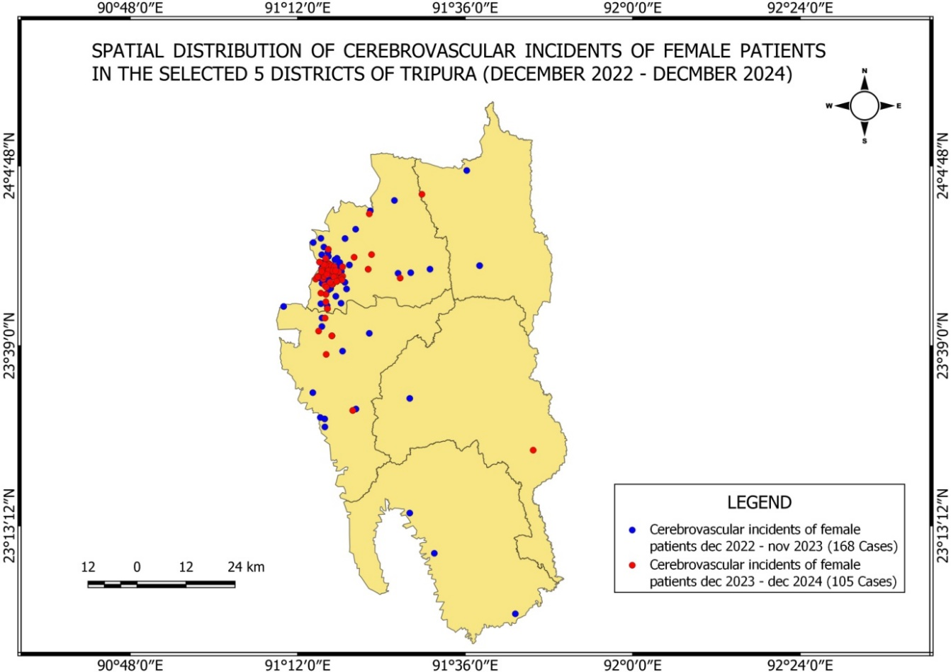

Fig.2 Spatial Distribution of Cerebrovascular Female Patients (Dec22-Dec24) map of study area

**3.1 Spatial Distribution of Cerebrovascular in West Tripura**

The geographic distribution of cerebrovascular events (like strokes) amongst female patients in the West Tripura district of Tripura for two-years from December 2022 to December 2024, the information is categorized into two distinct periods: the initial timeframe lasts from December 2022 to November 2023, during which 146 instances are documented (shown by blue dots); the latter timeframe extends from December 2023 to December 2024, during which 96 instances occurred (indicated by red dots). A distinct clustering of cases is noticeable in the south western section of the district, specifically within the Agartala Municipal Corporation area, particularly, found clustered pattern around urban and more densely populated city regions (Fig.3). Conversely, the central and northern zones exhibit markedly fewer cases, which may indicate variations in population density, access to healthcare, or other socio-environmental influences. The decrease in the number of cases from the first year to the second (from 146 to 96) may imply possible advancements in health awareness, early identification, or interventions, but further research would be essential to ascertain the underlying reasons.

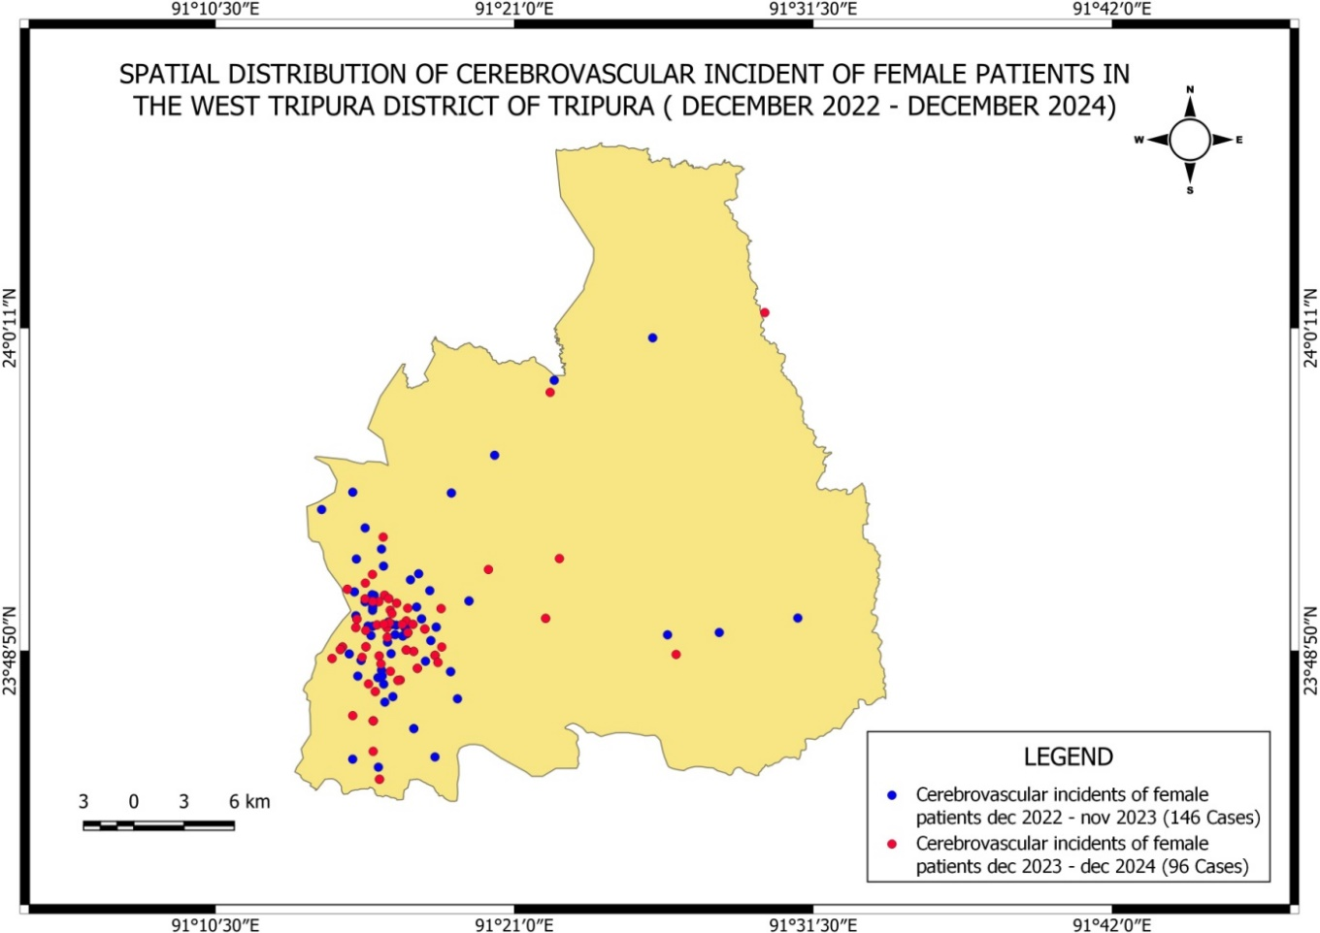

Fig.3. Spatial Distribution of Cerebrovascular Female Patients (Dec22-Dec24) map of West Tripura

The map illustrates the spatial arrangement of cerebrovascular events (like strokes) among female patients in the Agartala Municipal Corporation (AMC) region of Tripura for the time ranging from December 2022 to November 2023. A total of 111 cases have been logged and are depicted as blue dots on the map. The distribution reveals a relatively uniform spread of cases across the municipal area, with a prominent clustering in the central and southern sections of the city. These regions likely align with areas of increased population density, heightened urbanization, and potentially improved accessibility to healthcare services, which may contribute to a higher rate of diagnosis and documentation of such events. The northern section of the municipal area exhibits a smaller number of cases, which might be due to lower population density, variations in socioeconomic conditions, or access to health care facilities. Overall, this spatial trend emphasizes the significance of directing public health initiatives in more densely populated neighbourhoods, particularly concerning prevention, education, and prompt treatment of cerebrovascular conditions in women.

**3.2 Spatial Distribution of Cerebrovascular in Agartala Municipal Corporation (AMC)**

Map illustrates the spatial distribution of cerebrovascular events among female patients in the Agartala Municipal Corporation (AMC) area during two time periods: December 2022 to November 2023 (in blue) and December 2023 to December 2024 (in red). The visual data clearly shows a significant decrease in the number of reported cases, from 111 in the first period to 66 in the second. The earlier incidents (blue dots) seem to be more closely packed throughout the central and southern areas of AMC, suggesting a greater load at that time. In contrast, the cases from the previous year (red dots) are more spread out and less concentrated (Fig.4), indicating a possible improvement or shifts in awareness, intervention, or health-seeking conduct. The continued occurrence of events in specific central regions across both time periods might suggest health weaknesses related to population density, socioeconomic circumstances, or access to medical treatment.

**3.3 Spatial Distribution of Cerebrovascular in Sepahijala district**

Over the two-year period from December 2022 to December 2024, this map shows the spatial distribution of cerebrovascular episodes among female patients in the Sepahijala district of Tripura. It contrasts two timeframes: December 2022 to November 2023 (marked with blue dots) and December 2023 to December 2024 (depicted with red dots). There were 13 reported cases in the first period, which are rather spread over the district but somewhat concentrated in the southern and central regions. The number of cases fell to 8 in the year following, therefore showing a drop in frequency. More widely spaced in these recent cases with no clear clustering, this might indicate a random trend or improvements in local health conditions. Differences in population density, healthcare access, or reporting habits might explain the generally fewer cases in Sepahijala than in towns like Agartala. Still, the decline in reported events over time is a good indicator and could be related to improved knowledge, early treatments, or public health outreach programs aimed at stroke prevention measures among women in the area.

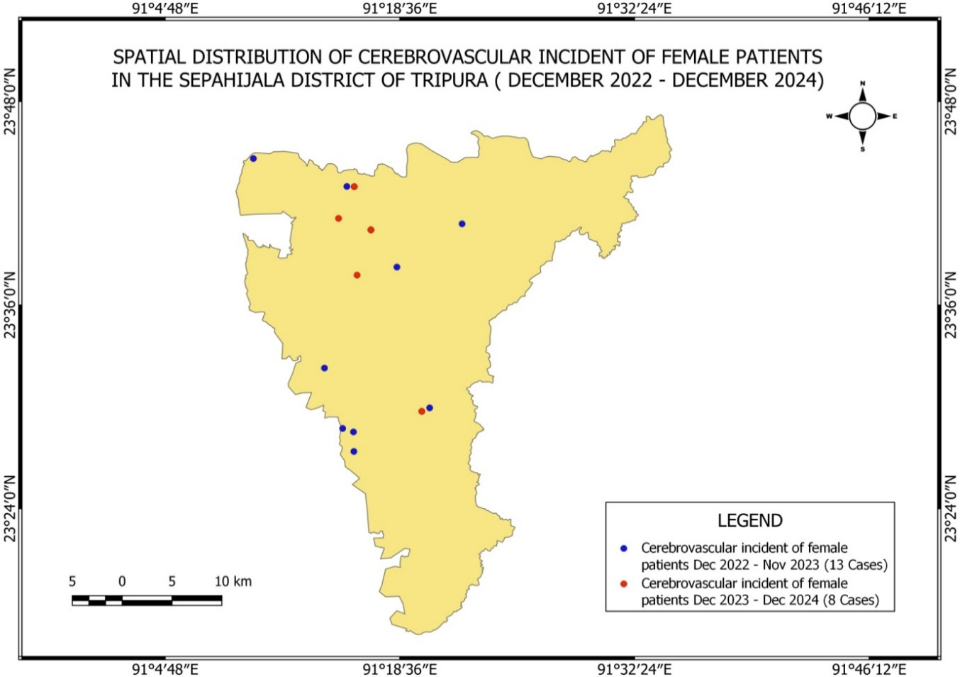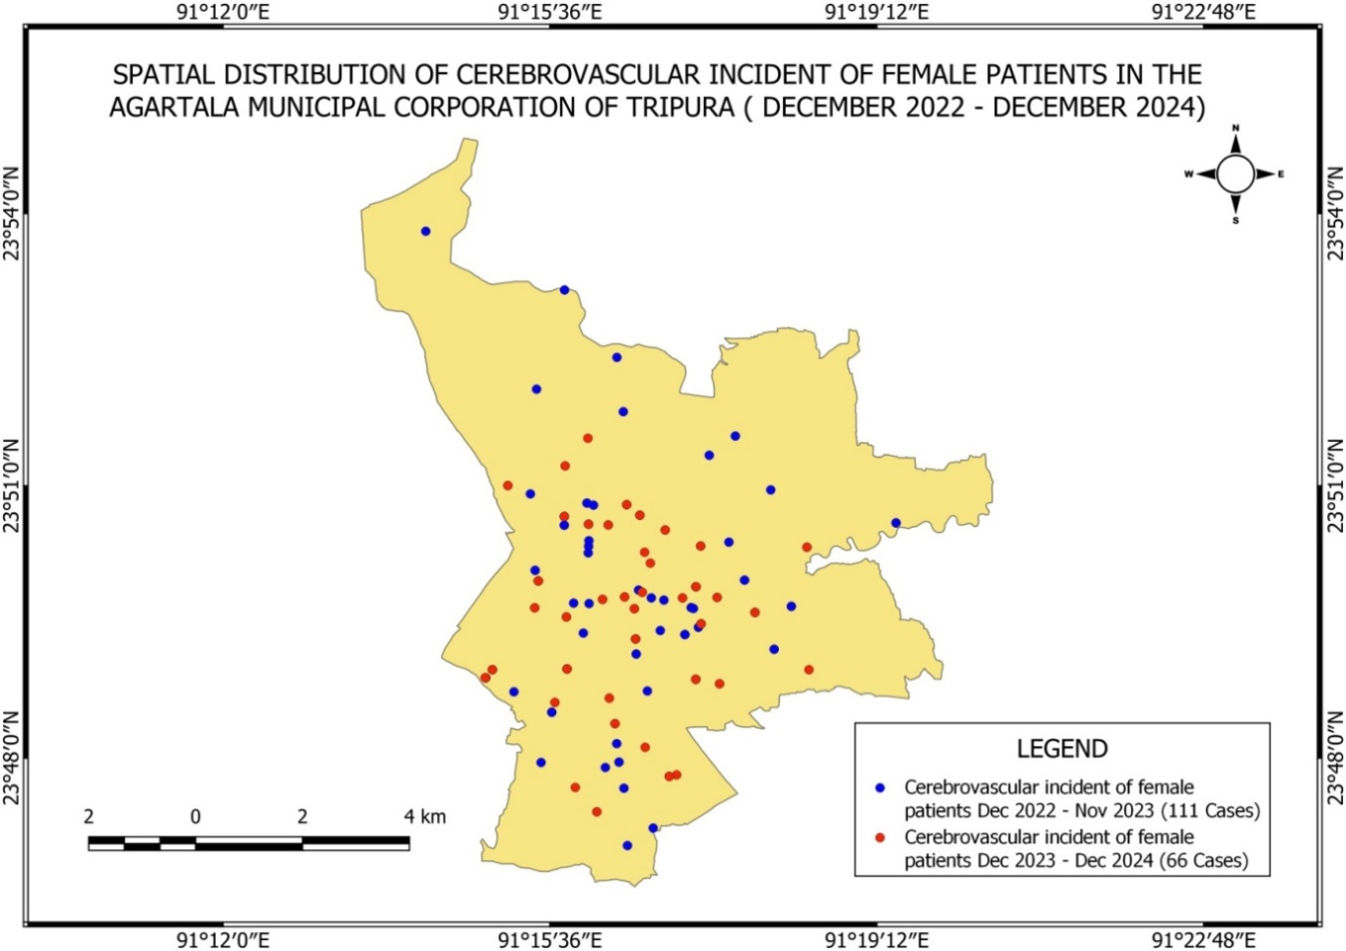

Fig.5 Spatial Distribution of Cerebrovascular Female Patients (Dec22-Dec24) in Sepahijala district

Fig.4 Spatial Distribution of Cerebrovascular Female Patients (Dec22-Dec24) map of Agartala

**3.3 Spatial Distribution of Cerebrovascular in Gomati district**

During the period of December 2022 to December 2024, the spatial distribution of cerebrovascular incidents among female patients in the Gomati district of Tripura and notes two cases noted over this period (Fig.6). The first instance a blue dot arose far to the west in the district between December 2022 and November 2023. Showed by a red dot and running between December 2022 and December 2024, the second instance resides in the southeast of the district. This spatial representation of the geographical occurrence of these health events helps future planning and focused medical reactions in the area.

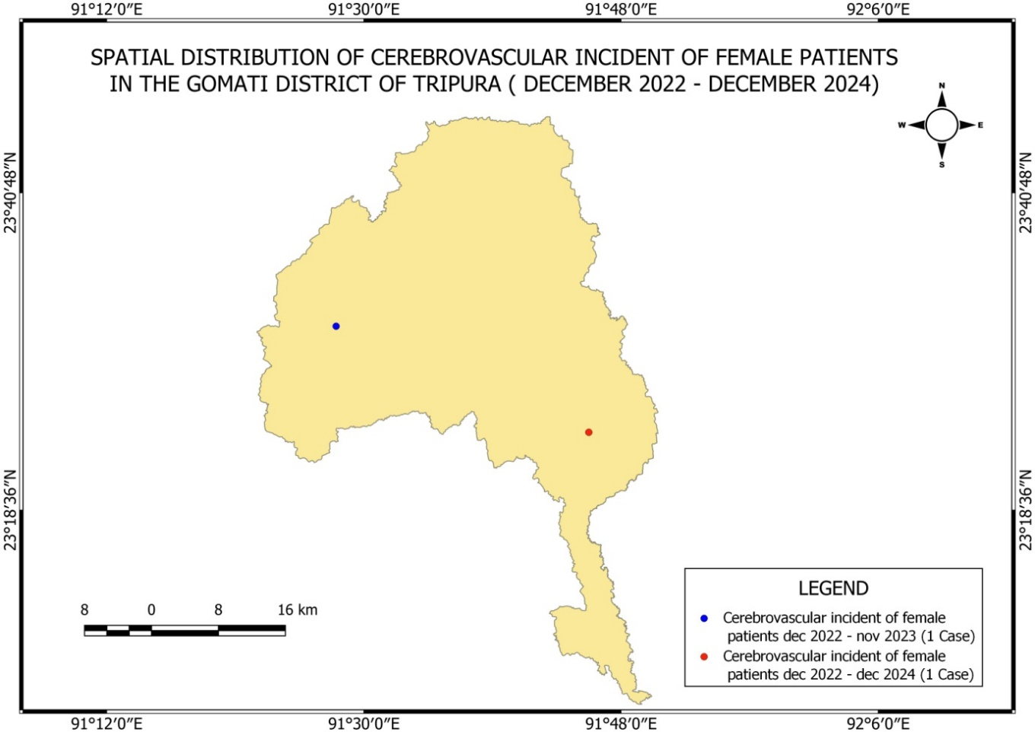

Fig.6 Spatial Distribution of Cerebrovascular Female Patients (Dec22-Dec24) in Gomati district

**3.5. Spatial Distribution of Cerebrovascular Female Patients in South District**

The geographical distribution of cerebrovascular episodes among female patients in the South District of Tripura during the study period, illustrated as blue dot on the map denotes each of the three events that were recorded (Fig.7). Due to the fact that the incidents are dispersed over the district, it is evident that these health issues are widespread and not limited to a single location. In order to address these risks,

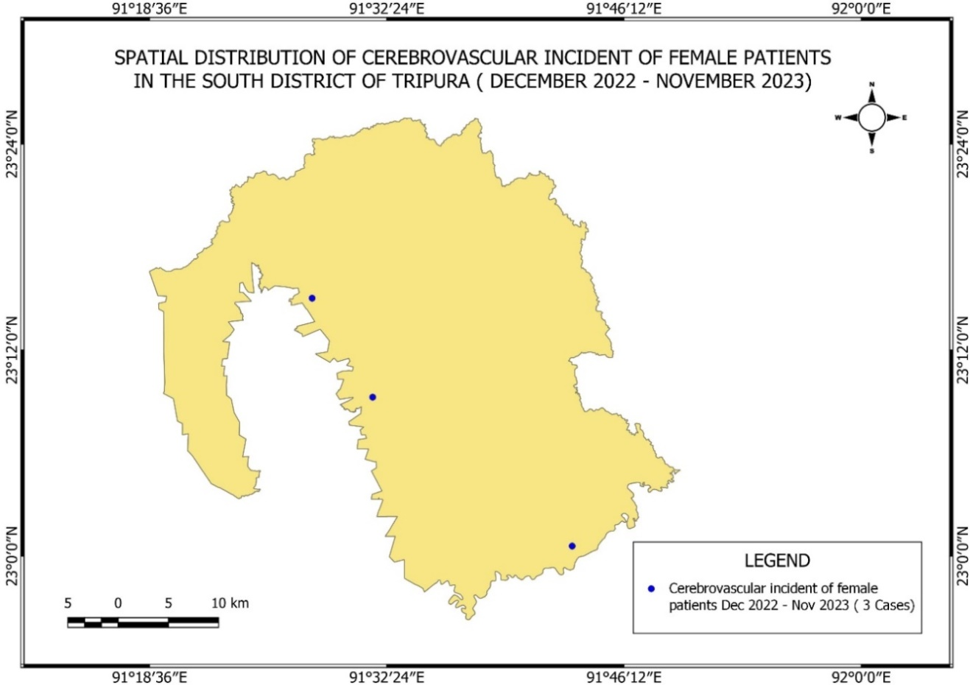

Fig.7 Spatial Distribution of Cerebrovascular Female Patients (Dec22-Dec23) in South Tripura

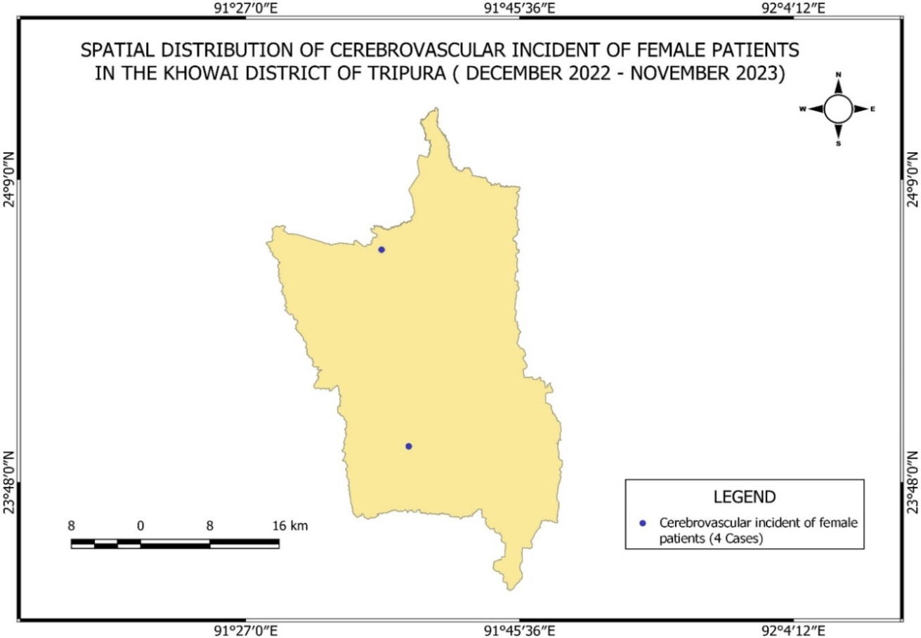

Fig.8 Spatial Distribution of Cerebrovascular Female Patients (Dec22-Dec23) in Khowai district

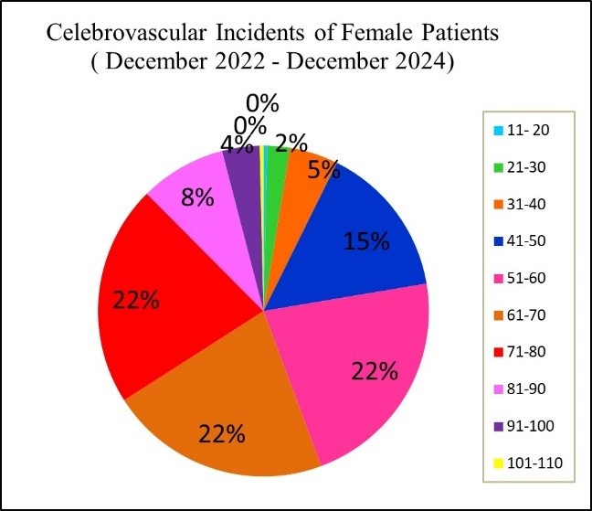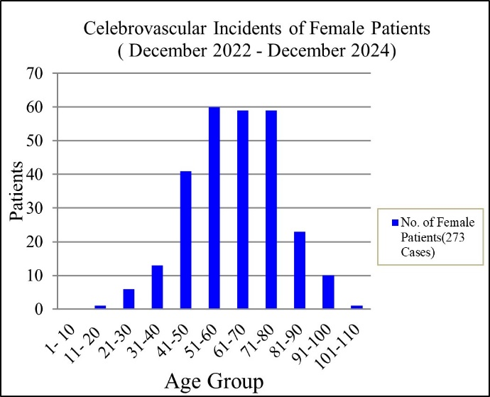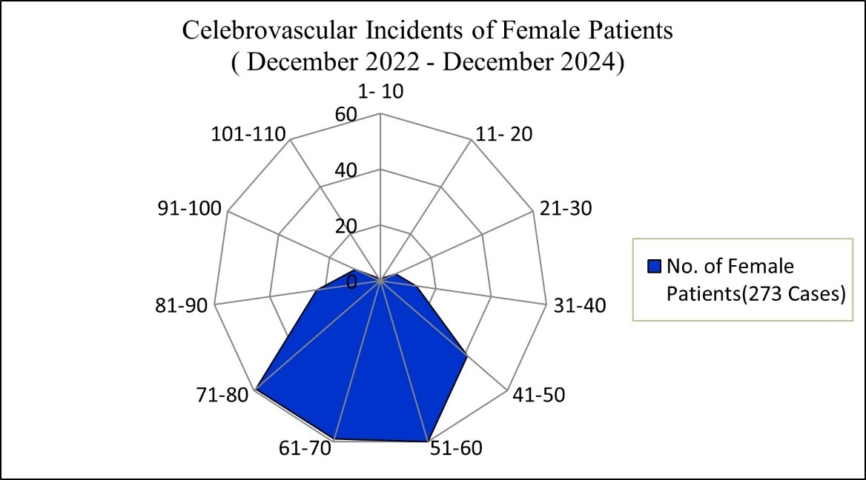

(a)

(b)

(c)

Fig.9a,b, and c. Bar, Pie and Radar Diagram of Cerebrovascular Female Patients (Dec22-Dec24)

The map displays the geographic distribution of cerebrovascular episodes among female patients in the Khowai area of Tripura between December 2022 and November 2023. Four cases in all have been located and are represented by blue dots on the map (Fig.8). Rather than concentrating in a single area, these occurrences are distributed across multiple parts of the county. According to these statistics, issues with women's cerebrovascular health have an impact on the entire region, which supports district-wide medical care and risk management strategies.

Female patients experienced 273 cerebrovascular events between December 2022 and December 2024, with an obvious focus in the 61–80 age range. Forming the main high-risk class, the three age categories—61–70, 71–80, and 51–60—each made for 22% of total cases. Incidence rates in patients younger than 40 or older than 80 were very low or non-existent; the 41–50 age bracket trailed with 15%. This regular pattern underlines the critical need of targeted preventative healthcare and screening in this demographic as the risk for cerebrovascular events among women reaches its maximum between the ages of 51 and 80 (Fig.10a, b, and c).

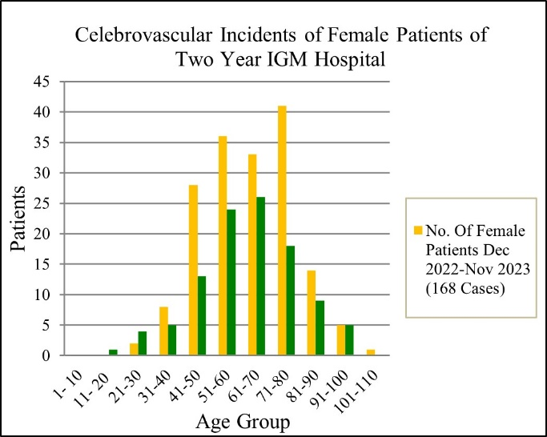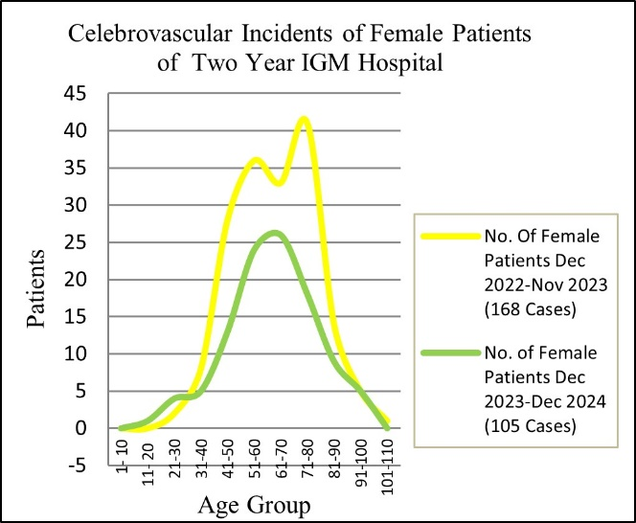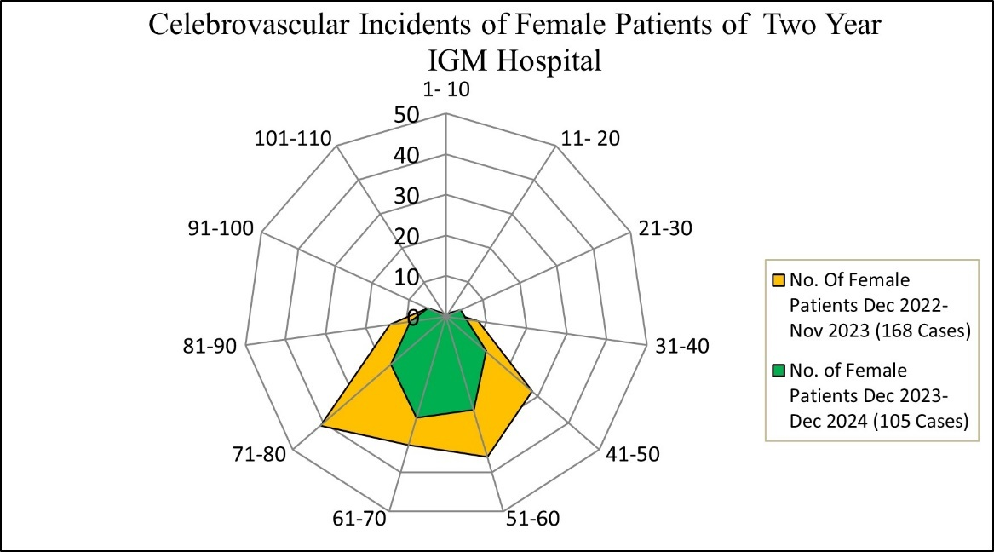

(a)

(b)

(c)

Fig.10a, b, and c. Bar, Pie and Radar Diagram of Cerebrovascular Female Patients Two year

Fig.10a, b, and c. Bar, Pie and Radar Diagram of Cerebrovascular Female Patients Two year

Cerebrovascular events among female patients at IGM Hospital show a consistent pattern of increased susceptibility in the 61–80 age group in the two-year combined December 2022 to December 2024 analysis of such events. Over 4,000 cases were reported during the first year (Dec 2022–Nov 2023), with a distinctive peak in the 71–80 age group. But the total number of cases dropped to 105 in the second year (Dec 2023–Dec 2024), while the same age ranges—61–70 and 71–80—remained the most affected. Graphs reveal that even if year-over-year variations in total cases have reduced in the second year, the age distribution of affected people stayed constant, underlining those older women, particularly those aged 61–80, still have the highest risk for cerebrovascular events (Fig.11a, b, and c).

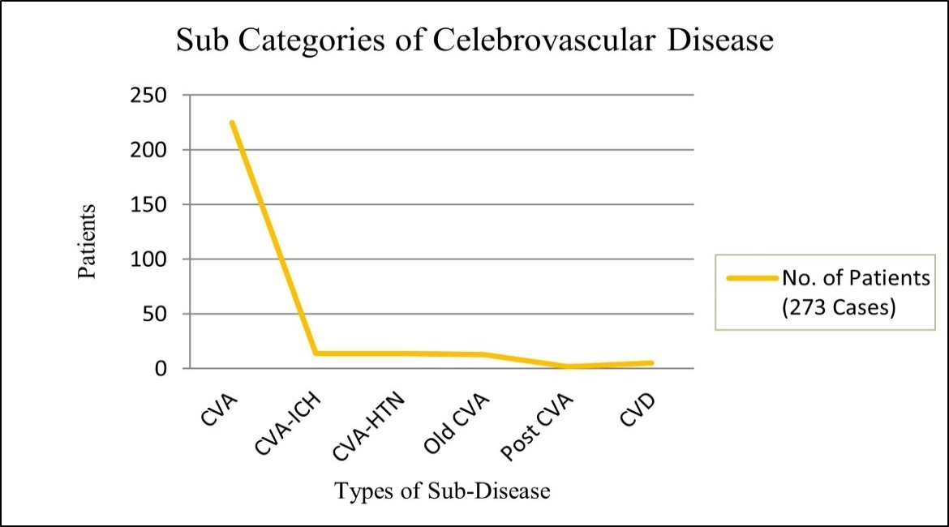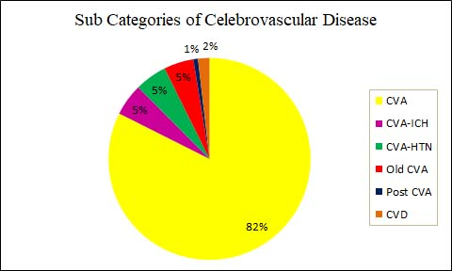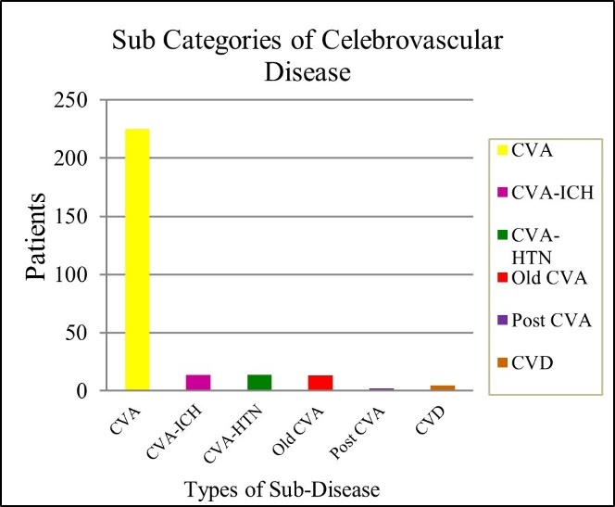

(a)

(b)

(c)

Fig.11a, b, and c. Bar, Pie and Line Diagram of Subcategories of Cerebrovascular Disease

Though more research on cerebrovascular disease is required, among the 273 cases recorded, the vast majority 82% were recognized as Cerebrovascular Accident (CVA), also known as stroke, thereby making it by far the most common subtype. Other subcategories were less frequent: CVA with Intracerebral Haemorrhage (CVA-ICH) and CVA related Hypertension (CVA-HTN) combined constituted 5% each of cases. Older CVA (patients with a history of earlier strokes) and Post CVA (patients in the recovery or follow-up phase) constituted 5% and 1%, respectively, in the mean whilst. Unusual instances encompassed cerebrovascular disease in general (2%) and Pontine CVA (a stroke affecting the pons area of the brainstem), which made just 1%. These results unmistakably show that CVA is the main worry in the larger category of cerebrovascular diseases, pointing to a pressing need for preventative and control measures concentrating on stroke and its immediate consequences (Fig.12a, b, and c).

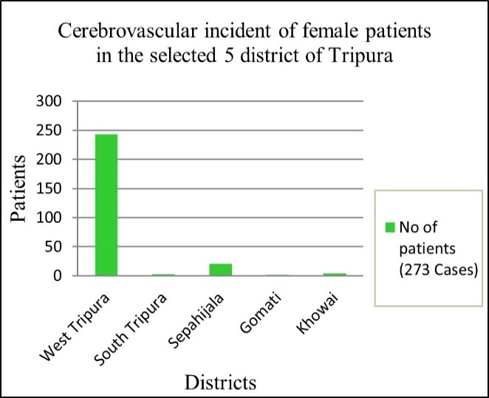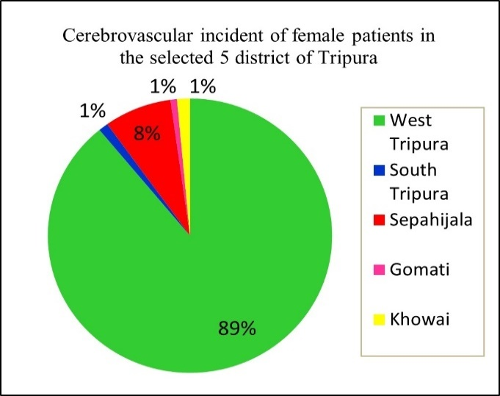

(a)

(b)

Fig.12a, and b, Bar, Pie Diagram of Cerebrovascular Female Patients in 5 selected districts

Of the 273 documented cases of cerebrovascular events among female patients from five chosen Tripura districts, West Tripura far out reported the largest number of cases, accounting for 89% of the total. By sharp contrast, South Tripura claimed 8 percent; Sepahijala, Gomati, and Khowai districts each only 1% of the aggregate cases. This huge difference points to West Tripura as a crucial hotspot for cerebrovascular disease among women, suggesting possible underlying causes including improved reporting capability, better access to medical services, or increased population density that merit deeper study and focused public health intervention (Fig.12a,b, and c)

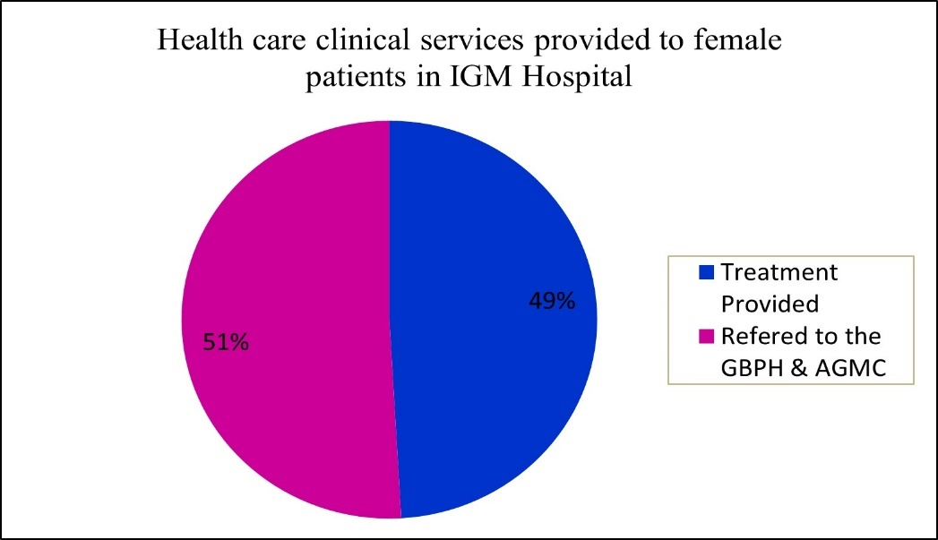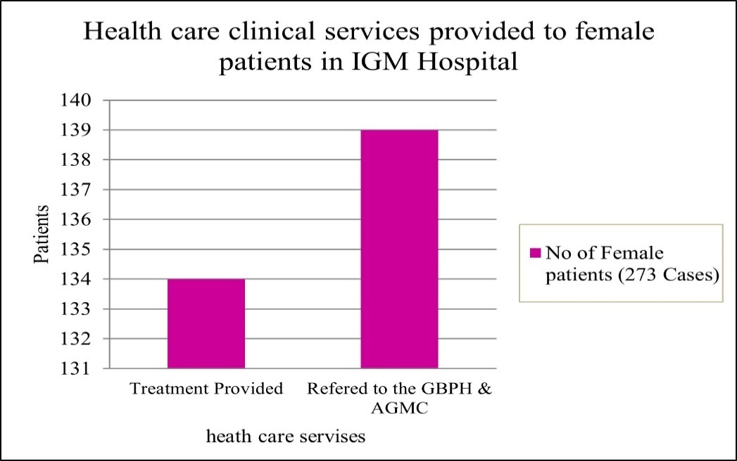

Fig.13a, and b. Bar and Pie Diagram of Clinical Services provided in the hospital

Among 273 female cases in IGM Hospital were split healthcare clinical services into two main groups: those directly treated at the hospital and those referred to GBP Hospital and AGMC. Visually, this is presented as a bar graph and a pie chart; the bar graph reveals the numeric distribution, and the pie chart shows that 49% of the female patients were treated at IGM Hospital, whereas a somewhat greater 51% were sent to other facilities. These close percentage points indicate a balanced but somewhat more dependence on referral sources for managing women patients' medical demands (Fig.13a, and b).

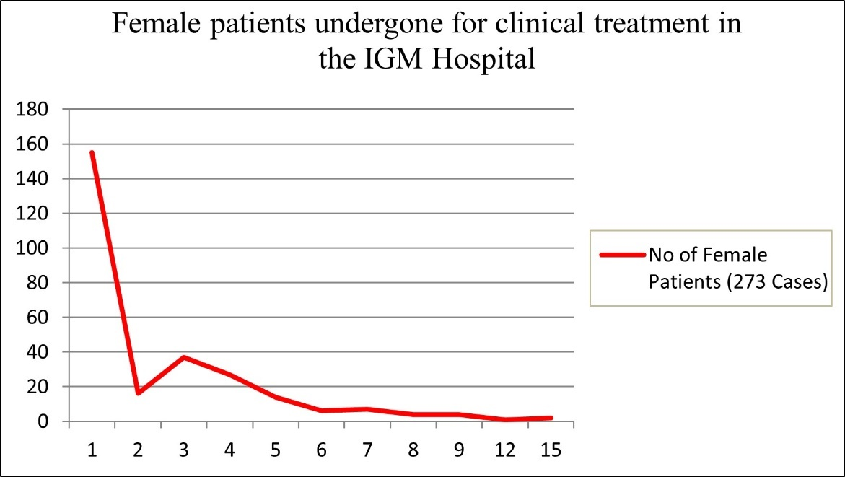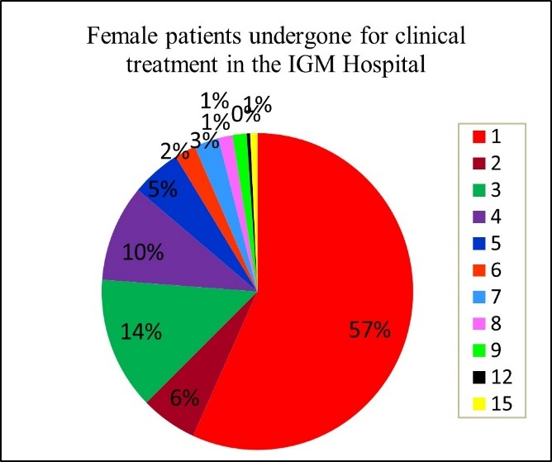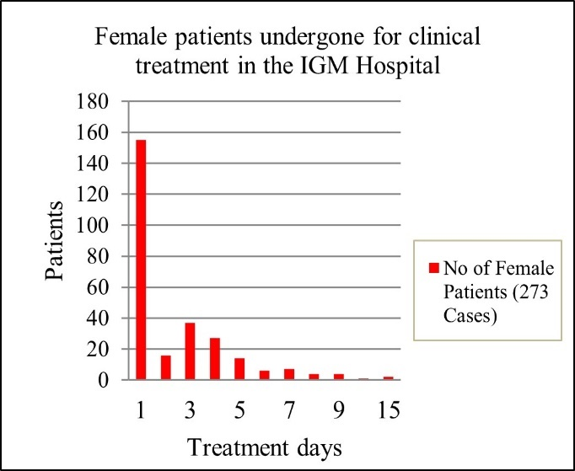

Fig.14a, b, and c. Bar, Pie and Line Diagram of Female Patients undergone clinical treatment in hospital

At IGM Hospital, the clinical treatment data for female patients reveals that most whooping 57% needed only one day of therapy, thus suggesting the pervasiveness of short-term or less severe conditions. The number of patients dropped sharply as treatment days climbed; 14% were treated for 2 days, 10% for 3 days, and only small percentages received treatment lasting longer, with 1% or less being treated for durations of 7 to 15 days. The bar graph, pie chart, and line graph all clearly show a steep drop in patient numbers as treatment length grew. Generally, the data shows that most female patients required little hospital stay, which points to either less serious illnesses or early interventions that work (14a, b, and c).

**Chi - Square Test**

|  |  |  |  |  |  |
| --- | --- | --- | --- | --- | --- |
| **Age Group** | **O** | **E** | **(O-E)** | **(O-E)^2** | **(O-E)^2/E** |
| 41-50 | 28 | 46 | -18 | 324 | 7.043478261 |
| 51-60 | 36 | 46 | -10 | 100 | 2.173913043 |
| 61-70 | 33 | 46 | -13 | 169 | 3.673913043 |
| 71-80 | 41 | 46 | -5 | 25 | 0.543478261 |
| **Total** | **138** |  |  |  | **13.43478261** |

Table.1 Chi-square table for most effected age group (Dec2022 - Nov2023)

Null hypothesis, H0 = CV doesn’t equally effective in age group.

Alternative hypothesis, H1 ≠ CV does equally effective in age group.

Total Number = 4

Mean Expected = Total Observed / (N-1) = 138/ (4-1) = 138/3 = 46

Chi-Square Value/ X2 = Sum of (O-E)^2/E = 13.43478261

Degree of Freedom = (N-1) = 4-1 = 3

Probability Value = 0.00378477

Significance at 3 level of DF of 0.05 = 7.815

P value < 0.01

A Chi-Square analysis was done between December 2022 and November 2023 to find out cerebrovascular (CV) disorders affected varied age groups of female patients equally. The study revealed a strong variation across age groups in the way the illness affected them; women aged 71 to 80 were the most adversely affected group. The most number of documented cases belonged to this age category: 41 of 138 total (Table.1). A chi-square test verified that the difference in cases across age groups was not random (χ² = 13.43, p < 0.01); this implies that age is a major factor in the prevalence of CV diseases among females and that older women especially in the age group of 71 - 80 are at significantly increased risk.

**Chi - Square Test**

|  |  |  |  |  |  |
| --- | --- | --- | --- | --- | --- |
| **Age Group** | **O** | **E** | **(O-E)** | **(O-E)^2** | **(O-E)^2/E** |
| 41-50 | 13 | 27 | -14 | 196 | 7.259259259 |
| 51-60 | 24 | 27 | -3 | 9 | 0.333333333 |
| 61-70 | 26 | 27 | -1 | 1 | 0.037037037 |
| 71-80 | 18 | 27 | -9 | 81 | 3 |
| **Total** | **81** |  |  |  | **10.62962963** |

Table.2 Chi-square table for most effected age group (Dec2023 - Dec2024)

Null hypothesis, H0 = CV doesn’t equally effective in age group.

Alternative hypothesis, H1 ≠ CV does equally effective in age group.

Total Number = 4

Mean Expected = Total Observed / (N-1) = 81/ (4-1) = 81/3 = 27

Chi-Square Value/ X2 = Sum of (O-E)^2/E = 21.712329

Degree of Freedom = (N-1) = 4-1 = 3

Probability Value = 0.013906842

Significance at 3 level of DF of 0.05 = 7.815

P value < 0.1

A statistical investigation was conducted from December 2023 to December 2024 to figure out cerebrovascular (CV) diseases were equally prevalent among various age categories of female patients. Among those most impacted according to the study were women aged 61 to 70, who made up the largest number of cases: 26 among 81(Table.2). Statistically significant, a chi-square test (χ² = 10.63, p < 0.0139) confirmed this difference, therefore it is not likely to have happened by chance. Age is a major determinant of the occurrence of CV conditions, with the age group of 61–70 riskier during this time than during another.

**Chi - Square Test**

|  |  |  |  |  |  |
| --- | --- | --- | --- | --- | --- |
| **Age Group** | **O** | **E** | **(O-E)** | **(O-E)^2** | **(O-E)^2/E** |
| 41-50 | 41 | 73 | -32 | 1024 | 14.02739726 |
| 51-60 | 60 | 73 | -13 | 169 | 2.315068493 |
| 61-70 | 59 | 73 | -14 | 196 | 2.684931507 |
| 71-80 | 59 | 73 | -14 | 196 | 2.684931507 |
| **Total** | **219** |  |  |  | **21.71232877** |

Table.3 Chi-square table for most effected age group (Dec2022 - Dec2024)

Null hypothesis, H0 = CV doesn’t equally effective in age group.

Alternative hypothesis, H1 ≠ CV does equally effective in age group.

Total Number = 4

Mean Expected = Total Observed / (N-1) = 219/ (4-1) = 219/3 = 73

Chi-Square Value/ X2 = Sum of (O-E)^2/E = 21.712329

Degree of Freedom = (N-1) = 4-1 = 3

Probability Value = 0.0000748678

Significance at 3 level of DF of 0.05 = 7.815

P value < 0.0001

A statistical study was undertaken between December 2022 and December 2024 to establish which age group of female patients suffered most from cerebrovascular (CV) diseases. With 219 cases recorded, the research examined four age ranges: 41–50, 51–60, 61–70, and 71–80 (Table.3). The distribution of cases over these age groups varied significantly according to a chi-square test, with a χ² value of 21.71 and a p-value <0. 0001. This robust statistical significance suggests that cerebrovascular problems did not impact all age groups symmetrically. Among the groups, women aged 51 – 60 were most impacted with the highest case count. Middle-aged women, especially those in their fifties, could be at higher risk according to these results, therefore they should be the emphasis of specialized knowledge and preventative healthcare programs.

**4. Conclusion**

The research on cerebrovascular events among female patients in Tripura during the period between December 2022 and December 2024 shows important geographical and demographic fluctuations. The spatial distribution map makes it obvious that West Tripura and Dhalai district have higher incidence rates, pointing to possible environmental or lifestyle risk elements and health facility discrepancies. In 2024, the most spikes, temporal analysis reveal that a slow increase of cases was occurred. This shows an increasing health burden calling for quick policy response. Women between 51 and 70 years old seem to be the most impacted group according age analysis, underscoring the need of direction screening and preventive care for middle-aged and older women. Reflecting national and international trends, among cerebrovascular subtype’s ischemic strokes are significantly more frequent than haemorrhagic strokes. Chronic diseases like diabetes and hypertension, which are major causes of ischemic strokes, call for more focus here. Finally, cerebrovascular occurrences among female patients in Tripura show a complicated pattern influenced by age, geography, and healthcare access. Pro-active policy measures, geographically informed planning, and fair distribution of healthcare will be important for reducing this increasing health issue. Integrating GIS-based epidemiological tools for surveillance, mapping, and analysis could be a datum of guidelines for the sustainable public health profile of Tripura.

1. **References**
2. Behera, P., *et al*., (2024), “Analyzing Stroke Burden and Risk Factors in India Using Data from the Global Burden of Disease Study”, *Scientific Reports*,. https://www.nature.com/articles/s41598-023-43977-z
3. Kalita, J., et al. “Prevalence, Contributing Factors, and Economic Implications of Strokes Among Older Adults: A Study of North-East India.” Journal Article, PMC, 2023. https://www.ncbi.nlm.nih.gov/pmc/articles/PMC10558533/
4. Carvalho, R., et al. “Assessment of Stroke Severity and Mortality (ASSAM): A Hospital-Based Study from North-East India.” *Indian Journal of Community and Family Medicine*, 2024. https://journals.lww.com/ijcf/fulltext/2024/10020/assessment_of_stroke_severity_and_mortality.3.aspx
5. Roy, P. “Factors Associated With Stroke Burden in India.” Amrita Journal of Medicine, 2021. https://journals.lww.com/amjm/fulltext/2021/17010/factors_associated_with_stroke_burden_in_india.1.aspx
6. Kamalakannan, S., *et al*., (2017), “Incidence & Prevalence of Stroke in India: A Systematic Review.” *The Indian Journal of Medical Research*, 146(2):175–185. https://doi.org/10.4103/ijmr.IJMR_516_15
7. Das, S., and T. K. Banerjee. “Stroke: Indian Scenario.” Circulation, vol. 118, no. 25, 2008, pp. 2719–2724. https://www.ahajournals.org/doi/10.1161/CIRCULATIONAHA.107.758159
8. Banerjee, T. K., and S. Das. “Fifty Years of Stroke Research in India.” Annals of Indian Academy of Neurology, vol. 19, No. 1, 2016, pp. 1–8. https://www.ncbi.nlm.nih.gov/pmc/articles/PMC4891166/
9. Ram, P., et al. “Risk Factors Predisposing to Acute Stroke in India: A Prospective Study.” Journal of Hypertension, 2021.
10. Kaul, S., et al. “Stroke Burden and Risk Factors in Developing Countries with Special Reference to India.” Journal of the Indian Medical Association, 2009.
11. Ramachandran, A., et al. “Risk Factors for Stroke in India: A Systematic Review.” PubMed, 2019.
12. Joshi, A., and S. Kaur. “Stroke Rehabilitation Services in India: Current Scenario and Future Prospects.” Rehabilitation Journal, 2022.
13. Babu, R., and M. Kurup. “Lifestyle Interventions and Stroke Prevention in India.” Indian Journal of Sports Medicine, 2019.
14. Patel, N., et al. “Urban-Rural Disparities in Stroke Outcomes in India.” The Lancet, 2015.
15. Gupta, S., et al. “Temporal Trends in Stroke in India: Data from the Global Burden of Disease Study.” GBD Publications, 2021.
16. Mondal, S., et al. “Stroke in Young Adults in India: An Emerging Concern.” Stroke Research Journal, 2022.
17. Kapoor, V., et al. “Patterns of Stroke Subtypes in India: A Multicenter Study.” Multicenter Stroke Study, 2020.