***Original Research Article***

**Dynamics of Dust Events in Riyadh: Analyzing the Impact of Precipitation from 2017 to 2023**

**Abstract**

This study investigates the relationship between precipitation and dust events occurrences in Riyadh, Saudi Arabia, during two distinct periods from 2017 to 2018 and 2022 to 2023. The primary objective is to analyze how variations in precipitation influence the frequency and intensity of dust events in Riyadh. Data were collected from the National Center for Meteorology (NCM), encompassing hourly records of dust events, precipitation, wind (speed\ direction). Statistical analyses were performed using SPSS, focusing on regression analysis and correlation coefficients to identify significant relationships. Findings reveal a notable inverse correlation between precipitation and dust events occurrences. In 2018, Riyadh recorded a total rainfall of 92 mm, which coincided with 276 dust events. In contrast, in 2023, rainfall increased significantly to 147.1 mm, leading to a dramatic reduction in dust events to just 44 events. The study highlights that continuous rainfall during the wet season from October to May, especially in substantial amounts, facilitates soil cohesion and increases moisture levels, thereby promoting vegetation cover. These findings underscore the critical role of precipitation in mitigating dust events activity, emphasizing the necessity of effective water management and environmental strategies to combat dust-related issues. The study contributes to a deeper understanding of the climatic factors influencing dust dynamics in urban environments, providing valuable insights for policymakers and environmental management strategies.

**Keywords**

Dust storms, Precipitation, Riyadh, Climate, Statistical analysis.

**Introduction:**

Dust and sand storms are common natural phenomena in arid regions, significantly impacting the environment and human health. This study focuses on Riyadh, the capital of Saudi Arabia, where the frequency of these phenomena has decreased in recent years. The objective of this research is to analyze the relationship between precipitation and the occurrence of dust events from 2017 to 2018 and 2022 to 2023. A review of the literature reveals that while previous studies have explored the impact of these factors on dust, there is a lack of comprehensive studies specifically addressing their effects in Riyadh. Therefore, this study serves as a new step aimed at filling the knowledge gap and providing recommendations based on the data and analyses conducted. Dust events are a natural meteorological phenomenon that occurs in desert locations (Prospero et al., 2002), where powerful winds carry dust and sand particles across large distances (Grousset et al., 2003). The size of the phenomenon ranges from dust devils that are just a few tens of meters wide to vast dust plumes that can span hundreds of thousands of square kilometers (N.J. Middleton, 1984, Grigoryev, et al.,1980). The Middle East, especially the Arabian Peninsula, is highly impacted by dust storms, with the African and Asian deserts serving as main dust suppliers (Awad et al., 2016). The Arabian Peninsula has been recognized by (Idso,1976, Chylek, et al., 1995, and D'Almeida, 1987) as one of five major global regions where dust storm activity is particularly intense. Prospero (1981) notes that a significant area of dust haze is typically observed in the Arabian Sea during the months of June, July, and August. Various studies have evaluated the aeolian contribution to sediments in the Arabian Gulf, as well as the Arabian and Red Seas (Emery, 1956; Sugden, 1963; Stewart, Pilkey et al., 1965; Kolla & Biscaye, 1977; Khalaf & Al-Hashash, 1983, Washington, et al., 2005). Additionally, some research has been conducted on aerosols over the Arabian and Red Seas (Cailleux, 1961; Aston et al., 1973; Sadasivan, 1978; Prodi, Santachiara et al., 1983, Zender, et al., 2003). Several authors have reported on dust storm frequencies in various parts of the Middle East (Coles, 1938; Katsnelson, 1970; Al-Najim, 1975; Safar, 1980), while (Goudie, 1983) provided a general overview of their distribution across the region. The Arabian Peninsula has enormous dunes, deserts, and topographical complicated terrain with minimal vegetation cover and low precipitation, which creates circumstances conducive to dust particle suspension in the atmosphere (Al-Hajji et al., 2025). The prevailing northwesterly winds, such as the Al Shamaal winds, play an important role in mobilizing dust across the peninsula (Awad et al., 2016; Mashat et al., 2016). Monthly and seasonal variability of aerosol index (AI) distributions between the northern and southern regions of Iraq, with maximum values occurring during the hot summer months and minimum values in the cold winter months (Attiyaet al, 2019). The results indicate that Iraq has been exposed to the maximum number of dust events in the spring and summer seasons over the past 35 years, with the highest activity in the southern and central regions such as Nasiriya and Baghdad, where suspended dust is more frequent than rising dust or dust storms (Attiya et al, 2020). The expansive dunes and deserts of the Arabian Peninsula, along with the surrounding topographically complex terrain, provide essential conditions for lifting dust into the atmosphere (Al-Hajji et al., 2025). This region is characterized by very low precipitation levels and sparse vegetation cover, which facilitate the movement of dust particles into the air (Albugami, 2019). In the Sahara, wind is the main carrier of sand. Obstacles like trees and terrain reduce wind velocity and increase pressure drop, promoting sand deposition and dune formation (Middleboe, et al., 2003, Tegen, et al., 2002, Remini et al, 2020). The Sahara Desert functions through surface winds and underground water, leading to the formation of vast ergs and significant underground bodies of water (Remini et al, 2021). They occur when extreme surface heating drives the air above to rise, causing hot ascending currents and resulting in pressure and temperature inequalities. The passage of colder breezes to fill the vacuum leads to the lifting of dust and sand particles to higher altitudes, depending on the intensity of the wind (Fisher, 1978, Abballo, 2016). By virtue of their distinctive optical properties, mineral dust aerosols scatter and absorb shortwave (SW) and absorb and reemit longwave (LW) radiation (e.g., Tegen and Lacis, 1996; Kinne et al., 2003; Dubovik et al., 2006), modifying, therefore, atmospheric thermodynamics, regional atmospheric circulations and the Earth's energy budget (e.g., Slingo et al., 2006; Sokolik & Toon, 1996; Heald et al., 2014, Carlson, et al., 1980, Hinds, et al.,1975). By modifying the radiative forcing, dust aerosols affect local climatic parameters such as temperature, winds and precipitation (Sharma et al., 2012; Rap et al., 2013; Liu et al., 2014; Chen et al., 2017). The amount of transported dust is directly influenced by the wind's intensity, and numerous internal and external elements contribute to the occurrence and increased frequency of dust storms (Al-Biyati, 2011, Sissakian, et al., 2013). Dust leads to a reduction in tropical cyclone activity over the North Atlantic Ocean, as revealed by a tropical cyclone tracking scheme (Al-Hajji et al., 2025). The most significant impact occurs in the optical regimes characterized by high absorption and scattering (Beckett, et al. 1956, Strong et al, 2018). While climatic conditions alone do not solely cause dust storms, factors such as temperature, relative humidity, land degradation at local and regional levels, topography, limited rainfall, and geographical location all contribute to the occurrence and frequency of dust storms (Al-Biyati, 2011; Al-Amshi et al., 2020). Severe dust movements significantly reduce visibility, impacting travel speeds and consequently affecting various economies (Asare-Ansah et al, 2022). Another study indicates that daily variations in Aerosol Optical Depth (AOD), along with wind speed, humidity, precipitation, and the spatial distribution of dust sources both within and outside the country, are significant factors (Ayanlade et al, 2019). Human factors, including the mismanagement and deterioration of natural resources, also play a role in the occurrence of dust storms. Identifying the synoptic meteorology associated with dust emissions, transport, and deposition is crucial for understanding the mechanisms driving the dust cycle from source areas to receptors (Al-Hajji et al., 2025). Dust storms typically occur in conjunction with strong pressure gradients and high wind speeds (Hermida et al., 2018, Al-Hamadi, A. 2020). Atmospheric suspension and transport of sand and dust bring a reasonable amount of electrification into the atmosphere which plays a very important role in the atmosphere-ionosphere coupling (Uluma et al, 2024, Edward et al., 2024). Key parameters such as mean sea pressure level (MSPL), geopotential height anomalies, wind speed, and wind direction have been utilized to assess dust emissions and transport across the Arabian Peninsula (Beegum et al., 2018; Hamidi et al., 2013; Mashat & Awad, 2016; Namdari et al., 2018). The predominant types of synoptic-scale dust storms in the Arabian Peninsula include the northwesterly Shamal wind, as well as pre-frontal and post-frontal winds (Francis et al., 2021; Hamidi et al., 2013; Middleton et al., 2017; Shao, Y et al., 2011). West Asia, particularly the Tigris–Euphrates alluvial plain, is experiencing severe desertification due to a variety of factors, both climatic and human-induced (Al-Hajji et al., 2025). Key contributors include global warming, land-use mismanagement, agricultural practices, overgrazing, marginal ploughing, and the impacts of years of warfare (Hui Cao et, al, 2015). Recent studies have highlighted high wind speeds as a key factor associated with dust storm outbreaks in Saudi Arabia (Alharbi & Abdel-Dayem, 2015; Alharbi & Abdel-Dayem, 2018). Dust storms in the region are most prevalent in spring and originate from the Karakum desert in Turkmenistan and the Sistan Basin in Iran. Synoptic weather conditions, including the configuration of high-pressure and low-pressure systems, influence dust storm activity in northern and southwestern Saudi Arabia (Awad et al., 2016; Al-Dabbas & Al-Nasrawi, 2017). The Jazmurian basin in southeastern Iran also serves as a dust storm source area affecting the northern Arabian Sea and surrounding regions (Al-Hajji et al., 2025). The occurrence of dust storms is linked to the Asian summer monsoon system and the activity of the Shamal and Levar winds over the Arabian Sea during the summer season (Zhang et al., 2003; El-Askary et al., 2014; El-Askary et al., 2013). Although dust storms can occur year-round in Saudi Arabia, their spatial and temporal distribution varies. Previous studies have shown regional differences in the peak season of dust storm activity. For instance, in the central region around the Al-Nafud desert, dust storms peak in the spring season (March, April, and May) (Rashki et al., 2013), (Kaskaoutis et al., 2013). The (A.S Modaihsh, 1997) revealed that Riyadh, the capital of Saudi Arabia, experiences substantial annual dust accumulation, primarily consisting of loam and silt loam with high levels of CaCO3, electrical conductivity, and pH (Al-Hajji et al., 2025). Notable trace elements detected include lead (66.8 μg/g), nickel (26.0 μg/g), and manganese (318.9 μg/g), likely from both natural and anthropogenic sources. Another study found that the removal of vegetation cover has contributed to the loosening of the topsoil, which in turn has led to the formation of clay and sand-sized particles (Sissiakan et al, 2013). Another study's findings revealed that kaolinite, gypsum, albite, quartz, and calcite were the major mineral dust components in airborne dust samples collected across Iraq, with high percentages of Zn and Pb found particularly in the eastern and central regions (Attiya et al, 2020). A severe dust storm in Sydney resulted in PM10 concentrations reaching up to 578.7 µg/m³, significantly exceeding the standard air quality limit of 50 µg/m³. The storm, driven by strong northwest winds and associated with low-pressure systems, highlighted the critical impact of dust storms on urban air quality and public health (Attiya et al, 2022). A massive dust storm in Baghdad significantly deteriorated air quality, with PM10 concentrations reaching up to 5000 µg/m³, far exceeding the standard limit of 50 µg/m³. This event was driven by northwest winds and low-pressure systems, exacerbated by regional drought conditions (Attiya et al, 2024). The severe dust storms significantly impact air quality and public health in Baghdad, with a notable increase in suspended particulate concentrations during storm events (Attiya et al, 2023). The dominant minerals in the dust were quartz and calcite, emphasizing the significant dust presence in the region. However, our understanding of how climate factors influence the spatial and temporal variations of dust storms across the entire Arabian Peninsula remains limited (Al-Hajji et al., 2025). This study aims to analyze the impact of precipitation (P), wind speed (WS), and wind direction (WD), on the occurrence of dust storms in the city of Riyadh from 2017 to 2018 and 2022 to 2023. Additionally, the study will compare these results with data from 2023 to understand the reasons behind the notable decrease in dust events in Riyadh during this year. It also seeks to provide a comprehensive characterization of the frequency and distribution of dust storms within the city. By exploring the relationship between dust storm occurrences and precipitation, the study aims to address existing knowledge gaps in this area. Additionally, it will highlight the regional dynamics of dust storms in Riyadh, offering new insights into their frequency, distribution, seasonality, and diurnal variations. However, there is a lack of comprehensive studies examining the relationship between dust storm occurrences in Riyadh and precipitation. While some research exists on dust storms in the broader Middle East region, it does not provide an in-depth analysis of their frequency, distribution, seasonality, and diurnal variation. This investigation aims to address this gap and contribute to a better understanding of these dynamics in Riyadh.

**Methodology:**

The methodology of this study focuses on the occurrence and characteristics of dust storms in Riyadh, utilizing a structured approach to data collection and analysis.

**Study Location:**

The city of Riyadh, the capital of Saudi Arabia, is located in the central region according to the administrative division of the country. It is represented in the current study by the climate station at King Khalid International Airport (OERK). Riyadh is geographically situated at a longitude of 46.43 degrees east and a latitude of 24.38 degrees north. It is also located at an elevation of 600 meters above sea level (Riyadh Development Authority, 2012). Riyadh has several geographical features that distinguish it from other cities in Saudi Arabia. It is situated in the eastern part of the heart of the Arabian Peninsula, in the middle of the Kingdom of Saudi Arabia, which occupies a central position among the continents of the world. This location gains further significance as it is located in the exact center of the Arabian Peninsula on a sedimentary plateau in the eastern part of the Najd Plateau. The main topographical features of Riyadh are characterized by its valleys, with Wadi Hanifa being the most important one. It cuts through the city from the northwest to the southeast, with a length of approximately 120 kilometers. The depth of the valley ranges from less than 10 meters to over 100 meters, and its width varies between less than 100 meters to nearly 1000 meters (Figure 1, 2) (Riyadh Development Authority, 2012; Almazroui & Islam, 2015; Al-Saud, 2018).

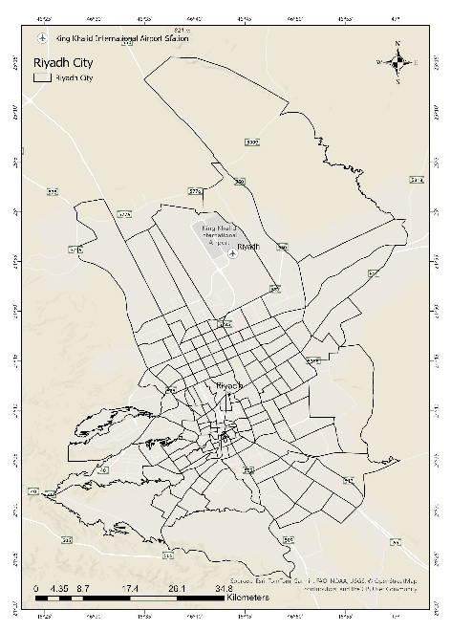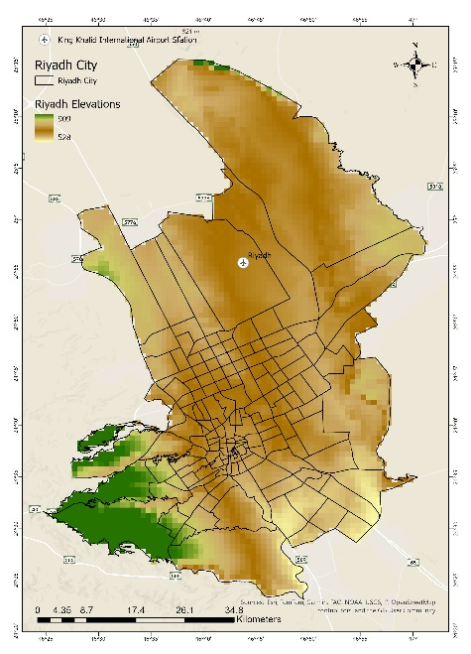

**Figure 1:** Study Area**Figure 2:** Elevation map of Riyadh

**Data Collection:**

Data collection was conducted in two primary categories: dust storm events and climate variables.

* **Dust Storm Events Data**: Hourly dust storm events data spanning from (2017 to 2018 and 2022 to 2023) were obtained from the National Center for Meteorology (NCM), the official climate agency in Saudi Arabia. This dataset includes several types of dust events, such as dust storms (DS), sandstorms (SS), blowing dust (BLDU), and blowing sand (BLSA). According to the World Meteorological Organization (WMO) standards as in this Volume II to the WMO Technical Regulations, 2025), dust events are defined by wind speeds exceeding 22 km/h and visibility less than 5 km. For dust and sandstorms, the criteria are wind speeds of 30 km/h or more and visibility of 1 km or less.
* **Climate Variable Data**: Monthly and seasonal climate data (Wind speed and direction, and precipitation) for Riyadh from (2017 to 2018 and 2022 to 2023) were acquired from NCM. This dataset encompasses daily rainfall totals, hourly and daily wind speed measurements, and wind direction observations.
* **Model Data**: The MERRA-2 (Modern-Era Retrospective analysis for Research and Applications, Version 2) data assimilation system represents a state-of-the-art atmospheric reanalysis product developed by NASA's Global Modeling and Assimilation Office (GMAO). The system builds upon the fifth-generation Goddard Earth Observing System Model (GEOS-5) atmospheric general circulation model (Molod et al., 2015), integrated with the Goddard Chemistry Aerosol Radiation and Transport (GOCART) module that simulates the physical and chemical processes of five primary aerosol types: black carbon, mineral dust (sand), organic carbon, sulfate, and sea salt aerosols (Chin et al., 2002). Additionally, data from the MEERA-2 numerical model was utilized to enhance the understanding of atmospheric conditions influencing dust storm occurrences. This model provided valuable insights into weather analyses and forecasts relevant to the study.

**Data Analysis Tools:**

The analysis employed numerous statistical methods and tools to examine the relationships between dust storm occurrences and precipitation. Regression analysis was utilized to identify potential correlations between precipitation and the frequency of dust storm events. Additionally, correlation coefficient analysis was performed to quantify the strength and direction of these relationships.

* **Wind Rose Diagrams**: To visualize wind patterns in Riyadh, data from the Iowa State University Mesonet was used to create wind rose diagrams. This tool provided a clear representation of wind speed and direction distributions, enhancing the understanding of atmospheric conditions that influence dust storm occurrences.
* **Spatial Analysis**: Spatial interpolation of dust storm events was performed using the **Spline with Barrier** tool in **ArcGIS Pro 3.3**, which allowed for the creation of continuous raster layers representing the spatio-temporal distribution of dust storms. This method facilitated the assessment of variability in dust storm events over time.
* For data processing, Microsoft Excel was used for initial data organization and linear trend fitting, while SPSS (Version 26) was employed for advanced statistical analyses, including simple regression coefficients and seasonal variations.

**Data Comparison and Visualization:**

To analyze the relationship between precipitation and dust storm occurrences, comparisons were made between dust-free weather conditions and dust storm conditions from (2017 to 2018 and 2022 to 2023). Visualizations, such as wind rose diagrams created from the Iowa State University data, illustrated wind speed and direction distributions. Additionally, the NASA Earth Observatory website was utilized to present case studies on dust storms affecting Riyadh, providing context and visual support for the findings. The MEERA-2 numerical model contributed to understanding the atmospheric conditions relevant to this study. This comprehensive methodology ensures a thorough analysis of the spatio-temporal variations in dust storm occurrences in Riyadh, providing valuable insights into the climatic factors influencing these events.

**Sources of Data:**

The study relied on primary data sources, including the National Center for Meteorology (NCM) for meteorological and dust storm data )<https://ncm.gov.sa/ar/Pages/default.aspx>( , and the Iowa State University for wind data visualization ([https://www.iastate.edu/](https://mesonet.agron.iastate.edu/sites/windrose.phtml)). Furthermore, the NASA Earth Observatory website was referenced for additional insights into dust storm events and their characteristics (<https://nasa.gov/>). The MEERA-2 numerical model (<https://nasa.gov/>) also contributed to understanding the atmospheric conditions relevant to this study. This comprehensive methodology ensures a thorough analysis of the spatio-temporal variations in dust storm occurrences in Riyadh, providing valuable insights into the climatic factors influencing these events.

**Results:**

**The statistical analysis of the climate variables:**

**Precipitation:**

Precipitation is considered as the effective climatic factor that can reduce the occurrence of dust and sandstorms. In Riyadh, rainfall falls into two types: the first type is called frontal rainfall, which is caused by low-pressure systems and occurs during the months of December, January, and February. The second type is called thunderstorm rainfall, locally known as "Al-Sariyat", and it occurs during the months of October, November, as well as at the end of the rainy season from October to May. Rainfall in Riyadh is characterized by its scarcity and variability, as is typical in desert regions. The amount of rainfall also varies significantly from year to year. From Oct 2017 to 2018 and Oct 2022 to 2023, the annual average rainfall was approximately 76 millimeters (mm). The annual rainfall in 2017 was around 84 mm, while in 2018, it reached approximately 108 mm. In 2022, it was about 92 mm, and compering with amounts in 2023, it reached around 147.1 mm, and the highest month was Jan 2023 reached 79.8 mm, and in Jan 2022 was 35.4 mm, and the lowest was in Jan in 2017 and 2018 reached 0 mm (Figure 3, 4). There is also a significant variation in rainfall amounts throughout the different months of the year 2017 to 2023. The peak rainfall months are February 2017 (36.8 mm), April 2018 (43.5 mm), December 2022 (46.5 mm), January 2023 (79.8mm). During the period of October 2017 to 2018, the average precipitation was approximately 120 mm. Notably, there was an increase in precipitation in April, with a recorded value of 44 mm. However, in December, the precipitation decreased to 5.3 mm. In contrast, the period from October 2022 to 2023 exhibited different precipitation and dust and sandstorm patterns. The average precipitation during this period was around 197 mm. The month of January experienced a substantial increase in precipitation, reaching 80 mm, whereas in December, there was a decrease to 6 mm.

Rainfall decreases noticeably in June, July, August, and September, with totals of 0.0, 1.1, 1.2 mm, respectively. illustrates the duration of dry spells in Riyadh. The dry season coincides with the period of strong northly winds, which contributes to the aeration of the soil and increases the chances of dust and sandstorms due to the low vegetation cover, soil disintegration, and higher temperatures, leading to an increase in airborne sand and dust particles.

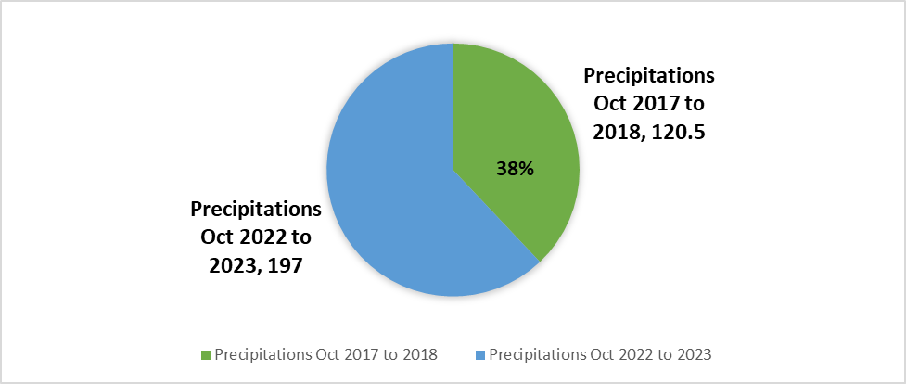

**62%**

**Figure 3:** Annually Precipitation in Riyadh during October 2017 to 2018 and October 2022 to 2023

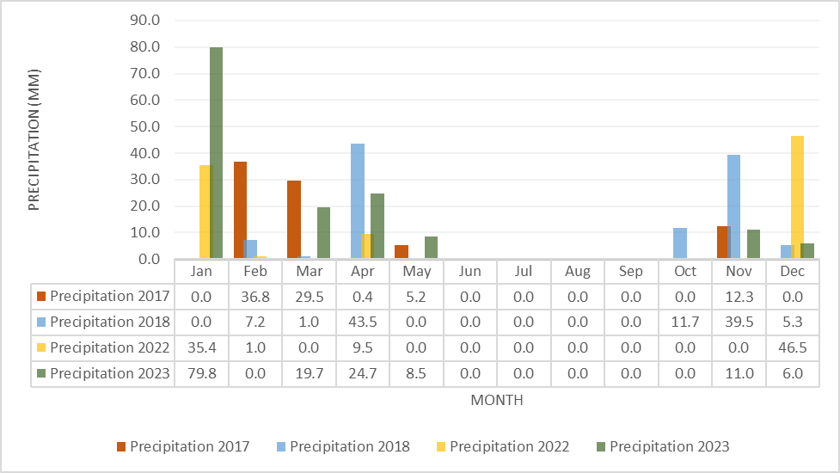

**Figure 4**: Monthly Precipitation in Riyadh during October 2017 to 2018 and October 2022 to 2023

**Wind speed and direction:**

The prevailing winds in Riyadh during the study period from 2017 to 2023 predominantly originated from the north, northeast, northwest, and east-southeast directions as showed in (Figure 5). The annual average wind speed in Riyadh was approximately 6.1 knots, while the average monthly wind speed recorded in 2023 was around 5 knots. These wind patterns are critical for understanding the atmospheric conditions that influence dust storm occurrences and overall climate in the region.

The (Figure 6) and (Table 1) showed that in the summer months, specifically June, July, and August, wind speeds tend to be higher, averaging around 7 knots. This increase can be attributed to the intense heat that creates stronger pressure gradients, leading to more vigorous wind activity. Conversely, during the winter months of December, January, and February, the average wind speed decreases to between 5 and 6 knots. The cooler temperatures during this season typically result in less turbulent wind conditions. In the spring and autumn seasons exhibit more variable wind patterns. In spring (March, April, and May), wind speeds fluctuate between 5 and 6 knots as temperatures rise, creating conditions that enhance atmospheric instability. In autumn (September, October, and November), wind speeds are slightly lower, ranging from 4 to 5 knots, as the region transitions into cooler weather. The accompanying wind rose diagrams illustrate the distribution of wind speeds and directions recorded in Riyadh. These visualizations reveal a notable frequency of winds coming from the north and northwest, consistent with the region's prevailing wind patterns. Most wind speeds are concentrated in the lower ranges of 2 to 6 knots, indicating that while calm conditions are common, stronger winds can occur, particularly during specific seasons or weather events.

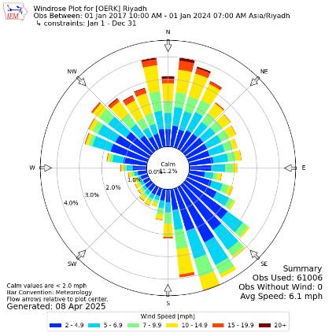

**Figure 5:** Annual wind rose at Riyadh, Wind Rose Plots[https://www.iastate.edu/](https://mesonet.agron.iastate.edu/sites/windrose.phtml)

**Table 1:** Monthly average wind speed (knots)\ directions during the period from Oct 2017 to 2018 and Oct 2022 to 2023

|  |  |  |  |  |  |  |  |  |  |  |  |  |
| --- | --- | --- | --- | --- | --- | --- | --- | --- | --- | --- | --- | --- |
| Month | Jan | Feb | Mar | Apr | May | Jun | July | Aug | Sep | Oct | Nov | Dec |
| Wind Speed | **5** | **6** | **6** | **7** | **6** | **7** | **7** | **6** | **5** | **4** | **5** | **5** |
| Wind Deration | **SSE** | **SSE** | **SSE** | **SSE** | **NNE** | **N** | **N** | **N** | **N** | **SE** | **N** | **SSE** |

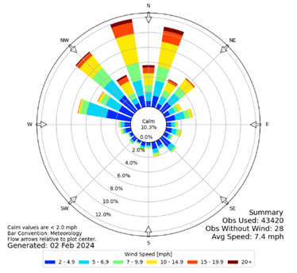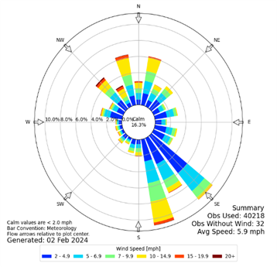

**Autumn** **Winter**

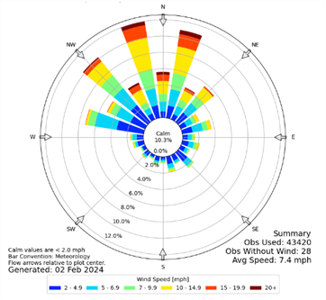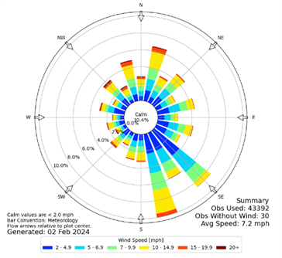

**Summer** **Spring**

**Figure 6:** Sessional wind rose at Riyadh, Wind Rose Plot [https://www.iastate.edu/](https://mesonet.agron.iastate.edu/sites/windrose.phtml)

**Dust and Sandstorms Events:**

During the study periods for rainfall seasons from Oct 2017 to Oct 2018 comparing with Oct 2022 to Oct 2023, Riyadh experienced approximately 171 annually average dust and sandstorm events during 2017, 2018, 2022, and 2023, according to the standard adopted for monitoring dust and sandstorm events by the World Meteorological Organization. This standard considers wind speeds exceeding 12 knots and visibility dropping below 5 kilometers to monitor all phenomena that fall under the standard, including DS, SS, BLDU.

Dust storms accounted for approximately 4% of all dust events, while sandstorms accounted for about 1.16%, and blowing dust accounted for approximately 95.32% these in all year’s study as showed in (Figure 7). It is evident that some years experienced an increase in dust storm events, such as 2018 and 2022 with the number of dust and sandstorm events reaching approximately 276 and 225 cases respectively. On the other hand, the years 2017 and 2023 had the lowest occurrence of dust and sand events with approximately 107 and 45 events respectively.

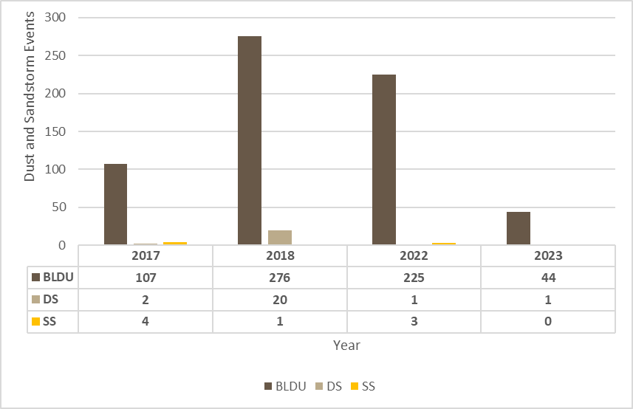

**Figures 7:** Dust and Sandstorms Events in 2017 to 2018 and 2022 to 2023

The frequency of dust and sand storm events from season to season, as shown in )Figure 8, 9). The highest frequency of dust and sandstorm events in Riyadh during the period from 2017 to 2018 comparing with 2022 to 2023 occurs in the summer season. The number of dust and sandstorm during summer season in 2017 to 2018 were approximately 15 storms representing 4%, with blowing dust events accounting for 383 cases representing 96%. As for the most frequent sandstorm events, they also occur in the spring season with 168 cases representing 92%. Dust and sandstorms accounted for about 11 storms representing 8%. in 2022 to 2023 occurs in the summer season, the dust and sandstorm were about 5 storms representing 2%, and the blowing dust was 269 cases representing 98%. As for the most frequent dust and sandstorm occur in the spring season with 3 storms representing 2%. blowing dust accounted for about 141 cases representing 98%. During this period, the winds are influenced by the seasonal Indian low-pressure system, with a southeast direction, which is of tropical origin. It is observed that wind speeds intensify during daylight hours and calm down during the night. This is followed by winter season follows, which witnessed approximately 44 cases accounting for 100% during 2017 to 2018, and in 2022 to 2023 was 52 cases accounting for 96%. Finally, the autumn season is the least in terms of registering dust and sandstorm events with approximately 13 cases representing 100 % during 2017 to 2018, and in 2022 to 2023 were about 9 cases accounting for 100%.

**Figure 8:** Dust Events during 2017 to 2018 comparing with 2022 to 2023.

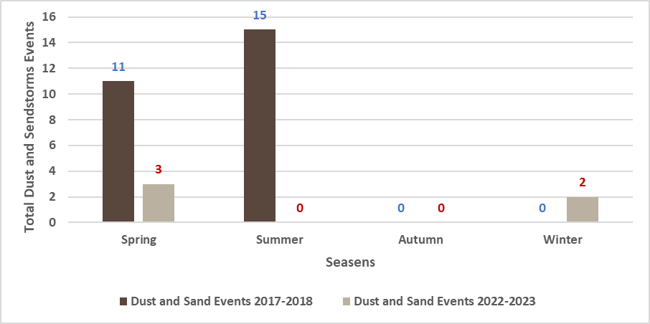

**Figure 9:** Dust and Sandstorms during 2017 to 2018 comparing with 2022 to 2023

Riyadh is exposed to dust and sandstorm events throughout the year, as shown in (Figures 10, 11, 12). The distribution of dust cases varies significantly across the months. The Total number of dust storm events during the study periods 2017, 2018, 2022, and 2023 were respectively 113, 297, 229, and 45 cases. Blowing dust events accounted for around 107, 276, 225, and 44 cases respectively for the same periods, with the highest average of frequency occurring in June, March, April, and May with average of 28, 19, 19, and 14 cases respectively. Comparing in 2023 the highest blowing dust accounted for around 44 cases, and highest frequency occurring in May, March, and April with total 16, 13, and 5 respectively. As for dust storms in 2007 to 2022, their average frequency were approximately 132 cases, they were more frequent in July, April, March, and May, with totals of 22, 21, 20, and 19 cases respectively, while their frequency decreased in Sep, November, and December, with totals of 1, 0, and 0 cases respectively. Comparing in 2023 the total frequency was approximately 1 case, it was more frequent in April with totals of 1 dust storm, while their frequency decreased in wholly the year with totals 0 dust storms.

Regarding sandstorms, their average frequency were approximately 65 cases. They were more frequent in July, April, May, and March, with averages of 23, 16, and 9 cases respectively. However, their frequency decreased in September, January, and October with totals of 0 cases respectively. Comparing in 2023, its totals frequency was approximately 0 cases in all year. It is evident that the highest frequency of dust storm events occurred between the spring and summer months, while the lowest frequency occurred during autumn and the early months of winter. Therefore, the season for dust storm events in Riyadh is primarily between the spring and summer seasons. During the second week of June, the winds become active and predominantly blow from the north. These winds intensify during daylight hours due to solar radiation. This period exhibits characteristics of the seasonal Indian low-pressure system, which extends widely from northwest India to the eastern Mediterranean Sea. Due to the strong winds, especially during midday, the air carries a significant amount of dust, often leading to reduced horizontal visibility during severe dust storm events to just a few meters. As showed in (Figures 11, 12) data regarding dust and sandstorm phenomena in Riyadh from 2017 to 2023 indicate significant changes in the frequency of these events. In 2018, the city experienced the highest levels of dust, recording 276 dust events and 21 sandstorms, reflecting severe climatic conditions. However, the numbers began to decline notably in the following years, with 225 dust events recorded in 2022 and only 44 events in 2023, alongside a reduction in sandstorms to just one event in 2023. This improvement may be attributed to enhanced environmental policies and increased awareness of the importance of environmental protection, contributing to reduced dust concentrations and improved air quality. These results are positive, as they could lead to better public health outcomes and the restoration of ecological balance in the region.

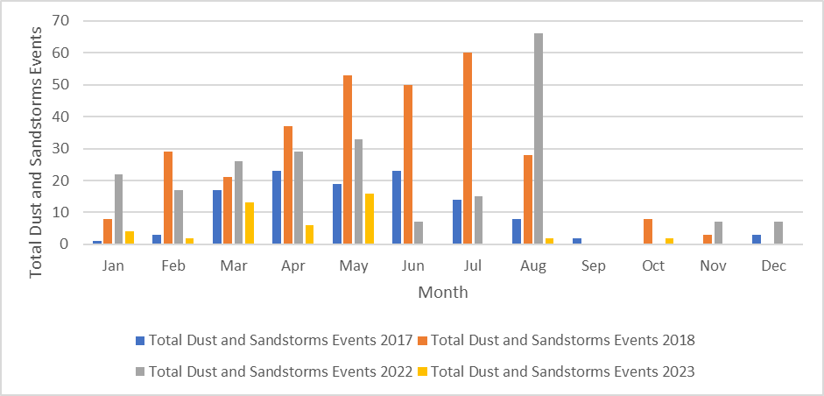

**Figure 10:** Monthly Variation in the Frequency of Dust and Sandstorms Events during the Period from 2017 to 2018 compering with 2022 to 2023

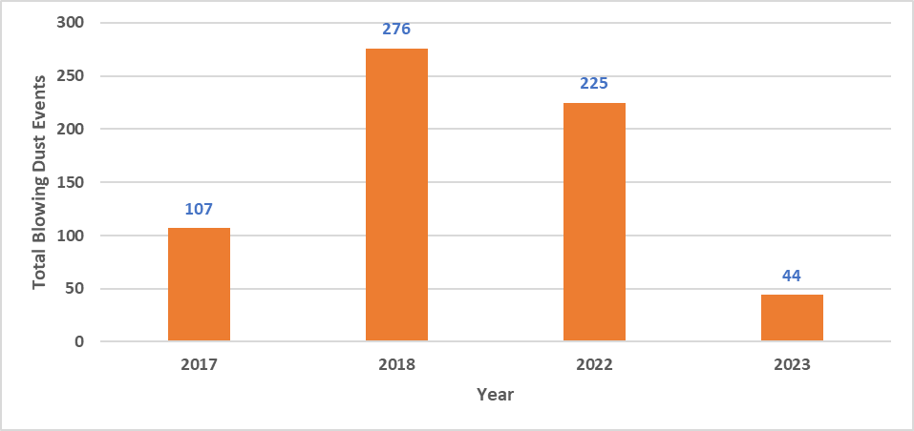

**Figure 11:** Yearly Variation in the Frequency of Blowing Dust during the Period from 2017 to 2018 compering with 2022 to 2023

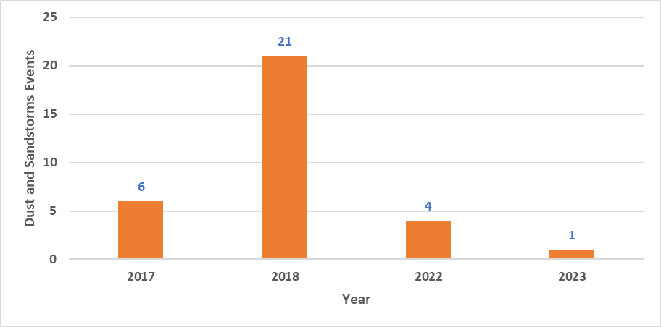

**Figure 12:** Yearly Variation in the Frequency of Dust and Sandstorms during the Period from 2017 to 2018 compering with 2022 to 2023

**Discussion:**

**Dust and Sand Storm Events Occurrences and Their Seasonal Distribution:**

Dust and sandstorm events are caused by the suspension of fine particles of soil due to wind speeds exceeding 33 km/h, resulting in horizontal visibility dropping to less than 1 km (Khaleel, 2018). Based on the visibility range during dust storm events in Riyadh from 2007 to 2023, the severity of dust and sandstorms was classified into four categories as follows: a group with visibility less than 0.1 km (very severe), less than 0.6 km (severe), less than 1 km (moderate), and less than 5 km (light).

**Group 1:**

This group includes very severe dust and sandstorms with visibility less than 0.1 km. During the study period, there were 39 storms, accounting for 1.15% of the total number of dust storm cases. Most of these storms occurred in the spring season, particularly in April, with an average of 22 storms, and the fewest occurred in winter with only 4 storms.

**Group 2:**

This group includes severe storms with visibility less than 0.6 km. There were approximately 30 storms in this category, accounting for 0.2% of the total number of dust storm cases. Most of these storms occurred in the spring season, especially in April, while they were less frequent in other seasons.

**Group 3:**

This group includes moderate dust and sandstorms with visibility less than 1 km. There were 36 storms in this category, representing 1.06% of the total. Most of these storms occurred in the spring season, with around 14 storms, while they were less common in the autumn and winter seasons.

**Group 4:**

This group includes light dust and sandstorms with visibility less than 5 km. The total number of storms in this category was approximately 208, accounting for 6.16% of the total number of dust storm cases. These storms were concentrated in the spring season, with an average of 92 storms, while they were less frequent in the autumn season (6 storms), followed by the winter season (52 storms), and the summer season (58 storms).

**The Relationship Between Precipitation and Dust and Sand Storms and Blowing Dust Event:**

The precipitation contributes significantly to the formation of dust and sandstorm events. (Table 2 and Figure 13, 14) demonstrate the correlation between precipitation and dust and sandstorm events in Riyadh during the study period from Oct 2017 to 2018 and from Oct 2022 to 2023. This is done by applying the simple correlation coefficient to clarify the nature and strength of the relationship between the studied phenomena and the independent variables that influence them. It is evident that one of the most suitable statistical equations for measuring the strength of the correlation between the precipitation and dust and sandstorm events is derived. The results of calculating the correlation coefficient between dust events (blowing dust, dust storms, and sandstorms) and precipitation indicate that the correlation between dust and sandstorm events and precipitation, a direct correlation of 0.33 is found, as well as with elevated dust at 0.32.

**Table 2:** Correlation Coefficients between Dust and Sandstorm Types and Precipitation during the Period from Oct 2017 to 2018 and Oct 2022 to 2023

|  |  |  |
| --- | --- | --- |
| Type of Dust storms\ Climate Elements | Blowing Dust | Dust and sandstorms |
| Precipitation | 0.32 | 0.33 |

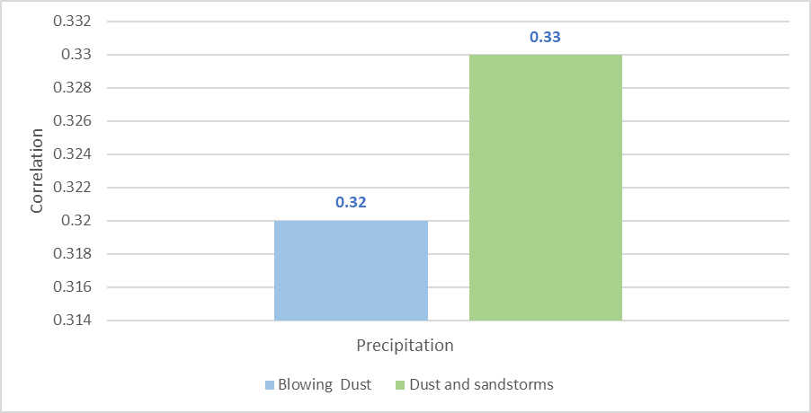

**Figure 13:** Correlation Coefficients between Types of Dust and Sandstorm Events and Precipitation during the from Oct 2017 to 2018 and Oct 2022 to 2023

Precipitation is considered a climatic factor that contributes to reducing the chances of dust and sandstorm occurrences. Increased rainfall opportunities help stabilize the soil and increase vegetation cover. Based on (Figure 15) and (Table 2) July which marks the end of the rainy season, recorded the highest rate of dust and sandstorm frequency (29 storms), while June recorded the highest rate of blowing dust frequency (73 cases). It can be inferred that there is a positive correlation between rainfall amount and increased rates of dust and sandstorm occurrences. It is also evident that there is a positive correlation between rainfall and the frequency of dust and sandstorms with a correlation coefficient of 0.33. Similarly, there is a positive correlation between rainfall and blowing dust with a correlation coefficient of 0.32.

According to the findings presented in (Figures 15, 16), this study examines the monthly occurrences of dust and sandstorm events and the total of precipitation during two distinct periods: October 2017 to 2018 and October 2022 to 2023. By comparing these two-time frames, significant differences in precipitation patterns and dust and sandstorm events were identified. During the period of October 2017 to 2018, the total of precipitation was approximately 120 mm. Notably, there was an increase in precipitation in April, with a recorded value of 44 mm. However, in December, the precipitation decreased to 5.3 mm. In terms of dust and sandstorm events, there were 13 occurrences in April, which were higher compared to other months. Conversely, there were no dust events recorded in December. In contrast, the period from October 2022 to 2023 exhibited different precipitation and dust and sandstorm patterns. The total of precipitation during this period was around 197 mm. The month of January experienced a substantial increase in precipitation reaching 80 mm, whereas in December there was a decrease to 6 mm. Regarding dust and sandstorm events, January had three occurrences, while December had none. The comparison between these two periods illustrates fluctuating precipitation levels from year to year. However, a correlation between precipitation and dust events was observed. Specifically, an inverse relationship was identified, whereby an increase in rainfall corresponded to a decrease in dust storm events from October 2022 to 2023, and a reduction in rainfall correlated with an increase in dust and sandstorm occurrences. A direct relationship was identified whereby an increase rainfall corresponded to an increased in dust and sandstorm events from October 2017 to 2018.

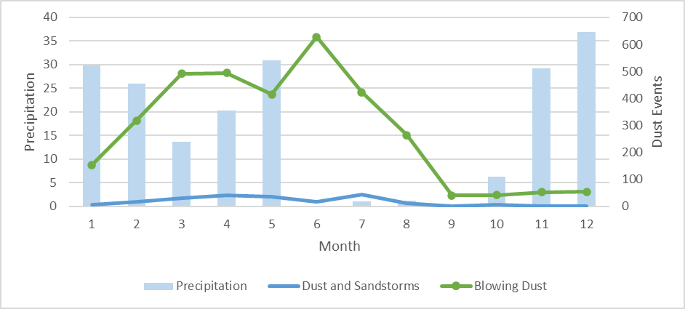

**Figure 14:** Monthly total of the number of days with dust and sandstorm events and the average precipitation during Oct 2017 to 2018 and Oct 2022 to 2023

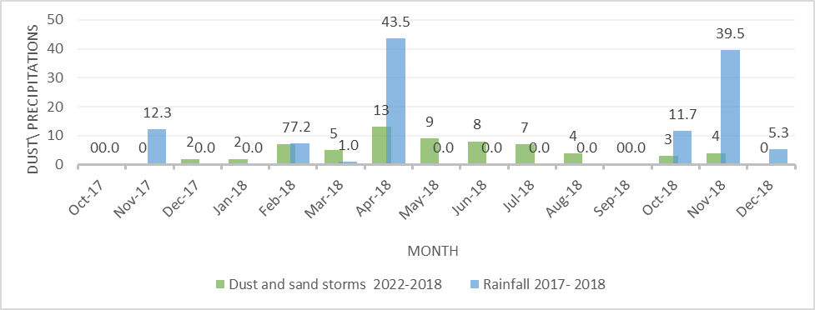

**Figure 15:** Monthly total of dust and sandstorm events and the precipitation during Oct 2017 to 2018

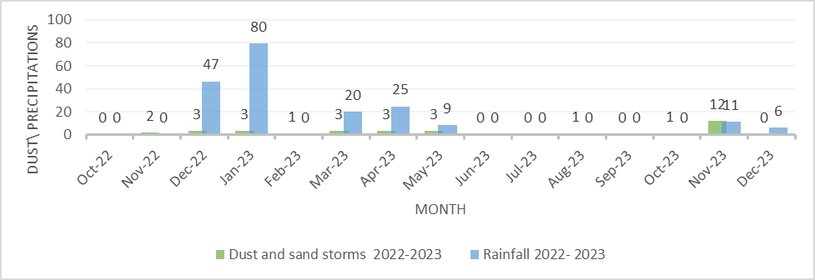

**Figure 16:** Monthly total of dust and sandstorm events and the precipitation during Oct 2022 to 2023

**Cases studies Dust Storm in Riyadh 26 April 2018 comparing with Dust Storm in Riyadh 28 April 2023:**

**Analysis of the Riyadh Dust Storm on April 26, 2018:**

The severe dust storm that struck Riyadh on April 26, 2018 serves as an important case study for understanding extreme dust events in arid regions in (Figure 17, 18). This analysis examines the meteorological conditions and atmospheric processes that contributed to the storm's development and intensity. Meteorological observations reveal critical factors that drove the storm's formation. As showed in (Figure 19) the Wind speeds reached 46 km/h (12.8 m/s) from a north-northwesterly direction (340-360°), creating ideal conditions for dust uplift and transport. These strong winds coincided with extremely dry air, as relative humidity values dropped to 17-25% across the region as showed in (Figure 20). The combination of high winds and low humidity allowed dust particles to remain suspended in the atmosphere for extended periods. In (Figure 21) showed that the Surface temperatures reaching 30.6°C prior to the storm's onset further enhanced atmospheric instability, contributing to the development of turbulent conditions that facilitated dust mobilization. And in (Figure 22) In April 2018, Saudi Arabia experienced an uneven distribution of rainfall, as illustrated in the accompanying map. The data showed that the southern and western regions of the kingdom, particularly around Medina and Makkah, received significant amounts of rain, with the highest recorded precipitation ranging between 100-200 mm. These areas are marked by darker colors, indicating increased rainfall rates. Specifically, the mountainous regions such as Asir and Al-Baha were notably affected by high precipitation due to their geographic features. Conversely, the northern and eastern regions, including parts of the Northern Borders, experienced much lower rainfall, with amounts less than 10 mm.

Synoptic-scale analysis shows the storm developed under a strong pressure gradient between a surface low over northern Saudi Arabia and higher pressure to the east. This pressure pattern generated persistent northerly winds that transported dust from source regions in the northern deserts. Upper-air observations revealed a shortwave trough moving eastward across the region, which enhanced vertical mixing in the atmosphere and helped maintain dust particles in suspension. The storm's afternoon timing coincided with maximum daytime heating and boundary layer expansion, creating optimal conditions for dust uplift and transport. As showed in (Figure 23, 24) the back-trajectory analysis indicates the dust originated in the Nafud Desert approximately 500 km north of Riyadh. Satellite imagery confirms widespread dust activity across northern Saudi Arabia in the hours preceding the Riyadh event. The particles followed a direct south-southeast trajectory, carried by the dominant low-level wind flow. MERRA-2 reanalysis data shows PM2.5 concentrations spiking to 400 μg/m³ during the event, far exceeding healthy levels. The storm's impacts were severe but relatively short-lived. Visibility dropped to zero meters during the peak intensity period, which lasted about one hour. While brief, the storm's intensity placed it among the most extreme dust events recorded in Riyadh, with wind speeds exceeding the 90th percentile for April climatology. The April 2018 period overall showed 30% higher dust activity compared to the 10-year average.

This analysis highlights several important implications for dust storm forecasting and mitigation. Improved high-resolution modeling could enhance prediction capabilities, particularly when combining MERRA-2 data assimilation with local observations. The public health impacts, evidenced by the extreme PM2.5 concentrations, underscore the need for real-time air quality monitoring and targeted advisories during such events. From a research perspective, this case demonstrates the complex interplay between synoptic-scale patterns and local boundary layer processes in generating extreme dust events, warranting further investigation into potential climate change connections and desertification impacts.

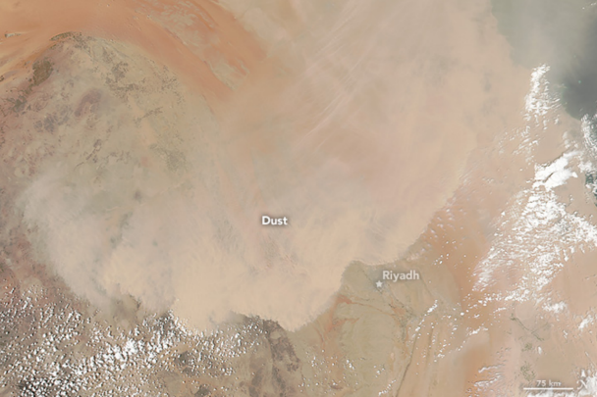

**Figure 17:** Imagery illustrating the occurrence of dust and sandstorms accompanying the north and northeast winds on April 26, 2018 <https://nasa.gov/>

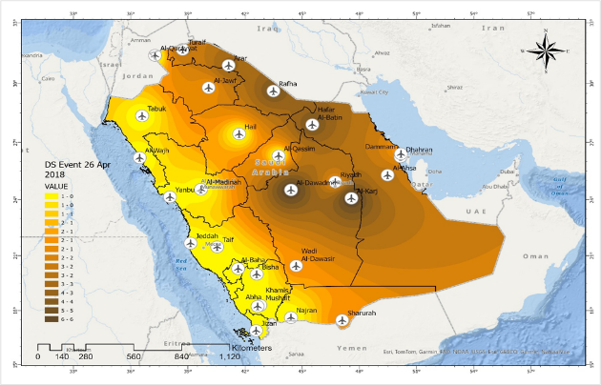

**Figure 18:** Dust Storm (DS) In 26 of April 2018.

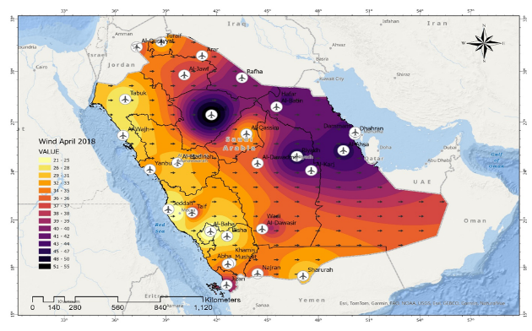

**Figure 19:** Mean Wind (Speed\ Direction) in April 2018.

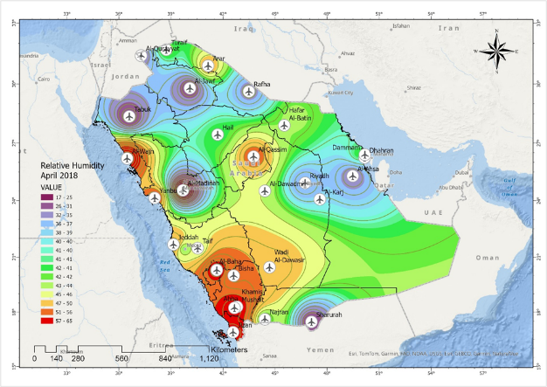

**Figure 20:** Mean Relative Humidity in April 2018.

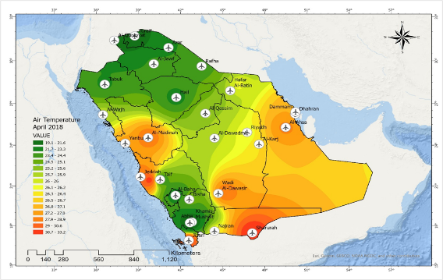

**Figure 21:** Mean Air Temperature in April 2018.

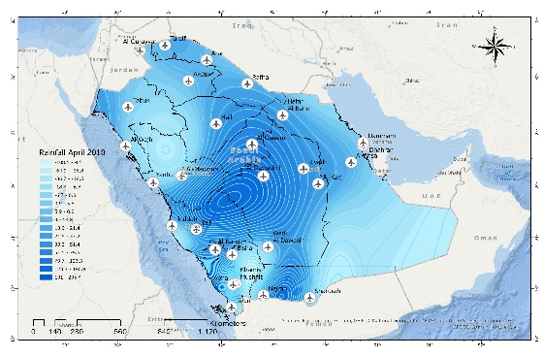

**Figure 22:** A mount of Precipitation in April 2018.

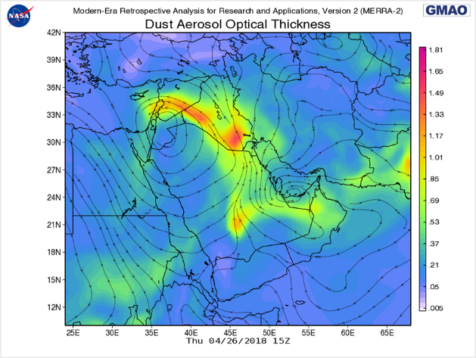

**Figure 23:** Dust Aerosol Optical Thickness at 26 of April 2018 in 15Z. <https://nasa.gov/>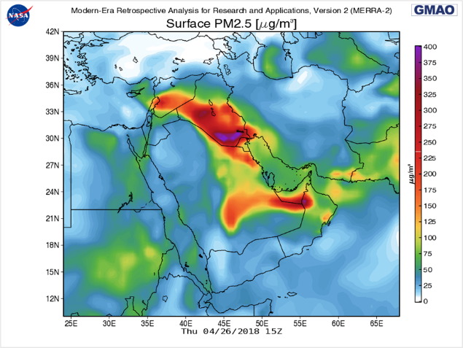

**Figure 24:** Surface PM 2.5 (μg/m³ ) at 26 of April 2018 in 15Z.

Source: <https://nasa.gov/>

**Analysis of the Dust Storm in Riyadh on April 28, 2023:**

On April 28, 2023, Riyadh experienced a moderate-intensity dust storm that lasted approximately two hours, from 15:00 to 17:00 local time in (Figure 25, 26). This event serves as an important case study for understanding dust storms in urban environments. This analysis focuses on the meteorological conditions and atmospheric processes that contributed to the storm's development and impact. Meteorological observations reveal critical factors that drove the storm's formation. As shown in (Figure 27), wind speeds reached approximately 30 km/h (8.3 m/s) from a north-northwesterly direction, creating favorable conditions for dust uplift and transport. These moderate winds coincided with extremely dry air, as relative humidity values dropped to around 20-30% (Figure 28). This combination allowed dust particles to remain suspended in the atmosphere. Surface temperatures prior to the storm reached approximately 28°C (Figure 29), which enhanced atmospheric instability and contributed to turbulent conditions that facilitated dust mobilization. The rainfall distribution map (Figure 30) indicates that some areas of the kingdom experienced little to no rainfall in April 2023, which may have exacerbated dust conditions.

Synoptic-scale analysis shows that the storm developed under a moderate pressure gradient, with a surface low to the north and higher pressure to the south, resulting in persistent northerly winds that transported dust from arid regions. Back-trajectory analysis indicates that the dust originated from surrounding deserts, illustrating a direct path toward Riyadh. MERRA-2 reanalysis data shows PM2.5 concentrations spiking to 250 µg/m³ during the event (Figure 31, 32), significantly exceeding healthy levels. Although the storm's duration was short, visibility dropped sharply, creating hazardous conditions for residents. This analysis highlights the importance of understanding local meteorological patterns and their implications for dust storm forecasting and air quality management. Enhanced modeling techniques, combined with real-time monitoring, could improve predictive capabilities. The public health implications, evidenced by elevated PM2.5 levels, emphasize the need for timely advisories during such events. The April 28, 2023 dust storm in Riyadh demonstrates the complex interplay between atmospheric conditions and dust mobilization.

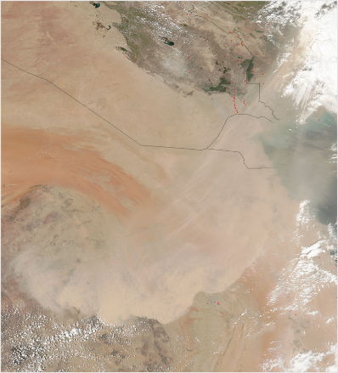

**Figure 25:** Imagery illustrating the occurrence of dust and sandstorms accompanying the north and northeast winds on April 28, 2023.

Source: Source: <https://nasa.gov/>

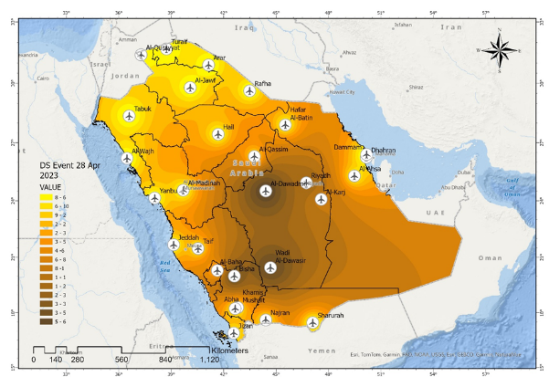

**Figure 26:** Dust Storm (DS) In 28 of April 2023.

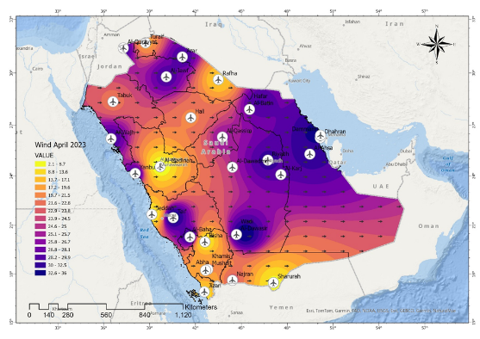

**Figure 27:** Mean Wind (Speed\ Direction) in April 2023.

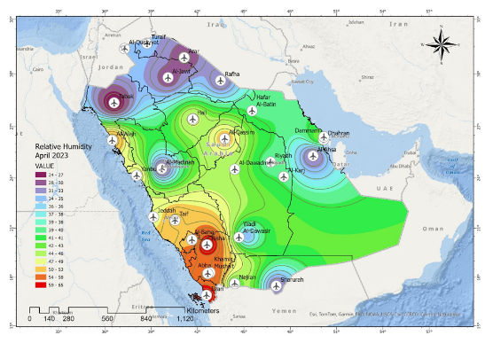

**Figure 28:** Mean Relative Humidity in April 2023.

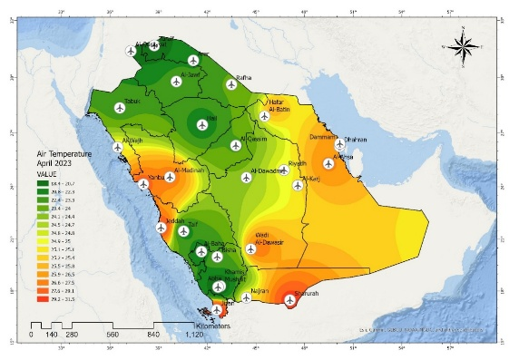

**Figure 29:** Mean Air Temperature in April 2023.

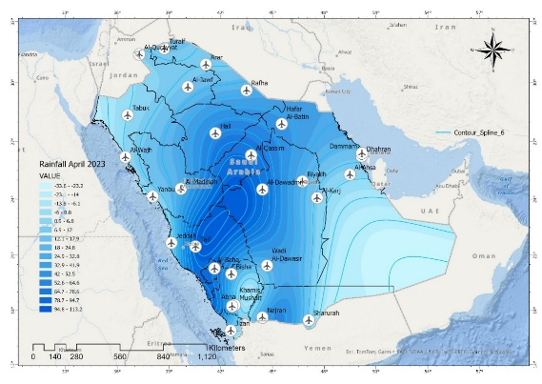

**Figure 30:** A mount of Precipitation in April 2023.

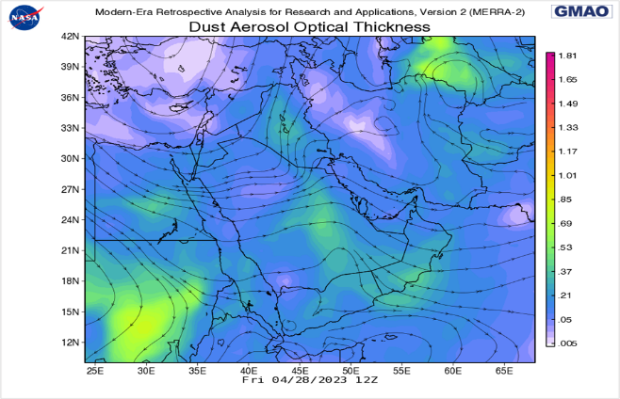

**Figure 31:** Dust Aerosol Optical Thickness at 28 of April 2023 in 12Z.

Source: Source: <https://nasa.gov/>

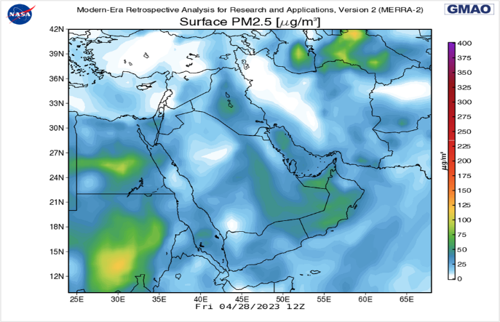

**Figure 32:** Surface PM 2.5 (μg/m³ ) at 28 of April 2023 in 12Z.

Source: Source: <https://nasa.gov/>

This study examines the dust storms that impacted Riyadh on April 26, 2018, and April 28, 2023, providing critical insights into the meteorological and climatic conditions influencing the occurrence of such phenomena in arid regions. The 2018 event was characterized as severe, with wind speeds reaching 46 km/h from a north-northwesterly direction, low relative humidity of 17-25%, and elevated temperatures of 30.6°C. These conditions facilitated the uplift of dust into the atmosphere, resulting in zero visibility during the storm's peak intensity. In contrast, the 2023 dust storm exhibited moderate intensity, with wind speeds varying between 24-52 km/h from a west-southwesterly direction, relative humidity ranging from 24-58%, and lower temperatures between 24.1-29.1°C. Although visibility was reduced to less than 800 meters, the event lasted longer than its 2018 counterpart. Analyses reveal that both storms originated from the Nafud Desert; however, the 2018 storm was more intense, with a 30% increase in dust activity compared to the 10-year average for April. This can be partially attributed to the soil moisture levels prior to each event.

As indicated in the soil moisture as showed (Figure 33, 34) for April 2018 and April 2023, the soil moisture levels in 2018 were significantly lower, which would have contributed to increased dust mobilization. The 2018 map shows drier conditions, with surface soil moisture values predominantly below 2%. In contrast, the 2023 map indicates slightly higher moisture levels, particularly in the southern regions of Saudi Arabia, which likely helped to stabilize the soil and reduce dust uplift. Furthermore, despite the 2022-2023 period experiencing greater precipitation (197 mm) than the 2017-2018 period (120 mm), the atmospheric conditions in 2018 were more conducive to dust formation and transport. The combination of lower soil moisture levels (1-2%) and higher wind speeds created an environment that favored dust storms. In the comparison of the two dust storms highlights the critical role of soil moisture in determining the intensity and duration of dust events. Higher soil moisture levels in 2023 contributed to less severe dust conditions, while the drier conditions in 2018 exacerbated dust mobilization, underscoring the importance of maintaining soil moisture for mitigating dust storm impacts in arid regions.

The findings from the analysis of dust storms in Riyadh on April 26, 2018, and April 28, 2023, align with and contrast against several other studies conducted in arid and semi-arid regions. For example, research conducted by Al-Dousari et al. (2020) on dust storms in the Arabian Peninsula indicated that such events are predominantly influenced by wind speed, humidity, and soil moisture. Their findings corroborate the significant role of low humidity and high wind speeds in facilitating dust uplift, similar to the conditions observed in the 2018 Riyadh storm. Moreover, a study by Zang et al. (2021) emphasized the effects of climate change on the frequency and intensity of dust storms, noting that increased temperatures and altered precipitation patterns could lead to more frequent and severe dust events. This aligns with the observation that the 2018 storm occurred during a period of higher dust activity compared to the ten-year average. In contrast, the moderate dust storm of April 2023, despite having higher precipitation amounts than in 2018, illustrates an important divergence from findings by Goudie and Middleton (2006), who suggested that increased rainfall typically mitigates dust storm occurrences by enhancing soil moisture. The relatively dry conditions in both October 2017-2018 and October 2022-2023, despite varying precipitation levels, challenge this conventional understanding and highlight the complexity of dust storm dynamics. Additionally, research by Prospero et al. (2012) on transboundary dust transport emphasizes the impact of regional factors and source areas on dust events. The findings regarding the Nafud Desert as a common source for both Riyadh storms echo this perspective, suggesting that regional climatic patterns and land use changes play a critical role in dust mobilization. While the local conditions in Riyadh reflect broader regional trends observed in other studies, they also underscore the necessity for targeted research to understand the multifaceted interactions between climatic variability, land surface conditions, and dust storm dynamics.

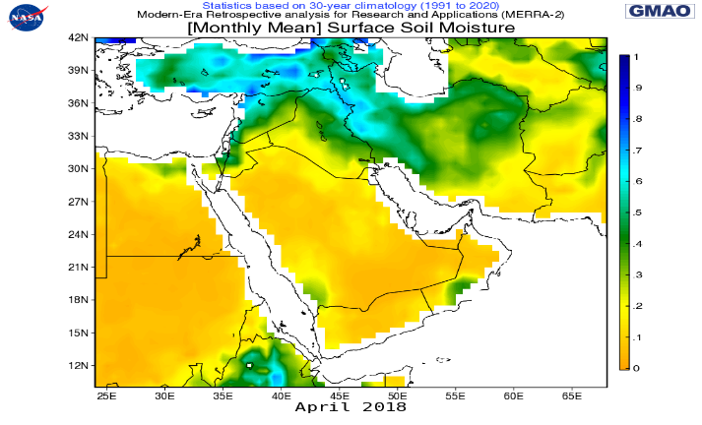

**Figure 33:** Surface Soil Moisture (Monthly Mean) of April 2018.

Source: Source: <https://nasa.gov/>

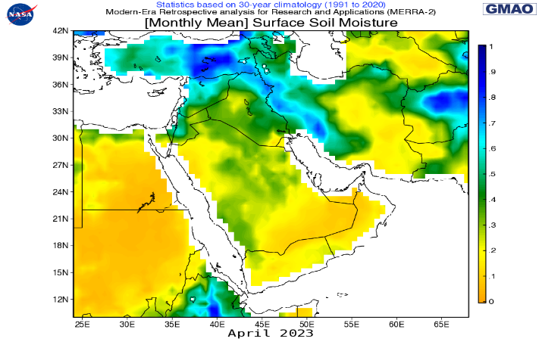

**Figure 34:** Surface Soil Moisture (Monthly Mean) of April 2023.

Source: Source: <https://nasa.gov/>

**Conclusion:**

The occurrence of dust and sandstorms in Riyadh is most common during the spring and summer months (March, April, May, June, and July), where their frequency and intensity increase. Most of these storms occur due to strong winds, low rainfall, limited vegetation cover, soil dryness, and lack of cohesion. The study found that the highest frequency of dust and sandstorm occurrences during the study period October 2017 to 2018 comparison with October 2022 to 2023 were the average in the months of May and August, with average approximately 36 and 18 cases respectively, comparing with the average cases in the same months in 2022- 2023 were reaching around 25, 34 cases respectively. This was attributed to high wind speeds, high temperatures, soil dryness, and lack of rainfall during these months. Dust and sandstorms are not limited to the spring and summer seasons, but it can also occur during the autumn and winter seasons.

May recorded the highest frequency of dust storm occurrences during the study period October 2017 to 2018 and October 2022 to 2023, the total with around 121 cases, and in May 2023 was recorded 6 dust events, followed by August (2017 to 2018 and 2022 to 2023) with total 104 cases, and in August (2023) was the total around 2 cases. The rate decreases during the autumn season in September and October, with an average of about 1 case in (2017 to 2018 and 2022 to 2023), and the total in (2023) at the same month reached 2, and 1 respectively. The study showed that the frequency of dust storm occurrences varies from month to month. The study indicated a positive correlation of 0.33 between dust and sandstorms and precipitation, as well as a correlation of approximately 0.32 with suspended dust

The study revealed that dust and sandstorms cause visibility to drop to less than 5 kilometers in an average of 20 storms during the study period from 2017 to 2018 and 2022 to 2023. And in April 2023 had 1 dust storm the horizontal visibility drops down 800 m. the study showed that the horizontal visibility also decreased to less than 5 kilometers in an average of 240 cases. The analysis of monthly dust and sandstorms events and precipitation data from two distinct periods, namely October 2017 to 2018 and October 2022 to 2023, reveals significant variations in weather patterns. The findings indicate that precipitation levels fluctuate from year to year, with contrasting effects on dust and sandstorm occurrences.

During the first period, there was the total precipitation of approximately 120 mm, with a notable increase in April and a decrease in December. Simultaneously, April exhibited the highest number of dust and sandstorm events, while December had none. In contrast, the second period showed a higher total of precipitation about 197 mm, with a substantial increase in January and a decrease in December. Similarly, January recorded a few dust and sandstorm events, while December had none. The observed correlation between precipitation and dust events is noteworthy. The results demonstrate an inverse relationship, whereby increased rainfall is associated with a decrease in dust storm events, while decreased rainfall corresponds to an increase in dust and sandstorm occurrences. These findings emphasize the dynamic interplay between precipitation and dust and sandstorm phenomena, underscoring the importance of climate factors in influencing such events. Understanding these relationships can provide valuable insights for climate researchers, policymakers, and stakeholders in implementing effective measures to mitigate the impact of dust and sandstorms and promote sustainable environmental practices.

**References:**

Al-Dousari, A. A., Al-Shehri, D. H., & Hossain, M. S. (2020). Dust storms in the Arabian Peninsula: Meteorological analysis and implications for public health. *Journal of Arid Environments*, 176, 104138. <https://doi.org/10.1016/j.jaridenv.2020.104138>

Goudie, A. S., & Middleton, N. J. (2006). Desert dust in the global system. *In The Role of Dust in the Climate System* (pp. 1-9). Springer. <https://doi.org/10.1007/978-3-540-32192-4_1>

Prospero, J. M., Blades, E., & Mathison, G. (2012). Interannual variability of African dust transport due to changes in the North Atlantic Oscillation. *Atmospheric Chemistry and Physics*, 12(21), 10753-10763. <https://doi.org/10.5194/acp-12-10753-2012>

Zang, Y., Wang, Y., & Liu, X. (2021). The impact of climate change on the frequency and intensity of dust storms: A review. *Earth-Science Reviews*, 220, 103751. <https://doi.org/10.1016/j.earscirev.2021.103751>

Rap A., C.E. Scott, D.V. Spracklen, N. Bellouin, P.M. Forster, K.S. Carslaw, A. Schmidt, G. Mann. Natural aerosol direct and indirect radiative effects, Geophys. Res. Lett., 40 (2013), pp. 3297-3301, 10.1002/grl.5044.

Modaihsh A.S, (1997). Characteristics and composition of the falling dust sediments on Riyadh city, Saudi Arabia, Journal of Arid Environments, Volume 36, Issue 2, 1997, Pages 211-223, ISSN 0140- 1963, <https://doi.org/10.1006/jare.1996.0225>.

Abballo, H. M. (2016). Dust storms in Iraq and their effect on the environment. Journal of Environment Pollution and Human Health, 4(2), 54-58.

Al-Amshi, H., et al. (2020). Analysis of dust storms in Iraq using satellite observations and ground-based measurements. Journal of Environmental Monitoring and Assessment, 192(1), 1-13.

Al-Biyati, H. K. (2011). Dust storms: Causes, effects, and reduction strategies. Journal of Environmental Protection, 2(05), 612-620.

Albugami, S., Palmer, S., Cinnamon, J., & Meersmans, J. (2019). Spatial and temporal variations in the incidence of dust storms in Saudi Arabia revealed from in situ observations. Geosciences, 9(4), 162. <https://doi.org/10.3390/geosciences9040162>.

Albugami, S., Palmer, S., Cinnamon, J., & Meersmans, J. (2019). Spatial and temporal variations in the incidence of dust storms in Saudi Arabia revealed from in situ observations. Geosciences, 9(4), 162. <https://doi.org/10.3390/geosciences9040162>.

Al-Dabbas, M. A., & Al-Nasrawi, H. A. (2017). Determination of dust storm frequency in the Middle East using long-term satellite data. Journal of Atmospheric and Solar-Terrestrial Physics, 159, 1-9.

Al-Hamadi, A. (2020). Dust storms in Riyadh: Causes and impacts. Environmental Science and Pollution Research, 27(12), 14567-14578. <https://doi.org/10.1007/s11356-020-08765-4>.

Alharbi, B. H., & Abdel-Dayem, M. S. (2018). Dust storms in Saudi Arabia: Implications on solar energy. Renewable and Sustainable Energy Reviews, 88, 254-273. <https://doi.org/10.1016/j.rser.2018.02.022>.

Alharbi, B. H., Maghrabi, A., & Tapper, N. (2013). The March 2009 dust event in Saudi Arabia: Precursor and supportive environment. Bulletin of the American Meteorological Society, 94(4), 515-528. <https://doi.org/10.1175/BAMS-D-11-00135.1>.

Alharbi, B. M., & Abdel-Dayem, A. M. (2015). Dust storms in Saudi Arabia: Implications on solar energy. Renewable and Sustainable Energy Reviews, 43, 943-957.

Alharbi, B. M., & Abdel-Dayem, A. M. (2018). Dust storms in Saudi Arabia: A comprehensive review. Renewable and Sustainable Energy Reviews, 88, 254-273.

Almazroui, M., & Islam, M. N. (2015). Climate of Saudi Arabia: An overview. Arabian Journal of Geosciences, 8(3), 1234-1245. <https://doi.org/10.1007/s12517-014-1345-6>.

Al-Moussawi, A. S., & Hamidi, M. A. K. (2014). Surface wind characteristics and their effects on the frequency of dust phenomena in the central and southern regions of Iraq. Geographical Research Journal (Discontinued). <https://journal.uokufa.edu.iq/index.php/kjg/article/view/6912>.

Al-Najim, F. A. (1975). Duststorms in Iraq. Bulletin ofColluvium Science, 16: 437-451.

Al-Saud, A. (2018). Geographical features of Riyadh: A study of the Najd Plateau. Journal of Geography and Geology, 10(2), 45-60. <https://doi.org/10.5539/jgg.v10n2p45>.

Asare-Ansah, A. B., Twumasi, Y. A., Ning, Z. H., Ansah, P. B., Frimpong, D. B., Owusu, F., Apraku, C. Y., Anokye, M., Loh, P. M., Armah, R. N. D., & Oppong, J. (2022). Tracking the Godzilla dust plume using Google Earth Engine platform. The International Archives of the Photogrammetry, Remote Sensing and Spatial Information Sciences, XLVI-M-2-2022, 33-38. <https://doi.org/10.5194/isprs-archives-XLVI-M-2-2022-33-2022>.

Aston, S. R., et al. (1973). Eolian dust from the lower atmosphere of the eastern Atlantic and Indian Oceans, China Sea and the Sea of Japan. Marine Geology.

Attiya, A. A., & Jones, B. G. (2020). Assessment of mineralogical and chemical properties of airborne dust in Iraq. SN Applied Sciences, 2(1614). <https://doi.org/10.1007/s42452-020-03326-5>.

Attiya, A. A., & Jones, B. G. (2020). Climatology of Iraqi dust events during 1980–2015. SN Applied Sciences, 2(845). <https://doi.org/10.1007/s42452-020-2669-4>.

Attiya, A. A., & Jones, B. G. (2022). An extensive dust storm impact on air quality on 22 November 2018 in Sydney, Australia, using satellite remote sensing and ground data. Environmental Monitoring and Assessment, 194, 432. <https://doi.org/10.1007/s10661-022-10080-1>.

Attiya, A. A., & Jones, B. G. (2023). Investigation of severe dust storms over Baghdad City by using remote sensing measurements and ground data. IOP Conference Series: Earth and Environmental Science, 1215(1), 012004. <https://doi.org/10.1088/1755-1315/1215/1/012004>.

Attiya, A. A., & Jones, B. G. (2024). A huge dust storm influenced air quality on 16 May 2022 in Baghdad City, Iraq; tracked using remote sensing techniques and meteorological data. IOP Conference Series: Earth and Environmental Science, 1371, 022036. <https://doi.org/10.1088/1755-1315/1371/2/022036>.

Attiya, A. A., Jones, B. G., & Marx, S. (2019). Spatial–temporal analysis of Aerosol Index (AI) distribution and some climatic factors: Case study from Iraq, 1980–2015. Modeling Earth Systems and Environment, 5, 203–216. <https://doi.org/10.1007/s40808-018-0528-8>.

Awad, A. M., Mashat, A. W., & Zaki, E. A. (2016). Dust storms in the Middle East: Sources of origin and their temporal characteristics. Aerosol and Air Quality Research, 16(7), 1710-1727.

Ayanlade, A., Atai, G., & Jegede, M. O. (2019). Variability in atmospheric aerosols and effects of humidity, wind and InterTropical discontinuity over different ecological zones in Nigeria. Atmospheric Environment, 201, 369-380. <https://doi.org/10.1016/j.atmosenv.2018.12.039>.

Al-Hajji, Z., Munir, S., Al-Qahtani, J., Alexiou, I., & Hafez, M. (2025). A Study of Spatial and Temporal Variations of Climatic Variables during Sand and Dust Storm Events in Riyadh Using in-Situ Observations. International Journal of Environment and Climate Change, 15, 381-399.

Beaumont, P. (1976). The Middle East: A geographical study.

Beckett, P. H. T., et al. (1956). The climate of Kerman, south Persia. Quarterly Journal of the Royal Meteorological Society.

C.L. Heald, D.A. Ridley, J.H. Kroll, S.R.H. Barrett, K.E. Cady-Pereira, M.J. Alvarado, C.D. Holmes. Contrasting the direct radiative effect and direct radiative forcing of aerosols, Atmos. Chem. Phys., 14 (2014), pp. 5513-5527, 10.5194/acp-14-5513-2014.

Cailleux, M. A. (1961). Sur une poussière transportée par le vent en Mer Rouge. Comptes Rendus.

Carlson, T. N., & Benjamin, S. (1980). Boundary layer dust occurrence. II. Atmospheric dust over the Middle East, Near East and North Africa. Journal of Atmospheric Sciences, 37, 193-213.

Chen, D., Liu, Z., Davis, C., & Gu, Y. (2017). Dust radiative effects on atmospheric thermodynamics and tropical cyclogenesis over the Atlantic Ocean using WRF-Chem coupled with an AOD Data Assimilation System. Atmospheric Chemistry and Physics, 17, 7917-7939. <https://doi.org/10.5194/acp-17-7917-2017>.

Chylek, P., & Wong, J. G. D. (1995). Geophysical Research Letters, 22, 929-931.

Chin, M.; Ginoux, P.; Kinne, S.; Torres, O.; Holben, B.N. Tropospheric Aerosol Optical Thickness from the GOCART Model and Comparisons with Satellite and Sun Photometer Measurements. J. Atmos. Sci. 2002, 59, 461–483.

Coles, F. E. (1938). Dust storms in Iraq. Meteorological Office, Professional Notes No. 84. 14 pp.

Sharma D., D. Singh, D.G. Kaskaoutis. Impact of two intense dust storms on aerosol characteristics and radiative forcing over Patiala, Northwestern India, Adv. Meteorol., 2012 (2012), 10.1155/2012/956814.

D'Almeida, G. (1987). Journal of Geophysical Research, 92, 3017-3026.

Dubovik, O., et al. (2006). Application of spheroid models to account for aerosol particle nonsphericity in remote sensing of desert dust. Journal of Geophysical Research, 111, D11208. <https://doi.org/10.1029/2005JD006619>.

Edward, U., Uga, C. I., Odhiambo, A. D., Adhikari, B., Gautam, S. P., Boniface, N., George, O., Giri, A., Teferi, D., Belay, N., & Silwal, A. (2024). Variability of ionospheric total electron content over Morocco during the Godzilla sand and dust storm of June 2020. International Journal of Astrophysics and Space Science, 12(1), 1-16. <https://doi.org/10.11648/j.ijass.20241201.11>.

El-Askary, H. M., El-Raey, M., & Haleem, M. A. (2014). Dust storms detection and monitoring over Egypt using MODIS data during the period 2001-2012. Journal of Atmospheric and Solar-Terrestrial Physics, 121, 67-74.

El-Askary, H. M., Kafatos, M., & Prasad, A. K. (2013). Dust storms over Egypt and Sudan: Temporal and spatial variability. International Journal of Remote Sensing, 34(20), 7322-7341.

Emery, K. O. (1956). Sediments and water of the Persian Gulf. Bulletin of the American Association of Petroleum Geologists.

Fisher, W. B. (1978). The Middle East.

Francis, D., Chaboureau, J.-P., Nelli, N., Cuesta, J., Alshamsi, N., Temimi, M., Pauluis, O., & Xue, L. (2021). Summertime dust storms over the Arabian Peninsula and impacts on radiation, circulation, cloud development and rain. Atmospheric Research, 250, 105364, <https://doi.org/10.1016/j.atmosres.2020.105364>.

Goudie, A. S. (1983). Dust storms in space and time. Progress in Physical Geography, 7, 502-530.

Goudie, A. S., & Middleton, N. J. (2006). Desert dust in the global system. Springer. <https://doi.org/10.1007/3-540-32355-6>.

Grigoryev, A. A., et al. (1980). Atmospheric dust observed from space. Part 1-analysis of pictures. WMO Bulletin.

Grousset, F. E., Ginoux, P., Bory, A., & Biscaye, P. E. (2003). Case study of a Chinese dust plume reaching the French Alps. Geophysical Research Letters, 30(6), 1277. <https://doi.org/10.1029/2002GL016833>.

Halos, H., Al-Jiboori, M. H., & Al-Taai, O. T. (2017). Impact of dust storm intensity on some metrological elements and aerosol optical properties (case study: Baghdad, Iraq). Current Journal of Applied Science and Technology, 18(6), 1-10. <https://doi.org/10.9734/BJAST/2016/31460>.

Hamidi M, Kavianpour MR, Shao Y. Synoptic analysis of dust storms in the Middle East. Asia-Pacific J Atmos Sci. 2013;49(3):279–286, <https://link.springer.com/article/10.1007/s13143-013-0027-9>.

Hinds, B. D., et al. (1975). Boundary layer dust occurrence. II. Atmospheric dust over the Middle East, Near East and North Africa. Journal of Atmospheric Sciences, 37, 193-213.

Hui Cao, Farshad Amiraslani, Jian Liu, Na Zhou (2015). Identification of dust storm source areas in West Asia using multiple environmental datasets, Science of The Total Environment, Volume 502, 2015, Pages 224-235, ISSN 0048-9697, <https://doi.org/10.1016/j.scitotenv.2014.09.025>.

Idso, J. A. (1976). Atmospheric dust and its effects on climate. Washington, DC: U.S. Department of Agriculture.

Kaskaoutis, D. G., Rashki, A., Houssos, E. E., Mofidi, A., Goto, D., Bartzokas, A., Francois, P., & Legrand, M. (2013). Meteorological aspects associated with dust storms in the Sistan region, southeastern Iran. Climate Dynamics, 45(1-2), 407-424. <https://doi.org/10.1007/s00382-014-2208-3>.

Kaskaoutis, D. J., Kourtidis, K., & Kallos, G. (2013). Dust storm frequency and its relationship with meteorological parameters over the Eastern Mediterranean. Atmospheric Chemistry and Physics, 13(3), 1561- 1573. <https://doi.org/10.5194/acp-13-1561-2013>.

Katsnelson, J. (1970). Frequency of duststorms at Be'er Sheva. IsraelJournal of Earth Sciences,19: 69-76.

Khalaf, F., et al. (1983). Aeolian sedimentation in the north-western part of the Arabian Gulf. Journal of Arid Environments.

Khalil, Y. (2018). Climatic characteristics of dust storms in Jordan (1975-2005). Delta Journal of Science and Technology, 7, 1-15, <https://mmacpanel.delta.edu.sd/includes/magazines/pdf/1_7_6>.

Kinne, S., et al. (2003). Monthly averages of aerosol properties: A global comparison among models, satellite data, and AERONET ground data. Journal of Geophysical Research, 108, 4634. <https://doi.org/10.1029/2001JD001253>.

L. Hermida, A. Merino, J.L. Sánchez, S. Fernández-González, E. García-Ortega, L. López, (2018). Characterization of synoptic patterns causing dust outbreaks that affect the Arabian Peninsula, Atmospheric Research, Volume 199, 2018, Pages 29-39, ISSN 0169-8095, <https://doi.org/10.1016/j.atmosres.2017.09.004.(https://www.sciencedirect.com/science/article/pii/S0169809516304756)>.

Liu, Y., Jia, R., Dai, T., Xie, Y., & Shi, G. (2014). A review of aerosol optical properties and radiative effects. Journal of Meteorological Research, 28, 1003-1028. <https://doi.org/10.1007/s13351-014-4045-z>.

Mashat, A. W., Awad, A. M., & Zaki, E. A. (2016). Dust storm characteristics in the Middle East and North Africa (MENA) region using multi-sensor MODIS, MISR, and OMI satellite data. Atmospheric Environment, 135, 58-70.

Molod, A.; Takacs, L.; Suarez, M.; Bacmeister, J. Development of the GEOS-5 atmospheric general circulation model: Evolution from MERRA to MERRA2. Geosci. Model Dev. 2015, 7, 1339–1356.

Middleboe, T., & Brandt, J. (2003). Soil moisture controls on dust emissions: Results from bare surfaces. Journal of Geophysical Research, 108(D7), 4197.

Middleton, N. J. (2017). Desert dust hazards: A global review. Aeolian Research, 24, 53-63, <https://doi.org/10.1016/j.aeolia.2016.12.001>.

Ministry of Environment, Water and Agriculture. (2019). Climate and weather in Saudi Arabia. Retrieved from <https://www.mewa.gov.sa/en/Pages/default.aspx>.

N.J. Middleton (1986). Dust storms in the Middle East, Journal of Arid Environments, Volume 10, Issue 2,1986, Pages 83-96, ISSN 0140-1963, <https://doi.org/10.1016/S0140-1963(18)31249-7>.

Namdari, S., Karimi, N., Sorooshian, A., Mohammadi, G., & Sehatkashani, S. (2018). Impacts of climate and synoptic fluctuations on dust storm activity over the Middle East. Atmospheric Environment, 173, 265-276. <https://doi.org/10.1016/j.atmosenv.2017.11.016>.

Prodi, F., Santachiara, G. & Oliosi, F. (1983). Characterisation of aerosols in marine environments (Mediterranean, Red Sea and Indian Ocean). Journal of Geophysical Research, 88C:10, 957-10, 968.

Prospero, J. M., Ginoux, P., Torres, O., Nicholson, S. E., & Gill, T. E. (2002). Environmental characterization of global sources of atmospheric soil dust identified with the NIMBUS 7 total ozone mapping spectrometer (TOMS) absorbing aerosol product. Reviews of Geophysics, 40(1), 1002. <https://doi.org/10.1029/2000RG000095>.

Rashki, A., Kaskaoutis, D. G., & Eriksson, P. G. (2013). A 12-year climatology of dust storm activity over the Red Sea. International Journal of Climatology, 33(9), 2375-2393.

Rashki, A., Kaskaoutis, D. G., Eriksson, P. G., Qiang, M., & Gupta, P. (2013). Dust storms and their horizontal dust loading in the Sistan region, Iran. Aeolian Research, 5(2), 51-62. <https://doi.org/10.1016/j.aeolia.2011.12.001>.

Remini, B. (2020). Awesome, the dust of the Sahara in the sky of the America continent: Godzilla, the biggest dust storm in half a century. Larhyss Journal, 43, 139-167. <https://doi.org/10.1234/larhyss.2020.43.139>.

Remini, B. (2021). The Sahara: A wind dynamic on surface and water in depth. Larhyss Journal, 47, 189. <https://openurl.ebsco.com/>.

Riyadh Development Authority. (2012). Riyadh city profile. Retrieved from <https://www.rcrc.gov.sa/en/projects/wadi-hanifah/>.

Naseema Beegum S., Imen Gherboudj, Naira Chaouch, Marouane Temimi, Hosni Ghedira, (2018). Simulation and analysis of synoptic scale dust storms over the Arabian Peninsula, Atmospheric Research, Volume 199, 2018, Pages 62-81, ISSN 0169-8095, <https://doi.org/10.1016/j.atmosres.2017.09.003>.

Sadasivan, S. (1978). Trace elements in size separated aerosols over sea. Atmospheric Environment.

Safar, M. I. (1980). Frequency of dust in day-time summer in Kuwait. Meteorological Department, State of Kuwait. 107 pp.

Shao, Y., Wyrwoll, K.-H., Chappell, A., Huang, J., Lin, Z., McTainsh, G. H., Mikami, M., Tanaka, T. Y., Wang, X., & Yoon, S. (2011). Dust cycle: An emerging core theme in Earth system science. Aeolian Research, 2(4), 181-204. <https://doi.org/10.1016/j.aeolia.2011.02.001>.

Sissakian, V., Al-Ansari, N., & Knutsson, S. (2013). Sand and dust storm events in Iraq. Natural Science, 5, 1084-1094. <https://doi.org/10.4236/ns.2013.510133>.

Slingo, A., et al. (2006). Observations of the impact of a major Saharan dust storm on the atmospheric radiation balance. Geophysical Research Letters, 33, L24817. <https://doi.org/10.1029/2006GL027869>.

Sokolik, I. N., & Toon, O. B. (1996). Direct radiative forcing by anthropogenic airborne mineral aerosols. Nature, 381, 681-683. <https://doi.org/10.1038/381681a0>.

Soodabeh Namdari, Neamat Karimi, Armin Sorooshian, GholamHasan Mohammadi, Saviz Sehatkashani, (2018). Impacts of climate and synoptic fluctuations on dust storm activity over the Middle East, Atmospheric Environment, Volume 173, 2018, Pages 265-276, ISSN 1352-2310, <https://doi.org/10.1016/j.atmosenv.2017.11.016,https://www.sciencedirect.com/science/article/pii/S1352231017307616>.

Strong, J. D. O., Vecchi, G. A., & Ginoux, P. (2018). The climatological effect of Saharan dust on global tropical cyclones in a fully coupled GCM. Journal of Geophysical Research: Atmospheres, 123, 5538-5559. <https://doi.org/10.1029/2017JD027808>.

Tegen, I., and A. A. Lacis (1996), Modeling of particle size distribution and its influence on the radiative properties of mineral dust aerosol, J. Geophys. Res., 101(D14), 19237–19244, doi:10.1029/95JD03610.

Tegen, I., Harrison, S. P., Kohfeld, K., Prentice, I. C., Coe, M., & Heimann, M. (2002). Impact of vegetation and preferential source areas on global dust aerosol: Results from a model study. Journal of Geophysical Research: Atmospheres, 107(D21), ACL 14-1.

Uluma, Edward., Uga, C. I., Odhiambo, A. D., Adhikari, B., Gautam, S. P., Boniface, N., George, O., Giri, A., Teferi, D., Belay, N., & Silwal, A. (2024). Variability of ionospheric total electron content over Morocco during the Godzilla sand and dust storm of June 2020. International Journal of Astrophysics and Space Science, 12(1), 1-16. <https://doi.org/10.11648/j.ijass.20241201.11>.

Washington, R., & Todd, M. C. (2005). Atmospheric controls on mineral dust emission from the Bodélé Depression, Chad: The role of the low-level jet. Geophysical Research Letters, 32(17), L17701.

Zender, C. S., Bian, H., & Newman, D. (2003). Mineral dust entrainment and deposition (DEAD) model: Description and 1990s dust climatology. Journal of Geophysical Research: Atmospheres, 108(D14), 4416.

Zhang, X. Y., Gong, S. L., Zhao, T. L., Arimoto, R., Wang, Y. Q., & Zhou, Z. J. (2003). Sources of Asian dust and role of climate change versus desertification in Asian dust emission. Geophysical Research Letters, 30(24), 2272.Washington, R., & Todd, M. C. (2005). Atmospheric controls on mineral dust emission from the Bodélé Depression, Chad: The role of the low-level jet. Geophysical Research Letters, 32(17), L17701.

Zender, C. S., Bian, H., & Newman, D. (2003). Mineral dust entrainment and deposition (DEAD) model: Description and 1990s dust climatology. Journal of Geophysical Research: Atmospheres, 108(D14), 4416.

Zhang, X. Y., Gong, S. L., Zhao, T. L., Arimoto, R., Wang, Y. Q., & Zhou, Z. J. (2003). Sources of Asian dust and role of climate change versus desertification in Asian dust emission. Geophysical Research Letters, 30(24), 2272.

Al-Biyati, H. K. (2011). Dust storms: Causes, effects, and reduction strategies. Journal of Environmental Protection, 2(05), 612-620.

Abballo, H. M. (2016). Dust storms in Iraq and their effect on the environment. Journal of Environment Pollution and Human Health, 4(2), 54-58.

Al-Amshi, H., et al. (2020). Analysis of dust storms in Iraq using satellite observations and ground-based measurements. Journal of Environmental Monitoring and Assessment, 192(1), 1-13.