*Opinion Article*

The Design of Magnetic Liquid Acceleration Sensor

.

ABSTRACT

|  |
| --- |
| This paper focuses on the design and performance of magnetic fluid acceleration sensors, systematically sorting out their theoretical basis, structural design, magnetization characteristics and dynamic response mechanism. Magnetic fluid, as a new type of functional material with both ferromagnetism and fluidity, has broad application prospects in inertial sensors due to its unique field control behavior. The article first reviews the development history of magnetohydrodynamic sensors at home and abroad, covering various sensing forms such as micro-pressure difference, tilt Angle and acceleration, and points out that its modular design provides a technical path for multi-dimensional performance optimization.  In terms of theoretical modeling, the article establishes a second-order inertial system model of the magnetohydrodynamic acceleration sensor, clarifies the action mechanisms of magnetic buoyancy and magnetic viscosity in restoring force and damping, and realizes the conversion of acceleration to electrical signal based on inductance and Hall elements respectively. Magnetic property analysis indicates that the magnetic fluid exhibits superparamagnetism, and its saturation magnetization intensity (coal-based > oil-based > water-based) is directly related to the sensor's sensitivity and dynamic range. The rationality of the magnetic circuit design was verified through finite element simulation, revealing the key influence of the magnetic gradient on displacement detection.  The dynamic performance test results show that the coal-based magnetohydrodynamic sensor has the optimal transient response (rise time 0.122 s, stabilization time 0.323 s, overshoot 11.4%) and maximum bandwidth (25.37 rad/s), indicating that it is suitable for high-frequency vibration scenarios. |

*Keywords: Magnetic liquid; Acceleration sensor Magnetic field; Miniaturization;comsol Simulation*

1. INTRODUCTION

A sensor is a device capable of detecting a specific measured quantity and converting it into a usable output signal according to a established rule. It is usually composed of a sensing unit and a signal conversion unit. In different disciplines, such devices have various names such as sensing elements, detectors, and converters, which actually reflects the technical terminology differences of the same type of devices in different application fields. Take the field of electronic technology as an example. Signal sensing components are often referred to as sensing components, such as temperature sensing components, magnetic field sensing components, light sensing components and gas sensing components, etc. In the field of ultrasonic technology, more attention is paid to energy conversion characteristics, such as piezoelectric transducers, etc. These names all have specific limitations in terms of conceptual connotations. In comparison, the term "sensor" has the widest applicability and comprehensiveness[1].

According to market research data, acceleration sensors have become an important category in the sensor field with a global market size of 190.84 billion US dollars (2021), and are expected to continue to expand at an average annual growth rate of 7%, reaching a market size of 327.9 billion US dollars by 2029. This type of sensor plays an irreplaceable role in scenarios such as smart terminals, automotive electronics, industrial automation, medical instruments, and earthquake early warning. For some special field applications, such as inertial guidance, earthquake monitoring, and tidal early warning, acceleration sensors play a crucial role. To develop new types of acceleration sensors, developing new materials is an important approach.

Magnetic liquid, also known as ferromagnetic fluid, is a new type of functional material. It is a stable colloidal suspension formed by uniformly and stably dispersing nanoscale ferromagnetic material particles in a certain liquid medium using surfactants [2]. The maintenance of magnetic particles at the nanoscale is mainly based on two physical mechanisms: Firstly, the kinetic energy provided by Brownian motion must be sufficient to overcome gravitational potential energy, which requires the particle volume to be small enough to remain suspended in response to the continuous collisions of carrier liquid molecules. Secondly, when the particle spacing is reduced to the nanometer level, van der Waals attraction will cause particle agglomeration. Therefore, surfactants such as oleic acid or linoleic acid must be introduced as dispersants. These amphiphilic molecules form a steric hindrance layer by anchoring one end to the particle surface and extending the other end in the carrier liquid, generating a sufficient repulsive barrier [3-4]. As a new type of functional material, the core feature of magnetic liquid lies in its simultaneous possession of the strong magnetization property of ferromagnetic materials and the flow characteristics of liquid. This unique combination of physical properties enables it to exhibit a variety of field-controlled intelligent behaviors, including magnetic field-dependent rheological properties, self-assembly structures, and magnetic levitation effects, etc.

Magnetic liquid acceleration sensors are a special type of inertial sensor, and their core components have multiple implementation forms: the inertial mass body can be a permanent magnet, a non-magnetic body, or a magnetic liquid; The elastic recovery unit can rely on electromagnetic force, magnetic buoyancy or magnetic repulsion. The damping system can be selected as electromagnetic damping or fluid viscous damping. The displacement detection module can adopt an inductive or capacitive structure. This modular design provides multi-dimensional technical paths for the performance optimization of sensors.

2. Research on the Current Situation of Magnetic Liquid Acceleration Sensors at Home and Abroad

Magnetic liquids have many properties that can be used to design sensors, including their electromagnetic properties, fluidity, optical properties, first-order buoyancy principle, and second-order buoyancy principle. The buoyancy effect unique to magnetic liquids consists of two basic modes: first-order buoyancy is manifested as the suspension of non-magnetic bodies in a gradient magnetic field; Second-order buoyancy enables the self-suspension of permanent magnets, which is attributed to the coupling effect between the magnet's own magnetic field and the magnetic liquid. These two buoyancy mechanisms together form the design basis of magnetic liquid sensors, especially the frictionless support scheme for inertial mass bodies. At present, the applications of magnetic liquids in sensors include micro-differential pressure sensors, flow sensors, tactile sensors, inertial sensors, optical fiber sensors, etc. The operational model of the magnetic liquid acceleration sensor is a second-order inertial system, and thus it belongs to an inertial sensor.

The earliest structural model of the magnetic liquid micro-differential pressure sensor was the U-tube micro-differential pressure sensor, which was proposed by foreign scholars in the early 1980s. Compared with the traditional ultrasonic U-tube micro-pressure difference sensor, the magnetic liquid U-tube micro-pressure difference sensor uses magnetic liquid as the sensitive element and applies the inductive principle. Its structure is shown in Figure 3. Magnetic liquid is injected into both ends of the U-shaped tube, and induction coils are evenly wound around it. Their inductances are L1 and L2. In the initial state, ∆P=0 and ∆h=0. When P1≠P2, ∆P=P1-P2. As a result, a height difference ∆h is generated at the liquid level of the magnetic liquid. Due to the electromagnetic properties of the magnetic liquid, the movement of the magnetic liquid in the tube causes the inductance of the induction coil to change, resulting in an inductance difference ∆ L. Within a certain measurement range, ∆L and ∆P have a linear relationship. Therefore, the pressure change can be indirectly measured by measuring the inductance change, and the pressure difference value can be obtained [5].

In 1993, Bacri J.C. proposed a micro-differential pressure sensor that indirectly measures pressure by detecting the deformation of a magnetic liquid film. The magnetic liquid film covers the cross-section of fiberglass reinforced plastic. There are three sets of coils between the permanent magnet and the film. The middle coil is the excitation coil, generating an alternating excitation magnetic field with N1 turns. The other two groups are inverting series-connected induction coils with N2 turns, which detect the changes in magnetic flux caused by the deformation of the magnetic liquid film [6]. This type of micro-differential pressure sensor is more sensitive and has no hysteresis phenomenon. However, it is only accurate when it does not move within the pressure measurement range. It is not resistant to high and low pressure and has significant application limitations.

In 2005, the Olaru.R research team innovatively proposed a design of an inductive tilt sensor based on the second-order buoyancy effect [8]. This sensor adopts a composite magnetic core structure and utilizes the self-suspension property of magnetic liquids on permanent magnets to detect the tilt Angle by measuring the change in coil inductance. This design concept was later extended and applied to the field of micro-differential pressure sensing, demonstrating the adaptability of magnetic liquids in multi-parameter measurements.

Yang Wenrong et al. from Hebei University of Technology proposed a magnetic liquid vertical acceleration sensor with a magnetic liquid film as the inertial mass. When the sensor is at rest, the magnetic liquid film is in a balanced state. When the sensor moves vertically, a vertical acceleration is generated. The magnetic liquid film moves up and down and is induced by the inductive coil, thereby achieving the measurement of the vertical acceleration [7].

Yao Jie and others from Beijing Jiaotong University designed a magnetic liquid acceleration sensor with a non-magnetic aluminum housing and a non-magnetic copper rod as the inertial mass through the method of inductance detection. The non-magnetic copper rod is suspended in the magnetic liquid. When the sensor generates acceleration, the movement of the non-magnetic copper rod causes the inductance of the inductive coil to change, and the cylindrical magnet provides a restoring force, thereby achieving the measurement of the inclination Angle or acceleration. Dumbbell-shaped non-magnetic copper rods can further enhance the linearity and stability of the sensor compared to cylindrical ones [8].

In addition to using inductive coils, Yao Jie and others from Beijing Jiaotong University designed a new type of magnetic liquid acceleration sensor by using Hall elements. The inertial mass is formed by connecting square permanent magnets with a non-magnetic cage and suspended in a magnetic liquid. When the inertial mass moves to one side, the distance between the inverted trapezoidal structure on the other side and the permanent magnet decreases, and the force acting on that side increases, causing the inertial mass to return to the equilibrium position. The acceleration is measured by detecting it with a Hall element [9].

3. Theoretical model and magnetization characteristics of magnetic liquid acceleration sensor

**3.1** **Theoretical model of magnetic liquid acceleration sensor**

The motion model of the magnetic liquid acceleration sensor can be represented by a simplified second-order inertial system. When the system is excited by the horizontal acceleration, the inertial mass block generates a relative displacement under the action of the inertial force F=ma. The elastic recovery force of this system is mainly provided by the first and second order buoyancy effects of the magnetic liquid, while the damping characteristics originate from the viscous resistance of the magnetic liquid and the hydrodynamic resistance generated when the mass block moves. In terms of detection methods, the system adopts two different sensing mechanisms: inductive detection senses the displacement of the mass block by measuring the change in coil inductance and uses closed-loop feedback control to restore the system to balance; The Hall detection mode acquires acceleration information by measuring the magnetic field changes caused by the displacement of permanent magnets. Both detection methods achieve the conversion from acceleration to electrical signals, but they have different dynamic response characteristics[10].

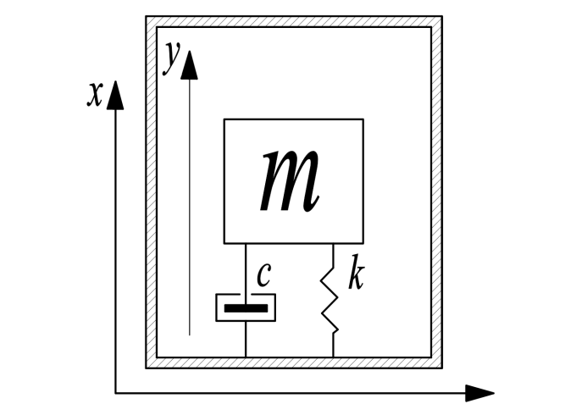

Fig 1.Schematic diagram of a second-order inertial system

In Figure 1, let the relative displacement of a rigid block with an inertial mass of m in the shell coordinate system be y(t), and the absolute displacement of the shell in the inertial coordinate system be x(t). The elastic recovery force of this system is determined by the nonlinear buoyancy characteristics of the magnetic liquid (including the first-order and second-order buoyancy components), and its equivalent stiffness coefficient is denoted as k. The damping force originates from the viscous effect of the magnetic liquid and the hydrodynamic resistance caused by the movement of the mass block, with an equivalent damping coefficient of c. When the sensor is fixedly connected to the object being measured, the displacement x(t) of the housing directly reflects the motion state of the object being measured. Considering the motion state of the inertial mass in the overall coordinate system, the motion equation of this inertial system can be written as

$m\frac{d^{2}y}{dt^{2}}+c\frac{dy}{dt}+ky=-m\frac{d^{2}x}{dt^{2}}⇒\frac{d^{2}y}{dt^{2}}+\frac{c}{m}\frac{dy}{dt}+\frac{k}{m}y=-\frac{d^{2}x}{dt^{2}}=-a$（1）

For an acceleration sensor, the acceleration a of the object to be measured is the input, and the displacement y of the inertial mass relative to the housing is the output. Under the zero initial condition, performing the Laplace transform on the above equation can yield

$\left(\begin{matrix}ms^{2}+cs+k\end{matrix}\right)Y\left(\begin{matrix}s\end{matrix}\right)=-mA\left(\begin{matrix}s\end{matrix}\right)$（2）

Therefore, the transfer function of the system can be written in the standard form of a second-order system

$H\left(\begin{matrix}s\end{matrix}\right)=\frac{Y\left(\begin{matrix}s\end{matrix}\right)}{A\left(\begin{matrix}s\end{matrix}\right)}=-\frac{m}{ms^{2}+cs+k}=\frac{-1}{s^{2}+\left(\begin{matrix}c/m\end{matrix}\right)s+\left(\begin{matrix}k/m\end{matrix}\right)}$（3）

Thus, the characteristic equation of the system is obtained

$s^{2}+\left(\begin{matrix}c/m\end{matrix}\right)s+\left(\begin{matrix}k/m\end{matrix}\right)$（4）

Convert the characteristic equation into the standard form of a second-order system

 （5）

**3.2 The magnetization characteristics of magnetic liquids**

The magnetization characteristics of magnetic liquids are the core physical basis for them to be used as sensitive materials for sensors. According to Langevanshun's magnetic theory, the macroscopic magnetization M of a magnetic liquid under the action of an external magnetic field H can be expressed as:

$M=NμL\left(α\right)$（6）

This theoretical model reveals three key characteristics of the magnetization intensity of magnetic liquids: linear magnetization in the weak field region ($α$ <<1), nonlinear in the medium field strength region, and saturation magnetization in the strong field region ($α$ >>1). Experimental studies have shown that magnetic liquids of different base carriers (such as coal-based and oil-based) have significantly different magnetization curves, which directly affect the performance of the sensor.

The influence of magnetization characteristics on sensors is mainly reflected in the following aspects: Firstly, the initial magnetic susceptibility determines the sensitivity of the sensor. Magnetic liquids with a high initial magnetic susceptibility can achieve weaker magnetic field detection. Secondly, the saturation magnetization intensity affects the dynamic range of the sensor, and it is necessary to select the appropriate magnetic liquid according to the specific application scenario. Furthermore, the nonlinear characteristics of the magnetization curve can cause changes in the linearity of the sensor's output signal, and compensation correction is required in precise measurements.

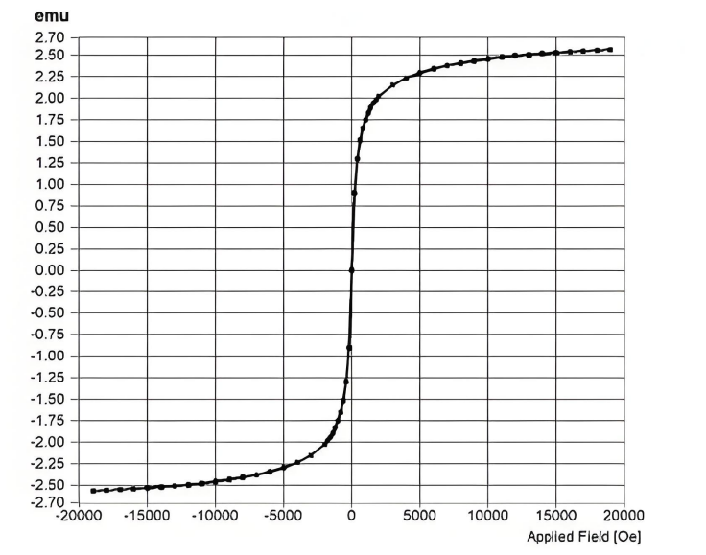

Fig. 2 Hysteresis loop chart of coal-based magnetic liquid

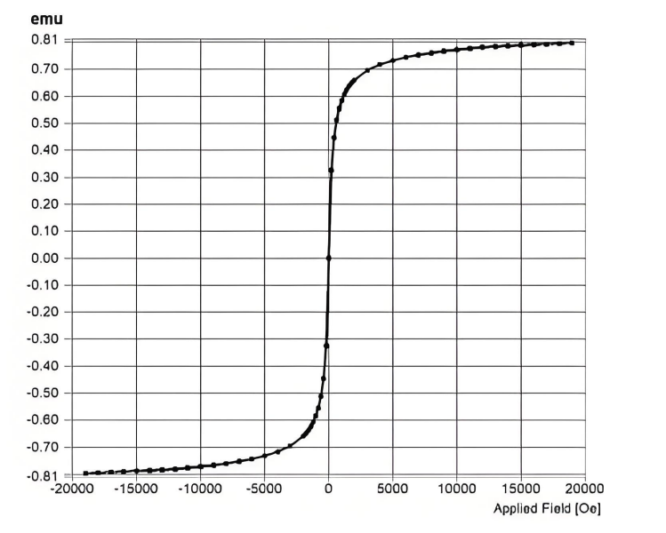

Fig. 3 Hysteresis loop chart of water-based magnetic liquid

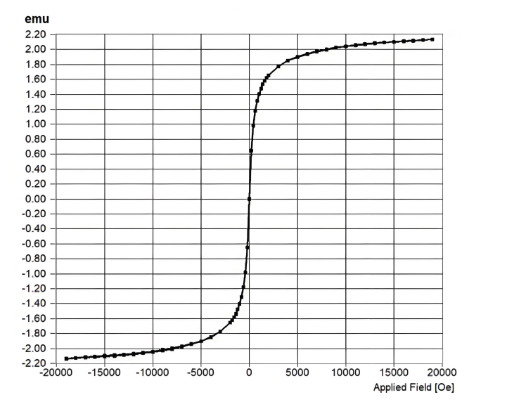

Fig. 4 Hysteresis loop chart of oil-based magnetic liquid

From the above figures 2, 3 and 4, the order of saturation magnetization intensity can be obtained as follows: coal-based > oil-based > water-based. It can be seen that the residual magnetization and coercive force of all magnetic liquids are approximately 0, and there is no hysteresis in the magnetization curve. This can prove that the magnetic liquid is a superparamagnetic material. The higher the saturation magnetization of a magnetic liquid, the higher the magnetic field it generates. Therefore, a higher output voltage can be obtained during measurement, which is more conducive to data processing. The higher the viscosity of the magnetic liquid, the greater the acceleration required for the inertial mass suspended in it to move to the same position than that of the magnetic liquid with lower viscosity. Therefore, when both reach the maximum range of the sensor tube, the sensor of the magnetic liquid with higher viscosity applies a greater acceleration, and thus the measurement range of the magnetic liquid with higher viscosity will be larger.

1. Magnetic field simulation of magnetic liquid acceleration sensor

This section conducts a simulation study on the internal magnetic field distribution of magnetic liquid acceleration sensors. By establishing a three-dimensional finite element model, the magnetic circuit system composed of two return magnets (200mT) at both ends and a permanent magnet (300mT) in the middle was numerically simulated, with the magnet being the rubidium magnet N52. The simulation results show that in the designed 85mm long transparent acrylic tube structure (the specific value of the inner diameter needs to be supplemented), the recovery magnet with a diameter of 5mm and a thickness of 4.5mm and the permanent magnet with a diameter of 4mm and a thickness of 6mm in the middle form a typical magnetic field gradient distribution. The obtained magnetic flux density mode image clearly shows the gradient variation characteristics of the axial magnetic field intensity, while the magnetic scale potential distribution intuitively reflects the attenuation law of magnetic potential energy in space. It is particularly worth noting that the symmetrical magnetic field generated by the centered arrangement of the permanent magnet and the reverse magnetic field formed by the returning magnets at both ends produce a specific gradient in the middle area of the acrylic tube. This magnetic field configuration provides the necessary field strength gradient conditions for the displacement detection of the magnetic liquid under the action of acceleration. The simulation results verified the rationality of the sensor's magnetic circuit design, providing a theoretical basis for the subsequent research on the dynamic characteristics of magnetic liquids.

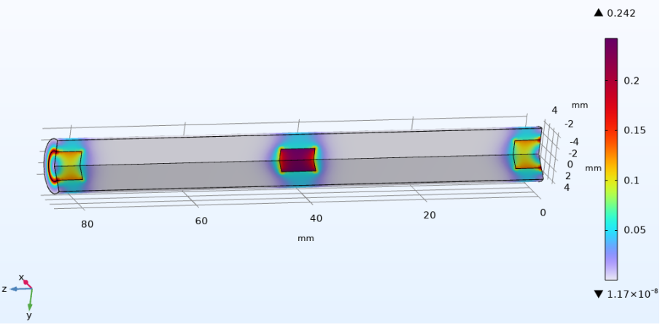

Fig.5 Magnetic flux density model (3d)

The magnetic flux density mode image visually presents the spatial distribution characteristics of the axial magnetic field intensity, which is directly related to the magnitude and direction of the magnetic volume force acting on the magnetic liquid and is a key parameter for determining the sensitivity of the sensor. The magnetic field gradient distribution diagram precisely quantifies the rate of change of the field strength in the detection area. Its gradient characteristics are closely related to the dynamic response characteristics of the sensor, especially having guiding significance for determining the linear range of acceleration detection. The magnetic marker potential distribution image reveals the attenuation law of magnetic potential energy in space, and this result verifies the effectiveness of the magnetic circuit design.

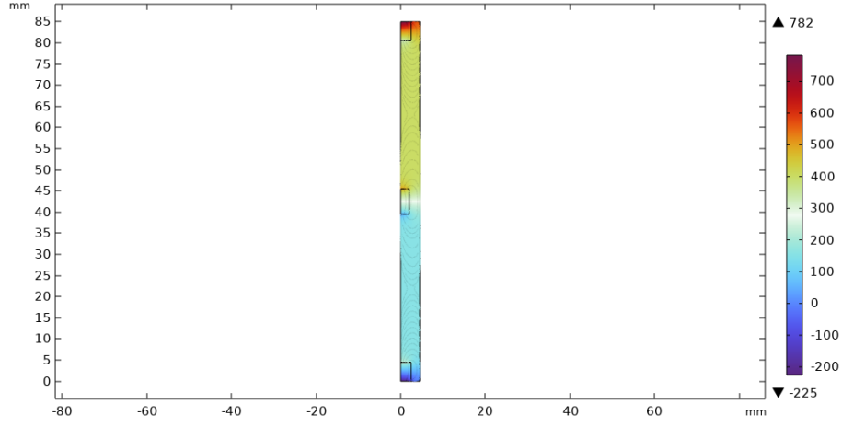

Fig.6 Magnetic marker potential

**5.Dynamic performance indicators of magnetic liquid acceleration sensors**

The dynamic performance indicators of magnetic liquid acceleration sensors reflect their response characteristics to time-varying input quantities and are an important basis for evaluating the sensor's ability to measure transient signals. Dynamic performance focuses on key parameters such as the response speed, frequency characteristics and stability of sensors under rapidly changing conditions. In terms of dynamic performance, the dynamic characteristics of the sensor are mainly evaluated through step response testing.

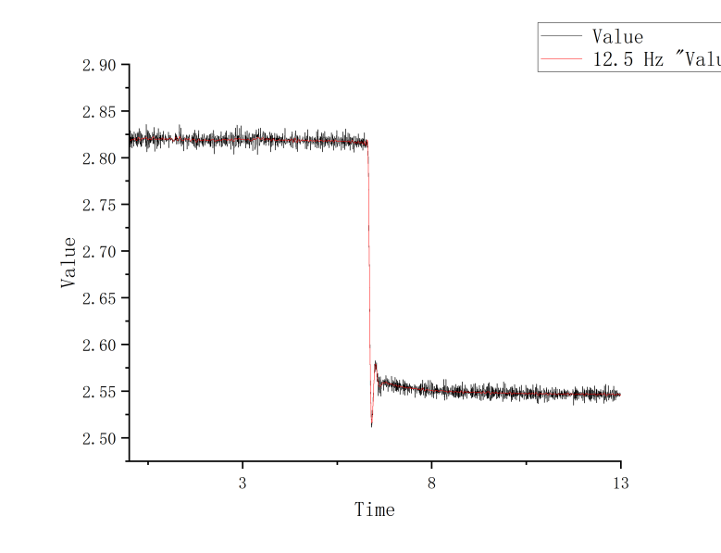

Fig.7 Coal-based step response

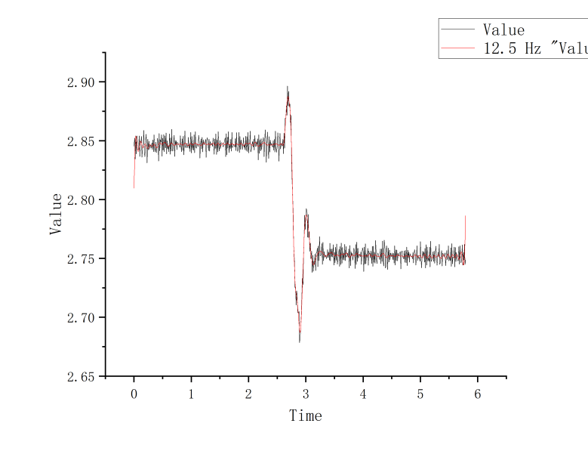

Fig.8 Water-based step response

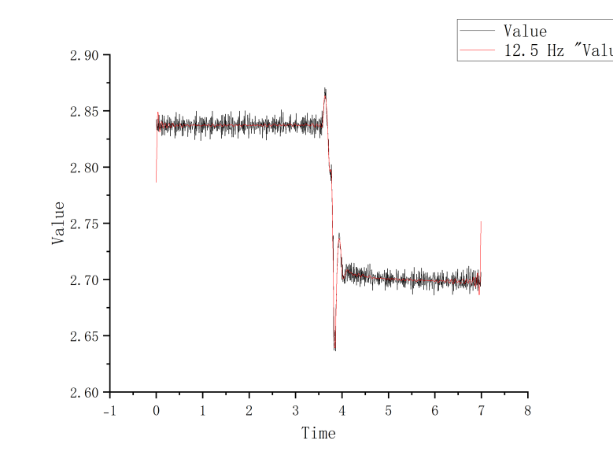

Fig.9 Oil-based step response

The above figure shows the step responses of three types of sensors from 5° to 0°, that is, from 0.85m/s ² to 0. The red line part represents the result after FFT filtering by origin. As can be seen from the above figure, the coal-based sensor has better step response performance. The specific dynamic performance of the sensor is shown in the table below. Coal-based sensors have the smallest rise time, stabilization time and peak time, so they respond more sensitually and have the least overshoot, which will not cause overly obvious signal fluctuations. And it has the largest bandwidth, faster response and stronger anti-interference ability. Therefore, it can be obtained that petroleum-based magnetic liquid is more suitable for sensor acceleration sensors.

Table 1 Dynamic Performance of Magnetic Liquid Acceleration Sensor

|  |  |  |  |  |  |  |  |
| --- | --- | --- | --- | --- | --- | --- | --- |
|  | Rising time tr/s | Stabilization time（5%）ts/s | Peak time  tp/s | Overshoot | Damping coefficient | Natural frequency $ω_{n}$ /rad/s | Bandwidth $ω_{b}$ /rad/s |
| Coal oil-based | 0.122 | 0.323 | 0.163 | 11.4% | 0.434 | 21.401 | 25.37 |
| Water-based | 0.173 | 0.468 | 0.286 | 68.4% | 0.504 | 12.718 | 15.60 |
| Engine oil base | 0.224 | 0.620 | 0.259 | 43.5% | 0.371 | 13.059 | 14.89 |

It should be particularly noted that the dynamic performance of magnetic liquid sensors is closely related to their unique rheological properties. Under the action of an external magnetic field, the magnetorheological effect exhibited by magnetic liquids will significantly affect their dynamic response. Experimental data show that appropriately enhancing the magnetic field gradient can improve the response speed of the sensor, but an overly strong magnetic field will lead to an increase in viscosity, which in turn reduces the operating frequency band. Therefore, in practical applications, it is necessary to optimize the magnetic field parameters according to the measurement requirements to achieve the best dynamic performance. Through system testing and parameter optimization, the magnetic liquid acceleration sensor can meet the dynamic performance requirements of most industrial vibration measurements(2) Since the tensioning integral robot directly analyzes it and its complexity, this paper deduces the mathematical model of the tensioning integral robot by using D-H parameter method. Matlab software was used to solve and calculate the above mathematical model, and Solidworks 3D modeling software was used to model the whole tensioner robot. The model was processed and imported into Adams for kinematic simulation, and the simulation results based on mathematical model were compared and verified.

COMPETING INTERESTS DISCLAIMER:

Authors have declared that they have no known competing financial interests OR non-financial interests OR personal relationships that could have appeared to influence the work reported in this paper.

References

[1] Yu Youwen, Chang Jian Principles and Engineering Applications of Sensors [M]. Xidian University Press,2000.

[2] Li Decai. Theory and Application of Magnetic Liquids [M]. Beijing: Science Press, 2003: 1-27.

[3] Chi Changqing. Physical Foundations and Applications of Ferromagnetic Fluids [M]. Beijing: Beihang University Press,2011, 11:1-15.

[4] Chi Changqing. Ferromagnetic Fluid Dynamics [M]. Beijing: Beihang University Press,1993:140-171.

[5]N. C. Popa. Transducer for the measurement of slopes vs. the horizontal[P].RO,A1, 98430.1989.

[6]Bacri J C , Lenglet J , Perzynski R ,et al.Magnetic fluid pressure sensor[J].Journal of Magnetism & Magnetic Materials, 1993, 122(1-3):399-402.

[7]Olaru R, Dragoi D D. Inductive tilt sensor with magnets and magnetic fluid[J]. Sensors and actuators A: Physical, 2005, 120(2): 424-428.

[8]Wenrong Yang, Qingxin Yang, Rongge Yan, et al. Theoretical and experimental researches on magnetic fluidacceleration sensor[J]. International Journal of Applied Electromagnetics and Mechanics, 2010, 33(12):655-663.

[9]Yao J , Huang C , Li D .Research On A Novel Ferrofluid Inertial Sensor With Levitating Nonmagnetic Rod[J].IEEE Sensors Journal, 2015, 16(5):1-1.

[10]Yao J , Liu S , Li Z ,et al.A Novel Ferrofluid Inclinometer Exploiting a Hall Element[J].IEEE Sensors Journal, 2016, 16(22):7986-7991.