**Experimental Study on behavior of Reinforced Concrete (RC) Slabs by Using Fiber Reinforced Polymers with Silica Fume as Admixture**

**ABSTRACT**

The flexural behavior of simply supported one-way slabs constructed with high-strength concrete

(HSC) and normal-strength concrete (NSC), and reinforced with glass fiber reinforced polymer

(GFRP) bars, was investigated experimentally with different 𝑝𝑓/𝑝𝑓𝑏 ratios. The ultimate load

capacity, crack patterns, failure modes, ultimate deflection, and concrete and GFRP steel bar

strains, are considered as main parameters A total of four large scale reinforced concrete simply supported slabs were prepared with dimensions of 750 mm width x 1500 mm length x 125 mm thickness, to study the performance of (NSC) and (HSC) slabs reinforced with conventional steel and GFRP bars under three-point load. Results showed that slabs reinforced with GFRP bars in both NSC and HSC exhibited higher deflections at each load increment compared to steel- reinforced slabs and recorded less ultimate load, compared to control slabs. Furthermore, GFRP reinforced slab failed by GFRP rupture and bond failure without any warning and showed large cracks compared to that reinforced with normal steel. Moreover, the experimental results are in accordance with those obtained from analytical results calculated using the ACI 440, CAN/CSA S806 and Eurocode 2 provisions. The predicted and experimental moments at cracking and ultimate loads aligned well for under-reinforced slabs, whereas the results for the over-reinforced GFRP slabs were slightly unconservative, as per CSA S806-12, also CSA S806 2012 showed a good agreement for a comparison between predicted and experimental mid-span deflection. The EURO EN 1992-1-1:2004 shows reasonable agreement with experimental cracks width results compared with other codes with error band not more than 10%.

**Keywords:** GFRP; Slab; flexural behaviors; HSC; failure modes.

**1. Introduction**

Glass fiber reinforced concrete (GFRC) is a relatively recent innovation in civil engineering and has seen widespread use in many countries since its introduction approximately two decades ago. This product has advantage of being light weight and thereby reducing the overall construction costs, ultimately leading to greater economic efficiency in building projects. [1]. FRP materials offer a practical and efficient substitute for steel reinforcement in concrete structures, due to their differing physical and mechanical characteristics from those of steel. [2]. Fiberglass composites provide several benefits such as cost-effective production, simple fabrication, reduced weight, and a superior strength-to-weight ratio. [3]**.** Various types of fibers are commercially available, such as steel, glass, synthetic, and certain natural fibers. Among these, glass fiber and polypropylene fiber are two highly effective micro-reinforcement materials commonly used to enhance the performance of concrete. [4], [5]**.** In the past 15 years, numerous researchers have consistently reported that, in the case of steel fibers, corrosion is less active as compared with steel bars [6], [7], [8], [9]. The combined impact of corrosion and fatigue significantly reduces the service life of structures. [10]**.** GFRP reinforcing bars possess higher tensile strength and greater corrosion resistance than conventional steel reinforcement. Additionally, their moderate flexural strength makes GFRP a suitable alternative to steel in foundation applications [11], [12].

several researchers have experimentally examined the flexural behavior of reinforced concrete (RC) members. From this selection investigations, experimental results show that GFRP reinforced concrete beams have lower load-carrying capacity and greater deflection compared to their steel-reinforced counterparts. [13], [14], [15]**.** GFRP rebars possess a lower modulus of elasticity, resulting in greater deflection under the same loads and span length [16], [17]. The flexural stiffness of GFRP-reinforced concrete slabs decreases after cracking leading to increased deflection. [18]. GFRP bars embedded in (HSC) demonstrated better performance in terms of deflection compared to those embedded in (NSC). [19]**.** On the other hand**,** several researchers found that GFRP slabs exhibited higher ultimate load-carrying capacities and superior fatigue performance compared to steel slabs. [20], [21], [22].

Concrete members reinforced with FRP bar generally exhibit greater deflections and strains than those reinforced with steel bar, primarily due to the lower modulus of elasticity and differing bond characteristics of FRP reinforcements. [23], [24]**.** GFRP-reinforced beams using (NSC) exhibit lower strains compared to (HSC) beams under the same load conditions. Additionally, beams

reinforced with sand-coated GFRP demonstrated smaller and narrower cracks than those reinforced with helically grooved GFRP, indicating better bond properties between the concrete and GFRP. [25], [26]**.** The GFRP bars demonstrated about 70% lower bond strength than the steel bars [27]**.** GFRP-reinforced elements develop cracks with greater widths compared to those observed in steel-reinforced elements [28], [29]**.** Concrete members reinforced with FRP exhibit linear behavior up to cracking, and continue to behave linearly after cracking, though with significantly reduced stiffness [23]. (HSC) improved both the ultimate-load capacity and initial shear cracking load [30]. In another study, The cracks of GFRP reinforced concrete slab are sparse with large crack width [18]. Use of FRP rebars with ultra-high performance fiber-reinforced concrete provided an advantage through increased tensile capacity in the beam, resulting in a higher ultimate load capacity. The beam also demonstrated typical reinforced concrete behavior, with cracking and failure occurring in the concrete under tension and compression. [31]. Cracks in GFRP-reinforced concrete slabs typically form earlier than in steel-reinforced slabs because GFRP bars have a lower stiffness (modulus of elasticity) and the first cracks usually appear at higher loads compared to unreinforced concrete, but lower loads compared to steel-reinforced slabs. GFRP bars do not yield like steel; instead, they exhibit linear-elastic behavior until failure. As a result, crack widths tend to be larger than in steel-reinforced slabs under similar loads. Crack spacing is generally wider compared to steel-reinforced concrete because GFRP has a lower bond strength with concrete. The width of cracks in the concrete was significantly influenced by the diameter of the reinforcing bars and the characteristics of their surface finish. [24], [25] , [32]**.** The slab which reinforced with steel bars demonstrated a typical ductile flexural failure mode, initiated by yielding of the steel reinforcement and followed by crushing of the concrete. Conversely, the slab reinforced with GFRP bars exhibited a brittle failure mechanism, governed predominantly by concrete crushing, with no yielding of the reinforcement. [33], [24], [15], [20], [34], [32]**.**

The observed failure modes in the tested GFRP-reinforced slabs included shear-compression failure, diagonal tension failure, and bond or anchorage failure. [30]**.** The flexural behavior of FRP-reinforced members is influenced by the governing failure mechanism, which may be either concrete crushing or rupture of the FRP reinforcement. The governing mode can be find out by evaluating the FRP reinforcement ratio relative to the balanced reinforcement [35].

For conventional concrete, the strains in the FRP rebars rose almost linearly with the applied load after the onset of cracking. [36], [37]. On the other hand, ultra high-performance fiber-reinforced concrete exhibited nonlinear load–strain behavior, with a gradual increase in strain at initial loading stages attributable to its strain-stiffens properties[38]**.** Other analysis used by [39] concluded that increasing concrete strength from (95) to (117) MPa exerted negligible influence on the concrete strain at equivalent applied load . The strain behavior of Smooth and sand coated GFRP reinforced concrete is increased about 44% and 14% respectively when evaluated with steel reinforced concrete [11]**.**

**2. Experimental Program**

For the experimental investigation, four concrete simply supported slabs were prepared with dimension of 750 mm width x 1500 mm length x 125 mm thick, to study the performance of (NSC) and HSC) slabs reinforced with conventional steel and GFRP bars subjected to three-point load. The ultimate load capacity, crack patterns, failure modes, ultimate deflection, concrete and GFRP/ steel bar strains, was obtained.

**2.1 Materials properties**

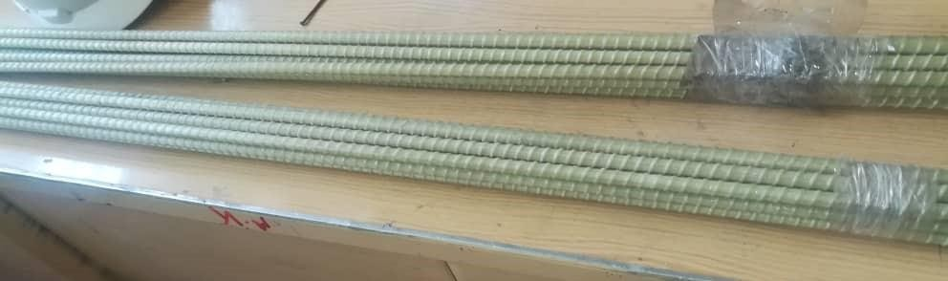

GFRB bar: Reinforcement of the slabs was achieved using glass fiber-reinforced polymer (GFRP) bars having a nominal diameter of 10 mm as shown Figure 1, which similar to those used by Yoo, D.-Y., N. Banthia, et al. [17], the properties are summarized in Table 1

*Table 1 Properties of GFRP bar*

*Figure 1 shown GFRP bars*

|  |  |  |  |  |  |  |
| --- | --- | --- | --- | --- | --- | --- |
|  | Normal | Nominal | Mas per | Ultimate | Ultimate Tensile | Max. |
| Material | Diameter | Area | meter run | Load | Strength (Mpa) | Strain |
|  | (mm) | (mm2) | (gm/m) | (kN) |  |  |
| GFRP | 10 | 78.57 | 138 | 80.72 | 1027.36 | 0.0258 |

Steel: High tensile deformed steel bar grade 460 confirming to BS 4449 was used for the experimentation. The mechanical properties are summarized in Table 2. Silica Fume: For the preparation of high-strength concrete, silica fume was supplied as a dry powder and incorporated into the mixture during batching (Sika Egypt Construction Chemicals), as shown in Figure .2

*Table 2 Mechanical properties of Reinforcements*

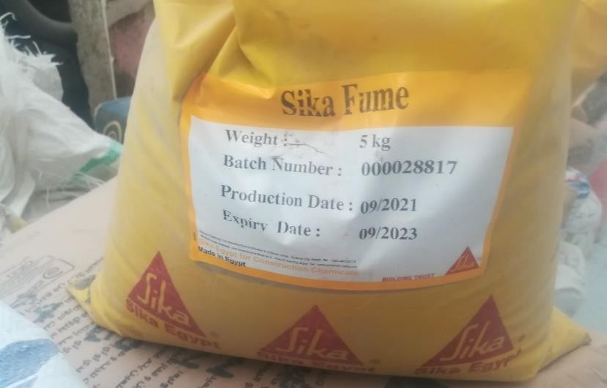

|  |  |  |  |  |
| --- | --- | --- | --- | --- |
| Type | Yield point | Tensile strength | Young modulus | Strain |
| MPa | MPa | GPa |
| Grade 500 | 503.5 | 634 | 205 | 0.0025 |

*Figure 2 Silica Fume used to produce high strength concrete*

Superplasticizer**:** A superplasticizer admixture was incorporated to enhance the workability of the high-strength concrete (SikamentR-163M) form (Sika Egypt Construction Chemicals) was used. The mixed proportions chosen for this study is given in Table 1. The mix was similar to those used by **[40].** Table 3 presents the composition of the two trial concrete mixtures considered in this study. The constituents were weighed in separate buckets. Mixing of the materials was carried out using a concrete mixer capable of handling up to 400 kg per batch for a period about 4 min (Figure.3). Mechanical vibration was employed to compact the concrete mixes, facilitating proper consolidation and reducing voids. The slump of the fresh concrete was measured to ensure compliance with the target workability specified in the design. After 24 hours, the specimens were demolded, submerged in water for curing, and subsequently tested at room temperature at the specified ages, as presented in Figure 4.

*Table 3 Mix proportion for Normal (N) and High (H) performance concrete*

|  |  |  |  |  |  |  |  |  |
| --- | --- | --- | --- | --- | --- | --- | --- | --- |
| Mix  (kg/m3) | Cement | Silica  Fume | Sand | Aggregate | | | Water | Super  Plastizer/L |
| 5MM | 10MM | 20MM |
| NSC | 416 | 0 | 721 | 0 | 338 | 790 | 207 | 0 |
| HSC | 400 | 44 | 710 | 393 | 797 | 0 | 140 | 7.9 |

Unconfined compressive strength was evaluated by casting six 150 mm cube specimens for each

mix, with tests conducted on three samples after 7 days and the remaining three after 28 days of water curing, as presented in Table 4.

*Table 4 Cubes designation*

No. Cube designation

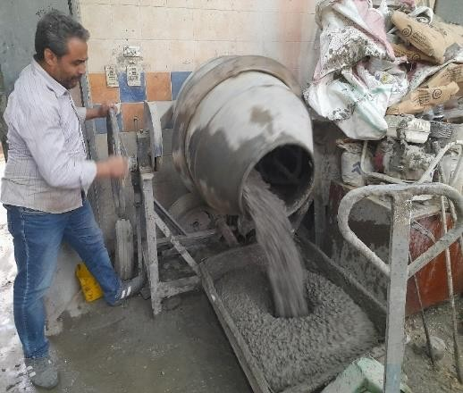

No. of

Date of Tested

Additive

|  |  |  |  |  |  |  |
| --- | --- | --- | --- | --- | --- | --- |
|  | | cubes | 7 days | 28 days |  | Grade |
| 1 | C1(control) | 6 | 3 | 3 | - | 30 |
| 2 | C1.1(control) | 6 | 3 | 3 | Silica Fume | 70 |

Mix

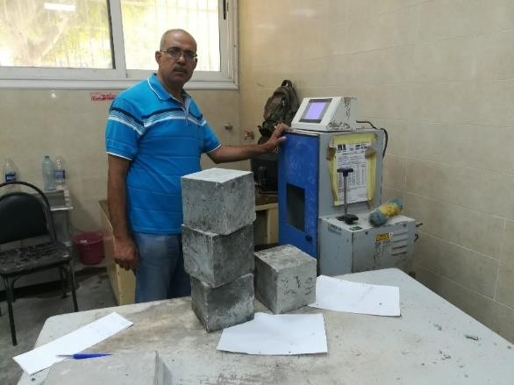

**2.2 Slab details**

*Figure 3* P*an mixer Figure 4* C*ubes’ test*

A series of four reinforced concrete slabs were fabricated and subjected to three-point loading to evaluate their flexural behavior. Details of tested slabs are shown in Table 5; with dimensions of 750 mm width, 1500 mm length, and 125 mm thickness. Slabs labeled as S30 and S70 were considered as control slabs, which provided with 5 and 10 number reinforced with high- yield steel bars (10mm) in the both longitudinal (1.5m) and transverse directions (0.75m) respectively as shown in Figure 5& Figure 6, with grade 30 and 70 respectively. Specimens F30 and F70 reinforced with GFRP bar and detailed also in Figure 5 & Figure 6.

All slabs were designed with a uniform clear cover of 25 mm on the top, bottom, and vertical sides.

Utilizing the specified bar diameters, slab F30 was classified as over-reinforced, exhibiting

a 𝜌𝑓/𝜌𝑓𝑏 ratio exceeding 1.0. In contrast, the other slab was designed to be tension-controlled,

with a ratio below 1.0, as per the CSA S806-12 [41].

Table 5 slabs details:

|  |  |  |  |  |  |  |
| --- | --- | --- | --- | --- | --- | --- |
| Slab  No.  designation | | Type of bar | Bar size (T) | specification  Additive | Mix Grade | 𝑃𝑓 /��𝑓� |
| 1 | S30 (control) | steel | 10 | - | 30 | 0.33 |
| 2 | S70 (control) | steel | 10 | Silica Fume | 70 | 0.19 |
| 3 | F30 | GFRP | 10 | - | 30 | 1.47 |
| 4 | F70 | GFRP | 10 | Silica Fume | 70 | 0.82 |

STEEL GFRP

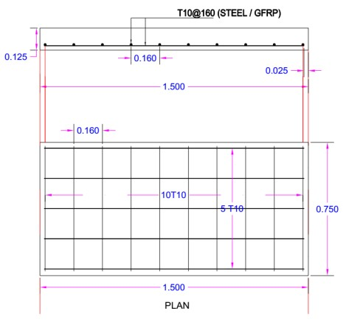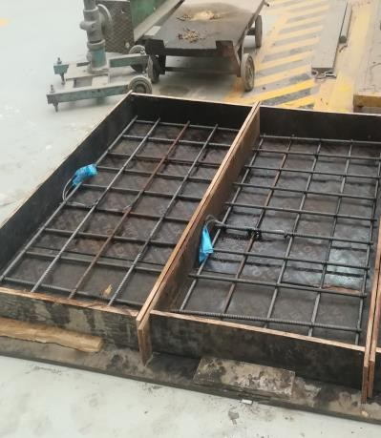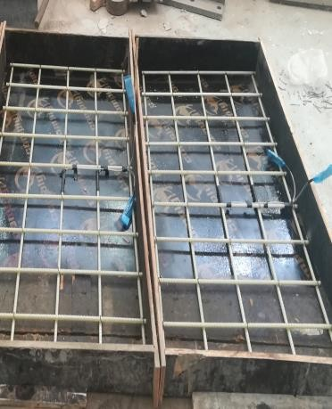

*Figure 5 Details of steel / GFRB diagram Figure 6 Actual Details of steel / GFRP*

**2.3 Specimen preparation and Test Setup**

The formwork was fabricated from 20 mm thick black plywood panels, which were screwed together in accordance with the previously specified slab dimensions as shown in Figure.

7. To facilitate demoulding, the internal surfaces and contact edges of the formwork were coated with oil before the placement of the reinforcement cage. The steel reinforcement cage was fabricated in the laboratory using deformed steel bars. An electrically powered hacksaw was used to cut the steel bars to their designated lengths in accordance with the design specifications. Spring steel reinforcement ties, spaced at (160) mm, were used to securely connect the longitudinal and transverse steel bars. To maintain the specified bottom and side cover in all slabs, triple cover concrete spacers were secured to the base and side of the reinforcement cage using wire ties.

Lifting anchors fabricated from 12 mm diameter bent bars were embedded on opposite sides of the formwork to enable safe transportation and handling of the slabs as shown in Figure 8.

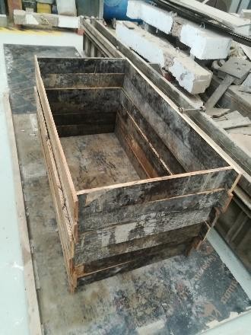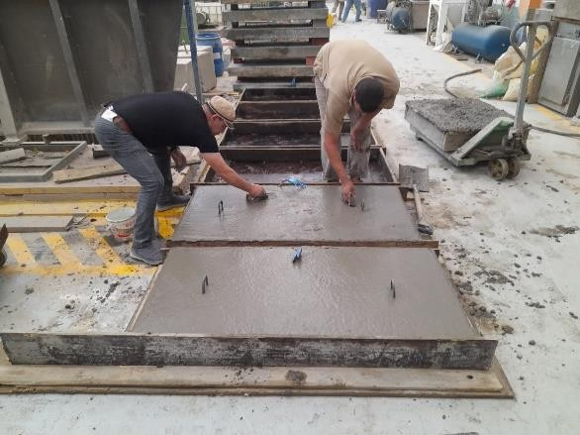

*Figure 7 Formwork used for slabs Figure 8 Two lifting anchors bars*

**2.4 Attachment of strain gauges**

To measure strains during the full loading sequence, Two electrical-resistance strain gauges of 6 mm length and 2.2 mm width strain gauges were mounted on the longitudinal reinforcement at the slab edges and mid-span- as shown in Figure 9, the strain gauges used were Polyester wire strain (FLAB-6-11) type from Tokyo Measuring Instruments Laboratory Co., Ltd, with temperature compensation of -10 to +100 C0 and with resistance of 120 Ω. Moreover, electrical-resistance strain gauges of 60 mm length and 1.0 mm width. Polyester wire strain gauges were installed on the top surface of the concrete slab, as illustrated in Figure 10, the strain gauges used was Polyester wire strain (PL-60-11) type from Tokyo Measuring Instruments Laboratory Co., Ltd also, with temperature compensation of +10 to +80 C0 and resistance of 120 Ω. An external strain gauge was affixed to the pre-cleaned concrete surface using a specialized adhesive to ensure optimal surface smoothness and bonding integrity. The gauge was subsequently encapsulated with protective layers of the specialized adhesive.

To prevent moisture infiltration during casting, each strain gauge was sealed using a combination of urethane sealant, plastic black tape, and synthetic rubber adhesive. The wiring associated with the strain gauges was carefully arranged to avoid damage during concrete placement and was additionally enclosed in protective coverings to maintain the operational reliability of the gauges.

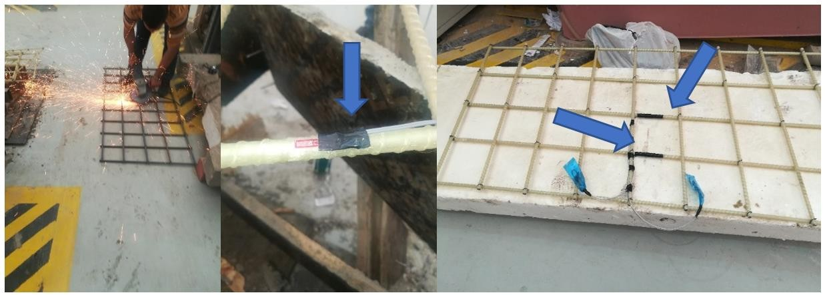

*Figure 9 Strain gauges attached on the GFRP and Steel bars.*

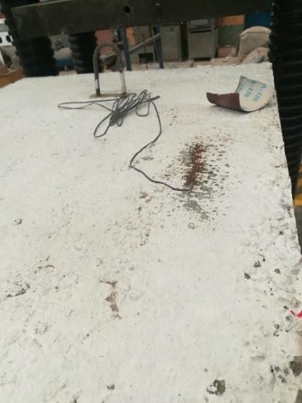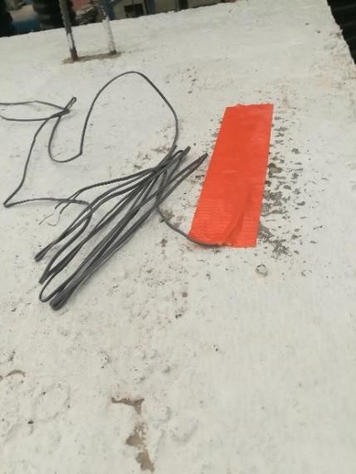

*Figure 10 Strain gauges attached on the top concrete surfaces.*

**2.5 Casting of concrete**

Concrete was poured directly from the mixer into the formwork, while internal vibrators were employed to eliminate air voids. The vibration process was conducted with particular care around the strain gauges, which made it relatively time-consuming. Upon completion of pouring and vibration, the top surfaces of the specimens were trowelled to achieve a smooth finish. Concrete cubes were also prepared, demolded the following day, and subsequently placed in a curing tank. A slump test was performed on-site during the pour, yielding a value of 105 mm, which was within acceptable limits. During the curing phase, the concrete slabs were submerged in water. Figure 11 presents the completed concrete slabs along with the timber cross members employed to reinforce and maintain the integrity of the formwork

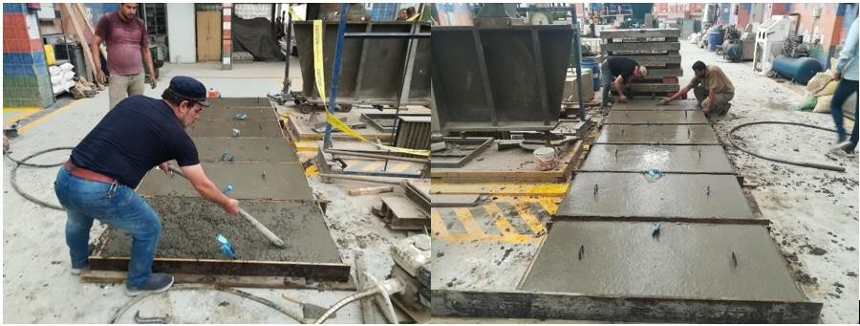

*Figure 11 Specimens preparation.*

**2.6 Experimental Configuration and Instrumentation**

Experimental testing was conducted on the slabs through a three-point loading configuration, as illustrated in Figures 12 and 13. A concentrated point load was applied through a 125 × 65 mm steel I-beam, which served to transfer the load from a 50 TON capacity hydraulic jack directly to the mid-span of the slab

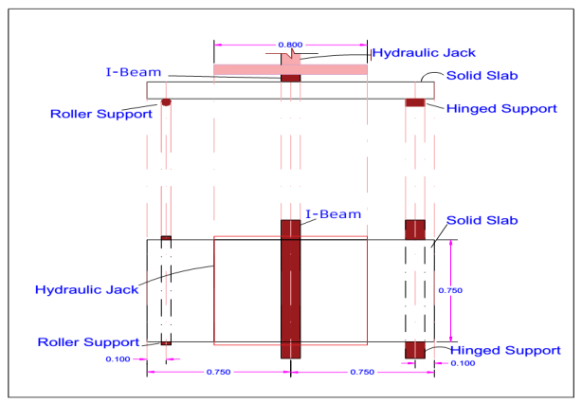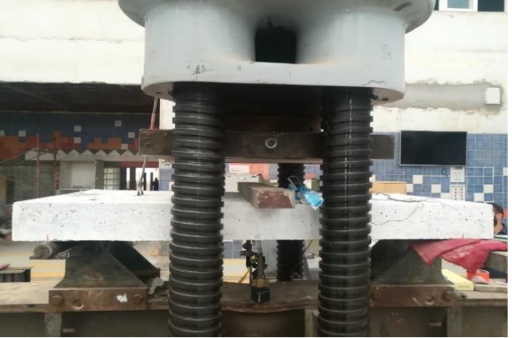

*Figure 12 Three-point loading Set-up diagram Figure 13 Actual Point Load Test Set up.*

LVDTs were used to monitor deflection and crack width in the tested slabs during loading, as depicted in Figure 14. Deflection measurements were obtained using LVDTs positioned beneath the two support points and at the mid-span of each slab The crack widths were measured during testing were made using LVDTs located on the long side surface at middle of slab.

Data related to the applied load, deflection, crack widths, and strains were collected through the use of the data compression load test controller (CLT5000). All the specimens were tested up to failure. The load was measured by a 500-kN capacity load cell. Incremental loading was conducted

at a rate of 300 kg/s via the load cell machine. The load corresponding to the initial crack formation was recorded, and the resulting crack pattern was marked on the surfaces of the slab.

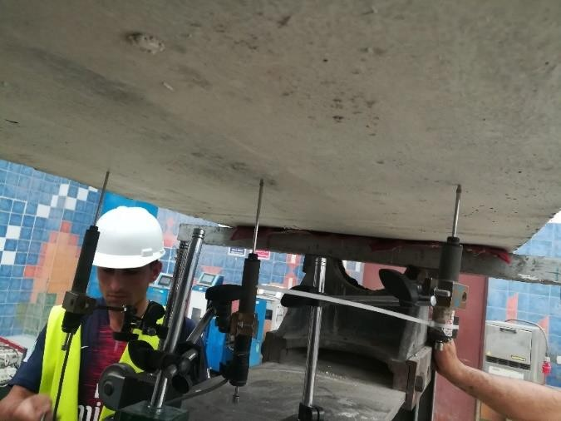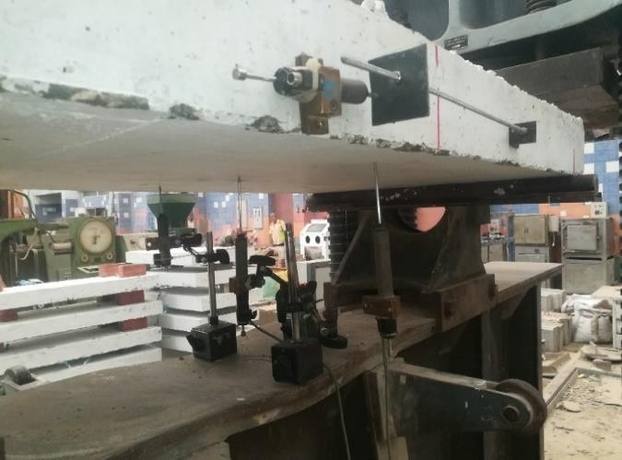

*Figure 14 LVDTs location to measure deflection and crack width during the test.*

**3. Experimental Data Analysis and Discussion**

**3.1 Modes of Failure and Crack Distribution**

A flexural crack first appeared when the applied load reached 25.0 kN for (S30) slab subjected to point load, the initial cracks developed at the bottom of the slab in the vicinity of the loading locations as shown in Figures 16 & Figure 17. The vertical and diagonal crack approximately angle of 45o occurred at the surface side around the load area by increasing the load. The vertical hair crack observed near right and left support with further load increments up to 82.4 and 103.0 kN respectively and the bottom Crack width, depth and number increased progressively with the corresponding rise in load levels. At an applied load of 107.6 KN, failure of the slab occurred as a result of steel reinforcement yielding, subsequently leading to concrete crushing under the

point loading.

Figure 18& Figure 19 show the failure mode in slab (S70); like the slab (S30), a flexural crack first appeared when the applied load reached 37.0 kN. The vertical and diagonal crack approximately angle of 45o occurred at the surface side around the load area by increasing the load. At an applied load of 121.5 kN, slab also failed by steel yielding, followed by concrete crushing under the point loading like slab (S30).

steel-reinforced slabs demonstrated a typical ductile flexural failure mechanism, initiated by the yielding of the reinforcement steel and subsequently followed by concrete crushing in the

compression zone. In slab (F30) which was reinforced with GFRP bar the vertical cracks occurred near the right side of the point load at load level of 29.4 kN. As load increased, four vertical flexural cracks occurred, and the crack extended at the bottom of slab as a line cracks along the shorter span as shown in Figures 20. By increasing load up to 75.5 kN cracks extend to the top side of slab, the cracks gradually developed an inclined orientation as they advanced toward the load application point and at load 78.7 kN leading to diagonal tension failure in slab. Final failure was preceded by a loud noise, indicating rupture of the GFRP at the bottom of the slab. This type of failure most likely to occur by GFRP rupture, [34] in this case the failure occurred by GFRP rupture and bond failure because bond in GFRP is less than conventional steel as shown in Figure 21. Figures 22 show the failure mode in slab (F70); like the slab (F30), but A flexural crack first appeared when the applied load reached 34.4 KN, about 20cm from the Applied load locations, two vertical flexural cracks occurred, and the crack extended at the bottom of slab as a line cracks along the shorter span. By increasing the load up to 73.6 kN, cracks extend to the top side of slab. Then the cracks gradually developed an inclined orientation as they advanced toward the load application point and the loading process culminated in diagonal tension failure of the slab at an applied load of 78.9 kN. Final failure was preceded by a loud noise, indicating rupture of the GFRP at the bottom of the slab. This type of failure is most likely to occur by GFRP rupture, in this case the failure occurred by GFRP rupture and bond failure because bond in GFRP is less than conventional steel.

**3.2 crack formation and propagation**

Throughout the testing process, loading was intermittently halted to visually inspect crack formation, allowing for the identification of the corresponding load levels at which cracking occurred. The failure modes of the specimens were documented based on these visual observations. The experimental results of crack formation and propagation during loading are summarized in Table 6 and Figure 15

*Table 6 Crack formation and propagation behavior of simply supported one way slab under three- point loading*

Slab ID Initial crack Maximum crack Failure

|  |  |  |  |  |  |  |  |  |
| --- | --- | --- | --- | --- | --- | --- | --- | --- |
|  | Load | Cracking | Crack | Load | Ultimate | Crack | No. of | mode |
| (kN) | moment | width | (kN) | moment | width | crack |  |
|  |  | (kN.m) | (mm) |  | (kN.m) | (mm) |  |  |
| S30 | 25 | 9.4 | 0.15 | 107.6 | 40.4 | 0.28 | 11 | Sy-cc |

|  |  |  |  |  |  |  |  |  |
| --- | --- | --- | --- | --- | --- | --- | --- | --- |
| S70 | 37 | 13.9 | 0.01 | 121.5 | 45.6 | 0.38 | 9 | Sy-cc |
| F30 | 29.4 | 11.0 | 0.09 | 78.7 | 29.5 | 1.54 | 16 | R-Bond-F |
| F70 | 30.4 | 11.4 | 0.02 | 78.9 | 29.6 | 1.92 | 19 | R-Bond-F |

*sy-cc: steel yielding, followed by concrete crushing.*

*R-Bond-F: GFRP rupture and bond failure.*

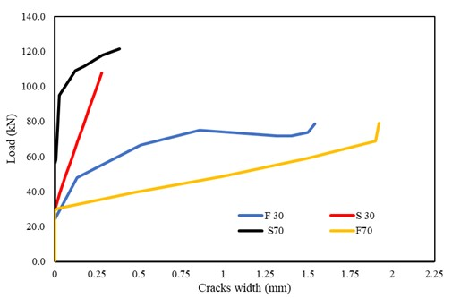

*Figure 15 Crack width behavior of simply supported one way slab under three-point loading*

Slab S30 exhibited an initial crack width about 0.015 mm at a load of 25.0 kN. With the continued increase in load, the crack width expanded to around 0.10 mm at 58.9 kN, and further to 0.28 mm at the ultimate failure load of 107.6 kN as shown in Figure 16.

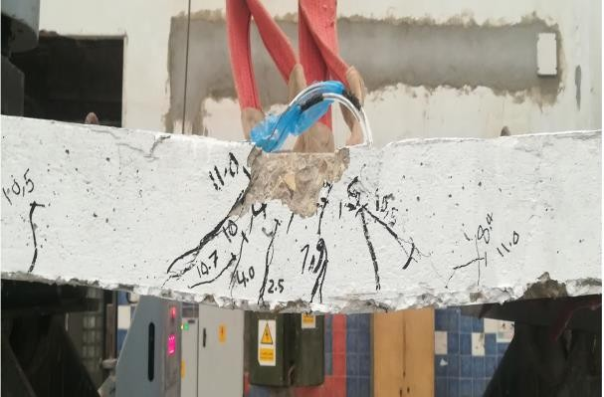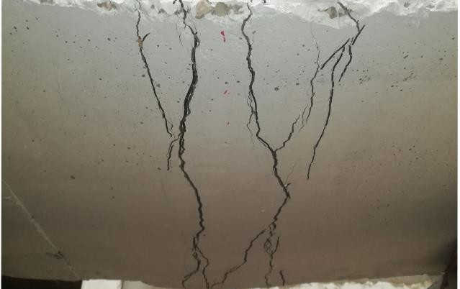

*Figure 16 Crack patterns on the surface side of the slab (S30)*

*Figure 17 Crack patterns on the bottom surface of the slab (S30)*

The first crack of slab (S70) appeared close to the point load under approximately 37.0 kN and it’s appeared similar like S30 with a width of 0.01 mm, as shown in Figure 18, as the load increased the cracks increased in width and numbers which is less than cracks occurred in slab (S30), The crack width about 0.10 mm at 96.2 kN and increased to 0.38 mm at the failure load of 121.5 kN.

Slab S70 exhibited a larger maximum crack width compared to slab S30, also the failure load is greater than (S30) about 1.36 and 1.13 times respectively.

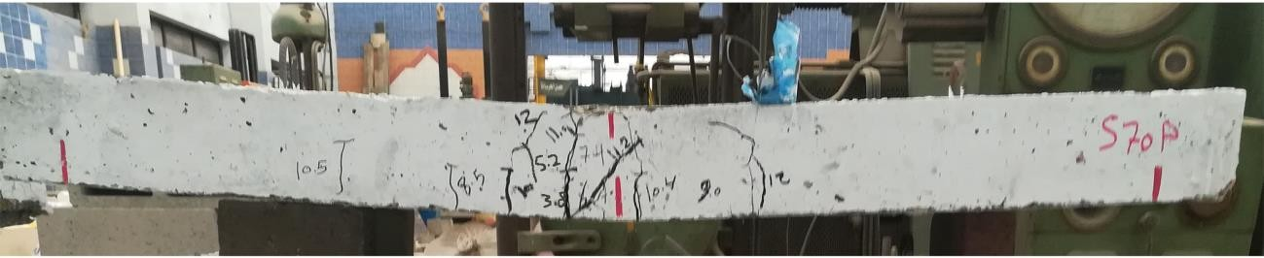

*Figure 18 Crack patterns on the surface side of the slab (S70)*

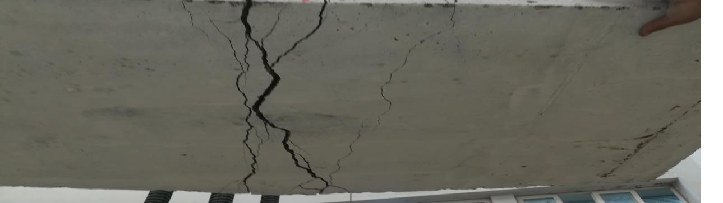

*Figure 19 Crack patterns on the bottom surface of the slab (S70)*

Slab F30 exhibited distinct crack formations compared to those observed in slabs S30 and S70, crack appear at approximately 1.18 times of the initial load of (S30), After increasing load, the crack width increased rapidly, and cracks spread along the span as shown in Figure 20.

Crack width reached 1.0 mm at 67.0 kN, then crack width increased rapidly and reached 1.54 mm at 78.7 kN (failure load), Cracks increased in width and number which is more than cracks occurred in slab (S30) by 5.50 and 1.45 time, respectively. Slab F70 exhibited distinct crack formation patterns compared to slab F30, which crack appear with small value (0.02) at approximately same value of the initial load of (F30), After increasing load, the crack width increased rapidly, and cracks spread along the span as shown in Figure 22.

*Figure 20 Crack patterns on the surface and bottom side of the slab (F30)*

*Figure 21 Bond failure of the slab (F30)*

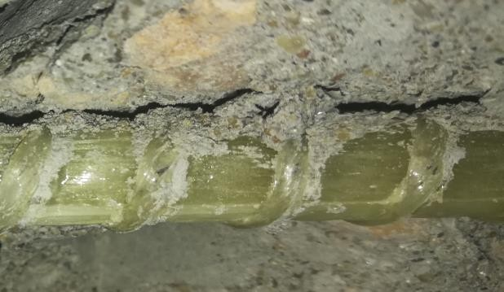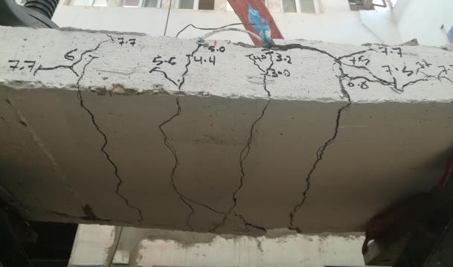

Crack width reached 1.0 mm at 48.9 kN, then crack width increased rapidly and reached 1.92 mm at 78.9 kN (failure load), cracks increased in width and number which is more than cracks occurred in slab (F30) by 1.25 and 1.20 times respectively. Finally, GFRP reinforced slab (F30 & F70) showed more, and larger cracks compared to steel reinforced slab (S30& S70) by approximately

5.0 times in width and 2.0 times in number, this was attributed to the lower modulus of elasticity and the brittle failure mechanism caused by FRP rupture. Also, its notes that crack width of high strength (S70 & F70) is more than normal strength (S30& F30) by 1.36 and 1.25 respectively, that due to high strength concrete is more brittle and crack propagate more suddenly and without much warning. Additionally, the bond between high strength and GFRP bar be less ductile, potentially affecting crack width.

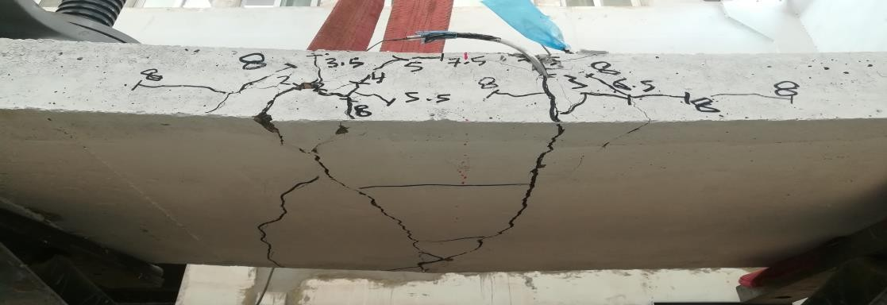

*Figure 22 Crack patterns on the surface and bottom side of the slab (F70)*

This finding is supported by [42], [43], [44], [45] and [28] whose concluded that FRP-reinforced elements typically exhibit greater deflection and wider crack widths compared to steel-reinforced members.

**3.3 Load- deflection behavior**

Four reinforced concrete slabs were tested under a 50 TON capacity load cell to investigate how the applied load influences the behavior and ultimate load-bearing capacity of the reinforced concrete slabs. This section presents the experimental study on the load-deflection behavior of the slabs. Table 7 provides the recorded load and deflection values for simply supported one-way slabs subjected to three-point loading. The load was applied in the form of a line load at the center of long span with an increment of 300 kg/s using the load cell machine. Deflection during testing was measured using Linear Variable Differential Transformers (LVDTs) positioned beneath the two edge points and at the mid-span of the slab. The three LVDTs recorded nearly identical displacement values, showing no significant variation among the measurement points. The mid-span deflection observed in the tested reinforced concrete slabs was presented in Figure 23, while Figure 24 illustrates the edge-span deflection versus load response for the tested reinforced concrete slabs.

Slab S30 demonstrated a linear load-deflection response up to 95.2 kN during the three-point loading test and deflection of 2 mm **;** which is greater by 3.8 times than the load of the first crack

25.0 kN, subsequently, the load-deflection curve deviated from linearity and increased nonlinearly**,** Variations in the curve slope reflect the progression of cracking within the concrete and the internal steel began to yield and the slab experiences large deflections without significant load increase up to the ultimate load capacity of 107.6 kN and deflection of 14.6 mm**;** then after sufficient plastic deformation, a steep drop in the curved and that indicates collapse. The deflection behavior of slab (S70) showed the similar behavior of slab (S30) with slight increase in ultimate load and deflection about 12.9% and 13.0% respectively.

The deflection behavior of slab (F30) which reinforced with GFRP bar with normal concrete strength exhibited an approximately linear response up to the point of failure. The deflection starts approximately at first crack load and at the same point of slabs (S30& S70). The deflection at mid span was higher than that of corresponding slab (S30) reinforced with steel by about 3.0 times although ultimate load was less than slab (S30) by about 36.0%. This behavior may be attributed to the lower modulus of elasticity of the GFRP bars compared to steel.

The deflection behavior of slab reinforced with GFRP bar with high concrete strength (F70) demonstrated also a nearly linear trend up to the failure load like slab (F30) and deflection start early about 20.0 kN before cracks appear, as load increase the deflection increase to become higher deflection of all slabs and higher than deflection of slab (S70) about 3.40 times**.**

*Table 7 Deflection values at Mid and Edge span*

|  |  |  |  |  |
| --- | --- | --- | --- | --- |
| Slab ID | Ultimate Load |  | **∆ exp. (mm)** |  |
|  | (kN) | (Mid span) |  | (Edge span) |
| S30 | 107.6 | 14.6 |  | 15.25 |
| S70 | 121.5 | 16.5 |  | 17.96 |
| F30 | 78.7 | 43.2 |  | 43.2 |
| F70 | 78.9 | 56.7 |  | 50.2 |

Slab F30 and F70 which reinforced with GFRP recorded the lower ultimate load of 78.7 and 78.9

kN, than the control slabs by a decreasing ratio of 27.0% and 35% respectively. On the other hand, the deflection at mid span was higher than that of corresponding slab (S30 and S70) reinforced with steel by about 3.0 and 3.40 times, respectively. This finding is similar to [46] who found a decreasing ratio of 39% and explain the reason to the small reinforcement ratio, which led to rupture of GFRP bars, also [33] demonstrated that using GFRP rebars in slabs resulted in a 42% reduction in ultimate load capacity compared to slabs reinforced with steel rebars of the same area and distribution. This reduction was attributed to premature concrete failure caused by excessive end slip of the GFRP rebars.

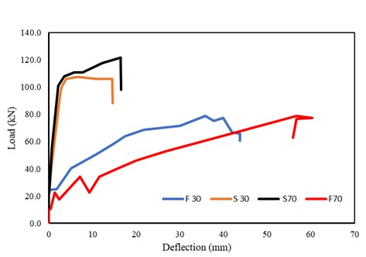

Figure 23 load - deflection curves at mid- span.

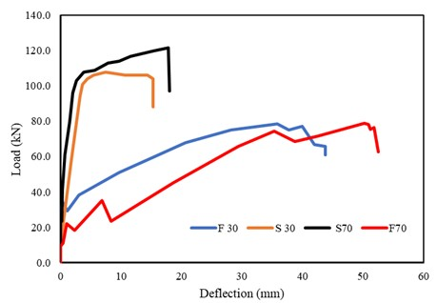

**3.4 Strain behavior**

**3.4.1 Concrete strains**

*Figure 24 load - deflection curves at edge- span.*

The strains in the concrete were affixed to the top face of the concrete slab as presented in Figure

10. Table 8 and Figure 25 Provides load–strain value and graphical representations for the tested slabs.

*Table 8 Concrete strain for tested specimens*

|  |  |  |
| --- | --- | --- |
| Slab ID | Ultimate Load (ton) | Maximum Strain (micro-strains) |
| S30 | 107.6 | 5663.9 |
| S70 | 121.5 | 2261 |
| F30 | 78.7 | 2159 |
| F70 | 78.9 | 1894 |

The strain of slab (S30) increased linearly up to 1900 micro-strains. After that the strain curve began to increase nonlinearly, variations in the curve slope reflect the progression of cracking within the concrete and the slab experiences large strain without significant load increase up to the ultimate load capacity of 107.6 kN and strain of 5664 micro-strains.

The strain curve of high strength concrete (S70) demonstrated also a nearly linear trend up to 900 micro-strains. After that the strain curve began to increase nonlinearly. The maximum strain of (S70) was lower than (S30) by 2.5 times.

The strain curve of slab reinforced with GFRP bar (F30) showed increased linearly up to 98% of the failure load. Finally, slab fail at load 78.7KN and strain of 2159 micro-strains which is lower than strain of slab (S30) by about 2.6 times. The strain of slab (F70) showed similar behavior of slab (F30) but the strain starts later than all slabs about 2.25 times of (F30) and ends also less than all slabs, about 13%. of (F30), this may be attributed to both materials (GFRP and HSC) are brittle which leads to limited strain capacity and sudden failure.

Certain strain readings shown in Figure 25 exceeded 3000 microstrain, which may be attributed to the onset of steel yielding, resulting in significantly increased concrete strains. Additionally, cracks may develop at the cement–aggregate interfaces due to mismatches in elastic modulus, thermal expansion, and moisture-related behavior, which become more pronounced as the concrete cures [47],[48].

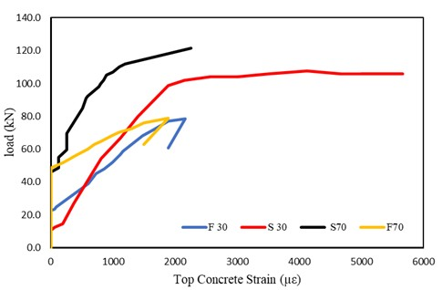

*Figure 25 Concrete strain in the top of the slabs near mid-span.*

**3.4.2 Steel and GFRP bar strains**

The strains in the steel were affixed to the longitudinal rebars to monitor strain during the full

loading sequence located at the slab’s edge and mid-span, as depicted in Figure 9. Table 9a, Figure

26 show the load-strain curves for the steel and GFRP reinforcement bars.

*Table 9a Strain value for steel and GFRP bars.*

|  |  |  |  |
| --- | --- | --- | --- |
| Slab ID | Ultimate load | Strain at Yield Strength | Maximum strain |
|  | (kN) | (micro-strains) | (micro-strains |
| S30 | 107.6 | 2546 | 11716 |

|  |  |  |  |
| --- | --- | --- | --- |
| S70 | 121.5 | 1974 | 20151 |
| F30 | 78.7 | - | 13775 |
| F70 | 78.9 | - | 19449 |

Prior to the initiation of concrete cracking, the bottom steel reinforcement in slab S30 showed

nearly zero strain. The strain curve started with a steep slope at load of 19.6 kN (near cracking load), with an increase of load, strain demonstrated a linear trend until the point of load 98.1 kN and strain of 2956 micro-strains, with an increase in the load the curve deviated slightly and strains in the reinforcements rapidly increased. A strain of 2546 micro-strains was recorded in the steel bars at yield strength stage. A notable rise in strain was observed afterward, occurring without any additional loading until maximum strain was reached at 11716 micro-strains.

Load strain curve of high strength steel reinforcement (S70) behaved differently than slab (S30), which it take more load before yielding – strain start after 1.54 times of initial crack load at 57.3

KN, and strain demonstrated a linear up to the 85% of the failure load, this may be attributed to that high strength concrete resist more load after the Initial crack occurred, the steel bar had not yet taken much load as the strain is almost close to zero in this stage and the curve is almost close to the Y-axis. A notable rise in strain was observed afterward, occurring without any additional loading until to 95% of failure load, then with an increase the load strain increases nonlinear up to failure load. A strain of 20151 micro-strains, approximately twice the strain of S30, was measured in the steel bars at the point of failure.

strain curve of slab reinforced with GFRP bar (F30) started with a load of 33.0 kN (approximately at first crack load) and showed drop of curve nonlinearly up to 2060 micro-strains at load 29.4 kN (at first crack load). After that with an increase of load, strain demonstrated a linear trend until the point of the failure load 78.7 kN and strain of 13775 micro-strains which was higher than that of corresponding slab reinforced with steel by about 5.4.

Prior to the initiation of concrete cracking at load 20.0 KN, the bottom steel reinforcement in slab (F70) showed nearly zero strain, then with increase loading strain increased linearity up to failure load. At this stage, the change in the slope of the curve indicates that the FRP began to carry a substantial portion of the load with larger strain up to 19449 micro-strains. which was higher than that of corresponding slab reinforced with steel by about 9.9 times.

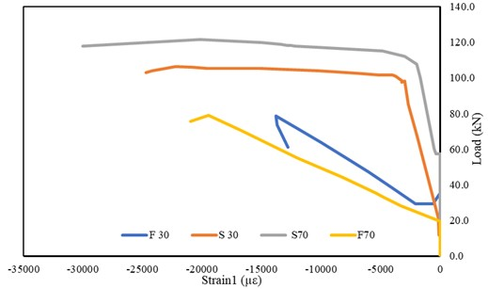

*Figure 26 load-strain for longitudinal steel and GFRP bars.*

**4. Valuation of the Analytical Equations Employed in This Study**

**4.1. Flexural Capacity**

In this study, the Crack moment (*Mcr*) and the Nominal moment capacity (*Mn*) were calculated using formulations in the CSA S806-12 code as the following equations

���� = �� ∗ 𝐼�

𝑦�

( 1 )

where: 𝑓� = 0.6𝜆 √𝑓� ’, *fr* represents the modulus of rupture in MPa, *fc’* denotes the compressive

strength of concrete in MPa, and λ represents a modification factor based on concrete density. In

the case of normal-weight concrete, λ =1.

Mn= α1 �1� fc’.bc(h0f − �1�/2)bh2bf *for* pf *≥* pfb ( 2 ) *Mn=* ����. ����. ��𝑓 *(h0f* − ��/2) *for* 𝑝𝑓 *<* 𝑝𝑓� ( 3 ) where: *α1= 0.85-0.0015 fc’* ≥ *0.67,* �1 *= 0.97 – 0.0025 fc’* ≥ *0.67*

*pfb = α1* �1*( fc’/ffu)(εcu /( εcu + εfu), pf = Af/bd, εcu:* concrete strain = 0.0035

Nominal load capacities from CSA S806-12 were calculated using the equation (*Pn = 4Mn/L*) ,

applicable to three-point loading, where *Mn* represents the nominal flexural capacity, and *L* denotes the clear span length (L =1500mm).This is similar calculation by [39]. Table 9b provides the experimental and predicted experimental cracking moment and Ultimate moment with CSA S806-12 of simply supported one-way slab under three-point loading.

*Table 9b Comparison of predicted and experimental cracking and nominal moments capacity*

Slab

ID

Load

(kN)

Crack moment (*Mcr*) Load

*Pn (*kN)

Nominal moment capacity

(*Mn*)

|  |  |  |  |  |  |  |  |  |
| --- | --- | --- | --- | --- | --- | --- | --- | --- |
|  | | Exp. (kN.m) | Pred. (kN.m) | Exp/Pred |  | Exp. (kN.m) | Pred. (kN.m) | Exp/Pred |
| S30 | 25 | 9.4 | 8.6 | 1.10 | 107.6 | 40.4 | 43.9 | 0.92 |
| S70 | 37 | 13.9 | 13.1 | 1.06 | 121.5 | 45.6 | 47.8 | 0.95 |
| F30 | 29.4 | 11.0 | 8.6 | 1.29 | 78.7 | 29.5 | 35.0 | 0.84 |
| F70 | 30.4 | 11.4 | 13.1 | 0.87 | 78.9 | 29.6 | 33.0 | 0.90 |
| Mean |  |  |  | 1.08 |  |  |  | 0.90 |

Stand. Dev. 0.17 0.05

The first-crack moment values were determined and found to lie within the range of 9.40 to

13.9 kN·m. The predicted and experimental moments at cracking and ultimate load aligned well for under-reinforced slabs, whereas the results for the over-reinforced GFRP slabs were slightly unconservative. An average ratio of 1.08 ± 0.17 was observed between the experimental and predicted moment capacities and 0.90 ± 0.05 for cracking and ultimate moment respectively as per CSA S806-12. This founding is similar by [49].

**4.2. crack width**

Crack width calculations in this study were based on the provisions outlined in CSA S6-06 [50], ACI 440.1R-06 [35] and EURO EN 1992-1-1:2004 code [51] as the following equations. According to CSA S6-06, Equation (4) is used to determine the crack width in FRP-reinforced one-way concrete slabs.

( 4 )

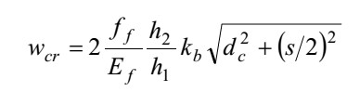

Where**:** *wcr* represents the crack width at the tensile surface of the flexural element (mm), *ff*: reinforcement stress, psi or MPa; *Ef:* Elastic modulus of the reinforcing material (psi or MPa); h2 denotes the distance from the extreme tension face of the section to the neutral axis, h1 represents the depth from the centroid of the tension steel or FRP bars to the neutral axis, dc: Distance from the extreme tension face to the centroid of the closest reinforcement bar; s: spacing of reinforcement bars: and *kb* represents a bond factor that reflects the effectiveness of the bond

between the FRP reinforcement and the adjacent concrete. For FRP bars exhibiting bond behavior comparable to that of uncoated steel bars, the bond coefficient *kb* is taken as 1.0.

ACI 440.1R-06 provides Eq. 5 for calculating the crack width in GFRP-reinforced concrete elements as follows:

( 5 )

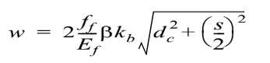

Where: *w*: represents the maximum width of a crack, in. or mm; β: Ratio of the distance from the neutral axis to the tension face, to the distance from the neutral axis to the centroid of the reinforcement.

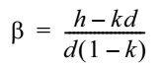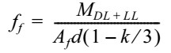

*dc=h-d*

For the purposes of this study, the bond coefficient *kb* is taken as 1.4. Eurocode2 [51] provides guidelines for calculating the crack width in GFRP-reinforced concrete elements. The empirical equation for maximum crack width is:

wk= Sr,max (εsm - εcm) (6)

where: Sr,max: represents maximum crack spacing, *εsm*: Mean tensile strain in the reinforcement due to the relevant combination of applied loads, *εcm*: Mean concrete strain between cracks, *εsm - εcm*:

� 𝑐��, � ��

the following equation can be used: *εsm - εcm =* 𝜎� −*kt*

𝑝��,���

(1 + ��∗ ����,��� )/��� ≥ 0.6 𝜎�/𝐸�

where: 𝜎𝑠 : Stress developed in the tensile reinforcement in a cracked section analysis, 𝛼𝑒: represents ratio Es/Ecm, fctm =0.3fck (2/3) ≤ C50/60, fctm = 2.12 ln (1+ fcm /10) >C50/60, fcm = fck +8 (MPA) Ecm = 22(fcm)/10)0.3 GPA, Sr,max = 𝑘3𝑐+𝑘1𝑘2𝑘4Ø/pp.eff, Ø: bar diameter. k1: A coefficient that accounts for the bond characteristics of the bonded reinforcement. It is taken as 0.8 for high-bond (deformed) bars and 0.6 for bars with an effectively plain surface, k2: A coefficient that accounts for the distribution of strain, it is taken as 0.5 for members in bending and 1.0 for members subjected to pure tension. Table 10 Comparison of predicted and experimental crack width of simply supported one-way slab under three-point loading.

Table 10 Comparison of predicted and experimental crack width of simply supported one-way slab under three-point loading.

|  |  |  |  |  |  |  |
| --- | --- | --- | --- | --- | --- | --- |
|  | | | | | | Crack width- (mm) |
|  |  | Experimental  Maximum crack | ACI 440.1R-06 |  | CSA S6-06 | EURO EN 1992-1-1:2004 |
|  |  | (*w*exp) | (*w*pred) (*w*exp / *w*pred) | (*w*pred) | (*w*exp / *w*pred) | (*w*pred) (*w*exp / *w*pred) |
| S30 | 107.6 | 0.28 | 0.41 0.68 | 0.26 | 1.08 | 0.30 0.93 |
| S70 | 121.5 | 0.38 | 0.41 0.93 | 0.26 | 1.46 | 0.37 1.03 |
| F30 | 78.7 | 1.54 | 1.91 0.84 | 1.2 | 1.28 | 1.50 1.03 |
| F70 | 78.9 | 1.92 | 1.91 1.04 | 1.2 | 1.60 | 1.84 1.04 |

Mean 0.87 1.36 1.01

Slab ID

Load (kN)

Stand. Dev. 0.15 0.23 0.05

Recommended values for the coefficients are k3=3.4 and k4=0.425, as per design guidelines, kt:

A factor that accounts for the duration of the applied load, it is taken as 0.6 for short-term loading

and 0.4 for long-term (sustained) loading. The experimental crack width values were compared

with the theoretical calculation according to several codes and results reported in Table 10. we

note that ACI Code and CSA Code don’t explicitly make strength of concrete (𝑓𝑐𝑢) a direct

parameter in crack width formula, but it influences on crack width indirectly through factor like

bond, tension stiffness and modulus of elasticity and based on strain and spacing, ACI assumes that cracking is governed mostly by steel/GFRP stress and bar spacing, not the concrete strength itself, while higher strength concrete does have slightly better bond, it's not a major factor in crack width empirically. Therefore, we find that there is a neglectable difference in crack width when increasing the strength of concrete from 30 to 70 MPA. ACI equations are acceptable for high strength slab (S70 and F70) but were slightly unconservative for the normal strength slab (S30 and F30), While CSA Code equations are acceptable for normal strength slab (S30 and F30) but were slightly unconservative for the high strength slab (S70 and F70). On the other hand, EURO EN

1992-1-1:2004 explicitly account of concrete strength (*fcu*) in crack width calculation through *fct*, *Ec* and bond factor. Therefore, EURO EN 1992-1-1:2004 had given good agreement with both normal and high strength experimental slab than other codes. An average experimental-to- predicted crack width ratio of 1.01 ± 0.05 was observed, demonstrating good correlation.

**4.3. Deflection**

The midspan deflections (δmax) of the slabs were estimated according to CSA S806 2012 using Eq.7. δmax = � �𝐿3 48 𝐸𝑐𝐼𝑐𝑟 (1 −8ƞ( 𝐿𝑔 𝑙 )2) (7) where: Icr= bd3k3/3+ ƞ𝑓𝐴𝑓𝑑2(1 − 𝑘)2 "Moment of inertia of the equivalent cracked section" d represents the effective depth, Af total area of the FRP reinforcement, ƞ𝑓 Ratio of the elastic modulus of the FRP reinforcement (Ef) to the elastic modulus of the concrete (Ec), 𝑘 = √2𝜌𝑓𝜌ƞ𝑓 +(𝜌𝑓𝜌ƞ𝑓)2-𝜌𝑓𝜌ƞ𝑓 "The ratio of the depth of the neutral axis to the effective depth of reinforcement.", 𝜌𝑓 is reinforcement ratio, L: “span length”, Lg: The length from the support to the point where Ma = Mcr and ƞ = (1 −𝐼𝑐𝑟 𝐼𝑔 ). Deflection obtained from CSA S806 2012 were compared with experimental deflection and results reported in Table 11.

*Table 11 Comparison between experimental and prediction Mid span deflection, as per CSA S806 2012*

Slab ID Ultimate Load

(kN)

Mid span

**∆ exp. (mm)**

CSA2012

**∆pred.(mm) ∆ exp./pred.**

|  |  |
| --- | --- |
| 15.18 | 0.96 |
| 18.17 | 0.91 |
| 41.14 | 1.05 |

S30 107.6 14.6

S70 121.5 16.5

F30 78.7 43.2

F70 78.9 56.7 52.05 1.09

Mean 1.0

Stand. Dev. 0.08

The predicted mid-span deflections showed strong correlation with experimental results for all tested slabs, consistent with the provisions of CSA S806-12. The average ratio of experimental to predicted deflection was 1.0, with a standard deviation of ±0.08, indicating reliable predictive accuracy.

**5. Conclusions**

This paper experimentally investigated the flexural behavior of (HSC) and (NSC) simply supported one-way slab reinforced with (GFRP) bars. The ultimate load capacity, crack patterns, failure modes, ultimate deflection, concrete and GFRP/ steel bar strains, was obtained**.** In light of the experimental and analytical results, the following conclusions are presented

1- Steel-reinforced slabs demonstrated a typical ductile flexural failure mechanism, initiated by the yielding of the reinforcement steel and subsequently followed by concrete crushing in the compression zone, while failure in GFRP slabs occurred by GFRP rupture and bond failure because bond in GFRP is less than conventional steel.

2- GFRP reinforced slab (F30 & F70) showed more, and larger cracks compared to steel reinforced slab (S30& S70) by approximately 5.0 times in width and 2.0 times in number.

3- crack width of high strength (S70 & F70) is more than normal strength (S30& F30) by 1.36 and 1.25 respectively.

4- Slab F30 and F70 which reinforced with GFRP recorded the lower ultimate load of 78.7 and

78.9KN, than the control slabs by a decreasing ratio of 27.0% and 35% respectively. On the other hand, the deflection at mid span was higher than that of corresponding slab (S30 and S70) reinforced with steel by about 3.0 and 3.40 times, respectively.

5- The NSC and HSC-steel reinforced slabs showed higher strains compared to the NSC and

HSC- GFRP-reinforced slabs at the same load level by 2.6 and 1.2 respectively

6- The predicted and experimental moments at cracking and ultimate stages aligned well for under-reinforced slabs, whereas the results for the over-reinforced GFRP slab were slightly unconservative. An average ratio of 1.08 ± 0.17 was observed between the experimental and predicted moment capacities and 0.90 ± 0.05 for cracking and ultimate moment respectively as per CSA S806-12

7- ACI equations for crack width are acceptable for HSC (S70 and F70) but were slightly unconservative for the NSC (S30 and F30), While CSA Code equations are acceptable for NSC (S30 and F30), but were slightly unconservative for the HSC (S70 and F70). On the other hand, EURO EN 1992-1-1:2004 explicitly account of concrete strength (fcu) in crack width calculation through *fct*, *Ec* and bond factor. Therefore, EURO EN 1992-1-1:2004 had given good agreement with both normal and high strength experimental slab than other codes. An average ratio of 1.01 ± 0.05 was observed between the experimental and predicted crack width.

8- The predicted mid-span deflections showed strong correlation with experimental results for all tested slabs, consistent with the provisions of CSA S806-12. The average ratio of

experimental to predicted deflection was 1.0, with a standard deviation of ±0.08, indicating reliable predictive accuracy.

**References:**

1. Harle, S., Glass Fiber Reinforced Concrete & Its Properties. INTERNATIONAL JOURNAL OF ENGINEERING SCIENCES & RESEARCH TECHNOLOGY 2014.

2. Stuart, V., L.S.J.P.o.t.I.o.C.E.-S. Cunningham, and Buildings, FRP reinforced-concrete slabs: a comparative design study. Proceedings of the Institution of Civil Engineers-

Structures and Buildings, 2017. **170**(8): p. 581-602.

3. Gautam Jain1, T.S., Naveen Kumar3, Navneet Kumar4,Ruby Pant4, A STUDY OF

FIBERGLASS MATERIAL WITH DIFFERENT COMPOSITIONS, in International Conference on Advances in Engineering Science Management & Technology (ICAESMT)-2019, Uttaranchal University, Dehradun, India 2019.

4. Zhu Yuan, Y.J., Mechanical properties and microstructure of glass fiber and polypropylene

fiber reinforced concrete: An experimental study. Construction and Building Materials

2021. **266**: p. 121048.

5. Shafei, B., et al., State-of-the-Art Review of Capabilities and Limitations of Polymer and

Glass Fibers Used for Fiber-Reinforced Concrete. Materials (Basel), 2021. **14**(2): p. 409.

6. Granju, J.-L., S.U.J.C. Balouch, and C. Research, Corrosion of steel fibre reinforced concrete from the cracks. Cement and Concrete Research 2005. **35**(3): p. 572-577.

7. Yu Zheng , G.Y., Yunfeng Pan, Investigation of ultimate strengths of concrete bridge deck slabs reinforced with GFRP bars. Construction and Building Materials, 2012. **28**(1): p. 482

492.

8. Selvaraju, Y.R., REVIEW ON BEHAVIOUR OF GLASS FIBRE REINFORCED

POLYMER RC MEMBERS, in International Conference on Explorations and Innovations in Engineering & Technology. 2016.

9. Fuhaid, A.F.A. and A.J.B. Niaz, Carbonation and corrosion problems in reinforced concrete structures. Buildings, 2022. 12(5): p. 586.

10. Bastidas-Arteaga, E.J.I.j.o.c.s. and materials, Reliability of reinforced concrete structures subjected to corrosion-fatigue and climate change. International journal of concrete

structures and materials, 2018. 12(1): p. 10.

11. Jabbar, S.A. and S.B.J.K.i.j.o.m.s. Farid, Replacement of steel rebars by GFRP rebars in

the concrete structures. Karbala international journal of modern science, 2018. 4(2): p. 216-

227.

12. Tapan, M., R.J.C. Aboutaha, and B. Materials, Effect of steel corrosion and loss of concrete cover on strength of deteriorated RC columns. Construction and Building Materials 2011.

**25**(5): p. 2596-2603.

13. Ifrahim, M.S., A.J. Sangi, and S.H. Ahmad. Experimental and numerical investigation of

flexural behaviour of concrete beams reinforced with GFRP bars. in Structures. 2023. Elsevier.

14. Patil, V.R.J.I.J.I.R.A.E., Experimental Study of Behavior of RCC Beam by Replacing Steel

Bars with Glass Fiber Reinforced Polymer and Carbon Reinforced Fiber Polymer (GFRP).

Int. J. Innov. Res. Adv. Eng, 2014. **1**: p. 205-210.

15. Ombres, L., T. Alkhrdaji, and A. Nanni. Flexural analysis of one way concrete slabs reinforced with GFRP rebars. in International meeting on composite materials, PLAST.

2000. Citeseer.

16. Masmoudi, A., et al., New parameter design of GFRP RC beams. Construction and

Building Materials 2012. **29**: p. 627-632.

17. Yoo, D.-Y., N. Banthia, and Y.-S.J.C.P.B.E. Yoon, Predicting service deflection of ultra-

high-performance fiber-reinforced concrete beams reinforced with GFRP bars. Composites

Part B: Engineering, 2016. **99**: p. 381-397.

18. Li-xiang, S., et al. Experimental study on flexural behavior of GFRP reinforced concrete slabs. in IOP Conference Series: Earth and Environmental Science. 2021. IOP Publishing.

19. Kalpana, V., K.J.J.o.r.p. Subramanian, and composites, Behavior of concrete beams reinforced with GFRP BARS. Journal of reinforced plastics and composites 2011. **30**(23):

p. 1915-1922.

20. Sivagamasundari, R. and G.J.T.O.C.E.J. Kumaran, A comparative study on the flexural

behaviour of one-way concrete slabs reinforced with GFRP reinforcements and conventional reinforcements when subjected to monotonic and repeated loading. The Open Civil Engineering, 2008. **2**(1): p. 24-34.

21. El-Ragaby, A., E. El-Salakawy, and B.J.J.o.C.f.C. Benmokrane, Fatigue life evaluation of

concrete bridge deck slabs reinforced with glass FRP composite bars. Journal of

Composites for Construction 2007. **11**(3): p. 258-268.

22. SARIKAYA, H. and H.E. BALCIOĞLU, THE EFFECT OF GLASS FIBER REBAR REINFORCEMENT ON FLEXURAL BEHAVIOUR OF REINFORCED CONCRETE STRUCTURAL ELEMENTS. 2018.

23. Abdalla, H.J.c.s., Evaluation of deflection in concrete members reinforced with fibre

reinforced polymer (FRP) bars. composite structures 2002. **56**(1): p. 63-71.

24. Chang, K., D.J.J.o.A.A. Seo, and B. Engineering, Behavior of one-way concrete slabs

reinforced with GFRP bars. 2012. **11**(2): p. 351-358.

25. El-Nemr, A., E.A. Ahmed, and B.J.A.s.j. Benmokrane, Flexural Behavior and

Serviceability of Normal-and High-Strength Concrete Beams Reinforced with Glass Fiber- Reinforced Polymer Bars. ACI structural journal, 2013. **110**(6).

26. Hossain, K., D. Ametrano, and M.J.J.o.B.E. Lachemi, Bond strength of GFRP bars in ultra- high strength concrete using RILEM beam tests. Journal of Building Engineering, 2017.

**10**: p. 69-79.

27. Yoo, D.-Y. and Y.-S.J.A.C.M. Yoon, Bond behavior of GFRP and steel bars in ultra-high-

performance fiber-reinforced concrete. Advanced Composite Materials, 2017. **26**(6): p.

493-510.

28. Sdiri, A., et al., Comparative Study of GFRP and Steel Rebar Bonding in Concrete: Experimental Analysis and Crack Prediction. Journal of Composite & Advanced Materials/Revue des Composites et des Matériaux Avancés, 2024. **34**(2).

29. Adam, M.A., et al., Structural Behavior of High-Strength Concrete Slabs Reinforced with

GFRP Bars. Polymers (Basel), 2021. **13**(17): p. 2997.

30. Abdul-Salam, B., et al., Mechanisms of shear resistance of one-way concrete slabs

reinforced with FRP bars. Construction and Building Materials, 2016. **127**: p. 959-970.

31. Ferrier, E., et al., Mechanical behaviour of ultra-high-performance short-fibre-reinforced

concrete beams with internal fibre reinforced polymer bars. Composites Part B: Engineering, 2015. **68**: p. 246-258.

32. Kabashi, N., et al. Flexural behavior and cracks in concrete beams reinforced with GFRP bars. in International Congress on Polymers in Concrete (ICPIC 2018) Polymers for Resilient and Sustainable Concrete Infrastructure 16. 2018. Springer.

33. Lotfy, E.M., S.M. Elzeiny, and A.M.J.P.o.t.I.o.C.E.-C.M. Rashad, Flexural capacity of

one-way GFRP concrete slabs. Proceedings of the Institution of Civil Engineers- Construction Materials 2011. **164**(3): p. 143-152.

34. Daoud, O. and A.J.F.J.o.E.S. Fadul, Shear behavior in beams reinforced with glass-fiber reinforced polymer bars (GFRPB) without stirrups. FES Journal of Engineering Sciences,

2020. **9**(1): p. 72-78.

35. Alkhrdaji, T., et al., Guide for the design and construction of structural concrete reinforced

with FRP bars. Proc., American Concrete Institute (ACI) Committee 2006. **440**.

36. Wang, H. and A.J.A.S.J. Belarbi, SP230, Flexural behavior of fiber-reinforced-concrete

beams reinforced with FRP rebars. ACI Structural Journal, SP230 2005. **51**(230): p. 895-

914.

37. Al-Rubaye, M., et al., Flexural behaviour of concrete slabs reinforced with GFRP bars and hollow composite reinforcing systems. Composite structures 2020. **236**: p. 111836.

38. Yoo, D.-Y., N. Banthia, and Y.-S.J.E.S. Yoon, Flexural behavior of ultra-high- performance fiber-reinforced concrete beams reinforced with GFRP and steel rebars.

Engineering Structures, 2016. **111**: p. 246-262.

39. Goldston, M., et al., Flexural behaviour of GFRP reinforced high strength and ultra high

strength concrete beams. Construction and Building Materials, 2017. **131**: p. 606-617.

40. Al-Jabri, K.S., et al., Copper slag as sand replacement for high performance concrete.

Cement and concrete composites 2009. **31**(7): p. 483-488.

41. CSA, Canadian Standards Association, Design and Construction of Building Structures

with Fibre-Reinforced Polymers, American Concrete Institute, Ontario, Canada, 2012, pp. S806–S812. 2012.

42. Michaluk, C.R., et al., Flexural behavior of one-way concrete slabs reinforced by fiber reinforced plastic reinforcements. ACI structural Journal 1998. **95**: p. 353-365.

43. Hassan, T., et al., Fibre reinforced polymer reinforcing bars for bridge decks. Canadian journal of civil engineering, 2000. **27**(5): p. 839-849.

44. Zhang, B., et al., Behaviour of one-way concrete slabs reinforced with CFRP grid reinforcements. Construction and Building Materials 2004. **18**(8): p. 625-635.

45. Tharmarajah, G., S. Taylor, and D. Robinson, Experimental and Numerical Investigation of Compressive Membrane Action in GFRP-Reinforced Concrete Slabs. Polymers (Basel),

2023. **15**(5): p. 1230.

46. Adam, M., et al., Structural Behavior of High-Strength Concrete Slabs Reinforced with

GFRP Bars. Polymers 2021, 13, 2997. Polymers (Basel), 2021. **13**(17): p. 2997.

47. Damian, K., et al., Finite element modeling of reinforced concrete structures strengthened

with FRP laminates. Report for Oregon Department Of Transportation, Salem 2001.

48. Osman, B.H., et al., Repair of pre-cracked reinforced concrete (RC) Beams with openings

strengthened using FRP sheets under sustained load. International Journal of Concrete

Structures and Materials, 2017. **11**: p. 171-183.

49. Alhoubi, Y., Z. Mahaini, and F.J.S. Abed, The flexural performance of BFRP-reinforced UHPC beams compared to steel and GFRP-reinforced beams. Sustainability 2022. **14**(22): p. 15139.

50. CSA, , “Canadian Highway Bridge Design Code,” Canadian Standard Association,

Rexdale, ON, Canada. 2006.

51. Eurocode2, E. EN1992 Eurocode 2: Design of concrete structures. in Proceedings of the

Institution of Civil Engineers-Civil Engineering. 1992.