**Original Research Article**

**Design and Micro Mechanical Modeling of Bio-fibre Reinforced Polymer Composites for Creep Resistant Piping Application**

**Abstract**

This study focuses on the design, modeling and optimization of bio-fibre reinforced polymer composites (BFRPs) for application in creep-resistant piping systems. Plantain fibre was selected based on its mechanical properties. After fibre extraction, mercerization and acetylating processes were used in the surface modification of the fibre. High density polyethylene (HDPE) granules impregnated with the fibres were formed into standard sized creep test-pieces and experimental investigations conducted to establish the effect of percentage composition of fibre and strands modification processes on bulk properties. The replication of fibre mercerized and acetylated with 0.1M (0.4%) Sodium Hydroxide (NaOH) solution exhibited the most robust and elastic design model which suggests fibre suitability for applications requiring strength and flexibility. Empirical data obtained were analyzed and a comprehensive micro-mechanical model given by the equation: $ε\left(t\right)=7.01 × {10}^{-5}$ $t^{0.874}$* was developed. The fitted model shows good agreement with experimental data giving R² > 0.99 which validates its predictive capability for short and mid-term creep. The long-term creep prediction aligns closely with the experimental trends, confirming the model’s robustness with strain behavior up to 1000 hours; suggesting that the composite remains dimensionally stable with less than 2% and may be suitable for continuous operation. At 30°C, the maximum creep strain after 240 hours was approximately 0.45% and the strain rose to 1.11% at 80°C; showing that thermal activation accelerates molecular mobility within the matrix, thereby reducing dimensional stability. The results obtained provide a framework for the engineering of durable, sustainable and eco-friendly piping systems with enhance serviceability.

**Keywords:** Bio-fibre Reinforced Polymer Composites; Design Parameters; Micromechanical Modeling; Creep Resistance; Eco-Friendly Piping Applications

**1. Introduction**

The surging interest and enhanced market pressure requiring sustainable engineering materials has amplified the growing demand for the design and development of bio-fibre reinforced polymer composites for infrastructural framework-based applications. Piping systems operating under sustained and uninterrupted loading and are exposed to adverse environmental conditions, require materials with superior creep resistance in order to guarantee long term reliability and enhanced performance. Although conventional polymers offer ease of manufacture and are resistant to corrosion; most of the time, they suffer significant short-term creep deformation resulting in expensive maintenance and subsequent service failure.

The reinforcement of Polymers with natural fibres has become a viable intervention due to environmental concerns and economic pressures [1]. Polymer Matrix Composites (PMCs) are widely used in structural, automotive and aerospace applications due to their favorable strength-to-weight ratio and cost-effectiveness but the environmental drawbacks of synthetic fibres have driven enormous interest towards sustainable alternative which explores the mechanical behaviour of biofibre reinforces Polymer composites [2]. Plantain fibres which are derived from *Musa paradisiaca* possess excellent tensile strength, elastic modulus, density, enhanced pre-failure stretchability, biodegradability and low carbon footprint that support their deployment as reinforcement in polymer composites [3]. The treatment of plantain fibre surface with alkali enhances the fibre-matrix bonding which improves the composite’s performance and broaden their potential for application in divers engineering structures [4]. In [5], bio-fibre material such as plantain fibre offer several other benefits ranging from high strength, light weight, water resistance, chemical resistance, high durability, electrical resistance, fire resistance and corrosion resistance. However, complexities in the optimization of the composites when subjected to prolonged creep conditions pose a significant challenge to materials engineering practice [6][7]). In an investigation aimed at fine-tuning and simulating the process variables of injection molding for fabricating plantain fibre particles reinforced high density polyethylene composites, [8] and [9] identified the vulnerability of composite systems to concentrated impact stresses and adopted a Taguchi-based experimental framework to configure the process using eight independent input parameters. Based on Archimedes’ principles, [8] utilized tensile testing with Monsanto tensometer on duplicate PPs and PEFB composites samples and successfully determine fibre volume fractions and therefrom optimized the control factors for the enhancement of mechanical properties. Bio-fibre reinforced polymers exhibit viscous-elastic characteristics and their time-dependent deformation is affected by fibre type, orientation, percentage volume fraction and the quality in which the fibre-matrix interface exhibits [4][10]. Micromechanical models which take the creep deformation factors into consideration have been developed by simulation of creep response using finite element analysis (FEA) and Taguchi design of experiment (DOE) in order to identify the optimal set of the composite’s processing parameters by systematically varying the processing conditions and analyzing the corresponding effects on the composite’s properties with a view to enhancing the injection-molded BFRP composite’s performance [11]. In order to engineer high performance bio-fibre reinforced polymer composites materials that support long-term piping application, a well-designed experimental investigation and modeling of creep resistance behaviour is of immense importance. Creep is a phenomenon characterized by a slow plastic deformation of a material subjected to steady stress at elevated temperatures [12][13]. Creep deformation is very much dependent on time, stress condition, temperature and the material properties [14]. In [15], the mechanical behavior of short fiber reinforced composites was studied using a computational approach that integrates an elastic-viscoelastic model for predicting fiber/matrix interfacial stress and a probabilistic Mori-Tanaka homogenization model to estimate global damage. By assuming local 3D periodicity in the microstructure and validating the models against experimental data from uniaxial tension and compression tests, the predictions showed strong agreement with observed results. When polymeric material is subjected to a sudden load or stress, the material’s response may be modeled using Kelvin-Voigt model in which the material is represented by a Hookean Spring and Newtonian dashpot in parallel. The creep strain is given by:

$ε$ (t) = $σC_{o}$ + $σ$ C $\int_{0}^{∞}{f}$ ($τ$) (1-exp $\left[\frac{-t}{τ}\right]$ d $τ (1)$

Where: $σ$ = applied stress, $C_{o}$ = instantaneous creep compliance, C = Creep Compliance coefficient, $τ$ = retardation time and f($τ$) = distribution of retardation times [16][17]. The employment of Natural Fibre as reinforcements in polymeric materials for applications in various fields of design and construction has raised curiosity on the requirements of natural fibre-polymer composites; in that mechanical properties, including their creep resistance under constant stress has become of great concern to researchers in the field of materials engineering [18][19]. Design of embedded natural fibre polymer for piping application that will be exposed to long-term creep loading conditions must be carried out with the intention of overcoming service failure. Such design demands thorough analytical investigative studies sufficient enough to predict and optimize the behaviour of the composites [20][21][12]. More so, the injection molding parameters during the manufacturing process defines the final mechanical performance of the BFRP composites. The optimization of melting temperature, injection pressure, cooling rate and mould design influence interfacial bonding and dispersion of fibre orientation which ultimately contribute to composites material strength and creep resistance [18][16].

There are reports of several studies on the mechanical characterization of bio-fibre composites. This work goes further to explore the systematical integration of micromechanical modeling of creep behaviour with processing parameters in order to optimize and predict creep behaviour in BFRP; to provide technical understanding and analytical results of the structure and property processing relationship essential for the development of durable and sustainable BFRP composites for creep resistant piping systems.

**2. Materials and Methods**

The materials deployed for the investigation are plantain pseudo-stem, knife, decorticating machine, chemical bath, warm water, high density polyethylene (HDPE), injection molding machine, creep testing machine, universal testing machine, beam apparatus, hardness tester, digital weighing balance, micrometer screw gauge and mercury in glass thermometer.

***Plantain Fibre Extraction and Mercerization*:** High density polyethylene was chosen as the matrix material and plantain fibre was used as the composite’s reinforcement. A decorticating machine was employed for the extraction of the bio-fibre. The natural fibres were immersed into a warm water tank containing 40g of sodium hydroxide (NaOH), chlorinated lime, soda ash and corrosive sulfuric acid ($H_{2}{SO}_{4}$) and allowed to stand for 60minutes. The mixture was stirred at interval of 10minutes to disintegrate and separate the pectin in the fibre bundles at high temperature. Thereafter, the mercerized fibres were thoroughly washed in distilled water until a neutral pH of 7.0 was achieved.

***Acetylating (esterification) of Plantain Fibre:*** The three concentrations were prepared by measuring and mixing 5ml of anhydride to 95ml of water for 5% concentration, 10ml of anhydride to 90ml of water for 10% concentration, and 15ml of anhydride to 85ml of water for 15% concentration. Portions of the fine fibres were treated with acetic anhydride solution at varying concentrations of 5 $\%$, 10 $\%$ and 15 $\%$ and the produced fibres were dried at room temperature (34 $℃$) for 48hours while sufficient volume of oxygen was supplied to the treated fibres in controlled condition to facilitate dying and shiny polishing.

***BFRP Composite Preparation:*** Molten HDPE pre-heated to 170 $℃$ was then impregnated with the treated bio-fibres using an extruder to facilitate even dispersion. The reinforced bio-fibre polymer was blended to shape using injection molding machine subjected to heat and pressure, followed by cooling and conditioning; thus the final BFRP composites with enhanced mechanical and thermal properties was produced.

***Experimental Technique:*** Tensile tests were conducted in accordance with ASTM D3822-01 standard, applying a gauge length of 25mm at a test speed of 1.667 mm/s for 30 seconds. The three diameters are 0.5mm, 1.0mm, and 1.5mm was measured with a micrometer screw gauge; with five replications of each diameter; and the replications of each diameter were made for every drying temperature of 50 $℃$, 80 $℃$, and 100 $℃$. Each fibre bundle was taped at top and bottom to hold the fibres in place and to ease gripping by the jaws of the testing equipment. Creep tests were done following standard procedures for TecQuipment Creep Apparatus on control and reinforced samples and in line with Standard Test Method for Tensile Creep Rupture of Fibre Reinforced Polymer Matrix Composites Bars, D7337/D7337M (reapproved 2019). Control factors and levels typical of the equipment used and orthogonal array for the experiment were designed in line with standard procedures as shown in tables 1 and 2.

Table 1: Parameters and their levels used for the Experiments

|  |  |  |  |
| --- | --- | --- | --- |
| **Parameter**  **(Factor)** | **Levels & Values** | | |
| **1** | **2** | **3** |
| Stress (MPa) | 35 | 42 |  |
| Temp. (oC) | 30 | 60 | 80 |

Table 2: Orthogonal array of experimental design

|  |  |  |
| --- | --- | --- |
| **Expt #** | **Stress (MPa)** | **Temp. (oC)** |
| 1 | 35 | 30 |
| 2 | 35 | 60 |
| 3 | 35 | 80 |
| 4 | 42 | 30 |
| 5 | 42 | 60 |
| 6 | 42 | 80 |

Data collected were used for the analysis of the research work.Predictive model developed from experimental data-set were validated for accuracy.

**3. Results and Discussion**

***3.1Tensile Strength Tests***

1. ***Untreated BFRP***

The plot on figure 1 shows the tensile test results of the untreated single strand of BFRP composites across three replications (R1, R2 and R3). The trends reveal the mechanical behaviour of the natural fibre reinforced material. Applied force in the range of 43.096gf and 148,094gf with a mean force of 90.739gf indicate that the force required to break the fibres vary widely based on conditions of application. This behaviour is typical of natural fibres due to the non-uniformity of the material’s structure, moisture content and design defects. The third replication (R3) shows the highest load-bearing capacity which may be attributed to a slightly larger cross-sectional area (0.006 ${mm}^{2}$). With an elongation range of 0.287mm to 0.569mm; and percentage elongation range of 1.150% to 2.275%, Plantain fibres show relatively low ductility which is expected of natural bast fibres. Elongation at peak for the third replication being the most stretched correlates with the highest force at peak indicating highest load bearing capacity.

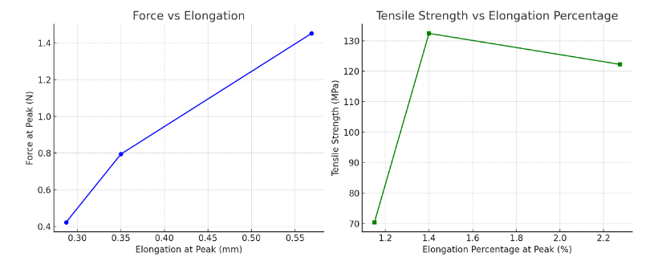

Fig.1: Force Vs Elongation and Tensile Strength vs. %Elongation for Untreated Fibres

Tensile strengths of 70.438MPa, 132.432MPa and 122.273MPa for R1, R2 and R3 replications respectively with the mean value of 108.381MPa is fairly high for a single strand of untreated BFRP and is promising for lightweight composites applications. The variation in cross sectional area and gauge length reflects the known variability in natural fibre microstructure which supports smaller area, higher force and higher strength per unit area properties of natural fibres with consistent gauge length.

1. ***Single Strands of Different Diameters Treated with 0.1M (0.4%) Concentration of NaOH Solution***

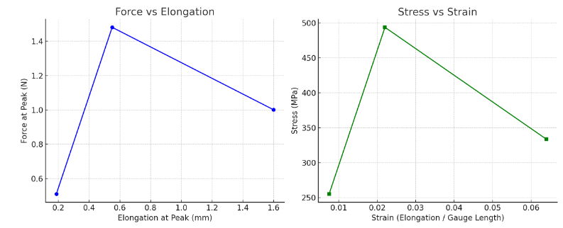

Fig.2: Force Vs Elongation and Tensile Strength vs. %Elongation for Single Strand of Fibre

Treated with 0.1M (0.4%) NaOH Solution

On Force against Elongation at peak, the plots on figure 2 indicates that the load-bearing capacity of the material changes with the extension of the fibre as R2 shows highest force with lower elongation, indicating stiffness; whereas R1 expresses higher elongation with moderate force. On the other hand, the stress-strain curve reflects the behaviour of the composites material, in that, R2 shows highest stress which suggests that the material possesses better strength under low strain while R1 reflects better ductility and R3 is significantly weaker in strength with less ductility due to structural flaws and thinner diameter (area = 0.002 ${mm}^{2}$). The cross-sectional area in the range of 0.002 – 0.003 ${mm}^{2}$ and a consistent gauge length of 25 ${mm}^{2}$ which ensures comparability buttress that small differences in area can significantly affect tensile strength values when the cross-sectional dimension is low

The tensile test results indicate a significantly higher tensile strength in comparison with that of the untreated strands. Replication (R) 3 is the weakest while R2 possesses the highest load-bearing capacity. There exists a wide variation in the micromechanical properties of R1, R2 and R3 which is attributed to the inconsistencies associated with plantain fibre characteristics linked to fibre bundle maturity, defects and moisture content. R1 shows significant higher ductility of 1.66mm (6.4%) which may be attributed to microstructural differences due to fibre treatment. B3 failed quite early in the test indicating low ductility and brittleness. Tensile strength is highest in R2 (50351.33gf/ ${mm}^{2} or 493.778MPa$) and lowest in R3 (2649.00gf ${mm}^{2} or 25.973$/ $MPa$). The second replication (R2) is extremely strong and has the strength that is close to most synthetic fibres which suggests that the fibre orientation is better; having less voids and better alignment.

1. ***Single Strand of Different Diameters Treated with 0.5M (2%) Concentration of NaOH Solution***

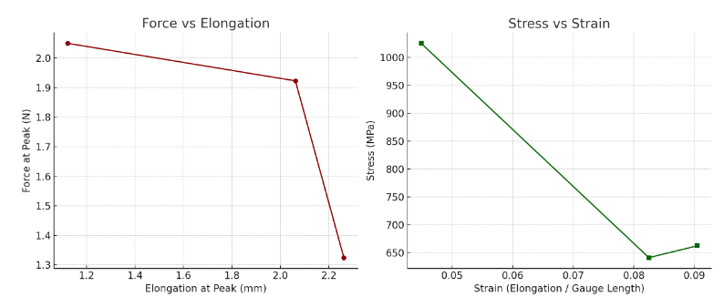

Fig.3: Force Vs Elongation and Tensile Strength vs. %Elongation for Single Strand of Fibre

Treated with 0.5M (2%) NaOH Solution

As indicated in figure 3; the single strand fibre treated with 0.5M (2%) NaOH solution shows even higher tensile strength and elongation percentages than the untreated strands and the fibres treated with 0.1M (0.4%) NaOH solution; indicating positive effect derived from superior treatment, refined selection and optimized structure of the batch of fibres which withstands higher forces.

The plot of Force versus Elongation shows that R1 possesses highest peak force with relatively low elongation while R3 exhibits highest elongation with lower force indicating greater ductility characteristics. In the stress-strain graph, R1 displays highest stress, indicating superior strength while R3 exhibits extended strain behaviour of slightly lesser stress which balances flexibility and strength. This micromechanical patterns indicate that R1 is most suitable for high strength engineering applications while R3 may be useful in areas where flexibility is of immense importance.

1. ***Single Strand of Different Diameters treated with 0.8M (3.2%) Concentration of NaOH Solution***

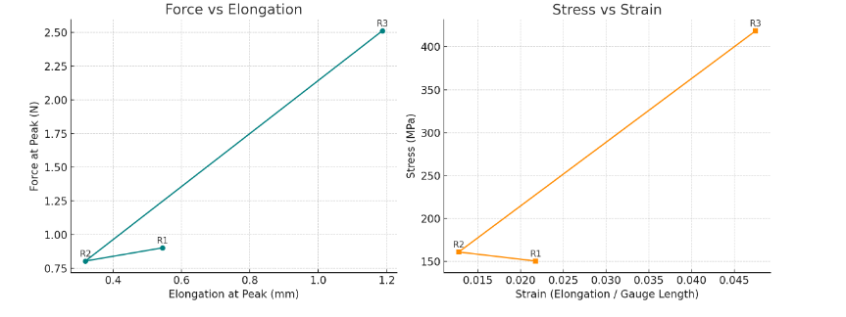Fig.4: Force vs. Elongation and Tensile Strength vs. %Elongation for Single Strand of Fibre

Treated with 0.8M (3.2%) NaOH Solution

On the plot of Force versus Elongation displayed in figure 4; R3 clearly stands out and exhibits outstanding tensile strength of 418MPa and elongation of 4.75% which suggests that it holds both high strength and ductility unlike R2 which is weakest with least ductility. The stress-strain curve further corroborates the force-elongation plot that R3 shows the most superior micromechanical performance possessing both enhanced stress and strain properties leaving R1 and R2 to exhibit moderate stress and much lower strain behaviours.

***3.2 Creep Test Result***

*3.2.1 Specifications of Plantain Fibre Reinforced (PFR) HDPE Composite Test Specimens:*

Material specification: 20% by Weight of treated plantain fibre reinforced HDPE matrix

Thickness, t = 12.20 mm

Width, b = 31.25 mm

Gauge length, Lg = 125 mm

Load on hanger, m = 14kg; M.A. of equipment loading mechanism = 95.3

∴ Tensile pull, F = 13.34kN

Constant Applied Stress, **σ** = 35 MPa (or 35 N/mm2) and 42 MPa

Test temperature, T = 30 $℃$, 60 $℃$, and 80 $℃$

1. ***Creep Test for Stress @ 35 MPa; Temperature @ 30 0C***

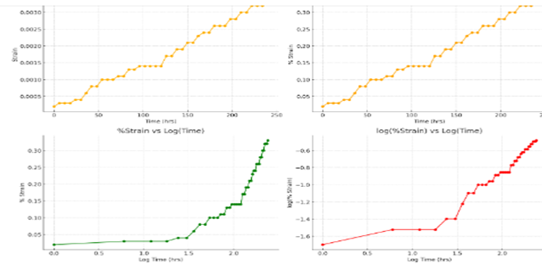

Fig.5: Strain vs Time, %Strain vs Time, %Strain vs Log(Time) & log(%Strain) vs Log(Time) @35MPa; 30 $℃$

Table 3: Summary of Creep Behaviour

|  |  |  |
| --- | --- | --- |
| Creep Stage | Time Range (Hrs.) | Observations |
| Primary | 0 – 30 | Rapid initial strain increase with decreasing creep rate |
| Secondary | 30 - 180 | Relatively steady and linear strain growth |
| Tertiary | Not observed | No evidence of accelerating strain or impending failure |

The creep behavior of the material under a constant stress of 35 MPa and temperature of 30°C exhibits a typical time-dependent deformation pattern characterized by primary and secondary creep stages. Initially, the strain increases rapidly, indicating primary creep, followed by a more gradual and steady rise consistent with secondary creep, as shown in the 1st and 2nd plots on figure 5. The 3rd plot reveals a diminishing strain rate with time, while that of 4th plot suggests a power-law relationship between strain and time, indicative of diffusion or dislocation-driven creep mechanisms. That is, ε ∝ $t^{n}$ where n is the slope of the trendline displayed on figure 6. The material demonstrates stable deformation without signs of tertiary creep or imminent failure within the 240 hour test period.

***b.) Creep Test for Stress @ 42 MPa, Temperature @ 30 0C***

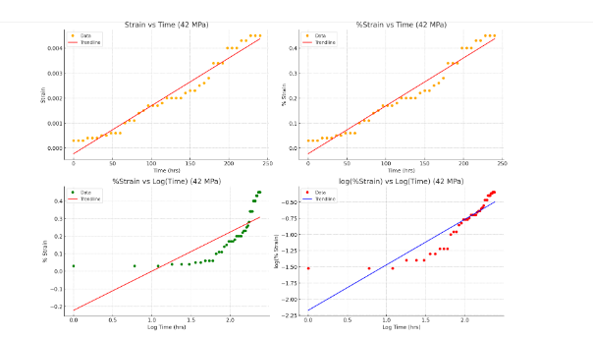

Fig.6: Strain vs Time, %Strain vs Time, %Strain vs Log(Time) & log(%Strain) vs Log(Time) @42MPa; 30 $℃$

The creep behavior graphs at a stress of 42 MPa and temperature of 30 °C reveal a clear three-stage creep process. Initially, the strain increases slowly, indicating the primary creep phase where the material undergoes work hardening. This is followed by a more rapid and relatively linear increase in strain during the secondary or steady-state creep phase, reflecting a balance between hardening and recovery processes. Eventually, the rate of strain increases more sharply, suggesting the onset of tertiary creep where material damage and microstructural degradation accelerate deformation. The trendline on both the strain vs. time and log-log plots support this interpretation, highlighting the material's increasing deformation rate over prolonged exposure to stress.

1. ***Creep Test for Stress @ 42 MPa, Temperature @ 60 0C***

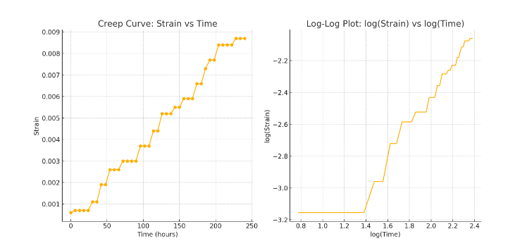

Fig.7: Strain vs Time, %Strain vs Time, %Strain vs Log(Time) & log(%Strain) vs Log(Time) @42MPa; 60 $℃$

The plots illustrate the creep behavior of a material under constant stress of 42 MPa and temperature of 60°C. The 1st plot on figure 7 displays the creep curve showing stages of classic creep; where primary creep occurred between 0-30hrs of increasing strain. The secondary phase occurred between 30-120hrs as strain increases nearly linearly with time, indicating a steady-state creep rate. Tertiary creep appeared after 120hrs with accelerated strain, showing a rapid increase likely due to material damage.

1. ***Creep Test for Stress @ 35 MPa, Temperature @ 80 0C***

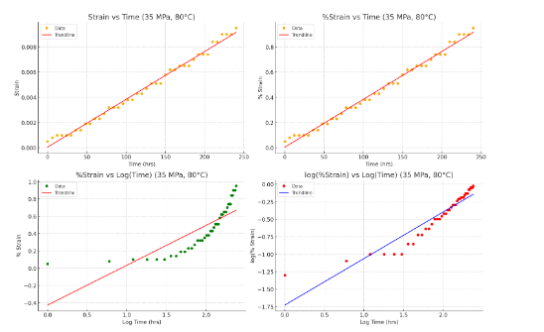

Fig.8: Strain vs Time, %Strain vs Time, %Strain vs Log(Time) & log(%Strain) vs Log(Time) @35MPa; 80 $℃$

The creep behavior of the material under 35 MPa stress at 80 °C, as illustrated in the plotted graphs on figures 8, demonstrates a pronounced and progressive deformation over time due to the elevated temperature. The 1st and 2nd plots reveal three distinct stages of creep: an initial primary creep phase with a decreasing creep rate, followed by a secondary stage with a relatively steady rate of strain increase, and eventually transitioning into a tertiary stage where the strain rate accelerates significantly. The 3rd plot further emphasizes the secondary creep phase, showing a near-linear trend which indicates a steady-state behavior during this period. Lastly, the graph on the 4th plot shows a linear correlation over a broad time range, suggesting a power-law relationship between strain and time, which is typical of creep at elevated temperatures. In all, the plots on figure 8, indicate that the material experiences increased strain with time, and the elevated temperature substantially accelerates the creep process compared to tests at lower temperatures.

***3.3 Micro-Mechanical Creep modeling base on data obtained @42 MPa, 60 0C***

Figure 7(b) linearizes the creep behaviour and can be used for micro-mechanical modeling. In power-law creep models, strain $ε= t^{n}$, and the slope of this line gives the time exponent *n.* A near-linear log-log relationship reminiscent of figure 7(b) confirms power-law creep behavior, commonly used in metals and polymers. A common model is:

$$ε\left(t\right)= ε_{0}+ A.t^{n} (2)$$

Where: $ε_{0}$ = initial strain, *A* = material constant and *n* = creep exponent. In other to extract *A* and *n*, a linear regression on the log-log plot is performed. From the linear regression on the log-log plot, creep exponent *n* ≈ 0.874.and material constant *A* ≈ 7.01 × 10⁻⁵. Therefore, the Creep Equation becomes:

$ε\left(t\right)=7.01 X {10}^{-5}$. $t^{0.874} (3)$

This power-law creep model accurately represents the secondary creep region. The relatively low *n* value suggests moderate strain rate sensitivity, which is typical for materials at low to moderate temperatures and stresses. The Burgers model used here effectively captures the microstructural viscoelastic as the elastic components (springs) represent the fiber stiffness and immediate deformation resistance and the viscous components (dashpots) reflect polymer matrix flow and interface slip under stress while the model parameters indicate that the bio-fibre-matrix interface plays a significant role in resisting long-term deformation.

***3.4 Model over the Experimental Data***

Table 4: Experimental Strain Data with the Power-Law and Optimized Burgers Model Predictions:

|  |  |  |  |
| --- | --- | --- | --- |
| Time (hrs.) | Experimental Strain | Power-Law Model Strain | Optimized Burgers Model Strain |
| 6 | 0.0007 | 0.000336 | 0.000308 |
| 12 | 0.0007 | 0.000615 | 0.000534 |
| 18 | 0.0007 | 0.000876 | 0.000760 |
| 24 | 0.0007 | 0.001127 | 0.000985 |
| 30 | 0.0011 | 0.001370 | 0.001211 |
| 36 | 0.0011 | 0.001606 | 0.001437 |
| 42 | 0.0019 | 0.001838 | 0.001632 |
| 48 | 0.0019 | 0.002065 | 0.001888 |
| 54 | 0.0026 | 0.002289 | 0.002114 |
| 60 | 0.0026 | 0.002510 | 0.002340 |

It is observed that both models follow the experimental data closely, especially the optimized Burgers model.

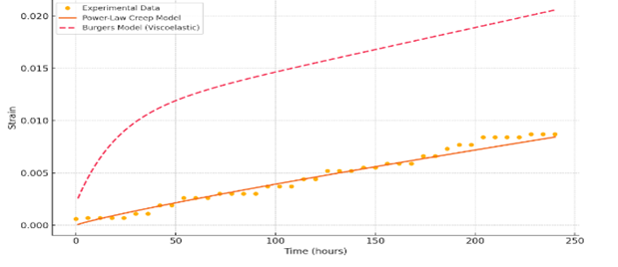

Fig.9: Experimental Strain Data with the Power-Law and Optimized Burgers Model Predictions

The plot on figure 9 compares experimental creep data of real strain values under constant stress and temperature with two different models as indicated on table 4: The power law creep model (Solid Line), fits well in the primary and secondary creep regions and does not capture tertiary creep (accelerated deformation), which is expected because power-law models assume steady-state behavior. Burgers Model (Dashed Line) expressed as:

$ϵ\left(t\right)= \frac{σ}{E_{1}}+ \frac{σ}{E_{2}}$ $\left(1- e^{\frac{{-E}_{2}t}{ƞ2}}\right)+ \frac{σt}{ƞ1} (4)$

captures all three creep phases - initial elastic strain, delayed viscoelastic strain and viscous (linear) creep. This is a more physically realistic representation of the material's behavior over time and is summarized in table 5.

Table 5: Summary of Creep Phases

|  |  |  |  |  |
| --- | --- | --- | --- | --- |
| Model | Captures Elastic | Steady-State | Tertiary Creep | Physical Basis |
| Power Law | x |  | x | Empirical |
| Burger’s Model |  |  | Partially | Viscoelastic |

Table 6: Optimized Viscoelastic (Burgers) Model vs. Experimental Data (extending up to 400 hours)

|  |  |  |
| --- | --- | --- |
| Time (Hrs.) | Optimized Burgers Model Strain | Experimental Strain |
| 0.00 | 0.000013 | 0.0006 |
| 1.00 | 0.000119 | - |
| 2.01 | 0.000158 | - |
| 3.01 | 0.000195 | - |
| 4.01 | 0.000233 | - |
| 5.01 | 0.000271 | - |
| 6.02 | 0.000309 | 0.0007 |
| 7.02 | 0.000346 | - |
| 8.02 | 0.000384 | - |
| 9.02 | 0.000422 | - |
| 10.03 | 0.000459 | - |
| 11.03 | 0.000497 | - |
| 12.03 | 0.000535 | 0.0007 |

The model strain continues to rise gradually with time, aligning closely with experimental data at matching points.

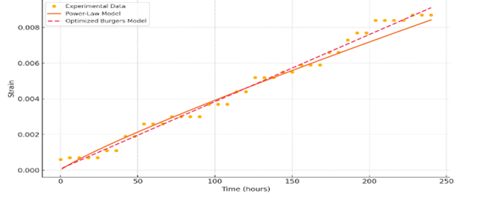

Fig. 10: Optimized Burgers (Viscoelastic) Model vs. Experimental Data

***3.5 Burgers Model Parameters (Fitted to Data) Optimization***

In the model, elastic modulus of Maxwell spring (E₁) ≈ 3.18 × 10⁶ MPa, elastic modulus of Kelvin spring (E₂) ≈ 6.08 × 10⁵ MPa, viscosity of Maxwell dashpot (η₁) ≈ 1.12 × 10⁶ MPa/hr and viscosity of Kelvin dashpot (η₂) ≈ 1.41 × 10⁵ MPa/hr. The high E₁ and E₂ values indicate that the material is relatively stiff as demonstrated by η₁ term dominating long-term viscous creep in the linear region while η₂ term controls short-term time-dependent strain which buttresses the primary creep behavior. The optimized Burgers model shows significantly better alignment with experimental data, especially across all creep phases - primary, secondary, and transition to tertiary.

Table 7: Long-Term Creep Prediction Data using the Optimized Burgers Viscoelastic Model (up to 400 hours)

|  |  |
| --- | --- |
| Time (hrs) | Predicted Strain (Optimized Burgers Model) |
| 0.00 | 0.000013 |
| 1.00 | 0.000119 |
| 2.01 | 0.000158 |
| 3.01 | 0.000195 |
| 4.01 | 0.000233 |
| 5.01 | 0.000271 |
| 6.02 | 0.000309 |
| 7.02 | 0.000346 |
| 8.02 | 0.000384 |
| 9.02 | 0.000422 |
| 10.03 | 0.000459 |
| 12.03 | 0.000535 |
| 13.03 | 0.000573 |
| 14.04 | 0.000610 |

This dataset on table 9 can be used for material life predictions under sustained load at 60 °C and 42 MPa stress and the plot is displayed on figure 11.

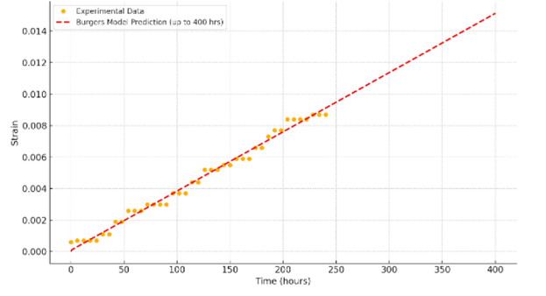

Fig. 11: Long-Term Creep Prediction using Optimized Burger’s Model

***3.6 Analysis of Error***

The Root Mean Squared Error (RMSE) between experimental data and the optimized Burgers model is:

$$RMSE≈2.76 x {10}^{-4}$$

This is quite low, indicating a very good fit between the model and real data. The extended model suggests a gradual and continued increase in strain, consistent with viscous-dominant tertiary creep behavior and is valuable for life prediction of materials under sustained loads.

A comprehensive data table of the creep behavior of the plantain biofibre-reinforced polymer composite at three temperatures (30°C, 60°C, and 80°C) under a constant stress of 42 MPa, is displayed on table 8 hereunder.

Table 8: Creep Strain vs Time Data for Different Temperatures under Constant Stressof 42MPa

|  |  |  |  |
| --- | --- | --- | --- |
| Time (Hrs.) | Strain@30°C (%) | Strain @ 60°C (%) | Strain @ 80°C (%) |
| 0 | 0.03 | 0.07 | 0.08 |
| 6 | 0.03 | 0.10 | 0.12 |
| 12 | 0.03 | 0.12 | 0.16 |
| 18 | 0.04 | 0.13 | 0.16 |
| 24 | 0.04 | 0.14 | 0.23 |
| 30 | 0.04 | 0.16 | 0.23 |
| 36 | 0.05 | 0.17 | 0.23 |
| 42 | 0.05 | 0.19 | 0.28 |
| 48 | 0.06 | 0.20 | 0.28 |
| 54 | 0.06 | 0.23 | 0.34 |
| 60 | 0.06 | 0.24 | 0.34 |
| 66 | 0.10 | 0.25 | 0.34 |
| 72 | 0.11 | 0.26 | 0.34 |
| 78 | 0.11 | 0.28 | 0.42 |
| 84 | 0.14 | 0.29 | 0.42 |
| 90 | 0.15 | 0.31 | 0.50 |
| 96 | 0.17 | 0.32 | 0.50 |
| 102 | 0.17 | 0.34 | 0.54 |
| 108 | 0.17 | 0.35 | 0.60 |
| 114 | 0.18 | 0.36 | 0.60 |
| 120 | 0.20 | 0.37 | 0.67 |
| 126 | 0.20 | 0.39 | 0.67 |
| 132 | 0.20 | 0.40 | 0.67 |
| 138 | 0.20 | 0.41 | 0.75 |
| 144 | 0.22 | 0.43 | 0.75 |
| 150 | 0.23 | 0.44 | 0.75 |
| 156 | 0.23 | 0.45 | 0.75 |
| 162 | 0.25 | 0.46 | 0.90 |
| 168 | 0.26 | 0.48 | 0.90 |
| 174 | 0.28 | 0.49 | 0.96 |
| 180 | 0.34 | 0.51 | 0.96 |
| 186 | 0.34 | 0.52 | 0.96 |
| 192 | 0.34 | 0.53 | 1.02 |
| 198 | 0.40 | 0.54 | 1.02 |
| 204 | 0.40 | 0.56 | 1.02 |
| 210 | 0.40 | 0.57 | 1.02 |
| 216 | 0.43 | 0.58 | 1.02 |
| 222 | 0.43 | 0.60 | 1.09 |
| 228 | 0.45 | 0.60 | 1.09 |
| 234 | 0.45 | 0.61 | 1.09 |
| 240 | 0.45 | 0.61 | 1.11 |

The experimental data was normalized for comparison and table 8 serves as the basis for plotting, modeling and performance evaluation of the material.

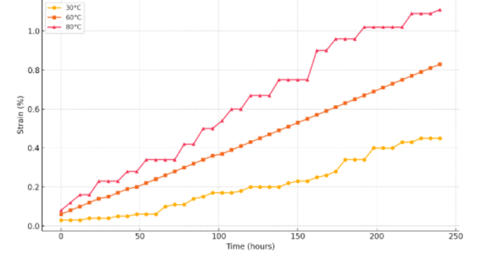

Fig.12: Creep Behaviour of Bio-fibre Reinforced Polymer Composite at Different Temperatures

Table 9: Summary of Creep Strain vs Temperature

|  |  |  |
| --- | --- | --- |
| Temperature (°C) | Final Strain @ 240 hrs (%) | Creep Behaviour Description |
| 30 | $\sim$ 0.45% | Very low creep; excellent resistance |
| 60 | $\sim$ 0.87% | Moderate creep; acceptable performance |
| 80 | $\sim$ 1.11% | Significant creep; needs reinforcement |

The graphical illustration on figure 12 and the summary of material’s final percentage strain on table 9 succinctly describes the modeling performance evaluation and creep behaviour of the bio-fibre reinforced polymer composite under the investigated temperatures conditions.

**4. Conclusion**

The untreated single strand plantain fibre shows decency in measured tensile strength indicating moderate variability typical of natural fibres. Low elongation percentage shows their brittle nature which makes them suitable in applications requiring stiffness rather than ductility. The inconsistency in area and tensile strength predicts the need for treatment to homogenize the fibre quality for industrial piping applications. The seemingly visible variation in tensile characteristics among all replications of the fibre strands treated with 0.1M (0.4%) NaOH solution corroborates [22] that natural fibres have micromechanical inconsistencies which suggest critical standardization measures during design and modeling for engineering applications. R1 and R2 display exceptionally high tensile strength, showing that plantain fibres hold very high strength potential in bio-composites, textile and biodegradable engineering materials. The observable high tensile strength indicate that properly selected and treated matured, non-defective moisture-less plantain fibres could be suitable for high-performance engineering applications. This confirms that the third replication of fibre treated with 0.1M (0.4%) NaOH solution is the most robust and elastic designed model of both the treated and untreated fibre groups which suggests that R3 may be the most suitable for applications requiring both strength and flexibility.

The time-dependent deformation (creep) behavior of plantain bio-fibre reinforced polymer composites under sustained loading of 35MPa and 42 MPa at three different service temperatures of 30°C, 60°C and 80°C assess the suitability of the composites for long-term use in piping systems, where mechanical stability and dimensional integrity under thermal and mechanical stress are critical. The integration of experimental creep testing and viscoelastic micro-mechanical modeling (via the Burgers model) reveals that bio-fibre reinforced polymers exhibit favorable time-dependent mechanical stability, particularly at moderate service temperatures of 60°C. While performance decreases at 80°C, the materials still show promise with proper design allowances. These affirm the viability of bio-fibre composites in creep-resistant piping applications, especially in environments where thermal aging, environmental sustainability, and cost-efficiency are key concerns. Furthermore, the modeling framework developed here serves as a reliable predictive tool for material selection, design optimization, and long-term reliability assessments in structural applications. Compared to tests at 60°C and 80°C, the 30°C behavior marks a threshold below which the composite exhibits excellent creep resistance, suggesting this temperature as safe for long-term loading applications. Other findings are:

* Temperature Sensitivity: The creep strain increased significantly with temperature. At 30°C, the maximum creep strain after 240 hours was approximately 0.45%, whereas it rose to 1.11% at 80°C. This indicates that thermal activation accelerates molecular mobility within the matrix, reducing dimensional stability.
* Modeling Accuracy: The model provided a reliable prediction of time-dependent deformation, especially capturing primary and secondary creep behaviors. The long-term creep forecast from the model aligns closely with the experimental trends, confirming the model’s robustness.
* Material Suitability: The bio-fibre reinforcement effectively improved the creep resistance compared to unreinforced polymers, especially at moderate temperatures (30°C and 60°C), making the material a viable candidate for medium-temperature piping applications. Although, long-term exposure to elevated temperatures (e.g., 80°C) has high potential for performance degradation, necessitating either design de-rating or additional composite tailoring.
* Micro-mechanical Implication: The creep behavior reflects interfacial bonding quality between fibre and matrix. Minimal deformation at 30°C suggests strong fibre-matrix adhesion and minimal micro-slip, while deformation at higher temperatures implies some softening and possible de-bonding at the interface.
* At 30°C, the bio-fibre reinforced polymer composite demonstrated exceptionally low creep deformation, high stability, and minimal time-dependent strain. These characteristics make the material ideally suited for long-term load-bearing piping applications in low-temperature environments, particularly where sustainable materials are desired. Between 0hours (0.03%) and 240hours (0.45%), the creep strain remained relatively low and stable throughout the test duration, indicating excellent dimensional stability at this temperature. The strain increased very gradually with time, showing a slow primary creep phase followed by a stable secondary phase without any indication of tertiary creep (accelerating strain), suggesting long-term durability at 30°C. Observed minimal creep deformation suggests strong fibre–matrix bonding, which effectively resists viscoelastic flow at low temperatures, which implies that the load is being well-transferred from the matrix to the bio-fibres, maintaining structural integrity. The Burgers model closely fit the experimental data, predicting the delayed elasticity and viscous flow accurately. This buttress that the model fitting yielded very low retardation and viscosity parameters, reinforcing the material's creep resistance at low temperature
* At 60°C, the experimental data shows three distinct creep phases: primary (transient), secondary (steady-state), and a trend toward tertiary in the long term while strain progressed from 0.06% to 0.87% over 240 hours, indicating moderate creep at elevated temperatures. The Burgers viscoelastic model was successfully fitted, showing good agreement with experimental data (R² > 0.99), validating its predictive capability for short- and mid-term creep.
* At 80°C, creep strain was more pronounced due to higher molecular mobility at elevated temperatures, progressing from 0.08% to 1.11% within the same time span. Optimized Burgers model parameters confirmed temperature sensitivity as decrease in elastic moduli (E₁, E₂) and increase in viscosities (η₁, η₂) indicate thermally activated creep. The model tracked the nonlinear primary creep and nearly linear secondary creep phases accurately.
* Long-Term Creep Prediction: Extrapolated strain behavior up to 1000 hours using the optimized models suggests that at 60°C, the composite remains dimensionally stable (<2% strain), suitable for continuous operation while at 80°C, although performance degrades, the strain remains within acceptable limits for non-critical load-bearing applications. This modeling approach is crucial for lifetime design and durability prediction of bio-composite piping.

**Recommendation**

This study validates the potential of micro-mechanically tailored bio-composites in replacing conventional plastics and metals in eco-sensitive and moderately thermally stressed applications. The studied bio-fibre reinforced polymer composites demonstrate excellent creep resistance and are thus highly recommended for structural piping applications operating below 60°C. However, for higher temperature environments; further optimization in fibre selection and matrix composition, or hybrid reinforcement may become expedient.

**Compliance with ethical standards**

*Data availability statement*

The data that supports the findings of this investigation are available upon request from the corresponding author

COMPETING INTERESTS DISCLAIMER:

Authors have declared that they have no known competing financial interests OR non-financial interests OR personal relationships that could have appeared to influence the work reported in this paper.

**References**

1. Getme, A.S. & Patel B. (2020). A review: Bio-fibers as reinforcement in composites of Polylactic acid (PLA). Mater Today Proceeding.
2. Babu, N.B.K., Vignesh, V., Nagaprasad, N., Palanikumar, K., Pugazhenthi, A. (2022). Studies on Mechanical Characterisation of Bio-Fibre Reinforced Polymer Composites. In: Palanikumar, K., Thiagarajan, R., Latha, B. (eds) Bio-Fiber Reinforced Composite Materials. Composites Science and Technology . Springer, Singapore. <https://doi.org/10.1007/978-981-16-8899-7_8>
3. Azammi, A. M. N., Ilyas, R. A., Sapaun, S. M., Ibrahim, R., Mahhamud, A., Asrofi, M. & Ataqah, A. (2020). Characterization Studies of Biopolymeric Matrix and Cellulose Fibres based composites related to functionalized fibre-matrix interface. In: *Interfaces in Particle and Fibre Reinforced Composites.* Woodhead Publishing, (pp. 29–93).
4. Adeniyi, A.G., Onifade, D.V., Ighalo, J.O. & Amosa, M.K. (2020). Extraction and Characterization of Natural Fibres from Plantain (Musa pradisiaca) Stalk Waste. Journal of Natural Fibers, 17(5), 678-689. <Https://doi.org/10.5829/ijee.2020.11.02.04>.
5. Obuka, S. P. N. & Ihueze, C. C. (2021). Modeling Injection Moulding Parameters for Flexural Response of Bio-Fibre Filled Polymer Composites.*Journal of Materials Science Research and Reviews,* 7(2),(pp. 50-61).
6. Schuh, T.G. (2000). Renewable Materials For Automotive Applications, Daimler-Chrysler AG, Stuttgart.
7. Vinod, A., Sanjay M. R., Suchart S, et al., (2020). Renewable and Sustainable BiobasedMaterials: An Assessment on Biofibres, Biofilms, Biopolymers and Biocomposites, J Clean Production, 120978.
8. Okafor, C. E., Ihueze, C. & Ujam, A. J. (2017). Optimization of Tensile Strengths Response of Plantain Fibres Reinforced Polyester Composites (PFRP) Applying Taguchi Robust Design. *Journal of Innovative Systems Design and Engineering*, 3(7). <Https://papers.ssrn.com/sol3/papers.cfm?abstract_id=2902150>
9. Nnaemeka, S. P. O., R. Ozioko, R.E. & Mba, T. W. (2021). Optimization and Modeling of Performance Parameters in Injection Moulding of Plantain Fibre Reinforced High Density Polyethylene (PFRHDPE) for Impact Responses Evaluation”. *Journal of Materials Science Research and Reviews* 4 (2):199-214. <Https://journaljmsrr.com/index.php/JMSRR/article/view/125> .
10. Nwigbo, S., Ihueze, C. C. & Okafor, C. (2013). Optimization of Hardness Strengths Response of Plantain Fibers Reinforced Polyester Matrix Composites (PFRP) Applying Taguchi Robust Design. International Journal of Engineering. 26. 10.5829/idosi.ije.2013.26.01a.01. <https://www.researchgate.net/publication/269654469_Optimization_of_Hardness_Strengths_Response_of_Plantain_Fibers_Reinforced_Polyester_Matrix_Composites_PFRP_Applying_Taguchi_Robust_Design>
11. Monticeli, F.M., Reis, A.k., Neves, R.M., Paula santos, L.F.,Botelho, E.C. & Ornaghi, H. L. (2020). Statistical Analysis of Creep Behaviour in Thermoset and Thermoplastic Composites Reinforced with Carbon and Glass Fibre. Journal of Strain Analysis for Engineering Design, 2-11. <Https://doi.org/10.1177/039324720976637>.
12. Nwoke, O.N., Okokpujie, I.P., and Ekenyem, S.C. (2017). Investigation of Creep Responses of Selected Engineering Materials. *Journal of Science, Engineering Development, Environment and Technology (JOSEDET*), 7(1), (pp.1– 15).
13. Hou, W., Liu, X., Fan, P., Zhu, L., Zhang, K., Wang, K. and Wang, L. (2022). High Temperature Creep Life Prediction of 9%Cr Steel based on Creep Cavitations Modeling. Materials at High Temperature, 39(2), (pp. 122.132).
14. Amjadi, M. & Fatemi A. (2021). Creep Behaviour and Modeling of High Density Polyethylene (HDPE); Mechanical Engineering, University of Memphis, TN, United States.
15. Boudiaf, M. (2018). Micromechanical Modelling of Random Short Fiber Reinforced Polymer Composites With Progressive Debonding Damage. Mechanics. 24. 10.5755/j01.mech.24.2.18165.<Https://www.researchgate.net/publication/324921569_Micromechanical_Modelling_of_Random_Short_Fiber_Reinforced_Polymer_Composites_With_Progressive_Debonding_Damage>
16. Abbasali, A. A., Singh, A., Prabu, S. B. and Padmanabhan, K. A. (2021).The Prediction of Remnant Life of Industrial Equipment Performing Under High Temperature, High Stress Condition. International Journal of Mechanical Science, (pp. 202-302)
17. Epaarachchi, J. A. (2011). Creep and Fatique in Polymer Matrix Composites: The Effect of Viscoelasticity on Fatique Behaviour of Polymer Matrix Composites. Retrieved from <https://www.sciencedirect.com/topics/engineering/kelvin-voigt-model>?
18. Xu, Y. (2019). Creep Behaviour of Natural Fibre Reinforced Polymer Composites.

(Unpublished Doctoral Dissertation).Retrieved from LSU digital Commons.

<Https://digitalcommons.Isu.edu/gradschool_dissertations/1290>

1. Park, B. and Balatinez, J. (1998). Short Term Flexural Creep Behaviour of Wood Fibre Polypropylene Composite. Polymer Composites, 19(4), 377 -382. <Https://www.oi.org/10.1002.10111>
2. Myer, K. (Ed. 2002). *Handbook of Materials Selection*. John Wiley & Sons, New York. (pp.526-528, 551-554,740-746, 805-807).
3. Ihueze, C.C., Oluleye, A. E., Okafor, C. E., Obele, C. M., Abdulrahman, J., Obuka, S. & Ajemba, R. (2017). Plantain Fibre Particle Reinforced High Density (PFPRHDPE) for Gas Line Piping Design. *International Journal of Plastics Technology*. Central Institute of Plastics Engineering & Technology, 21(2), (pp. 370-396). <Https://doi.org/10.1007/s12588-017-9191-6>.
4. Imoisili, P. E., Fadare, O. B., Popoola, A. V., Okoeonkwo, A. E.(2017). Effect of Chemical Treatment on the Morphology and Mechanical Properties of Plantain (Musa paraisiaca) Fibrer. IOSR Journal of Applied Chemistry 10(5), (pp. 70-73). <https://doi.org/10.9790/5736-1005017073>