**Original Research Article**

**Effect of Tyre Pressure on Braking Distance of Tubeless Tyres on Asphalt Road**

**Abstract**

|  |
| --- |
| **Aim:** To investigate the influence of tyre pressure on the braking distance of tubeless tyres on smooth asphalt roads in Ghana.  **Methodology:** An experiment was conducted involving a Toyota pickup car, model year 2016 HILUX/DLX, on an asphalt road, at Akenten Appiah-Mensah University of Skills Training and Entrepreneurial Development-Kumas, Ghana. The data were analysed with Microsoft Excel [Version 21] and presented in tabular and graphical forms, and interpreted to satisfy the research objective.  **Results:** The study observed that at the standard tyre pressure of 40psi, the average stopping distance was lower than that experienced at under-inflated and over-inflated tyre pressures at a test vehicle speed of 60km/h. Besides, the study found that as the tyre pressure increases, the braking distance increases correspondingly at 60km/h of the test vehicle. The study indicated that the lower the tyre pressure, the longer the braking distance at a test vehicle speed of 60km/h.  **Conclusion:** The study concluded that the tyre pressure plays a vital role in contributing to addressing road traffic accidents as it influences the distance taken to stop a motor vehicle. The study findings can be used to guide stakeholders in formulating recommendations for tyre pressures for road operations in Ghana and elsewhere. |

**Keywords**

Road traffic accidents, injury of drivers, Motor vehicle collision, tyre pressure, braking distance.

**1** **Introduction**

Motor vehicle accidents are a menace on the road. This phenomenon is not only occurring locally, regionally, but globally too. For instance, Ahmed et al. (2023) cited that at the global front, over 1.35 million people die on the roads due to road traffic accidents annually. At the regional level, Africa is the continent at the forefront in terms of the rate of road traffic fatalities globally, while being the least motorized in comparison to the other five continents (Adedeji et al., 2021). Similarly, at the local level, statistics of road traffic accidents on the Ghanaian roads from January to March 2025 stood at 3,674 road traffic crashes. These crashes represent 6,143 vehicles across all classes (e.g., private, commercial, motor bikes /cycles). This led to 5,039 casualties, including 752 fatalities and 4,287 injuries as reported by the National Road Safety Authority of Ghana (NRSAG) (Accessed on January 12, 2025, Website: https://www.nrsa. gov.gh). Adedeji et al. (2021) noted that the rate of traffic fatalities in Ghana is increasing, notwithstanding the efforts to minimize it. Amid these worrisome figures, it is projected that road traffic injuries will be the seventh leading cause of death worldwide by 2030(Ahmed et al., 2023).

This phenomenon is accounted for by a multitude of factors. Although some of these factors may be country-specific, they cut across geographical settings. For instance, In Ghana, Agebure et al. (2023)found that factors such as human error (e.g., low driving skills, excessive speeding, and poor vision of the driver), road conditions (e.g., bad road networks, no lane markings, and no speed limit signs were found as causal factors of road traffic accidents), faulty vehicles (e.g., defective tyres, brakes, and lights), and environmental conditions (e.g., bad weather conditions and stray animals) are responsible for road traffic accidents. Also, another study conducted in Iraq revealed that motor vehicle collision is the most common cause of Road Traffic Accidents (RTAs), responsible for 64.6% of the total RTAs among pickup, taxi, and motorcycle, as compared to private cars. It is further found that drivers' faults accounted for 81.4% of RTAs. This is followed by road issues, mechanical car faults, and environmental factors, accounting for 15%, 2.4%, and 1.2%, respectively. In addition, it indicated that speeding, low level of education, gender, young age, and alcohol intake are driver-related factors responsible for RTAs(Abdulla et al., 2023). Yuan et al. (2023) stated that the main factors responsible for Road Traffic injuries in China are in four dimensions, namely, human behaviours, road conditions, vehicles and the environment. Likewise, a study done in Sri Lanka on road traffic crashes, injury, and fatality showed poor road infrastructure, the use of different tyres on the same vehicle, a low commitment to implementing road safety policies, and inadequate enforcement of traffic laws are accountable for road traffic accidents(Dharmaratne et al., 2015).

Diverse efforts are being made to address this menace. Stakeholders such as governments and their agencies, corporate institutions, and academic researchers are implementing diverse strategies to curb road traffic accidents. From the perspective of academic researchers, many studies are done to inform policy decisions on road traffic. Notably among them include Bradley and Eng (2009) study on tyre Pressure Control Systems (TPCS) and their effect on braking efficiency, Jánošík et al. (2021) work on brake types and their effect on firefighting truck braking distances, and Veas' (2023) study on tyres' influence on braking distance globally. In Ghana, such works are done too (e.g. Adedeji et al., 2021; Agebure et al., 2023). However, little is known about the influence of tyre pressure on the braking distance of tubeless tyres on smooth asphalt roads in Ghana.

A thorough understanding of how tubeless tyres react to braking distance under different tyre pressures will greatly help in reducing road traffic accidents. This knowledge will assist drivers, tyre maintenance technicians, and road traffic law enforcement agencies in determining the correct tyre pressure for vehicle operation on an asphalt road surface. It will also highlight whether there is a need to move away from the traditional practice of using a single recommended tyre pressure for all surfaces. Additionally, it will inform drivers about the appropriate braking distance with specific tyres and tyre pressures on certain road types under a given speed. Ultimately, this can contribute to lowering the number of accidents and safeguard vehicles and their occupants, including the driver, passengers, and cargo.

The focus of this study is to investigate the effect of tyre pressure on the braking distance of tubeless tyres on smooth asphalt roads in Ghana. To attain this objective, an experimental study was conducted involving a Toyota pickup of model year 2016 Hilux/DLX fitted with tubeless tyres of a tread height of 5 mm on a smooth asphalt road. This was done at Akenten Appiah-Mensah University of Skills Training and Entrepreneurial Development from the 6th to the 7th of February 2025. The 2016 year's model of Toyota was selected for study due to its high population in Ghana.

**2 Materials and Methods**

**2.1 Experiment Design**

The study is an experimental design. An experiment is a type of research in which independent variables are manipulated and their effects upon the dependent variables are observed. This design was chosen because it allowed the researcher to manipulate tyre pressure and assess its impact on braking distance on a given road surface. However, the drawbacks of this type of study are the influence of the confounded variables on the experiment over which the researcher has no control. To mitigate such effects, such as factors like wind speed and ambient temperature, the experiment was done at a wind speed of zero meters per second (0m/s) and an ambient temperature of 200C. This was necessary to ensure that wind speed does not influence braking distance. Furthermore, it is also necessary to ensure that there is no heat exchange between the tyres and the surrounding air since the cold operating temperature of a tyre is 20°C.

**2.2 Test Vehicle Specifications**

The Motor Vehicle used for the experiment was a Toyota pickup car, model year 2016 HILUX/DLX. The car was fitted with tubeless tyres for the test. The specifications of the test vehicle are illustrated in Table 1, while the test vehicle is shown in Fig.1 of Appendix A**.**

**Table 1: Specifications of** **the Toyota pickup car model year 2016 HILUX/DLX.**

|  |  |  |  |
| --- | --- | --- | --- |
| Characteristics | | Parameters | |
| Engine | | 2.4-litre diesel | |
| Engine code | | 2GD-FTV | |
| Type | | 4-cylinder in-line | |
| Valve mechanism | | 16-valve DOHC | |
| Displacement (cc) | | 2,393 | |
| Bore x stroke (mm) | | 92.0x90.0 | |
| Compression ratio | | 15.6:1 | |
| Max. power (bhp/DIN hp/kW @rpm) | | 148/150/110@3,400 | |
| Max. torque (Nm @ rpm) | | 400@1,600-2,000 | |
| TRANSMISSION | | 6MT | 6AT |
| Gear ratios | 1st | 4.784 | 3.600 |
| 2nd | 2.423 | 2.090 |
| 3rd | 1.443 | 1.488 |
| 4th | 1.000 | 1.000 |
| 5th | 0.777 | 0.687 |
| 6th | 0.643 | 0.580 |
| Reverse | 4.066 | 3.732 |
| Deferential gear ratio (final drive) | | 3.583 | 4.100 |

**2.3 Measurement and data collection procedures**

**2.3.1 Tyre Pressure Adjustment**

*1.* ***Calibration of the tyre pressure gauge***

The tyre pressure gauge was first tested for accuracy before data collection. To check the accuracy of the tyre pressure gauge, two tyre pressure gauges were used to measure the tyre pressure of the same tyre of the test motor vehicle. If the pressures were within a tolerance of one psi (21 KPa), the pressure gauges were considered accurate. However, if the readings of the tyre pressure gauges fell outside a one-psi tolerance, the gauges were immediately replaced.

*2.* ***Measurement procedure for tyre pressure***

The actual tyre pressure of each tyre was measured when the tyre was cold by doing the following:

1. Measure the temperature of each tyre with an infra-red pyrometer when the tyre is at rest for not less than two hours
2. Unscrew the valve dust cap of the tyre
3. Press firmly the air chuck of the tyre pressure gauge onto the tyre valve
4. Take the pressure reading from the gauge dial as shown in Fig.2 of Appendix A
5. Leave tyre pressure unadjusted when the measured air pressure of the tyre is within the desired pressure
6. Adjust tyre pressure to the right treatment level by increasing the tyre pressure using an air compressor or deflating the tyre pressure using the pressure gauge.
7. Recheck with the tyre pressure gauge to ensure that the right treatment level was attained
8. Screw back the tyre valve dust cap
9. Record tyre pressure in the datasheet in the appropriate column

**2.3.2 Tyre Pressure**

1. The tyre pressures of all four tyres of the test vehicle were adjusted to the following levels of tyre pressures for the test runs to determine the braking distance on the dry asphalt road surface. Three experimental groupings were done using the following tyre pressures:

1. The manufacturers’ recommended tyre pressure, i.e., 40 PSI
2. Under-inflated tyre pressures, i.e., 38 PSI, 36 PSI, 34 PSI, and 32PSI.
3. Over-inflated tyre pressures i.e., 48PSI, 46 PSI; 44 PSI, and 42 PSI

2. Each tyre pressure, except the recommended tyre pressure, was treated to a decreasing incremental tyre pressure of 2 psi with a Dial Tyre Pressure Gauge [Model No. TST/PG97], with each tyre pressure measured at a tyre temperature of 20°c which was made known by an Infrared Thermometer (model: THTK-803).

**2.3.3 Test Run and Measurement Procedures for Braking Distance**

The study was conducted to investigate the effect of tyre pressure on braking distance. All trials (experiments) were conducted between the 6th to the 7th February, 2025. Precautionary steps were taken to block the chosen road from by-users such as motorists and pedestrians. This was necessary to avoid any accident because clearance was not obtained from the ethical committee since it was not constituted at the time of the study by the University.

During the test, the motor vehicle user (test driver) accelerated the test vehicle from a start point to a speed of 60km/h, then switched on the headlamps to indicate the attainment of the speed of 60km/h. This point was marked with a signpost. At the same time, the driver carefully shifted the gear lever to neutral while engaging the brake pedal to bring the motor vehicle to a complete stop on the asphalt road. The braking distance was measured from the start of application of the brakes marked with a signpost to the point where the vehicle stopped with an AGORA Field tape (model: DS-FTMAMZ1020) and a calibrated Bowmonk 2000 Decelerometer machine, as shown in Fig.3(a) and (b) of APPENDIX A. Three (3) test runs at the speed of 60 km/h were performed for each increment of tyre pressure, and braking distances were measured as aforementioned. The results were recorded in a data collection sheet and braking distances averaged. This was done to nullify human error.

**2.4 Data Analysis**

The gathered data were first subjected to the test of statistical assumptions of regression analysis. The data were found to have satisfied the following assumptions:

1. The variables of analysis should be interval or ratio variables.
2. There must be a linear relationship between the two variables,
3. There should be no significant outliers.
4. The residuals (errors) of the regression line should be approximately normally distributed.

Secondly, the data were subjected to a simple regression analysis. This was done with Microsoft Excel (Version 21) on an HP Desktop computer with the following specifications: (64-bit operating system, x64-based processor [12th gen intel(r) core(tm) i3-12100 3.30 ghz], Ram 12.0 Gb [11.7 Gb]).

**3 Results and Discussions**

This section contains the data analysis, results, and the discussion of the results. The summaries of data analysis are presented in tabular and graphical forms and interpreted to satisfy the research objectives.

**3.1****.1 The Effect of Over-Inflated Tyre Pressure on the Braking Distance of a Tubeless**

**Tyre on Smooth (Asphalt) Road Surface**

To determine the effect of overinflated tyre pressure on the braking distance of a tubeless tyre on smooth (asphalt) road surfaces, the experimental data gathered on overinflated tyre pressure and braking distance were subjected to regression analysis using Microsoft Excel (Version 21) and the outputs presented in Tables 2, 3, 4, 5, and Fig.4.

**Table 2:** Summary Output

*Regression Statistics*

Multiple R 0.996545758

R Square 0.993103448

Adjusted R Square 0.989655172

Standard Error 0.09486833

Observations 4

**Source:** Author’s Field Data, June 2024

**Table 3.:** ANOVA

*df SS MS F Significance F*

Regression 1 2.592 2.592 288 0.003454242

Residual 2 0.018 0.009

Total 3 2.61

**Source:** Author’s Field Data, June 2024

**Table 4:** Coefficient

*Coefficients Standard Error t Stat P-value Lower 95% Upper 95%*

Intercept -5.45 0.955771939 -5.70219712 0.0294052 -9.562355 -1.33764526

Tyre pressure (psi)0.36 0.021213203 16.97056275 0.003454242 0.2687270 0.451273048

**Source:** Author’s Field Data, June 2024

**Table 5:** Effect of Over-Inflated Tyre Pressure on the Braking Distance

*Level of Tyre Pressure Observed Braking Predicted Braking Residuals(m)*

*(psi) Distance(m) Distance (m)*

42 9.7 9.67 0.03

44 10.3 10.39 -0.09

46 11.2 11.11 0.09

48 11.8 11.83 -0.03

**Source:** Author’s Field Data, June 2024

**Figure 4:** Effect of Over-Inflated Tyre Pressure on Braking Distance of a Tubeless Tyre

**Source:** Author’s Field Data, June 2024

Table 2 indicates a strong correlation between the level of tyre pressure and braking distance (R=0.99). Also, ninety-nine per cent (99%) of the variation in braking distance is accounted for by differences in the tyre pressure (R2= 0.993). Table 3 further explains that the level of over-inflation significantly accounts for the changes in braking distance (F= (1,2) =288, P=0.003454242, R2= 0.993; C.I =0.2687270, 0.451273048). The regression coefficient (B = 0.36) (Table 4) shows that an increase in one unit of over-inflated tyre pressure corresponds to an increase in braking distance by 0.36m. This implies that during over-inflation, tyre pressure increases linearly with braking distance. This is corroborated by Table 5. The linear regression model predicts that an over-inflation of 42PSI leads to a braking distance of 9.67m with a residual error of 0.03m, while a further increase in tyre pressure to 48PSI results in a braking distance of 11.83m with an error margin of -0.03m. This is shown by the steady inclination of the line of best fit in Fig.4.

It can therefore be concluded that any rise in tyre pressure above the recommended level results in a proportional increase in braking distance. This result is supported by Stoklosa and Bartnik (2022) and others. Stoklosa and Bartnik (2022) conducted a similar study that compared the performance of summer and winter Goodyear DuraGrip 195/65 R15 summer tyres on wet, dry, and rough road surfaces. They found that on dry asphalt roads, when the standard tyre pressure of 0.20MPa rose to 0.25 MPa and 0.30 MPa, the average stopping distance increased from 11.27 m to 11.25 m and 11.57m with a vehicle speed of 50km/h. The slight difference in increment of braking distance found by Stoklosa and Bartnik (2022) might have been a result of the rough nature of the road surface and test vehicle speed which might have increased tyre-road surface friction enhancing braking retardation. Jaco (2023) braced this; he noted that overinflated tyres lead to an increased braking distance, potentially putting the driver and passengers at risk during abrupt stops.

**3.1.2 The Effect of Recommended Tyre Pressure on the Braking Distance of a Tubeless on Smooth (Asphalt) Road Surface**

The data from tyre pressures and matching average braking distance were presented in Table 6 using Microsoft Excel. This is because simple linear regression analysis could not be performed. After all, the recommended tyre pressure was held constant during the test.

**Table 6:** **Effect of Recommended Tyre Pressure on the Braking Distance** **of a**

**Tubeless Tyre on Smooth (Asphalt) Road Surface**

|  |  |  |  |  |  |
| --- | --- | --- | --- | --- | --- |
| Test  Number | Vehicle Weight  KG | Test speed  [km/h] |  | | Mean Braking Distance[m] |
|  | **UNDER-INFLATED PRESSURE** | | | | |
| 1 | 2600 | 60 | |  | **16.5** |
|  |  | **RECOMMENDED TYRE PRESSURE** | |  |  |
| 2 | 2600 | 60 | |  | **9.6** |
|  | **OVER-INFLATED TYRE PRESSURE** | | | | |
| 3 | 2600 | 60 | |  | **10.75** |
|  |  | | | | |
|  |  |  | |  |  |
|  |  |  | |  |  |
|  |  |  | |  |  |

**Source:** Author’s fieldwork 2024

From Table 7, it is observed that at a standard tyre pressure of 40PSI, the average stopping distance of the test vehicle was 9.6m, which was less than that of the distances experienced by under-inflated and over-inflated tyre pressures at an equivalent vehicle speed of 60km/h. This is confirmed by Stoklosa and Bartnik (2022). In their study which compared the performance of summer and winter tyres on wet, dry, and rough road surfaces, Stoklosa and Bartnik (2022) observed that at a vehicle speed of 50km/h, it took an average distance of 11.27m for the test vehicle to come to a halt with Goodyear DuraGrip 195/65 R15 summer tyre on dry asphalt. Moreover, Kadikyanov et al. (2014) re-echoed the same observation when they concluded that it takes the shortest distance for the Ford vehicle to stop with recommended tyre pressure due to its highest average deceleration. This implies that drivers of motor vehicles should adhere to the recommended tyre pressure to gain greater control over the stopping distance.

**4.2.3 The** **Effect of Under-Inflated Tyre Pressure on the Braking Distance of a Tubeless Tyre on a Smooth (Asphalt) Road Surface**

The data collected on the under-inflated tyre pressure and braking distance of a tubeless tyre on the three test trials to ascertain the effect of under-inflated tyre pressure on the braking distance of a tubeless tyre on a smooth(asphalt) road Surface were subjected to regression analysis using Microsoft Excel (version 21) and the outputs presented as Tables 7, 8; 9, 10, and Figure 5.

**Table 7:** Summary Output

*Regression Statistics*

Multiple R 0.9690874

R Square 0.9391304

Adjusted R Square 0.9086957

Standard Error 0.2898275

Observations 4

**Source:** Author’s Field Data, June 2024

**Table 8:** ANOVA

*df SS MS F Significance F*

Regression 1 2.592 2.592 30.85714 0.030912576

Residual 2 0.168 0.084

Total 3 2.76

**Source:** Author’s Field Data, June 2024

**Table 9:** Coefficients

*Coefficients Standard Error t Stat P-value Lower 95% Upper 95%*

Intercept 29.1 2.272883631 12.80312 0.006045 19.32057104 38.87942896

Tyre Pressure (PSI) -0.36 0.064807407 -5.55492 0.030913 -0.638843767 -0.081156233

**Source:** Author’s Field Data, June 2024

**Table 10:** Effect of Under-Inflated Tyre Pressure on the Braking Distance

*Level of Tyre Pressure (PSI) Observed Braking Predicted Braking Residuals (m)*

*Distance (m) Distance (m)*

32 17.4 17.58 -0.18

34 17.2 16.86 0.34

36 16.0 16.14 -0.14

38 15.4 15.42 -0.02

**Source:** Author’s Field Data, June 2024

**Figure 5:** Effect of Under-Inflated Tyre Pressure on the Braking Distance of a Tubeless Tyre

**Source:** Author’s Field Data, June 2024

Table 7 demonstrates a strong correlation between under-inflated tyre pressure and braking distance (R=0.96). Also, ninety-three per cent (93%) of the variation in braking distance can be explained by the differences in the tyre pressure (R2= 0.93) below the recommended level. Table 8 further explains that the level of under-inflation significantly accounts for the changes in braking distance (F= (1,2) = 30.85714, P=0.030912576, R2= 0.93, C. I= -0.638843767, -0.081156233). The regression coefficient (B = -0.36) (Table 9) shows that an increase in one unit of under-inflated tyre pressure corresponds to a decrease in braking distance by 0.36m. The implication is that during under-inflation, braking distance increases inversely proportional to tyre pressure. This is validated by Table 10. The linear regression model predicts that an under-inflation of 32PSI leads to a braking distance of 17.58m with a residual [error] of -0.18m, while a further increase in tyre pressure at 38PSI towards the recommended level results in a decrease in braking distance to 15.42m with a residual error of -0.02m. This is shown by the stable decline of the line of best fit towards the right in Fig.5.

Thus, it is concluded that as tyre pressure decreases below the recommended level, braking distance increases and vice versa. This observation is corroborated by Stoklosa and Bartnik (2022). Their research, which compared the performance of summer and winter Goodyear DuraGrip 195/65 R15 tyres on wet, dry, and rough road surfaces, found that an under-inflated tyre pressure of 0.10 MPa resulted in a braking distance of 11.46 meters. In support, Rievaj, Vrábel, and Hudák (2013) and Tang et al. (2017) corroborated that a lower inflated tyre leads to a longer braking distance, especially at a velocity of 50km/hr. at varying tyre pressures. In his study, Parczewski (2013) revealed that lowering the inflation pressure in one or all tyres indicated a significant vehicle control and increased stopping distances. On the contrary, Radu et al (2018) found that by decreasing the tyre pressure from 2.4 bars to 1.5 bars, the braking distance was improved by approximately 20% on both snow and asphalt roads. Likewise, Savitski et al. (2015) observed that as the tyre pressure decreased from 3.5 bar to 1.5 bar, the braking distance decreased from 70.9 metres to 60.3 metres, coupled with average deceleration increasing from 1.56m/s2 to 1.81m/s2 respectively. Such contrasting results might have been due to the test road coefficient of friction and therefore need further investigation. The practical implication is that under-inflated pressure prolongs braking distance and should be avoided by drivers at all costs unless done for a purpose.

**4 CONCLUSION**

The study aims to investigate the effect of tyre pressure on the braking distance of tubeless tyres on smooth asphalt roads in Ghana. The study observed that at the standard tyre pressure of 40psi, the average stopping distance was lower than that experienced at under-inflated and over-inflated tyre pressures at a test vehicle speed of 60km/h. Besides, the study found that as the tyre pressure increases, the braking distance increases correspondingly at 60km/h of the test vehicle. The study indicated that the lower the tyre pressure, the longer the braking distance at a test vehicle speed of 60km/h. These results are supported by those found by Stoklosa and Bartnik (2022) Jaco (2023), and Kadikyanov et al. (2014). However, the results of Radu et al (2018) showed contrary evidence.

**Limitations of the study**

The driver’s reaction time was not considered in assessing the stopping distance, as this may influence the distance between the position of the motor vehicle and the accident object. Also, the findings may not apply to all road surfaces, but they have provided insight into vehicular behaviour on the asphalted road during braking at moderately high speeds under varying tyre pressures.

**Declaration of conflicting interests**

The author(s) have admitted no potential conflicts of interest for the study, authorship, and/or publication of this article.

**Declaration of Generative AI and AI-assisted technologies**

The authors have not used generative AI and AI-assisted technologies in doing this work.

**COMPETING INTERESTS DISCLAIMER:**

Authors have declared that they have no known competing financial interests OR non-financial interests OR personal relationships that could have appeared to influence the work reported in this paper.

**References**

Abdulla, R., Qader, B., & Sdiq, K. (2023). Traffic Accident Traits and Driver Characteristics Implication on Road Accidents using Descriptive Analysis: A Cross Sectional Study in Sulaymaniyah, Iraq. In *Traffic Accident Traits and Driver Characteristics Implication on Road Accidents using …* (Vol. 13, Issue 2). www.etasr.com

Adedeji, J. A., Feikie, X., Dzogbewu, T. C., & Mostafa, M. (2021). Reaction behaviour of drivers to marked and unmarked road: Ghana perspective. *Put i Saobraćaj*, *67*(1), 1–6. https://doi.org/10.31075/pis.67.01.01

Agebure, A. B., Amedorme, S. K., & Johnson, A. N. (2023). Causes and Strategies for Reducing Road Traffic Accidents in the Bongo District of Ghana. *Journal of Engineering Research and Reports*, *25*(9), 166–178. https://doi.org/10.9734/jerr/2023/v25i9990

Ahmed, S. K., Mohammed, M. G., Abdulqadir, S. O., El-Kader, R. G. A., El-Shall, N. A., Chandran, D., Rehman, M. E. U., & Dhama, K. (2023). Road traffic accidental injuries and deaths: A neglected global health issue. *Health Science Reports*, *6*(5). https://doi.org/10.1002/hsr2.1240

Bradley, A., & Eng, P. (2009). *A report prepared for the Engineering and Research Support Committee (ERSC) of the Council of Deputy Ministers Responsible for Transportation and Highway Safety Introduction to Tire Pressure Control Systems (TPCS) and synthesis of key research findings in highway and urban applications Contract Report CR-4554A-1 Reserved for FPInnovations, Feric Division staff and contract cooperators*. www.feric.ca

Dharmaratne, S. D., Jayatilleke, A. U., & Jayatilleke, A. C. (2015). Tendances en matière d’accidents, de blessures et de mortalité de la route au Sri Lanka: 1938–2013. *Bulletin of the World Health Organization*, *93*(9), 640–647. https://doi.org/10.2471/BLT.14.150193

Jacob. (2023, June 12). *Maximize Your Safety: Understanding Tire Pressure and Braking Distance.* Jacosuperiorproducts.com/blogs/news/maximize-your-safety-understanding -tire-pressure-braking-distance

Jánosík, L., Jánosíková, I., Kuczaj, J., Polednák, P., Šudrychová, I., Tomásek, M., & Vlcek, J. (2021). MEASURING of BRAKING DISTANCES of FIREFIGHTING TRUCKS. *Communications - Scientific Letters of the University of Žilina*, *24*(2), F1–F13. https://doi.org/10.26552/com.C.2022.2.F1-F13

Kadikyanov, E., Lyubenov, E., Prof, A., Evtimov, I. I., & Ivanov, E. (n.d.). *A STUDY OF PRESSURES IN PNEUMATIC TYRE INFLUENCE ON VEHICLES BRAKING DECELERATION ИЗСЛЕДВАНЕ НА ВЛИЯНИЕТО НА НАЛЯГАНЕТО В ПНЕВМАТИЧНИТЕ ГУМИ ВЪРХУ СПИРАЧНОТО ЗАКЪСНЕНИЕ НА АВТОМОБИЛИ*.

Parczewski, K. (2013). Effect of tyre inflation preassure on the vehicle dynamics during braking manouvre. In *Eksploatacja i NiEzawodNosc-MaiNtENaNcE aNd REliability* (Vol. 15, Issue 2). www.ein.org.pl

Radu, A. I. D. T. and T. G. (2018). Influence of Tyre Pressure on Braking Distance When Driving on Snow and Asphalt. In Institute of Physics Publishing (Ed.), *IOP Conference Series :Materials Engineering and Science* (pp. 1–8). Institute of Physics Publishing.

Savitski, D., Hoepping, K., Ivanov, V., & Augsburg, K. (2015). Influence of the Tire Inflation Pressure Variation on Braking Efficiency and Driving Comfort of Full Electric Vehicle with Continuous Anti-Lock Braking System. *SAE International Journal of Passenger Cars - Mechanical Systems*, *8*(2), 460–467. https://doi.org/10.4271/2015-01-0643

Stokłosa, J., & Bartnik, M. (2022). INFLUENCE OF TIRE PRESSURE ON THE VEHICLE BRAKING DISTANCE. *Archives of Automotive Engineering*, *97*(3), 60–73. https://doi.org/10.14669/AM/155136

Yuan, P., Qi, G., Hu, X., Qi, M., Zhou, Y., & Shi, X. (2023). Characteristics, likelihood and challenges of road traffic injuries in China before COVID-19 and in the postpandemic era. In *Humanities and Social Sciences Communications* (Vol. 10, Issue 1). Springer Nature. https://doi.org/10.1057/s41599-022-01482-0

**APPENDIX A**

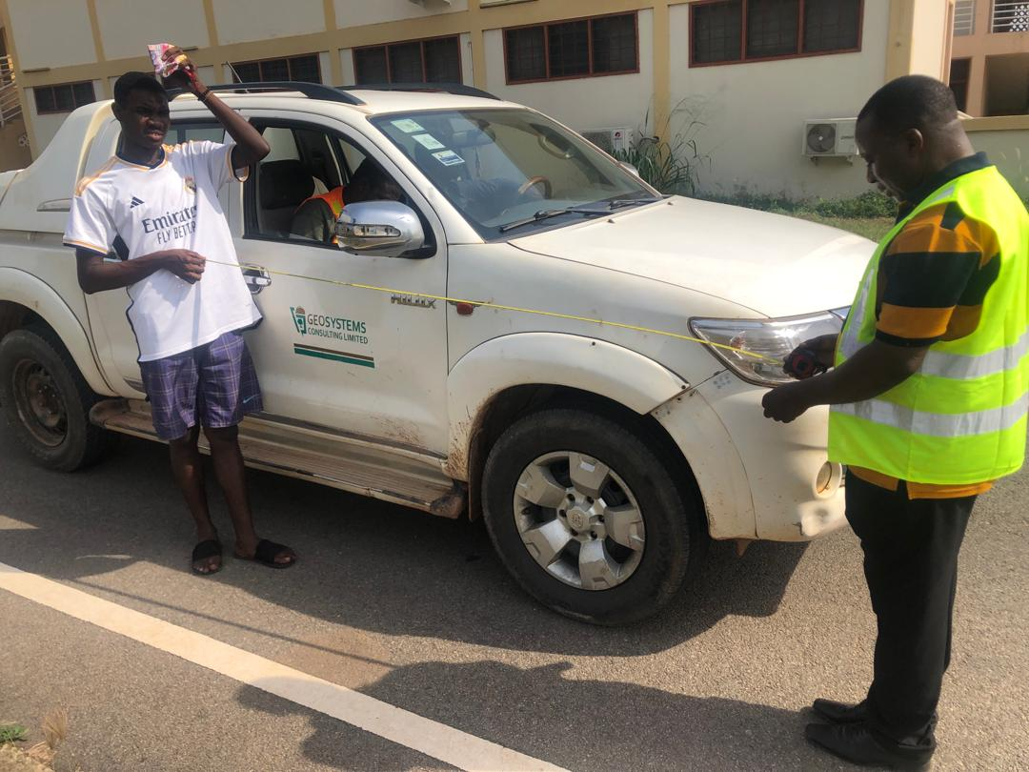

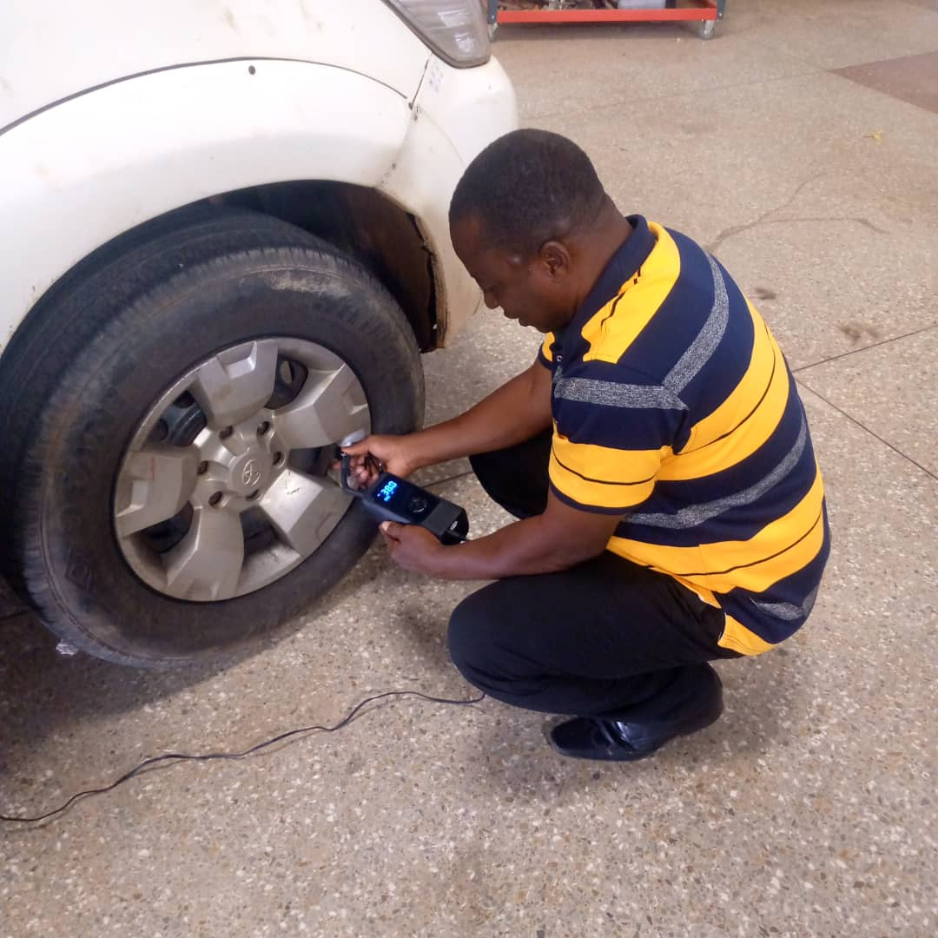**Fig. 1:** Toyota Pickup Car Model Year 2016 HILUX/DLX

**Fig.2.:** Pressure Reading with Pressure Dial Gauge

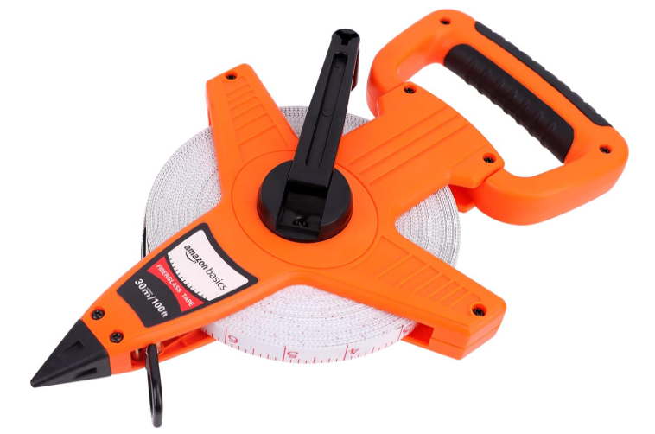

**Fig.3(a):** AGORA Field Tape

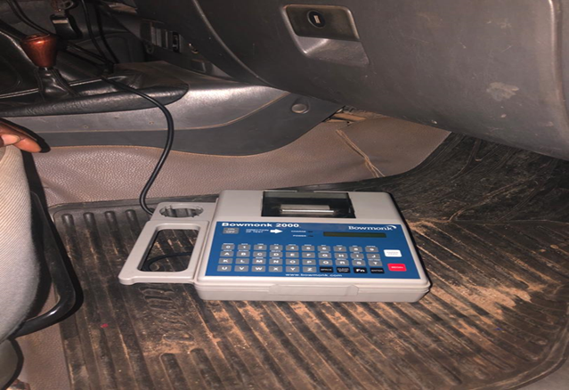

**Fig. 3(b):** Bowmonk 2000 Decelerometer