Design and Development of Low-Cost Active Battery Balancing Technique for Electric Motorcycles

.

ABSTRACT

|  |
| --- |
| With growing emphasis on environmental sustainability, electric mobility systems are gaining traction worldwide. These systems depend heavily on battery storage to deliver the energy needed to power their drive mechanisms. Lithium-Ion battery cells are used to build the battery modules and package, where the module contains battery cells and the package includes all battery modules that are configured and connected in different configurations. To keep these batteries running smoothly and safely during charging and discharging, a battery management system (BMS) is indispensable for oversight and protection. This research dives into the design and development of balancing techniques for these battery setups, exploring both passive and active methods. SIMULINK/MATLAB tool is used to model and simulate different configurations to assess their performance, and the results pointed clearly to the strengths of active balancing over its passive counterpart. Experiments are conducted to evaluate the novel active balancing, incorporating magnetic coils and power converters to decrease power losses with respect to the passive balancing technique. The novel active battery balancing technique optimizes the power consumption by 64% with respect to convention methods. |

*Keywords: Active Battery Balancing Technique; Battery Management System; Electric Motorcycles; Electric Mobility Systems*

1. INTRODUCTION

Electric mobility (E-Mobility) systems offer a sustainable and environmentally friendly alternative to traditional combustion engine vehicles, addressing concerns such as air pollution and dependence on fossil fuels. The E-Mobility systems require storage energy systems to provide the required power, which represent battery packages. Various battery types, such as Nickel-Metal Hydride, Lead-Acid, lithium-ion, lithium-polymer, and solid-state batteries, offer distinct advantages in terms of energy density, weight, and cycle life. The Lithium-Ion battery type is used for storing the energy in E-Mobility systems, as they bring very valuable advantages, such as high energy density, fast charging time and being lightweight [1-2]. This work focuses on the design and development of techniques to balance the battery cells in the battery packages in Electric Motorcycle (E-Motorcycles), which is included in BMS (battery management system). The BMS is a critical component that ensures the optimal operation and safety of these batteries. It monitors and manages key parameters such as voltage, current, and temperature, enhancing battery lifespan and preventing issues like overcharging or overheating. The BMS regulates the charging and discharging process to avoid overcharging and over discharging by keeping a close watch on the battery's voltage, temperature, and state of charge [2-4]. There are two battery packages in the E-Mobility systems, which are high-voltage (HV) and low-voltage (LV) battery systems. The HV battery system is the main component in the powertrain system and provides power to the motor drive system and LV battery systems powers the auxiliary devices. Figure 1 illustrates the system overview of E-Motorcycle, where the HV and LV battery are 48V and 12V, respectively, the OBC (on board charger) is used to charge the HV battery. This paper focuses on the design and development of battery balancing techniques in the BMS for E-Motorcycles, this includes simulation work and analysis, as described in the following sections.

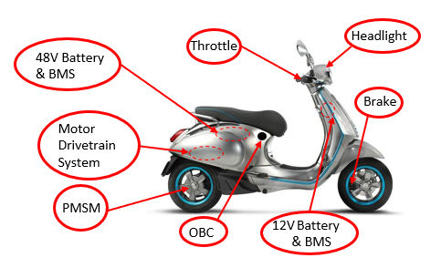

**Fig. 1. System overview of E-Motorcycle**

This paper is structured as follows. Section I explains the benefits of E-Mobility. Section II describes the methodology of the BMS and balancing techniques. Section III illustrates the simulation works and analysis of different battery package configurations and battery balancing techniques. Section IV demonstrates the BMS architecture, highlighting the proposed active balancing technique. Section V shows the experimental setup and results, including the discussion. Finally, the conclusion is drawn in Section VI.

2. METHODOLOGY

The growing demand for cleaner and more effective transportation solutions was addressed by focusing on E-Motorcycles and the development of an affordable battery system. The literature search shows the developed BMS for E-Motorcycles and E-Mobility systems [2, 4]. This research includes a comprehensive exploration of different battery balancing techniques in BMS used in E-Mobility systems, emphasizing their advantages and disadvantages. There are three battery balancing techniques that are passive, active, and hybrid schemes [4-6], these techniques are compared and analyzed regarding the system requirements (cost and efficiency). Passive and active battery balancing techniques are designed modeled, and developed for the HV and LV battery systems in this work. The HV battery package contains 104 lithium-ion battery cells that are configured as 13S8P or 8P13S, the LV battery system contains 8 lithium-ion battery cells that are configured as 4S2P or 2P4S. Simulation models are designed and built to analyze and compare the system performance of the different battery package configurations as series or parallel for the passive and active balancing techniques. These simulation studies show and advocate the best battery configuration to execute for the battery package configuration with respect system requirements that are low cost and applicable for recyclable/reusable lithium-ion battery cells, as illustrated in Section III. The passive battery balancing technique is developed and analyzed in [2, 4], this work focuses on the design and development of the active battery balancing technique, where the proposed active battery balancing system is compared with the passive technique regarding the power losses.

This work presents a novel active battery balancing technique, whereas the battery cells are balanced from each other with respect to their SoC (state of charge) values that depend on voltage level. Figure 2 illustrates the system overview architecture of the proposed active battery balancing technique for HV battery systems, whereas all battery cells are connected to the same common line and the power is stored through coils and power converters. This is achieved through a microcontroller unit (MCU) in the embedded system that manages the current flow to achieve voltage balance between the batteries during the charging and discharging stages. A novel scheme is used to control each battery cell individually and separately without floating issues, where the different voltage levels are adjusted to activate and deactivate the target battery cell for charging and discharging. An active control system using a Flyback converter is employed to achieve balancing to each battery cell, where a battery with low voltage is designated as the balancing target, and balance is continuously executed until all batteries reach equilibrium. Voltage is monitored to avoid overcharging, with the charging current being halted if any battery exceeds the maximum allowable limit. These innovations enable maintaining a steady balance of batteries, enhancing system performance, and ensuring safety. The novelty of the proposed active balancing technique is that the battery cells are balanced by each other regarding the voltage and SoC values without applying/exciting any external source (voltage/power) to balance low SoC battery cells. The proposed technique is designed to achieve low-cost requirement as well. This novel active balance technique is implemented to balance the battery systems, as described in the following sections.

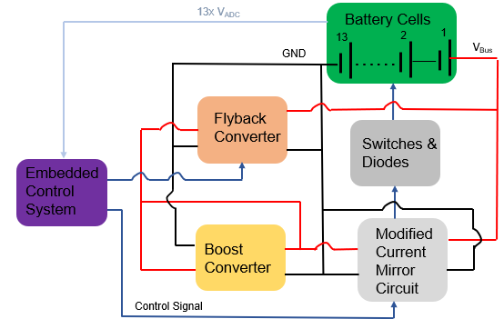

**Fig. 2. Block diagram of proposed active balancing technique**

3. SIMULATION WORKS

This section illustrates the simulation model and results of the BMS, focusing on the passive and active balancing techniques. There are many battery configurations for LV and HV battery systems, the simulation works are conducted for some configurations of the series and parallel battery cell schemes for the passive and active balancing techniques to explore the suitable configuration and balancing technique, as described in the following subsections.

**3.1 Passive Balancing Technique**

In the passive balancing method, resistors are connected in parallel to the cells within each module. These resistors are selectively activated through switching circuits, which are controlled based on the measured SoC of individual cells. For cells with a higher SoC, the resistors are engaged to dissipate excess energy in the form of heat, thereby reducing their SoC to achieve equilibrium across the module. This approach is illustrated in the accompanying figures, where the control mechanism for balancing is depicted. Figure 3 shows the SIMULINK model of passive model of HV battery pack configured as 8P13S (as an example). The package consists of thirteen battery modules connected in series (Figure 3(a)), and the module consists of eight battery cells connected in parallel, as shown in Fig. 3(b). The simulation is conducted over 4000 seconds (66.67 minutes (1.1 hrs)), showing the SoC, voltage, and current profiles of the battery package and module, where the voltage of the battery package reaches to the maximum voltage value (54V) when the balancing among the thirteen modules achieve, as illustrated in Figure 4. The SoC and voltage values of the thirteen modules are different at the beginning of the simulation and reach to 95% and 4.15 V at 3000 seconds, respectively, the current from the modules reach to zero, whereas the balancing among modules occurs and there is no current passing among modules, as shown in Figure 5 (a, b, & c). Figures 6&7 show the voltage, current, and SoC profiles for the LV battery of 4S2P configuration, where the voltage and SoC profiles of the two modules stabilize at 15.8 V and 75%, respectively, which share same performance of 8P13S.

  
**(a)**  
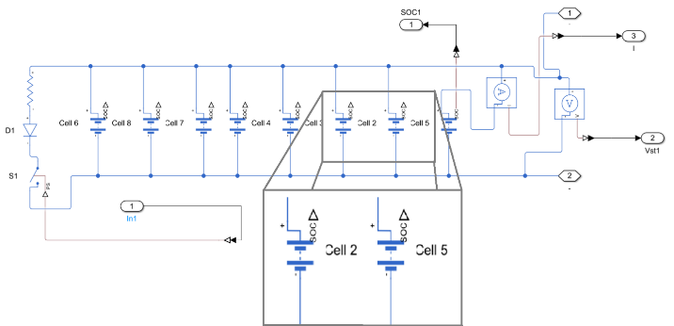  
**(b)**

**Fig. 3. Passive balancing technique of 8P13S battery configuration; (a) package and (b) module levels**



**Fig. 4. Voltage and current profile for 8P13S package using passive balancing method**



**(a)**



**(b)**



**(c)**

**Fig. 5.** **Module performance of 8P13S of passive balancing method; (a) SoC, (b) Voltage, and (c) Current**



**Fig. 6. Voltage and current profile of 4S2P package using passive balancing method**

**3.2 Active Balancing Technique**

Active balancing is implemented to enhance the efficiency and longevity of the battery package, particularly in configurations like the 8P13S and 4S2P battery packs, as same configurations for the passive balancing for the comparison. Unlike passive balancing, which dissipates excess energy as heat, active balancing redistributes energy among the modules, transferring it from modules with higher SoC to those with lower SoC. This approach ensures efficient energy utilization while maintaining SoC uniformity across the battery pack. The Flyback converter is employed as the central balancing mechanism. The Flyback converter is a cost-effective and efficient topology, capable of isolating and transferring power between modules. Each module in the battery pack is connected to the Flyback converter through a network of switches, allowing precise control over power transfer. Figure 8 shows the SIMULINK model of the proposed active balancing technique for 8P13S battery package, where the output of the Flyback feed the thirteen modules through the switches and modified current mirror circuits. The voltage of the battery package reaches to 52V and the current fluctuate between 0 &1 A regarding the charging process among the modules and battery cells, as illustrated in Figure 9. The system identifies modules with lower SoC that need to energy and modules with higher SoC requiring lower charge. The Flyback converter actively transfers energy from the higher SoC module to the lower SoC module using its primary and secondary windings. The control strategy ensures minimal power loss and avoids overcharging or undercharging the modules as shown in Figure 10. The performance of the LV battery package (4S2P) and its module are illustrated in Figures 11& 12, which share same system performance of HV battery system.



**(a)**



**(b)**

  
**(c)**

**Fig. 7. Module performance of 4S2P using passive balancing method; (a) SoC, (b) Voltage, and (c) Current**

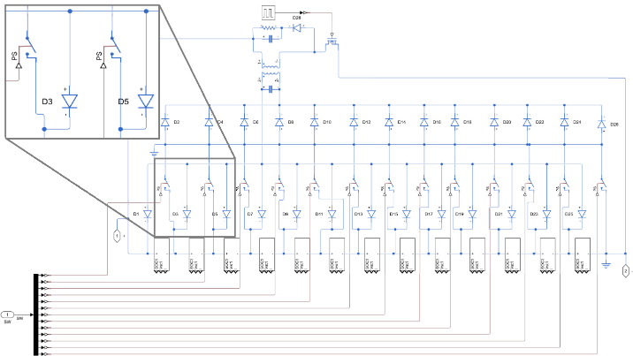

**Fig. 8. Active balancing technique of 8P13S battery configuration**

The current waveforms highlight the energy flow between modules, facilitated by the Flyback converter. The directional flow of current, as observed in the waveforms, indicates the active transfer of power. Distinct spikes in current correspond to the activation of the Flyback converter for specific modules, emphasizing its role in balancing operations, where the current profile in the battery package (in Figure 9) is same of the module level because of the series connection and the flow current balances the battery cells with respect to the SoC values. The voltage levels of individual modules before and after balancing are displayed. Modules with higher initial SoC show a gradual decrease in voltage as energy is transferred out, while modules with lower initial SoC exhibit a corresponding increase, as illustrated in Figures 10 & 11. The transition period reflects the operational efficiency of the Flyback converter in redistributing energy.

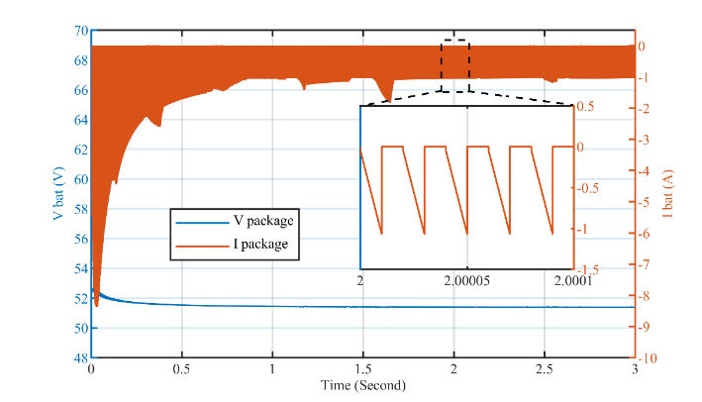

**Fig. 9. Voltage and current profile of 8P13S package using active balancing method**

 

1. **(b)**

**Fig. 10. Module performance of 8P13S using active balancing method; (a) SoC and (b) Voltage**



**Fig. 11. Voltage and current profile of 4S2P package using active balancing method**



**(a)**



**(b)**



**(c)**

**Fig. 12. Module performance of 4S2P using active balancing method; (a) SoC, (b) Voltage, and (c) Current**

4. BMS ARCHITECTURE

The BMS is a critical component in the battery systems, tasked with the fundamental functions and goals of ensuring the optimal performance and longevity of battery packages. These multifaceted objectives include maintaining an accurate SoC in individual cells, preventing overcharging or over-discharging, closely monitoring and regulating voltage and temperature, controlling current within safe limits, actively or passively balancing cell states, detecting safety hazards and faults, and logging data for analysis. Among the key functions of a BMS is cell balancing, a crucial process that equalizes the SoC and voltage levels among individual cells within the battery package, which can be executed using balancing techniques [4-8]. The simulation results (Figures 4-7 and 9-12) in Section III contribute in the system performance comparison between passive and active balancing techniques. The passive balancing mechanism leverages a straightforward principle: the switching operation dynamically connects or disconnects the resistors, targeting high SoC cells until the SoC levels align with others in the module. While this method is simple and cost-effective, its energy dissipation makes it less efficient compared to active balancing. The battery modules of 8P13S configuration (Figures 4-5 & 9-10) are balanced in the active passive techniques in 30 and 50 minutes, respectively, so the active balancing technique achieves balancing faster than the passive technique. Same performance of the 4S2P configuration, this is due to the self-balancing among the modules and battery cells, which are stored in the magnetic coils in the Flyback converter, as described in Section III. The simulation analysis and system comparison affirm that the active balancing is better than the passive balancing with respect the efficiency in the expense of the cost. The proposed active balancing technique aims to use low-cost approach in the design and development scheme through using simple magnetic components, as described in the system design. The proposed idea of the active balancing is based on using Flyback converter, where the process starts calculating the individual SoC of each battery (that is a function of the cell voltage) point within the system. These voltages are then summed to determine the total voltage of the batteries. Subsequently, the voltage of each battery is computed by subtracting the individual values from the total. The flow then identifies the battery with the lowest voltage, marking it as the target for the balancing process. An order is initiated to balance this specific battery, and the process iterates until all batteries reach equilibrium. An essential aspect of the flow of proposed active balancing is monitoring the permissible voltage threshold. If the voltage of any individual battery cell surpasses the allowable limit, the charging current comprises the total current charging the entire battery package is halted. This strategic pause ensures that the current drawn by the balancing circuit to address the battery with the lowest voltage does not contribute to an overcharge scenario. Consequently, the batteries remain in a constant state of balance, promoting optimal performance and safety within the system, as illustrated in the flowchart (Fig. 13).

**Fig. 13. Flowchart of active balancing in BMS**

The proposed active balance BMS is designed based on series configuration of the battery cells in the module. This due to the simulation results and analysis in Section III (Figures 4-5 & 9-12) and the series configuration in the module is safer than the parallel’s when there is damaged/bad battery cell(s) in the module, whereas the bad battery cell(s) share the same current value of the battery cell and module. The schematic diagram of the proposed system is shown in Figure 14, where it represents the LV battery system, and the output voltage of battery cells connected in series (the battery module) are connected to a Boost converter to output higher voltage than the combinations of the battery cells to drive the modified current mirror circuit, as shown in Figure 2. The modified current mirror circuit configures the required threshold *VGS* of the MOSFET for the battery cells, with respect to the voltage values of the battery cells. Maintaining the gate-source voltage (*VGS*) higher than the minimum threshold voltage is considered essential to regulate the charging process effectively. The MCU in the BMS monitors the voltage values of the battery cells, estimates the SoC and performs balancing between the cells through a power converter. A Flyback converter is connected to the output of the battery module (4 or 13 battery cells) to step down the voltage to 6V to charge the battery cells, as illustrated in Figure 14.

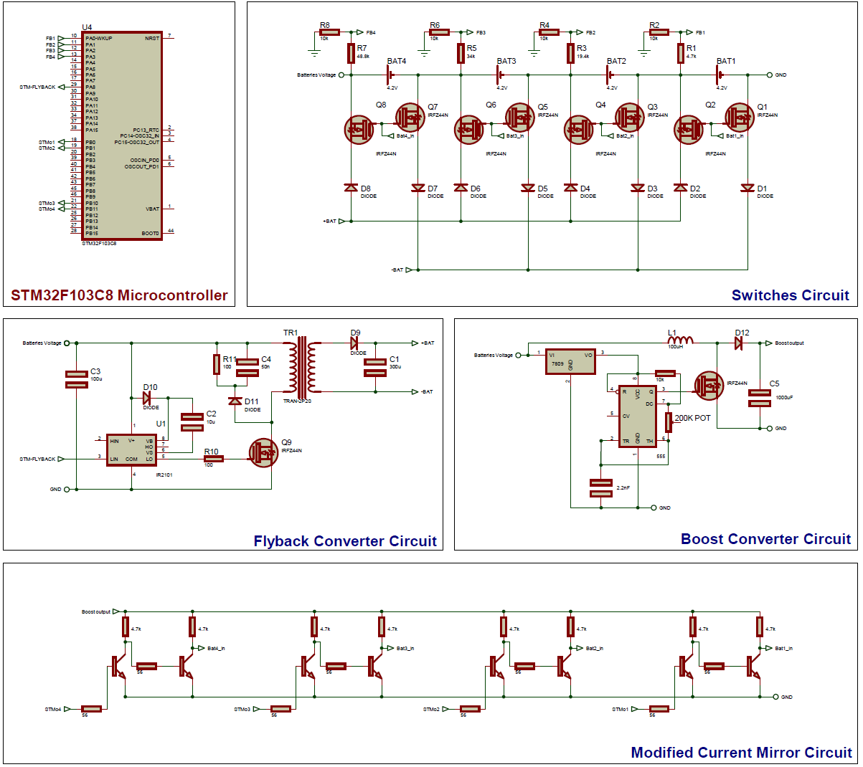

**Fig. 14. Schematic diagram of active balancing BMS technique**

5. EXperimental results and discussion

This section represents the experimental setup and results of the proposed active balancing BMS, whereas it is built as sub-assembly boards. Figure 15 illustrates the PCBA (printed circuit board assembly) of the novel active balancing BMS, where the control (MCU), current mirror circuit, switch circuit (including battery holders), Boost converter, and Flyback converter are connected via connectors and cables. The PCBA setup is used to eliminate EMI (electromagnetic interference) and be easy in debugging and troubleshooting. The novel active balancing BMS scheme is deployed for the LV battery package and HV battery module, where the only difference is the number of the battery cells, so the HV battery pack should have more switches (MOSFETs) and higher output voltage of the Boost converter than the LV battery package. The feedback voltage circuits (using voltage divider circuits) should be also different to cover the operating voltage of the 16V and 50V from the LV and HV battery pack, respectively. The MCU is responsible for directing the current to one battery at a time, ensuring that the battery voltage reaches the desired level before transitioning to the next battery in a predefined sequence. This process is facilitated through the use of MOSFET switches, with the MCU continuously monitoring the feedback values from the battery cells and managing the charging and discharging states of the battery cells. This sophisticated balancing methodology is executed for the battery systems. The Lithium-Ion battery cell needs 4V for charging, whereas 1.8V is consumed in the diodes and switches, which is considered a power loss of this novel active balancing technique. This power loss equals 0.18W for the module, including the losses from the diodes and *RDS* of the MOSFETs, where 0.1A is used to balance the battery cell. The energy and power are stored in the magnetic components of the Flyback converter, which is used to balance the battery cells effectively without burning extra power and energy over passive components (resistor load) as the passive balancing technique. The commonly used resistor in the passive balancing is 50Ω [2], so the total power loss is 0.5W from balancing extra power and voltage from the battery cells, as 0.1A is used to balance the extra power. The Flyback converter is controlled through the switching frequency by the MCU to output the charging voltages (6V) with respect to the input voltage value, where it is a combination of the battery cells of the LV & HV battery modules. The Flyback converter is used to achieve the isolation purposes for reserving the power and energy [8-9]. The MCU (main processor) of the BMS is deployed in a STM kit (Stm32f103c8) to perform the novel BMS functions. The MOSFET (Irfz44n) and diodes are used to switch among the battery cells in the module and pack of the HV and LV battery systems, respectively. These and MOSFETs are chosen with respect to the operating voltage 50V for the battery package and the *RDSon* to minimize the power losses [8, 10].

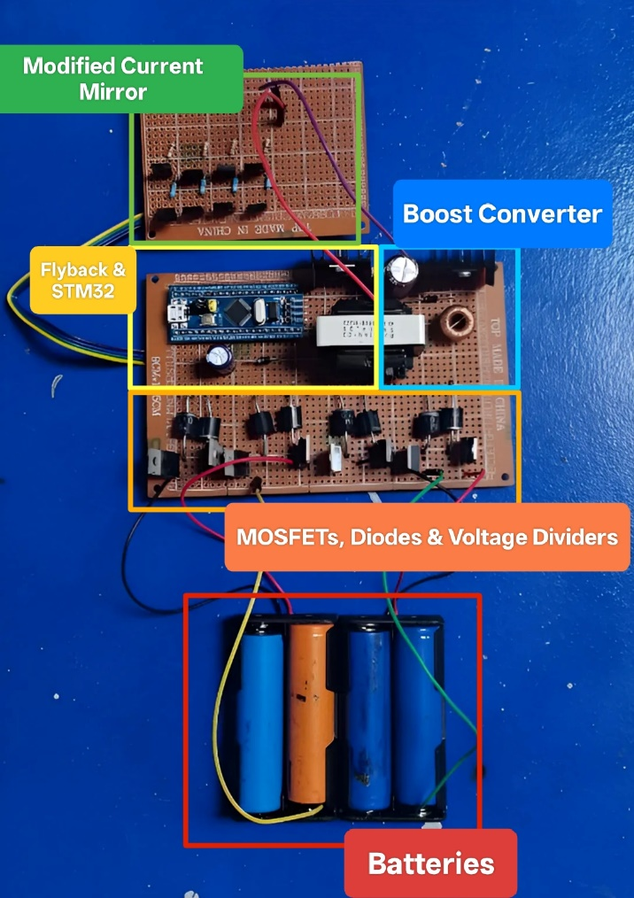

**Fig. 15. Experimental setup of active balancing BMS technique**

The Boost converter outputs higher voltage than the combined battery cells that are connected in series (module) to achieve the required threshold *VGS* of the MOSFETs for the battery cells. Figure 16 shows the voltage profiles of the Boost converter when the input voltage (combined battery cells) is built to output LV (12V) and HV (48V) battery systems. The high overshoot of the Boost converter happens for 0.5 milliseconds, as shown in Figure 16 (b), the chosen MOSFET handles this overshoot through the *VDS*. The Boost converter and modified current mirror circuit are used to eliminate floating ground issues in switching between the battery cells in the modules and packages. The isolated Flyback converter charges and stores the energy to balance the battery cells, as illustrated in Figure 17 (output charging voltage). The MCU of BMS acquires the voltage values of the battery cells through the voltage divider and ADC, as shown in Figure 2. The raw data of the ADC (voltage values) are sampled at 10 seconds and processed, so the BMS performs the active balancing among the battery cells. This work highlights the output profile of the LV BMS module, whereas Figure 18 shows the sampled raw data of the LV battery module (4 battery cells connected in series), where the maximum required voltage cell is 4 V. The lowest voltage value of the battery cell is 2.4V and the voltage of all four battery cells are less than 2.7V at the beginning. All four battery cells achieve the battery balancing among them in 7.3 minutes, where their voltage values reach to 4V, 0.1A is used to balance the battery cells to minimize the power loss in expense of the time to balance the battery cells. This active balancing occurs among the battery cells without injecting or applying external energy/power and this is the novelty of the BMS design, where the low SoC and voltage battery cells are balanced/fed from the high battery cells. This technique achieves efficiency and cost-effective, where this balancing technique minimizes the power loss and improves the power consumption by 64% with respect to the traditional passive balancing technique at 0.1A of current balancing.

**(a)**

**(b)**

**Fig. 16. Voltage profiles of the Boost converter; (a) LV battery and (b) HV battery**

**Fig. 17. Output performance of the Flyback converter**



**Fig. 18. Voltage profiles of the battery cells in LV battery module**

6. CONCLUSION and FUTURE WORKS

This work analyzed and characterized different balancing techniques in the BMS for E-Mobility systems. Different battery configurations of the LV and HV battery systems were modeled and simulated for passive and active balancing techniques using MATLAB/SIMULINK. The simulation results and analysis showed that the active balancing technique is more efficient than the passive scheme, and series battery cells configuration in the module level is suitable with respect to the system requirements, as illustrated in Figures 4-5 & 9-10. The experimental setup presented a novel active balancing technique by employing a Flyback converter-based design and Boost converter to avoid floating ground issue in the switching circuit of the BMS. Simulation and experimental results demonstrate the scalability and reliability of this approach for LV and HV battery systems. The analysis of the experiments affirmed that the system achieved 64% improvement in energy efficiency over traditional passive balancing scheme while maintaining cost-effectiveness.

References

1. Sivak, M. and Schoettle, B. (2018). Relative Costs of Driving Electric and Gasoline Vehicles in the Individual U.S. States. University of Michigan. https://trid.trb.org/view/1508116.
2. Elbeshbeshy, A. M., Matar, O., Shawky, A., Alaaeldin, A., Faiod, H. S., Gomaa, M. A., Habiba, A. A., Shaheen, A. G., Kaddah, S. S., and Badr, B. M. (2023). Design and Development of a Low-Cost Battery System for Electric Motorcycles. 24th IEEE MEPCON, Mansoura, Egypt. DOI: 10.1109/MEPCON58725.2023.10462347.
3. Lu, L., Han, X., Li, J., Hua, J., and Ouyang, M. (2013). “A review on the key issues for lithium-ion battery management in electric vehicles. J. Power Sources, 226, 272–288. DOI: https://doi.org/10.1016/j.jpowsour.2012.10.060.
4. Ethman, Y., Elbastawesy, M., Emad, M., Younes, I., Al-Hosseny, B. I., Matar, O., Farahat, A., Kaddah, S. S., and Badr, B. M. (2023). Design of a Low-Cost Battery Management System for Low Power Applications of Photovoltaic Systems. Proc. CPERE Conference, Luxor, Egypt. DOI: 10.1109/CPERE56564.2023.10119604.
5. Dai, H., Jiang, B., Hu, X., Lin, X., Wei, X., and Pecht, M. (2021). Advanced Battery Management Strategies for a Sustainable Energy Future: Multilayer Design Concepts and Research Trends. Renewable and Sustainable Energy Reviews, 138, 110480, 2021. DOI: https://doi.org/10.1016/j.rser.2020.110480
6. Linden, D. and Reddy, T. B. (2002) Handbook of Batteries. (3rd ed.) New York, USA: McGraw-Hill.
7. Yang, Z., Liu, X., Shen, L., and Zhang, C. (2023). State-of-the-Art and Future Perspectives on Battery Management Systems for Electric Vehicles. IEEE Transactions on Industrial Electronics, 70(5), 3941–3954. DOI: 10.1109/TIE.2023.3256507.
8. Bergveld, H. J., Kruijt, W. S., and Notten, P. H. L. (2002). Battery Management Systems: Design by Modeling. Dordrecht, The Netherlands: Springer.
9. Matar, O., Elbastawesy, M., Ethman, Y., Mohamed, Y., Ehab, A., Younes, I., Khalid, M., Kaddah, S. S., and Badr, B. M. (2022). Design and Development of DC-DC Converters Based on IoT Systems for Photovoltaic Applications in Egypt. 23rd IEEE MEPCON, Cairo, Egypt. DOI: 10.1109/MEPCON55441.2022.10021730.
10. MOSFET (IRFZ44N). https://www.infineon.com/cms/en/product/power/mosfet/n-channel/irfz44n/