DETERMINANTS OF COST VARIABILITY IN STEALTH MONOPOLE TOWER CONSTRUCTION PROJECTS IN GHANA

.

ABSTRACT

|  |
| --- |
| **Aims:** To identify the most significant determinants that impact the cost of Stealth Monopole Tower projects in Ghana.  **Study design:** Both Quantitative and Qualitative Study.  **Place and Duration of Study:** The Department of Electrical and Electronic Engineering at University of Mines and Technology, Ghana, between January 2024 and July 2025.  **Methodology:** The researcher designed questionnaires in collecting and gathering the data for the analysis. Sixty (60) out of eighty (80) distributed questionnaires were returned, screened, coded in Excel, and analyzed using factor analysis in SPSS (version 21) to reduce 18 factors to five key factors. These were Quality of completed work by contractor (QC), Experience of contractor (EC), Classification of company to assign work (CC), Holidays and emergency events (HE) and Site area (SA).  **Results:** Site Area was the only significant factor at a p-value of 0.021 after regression. It was the ultimate determining factor used to take critical decision of the market viability of tower projects cost. Strategically, lowering the cost of Stealth Monopole tower project requires a smaller land size area for the tower project if it is going to be placed at high densely populated area.  **Conclusion:** The Site Area will empower tower companies in selecting towers such as stealth monopole, which comes in a smaller form to occupy smaller size area for the tower projects. Again, the focus of tower organization in taking decision to place tower at a particular location must take into account the irreversible fixed cost, variable cost, ongoing uncertainty and timing of the project. |

*Keywords: Stealth Monopole Tower; Site Area; Determinant; Cost; Variability*

1. INTRODUCTION

1.1 Background of Study

In recent times, mobile communication companies in Ghana have experienced significant growth, supported by the expansion of network infrastructure. The rising costs associated with deploying, operating, and maintaining this infrastructure are prompting a shift toward innovative approaches in wireless network development and management (Koumadi et al., 2013). Technological advancements and regulatory requirements have led mobile network operators to outsource infrastructure operations, focusing on cost savings and efficiency, while promoting passive infrastructure sharing as a practical resource optimization strategy (Koumadi et al., 2013).

The telecommunications industry has significantly contributed to both Ghana’s national economy and the global economy, with the NCA's 2010 guidelines enabling network operators to outsource GSM cell site operations to tower companies, allowing them to focus on their core functions (Danso and Antwi, 2012). Tower designs have evolved with technology, shifting from very tall structures (up to 120 meters) to much shorter ones (as low as 10 meters), and now include various types such as lattice, rooftop, guyed, palm tree, billboard (stealth), monopole towers, and small digital infrastructure (Danso and Antwi, 2012).

As urban populations grow and land becomes scarcer, people have become increasingly reluctant to lease their properties for cell tower installation. While they previously allowed towers in compounds and on rooftops, concerns over environmental effects now make many landowners unwilling to permit such installations (Danso and Antwi, 2012). Although some health concerns lack scientific support, rooftop property owners still worry about the risk of towers collapsing and posing a danger to nearby residents (Derban, 2011).

1.2 Problem Statement

In the capital cities of Ghana, where acquisition of land for mounting tower is a big problem because there is not enough space for people to abode. The people and the telecom industries are struggling for the same land. The Chief and individual landowners are struggling over land and leasing of land to telecom companies (Osei-Owusu and Henten, 2017).

Currently, telecom companies face challenges as some chiefs assert ownership over legally registered lands due to the commercial nature of cell site installations. Additionally, community members increasingly question the benefits they receive from these installations, expressing dissatisfaction over the lack of visible returns from royalties paid by telecom companies. Many communities in Ghana also oppose tower installations out of concern that radiation from the towers may pose health risks (Tetteh, 2012; Kuofie and Boateng, 2011; Atsu et al., 2014).

Tower companies must shift their focus from the traditional towers that occupy large space to those that can fit into smaller land size. They must investigate into factors that influences the cost of the tower construction and focus on these factors to select economical towers in the near future (Hatsu et al., 2016 Owusu-Manu et al., 2019). Therefore, this study seeks to identify the determinants that affect the cost of stealth monopole tower projects in Ghana.

1.3 Objectives of the Study

The objectives of this project are to;

i. identifies the determinants that affects the cost of stealth monopole tower projects in Ghana.

ii. propose to tower construction managers a cost-effective way of constructing stealth monopole tower in Ghana.

1.4 Literature Survey

Deregulation of the telecommunication sector occurred from 1994 to 2000, which saw a dramatic competition within the telecommunication industry in Ghana. This triggered government to shift focus from government owned properties into privatization like Ghana Telecom becoming Vodafone Ghana. Government objectives were to encourage the ownership and operation of Ghanaian telecommunication companies and set up National Communication Authority (NCA), to regulate and control the activities of the telecommunication networks. From the year 2002 to 2007, the telecommunication industry experienced a growth of 9.3% making the industry one of the fastest growing in the world (Hatsu et al., 2016).

Mobile telecommunication market in Ghana has experienced a progressive growth making it one of the fastest on the African continent. Mobile telecommunication investors and operators are burden with huge capital expenditures such as assets or infrastructure because of competition in the market. Historically, the telecommunication industry in Ghana has gone through a lot of transition due to technology. As of 2003, there were less than one million telephone lines in Ghana but the number increased to more than 17 million at the end of 2010 indicating 75% of mobile penetration (Hatsu et al., 2016). Network companies such as Vodafone, Mobile Telecommunication Network (MTN), Airtel- Tigo, Expresso, Surfline and Globacom (GLO) in Ghana are experiencing increasing subscribers for voice calls, internet and video services. In order to survive the stiff competition by the network operators’, strategies include rebranding, infrastructure sharing, mergers and acquisitions have been adopted (Koumadi et al., 2018; Wikle, 2002).

A cellular tower and base stations are installed to cover a larger geographical region than your home; they can handle hundreds of cellphones concurrently, operate in multiple radio frequencies and allows the caller to make a handoff call between two base stations while in motion. Towers, cells, hexes are the backbones of a wireless communication network. The towers are placed in such a way that multiple cells form hexagonal mesh for easy switching between the base stations (Lan et al., 2011).

Four basic components of a cellular mobile network are mobile station, base station, mobile switching center and public switched telephone network. The mobile station creates a network between mobile subscriber and the base station whereas the base station handles the call traffic up and downstream from the mobile subscribers in their respective cells. The mobile switching center are structure to connect the base station to the public switching telephone network. The PSTN creates a path between the caller parties with the global world and maintains the link until the duration of the call (Karulkar and Oh, 2016)

The introduction of new technologies such as CDMA or 3G will make a site hosting a single mobile operator shelter multiple base stations, each serving a different air interface technology (Bankole et al., 2015). Among these are Self Supporting Tower see Figure 1, Guyed Tower see Figure 2, Tubular Manopole see Figure 3, and Stealth Manopole see Figure 4.

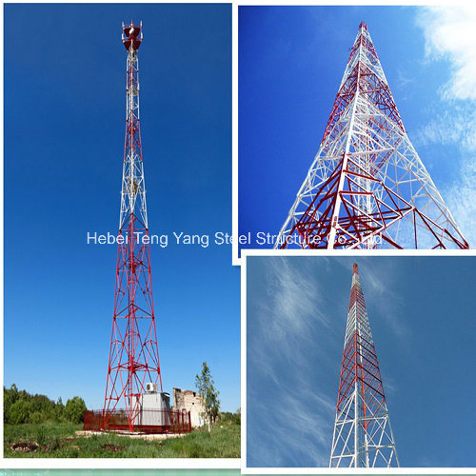

Figure 1 Self Supporting Tower

Source: [www.hbtengyang.en.made-in-china](http://www.hbtengyang.en.made-in-china)

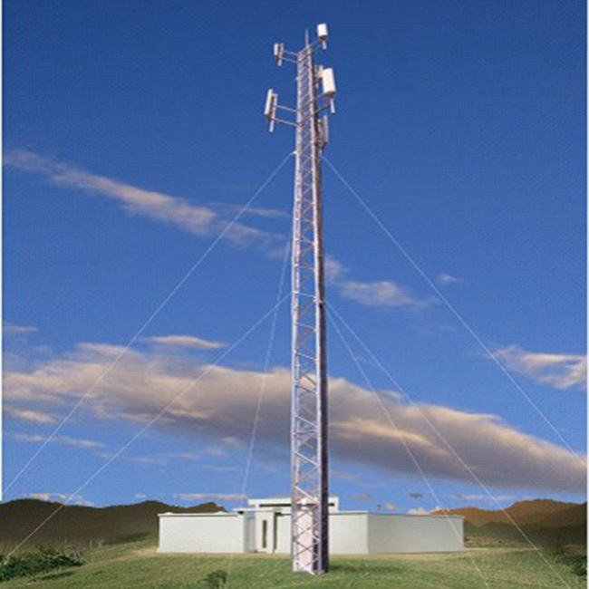

Figure 2 Guyed Tower

Source: [www.steeltowerchn.com](http://www.steeltowerchn.com)

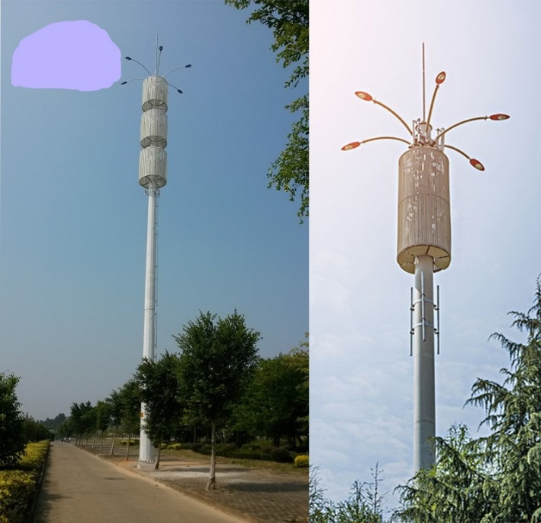

Figure 3 Tubular Manopole Tower

Source: [www.gordtelecom.com](http://www.gordtelecom.com)

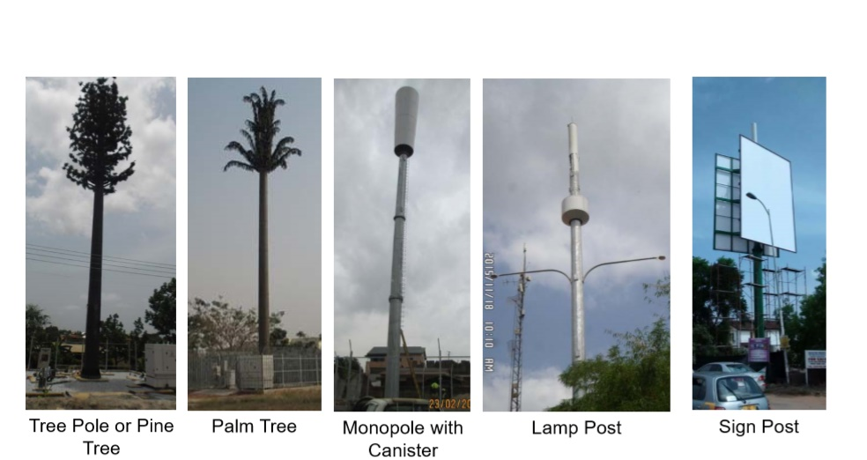

Figure 4 Stealth Manopole Tower

Source: [www.fotosearch.com](http://www.fotosearch.com)

Sites must have easy and cheap access from a public road. Sites must not have conditions that would make constructing a tower unduly expensive. These conditions can include wetlands, poor or rocky soil conditions significant distance to the cell tower site from main road, lots of trees, possible hazardous waste on the property and high voltage power lines (Laurence et al., 2000; El-Kholy, 2015). Identification of all possible works that needs to be done on site should be captured since it serves as the foundation for the design work. The penetrometer is an instrument used for the soil test and must reach minimum depth of 4meter unless there is a rebound. TSS help to capture the Deep Cone Penetration (DCP) on the site area/locations for at least five spots (Paksereht and Asgari, 2012).

Tower design involves developing a sketch of a potential cell site tower to fit into the already existing tower programs of the network operator. Design should be simple, standardized as far as possible, flexible executable on ground and should show TSS information on specific constraints and requirements. The commitments and decisions during design phase have a very high level of influence on the project cost as any deviation from the actual work on the ground may result in disruption and delay (risk) of work (Paksereht and Asgari, 2012). Risk can therefore be defined as "exposure to the possibility of economic and financial loss or gain, physical damage or injury or delays as a consequence of uncertainty associated with persuing particular course of action"(Bortkiewicz et al., 2004; Ismail, 2014). Risk is an unforeseen event, which is abstract in nature and is arduous to measure with accuracy or precision. It results in loss in terms of money, time, materials, machinery and other associated activities (Ismail, 2014).

Cost estimation is the predictive process used to quantify, cost and price the resources required by the scope of project to give an output that could be used for budgeting, cost or value analysis, decision making in business, asset; for project cost and schedule control processes (Vaardini et al., 2016; Al-Zwainy and Hadhal, 2015; Enshassi et al., 2005). Ameh et al. (2010) revealed the significant factors that caused cost overruns in the development of telecommunication projects in Nigeria. This study involved 53 telecommunication projects scattered over the six geopolitical zones. The outcome of the result indicated that the three major causes of cost overruns were lack of experience of contractors on telecommunication projects, high cost of imported materials, and fluctuation in the prices of materials. In addition, (Amu and Adesanya, 2011) investigated the factors that contributed to time overrun in Nigerian construction project. The result showed that funding and payment, contractor and client factors were the major factors that contributed to the delay of projects.

Gündüz et al. (2013) conducted a survey on Turkey construction projects to determine the delay factors. Eighty-three (83) delay factors were identified and categorized into 9 major categories. Results of their study indicated that the most significant factors were inadequate contractor experience, ineffective project planning and scheduling, poor site management and supervision, design change by owner, late delivery of materials, unreliable subcontractors, delay in performing inspection and testing, unqualified workers, change orders, delay in site delivery, poor communication and coordination with other parties, delay in approving design documents, delay in progress payments, slowness in decision making, and unexpected surface and subsurface conditions. Azhar et al. (2008) studied the main factors that caused cost overrun in Pakistan construction sector and their results indicated that the top ten cost overrun factors were fluctuation in prices of raw materials, unstable cost of manufactured materials, high cost of machineries, lowest bidding procurement procedures, poor project (site) management/ poor cost control, delays between design and 16 procurement phases, incorrect/inappropriate methods of cost estimation, additional work, improper planning, and unsupportive government policies.

Fugar and Agyakwah-Baah (2010) conducted a study to investigate the causes of delay in building construction projects in Ghana through interviews and questionnaires survey. A total of 32 causes of delay were analyzed and the top ten influencing factors in causing delay were underestimation of the costs of projects, underestimation of the complexity of projects, delay in honoring certificates, difficulty in accessing bank credit, poor supervision, underestimation of time for completion of projects by contractors, shortage of materials, poor site management, fluctuation of prices, and poor professional management.

Danso and Antwi (2012) conducted a study to identify the factors influencing time and cost overruns in telecom tower construction in Ghana. A total of 26 causes of time overruns were analyzed and the study identified 15 major factors that causes time overruns namely, clients delay of payment certificates, unrealistic clients requirements, lack of tower materials in the local markets, delays in design work and design information, contract modifications, poor workmanship leading to rework, poor site management, unethical behaviors of contractors to achieve high profits, uncompromising attitudes between parties, major disputes/negotiations on site, design scope changes, lack of quality assurance/control, inadequate managerial skills for all parties, poor contract management by consultant and lack of job security for consultants team. Al-Zwainy and Hadhal (2015) conducted a study to identify the factors that influence the cost estimates of telecommunication tower project in Iraq. The survey identified twenty (20) factors that affects cost estimation in the telecommunication industry and the result showed eleven (11) major significant factors as tower types, availability of materials, main cable, tower height, site works/site area, foundation types, section type, variation orders, construction method, quality of completed works and market conditions.

In Ghana, there have been an inadequate study on determining factors that impact the cost of stealth monopole tower projects.

2. material and methods

2.1 Introduction

This section describes the whole research method, deliberation and support of data gathering methods employed are explained. The methodology also informs the strategy and procedure employed in carrying out the research agenda and how the data collected is interpreted.

**2.2 Research Strategy**

This research is an applied quantitative study in Ghana focused on identifying factors influencing the cost of stealth monopole tower projects. The approach is primarily exploratory and descriptive, aiming to understand the current situation without altering it or examining cause-and-effect relationships. The descriptive aspect evaluates the situation as it is, while the exploratory method helps clarify research problems and gather initial data, especially given limited prior knowledge on the topic. This approach also allows for the formulation of research questions, defining populations, and planning analysis methods before starting the study.

**2.3 Population of the Research**

The population is the total collection of individuals or objects with common, binding characteristics or traits. The population for this study comprises of companies license to operate as authorized Tower companies to own and manage towers in Ghana. These are Helios Tower Ghana (HTG) Managed Services Limited, Eaton Tower Ghana, American Tower (ATC) Ghana, African Tower Ghana and Contractors that are involved in construction of telecommunication tower projects such as Mobile Telecommunication Infrastructure Limited (MTI) Ghana, I engineering Ghana Limited and Netis Ghana Limited. All these companies’ offices are situated in the Capital City Accra. The main aim of settling on this group of companies is that they all have the professional skills and knowledge about the tower projects businesses.

**2.4 Sampling Techniques and Sample Size**

According to Gerges *et al*. (2018) the process of sampling makes it possible to limit a study to a relatively small portion of the population. A sample is a representative selection of a population. The tower companies and contractors in the capital city Accra were purposively selected because they all have the professional skills and practical knowledge in the tower projects of the telecommunication industries in Ghana. Purposive sampling is usually used in research when sampling informants are with a specific knowledge or skill, (Berg and Karlsen, 2016).

Professionals in the telecommunication industries who are directly involved in the construction of the communication tower projects were purposively selected. The identified and selected professionals include civil engineers, electrical engineers, project managers, architects, supervisors and managers in various tower companies.

Determination of sample size research is based on several factors. These include population size, the risk of selecting a “bad “sample and the allowable sample error, (Fadiya *et al*., 2015). 80 respondents were selected due to the nature of the study. The breakdowns of the size are shown in Table 1.

**Table 1. Distribution of Questionnaire forms**

|  |  |  |
| --- | --- | --- |
| **Name of Firm** | **Distributed** | **Received** |
| American Tower Company (ATC) Ghana | 25 | 20 |
| Eaton Tower Ghana | 15 | 9 |
| Helios Tower Ghana (HTG) Managed Services Limited | 15 | 10 |
| Netis Ghana Limited | 10 | 9 |
| I engineering Ghana Limited | 5 | 5 |
| African Tower Ghana | 5 | 4 |
| Mobile Telecommunication Infrastructure Limited (MTI) | 5 | 3 |
| Total | 80 | 60 |

This respondent’s selection became necessary because those with knowledge and experience in the communication tower projects could only provide the information needed.

**2.5 Data Collection**

Questionnaire was the research instruments used for the study. This was designed in line with the objectives of the study. The research is a qualitative and quantitative type and data collected from the selected respondents were analyzed. Burke *et al*. (2017) insists that scientists cannot foretell people’s reasoning unless querying them about it. The questionnaires are self-administered questions. The questionnaires were closed questions for respondents not open one because the closed questions are easier to code and analyzed which may increase response rate. The section A of the questionnaires is about the background of the respondent’s example gender, educational level and experience. The section B of the questionnaire is about cost estimation of the tower projects and it was adopted from the literature review. The section C of the questionnaire assesses the factors that affect the cost of communication tower projects. All constructs are measured using five-point Likert scales (from non-significant =1 to extremely significant =5).

Respondents were assured of the confidentiality of this exercise and it will be used solely for academic purposes. Ninety percent of the questionnaires were delivered to the respondents mainly by hand and ten percent of it were through e-mail address and WhatsApp. The one-week interval provided some time for respondents to complete and submit the completed questionnaires. The respondents therefore had enough time to put across their propositions under a stress-free

Condition. This procedure is hoped to source quality responses for analysis. Most of the respondent were always on the field so it was very difficult to get all of them unless the researcher do a follow up to the field. The researcher experience in the communication tower projects also help in the data collection and respondents feel comfortable during interaction and explanation of the questionnaires. This make the response rate to be faster than expected since it is very difficult to receive information from engineers on the field. The questionnaires can be found in Appendix A. 80 questionnaires were distributed to respondents and 60 were received for the analysis.

**2.6 Validity and Reliability Test**

In 1951, Lee Cronbach developed Cronbach’s alpha, α or coefficient alpha that measures the reliability or internal consistency of a one latent variable. Reliability in statistics and psychometrics is the overall consistency of a measure. A measure is said to have a high reliability if it produces similar results under consistent conditions. “It is the characteristic of a set of test scores that relates to the amount of random error from the measurement process that might be embedded in the scores. Scores that are highly reliable are accurate, reproducible, and consistent from one testing occasion to another. That is, if the testing process were repeated with a group of test takers, essentially the same results would be obtained”. Psychometrics professor Mohsen Tavakol and medical education professor Reg Dennick suggest that improving your knowledge about internal consistency and unidimensionality will lead to the correct use of Cronbach’s alpha.

A rule of thumb for interpreting alpha for dichotomous questions (i.e. questions with two possible answers) or Likert scale questions is shown below.

**Table 2. A Rule of Thumb**

|  |  |  |
| --- | --- | --- |
| **Cronbach’s alpha** | **Internal consistency** | **Cronbach’s alpha** |
| $$α≥0.9$$ | Excellent | $$α≥0.9$$ |
| 0.9 > α ≥ 0.8 | Good | 0.9 > α ≥ 0.8 |
| 0.8 > α ≥ 0.7 | Acceptable | 0.8 > α ≥ 0.7 |
| 0.7 > α ≥ 0.6 | Questionable | 0.7 > α ≥ 0.6 |
| 0.6 > α ≥ 0.5 | Poor | 0.6 > α ≥ 0.5 |
| 0.5 > α | Unacceptable | 0.5 > α |

In general, a score of more than 0.7 is usually okay. However, some higher values of 0.90 to 0.95 show excellent internal consistency of a latent variable.

**2.6 Data Analysis Techniques**

The data collected was edited, sorted, coded and quantitatively analyzed. The data was analyzed using Statistical Package for Social Science (SPSS Version 21) and Microsoft. Frequency tables, percentages, bar charts and other descriptive means were also used to analyze the data on the general information about the respondents. Results from these analyses provided the basis for conclusions drawn. Each response obtained from the field was analyzed and the appropriate outcome was elucidated.

**2.6.1 Regression**

Regression method was used to analyze the data that was collected from the questionnaires. Regression is a forecasting technique that measures the relationship of one variable to one or more other variables. Simple linear regression relates one dependent variable to one independent variable in the form of a linear equation:

$y=a+bx$ (1)

Where y is the dependent variable, $a$ is the intercept, $b$ is the slope and $x$ is the independent variable.

**2.6.2 Multiple Regression**

Multiple regression reflects the relationship between a dependent variable and two or more independent variables. A multiple regression model has the following general form:

$y=βo+β1x1+ β2x2+β3x3+β4x4+…+Bkxk+e$ (2)

Where

$βo$ is the intercept

$β1…Bk$ are parameters representing the contribution of the independent variables

$x1…xk$ are independent variables

$e$ is the error components of the equation.

**2.6.3 Analysis of Variance**

Analysis of variance (ANOVA) was use on the independent variables to split the observed aggregate variability found inside the data set into two parts namely the systematic factors and random factors. The systematic factors have a statistical influence on the given data set, while the random factors do not. In analyzing the data, ANOVA test was used to determine the influence that independent variables have on the dependent variable in the regression that was run.

3. results and discussion

**3.1 Overview of Analysis**

This chapter focuses on the discussions of the results derived from the analysis. The chapter also presents the systematic processes through which the methods were used to achieve the objectives of the research.

**3.2 The Demographic Information**

The number of respondents that filled the questionnaires were 60, with respect to gender, 98% of participants in the survey were male whilst 2% were female (see Fig. 5). This shows that there are few female professionals plying their profession in communication tower project. For education, 100% of the respondents were in the tertiary category as shown in Fig. 6.

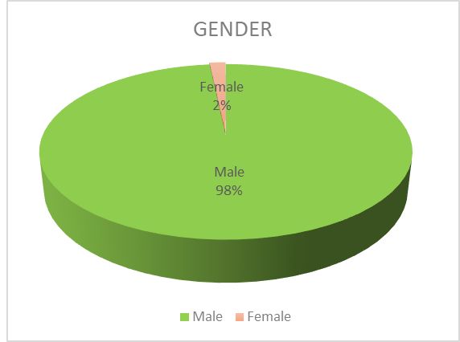

**Fig. 5. Gender Distribution**

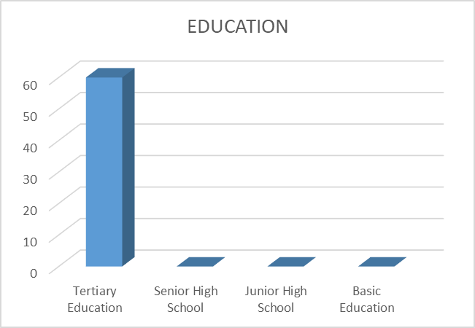

**Fig. 6. Education Representation**

Fig. 7 present the situation of work experience, there was 5% of the respondents having less than 1 year experience with the rest as follows, 2-5 years (13%), 6-10 years (24%), 11-15 years (14%) and above 15 years (18%). The survey conducted showed that 81% of respondents were above 5 years of working experience, which is an indication that the participants are well vexed in their profession (see Fig. 7).

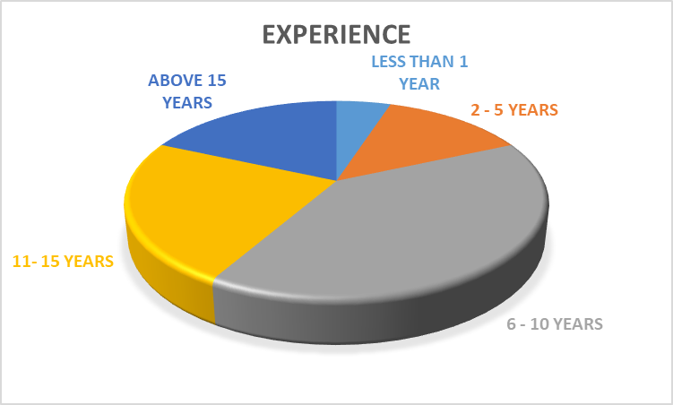

**Fig. 7. Experience Representation**

In the department category, 87% respondents agreed that there was special department allocated for cost estimation in the tower companies whilst 13% said No to the question as shown in Fig. 8. The survey showed that 92% of Project Manager does the cost estimation for the tower project and 8% of Civil Engineers do the cost estimation for the tower project as shown in Fig. 9.

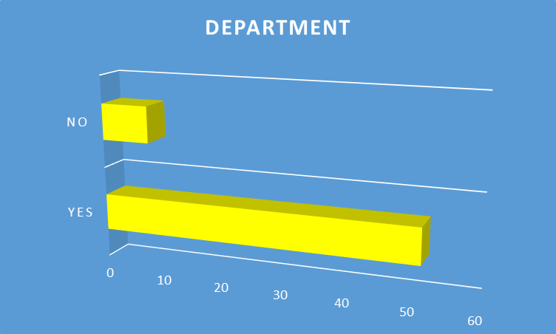

**Fig. 8. Department Representation**

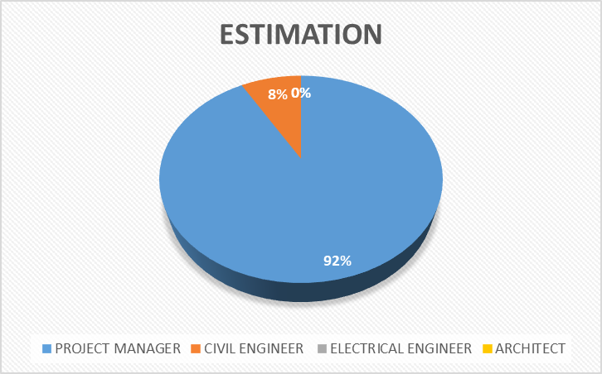

**Fig. 9. Estimation Representation**

Fig. 10 is a representation of cost estimation method by respondents. 77% respondents are of the view that Bottom-up Estimation approach is broadly use for cost estimation of the tower project. The survey conducted reveal that 8% respondents agreed that Analogous and Parametric Estimation are respectively use for cost estimation of the tower project. Finally, the survey indicated that 7% of participates agreed that Three-point Estimation is also use to cost estimate the tower project.

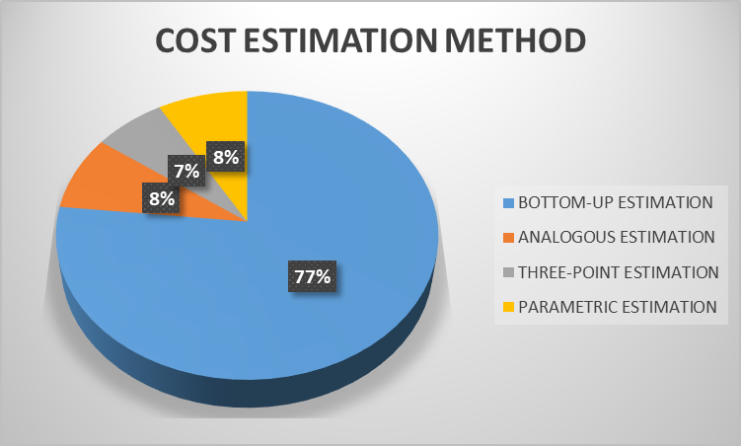

**Fig. 10. Cost Estimation Method Representation**

**3.3 Analysis of Data Presentation**

The descriptive statistics of Table 4 displayed the mean and standard deviation among the variables.

**Table 3. Descriptive Analysis**

|  |  |  |  |  |  |
| --- | --- | --- | --- | --- | --- |
| **Variable** | **N** | **Minimum** | **Maximum** | **Mean** | **Standard Deviation** |
| GEN | 60 | 1 | 2 | 1.02 | 0.129 |
| EDU | 60 | 1 | 1 | 1.00 | 0.000 |
| EXP | 60 | 1 | 5 | 3.37 | 1.089 |
| DEPT | 60 | 1 | 2 | 1.13 | 0.343 |
| EST | 60 | 1 | 2 | 1.08 | 0.279 |
| METHOD | 60 | 1 | 4 | 1.47 | 0.947 |
| ST | 60 | 1 | 5 | 4.67 | 0.774 |
| TT | 60 | 1 | 5 | 4.65 | 0.732 |
| AM | 60 | 1 | 5 | 4.32 | 1.049 |
| CL | 60 | 1 | 5 | 4.00 | 1.120 |
| TH | 60 | 2 | 5 | 4.50 | 0.854 |
| SA | 60 | 2 | 5 | 4.35 | 0.860 |
| TF | 60 | 3 | 5 | 4.75 | 0.541 |
| SEC T | 60 | 1 | 5 | 3.87 | 1.186 |
| VO | 60 | 1 | 5 | 3.28 | 1.223 |
| QC | 60 | 1 | 5 | 3.85 | 1.412 |
| EC | 60 | 1 | 5 | 3.63 | 1.288 |
| MC | 60 | 1 | 5 | 3.50 | 1.200 |
| SC | 60 | 1 | 5 | 2.97 | 1.248 |
| CM | 60 | 1 | 5 | 3.95 | 1.032 |
| SITE C | 60 | 1 | 5 | 4.12 | 0.958 |
| MA | 60 | 1 | 5 | 3.15 | 1.412 |
| HE | 60 | 1 | 5 | 2.50 | 1.347 |
| CC | 60 | 1 | 5 | 2.82 | 1.295 |

The received questionnaires respondents were 60 represented by N. Appendix B give the full meaning to the abbreviated variable show in Table 3. The minimum and maximum values used to collect the data range from 1 to 5. The statistical mean shows each of the variables average values derived from the central tendency of the data distribution with highest being TF (4.75) and the lowest is EDU (1.00). The standard deviation measures the dispersion of the data in relation to the mean. The more spread out the data, the higher the standard deviation and the more the data points are further from the mean. The standard deviation of the variables showed their dispersion from the mean.

The variable from Gender to Classification of company is significant as each individual Cronbach’s alpha is greater than (p > 0.7) showed by Table 4.

**Table 4. Total Statistics**

|  |  |  |  |  |  |
| --- | --- | --- | --- | --- | --- |
| **Variable** | **Scale Mean if Item Deleted** | **Scale Variance if Item Deleted** | **Corrected Item-Total Correlation** | **Squared Multiple Correlation** | **Cronbach's Alpha if Item Deleted** |
| GEN | 75.92 | 140.620 | 0.145 | 0.344 | 0.865 |
| EDU | 73.57 | 134.928 | 0.196 | 0.400 | 0.866 |
| EXP | 75.80 | 141.180 | -0.027 | 0.446 | 0.866 |
| DEPT | 75.85 | 140.130 | 0.132 | 0.726 | 0.865 |
| EST | 75.47 | 143.406 | -0.142 | 0.812 | 0.875 |
| METHOD | 72.27 | 133.589 | 0.385 | 0.544 | 0.860 |
| ST | 72.28 | 133.495 | 0.416 | 0.702 | 0.859 |
| TT | 72.62 | 127.969 | 0.506 | 0.619 | 0.856 |
| AM | 72.93 | 127.284 | 0.496 | 0.704 | 0.856 |
| CL | 72.43 | 130.724 | 0.493 | 0.853 | 0.857 |
| TH | 72.58 | 129.535 | 0.552 | 0.699 | 0.855 |
| SA | 72.18 | 134.729 | 0.483 | 0.760 | 0.859 |
| TF | 73.07 | 124.673 | 0.567 | 0.609 | 0.853 |
| SEC T | 73.65 | 127.214 | 0.449 | 0.663 | 0.858 |
| VO | 73.08 | 119.840 | 0.622 | 0.800 | 0.850 |
| QC | 73.30 | 124.688 | 0.512 | 0.811 | 0.855 |
| EC | 73.43 | 125.741 | 0.516 | 0.721 | 0.855 |
| MC | 73.97 | 123.728 | 0.569 | 0.781 | 0.853 |
| SC | 72.98 | 127.678 | 0.529 | 0.705 | 0.855 |
| CM | 72.82 | 129.305 | 0.498 | 0.667 | 0.856 |
| SITE C | 73.78 | 120.173 | 0.611 | 0.816 | 0.851 |
| MA | 74.43 | 122.995 | 0.545 | 0.667 | 0.854 |
| HE | 74.12 | 123.630 | 0.548 | 0.691 | 0.854 |
| CC | 75.92 | 140.620 | 0.145 | 0.344 | 0.865 |

Table 5. shows information about the diagnostic measure on the reliability coefficient that examines the consistency of the whole variables as a one latent variable. The overall standardized alpha 0.854 is higher than the general rule of thumb limit for Cronbach’s alpha (p > 0.70) especially interpreting alpha for dichotomous questions or Likert scale questions. This shows that the entire variables are all significant with respect to the Cronbach’s Alpha 0.863 in Table 5.

**Table 5. Reliability Statistics**

|  |  |  |  |
| --- | --- | --- | --- |
| **Cronbach’s Alpha** | **Cronbach’s Alpha based on Standardized items** | | **Number of items** |
| 0.863 | | 0.854 | 23 |

(P > 0.7), (Hair *et al*., 2013)

Table 6. shows the variables per factor matrix arranging from top to down (high importance from top to low importance down). The variable QC (0.821) is the highest ranked and the variable MC (0.465) is the lowest ranked indicated by the Factor Matrix extraction method.

**Table 6. Factor Matrix**

|  |  |  |  |  |
| --- | --- | --- | --- | --- |
| **Variables** | **Factors** | | | |
| **1** | **2** | **3** | **4** |
| QC | 0.821 | -0.362 | -0.31 | -0.063 |
| EC | 0.675 | -0.431 | 0.122 | 0.244 |
| CC | 0.632 | -0.216 | 0.336 | 0.126 |
| HE | 0.616 | -0.156 | 0.350 | -0.061 |
| SA | 0.587 | 0.316 | -0.178 | 0.092 |
| MA | 0.570 | 0.101 | 0.318 | -0.471 |
| CM | 0.557 | 0.153 | -0.082 | -0.314 |
| SEC T | 0.543 | 0.387 | -0.073 | -0.167 |
| AM | 0.539 | -0.057 | -0.03 | 0.079 |
| SITE C | 0.533 | 0.212 | -0.082 | -0.301 |
| VO | 0.525 | -0.118 | 0.078 | 0.476 |
| CL | 0.506 | 0.434 | -0.196 | -0.156 |
| ST | 0.419 | 0.313 | -0.326 | 0.121 |
| TH | 0.451 | 0.683 | -0.048 | 0.179 |
| TT | 0.417 | 0.631 | -0.175 | 0.106 |
| TF | 0.445 | 0.618 | -0.132 | 0.251 |
| SC | 0.589 | 0.012 | 0.610 | 0.216 |
| MC | 0.465 | 0.280 | 0.471 | -0.355 |

|  |
| --- |
| **Extraction Method: Maximum Likelihood.** |

**3.4 Component Factor Analysis**

Table 7 contains the information regarding the 18 possible factors with respect to their relative explanatory power as expressed by their eigenvalues. The Factor analysis is such that the Factor solution extracts the Factors in the order of their importance, with Factor 1 accounting for the most percentage variance, Factor 2 slightly less, and so on through to the 18th Factor. In addition to assessing the importance of each Factor, their corresponding percentage of variance were considered in selecting the number of Factors, Factor 1 (35.30%), Factor 2 (14.94%), Factor 3 (8.90%), Factor 4 (6.66%) and Factor 5 (5.95%). The remaining 13 Factors were not retained for further analysis. Two criteria were evaluated in order to decide on the number of factors to retain. These were the Total variance Explained and Scree plot. From Table 7 all factors with percentage variance less than (p < 0.05) were rejected and these factors were not retained for the next analysis. Five Factors with eigenvalues greater than 1 were retained for the next analysis. Table 7 shows records of Factor 1 (6.354), Factor 2 (2.690), Factor 3 (1.603), Factor 4 (1.200) and Factor 5 (1.072) with their respective eigenvalues. The Screen plot (See Figure 11) is the graphical representation of the five Factors with eigenvalues that were greater than 1 or Factors that have been retained at the eigenvalues cut off (identifying the “elbow” in the eigenvalues) which is greater than 1. No factors with eigenvalues less than 1.0 were retained.

**Table 7. Total Variance Explained**

|  |  |  |  |  |  |  |
| --- | --- | --- | --- | --- | --- | --- |
| **Component** | **Initial Eigenvalues** | | | **Extraction Sums of Squared Loadings** | | |
| **Total** | **% of Variance** | **Cumulative %** | **Total** | **% of Variance** | **Cumulative %** |
| 1 | 6.354 | 35.300 | 35.300 | 6.354 | 35.300 | 35.300 |
| 2 | 2.690 | 14.943 | 50.242 | 2.690 | 14.943 | 50.242 |
| 3 | 1.603 | 8.907 | 59.150 | 1.603 | 8.907 | 59.150 |
| 4 | 1.200 | 6.668 | 65.818 | 1.200 | 6.668 | 65.818 |
| 5 | 1.072 | 5.956 | 71.773 | 1.072 | 5.956 | 71.773 |
| 6 | 0.831 | 4.617 | 76.39 |  |  |  |
| 7 | 0.745 | 4.139 | 80.529 |  |  |  |
| 8 | 0.576 | 3.200 | 83.729 |  |  |  |
| 9 | 0.563 | 3.126 | 86.854 |  |  |  |
| 10 | 0.531 | 2.952 | 89.806 |  |  |  |
| 11 | 0.404 | 2.242 | 92.048 |  |  |  |
| 12 | 0.334 | 1.853 | 93.901 |  |  |  |
| 13 | 0.300 | 1.669 | 95.57 |  |  |  |
| 14 | 0.241 | 1.341 | 96.911 |  |  |  |
| 15 | 0.192 | 1.065 | 97.976 |  |  |  |
| 16 | 0.165 | 0.918 | 98.895 |  |  |  |
| 17 | 0.120 | 0.664 | 99.559 |  |  |  |
| 18 | 0.079 | 0.441 | 100 |  |  |  |

**Extraction Method: Principal Component Analysis**

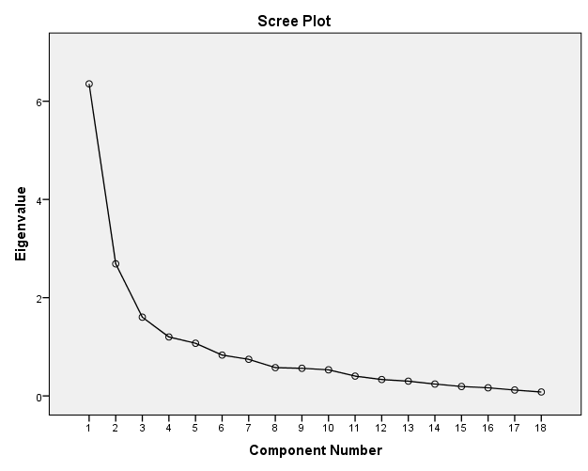

**Figure 11. Screen Plot for Eigenvalue and Component Number**

The factor analysis is a way to condense the data in many variables into a just a few variables. Therefore, the technique in extracting the 18th variables into few data (five factors) and use it for the next analysis is very important.

Table 8. shows Statistical reliability test between the variables. The ANOVA F Statistics value (100.479) of the variables were significant at (0.000) comparing with the standard confidence level ratio of (p < 0.01). This is an indication that the variables are reliable with a significant level of (0.000) as shown in Table 8.

**Table 8 ANOVA**

|  |  |  |
| --- | --- | --- |
| **ANOVA between**  **Variables** | **F** | **p-value** |
| 100.479 | 0.000 |

Hotelling’s T-squared Test was conducted on the remaining five variables (QC, EC, CC, HE and SA) to determine the reliability of the remaining data. Table 9 shows that these variables were significant at (0.000) comparing with the standard confidence level of (p < 0.01). The five variables were showing as if they were not part of the distribution (see Figure 7). Again, one of the variables seems to be an outlier or a member of a separate group as shown in Figure 7. The Hotelling’s T-squared is an indication that even though the variables were condense into smaller size and variables seems to be isolated, the variables were significant at (0.000) as shown in Table 9. These variables (QC, EC, CC, HE and SA) are significant for the next analysis.

**Table 9 Hotelling’s T-Squared Test**

|  |  |  |
| --- | --- | --- |
| **Hotelling’s T Squared** | **F** | **p-value** |
| 4926.732 | 144.234 | 0.000 |

## **3.5 Regression of Factors that affect the Stealth Monopole Tower Projects in Ghana**

In statistical modeling, regression analysis is a set of statistical processes for estimating the relationship between a dependent variable (Method) and one or more independent variables (QC, EC, CC, HE, and SA). The overall idea of regression was to examine which of the independent variables (QC, EC, CC, HE and SA) particularly were significant predictors of the outcome variable (Method). The five variables (QC, EC, CC, HE and SA) were regressed in relation to the method used by the tower companies in estimating the cost of stealth monopole tower projects. Table 10 shows the result of correlation (model summary); Table 11 shows the ANOVA Test results when the five variables were regressed; and Table 12. shows the coefficients of regression.

**Table 10. Shows result of correlation (Model Summary)**

|  |  |  |  |  |
| --- | --- | --- | --- | --- |
| **Model** | **R** | **R-Square** | **Adjusted R Square** | **Standard Error of the Estimate** |
| 1 | 0.441a | 0.194 | 0.120 | 0.889 |

1. Predictors: (Constant), CC, SA, QC, HE, EC
2. Dependent Variable: METHOD.

**Table 11. Shows the ANOVA Test**

|  |  |  |  |  |  |
| --- | --- | --- | --- | --- | --- |
| **Model** | **Sum of Squares** | **df** | **Mean Square** | **F** | **Sig.** |
| Regression | 10.290 | 5 | 2.058 | 2.606 | 0.035b |
| Residual | 42.643 | 54 | 0.790 |  |  |
| Total | 52.933 | 59 |  |  |  |

1. Predictors: (Constant), CC, SA, QC, HE, EC
2. Dependent Variable: METHOD.

**Table 12 Shows the Regression Coefficients Values**

|  |  |  |  |  |  |
| --- | --- | --- | --- | --- | --- |
| **Model** | **Unstandardized Coefficients** | | **Standardized Coefficients** | **t** | **Sig.** |
| **B** | **Std. Error** | **Beta** |
| (Constant) | 2.96 | 0.619 |  | 4.781 | 0.000 |
| SA | -0.352 | 0.148 | -0.320 | -2.378 | 0.021 |
| QC | 0.053 | 0.117 | 0.079 | 0.452 | 0.653 |
| EC | 0.168 | 0.129 | 0.228 | 1.296 | 0.200 |
| HE | -0.190 | 0.115 | -0.270 | -1.653 | 0.104 |
| CC | -0.107 | 0.128 | -0.146 | -0.830 | 0.410 |

1. Dependent Variable: METHOD

In Table 10, the R called the linear coefficient of correlation, measures the direction and strength of a linear relationship between two variables. The value of R (0.44) which is a positive value is an indication that the coefficient of correlation and the relationship between the dependent (METHOD) variable and the independent variables (SA, QC, EC, HE and CC) were very strong. The determination coefficients (R²) represent the percentage of the data that is nearest to the line of best fit. Also, the coefficient of determination equal to 19.4% means 19.4% of the total variation in dependent variable (METHOD) (y) will be explained with the linear relationship x and y. The other 80.6% of total variation in y remains unexplained.

Table 11, shows the test result of reliability on the variable to form one latent variable. The result of the ANOVA using the F- statistic indicates that the variable is significant at level (0.035) as shown in Table 11 less than the acceptable standard of confidence level (p < 0.05).

**3.6 Analyzing the Significant factors effects on cost of Stealth Monopole tower projects in Ghana**

Table 12 shows regression coefficients values. Regression analysis was used to generate an equation to explain the mathematical relationship between the dependent variable (METHOD) and the independent variables (SA, QC, EC, HE and CC) as shown in equation 3. From the analysis, ‘B’ represents the unstandardized coefficients and ‘Beta’ as standard coefficients, which was used to identify the independent variables having major impact on the dependent variables. Using t-test at significant level at 5%. SA (Site Area or Site Location) is the only significant factor that had effect on the cost of stealth monopole tower project with p-value of (0.021) in relation to the dependent variable (METHOD) as shown in Table 4. The values of unstandardized coefficients were used to develop a mathematical equation showing the relationship between the dependent variable (METHOD) and the independent variables (Constant, SA, QC, EC, HE, and CC).

Total Cost (Method) (y) = 2.960 – 0.352SA + 0.053QC + 0.168EC – 0.190HE – 0.107CC … (3)

**4.7 Discussion**

Using SPSS as a statistical tool on the variables to identify the factors that affect the cost of stealth monopole tower project in Ghana, showed that all the variables (100%) were significant per the Cronbach’s alpha test (see Table 5). In order to determine the significant factors that affect the cost of the tower project, factor analysis was applied to compress the variables and put them into a common score. These separated the variables and five independent variables were retained. These five independent variables were (QC, EC, CC, HE and SA) and they are the significant factors that affects the cost of tower build. The tower companies have to take a close look at these five variables and their contribution to the cost of the tower built. Quality of completed work by contractor, experience of contractor, classification of company to assign work, holidays and emergency events and site area contributed 71.77% to the cost of stealth monopole tower project (see Table 7). The output of an experience contractor will produce a quality work done and there will be less snags and rectification on the tower project. This will reduce the cost of the tower project. Holidays and emergency events can bring the communication tower projects to a stop and can cause high cost of the tower project.

Further analysis was done by regressing these five variables (QC, EC, CC, HE and SA) in order to achieve the significant factors effects on cost of communication tower project. Method (y) was used as dependent variable and (QC, EC, CC, HE and SA) as independent variable to generate an equation. The outcome of regression shows that only site area (SA) was the significant factor that had effect on the cost of the stealth monopole tower project with t-test (-2.378), p-value (0.021) and a significant level of 5%. The equation of unstandardized coefficient of the regression indicates that any unit change in the partial value of x will cause a change in the y (Method). If the other variables remain constant, a unit change of 0.352 of the site area will reduce the cost of tower project drastically. If the other variables remain constant, then a unit change of 0.190 of holidays and emergency events will reduce the tower projects. Again, if the other variables remain constant then a unit change of 0.107 of classification of company will reduce the cost of the tower project. According to Al-Zwainy and Hadhal, 2016 regression conducted, the result showed five variables that were Foundation Type (FT), Tower Type (TT), Height of Tower (HT), Main Cable (MC) and Site Area (SA) significant. The researcher out of the regression was similar to His but the researcher went further to identify the most significant variable that affect the cost of communication tower project.

In choosing site area for building of tower project, the tower operators must consider the market viability of the tower location and situate the tower closer to high densely populated area or the location closer to market place where people converge to provide services to the surrounding areas (Brown, 1995; Agarwal, 2007). The location area or site area gives the tower operators fair idea to identify the type of soil on which the tower will be constructed. This enables structural analysis to be performed in determining whether the cost of building the tower will be in the acceptable range. In constructing a communication tower, it should be situated at a place where there are people around and these people benefiting from it.

Again, the focus of tower organization in taking decision to place tower at a particular location area have to take into account the irreversible fixed cost, variable cost, ongoing uncertainty and timing of the project. Looking at the location of the site area, if the uncertainty is higher, the real option theory suggest that tower companies should wait on project or vice versa (Bulan, 2005, Chen, 2006; and Yuan, 2009).

Finally, Tower organizations have to focus on adopting new types of towers in the market, which are design to occupy a smaller size of land space as compare to lattice towers. At high densely populated area such as market place, the mall and the hospital stealth monopole will be suitable because it helps to solve aesthetics nature of the environment. Stealth monopole will reduce public rising concern about the fear of placing tower in the communities and most importantly reduce the cost of building communication tower project.

**4.7 Summary**

The focus of this study is to identify the most significant factors that affect cost of stealth monopole tower projects in Ghana. The researcher identifies 18 factors that affects cost of stealth monopole tower projects in Ghana. The researcher designed questionnaires in collecting and gathering of data for the analysis. Eighty (80) questionnaires were distributed to respondents and sixty (60) were returned by the respondents. The sixty (60) received questionnaires were audited, screen and coded in Excel sheet for further analysis. Factor analysis was used to reduce the 18 factors to five variables using Statistical Package for Social Science (SPSS version 21). The five variables (QC, EC, CC, HE and SA) were regressed in relation to the method used by the tower companies in estimating the cost of communication tower projects in Ghana. Site Area or Site Location was the only variable that was significant at (0.021) in relation to independent variables having major impact on the dependent (METHOD) variable after regression. The Site Area or Site Location answered the objective of the research and statement of the problem. In building a stealth monopole tower project, the ultimate factor that is use to take critical decision is Site Area or Site Location. The Site Area is use to determine the market viability of the project. The cost of the project largely depends on the Site Area and other factors such as QC, EC, CC and HE. In order to lower the cost of communication tower project in Ghana, tower companies must strive to acquire a smaller size coverage area for the tower project. The Site Area will empower tower companies in selecting towers such as stealth monopole, which comes in a form to occupy smaller size area for the tower projects.

4. Conclusion

Conclusions drawn from the research are that:

1. The factors that affects the cost of stealth monopole tower projects in Ghana were site type (ST), tower type (TT), availability of materials (AM), cable length (CL), tower height (TH), site area or site location (SA), tower foundation (TF), section type (SEC T), variation order (VO), quality of completed works by contractor (QC), experience of contractor (EC), market conditions (MC), security condition (SC), construction method (CM), site conditions (SITE C), method of assembling the tower (MA), holidays and emergency events (HE), and classification of company to assign tower project (CC).
2. The significant factors that affect the cost of stealth monopole tower projects in Ghana were site area (SA), quality of completed works (QC), experience of contractor (EC), holidays and emergency events (HE) and classification of company to assign tower project (CC).
3. The significant factors effects on cost of stealth monopole tower projects in Ghana was Site Area (SA) after the regression analysis on the final five significant factors.

**COMPETING INTERESTS DISCLAIMER:**

**Authors have declared that they have no known competing financial interests OR non-financial interests OR personal relationships that could have appeared to influence the work reported in this paper.**

Consent (where ever applicable)

Authors have declared that no competing interests exist.

Definitions, Acronyms, Abbreviations

GEN Gender

EDU Educational Level

EXP Years of Experience

DEPT Department of the Respondents

EST Cost Estimation

METH Method use by Tower Companies to cost estimate the tower projects

ST Site type (Greenfield or Rooftop)

TT Tower type (Self-supporting or Monopole)

AM Availability of materials for tower project

CL Cable length contribution to the tower project

TH Tower height

SA Site Area or Site location

TF Tower foundation

SEC T Section type (Tubular or Lattice)

VO Variation Order

QC Quality of completed works

EC Experience of contractor

MC Market conditions

SC Security condition

CM Construction method

SITE C Site conditions

MA Method of assembling the tower

HE Holidays and Emergency Events

CC Classification of company

References

Agarwal, P., (2007). Walter Christaller: Hierarchical patterns of urbanization. Centre of Spatially Integrated Social Science.

Ajzen, I. and Madden, T.J., (1986). Prediction of goal-directed behavior: Attitudes, intentions, and perceived behavioral control. Journal of experimental social psychology, 22(5), 453-474.

Al-Zwainy, F.M.S. and Hadhal, N.T., (2015). Investigation and evaluation of the cost estimation methods of Iraqi communication projects. International Journal of Engineering and Management Research (IJEMR), 5(5), 362-369.

Ameh, O.J., Soyingbe, A.A. and Odusami, K.T., (2010). Significant factors causing cost overruns in telecommunication projects in Nigeria. Journal of Construction in Developing Countries, 15(2), 49-67.

Amu, O.O. and Adesanya, D.A., (2011). Mathematical expressions for explaining project delays in South Western Nigeria. Singapore Journal of Scientific Research, 1(1), 59-67.

Ameyaw, E.E., Pärn, E., Chan, A.P., Owusu-Manu, D.G., Edwards, D.J. and Darko, A., (2017). Corrupt practices in the construction industry: Survey of Ghanaian experience. Journal of Management in Engineering, 33(6), p.05017006.

Anonymous (2019), “Microwaves, Phones do not cause Cancer But…”, <https://www.graphic.com.gh/news/health/microwaves-phones-do-not-cause-cancer-but.html>

Anononymous (2019a), “Radio Masts and Towers”, <https://en.wikipedia.org/wiki/Radio_masts_and_towers>.

Anonymous (2015), “What are Telecom Towers”, <https://www.quora.com/What-are-telecom-towers>

Anonymous (2010), “National Communication Authority regulatory framework guidelines”, <https://nca.org.gh/regulatory-framework/>

Azhar, N., Farooqui, R.U. and Ahmed, S.M., (2008), August. Cost overrun factors in construction industry of Pakistan. In First International Conference on Construction in Developing Countries (ICCIDC–I), Advancing and Integrating Construction Education, Research & Practice, 499-508.

Bentil, E., Nana-Addy, R.E., Asare, E.K. and Fokuo-Kusi, A., (2017). The Level of Existence and Impact of Cost and Time Overruns of Building Construction Projects in Ghana. Civil and Environmental Research, 9(1), 15-24.

Berg, M.E. and Karlsen, J.T., (2016). A study of coaching leadership style practice in projects. Management Research Review, 39(9), 1122-1142.

Bortkiewicz, A., Zmyślony, M., Szyjkowska, A. and Gadzicka, E., (2004). Subjective symptoms reported by people living in the vicinity of cellular phone base stations: review. Medycyna pracy, 55(4), 345-351.

Brown, S., (1995). Christaller knew my father: Recycling central place theory. Journal of Macromarketing, 15(1), 60-72.

Bulan, L.T., (2005). Real options, irreversible investment and firm uncertainty: new evidence from US firms. Review of Financial Economics, 14(3-4), 255-279.

Burke, C.S., Georganta, E. and Hernandez, C., (2017). The importance of time in team leadership research. In Team Dynamics Over Time, Emerald Publishing Limited, 95-122.

Chen, J., (2006). An analytical theory of project investment: a comparison with real option theory. International Journal of Managerial Finance, 2(4), 354-363.

Cohen, S., Costanzo, A. and Manes-Rossi, F., (2017). Auditors and early signals of financial distress in local governments. Managerial Auditing Journal, 32(3), 234-250.

Cronbach, L., 1951. J. (1951). Coefficient alpha and the internal structure of tests. Psychometrika, 16(3), 247-334.

Danso, H. and Antwi, J.K., (2012). Evaluation of the factors influencing time and cost overruns in telecom tower construction in Ghana. Civil and Environmental Research, 2(6), 15-24.

DeMarco, M. and Matusitz, J., (2011). The impact of central-place theory on Wal-Mart. Journal of Human Behavior in the Social Environment, 21(2), 130-141.

Derban, S., (2011). Telecom Infrastructure Sharing as a Strategy for Cost Optimisation (Doctoral dissertation).Simpson, T., (2012). Optimal Location of Mobile Telecommunication Masts. A case study of cape coast metropolitan area (Doctoral dissertation).

Di Carlo, A., White, N., Guo, F., Garrett, P. and Litovitz, T., (2002). Chronic electromagnetic field exposure decreases HSP70 levels and lowers cytoprotection. Journal of cellular biochemistry, 84(3), 447-454.

Eaton, B.C. and Lipsey, R.G., (1982). An economic theory of central places. The economic journal, 92(365), 56-72.

El-Kholy, A.M., (2015). Predicting cost overrun in construction projects. International journal of construction engineering and management, 4(4), 95-105.

Enshassi, A., Mohamed, S. and Madi, I., (2005). Factors affecting accuracy of cost estimation of building contracts in the Gaza Strip. Journal of Financial Management of Property and Construction, 10(2), 115-125.

Fadiya, O., Georgakis, P., Chinyio, E. and Nwagboso, C., (2015). Decision-making framework for selecting ICT-based construction logistics systems. Journal of engineering, design and technology, 13(2), 260-281.

Fogarty, G.J. and Shaw, A., (2010). Safety climate and the theory of planned behavior: Towards the prediction of unsafe behavior. Accident Analysis & Prevention, 42(5), 1455-1459.

Yuan, F.C., (2009). Simulation–optimization mechanism for expansion strategy using real option theory. Expert Systems with Applications, 36(1), 829-837.

Fugar, F.D. and Agyakwah-Baah, A.B., (2010). Delays in building construction projects in Ghana. Construction Economics and Building, 10(1-2), 103-116.

Gerges, M., Penn, S., Moore, D., Boothman, C. and Liyanage, C., (2018). Multi-storey residential buildings and occupant’s behaviour during fire evacuation in the UK: Factors relevant to the development of evacuation strategies. International Journal of Building Pathology and Adaptation, 36(3), 234-253.

Gündüz, M., Nielsen, Y. and Özdemir, M., (2012). Quantification of delay factors using the relative importance index method for construction projects in Turkey. Journal of management in engineering, 29(2), 133-139.

Hair, J., Black, W., Babin, B. and Anderson, R. (2013), Multivariate Data Analysis, 7th edition, Pearson New International Edition, 89-231.

Hatsu, S., Mabeifam, U.M. and Paitoo, P.C., (2016). Infrastructure Sharing Among Ghana’s Mobile Telecommunication Networks: Benefits and Challenges. American Journal of Networks and Communications, 5(2), 35-45.

Ismail, I., (2014). Risk assessment of time and cost overrun factors throughout construction project lifecycle (Doctoral dissertation, University Tun Hussein Onn Malaysia).

Karulkar, S.A. and Oh, J.Y., (2016). Optimal Placement of Base Station for Cellular Network Expansion. Information Systems, 17(2), 215-221.

Koumadi, K.M., Folley, R., Quist-Aphetsi, K. and Acakpovi, A., (2013). Technical challenges of tower sharing in multi-operator mobile communication environments. International journal of informatics and communication technology, 2(3), 124-131.

Lan, L., Gou, X., Xie, Y. and Wu, M., (2011). Intelligent GSM Cell Coverage Analysis System Based on GIS. JCP, 6(5), 897-904.

Laurence, J.A., French, P.W., Lindner, R.A. and Mckenzie, D.R., (2000). Biological effects of electromagnetic fields—Mechanisms for the effects of pulsed microwave radiation on protein conformation. Journal of Theoretical Biology, 206(2), 291-298.

Leedy, P.D. and Ormrod, J.E., (2015). Practical Research: Planning and Design, Global Edition.

Cronbach, L., 1951. J. (1951). Coefficient alpha and the internal structure of tests. Psychometrika, 16(3), 247-334.

Malekianifard, M., Esfahani, A.N. and Veysanlu, F., (2018). Quantitative model of safety working behaviors management staff on construction projects based on the theory of planned behavior: The case of study twin towers telecommunication of company of Tehran. International Journal of Occupational Hygiene, 10(2).

Mohammed, A.A., Hafeez-Baig, A. and Gururajan, R., (2019). A qualitative research to explore practices that are utilised for managing talent development in the higher education environment: A case study in six Australian universities. Journal of Industry-University Collaboration, 1(1), 24-37.

Nawaz, T., Shareef, N.A. and Ikram, A.A., (2013). Cost performance in construction industry of Pakistan. Industrial Engineering Letters, 3(2), 19-33.

Osei-Owusu, A. and Henten, A., (2017). The land rental system and diffusion of telecom infrastructure in Ghana: an institutional and transaction economics approach. Eurasian Business Review, 7(2), 183-202.

Pakseresht, A. and Asgari, G., (2012). Determining the critical success factors in construction projects: AHP approach. Interdisciplinary Journal of Contemporary Research in Business, 4(8), 383-393.

Repacholi, M.H., Basten, A., Gebski, V., Noonan, D., Finnie, J. and Harris, A.W., (1997). Lymphomas in Eμ-Pim1 transgenic mice exposed to pulsed 900 MHz electromagnetic fields. Radiation research, 147(5), 631-640.

Sunindijo, R.Y., (2015). Improving safety among small organizations in the construction industry: key barriers and improvement strategies. Procedia Engineering, 125, 109-116.

Tavakol, M. and Dennick, R., (2011). Making sense of Cronbach's alpha. International journal of medical education, 2, p.53.

Tetteh, M., (2012). An Assessment of Project Risk Management in the Construction of Telecommunication Towers (Doctoral dissertation).

Vaardini, S., Karthiyayini, S. and Ezhilmathi, P., (2016). Study on cost overruns in construction projects: a review. International Journal of Applied Engineering Research, 11(3), 356-363.

Wikle, T.A., (2002). Cellular tower proliferation in the United States. Geographical Review, 92(1), 45-62.

Zaghloul, R. and Hartman, F., (2003). Construction contracts: the cost of mistrust. International Journal of Project Management, 21(6), 419-424.

Zulkuf Akdag, M., Salih Celik, M., Ketani, A., Nergiz, Y., Deniz, M. and Dasdag, S., (1999). Effect of chronic low-intensity microwave radiation on sperm count, sperm morphology, and testicular and epididymal tissues of rats. Electro-and magnetobiology, 18(2), 133-145.

APPENDIX Asurvey questionnaire

The purpose of this study is to identify the factors that influences or contribute to the cost estimation of stealth monopole tower projects in Ghana. Kindly indicate your preference among alternative answers for each question by ticking in the appropriate box. Where alternative answers are not provided, fill in the gaps provided. Respondents are assured of the confidentiality of this exercise because it will be solely be used for academic purpose. Thank you for your contribution.

**SECTION A: BACKGROUND INFORMATION**

1. **Gender**
2. Male [ ]
3. Female [ ]
4. **Educational level**
5. Tertiary Education [ ]
6. Senior High School [ ]
7. Junior High School [ ]
8. Basic Education [ ]
9. **How many years of experience do you have in executing tower projects?** 
   1. Less than 1 year [ ]
   2. 2-5 years [ ]
   3. 6 -10 years [ ]
   4. 11 -15 years [ ]
   5. Above 15 years [ ]

**SECTION B: COST ESTIMATION OF TOWER PROJECTS**

1. **Does your company have a special department or section for cost estimation?** 
   1. Yes [ ] b. No [ ]
2. **Who does the cost estimation of the tower projects?**
3. Project Manager [ ]
4. Civil Engineer [ ]
5. Electrical Engineer [ ]
6. Architect [ ]
7. **What method does your company use to cost estimate tower projects?**
8. Bottom-up Estimating [ ]
9. Analogous estimating [ ]
10. Three-point estimating [ ]
11. Parametric estimating [ ]

**SECTION C: FACTORS THAT INFLUENCES THE COST OF THE TOWER PROJECTS**

This section of the questionnaires deals with factors affecting the cost of the tower projects. Deploying a 5-point Likert scale. Kindly evaluate the following statements. Where 5- imply that, the statement is extremely significant and that the factors truly influence or contribute to cost of the tower projects. 1- Implying that the factors have no significant effect on the cost of the tower projects.

|  |  |  |  |  |  |
| --- | --- | --- | --- | --- | --- |
|  | **1** | **2** | **3** | **4** | **5** |
| Site type (Greenfield or Rooftop) is considered when our organization is estimating tower cost projects |  |  |  |  |  |
| Tower type (Self-supporting or Monopole) influences the cost of the tower projects |  |  |  |  |  |
| Availability of Materials for tower projects is necessary and have effect on the cost of the tower build |  |  |  |  |  |
| Cable length is considered in cost estimating of the tower project and contribute to the cost of the tower projects |  |  |  |  |  |
| In constructing a tower project, tower height is considered to be a contributing factor to the cost of the tower project |  |  |  |  |  |
| Site Area or Site location is considered in the cost estimating of the tower project |  |  |  |  |  |
| Type of Tower Foundation contribute to the cost of the tower projects |  |  |  |  |  |
| Section Type (Tubular or Lattice) influences the cost of the tower build |  |  |  |  |  |
| Variation order is considered when estimating the cost of the tower build and contribute to the cost of the tower project |  |  |  |  |  |
| The quality of completed works have effect on the cost of the tower project |  |  |  |  |  |
| The experience of the contractor contributes to the cost of the tower build by doing a good work or poor work |  |  |  |  |  |
| The market conditions are considered before siting a site and these conditions influences the cost of the tower build |  |  |  |  |  |
| The security condition is considered before and after the tower built and serve as a factor that contribute to the cost of the tower project |  |  |  |  |  |
| The construction method is considered when building the tower and influences the cost of the tower project |  |  |  |  |  |
| The site conditions influence the cost of the tower projects |  |  |  |  |  |
| Method of assembling the tower contribute to the cost of the tower projects |  |  |  |  |  |
| Holidays and emergency events influence the cost of tower projects |  |  |  |  |  |
| Classification of company to assign tower project works influence the cost of the tower project. |  |  |  |  |  |

***Thank you for your cooperation***