Original Research Article

Effect of power and temperature on ultrasound enhanced convective drying of fabric

.

# ABSTRACT

|  |
| --- |
| Ultrasound enhanced convective drying has emerged as a promising and effective method for drying porous materials. This study investigates the combined effects of ultrasonic power and temperature on fabric drying kinetics. Results indicate that at 60 °C, increasing the ultrasonic power from 0 W to 90 W reduces the drying time by 33.3%, accompanied by an increase in effective moisture diffusivity from 3.85×10−10 m2/s to 5.73×10−10 m2/s. Temperature elevation similarly enhances drying efficiency, with effective moisture diffusivity rising from 3.24×10−10 m2/s at 30°C to 5.73×10−10 m2/s at 60 °C under 90 W. The activation energy was calculated as 6.85 W/g (ultrasonic power variation) and 16.73 kJ/mol (temperature variation). Notably, at 60 °C, the heat transfer coefficient remained stable at 27.16 W/m²·K across all ultrasonic powers, whereas the mass transfer coefficient increased from 1.67×10-5 m/s (0 W) to 1.98×10-5 m/s (90 W). Under a constant 90 W power, the heat transfer coefficient exhibited a slight increase with temperature (from 26.31 W/(m²·K) at 30°C to 27.16 W/(m²·K) at 60°C), while the mass transfer coefficient showed more pronounced enhancement (1.35×10-5 m/s at 30°C to 1.98×10-5 m/s at 60°C). These results underscore the synergistic interplay between elevated temperature and ultrasonic power in intensifying both heat and mass transfer mechanisms. |

*Keywords: Fabric drying; ultrasound enhanced convective drying; effective moisture diffusivity; heat and mass transfer coefficient*

# 1. INTRODUCTION

With the rapid development of the textile industry, drying has become a key technology for improving production efficiency, product quality, and reducing energy consumption. Traditional drying methods, such as hot air drying and microwave drying (Li et al., 2025, Fu et al., 2019), are commonly employed in textile processing. However, these methods suffer from significant drawbacks, including long drying times, high energy consumption, and uneven drying, which limit improvements in production efficiency and fail to meet environmental sustainability requirements. As an effective alternative, ultrasound enhanced convective drying technology has proven to be a promising drying method. By utilizing mechanical and sponge effects, this method accelerates moisture removal, enhances energy efficiency, reduces both internal and external mass transfer resistance, and preserves the quality of the dried material (Li and Chen, 2017).

Ultrasound enhanced convective drying technology integrates ultrasonic vibrations into the traditional convective drying process. By exploiting the cavitation effect and vibration transmission of ultrasound, this technique accelerates moisture evaporation and enhances heat transfer both within and around the material, thereby improving drying efficiency. The influence of ultrasound on the microstructure of fabrics can increase their porosity and permeability, facilitating the migration of moisture from the fiber interior to the surface, and thus speeding up the drying process. Ultrasound enhanced convective drying has been extensively applied in the drying of fruits, vegetables, and food products, significantly reducing drying times (Zhang and Abatzoglou, 2020).

In ultrasonic fabric drying, direct mechanical coupling between the piezoelectric transducer and the wet fabric causes moisture within the fabric to be ejected as fine droplets. Researchers at Oak Ridge National Laboratory developed a ultrasonic fabric drying technology to enhance the drying process (Dupuis et al., 2019). Li and Chen employed ultrasonic power to improve fabric drying and observed a nonlinear relationship between ultrasonic power and drying rate (Li and Chen 2017). Fuente-Blanco et al.(Fuente-Blanco et al., 2006) conducted experimental research on the ultrasonic drying process of cylindrical carrots, using a high-power rectangular aluminum plate transducer. Their results indicated that, within the same drying time, higher ultrasonic power led to a greater dehydration rate of the sample. Sabarez et al. (Sabarez et al., 2012) found a reduced energy consumption and increased production throughput after application of ultrasonic energy in hot air drying process of apples. Peng and Moghaddam (Peng and Moghaddam 2020) studied fabric drying technology based on ultrasonic vibrations, experimentally analyzing the effects of different frequencies and powers on the drying process. The results indicated that the drying process could be divided into a nonlinear phase dominated by mechanical vibrations and a linear phase dominated by thermal evaporation. The Weibull model was found to more accurately describe the ultrasonic drying process. García-Pérez et al. (García-Pérez et al., 2009) conducted a series of experimental and theoretical studies on ultrasonic-assisted convective drying of food materials. The findings revealed that increasing ultrasonic power, drying air velocity, and temperature all contributed to faster drying. By integrating these experimental results with theoretical models, they derived relationships between the various parameters and their effects on the mass transfer and heat transfer coefficients during the drying process.

Although ultrasound enhanced convective drying has shown potential as an alternative drying method, existing studies are primarily focused on its application in food and agricultural products, with limited investigation into its use for fabrics. The aim of this study is to systematically evaluate the performance of ultrasound enhanced convective drying under varying conditions of ultrasonic power and temperature, with a particular focus on its effects on fabric drying kinetic, effective moisture diffusivity, and heat and mass transfer coefficients. Through in-depth analysis of experimental data, this study will reveal the impact of ultrasonic power and temperature variations on the fabric drying process. The findings will provide a theoretical foundation and practical guidance for the future development of more energy-efficient and effective drying technologies.

# 2. material and methods

## 2.1 Materials

Commercially available 100% cotton fabric was selected as the experimental material. The fabric was cut into square samples with dimensions of 100 × 100 mm and a nominal thickness of 1 mm. To ensure uniform and complete saturation, all samples were immersed in distilled water at room temperature for 24 hours. Excess surface water was gently removed using absorbent paper. The saturated samples were immediately sealed in airtight bags and stored in a refrigerated environment to minimize moisture loss prior to testing.

To determine the initial moisture content of the fabric, three wet samples were weighed and subsequently dried in an oven at 105°C for 24 hours. The initial moisture content of the wet fabric was determined to be 3.80 ± 0.01 g water/g fiber.

## 2.2 Experimental procedure

The experimental investigation of ultrasound enhanced convective drying of fabrics was conducted using the setup shown in Fig. 1. The experimental system mainly consists of several key components, including an ultrasonic generator, ultrasonic transducer, ultrasonic vibration plate, oven, centrifugal fan, PTC heating module, temperature control module, hot-wire anemometer, wind speed control module, and electronic balance. Initially, the system was preheated at an air velocity of 5 m/s for 20 min to ensure uniform drying temperature throughout the chamber. After preheating, the wet samples were placed on the ultrasonic vibration plate inside the drying chamber, enabling the acoustic energy to be directly transmitted from the vibration plate to the fabric fiber samples. The ultrasonic generator was then activated, and drying experiments were carried out under different temperatures (30 °C, 40°C, 50 °C, and 60 °C) and ultrasonic power levels (0 W, 50 W, 70 W, and 90 W). The mass of the samples was periodically monitored until a constant mass was achieved. Throughout all experiments, the hot air velocity was consistently maintained at 5 m/s.

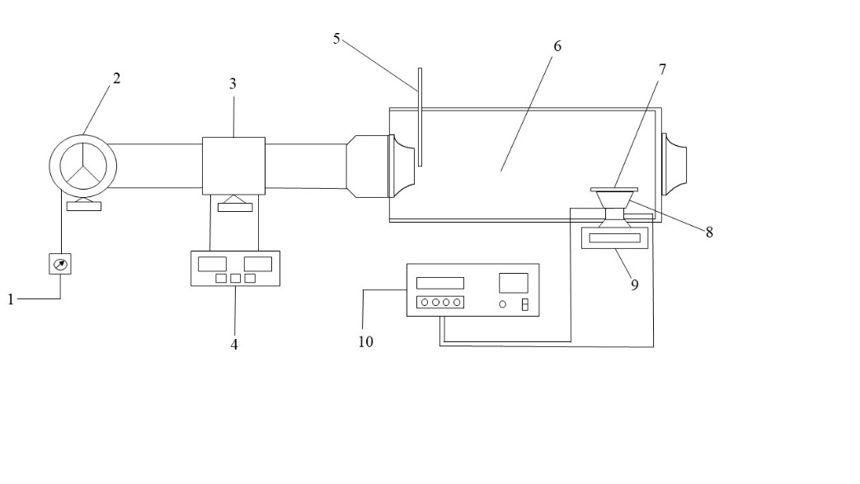

**Fig. 1 Schematic diagram of the fabric drying experimental setup. (1. Wind speed control module 2. Centrifugal fan 3. PTC heating module 4. Temperature control module 5. Hot-wire anemometer 6. Oven 7. Ultrasonic vibration plate 8. Ultrasonic transducer 9. Electronic balance 10. Ultrasonic generator)**

## 2.3 Moisture content and drying rate

The moisture content (*M*, g water/g fiber) of fibric at drying time *t* was calculated by using the following equations.

 (1)

where *m*i is the mass of the fabric at drying time *t* (g); and *m*d is the mass of the completed dried fabric (g).

The moisture content can be converted into a dimensionless parameter known as the moisture ratio (*MR*), which represents the ratio of water removed at any given time to the total amount of water initially available. It is calculated using the following equation.

 (2)

where *M*t is the moisture content at drying time *t* (g water/g fiber), *M*i is the initial moisture content (g water/g fiber) and *M*e is the equilibrium moisture content (g water/g fiber).

The drying rate (*DR*, g water/(g fiber·min)) of fabric at any time in the drying process was thus determined by Eq. (3).

 (3)

where *t*1 and *t*2 are the drying time (min), *M*t1 and *M*t2 are the moisture contents of fabric at drying time *t*1 and *t*2 (g water/g fiber).

## 2.4 Calculation of the effective moisture diffusivity and activation energy

Assuming internal moisture transfer as the dominant mechanism, the variation of moisture content as a function of time could be expressed in the form of Eq. (4).

 (4)

where *D*eff is the effective moisture diffusivity (m2 /s).

Assuming that the moisture content in fabric is uniform, the solution of Eq. (5) for a plane sheet is as follow (Shatanawi et al., 2023):

 (5)

where, *L* is the half-thickness of samples (m).

For long drying time and neglected shrinkage of the dried material over the drying time, the first part of the equation provides a good approximation, thus Eq. (5) can be simplified in the form of Eq. (6) as

 (6)

Taking the natural logarithm on both sides of Eq. (6) results in:

 (7)

By plotting the curve ln(*MR*) against time (*t*), a slope line *k*eff is obtained and the *D*eff can be calculated in Eq. (8).

 (8)

As a thermally activated process, the drying activation energy (*E*a) could be evaluated according to the Arrhenius equation(Mou and Chen, 2021).

 (9)

where *D*0 is the pre-exponential factor (m2/s), *E*a is the apparent activation energy (kJ/mol), *R* is the molar gas constant (J/mol K), and *T* is temperature (K).

For ultrasound enhanced convective drying, a modified Arrhenius equation was used to calculate the activation energy(Luka et al., 2023).

 (10)

where *P*is the ultrasonic generator power (W); *m* is the mass of the sample (g).

By linear fitting, the line slope could be used to calculated the apparent activation energy.

 (11)

## 2.5 Heat and mass transfer coefficient

The dimensionless numbers are the most common tool for estimating most materials’ heat and mass transfer coefficients. The Nusselt and Sherwood correlations for laminar flow over flat plates were applied to estimate the ultrasound enhanced convective heat and mass transfer coefficients for fibric drying. The convective heat transfer coefficient was estimated from Eq. (12) (Kumar et al., 2022).

 (12)

where *L* is the characteristic length (m); *λ*a is the air thermal conductivity, W/(m·K); Re is Reynolds number, Pr is Prandtl number.

Similarly, the mass transfer coefficient can be calculated from the following equation (Kumar et al., 2022).

 (13)

where Sc is Schmidt number; *Da* is the effective moisture diffusivity, m2/s.

# 3. results and discussion

## 3.1 The effect of ultrasonic power on ultrasound enhanced convective drying

Fig. 2 illustrates the effect of different ultrasonic powers on the drying process of fabric at 60 °C. As drying time progresses, the overall moisture content of the fabric gradually decreases. Without ultrasonic enhancement, the time required to reach the same moisture content is the longest, at 15 min. With the application of ultrasound, the drying time is significantly reduced, and as the ultrasonic power increases from 50 W to 90 W, the drying time decreases from 13 min to 12 min and 10 min, respectively. Compared to drying without ultrasonic enhancement, the maximum drying time was reduced by 33.3%, indicating the higher ultrasonic power results in greater drying efficiency. This improvement is primarily attributed to the stronger mechanical vibrations and disturbances generated by higher power ultrasound, which significantly enhance heat and mass transfer on the surface of the material. Fig. 2(b) further shows that, under non-ultrasonic conditions, there are three distinct stages in the drying process: the acceleration period, the constant rate period, and the falling rate period. However, with the application of ultrasound, the constant rate phase disappears, leaving only a distinct acceleration phase and falling rate phase. During the acceleration phase, the drying rate increases monotonically, and the maximum drying rate significantly increases with higher ultrasonic power. Compared to non-ultrasonic conditions, the maximum drying rate increases by 42.4%, 10.5%, and 6.2% under ultrasonic powers of 50W, 70W, and 90W, respectively. This demonstrates that ultrasound enhances the efficiency of water migration and evaporation during the drying process, with particularly pronounced effects under high-power conditions.

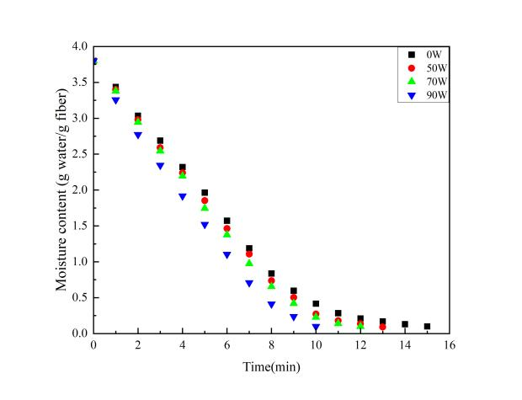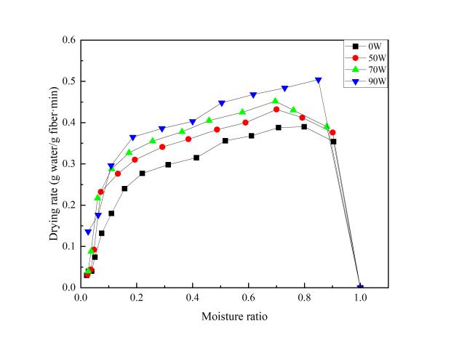

1. b).

**Fig. 2 Drying curves of fibric at different ultrasonic powers a). Moisture content vs. drying time; b). Drying rate vs. moisture ratio**

## 3.2 The effect of drying temperature on ultrasound enhanced convective drying

Fig. 3 illustrates the effect of different temperatures on the drying process of fabric under the conditions of 90 W. It can be observed that at all temperatures, the moisture content of the fabric gradually decreases as drying time increases. Higher temperatures significantly shorten the time required to reduce the moisture content of fabric to 0.1 g water/g fiber. For example, under the ultrasonic power of 90 W, the drying time was 19 min at 30 °C, 16 min at 40 °C, 12 min at 50 °C and 10 min at 60 °C. Similar results were obtained during fabric drying at other ultrasound intensities and without sonication. The positive effect of temperature on drying kinetics of agri-products has also been extensively reported in many other studies (Szadzińska et al., 2016, Corrêa et al., 2017). At 60 °C, the reduction in moisture content occurs significantly faster, indicating that higher drying temperatures enhance the heat transfer capacity of the air, accelerate moisture evaporation, and thereby significantly shorten the overall drying time. As shown in Fig. 3b, at 30 °C, in addition to the acceleration and falling rate periods, a constant rate period is observed. However, as the temperature increases, the constant rate period disappears. At 60°C, the peak drying rate is the highest, and the time to reach this peak is delayed. This demonstrates that higher temperatures accelerate surface moisture evaporation, delay the onset of the falling-rate period, and significantly increase the drying rate, further reduce the overall drying time.

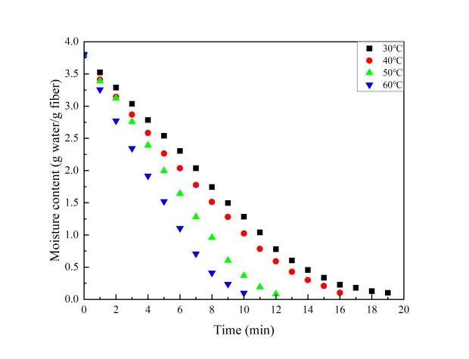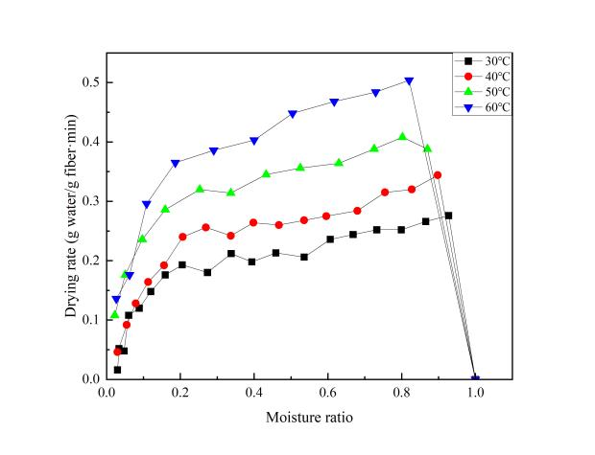

a). b).

**Fig. 3. Drying curves of fibric at different drying temperatures a). Moisture content vs. drying time; b). Drying rate vs. moisture ratio**

## 3.3 Effective moisture diffusivity and activation energy of fabric drying

The effective moisture diffusivity at different temperatures and ultrasonic powers are presented in Table 1. As shown in Table 1, at a temperature of 60°C, as the ultrasonic power increases, the effective moisture diffusivity progressively improves, rising from 3.85×10−10 m2/s at 50 W to 5.73×10−10 m2/s at 90 W. This trend demonstrates that increasing ultrasonic power significantly promotes the efficiency of moisture diffusion from the material interior to the surface. At an ultrasonic power of 90 W, the effective moisture diffusivity increases significantly with the rise in temperature, from 3.24×10−10 m2/s at 30°C to 5.73×10−10 m2/s at 60 °C. This indicates that higher temperatures enhance the diffusion process, accelerating the migration rate of moisture from the fiber interior to its surface.

**Table 1. Variation with air temperature of effective moisture diffusivity**

**and activation energy of fabric drying**

|  |  |  |  |
| --- | --- | --- | --- |
| **Temperature (**°C**)** | **Ultrasonic power(W)** | **Effective moisture diffusivity(m2/s)** | **Activation energy** |
| 60 | 0 | 3.85×10-10 | 6.85 |
| 60 | 50 | 4.95×10-10 |
| 60 | 70 | 5.26×10-10 |
| 60 | 90 | 5.73×10-10 |
| 30 | 90 | 3.24×10-10 | 16.73 |
| 40 | 90 | 3.91×10-10 |
| 50 | 90 | 4.89×10-10 |

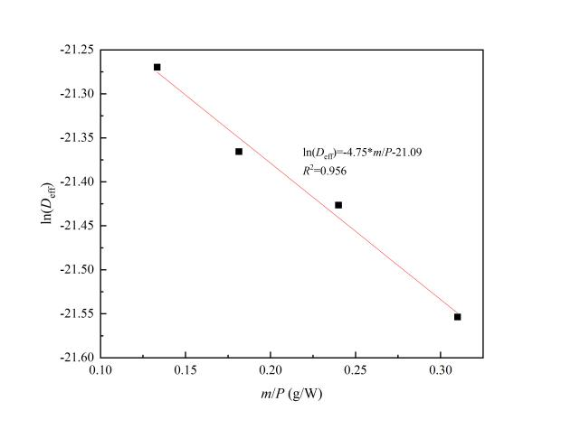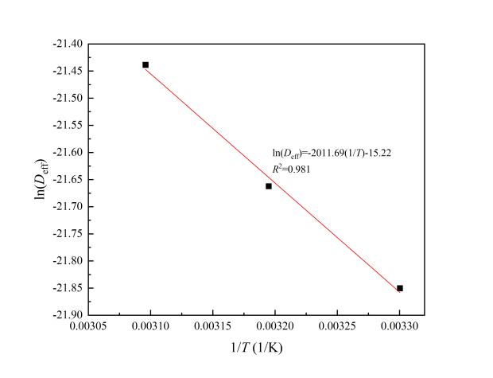

a). b).

**Fig. 4. a). Plot of In (*D*eff) versus *m*/*P*; b). Plot of In (*D*eff) versus 1/*T*.**

The activation energy for ultrasonic-enhanced convective drying was then calculated using Eq. (10). From the relationship between ln(*D*eff) and *m*/*P* for convective drying of fabric, as shown in Fig. 4a, the activation energy was determined to be 6.85 W/g.

Additionally, from the relationship between ln(*D*eff) and 1/*T*, as shown in Fig. 4b, the activation energy was calculated to be 16.73 kJ/mol.

## 3.4 Heat and mass transfer coefficients

**Table 2. The variation with drying ultrasonic power and temperature of heat and mass transfer coefficients of fabric drying**

|  |  |  |  |  |  |
| --- | --- | --- | --- | --- | --- |
| **Temperature (°C)** | **Ultrasonic power(W)** | **Nu** | **Sh** | ***h*t(W/(m2·K))** | ***h*m(m/s)** |
| 60 | 0 | 96.64 | 3751.63 | 27.16 | 1.67×10-5 |
| 60 | 50 | 96.64 | 3634.56 | 27.16 | 1.80×10-5 |
| 60 | 70 | 96.64 | 3561.71 | 27.16 | 1.87×10-5 |
| 60 | 90 | 96.64 | 3461.54 | 27.16 | 1.98×10-5 |
| 30 | 90 | 101.66 | 4152.20 | 26.31 | 1.35×10-5 |
| 40 | 90 | 99.90 | 3910.91 | 26.60 | 1.53×10-5 |
| 50 | 90 | 98.00 | 3639.09 | 26.98 | 1.78×10-5 |

At 60 °C, as the ultrasonic power increased from 0 W to 90 W, the mass transfer coefficient showed a significant enhancement, rising from 1.67×10−5m/s to 1.98×10−5 m/s. This indicates that the increase in ultrasonic power substantially improved the mass transfer process. In contrast, the heat transfer coefficient remained constant at 27.16 W/m²·K. When the ultrasonic power was fixed at 90 W, the heat transfer coefficient increased exhibited a slight increase with rising temperature, from 26.31 W/m²·K at 30°C to 27.16 W/m²·K at 60 °C. Meanwhile, the mass transfer coefficient experienced a more pronounced increase, from 1.35×10−5m/s at 30°C to 1.98×10−5 m/s at 60 °C. Overall, the synergistic effect of high temperature (60 °C) and high ultrasonic power (90 W) significantly accelerated the heat and mass transfer processes, highlighting these conditions as critical for optimizing the efficiency of fabric drying.

# 4. Conclusion

This study highlights the potential of ultrasound-enhanced convective drying as an efficient method for fabric dewatering. The integration of ultrasonic vibrations with traditional convective drying significantly improved drying performance by accelerating moisture transfer and reducing drying time. The results showed that increasing ultrasonic power from 0 W to 90 W reduced drying time by up to 33.3 %, demonstrating the effectiveness of ultrasound in enhancing mass transfer through cavitation and micro-agitation effects. Additionally, higher drying temperatures (ranging from 30 °C to 60 °C) further accelerated the drying process by increasing the vapor pressure gradient, thus promoting faster moisture evaporation. The combined effects of ultrasonic power and temperature exhibited a synergistic impact on drying efficiency. Moreover, the effective moisture diffusivity increased with both ultrasonic power and temperature, emphasizing enhanced moisture migration within the fabric. The findings provide valuable insights into the mechanisms of ultrasound-enhanced convective drying and its practical implications for fabric drying applications. By demonstrating enhanced drying kinetics and energy efficiency, this study lays the groundwork for the development of more sustainable and cost-effective drying technologies in the fabric industry.

# DISCLAIMER (ARTIFICIAL INTELLIGENCE)

Author(s) hereby declares that NO generative AI technologies such as Large Language Models (ChatGPT, COPILOT, etc.) and text-to-image generators have been used during the writing or editing of this manuscript.

# References

[1] Li G., Chen L., Shu W., Lian S., &Chen H. (2025) A novel drying process for knitted fabrics based on heat-wet coupling model[J]. *Applied Thermal Engineering*, 258. 124609.

[2] Fu W., Deng J., & Li X. (2019) Microwave drying of fabrics[J]. *Journal of Microwave Power and Electromagnetic Energy*, 53(1), 12-23.

[3] Li P. & Chen Z. (2017) Experiment study on porous fiber drying enhancement with application of power ultrasound[J]. *Applied Acoustics*, 127, 169-174.

[4] Zhang Y. & Abatzoglou N. (2020) Review: Fundamentals, applications and potentials of ultrasound-assisted drying[J]. *Chemical Engineering Research and Design*, 154, 21-46.

[5] Dupuis E. D., Momen A. M., Patel V. K. & Shahab S. (2019) Electroelastic investigation of drying rate in the direct contact ultrasonic fabric dewatering process[J]. *Applied Energy*, 235, 451-462.

[6] de la Fuente-Blanco S., Riera-Franco de Sarabia E., Acosta-Aparicio V. M., Blanco-Blanco A. & Gallego-Juárez J. A. (2006) Food drying process by power ultrasound[J]. *Ultrasonics*, 44, e523-e527.

[7] Sabarez H. T., Gallego-Juarez J. A. & Riera E. (2012) Ultrasonic-Assisted Convective Drying of Apple Slices[J]. *Drying Technology*, 30(9), 989-997.

[8] Peng C. & Moghaddam S. (2020) Experimental Evaluation and Kinetic Analysis of Direct-Contact Ultrasonic Fabric Drying Process[J]. *Journal of Thermal Science and Engineering Applications*, 13(021025).

[9] García-Pérez J. V., Cárcel J. A., Riera E., & Mulet A. (2009) Influence of the Applied Acoustic Energy on the Drying of Carrots and Lemon Peel[J]. *Drying Technology*, 27(2), 281-287.

[10] Shatanawi W. Abbas N., Shatnawi T. A. M. & Hasan F. (2023) Heat and mass transfer of generalized fourier and Fick's law for second-grade fluid flow at slendering vertical Riga sheet[J]. *Heliyon*, 9(3).

[11] Mou X. & Chen Z. (2021) Study on the ultrasound-assisted drying process of deformable porous materials[J]. *Journal of Food Engineering*, 306.

[12] Luka B. S., Vihikwagh Q. M., Ngabea S. A., Mactony M. J., Zakka R., Yuguda T. K. & Adnouni M. (2023) Convective and microwave drying kinetics of white cabbage (Brassica oleracae var capitata L.): Mathematical modelling, thermodynamic properties, energy consumption and reconstitution kinetics[J]. *Journal of Agriculture and Food Research*, 12.

[13] Kumar A., Kandasamy P., Chakraborty I. & Hangshing L. (2022) Analysis of energy consumption, heat and mass transfer, drying kinetics and effective moisture diffusivity during foam-mat drying of mango in a convective hot-air dryer[J]. *Biosystems Engineering*, 219, 85-102.

[14] Szadzińska J., Kowalski S. J. & Stasiak M. (2016) Microwave and ultrasound enhancement of convective drying of strawberries: Experimental and modeling efficiency[J]. *International Journal of Heat and Mass Transfer*, 103, 1065-1074.

[15] Corrêa J. L. G., Rasia M. C., Mulet A. & Cárcel J. A. (2017) Influence of ultrasound application on both the osmotic pretreatment and subsequent convective drying of pineapple (Ananas comosus)[J]. *Innovative Food Science & Emerging Technologies*, 41, 284-291.