***Review Article***

**Literature review on the decomposition kinetics of lignocellulosic biomass for efficient energy recovery**

ABSTRACT

This work provides a synthesis of research conducted over the last ten years on the thermal decomposition kinetics of biomass residues, with the aim of their energy recovery. Many researchers have explored this topic, highlighting the importance of thermogravimetric analysis as a key step in obtaining essential information for the determination of kinetic parameters. Two main approaches have been adopted for this determination: the model-free method, known as isoconversional, and the method based on a predefined kinetic model. The inherent complexity of thermal decomposition kinetics means that some previous works have limitations, particularly in the accuracy of the models or the interpretation of the results. These shortcomings highlight the need to improve current methods to fill the gaps in this field of research. Thus, this work proposes a series of perspectives to guide future research and improve the efficiency and accuracy of kinetic studies. These perspectives include the development of new models more representative of complex mechanisms, the improvement of experimental techniques, and the integration of advanced technologies for better data analysis.

***Keywords:*** thermogravimetric analysis, model-free method, thermal decomposition, biomass

1. INTRODUCTION

Benin, a West African country, is distinguished by relatively low energy consumption, with excessive and unsustainable use of biomass as an energy source [1]. According to research by SIE Benin (Energy Information System of Benin), the country's total energy consumption in 2022 amounts to 1,479,940.92 MWh, 95.42% of which comes from biomass. The average daily consumption of firewood is 3.36 kg per household in urban areas and 6.02 kg per household in rural areas according to SIE. In 2022, agriculture represents approximately 22.8% of GDP and employs 60% of Benin's working population. The country has considerable potential for agricultural and household waste (293 Kt of agricultural residues according to SIE Benin 2021) which could be transformed into energy.Energy recovery from biomass waste has become a major challenge in the current context of transition towards renewable and sustainable energy sources. These residues, from agriculture, forestry or the agri-food industry, represent an abundant and underexploited resource which, if properly managed, could significantly contribute to reducing dependence on fossil fuels and mitigating greenhouse gas emissions [2]. In most of our countries, this energy recovery from residues is often poorly designed, which prevents the maximum energy from being extracted and thus hinders the development of this renewable energy sector.

One of the key steps in the energy recovery of biomass is understanding the mechanisms of its thermal decomposition. This decomposition, or pyrolysis, is a complex process influenced by many factors, such as the chemical composition of the biomass, temperature conditions, and the possible presence of catalysts [3]. Thermal decomposition kinetics, which describes the rate at which biomass decomposes under the influence of heat, is essential for optimizing energy conversion processes, whether for the production of biochar, biogas or bio-oils [4].

Over the last decade, numerous studies have been conducted to elucidate the thermal decomposition kinetics of biomass residues, mainly using two approaches: isoconversional methods, which do not require a prior model, and methods based on specific kinetic models [5].This research has enabled significant advances, but has also highlighted challenges and gaps, particularly with regard to the accuracy of models and the interpretation of experimental data.

In this context, this review aims to review recent work on the thermal decomposition kinetics of biomass residues, highlighting the methods used, the results obtained, as well as the limitations and research perspectives. By providing an overview of current advances and challenges, this article aims to contribute to improving knowledge and practices in this crucial field for the development of renewable energies.

1. ***Recent work on the kinetics of thermal decomposition of biomass residues***

Energy recovery from lignocellulosic biomass and agricultural residues primarily involves thermal processes such as pyrolysis and combustion. Several studies have explored the thermal characteristics, decomposition kinetics, and performance of briquettes derived from these biomasses. This literature review aims to present a synthesis of the results of this research, focusing on methodological approaches, results obtained, and implications for optimized energy recovery.

* 1. ***Thermal decomposition kinetics of biomass***

Recent work has deepened our understanding of biomass pyrolysis mechanisms, highlighting the diversity of thermal behaviors depending on the nature of the material. Studies on the pyrolysis of pine wood, rice husk, and bamboo, as shown by Hu et al., revealed that each type of biomass exhibits unique thermal characteristics, directly influencing kinetic parameters such as activation energy and decomposition temperatures [5]. The variability of kinetic results depending on the methods used was highlighted by Cai et al., who demonstrated that the integration of low temperatures in the calculations improves the accuracy of the activation energies obtained [6].

The influence of the chemical composition of biomasses on the pyrolysis stages has also been addressed, with Wilson et al. showing that tropical agricultural residues are distinguished by a higher thermal reactivity compared to forest residues, notably due to their hemicellulose and lignin content.[7] These results are confirmed by Emiola Sadiq et al., who observed distinct decomposition stages for agricultural biomasses, which contrasts with the behavior of forest residues [8]. Studies such as those of El-Sayed et al. [9] and Singh et al. [10] focused on the use of thermogravimetric analysis (TG/DTG/DTA) to examine the thermal decomposition of various biomass residues. These techniques provide accurate data on mass loss as a function of temperature, thus providing essential information on the thermal stability and degradation stages of biomasses.

* 1. **Modeling and optimization of pyrolysis processes**

Kinetic modeling plays a crucial role in understanding and optimizing pyrolysis processes. The work of Yan et al. validated the use of the DAEM-G3 model to accurately describe the three distinct phases of coal pyrolysis, suggesting that this model could be applied to other types of biomass [11]. Furthermore, the methodologies developed by Sobek et al.[12] and Luo et al. [13] to estimate kinetic parameters have made it possible to improve the prediction of degradation behaviors, particularly for sewage sludge and mixed biomasses.

These methodological advances offer prospects for better design of pyrolysis reactors and optimization of operating conditions, taking into account the specificities of each raw material. The integration of new approaches, such as catalytic and microwave pyrolysis, explored by Wang et al, could further improve the energy efficiency and quality of biomass products [14].

1. material and methods
   1. **Materials**

According to the literature, the study of the decomposition kinetics of lignocellulosic biomass is mainly based on the use of thermogravimetric analyzers, available in various models. Thus, Hu et al.[15] used a tga/dta analyzer (model sdt q600, ta instruments, usa) to perform thermogravimetric analyses (tga) at slow heating rates.

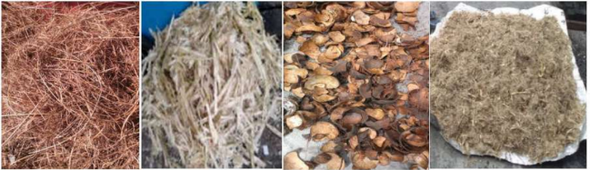

**Fig. 1. Some examples of dried waste (from left to right, rattan waste, sugarcane bagasse, coconut shells and pineapple peels)** [2].

* 1. **Methods**

To describe the kinetics of thermal decomposition of biomass residues, two methods are used in the literature: iso-conventional model, called model-free method, and the model-based method [5].

The isoconversional kinetic model is a method used in chemical kinetics to determine the kinetic parameters of a reaction without making any prior assumptions about the reaction mechanism [5]. Unlike traditional kinetic models that require an assumption about the reaction mechanism, isoconversional methods focus on the reaction's evolution as a function of the conversion progress (i.e., the percentage of reaction completed) at different temperatures. The isoconversional model does not require knowledge of the specific reaction mechanism. It is based on the assumption that, for a certain degree of conversion, the reaction follows the same kinetic parameters, regardless of the temperature.

The model-based kinetic method, also called the model-based method or model-fitting method, is a commonly used approach in chemical kinetics to determine the kinetic parameters of a chemical reaction. Unlike isoconversional methods, this approach relies on the assumption of a specific reaction model that describes the reaction mechanism [5] The goal is to find the kinetic parameters (such as activation energy and pre-exponential factor) that allow the chosen model to best fit the experimental data. This method assumes a specific reaction model, that is, a mathematical function that describes how the conversion (or mass loss, or some other measured parameter) evolves with time or temperature. The chosen model often corresponds to a known reaction mechanism, such as first-order decomposition, second-order reaction, or a more complex model. Table 1 shows a summary of the different models used in the literature.

**TABLE 1*.* Kinetic model used in the literature**

|  |  |  |
| --- | --- | --- |
| ***Kinetic method*** | ***Model type*** | ***Equation*** |
| ***Arrhenius method*** [16] | Simple model | $k\left(T\right)=Ae^{\frac{{-E}_{a}}{RT}}$ (1) |
| ***Coats-Redfern method*** [17] | No-Isoconversional | $\ln\left(\frac{-\ln\left(1-α\right)}{T^{2}}\right)=\ln{(\frac{AR}{βE_{a}}}$) - $\frac{E_{a}}{RT}$ (2) |
| ***Flynn-Wall-Ozawa (FWO) method*** [18] | isoconversional | $\log\left(β\right)=\log\left(\frac{AE_{a}}{RG\left(α\right)}\right)=2,315-0,4567 \frac{E_{a}}{RT}$ (3) |
| ***Kissinger-Akahira-Sunose (KAS) method*** [13] | isoconversional | $\ln\left(\frac{β}{T^{2}}\right)=\ln\left(\frac{AR}{E_{a}}\right)-\frac{E_{a}}{RT}$.  (4) |
| ***Friedman method*** [8] | Isoconversional | $\ln\left(β\frac{dα}{dT}\right)=\ln\left(Af\left(α\right)\right)-\frac{E_{a}}{RT} .$ (5) |
| ***Vyazovkin's method*** [8] | Iso-conversional | $\int_{0}^{α}{\frac{dα}{f(α)}}$ = $\int_{T_{0}}^{T}{\frac{A}{β}}e^{\frac{-E_{a}}{RT}dT}.$ (6) |
| ***Distributed Activation Energy Method (DEAM)*** [11] | Iso-conversional | $k\left(T\right)=\int_{0}^{∞}{k\left(E\right)g\left(E\right)dE.}$ (7) |
| ***Fraser-Suzuki Deconvolution Method*** [19] | No-Isoconversional | $\frac{dα}{dT}=\sum_{i=1}^{3}{c_{i}H_{p,i}}exp\left\{-\frac{ln2}{A_{s,i}^{2}}ln{\left[1+2A_{s,i}\frac{(T-T_{p,i})}{w_{hf,i}}\right]}^{2}\right\}.$ (8) |
| ***Horowitz-Metzger method*** [20] | No-Iso-conversional | $\ln\left(\frac{1}{1-α}\right)=\frac{E_{a}}{RT}+\ln\left(\frac{A}{β}\right)-\frac{E_{a}}{T}$ (9) |

$E_{a}$: Activation energy ; $A$: Pre-exponential factor ; $α$: Conversion rate ; $T$: Temperature  ; $β$: heating speed ; $R$: ideal gas constant

Hu and al.[19] determined the activation energy and pre-exponential factor from the distributed activation energy model (DAEM) and Fraser-Suzuki deconvolution of three biomasses, pine wood, rice husk and bamboo.

* 1. ***Briquette production: quality, performance and prospects***

Briquette production from biomass residues requires a thorough understanding of the interactions between manufacturing parameters and raw material properties. Comparative studies by Bisen et al. [21] and Gendek et al. [22] showed that biomass composition, along with particle size and moisture, directly influence the density, durability, and calorific value of briquettes. Furthermore, research by Philippe et al. revealed that briquettes made from peanut and cashew shells have high calorific value but high ash content, posing a challenge for their large-scale use [23].

The addition of binders and the mixing of different biomasses have been identified as strategies to improve the performance of briquettes, as demonstrated by the work of Ndindeng et al.[24] and Waheed et al.[16], which respectively optimized the quality of rice husk briquettes and reduced pollutant emissions from mixed briquettes. Chemical demineralization techniques, explored by Tang et al., also showed potential to improve briquette combustion while reducing ash emissions [25]. Studies on co-pyrolysis, such as that of Singh et al.[10], show potential synergistic effects when biomasses are blended with polymers such as polyethylene. These interactions can improve yields of desired products, while reducing unwanted emissions. Research on the addition of additives, as discussed by Nath et al.[26], also showed an improvement in combustion parameters. Yiga et al. studied the characteristics of rice husk briquettes, highlighting their high energy density and high calorific value, making them efficient for energy production [27]. Furthermore, Godjo et al. study on cashew nut shell briquettes demonstrated that these materials can serve as a viable substitute for traditional charcoal in Benin, with advantages in terms of density and strength [28]. Alabi et al. highlighted the importance of numerical simulation to understand and optimize the energy performance of briquettes [29], while Otitolaye et al. investigated the properties of corn cobs as a biofuel, highlighting their high potential for sustainable energy production [30].

1. results
   1. **Thermogravimetric analysis of lignocellulosic biomass**

Fig.2. presents the results of thermogravimetric analysis at different heating rates of bread wood, rice husk and bamboo.

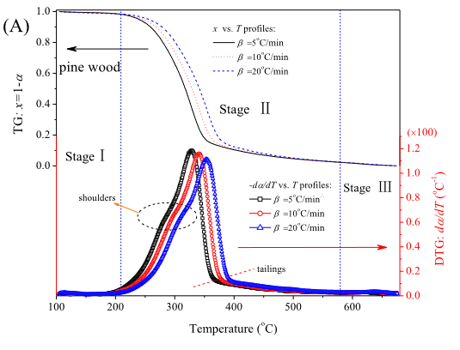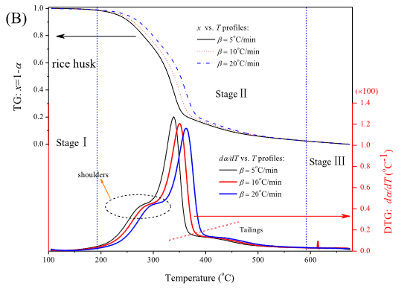

**Fig.2. TG and DTG profiles at heating rates of 5;10; and 20°C/min: (A) pine wood, (B) rice husk, and (C) bamboo** [19]**.**

Thermal decomposition of pine wood, rice husk, and bamboo occurs in three main stages: evaporation of water and light volatiles with little mass loss, devolatilization, responsible for most of the mass loss, and thermal degradation of residual carbonaceous materials, resulting in little mass loss. These observations, confirmed by El-Sayed et al.[9], also apply to the pyrolysis of palm fronds, olive leaves and wheat straw, studied using thermogravimetric techniques (TG, DTG, and DTA). These tools provide accurate data on mass losses and thermal stability, facilitating the kinetic modeling of biomasses.

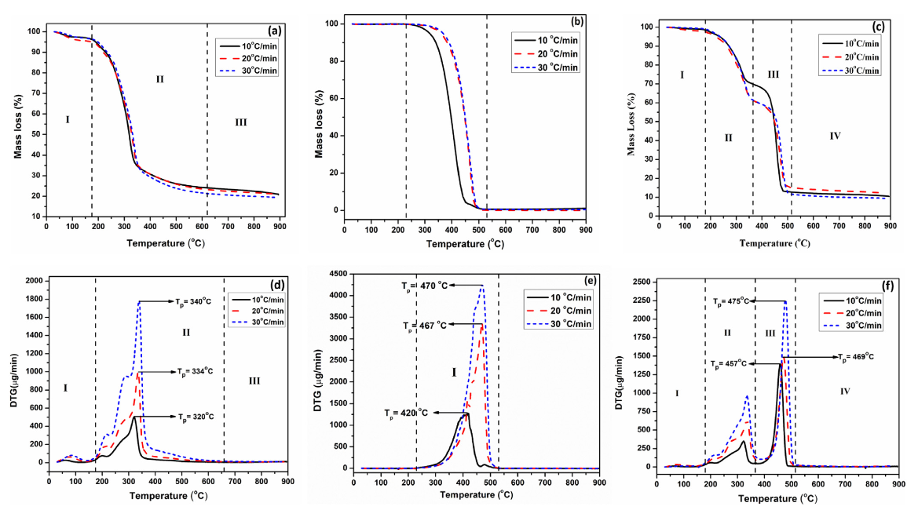

**Fig. 3.** **(a) TG curves for CC; (b) TG curves for PE; (c) TG curves for CC + PE mixture; (d) DTG curves for CC; (e) DTG curves for PE; (f) DTG curves for CC + PE mixture** [10].

The study of the TG and DTG curves of the mixturecorn cob (CC) + polyethylene (PE) revealed four distinct stages of thermal decomposition:

Region I (30–180 °C): minor mass loss (~1.7%) due to humidity, mainly from the corn cob.

Region II (180–355 °C): mass loss of approximately 33.4%, corresponding to the decomposition of hemicellulose, cellulose and extracts. A first DTG peak is observed there.

Region III (355–495 °C): higher mass loss (~51.1%) linked to the degradation of PE and CC; second DTG peak, more intense, indicating a decomposition dominated by PE.

Region IV (above 495°C): moderate residual loss (~3.4%).

The degradation temperatures of CC (175–400 °C) and PE (230–510 °C) overlap, favoring asynergistic interactionbetween the vapors of the two materials. This led to aoverall improvement of thecoprolysis: reduction of activation energy, lowering of maximum degradation temperatures, increase of degradation rates and potential improvement of product quality.

Theredegradation rateof the mixture in region II is reduced compared to that of CC alone, due to themerger of the EP, which slows down devolatilization. On the other hand, in region III, the joint decomposition of polymers (PE) and componentslignocellulosic(CC) increases the degradation rate.

Finally, thepresence of PE reduces solid residue yieldfrom 20% (for the CC alone) to 10% during thecoprolysis, confirming the beneficial effect of PE in the CC thermal conversion process.

* 1. **Calculates activation energy and pre-exponential factor**

Fig. 3. shows the variation of activation energy and pre-exponential factor as a function of conversion rate obtained from Fraser-Suzuki deconvolution.



**Fig. 4. Activation energy and pre-exponential factor as a function of conversion rate. A (pseudo hemicellulose), B (pseudo cellulose), C (pseudo lignin)** [19].

The complex variation of activation energy as a function of the degree of conversion demonstrates that the pyrolysis of lignocellulosic biomass cannot be modeled by a single-step reaction. Yan et al. [11] confirmed this finding using the distributed activation energy method with three Gaussians (DAEM-G3), showing that the activation energy increases as the reaction progresses. The mean values ​​of the activation energy, its standard deviation, and those of the pre-exponential factor are summarized in Table 2.

**TABLE 2. Results of Fraser-Suzuki deconvolution simulation.**

|  |  |  |  |  |  |  |  |  |  |
| --- | --- | --- | --- | --- | --- | --- | --- | --- | --- |
| Raw materials | Hemicellulose | | | Cellulose | | | Lignin | | |
| lnA(ln $S^{-1})$ | E (KJ/mol) | σ(KJ/mol) | lnA(ln $S^{-1})$ | E (KJ/mol) | σ(KJ/mol) | lnA(ln $S^{-1})$ | E (KJ/mol) | σ(KJ/mol) |
| Pine wood | 28.8 | 162.84 | 4.6 | 30.42 | 188.14 | 1.79 | 30.56 | 212.12 | 33.31 |
| Rice husk | 29.7 | 168.63 | 5.59 | 30.42 | 206.71 | 2.68 | 30.57 | 221.21 | 33.35 |
| Bamboo | 25.92 | 154.55 | 5.01 | 31.09 | 190.45 | 2.6 | 32.65 | 199.08 | 37.24 |

The three materials exhibit distinct thermal behaviors: rice husk generally requires more energy to decompose, while bamboo shows large kinetic variability, particularly for lignin. Although the results are consistent with experimental data and outperform the DEAM method in accuracy, the high standard deviation of the activation energy for lignin highlights the need for model optimization to improve their accuracy and refine the explanation of biomass kinetics.

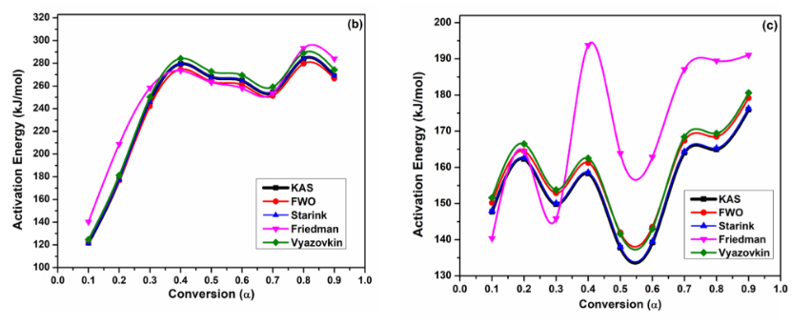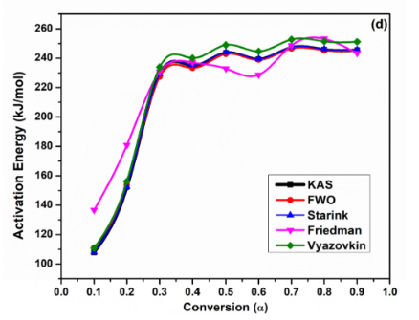

**Fig.5. (b) Chartof conversion energy versus activation energy for CC; (c) Chartof the conversion energy versus the activation energy for PE; (d) Chartconversion vs energy activation for the CC + PE mixture** [10].

For THE polyethylene, L'Ea average is between 148 and 171 kJ**/mol** depending on the method used, with correlation coefficients R² > 0.99.

For there corn cob, L'Ea average is slightly higher, varying between 238 and 248 kJ/mol, depending on the methods. The values ​​are concordantbetween them, with **good** R² (≥ 0.966) and good agreement with previous data.

For the CC + PE mixture, L'Ea average varies between 216 and 221 kJ/mol, with high R²values(up to 0.998), indicating a good fit.

1. ***Results of the kinetics of thermal decomposition of biomass residues from some authors***

Many researchers have explored the kinetics of various biomasses using different methods. Their main objective was to understand the reaction mechanisms during the pyrolysis of these biomasses with the aim of recovering them energetically. This study sought to determine the activation energies and the pre-exponential factor. Activation energy represents the minimum energy required for a chemical reaction to occur, thus indicating the sensitivity of the reaction to temperature [31]. Knowing this energy makes it possible to predict at what temperature a chemical reaction, such as thermal decomposition or pyrolysis, will begin significantly[31].The higher the activation energy, the higher the temperature required for the reaction to occur. This makes it possible to optimize the conditions of industrial processes, particularly in the production of energy from biomass, by adjusting the temperature to maximize the efficiency of the reactions [17].

The pre-exponential factor, on the other hand, is a term in the kinetic model that describes the frequency at which molecules react when they have the necessary energy. This factor, which takes into account molecular collisions and the orientation of the reactants, provides information on the probability of a reaction occurring, independent of the required energy. It helps to better understand the stereospecific or geometric aspects of reactions, as well as the frequency of effective collisions between reactant molecules, which is essential for predicting the reaction rate and for sizing chemical reactors in industrial applications [17].

Table 3 presents the results of the thermal decomposition kinetics of certain biomasses.

**Table 3.** **Results of thermal decomposition kinetics of different types of biomass obtained by different authors in the literature.**

|  |  |  |  |  |
| --- | --- | --- | --- | --- |
| ***Authors*** | ***Method*** | ***Type of biomass*** | ***Ea (kJ/mol)*** | ***A (1/s)*** |
| ***Damartzis et al.***[32] | Isoconversional methods (FWO, KAS) | Thistle stems | 29.0−229.7 | 18 to 2.3 × 10^19 |
| ***Hu et al.***[5] | Fraser-Suzuki deconvolution and the iso-conventional method | Pine wood | 152.43−210.39 | 3.22 × 10^12 to 1.87 × 10^13 |
| ***Rueda-Ordóñez et al.*** [34] | Isoconversional methods | Sugarcane straw | 154.1−177.8 | 1.82 × 10^9 |
| ***Huang et al.***[8] | KAS, FWO, Coats−Redfern | Soy straw | 154.15−156.22 | 4.26 × 10^13 to 1.09 × 10^16 |
| ***Mishra et al.***[35] | Model without mechanism | Palm kernel shell | 88-146 | 3.00 × 10^7 to 6.00 × 10^12 |
| ***Lopes et al.***[36] | Isoconversional method | Guarana seed residue | 52-171 | 6.55−9.40 × 10^4 |
| ***Collazzo et al.***[37] | KAS, FWO isoconversional methods | Elephant grass | 46.5−185.28 | 0.6 × 10^1 to 2.7 × 10^9 |
| ***Walkowiak and Bartkowiak***[8] | F1: Growth of individual radicals (first-order kinetic process)D3: Three-dimensional diffusionR3: Three-dimensional translocation | Raw and roasted willow | 138.1−227.3 | 1.19 × 10^10 to 1.27 × 10^19 |
| ***Açıkalın et al*** [17] | Coats-Redfern | Orange peel | 120.68 - 144.78 | 9.8150×10^10 to 4.909310^13 |

1. **RESEARCH PERSPECTIVE**

After reading and understanding the literature, several avenues can be developed with the aim of contributing to the development of this science that is thermal decomposition kinetics.

* 1. ***Expanding the application of kinetic methods***

Apply these kinetic methods to a wider range of biomasses to identify more efficient feedstocks for biofuel production. This includes examining the effect of different experimental parameters, such as higher heating rates and the use of reactive atmospheres, such as oxidizing atmospheres.

* 1. Optimization of briquette production parameters

Optimize briquette production parameters, such as pressure, temperature, and humidity, to maximize energy density while minimizing pollutant emissions. At the same time, determine the optimal binder ratio for each type of biomass charcoal to improve briquette quality.

* 1. Environmental and economic impact studies

Study the long-term environmental and economic impact of using biomass briquettes to fully assess their viability as an alternative to fossil fuels. Further analysis should include emissions of pollutants other than CO2 and CO, with proposals to minimize these emissions.

* 1. ***Integration of advanced combustion technologies***

Develop and integrate advanced combustion technologies to improve the energy conversion efficiency of biomass briquettes, thereby reducing emissions and increasing profitability.

* 1. Optimization of the composition of briquettes

Explore the optimization of briquette compositions by integrating various biomass materials and additives, as well as the use of different types of binders or combinations of binders to improve the combustion performance and durability of briquettes, particularly in humid environments.

* 1. ***Combustion performance studies***

To study the effect of compaction pressure on ignition time, flame duration and combustion rate of briquettes through firing tests. Also to investigate the transient and dynamic effects of combustion by changing the initial conditions and combustion regimes.

* 1. ***Valorization of pyrolysis by-products***

Investigate the recovery of pyrolysis by-products, such as biochar from corn cobs, for applications such as soil improvement or as an adsorbent material, thus contributing to a more integrated and sustainable use of biomass.

1. **CONCLUSION**

The thermal decomposition kinetics of solid biomass residues is a crucial research area for the energy recovery of these renewable resources. Over the past decade, studies have provided insights into the complex mechanisms governing the pyrolysis and thermal decomposition of various types of biomass. Isoconversional methods and approaches based on specific kinetic models have each made significant contributions, offering complementary perspectives on the dynamics of these processes.

However, despite the progress made, challenges remain. Limitations associated with the accuracy of existing models, the variability of experimental data, and the inherent complexity of decomposition mechanisms all require further research. To address these challenges, it is essential to develop new models that are more representative of real-world mechanisms, improve experimental techniques, and integrate advanced analytical tools. Furthermore, a better understanding of the interactions between kinetic parameters and thermal treatment conditions could help optimize biomass conversion processes, thus increasing their efficiency and economic viability. The research perspectives proposed in this review aim to guide future work towards these objectives, in order to fill current gaps and enhance the potential of biomass as a sustainable energy source.

In conclusion, the thermal decomposition kinetics of biomass residues remains a rapidly evolving field, with significant scientific and technological challenges. Continued efforts in this area are essential to transform these residues into a viable energy resource, thus contributing to the global energy transition and the fight against climate change.

COMPETING INTERESTS

Authors have declared that no competing interests exist.

References

[1] « Plan stratégique du ministère de l’énergie 2020-2024 ».

[2] A. B. YATOPA, M. SAKARIYOU, et A. KOFFI, « Projet développer le Bénin à partir des sources d’énergies renouvelables : Identification et cartographie des potentialités et sources d’énergie renouvelables assorties des possibilités d’exploitation, rapport final, PNUD ».

[3] D. G. F. Adamon, L. Fagbemi, et A. Bensakhria, « Détermination des paramètres cinétiques globaux de la conversion thermochimique des rafles de maïs et balles de riz du Bénin », 2015.

[4] F. Adamon Gildas David, « Modélisation de la cinétique de gazéification étagée de la biomasse tropicale : cas des balles de riz et des rafles de maïs ».

[5] M. Hu et al., « Thermogravimetric kinetics of lignocellulosic biomass slow pyrolysis using distributed activation energy model, Fraser–Suzuki deconvolution, and iso-conversional method », Energy Convers. Manag., vol. 118, p. 1‑11, juin 2016, doi: 10.1016/j.enconman.2016.03.058.

[6] J. Cai et L. Bi, « Precision of the Coats and Redfern Method for the Determination of the Activation Energy without Neglecting the Low-Temperature End of the Temperature Integral », Energy Fuels, vol. 22, no 4, p. 2172‑2174, juill. 2008, doi: 10.1021/ef8002125.

[7] L. Wilson, W. Yang, W. Blasiak, G. R. John, et C. F. Mhilu, « Thermal characterization of tropical biomass feedstocks », Energy Convers. Manag., vol. 52, no 1, p. 191‑198, janv. 2011, doi: 10.1016/j.enconman.2010.06.058.

[8] T. Emiola-Sadiq, L. Zhang, et A. K. Dalai, « Thermal and Kinetic Studies on Biomass Degradation via Thermogravimetric Analysis: A Combination of Model-Fitting and Model-Free Approach », ACS Omega, vol. 6, no 34, p. 22233‑22247, août 2021, doi: 10.1021/acsomega.1c02937.

[9] S. A. El-Sayed, T. M. Khass, et M. E. Mostafa, « Thermal degradation behaviour and chemical kinetic characteristics of biomass pyrolysis using TG/DTG/DTA techniques », Biomass Convers. Biorefinery, vol. 14, no 15, p. 17779‑17803, août 2024, doi: 10.1007/s13399-023-03926-2.

[10] S. Singh, T. Patil, S. P. Tekade, M. B. Gawande, et A. N. Sawarkar, « Studies on individual pyrolysis and co-pyrolysis of corn cob and polyethylene: Thermal degradation behavior, possible synergism, kinetics, and thermodynamic analysis », Sci. Total Environ., vol. 783, p. 147004, août 2021, doi: 10.1016/j.scitotenv.2021.147004.

[11] J. Yan et al., « Kinetic analysis and modeling of coal pyrolysis with model-free methods », Fuel, vol. 241, p. 382‑391, avr. 2019, doi: 10.1016/j.fuel.2018.12.079.

[12] S. Sobek et S. Werle, « Solar pyrolysis of waste biomass: Part 2 kinetic modeling and methodology of the determination of the kinetic parameters for solar pyrolysis of sewage sludge », Renew. Energy, vol. 153, p. 962‑974, juin 2020, doi: 10.1016/j.renene.2020.02.061.

[13] L. Luo et al., « Insight into Pyrolysis Kinetics of Lignocellulosic Biomass: Isoconversional Kinetic Analysis by the Modified Friedman Method », Energy Fuels, vol. 34, no 4, p. 4874‑4881, avr. 2020, doi: 10.1021/acs.energyfuels.0c00275.

[14] G. Wang et al., « A Review of Recent Advances in Biomass Pyrolysis », Energy Fuels, vol. 34, no 12, p. 15557‑15578, déc. 2020, doi: 10.1021/acs.energyfuels.0c03107.

[15] M. Hu et al., « Thermogravimetric kinetics of lignocellulosic biomass slow pyrolysis using distributed activation energy model, Fraser–Suzuki deconvolution, and iso-conversional method », Energy Convers. Manag., vol. 118, p. 1‑11, juin 2016, doi: 10.1016/j.enconman.2016.03.058.

[16] M. A. Waheed, O. A. Akogun, et C. C. Enweremadu, « Influence of feedstock mixtures on the fuel characteristics of blended cornhusk, cassava peels, and sawdust briquettes », Biomass Convers. Biorefinery, vol. 13, no 17, p. 16211‑16226, nov. 2023, doi: 10.1007/s13399-023-04039-6.

[17] K. Açıkalın, « Evaluation of orange and potato peels as an energy source: a comprehensive study on their pyrolysis characteristics and kinetics », Biomass Convers. Biorefinery, vol. 12, no 2, p. 501‑514, févr. 2022, doi: 10.1007/s13399-021-01387-z.

[18] Y. Liu, S. Yu, Y. Zhu, D. Wang, et J. Liu, « Modeling, planning, application and management of energy systems for isolated areas: A review », Renew. Sustain. Energy Rev., vol. 82, p. 460‑470, févr. 2018, doi: 10.1016/j.rser.2017.09.063.

[19] M. Hu et al., « Thermogravimetric kinetics of lignocellulosic biomass slow pyrolysis using distributed activation energy model, Fraser–Suzuki deconvolution, and iso-conversional method », Energy Convers. Manag., vol. 118, p. 1‑11, juin 2016, doi: 10.1016/j.enconman.2016.03.058.

[20] N. Regnier et C. Guibe, « Methodology for multistage degradation of polyimide polymer », Polym. Degrad. Stab., vol. 55, no 2, p. 165‑172, janv. 1997, doi: 10.1016/S0141-3910(96)00115-2.

[21] K. S. Bisen, P. Sharma, B. Gupta, et P. Baredar, « Development and experimental characterization of energy efficient poultry litter & plant weeds based briquettes (PLPWBB) by comparing with rice husk briquettes », Mater. Today Proc., vol. 46, p. 5428‑5432, 2020, doi: 10.1016/j.matpr.2020.09.130.

[22] A. Gendek, M. Aniszewska, J. Malaťák, et J. Velebil, « Evaluation of selected physical and mechanical properties of briquettes produced from cones of three coniferous tree species », Biomass Bioenergy, vol. 117, p. 173‑179, oct. 2018, doi: 10.1016/j.biombioe.2018.07.025.

[23] B. H. Philippe, G. N. Lat, N. Alfredo, et K. Diouma, « Physicochemical and mechanical properties of biomass coal briquettes produced by artisanal method », Afr. J. Environ. Sci. Technol., vol. 12, no 12, p. 480‑486, déc. 2018, doi: 10.5897/AJEST2018.2568.

[24] S. A. Ndindeng et al., « Quality optimization in briquettes made from rice milling by-products », Energy Sustain. Dev., vol. 29, p. 24‑31, déc. 2015, doi: 10.1016/j.esd.2015.09.003.

[25] L. Tang et al., « Thermogravimetric Analysis of the Combustion Characteristics and Combustion Kinetics of Coals Subjected to Different Chemical Demineralization Processes », ACS Omega, vol. 7, no 16, p. 13998‑14008, avr. 2022, doi: 10.1021/acsomega.2c00522.

[26] B. Nath, G. Chen, L. Bowtell, et E. Graham, « An investigation of thermal decomposition behavior and combustion parameter of pellets from wheat straw and additive blends by thermogravimetric analysis », Int. J. Thermofluids, vol. 22, p. 100660, mai 2024, doi: 10.1016/j.ijft.2024.100660.

[27] V. A. Yiga, A. Nuwamanya, A. Birungi, M. Lubwama, et H. N. Lubwama, « Development of carbonized rice husks briquettes: Synergy between emissions, combustion, kinetics and thermodynamic characteristics », Energy Rep., vol. 9, p. 5977‑5991, déc. 2023, doi: 10.1016/j.egyr.2023.05.066.

[28] T. Godjo, « Densification et analyse des propriétés physiques de biocharbon produit à partir des coques déchets d’anacarde au Bénin », vol. 19, no 3, 2017.

[29] O. Alabi, T. Adeyi, et S. Ekun, « Analyzing Energy Performance and Assessing Dry Moisture Content of Briquettes through Numerical Investigations », Eng. Technol. J., vol. 0, no 0, p. 1‑10, déc. 2023, doi: 10.30684/etj.2023.143782.1608.

[30] V. O. Otitolaiye et al., « Fuel Characterisation of the Physicochemical, Thermal and Kinetic Properties of Corn Cob Biomass Wastes for Potential Energy Recovery », Pet Coal, 2020.

[31] P. A. Diedhiou, « Étude hydrodynamique et valorisation énergétique par transformation thermochimique de déchets de biomasse pour l’alimentation d’une briqueterie ».

[32] Th. Damartzis, D. Vamvuka, S. Sfakiotakis, et A. Zabaniotou, « Thermal degradation studies and kinetic modeling of cardoon (Cynara cardunculus) pyrolysis using thermogravimetric analysis (TGA) », Bioresour. Technol., vol. 102, no 10, p. 6230‑6238, mai 2011, doi: 10.1016/j.biortech.2011.02.060.

[33] M. Gogoi et al., « Assessments of pyrolysis kinetics and mechanisms of biomass residues using thermogravimetry », Bioresour. Technol. Rep., vol. 4, p. 40‑49, déc. 2018, doi: 10.1016/j.biteb.2018.08.016.

[34] Y. J. Rueda-Ordóñez, « Isoconversional kinetic study of the thermal decomposition of sugarcane straw for thermal conversion processes ».

[35] G. Mishra, J. Kumar, et T. Bhaskar, « Kinetic studies on the pyrolysis of pinewood », Bioresour. Technol., vol. 182, p. 282‑288, avr. 2015, doi: 10.1016/j.biortech.2015.01.087.

[36] F. C. R. Lopes, J. C. Pereira, et K. Tannous, « Thermal decomposition kinetics of guarana seed residue through thermogravimetric analysis under inert and oxidizing atmospheres », Bioresour. Technol., vol. 270, p. 294‑302, déc. 2018, doi: 10.1016/j.biortech.2018.09.021.

[37] G. C. Collazzo et al., « A detailed non-isothermal kinetic study of elephant grass pyrolysis from different models », Appl. Therm. Eng., vol. 110, p. 1200‑1211, janv. 2017, doi: 10.1016/j.applthermaleng.2016.09.012.

[38] R. Kaur, P. Gera, M. K. Jha, et T. Bhaskar, « Pyrolysis kinetics and thermodynamic parameters of castor (Ricinus communis) residue using thermogravimetric analysis », Bioresour. Technol., vol. 250, p. 422‑428, févr. 2018, doi: 10.1016/j.biortech.2017.11.077.