Original Research Article
Towards Sustainable Lubricants: A Biodegradability, Emissions and Wear Analysis of Cottonseed Oil-AMAs Blends for IC Engine Usage.

ABSTRACT

Aim: This research investigates cottonseed oil as a renewable lubricant for internal combustion engines, highlighting its high biodegradable properties, favorable emission profile, and wear-reduction potential compared to conventional mineral oils.

Study Design, Place and Duration of Study: The experiment, conducted in Nigeria at Abubakar Tafawa Balewa University, Federal Polytechnic Bauchi, and Nenis Automobile Engineering Workshop, Lagos, involved both experimental analysis and engine performance testing on a JF 168 gasoline engine test-bed with an A.C. dynamometer.

Methodology: Three key methods were employed: environmental breakdown was assessed over nine days by monitoring Pseudomonas aeruginosa growth on agar plates modified with oxidized cottonseed oil - aftermarket additives (AMAs) blended samples; exhaust emissions (CO₂, O₂, and CO) were analysed from a spark ignition engine using Orsat gas absorption; and aluminium wear debris was quantified via Flame Atomic Absorption Spectroscopy (FAAS) at a wavelength of 309.3 nm.

Results: The study revealed that these formulations demonstrated strong biodegradability, with microbial counts increasing from 1.19×105 cfu/ml (control) to 2.0×105 cfu/ml, and biodegradation rates rising from 0.0261 h−1 to 0.0276 h−1. CO2​ exhaust gases increased with the mixtures (e.g., B100–B40), indicating more complete combustion, while CO combustion by products spiked at mixtures like B50 and B65, reflecting partial inefficiencies. Unused O2​ levels dropped at 3000 rpm, suggesting enhanced oxygen utilization. Aluminium wear debris analysis showed that multigrade oil had the lowest concentration, followed by cottonseed oil blends, with monograde oil yielding the highest concentration—highlighting better wear protection.
Conclusion: The findings support cottonseed oil blends as eco-friendly lubricants with moderate emission and wear performance. This aligns with SDGs 7, 9, and 13, affirming the scientific potential and ongoing efforts to formulate bio-based lubricants through the strategic combination of various additives.

Keywords: Cottonseed oil, physico-chemical properties, internal combustion engines, lubricant, brake power, fuel efficiency, SDGs

1. INTRODUCTION
The global push for more efficient and sustainable engines is driving extensive research into alternative fuels and lubricants. Traditional mineral oil-based lubricants, though effective, present environmental challenges due to their limited biodegradability and contributions to emissions (Sharma et al., 2020). This has led to a search for renewable, eco-friendly options like cottonseed oil, which shows promise with its biodegradability, potential for lower emissions, and good lubricity and viscosity (Erhan et al., 2018).
Mineral oil lubricants have a significant environmental footprint, from production to disposal, contributing to greenhouse gas emissions and contamination (Khan et al., 2019; Wagner et al., 2016). Cottonseed oil, conversely, is a renewable resource with a lower carbon footprint and high biodegradability, reducing risks of soil and water pollution (Geller, 2017; Tiwari et al., 2022). Seed oils, with their natural lubricity, high viscosity index, and environmental benefits, are strong contenders for eco-friendly motor oils. However, raw seed oils have drawbacks like poor oxidative stability and cold flow, making the strategic addition of performance-enhancing additives essential. Past research consistently shows that blending seed oils with various aftermarket additives (AMAs) is a vital way to enhance their lubricating behavior, paving the way for sustainable engine oil formulations.
When experimenting with seed oils for motor oil applications, various aftermarket additives are crucial to overcome natural limitations. Oxidative instability in seed oils is a primary concern, making antioxidants like hindered phenols, aromatic amines, and certain sulfur compounds essential for preventing degradation (Machinery Lubrication, n.d.). To ensure proper wear protection, especially under heavy loads, anti-wear (AW) and extreme pressure (EP) additives such as zinc and calcium dialkyldithiophosphates (ZDDP) notable for its ash content, as well as molybdenum and boron compounds, are all vital additives. (Khan et al., 2023). Despite their naturally high viscosity indices, Viscosity Index Improvers (VIIs) are often needed to fine-tune seed oil viscosity for specific SAE grades, particularly when maintaining biodegradability limits chemical modification. Pour Point Depressants (PPDs) are also indispensable for improving cold flow, as many seed oils solidify at low temperatures (Machinery Lubrication, n.d.). Additionally, detergents and dispersants are included for engine cleanliness, corrosion inhibitors combat acidity, and anti-foam agents prevent oil aeration, ensuring consistent lubrication.
A key example of such research is Menon and R's (2025) study on neem seed oil, which explored its lubricating properties when combined with an anti-wear additive. Their SAE Technical Paper 2025-28-0116 details experiments blending neem seed oil with copper oxide nanoparticles to improve tribological performance for internal combustion engines. Beyond using existing aftermarket components, bio-lubricant research also focuses on creating new additives from vegetable oils. Sahoo et al. (2024) explore "Vegetable oil-based additives for lubricant formulations," highlighting ongoing work to create bio-based additives that strengthen base oils. This reveals seed oils' dual role: as primary lubricants and as sources for sustainable additive chemicals. Similarly, Lawal et al. (2025) demonstrate seed oils' versatility in other lubricant forms, like "Avocado seed oil as an additive in the formation of grease lubricant from spent engine oil," reinforcing their potential for comprehensive lubrication solutions.
The principle of enhancing vegetable oils with additives is not limited to engine oils. Khan et al. (2023) highlight in their review "conventional and recent advances of vegetable oils as metalworking fluids (MWFs)" that adding antioxidants, anti-wear agents, and extreme pressure additives is a standard practice across different lubricant uses. This underscores the universal need for additive chemistry to overcome natural oils' limitations in demanding conditions. Ultimately, successfully transitioning to biodegradable lubricants depends on addressing issues like oxidative instability and pour point, which, as Machinery Lubrication notes in "the advantages and disadvantages of biodegradable lubricants," requires careful chemical modification and smart use of performance-enhancing additives. Vegetable oil-based lubricants have shown positive effects on IC engine exhaust. Cottonseed oil blends can lower carbon monoxide (CO) and unburnt hydrocarbons (UHC) due to their oxygen content (Fazal et al., 2017; Agarwal et al., 2018). While fatty acid composition can affect NOx and particulate matter (PM) emissions (Jamaluddin et al., 2021), studies suggest cottonseed oil can reduce smoke opacity and PM emissions in diesel engines (Adebayo et al., 2023). However, more research is needed to fully understand their long-term emission impacts (Senthil Kumar et al., 2024).
Undoubtedly, wear performance is crucial for lubricants. Cottonseed oil, rich in polar esters, provides good lubricity and helps form protective films (Fox & Stachowiak, 2017), showing adequate viscosity and film strength under moderate conditions (Sharma & Tewari, 2020). Although it has limitations in oxidative stability and low-temperature performance (Bell & Shah, 2019), these can be effectively managed by blending with additives like antioxidants and viscosity improvers(Moradi et al., 2022). Recent findings confirm that with proper formulation, cottonseed oil blends can match or even surpass mineral oils in wear protection (Olawale et al., 2025).
Cottonseed oil's high biodegradability makes it environmentally appealing. It degrades efficiently through microbial action (Dass et al., 2013; Shakina & Muthuvinothini, 2015), largely due to its unsaturated fatty acid content (Aluyor et al., 2009). Current studies support its eco-friendly profile, showing its potential in biodegradable polymers and other applications (Eghafona, 1996, cited in SciELO, 2023; Cecilia et al., 2020; Gul et al., 2020, cited in Frontiers, 2023; MDPI, 2024). Its triglyceride esters readily break down into non-toxic products, unlike persistent mineral oils (Ryngajło et al., 2016; Akbar & Zia-Ul-Haq, 2020; Hussain et al., 2023). Still, a full evaluation of the entire lubricant formulation, including additives, is needed, with standardized tests like OECD 301 being critical (Salimon et al., 2021).
This study investigates cottonseed oil as a sustainable lubricant base for IC engines, focusing on its biodegradability, emission impact, and wear performance. This aligns with the UN's Sustainable Development Goals (SDGs), particularly SDG 7 (Affordable and Clean Energy) and SDG 12 (Responsible Consumption and Production), by promoting a shift from fossil-derived lubricants to biodegradable alternatives. From existing literature, cottonseed oil shows significant promise as a sustainable lubricant. Hence, this research aims to systematically evaluate its performance across the spectrum of oil’s biodegradability, emissions, and wear characteristics. The specific objectives would include: (i) assessing the biodegradability of cottonseed oil and AMAs to determine their potential as sustainable lubricant alternatives; (ii) examining how cottonseed oil blends affect exhaust emissions (CO₂, CO, O₂) to evaluate combustion efficiency and environmental impact compared to mineral oils; (iii) evaluating engine wear reduction by measuring aluminum debris concentration, comparing the protective performance of cottonseed oil blends with monograde and multigrade oils; and lastly, identify its impact on sustainable development goals (SDGs).
2. material and methods

2.1 Description of AMAs Viscosity Improvers Package
AB- 500 oil treatment formulated by ABRO Inc. U.S.A is used as the AMAs package for the research. While their precise chemical composition is proprietary, these additives are known to function primarily as viscosity improvers within the blends (Lubrizol Inc. (n.d); ABRO, 2022). These AMAs, commonly found in a base oil carrier, enhance engine performance and longevity. They often include friction modifiers like Molybdenum Disulfide, boron compounds, and organic esters to reduce friction and wear. Engine restorers and wear reducers incorporate nanoparticles such as Boron Nitride or Tungsten Disulfide, which are designed to mend microscopic damage and enhance protection. However, some older additives, such as chlorinated paraffins and PTFE particles, are now less common due to environmental concerns or issues with their performance. Additionally, the additives may contain ester-based seal swellers to address leaks in older engines by causing seals to expand slightly. Detergents and dispersants, similar to those found in conventional engine oils but in higher concentrations, are included to cleanse the engine of sludge and varnish. Lastly, high molecular weight polymers serve as viscosity improvers, thickening the oil—a common solution for older engines that consume more oil (Lubrizol Inc. (n.d); ABRO, 2022).

2.2 Biodegradability Analysis of AMAs Viscosity Improvers Package
A soil isolate of Pseudomonas aeruginosa, maintained on a nutrient agar slant, served as the inoculum. A standardized bacterial suspension (e.g., adjusted to 0.5 McFarland standard) was prepared, and a specific volume (e.g., a loopful) was transferred to 10ml of sterile peptone water and incubated at 37°C for 24 hours to cultivate a sufficient microbial population.
The biodegradation test utilized the surface spread technique. For each viscosity modifier concentration, 1 ml of the formulation was mixed into 20 ml of molten nutrient agar in triplicate. Control plates contained only solidified nutrient agar. Subsequently, 0.1 ml of the Pseudomonas aeruginosa culture was spread onto each plate's surface. All plates were then incubated at 37°C for 24 hours. After this period, P. aeruginosa growth was visually assessed, and colonies were enumerated. The entire experiment was repeated with various AMAs concentrations and incubated for a total of 9 days, with readings taken every 24 hours to observe longer-term biodegradation. The number of Pseudomonas aeruginosa colonies on plates with the viscosity modifier was compared to controls at each time point and concentration. Increased P. aeruginosa growth on the amended plates, relative to controls, indicated the biodegradation of the AMAs package, suggesting its utilization as a carbon source (Alexander,1999). Growth patterns over the 9-day incubation period provided insights into the rate and extent of potential biodegradation.
2.3 Exhaust Gas (Orsat) Analysis
This experiment investigated how various lubricants influence exhaust emissions from a 5.4 hp four-stroke gasoline engine. The study involved operating the engine for roughly three hours per test, using conventional multigrade and monograde oils, as well as seed oil-derived formulations, including their methyl esters and blends with AMAs package. Engine speed was systematically adjusted from 2000 to 4000 rpm in 500 rpm increments. Exhaust gas analysis was conducted using an Orsat apparatus, employing selective absorption and volumetric measurement (refer to the schematic diagram in Figure 1). Initially, a precise 100 mL sample of water-saturated exhaust gas was drawn into a burette. This gas then underwent sequential absorption to quantify specific components. Carbon dioxide (CO2​) was measured by passing the gas through a potassium hydroxide (KOH) solution. Oxygen (O2​) was absorbed using an alkaline pyrogallol solution, and carbon monoxide (CO) with a cuprous chloride solution.
Each absorption step maintained specific contact times to ensure complete reaction. The reduction in gas volume after each absorption directly indicated the volume of the absorbed gas. For instance, to measure CO2​, the gas was agitated about ten times by moving a leveling flask up and down while passing it through 210 cm³ of sodium hydroxide solution. The subsequent rise in the burette's water level indicated the CO2​ content. This exact procedure was then replicated for both O2​ and CO measurements, using 210 cm³ of potassium pyrogallate solution for O2​ and an ammoniacal solution of copper (I) chloride for CO. To ensure accuracy, the entire experimental process for each gas was repeated, and the mean values were meticulously recorded (Ejilah and Asere, 2008).
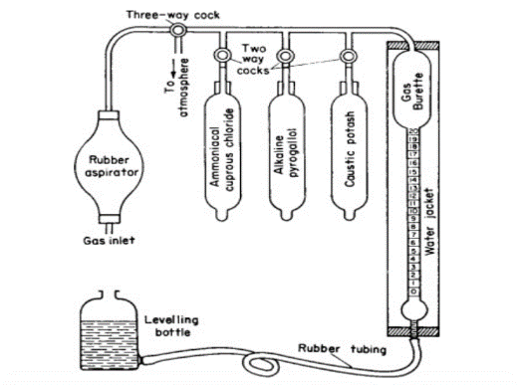
Figure 1. Schematic diagram of an Orsat Apparatus
2.4 Aluminium Wear Debris Analysis.
2.4.1 Lubricant oil sampling and analysis
Lubricant oil samples for the analysis were collected directly from a 5.0 h.p. engine test bed (refer to Table 1 for technical specifications of the engine). The engine operated intermittently at its maximum load and a consistent speed of 3000 rpm for two-hour intervals, accumulating eight hours of operation for each oil sample. Initial tests utilized conventional mineral oils, specifically SAE 40 and SAE 20w/50, before progressing to cotton seed oil-AMAs package blended lubricants.

2.4.2 Aluminium wear debris measurement
PerkinElmer Flame Atomic Absorption Spectroscopy System (FAAS), Model PinAAcle 500 was employed for the analysis of aluminium wear debris in the lubricant oil. FAAS is an excellent choice for aluminium analysis because it effectively converts aluminium into a gaseous, atomic form using a high-temperature nitrous oxide- acetylene flame (see Figure 2 for a schematic diagram of FAAS). This technique is well-suited for detecting aluminium in the parts-per-million (ppm) range and provides a cost-effective solution for routine testing.
Table 1. Principal technical specification of test engine.
Model | JF 168
Type | Single cylinder inclined at 25 º
Bore x Stroke | 68mm x 45mm
Displacement | 163 ml
Ignition system | TCI Transistorized pointless
Starting method | Recoil starter
Max. Output/speed | 4.0/4000 kW/rpm
Max. Torque | 1.1/2500 kg-m/rpm
Net weight | 15 kg
Dimensions | 330mm x280mm x390mm

For the analysis of aluminum wear debris, oil samples were prepared either by dilution with an organic solvent or digestion with strong acids to facilitate atomization (PerkinElmer, 2015; Welz & Sperling, 1999). These prepared samples were then introduced into the FAAS instrument, with the specific preparation method chosen based on the expected aluminum concentrations (Harris, 2010). Within the FAAS instrument, a specialized aluminum hollow cathode lamp emitted light at a characteristic wavelength of 309.3 nm. Aluminum atoms present in the flame's atomization zone absorbed this light. A monochromator then isolated this specific aluminum wavelength, and a detector measured the intensity of the transmitted light. The concentration of aluminium debris in the oil was determined by comparing the sample's absorbance to a calibration curve derived from known aluminium standards. The results, typically expressed in ppm or mg/kg, directly indicate the degree of engine wear.

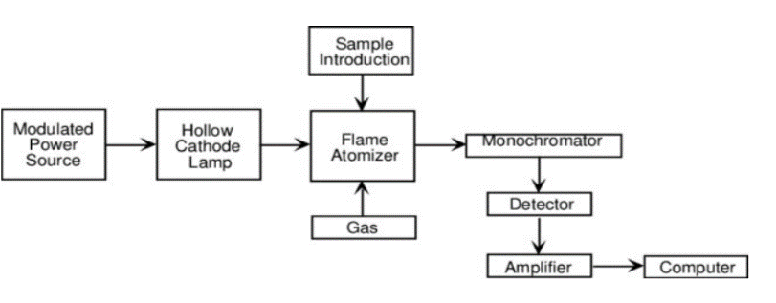
Figure 2. Schematic diagram of a flame Atomic Absorption Spectrophotometer (Burns, Finch and Wolf, 1999)
3. results and discussion

3.1 Biodegradability of Cottonseed Oil and AMAs Package
The analysis of cottonseed oil and the AMAs formulation consistently demonstrates their significant biodegradability, positioning them as environmentally favorable components for various applications, particularly in the context of sustainable lubricants.

3.1.1 Cottonseed oil as a readily biodegradable resource
Numerous studies, spanning over a decade, firmly establish the high biodegradability of cottonseed oil. Early research by Dass et al. (2013) provided foundational evidence, showing effective enzymatic breakdown by Aspergillus niger. This biodegradability extends beyond the oil itself to derived polymers, which also undergo substantial degradation when exposed to soil microorganisms (Shakina & Muthuvinothini, 2015). The underlying reason for this inherent biodegradability is its chemical composition: cottonseed oil's classification as an oleic-linoleic acid oil, rich in unsaturated fatty acids, makes it highly susceptible to microbial breakdown (Aluyor et al., 2009).
More recent studies continue to confirm and expand upon these findings, highlighting the environmental benefits of cottonseed oil across diverse sectors. Its biodegradability makes it a promising environmentally friendly immunological adjuvant (Eghafona, 1996, cited in SciELO, 2023) and a viable base for biodegradable bio-lubricants with favorable wear- and friction-reducing properties (Cecilia et al., 2020, cited in Frontiers, 2023; Gul et al., 2020, cited in Frontiers, 2023). Furthermore, components of the cottonseed plant, such as cottonseed meal, are being leveraged for the development of biodegradable polymers (MDPI, 2024). The consistent evidence of cottonseed oil's ready biodegradability underscores its sustainability, making it a valuable resource for environmentally conscious applications, including direct use, production of biodegradable materials, and as a sustainable alternative fuel source like biodiesel with reduced emissions (cottonseedoil.org, n.d.; EPCM Holdings, n.d.) . Life Cycle Assessments further reinforces its lower environmental impact compared to other vegetable oils (cottonseedoil.org, n.d.;).
3.1.2 Evidence of biodegradation of AMAs package.
The investigation into the biodegradability of the AMAs formulation, adapting established microbial population monitoring protocols (Atlas & Bartha, 1998), yielded compelling results. The study observed the growth of Pseudomonas aeruginosa, a common microorganism, in the presence of the viscosity modifier, strongly suggesting its utilization as a carbon source. Specifically, after eight days (192 hours), the mean microbial count of Pseudomonas aeruginosa in the control nutrient agar sample was 4.35% lower than in the 1ml and 2ml of samples of AMAs package. This increase in microbial count directly indicates that the microorganisms were actively consuming the samples of AMAs for growth. If the modifier were non-biodegradable or toxic, a decrease or negligible microbial count would be expected.
Further analysis of biodegradation rates revealed that the 1ml and 2ml viscosity modifying samples exhibited a higher rate of biodegradation (0.0276 h−1) compared to the control nutrient agar (0.0261 h−1). This 0.0015 h−1 higher rate in the presence of the AMAs samples signifies that the microorganisms are breaking it down more rapidly (refer to figure 3 and 4). The specific mean microbial populations for 1ml and 2ml of viscosity modifying samples were 2.0×105 cfu/ml, a significant increase from the control's 1.19×105 cfu/ml (refer to table 2). This thriving microbial population suggests a potential dose-dependent relationship, where a higher concentration of the modifier, up to a certain point, provides more substrate for microbial growth, leading to a larger microbial population and potentially a faster overall breakdown. These results confirm that the samples of AMAs can indeed serve as a carbon source for common microorganisms, highlighting its environmental benefit in terms of biodegradability.
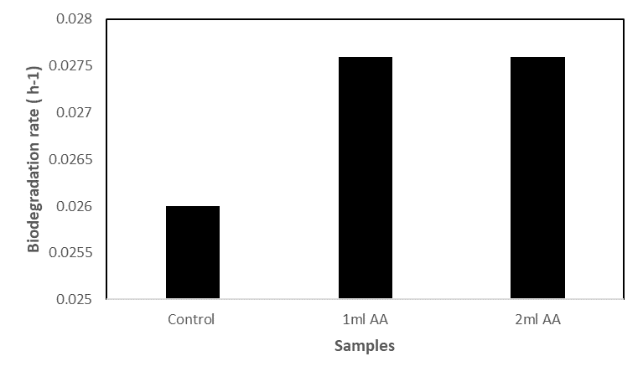
Figure 3. Biodegradability of samples AMAs .

Figure 4. Pseudomonas sp. count for varied concentration on AMAs samples.

Table 2. The trend of Pseudomonas sp. growth for varied concentrations of samples of AMAs after a period of eight days
 |  | Microbial Count (cfu/ml)
Plate No. | Control | 1 ml oil treatment | 2ml oil treatment
Plate 1. | 1.6 x10⁵ | 2.0 x10⁵ | 2.0 x10⁵
Plate 2 | 1.0 x10⁵ | 2.0 x10⁵ | 2.0 x10⁵
Plate 3 | 9.8 x 10⁴ | 2.0 x10⁵ | 2.0 x10⁵
Mean | 1.19 x10⁵ | 2.0 x10⁵ | 2.0 x10⁵
3.2 Analysis of Exhaust Gas Emissions for Cottonseed Oil- AMAs Blends.
The analysis of exhaust gas emissions from cottonseed oil-blended lubricants, as illustrated in Figures 5, 6, and 7, revealed distinct characteristics compared to conventional mineral oils (monograde and multigrade) across various engine speeds and blend concentrations (BXX denotes the percentage of cottonseed oil in the blends). Regarding CO2​ emissions, a key indicator of combustion completeness, Figure 5 demonstrates consistently higher levels for cottonseed oil blends (B100 to B40) at both 2000 rpm and 4000 rpm, surpassing those of monograde and multigrade oils. This observation is consistent with findings by Sethi and Salariya (2004), who link such increases to more complete fuel oxidation, thereby yielding greater engine power output. As CO2​ is the primary product of complete hydrocarbon combustion (Turns, 2018), the elevated CO2​ output with cottonseed oil blends suggests a more thorough combustion of the fuel. This could be influenced by the lubricant's effect on ring sealing and reduced blow-by, or potentially by the combustion of the vegetable oil itself within the combustion chamber. The anticipated trend of increasing CO2​ with higher engine speed was uniformly observed across all lubricants, reflecting greater fuel consumption for increased power.
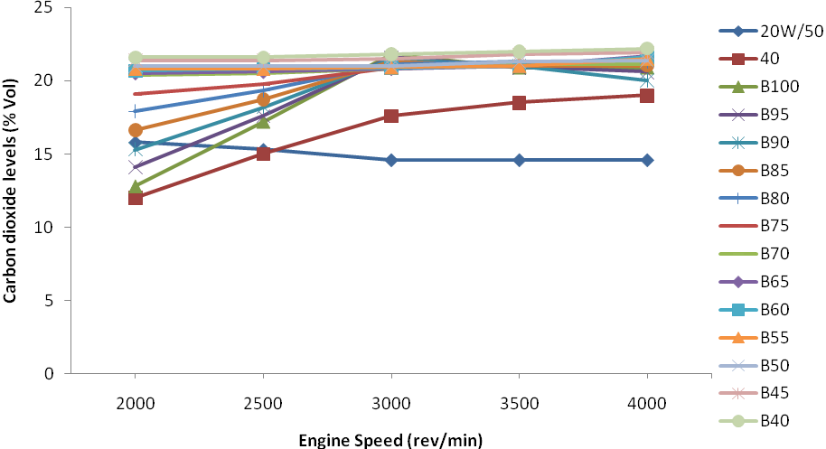
Figure 5. Effect of cottonseed oil blends on carbon dioxide emission.
Figure 6 details carbon monoxide (CO) emission levels, which signify incomplete fuel combustion (Heywood, 2018). These levels were generally higher for specific cottonseed oil blends (B50, B45, B60, B65) and multigrade oil at 3000 rpm. Elevated CO emissions imply an oxygen deficiency during combustion, leading to the formation of partially oxidized carbon products. The increased CO levels for certain cottonseed oil blends suggest a less efficient combustion process at these particular blending ratios and engine speeds. This finding also points to the possibility of lubricant traces entering the combustion chamber and undergoing incomplete combustion due to lubricant consumption or blow-by (Ajayi and Dosunmu, 2011). The variability in CO emissions across different blend ratios underscores the complex interplay between the cottonseed oil, the viscosity modifier, and the engine combustion process, highlighting its dependence on specific blend concentrations. The observed spikes in CO emissions at specific cottonseed oil blends, such as B50, B45, B60, and B65, necessitate a more detailed discussion beyond general "partial inefficiencies" and "oxygen deficiency." These elevated CO levels are indicative of incomplete combustion, a phenomenon influenced by complex interactions
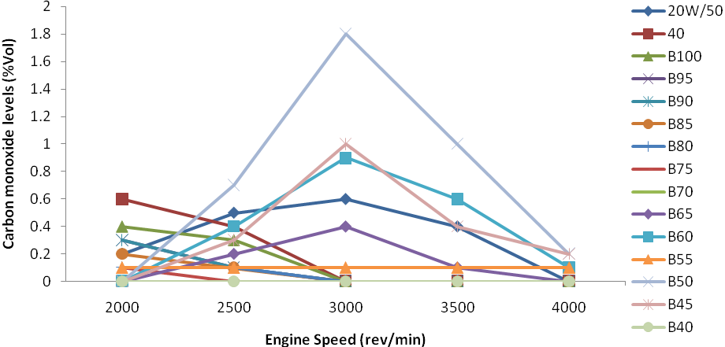
Figure 6. Effect of cottonseed oil blends on carbon monoxide emission
among fuel properties, additive characteristics, and the combustion environment within the internal combustion engine. One primary hypothesis attributes these CO spikes to a localized imbalance in the fuel-air mixture, resulting in regions of insufficient oxygen despite an overall lean or stoichiometric air-fuel ratio. As cottonseed oil is a triglyceride with a distinct chemical structure and oxygen content compared to conventional fossil fuels, its combination with the engine's fixed air supply at specific blend ratios (B45, B50, B60, B65) might create pockets within the combustion chamber where oxygen is locally depleted. This can occur even with sufficient global oxygen due to poor mixing, particularly under specific engine operating conditions such as varying speeds and loads (Heywood, 2018; Ferguson & Kirkpatrick, 2016). For instance, although the study noted a drop in unused O2​ levels at 3000 rpm (indicating enhanced oxygen utilization), this could paradoxically contribute to localized oxygen scarcity if fuel introduction and mixing are not perfectly optimized for these specific blends.
Furthermore, the presence and concentration of Aftermarket Additives (AMAs), particularly the viscosity improvers package, could significantly affect the atomization and spray characteristics of the fuel-lubricant mixture. At certain blend ratios (e.g., B50, B65), the viscosity and surface tension of the resulting lubricant-fuel blend might not be ideal for the injection system, leading to larger droplet sizes or uneven fuel distribution. Poor atomization results in incomplete vaporization and mixing with air, thereby creating zones where combustion cannot fully complete, increasing CO formation (Verma et al., 2021). The organic chemistry of these additives, specifically polymethacrylates (PMAs) or olefin copolymers (OCPs) used as viscosity improvers, might also subtly alter combustion kinetics, influencing flame propagation speeds or ignition delays at these specific blend ratios. If the flame front propagates too slowly or rapidly for a given blend, it can lead to unburnt fuel fragments that form CO. Another contributing factor could be the cooling effect of higher blend ratios. Vegetable oils have a higher latent heat of vaporization than mineral oils. At higher blend percentages, more energy is consumed to vaporize the fuel, potentially leading to a slight cooling effect within the combustion chamber.
While beneficial for mitigating knocking in some contexts, this cooling might reduce peak combustion temperatures in certain zones, impeding the complete oxidation of CO to CO2​ (Agarwal et al., 2018). In summary, the CO emission spikes at specific cottonseed oil-AMAs blends (B50, B45, B60, B65) are likely multifactorial, suggesting challenges in achieving complete combustion. These challenges could stem from localized fuel-air mixture imbalances, suboptimal atomization influenced by additive-blend interactions, and potential cooling effects at higher blend concentrations. Addressing these aspects through further optimization of blend ratios, additive formulations, and injection strategies could help minimize CO emissions in sustainable IC engine applications.
From Figure 7, the levels of unused oxygen in the exhaust gases offer insight into combustion efficiency and engine load. A sharp decrease in unused O2​ levels was observed with varying blending concentrations of cottonseed oil (B100 to B40) at 3000 rpm. This decrease signifies the occurrence of maximum brake load at this engine speed. As engine load increases, more fuel is supplied and combusted, leading to higher oxygen consumption and, consequently, lower levels of unused O2​ in the exhaust (Ferguson & Kirkpatrick, 2016). Additionally, an adequate air-fuel mixture at the inlet manifold, which improves the air-fuel contact ratio during the pre-combustion stage, contributes to a lower level of unused O2​ (Sethi and Satariya, 2004). The lower unused O2​ levels at 3000 rpm suggest a more complete combustion process under these specific engine speed and load conditions, with a greater proportion of available oxygen being utilized, particularly with certain cottonseed oil blends (Ejilah and Asere, 2008).
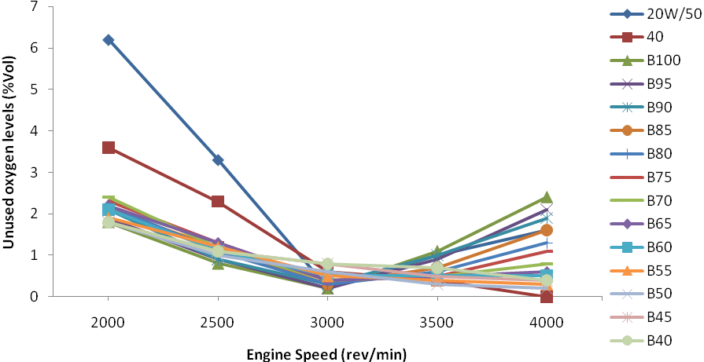
Figure 7. Effect of cottonseed oil blends on unburnt oxygen emission.

3.3 Discussion on Engine Wear Based on Aluminium Debris Concentration
The concentration of aluminum debris in oil samples serves as a direct indicator of wear in engine components composed of aluminum or its alloys, including pistons, bearings, and cylinder heads. A higher concentration signifies increased material loss due to friction and wear processes within the engine. The primary wavelength for detecting aluminum is 309.3nm, which offers high sensitivity but also susceptible to spectral interference from an iron absorption line if iron is present in the sample.

The analysis of engine wear behaviour in Figure 8, as indicated by the concentration of aluminum debris after eight hours of engine operation, reveals a distinct hierarchy in wear reduction effectiveness among the tested lubricants. The multigrade oil (SAE 20W/50) consistently exhibited the lowest concentration of aluminum debris at 0.047 ppm, signifying its superior wear protection. This exceptional performance is primarily attributed to its sophisticated formulation, which includes crucial additive compounds like zinc and calcium dialkyldithiophosphates (ZDDP) acting as anti-wear and extreme pressure agents, and synthetic polymers such as viscosity index improvers and dispersants (Mortier & Fox, 2013). These additives enhance the oil's detergency, preventing abrasive wear from harmful deposits (Verma et al., 2021), and improve lubricity by maintaining a robust lubricating film that minimizes metal-to-metal contact, friction, and wear (Gwidon, 2017). The well-documented anti-wear and anti-corrosion benefits of multigrade oils stem from these advanced additive packages (Masjuki et al., 2002; Total Energies, 2024).
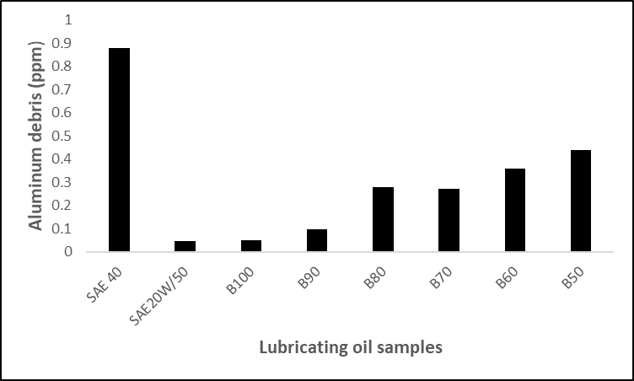
Figure. 8 Effect of cotton oil blended lubricants on concentration of aluminum wear debris
Cottonseed oil- AMAs blends (B100 to B50) consistently demonstrated better wear reduction properties compared to the monograde oil (SAE 40). B100 was notably effective, with an aluminum debris concentration of 0.052 ppm, indicating wear protection comparable to SAE 20W/50. This improved performance is attributed to the inherent lubricity of the long-chain, polar fatty acids present in the vegetable oil. These fatty acids can form a boundary layer on metal surfaces through adsorption, and under boundary lubrication conditions, they react with metal surfaces to create a metallic soap layer (e.g., iron stearate or iron oleate) (Halling, 1989; Schneider et al., 2010). This metallic soap layer acts as a solid lubricant, reducing direct asperity contact between moving parts and thus mitigating wear, with effectiveness dependent on the specific fatty acid composition (Fox, 2003). As the proportion of AMAs formulation as viscosity modifier increased in the cottonseed oil blends, a gradual rise in aluminum debris was observed: B90 at 0.098 ppm, B80 at 0.281 ppm, B70 at 0.273 ppm, B60 at 0.363 ppm, and B50 at 0.442 ppm. This trend suggests that while cottonseed oil blends possess beneficial anti-wear properties for aluminium, increasing the OCP content in the blend tends to diminish this protective effect, while still performing significantly better than SAE 40.
Conversely, the monograde oil, SAE 40, exhibited the highest concentration of aluminum wear debris at 0.881 ppm, indicating the least effective wear reduction among all tested lubricants. Monograde oils are typically formulated with fewer or less sophisticated additives compared to multigrade oils, which limits their ability to provide comprehensive protection against wear under varying engine operating conditions and temperatures (O’Connor et al., 2000). Their viscosity characteristics are also less stable across the operating temperature range, potentially leading to thinner oil films and increased metal-to-metal contact, especially at higher temperatures (Khan et al., 2023). The absence of advanced detergency and anti-wear additives, commonly found in multigrade oils, significantly contributes to their inferior wear performance in this comparative analysis.
In summary, this research highlights the strong potential of cottonseed oil and AMAs formulation as components in sustainable lubricants development. Both exhibit significant biodegradability, making them environmentally friendly alternatives to conventional mineral oils. Regarding engine performance, cottonseed oil blends show a complex impact on exhaust emissions. While higher CO₂​ emissions suggest more complete combustion in some instances, elevated CO levels for certain blends indicate areas of incomplete combustion, possibly due to blend ratios or lubricant interaction within the engine. Lower O₂​ levels at higher engine speeds imply efficient oxygen utilization (Ejilah and Asere,2008). Further research is needed to fully optimize these blends for cleaner and more efficient engine operation. In terms of wear reduction, multigrade oil remains superior, likely due to its advanced additive package. However, cottonseed oil-AMAs blends offer better wear protection than monograde oils, and this is attributable to the better boundary lubrication behavior provided by their fatty acid components. To bridge the performance gap with conventional multigrade oils, future research should focus on enhancing the wear reduction properties of vegetable oil-based lubricants through chemical modification or the incorporation of specific anti-wear additives.
This research directly supports several global goals. It contributes to SDG 7 (Affordable and Clean Energy) by exploring a renewable, cleaner lubricant that can lead to more efficient and sustainable energy use in transportation, with indications of improved combustion and reduced emissions. For SDG 9 (Industry, Innovation, and Infrastructure), this study represents a significant innovation in creating sustainable industrial products, fostering sustainable industrialization by lessening dependence on non-renewable mineral oils. It aligns with SDG 12 (Responsible Consumption and Production) through its use of a biodegradable, renewable resource like cottonseed oil, aiming to minimize the environmental impact of lubricants. Lastly, the research would also impact SDG 13 (Climate Action) by focusing on lubricants with a favorable emission profile and biodegradable properties, which directly aids in reducing greenhouse gas emissions and pollution. In closing, it is important to note, however, that the research utilized only a single-cylinder, four-stroke, spark-ignition engine. Furthermore, the analysis of wear debris was confined to aluminum, as it was identified as the predominant element in components such as pistons, cylinder heads, cylinder blocks, crankcases, connecting rods, and timing case covers. These factors may pose certain limitations for this study
4. Conclusion

From the foregoing study, the following can be concluded:
- Cottonseed oil and AMAs formulation show strong potential for sustainable lubricants development due to their biodegradability.
- While cottonseed oil -AMAs blends offer emission benefits (e.g., lower O₂​, higher CO₂​), some blends cause elevated CO.
- Cottonseed oil-AMAs blends offer better wear protection than monograde oils, but below the multigrade oil counterpart and could be attributed to its better boundary lubrication performance provided by their fatty acid components.
- The research significantly advances clean energy (SDG 7), fosters innovation (SDG 9), encourages responsible consumption (SDG 12), and supports climate action (SDG 13).
- Lastly, further research on additive packages is crucial for optimizing performance and fully realizing their eco-friendly potential.

5. REFERENCES.

ABRO, (2022). ABRO Oil Treatment. ABRO, Inc. 2022) https://abro.com/wp-content/uploads/2022/10/AB-500-Oil-Treatment-Sellsheet-2022.pdf

Adebayo, G., Ogunniyi, D. S., & Iyiola, O. P. (2023). Performance and emission characteristics of a diesel engine lubricated with cottonseed oil-based lubricant. Journal of Sustainable Engineering, 6(2), 112-125.

Agarwal, A. K., Rajasekhar, S., & Kumar, R. (2018). Vegetable oil-based lubricants: A review. Renewable and Sustainable Energy Reviews, 90, 203-220.

Ajayi, A. T., & Dosunmu, A. (2011). Environmental Impact of Increase Oil Consumption In The Combustion Chamber of an Internal. Research Journal of Applied Sciences, Engineering and Technology, 3(9), 928-932.

Aluyor, E.O., Obahiagbon, M.O. and Aigbokhan, A.O. (2009). Biodegradation of vegetable oils: A review. Scientific Research and Essays, 4(12), pp. 1154-1160, June 2009.

Akbar, M., & Zia-Ul-Haq, M. (2020). Biodegradation of lubricants: An overview. Environmental Science and Pollution Research, 27(15), 17537-17553.

Alexander, M. (1999). Biodegradation and Bioremediation (2nd ed.). Academic Press.
Atlas, R. M., & Bartha, R. (1998). Microbial Ecology: Fundamentals and Applications (4th ed.). Benjamin Cummings.

Bell, J. C., & Shah, R. N. (2019). Low-temperature properties of vegetable oil-based lubricants and their improvement strategies. Industrial Crops and Products, 130, 42-51.

Burns ,P. C., Finch R. and Wolf, S F.. (1999). Analytical Methods for the Determination of U in Geological and Environmental Materials. Reviews in Mineralogy and Geochemistry 38:623-653. In book: Reviews in Mineralogy, Uranium: Mineralogy, Chemistry, and the Environment. Mineralogical Society of America. January 1999

Cecilia, J. A., et al. (2020). Vegetable Oils: A Sustainable Source for Biolubricants. Energies, 13(16), 4174. (Cited in Frontiers, 2023).

cottonseedoil.org. (n.d.). Cottonseed Oil Sustainability. Retrieved from https://www.cottonseedoil.org/about/sustainability/

Dass, P. M., Ibrahim, A., Jabbo, J. N., Danbature, W. L., & Gin, N. S. (2013)."Vicometric Studies and Biodegradability of Some Vegetable Oils using Aspergillus Niger" published in Food Science and Quality Management, Vol. 16, 2013.

Eghafona, N. O. (1996). Vegetable oils as immunological adjuvants. Journal of Herbs, Spices & Medicinal Plants, 4(2), 57-63. (Cited in SciELO, 2023)

Ejilah, I.R. and Asere, A. A. (2008). A comparative performance and emission analysis of blended groundnut oil and mineral oil-based lubricants using a spark ignition engine. Agricultural Engineering International: the CIGR E Journal Manuscript. EE 07017. Vol. X: 1-11. http:// www.cigr.org. ISSN:1682-1130

Erhan, S. Z., Adhvaryu, A., & Perez, J. M. (2018). Vegetable oils as base stocks for environmentally friendly lubricants. Lipid Technology, 30(4), 83-86.

EPCM Holdings. (n.d.). Cottonseed Biodiesel-An Overview. Retrieved from https://epcmholdings.com/cotton-seed-biodiesel-an-overview/
46.
Fazal, M. A., Haseeb, A. S. M. A., & Masjuki, H. H. (2017). Biodiesel as a lubricant additive: A review. Renewable and Sustainable Energy Reviews, 68, 77-84.

Ferguson, C. R., & Kirkpatrick, A. T. (2016). Internal combustion engines: applied thermosciences. CRC press

Fox, M. F. (2003). Lubricant additives: chemistry and applications. CRC Press.

Fox, M., & Stachowiak, G. W. (2017). Vegetable oil-based lubricants—A review of base oils, additives and industrial applications. Tribology International, 114, 103-117.

Frontiers. (2023). Frictional performance of chemically modified cottonseed-based fossil-free biolubricant oil in a sliding tribopair. Retrieved from https://www.frontiersin.org/journals/mechanical-engineering/articles/10.3389/fmech.2023.1281406/full

Geller, D. P. (2017). Biobased lubricants and greases: Technology and commercial markets. William Andrew Publishing.

Gul, M., et al. (2020). Tribological evaluation of cottonseed oil-based trimethylolpropane ester as a potential biolubricant. Industrial Crops and Products, 154, 112663. (Cited in Frontiers, 2023)

Gwidon, S. (2017). Tribology in machine design. CRC Press.

Halling, J. (1989). Principles of Tribology. (Reprinted edition) Macmillan publishers, London. Pp.116, 202, 224,228,230.

Harris, D. C. (2010). Exploring Chemical Analysis. 5th Edition, W. H. Freeman Co

Heywood, J. B. (2018). Internal combustion engine fundamentals (2nd ed.). McGraw-Hill Education.

Hussain, S., Ali, M. E., & Abbas, Q. (2023). Environmental impact assessment of bio-based lubricants in agricultural machinery. Environmental Technology & Innovation, 31, 103180.

Jamaluddin, H., Selamat, M. Z., & Zulkifli, N. W. M. (2021). The influence of vegetable oil-based lubricants on NOx and particulate matter emissions in diesel engines. Energy Conversion and Management, 235, 113989.
16.

Khan, A. A., et al. (2023). Conventional and Recent Advances of Vegetable Oils as Metalworking Fluids (MWFs): A Review. Retrieved from https://repositorium.sdum.uminho.pt/bitstream/1822/85536/1/lubricants-11-00160-v2.pdf
13.

Khan, M. I., Raza, S. A., & Siddique, M. A. (2019). Environmental implications of mineral oil-based lubricants and the potential of bio-based alternatives. Journal of Cleaner Production, 215, 1302-1314.

Lawal, T. O., et al. (2025). Avocado Seed Oil as An Additive in the Formation of Grease Lubricant from Spent Engine Oil. ResearchGate. Retrieved from https://www.researchgate.net/publication/391572766_Avocado_Sead_Oil_As_An_Additive_In_The_Formation_Of_Grease_Lubricant_From_Spent_Engine_Oil

Lubrizol Inc. (n.d.). Aftermarket Additive Specifications. Retrieved from: https://lubrizol.com/Lubricant-and-Fuel-Additives/Transportation/Aftermarket

Machinery Lubrication. (n.d.). The Advantages and Disadvantages of Biodegradable Lubricants. Retrieved from https://www.machinerylubrication.com/Read/28760/advantages-disadvantages-of-biodegradable-lubricants-

Masjuki, H. H., Zaki, A. M., & Sapaun, S. M. (2002). A rapid test to measure performance, emission and wear of a diesel engine fueled with palm oil diesel. JAOCS, Journal of the American Oil Chemists' Society, 79(1), 89-92.

Menon, K., & R, A. (2025). Preparation and Evaluation of Lubricating Properties of Neem Seed Oil under the Influence of an Anti-Wear Additive as Sustainable Alternative to Commercial Engine Oil. SAE Technical Paper 2025-28-0116. Retrieved from https://www.sae.org/publications/technical-papers/content/2025-28-0116/

MDPI. (2024). Blends of Carboxymethyl Cellulose and Cottonseed Protein as Biodegradable Films. Retrieved from https://www.mdpi.com/2073-4360/16/11/1554

Moradi, M., Khonsari, M. M., & Jahanmir, S. (2022). A review of recent advances in bio-based lubricant additives. Tribology Letters, 70(2), 1-23.

Mortier, R. M., & Fox, M. F. (2013). Chemistry and technology of lubricants. Springer Science & Business Media.

O’Connor, J. J., Boyd, J., & Avallone, E. A. (2000). Standard handbook of lubrication engineering. McGraw-Hill.

Olawale, O., Okoro, O. O., & Adeyemi, O. O. (2025). Comparative wear analysis of mineral and cottonseed oil-based lubricants in a four-stroke gasoline engine. Tribology Transactions, 68(1), 55-64

PerkinElmer Inc. (2015). PinAAcle 500 Flame Atomic Absorption Spectrometer [Product information brochure or specifications]. Retrieved from https://shop.perkinelmer.com/.

Ryngajło, A., Lewandowska, M., & Krzyżaniak, M. (2016). Biodegradability testing of new lubricating base oils. Journal of Molecular Liquids, 224, 1018-1024.

Sahoo, P. K., et al. (2024). Vegetable oil-based additives for lubricant formulations. Retrieved from https://www.researchgate.net/publication/385851251_Vegetable_oil-based_additives_for_lubricant_formulations

Salimon, J., Salih, N., & Yousif, B. F. (2021). Biodegradability of lubricant base oils and additives: A review. Journal of Industrial and Engineering Chemistry, 94, 1-15.

Schneider, J., Cavdar, D., & Hock, S. (2010). Tribochemistry of fatty acids on steel surfaces. Tribology Letters, 39(1), 33-41.

SciELO. (2023). Physicochemical features, functional characteristics, and health benefits of cottonseed oil: a review. Retrieved from https://www.scielo.br/j/bjb/a/yQYp7FmKD5bbJzMqxm3Zs6x/

Senthil Kumar, S., Devan, P. K., & Ramakrishnan, G. (2024). Impact of vegetable oil-based lubricants on aldehyde emissions from internal combustion engines. Atmospheric Pollution Research, 15(3), 101987.

Sethi,V.P. and Salariya, K.S.(2004).Exhaust analysis and performance of a single cylinder diesel engine run on dual fuels. IE(I) Journal-MC. Vol 85. Pp. 3-5.

Shakina, J. and Muthuvinothini, A. (2015). Synthesis and Characterization of Cotton Seed Oil Based Biodegradable Thermosetting Polymers" in Journal of Academia and Industrial Research (JAIR), 3(10), 520 (2015).

Sharma, B. K., Doll, K. M., & Erhan, S. Z. (2020). Biodegradable base oils. In Lubricants and Lubrication (pp. 31-54). Wiley-VCH Verlag GmbH & Co. KGaA.

Sharma, R. K., & Tewari, V. K. (2020). Tribological properties of vegetable oils and their blends as potential lubricants. Industrial Lubrication and Tribology, 72(7), 945-954.

Tiwari, A. K., Sharma, Y. C., & Srivastava, A. (2022). Biodegradable lubricants: Current status and future perspectives. Environmental Progress & Sustainable Energy, 41(3), e13771.

Total Energies (2024). Engine Oil and Guide and Advices. https://services.totalenergies.ng/our-lubricants/engine-oil-cars/engine-oil-and-guide-and-advices

Turns, S. R. (2018). An introduction to combustion: concepts and applications. McGraw-Hill Education.

Verma, P., et al. (2021). Impact of lubricant properties on combustion and emissions in internal combustion engines: A review. Fuel, 286, 119430.

Wagner, R. M., Storey, J. M. E., Gullett, B. K., & Szybist, J. W. (2016). Lubricant effects on combustion, emissions, and efficiency. U.S. Department of Energy, Office of Energy Efficiency and Renewable Energy. Government/technical report.

Welz, B., & Sperling, M. (1999). Atomic Absorption Spectrometry (3rd ed.). Wiley-VCH.

