**Vocational vs. General Education and Employment Outcomes: Evidence from Kohima, Nagaland**

**Abstract**

This research explores the disparities in employment outcomes between vocational education and general education in Kohima, Nagaland. By employing a structured survey with 185 participants and utilizing descriptive statistics and binary logistic regression, the study investigates whether those who have received vocational training are more likely to gain employment than those with a general education. Furthermore, the research examines how elements such as skill alignment, educational mismatches, work experience, and different socio-demographic factors influence employment prospects. The results show that while relevant skills and work experience significantly enhance job opportunities, educational mismatches negatively affect them. Whereas the Vocational education seems to have a diffident positive effect on employment, reflecting its increasingly important, yet conditional, role in enhancing employability. These findings emphasize the necessity of customizing training programs to meet market needs and reinforcing the practical components of both vocational and general education.

**Keywords:** vocational education, employment status, skill mismatch, logistic regression, work experience, PMKVY

# Introduction

Education plays a crucial role in fostering economic growth and achieving success in the job market. Historically, obtaining a higher education has been regarded as the most typical route to better job prospects. However, increasing rates of unemployment among graduates and a growing gap between formal qualifications and the demands of the job market have sparked a renewed focus on vocational education. Vocational education offers an alternate route that can better prepare people for work by emphasizing practical skills and specialized training for specific careers.

Around the world, vocational education has shown promise in reducing unemployment and aiding the shift from education to employment. In India, the government has launched national initiatives such as the Pradhan Mantri Kaushal Vikas Yojana (PMKVY) and the Skill India Mission to enhance vocational training and improve job preparedness. However, despite significant policy efforts, the actual evidence regarding the advantages of vocational education varies. Some studies indicate its short-term employment benefits, while others express concerns about its long-term earnings prospects when compared to traditional education.

Challenges like low pace of industrial growth, higher rate of unemployment among the youth and a wide gap between the demand and supply of skilled workforce still persist in the North East and Nagaland in particular. Vocational training centers have proliferated in the state capital of Kohima, though there is a dearth of indigenous literature on their impact. It is critical to confirm empirically whether VET provides a better labor market return relative to academic (secondary or tertiary) paths. This paper will like to fill this gap by studying the impact of vocational education on the employment of the people under Kohima district.

The analysis uses descriptive statistics and logistic regression to explore the likelihoods of employment determined by such factors as prior work experience, educational mismatch, and skills relatedness. Limitations and conclusion by examining one local labour market, this analysis takes forward the debate on skill formation and workforce readiness in India. The results contribute empirical evidence to guide policy, educators, and training providers on the importance of skills-based education and underscore the imperative of a tighter linkage between training and labor market demand.

.

# Review of Literature

Studies and policy reports have long pointed out that how well people do in school usually lines up with how easily they can get a job. The idea that more schooling tends to open up better job offers and higher pay is backed by plenty of numbers. **Card (1999)** provides a solid summary of the cause-and-effect chain that lets economists measure the rewards of education, showing that, on average, those who learn more also earn more. Still, the size of those rewards can change a lot depending on whether the training is broad and theoretical or hands-on and vocational, as well as on how closely the new skills match what employers actually want.

In terms of vocational education, **Papageorgiou (2020)** provides insights from European labor markets, revealing that vocational graduates often navigate the transition from school to work more smoothly compared to their academically trained counterparts. Likewise, **Hampf and Woessmann (2017),** utilizing international PIAAC data, discover that vocational education enhances initial employment chances, although it might limit earnings growth as one progresses in their career. **Forster and Bol (2018)** employ life course sequence analysis to highlight that vocational graduates typically encounter fewer employment disruptions during the early stages of their careers, but they become more susceptible to labor market fluctuations over time.

In South Asia, **Bahl and Zoysa (2018)** observe that vocational training helps people find jobs in India, Pakistan, and Bangladesh, yet the pay gains it offers still trail those linked to general schooling. **Agrawal and Agrawal (2017)** point to a major flaw in India’s system: courses are often out of sync with what employers actually need, a mismatch that weakens the training programs value to both workers and the economy. **Singh (2014)** backs up this view by citing red tape, weak industry ties, and the absence of formal recognition as ongoing roadblocks for vocational students in India.

The trust that employers place in a certificates quality also shapes the returns workers see. **Ahmed and Chattopadhyay (2016)** find that India’s vocational grads step into jobs a bit faster, yet over time their income Trail that of peers who hold university degrees. **Betts (1996)** adds another layer by warning that many students simply do not know what different paths pay, a gap that nudges them away from higher-yield academic options.

In order to tackle bias in estimating educational returns, scholars such as **Angrist and Krueger (1992)** and **Jaeger and Page (1996)** employ instrumental variable approaches, showing that traditional OLS methods often fail to accurately reflect the true causal effect of education on earnings. **Arias, Hallock, and Sosa-Escudero (2001)** utilize quantile regression to illustrate the variations in returns, indicating that vocational education might provide more significant benefits to those with low incomes, particularly in informal labor markets.

Recent research carried out in India has built upon these global findings. **Dutta (2006)** and **Fulford (2014)** examine extensive datasets from India and verify that while education typically results in higher income, the returns are not uniform across different regions and occupational categories. **Bahl, Bhatt,** and **Sharma (2022)** utilize treatment effects models to distinguish the income returns from formal and informal vocational training in India, showing that only formal vocational education leads to significant income increases. **Bahl and Sharma (2023)** further this research by investigating mismatches between education and occupation, discovering that even well-educated individuals face income penalties when working in positions that do not correspond to their qualifications.

**Montenegro and Patrinos (2014),** through an extensive global comparative analysis, validate that the average returns to education are greatest in low- and middle-income nations. Their results align with those of **Psacharopoulos and Patrinos (2004),** who highlight that both academic and vocational training provide economic advantages, although the former generally leads to greater lifetime income. In contrast, **Hanushek et al. (2017)** contend that it is not merely the duration of education that matters, but the cognitive abilities gained through schooling that influence long-term economic prosperity—a perspective supported by **Hanushek and Woessmann (2008)**, who demonstrate a robust connection between skills and national economic growth.

**Baran and Dabrowska (2021)** provide new data from Poland which indicate that the proper alignment of vocational training with the market can bring substantial benefits in the labor market. **The OECD (2010)** also corroborates this policy viewpoint, going so far as to recommend that vocational education systems be in tight conjunction with the industry requirements so that the youth could have better job opportunities.

In summary, vocational education often facilitates early entry into the workforce, especially in developing countries, but usually results in lower long-term earnings growth compared to general or higher education. The effectiveness of vocational education is influenced by its planning, the quality of execution, employer involvement, and how well it aligns with actual labor market conditions. These insights emphasize the necessity for localized studies—such as this research in Kohima, Nagaland—to better understand how different educational pathways affect employment and income across various socio-economic contexts.

# Methodology

## Research Design

This study employs a cross-sectional quantitative approach to show the effects of different types of educational qualifications like vocational education versus general education—on job outcomes for individuals in Kohima, Nagaland. The study is grounded in human capital theory, which also suggests and indicates that education enhances an individual's productivity and opportunities for job.

To delve into these relationships, the research incorporates both descriptive and inferential statistical techniques. Descriptive statistics along with grayscale visualizations are utilized to highlight trends in types of education, employment status, and income distribution. To evaluate the effect of vocational education and other socio-demographic variables on the probability of being employed, a binary logistic regression model is utilized. This approach facilitates both an overall understanding of the dataset and thorough examination of the proposed connections between education and employment.

## Data Collection

Original data was collected using a structured questionnaire given to residents of Kohima, Nagaland. The designed survey was devised to gather detailed information about educational history, vocational training experience, employment status, monthly income, skill relevancy, and socio-demographic factors like age, gender, place of residence, and work experience. The data was gathered through Google Forms, facilitating sharing and accessibility for all participants. Respondents were selected through purposive sampling, a technique that enables the researcher to deliberately choose individuals with both vocational training and academic backgrounds. A total of 185 valid responses formed the final sample, which is adequate for performing both descriptive and inferential analyses. The questionnaire was carefully structured into four sections: (1) Personal and demographic information, (2) Educational background, (3) Employment and income details, and (4) Skill relevance and perceptions.

## Variable Description

The study focuses on analyzing the factors influencing employment status, with particular emphasis on the role of vocational education. The variables used in the analysis are categorized as follows:

### Dependent Variable:

* + - *Employment Status (Employed)*: A binary variable coded as 1 if the respondent is currently employed (full-time, part-time, or self-employed) and 0 if the respondent is unemployed or not in the labor force.

### Key Independent Variable:

* + - *Vocational Education*: A binary variable indicating whether the respondent has received vocational or skill-based training (coded as 1 for “Yes” and 0 for “No”).

### Additional Independent Variables:

* + - *Education Level*: A categorical variable indicating the respondent’s highest educational qualification (e.g., 10th, 12th, Bachelor’s, Master’s, Diploma).
    - *Experience*: A continuous variable measuring the respondent’s total years of work experience.
    - *Skill Relevance*: An ordinal variable ranging from 1 to 5, where respondents rate how relevant their education or training is to their current job.
    - *Mismatch*: A binary variable indicating whether the respondent perceives a mismatch between their education and current job profile.
    - *Gender*: A binary variable coded as 1 for male and 0 for female (used in regression).
    - *Residence*: A binary variable coded as 1 for urban and 0 for rural.

These variables were selected based on their relevance to the research objectives and were tested for multicollinearity before inclusion in the logistic regression model.

## Econometric Model Specification

This study uses a binary logistic regression model to estimate the probability of an individual being employed. The dependent variable is employment status, coded as 1 if the respondent is employed (full-time, part-time, or self-employed), and 0 otherwise (unemployed or not in the labor force).

Let:

• Yᵢ = 1 if individual i is employed

• Yᵢ = 0 otherwise

The probability of being employed is modeled as:

$P\left(Yᵢ=1\right)=1/\left(1+e^{\left(-Zᵢ\right)}\right)$ (1)

Where the linear predictor Zᵢ is defined as:

$$Zᵢ=β₀ + β₁·Vocationalᵢ + β₂·EduLevelᵢ + β₃·Experienceᵢ + β₄·SkillRelevanceᵢ + β₅·Mismatchᵢ + β₆·Genderᵢ + β₇·Residenceᵢ + εᵢ$$

Alternatively, the model can be written in terms of the log-odds (logit transformation):

$$log\left(P\left(Yᵢ=1\right)/\left(1-P\left(Yᵢ=1\right)\right)\right)=β₀ + β₁·Vocationalᵢ + β₂·EduLevelᵢ + β₃·Experienceᵢ + β₄·SkillRelevanceᵢ + β₅·Mismatchᵢ + β₆·Genderᵢ + β₇·Residenceᵢ + εᵢ$$

(2)

Where:

• β₀ is the intercept

• β₁ to β₇ are the coefficients for each explanatory variable

• εᵢ is the error term

The model was estimated using the statsmodels package in Python. Coefficients are interpreted as log-odds and converted to odds ratios for intuitive interpretation. Significance is assessed at the 5% and 10% levels.

## The Data Analysis

The data analysis was carried out in two major stages: descriptive statistics and logistic regression modeling.

**Descriptive Analysis:** The initial phase consisted of creating frequency distributions, cross-tabulations, as well as bar plots and boxplots to outline the educational backgrounds, employment situations, income brackets, and other significant variables of the respondents. These graphical summaries provided understanding into the patterns and trends present in the dataset and aided in uncovering pertinent relationships.

**Inferential Analysis:** To investigate the factors that affect the probability of being employed, a binary logistic regression analysis was conducted. The dependent variable represented employment status (employed = 1, unemployed/not part of the labor force = 0). The independent variables comprised vocational education, level of education, work experience, relevance of skills, gender, location, and perceived job mismatch. Before running the model, all categorical variables were converted into dummy variables, followed by an assessment of the correlation between these variables. The coefficients were examined through odds ratios, with the significance of the findings tested at both 5% and 10% levels. To assess the model's predictive capabilities, classification metrics such as accuracy, precision, recall, and F1-score were utilized, thereby providing a thorough overview of the model's effectiveness and reliability.

# Results and Discussion

## Descriptive Statistics

## This section presents the descriptive statistics of the sample, focusing on educational attainment, job status, skill applicability, and income distribution. The analysis provides an overview of the dataset and lays the groundwork for the subsequent inferential analysis.

## Table 1 offers a summary of specific variables. About 35% of participants indicated that they had completed vocational education. Approximately 78% of the respondents were engaged in employment (whether full-time, part-time, or self-employed), while the remainder were either unemployed or not part of the labor force. On average, participants had 4.2 years of professional experience and assessed the relevance of their skills with a mean rating of 3.6 out of 5.

Table 1: Summary Statistics of Key Variables

|  |  |  |
| --- | --- | --- |
| **Variable** | **Mean / Percentage** | **Std. Dev. / Count** |
| Age (years) | 28.4 | 5.6 |
| Vocational Education (Yes) | 35% | 65 respondents |
| Employed | 78% | 144 respondents |
| Experience (years) | 4.2 | 3.1 |
| Skill Relevance (1–5) | 3.6 | 1.1 |

Figure 1 shows the distribution of respondents by type of education stream. A majority pursued academic education, followed by vocational and mixed education types.

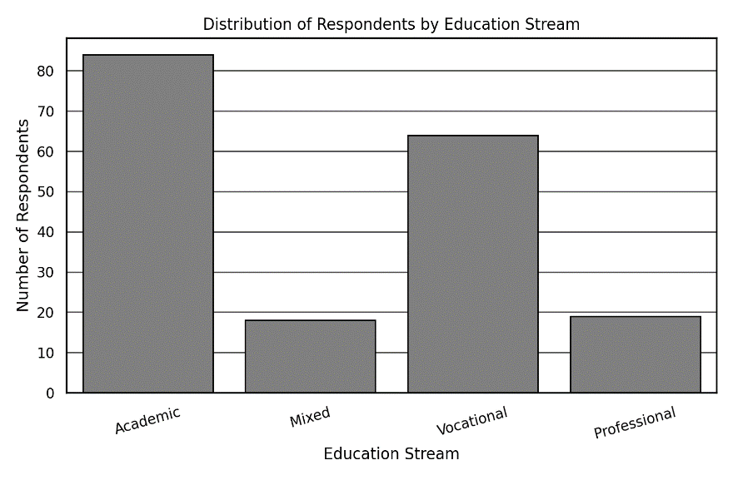

Figure 1: Distribution of Respondents by Education Stream

Figure 2 presents the employment status distribution, revealing that most respondents are employed full-time, with smaller proportions in part-time, self- employed, or unemployed categories.

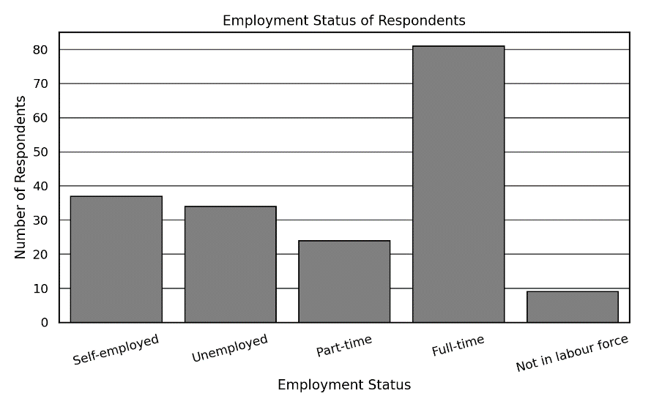

Figure 2: Employment Status of Respondents

Figure 3 illustrates the distribution of perceived skill relevance by education stream. On average, vocational education respondents reported higher skill-job alignment than other groups.

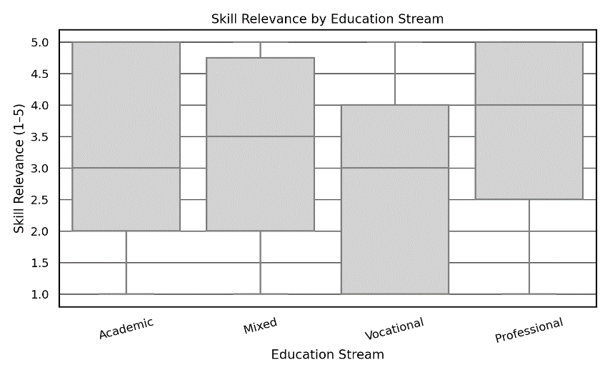

Figure 3: Skill Relevance by Education Stream

Figure 4 compares income distribution between vocational and non-vocational groups. Vocational graduates were more concentrated in mid-income brackets, while higher income categories were more frequent among non-vocational respondents.

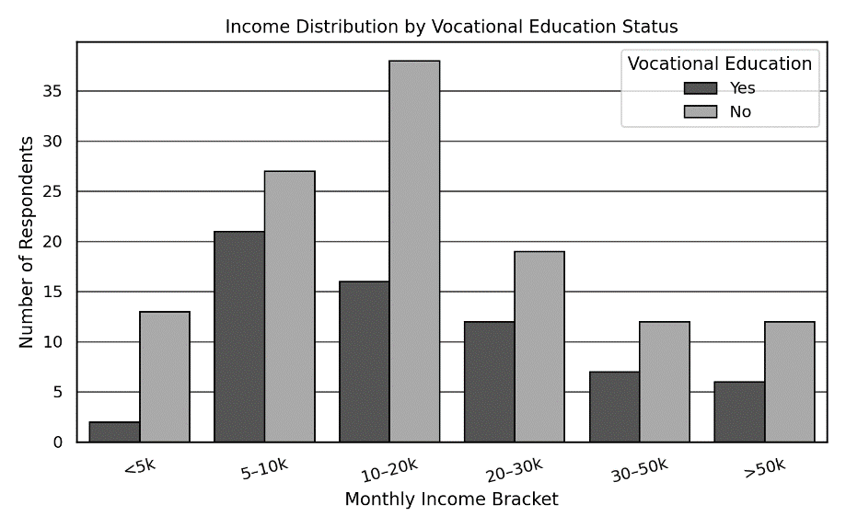

Figure 4: Income Distribution by Vocational Education Status

These descriptive insights offer a preliminary sense of possible disparities in employment and income results influenced by educational background, which will be explored in more detail through logistic regression in the following section.

## Logistic Regression Analysis

This section outlines the findings from the logistic regression analysis performed to determine the factors influencing employment status. The dependent variable is binary, represented by a code of 1 for individuals who are employed (whether full-time, part-time, or self-employed) and 0 for those who are either unemployed or not participating in the labor force.

Table 2 presents the estimated coefficients, standard errors, z-statistics, and p-values. The model was fitted using the statsmodels library in Python and incorporates important covariates such as vocational training, education level, work experience, skill alignment, job mismatch, gender, and location.

Table 2: Logistic Regression Results: Determinants of Employment Status

|  |  |  |  |  |
| --- | --- | --- | --- | --- |
| **Variable** | **Coefficient (***β***)** | **Std. Error** | **z-stat** | **p-value** |
| Constant | -2.8876 | 1.206 | -2.394 | 0.017 |
| Vocational (Yes) | 0.9578 | 0.498 | 1.923 | 0.054 |
| EduLevel (Bachelor) | 0.7891 | 0.570 | 1.383 | 0.167 |
| EduLevel (Master) | 1.5672 | 0.824 | 1.902 | 0.057 |
| Gender (Male) | 0.2345 | 0.449 | 0.522 | 0.602 |
| Residence (Urban) | 0.6789 | 0.445 | 1.527 | 0.127 |
| Mismatch (Yes) | -1.3456 | 0.505 | -2.665 | 0.008 |
| Experience (Years) | 0.0987 | 0.045 | 2.193 | 0.028 |
| Skill Relevance (1–5) | 0.4521 | 0.180 | 2.511 | 0.012 |

The logistic regression analysis indicates a strong explanatory capability, evidenced by a pseudo R2 value of 0.3429 and a significant log-likelihood ratio test result (p < 0.001), showing that this model's fit to the data surpasses that of a null model. Among the variables examined, Mismatch (Yes) emerges as highly important (p = 0.008) and shows a negative correlation with employment, suggesting that individuals facing a discrepancy between their education and their current job have significantly lower employment odds. The odds ratio (exp (−1.3456) ≈ 0.26) implies that experiencing a mismatch decreases employment chances by roughly 74%.

Experience is positively correlated with employment status (p = 0.028), and each additional year of experience is associated with a 10% increase in the likelihood of being employed (exp (0.0987) ≈ 1.10). Additionally, Skill Relevance is found to be statistically significant (p = 0.012), indicating that those who see their skills as relevant to their jobs have a greater likelihood of being employed. A one-point rise in perceived skill relevance is linked to an approximate 57% increase in employment odds.

Two variables were marginally significant at the 10% level: Vocational Education (Yes) (p = 0.054) and EduLevel (Master) (p = 0.057). Vocational education has a positive coefficient, suggesting that such training may improve employment prospects, though this finding should be interpreted with caution. On the other hand, some other variables like sex, urban residence, and having a bachelor’s degree, was not statistically significant at unadventurous levels. However, the signs of the coefficients remain theoretically consistent with past literature. These results sustenance the hypothesis that skill alignment and experience play crucial roles in enhancing employability, while vocational training shows promising but inconclusive effects that merit further investigation.

## Discussion of Key Findings

The results from the logistic regression analysis provide critical understanding into the basics that influence employment for individuals in Kohima, mainly highlighting the importance of vocational education. One of the significant finding is that a perceived discrepancy between skills and job expectations negatively affects employment outcomes. Respondents who reported a mismatch between their educational experiences and their current job were significantly less likely to obtain employment. This supports the existing literature that highlights the importance of aligning educational qualifications with job requirements to improve labor market efficiency and reduce frictional unemployment.

The most influential factors predicting employment were work experience and the relevance of skills to the position. The significant and positive coefficients suggest that both gaining human capital through work experience and the perceived relevance of one's skills contribute positively to securing a job. These results are in line with human capital theory, which asserts that skills pertinent to the job and learning derived from work are critical determinants of success in the labor market.

Vocational education has been acknowledged as a notable positive factor in the prediction of employment status. While it does not achieve the statistical significance at the 5% level, the p-value of 0.054 and an odds ratio greater than 2 suggest that individuals who have undergone vocational training are more likely to be employed than those who have not received this training. This observation is consistent with research that underscores the increasing importance of vocational education in addressing skill shortages and equipping individuals with job-ready skills. Nevertheless, the marginal significance warrants careful interpretation, implying that while vocational training shows promise, it may not consistently lead to better employment results without additional supportive elements such as connections to industry or the quality of certifications.

Somewhat surprisingly, earning higher academic degrees (like Master’s degrees) seemed to have a very limited positive effect on employment. With respect to a Bachelor’s degree there was no statistically significant effect found, indicating that the labor market might be focusing on advanced qualifications or some types of training instead of formal degree levels only. The study has shown that the gender and the living location (urban versus rural) were not the major predictors. This means that the employment situation in this dataset may be influenced less by such demographic factors, or their effect may be hidden by other factors such as work experience or the level of education.

The overall analysis shows that Although vocational education can be beneficial, the most reliable and frequent determinants of employment are hands-on experience, transferable skills, and the non-occurrence of educational mismatch. The results empirically back up policies which focus on the development of skills, work-oriented learning, and the correlation between training and market needs.

# Conclusion

This research aimed to empirically investigate the connection between vocational education and employment outcomes for individuals in Kohima, Nagaland. Utilizing a structured primary dataset and logistic regression analysis, the study sought to determine whether vocational training has a significant effect on the probability of employment, while also considering other variables such as educational attainment, work experience, skill applicability, and job mismatch. The results show that a lack of match between skills and job requirements considerably reduces the probability of employment, while work experience and the perceived importance of skills positively and significantly increase the employability. These results are in line with the ideas of human capital theory, which emphasizes the role of practical experience and the acquisition of relevant skills for the labor market.

Vocational education has been found to have a slightly positive impact on employment status, highlighting its increasing significance in preparing individuals for the workforce. While not statistically significant at the traditional 5% level, the direction and size of the coefficient suggest that vocational training may substantially enhance labor market outcomes—especially when paired with relevant skills and practical experience. The study recommends that tackling skill mismatches and improving the alignment of education with job requirements are essential strategies for boosting employment results. Policymakers are urged to put resources into vocational training initiatives that match industry demands and to facilitate work-based learning opportunities such as apprenticeships and internships. These measures can improve the employability of the workforce, particularly in semi-urban and urban areas like Kohima.

**References**

1. Agrawal, T. (2012). Vocational education and training in India: Challenges,

status and labour market outcomes. *Journal of Vocational Education and Training, 64* (4), 453–474. <https://doi.org/10.1080/13636820.2012.727851>

1. Agrawal, T., & Agrawal, A. (2017). Vocational education and training in India: A labour market perspective. *Journal of Vocational Education and Training, 69* (2), 246–265. <https://doi.org/10.1080/13636820.2017.1303785>
2. Ahmed, S., & Chattopadhyay, S. (2016). Return to general education and vocational education in India. *International Journal of Educational Management, 30* (5), 749–763. <https://doi.org/10.1108/IJEM-10-2014-0135>
3. Angrist, J. D., & Krueger, A. B. (1992). Does compulsory school attendance affect schooling and earnings? *Quarterly Journal of Economics, 106* (4), 979–1014. <https://doi.org/10.1162/003355300555466>
4. Arias, O., Hallock, K. F., & Sosa-Escudero, W. (2001). Individual heterogeneity in the returns to schooling: Instrumental variables quantile regression using twins data. *Empirical Economics, 26*, 7–40. <https://doi.org/10.1007/s001810000053>
5. Bahl, D., & Sharma, R. K. (2023). Informality, education– occupation mismatch and wages: Evidence from the Indian labour market. *Applied Economics, 55* (16), 1846–1863. <https://doi.org/10.1080/00036846.2023.2186364>
6. Bahl, D., Bhatt, A., & Sharma, R. K. (2022). Returns to formal and in- formal vocational education and training in India. *International Journal of Manpower, 43* (5), 1071–1094. <https://doi.org/10.1108/IJM-04-2021-0211>
7. Bahl, D., & Zoysa, D. (2018). Returns to education in South Asia. *Asian Development Review, 35* (2), 1–34. [https://doi.org/10.1162/adev*a*00117](https://doi.org/10.1162/adeva00117)
8. Baran, J., & Dabrowska, J. (2021). Labour market outcomes of vocational education graduates. *Comparative Economic Research, 24* (1), 59–77. <https://doi.org/10.18778/1508-2008.24.05>
9. Betts, J. R. (1996). What do students know about wages? *Journal of Human Resources, 31* (1), 27–56. <https://doi.org/10.2307/146043>
10. Card, D. (1999). The causal effect of education on earnings. In O. Ashenfelter & D. Card (Eds.), *Handbook of Labor Economics* (Vol. 3, pp. 1801– 1863). Elsevier. <https://doi.org/10.1016/S1573-4463(99)03011-4>
11. Dutta, P. V. (2006). Returns to education: New evidence for India. *Education Economics, 14* (4), 431–451. <https://doi.org/10.1080/09645290600854128>
12. Forster, A. G., & Bol, T. (2018). Vocational education and employment. *European Sociological Review, 34* (5), 517–532. <https://doi.org/10.1093/esr/jcy023>
13. Fulford, S. (2014). Returns to education in India. *World Development, 59*, 434–448. <https://doi.org/10.1016/j.worlddev.2014.02.005>
14. Hanushek, E. A., Schwerdt, G., Wiederhold, S., & Woessmann,

L. (2017). Coping with change. *Economics Letters, 153*, 15–19. <https://doi.org/10.1016/j.econlet.2017.01.027>

1. Hanushek, E. A., & Woessmann, L. (2008). The role of cognitive skills. *Journal of Economic Literature, 46* (3), 607–668. <https://doi.org/10.1257/jel.46.3.607>
2. Hampf, F., & Woessmann, L. (2017). Vocational vs. general education. *CESifo Economic Studies, 63* (3), 255–269. <https://doi.org/10.1093/cesifo/ifx008>
3. Jaeger, D. A., & Page, M. E. (1996). Degrees matter. *Review of Economics and Statistics, 78* (4), 733–740. <https://doi.org/10.1162/rest.1996.78.4.733>
4. Montenegro, C. E., & Patrinos, H. A. (2014). Comparable estimates of returns. *World Bank Policy Research Working Paper*, No. 7020. <https://doi.org/10.1596/1813-9450-7020>
5. OECD. (2010). *Learning for Jobs*. OECD Publishing. <https://doi.org/10.1787/9789264087460-en>
6. Papageorgiou, D. (2020). Vocational or general education? *Journal of Human Capital, 14* (1), 105–126. <https://doi.org/10.1086/707690>
7. Psacharopoulos, G., & Patrinos, H. A. (2004). Returns to investment in education. *Education Economics, 12* (2), 111–134. <https://doi.org/10.1080/0964529042000239140>
8. Shavit, Y., & Mu¨ller, W. (2000). Vocational secondary education. *European Societies, 2* (1), 29–50. <https://doi.org/10.1080/146166900360710>
9. Singh, M. (2014). Vocational education and training in India. *International Journal of Training Research, 12* (2), 167–177. <https://doi.org/10.1080/14480220.2014.11082038>