**Original Research Article**

**Assessing Decadal Changes in Groundwater Levels Using Trend Analysis: A Case Study from Nuthankal, Telangana**

.

ABSTRACT

|  |
| --- |
| This study investigates groundwater level changes in Nuthankal village, Suryapet district, Telangana, using monthly data from 2014 to 2024. Statistical trend analysis methods, including the Mann-Kendall test, Sen’s slope estimator, Modified Mann–Kendall test, and Innovative Trend Analysis, were applied to detect patterns in groundwater fluctuations. Results reveal a significant upward trend in groundwater levels, with the water table rising from 10–12 meters to 3–5 meters below ground over the decade. The most pronounced improvements occur during the monsoon, post-monsoon, and winter seasons, attributed to enhanced recharge and reduced extraction. These findings highlight the effectiveness of advanced trend analysis techniques in groundwater monitoring and emphasize the importance of sustained water management practices for ensuring long-term water security in the region. |

*Keywords: Groundwater trends, Mann–Kendall test, Sen’s slope estimator, Innovative Trend Analysis, Water table fluctuations, Telangana groundwater*

*)*

1. INTRODUCTION

In India, groundwater is a major source for farming and drinking, supporting about 60% of irrigation and 85% of rural drinking needs. This reliance is well documented by the Central Ground Water Board (CGWB) and highlighted in recent reviews on national water resources (Central Ground Water Board, 2024; Ministry of Jal Shakti, 2024). However, due to overuse, low rainfall, and poor water management, groundwater levels are falling. According to the CGWB, nearly 70% of districts have seen a decline, with many areas marked as "over-exploited" or "critical" (Central Ground Water Board, 2024).

In Telangana, groundwater is also heavily used for agriculture and drinking. As reported by the Telangana Groundwater Department in its 2025 annual report (State ground water level scenario, 2025), the average groundwater level was 10.69 meters below ground level as of January 2025, slightly better than the previous year. Still, districts like Ranga Reddy, Medak, Nalgonda, and Mahbubnagar face severe stress, with levels often going beyond 20 meters. Out of 595 mandals, more than 150 are classified as semi-critical to over-exploited (Telangana Groundwater Department, 2025).

Likewise, in Suryapet district, groundwater is monitored through 50 piezometers and 64 observation wells across 23 mandals. According to the Telangana Groundwater Department (2025), the average groundwater level improved from 8.28 meters in February 2024 to 5.97 meters in February 2025, showing a rise of 2.31 meters. This improvement is mainly due to good rainfall of 905.6 mm, which is 23% above the normal 737.3 mm. However, some areas still recorded deep water levels up to 22.53 meters, indicating uneven recovery. As emphasized by Kumar et al., (2023) in his work on groundwater trend analysis, it is crucial to monitor and analyze groundwater level trends to plan better water use, recharge groundwater through rainwater harvesting, and protect this precious resource for future generations. Earlier studies primarily employed simple methods such as linear regression (Yadav et al., 2023). However, with the availability of larger datasets and more sophisticated analytical tools, researchers now favour robust statistical techniques that provide more reliable and comprehensive insights into groundwater level changes over time. Advanced methods like the Mann–Kendall test, Sen’s slope estimator, and Innovative Trend Analysis have gained popularity for studying groundwater trends (Vinushree et al., 2022; Kumar et al., 2023; Yadav et al., 2023). These approaches are advantageous because they do not require strict data assumptions and can effectively handle real-world variability and non-normal data distributions. Recent climatic studies in Telangana have analysed rainfall and temperature trends using advanced statistical methods, highlighting significant spatial and temporal variability across the region (Bellamkonda et al., 2022; Preethi et al., 2024; Laasya et al., 2024; Vakapalli et al., 2024). Such climatic fluctuations directly influence groundwater recharge and availability.

2. methodology :

In this study, we analyse monthly groundwater level data from Nuthankal village, Suryapet district, Telangana, collected from 2014 to 2024. Advanced statistical methods, including the Mann-Kendall test, Sen’s slope estimator, Modified Mann-Kendall test, and Innovative Trend Analysis were applied to identify clear trends and shifts in groundwater levels over time. These methods do not require strict distributional assumptions and provide robust insights to support effective water management, drought mitigation, and risk reduction related to water scarcity in the region. The details of each statistical method are described as follows.

**2.1.1 Trend Analysis**

A trend in a time series dataset shows a steady direction or pattern, indicating whether values are generally increasing (positive trend) or decreasing (negative trend) over time. Both parametric and non-parametric statistical methods are available to detect such trends. In this study, a combination of these techniques has been used for data analysis. The main methods applied include the Mann-Kendall Test, Sen’s Slope Estimator, Modified Mann-Kendall Test, and Innovative Trend Analysis. These approaches are widely recognized and have been applied in groundwater studies across India and internationally, as seen in recent works by Sinha Subha (2023), Fuladipanah *et al.* (2025) and Swain *et al.* (2022).

**2.2.1 The Mann–Kendall Trend Test**

The Mann-Kendall (MK) non parametric test is widely recommended for environmental and hydrological studies. This test is effective in identifying monotonic trends (either increasing or decreasing) in a dataset, without assuming any specific distribution of the data. The MK test is also robust against outliers and missing values (Neel Kamal *et al*., 2018)

Let $x_{1},x_{2},x_{3},…,x_{n}$ represent *n* observations over time, where $x_{j}$ ​ denotes the value at time *j*. The Mann–Kendall statistic *S* is defined as:

$$S=\sum_{i=1}^{n-1}{\sum_{j=i+1}^{n}{sgn(x_{j}-x_{i}}})$$

Where the sign function is given by:

$$sgn\left(x_{j}-x_{i}\right)=\left\{\begin{aligned}+1 if x_{j}-x_{i}>0 \\ 0 if x_{j}-x_{i}=0 \\ -1 if x_{j}-x_{i}<0\end{aligned}\right.$$

Here, $x_{i}$ ​ and $x_{j}$ are the values in years *i* and *j*, with *j > i*, and *n* is the total number of observations. The statistic *S* represents the difference between the number of positive and negative value pairs across all data points.

For datasets with a large sample size *(n>10),* the distribution of *S* can be approximated by a normal distribution, and the standardized test statistic $Z_{mk}$ is used. The mean and variance of *S* are given as:

$$E\left(S\right)=0$$

$$Var\left(S\right)=\frac{n\left(n-1\right)\left(2n+5\right)-\sum_{p=1}^{q}{t_{p}\left(t_{p}-1\right)\left(2t_{p}+5\right)}}{18}$$

where *q* is the number of tied groups in the data, $t_{p}$ is the number of data points in the *pth* tied group. The standardized test statistic $Z_{mk}$ ​ is then computed as:

$$Z_{mk}=\frac{s-1}{\sqrt{var\left(s\right)}} if s>0$$

$$=0 if s=0$$

$$=\frac{s-1}{\sqrt{var\left(s\right)}} if s<0$$

This standardized statistic $Z_{mk}$ ​ follows the standard normal distribution under the null hypothesis. A positive $Z_{mk}$ ​ value indicates an increasing trend, whereas a negative $Z_{mk}$ ​ value suggests a decreasing trend. The null hypothesis of no trend is rejected if the absolute value of $Z_{mk}$ ​ exceeds the critical value of the standard normal distribution at the chosen significance level α: $\left|Z_{mk}\right|≥Z_{1}α/2$.

**2.2.2 Sen’s Slope Estimator**

The Sen’s Slope Estimator is a non-parametric method used to determine the magnitude of a trend in a time series, especially when the data are not serially autocorrelated. This method is particularly useful when the underlying trend is assumed to be approximately linear over time (Vinushree et al., 2022)

It can be represented as

$$f\left(t\right)=Qt+B$$

where *Q* is the slope of the trend, *B* is a constant, *t* is time. To estimate the slope *Q*, Sen’s method calculates the slopes of all possible pairs of data points using the following formula:

$$Q_{i}=\frac{x_{j}-x_{k}}{j-k} for all j>k$$

where $x_{j}$ and $x_{k}$ are the data values at time points *j* and *k* respectively. If the time series contains *n* observations, a total of $N= \frac{n\left(n-1\right)}{2}$ slope estimates $Q_{t}$ will be computed. The Sen’s slope estimate *Q* is then calculated as the median of these $Q_{i}$ ​ values:

$$Q=\left\{\begin{aligned}Q_{\left(\frac{n+1}{2}\right)} if N is odd \\ \frac{1}{2}\left[Q_{\left(\frac{n}{2}\right)}+Q_{\left(\frac{n+1}{2}\right)}\right] if N is even\end{aligned}\right.$$

To estimate the intercept *B* in $f\left(t\right)$, the values of $x_{i}-Q_{ti}$ are computed for all *i*, and the median of these values is taken as the estimate of *B*. Sen’s method is robust and provides a reliable estimate of trend magnitude, even in the presence of missing values or outliers.

**2.2.3. Modified Mann-Kendall Test**

The Modified Mann–Kendall (MMK) test is a non-parametric statistical method used to examine monotonic trends in a time series, particularly when the data exhibit positive autocorrelation. This method improves the reliability of the Mann–Kendall test by correcting for serial correlation (Kumar et al., 2023) .The MMK test has also been used in integrated trend analysis approaches and in the assessment of groundwater trends( Sinha Subha 2023). The corrected variance of the MK statistic *S* in the MMK test is calculated as:

$$V^{*}\left(S\right)=V\left(S\right)\frac{n}{n^{*}}$$

where $\frac{n}{n^{*}}$ is a correction factor. $V\left(S\right)$ is calculated as in the original MK test. The null hypothesis (Ho) assumes that there is no trend in the time series. The test statistic is then standardized using the corrected variance, and the null hypothesis is rejected if Z transformed value exceeds the Z critical value at a given significance level $(\left|Z_{mk}\right|≥Z_{1}α/2$).

**2.2.4. Innovative Trend Analysis**

The Innovative Trend Analysis (ITA) is a newer approach that can detect both monotonic and non-monotonic trends and is increasingly used in combination with the Mann-Kendall test and Sen’s slope estimator for comprehensive groundwater studies(Swain et al.,2022).

3. results and discussion

In the present study, monthly groundwater level data from Nuthankal village, located in Nuthankal mandal of Suryapet district, Telangana, was collected for the period from 2014 to 2024. To understand the nature of the data, basic statistical measures were analysed and tabulated (Table 1). The groundwater data depicted that, on average, the water table is about 7.24 metres below the ground, with median and mode values close to this, indicating a fairly balanced and symmetrical distribution. There is noticeable variation in water levels, likely due to seasonal changes or year-to-year differences, as reflected by the standard deviation of 3.78 metres and a wide range from 0.29 to 14.38 metres. The small standard error suggests that the average value is a reliable estimate. The data’s skewness is nearly zero, meaning it is almost symmetrical, while the negative kurtosis indicates a flatter distribution with fewer extreme values. Overall, the dataset appears reasonably stable with moderate variability.

**Table 1.** Descriptive Statistics of Ground water level of Nuthankal, Telangana

|  |  |
| --- | --- |
| **Statistics** | **Values** |
| Mean | 7.24 |
| Standard Error | 0.33 |
| Median | 7.60 |
| Mode | 8.35 |
| Standard Deviation | 3.78 |
| Sample Variance | 14.29 |
| Kurtosis | -1.11 |
| Skewness | -0.01 |
| Range | 14.09 |
| Minimum | 0.29 |
| Maximum | 14.38 |
| Sum | 955.27 |
| Count | 132.00 |

* 1. **Trend of Ground water analysis**

The groundwater level in Nuthankal shows a mean of 7.24 meters and a median of 7.60 meters, which are quite close, indicating a balanced distribution of groundwater levels. The most common depth (mode) was 8.35 meters. Groundwater depth ranged widely from 0.29 meters to 14.38 meters, showing high variation depending on season or location. The total sum of groundwater levels for 132 observations was 955.27 meters. The standard deviation was 3.78 meters, meaning groundwater levels varied significantly from the average. The variance was 14.29, which confirms this fluctuation. In the early years, the water table was deep (10–12 metres below ground level), making groundwater less accessible. But by 2024, findings often revealed depths of just 3–5 metres, meaning the water table had risen closer to the surface, making groundwater easier to reach. This improvement accelerated especially after 2020, suggesting better recharge conditions or reduced extraction in recent years.

GWL = 10.92 + -0.0562 × Time Index

The equation GWL = 10.92 − 0.0562 × Time Index models the change in groundwater levels over time in a linear fashion (Fig.1). The value 10.92 represents the estimated groundwater depth (in meters) at the beginning of the study period, indicating that initially, the water table was about 10.92 meters below the ground surface. The variable Time Index corresponds to the time elapsed in months since the start of the study. The coefficient −0.0562 indicates that the groundwater depth decreases by approximately 0.0562 meters each month, meaning the water table is rising closer to the surface at a steady rate of about 5.6 centimeters per month. This linear trend suggests a consistent improvement in groundwater availability over the observed decade.

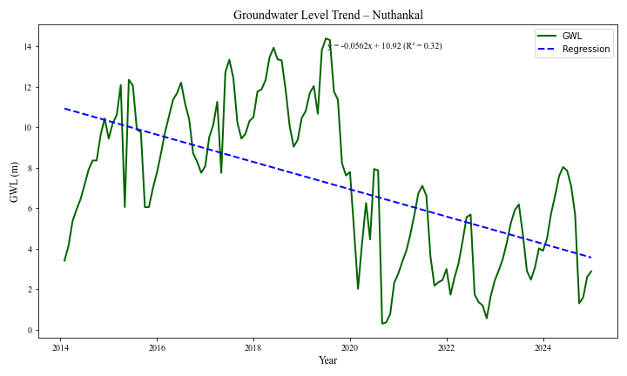

**Fig.1.** Linear Trend analysis of GWL in Nuthankal village, Suryapet (2014-2024)

The MK test (Table 2) showed a negative tau value of –0.33 with a highly significant p-value (p < 0.000001), indicating that the water table is rising significantly over time. The Sen’s slope was –0.054 m/month, meaning the water table has been improving by about 5.4 cm every month or nearly 0.65 m/year (Table 3). Even after accounting for autocorrelation (autocorrelation = 0.826), the trend remained strong, with a modified Kendall’s tau of –0.23 (p = 0.019) confirming a steady and statistically meaningful rise in groundwater levels. These findings are consistent with results from Vinushree et al. (2022), who also reported significant upward groundwater trends using similar non-parametric techniques in semi-arid and Mediterranean environments.

Season-wise analysis revealed the strongest groundwater rise during the monsoon (tau = –0.371), post-monsoon (–0.472), and winter seasons (–0.299), all with p-values less than 0.05, demonstrating significant seasonal recharge (Table 4). The pre-monsoon season showed a weaker and non-significant trend (tau = –0.193, p = 0.118), possibly due to higher water use or dry conditions. Similar seasonal recharge patterns have been documented by Sinha Subha (2023) and Kumar et al., (2023) in their studies on groundwater trends in India.

**Table 2:** Mann-Kendall (MK) and Modified Mann-Kendall (MMK) Test Results for Groundwater Levels in Nuthankal, Suryapet

|  |  |
| --- | --- |
| **Statistic** | **Value** |
| Tau | -0.33 |
| Z (Original) | -5.700 |
| P-value (2-sided) | 1.19E-08 |
| Corrected Zc | -2.35 |
| Corrected P-value | 0.019 |
| N/N* (Correction Factor) | 5.87 |

**Table 3:** Sen’s Slope Estimator for Groundwater Levels in Nuthankal, Suryapet

|  |  |
| --- | --- |
| **Statistic** | **Value** |
| Sen's Slope | -0.054 |
| 95% Confidence Interval (Lower) | -0.070 |
| 95% Confidence Interval (Upper) | -0.038 |
| Old Variance | 258410.3 |
| New (Corrected) Variance | 1516138 |

**Table 4:** Seasonal Mann-Kendall Trend in Groundwater Levels, Nuthankal, Suryapet

|  |  |  |  |
| --- | --- | --- | --- |
| **Season** | **Tau** | **P-value** | **Interpretation** |
| Monsoon | -0.371 | 0.0004 | Significant decreasing trend |
| Post-monsoon | -0.472 | 0.00232 | Significant decreasing trend |
| Pre-monsoon | -0.193 | 0.118 | No significant trend |
| Winter | -0.299 | 0.015 | Significant decreasing trend |

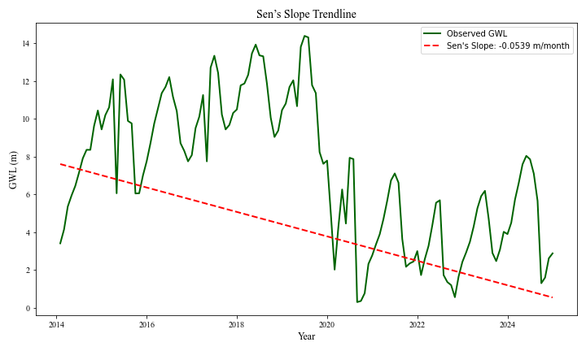

**Fig. 2.** GWL Trend with Sen’s Slope at Nuthankal (2014–2024)

The Innovative Trend Analysis graphs (Figs. 3 and 4) further support these findings, showing that most data points lie above the diagonal reference line, indicating that groundwater levels in recent years have consistently improved compared to earlier periods. This strong upward trend across multiple tests suggests that groundwater in Nuthankal has become more stable, reliable, and easier to access over time. Swain et al. (2022) similarly highlighted the effectiveness of Innovative Trend Analysis combined with Mann-Kendall tests in detecting subtle groundwater improvements in comparable regions.

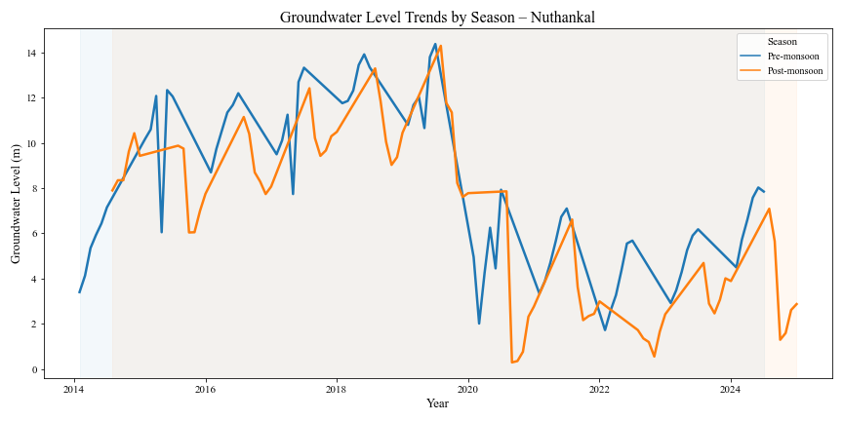

**Fig. 3:** Innovative Trend Analysis of Groundwater Levels in Nuthankal

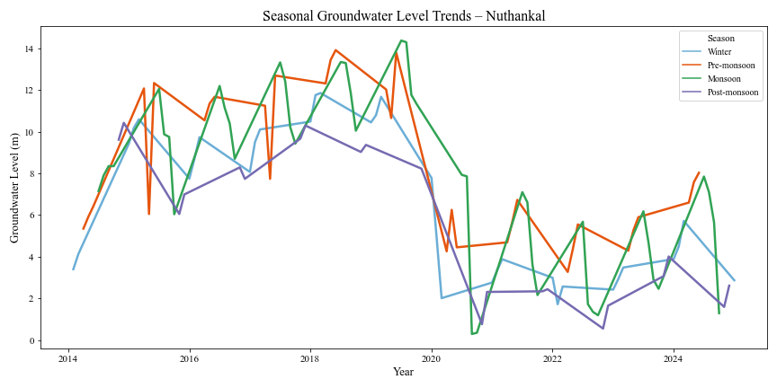

**Fig. 4:** Quartile Segmented Innovative Trend Analysis of Groundwater Levels in Nuthankal

4. Conclusion

The comprehensive analysis of groundwater levels in Nuthankal from 2014 to 2024 reveals a clear and strong improvement from 2014 to 2024. In the earlier years, the water table was very deep, around 10 to 12 meters below the ground, making it hard to access. But by 2024, the water table has risen to around 3 to 5 meters, meaning groundwater is now much easier to reach. This steady improvement is supported by various trend tests like the Mann-Kendall and Sen’s slope, which show that groundwater levels are rising by about 6 cm every month. This positive change has been strongest during the monsoon, post-monsoon, and winter seasons, thanks to better rainfall recharge and possibly reduced water extraction. The Innovative Trend Analysis also clearly shows that groundwater levels in recent years are much better compared to earlier years. This means that the groundwater system in Nuthankal is recovering well, becoming more reliable, and offering hope for better water security in the future if good management practices continue.

References

* Bellamkonda, J., Admala, M., Rathod, S., Tuti, M. D., Kallakuri, S., Bhanusree, D., & Reddy, B. N. K. (2022). Trend analysis of rainfall in Telangana State (India) using advanced statistical approaches. *International Journal of Environment and Climate Change*, 12(11), 3405–3413. Retrieved from <https://www.researchgate.net/publication/364896251>
* Central Ground Water Board. (2024). *Annual Ground Water Quality Report 2024*. Ministry of Jal Shakti, Government of India. Retrieved from <https://cgwb.gov.in/en/annual-ground-water-quality-report-2024>
* Ministry of Jal Shakti. (2024). *Annual Report 2023–24*. Department of Water Resources, River Development & Ganga Rejuvenation. Retrieved from <https://cdnbbsr.s3waas.gov.in/s3a70dc40477bc2adceef4d2c90f47eb82/uploads/2024/07/202407241362014549.pdf>
* Telangana Groundwater Department. (2025). *State Ground Water Level Scenario – January 2025*. Government of Telangana. Retrieved from <https://gwdata.cgwb.gov.in/download/Bulletin/Telangana-WL-Bulletin-January2025.pdf>
* Telangana Groundwater Department. (2025). *Brief Note on State Ground Water Level Scenario – April 2025*. Government of Telangana. Retrieved from <https://gwd.telangana.gov.in/Document/Document_20250626125001154_7115.pdf>
* Preethi, A., Kallakuri, S., Rathod, S., & Meena, A. (2024). Trend Analysis of Rainfall in Mahabubnagar District of Telangana State, India. *International Journal of Environment and Climate Change*, 14(8), 502–510. Retrieved from [http://dx.doi.org/10.9734/ijecc/2024/v14i84370](https://dx.doi.org/10.9734/ijecc/2024/v14i84370)
* Laasya, K. N. V., Kallakuri, S., Rathod, S., Neelima, L., Meena, A., & Jyostna, B. (2024). Statistical assessment of temperature trends and change points in Telangana State, India. *International Journal of Environment and Climate Change*, 14(4), 397–407. Retrieved from <https://journalijecc.com/index.php/IJECC/article/view/4126>
* Vakapalli, P., & Rathod, S. (2024). Spatio-temporal analysis of rainfall and temperature trends in Telangana using Mann–Kendall and Sen’s slope methods. *International Journal of Climate and Water Resources*, 9(1), 55–68. [387-Statistical Analysis of Temperature Trends and Identification of Change Points in Nalgonda District, Telangana State, India.pdf](https://www.plantarchives.org/article/387-Statistical%20Analysis%20of%20Temperature%20Trends%20and%20Identification%20of%20Change%20Points%20in%20Nalgonda%20District,%20Telangana%20State,%20India.pdf)
* Sinha, S. (2023). Analyzing groundwater level trend by hybrid approach in 37 districts of Bihar State, India. *World Water Policy*, 9, 639–668. Retrieved from <https://onlinelibrary.wiley.com/doi/10.1002/wwp2.12131>
* Fuladipanah, H., Sarkar, H., Mishra, R., & Ojha, C. S. P. (2025). Application of machine learning techniques in the evaluation of local groundwater level using field gravity data: Insights from random forest and random tree. *Hydrology Research*, 56(5), 383–396. <https://doi.org/10.2166/nh.2025.108>
* Vinushree, R., Ashalatha, K. V., Saif, M. R., Kumari, V. J., & Shanwad, U. K. (2022). Trend analysis of groundwater level using Mann-Kendall test in Dharwad district. *The Pharma Innovation Journal*, SP-11(5), 596–600. Retrieved from <https://www.thepharmajournal.com/archives/2022/vol11issue5S/PartI/S-11-4-179-635.pdf>
* Swain, S., Das, M., Bhuyan, K., & Borah, D. (2022). Groundwater dynamics in the Middle Brahmaputra River Basin: A case study of shallow aquifers in Inner Guwahati City, Assam, India. *Geographies*, 4(4), 675–686. <https://doi.org/10.3390/geographies4040037>
* Kumar, S., Ahmed, S. A., & Karkala, J. (2023). Time series data and rainfall pattern subjected to climate change using non-parametric tests over a vulnerable region of Karnataka, India. *Journal of Water and Climate Change*, 14(5), 1532–1550. <https://doi.org/10.2166/wcc.2023.441>
* Neel Kamal & Sanjay Pachauri. (2018). Mann-Kendall Test – A Novel Approach for Statistical Trend Analysis. *International Journal of Computer Trends and Technology*, 63(4), 18–24. Retrieved from IJCTT Journal
* Yadav, B., Patidar, N., Sharma, A., Panigrahi, N., Sharma, R. K., Loganathan, V., ... & Parker, A. (2023). Estimation of groundwater recharge in semiarid regions under variable land use and rainfall conditions: A case study of Rajasthan, India. *PLOS Water*, 2(3), e0000061. <https://doi.org/10.1371/journal.pwat.0000061>