***Original Research Article***

**Assessment of genetic variability, heritability and genetic advance for yield and nutritional traits in hybrid rice (*Oryza sativa* L.)**

**ABSTRACT**

The present study was conducted during Kharif, 2024 at ICAR-Indian Institute of Rice Research (IIRR), Hyderabad, to assess genetic variability, heritability, and genetic advance for yield and nutritional traits in sixty rice (Oryza sativa L.) genotypes, comprising 52 advanced breeding lines, three restorers and five checks for yield and nutritional comparison. The experiment was laid out in an alpha lattice design with three replications. Analysis of variance revealed highly significant differences among genotypes for all 14 studied traits, indicating ample genetic variability, which is essential for effective selection and genetic improvement. The phenotypic coefficient of variation (PCV) was slightly higher than the genotypic coefficient of variation (GCV) across all traits, highlighting minor environmental influence. Notably, for days to 50% flowering (DFF), 1000 grain weight (TGW), and single plant yield (SPY), the PCV and GCV values were nearly identical, suggesting that these traits are predominantly governed by genetic factors and are less influenced by the environment. High GCV was recorded for number of unfilled grains per panicle (41.99%), single plant yield (22.55%), number of filled grains per panicle (22.25%), 1000 grain weight (19.91%), indicating high genetic variability. Moderate GCV was observed for plant height, productive tillers, panicle length zinc content in brown and polished rice, and protein content of brown rice, whereas low GCV was noted for days to 50% flowering and spikelet fertility, Iron content of brown rice and polished rice. High heritability coupled with high genetic advance as a percent of mean was recorded for most yield and nutritional traits, suggesting the predominance of additive gene action and effectiveness of simple selection. The study concludes that substantial genetic improvement can be achieved by selecting superior genotypes for both yield enhancement and nutritional biofortification in rice breeding programmes

Keywords: Hybrid Rice, Variability, Heritability, Genetic Advance, Iron, Zinc, Protein content.

1. **INTRODUCTION**

Rice (*Oryza sativa* L.), one of the most important food crops in Asia, supplies more than 90% of the world’s rice and 20% of the global dietary energy and feeds more than half of the world’s population [3]. It is often referred to as the “global grain”[16] and serves as a primary food source for half of the global population and two-thirds of the population in India [1]. As of 2023, the world production volume of rice (milled rice) stands at 522.6 million tonnes[18] while India produces 137.82 million tonnes. In crop year 2023, there were around 168 million hectares of rice-cultivated area worldwide. India was estimated to be the leading global producer of rice and to harvest about 47 million hectares of rice [19]. It is anticipated that by 2030, India’s rice demand will rise to 159 million tonnes, however, historical data reveal that the annual yield growth has only increased by approximately 1% over the last ten years [8]. India’s national average yield, at approximately 2.7–3.0 t ha⁻¹, remains substantially lower due to the continued cultivation of older inbred varieties, fragmented landholdings, limited quality seed access, and suboptimal agronomic practices [4]. These problems can be tackled to a great extent using hybrid rice technology as this results in incorporating rice crop having traits such as higher yields, shorter maturity period, better input efficiency, efficient land use, resilience to stress conditions.

Hybrid rice technology presents a promising method to improve rice yields, particularly in India, where average productivity remains below global benchmarks. Utilizing heterosis through F1 hybrids has been proven to provide a yield increase of 15-20% compared to traditional inbred varieties [14, 23, 24, 25] as evidenced by successes in countries such as China and other Asian nations [17]. Notable variability in grain yield and associated traits among various genotypes has been reported, indicating significant potential for further improvements through hybrid breeding. Recent breeding initiatives have increasingly focused on the dual objectives of enhancing yield potential and improving nutritional quality by selecting genotypes with higher grain iron, zinc, and protein content. Biofortification, which involves enriching rice with essential micronutrients like iron and zinc, provides a sustainable and economical strategy to combat hidden hunger, particularly in populations with limited access to diverse food options [6].

The existence of sufficient genetic variability is considered essential for any effective crop improvement initiative. In rice cultivation, relying solely on phenotypic selection based on performance can sometimes be misleading, as environmental factors may obscure the true genotypic potential, resulting in subpar performance in later generations. Thus, to attain consistent genetic enhancement, it is vital to select genotypes using genetic metrics such as heritability and genetic advance. The genotypic coefficient of variation (GCV) is a dependable measure for assessing the level of genetic variability and indicates the percentage of variation due to genetic factors. Analyzing genetic variability measures alongside heritability and genetic advance aids in forecasting the expected genetic gain from selection [2]. Given this context, the present study was conducted to evaluate a total of 60 rice genotypes, comprising 52 advanced breeding lines developed using zinc-rich donor parents in the background of popular restorer lines, along with three restorers and five checks. The evaluation focused on assessing genetic variability, heritability, and genetic advance for grain yield, its component traits, and key nutritional quality parameters including grain iron, zinc, and protein content. The study aims to identify effective selection strategies and promising genotypes or parental lines for improving grain yield and supporting biofortification efforts in rice breeding programs

**2. MATERIALS AND METHODS**

The present investigation was conducted during Kharif, 2024 at the research farm, ICAR-IIRR, Hyderabad. A total of sixty rice genotypes were evaluated for variability and genetic parameters with respect to yield, yield-attributing and nutritional quality traits. The experimental material comprised fifty-two advanced breeding lines developed in the backgrounds of three widely used restorer lines (IBL57/RN32, RPHR1005, and KMR3R), along with one popular high-yielding variety (BPT5204), one hybrid (US312), one protein-rich variety (CR Dhan 311), and zinc-rich varieties (DRR Dhan 45 and DRR Dhan 48), which were used as checks. The complete list of genotypes used in the present study is presented in Table 2.

Each genotype was sown with a spacing of 20 cm between rows and 15 cm between plants, following an Alpha lattice design with three replications. Standard agronomic practices and recommended package of practices were followed uniformly for all the experimental units. Phenological data on days to 50% flowering were recorded for each genotype. At maturity, five plants were selected randomly to record observations on yield and yield component traits, namely plant height (cm), number of productive tillers per plant, panicle length (cm), number of filled grains per panicle, number of unfilled grains per panicle, spikelet fertility (%), 1000-grain weight (g), and single plant yield (g). In addition, grain samples from each replication were collected for estimation of quality parameters, including iron (Fe) and zinc (Zn) concentrations in both brown and polished rice, and protein content in brown rice, using standard laboratory procedures. Mean performance of the genotypes was calculated, and genetic variability parameters were estimated. The genotypic (GCV) and phenotypic (PCV) coefficients of variation were calculated using the formula given by [2]. The PCV and GCV values were categorized as low (0-10%), moderate (10-20%), and high (>20%) following [15]. Heritability in a broad sense (h²b) was estimated following the method of [7] and [5]. The genetic advance as a percentage of the mean was calculated as per [7]. These genetic parameters provided insight into the variability present in the population and the scope for improvement through selection.

**2.1 Estimation of Variability Parameters**

1. **Genotypic variance**: It is the variance contributed by genetic causes or the occurrence of differences among the individuals due to their genetic makeup.



Where,

Vg = Genotypic variance, MSg = Treatment mean square, MSe = Error mean square, and r = Number of replications

1. **Phenotypic variance**: It is the sum of variances contributed by genetic causes and environmental factors and was computed as;

VP = Vg + MSe

Where,

Vp = Phenotypic variance, Vg = Genotypic variance and MSe = Error mean square

1. **Genotypic coefficient of variation (GCV):** The magnitude of genetic variation existing in the character was estimated by the formula;



GCV

Where,

Vg = Genotypic variance, x̄ = Population mean of the character

**d) Phenotypic coefficient of variation (PCV):** The magnitude of phenotypic variation existing in a character was estimated by using the following formula;



PCV =

Where,

VP = Phenotypic variance, x̄ = Population mean of the character

**Table 1 Classification of Genetic Parameters**

| **Parameter** | **Classification** | **Range** | | **Reference** | | |
| --- | --- | --- | --- | --- | --- | --- |
| **GCV & PCV** | Low | | < 10% | | [15] |
|  | Moderate | | 10 – 20% | |  |
|  | High | | > 20% | |  |
| **Heritability (h²)** | Low | | 0 – 30% | | [12] |
|  | Moderate | | 30.1 – 60% | |  |
|  | High | | > 60% | |  |
| **Genetic Advance (GAM)** | Low | | 0 – 10% | | [7] |
|  | Moderate | | 10.1 – 20% | |  |
|  | High | | > 20% | |  |

**Table 2 List of genotypes used**

|  |  |  |  |  |  |  |  |
| --- | --- | --- | --- | --- | --- | --- | --- |
| S. no. | Genotypes | S. no. | Genotypes | S. no. | Genotypes | S. no. | Genotypes |
| 1 | ABL- 1 | 16 | ABL- 16 | 31 | ABL- 31 | 46 | ABL- 46 |
| 2 | ABL- 2 | 17 | ABL- 17 | 32 | ABL- 32 | 47 | ABL- 47 |
| 3 | ABL- 3 | 18 | ABL- 18 | 33 | ABL- 33 | 48 | ABL- 48 |
| 4 | ABL- 4 | 19 | ABL- 19 | 34 | ABL- 34 | 49 | ABL- 49 |
| 5 | ABL- 5 | 20 | ABL- 20 | 35 | ABL- 35 | 50 | ABL- 50 |
| 6 | ABL- 6 | 21 | ABL- 21 | 36 | ABL- 36 | 51 | ABL- 51 |
| 7 | ABL- 7 | 22 | ABL- 22 | 37 | ABL- 37 | 52 | ABL- 52 |
| 8 | ABL- 8 | 23 | ABL- 23 | 38 | ABL- 38 | 53 | IBL57 |
| 9 | ABL- 9 | 24 | ABL- 24 | 39 | ABL- 39 | 54 | RPHR1005 |
| 10 | ABL- 10 | 25 | ABL- 25 | 40 | ABL- 40 | 55 | KMR3R |
| 11 | ABL- 11 | 26 | ABL- 26 | 41 | ABL- 41 | 56 | CR Dhan 311 |
| 12 | ABL- 12 | 27 | ABL- 27 | 42 | ABL- 42 | 57 | DRR Dhan 45 |
| 13 | ABL- 13 | 28 | ABL- 28 | 43 | ABL- 43 | 58 | DRR Dhan 48 |
| 14 | ABL- 14 | 29 | ABL- 29 | 44 | ABL- 44 | 59 | US312 |
| 15 | ABL- 15 | 30 | ABL- 30 | 45 | ABL- 45 | 60 | BPT5204 |

**RESULTS AND DISCUSSION**

The analysis of variance (ANOVA) revealed highly significant differences among treatments (genotypes) for all the studied traits, indicating the presence of ample genetic variability within the evaluated genotypes (Table 3). The significant treatment effects validate the diversity of the genetic material under study and justify further statistical analysis of variability, heritability, and genetic advance.

**Table 3** **Analysis of variance for yield and its components and nutritional traits in rice (*Oryza sativa* L.)**

|  |  |  |  |  |  |  |  |  |  |
| --- | --- | --- | --- | --- | --- | --- | --- | --- | --- |
| Source of variation | Df | DFF | PH | PL | PT | TGW | FGPP | UG | SF |
| Replication | 2 | 9.867 | 14.65 | 7.96* | 5.86* | 7.98 | 2645.9 | 133.94* | 68.68 |
| Treatments | 59 | 129.07** | 673.19** | 21.21** | 7.13** | 58.21** | 5557.2** | 701.61** | 96.18** |
| Blocks within replications | 15 | 2.843 | 14.09 | 3.05 | 1.94 | 0.494 | 197.1 | 37.13 | 9.56 |
| Error | 103 | 1.427 | 10.50 | 1.99 | 1.59 | 0.492 | 196.8 | 33.45 | 8.76 |
| Total | 179 | 143.21 | 712.43 | 34.21 | 16.52 | 67.18 | 8596.9 | 906.13 | 183.18 |

|  |  |  |  |  |  |  |  |
| --- | --- | --- | --- | --- | --- | --- | --- |
| Source of variation | Df | SPY | IBR | ZBR | IPR | ZPR | PBR |
| Replication | 2 | 0.708 | 1.209 * | 26.90 | 0.063* | 16.40 | 32.95 |
| Treatments | 59 | 41.51** | 1.81** | 23.29** | 0.071 ** | 15.46 ** | 5.01** |
| Blocks within replications | 15 | 0.444 | 0.281 | 3.47 | 0.011 | 2.07 | 0.63 |
| Error | 103 | 0.35 | 0.375 | 2.93 | 0.015 | 1.85 | 0.85 |
| Total | 179 | 43.01 | 3.675 | 56.59 | 0.160 | 35.78 | 39.44 |

**Note: * Indicates significance at 5 per cent probability level Df= Degrees of freedom**

**\*\* Indicates significance at 1 per cent probability level**

**Where, DFF**= Days to 50% Flowering, **PH=** Plant Height (cm), **PT=** Number of productive tillers per plant**, PL=** Panicle Length (cm), **TGW=** Thousand grain weight(g), **FG=** Number of filled grains/panicle, **UG=** Unfilled grains/panicle, **SF=** Spikelet fertility(%), **SPY=** Single plant Yield(g), **IBR=** Iron content of brown rice (ppm), **ZBR=** Zinc content of brown rice (ppm), **IPR=** Iron content of polished rice (ppm), **ZPR=** Zinc content of polished rice (ppm), **PBR=** Protein content of brown rice (ppm).

In contrast, non-significant differences were observed for blocks within replications across most traits. This suggests that the variation among blocks within the same replication was minimal, and the blocking structure effectively controlled field heterogeneity. Significant differences between replications were observed for specific traits such as plant height (PH), number of productive tillers (PT), spikelet fertility (SF), and certain micronutrient parameters like iron and zinc concentrations (e.g., IBR and ZPR). This significance across replications could be attributed to subtle environmental gradients (e.g., moisture, soil fertility, microclimate) existing across different replications in the field layout during the Kharif season, which influenced these specific characters. However, since replication effects are treated as random in the analysis model, the significance observed here does not interfere with the primary objective of estimating genetic variability among genotypes. Similar trends of significant treatment effects, non-significant block effects, and selective significance in replication effects have been reported in rice field evaluations by previous researchers such as [9] and [10]. This reinforces the validity of the experimental layout and the reliability of the results obtained in the present investigation.

The coefficient of variation analysis showed that for all traits, the phenotypic coefficient of variation (PCV) values slightly exceeded the genotypic coefficient of variation (GCV), highlighting the minimal impact of environmental factors on the expression of these traits. Notably, for days to 50% flowering (DFF), 1000 grain weight (TGW), and single plant yield (SPY), the PCV and GCV values were nearly identical, suggesting that these traits are predominantly governed by genetic factors and are less influenced by the environment. Similar findings were reported by [20] for traits such as plant height, days to flowering, and grain yield in rice hybrids, where close proximity of PCV and GCV indicated strong genetic control. The results of the variance analysis are shown in Table 3, while the estimates for mean, variability, heritability, and genetic advance for each trait are detailed in Table 4.

**Table 4. Estimates of mean, range, heritability and genetic advance for yield and yield contributing characters in advanced breeding lines**

|  |  |  |  |  |  |  |  |
| --- | --- | --- | --- | --- | --- | --- | --- |
| Characters | Mean | Range | | Coefficient of variability | | Heritability (%) broad sense | Genetic Advance as percent of mean (at 5%) |
| Min. | Max. | GCV% | PCV% |
| Days to 50% Flowering | 104.28 | 91 | 117 | 6.251 | 6.368 | 96.4 | 12.639 |
| Plant Height (cm) | 115.52 | 74.9 | 151.3 | 12.862 | 13.177 | 95.3 | 25.861 |
| Number of productive  tillers per plant | 22.33 | 6 | 16 | 11.293 | 13.054 | 74.8 | 20.125 |
| Panicle Length (cm) | 8.98 | 16.3 | 28.2 | 15.234 | 20.851 | 53.4 | 22.929 |
| Number of filled grains/panicle | 189.94 | 114 | 282 | 22.254 | 23.448 | 90.1 | 43.509 |
| 1000 grain weight | 22.02 | 13.6 | 32.4 | 19.916 | 20.169 | 97.5 | 40.512 |
| Number of Unfilled grains/panicle | 35.52 | 12 | 85 | 41.998 | 45.084 | 86.8 | 80.593 |
| Spikelet fertility | 84.20 | 64 | 93.8 | 6.403 | 7.313 | 76.7 | 11.551 |
| Single plant Yield | 16.43 | 6.6 | 25.3 | 22.545 | 22.844 | 97.4 | 45.835 |
| Iron content of brown rice (ppm) | 7.49 | 5.76 | 9.27 | 9.272 | 12.278 | 57 | 14.422 |
| Zinc content of brown rice (ppm) | 20.82 | 16.53 | 29.17 | 12.491 | 15.004 | 69.3 | 21.423 |
| Iron content of polished rice (ppm) | 1.50 | 1.16 | 1.86 | 9.117 | 12.167 | 56.2 | 14.074 |
| Zinc content of polished rice (ppm) | 16.49 | 13.08 | 22.98 | 12.098 | 15.349 | 70.7 | 22.360 |
| Protein content of brown rice (ppm) | 10.06 | 7.88 | 13.24 | 11.737 | 14.794 | 62.9 | 19.182 |

In this study, GCV estimates varied significantly among the traits examined. The highest genotypic coefficient of variation (GCV) was noted for the number of unfilled grains per panicle (41.99%), followed by single plant yield (22.55%), the number of filled grains per panicle (22.25%), and 1000 grain weight (19.91 (Table 3). Comparable results were previously documented by [21] for single plant yield and 1000 grain weight, [22] for number of filled grains per panicle and single plant yield, [26] for grain iron and zinc content concerning micronutrient traits and yield-related components in rice. Moderate GCV was observed for plant height (12.86%), the number of productive tillers per plant (11.29%), panicle length (15.23%), zinc content in brown rice (12.49%), and protein content (11.73%). These results align with the findings of [28] for plant height and number of productive tillers, [16] for panicle length and number of productive tillers and [29] for protein content, plant height, and panicle length, who also noted moderate genetic variability for these traits in rice.

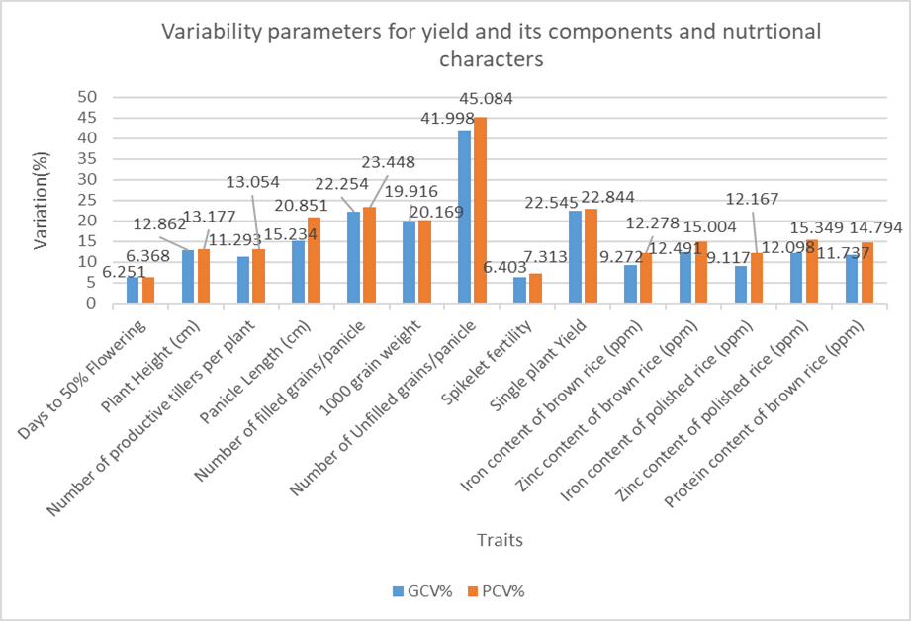

**Figure 1 Variability parameters for yield and its components and nutritional characters**

Conversely, low GCV values were found for spikelet fertility (6.40%), days to 50% flowering (6.25%), iron content in brown rice (9.27%) and iron content in polished rice (9.11%), indicating reduced genetic variability for these traits. Similar observations of low GCV for days to 50% flowering were reported by [13] and [11] while low GCV for spikelet fertility was noted [30] and [27] and for panicle length by [9] and [10]. The fact that PCV values were slightly greater than GCV values across all traits suggests that, although there is significant genetic variability, the influence of environmental factors should not be overlooked in the expression of these traits. This implies that selection-based improvement is possible, particularly for traits with high GCV, as they are less influenced by environmental conditions.

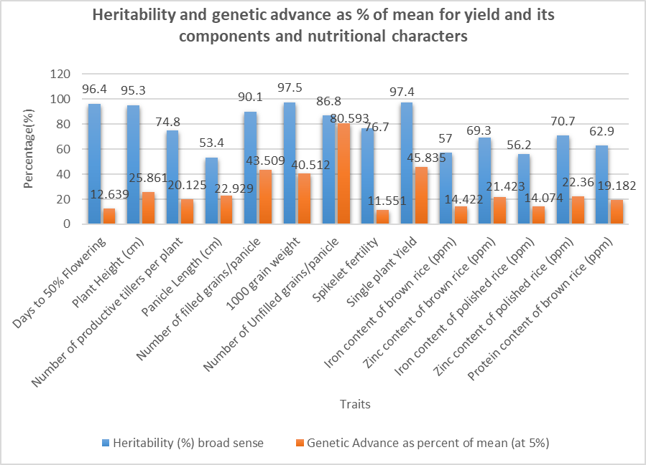

**Figure 2 Heritability and genetic advance as % of mean for yield and its components and nutritional characters**

Considerable variability was observed in the estimates of broad-sense heritability and genetic advance as a percent of mean (GAM) across different yield and nutritional traits (Figure 2). High heritability (>60%) was recorded for most traits, indicating the predominance of genetic factors over environmental influences. Very high heritability (>90%) was observed for days to 50% flowering, plant height, 1000 grain weight, number of unfilled grains per panicle, and single plant yield, suggesting strong genetic control and a high probability of success through direct selection. Moderate heritability (30-60%) was noted for number of filled grains per panicle, panicle length, and spikelet fertility, while grain micronutrient traits exhibited low to moderate heritability, indicating a higher influence of environmental factors. High GAM (>20%) was observed for unfilled grains per panicle, single plant yield, 1000 grain weight, spikelet fertility, and filled grains per panicle, reflecting the predominance of additive gene action and greater scope for genetic improvement through direct selection. In comparison, the noted moderate heritability and low genetic gain per generation for nutritional traits such as grain iron, zinc, and protein levels indicate that simple selection processes are unlikely to yield significant genetic improvements. This challenge arises from the intricate genetic makeup of these traits, which are controlled by multiple minor genes and their responsiveness to environmental variations. While yield-related traits can be effectively enhanced through straightforward phenotypic selection, improving nutritional traits demands a more advanced approach. This includes conducting multi-location trials, employing marker-assisted selection, and implementing biofortification techniques. These findings underscore the importance of adopting trait-specific breeding strategies—conventional selection for yield traits and molecular-assisted approaches for nutritional traits—towards the development of high-yielding, nutrient-rich rice varieties suitable for diverse environments.

**Table 5 Genetic Variability, Heritability and Genetic Advance Summary Based on Present Study**

| **Trait** | **GCV** | **Heritability (h²%)** | **Genetic Advance as % of Mean (GAM)** | **Selection Potential** | **Breeding Implications** |
| --- | --- | --- | --- | --- | --- |
| **Single Plant Yield (SPY)** | High | Very High (97.4%) | Very High (~45.83%) | Very High | Strong additive gene action; direct phenotypic selection will be highly effective |
| **1000-Grain Weight (TGW)** | High | Very High (97.5%) | Very High (~40.51%) | Very High | High potential for improvement through simple selection |
| **Filled Grains per Panicle (FGPP)** | High | High (90.1%) | Very High (~43.50%) | High | Selection will be effective; additive effects predominant |
| **Unfilled Grains per Panicle (UG)** | Very High | High (86.8%) | Very High (~80.59%) | High (for reduction) | Large scope for reducing unfilled grains through selection |
| **Zinc Content (Polished Rice)** | Moderate | Moderate (70.7%) | High (~22.36%) | Moderate | Feasible improvement via selection; suitable for biofortification breeding |
| **Protein Content (Brown Rice)** | Moderate | Moderate (62.9%) | Moderate (~19.18%) | Moderate | Scope exists but slow progress; multiple cycles or recurrent selection preferred |
| **Iron Content (Brown Rice)** | Low–Moderate | Moderate (57%) | Moderate (~14.42%) | Low–Moderate | Limited improvement via direct selection; MAS or introgression preferred |
| **Days to 50% Flowering (DFF)** | Low | Very High (96.4%) | Moderate (~12.63%) | Moderate | Despite high heritability, slow progress expected due to low variability |
| **Spikelet Fertility (SF)** | Low | Moderate–High (76.7%) | Low (~11.55%) | Low | Environmental influence significant; indirect selection advisable |
| **Productive Tillers (PT)** | Moderate | Moderate (74.8%) | Moderate (~20.12%) | Moderate | Additive and non-additive effects; moderate progress through selection |
| **Panicle Length (PL)** | Moderate | Moderate (53.4%) | Moderate (~22.92%) | Moderate | Selection response possible; additive effects moderately expressed |
| **Zinc Content (Brown Rice)** | Moderate | Moderate (69.3%) | High (~21.42%) | Moderate | Selection possible; environmental influence manageable |
| **Iron Content (Polished Rice)** | Low–Moderate | Moderate (56.2%) | Moderate (~14.07%) | Low | Selection less effective; better with MAS or indirect approaches |
| **Plant Height (PH)** | Moderate | Very High (95.3%) | High (~25.86%) | High | Effective improvement through phenotypic selection |

**Table 6 Trait Grouping Based on GCV, Heritability and GAM**

| **Group** | **Traits** | **GCV** | **Heritability** | **GAM** | **Breeding Implications** |
| --- | --- | --- | --- | --- | --- |
| **Group I: High GCV + High Heritability + High GAM** | SPY, TGW, FGPP, UG | High | High | High | Strong additive gene action; rapid gain through selection |
| **Group II: Moderate GCV + Moderate to High Heritability + Moderate GAM** | Zinc (BR, PR), Protein (BR), Productive Tillers, Panicle Length, Plant Height | Moderate | Moderate–High | Moderate–High | Selection effective; biofortification feasible; may require multiple cycles |
| **Group III: Low GCV + High Heritability + Moderate GAM** | Days to 50% Flowering (DFF) | Low | High | Moderate | Selection possible but slow; useful for early maturity lines |
| **Group IV: Low–Moderate GCV + Low–Moderate Heritability + Low–Moderate GAM** | Spikelet Fertility, Iron (BR, PR) | Low–Moderate | Moderate | Low–Moderate | Limited direct selection response; recommend MAS, backcrossing, or recurrent selection |

**CONCLUSION**

The present investigation on sixty diverse rice genotypes, comprising advanced breeding lines and nutritional checks, revealed significant genetic variability for yield traits, yield-attributing components, and nutritional quality traits such as grain iron, zinc, and protein content. The high estimates of genotypic coefficient of variation (GCV), broad-sense heritability and genetic advance as percent of mean (GAM) for key yield traits like grain yield per plant,1000-grain weight, number of filled grains per panicle, and single plant yield indicate the predominance of additive gene action, suggesting that substantial genetic improvement can be effectively achieved through direct phenotypic selection. In contrast, moderate heritability coupled with low genetic advance for nutritional traits, particularly grain iron and protein content, points to complex genetic control and greater environmental influence, necessitating multi-location evaluation and marker-assisted selection strategies. Overall, the study highlights the potential of certain genotypes for combining high yield and improved nutritional quality, providing a robust foundation for future rice breeding programs aimed at enhancing both productivity and nutritional security through targeted selection and biofortification approaches.

**REFERENCES**

1. Behera B, Mohanty S, Bastia D, Sahu RK. (2018). Status of rice production in India and prospects of hybrid rice technology. International Journal of Agriculture, Environment and Biotechnology, 11(2): 227-234.
2. Burton GW. (1952). Quantitative inheritance in grasses. Proceedings of the 6th International Grassland Congress, 1: 277-283.
3. Cheng S, Zeng DL, Lei C, Cao LY, Wang J, Ling HQ, Zhang G, Guo L, Du B, Chen W, Zhu L. (2021). Rice yields and global food security. Annual Review of Plant Biology, 72: 1-28.
4. FAO. (2022). FAOSTAT statistical database. Food and Agriculture Organization of the United Nations. <https://www.fao.org/faostat/en/>
5. Hanson CH, Robinson HF, Comstock RE. (1956). Biometrical studies of yield in segregating populations of Korean Lespedeza. Agronomy Journal, 48(6): 268-272.
6. Jena KK, Hechanova SL, Verdeprado H, Prahalada GD, Kim SM. (2019). Developing rice lines with high iron and zinc through biofortification approach. Agronomy, 9(5): 238.
7. Johnson HW, Robinson HF, Comstock RE. (1955). Estimates of genetic and environmental variability in soybeans. Agronomy Journal, 47(7): 314-318.
8. Khush GS. (2013). Strategies for increasing the yield potential of cereals: case of rice as an example. Plant Breeding, 132(5): 433-436.
9. Nithya R, Sujatha K, Bharathi M, Sreedhar K. (2020). Genetic variability, heritability and genetic advance in rice (*Oryza sativa* L.) hybrids and parental lines for yield and yield components. Journal of Pharmacognosy and Phytochemistry, 9(2): 1335-1339.
10. Pradhan S, Prakash S, Sahu RK, Satpathy S, Mishra B. (2023). Assessment of genetic variability and trait association in rice (*Oryza sativa* L.). International Journal of Chemical Studies, 11(1): 43-47.
11. Rani J, Kumar A, Kumar V, Kumar M. (2022). Genetic variability studies for yield and its contributing characters in rice (*Oryza sativa* L.). International Journal of Environment and Climate Change, 12(12): 183-190.
12. Robinson HF, Comstock RE, Harvey PH. (1949). Estimates of heritability and degree of dominance in corn. Agronomy Journal, 41(8): 353-359.
13. Saha S, Ghosh P, Ghosh P. (2019). Genetic variability, heritability, genetic advance and correlation among yield and quality attributing traits in rice (*Oryza sativa* L.). International Journal of Chemical Studies, 7(1): 120-124.
14. Shull GH. (1914). Duplicate genes for capsule form in Bursa bursa-pastoris. Zeitschrift für Induktive Abstammungs- und Vererbungslehre, 12(1): 97-149.
15. Sivasubramanian S, Madhavamenon P. (1973). Genotypic and phenotypic variability in rice. Madras Agricultural Journal, 60: 1093-1096.
16. Singh S, Kumar S, Kumar D, Kumar S. (2020). Assessment of genetic variability, heritability and genetic advance in rice (*Oryza sativa* L.) under normal and late sown conditions. Journal of Pharmacognosy and Phytochemistry, 9(4): 2187-2191.
17. Sreewongchai T, Toojinda T, Thanintorn N, Kosawang C, Vanavichit A. (2014). Improving yield potential in Thai rice (*Oryza sativa* L.) using hybrid rice breeding technology. SABRAO Journal of Breeding and Genetics, 46(2): 242-255.
18. Statista. (2023). World production volume of milled rice from 2008/09 to 2022/23. <https://www.statista.com/>
19. Statista. (2025). Rice harvested area in India and worldwide. <https://www.statista.com/>
20. Sudeepthi K, Swapna R, Shankar A. (2020). Genetic variability, heritability and genetic advance studies in rice hybrids. Journal of Pharmacognosy and Phytochemistry, 9(4): 1995-1999.
21. Suman K, Rani NS, Babu VR, Hemakanthi B. (2020). Genetic variability studies for yield and its components in rice (*Oryza sativa* L.). The Pharma Innovation Journal, 9(10): 142-145.
22. Umarani R, Sujatha K, Lokeswari Y, Bindu P. (2017). Studies on genetic variability, heritability and genetic advance in rice (*Oryza sativa* L.). International Journal of Pure and Applied Bioscience, 5(6): 940-946.
23. Virmani SS. (1996). Hybrid rice. Advances in Agronomy, 57: 377-462.
24. Virmani SS, Mao CX, Hardy B. (2003). Hybrid Rice for Food Security, Poverty Alleviation and Environmental Protection. International Rice Research Institute (IRRI), Philippines.
25. Yuan LP. (2015). Development of hybrid rice to ensure food security. Rice Science, 22(3): 129-130.
26. Ravindrababu V, Subrahmanyam D, Bhadana VP, Usharani G, Raju NL. (2012). Assessing genetic variability for nutritional and yield traits in rice (*Oryza sativa* L.). Journal of Rice Research, 5(1&2): 24-29.
27. Kumar S, Sharma V, Sharma A, Choudhary S. (2023). Assessment of genetic variability in rice (*Oryza sativa* L.) for yield and its contributing traits. Journal of Pharmacognosy and Phytochemistry, 12(1): 397-400.
28. Devi KN, Singh NB, Athokpam H, Singh L. (2020). Genetic variability, heritability and genetic advance for grain yield and its components in rice (*Oryza sativa* L.). International Journal of Current Microbiology and Applied Sciences, 9(2): 2413-2418.
29. Shivani, Bhatt BP, Gupta HS, Singh AK. (2018). Studies on genetic variability, heritability and genetic advance in advanced breeding lines of rice (*Oryza sativa* L.). Journal of Pharmacognosy and Phytochemistry, 7(2): 680-684.
30. Islam MA, Siddique MA, Rahman MA, Bhuiyan MSR, Shahidullah SM. (2019). Genetic variability, heritability and genetic advance in some selected rice (Oryza sativa L.) genotypes. International Journal of Plant & Soil Science, 28(6): 1-8.