**Original Research Article**

**Haemato-Biochemical and Immunological Profiling of Turkeys (*Meleagris gallopavo*) Under Intensive Rearing System in India**

**Abstract**

The study was undertaken to evaluate the haematological, biochemical, and immunological parameters of turkeys (*Meleagris gallopavo*) reared under an intensive housing system in Indian conditions. A total of 72 day-old healthy turkey poults were wing-banded, weighed, and randomly distributed into three replicates (24 poults each) and maintained under standard management practices as per ICAR (2013) feeding guidelines. Data were recorded at the 6th and 12th weeks of age to assess physiological and immunological development. Among haematological parameters, total erythrocyte count (TEC: 3.34 × 10⁶/µl) and total leukocyte count (TLC: 13.6 × 10³/µl) were significantly higher (p<0.01) at 6 weeks, while haemoglobin (Hb: 10.95 g/dl), packed cell volume (PCV: 36.8%), mean corpuscular volume (MCV: 148.2 fL), and mean corpuscular haemoglobin concentration (MCHC: 28.58 g/dl) were significantly higher (p<0.01) at 12 weeks. Among biochemical parameters, blood glucose (247.79 mg/dl), AST (301.4 U/L), and ALT (5.16 U/L) showed significant variations with age and between replicates, while total protein, creatinine, BUN, cholesterol, and triglycerides did not differ significantly. Immunological assessment revealed that both humoral immunity (HA titre: 4.6) and cell-mediated immunity (PHA-P response: 0.93 mm) were significantly enhanced (p<0.01) at 12 weeks compared to 6 weeks. The study concludes that age significantly influences several blood and immune parameters, and that intensive rearing, when managed effectively, supports normal physiological development and immune competence in turkeys. These findings can serve as a reference for further research and for optimizing turkey production strategies in India.

**Keywords:** *Biochemical, Haematological, Immunological, Intensive rearing, Turkey*

**Introduction**

The poultry sector significantly contributes to India's GDP and provides employment across various socio-economic strata. Indian poultry systems include traditional backyard setups and intensive commercial farming, with the latter evolving over the last four decades into a highly organized, vertically integrated industry. Globally, poultry production comprises chickens (63%), ducks (11%), geese (9%), turkeys (5%), pigeons (3%), and guinea fowls (3%) (Besbes, 2009). Turkey (Meleagris gallopavo), though lesser-known in India, is economically and nutritionally valuable, ranking behind chicken, duck, guinea fowl, and quail in global importance (Anandh and Jagatheesan, 2015). Globally, turkeys account for about 2% of the poultry population (Hayet et al., 2021). In India, Broad Breasted Bronze, Broad Breasted White, and Beltsville Small White are the most common breeds reared (Anandh and Jagatheesan, 2015). Turkey meat is increasingly favored for its high protein and low-fat content, offering 24% protein, 6.6% fat, and 162 kcal per 100 grams (Asaduzzaman et al., 2017). It is also preferred for its superior foraging and fiber digestion capabilities (Thomas et al., 2014). The aesthetic appeal and nutritional value of turkey have bolstered its appeal (Ogundipe and Dafwang, 1980). Blood profile analysis is essential for monitoring bird health. Hematological parameters vary due to multiple factors such as age, sex, breed, and environmental conditions (Olorode and Longe, 2000). Standard values in turkeys include Hb: 9.1–13.2 g/dL, PCV: 32.4–40.6%, erythrocyte count: 2.5–3.3×10⁶/µL, leukocyte count: 15.6–23.1×10³/µL, heterophils: 41–55%, lymphocytes: 37–50%, and monocytes: 3–6% (Arora, 2010). Deviations in these values can signal stress, infection, dehydration, or immunosuppression. Biochemical markers help assess organ functionality. Normal values include total protein: 3.5–5.6 g/dL, albumin: 1.5–2.8 g/dL, glucose: 190–240 mg/dL, cholesterol: 120–180 mg/dL, uric acid: 4.5–8.2 mg/dL, AST: 180–240 U/L, and ALT: 12–20 U/L (Pavlak et al., 2005). Elevated AST and ALT indicate liver dysfunction, while high uric acid suggests renal impairment. Routine monitoring aids early diagnosis and informs therapeutic and nutritional strategies. The turkey’s immune system includes innate and adaptive branches. Adaptive immunity involves cell-mediated and humoral responses, with the latter focusing on antibody production for combating infections. Monitoring antibody titers post-vaccination is a standard practice to evaluate immune response (Yang et al., 2017). Despite its advantages, turkey farming in India is underdeveloped, lacking robust scientific management. Enhancing disease resistance and understanding correlations between humoral immunity and reproductive performance are critical for sustainable development. Scientific rearing practices and targeted genetic improvements are essential for advancing commercial turkey farming under Indian conditions (Thomas et al., 2014).

**MATERIALS AND METHODS:**

The study was carried out at Imaliya Farm, Department of Poultry Science, NDVSU, Jabalpur, using 72 day-old turkey poults procured from the university hatchery and reared under intensive housing up to 12 weeks of age. Uniform brooding, feeding, and watering practices were followed across all replicates. Poults received Lixen powder and Vitamin B-complex during the first three days, and a coccidiostat (Diclazuril @ 1 kg/ton feed) was added during brooding. Vaccination included ND (B1 strain) at day-old, Fowl pox at 4–5 weeks, ND (R2B) at 6 weeks, and Cholera between 8–10 weeks. Skimmed milk powder (40 g/15 L) was added to drinking water 15 minutes before each vaccination to improve efficacy.

**Experimental Design**

All 72 healthy poults were weighed, wing-banded, and randomly assigned into three replicates, each containing 24 birds. The experiment was conducted in a floor housing system with individual pens arranged on both sides of a central passage. Before the start of the experiment, the entire poultry house was thoroughly cleaned, whitewashed, disinfected, and dried, and left vacant for three days to ensure biosecurity. Sawdust was used as litter material and was uniformly spread on the floor to a depth of approximately 2 cm. Each replicate was provided with identical brooding, feeding, and watering arrangements to maintain uniformity. The turkey poults were fed a standard diet formulated as per ICAR (2013) feeding standards. Two phases of feeding were followed: Poult phase (0–6 weeks): Turkey chick ration, Grower phase (6–12 weeks): Turkey grower ration. The composition of the experimental diet is detailed in (Table 1)

**Table 1:** Composition of turkey chick and turkey grower diet

|  |  |  |  |
| --- | --- | --- | --- |
| **S. No.** | **Ingredients**  **(Part/100kg)** | **0-6 weeks diet**  **(CP 24%, 2800 kcal ME/kg)** | **6-12 weeks diet**  **(CP 22%, 2800 kcal ME/kg)** |
| 1 | Maize | 43.5 | 47 |
| 2 | Soyabean meal | 37.5 | 32.6 |
| 3 | Deoiled rice polish | 16.1 | 17.5 |
| 4 | Mineral mixture | 1.50 | 1.50 |
| 5 | Vitamins mixture | 0.25 | 0.25 |
| 6 | Lime stone powder | 0.35 | 0.35 |
| 7 | Dicalcium phosphate | 0.40 | 0.40 |
| 8 | Salt | 0.30 | 0.30 |
| 9 | Coccidiostat (diclazuril) | 0.10 | 0.10 |
| Total | - | 100 | 100 |

**MEASUREMENTS AND OBSERVATIONS**

The following observations were recorded during the experimental period

1. **Hematological Parameter of Turkey:**

**Collection and processing of blood**

About 3 ml of pooled blood sample from 6 birds of each replicate (not more than 1 % of body weight from each bird) was drawn in sterile heparinised vacutainer tube from wing vein puncture, posing minimum disturbance to the bird on day 6th and day 14th at 7.00 A.M. in the morning. Immediately after collection the tubes were transported to the laboratory in ice for further processing. A part of blood sample was used for hematological studies (RBCs, WBCs, DLC, Hb, PCV, MCV, MCH, and MCHC). The remaining blood was utilized for plasma separation and biochemical examination.

1. **Total Erythrocyte Count (TEC)**

The RBC diluting fluid used in this procedure consists of 3.88 g NaCl, 2.50 g Na₂SO₄, 2.91 g Na₂HPO₄·12H₂O, 0.25 g KH₂PO₄, 7.60 g formalin (37%), and 0.10 g methyl violet (28), with distilled water added to make a final volume of 1000 ml. For the estimation of Total Erythrocyte Count (TEC), blood is drawn up to the 0.5 mark in an RBC diluting pipette, followed by the diluting fluid up to the 101 mark. The contents are mixed thoroughly by rotating the pipette between the palms for 2 minutes. A clean hemocytometer with a cover slip is used, and a few drops from the pipette are discarded before allowing the diluted blood to enter the counting chamber by capillary action. After a settling period of 5 minutes, red blood cells are counted under a high-power microscope within 5 secondary squares (80 small squares) of the central large square. Cells on the left and lower boundary lines are included, while those on the right and upper boundaries are excluded. The total number of cells counted in these squares is used to calculate TEC using the formula: TEC = N × 10,000 erythrocytes/μl, where N is the number of cells counted.

1. **Total Leukocyte Count**

The WBC diluting fluid is prepared using 1 ml methylene blue, 3 ml glacial acetic acid, and distilled water to make a total volume of 100 ml. For Total Leukocyte Count (TLC), blood is drawn up to the 0.5 mark in a WBC diluting pipette, and diluting fluid is then added up to the 11 mark. The contents are thoroughly mixed by rotating the pipette between the palms for 2 minutes. The first few drops from the pipette are discarded before loading the hemocytometer chamber. A cover slip is placed on the hemocytometer, and the chamber is filled by gently touching the pipette tip to the junction between the edge of the chamber and the cover slip, allowing diluted blood to enter by capillary action without air bubbles. After allowing 5 minutes for the cells to settle, leukocytes are counted under low power (10X) in the four large corner squares of the hemocytometer. Cells touching the left and lower margins are included, while those on the right and upper margins are excluded. The TLC is calculated using the formula: TLC = N × 50 leukocytes/μl, where N is the total number of cells counted.

1. **Packed Cell Volume (PCV):**

Take the blood sample in the syringe with long needle and insert the needle in hematocrit tube so that it touches the bottom of the tube. Slowly and slowly raise the needle. Simultaneously release blood slowly so that Wintrobe tube gets completely filled to the top without any air bubbles. Then make the level of blood sample upto mark 10 on right side of the Wintrobe tube where calibration is from bottom to top. Put the tube into the centrifuge machine and rotate it at the 3000 rpm for 30 minutes. After centriguagtion we see erythrocyte mass at the bottom called as PCV. A white to grey layer of leucocyte and thrombocyte occurring immediately above the red cell mass called as buffy code and there is plasma. The level at which packed red cells is found is multiplied by 10 which will give the PCV per 100 ml of blood or PCV %.

1. **Estimation of Haemoglobin**

Take 4-5 drops of 0.1 N HCl in graduted tube of Sahils Hemoglobinometer and then add exactly 20 µl (0.02 ml) of blood sample to the hemoglobinometer tube with the help of hemoglobin pipette and mix properly with the help of stirrer. Allow the tube to stand for 10 minutes for formation of acid hematin. Brown colour is developed. Then dilute the hematin solution with distilled water till the colour matchs with glass standards, and read the lower meniscus while taking the readings. This will give Hb concentration as gm per 100 ml of blood or gm% or gm per dl of blood.

1. **Erythrocyte indices**

The following erythrocyte indices were calculated: -

1. **Mean corpuscular volume (MCV) in femtolitre (fL)**

$$MCV (fL=\frac{Vol. of RBC in 100 ml of blood (PCV)}{No of RBC in 100 ml of blood (Count)}$$

Or

$$MCV (fL ) =\frac{ hct (\%) }{RBC (Millon/ml)}×10$$

1. **Mean corpuscular haemoglobin concentration (MCHC) in g/dl**

$$MCHC (g/dl=\frac{Hb (g/dl)}{RBC (million/ml)}×10$$

Or

$$MCHC (g/dl)=\frac{Hb 9g/dl}{RBC (Millon/ml)}×10$$

1. **Biochemical parameters of Turkey:**

Serum was isolated from the blood sample collected at 6 and 12 weeks of age from 6 birds each replicate in 2000 rpm for 15 minutes. Following biochemical parameters were recorded.

1. **Blood glucose:**

Blood glucose was measured by using Glucose Oxidase (Trinder, 1969) method and the result was expressed as milligram per deciliter (mg/dl). In Trinder’s method, glucose in the sample is oxidized to yield gluconic acid and hydrogen peroxidase in the presence of glucose oxidase. Take 1 ml glucose working reagent and add 0.01 ml of sample in a test tube. Mix well and incubate for 15 minutes at 370C.Read absorbance of the standard and each test at 505 nm against reagent blank. Glucose was calculated by the following formula:

$Glucose (mg/dl)=\frac{Absorbance of Test}{Absorbance of Standard}×$ Concentration of Standard (mg/dl)

1. **Total Protein:**

In this study, the Erba Mannheim LiquiXX Total Protein Biuret Method, an end-point diagnostic reagent kit, was employed for the in vitro quantitative estimation of total protein in broiler serum. The procedure involved pipetting 1000 µl of the working reagent into three separate tubes labeled Blank, Standard, and Test. To the Blank tube, 20 µl of distilled water was added; to the Standard tube, 20 µl of protein standard; and to the Test tube, 20 µl of serum sample. The contents of each tube were mixed thoroughly and incubated at 37°C for 10 minutes. Following incubation, the absorbance of the Standard and Test solutions was measured at 546 nm using the reagent blank as reference. This colorimetric method allowed for precise quantification of total protein based on the biuret reaction.

$Total protein (g/dL) = \frac{Absorbance of test }{Absorbance of standard }×$ Concentration of standard (g/dL)

1. **Alanine Transaminase (ALT):**

SGPT/ALT was estimated by 2, 4-DNPH (Reitman and Frankel, 1957), using commercial kit (Span Diagnostics Ltd., India) (Table 2)

**Table 2:** Alanine Transaminase (ALT):

|  |  |  |  |  |  |
| --- | --- | --- | --- | --- | --- |
| **S.No.** | **Pipette into tube marked** | **Blank** | **Standard** | **Test** | **Control** |
| Volume in ml | | | | | |
| **1.** | Reagent 1 | 0.25 | 0.25 | 0.25 | 0.25 |
| **2.** | Serum/Plasma | **-** | **-** | 0.05 | **-** |
| **3.** | Standard (150 U/L) | **-** | 0.05 | **-** | **-** |
| Mixed well and incubated at 37˚C for 60 minutes | | | | | |
| **5.** | Reagent 2 | 0.25 | 0.25 | 0.25 | 0.25 |
| **6.** | Deionised water | 0.05 | **-** | **-** | **-** |
| **7.** | Serum/Plasma | **-** | **-** | **-** | 0.05 |
| Mixed well and standard at room temperature (15 - 30˚C) for 20 minutes | | | | | |
| **9.** | Solution 1(1ml Reagent 3 +9ml DW | 0.25 | 0.25 | 0.25 | 0.25 |
| **10.** | Mixed well and read the O.D. against purified water in a photometer at 505 nm, within 15 minutes | | | | |



1. **Aspartate Transaminase (AST):**

SGOT/AST was estimated by 2, 4-DNPH (Reitman and Frankel, 1957), using commercial kit (Span Diagnostics Ltd., India) (Table 3)

**Table 3:** Aspartate Transaminase (AST):

|  |  |  |  |  |  |
| --- | --- | --- | --- | --- | --- |
| **S.No.** | **Pipette into tube marked** | **Blank** | **Standard** | **Test** | **Control** |
| Volume in ml | | | | | |
| 1. | Reagent 1 | 0.25 | 0.25 | 0.25 | 0.25 |
| 2. | Serum/Plasma | - | - | 0.05 | - |
| 3. | Standard (114 IU/L) | - | 0.05 | - | - |
| Mixed well and incubated at 37˚C for 60 minutes | | | | | |
| 5. | Reagent 2 | 0.25 | 0.25 | 0.25 | 0.25 |
| 6. | Deionized water | 0.05 | - | - | - |
| 7. | Serum/Plasma | - | - | - | 0.05 |
| Mixed well and standard at room temperature (15 - 30˚C) for 20 minutes | | | | | |
| 9. | Solution 1(1ml Reagent 3 + 9ml DW) | 0.25 | 0.25 | 0.25 | 0.25 |
| Mix and read the O.D. against purified water in a photometer at 505 nm, within 15 minutes | | | | | |



1. **Creatinine:**

Creatinine was measured colorimetrically by using Jaffe’s method (Bower, 1980) and the results were expressed as milligram per deciliter (mg/dl). Creatinine reacts with alkaline picrate to produce a Jaffe’s reaction. Take 1 ml reagent and add 0.1 ml of sample in a test tube. Mix well and read initial absorbance (A1) 20 seconds after mixing and final absorbance (A2) 80 seconds after mixing. Creatinine was calculated by the following formula:

Creatinine (mg/dl) = (ΔA of Test / ΔA of Standard) × Concentration of Standard (mg/dl)

Where:

ΔA = A₂ - A₁

(A₂ = absorbance after reaction, A₁ = blank or initial absorbance)

1. **Blood Urea Nitrogen (BUN):**

Blood Urea Nitrogen was measured by using Diacetyl Monoxime Method (Karr,1924) and the results were expressed as miligram per deciliter (mg/dl). Take 1 ml reagent and add 0.02 ml of sample in a test tube. Mix well and aspirate standard followed by samples. BUN was calculated by the following formula:

The correctly formatted formula for calculating Blood Urea Nitrogen (BUN) is:

BUN (mg/dl) = (ΔA of Test / ΔA of Standard) × Concentration of Standard (mg/dl)

Where:

ΔA = A₂ - A₁

(A₂ = absorbance of the sample or standard, A₁ = absorbance of the blank)

1. **Total Cholesterol:**

Erba Mannheim cholesterol *DES* dynamic extended stability CHOD-pad method (with LCF) end point diagnostic reagent kit was used for *in vitro* quantitative determination of cholesterol in broiler serum in this study (Table 4)

**Table 4:** Total Cholesterol

|  |  |  |  |
| --- | --- | --- | --- |
| **Pipette into tubes marked** | **Blank** | **Standard** | **Test** |
| Working Reagent | 1000 µl | 1000 µl | 1000 µl |
| Distilled water | 20 µl | - | - |
| Standard | - | 20 µl | - |
| Test | - | - | 20 µl |

1. Mix well, incubate at 370C for 10 minutes.

2. Aspirate blank followed by standard and tests.

3. Read the absorbance of standard and each test tube against blank at 505 nm on bichromatic analyzer.

$$Cholesterol (mg/dL) =\frac{Absorbance of test}{Absorbance of standard }× concentration of standard (mg/dL)$$

1. **Triglyceride:**

Erba Mannheim Triglycerides *DES* dynamic extended stability with lipid clearing agent GPO–trinder method, end point diagnostic reagent kit was used for *in vitro* quantitative determination of triglycerides in broiler serum in this study (Table 5)

**Table 5:** Triglyceride

|  |  |  |  |
| --- | --- | --- | --- |
| **Pipette into tubes marked** | **Blank** | **Standard** | **Test** |
| Working Reagent | 1000 µl | 1000 µl | 1000 µl |
| Distilled water | 10 µl | - | - |
| Standard | - | 10 µl | - |
| Test | - | - | 10 µl |

1. Mix well, incubate at 370C for 10 minutes.

2. Read the absorbance of standard and each test tube at 505 nm on dichromatic analyzer against reagent blank.

$Triglycerides (mg/dL) =\frac{Absorbance of test }{Absorbance of standard }×$ concentration of standard (mg/dL)

1. **Immune response**
2. **Humoral immune response**
3. **Preparation of sheep red blood cell (SRBC) suspension:**

Blood from jugular vein of healthy sheep was collected in Alsever’s solution. The blood was centrifuged at 2500 rpm for about 10 minutes. The supernatant was discarded and red blood cells were washed thrice in PBS. Suspension of SRBC (1% v/v) in PBS was prepared and stored in refrigerator at 4˚C until use.

1. **Immunization and harvesting of immune serum:**

1.0 ml suspension of SRBC was injected intravenously to 6 birds in each replicate to study the primary antibody response to SRBC. After 5 days 2 ml blood was collected from the wing vein. The blood was allowed to clot, the serum was collected and frozen (-20˚C) until analyzed for the antibody titres to SRBC.

**Haemagglutination test (HA test):**

The antibody titre to SRBC was determined by HA methods (Siegel and Gross, 1980).

**Procedure:**

1. 50 µl of PBS was pipetted out in each well of the micro titter plate.
2. 50 µl of serum was added in the first well.
3. Two fold serial dilution were made up to row 11 and 12 was kept as control.
4. 50 µl of 1% SRBC was added in each well and mixed by gentle tapping
5. The plates were covered and then kept at 37˚C for 1 hour for incubation.
6. The plates were read under bright light.
7. The reciprocal of highest dilution showing clear agglutination was the ends titre. The titre were expressed as log 2.
8. **Cell-mediated immune response:**

The cellular immune response was assessed by cutaneous basophilic hypersensitivity test by using PHA-P (Phytohaemagglutinin, lectin from *Phaseolus vulgaris*). 6 birds from each replicate were selected and the toe thickness of both left and right foot at 3rd and 4th interdigital spaces were measured by micrometer. Immediately after measurements 100 mg of PHA-P suspended in 0.1 ml of phosphate buffer saline (PBS) and 0.1 ml of PBS was injected into right and left foot (acted as control), respectively. The web swelling of both the foots were measured 24 hours after injection. The cell-mediated immune response (CMIR) or Foot Web Index was determined by using the following formula

FWI = (R2-R1) - (L2-L1) (Corrier and DeLoach, 1990).

where R2- thickness after 24 hours of PHA-P injection

R1- thickness before injection of PHA-P

L2- thickness after 24 hours of PBS solution

L1- thickness before injection of PBS solution

**STATISTICAL ANALYSIS:**

Statistical analysis of the data was done by analysis of variance using completely randomized design (CRD) as per Snedecor and Cochran (1994). Differences among the treatments were tested for significance by Duncan’s Multiple Range Test (1955).

**RESULTS AND DISCUSSION:**

**1. Haematological Studies**

The haematological profile observed in this study presents values for Total Erythrocyte Count (TEC), Total Leukocyte Count (TLC), Haemoglobin (Hb), Packed Cell Volume (PCV), Mean Corpuscular Volume (MCV), and Mean Corpuscular Hemoglobin Concentration (MCHC) across three replicates (R1, R2, R3) at 6 and 12 weeks of age, as shown in (Table 6 and Figures 1 and 2). TEC values showed a gradual decline from 6th to 12th week across all replicates, with R2 recording a significantly higher TEC at the 12th week (p<0.01). TLC values remained consistent across replicates, with no significant differences throughout the experimental period. For haemoglobin concentration, R2 demonstrated significantly higher levels at the 6th week (p<0.01), while all replicates converged to comparable values by the 12th week. PCV values at the 6th week were significantly higher in R2 (p<0.01), though no significant variation was found at the 12th week. MCV values remained statistically similar across replicates, suggesting stable red cell size throughout. MCHC values showed significant differences at both 6th and 12th weeks, with R3 registering the highest MCHC at 12 weeks (p<0.01). These findings corroborate earlier studies by Lazar et al. (2012) in hybrid B.U.T 6 turkeys and other research by Olaniyi et al. (2012), Sogunle et al. (2008), and Safiyu et al. (2020), who noted minimal impact of rearing systems on turkey haematology. The TEC, TLC, Hb, and PCV values fall within normal physiological ranges previously established for indigenous and crossbred turkeys (Isidahomen et al., 2013). Contrarily, studies on chickens by Addass et al. (2012) and Etim et al. (2014) indicated higher haematological indices in indoor-reared birds, highlighting species-specific responses. Moreover, Milenkaya et al. (2013) reported sex and reproductive stage-related variations in haematological indices, which could explain discrepancies due to physiological or environmental differences from the current study.

**Table 6: Hematological parameters of Turkey in different replicates at 6 weeks interval**

|  |  |  |  |  |
| --- | --- | --- | --- | --- |
| **Parameters** | **Age** | **R1** | **R2** | **R3** |
| **TEC**  **(106/µl)** | **6th week** | 3.34±0.03 | 3.35±0.03 | 3.32±0.00 |
| **12th week** | 3.13b±0.02 | 3.21a±0.02 | 3.20a±0.00 |
| **TLC**  **(103/µl)** | **6th week** | 13.63±0.16 | 13.58±0.16 | 13.58±0.00 |
| **12th week** | 12.94±0.13 | 13.05±0.13 | 13.07±0.00 |
| **Hb**  **(g/dl)** | **6th week** | 10.24b±0.15 | 10.57a±0.15 | 10.52ab±0.00 |
| **12th week** | 10.95±0.13 | 11.20±0.13 | 10.99±0.00 |
| **PCV**  **(%)** | **6th week** | 36.29b±0.39 | 37.20a±0.39 | 36.41ab±0.00 |
| **12th week** | 36.83±0.40 | 36.20±0.40 | 36.62±0.00 |
| **MCV**  **(fL)** | **6th week** | 145.54±2.25 | 147.54±2.25 | 146.37±0.00 |
| **12th week** | 146.54±2.27 | 148.25±2.27 | 147.20±0.00 |
| **MCHC**  **(g/dl)** | **6th week** | 28.04a±0.51 | 27.70ab±0.51 | 26.75b±0.00 |
| **12th week** | 27.41b±0.47 | 27.41b±0.47 | 28.58a±0.00 |

Means with atleast one common superscripts in a column are nonsignificant (p<0.01)

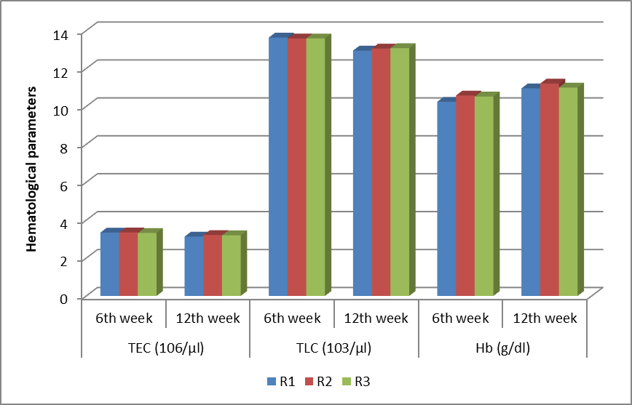

**Figure 1: Hematological parameters of Turkey in different replicates at 6 weeks interval**

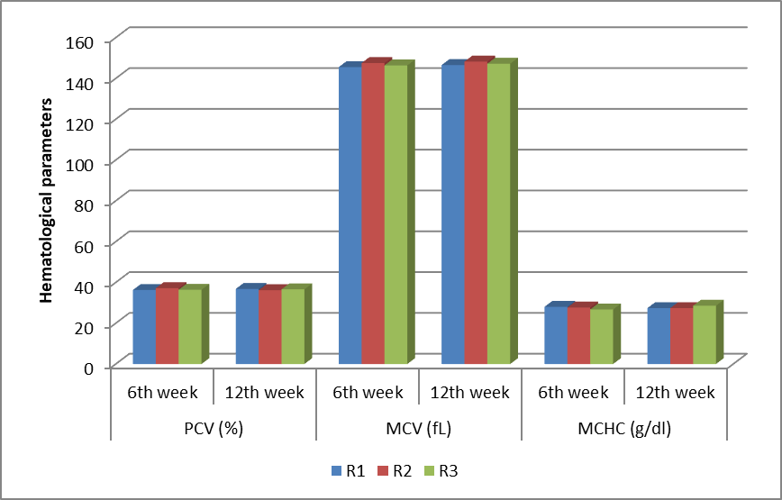

**Figure 2: Hematological parameters of Turkey in different replicates at 6 weeks interval**

**2. Biochemical Studies**

The biochemical parameters of turkeys were assessed at 6-week intervals to evaluate their physiological and metabolic responses under intensive rearing, with data represented in (Table 7 and Figures 3–5). Blood glucose levels showed a statistically significant increase in R3 at the 6th week (p<0.01), while no significant differences were noted at the 12th week. Total protein values remained consistent across all replicates throughout the study period, indicating stable protein metabolism. Aspartate transaminase (AST) and alanine transaminase (ALT) activities increased from the 6th to the 12th week in all replicates, though no significant differences were observed, suggesting uniform liver function. Creatinine levels remained identical (0.15 ± 0.00 mg/dL) across all replicates and time points, reflecting stable renal function. Similarly, blood urea nitrogen (BUN) values showed minimal variation between 1.33 and 1.35 mg/dL, with no significant differences among groups. Total cholesterol levels ranged from 128.91 to 137.87 mg/dL, while triglyceride concentrations varied between 171.25 and 175.16 mg/dL, neither showing significant replicate-based variation. These observations align with Bounous et al. (2000), who documented glucose values of 215–500 mg/dL and cholesterol levels of 60–220 mg/dL in wild juvenile turkeys, with noted seasonal fluctuations. The cholesterol values recorded in the present study suggest physiological normalcy and absence of metabolic stress. Comparable ALT, AST, total protein, and globulin values were also reported by Schmidt et al. (2010), while Ibrahim et al. (2012) provided similar serum values in turkeys raised under semi-arid Nigerian conditions. Slightly higher biochemical indices observed by Agina et al. (2015) in domestic turkeys such as total cholesterol (185.7 mg/dL), creatinine (1.05 mg/dL), AST (83.68 IU/L), and ALT (13.08 IU/L) could be attributed to breed differences, dietary variations, or environmental influences, underscoring the relevance of localized physiological benchmarks in turkey farming.

Bottom of Form

**Table7: Biochemical parameters of Turkey in different replicates at 6 weeks interval**

|  |  |  |  |  |
| --- | --- | --- | --- | --- |
| **Parameters** | **Age** | **R1** | **R2** | **R3** |
| **Blood glucose (mg/dl)** | **6th week** | 241.91b±4.37 | 247.50ab±4.37 | 252.83a±0.00 |
| **12th week** | 247.79±4.11 | 247.91±4.11 | 254.04±0.00 |
| **Total protein (g/dl)** | **6th week** | 3.67±0.09 | 3.55±0.09 | 3.55±0.00 |
| **12th week** | 3.63±0.08 | 3.59±0.08 | 3.63±0.00 |
| **AST (U/L)** | **6th week** | 269.25±3.68 | 275.70±3.68 | 272.70±0.00 |
| **12th week** | 292.20±4.80 | 301.41±4.80 | 296.30±0.00 |
| **ALT (U/L)** | **6th week** | 4.45±0.09 | 4.51±0.09 | 4.43±0.00 |
| **12th week** | 5.09±0.09 | 5.16±0.09 | 5.05±0.00 |
| **Creatinine (mg/dl)** | **6th week** | 0.15±0.00 | 0.15±0.00 | 0.15±0.00 |
| **12th week** | 0.15±0.00 | 0.15±0.00 | 0.15±0.00 |
| **BUN (mg/dl)** | **6th week** | 1.33±0.00 | 1.34±0.00 | 1.34±0.00 |
| **12th week** | 1.34±0.00 | 1.35±0.00 | 1.35±0.00 |
| **Total cholesterol (mg/dl)** | **6th week** | 128.91±3.59 | 134.25±3.59 | 131.41±0.00 |
| **12th week** | 136.37±3.80 | 137.87±3.80 | 132.00±0.00 |
| **Triglyceride (mg/dl)** | **6th week** | 175.16±2.28 | 172.30±2.28 | 172.45±0.00 |
| **12th week** | 171.25±2.18 | 174.12±2.18 | 174.50±0.00 |

Means with atleast one common superscripts in a column are nonsignificant (p<0.01)

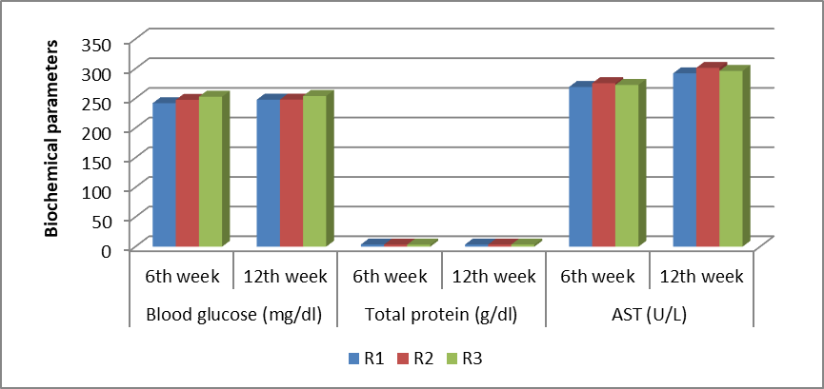

**Figure 3: Biochemical parameters of Turkey in different replicates at 6 weeks interval**

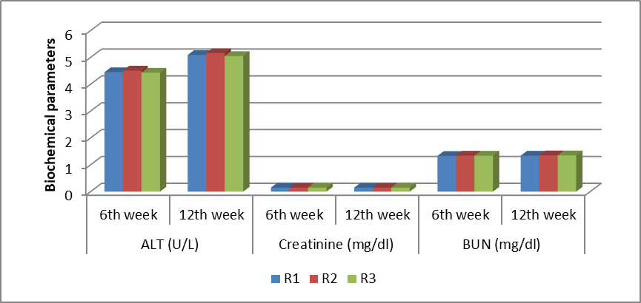

**Figure 4: Biochemical parameters of Turkey in different replicates at 6 weeks interval**

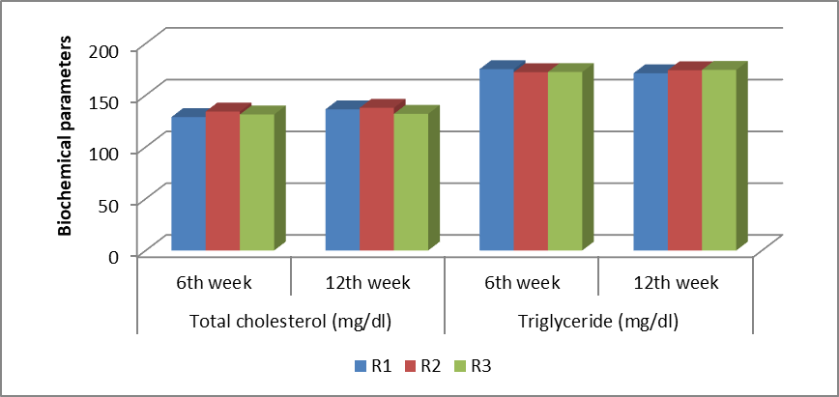

**Figure 5: Biochemical parameters of Turkey in different replicates at 6 weeks interval**

**3. Immunological Studies**

The immunological performance of turkeys reared under an intensive system was evaluated at 6 and 12 weeks using two key indicators humoral and cell-mediated immunity with data presented in (Tables 8 and 9 and visualized in Figures 6 and 7). Humoral immunity, assessed through haemagglutination (HA) titre against sheep red blood cells (SRBCs), showed values of 3.33 ± 0.59 (6th week) and 4.66 ± 0.74 (12th week) in R1, 3.33 ± 0.59 and 4.33 ± 0.74 in R2, and 3.33 ± 0.00 and 4.00 ± 0.00 in R3, with no statistically significant differences across replicates, indicating consistent antibody responses. Cell-mediated immunity, measured via toe web swelling in response to intradermal phytohaemagglutinin-P (PHA-P) injection, showed significant variation; R1 exhibited the highest swelling response at 12 weeks (0.93 ± 0.01 mm, p<0.01), suggesting stronger cellular immunity. These findings are consistent with Li et al. (2000), who reported peak antibody titres on day 10 in males and day 7 in females post-primary SRBC challenge, and day 7 in both sexes after a secondary challenge. Loa et al. (2001) documented a significant HA titre increase (~3.4) by day 3 post-SRBC injection and toe web swelling of 0.35–0.48 mm in turkeys, with no significant group-wise differences. Cheema et al. (2007) also observed comparable humoral and cell-mediated responses in both commercial and random-bred turkey strains, emphasizing that while genetic background influences immune response, environmental conditions and nutrition are crucial determinants. Bhattacharyya et al. (2018) further reported that maternal dietary interventions did not affect humoral responses to SRBC in turkey poults, supporting the present study’s finding of uniform HA titres across replicates, thus reinforcing the idea that rearing system and experimental diet had minimal effect on the humoral immune profile.

A total of 72 healthy day-old turkey poults were wing-banded, weighed, and randomly assigned into three replicates with 24 poults each, receiving uniform brooding, feeding, and watering conditions. Standard poult and grower rations were provided as per ICAR (2013) feeding norms. Blood sampling and parameter evaluation were carried out at the 6th and 12th weeks of age. Among the haematological indices, TEC (3.34 × 10⁶/µl) and TLC (13.6 × 10³/µl) were significantly higher (p<0.01) at the 6th week, whereas Hb (10.95 g/dl), PCV (36.8%), MCV (148.2 fL), and MCHC (28.58 g/dl) showed significantly elevated values (p<0.01) at the 12th week. Biochemical analysis revealed significant differences in blood glucose (247.79 mg/dl), AST (301.4 U/L), and ALT (5.16 U/L) between age intervals and across replicates (p<0.01), while parameters such as total protein (3.63 g/dl), creatinine (0.15 mg/dl), BUN (1.35 mg/dl), cholesterol (137.8 mg/dl), and triglycerides (175.1 mg/dl) remained statistically unaffected. Immunological evaluation showed that humoral immunity, measured via HA titre against SRBCs, was significantly higher (p<0.01) at the 12th week (4.0–4.6) than the 6th week. Similarly, cell-mediated immunity assessed through toe web swelling following PHA-P injection peaked at the 12th week (mean: 0.93 mm, p<0.01), indicating a progressive enhancement in immune response with age under intensive rearing conditions.

**Table 8: HA titre of Turkey in different replicates at 6 weeks interval**

|  |  |  |  |
| --- | --- | --- | --- |
| **Interval** | **R1** | **R2** | **R3** |
| **6th week** | 3.33±0.59 | 3.33±0.59 | 3.33±0.00 |
| **12th week** | 4.66±0.74 | 4.33±0.74 | 4.00±0.00 |

Means with atleast one common superscripts in a column are nonsignificant (p<0.01)

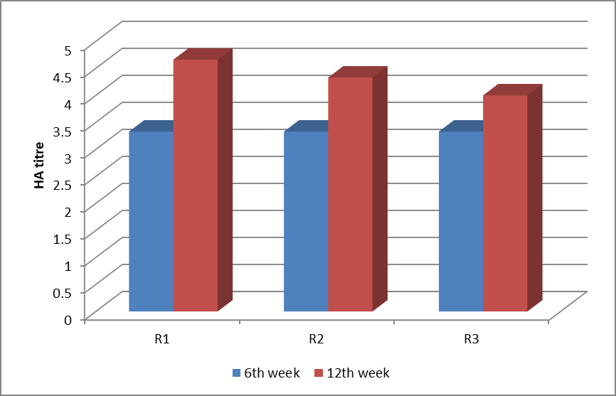

**Figure 6: HA titre of Turkey in different replicates at 6 weeks interval**

**Table 9: Cell-mediated immunity (by using PHA-P) (in mm) of Turkey in different replicates at 6 weeks interval**

|  |  |  |  |
| --- | --- | --- | --- |
| **Interval** | **R1** | **R2** | **R3** |
| **6th week** | 0.84a±0.01 | 0.76b±0.01 | 0.77b±0.00 |
| **12th week** | 0.93a±0.01 | 0.85b±0.01 | 0.86b±0.00 |

Means with atleast one common superscripts in a column are nonsignificant (p<0.01)

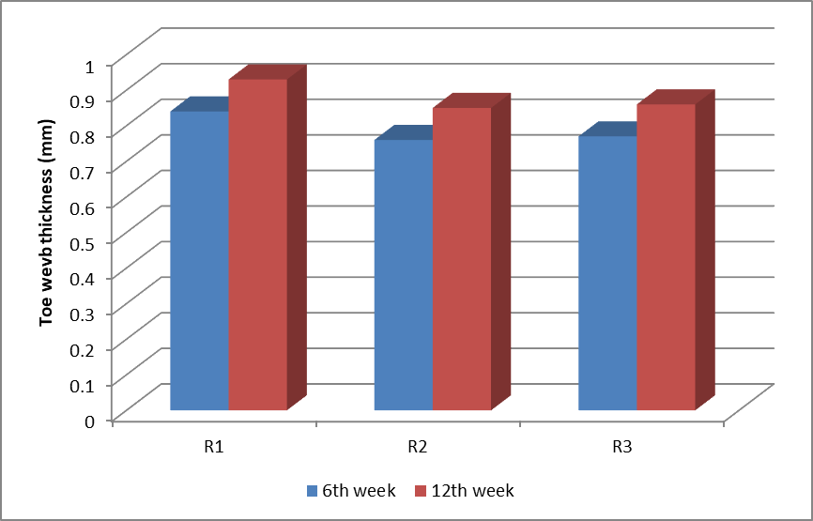

**Figure 7: Cell-mediated immunity (by using PHA-P) (in mm) of Turkey in different replicates at 6 weeks interval**

**CONCLUSION**

The present study highlights the dynamic changes in haematological, biochemical, and immunological parameters of turkeys reared under an intensive system, demonstrating that age plays a significant role in physiological development. Haematological indices such as TEC and TLC were significantly higher at the 6th week, while Hb, PCV, MCV, and MCHC increased at the 12th week, reflecting progressive haematological maturation. Among the biochemical parameters, blood glucose, AST, and ALT exhibited significant variations with age and between replicates, suggesting ongoing metabolic adaptation. In contrast, total protein, creatinine, BUN, cholesterol, and triglycerides remained relatively consistent, indicating stable physiological status across different stages of growth. Immunologically, both humoral and cell-mediated responses were significantly enhanced at 12 weeks of age, confirming that immune competence strengthens as birds mature. These outcomes reinforce the importance of age-appropriate management, nutrition, and health monitoring to support optimal growth and immunity. The results also establish a valuable reference point for future research and practical strategies related to genetic selection, nutritional formulation, and disease prevention in turkeys reared under Indian conditions.

COMPETING INTERESTS DISCLAIMER:

Authors have declared that they have no known competing financial interests OR non-financial interests OR personal relationships that could have appeared to influence the work reported in this paper.

**REFERENCES:**

Agina, O.A., Ezema, W.S. and Nwishienyi, C.N. (2015). Haemato-biochemical profile of apparently healthy domestic turkeys (*Meleagris gallopavo*) in Nsukka, Enugu state, Nigeria. *Animal Research International*, 12(1): 2120-2129.

Anandh, M.A. and Jagatheesan, P.N.R. (2015). Reproductive performance of beltsville small white and broad breasted bronze turkeys (*Meleagris gallopavo*) under hot humid climatic condition. *Indian Journal of Animal Research*, 49(6): 847-850.

Arora, K.L. (2010). Differences in haemoglobin and packed cell volume in blood collected from different sites in Japanese quail (*Coturnix japonica*). *International Journal of Poultry Science*, **9**(9): 828-830.

Asaduzzaman, M., Salma, U., Ali, H.S., Hamid, M.A. and Miah, A.G. (2017). Problems and prospects of turkey (*Meleagris gallopavo*) production in Bangladesh. *Research in* *Agriculture Livestock and Fisheries*, **4**(2): 77-90.

Besbes, B. (2009). Genotype evaluation and breeding of poultry for performance under sub-optimal village conditions. *World’s Poultry Science Journal*, 65: 260-271.

Bhattacharyya, A., Majumdar, S., Bhanja, S.K., Mandal, A.B. and Kadam, M. (2018). Effect of maternal dietary manipulation and in ovo injection of nutrients on the hatchability indices, post-hatch growth, feed consumption, feed conversion ratio and immunocompetence traits of turkey poults. *Journal of Applied Animal Research*, **46**(1): 287-294.

Bounous, D.I., Wyatt, R.D., Gibbs, P.S., Kilburn, J.V. and Quist, C.F. (2000). Normal hematologic and serum biochemical reference intervals for juvenile wild turkeys. *Journal of Wildlife Diseases*, **36**(2): 393-396.

Brant, A.W. (1998). A brief history of the turkey. *World´s Poultry Science Journal*, 54(4):   
 365-373.

Cheema, M.A., Qureshi, M.A., Havenstein, G.B., Ferket, P.R. and Nestor, K.E. (2007). A comparison of the immune response of 2003 commercial turkeys and a 1966 randombred strain when fed representative 2003 and 1966 turkey diets. *Poultry Science*, **86**(2): 241-248.

Duncan, D.B. (1955). Duncan new multiple range test. *Biometrics*, **11**: 1-42.

Etim, N.N., Williams, M.E., Akpabio, U. and Offiong, E.A. (2014). Haematological parameters and factors affecting their values. *Agricultural Science* **2**(1): 37-47.

Hayet, S., Sujan, K.M., Mustari, A. and Miah, M.A. (2021). Hemato-biochemical profile of turkey birds selected from Sherpur district of Bangladesh. *International Journal of Advanced* *Research in Biological Sciences*, 8(6): 1-5.

Ibrahim, A.A., Aliyu, J., Abdu, M.I. and Hassan, A.M. (2012). Effects of age and sex on serum biochemistry values of turkeys (*Meleagris gallopavo*) reared in the semi-arid environment of Nigeria. *World Applied Sciences Journal*, **16**(3): 433-436.

ICAR. (2013). Nutrient requirements of Animals-Poultry (ICAR-NIANP). pp 13-16.

Isidahomen, C.E., Njidda, A.A. and Amaza, I.B. (2013). Effect of genotype on haematology and serum biochemistry values of turkeys (*meleagris gallopavo*) reared in Southern Nigeria. *International Journal of Agriculture and Biosciences*, **2**(1): 297-301.

Lazar, R., Boişteanu, P.C., Muntean, C., Apetroaei, C.A. and Ciobanu, M.M. (2012). Characterisation of the haematological profile of the hybrid BUT 6 turkey raised in Romania. *University of Agricultural Sciences and Veterinary Medicine Iasi*, **58**(2): 254-257.

Li, Z., Nestor, K.E., Saif, Y.M. and Anderson, J.W. (2000). Antibody responses to sheep red blood cell and *Brucella abortus* antigens in a turkey line selected for increased body weight and its randombred control. *Poultry Science*, **79**(6): 804-809.

Loa, C.C., Lin, T.L., Wu, C.C., Bryan, T., Thacker, H.L., Hooper, T. and Schrader, D. (2001). Humoral and cellular immune responses in turkey poults infected with turkey coronavirus. *Poultry Science*, **80**(10): 1416-1424.

Miah, G., Khanom, M.F., Lima, A., Sohel, S. and Hossain, M.A. (2020). Comparative performance of three varieties of turkey (*Meleagris gallopavo*) raised under semi-intensive system. *Bangladesh Journal of Veterinary and Animal Sciences*, **8**(1): 29-34.

Milenkaya, O., Weinstein, N., Legge, S. and Walters, J.R. (2013). Variation in body condition indices of crimson finches by sex, breeding stage, age, time of day, and year. *Conservation Physiology*, **1**(1): 1-14.

Ogundipe, S.O. and Dafwang, I.I. (1980). Turkey production in Nigeria. *National Agricultural Extension Research and Liaison Service Bulletin*, **22**: 2-22.

Olaniyi, O.A., Oyenaiya, O.A., Sogunle, O.M., Akinola, O.S., Adeyemi, O.A. and Ladokun, O.A. (2012). Free-range and deep litter housing systems: effect on performance and blood profile of two strains of cockerel chickens. *Tropical and Subtropical Agroecosystems,* **15**(2): 511-523.

Olorode, B.R. and Longe, O.G. (2000). Effect of replacing palm kernel cake with shea butter cake on quality characteristics, haematology and serum chemistry of laying hens. *Nigerian Journal of Animal Production*, **27**: 19-23.

Onyeanusi, B.I. (2007). Calcium and Phosphorus levels in Nigerian guinea fowls. *International Journal of Poultry Science*, **6**(8): 610-611.

Pavlak, M., Vlahovic, K., Jarcic, J., Dorc, A. and Zupancic, Z. (2005). Age, sexual and seasonal differences of haematological values and antibody status to Chlamydophila species in feral and racing pigeons from an urban environment. *European Journal of* *Wildlife Research*, **51**(4): 271-276.

Safiyu, K.K., Sogunle, O.M., Egbeyale, L.T., Morolayo, O.A., Odutayo, O.J. and Shittu, T.A. (2020). A study on the impacts of rearing system, sex and plumage colour on haemato-biochemical indices of local turkey breeds (*Meleagris gallopavo*). *Tropical Agriculture*, **97**(1): 5-10.

Schmidt, E.M., Paulillo, D.S., Martins, A.C. and Lapera G.R. (2009). Hematology of the Bronze turkey: Variation with age and gender. *International Journal of Poultry* *Science*, **8**(8): 752-754.

Snedecor, G.W. and Cochran, W.G. (1994). Statistical Methods, 8th Edn., The lowa state university press, Ames, Lowa, USA, 503 p.

Sogunle, O.M., Egbeyale, L.T., Bajomo, T.T., Bamigboje, O.V. and Fanimo, A.O. (2008). Comparison of the performance, carcass characteristics and haematological parameters of broiler chicks reared in cage and floor. *Pakistan Journal of Biological Sciences,* **11**(4): 480-483.

Thomas, K.S., Reetha, T.L. and Babu, M. (2014). Growth performance of Turkeys under field condition. *The Indian Journal of Field Veterinarians*, **9**(4): 82.

Yang, L., Liu, S., Ding, J., Dai, R., He, C., Xu, K. and Meng, H. (2017). Gut microbiota co-microevolution with selection for host humoral immunity. *Frontiers in Microbiology*, **8**(5): 1-4.