***Original Research Article***

**Genetic Variability and Principal Component Analysis of Phenotypic Traits in Aromatic Rice Genotypes**

**Abstract**

**Aims:** To assess genetic variability and identify key phenotypic traits influencing yield in aromatic rice genotypes using principal component analysis (PCA) for targeted breeding programs.

**Study design:** Augmented Randomized Block Design.

**Place and Duration of Study:** ICAR-Indian Institute of Rice Research, Hyderabad, India, during the 2023 cropping season.

**Methodology:** Ninety-six rice genotypes, alongside five control varieties (three aromatic are Pb 1121, HUR 1309, RNR 15459; two non-aromatic are MTU 1010, Gb 3), were evaluated for phenotypic traits including plant height, flag leaf length, number of tillers, panicle length, filled grains per panicle, 1000-grain weight, grain yield, harvest index, plant yield, and days to 50% flowering. Analysis of variance (ANOVA) was conducted to assess treatment effects, with phenotypic (PCV) and genotypic (GCV) coefficients of variation calculated. Heritability and genetic advance as a percentage of the mean (GAM) were estimated. PCA was applied to identify traits contributing to variance.

**Results:** ANOVA revealed significant treatment effects (P < 0.01) for all traits, indicating high genetic variability. Panicle length showed the highest variability (PCV: 38.61%, GCV: 37.62%) and genetic advance (GAM: 76.81%). Heritability ranged from 27% (1000-grain weight) to 99.42% (flag leaf length). PCA identified four components explaining 71.67% of total variance, with flag leaf length, plant height, and productive tillers as major contributors. Significant block effects were observed, suggesting environmental influences.

**Conclusion:** The study confirms substantial genetic diversity in aromatic rice genotypes, with high heritability and genetic advance indicating potential for phenotypic selection. Key traits identified by PCA can guide breeding programs to enhance yield and resilience, though robust experimental designs are needed to mitigate environmental effects.

**Keywords:** Genetic variability, aromatic rice, phenotypic traits, principal component analysis (PCA), heritability, genetic advance.

**1.Introduction**

Rice (*Oryza sativa* L.) is an essential cereal crop that serves as the primary energy source and staple food for more than half of the world's population, with approximately 90% of its production and consumption concentrated in Asia (Khan *et al.* 2015). The genetic diversity of rice, which includes its wild ancestors and landraces, represents a crucial resource for breeding programs focused on developing new varieties that exhibit improved yield, stress resistance, and adaptability (Nambara and Nonogaki, 2012; Nachimuthu *et al.* 2015). Despite the availability of this extensive genetic reservoir, only a limited portion has been effectively utilized, resulting in a high degree of genetic similarity among commercial rice cultivars (Das et al., 2013). Aromatic rice, known for its superior grain quality and appealing aroma, constitutes a significant agricultural commodity, particularly in India, where it accounts for over 30% of the cultivated area, primarily consisting of small to medium-grained varieties (Chakravorty and Ghosh, 2013; Sarma *et al.* 2016). Since the mid-20th century, traditional breeding practices have markedly enhanced rice yields; however, the increasing food demand driven by population growth necessitates further exploration of genetic resources (Perez-de-Castro *et al.* 2012).

Genetic variability is essential for effective breeding, as it enables breeders to select for desirable traits such as high yield and stress tolerance, which are frequently heritable (Tiwari *et al.* 2011). Landraces, characterized by their local adaptation and resistance to biotic and abiotic stresses, are particularly valuable for crop improvement, in contrast to many modern varieties that may lack these attributes (Kovach and McCouch, 2008; Sang and Ge, 2013). A comprehensive understanding of genetic divergence among rice genotypes is critical for the selection of parental lines for hybridization, thereby optimizing heterotic combinations and conserving resources (Ahmed *et al.* 2016). However, the evaluation of multiple traits can be intricate, as many may not significantly contribute to the discrimination of germplasm.

Principal Component Analysis (PCA) serves as a vital multivariate analytical tool that simplifies this complexity by condensing multidimensional data into a limited number of principal components that encapsulate the majority of the variation (Maji and Shaibu, 2012; Tiwari *et al.* 2020). PCA produces eigenvectors and component scores, which enable breeders to identify traits with substantial discriminatory power, where higher coefficients signify greater efficacy in distinguishing accessions (Leonard and Peter, 2009; Ringer, 2008). This analytical approach is particularly advantageous for examining yield and associated traits in aromatic rice landraces, as it elucidates patterns and reduces redundancy within datasets (Nachimuthu *et al.* 2014; Mahendran *et al.* 2015). By quantifying the importance of each dimension, PCA facilitates the selection of genetically diverse parental lines, thereby enhancing breeding efficiency and supporting the development of high-yielding, resilient rice varieties to address global food demands.

**2.Materials and Methods**

The current study was carried out at the ICAR-Indian Institute of Rice Research (ICAR IIRR) situated in Hyderabad, India. The experimental framework comprised 96 rice genotypes in addition to five standard (check) varieties, which included three aromatic genotypes (Pb 1121, HUR 1309, RNR 15459) and two non-aromatic genotypes (MTU 1010, Gb 3). The cultivation was executed using an Augmented Randomized Block Design, which incorporated replications of the check varieties. Seedlings, aged 25 days and nurtured in a nursery, were transplanted at a spacing of 20 cm x 15 cm. For each genotype within each replication of the check, five representative plants were randomly selected to assess various phenotypic traits, including plant height (cm), flag leaf length (cm), flag leaf width (cm), total tillers per plant, productive tillers per plant, panicle length, spikelets per panicle, biological yield, harvest index, test weight, and seed yield per plant (g). The days to 50% flowering and days to maturity were calculated on a plot basis, and the data were subjected to statistical analysis. Variability was evaluated following the analysis of variance (ANOVA) procedures as delineated by (Panse and Sukhatme 1967). The phenotypic coefficient of variation (PCV) and genotypic coefficient of variation (GCV) were calculated using the formula established by (Burton *et al.* 1952), while broad-sense heritability (h²) was estimated in accordance with the methodology proposed by (Burton and De Vane 1953). The expected genetic advance was computed utilizing the approach described by (Johnson *et al.* 1955), with R software employed for the analysis. Principal Component Analysis (PCA) was implemented to reduce the dimensionality of the multivariate data to a limited number of principal axes, generating an eigenvector for each axis and producing component scores for the measured traits. The analysis of principal components, eigenvalues, eigenvectors, and the biplot between PC1 and PC2 was conducted using KAU Grapes software.

**3.Results and Discussion**

**3.1 Analysis of variance (ANOVA)**

The research findings include an analysis of variance (ANOVA) that identifies significant treatment effects on various phenotypic traits, with highly significant differences (**P ≤ 0.01**) observed for traits such as 1000-grain weight (1000GW), days to fifty percent flowering (DFF), filled grains per panicle (FGPP), flag leaf length (FLL), number of tillers (NT), plant height (PH), panicle length (PL), productive tillers (PT), and single plant yield (SPY),(Table 1). These results indicate substantial treatment influence and genetic variability among the entries. Although block effects were significant for most traits, suggesting variability due to environmental or management factors, productive tillers did not exhibit significant block effects, indicating a degree of uniformity. Further analysis indicated that both check varieties and test entries significantly contributed to the observed variation, with notable differences between them for several traits; however, 1000GW and productive tillers displayed non-significant differences, suggesting comparable performance. Overall, the results underscore the potential for selecting superior genotypes for yield and related traits, while also highlighting the necessity of a robust experimental design due to the significant block effects observed.

**3.2 Variability Parameters**

The analysis of variance demonstrated significant differences among aromatic rice varieties across all examined traits, highlighting considerable genetic variability within the germplasm, which is essential for effective crop enhancement. The phenotypic coefficient of variation (PCV) consistently surpassed the genotypic coefficient of variation (GCV), indicating some degree of environmental influence; however, genetic factors were predominantly influential. Among the traits assessed, panicle length (PL) exhibited the highest variability, with a PCV of 38.01% and a GCV of 37.62%. This was followed by filled grains per panicle (FGPP), which had a PCV of 32.90% and a GCV of 31.22%, and single plant yield (SPY), with a PCV of 29.94% and a GCV of 28.83%. Additionally, the number of tillers (NT), productive tillers (PT), and 1000-grain weight (1000GW) also displayed high variability, with both PCV and GCV exceeding 25% (Table 2). In contrast, plant height (PH) and flag leaf length (FLL) demonstrated moderate variability, while days to 50% flowering (DFF) exhibited the lowest variability, with a PCV of 9.70% and a GCV of 9.14%. The minimal difference between PCV and GCV for most traits suggests a limited environmental impact, thereby facilitating effective phenotypic selection, which is consistent with the findings of (Selvaraj *et al.* 2011), (O.T *et al.* 2017), and (Sumanth *et al.* 2017).

**3.3 Heritability**

Heritability estimates were notably high, ranging from 86.27% for 1000GW to 99.42% for FLL. Traits such as PL (97.96%), NT (96.28%), and PH (98.61%) exhibited heritability values exceeding 90%, indicating strong genetic control and the potential for effective phenotypic selection. These findings corroborate the results of (Anbanandan *et al.* 2009), (Dhurai *et al.* 2014), (Khatun *et* *al*. 2015), and (Bitew *et* *al*. 2016), which confirm high heritability for critical rice traits.

**3.4 Genetic Advance**

The genetic advance as a percentage of the mean (GAM) was highest for PL (76.81%), FGPP (61.12%), and FLL (40.97%), suggesting substantial potential for improvement through selection. NT (53.92%), PT (55.06%), and SPY (57.29%) also demonstrated high GAM values, while DFF (17.77%) and 1000GW (51.06%) exhibited moderate values. The combination of high heritability and high GAM indicates the presence of additive gene action, thereby supporting straightforward selection methods for genetic enhancement, as noted by (Johnson *et* *al*. 1955), (Singh *et* *al*. 2016).

**3.5 Principal Component Analysis**

The results of the Principal Component Analysis (PCA) elucidated the genetic variation among the genotypes for all phenotypic traits under investigation. Principal components with eigenvalues exceeding 1 and a variation percentage greater than 4% were deemed significant (Brejda *et al*. 2000). The outcomes of the PCA illustrated the genetic diversity among rice genotypes concerning the studied traits. 'Eigenvalues' serve as a measure of the significance and contribution of each component to the total variance, while each coefficient of the eigenvectors indicates the extent of contribution of each original variable associated with each principal component. There are no standardized tests to ascertain the significance of eigenvalues and coefficients (Jolliffe, 2002) (Table 3 and Figure 1). Appropriate values assess the importance and contribution of each component to the overall variance, while each value reflects the degree of contribution of the various principal components explaining the variability. This suggests a tendency for these components to remain correlated and should be considered during the utilization of these traits in breeding programs (Chakravorty *et al*. 2013).

Principal Component Analysis (PCA) indicated that among the nine characteristics examined, only four principal components (PCs) demonstrated eigenvalues exceeding 1 collectively accounting for approximately 71.67% of the cumulative variability among the studied traits. The remaining components were excluded from further analysis due to their eigenvalues being less than one. Principal components with eigenvalues >1 explained more total variation in the data than individual attributes (Brejda *et al*. 2000). Similar results were obtained by (Ahmed *et al*. 2016). where the first five principal components were found to be significant and contributed 82.9% of the total variation in 31 rice germplasm. Consequently, these four PCs were prioritized for additional interpretation. Among these, PC1 accounted for the highest variation, explaining 28.3% of the total variance with an eigenvalue of 1.6. The subsequent principal components, PC2, PC3, and PC4, elucidated variations of 18.36%, 13.4%, and 11.61%, respectively. Only these four components, which possessed eigenvalues greater than 1, were deemed suitable for further investigation. Principal components with eigenvalues exceeding 1 are known to elucidate a greater total variation in the dataset compared to individual attributes (Brejda *et al*. 2000). Similar findings were reported by (Dhakal *et* *al*. 2020), who identified that the first five principal components were significant and contributed to 84.67% of the total variation in a study involving 30 rice germplasm.

The principal component PC1 exhibited positive correlations with the variables FLL (0.1905), X1000gw (0.138), and PH (0.0994), while demonstrating negative correlations with PL (-0.1106), FGPP (-0.2872), DFF (-0.2991), SPY (-0.3912), PT (-0.5414), and NT (-0.5518). PC2 showed positive correlations with PH (0.5696), PL (0.5128), FLL (0.3102), PT (0.1418), NT (0.13), and DFF (0.0087), while negatively correlating with FGPP (-0.0885), SPY (-0.3166), and X1000gw (-0.4138). PC3 had positive correlations with X1000gw (0.3201), PT (0.3177), NT (0.3124), and PL (0.1452), while negatively correlating with PH (-0.1174), SPY (-0.2269), FLL (-0.276), DFF (-0.3659), and FGPP (-0.6345). Lastly, PC4 exhibited positive correlations with X1000gw (0.5653), FLL (0.5607), SPY (0.331), DFF (0.296), PH (0.2944), PT (0.0758), and NT (0.0681), while showing negative correlations with PL (-0.0923) and FGPP (-0.2519) (refer to Table 4 and Figure 2). Through PCA, we were able to identify the traits responsible for genotypic variation within the group. Ilieva et al. (2019) also reported four principal components with eigenvalues greater than 1, which accounted for 72.48% of the total variance, underscoring the significant influence of the identified traits on the phenotypes of germplasm lines. PCA has been employed by various researchers, including (Gana *et al.* 2013), (Yugandhar *et al*. 2018), and (Ilieva *et al.* 2019), for the characterization of different rice germplasm lines. This analytical approach is instrumental in identifying traits that significantly impact the phenotypes of various rice landraces, which is crucial for the selection processes in breeding programs.

**Table 1. Analysis of variance for 9 characters in aromatic rice germplasm**

|  |  |  |  |  |  |  |  |  |  |  |
| --- | --- | --- | --- | --- | --- | --- | --- | --- | --- | --- |
| Source | Df | Mean.Sq | | | | | | | | |
| **1000GW** | **DFF** | **FG PP** | **FLL** | **NT** | **PH** | **PL** | **PT** | **SPY** |
| Block (ignoring Treatments) | 7 | 18.04** | 112.22** | 3248.56** | 55.39** | 19.33** | 556.55** | 95.77** | 12.06** | 67.25** |
| Treatment (eliminating Blocks) | 100 | 19.27** | 115.57** | 2884.10** | 42.85** | 12.52** | 657.13** | 84.26** | 9.12** | 61.11** |
| Treatment: Check | 4 | 102.18** | 202.29** | 7693.28** | 44.28** | 101.50** | 219.93** | 2.60ns | 73.12** | 376.62** |
| Treatment: Test and Test vs. Check | 96 | 15.81** | 111.96** | 2683.72** | 42.80** | 8.81** | 675.35** | 87.67** | 6.45** | 47.97** |
| Error (Residuals) | 28 | 2.34 | 12.39 | 288.97 | 0.24 | 0.38 | 5.85 | 1.87 | 0.13 | 2.31 |

(FGPP: filled grains per panical, PT: productive tillers, PL: panical length, PH: plant height, NT: number of tillers FLL: flag leaf length, DFF: days to 50 % flowering 1000gw: thousand grain weight, SPY: single plant yield).

**Table 2: Estimates of range, grand mean, coefficients of variation (%), heritability and genetic advance for 9 characters in aromatic rice germplasm.**

|  |  |  |  |  |  |  |  |  |  |  |  |  |  |  |
| --- | --- | --- | --- | --- | --- | --- | --- | --- | --- | --- | --- | --- | --- | --- |
| Trait | Mean | PV | GV | EV | GCV | GCV.category | PCV | PCV.category | ECV | hBS | hBS.category | GA | GAM | GAM.category |
| 1000GW | 14.38 | 17.01 | 14.68 | 2.34 | 26.65 | High | 28.69 | High | 10.63 | 86.27 | High | 7.34 | 51.06 | High |
| DFF | 108.44 | 110.60 | 98.21 | 12.39 | 9.14 | Low | 9.70 | Low | 3.25 | 88.80 | High | 19.26 | 17.77 | Medium |
| FG PP | 163.70 | 2901.02 | 2612.05 | 288.97 | 31.22 | High | 32.90 | High | 10.38 | 90.04 | High | 100.05 | 61.12 | High |
| FLL | 32.29 | 41.60 | 41.36 | 0.24 | 19.92 | Medium | 19.97 | Medium | 1.52 | 99.42 | High | 13.23 | 40.97 | High |
| NT | 11.73 | 10.14 | 9.76 | 0.38 | 26.64 | High | 27.15 | High | 5.24 | 96.28 | High | 6.32 | 53.92 | High |
| PH | 122.90 | 420.94 | 415.09 | 5.85 | 16.58 | Medium | 16.69 | Medium | 1.97 | 98.61 | High | 41.74 | 33.96 | High |
| PL | 25.20 | 91.71 | 89.84 | 1.87 | 37.62 | High | 38.01 | High | 5.43 | 97.96 | High | 19.35 | 76.81 | High |
| PT | 9.84 | 7.15 | 7.02 | 0.13 | 26.93 | High | 27.17 | High | 3.63 | 98.22 | High | 5.42 | 55.06 | High |
| SPY | 18.86 | 31.88 | 29.57 | 2.31 | 28.83 | High | 29.94 | High | 8.06 | 92.76 | High | 10.81 | 57.29 | High |

(FGPP: filled grains per panical, PT: productive tillers, PL: panical length, PH: plant height, NT: number of tillers FLL: flag leaf length, DFF: days to 50 % flowering X1000gw: thousand grain weight, SPY: single plant yield).

**Table 3: Eigen value, proportion and cumulative variation of analyzed components**

|  |  |  |  |
| --- | --- | --- | --- |
| Principal Component | Eigen value | Proportion of Variance | Cumulative Proportion |
| PC1 | 2.5 | 28.304 | 28.304 |
| PC2 | 1.7 | 18.355 | 46.659 |
| PC3 | 1.2 | 13.403 | 60.062 |
| PC4 | 1.0 | 11.61 | 71.672 |
| PC5 | 0.9 | 9.456 | 81.129 |
| PC6 | 0.7 | 7.319 | 88.448 |
| PC7 | 0.6 | 6.573 | 95.02 |
| PC8 | 0.4 | 4.43 | 99.45 |
| PC9 | 0 | 0.55 | 100 |

**Table 4: Principal components for studied traits in 101 rice genotypes**

|  |  |  |  |  |  |  |  |  |  |
| --- | --- | --- | --- | --- | --- | --- | --- | --- | --- |
| Traits | PC1 | PC2 | PC3 | PC4 | PC5 | PC6 | PC7 | PC8 | PC9 |
| SPY | -0.3912 | -0.3166 | -0.2269 | 0.331 | -0.0292 | -0.3643 | -0.0004 | 0.6714 | 0.0356 |
| 1000gw | 0.138 | -0.4138 | 0.3201 | 0.5653 | 0.2353 | -0.3329 | -0.1174 | -0.4558 | 0.001 |
| DFF | -0.2991 | 0.0087 | -0.3659 | 0.296 | 0.5951 | 0.5674 | 0.0403 | -0.1061 | 0.0031 |
| FLL | 0.1905 | 0.3102 | -0.276 | 0.5607 | -0.444 | 0.0346 | 0.5114 | -0.1088 | -0.0724 |
| NT | -0.5518 | 0.13 | 0.3124 | 0.0681 | -0.2031 | 0.0739 | -0.087 | -0.1192 | -0.7127 |
| PH | 0.0994 | 0.5696 | -0.1174 | 0.2944 | -0.0002 | -0.1199 | -0.7354 | 0.0725 | 0.0689 |
| PL | -0.1106 | 0.5128 | 0.1452 | -0.0923 | 0.5279 | -0.5023 | 0.4041 | 0.0237 | -0.0218 |
| PT | -0.5414 | 0.1418 | 0.3177 | 0.0758 | -0.2409 | 0.0899 | 0.0492 | -0.1769 | 0.693 |
| FGPP | -0.2872 | -0.0885 | -0.6345 | -0.2519 | -0.1206 | -0.3912 | -0.0945 | -0.5168 | -0.0042 |

(FGPP: filled grains per panical, PT: productive tillers, PL: panical length, PH: plant height, NT: number of tillers FLL: flag leaf length, DFF: days to 50 % flowering 1000gw: thousand grain weight, SPY: single plant yield).

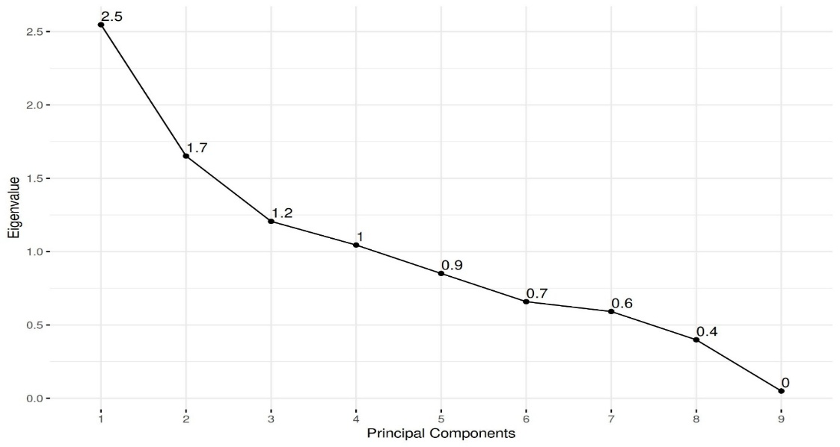

Figure 1: Contribution of each principal component to total explained variance in the phenotypic diversity of rice genotypes.

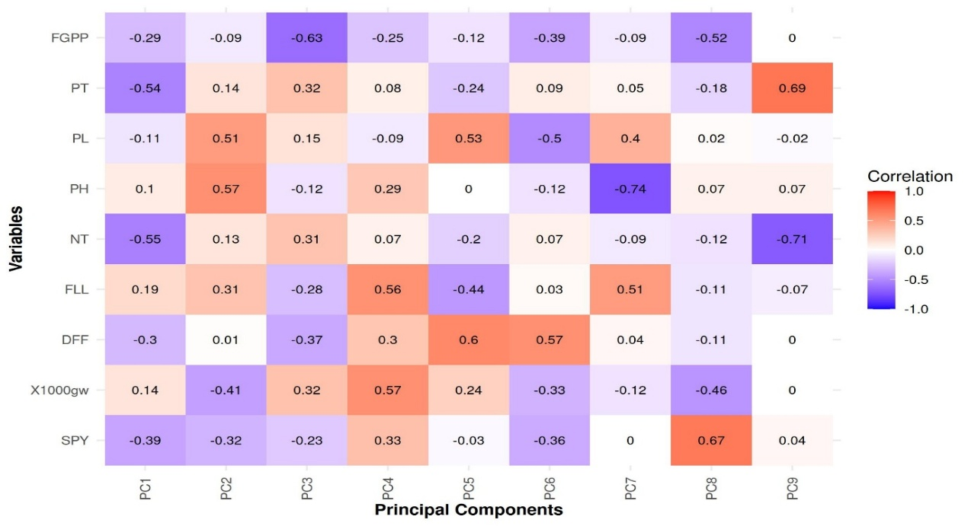

Figure 2: Principal component analysis and its component value for 101 phenotypic traits of rice genotypes. Red shades represent positive correlations, blue shades indicate negative correlations, White or neutral colors show weak or no correlation. (FGPP: filled grains per panical, PT: productive tillers, PL: panical length, PH: plant height, NT: number of tillers FLL: flag leaf length, DFF: days to 50 % flowering X1000gw: thousand grain weight, SPY: single plant yield).

**4.CONCLUSION**

The research highlights the substantial genetic diversity observed among rice hybrids in relation to critical agronomic characteristics. This was evidenced by the analysis of variance (ANOVA), which indicated highly significant treatment effects (P ≤ 0.01) across various traits, including 1000-grain weight, days to fifty percent flowering, filled grains per panicle, flag leaf length, number of tillers, plant height, panicle length, productive tillers, and single plant yield. The identified variability, coupled with high heritability estimates ranging from 86.27% to 99.42% and significant genetic advance as a percentage of mean (GAM), which reached up to 76.81% for panicle length, suggests a robust genetic foundation for these traits and considerable potential for improvement through phenotypic selection. The minimal disparity between phenotypic (PCV) and genotypic (GCV) coefficients of variation indicates a limited influence of environmental factors, thereby enhancing the reliability of trait selection. Furthermore, Principal Component Analysis (PCA) revealed the genetic diversity, with four principal components explaining 71.67% of the total variance, and identified key traits such as flag leaf length, plant height, and productive tillers as significant contributors to phenotypic variation. The presence of significant block effects for most traits underscores the importance of employing rigorous experimental designs to reduce the impact of environmental or management variability. Overall, these findings demonstrate the potential for selecting superior rice genotypes concerning yield and related traits, thereby supporting focused breeding programs aimed at advancing crop improvement.

References

Ahmed, H. U., Abdullah, H. M., Akhter, M., & Ahmed, Z. U. (2016). Genetic variability and character association in aromatic rice. Bangladesh Journal of Agricultural Research, 41(1), 67-77.

Anbanandan, V., Jebaraj, S., & Vanniarajan, C. (2009). Genetic variability and heritability studies in rice (Oryza sativa L.). Madras Agricultural Journal, 96(1-6), 1-4.

Bitew, A., Alemayehu, G., & Tolessa, B. (2016). Genetic variability, heritability and genetic advance for yield and yield related traits in upland rice (Oryza sativa L.) genotypes in Northwestern Ethiopia. African Journal of Biotechnology, 15(19), 839-846.

Brejda, J. J., Moorman, T. B., Karlen, D. L., & Dao, T. H. (2000). Identification of regional soil quality factors and indicators: I. Central and Southern High Plains. Soil Science Society of America Journal, 64(6), 2115-2124.

Burton, G. W. (1952). Quantitative inheritance in grasses. Proceedings of the 6th International Grassland Congress, 1, 277-283. Burton, G. W., & De Vane, E. H. (1953). Estimating heritability in tall fescue (Festuca arundinacea) from replicated clonal material. Agronomy Journal, 45(10), 478- 481.

Chakravorty, A., & Ghosh, P. D. (2013). Genetic diversity in aromatic rice genotypes using agro-morphological traits. Journal of Crop and Weed, 9(2), 109-114. Das, B., Sengupta, S., Parida, S. K., Roy, B., & Ghose, M. (2013).

Genetic diversity and population structure of rice landraces from Eastern India. Genetic Resources and Crop Evolution, 60(3), 1239-1253. Dhakal, K., Kushwaha, U. K. S., & Dhakal, K. H. (2020).

Genetic diversity analysis of rice (Oryza sativa L.) genotypes using principal component analysis. Archives of Agriculture and Environmental Science, 5(3), 283-290.

Dhurai, S. Y., Reddy, D. M., & Reddy, K. H. P. (2014). Genetic variability, heritability and genetic advance in rice (Oryza sativa L.). Andhra Pradesh Journal of Agricultural Sciences, 20(2), 1-5.

Gana, A. S., Shaba, S. Z., & Tsado, E. K. (2013). Principal component analysis of morphological traits in thirty-nine accessions of rice (Oryza sativa L.) grown in a rainfed lowland ecology of Nigeria. Journal of Plant Breeding and Crop Science, 5(6), 120-126.

Ilieva, V., Ivanova, V., & Penchev, E. (2019). Evaluation of genetic diversity in rice (Oryza sativa L.) using principal component analysis. Agricultural Science and Technology, 11(3), 223-228.

Johnson, H. W., Robinson, H. F., & Comstock, R. E. (1955). Estimates of genetic and environmental variability in soybeans. Agronomy Journal, 47(7), 314-318.

Jolliffe, I. T. (2002). Principal Component Analysis. 2nd ed. New York: Springer. Khan, M. A., Hanif, M., Abbas, M., Mahmood, A., & Jaskani, M. J. (2015). Genetic diversity in rice (Oryza sativa L.) germplasm. Pakistan Journal of Agricultural Sciences, 52(1), 1-6.

Kovach, M. J., & McCouch, S. R. (2008). Leveraging natural diversity: back to the future for rice improvement. Crop Science, 48(2), 525-537.

Maji, A. T., & Shaibu, A. A. (2012). Application of principal component analysis for rice germplasm characterization and evaluation. Journal of Plant Breeding and Genetics, 1(2), 87-93.

Nachimuthu, V. V., Robin, S., Sudhakar, D., Rajeswari, S., & Raveendran, M. (2014). Genetic diversity analysis of rice germplasm lines for yield and grain quality traits. African Journal of Biotechnology, 13(19), 1989-1996.

Nambara, E., & Nonogaki, H. (2012). Seed biology in the 21st century: perspectives and new directions. Plant and Cell Physiology, 53(1), 1-4.

O. T., Akinwale, M. G., Gregorio, G., & Nwilene, F. E. (2017). Heritability and genetic advance estimates for yield and its components in rice (Oryza sativa L.). Journal of Plant Breeding and Crop Science, 9(2), 12-18.

Panse, V. G., & Sukhatme, P. V. (1967). Statistical Methods for Agricultural Workers. 2nd ed. New Delhi: Indian Council of Agricultural Research.

Perez-de-Castro, A. M., Vilanova, S., Canizares, J., Pascual, L., Blanca, J. M., Diez, M. J., Prohens, J., & Pico, B. (2012). Application of genomic tools in plant breeding. Current Genomics, 13(3), 179-195.

Sang, T., & Ge, S. (2013). Understanding rice domestication and implications for cultivar improvement. Current Opinion in Plant Biology, 16(2), 139-146. Sarma, R. N., Bahar, F. A., & Das, S. (2016).

Genetic diversity in aromatic rice genotypes of Assam, India. Journal of Crop Science and Biotechnology, 19(2), 117-124.

Selvaraj, C. I., Nagarajan, P., Thiyagarajan, K., & Bharathi, M. (2011). Genetic variability and heritability in rice (Oryza sativa L.). Electronic Journal of Plant Breeding, 2(1), 91-94.

Singh, R. K., Chaudhary, B. D., & Sharma, P. C. (2016). Biometrical Methods in Quantitative Genetic Analysis. 3rd ed. Ludhiana: Kalyani Publishers.

Sumanth, V., Suresh, B. G., & Reddy, D. M. (2017). Genetic variability studies in rice (Oryza sativa L.) for yield and yield attributing traits. International Journal of Current Microbiology and Applied Sciences, 6(6), 2349-2356.

Tiwari, D. K., Pandey, P., Giri, S. P., & Dwivedi, J. L. (2011). Genetic variability and correlation studies in rice (Oryza sativa L.). Journal of Rice Research, 4(1), 1-6.

Yugandhar, P., Savithramma, N., & Devi, P. S. (2018). Multivariate analysis of genetic diversity in rice (Oryza sativa L.) germplasm. Journal of Pharmacognosy and Phytochemistry, 7(3), 3231-3235.