**Original Research Article**

**Evaluation of Agronomic Traits and Genetic Relationships among Elite Breeding Lines of Castor (*Ricinus communis L*.)**

**ABSTRACT**

**Aims:** To evaluate genetic variability, heritability, and trait associations among 50 elite castor breeding lines and two check varieties to identify key agronomic traits for improving seed yield and oil content.

**Study Design:** Augmented randomized complete block design.

**Place and Duration of Study:** Narkhoda research farm, ICAR - Indian Institute of Oilseeds Research, Hyderabad, India, during the kharif season of 2024.

**Methodology**: Fifty advanced breeding lines and two check varieties (PCS 262 and DPC-9) were assessed for eleven agronomic traits, including days to 50% flowering, plant height, primary spike length, and seed yield. Data were collected from five plants per genotype, and statistical analyses included ANOVA, genotypic and phenotypic coefficients of variation (GCV, PCV), heritability, genetic advance, and correlation analysis using INDOSTAT version 9.1.

**Results:** High GCV and heritability were observed for seed yield per plot (GCV: 22.06%, heritability: 86.44%), capsules per primary spike (27.25%, 81.56%), and primary spike length (18.53%, 96.93%), indicating strong potential for selection. Seed yield was positively correlated with spike length (r = 0.467**, P < 0.01) and oil content (r = 0.301*, P < 0.05), while negatively correlated with days to 50% flowering (r = -0.285*, P < 0.05).

**Conclusion:** The study highlights significant genetic variability and strong trait associations, particularly for primary spike length, capsule number, and seed yield, which can be prioritized in breeding programs to develop high-yielding, oil-rich castor varieties. eywords: Castor; genetic variability; phenotypic correlation; elite; seed yield.

**Keywords:** Castor; genetic variability; phenotypic correlation; elite; seed yield.

**1.INTRODUCTION**

Castor (*Ricinus communis L*.), a monotypic species in the Euphorbiaceae family, is an industrially significant non-edible oilseed crop with a rich history dating back to 4,000 B.C., as evidenced by seeds found in Egyptian tombs (Purseglove, 1981). Native to tropical Africa, particularly Ethiopia, castor is now cultivated globally across tropical and temperate regions due to its adaptability to diverse climates (Weiss, 2000; Anjani, 2012). Castor oil is valued for its unique composition, particularly its high ricinoleic acid content (80–90%), making it indispensable in more than 700 industrial applications, including lubricants, pharmaceuticals, cosmetics and as a feedstock for biodiesel (Brigham, 1993; Hegde & Sudhakara Babu, 2002; Anjani, 2012; Senthilvel *et al*.,2016). Its medicinal uses are diverse, ranging from traditional laxatives to treatments for skin disorders and dry eyes (Ogunniyi, 2006; Goto *et al*., 2002; Khanal *et al*.,2007).

As a hardy, drought-tolerant crop, castor can be grown on marginal soils with minimal inputs, providing significant economic returns (Gana, 2015; Salihu *et al*.,2014; Amosun *et al*.,2013).). However, commercial production faces challenges such as concerns regarding toxins in seeds, unstable global markets, and limited genetic improvement (Brigham, 1993). The plant exhibits significant phenotypic and genetic diversity, characterized by variations in growth habit, seed size, oil content, and yield-related traits, which are influenced by its monoecious nature and the potential for up to 50% cross-pollination (Allan *et al*., 2007; Delvadiya *et al*., 2024). Genetic variability is important for developing improved crop varieties with better yield, quality and adaptability. This variability arises from mutation and genetic recombination, which create differences among individuals in a population (Narkhede *et al*., 2024; Hapsari *et al*., 2018). Genetic improvement of castor relies on understanding the variability in agronomic traits and genetic relationships among advanced breeding lines. High genotypic variability and heritability are critical for effective selection, while trait associations provide insights into yield-contributing characters (Zheng *et al*.,2010; Jyothsna *et al*.,2016). Field-based evaluations of elite breeding lines remain limited in castor, particularly in terms of quantifying phenotypic, genotypic and environmental coefficients of variation and their implications for breeding (Rao *et al*.,2009; Qurban, 2015).

Besides variability, analyzing the relationships among traits is a powerful strategy for enhancing crop yield and quality, (Iqbal *et al*., 2018). In plant breeding, it is vital to consider not only the yield but also its associated traits, as the direction and strength of these relationships determine how one trait is influencing the others. Emphasizing traits positively correlated with yield can result in the simultaneous improvement of multiple desirable characters (Sharma *et al*., 2014; Khan *et al*., 2016).

Given these considerations, the present study aims to estimate genetic variability and character associations among yield-related traits in selected elite castor breeding lines. Such studies are necessary for advancing castor breeding programs, improving agronomic performance and ensuring the sustainable expansion of this economically vital crop.

**2.MATERIAL AND METHODS**

The experiment was performed during the *kharif* season of 2024 at the Narkhoda research farm of the ICAR - Indian Institute of Oilseeds Research (ICAR-IIOR), Hyderabad, India. The experimental site (17.260°N and 78.320°E) is characterized by a semi-arid climate with red sandy loam soil, suitable for castor cultivation. The monthly meteorological data during the study are provided in Figure 1.

The experimental material consisted of 50 advanced breeding lines, evaluated alongside two check varieties: PCS 262 (selected for yield-related traits) and DPC 9 (selected for their pistillate characteristics). The study was conducted in an augmented randomized complete block design (Federer, 1956), with the check varieties replicated five times to account for environmental variation. Each line was sown in a row measuring 6.0 meters long, with a spacing of 90 cm between rows and 60 cm between the plants within rows. Standard agronomic practices, including irrigation, fertilization and pest control, were implemented to ensure optimal crop growth. Eleven agronomic and yield-related traits were recorded viz., days to 50% flowering, days to maturity of primary spike, number of nodes to the primary spike, plant height (cm), total length of primary spike (cm), effective length of primary spike (cm), number of capsules per primary spike, number of effective spikes per plant, 100 seed weight (g), seed yield per plot (g) and oil content (%). For each genotype, data were collected from five randomly selected plants and mean values were used for statistical analysis.

Analysis of variance (ANOVA) for the augmented randomized complete block design was performed following the method of Federer (1956), as described by Panse and Sukhatme (1964). Genotypic and phenotypic variances were estimated according to Burton (1953) and the range of variation was categorized based on Subramanian and Menon (1973). Broad sense heritability was calculated using the formula of Hanson *et al*., (1956), with classification as per Johnson *et al*., (1955). Genetic advance was projected using the method of Johnson *et al*., (1955). Variance and covariance components for trait pairs were estimated using the approach of Al-Jibouri *et al*., (1958) and correlation coefficients were calculated accordingly. The significance of correlation coefficients was tested using critical values from Fisher and Yates (1963). INDOSTAT version 9.1. was used to perform all statistical analysis.

**Figure -1: Monthly means of meteorological data**

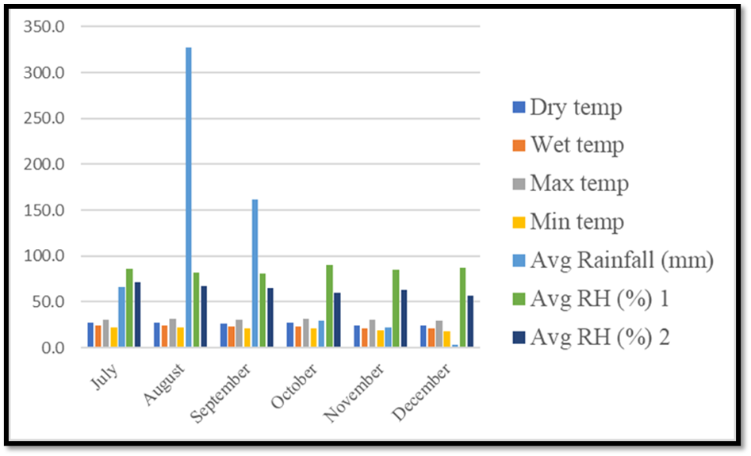

(Dry temp - Dry temperature, Wet temp- Wet temperature, Max.Temp – Maximum temperature, Min.Temp – Minimum temperature, Avg RH-I – Average Relative humidity –I, Avg RH –II – Average Relative humidity –II, Avg Rainfall- Average Rainfall)

**3. RESULTS AND DISCUSSION**

**3.1 Analysis of Variance**

In the present study, the data of the eleven quantitative traits collected from the 50 genotypes and two checks were subjected to Analysis of Variance (ANOVA) and the results are presented in Table 1.

The ANOVA results (Table 1) show that genetic variation between genotypes and environmental differences across blocks significantly influenced several traits. Notably, the traits like days to 50% flowering, days to maturity of the primary spike, number of nodes to the primary spike, plant height (cm), total length of the primary spike (cm), number of effective spikes per plant, 100 seed weight (g), seed yield per plot (g) and oil content (%) showed significant effect. In contrast, the traits such as the effective length of the primary spike (cm) and the number of capsules per primary spike did not show significance. This distinction is important because it may allow researchers and plant breeders to focus their efforts on traits that are responsive to genetic and environmental influences, such as flowering time, plant height, and yield-related characteristics, which could be more likely to show improvement through selective breeding and environmental management (Kumar *et al*., 2023)

**Table 1: Analysis of variance for different characters in advanced lines of castor studied during *kharif*, 2024**

|  |  |  |  |  |  |  |  |  |  |  |  |
| --- | --- | --- | --- | --- | --- | --- | --- | --- | --- | --- | --- |
| **Source of Variation** | **DFF** | **DM** | **PH** | **NN** | **PSL** | **ESL** | **NESPP** | **NC** | **HSW** | **SY** | **OC** |
| **Block (ignoring Treatments)** | 39.40* | 44.52** | 1234.97** | 10.53** | 23.97 | 59.04 | 5.60** | 340.71 | 1.88 | 465.09* | 3.39 |
| **Treatment** | 43.58* | 16.62** | 436.48** | 4.84** | 76.14* | 81.14 | 1.36* | 266.28 | 25.49* | 446.51* | 21.52* |
| **Treatment: Check** | 160.00** | 40.00 | 11.24 | 1.76* | 55.46 | 18.5 | 0.48 | 190.1 | 60.52* | 39.6 | 53.27* |
| **Treatment: Test/Test vs. Check** | 41.25** | 16.15** | 444.98** | 4.90** | 76.55* | 82.39 | 1.38* | 267.81 | 131.58** | 454.65* | 20.88* |
| **Residuals (Error)** | 4.00 | 0.25 | 16.66 | 0.17 | 12.11 | 16.10 | 0.15 | 69.01 | 2.98 | 65.32 | 1.92 |

* Significant at 5 % level, ** Significant at 1 % level

DFF - Days to 50% flowering, DM - Days to maturity of primary spike, PH - Plant height (cm), NN - Number of nodes to the primary spike, PSL - Total length of primary spike (cm), ESL - Effective length of primary spike (cm), NESPP - Number of effective spikes per plant, NC - Number of capsules per primary spike, HSW - 100 seed weight (g), SY - Seed yield per plot (g), OC - Oil content

**3.2 Mean Performance of Advanced Breeding Lines**

The average number of days to 50% flowering among the fifty advanced breeding lines and two checks was 58.6 days, with values from 47 days in PCS-437 to 78 days in DCS-107. The mean maturity period of the primary spike was 98.6 days, with ICS-313 maturing in 89 days and PCS-458 in 109 days. The average plant height was 73.52 cm, with a minimum of 35.8 cm recorded in PPL-1002 and a maximum of 150.6 cm in PCS-460. The number of nodes to the primary spike ranged from 11 in PCS-474 to 22 in PCS-458, with a mean of 15.7. The average total length of the primary spike was 44.5 cm, with values ranging from 19.8 cm in ICS-307 to 66.52 cm in ICS-312. Effective primary spike length varied from 17 cm in ICS-307 to 60.6 cm in PCS-481, with a mean of 39.3 cm. The average number of effective spikes per plant was 4.5, ranging from 2 spikes in DCS-107 to 8 in PCS-474. The number of capsules per primary spike ranged from 24 in PCS-474 to 92 in PCS-481, with a mean of 51.5. The 100 seed weight ranged from 13.8 g in PCS-503 to 35.4 g in ICS-318, with an average of 27.1 g. Seed yield per plot

averaged 91.9 g, with the lowest value of 50.12 g in ICS-305 and the highest of 137.6 g in ICS-160. Oil content ranged from 28.89% in ICS-316 to 51.93% in ICS-309, with an average of 44.06%. The mean values of all the genotypes are presented in Table 2.

**Table- 2: Mean performances of the characters in the advanced lines of castor studied during *kharif* 2024**

|  |  |  |  |  |  |  |  |  |  |  |  |
| --- | --- | --- | --- | --- | --- | --- | --- | --- | --- | --- | --- |
|  | **DFF** | **DM** | **PH** | **NN** | **PSL** | **ESL** | **NESPP** | **NC** | **HSW** | **SY** | **OC** |
| **PCS 262** | 49 | 92 | 15 | 68.6 | 47.4 | 39.8 | 65 | 5.4 | 28.6 | 92.5 | 45.67 |
| **DPC 9** | 55 | 95 | 14 | 65.6 | 44.8 | 44.8 | 65 | 4.4 | 31.4 | 88.4 | 45.33 |
| **ICS 299** | 63 | 102 | 17 | 65.4 | 55.4 | 55.4 | 52.4 | 5 | 29.8 | 113.88 | 46.96 |
| **ICS 301** | 56 | 94 | 15 | 58.4 | 40 | 40 | 52.6 | 7.4 | 32 | 130.72 | 49.27 |
| **ICS 302** | 63 | 96 | 17 | 76.8 | 52.2 | 45.8 | 79.2 | 6.2 | 33.8 | 107.68 | 46.79 |
| **ICS 303** | 65 | 93 | 16.2 | 87.2 | 44.4 | 44.4 | 65 | 5.2 | 22.6 | 65.24 | 34.72 |
| **ICS 304** | 63 | 97 | 16 | 58.8 | 46 | 39 | 49.8 | 3.4 | 24 | 94.88 | 36.43 |
| **ICS 305** | 63 | 99 | 15 | 71.6 | 36 | 34.2 | 35 | 4.8 | 27.6 | 50.12 | 41.18 |
| **ICS 306** | 55 | 92 | 14 | 60.8 | 38.4 | 32.2 | 25.4 | 6.6 | 28 | 93.1 | 47.41 |
| **ICS 307** | 60 | 98 | 13 | 45.8 | 19.8 | 17 | 28.2 | 6 | 25.8 | 59.08 | 41.56 |
| **ICS 309** | 65 | 97 | 17.8 | 106.8 | 44 | 36.2 | 68.8 | 4.8 | 35 | 75.8 | 51.93 |
| **ICS 310** | 61 | 101 | 14 | 63 | 43.4 | 43.4 | 67 | 4 | 26.4 | 112.56 | 36.87 |
| **ICS 312** | 57 | 92 | 16 | 65 | 66.2 | 58.4 | 52 | 4.2 | 20.6 | 108.3 | 38.96 |
| **ICS 313** | 47 | 89 | 12 | 50.2 | 41.2 | 35.2 | 42.4 | 4.6 | 28.6 | 117.4 | 45.32 |
| **ICS 316** | 68 | 100 | 16 | 69 | 61.4 | 56.6 | 50.8 | 3.6 | 28.2 | 83.86 | 28.89 |
| **ICS 317** | 65 | 95 | 14.8 | 75.8 | 43.2 | 43.2 | 34.4 | 5.2 | 29.8 | 80.52 | 42.44 |
| **ICS 318** | 51 | 99 | 13 | 47.2 | 37.4 | 31.8 | 27.2 | 4.25 | 35.4 | 77.88 | 43.46 |
| **ICS 319** | 55 | 95 | 15 | 70.6 | 36.8 | 28.8 | 24.4 | 5.8 | 23 | 78.68 | 45.63 |
| **ICS 320** | 61 | 92 | 16 | 86.4 | 38.6 | 31.2 | 50.2 | 5.6 | 25.4 | 104.36 | 42.86 |
| **ICS 321** | 56 | 97 | 15 | 85.6 | 34.8 | 34.8 | 33.2 | 4.8 | 26.4 | 85.4 | 43.87 |
| **ICS322** | 57 | 100 | 14 | 89.2 | 42 | 42 | 58.6 | 5.4 | 20 | 96.44 | 36.5 |
| **ICS 153** | 51 | 92 | 13 | 49 | 35.4 | 32.4 | 30.6 | 4.8 | 19.8 | 60.2 | 39.93 |
| **ICS 154** | 62 | 98 | 13 | 59.8 | 42.2 | 38.4 | 45 | 4.2 | 21 | 80.54 | 44.8 |
| **ICS 155** | 68 | 97 | 14 | 85 | 37.4 | 23.4 | 26.4 | 3.4 | 24.2 | 81.44 | 44.83 |
| **ICS 156** | 58 | 97 | 16 | 69 | 33.6 | 29.2 | 42.4 | 3.4 | 28.8 | 112.96 | 41.88 |
| **ICS 157** | 57 | 105 | 13 | 68 | 44.4 | 42 | 54.8 | 2.6 | 23.4 | 102.54 | 45.93 |
| **ICS 158** | 61 | 101 | 16 | 71.2 | 42.6 | 34 | 37 | 2.6 | 27.2 | 75.4 | 47.45 |
| **ICS 159** | 60 | 100 | 17 | 61 | 43 | 35.6 | 51.4 | 3 | 25.6 | 107.68 | 42.95 |
| **ICS 160** | 59 | 103 | 15 | 67 | 45 | 38.4 | 75.4 | 4.6 | 31.8 | 137.6 | 44.95 |
| **ICS 162** | 60.5 | 103.3 | 16 | 63.94 | 48.14 | 39.44 | 70.98 | 4.08 | 29.82 | 122.52 | 45.58 |
| **PCS 518** | 67 | 100 | 16 | 95 | 41.8 | 39.4 | 46.6 | 2.4 | 22.6 | 62.08 | 43.28 |
| **PCS 458** | 59 | 109 | 22 | 127.6 | 54 | 46.4 | 56.4 | 2.4 | 28.7 | 118.48 | 39.99 |
| **DCS 107** | 78 | 101 | 17 | 84.2 | 33.2 | 32 | 31.4 | 2 | 27.6 | 56.66 | 42.85 |
| **PCS 503** | 65 | 101 | 21 | 119.4 | 43.4 | 41.4 | 67.4 | 4 | 13.8 | 86.92 | 38.63 |
| **PCS 481** | 56 | 106 | 17 | 92.2 | 62.6 | 60.6 | 91.6 | 5.2 | 21.2 | 94.84 | 47.77 |
| **PCS474** | 47 | 101 | 11 | 36 | 26.8 | 23 | 23.6 | 8.6 | 19 | 106.56 | 45.75 |
| **PCS520** | 65 | 97 | 18 | 95 | 46.4 | 41.8 | 64.8 | 5.8 | 29.6 | 119.28 | 46.28 |
| **PCS460** | 67 | 101 | 20 | 82.6 | 37.2 | 34.8 | 56.2 | 3.6 | 33.6 | 109.28 | 44.17 |
| **PCS440** | 65 | 105 | 18 | 150.6 | 42.2 | 39.6 | 69 | 3.6 | 28.2 | 93.16 | 42.85 |
| **PCS435** | 60 | 107 | 16 | 77.2 | 63.2 | 53.6 | 64.4 | 3.6 | 29 | 136.54 | 45.48 |
| **PCS 124** | 53 | 99 | 17 | 72.4 | 39.6 | 36.6 | 49.6 | 4.2 | 22 | 89.52 | 46.02 |
| **MGP 27** | 52 | 98 | 13 | 61.2 | 53.4 | 48.2 | 57 | 4 | 32.6 | 114.96 | 46.58 |
| **PCS 441** | 67 | 95 | 19 | 123 | 39 | 34.4 | 43.2 | 4 | 23.8 | 75.92 | 39.18 |
| **PCS 383** | 55 | 99 | 18 | 68.2 | 51.4 | 45.8 | 48 | 3.8 | 23.4 | 96.2 | 38.7 |
| **M-574** | 57 | 95 | 15.8 | 39.8 | 49.2 | 49.6 | 48.8 | 4.2 | 27.6 | 80 | 43.25 |
| **PCS 372** | 53 | 97 | 17 | 79 | 41.2 | 28.4 | 42 | 4.2 | 28.2 | 81.92 | 46.94 |
| **MGP-83** | 58 | 99 | 19 | 108.8 | 41.4 | 37 | 47 | 3.6 | 20.4 | 55.46 | 41.04 |
| **PPL 1002** | 56 | 92 | 12 | 35.8 | 37.4 | 31.6 | 25.8 | 3.4 | 26.4 | 75.24 | 43.5 |
| **PCS 437** | 47 | 102 | 14 | 68.2 | 44.8 | 35.8 | 39 | 3.2 | 34 | 88.04 | 45.41 |
| **PCS 438** | 66 | 100 | 21 | 75.4 | 41 | 34.4 | 42 | 3.2 | 24.4 | 69.16 | 41.49 |

* Significant at 5 % level, ** Significant at 1 % level

DFF - Days to 50% flowering, DM - Days to maturity of primary spike, PH - Plant height (cm), NN - Number of nodes to the primary spike, PSL - Total length of primary spike (cm), ESL - Effective length of primary spike (cm), NESPP - Number of effective spikes per plant, NC - Number of capsules per primary spike, HSW - 100 seed weight (g), SY - Seed yield per plot (g), OC - Oil content

**3.3 Genetic variability parameters**

To evaluate genetic variability in breeding programs, key parameters such as the genotypic coefficient of variation (GCV), phenotypic coefficient of variation (PCV), heritability and genetic advance are used to assess the potential for selection and genetic enhancement (Islam *et al*., 2022). The details of genetic variability parameters are presented in Table 3 and Figures 2 and 3

The genotypic coefficient of variation (GCV) quantifies the extent of trait variation attributed to genetic factors in castor. Traits such as the number of nodes to the primary spike (4.37), days to 50% flowering (8.25) and oil content (8.88) exhibited low GCV, indicating limited genetic diversity. Moderate GCV was noticed for plant height (14.84), for total length of primary spike (18.53) and 100 seed weight (16.61). In contrast, high GCV was recorded for the effective length of primary spike (21.57), seed yield per plot (22.06), number of capsules per primary spike (27.25), and number of effective spikes per plant (28.61), suggesting substantial genetic variability and strong potential for trait improvement. These results align well with previous studies by Bhatt *et al.* (2015), Maphumulo *et al.* (2015), and Song *et al.* (2013), which also reported low genetic variability for traits like days to 50% flowering and oil content, moderate variability for plant height and 100 seed weight, and high variability for seed yield per plot in castor.

The phenotypic coefficient of variation (PCV) captures total observable variation, including genetic and environmental influences. Low PCV was noted for the number of nodes to the primary spike (4.40), days to 50% flowering (8.90) and oil content (9.43), indicating trait stability with minimal environmental impact. Moderate PCV was observed for days to maturity (10.35), plant height (15.07) and 100 seed weight (17.82). High PCV was found for the total length of primary spike (20.17), effective length of primary spike (23.88), seed yield per plot (23.73), number of capsules per primary spike (31.94) and number of effective spikes per plant (29.95). The close alignment between GCV and PCV for most traits suggests that genetic factors predominantly drive these traits with limited environmental influence. These observations are in agreement with the results reported by Belete *et al.* (2011), Kant *et al.* (2001), and Joshi *et al.* (2009), who also found low PCV for traits like number of nodes to primary spike and oil content, moderate PCV for plant height and 100 seed weight, and high PCV for yield-related traits..

Broad sense heritability reflects the proportion of phenotypic variation due to genetic factors, indicating the potential effectiveness of selection. Very high heritability was observed for the number of nodes to the primary spike (98.6%), plant height (96.94%), total length of primary spike (96.9%) and number of effective spikes per plant (91.2%), suggesting strong genetic control . High heritability was also noted for days to maturity (89.40%), oil content (88.53%), 100 seed weight (86.8%), seed yield per plot (86.4%), effective length of primary spike (84.4%), days to 50% flowering (82.5%) and number of capsules per primary spike (81.6%), supporting their suitability for selection. These findings of high heritability observed for days to maturity, oil content, and 100 seed weight agree with the findings of Jeena *et al.* (2003) and Azharudheen *et al.* (2013).

Genetic advance as a percentage of the mean (GAM) estimates the potential improvement in a trait through selection based on heritability and variability. Low GAM noted for the number of nodes to the primary spike (8.9%). Moderate GAM was noted for days to 50% flowering (15.2%), oil content (17.2%), and days to maturity (19.1%), indicating limited improvement potential. Moderate GAM was noted for days to maturity (19.1%). High GAM was recorded for plant height (30.2%), 100 seed weight (31.9%), total length of primary spike (35.1%), effective length of primary spike (40.2%), seed yield per plot (42.3%), number of capsules per primary spike (47.9%) and number of effective spikes per plant (56.4%). The high GAM observed for plant height, seed weight, spike lengths, seed yield, and capsule number points to a strong potential for genetic improvement. The combination of high heritability and high GAM highlights that additive genetic factors mainly control these traits and are highly responsive to selection efforts. This pattern has been consistently reported Bhatt *et al.* (2015) and Maphumulo *et al.* (2015).

**Figure-2. Genotypic and Phenotypic coefficient of variation of the studied traits in castor**

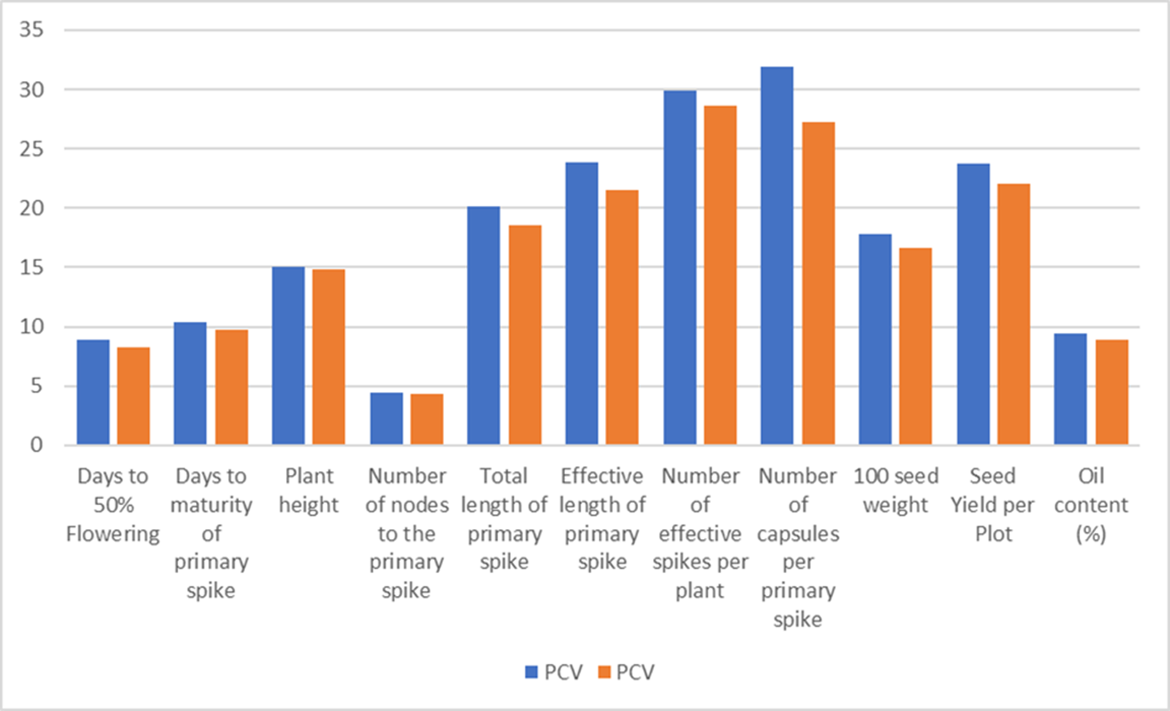

**Figure-3. Broad sense heritability (hBS) and genetic advance as percent of the mean (GAM) of the studied traits in castor**.

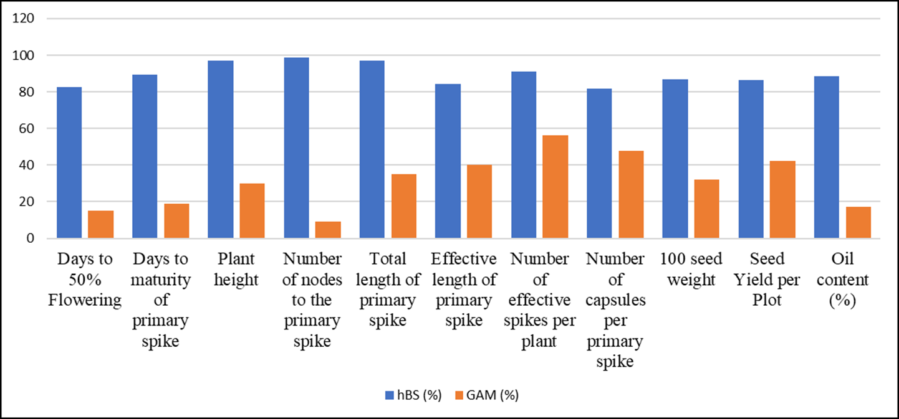

**3.4 Character Association Studies**

In the present study, days to 50% flowering was positively correlated with plant height and the number of nodes to the primary spike. This suggests that plants with delayed flowering may tend to be taller and have more nodes, a pattern also observed in previous studies investigating morphological trait associations in castor (Azharudheen *et al*., 2013; Phuke *et al*., 2017; Patel *et al*., 2018). In contrast, earlier flowering was associated with higher seed yield, greater oil content and an increased number of effective spikes, which are consistent with findings that early-flowering genotypes often show improved yield and oil content due to more efficient resource allocation (Belete *et al*., 2011; Rukhsar *et al*., 2017).

Similarly, days to maturity of the primary spike showed positive associations with plant height, effective spike length and number of nodes, suggesting that later-maturing plants may be taller and have longer spikes, consistent with reports emphasizing the interconnectedness of maturity and vegetative growth traits in castor (Phuke *et al*., 2017; Goodarzi *et al*., 2012). In contrast, early maturity was associated with a higher number of effective spikes. (Belete *et al*., 2011; Chaudhari *et al*., 2019).

Plant height exhibited strong positive correlations with the number of nodes, days to flowering and maturity, and the number of capsules (Azharudheen *et al*., 2013; Patel *et al*., 2018), but a negative correlation with the number of effective spikes, as also reported in morphological diversity analyses (Phuke *et al*., 2017). The number of nodes to the primary spike was positively associated with plant height, flowering time, capsule number, maturity and spike length, underscoring the interconnected nature of these traits (Azharudheen *et al*., 2013; Patel *et al*., 2018)

The total and effective lengths of the primary spike were strongly correlated with the number of capsules and seed yield, suggesting that longer spikes could support more capsules and contribute to higher yields (Maphumulo *et al*., 2015; Kant *et al*., 2001; Joshi *et al*., 2009; Patel *et al*., 2018). The number of effective spikes per plant was negatively correlated with plant height and days to maturity but positively associated with oil content. This suggested that genotypes with more spikes may be shorter, mature earlier, and produce a higher oil content (Song *et al*., 2013; Bhatt *et al*., 2015).

The number of capsules per primary spike exhibited positive correlations with seed yield, spike length, plant height, and the number of nodes, underscoring its critical role in yield determination (Maphumulo *et al*., 2015; Patel *et al*., 2018; Chaudhari *et al*., 2019). The 100 seed weight was significantly positively correlated with seed yield and oil content, suggesting that heavier seeds may enhance both yield and oil content (Jeena *et al*., 2003; Bhatt *et al*., 2015; Rukhsar *et al*., 2017).

Seed yield per plot was primarily influenced by the number of capsules, hundred-seed weight, total and effective spike length, and oil content, with earlier flowering also contributing to higher yields (Song *et al*., 2013; Joshi *et al*., 2009; Patel *et al*., 2018). Oil content was positively correlated with hundred-seed weight, the number of effective spikes, and seed yield, and was further enhanced by earlier flowering (Figure 4 & Figure 5).

Thus, we can conclude that breeding programs should prioritize primary spike length, effective spike length, and 100-seed weight to improve total seed yield and oil content. (Jeena *et al*., 2003; Rukhsar *et al*., 2017).

**Table 4. Correlation coefficients of yield attributing traits in the advanced lines of castor studied during *kharif*, 2024**

|  |  |  |  |  |  |  |  |  |  |  |  |
| --- | --- | --- | --- | --- | --- | --- | --- | --- | --- | --- | --- |
| **Traits** | **DFF** | **DM** | **PH** | **NN** | **SL** | **ESL** | **NESPP** | **NC** | **HSW** | **SY** | **OC** |
| **DFF** | 1 | 0.201 | 0.445*** | 0.467*** | -0.035 | 0.059 | -0.257* | -0.018 | -0.039 | -0.285* | -0.067 |
| **DM** |  | 1 | 0.295* | 0.303* | 0.245 | 0.288* | -0.271* | 0.297* | 0.039 | 0.06 | 0.369** |
| **PH** |  |  | 1 | 0.705*** | 0.123 | 0.119 | -0.296* | 0.339** | -0.109 | -0.147 | 0.299* |
| **NN** |  |  |  | 1 | 0.267* | 0.228 | -0.332** | 0.334** | -0.076 | -0.194 | 0.133 |
| **SL** |  |  |  |  | 1 | 0.902*** | -0.174 | 0.627*** | 0.095 | -0.043 | 0.467** |
| **ESL** |  |  |  |  |  | 1 | -0.087 | 0.634*** | 0.053 | -0.067 | -0.323* |
| **NESPP** |  |  |  |  |  |  | 1 | 0.016 | 0.017 | 0.290* | 0.079 |
| **NC** |  |  |  |  |  |  |  | 1 | 0.191 | 0.16 | 0.370** |
| **HSW** |  |  |  |  |  |  |  |  | 1 | 0.502*** | -0.029 |
| **SY** |  |  |  |  |  |  |  |  |  | 1 | 0.301* |
| **OC** |  |  |  |  |  |  |  |  |  |  | 1 |

(* Significant at 5 % level, ** Significant at 1 % level)

DFF - Days to 50% flowering, DM - Days to maturity of primary spike, PH - Plant height (cm), NN - Number of nodes to the primary spike, PSL - Total length of primary spike (cm), ESL - Effective length of primary spike (cm), NESPP - Number of effective spikes per plant, NC - Number of capsules per primary spike, HSW - 100 seed weight (g), SY - Seed yield per plot (g), OC - Oil content

**Figure- 4. Phenotypic correlations among different traits under study**

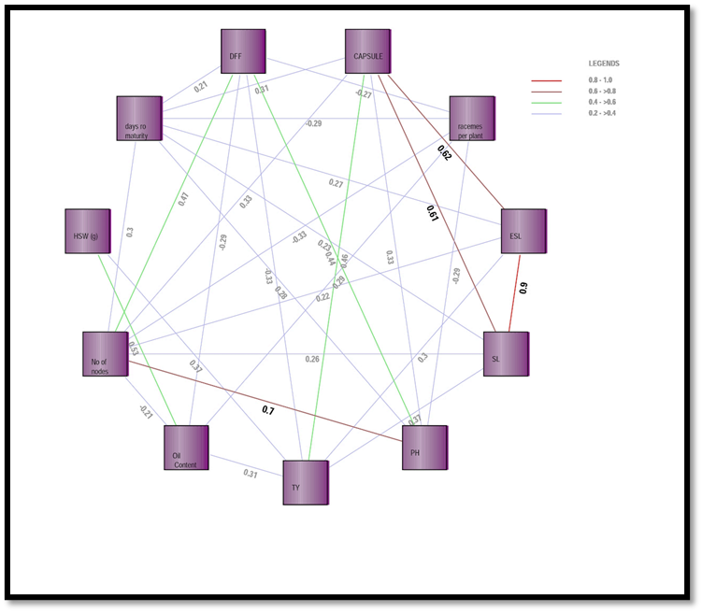DFF - Days to 50% flowering; Days to Maturity - Days to maturity of primary spike; PH - Plant Height (cm); No of Nodes - Number of nodes to the primary Spike; PSL - Total length of primary spike (cm); ESL - Effective length of primary spike (cm); Spikes/Plant - Number of effective spikes per plant; CAPSULE - Number of capsules per primary spike; HSW (g) - 100 Seed weight (g); TY - Seed yield per plot (g); Oil Content - Oil content (%)

**Figure-5. Shaded correlation matrix of different traits under study**

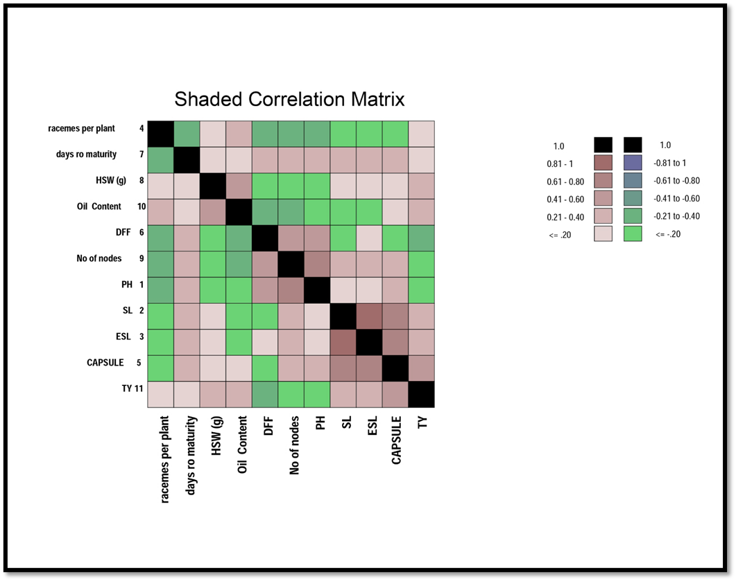

DFF - Days to 50% flowering; Days to Maturity - Days to maturity of primary spike; PH - Plant Height (cm); No of Nodes - Number of nodes to the primary Spike; SL - Total length of primary spike (cm); ESL - Effective length of primary spike (cm); Spikes/Plant - Number of effective spikes per plant; CAPSULE - Number of capsules per primary spike; HSW (g) - 100 Seed weight (g); TY - Seed yield per plot (g); Oil Content - Oil content (%)

**4. CONCLUSION**

This study demonstrates substantial genetic variability among elite castor (*Ricinus communis L*.) breeding lines for key agronomic and yield traits, including primary spike length, effective spike number, capsule count, 100 seed weight, and seed yield. These traits exhibited high genotypic and phenotypic variation, moderate to high heritability, and strong genetic advance, indicating excellent potential for improvement through selective breeding. Positive correlations among yield components further support their importance as selection criteria. Future breeding programs should focus on validating the stability of these high-variability traits and utilizing significant trait correlations to refine selection strategies. Incorporating wild relatives and diverse germplasm will further enhance genetic diversity and resilience, supporting the development of stable, high-yielding, oil-rich castor varieties suitable for various environments.

**References**

Allan, G., Williams, A., Rabinowicz, P.D., Chan, A.P., Ravel, J. and Keim, P. (2007). Worldwide genotyping of castor bean germplasm (*Ricinus communis L*.) using AFLPs and SSRs. Genetic Resources and Crop Evolution, 55(3): 365–378.

Al-Jibouri, H.A., Miller, P.A. and Robinson, H.F. (1958). Genotypic and environmental variances and covariances in an upland cotton cross of interspecific origin. Agronomy Journal, 50(10): 633–636.

Amosu, J.O., Bashir, M.A., Lawal, O.I. and Ogunmuyiwa, O.A. (2013). Economic potentials of castor bean (*Ricinus communis L*.) in Nigeria. International Journal of Agriculture and Crop Sciences, 5(24): 2949–2954.

Anjani, K. (2012). Castor genetic resources: A primary gene pool for exploitation. Industrial Crops and Products, 35(1): 1–14.

Azharudheen, T.P.M., Patel, K.V. and Patel, V.J. (2013). Character association and path analysis in castor (*Ricinus communis L*.). Journal of Oilseeds Research, 30(2): 152–156.

Belete, K., Ayalew, A. and Bekele, G. (2011). Genetic variability and association of characters in some Ethiopian castor (*Ricinus communis L*.) accessions. Ethiopian Journal of Applied Science and Technology, 2(1): 45–54.

Bhatt, R.V., Reddy, A.V. and Rao, P.V. (2015). Correlation and path coefficient analysis in castor (*Ricinus communis L*.). Journal of Oilseeds Research, 32(1): 38–42.

Brigham, R.D. (1993). Castor: Return of an old crop. In: J. Janick and J.E. Simon (eds.), New Crops. Wiley, New York, pp. 380–383.

Burton, G.W. (1953). Quantitative inheritance in grasses. Proceedings of the International Grassland Congress, 1: 277–283.

Chaudhari, S., Patel, V.J. and Anjani, K. (2019). Genetic variability and trait associations in castor (*Ricinus communis L*.). Journal of Oilseeds Research, 36(2): 98–103.

Delvadiya, I., Ginoya, A.V., Madariya, R.B and Dobariya, K.L. 2024. Morphological diversity in castor (*Ricinus commun*is L.): a metroglyph analysis approach to reveal hidden patterns: metroglyph Analysis in Castor (Ricinus communis L.). Annals of Arid Zone. 63(1): 99-105.

Dhivya, D., Senthilvel, S., Anjani, K. and Rao, M.V. (2024). Genetic diversity analysis in castor (*Ricinus communis L*.) using SSR and SNP markers. Plant Genetic Resources, 22(2): 89–97.

Federer, W.T. (1956). Augmented (or Hoonuiaku) designs. Hawaiian Planters' Record, 55: 191–208.

Fisher, R.A. and Yates, F. (1963). Statistical Tables for Biological, Agricultural and Medical Research. 6th ed. Oliver and Boyd, Edinburgh.

Gana, A.K. (2015). Castor production and utilization for economic development in Nigeria. Journal of Agricultural Extension and Rural Development, 7(3): 78–85.

Goodarzi, M., Bagheri, A. and Safavi, S.M. (2012). Genetic variability and trait associations in castor (*Ricinus communis L*.). Journal of Agricultural Science and Technology, 14(3): 567–574.

Goto, M., Yamamura, Y., Hayashi, S. and Fujii, T. (2002). Anti-inflammatory effects of castor oil derivatives. Journal of Natural Medicines, 56(4): 145–148.

Hanson, C.H., Robinson, H.F. and Comstock, R.E. (1956). Biometrical studies of yield in segregating populations of Korean lespedeza. Agronomy Journal, 48(6): 268–272.

Hapsari, D., Sarwono, E. and Nugroho, M. (2018). Genetic variability and its implications in crop improvement. Journal of Tropical Crop Science, 5(2): 67–74.

Hegde, D.M. and Sudhakara Babu, S.N. (2002). Castor oil: A vital industrial raw material. Journal of Oilseeds Research, 39(1): 1–10.

Islam, M.R., Rahman, M.M. and Hossain, M.A. (2022). Genetic variability and trait associations in castor (*Ricinus communis L*.). Bangladesh Journal of Agricultural Research, 47(2): 201–210.

Jeena, A.S., Upadhyay, R.K. and Singh, R.P. (2003). Genetic variability and character association in castor (*Ricinus communis L*.). Indian Journal of Genetics and Plant Breeding, 63(2): 155–158.

Joshi, M., Patel, C.J. and Patel, V.J. (2009). Correlation and path analysis in castor (*Ricinus communis L*.). Journal of Oilseeds Research, 26(2): 112–115.

Jyothsna, K., Anjani, K. and Rao, M.V. (2016). Genetic variability and trait association studies in castor (*Ricinus communis L*.). Journal of Oilseeds Research, 33(1): 45–50.

Kant, L., Gulati, S.C. and Singh, D.P. (2011). Genetic variability and association analysis in castor (*Ricinus communis L*.). Indian Journal of Agricultural Sciences, 81(6): 524–528.

Khanal, S., Shakya, S.M. and Bhattarai, S. (2007). Castor oil in pharmaceutical applications. Journal of Nepal Pharmaceutical Association, 25(1): 34–39.

Kumar, R., Sharma, P., Singh, A., and Gupta, S. (2023). Analysis of genetic and environmental influences on agronomic traits in oilseed crops. Journal of Plant Breeding and Genetics, 45(2): 123–135.

Maphumulo, T.C., Derera, J. and Sibiya, J. (2015). Genetic variability and trait associations in castor (*Ricinus communis L*.) germplasm. South African Journal of Plant and Soil, 32(3): 149–155.

Narkhede, G.W., Anjani, K. and Rao, M.V. (2024). Genetic diversity and variability in castor (*Ricinus communis L*.) germplasm. Journal of Oilseeds Research, 41(1): 23–30.

Ogunniyi, D.S. (2006). Castor oil: A vital industrial raw material. Bioresource Technology, 97(9): 1086–1091.

Panse, V.G. and Sukhatme, P.V. (1964). Statistical Methods for Agricultural Workers. 2nd ed. Indian Council of Agricultural Research, New Delhi.

Patel, V.J., Anjani, K. and Rao, M.V. (2018). Genetic variability and trait associations in castor (*Ricinus communis L*.). Journal of Oilseeds Research, 35(2): 98–103.

Phuke, R.M., Anjani, K. and Rao, M.V. (2017). Genetic variability and trait association in castor (*Ricinus communis L*.) under rainfed conditions. Journal of Oilseeds Research, 34(2): 98–103.

Purseglove, J.W. (1981). Tropical Crops: Dicotyledons. Longman, London.

Qurban, A. (2015). Genetic variability and heritability in castor (*Ricinus communis L*.). Journal of Agricultural Research, 53(2): 201–208.

Rao, P.V., Reddy, A.V. and Anjani, K. (2009). Genetic variability and association studies in castor (*Ricinus communis L*.). Journal of Oilseeds Research, 26(1): 34–38.

Rukhsar, Patel, V.J. and Anjani, K. (2017). Genetic variability and trait associations in castor (*Ricinus communis L*.). Journal of Oilseeds Research, 34(2): 98–103.

Sahlin, E., Patel, V.J. and Anjani, K. (2014). Castor production systems for marginal lands. Journal of Sustainable Agriculture, 38(5): 567–578.

Salihu, B.Z., Gana, A.K. and Apuyor, B.O. (2014). Castor oil plant (*Ricinus communis L*.): Botany, ecology and uses. International Journal of Science and Research, 3(5): 1333–1341.

Senthilvel, S., Shaik, M. and Anjani, K. (2016). Molecular diversity and trait association in castor (*Ricinus communis L*.). Plant Genetic Resources, 14(3): 201–209.

Sharma, V., Singh, S.K. and Kumar, A. (2014). Genetic linkage and character association in crops. Indian Journal of Genetics and Plant Breeding, 74(3): 345–350.

Song, W.K., Kim, H.M. and Lee, J.K. (2013). Genetic variability and character association in castor (*Ricinus communis L*.). Korean Journal of Crop Science, 58(3): 245–251.

Subramanian, S. and Menon, P.M. (1973). Variability and correlation studies in castor (*Ricinus communis L*.). Madras Agricultural Journal, 60(1): 1–5.

Weiss, E.A. (2000). Oilseed Crops. 2nd ed. Blackwell Science, Oxford.

Zheng, Y., Li, J. and Zhang, H. (2016). Genetic variability and trait associations in castor (*Ricinus communis L*.). Journal of Oilseeds Research, 33(2): 112–118.