***Short Research Article***

**Influence of Cutting Maturity on Vegetative Growth and Floral Traits of *Hydrangea macrophylla* in Pot Culture**

**ABSTRACT**

A study was conducted to evaluate the effect of cutting maturity on vegetative growth and flowering behavior of *Hydrangea macrophylla* L. under subtropical conditions of Bhubaneswar, Odisha. Uniformly rooted softwood, semi-hardwood, and hardwood cuttings were transplanted in pots and maintained under shade net conditions. Significant differences were observed among cutting types for several morphological and floral traits. Plants derived from softwood cuttings exhibited superior performance, producing the highest plant height (18.51 cm), maximum number of branches (2.28), largest leaf area (130.15 cm²), earliest flower bud initiation (43.57 days), and largest flower head diameter (14.08 cm). Additionally, flower heads from softwood cuttings maintained their original pink color for a significantly longer duration (97.85 days), indicating extended post-flowering longevity. While hardwood cuttings produced more leaves and flower heads per plant, their overall performance was inferior to softwood cuttings in terms of flowering quality and earliness. The results suggest that softwood cuttings, owing to their juvenility and physiological vigor, are best suited for producing high-quality *Hydrangea macrophylla* plants in containerized systems under subtropical climates.

**Keywords**: *Hydrangea macrophylla*, *Stem cuttings, soft cuttings, Flowering behavior, Leaf area, Cutting maturity, Subtropical conditions*

**1. INTRODUCTION**

Shrubs form an integral component of ornamental horticulture, valued for their aesthetic foliage and seasonal floral display. Among them, *Hydrangea macrophylla* L., commonly referred to as the "queen of flowering shrubs", is widely appreciated for its large, colorful, and long-lasting flower heads. Native to temperate climates, hydrangeas have shown promising adaptability in certain subtropical and mid-elevation regions of India, including Bhubaneswar, where their winter flowering behavior under potted culture is increasingly being explored.

Successful cultivation of *Hydrangea macrophylla* depends not only on propagation success but also on the post-rooting performance of the plants in terms of vegetative growth and floral quality. While stem cuttings are a common propagation method, the maturity of the cutting—whether softwood, semi-hardwood, or hardwood—has a significant influence on physiological characteristics such as shoot development, leaf expansion, floral initiation, and overall plant vigor. Earlier studies have indicated that juvenile tissues often possess greater cell division activity, hormonal responsiveness, and faster transition to reproductive stages compared to more lignified tissues.

However, limited information is available regarding how different cutting maturities influence vegetative and reproductive parameters in container-grown *Hydrangea macrophylla* under subtropical lowland conditions. Understanding these responses is essential for standardizing pot culture techniques and optimizing flower quality and longevity for landscape or commercial use. Jena et al., 2025 studied that to restore environmental degradation and limit the use of chemical fertilizer, study of bioenzymes using semi-hardwood cuttings of Cordyline is essential.

The present investigation was undertaken to assess the influence of softwood, semi-hardwood, and hardwood cuttings on plant growth and flowering performance of *Hydrangea macrophylla* under shade net conditions in Bhubaneswar, Odisha.

**2. METHODOLOGY**

**2.1. Experimental Site**

The experiment was conducted at the Department of Floriculture and Landscaping, College of Agriculture, Odisha University of Agriculture and Technology (OUAT), Bhubaneswar, India. The location experiences a humid subtropical climate, with mild winter temperatures that support winter flowering in container-grown ornamental shrubs.

**2.2. Plant Material and Treatments**

Uniformly rooted cuttings of *Hydrangea macrophylla* obtained from a previous propagation trial were used. Three types of cuttings based on maturity were evaluated:

T₁: Softwood cuttings

T₂: Semi-hardwood cuttings

T₃: Hardwood cuttings

Each treatment was replicated seven times, with one plant per pot per replication. The experiment was laid out in a Completely Randomized Block Design (CRBD).

**2.3. Potting and Media**

Rooted cuttings were transplanted into 30 cm earthen pots containing a standardized potting mixture of soil: farmyard manure: sand in 2:1:1 ratio. Proper drainage was ensured by placing broken earthen pot pieces at the bottom. Pots were pre-filled and lightly watered two days before planting.

**2.4. Aftercare and Maintenance**

All pots were placed under a 75% agro shade net and maintained uniformly. Daily watering was done with a rose cane in the morning. Hand weeding was conducted at 15-day intervals to maintain a weed-free growing environment.

**2.5. Fertilization**

A basal fertilizer mixture was prepared by mixing 10 kg soil with 50 g each of urea (N), single super phosphate (P), and muriate of potash (K). A 20 g portion of this mixture was applied to each pot at 20 days after transplanting.

**2.6. Staking**

To support the developing plants and flower heads, staking was done using wooden sticks after visible bud emergence. Plants were tied gently to avoid damage to developing inflorescences.

**2.7. Observations Recorded**

The following parameters were recorded at flowering stage:

* Plant height (cm)
* Number of branches per plant
* Number of leaves per plant
* Leaf area (cm²) of the 3rd leaf from the apex (calculated using the formula: Leaf area = L × B × 0.6)
* Days to flower bud initiation (DAT)
* Number of flower heads per plant
* Average number of florets per head
* Flower head diameter (cm)
* Flower life (days till turning green)

**2.8. Statistical Analysis**

Data were subjected to analysis of variance (ANOVA) using CRBD. Mean comparisons were performed using the Critical Difference (CD) at 5% level of significance. Percentage data were angularly transformed before analysis wherever necessary.

**3. RESULTS AND DISCUSSION**

**3.1. Plant Height and Branching at Flowering**

Significant differences were observed in plant height at flowering across different cutting types (Table 1). Plants raised from softwood cuttings attained the greatest height (18.51 cm), which was significantly higher than those from semi-hardwood (13.78 cm) and hardwood cuttings (14.85 cm). The enhanced vertical growth in softwood cuttings is likely due to their juvenile physiological state, which supports rapid cell division and shoot elongation. Similar trends have been reported by Bhattacharjee et al. (1986) and Costa et al. (2002), who noted better shoot development in juvenile tissues. Branch production followed a similar pattern. Softwood cuttings produced significantly more branches (2.28 per plant) than semi-hardwood and hardwood cuttings (1.42 each). This could be attributed to the presence of active axillary buds and higher meristematic activity in younger tissues.

**Table 1- Plant height at flowering (cm), number of branches appeared at flowering and number of leaves at flowering**

|  |  |  |  |
| --- | --- | --- | --- |
| **Treatments** | **Plant height at flowering (cm)** | **Number of branches appeared at flowering** | **Number of leaves at flowering** |
| T1 (Softwood cutting) | 18.51 | 2.28 | 17.00 |
| T2 (Semi hardwood cutting) | 13.78 | 1.42 | 16.14 |
| T3 (Hardwood cutting) | 14.85 | 1.42 | 20.57 |
| ‘F’ Test | * | * | NS |
| SE(M)± | 1.07 | 0.23 | 1.33 |
| CD at 5% | 3.18 | 0.69 | - |

* = Significant at 5% level. ** = Significant at 1% level.

**3.2. Leaf Traits**

No significant differences were observed in the total number of leaves per plant, though hardwood cuttings showed a slightly higher mean leaf count (20.57), followed by softwood (17.00) and semi-hardwood cuttings (16.14). However, leaf area of the third apical leaf differed significantly. Plants from softwood cuttings recorded the largest leaf area (130.15 cm²), while hardwood and semi-hardwood cuttings exhibited significantly lower values (81.00 cm² and 73.82 cm², respectively). The larger leaf area may contribute to higher photosynthetic efficiency and better floral development.

**Table 2-Leaf area of 3rd leaf at flowering (sq.cm), days taken for flower bud formation and flower head diameter (cm)**

|  |  |  |  |
| --- | --- | --- | --- |
| **Treatments** | **Leaf area of 3rd leaf at flowering (sq.cm)** | **Days taken for flower bud formation (days after transplanting)** | **Flower head diameter (cm)** |
| T1 (Softwood cutting) | 130.15 | 43.57 | 14.08 |
| T2 (Semi hardwood cutting) | 73.82 | 65.35 | 9.32 |
| T3 (Hardwood cutting) | 81.00 | 56.02 | 11.72 |
| ‘F’ Test | ** | ** | * |
| SE(M)± | 9.79 | 1.23 | 1.05 |
| CD at 5% | 29.01 | 3.66 | 3.12 |

* = Significant at 5% level. ** = Significant at 1% level.

**3.3 Flower Bud Initiation and Development**

The earliest flower bud formation was observed in plants raised from softwood cuttings (43.57 days after transplanting), significantly earlier than in hardwood (56.02 days) and semi-hardwood cuttings (65.35 days). Early flowering in softwood-derived plants can be attributed to their faster vegetative growth and metabolic readiness to transition into reproductive phase (Guo *et al*., 1995).

Flower head diameter also varied significantly, with softwood cuttings producing the largest blooms (14.08 cm), followed by hardwood (11.72 cm) and semi-hardwood cuttings (9.32 cm). This supports the hypothesis that early vegetative vigor promotes superior floral development.

**3.4. Floral Output and Longevity**

While number of florets per head and number of flower heads per plant did not differ significantly, softwood cuttings produced more florets per head (434.14) compared to hardwood (344.42) and semi-hardwood (308.71). Interestingly, hardwood cuttings produced the highest number of flower heads per plant (1.71), although statistically non-significant. This may be due to higher branching in mature tissues, but with reduced flower quality.

Flower head longevity, measured as days until color change from pink to green, showed a significant difference. Flowers from softwood cuttings maintained original color for the longest duration (97.85 days), followed by hardwood (95.71 days) and semi-hardwood (89.28 days). The extended floral life in softwood-derived plants is a key trait for ornamental value and cut flower potential.

**Table 3- Number of florets per head, number of flower heads per plant at flowering and flower head life**

|  |  |  |  |
| --- | --- | --- | --- |
| **Treatments** | **Number of florets per head** | **Number of flower heads per plant at flowering** | **Flower head life**  **(Days till tuning green colour)** |
| T1 (Softwood cutting) | 434.14 | 1.28 | 97.85 |
| T2 (Semi hardwood cutting) | 308.71 | 1.28 | 89.28 |
| T3 (Hardwood cutting) | 344.42 | 1.71 | 95.71 |
| ‘F’ Test | NS | NS | * |
| SE(M)± | 39.4 | 0.22 | 2.15 |
| CD at 5% | - | - | 6.40 |

* = Significant at 5% level. ** = Significant at 1% level.

**Fig. 1 - Flowering in potted plants**

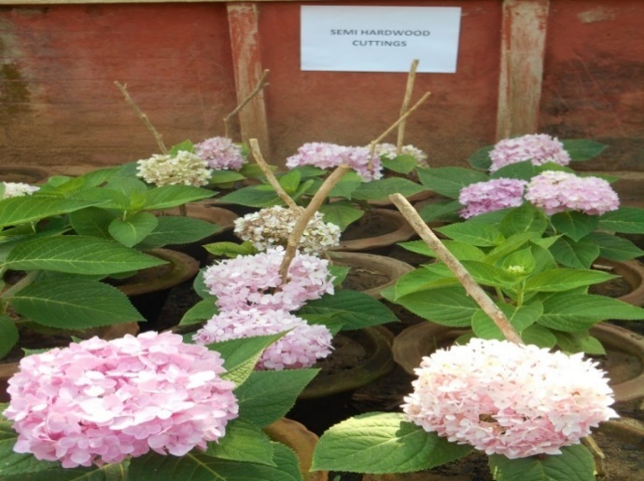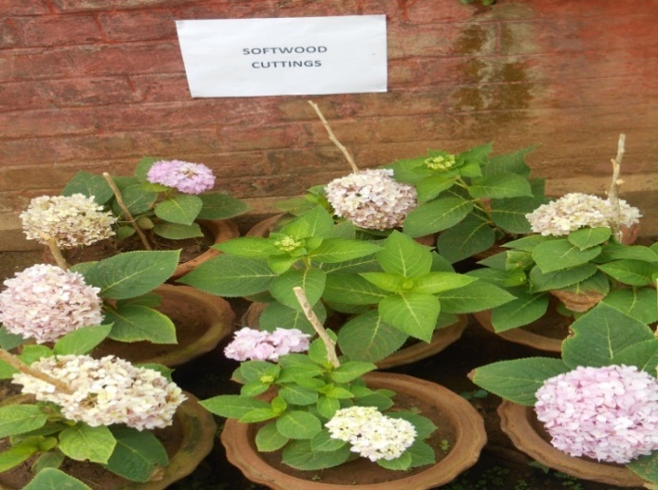

**Fig.1.a: Plants grown out of Soft-wood cuttings**

**Fig.1.b: Plants grown out of Semi-hardwood cuttings**

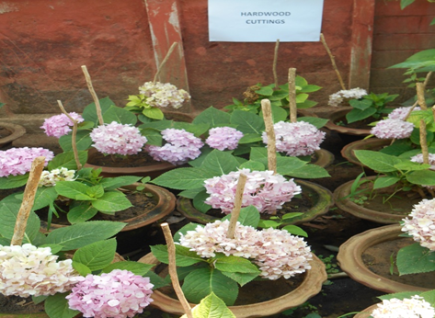

**Fig. 1.c: Plants grown out of hardwood cutting**

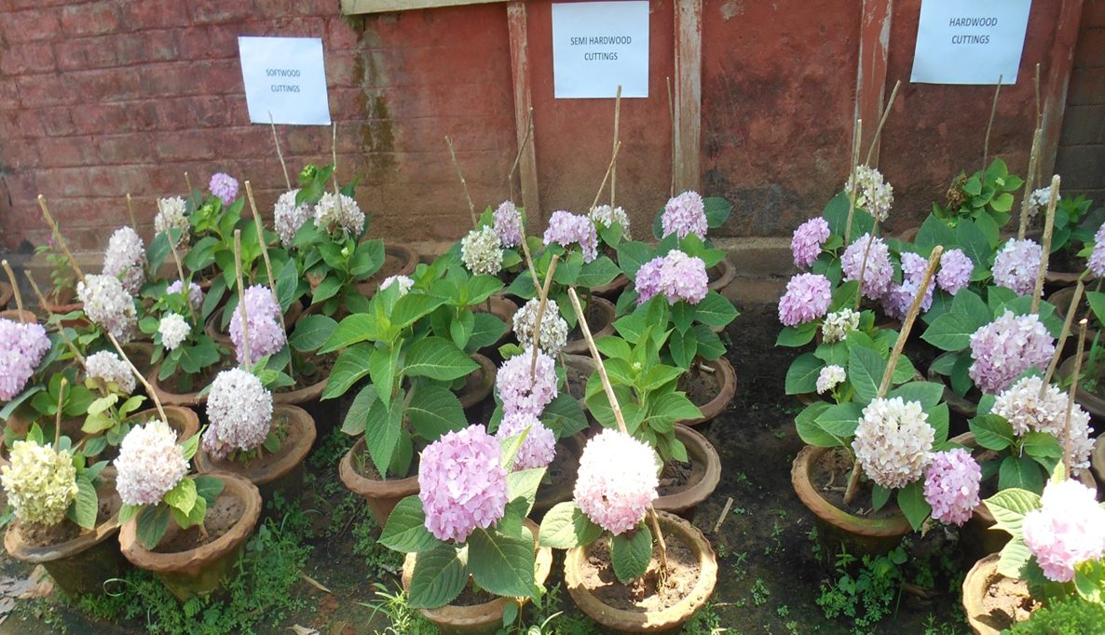

**Fig. 2: General view of the potted cuttings at flowering**

**3.5. Summary of Findings**

Overall, softwood cuttings resulted in the most desirable combination of traits: early flowering, larger flower heads, greater leaf area, and extended flower longevity. These results validate the role of cutting maturity in determining subsequent plant performance. Juvenile tissues retain superior regenerative and physiological capacities, making them ideal for both propagation and ornamental display purposes.

**4. CONCLUSION**

The maturity of stem cuttings has a pronounced effect on the vegetative and floral development of *Hydrangea macrophylla* grown under subtropical pot culture. Among the three types tested, softwood cuttings demonstrated superior performance across most growth and reproductive parameters, including greater plant height, increased branching, larger leaf area, earlier flower bud initiation, larger flower head diameter, and prolonged flower life. These outcomes highlight the physiological advantages of juvenile plant tissues in terms of both vegetative vigor and floral quality.

Although hardwood cuttings showed marginally higher flower head numbers, the overall quality and longevity of blooms from softwood-derived plants make them more suitable for ornamental and potential commercial use. The findings of this study provide practical recommendations for nursery managers and floriculture practitioners seeking to optimize *Hydrangea macrophylla* production in containers under warm winter climates. Future studies may explore seasonal influences or integrate microbial inoculants to further enhance flowering performance and stress resilience.

**5. REFERENCES**

Bhattacharjee, S. K., Rani, A., & Singh, N. (1986). Standardization of propagation of Hibiscus rosa-sinensis Linn. from stem cuttings. *Indian Journal of Horticulture*, **43**(3–4), 235–241.

Costa, C. T., Zanette, F., & Fett-Neto, A. G. (2002). Influence of leaf area on rooting and survival of single-node softwood cuttings of rose. *Acta Horticulturae*, **598**, 131–135. https://doi.org/10.17660/ActaHortic.2002.598.15

Ermakova, I. V. (1971). Developmental morphology of flower bud formation in hydrangea. *Fiziologiya Rastenii*, **18** (5), 911–918. (Translated summary)

Guo, D. P., Niu, J. Y., Zhang, J. G., & Liu, H. X. (1995). Effect of photoperiod and temperature on floral induction in Hydrangea macrophylla. *Acta Horticulturae Sinica*, **22**(3), 254–258.

Jena, S. S., Tripathy, L., Maharana, K., & Jena, P. (2025). Bioenzyme-mediated growth enhancement in Cordyline (Cordyline terminalis): A developmental study. *Plant Cell Biotechnology and Molecular Biology*, ***26***(7-8), 116-132.