**Original Research Article**

**Studies on soil physicochemical properties of different crop ecosystems of Jorhat district for future cropping and soil management strategies**

**ABSTRACT:**

Soil physicochemical properties are key indicators of soil fertility and agricultural sustainability, yet they are profoundly influenced by land use practices. This investigation was undertaken to evaluate the influence of different land use systems on soil physicochemical properties in Jorhat district, Assam. The study encompassed five representative land use types: barren land, paddy, flower crops, fruit-based homestead, and rice-vegetable systems. Surface soil samples (0–15 cm depth) were collected under each system with three replications. Laboratory analyses were conducted to determine bulk density, particle density, porosity, pH, electrical conductivity (EC), available nitrogen (N), available phosphorus (P₂O₅), available potassium (K₂O), and organic carbon (OC). Results from one-way analysis of variance (ANOVA) indicated statistically significant differences (p < 0.05) among land use systems for most parameters, with the exception of porosity and EC. Tukey’s Honest Significant Difference (HSD) test further elucidated pairwise variations among the land uses. The findings revealed that fruit-based homestead and rice-vegetable systems significantly enhanced soil quality indicators such as organic carbon and nutrient availability, whereas barren land and monocropped paddy fields exhibited relatively poor fertility status. These results underscore the importance of diversified and organic-input-rich cropping systems in promoting soil health and long-term agricultural sustainability in the Upper Brahmaputra Valley Zone of Assam.

***Keywords:*** *Land use systems, soil physiochemical properties, ANOVA, Tukey HSD, organic carbon, nitrogen, phosphorus, potassium*

1. **INTRODUCTION**

Soil is a vital natural resource that forms the foundation of terrestrial ecosystems and serves as a key determinant of agricultural productivity and environmental quality. It is a dynamic and complex system composed of mineral particles, organic matter, water, air, and a diverse population of microorganisms derived from the decomposition of plant and animal residues (Brady & Weil, 2017). Referred to as the “skin of the Earth,” soil plays a critical role in regulating essential ecosystem functions, including nutrient cycling, water retention, carbon storage, and biological activity (Paul, 2015).

Among the various properties that influence soil functionality, fertility status remains central to sustaining crop productivity and ecological balance. Plants derive nutrients from two primary sources in the soil—organic matter and minerals. Organic matter, through decomposition, not only contributes to nutrient supply but also improves soil structure and enhances its capacity to retain moisture and support microbial life (Veum et al., 2021). Key indicators commonly used to assess soil fertility and health include pH, electrical conductivity (EC), cation exchange capacity (CEC), and concentrations of essential nutrients such as nitrogen (N), phosphorus (P), potassium (K), and organic carbon (Maddonni et al., 1999; Veum et al., 2021). Soil pH, in particular, regulates the solubility and availability of nutrients, with most nutrients being optimally accessible at neutral pH values. EC reflects salinity levels, which influence crop tolerance and yield, while CEC represents the soil’s ability to retain and exchange nutrient cations essential for plant growth (Jung et al., 2005; Karlen et al., 1997).

Land use practices are known to exert significant influence on the physicochemical and biological properties of soils. Changes in land use—such as the conversion of forests to croplands, adoption of intensive agriculture, or development of settlements—can lead to shifts in soil structure, nutrient availability, microbial dynamics, and overall soil fertility (Six et al., 2002; Zhang et al., 2010). Repeated tillage, deforestation, and unsustainable land management practices have been linked to soil degradation, nutrient depletion, and a decline in organic matter content, thereby compromising soil productivity and long-term agricultural sustainability (Lal, 2006; Davidson & Ackerman, 1993). As such, understanding the relationship between land use systems and soil fertility is essential for promoting sustainable land management and ensuring the resilience of agricultural ecosystems (Bünemann et al., 2018; Tilman et al., 2002).

While numerous studies have investigated the impact of land use on soil fertility in various agro-ecological regions globally and across India, there is a notable lack of region-specific data for northeastern India, particularly in the soils of Assam. The Jorhat district, located in the Upper Brahmaputra Valley Zone, represents an agriculturally significant region where diverse land use systems coexist. However, limited research has been conducted to evaluate how these varying land uses affect soil fertility status in this specific context. In view of this gap, the present study was undertaken to assess the effect of different land use systems on the fertility status of soils in Jorhat district. The objective is to generate empirical data that can inform sustainable land use planning, soil health management, and long-term agricultural development in the region.

**2. MATERIALS AND METHODS**

**2.1 Study Area** The study was carried out in the Jorhat district of Assam, located in the Upper Brahmaputra Valley Zone (UBVZ), which lies between 26°45′N to 27°15′N latitude and 93°15′E to 94°15′E longitude. The area experiences a humid subtropical climate, receiving average annual rainfall between 2000–2500 mm and temperatures ranging from 7°C in winter to 36°C in summer. The predominant soil types are alluvial with loamy to clayey textures (Borah et al., 2019).

**2.2 Experimental Design and Sampling** Five different land use systems were selected based on field survey and land use classification: barren land, paddy fields, flower crops, fruit-based homesteads, and rice-vegetable cropping systems. Soil samples were collected from the surface layer (0–15 cm) using a random sampling method, with six replications per land use type. Each composite sample was formed by mixing five subsamples taken within a 10 m × 10 m plot. Samples were air-dried, ground, and sieved using a 2 mm mesh sieve before laboratory analysis (Ghosh et al., 2018).

**2.3 Soil Physicochemical Analysis** Bulk density was determined using the core method and particle density by pycnometer (Blake & Hartge, 1986). Porosity was calculated using the formula: Porosity (%) = [1 - (BD/PD)] × 100. Soil pH and EC were measured in a 1:2.5 soil-water suspension using a digital pH meter and EC meter (Jackson, 1973). Available nitrogen was determined by the alkaline KMnO₄ method (Subbiah & Asija, 1956), phosphorus by Olsen’s method (Olsen et al., 1954), potassium via flame photometry using 1N NH₄OAc extraction (Pratt, 1965), and organic carbon using Walkley and Black’s method (Walkley & Black, 1934).

**2.4 Statistical Analysis** Data were subjected to one-way ANOVA to test the significance of variations among land use types. Tukey’s HSD post hoc test was applied to determine the group-wise differences. Analysis was conducted using SPSS version 26.0 with a confidence level of 95% (p < 0.05).

**3. RESULTS AND DISCUSSION**

Soil physicochemical properties play a pivotal role in determining soil health, productivity, and sustainability. The assessment of parameters such as bulk density, particle density, porosity, pH, electrical conductivity, organic carbon, and available nutrients provides essential insights into the effects of land use practices on soil quality (Lal, 2006; Bünemann et al., 2018).

Table 1: Soil physico-chemical properties under different land use systems

|  |  |  |  |  |  |  |  |  |
| --- | --- | --- | --- | --- | --- | --- | --- | --- |
| **Land Use System** | **BD (g/cm³)** | **Porosity (%)** | **pH** | **EC (dS/m)** | **N (kg/ha)** | **P₂O₅ (kg/ha)** | **K₂O (kg/ha)** | **OC (%)** |
| Barren Land | 1.58 ± 0.02 **a** | 37.5 ± 1.14 **b** | 5.39 ± 0.18 **ab** | 0.036 ± 0.009 **a** | 101.64 ± 6.89 **d** | 16.07 ± 1.29 **d** | 113.5 ± 4.17 **c** | 0.62 ± 0.04 **d** |
| Paddy | 1.25 ± 0.09 **c** | 46.5 ± 2.01 **a** | 5.07 ± 0.12 **b** | 0.036 ± 0.009 **a** | 330.37 ± 30.61 **a** | 25.38 ± 1.89 **c** | 104.9 ± 17.78 **c** | 1.32 ± 0.06 **c** |
| Flower Crops | 1.57 ± 0.06 **a** | 38.9 ± 4.00 **b** | 5.97 ± 0.28 **a** | 0.033 ± 0.007 **a** | 115.56 ± 27.79 **d** | 42.11 ± 2.56 **a** | 218.6 ± 3.08 **a** | 1.57 ± 0.09 **b** |
| Fruit-based Homestead | 1.40 ± 0.06 **b** | 39.6 ± 2.79 **b** | 5.63 ± 0.32 **ab** | 0.086 ± 0.008 **a** | 326.71 ± 15.43 **a** | 31.43 ± 1.14 **b** | 149.6 ± 6.94 **b** | 2.02 ± 0.06 **a** |
| Rice-Vegetable | 1.32 ± 0.12 **bc** | 40.3 ± 3.99 **b** | 5.41 ± 0.27 **ab** | 0.191 ± 0.12 **a** | 348.04 ± 18.16 **a** | 32.05 ± 2.56 **b** | 148.3 ± 4.93 **b** | 1.66 ± 0.03 **b** |

* Values are **mean ± SE**. Means sharing the **same letter** in a column are **not significantly different** at p ≤ 0.05

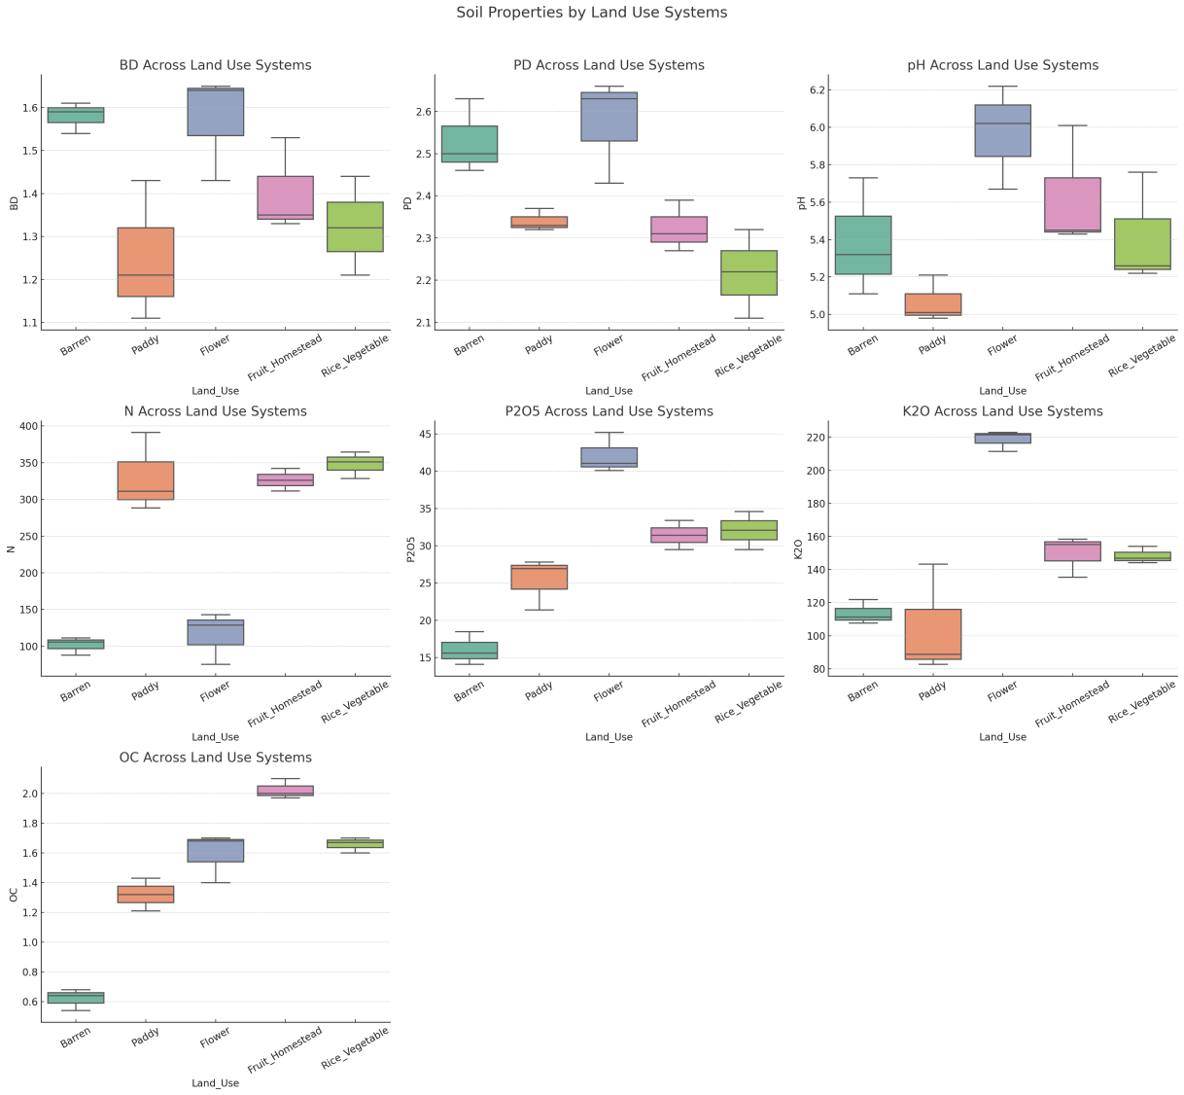

Figure 1 Boxplots showing soil physico-chemical properties across different land use systems (BD-Bulkdensity (g cm-3), PD Particle density (g cm-3), N-Available Nitrogen (kg ha-1), P2O5 Available phosphorus (kg ha-1), K2O-Available Potassium (kg ha-1), OC-Soil organic carbon (%).

**3.1 Bulk and Particle Density** Bulk density (BD) and particle density (PD) are physical properties that influence porosity, root penetration, and water retention. High BD indicates compacted soil with lower pore space, while PD reflects the mineralogical composition of soil particles (Brady & Weil, 2017). In the present study, significant variations were observed across land use types (p = 0.0207 for BD and p = 0.0028 for PD) (Table 1). Paddy systems exhibited the lowest bulk density (1.25 g/cm³), likely due to puddling and high organic matter inputs that reduce soil compaction (Sharma et al., 2021). Waterlogging in paddy fields causes breakdown of soil aggregates and displaces air, lowering soil mass per unit volume (Adhikari et al., 2019). Conversely, flower crop systems recorded the highest particle density, possibly due to greater mineral content and frequent tillage operations that disturb soil structure (Liang et al., 2020).

**3.2 Soil pH and Electrical Conductivity (EC)** Soil pH is a master variable influencing nutrient availability, microbial activity, and chemical reactions in the soil (Paul, 2015). It is sensitive to fertilization practices, crop residues, and liming. In this study, pH differed significantly among systems (p = 0.0285) ( Table 1), ranging from acidic in paddy fields (5.07) to near-neutral in flower crop systems (5.97). The relatively higher pH in flower beds may reflect lime applications or organic residues with alkaline characteristics like vermicompost with banana pseudo stem as raw material. Acidification in paddy soils is likely due to anaerobic conditions and continuous use of ammonium-based fertilizers (Zhang et al., 2010; Zhang et al., 2019). EC, which indicates soluble salt content, showed no significant difference (p = 0.3782) (Table 1), with all values within acceptable agricultural thresholds (Figure 1). This aligns with Das et al. (2022), who reported stable EC values across cropping systems in the Brahmaputra valley, suggesting negligible salinity stress.

**3.3 Available Nutrients (N, P, K)** Nutrient availability is a key determinant of soil fertility. Nitrogen is essential for vegetative growth, phosphorus for root development and energy transfer, and potassium for water regulation and disease resistance (Maddonni et al., 1999). Highly significant differences were found in available nitrogen (p < 0.00001), phosphorus (p < 0.00001), and potassium (p = 0.00006) (Table 1). Fruit-based homestead and rice-vegetable systems had the highest values for all three nutrients. This can be attributed to regular addition of organic inputs such as compost and tree litter, which enhance mineralization and nutrient cycling (Singh et al., 2021; Bhowmik et al., 2022). In contrast, nutrient depletion in barren lands and monocropped paddy fields could be due to erosion, nutrient leaching, and lack of organic amendments (Lal, 2006; Tilman et al., 2002). Monoculture reduces belowground biomass and limits nutrient replenishment through residues (Kaur et al., 2023).

**3.4 Organic Carbon (OC)** Soil organic carbon is a vital component of soil organic matter and contributes to nutrient cycling, aggregation, and biological activity (Veum et al., 2021). OC varied significantly across systems (p < 0.00001), ranging from 0.62% in barren land to 2.02% in fruit-based systems. The high carbon stock in fruit-based systems is likely due to sustained input from root biomass, leaf litter, and minimal soil disturbance that protects organic matter from decomposition (Kundu et al., 2020; Bünemann et al., 2018). Crop diversification enhances microbial carbon use efficiency and promotes carbon sequestration in soil aggregates (Gattinger et al., 2012).

**3.5 Tukey HSD Analysis** Tukey’s HSD test revealed distinct groupings among land use types for all significant parameters (Table 1). Barren land consistently formed a separate group with the lowest nutrient and carbon levels, while fruit-based and rice-vegetable systems clustered together with the highest values. These findings align with Ahmed et al. (2023), who reported superior soil quality under diversified and perennial cropping systems in Northeast India. Enhanced biological activity, continuous ground cover, and improved microclimatic conditions in such systems contribute to better nutrient retention and carbon buildup (Choudhury et al., 2018).

Overall, the results highlight the importance of integrated and biologically enriched systems in maintaining soil fertility and ecological balance. These systems not only enhance nutrient availability and carbon content but also promote microbial health, structural stability, and resilience to environmental stress (Six et al., 2002; Bünemann et al., 2018).

**4. CONCLUSION**

The findings of this study clearly establish that land use practices exert a profound influence on soil physicochemical properties in the Jorhat district of Assam. Systems integrating perennial vegetation, organic recycling, and crop diversification—such as fruit-based homesteads and rice-vegetable rotations—significantly improve key soil quality indicators, including organic carbon, nutrient availability, and reduced bulk density. These systems create favorable conditions for microbial activity, enhance soil structure, and support long-term sustainability of agricultural productivity. On the contrary, barren and intensively monocropped lands like paddy fields exhibit depleted fertility and lower organic matter status, thereby compromising soil resilience. Given the challenges posed by climate variability and land degradation in the northeastern region, adopting integrated land use models becomes essential. Such systems not only improve soil health but also contribute to biodiversity conservation, carbon sequestration, and enhanced livelihood opportunities for smallholder farmers. Therefore, it is imperative for policymakers, researchers, and development agencies to prioritize the promotion of ecologically sound, socially acceptable, and economically viable land use strategies for sustainable agricultural intensification in the region.

COMPETING INTERESTS DISCLAIMER:

Authors have declared that they have no known competing financial interests OR non-financial interests OR personal relationships that could have appeared to influence the work reported in this paper.

**REFERENCES:**

Adhikari, B., Kafle, B., & Adhikari, D. (2019). Influence of puddling on soil physical properties and rice yield. *Journal of Agriculture and Environment*, 20, 95–104.

Ahmed, M., Das, A., & Sarmah, R. (2023). Soil fertility and microbial dynamics under diversified land use systems in Northeast India. *Indian Journal of Soil Conservation*, 51(1), 34–41.

Bhowmik, D., Sarma, K., & Das, P. (2022). Effect of organic amendments on soil nutrient status and productivity in Assam. *Journal of the Indian Society of Soil Science*, 70(2), 184–190

Blake, G.R., & Hartge, K.H. (1986). Bulk Density. In: *Methods of Soil Analysis Part 1: Physical and Mineralogical Methods* (pp. 363–375). ASA.

Borah, D., Hazarika, S., & Kalita, M. (2019). Soil classification and fertility mapping of Jorhat district. *Indian Journal of Soil Science*, 67(3), 289–296.

Brady, N.C., & Weil, R.R. (2017). *The Nature and Properties of Soils* (15th ed.). Pearson.

Bünemann, E.K., Bongiorno, G., Bai, Z., Creamer, R.E., De Deyn, G., de Goede, R., ... & Brussaard, L. (2018). Soil quality – A critical review. *Soil Biology and Biochemistry*, 120, 105–125.

Choudhury, S.G., Singh, R., Hazra, K.K., Datta, A., Patra, A.K., & Sharma, A.R. (2018). Tillage and crop residue management effects on soil aggregation and carbon pools under rice–wheat cropping system. *Soil and Tillage Research*, 180, 135–144.

Das, T., Baruah, U., & Hazarika, B. (2022). Impact of different cropping systems on soil health in Brahmaputra Valley. *Journal of Agricultural Sciences*, 40(2), 99–107.

Davidson, E.A., & Ackerman, I.L. (1993). Changes in soil carbon inventories following cultivation. *Biogeochemistry*, 20(3), 161–193.

Ghosh, S., Nath, A.J., & Das, A.K. (2018). Soil fertility and carbon dynamics under traditional land-use systems in Northeast India. *Agroforestry Systems*, 92(4), 1011–1023.

Jackson, M.L. (1973). *Soil Chemical Analysis*. Prentice Hall of India.

Kaur, J., Singh, B., & Singh, J. (2023). Long-term monoculture affects nutrient cycling and microbial community. *Soil Use and Management*, 39(1), 93–104.

Kundu, S., Bhattacharyya, R., & Bandyopadhyay, K.K. (2020). Organic carbon dynamics under long-term land use change. *Soil Use and Management*, 36(4), 582–593.

Lal, R. (2006). Enhancing crop yields through restoration of soil organic carbon pool. *Land Degradation & Development*, 17(2), 197–209.

Maddonni, G.A., Otegui, M.E., & Andrieu, B. (1999). Effects on maize canopy architecture and light attenuation. *Field Crops Research*, 62(3), 153–162.

Olsen, S.R., Cole, C.V., Watanabe, F.S., & Dean, L.A. (1954). *Estimation of available phosphorus in soils by extraction with sodium bicarbonate*. USDA Circular No. 939.

Paul, E.A. (2015). *Soil Microbiology, Ecology and Biochemistry* (4th ed.). Academic Press.

Pratt, P.F. (1965). Potassium. In: *Methods of Soil Analysis Part 2: Chemical and Microbiological Properties*, 1022–1030.

Sharma, R., Tripathi, R., Nayak, A.K., Singh, G., & Shahid, M. (2021). Long-term effects of puddling on soil properties. *Agricultural Research*, 10(2), 140–148.

Singh, M., Yadav, S.K., & Bhatt, B.P. (2021). Role of homestead agroforestry in soil fertility. *Agroforestry Systems*, 95(6), 1133–1144.

Six, J., Conant, R.T., Paul, E.A., & Paustian, K. (2002). Stabilization mechanisms of soil organic matter. *Plant and Soil*, 241(2), 155–176.

Subbiah, B.V., & Asija, G.L. (1956). A rapid procedure for the estimation of available nitrogen. *Current Science*, 25, 259–260.

Tilman, D., Cassman, K.G., Matson, P.A., Naylor, R., & Polasky, S. (2002). Agricultural sustainability and intensive practices. *Nature*, 418(6898), 671–677.

Veum, K.S., Goyne, K.W., Kremer, R.J., & Anderson, S.H. (2021). Soil health indicators and ecosystem services. *Agronomy Journal*, 113(1), 454–465.

Walkley, A., & Black, I.A. (1934). An examination of the Degtjareff method for determining soil organic matter. Soil Science, 37, 29–38.

Zhang, Q., Wang, Y., & Li, X. (2010). Effects of land use change on soil fertility in karst region. Environmental Earth Sciences, 60(5), 889–897.

Zhang, Y., Yu, D., & Shi, X. (2019). Soil acidification in Chinese croplands. Geoderma, 341, 183–191.