**Comparative Effect of Soil and Foliar Zinc Application on the Yield of Tea (Camellia sinensis L.) in Northern Bangladesh**

ABSTRACT

Zinc (Zn) deficiency is a common limitation in tea (*Camellia sinensis* L.) production affecting its yield and quality negatively. An experiment was conducted at Islam Tea State, Thakurgaon, Bangladesh for comparing the efficacy of soil and foliar Zn application on yield of tea and to fix the best dose of it. ZnSO₄ was applied at 0, 100, 200, 300, and 400 g ha-1 in the soil and (0, 100, 200, 300, and 400 mg L-1 as foliar spray) at 45-day intervals for 135 days. At regular intervals, tea leaves were picked and weighed to observe productivity. It was found that a leaf yield significantly (p < 0.05) greater than that of control plants was obtained after the application in both a manners. The highest soil application yield (511.78 g plant-1) with 400 g ha-1 was 5% higher, while the foliar application yield (562.25 g plant-1) at 400 mg L-1 was 8% higher. However, foliar application was more successful, probably because Zn in that form was absorbed faster by the leaf cuticle. These results could mean that foliar application of 400 mg L-1 Zn resulted the most profitable way of increasing the tea yield under Zn-deficient condition, providing a possible agronomic solution to optimize productivity in

Key words: Tea, soil zinc, foliar zinc, leaf production, northern Bangladesh

INTRODUCTION

Tea (Camellia sinensis L.), a perennial evergreen tree of the family Theaceae, is one of the most popular non-alcoholic beverages worldwide. Widely appreciated for its fragrance, taste as well as extensive health benefits, tea has become an indispensable part of economy, culture and diet in certain countries. The bioactive ingredients in tea, for example, catechins, flavonoids, and polyphenols, play a remarkable role in its antioxidant, antimicrobial, and medicinal traits (Brimson et al., 2022; Dufresne & Farnworth, 2001). Internationally, tea is grown in subtropical and tropical zones, providing the favorable climate for this valuable crop.

Bangladesh has been growing tea for over 180 years, and it provides an important part of the economy in rural areas and employment to millions. ^ The country is one of the leading tea-producing countries with more than 167 numbers of commercial tea estates spread over area ranging from 280,000 acres (1.1 × 105 ha) employing more than 150,000 workers (Islam and Al-Amin, 2025). After jute tea is the second major cash crop, as well as agriculturally and commercially important for domestic consumption and export. North-eastern parts of Bangladesh such as Sylhet, Moulvibazar and Panchagarh and the northern districts like Panchagorh, Thakurgaon and Dinajpur provide agro-climatic conditions suitable for tea growing.

Field of study of nutrient management in tea For obtaining maximum production of tea, a holistic knowledge of nutrient requirement of tea in both macronutrients (N, P, K) and micronutrients (Zn, B, Mn) is essential. Among them, zinc (Zn) is an important micronutrient, which is essential for various physiological and biochemical activities in plants. On the other hand, zinc is also a structural and functional element of more than 300 enzymes proteins that participate in the most important metabolic routes of metabolism, such as protein synthesis, auxins production, and chlorophyll biosynthesis, membrane integrity, antioxidant defense (Peck and McDonald, 2010;). Previous investigations in the same location have found the reduction in growth and yield due to secondary and micronutrients, including Zn in the major crops (Hossain et al., 2001). While essential, Zn deficiency is quite widespread in agricultural soil, especially in the tropics and subtropics due to high phosphorus content, sandy or calcareous texture, and organic matter inadequacies which limits Zn's bioavailability (Alloway, 2008, Khan et al., 2006).

The prevalence of Zn deficiency in tea-growing areas of countries like Sri Lanka, India and China has been reviewed (Krishnakumar et al. 2024), and this trend has also been reported in Bangladesh. Zn deficiency symptoms in tea plant include decrease in growth, short internodes, reduction in the size of leaf, interveinal chlorosis, bronzing of the leaves, and increase in susceptibility to abiotic stress such as chilling (Nelson 2006; Huang et al. 2021). Recent situation in Dinajpur was reported as showing the adverse effect of changes of land use on soil nutrient availability (Khan and Alam, 2025). The physiological deficiency of Zn results in reduction in both yield and leaf quality and affects the marketability of processed tea.

There are two fundamentally opposite fertilizing approaches for treating Zn deficiency of crops: soil application and foliar application. Fertilization of the soil is still the principal way, where the nutrients are brought to the plant by root uptake. However, this strategy, although useful for macronutrients, may not be cost-effective for some micronutrients like Zn which can be immobilized by the soil, leached or poorly mobilized in acidic or high pH soils (Ahmad et al., 2012; Khan and Alam, 2025). By contrast, foliar application affords an efficient and targeted means of delivering micronutrients, particularly when applied at key developmental periods or in situations where it is difficult to supply nutrients to the crop via the root system. Foliar feeding allows the nutrients to be absorbed directly through the leaf cuticles and stomata and is one way to overcome the barriers imposed by the soil (Njogu et al., 2014).

The foliar application of Zn is particularly beneficial for tea plant. Tea leaves are coated with a wax cuticle that might improve in Zn absorption and transport to the developing tissues. It has been demonstrated that foliar Zn application promotes shoot proliferation, chlorophyll content, stress tolerance and polyphenol concentration, and therefore increases both yield and quality (Biswas et al., 2016; Garcia-López et al., 2019; Chen, 2021). Furthermore, foliar application has been reported to increase the yield by 12–25% in comparison to sole soil fertilization indicating its agro- as well as economica significance (Kentelky & Szekely‐Varga, 2021).

Although there is an exciting amount of evidence coming from the main tea-producing countries, there has been limited country-specific systematic research on Zn fertilizer practice in the tea industry of Bangladesh. Of these, nitrogen, phosphorus, and potassium are the main active fertilization factors, but low focus is placed on micro and macro- nutrients during conventional fertilization practices. Therefore, Zn deficiency typically remains unrecognised and unaddressed, and poor growth and productivity are the consequence. Filling this knowledge gap is essential for better nutrient management practice and sustainable tea productivity in the country.

Moreover, although both soil and foliar applications have been separately investigated, comparative studies on them in the same agro-climatic conditions are few. A comparative assessment of these two approaches can offer new perspectives on the effectiveness, efficiency and assimilative capacity of the techniques and ascertain the likelihood of incorporation in current fertilization schedules. Knowledge of the influence of Zn application not only on biomass accumulation and but also on nutrient residue in leaves and post-harvest soil properties is essential for providing recommendations to tea growers and industry players.

In this situation, the present study aimed to explore the effect of soil and foliar Zn application at three dosages on tea yield in a commercial plantation in North Bangladesh. The trial was conducted to: assess the impact of Zn fertilization by soil and foliar application on the vegetative growth and fresh leaf yield of the tea plants; and compare the efficiency of the application method of Zn between the soil application and foliar application.

METHODS AND MATERIALS

**Study Area and Duration**

A field experiment was conducted at the Islampur Tea Estate in Baliadanghi Upazila, Thakurgaon district, located in the northwestern region of Bangladesh (26.16°N latitude, 88.28°E longitude; elevation 58 m). The site lies within the Old Himalayan Piedmont Plain, classified under Agro-Ecological Zone 1 (AEZ-1). The study was carried out over a five-month period, from March to August 2022, encompassing the early monsoon and peak vegetative growth stages of tea.

**Climatic and Edaphic Conditions**

The experimental area experiences a subtropical monsoon climate, with an annual rainfall average of approximately 1700 mm, most of which occurs between June and October. Average summer and winter temperatures range from 31°C to 19°C, respectively (Banglapedia, 2014). The soil of the experimental site is classified as fine sandy loam to loamy sand, moderately acidic (pH 4.8–5.2), well-drained, and representative of typical tea-growing conditions in the region.

**Experimental Design and Treatments**

The experiment was arranged in a randomized complete block design (RCBD) with two modes of zinc application—soil and foliar—and five dosage levels for each method:

**Soil-applied treatments:**

* T₁: Control (no Zn)
* T₂: 100 mg ZnSO₄ ha-1
* T₃: 200 mg ZnSO₄ ha-1
* T₄: 300 mg ZnSO₄ ha-1
* T₅: 400 mg ZnSO₄ ha-1

**Foliar-applied treatments:**

* FT₁: Control (no Zn)
* FT₂: 100 mg ZnSO₄ per liter (mg L-1)
* FT₃: 200 mg ZnSO₄ per liter
* FT₄: 300 mg ZnSO₄ per liter
* FT₅: 400 mg ZnSO₄ per liter

Each treatment was replicated three times. All plots received the standard basal fertilizer dose recommended by the Bangladesh Tea Research Institute (BTRI): urea at 15 kg/bigha, triple superphosphate (TSP) at 20 kg/decimal, muriate of potash (MoP) at 20 kg/decimal, and a single application of poultry litter annually.

Zinc Application Protocol

Zinc (Zn) was applied in the form of ZnSO₄·7H₂O. Treatments were performed every 45 days, thus 3 times over 135 days of treatment. The root-related fraction of soil-applied Zn was placed directly into the root zone and foliar applications were performed using a hand-held sprayer to achieve uniform coverage of foliar surface. Foliar sprays were made in the morning to reduce evapotranspiration losses and provide opportunity for nutrient uptake.

Leaf Harvest and Yield Measurement

Leaves of the tea were collected at 45, 90, and 135 days from the initial Zn application. A total of 100 freshly plucked tea shoots (two leaves and a bud) were collected from each treatment plot and weighed in the field with a precision digital balance. In the present study yield response was measured as cumulative fresh leaf weight over all harvests.

Statistical Analysis

The results of all the experiments were analyzed by ANOVA in IBM SPSS Statistics version 22. The means of the treatments were compared by Tukey’s Honestly Significant Difference (HSD) test at significance level p < 0.05. The response of leaf yield and soil nutrient dynamics to treatments were depicted graphically

RESULTS AND DISCUSSION

**Effect of Soil Zinc (Zn) Applications on Tea leaves**

The effects of different soil-applied zinc (Zn) dosages on fresh tea leaf yield, measured as the total weight (g) of 100 shoots harvested at 45, 90, and 135 days after initial Zn application has been presented in Figure 1. The treatments included five soil Zn levels: 0 (control), 100, 200, 300, and 400 g ha-1 Zn, denoted as T₁ through T₅, respectively.

At 45 days, the maximum fresh leaf weight was recorded in T₄ (300 g ha-1), producing an average of 376.79 g plant-1, while the lowest was observed in the control (T₁) with 304.86 g plant-1. Interestingly, the 400 g ha-1 treatment (T₅) yielded slightly lower than T₄ at this stage (370.83 g plant-1), suggesting that moderate Zn doses may stimulate more immediate vegetative response.

At 90 days, the trend shifted: T₅ surpassed all other treatments, recording a leaf yield of 492.20 g plant-1, followed by T₄ (484.44 g plant-1) and T₃ (418.17 g plant-1). This progression indicates a cumulative effect of Zn availability in the soil, enhancing nutrient uptake and metabolic activity over time.

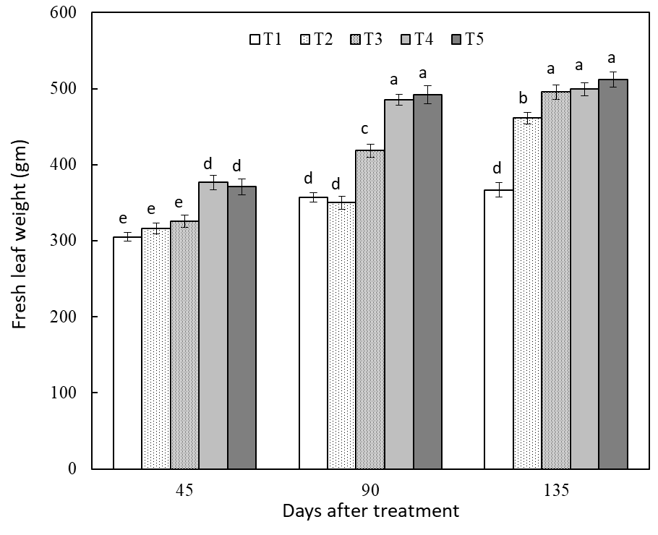

Figure 1. Fresh leaf production of tea after Zn application in soil Data are means of 3 replications. T₁ Control, T2 = 100 g ha-1, T3 = 200 g ha-1, T4 = 300 g ha-1 and T5 = 400 g ha-1 of Zn application in soil. Means having dissimilar letter (s) differ significantly as per 0.05 level of probability.

At 135 DAS, T₅ was still superior with 511.78 g plant-1, which increased gradually from earlier intervals and validated the long-term efficacy of higher Zn application. The relative lowest yielding was the control plot (T₁), indicating yield-limiting ability of Zn deficiency in tea soils at all sampling periods.

The data in Figure 1 illustrate a clear dose response to soil-applied Zn, which had the effect of enhancing the yield response over years. Zn’s role for enzyme activation, auxin biosynthesis and membrane stability are responsible for positive effect of Zn on leaf expansion and biomass buildup (Reddy and Kumari, 2022). These observations may be in agreement with previous findings (Biswas et al., 2016), which demonstrated that Zn fertilization promotes growth of the tea shoot and the plucking efficiency. However revelations are that even as 300 g ha-1 (T₄) is sufficient for early yield response, 400 g ha-1 (T₅) is better for continued productivity. The lack of toxicity symptoms at the maximum dose also suggests that this concentration is below phyto-toxic levels of tea at the acidic soil pH condition.

Effect of foliar Zn application to tea leaves

Effect of foliar applied zinc (Zn) at various levels on the fresh weight of leaves of tea based at 45 days intervals up to 135 days Data depicted in Figure 2 indicated the fresh weight of tea leaves. Treatments included five Zn levels, sprayed in the form of foliar: 0 (control), 100, 200, 300 and 400 mg L-1, named FT₁ to FT₅, respectively.

The greatest fresh leaf weight (393.69 g plant-1) at 45 DAT was obtained from FT₅ (400 mg L-1), and FT₄ (300 mg L-1) was in second place, with 347.62 g plant-1. The control (FT₁) yielded only 175.42 g plant-1, which indicated the initial lack of Zn in the system, and the success of the foliar application in correcting rapidly the shortage and also improving the vegetative growth. These findings demonstrated the higher Zn-use efficiency ability of foliar Zn particularly at the young flushes of tea shoots.

The highest leaf biomass (498.00 g plant-1) at 90 d was again obtained with FT₅, followed closely by FT₄ (485.00 g plant-1) and FT₃ (471.31 g plant-1). This indicates that there is a significant cumulative effect of Zn on increases in leaf area and shoot. The control treatment yet had the least yield (441.84 g of plant-1) that affirmed the limiting influence of Zn deficiency on tea productivity.

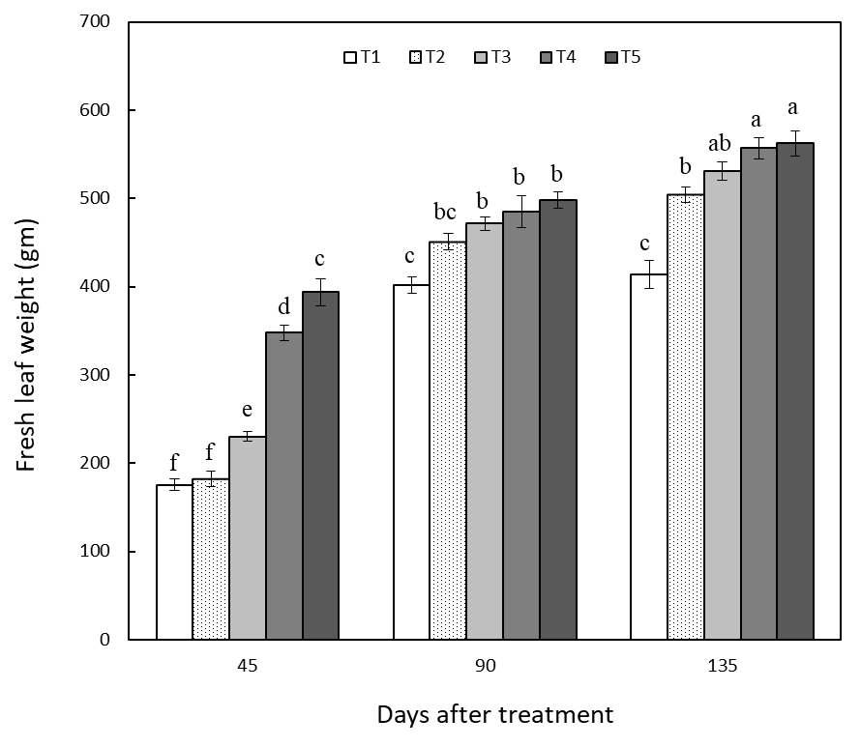

Figure 2. Fresh leaf production of tea after foliar application of Zn. Data are means of 3 replications. T. Control, T2-100 mg/da, T₁= 200mg/da, Ta-300 mg/da, Ts 400 mg/da of Zn application in soil. Means having dissimilar letter (s) differ significantly as per 0.05 level of probability.

By 135 days, FT₅ maintained its dominance, achieving the maximum recorded yield of 562.25 g plant-1, compared to just 53.93 g plant-1 in FT₁. The performance of FT₄ (557.00 g plant-1) and FT₃ (531.06 g plant-1) also remained consistently high, indicating that Zn sprayed directly onto foliage effectively sustains yield across multiple harvests.

The results from Figure 2 clearly demonstrate that foliar application of Zn significantly improves tea leaf yield in a dose-dependent manner. The superior performance of FT₅ at all stages reflects the rapid absorption and utilization of Zn through the leaf surface, bypassing limitations associated with soil-based delivery systems such as fixation or low solubility (Fageria et al., 2009; Xie et al., 2020). This is especially important in tea, where the cuticle layer of young leaves facilitates effective foliar nutrient penetration (Chen, 2021). Comparing the foliar treatments, the 400 mg/L concentration (FT₅) emerged as the most effective across all time intervals, with no evidence of phytotoxicity, suggesting that this level is both agronomically effective and physiologically safe for tea plants under field conditions. These findings are consistent with previous studies by Biswas et al. (2016) and Njogu et al. (2014), which demonstrated that foliar feeding of micronutrients enhances shoot vigor, chlorophyll synthesis, and tea quality attributes. Additionally, the quick onset of response in the 45-day interval underscores foliar feeding as an ideal strategy during periods of high nutrient demand or stress.

In conclusion, Figure 2 provides strong evidence that foliar application of Zn at 400 mg L-1 significantly enhances fresh leaf yield in tea, outperforming lower doses and the untreated control across all growth stages. This method offers an efficient, rapid, and sustainable approach to correcting Zn deficiency and boosting productivity in tea plantations.

**Relationship Between Soil Zinc Application and Tea Leaf Production**

Figure 3 presents the relationship between varying rates of soil-applied zinc (Zn) and the corresponding tea leaf yield, measured as cumulative fresh weight of 100 shoots. A clear positive correlation was observed between Zn dosage and leaf production (R2 = 0.9693**), indicating that increased Zn availability in the root zone enhances vegetative growth and biomass accumulation in tea plants.

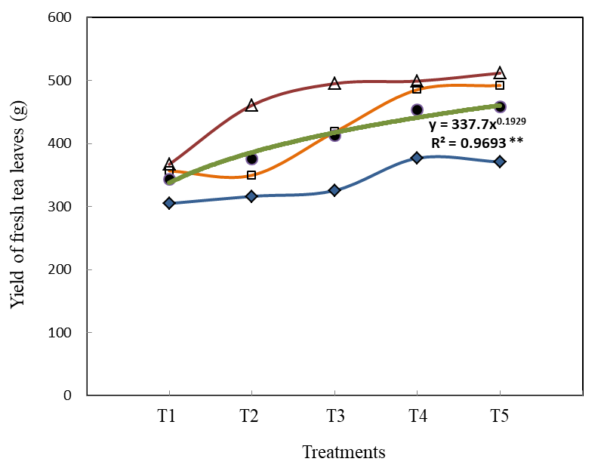

Figure 3. Relationship between soil Zn application and production of tea leaves Closed circles represent average fresh tea leaves production.

The response curve suggests a steady increase in yield from the control (0 g ha-1) to the highest treatment level (400 g ha-1). The optimal yield was recorded in T₅ (400 g ha-1), indicating that this dosage sufficiently meets the Zn requirements of tea under acidic soil conditions without inducing toxicity. The upward trend confirms the role of Zn in enhancing physiological functions such as enzyme activation, chlorophyll synthesis, and auxin regulation—all of which are critical for shoot elongation and leaf expansion (Reddy and Kumari, 2022).

This result also underscores the cumulative nature of soil Zn application: while it may act more slowly than foliar feeding, it sustains nutrient supply over a longer period through root uptake. Similar findings were reported by Mukhopadhyay et al. (2016) and Khan et al. (2015), who found that soil-applied Zn improved photosynthetic efficiency and leaf biomass in perennial crops.

The curve did not plateau at 400 g ha-1, suggesting that yields might continue to rise slightly with higher doses, although agronomic or environmental limits may be approached. Site-specific nutrient optimization, as demonstrated in similar studies in the region (Khan and Hoque, 2025), reinforces the importance of dose-based trials. Future studies could further investigate this potential threshold. Nonetheless, the significant yield response validates 400 g ha-1 Zn as an agronomically effective and environmentally safe soil application rate for tea cultivation.

**Relationship Between Foliar Zinc Application and Tea Leaf Production**

The relationship between foliar-applied Zn doses and cumulative fresh leaf yield has been illustrated in Figure 4. As with soil application, a strong positive linear response was observed (R2 = 0.9828**), with leaf yield increasing with higher Zn concentrations. The steep slope of the curve reflects the superior efficiency and immediacy of foliar Zn delivery compared to soil-based methods.

The maximum yield was observed at 400 mg L-1 (FT₅), reinforcing the earlier findings from Figure 2. The curve's trajectory also suggests that foliar Zn at this level fulfills the nutrient demands of tea plants without inducing toxicity. The effectiveness of foliar application is largely attributed to direct uptake through the cuticle and stomata, leading to faster translocation and utilization of Zn in the leaves where it is most needed during active flush growth (Chen, 2021; Njogu et al., 2014).

Unlike soil-applied Zn, which may be subject to fixation, leaching, or pH constraints, foliar-applied Zn acts independently of soil conditions, making it especially suitable for Zn-deficient or degraded soils. The consistency of the curve across all data points suggests minimal diminishing returns up to 400 mg L-1, affirming this as the optimal dose under the tested conditions.

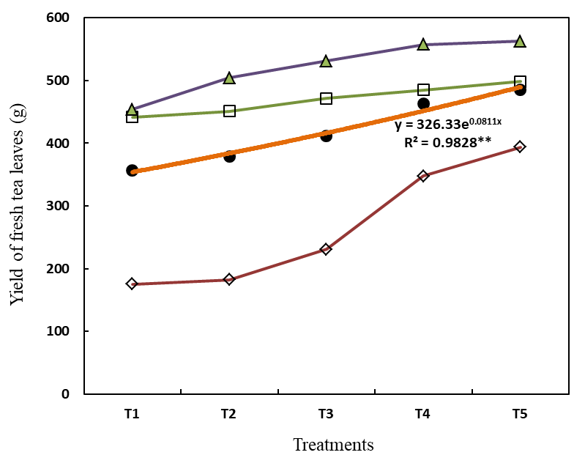

Figure 4. Relationship between foliar Zn application and production of tea leaves. Closed circles represent average fresh tea leaves production

Additionally, foliar feeding aligns with commercial tea harvesting schedules, where rapid nutrient support is needed during peak flush periods. Kentelky and Szekely-Varga (2021) reported that foliar fertilizers significantly boost yield and plant vigor in various high-value crops, including perennials.

### ****Comparative Interpretation of foliar and soil zinc application****

Taken together, **Figures 3 and 4 clearly demonstrate that both soil and foliar Zn applications positively influence tea leaf yield**, with a stronger response observed in foliar-fed treatments (R2 = 0.9693** in soil and R2 = 0.9828** in foliar application, Figure 3 and 4, respectively). While soil application supports long-term nutrient availability and soil fertility management, foliar feeding offers rapid, targeted correction of Zn deficiency and maximized productivity within a short time frame. Importantly, neither method showed signs of over-fertilization or toxicity at the highest tested dose (400 g ha-1 or 400 mg L-1), suggesting a **safe upper limit for agronomic use** in acidic tea-growing soils.

These findings support an **integrated Zn management approach**, where soil application could be used for baseline Zn enrichment and foliar sprays could serve as supplemental treatments during critical growth phases. Such a strategy would optimize resource use efficiency and ensure sustainable tea production in Zn-deficient regions like northern Bangladesh.

### ****Conclusion****

This research demonstrated that zinc (Zn) fertilization, applied through both soil and foliar methods, significantly enhances the fresh leaf yield of tea (Camellia sinensis L.) under the acidic soil conditions of northern Bangladesh. While both application methods were effective, foliar application of Zn at 400 mg/L consistently produced the highest yield, outperforming soil application at equivalent dosages. The superior performance of foliar Zn application is attributed to its rapid absorption and efficient translocation within the plant, overcoming the limitations of soil-based nutrient delivery. Post-harvest soil analysis further confirmed that Zn application improved soil Zn availability without negatively affecting pH or other key soil properties. These findings underscore the critical role of Zn in tea nutrition and support the integration of foliar Zn fertilization into standard nutrient management practices. Adoption of this strategy has the potential to enhance tea productivity, improve leaf quality, and ensure sustainable cultivation in Zn-deficient tea-growing regions.

REFERENCES

Ahmad W, Watts MJ, Imtiaz M, Ahmed , and Zia MH. 2012. Zinc deficiency in soils, crops and humans. Agrochimica. 56(2): 65-97.

Alloway BJ. 2008. Zinc in Soil and Crop Nutrition International Zinc Association. Brussels, Belgium.

Biswass A, Khan AQ, Ali NM, Zohora FT and Saha A. 2016. Effect of foliar application of zinc on the yield of tea. Bangladesh Tea Journal. 45: 18-22.

Brimson JM, Prasanth MI, Kumaree KK, Thitilertdecha P, Malar DS, Tencomnao T and Prasansuklab A. 2022. Tea Plant (Camellia sinensis) A current update on use in diabetes, obesity and cardiovascular disease. Nutrients. 15(1): 37-54. <https://doi.org/10.3390/nu15010037>

Chen M. 2021. The tea plant leaf cuticle from plant protection to tea quality. Frontiers in Plant Science. 12: 47-75. <https://doi.org/10.3389/fpls.2021.751547>

Dufresne CJ and Farnworth ER. 2001. A review of latest research findings on the health promotion properties of tea. The Journal of Nutritional Biochemistry 12(7): 404-421. <https://doi.org/10.1016/S0955-2863(01)00155-3>

Fageria NK, Filho MB, Moreira A and Guimarães CM. 2009. Foliar fertilization of crop plants. Journal of Plant Nutrition. 32(6): 1044-1064. <https://doi.org/10.1080/01904160902872826>

Garcia-López JI, Niño-Medina G, Olivares-Sáenz E, Lıra-Saldivar RH, Barriga-Castro ED, Vázquez-Alvarado R, Rodriguez-Salinas PA and Zavala-Garcia F. 2019. Foliar application of zinc oxide nanoparticles and zinc sulfate boosts the content of bioactive compounds in habanero peppers. Plants. 8(8): 254-274. <https://doi.org/10.3390/plants8080254>

Hossain MB, Ahmed S, Hossain AKMM, Khan MSHand T.N. Kumar. 2001. Effect of secondary and micronutrients on the yield and nutrient uptake by BRRI Dhan 32 in the Old Himalayan Piedmont plain and Tista Meander floodplain soil. *Journal of Biological Sciences*. 1(11): 1051-1055. DOI: [10.3923/jbs.2001.1051.1055](https://doi.org/10.3923/jbs.2001.1051.1055)

## [Huang](https://pubs.rsc.org/en/results?searchtext=Author%3AShan%20Huang) S, [Zuo](https://pubs.rsc.org/en/results?searchtext=Author%3ATing%20Zuo) T,  [Zheng](https://pubs.rsc.org/en/results?searchtext=Author%3AXin%20Zheng) X, [Zhuo](https://pubs.rsc.org/en/results?searchtext=Author%3AChao%20Zhuo) C,  [Hou](https://pubs.rsc.org/en/results?searchtext=Author%3AQiong%20Hou) Q, [Yao](https://pubs.rsc.org/en/results?searchtext=Author%3ALongren%20Yao) L, [Wang](https://pubs.rsc.org/en/results?searchtext=Author%3AXiaojun%20Wang) X, [Wang](https://pubs.rsc.org/en/results?searchtext=Author%3AJian%20Wang) J  and  [Ni](https://pubs.rsc.org/en/results?searchtext=Author%3AWuzhong%20Ni) W. 2021. Foliar application of glycinebetaine and Zn fertilizer improves both the apparent and functional qualities of albino tea (Camellia sinensis (L.) O. Kuntze]. **Food Funct. 12:** 9476-9485. <https://doi.org/10.1039/D1FO01398J>

Islam MN and Al-Amin M. 2025. Ethnicity, culture and human development of Bangladesh’s tea workers. Labor History. 66(2): 226-242. <https://doi.org/10.1080/0023656X.2024.2353090>

Kentelky E and Szekely-Varga Z. 2021 Impact of foliar fertilization on growth, flowering, and corms production of five Gladiolus varieties Plants. 10(9): 1963-1973. <https://doi.org/10.3390/plants10091963>

Khan MSH and Alam MM. 2025. The role of ecosystem transformation and agricultural expansion and its effect on some soil properties in Shingra and Birganj National Forests, Dinajpur, Bangladesh. Asian Journal of Research in Agriculture and Forestry. 11(2): 163-171. <https://doi.org/10.9734/ajraf/2025/v11i2395>

Khan MSH and Hoque MR. 2025. [Optimizing NPKS Fertilization for Onion Yield and Soil Health in Dinajpur, Bangladesh](https://scholar.google.com/citations?view_op=view_citation&hl=en&user=yhXLucUAAAAJ&cstart=20&pagesize=80&citation_for_view=yhXLucUAAAAJ:J_g5lzvAfSwC). International Journal of Plant and Soil Science. 37(3): 87-95. DOI: <https://doi.org/10.9734/ijpss/2025/v37i35350>

Khan MSH, Mian MJA, Akhter A and Khosruzzaman M. 2006. [Physico-chemical changes of paddy soils under long-term intensive fertilization](https://scholar.google.com/citations?view_op=view_citation&hl=en&user=yhXLucUAAAAJ&citation_for_view=yhXLucUAAAAJ:ufrVoPGSRksC). Asian Journal of Plant Sciences 5: 105-111. <https://www.cabidigitallibrary.org/doi/full/10.5555/20063045771>

Khan MSH, Wagatsuma T, Akhter A and Rao IM. 2015. Differences among rice cultivars in their adaptation to low ionic strength solution with toxic level of aluminum that mimics tropical acid soil conditions. Journal of Plant Nutrition. 38: 1973-1983. <https://doi.org/10.1080/01904167.2015.1061544>

Krishnakumar, V., Kumar, T.R., Murugesan, P. (2024). Tea (*Camellia sinensis* (L.) O. Kuntze). In: Thomas, G.V., Krishnakumar, V. (eds) Soil Health Management for Plantation Crops. Springer, Singapore. pp. 391-486. <https://doi.org/10.1007/978-981-97-0092-9_10>

Mukhopadhyay M, Mondal TK and Chand PK. 2016. Biotechnological advances in tea (Camellia sinensis [L.] O. Kuntze): a review. Plant Cell Reports. 35: 255-287. DOI 10.1007/s00299-015-1884-8

Nelson S. 2006. Zinc deficiency in tea (Camellia sinensis) Plant Disease. pp. 34. https://scholarspace.manoa.hawaii.edu/server/api/core/bitstreams/27c2ed01-bdd1-4acf-90e1-14274475ad99/content

Njogu RN, Kariuki DK, Kamau DM and Wachira FN. 2014. Effects of foliar fertilizer application on quality of tea (Camellia sinensis) grown in the Kenyan highlands. American J. Plant Science. 5(18): 2707-2715. DOI**:**[10.4236/ajps.2014.518286](http://dx.doi.org/10.4236/ajps.2014.518286)

Peck, A. W. and McDonald, G. K. 2010. Adequate zinc nutrition alleviates the adverse effects of heat stress in bread wheat. Plant and Soil. 337(1): 355-374. DOI: https://doi.org/10.1007/s11104-010-0532-x

Reddy NS and Kumari K. 2022. Importance of zinc in plant nutrition: A review. Asian J. Microbiol. Biotech. Env. Sc. 24(3): 490-493. DOI: <http://doi.org/10.53550/AJMBES.2022.v24i03.008>

Xie R, Zhao J, Lu L, Brown P, Guo J and Tian S. 2020. Penetration of foliar-applied Zn and its impact on apple plant nutrition status. Horticulture Research. 7(147): 1-12. <https://doi.org/10.1038/s41438-020-00369-y>