ASSESSMENT OF CHILLI HYBRIDS FOR HIGHER PRODUCTIVITY IN KALLAKURICHI DISTRICT OF TAMIL NADU

Abstract
An On Farm Testing (OFT) on Assessment of Chilli hybrids for higher productivity in Kallakurichi District of Tamil Nadu was carried out in 15 farmer’s field at five locations during 2022-23 and 2023-24. Among the hybrids tested, the maximum fruit length (9.96cm), fruit girth (1.46cm), number of fruits per plant (244.62) and maximum number of fruits per kg (142.96) were observed in Chilli hybrid TNAU Co (CH) 1. Further highest green chilli yield (21.26t/ha) was obtained from Co(CH) 1 than Arka Tanvi (15.41t/ha). Farmers also realized that the highest net profit (2.733 lakhs) with highest B: C ratio (1:2.6) from the cultivation of Chilli hybrid Co(CH)1 than Arka Tanvi (1.76 lakhs and 1:1.62). Based on the result obtained in OFT, the chilli hybrid Co (CH) 1 further popularized through Front Line Demonstrations in 10 farmers field, training and other awareness programmes in Kallakurichi District of Tamil Nadu.
Keywords
Hybrid Chilli – Co (CH) 1 – Arka Tanvi – Yield performance
Introduction
Chilli is one of the important vegetable cum spice crop in India. India is the major global producer, consumer, and exporter of chilli. In this country, Andhra Pradesh is the leading producer of green chilli, followed by Telangana, Karnataka and Maharashtra, with significant production also in states like Tamil Nadu, Bihar and Madhya Pradesh. Tamil Nadu ranks eighth position in Chilli cultivation. Annual production of Green Chilli in India in 2021-22 was 42,20,720 MT. The top 10 producing states accounted for 94.58% of Green Chilli production in India in the fiscal year 2021-22. It has acquired the status of World’s most popular vegetable crop due to its wider adaptability to various ago-climatic conditions (Gupta et al., 2015). Chilli is not merely a culinary delight but an integral part of our traditions with significant links to agriculture and day today life. Tamil Nadu boasts a rich history of chilli farming, with districts like Dindigul, Madurai, and Krishnagiri taking centre stage. Kallakurichi District, comes under North Eastern Agro Climatic Zone of Tamil Nadu. Agriculture is the most predominant sector of this district economy, 30% of the population engaged in agriculture and other allied activities for their livelihood. In this district, Chilli is being cultivated in an area of 543 ha with a production of 10095 quintals of green chilli in 2022-23. Private hybrids are ruling in the market as well as among the farmers though these hybrids show less pungency. But the cost of private hybrid seeds is so high which accounts more proportion of the farmers expenditure towards cost of cultivation (Malathi et al., 2023). Here 70 percent of the farmer cultivating private hybrids, but these hybrids are low yielder, also showing less pungency, exhibits more flower shedding and susceptible to high pest and disease incidence. Hence an OFT was formulated to assess the performance of public sector hybrids Arka Tanvi and TNAU Chilli Hybrid Co(CH)1 for higher yield in farmers field of Kallakurichi District during 2022-23.
Materials and Methods
A field experiment was conducted as an on farm trial in fifteen farmers field of five different locations of Moongilpadi, Keezhkuppam, Siruvangur, Nainarpalayam and Eriyur villages of Chinnasalem and Kallakurichi blocks in Kallakurichi district during Kharif season of 2022 - 23 in chilli using hybrids Arka Tanvi and TNAU Chilli Hybrid Co(CH)1 with Private Hybrid (drought and powdery mildew tolerant hybrid with medium pungency fruits of more than 11 cm long and diameter of 0.9 to 1.3 cm) as check hybrid. The mean performance of different traits such as plant height, fruit length (cm), fruit girth (cm), fruit weight (g), number of fruits per plant, fruit yield per hectare (tonnes), net returns per hectare and benefit cost ratio have been recorded and data was subjected to statistical analysis (Panse and Sukhatme, 1985).
Results and Discussion
The special features of Chilli hybrid TNAU Co(CH)1 plants are semi tall, spreading and highly branched. Fruits are smooth, elongated, tapering towards the tip and 10.5 – 12.0 cm long. Unripe fruits are light green in colour. The capsaicin and oleoresin contents were 0.58 % and 14.0 % respectively. It yields about 6.74 t/ha of dry pod and 28.10 t/ha of green chilli in a crop duration of 195-205 days. Ascorbic acid is 120 mg/100 g fruit. It is moderately resistant to fruit rot disease. Duration: 195-205 days, Season :June – July, September – October and January – February, Yield – Green fruit : 28.10 t/ha and Dry fruits : 6.74 t/ha. Similarly the special features of Arka Tanvi, it is a high yielding chilli F1 hybrid suitable for green and dry chilli market, plants are tall and spreading, fruits pendent, firm, medium pungent, green and turn deep red on maturity, smooth turn wrinkled on maturity, tolerant to chilli leaf curl virus, yield potential 80-100q green and 30-35 q dry chilli per 0.4 ha.

Growth parameter
Plant Height
The maximum plant height (Table.1) was observed in private hybrid (77.43 cm) followed by TNAU Chilli hybrid Co(CH)1 (71.29 cm) and the minimum plant height was noticed in Arka Tanvi (62.07 cm). The variation in plant height might be due to basic growth features of hybrids, inherent properties, hormonal factor and vigour of the crop. Similar results were also reported by Arain and Sial., 2022 and Sharath et al.,2023.
Yield parameters
Fruit length and Fruit girth (cm)
With respect to fruit length and fruit girth (Table 1 and Figure.1.), the maximum fruit length was observed in TNAU Chilli hybrid Co(CH)1 (9.96 cm) followed by Arka Tanvi (9.02 cm). The least fruit length was noticed in private hybrid (6.92 cm). Similarly, fruit girth of the chilli was maximum (1.46cm) in Arka Tanvi which is on par with TNAU Chilli hybrid Co(CH)1 (1.42cm). The least was observed in private hybrid (1.3 cm). This might be due to favourable climatic conditions and genetic makeup of the hybrid for wider adaptability. In addition to the inherent genetic makeup of the plant, the length of the fruit is closely correlated with the quantity of nutrients consumed and the plant’s vegetative state. This is in accordance with the findings of Byneni Keerthana etal.,2024 and Sharath et al.,2023
Number of fruits per plant and number of fruits per kg
Regarding yield characters, Chilli hybrid TNAU Co(CH)1 recorded the maximum number of fruits per plant (244.62) and number of fruits per kg (142.96) and it was followed by Arka Tanvi (209.91&162.78), whereas the private hybrid registered lowest number of fruits (169.98) and number of fruits per kg (176.69) (Table 1&2, Figure.1 & 2.).This might be due to higher fruit length and fruit girth. Similar results were reported by Kavitha et al. (2018); Rajamanickam (2020); Verma et al. (2020); Malathi et al. (2023) and Sathish et al.(2024).

Fig.1.Fruit characteristics of chilli hybrids

Fig.2. Number of fruits and green chilli yield of chilli hybrids

Green Chilli Yield (t/ha)
In the present study, it was revealed that, Chilli hybrid TNAU Co(CH)1 recorded the highest green chilli yield of 21.26 tonnes per ha and it was followed by Arka Tanvi (15.41t/ha) and the lowest yield was recorded in private hybrid (14.52t/ha). This might be due to more number of fruits per plant observed in TNAU Chilli hybrid Co(CH)1. Further, the fluctuation in chilli yield is likely caused by the differences in the accumulation of photosynthates that are transported from source (leaves) to sink (fruits). Also, fruit weight at maturity varies according to cultivars, time of harvest, soil fertility and cultural management. Awasthi et al. (2021) and Jeevitha et al. (2021) found similar findings.
Economics
The highest net returns (2.73lakhs/ha) and B:C ratio (2.6) was recorded in Chilli hybrid Co(CH)1 compared to Arka Tanvi (1.76 & 1.62) and Private hybrid (1.44 & 1.31) respectively.This might be due to high yield potential and genetic makeup of the individual hybrid. This is in conformity with the findings of Malathi et al.,2023 and Sathish et al.,2024
Conclusion
It was concluded that the Chilli hybrid Co(Ch)1 recorded higher yield and net return than Arka Tanvi and Private hybrid in Kallakurichi District of Tamil Nadu which in-turn helped the farmers to improve their economic status. Apart from yield attributes, Chilli hybrid Co(Ch)1 fetches good market preferences. The same hybrid was promoted under FLD programmes for popularization of this hybrid among the farming community.Therefore,it is feasible to suggest that this hybrid for commercial cultivation in Kallakurichi District.

Table 1. Vegetative and Yield performance of Chilli hybrids
Particulars | Plant Height (cm) |  |  | Fruit length (cm) |  |  | Fruit girth (cm) |  |  | No.of fruits per plant
 | CoCH1 | Arka Tanvi | Private Hybrid | CoCH1 | Arka Tanvi | Private Hybrid | CoCH1 | Arka Tanvi | Private Hybrid | CoCH1 | Arka Tanvi | Private Hybrid
Mean | 71.29 | 62.07 | 77.43 | 9.96 | 9.02 | 6.92 | 1.42 | 1.46 | 1.3 | 244.62 | 209.91 | 169.98
S.EM | 2 | 1.08 | 1.73 | 0.43 | 0.35 | 0.24 | 0.11 | 0.11 | 0.1 | 2.22 | 3.99 | 2.46
CD @ 5% | 5.8 | 3.13 | 5 | 1.25 | 1.01 | 0.68 | 0.31 | 0.32 | 0.28 | 6.42 | 11.56 | 7.13
S.Ed | 2.83 | 1.53 | 2.44 | 0.61 | 0.49 | 0.33 | 0.15 | 0.16 | 0.14 | 3.13 | 5.64 | 3.48

Table.2. Green Chilli yield and economics of Chilli hybrids
Particulars | No.of fruits per Kg |  |  | Green Chilli yield (t/ha) |  |  | Net returns (Rs in Lakh/ha) |  |  | B:C ratio
 | CoCH1 | Arka Tanvi | Private Hybrid | CoCH1 | Arka Tanvi | Private Hybrid | CoCH1 | Arka Tanvi | Private Hybrid | CoCH1 | Arka Tanvi | Private Hybrid
Mean | 142.96 | 162.78 | 176.69 | 21.26 | 15.41 | 14.52 | 2.73 | 1.76 | 1.44 | 2.6 | 1.63 | 1.31
S.EM | 2.72 | 2.42 | 4.47 | 0.8 | 0.5 | 0.41 | 0.13 | 0.08 | 0.07 | 0.08 | 0.03 | 0.05
CD @ 5% | 7.87 | 7.01 | 12.94 | 2.32 | 1.44 | 1.19 | 0.38 | 0.23 | 0.19 | 0.24 | 0.09 | 0.15
S.Ed | 3.84 | 3.42 | 6.32 | 1.13 | 0.7 | 0.58 | 0.18 | 0.11 | 0.09 | 0.12 | 0.04 | 0.07

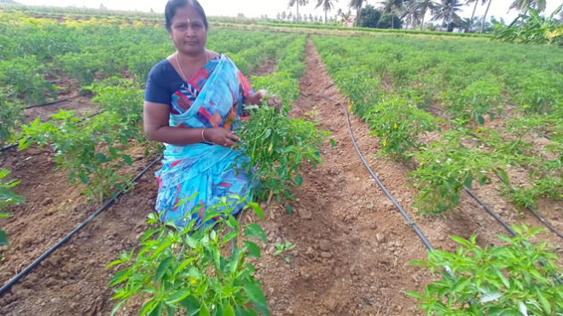 | 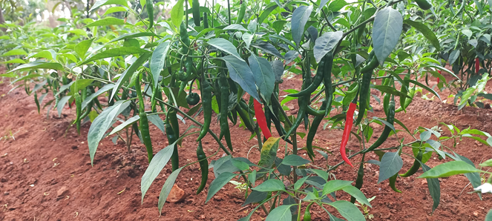
Chilli hybrid Co(Ch)1 at 3 MAP | Yielding stage
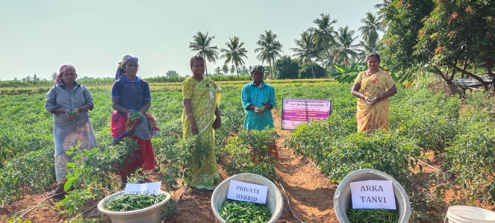 | 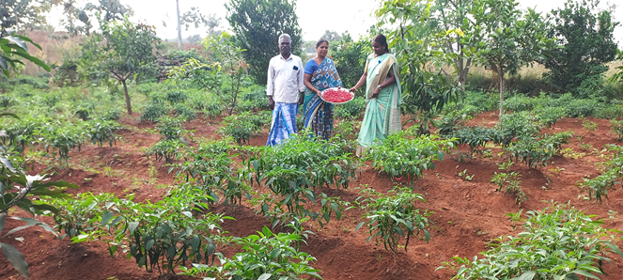
Harvested chilli
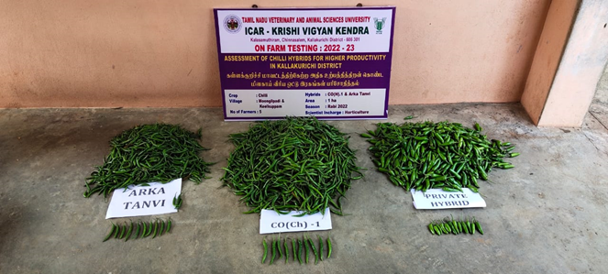 | 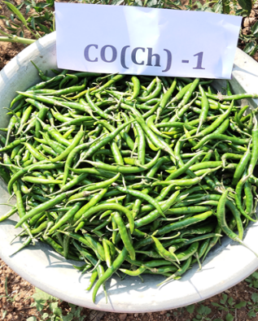
Performance of Chilli hybrids

Figure 3: Yield performance of Chilli hybrids

REFERENCES

Arain SM and Sial MA.2022. Association analysis of fruit yield and other related attributes in four chilli (Capsicum annum L.) genotypes grown in Sindhi province, Pakistan. Pak J Botany,54(3):817-822
Awasthi M,Singh, D and Bahadur.2021. Varietal evaluation of Chilli (Capsicum annuum L) for growth, yield and quality in Prayagraj agro-climatic condition. J.Pharma Innov,10(10):1267-1269
Byneni Keerthana, Vijay Bhahadur and Samir E Topno.2024. Evaluation on different hybrids of chilli (Capsicum annum L.) for growth,fruit yield and quality. International Journal of Research in Agronomy.7 (7):198-201
Gupta. A.J., Chattoo, M.A. and Lal, S. 2015. Drip irrigation and fertigation tecthnology for improved yield, quality, water and fertilizer use efficiency in hybrid tomato. Journal of Agri-search 2(2):94-99.
Jeevitha J, Devi H. Pugalendhi L and Premelatha N.2021.Performance assessment of various chilli species grown under shadenet for growth, yield and quality characters in Coimbatore region,India. J Pharma Innova.10 (11) :625 - 630
Kavitha P S, Sudha A and Srividhya S. 2018.Assessment of Chilli varieties in Salem district for higher productivity. Journal of Horticultural Science.13 (1), 119-121
Malathi G, Jegathambal R, Vijayan P, Kalai Selvi and Anand G. 2023. Assessing the performance of Chilli hybrid (Capsicum annuum L.) hybrids TNAU Chilli hybrid Co1 and Arka Saanvi in Salem District of Tamil Nadu. International Journal of Engineering Technology and Management Sciences. 7(1): 70-73
Malathi,G.,Vijayan,R,Vijayakumar,R..M Kohila,P and N.Sriram. 2023.Assessment of per se performance of Chilli (Capsicum annum) hybrids in Salem District of Tamil Nadu. International Advanced Research Journal in Science,Engineering and Technology, 8(8):480-482
Panse VG and Sukhatme PV.1985. Statistical methods for agriculyural workers.2nd edn ICAR, New Delhi. 87-89
Rajamanickam C. 2020. Assessment of Chilli (Capsicum annum L) hybrids for growth and yield characters. Journal of Krishi Vigyan,8(2):12-15
Sathish G, Sundharaiya K. Tamilselvi C. Yogameenakshi P, Vijayashanthi V A, .Arul Arasan P, Geethalakshmi I and Sivakumar V. 2024. Assessment of Chilli hybrids for growth, yield and economics at Thiruvallur District of Tamil Nadu. Biological forum -An International Journal. 16(3):153 -156
Sharath,M N,.Srinivasa Devaraju,V,Lakshmanan D,Chandrasekar,S Y and Nikhil Gowda,M N.2023.Performance of studies of Chilli (Capsicum annuum L.) hybrids for growth and yield traits under hill zone of Karnataka .Environment and Ecology.41(1C):732-736
Verma,R. K.Maurya,R, Ghosh S,Kumar V,Verma R.B.Singh, A.P and Kumar.P.2020. Assessing the efficacy of plant growth and yield of chilli (Capsicum annum L ) in Koshi region of Bihar an On Farm Trial. Journal of Pharmocognosy and Phytochemistry,9(3):858-859

