Estimation and Availability of Male Moths in Cotton Ecosystems Using Pheromone Trap Monitoring

.

ABSTRACT

Aims of Study: A two-year field experiments (Kharif 2023 and 2024) were conducted across MCRS, NAU, Surat and RCRS, NAU, Bharuch to monitor the seasonal activity and abundance of major lepidopteran pests through pheromone traps in both Bt (protected and unprotected) and non-Bt (protected and unprotected) cotton varieties.
Results: Results indicated that PBW activity peaked from the 41st to 52nd SMW, with significantly higher male moth catches in non-Bt cotton (Suraj) compared to Bt hybrids (G. Cot. Hy. 8 BG II), particularly under unprotected conditions. ABW showed peak activity between the 43rd and 48th SMW, again with higher catches in non-Bt plots. SBW recorded consistently low incidence, whereas LEC exhibited sustained trap catches from the 36th to 49th SMW. Correlation analyses revealed that PBW and LEC activities were positively associated with maximum temperature and sunshine hours, while negatively correlated with humidity, rainfall, wind speed and number of rainy days. These findings suggest that dry and warm conditions promote pest activity, with non-Bt cotton being more susceptible. Male moth availability of key cotton pests pink bollworm (PBW), American bollworm (ABW), spotted bollworm (SBW) and leaf-eating caterpillar (LEC) was estimated using peak pheromone trap catch data from kharif 2024–25, assuming 5% of cotton farmers in Gujarat and India adopted the recommended 5 traps/ha. Estimated male moth populations during peak periods were 1507.71, 719.10, 11.72 and 1127.23 lakh in Gujarat and 7215.19, 3441.25, 56.09 and 5394.40 lakh across India for PBW, ABW, SBW and LEC, respectively.

Keywords: (Cotton pests, Pheromone traps, Pest monitoring, population dynamics, Correlation)

1. INTRODUCTION

Cotton is one of the most important commercial fiber crops in India, occupying a significant share of the total cultivated area. In the year 2024–25, cotton is grown on approximately 114.47 lakh hectares across the country, with Gujarat alone accounting for 23.92 lakh hectares (Anon., 2025). However, the cotton ecosystem is frequently threatened by several lepidopteran pests, most notably the bollworms Pectinophora gossypiella (Saunders), Helicoverpa armigera (Hubner) and Earias vittella (Fabricius) along with the leaf-eating caterpillar Spodoptera litura (Fabricius). These pests cause considerable damage, particularly in non-Bt cotton fields, leading to severe yield losses if not properly managed. As a component of Integrated Pest Management (IPM), pheromone traps are extensively deployed for the monitoring, surveillance and mass trapping of male moths, thereby disrupting the mating cycle and reducing the pest population over time (Anon., 2024). These traps are especially beneficial in organic and natural farming systems where chemical inputs are minimized. Pheromone-based trapping offers a non-toxic, target-specific and environmentally benign method of pest control that aligns well with sustainable agricultural practices. Given the extensive deployment of pheromone traps across cotton-growing regions, large numbers of male moths are collected routinely during the crop season. This provides an untapped biological resource that can be utilized for various biotechnological applications. One such promising avenue is the extraction of chitin and its derivative chitosan from the exoskeletons of these insects. Chitin is a structural polysaccharide present in the cuticle of arthropods and its deacetylated form, chitosan possesses a wide range of biofunctional properties including antimicrobial, insecticidal and film-forming characteristics. Recent studies have highlighted the insecticidal potential of chitin and chitosan. Casals et al. (2002) demonstrated their efficacy against homopteran pests, while Zhang et al. (2003) reported significant activity against several lepidopteran species. These findings suggest that biopolymers extracted from pest insects themselves could be recycled and repurposed as a part of eco-friendly pest control solutions, creating a circular approach to pest management.
Therefore, this study aims to investigate the availability, seasonal dynamics and collection potential of male moths from pheromone traps in cotton fields, with a focus on their utilization as a source of chitin for chitosan production. Understanding the abundance and periodicity of these trapped moths will not only support pest monitoring efforts but also facilitate the development of novel, sustainable bioproducts from insect biomass.
2. material and methods
To monitor bollworms and leaf-eating caterpillars in Bt and non-Bt cotton, pheromone traps (@ 5 traps/ha) were installed using Pherosensor-TM-SP-Sleeve Traps designed by Pheromone Chemicals, Hyderabad. The details of the pheromone traps and lures used are given in the Table 1. These traps, containing insect-specific lures, were installed at MCRS, Surat and RCRS, Bharuch at a rate of 2 traps per 4000 m² from 45 DAS until the end of the crop season during 2023–24 and 2024–25. Initially placed 1.0 m above ground, trap height was adjusted to remain 1.0 ft above the crop canopy as it grew. Lures were replaced every 40–45 days and traps were spaced 30 m apart. Hygiene was maintained while handling lures to ensure effectiveness.
Table 1: The details of the pheromone traps and lures*
Sr. No. | Common name | Scientific name | Common name of pheromone | Details of pheromone
1 | Pheromone trap |  |  | Pherosensor-TM-SP-Sleeve Trap
2 | Pink bollworm  (PBW) | Pectinophora gossypiella Saunders | Gossyplure | Z, Z- and Z, E- isomers of 7,11-hexadecadienyl acetate
3 | American bollworm (ABW) | Helicoverpa armigera  Hubner | Helilure | (Z)-11-Tetradecen-1-ol
4 | Spotted bollworm (SBW) | Earias vittella Fab. | Ervitlure | Z, Z- and Z, E- isomers of 7,11-hexadecadienyl acetate
5 | Leaf eating caterpillar (LEC) | Spodoptera litura Fab. | Spodolure | (Z)-11-hexadecenal
*Source: Pheromone chemicals, IDA Nacharam, Hyderabad-500076, TS, India
2.1 Incidence of Male Moths through Pheromone Trap Catches
Male moths were recorded weekly from pheromone traps installed at 45 days after sowing (DAS) in Bt and non-Bt cotton fields, as well as in protected and unprotected plots over two years (2023–24 and 2024–25). Trapped moths were collected, dried and stored for further analysis. Trap catch data were analyzed to estimate seasonal and peak moth activity. For correlation analysis with weather parameters, data from Bt unprotected blocks were used due to their wider cultivation. Weather variables such as temperature, humidity, rainfall, sunshine and wind speed recorded at nearby observatories (MCRS, Surat and RCRS, Bharuch) were used. Correlation coefficients between moth catches and weather parameters were calculated following Steel and Torrie (1980).
2.2 Estimation of Moths Availability through Pheromone Trap Installation
Weekly pheromone trap catch data from protected blocks at Surat and Bharuch during 2023–24 and 2024–25 was used to estimate the availability of male moths for chitin and chitosan extraction. Estimations were based on pooled two-year data, considering both peak activity periods (>10 moths/trap/week) and the entire season. Simple mathematical conversions were applied, assuming that 5 per cent of farmers in Gujarat or India implemented the recommended practice of installing 5 pheromone traps per hectare with timely lure replacements for monitoring bollworms and leaf-eating caterpillars.
Availability during the whole season and peak period:
= Avg. Total number of male moth catches/trap for whole season and peak periods only x 5 traps/ha for monitoring x 5% cotton farmers’ area of Gujarat and/or India

3. results and discussion
3.1 Incidence of Male Moths through Pheromone Trap Catches at Main cotton research station, Surat
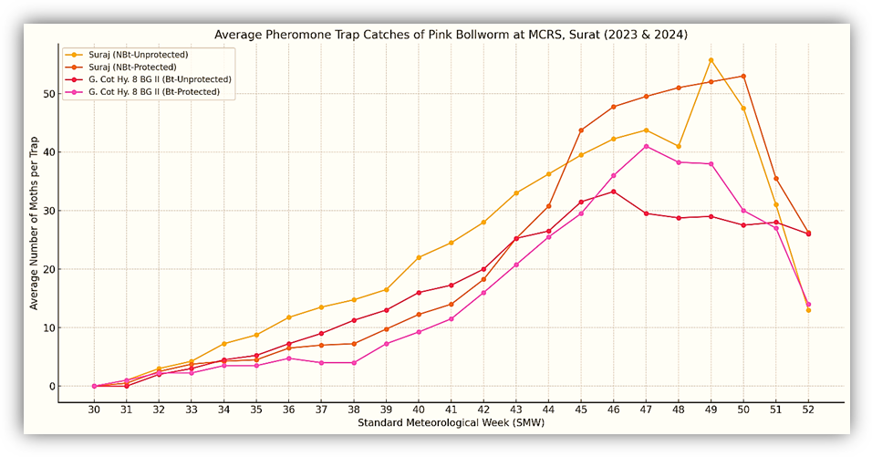
Pink bollworm (PBW): The two year pooled data of protected plots (G. Cot. Hy. BG II) during 2023 and 2024 revealed that the PBW was found active from 31st to 52nd SMW and their peak activity (>10.0 moths/trap) was noticed from the 41st Figure 1. Average pheromone trap catches of PBW at Surat
(second week of October) to 52nd (last week of December) SMW (Figure 1). The two year pooled data of unprotected plots revealed that the PBW was found active from 31st to 52nd SMW and their peak activity (>10.0 male moths/trap) was noticed from the 38th (third week of September) to 52nd (last week of December) SMW. In protected and of Suraj the two year pooled data revealed that the PBW was found active from 31st to 52nd SMW and their peak activity (>10.0 male moths/trap) was noticed from the 40th (first week of October) to 52nd (last week of December) SMW. The two year pooled of unprotected plots, data revealed that the PBW was found active from 32nd to 52nd SMW and their peak activity (>10.0 male moths/trap) was noticed from the 37th (second week of September) to 52nd (last week of December) SMW.
American bollworm (ABW): The two year pooled data of (G. Cot. Hy. BG II) protected plots, revealed that the ABW was found active from 32nd to 50th SMW and their peak activity (>10.0 male moths/trap) was noticed from the 39th (last week of September) to 47th (third week of November) SMW. In the unprotected plots, the two year pooled data revealed that the ABW was found active from 32nd to 48th SMW and their peak activity (>10.0 male moths/trap) was noticed from the 43rd (fourth week of October) to 48th (last week of November) SMW (Figure 2).
In the variety Suraj (protected plots) the two year pooled data revealed that the ABW was found active from 31st to 49th SMW and their peak activity (>10.0 male moths/trap) was noticed from the 44th (first week of November) to 48th (first week of December) SMW. The two year pooled data of unprotected plots revealed that the ABW was found active from 32nd to 50th SMW and their peak activity (>10.0 male moths/trap) was noticed from the 37th (second week of September) to 48th (first week of December) SMW. The difference in the trap catches of male moths of ABW was found not significant between the trap catches of male moths of protected and unprotected plots. Further, the difference in the trap catches of male moths of ABW was found significant between the trap catches of male moths in unprotected plots of G. Cot. Hy. 8 BG II and Suraj showing a greater number of male moths wandering in non Bt variety than Bt hybrid may be due to more pronounced activity in conventional non Bt variety for egg laying and infestation having no toxins.
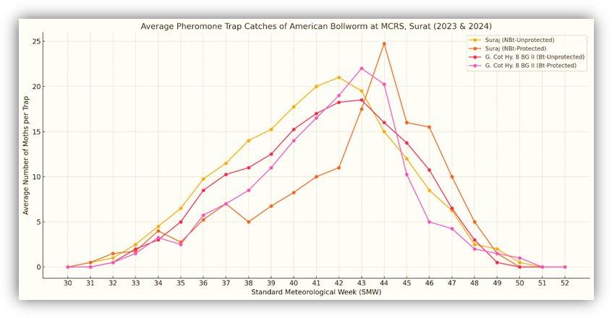

Figure 2. Average pheromone trap catches of ABW at Surat
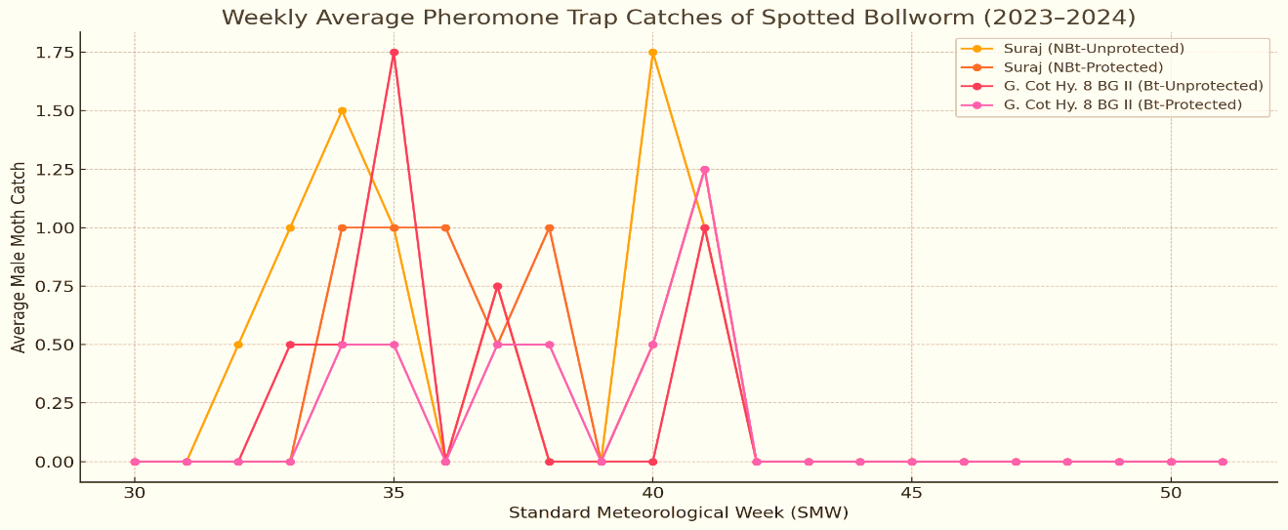
Spotted bollworm (SBW): The two year pooled data on trap catches of male moths of SBW in protected of G. Cot. Hy. BG II revealed that the spotted bollworm was found active from 34th (third week of August) to 41st (second week of October) SMW only and their catches were very low. In unprotected plots, trap catches showed that the SBW was found active from 33rd (second week of August) to 41st (second week of October) SMW only and their catches were very low (Figure 3).

Figure 3. Average pheromone trap catches of SBW at Surat
The data on trap catches of male moths of SBW in protected plots of Suraj revealed that the spotted bollworm was found active from 34th (third week of August) to 41st (second week of October) SMW only and their catches were very low. In unprotected plots, trap catches showed that the spotted bollworm was found active from 34th (third week of August) to 41st (second week of October) SMW only and their catches were very low.
Leaf eating caterpillar (LEC): The data on trap catches of male moths of LEC in protected of G. Cot. Hy. BG II, revealed that the leaf eating caterpillar was found active from 31st to 52nd SMW and their peak activity (>10.0 male moths/trap)
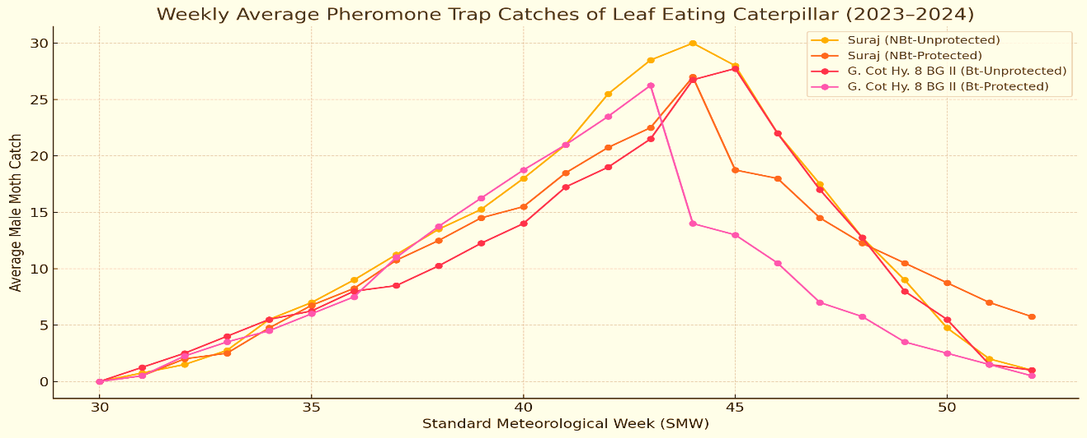
was noticed from the 36th (last week of October) to 46th (third week of November) SMW. In unprotected plots, trap catches revealed that the leaf eating caterpillar was found active from 31st to 52nd SMW and their peak activity (>10.0 male moths/trap) was noticed from the 38th (third week of September) to 48th (last week of November) SMW. In Suraj, non Bt variety, the data on trap catches of male moths from protected plots revealed that the LEC was found active from 31st to 52nd SMW and their peak activity (>10.0 male moths/trap) was noticed from the 37th (second week of September) to 49th (first week of December) SMW. In unprotected plots, trap catches revealed that the LEC was found active from 31st to 52nd SMW and their peak activity (>10.0 male moths/trap) was noticed from the 39th (last week of September) to 49th (first week of December) SMW (Figure 4).
Figure 4. Average pheromone trap catches of LEC at Surat
Regional Cotton Research Station, Bharuch
Pink bollworm: The data on trap catches of male moths of PBW in protected plots of Rasi 2 BG II the two year pooled data revealed that the pink bollworm was found active from 32nd to 52nd SMW and their peak activity (>10.0 male moths/trap) was noticed from the 40th (first week of October) to 48th (last week of November) SMW. In unprotected plots, two year pooled data revealed that the PBW was found active from 31st to 52nd SMW and their peak activity (>10.0 male moths/trap) was noticed from the 39th (last week of September) to 48th (last week of November) SMW. The data on trap catches of male moths of PBW in protected plots of Suraj (Non-Bt cotton variety) during 2023 and 2024 revealed that the PBW was found active from 31st to 52nd SMW and their peak activity (>10.0 male moths/trap) was noticed from the 40th (first week of October) to 52nd (last week of December) SMW. In unprotected plots, trap catches data of two year pooled revealed that the PBW was found active from 31st to 52nd SMW and their peak activity (>10.0 male moths/trap) was noticed from the 40th (first week of October) to 52nd (last week of December) SMW (Figure 5).
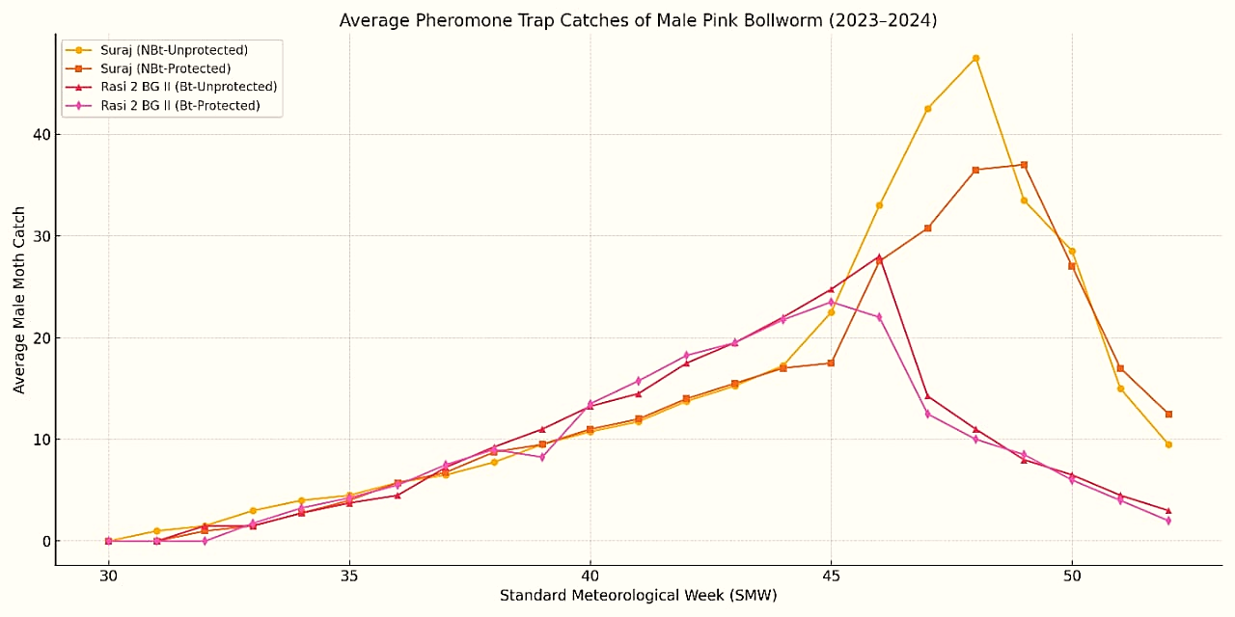
Figure 5. Average pheromone trap catches of PBW at Bharuch
American bollworm: The data on trap catches of male moths of ABW in protected plots of Rasi 2 BG II (Bt cotton hybrid) during 2023 and 2024, revealed that the ABW was found active from 33rd to 50th SMW and their peak activity (>10.0 male moths/trap) was noticed from the 39th (last week of September) to 45th (first week of November) SMW. In unprotected plots, trap catches the two year pooled data revealed that the ABW was found active from 32nd to 51st SMW and their peak activity (>10.0 male moths/trap) was noticed from the 40th (first week of October) to 45th (second week of November) SMW. The data on trap catches of male moths of ABW in protected plots of Suraj (Non-Bt cotton variety) during 2023 and 2024. The two year pooled data revealed that the ABW was found active from 32nd to 51st SMW and their peak activity (>10.0 male moths/trap) was noticed from the 39th (last week of September) to 48th (last week of November) SMW. In unprotected plots, trap catches of two year pooled data revealed that the ABW was found active from 31st to 48th SMW and their peak activity (>10.0 male moths/trap) was noticed from the 39th (last week of September) to 48th (last week of November) SMW (Figure 6).
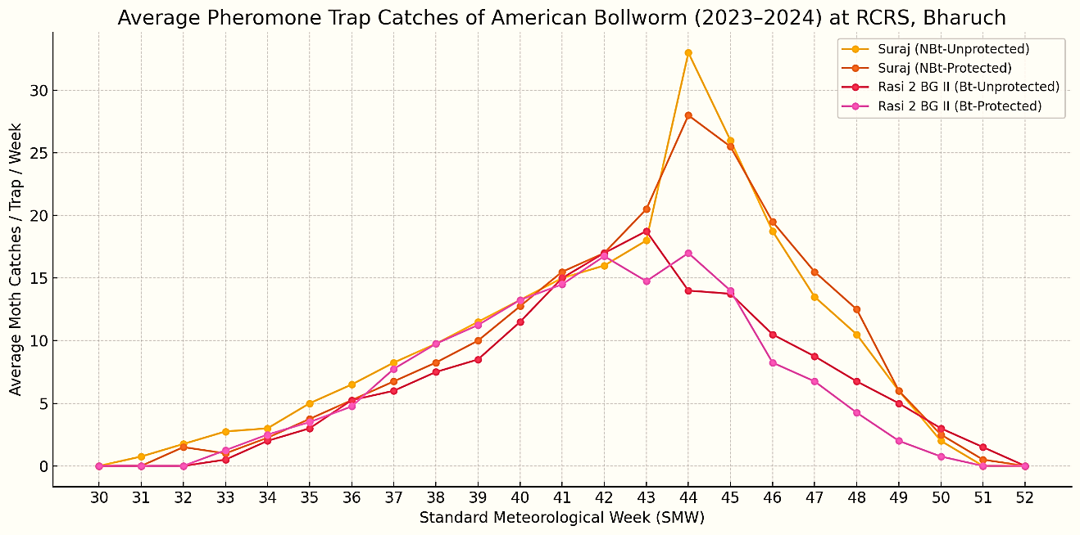Figure 6. Average pheromone trap catches of ABW at Bharuch
Spotted bollworm: The data on trap catches of male moths of SBW in protected and unprotected plots of Rasi 2 BG II during 2023 and 2024. The two year pooled data revealed that the spotted bollworm was found active from 35th (last week of August) to 38th (third week of September) SMW and their activity (1.0 male moths/trap). In unprotected plots, trap catches revealed that the SBW was found active from 35th (last week of August) to 39th (fourth week of September) SMW (>1.0 male moths/trap). The data on trap catches of male moths of SBW in protected and unprotected plots of Suraj (Non-Bt cotton variety) during 2023 and 2024. The two year pooled data revealed that the spotted bollworm was found active from 35th to 38th SMW and their overall activity (>1.0 male moths/trap) was noticed from the 35th (last week of August) to 41st (second week of October) SMW. In unprotected plots, trap catches of two year pooled data revealed that the SBW was found active from 35th to 40th SMW and their overall activity (>1.0 male moths/trap) was noticed from the 34th (third week of August) to 40th (first week of October) SMW (Figure 7).
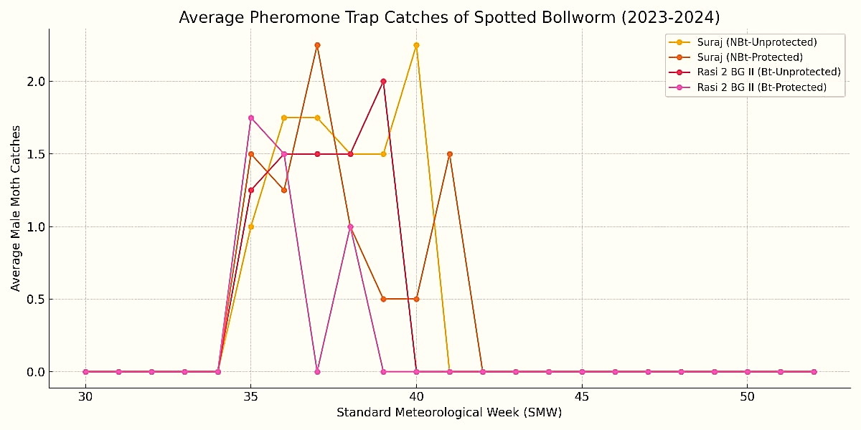

Figure 7. Average pheromone trap catches of SBW at Bharuch
Leaf eating caterpillar: The data on trap catches of male moths of LEC in protected and unprotected plots of Rasi 2 BG II (Bt cotton hybrid) during 2023 and 2024. The two year pooled data revealed that the LEC was found active from 32nd to 52nd SMW and their peak activity (>10.0 male moths/trap) was noticed from the 38th (last week of October) to 48th (third week of November) SMW. In unprotected plots, trap catches of two year pooled data revealed that the LEC was found active from 32nd to 52nd SMW and their peak activity (>10.0 male moths/trap) was noticed from the 38th (third week of September) to 48th (last week of November) SMW. The data on trap catches of male moths of LEC in protected and unprotected plots of Suraj (Non-Bt cotton variety) during 2023 and 2024. The two year pooled data revealed that the LEC was found active from 32nd to 52nd SMW and their peak activity (>10.0 male moths/trap) was noticed from the 40th (first week of October) to 49th (first week of December) SMW. In unprotected plots, trap catches of two year pooled data revealed that the LEC was found active from 32nd to 52nd SMW and their peak activity (>10.0 male moths/trap) was noticed from the 39th (last week of September) to 50th (second week of December) SMW (Figure 8).
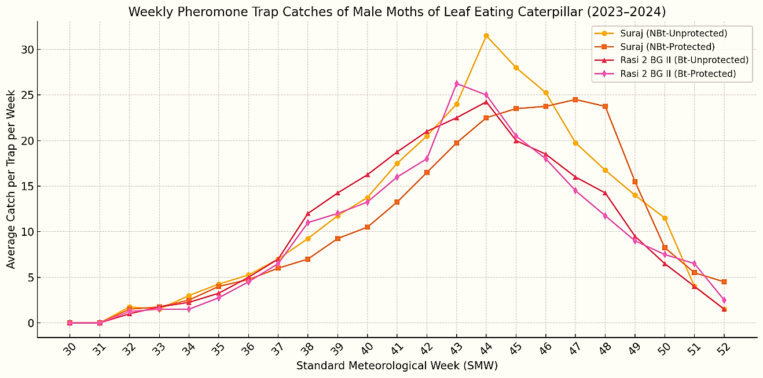
Figure 8. Average pheromone trap catches of LEC at Bharuch
3.2 Correlation of Trap Catches of Male Moths with Weather Parameters
To ascertain the influence of weather parameters on the trap catches of male moths of the bollworms and leaf eating caterpillar, the data recorded on G. Cot. Hy. 8 BG II in unprotected plots during 2023-24 and 2024-25 at both the locations viz., MCRS, NAU, Surat and RCRS, NAU, Bharuch.
Main cotton research station, Surat
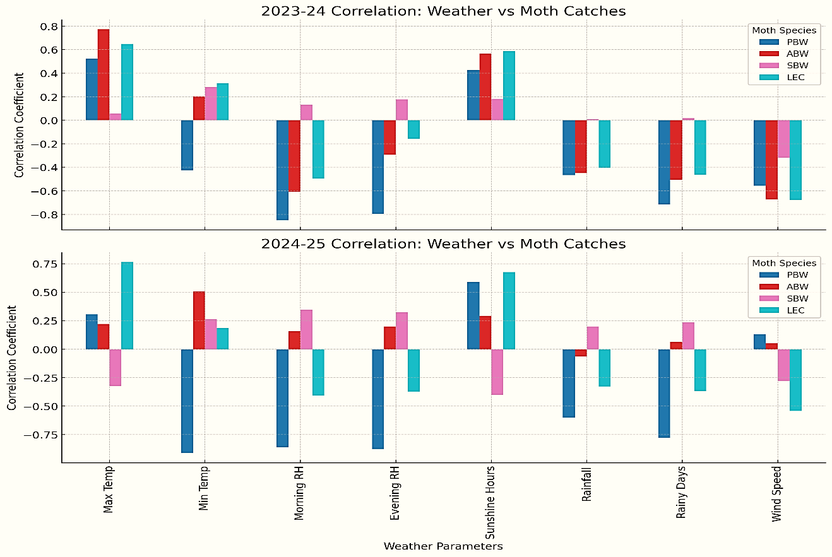
The data on the trap catches of male adult moths of bollworms and leaf eating caterpillar in G. Cot Hy. 8 BG II in unprotected during Kharif, 2023 and 2024 are showing herewith. The two-year data on pheromone trap catches in G. Cot Hy. 8 BG II (unprotected) at Surat during Kharif 2023 and 2024 reveal clear patterns in the influence of weather parameters on the population dynamics of bollworms and the leaf eating caterpillar (LEC). PBW showed consistent sensitivity to weather parameters across both years. Positive correlation with sunshine hours and maximum temperature, indicating increased activity during hot sunny periods. Negative correlations with humidity (morning and evening), rainfall, rainy days and Figure 9. Correlation between trap catches of moths in unprotected block of Bt cotton with weather parameter at Surat
wind speed, suggesting a preference for dry and stable weather. In 2023, ABW activity was positively influenced by maximum temperature and sunshine hours and negatively by humidity, rainfall, rainy days and wind speed. In 2024, only minimum temperature showed a significant positive correlation, while other weather parameters had no significant impact, indicating a weaker or shifting relationship in the second year. SBW were observed no significant correlations in either year, implying that SBW population dynamics are likely governed by factors other than weather or the species exhibits greater ecological tolerance. LEC displayed highly significant positive correlations with maximum temperature and sunshine hours across both years, favoring warm and sunny conditions.
Regional cotton research station, Bharuch
The two year data on pheromone trap catches in Rasi 2 BG II (unprotected) at Bharuch during Kharif 2023 and 2024 reveal clear patterns in the influence of weather parameters on the population dynamics of bollworms and the leaf eating caterpillar (LEC). PBW activity was strongly influenced by weather conditions in both years. It showed highly significant positive correlations with maximum temperature and sunshine hours, suggesting that hot and sunny weather enhances PBW activity. Additionally, negative correlations with wind speed, relative humidity and rainy days indicate that humid and windy conditions reduce PBW incidence. ABW displayed a clear preference for higher temperatures, with highly significant positive correlations with maximum temperature in both years with minimum temperature in 2024. It also, negatively correlated with humidity, rainy days and wind speed in 2023. This suggests that temperature is the primary driver of ABW activity, while other environmental factors may have a more variable influence. SBW consistently recorded low catches with no significant correlations to any weather parameters, indicating that SBW population dynamics were largely unaffected by environmental fluctuations during the study period, or its presence was too limited for meaningful statistical inference. LEC showed strong and consistent positive correlations with maximum temperature and sunshine hours in both years, confirming that warm and sunny weather is highly conducive to LEC activity.
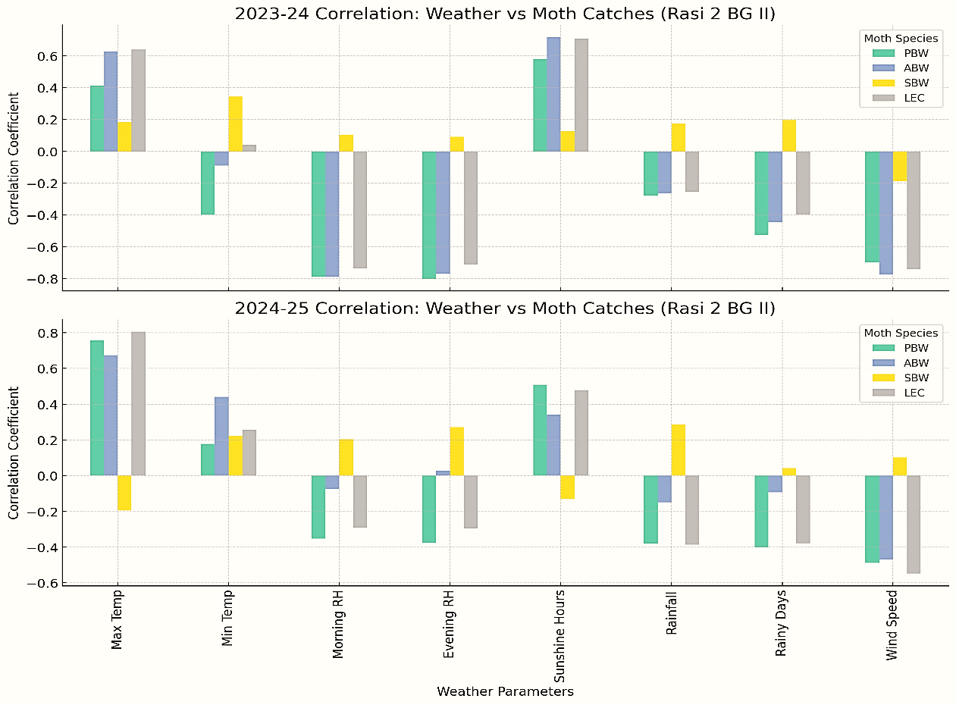
Our results are consistent with the findings of Bhanderi et al. (2017) trap catches of moths of H. armigera and E. vittella was noticed from 36th and 40th SMW, respectively and continued till the end of the crop season. The moths of S. litura was active during 34th to 46th SMW and maximum trapping was recorded during 42^{n d} SMW. Pink bollworm activity during 44th to 50th SMW, which ranged from av. 207.50 to 1440 moths/trap/week. Also, Kalola et al. (2017) observed moth catches of pink bollworm started from 37th SMW (Second week of September), gradually increased and reached at peak during 5th SMW (first week of February). S. litura moth catches built up from 33rd SMW and reached at peak during 41st SMW. Most of the weather parameters were found significant but negatively correlated with both the moth activity. Therefore, our results are in strong agreement with their observations.
Figure 10. Correlation between trap catches of moths in unprotected block of Bt cotton with weather parameter at Bharuch
3.3 Estimation of Moths Availability through Pheromone Trap Installation
The availability of male moths of key cotton pests pink bollworm (PBW), American bollworm (ABW), spotted bollworm (SBW) and leaf eating caterpillar (LEC) was estimated using two years of pheromone trap data from irrigated (Surat) and rainfed (Bharuch) areas. The estimation assumed that 5 per cent of farmers in Gujarat and India adopted the recommended practice of installing 5 pheromone traps per hectare, with regular lure replacement. Based on the cotton area distribution (35% irrigated, 65% rainfed), the projected availability of male moths during peak infestation periods in 5% of cotton area was:
In Gujarat: 1507.71 (PBW), 719.10 (ABW), 11.72 (SBW) and 1127.23 lakh (LEC) moths
In India: 7215.19 (PBW), 3441.25 (ABW), 56.09 (SBW) and 5394.40 lakh (LEC) moths
These figures represent the potential for using peak-season male moth collections for chitin extraction and chitosan production.

4. Conclusion
During the kharif seasons of 2023 and 2024, a study was carried out in bt and non-bt cotton fields at Surat and Bharuch to monitor male moth populations using pheromone traps. The research targeted four major lepidopteran pests: pink bollworm (PBW), American bollworm (ABW), spotted bollworm (SBW) and the leaf eating caterpillar (LEC). PBW and LEC were identified as the most prevalent and climate-sensitive pests, with significantly higher catches in non-bt cotton, underscoring the effectiveness of bt cotton in pest suppression. ABW also showed increased activity in non-bt fields but had inconsistent responses to weather conditions. SBW was recorded at low levels across all cotton types and appeared unaffected by weather or pest control measures. Weather analysis revealed that higher temperatures and longer sunshine durations boosted PBW and LEC activity, while humidity, rainfall and wind speed reduced it. These results highlight the importance of integrating weather-based pest forecasting into pest management practices to improve the timing of monitoring and control efforts, ultimately reducing dependency on chemical pesticides.

References

Anonymous (2024). ICAR-AICRP (Cotton) Annual Report (2023-2024) ICAR- All India Coordinated Research Project on Cotton, Nagpur.
Anonymous (2025). Cotton Association of India. https://caionline.in/news_reports/cab_area_production
Bhanderi, G. R.; Patel, R. D.; Desai, H. R.; Solanki, B. G. & P. S. B. (2017). Impact of meteorological factors on sex pheromone trap catches of cotton bollworms in South Gujarat. Trends in Biosciences, 10(30): 6249-6253.
Casals P.; Cardenas G.; Galvez G.; Villar, A. & Cabrera G. (2002). Agricultural applications of chitosan and derivatives. In: Proceedings 10th IUPAC International Congress on the Chemistry of Crop Protection, Basel, 1: 228.
Kalola, A. D.; Parmar, D. J.; Motka, G. N.; Vaishnav, P. R.; Bharpoda, T. M. & Borad, P. K. (2017). Weather based relationship of adult moth catches of pink bollworm (P. gossypiella) and leaf eating caterpillar (S. litura) in cotton growing area of Anand, Gujarat. Journal of Agrometeorology, 19(1): 75-77.
Steel, R. G. D. & Torrie, J. H. (1980). Principles and procedures of statistics. New York, USA: Mcgraw Hill Book Company.
Zhang, M. I.; Tan, T.; Yuan, H. & Rui, C. (2003). Insecticidal and fungicidal activities of chitosan and oligo chitosan. Journal of Bioactive and Compatible Polymers, 18: 391-400.
APPENDIX

Table 1: Pheromone trap catches of male moths of pink bollworm at MCRS, Surat in 2023 and 2024

SMW | Suraj (NBt-Unprotected) |  |  | Suraj (NBt-Protected) |  |  | G. Cot Hy. 8 BG II (Bt-Unprotected) |  |  | G. Cot Hy. 8 BG II (Bt-Protected)
SMW | 2023 | 2024 | Avg. | 2023 | 2024 | Avg. | 2023 | 2024 | Avg. | 2023 | 2024 | Avg.
30 | 0.00 | 0.00 | 0.00 | 0.00 | 0.00 | 0.00 | 0.00 | 0.00 | 0.00 | 0.00 | 0.00 | 0.00
31 | 0.00 | 2.00 | 1.00 | 0.00 | 1.00 | 0.50 | 0.00 | 0.00 | 0.00 | 0.00 | 2.00 | 1.00
32 | 1.00 | 5.00 | 3.00 | 2.00 | 3.00 | 2.50 | 2.00 | 2.00 | 2.00 | 1.00 | 3.50 | 2.25
33 | 3.00 | 5.50 | 4.25 | 2.50 | 5.00 | 3.75 | 3.50 | 2.50 | 3.00 | 1.50 | 3.00 | 2.25
34 | 4.50 | 10.00 | 7.25 | 3.50 | 5.00 | 4.25 | 5.00 | 4.00 | 4.50 | 3.00 | 4.00 | 3.50
35 | 5.00 | 12.50 | 8.75 | 1.50 | 7.50 | 4.50 | 5.00 | 5.50 | 5.25 | 2.00 | 5.00 | 3.50
36 | 7.50 | 16.00 | 11.75 | 4.00 | 9.00 | 6.50 | 8.50 | 6.00 | 7.25 | 2.00 | 7.50 | 4.75
37 | 8.00 | 19.00 | 13.50 | 3.00 | 11.00 | 7.00 | 10.00 | 8.00 | 9.00 | 4.00 | 4.00 | 4.00
38 | 8.50 | 21.00 | 14.75 | 2.00 | 12.50 | 7.25 | 13.00 | 9.50 | 11.25 | 5.00 | 3.00 | 4.00
39 | 10.00 | 23.00 | 16.50 | 5.50 | 14.00 | 9.75 | 15.00 | 11.00 | 13.00 | 6.50 | 8.00 | 7.25
40 | 18.00 | 26.00 | 22.00 | 6.50 | 18.00 | 12.25 | 19.00 | 13.00 | 16.00 | 9.00 | 9.50 | 9.25
41 | 20.00 | 29.00 | 24.50 | 8.00 | 20.00 | 14.00 | 20.50 | 14.00 | 17.25 | 12.00 | 11.00 | 11.50
42 | 24.00 | 32.00 | 28.00 | 14.00 | 22.50 | 18.25 | 22.00 | 18.00 | 20.00 | 19.00 | 13.00 | 16.00
43 | 31.00 | 35.00 | 33.00 | 22.50 | 28.00 | 25.25 | 30.00 | 20.50 | 25.25 | 23.00 | 18.50 | 20.75
44 | 33.00 | 39.50 | 36.25 | 28.50 | 33.00 | 30.75 | 31.00 | 22.00 | 26.50 | 29.00 | 22.00 | 25.50
45 | 38.00 | 41.00 | 39.50 | 39.50 | 48.00 | 43.75 | 39.00 | 24.00 | 31.50 | 34.00 | 25.00 | 29.50
46 | 41.50 | 43.00 | 42.25 | 42.50 | 53.00 | 47.75 | 40.00 | 26.50 | 33.25 | 43.00 | 29.00 | 36.00
47 | 43.00 | 44.50 | 43.75 | 50.00 | 49.00 | 49.50 | 32.00 | 27.00 | 29.50 | 51.00 | 31.00 | 41.00
48 | 35.00 | 47.00 | 41.00 | 56.00 | 46.00 | 51.00 | 28.00 | 29.50 | 28.75 | 44.00 | 32.50 | 38.25
49 | 62.00 | 49.50 | 55.75 | 63.00 | 41.00 | 52.00 | 25.00 | 33.00 | 29.00 | 41.00 | 35.00 | 38.00
50 | 44.00 | 51.00 | 47.50 | 68.00 | 38.00 | 53.00 | 21.00 | 34.00 | 27.50 | 34.00 | 26.00 | 30.00
51 | 30.00 | 32.00 | 31.00 | 38.00 | 33.00 | 35.50 | 18.00 | 38.00 | 28.00 | 32.00 | 22.00 | 27.00
52 | 11.00 | 15.00 | 13.00 | 30.50 | 22.00 | 26.25 | 11.00 | 41.00 | 26.00 | 12.00 | 16.00 | 14.00
Total | 478.00 | 598.50 | 538.25 | 491.00 | 519.50 | 505.25 | 398.50 | 389.00 | 393.75 | 408.00 | 330.50 | 369.25
Mean | 20.78 | 26.02 | 23.42 | 21.35 | 22.59 | 21.97 | 17.33 | 16.91 | 17.12 | 17.74 | 14.37 | 16.05
SD | 17.59 | 16.06 | 16.62 | 22.56 | 17.01 | 19.27 | 12.24 | 12.84 | 11.47 | 17.01 | 11.27 | 14.06
‘t’ test |  |  | NBt Unprotected v/s NBt-Protected |  |  | 1.04 | NBt Unprotected v/s Bt Unprotected |  | 3.95* | Bt Unprotected v/s Bt-Protected |  | 0.91
*Significant at 5% level of significance

Table 2: Pheromone trap catches of male moths of American bollworm at MCRS, Surat in 2023 and 2024
SMW |  | Suraj (NBt-Unprotected) |  |  |  |  |  | Suraj (NBt-Protected) |  |  |  |  |  | G. Cot Hy. 8 BG II (Bt-Unprotected) |  |  |  |  |  | G. Cot Hy. 8 BG II (Bt-Protected)
 |  | 2023 |  | 2024 |  | Avg. |  | 2023 |  | 2024 |  | Avg. |  | 2023 |  | 2024 |  | Avg. |  | 2023 |  | 2024 |  | Avg.
30 |  | 0.00 |  | 0.00 |  | 0.00 |  | 0.00 |  | 0.00 |  | 0.00 |  | 0.00 |  | 0.00 |  | 0.00 |  | 0.00 |  | 0.00 |  | 0.00
31 |  | 0.00 |  | 1.00 |  | 0.50 |  | 0.00 |  | 1.00 |  | 0.50 |  | 0.00 |  | 0.00 |  | 0.00 |  | 0.00 |  | 0.00 |  | 0.00
32 |  | 1.00 |  | 1.00 |  | 1.00 |  | 2.00 |  | 1.00 |  | 1.50 |  | 0.00 |  | 1.00 |  | 0.50 |  | 0.00 |  | 1.00 |  | 0.50
33 |  | 2.00 |  | 3.00 |  | 2.50 |  | 1.00 |  | 2.50 |  | 1.75 |  | 1.00 |  | 3.00 |  | 2.00 |  | 1.00 |  | 2.00 |  | 1.50
34 |  | 5.00 |  | 4.00 |  | 4.50 |  | 5.00 |  | 3.00 |  | 4.00 |  | 2.00 |  | 4.00 |  | 3.00 |  | 2.50 |  | 4.00 |  | 3.25
35 |  | 6.50 |  | 6.50 |  | 6.50 |  | 1.00 |  | 4.50 |  | 2.75 |  | 4.00 |  | 6.00 |  | 5.00 |  | 2.00 |  | 3.00 |  | 2.50
36 |  | 8.50 |  | 11.00 |  | 9.75 |  | 5.50 |  | 5.00 |  | 5.25 |  | 6.00 |  | 11.00 |  | 8.50 |  | 5.00 |  | 6.50 |  | 5.75
37 |  | 10.00 |  | 13.00 |  | 11.50 |  | 8.00 |  | 6.00 |  | 7.00 |  | 8.00 |  | 12.50 |  | 10.25 |  | 7.00 |  | 7.00 |  | 7.00
38 |  | 12.50 |  | 15.50 |  | 14.00 |  | 2.50 |  | 7.50 |  | 5.00 |  | 9.00 |  | 13.00 |  | 11.00 |  | 6.50 |  | 10.50 |  | 8.50
39 |  | 14.50 |  | 16.00 |  | 15.25 |  | 5.50 |  | 8.00 |  | 6.75 |  | 12.00 |  | 13.00 |  | 12.50 |  | 9.00 |  | 13.00 |  | 11.00
40 |  | 19.00 |  | 16.50 |  | 17.75 |  | 7.00 |  | 9.50 |  | 8.25 |  | 15.00 |  | 15.50 |  | 15.25 |  | 12.50 |  | 15.50 |  | 14.00
41 |  | 22.00 |  | 18.00 |  | 20.00 |  | 9.00 |  | 11.00 |  | 10.00 |  | 18.00 |  | 16.00 |  | 17.00 |  | 15.00 |  | 18.00 |  | 16.50
42 |  | 22.50 |  | 19.50 |  | 21.00 |  | 8.50 |  | 13.50 |  | 11.00 |  | 19.50 |  | 17.00 |  | 18.25 |  | 18.00 |  | 20.00 |  | 19.00
43 |  | 19.00 |  | 20.00 |  | 19.50 |  | 20.00 |  | 15.00 |  | 17.50 |  | 24.00 |  | 13.00 |  | 18.50 |  | 21.00 |  | 23.00 |  | 22.00
44 |  | 13.00 |  | 17.00 |  | 15.00 |  | 33.00 |  | 16.50 |  | 24.75 |  | 21.00 |  | 11.00 |  | 16.00 |  | 23.50 |  | 17.00 |  | 20.25
45 |  | 12.00 |  | 12.00 |  | 12.00 |  | 21.00 |  | 11.00 |  | 16.00 |  | 17.00 |  | 10.50 |  | 13.75 |  | 12.00 |  | 8.50 |  | 10.25
46 |  | 8.00 |  | 9.00 |  | 8.50 |  | 19.00 |  | 12.00 |  | 15.50 |  | 15.50 |  | 6.00 |  | 10.75 |  | 4.00 |  | 6.00 |  | 5.00
47 |  | 5.00 |  | 7.50 |  | 6.25 |  | 12.00 |  | 8.00 |  | 10.00 |  | 10.00 |  | 3.00 |  | 6.50 |  | 3.00 |  | 5.50 |  | 4.25
48 |  | 2.00 |  | 3.00 |  | 2.50 |  | 8.00 |  | 2.00 |  | 5.00 |  | 4.00 |  | 2.00 |  | 3.00 |  | 0.00 |  | 4.00 |  | 2.00
49 |  | 1.00 |  | 3.00 |  | 2.00 |  | 2.00 |  | 1.00 |  | 1.50 |  | 1.00 |  | 0.00 |  | 0.50 |  | 0.00 |  | 3.00 |  | 1.50
50 |  | 0.00 |  | 1.00 |  | 0.50 |  | 0.00 |  | 0.00 |  | 0.00 |  | 0.00 |  | 0.00 |  | 0.00 |  | 0.00 |  | 2.00 |  | 1.00
51 |  | 0.00 |  | 0.00 |  | 0.00 |  | 0.00 |  | 0.00 |  | 0.00 |  | 0.00 |  | 0.00 |  | 0.00 |  | 0.00 |  | 0.00 |  | 0.00
52 |  | 0.00 |  | 0.00 |  | 0.00 |  | 0.00 |  | 0.00 |  | 0.00 |  | 0.00 |  | 0.00 |  | 0.00 |  | 0.00 |  | 0.00 |  | 0.00
Total |  | 183.50 |  | 197.50 |  | 190.50 |  | 170.00 |  | 138.00 |  | 154.00 |  | 187.00 |  | 157.50 |  | 172.25 |  | 142.00 |  | 169.50 |  | 155.75
Mean |  | 7.98 |  | 8.59 |  | 8.28 |  | 7.39 |  | 6.00 |  | 6.70 |  | 8.13 |  | 6.85 |  | 7.49 |  | 6.17 |  | 7.37 |  | 6.77
SD |  | 7.59 |  | 7.15 |  | 7.31 |  | 8.56 |  | 5.29 |  | 6.66 |  | 8.03 |  | 6.15 |  | 6.78 |  | 7.38 |  | 7.07 |  | 7.13
‘t’ test |  |  |  |  |  | NBt Unprotected v/s NBt-Protected |  |  |  |  |  | 1.42 |  | NBt Unprotected v/s Bt Unprotected |  |  |  | 2.62* |  | Bt Unprotected v/s Bt-Protected |  |  |  | 1.55
*Significant at 5% level of significance
 | Table 3: Pheromone trap catches of male moths of spotted bollworm at MCRS, Surat in 2023 and 2024
 | SMW |  | Suraj (NBt-Unprotected) |  |  |  |  |  | Suraj (NBt-Protected) |  |  |  |  |  | G. Cot Hy. 8 BG II (Bt-Unprotected) |  |  |  |  |  | G. Cot Hy. 8 BG II (Bt-Protected)
 |  |  | 2023 |  | 2024 |  | Avg. |  | 2023 |  | 2024 |  | Avg. |  | 2023 |  | 2024 |  | Avg. |  | 2023 |  | 2024 |  | Avg.
 | 30 |  | 0.00 |  | 0.00 |  | 0.00 |  | 0.00 |  | 0.00 |  | 0.00 |  | 0.00 |  | 0.00 |  | 0.00 |  | 0.00 |  | 0.00 |  | 0.00
 | 31 |  | 0.00 |  | 0.00 |  | 0.00 |  | 0.00 |  | 0.00 |  | 0.00 |  | 0.00 |  | 0.00 |  | 0.00 |  | 0.00 |  | 0.00 |  | 0.00
 | 32 |  | 0.00 |  | 1.00 |  | 0.50 |  | 0.00 |  | 0.00 |  | 0.00 |  | 0.00 |  | 0.00 |  | 0.00 |  | 0.00 |  | 0.00 |  | 0.00
 | 33 |  | 0.00 |  | 2.00 |  | 1.00 |  | 0.00 |  | 0.00 |  | 0.00 |  | 0.00 |  | 1.00 |  | 0.50 |  | 0.00 |  | 0.00 |  | 0.00
 | 34 |  | 1.00 |  | 2.00 |  | 1.50 |  | 0.00 |  | 2.00 |  | 1.00 |  | 0.00 |  | 1.00 |  | 0.50 |  | 0.00 |  | 1.00 |  | 0.50
 | 35 |  | 2.00 |  | 0.00 |  | 1.00 |  | 0.00 |  | 2.00 |  | 1.00 |  | 1.00 |  | 2.50 |  | 1.75 |  | 0.00 |  | 1.00 |  | 0.50
 | 36 |  | 0.00 |  | 0.00 |  | 0.00 |  | 2.00 |  | 0.00 |  | 1.00 |  | 0.00 |  | 0.00 |  | 0.00 |  | 0.00 |  | 0.00 |  | 0.00
 | 37 |  | 1.50 |  | 0.00 |  | 0.75 |  | 1.00 |  | 0.00 |  | 0.50 |  | 1.50 |  | 0.00 |  | 0.75 |  | 1.00 |  | 0.00 |  | 0.50
 | 38 |  | 0.00 |  | 0.00 |  | 0.00 |  | 2.00 |  | 0.00 |  | 1.00 |  | 0.00 |  | 0.00 |  | 0.00 |  | 0.00 |  | 1.00 |  | 0.50
 | 39 |  | 0.00 |  | 0.00 |  | 0.00 |  | 0.00 |  | 0.00 |  | 0.00 |  | 0.00 |  | 0.00 |  | 0.00 |  | 0.00 |  | 0.00 |  | 0.00
 | 40 |  | 2.50 |  | 1.00 |  | 1.75 |  | 1.00 |  | 0.00 |  | 0.50 |  | 0.00 |  | 0.00 |  | 0.00 |  | 1.00 |  | 0.00 |  | 0.50
 | 41 |  | 2.00 |  | 0.00 |  | 1.00 |  | 2.50 |  | 0.00 |  | 1.25 |  | 2.00 |  | 0.00 |  | 1.00 |  | 2.50 |  | 0.00 |  | 1.25
 | 42 |  | 0.00 |  | 0.00 |  | 0.00 |  | 0.00 |  | 0.00 |  | 0.00 |  | 0.00 |  | 0.00 |  | 0.00 |  | 0.00 |  | 0.00 |  | 0.00
 | 43 |  | 0.00 |  | 0.00 |  | 0.00 |  | 0.00 |  | 0.00 |  | 0.00 |  | 0.00 |  | 0.00 |  | 0.00 |  | 0.00 |  | 0.00 |  | 0.00
 | 44 |  | 0.00 |  | 0.00 |  | 0.00 |  | 0.00 |  | 0.00 |  | 0.00 |  | 0.00 |  | 0.00 |  | 0.00 |  | 0.00 |  | 0.00 |  | 0.00
 | 45 |  | 0.00 |  | 0.00 |  | 0.00 |  | 0.00 |  | 0.00 |  | 0.00 |  | 0.00 |  | 0.00 |  | 0.00 |  | 0.00 |  | 0.00 |  | 0.00
 | 46 |  | 0.00 |  | 0.00 |  | 0.00 |  | 0.00 |  | 0.00 |  | 0.00 |  | 0.00 |  | 0.00 |  | 0.00 |  | 0.00 |  | 0.00 |  | 0.00
 | 47 |  | 0.00 |  | 0.00 |  | 0.00 |  | 0.00 |  | 0.00 |  | 0.00 |  | 0.00 |  | 0.00 |  | 0.00 |  | 0.00 |  | 0.00 |  | 0.00
 | 48 |  | 0.00 |  | 0.00 |  | 0.00 |  | 0.00 |  | 0.00 |  | 0.00 |  | 0.00 |  | 0.00 |  | 0.00 |  | 0.00 |  | 0.00 |  | 0.00
 | 49 |  | 0.00 |  | 0.00 |  | 0.00 |  | 0.00 |  | 0.00 |  | 0.00 |  | 0.00 |  | 0.00 |  | 0.00 |  | 0.00 |  | 0.00 |  | 0.00
 | 50 |  | 0.00 |  | 0.00 |  | 0.00 |  | 0.00 |  | 0.00 |  | 0.00 |  | 0.00 |  | 0.00 |  | 0.00 |  | 0.00 |  | 0.00 |  | 0.00
 | 51 |  | 0.00 |  | 0.00 |  | 0.00 |  | 0.00 |  | 0.00 |  | 0.00 |  | 0.00 |  | 0.00 |  | 0.00 |  | 0.00 |  | 0.00 |  | 0.00
 | 52 |  | 0.00 |  | 0.00 |  | 0.00 |  | 0.00 |  | 0.00 |  | 0.00 |  | 0.00 |  | 0.00 |  | 0.00 |  | 0.00 |  | 0.00 |  | 0.00
 | Total |  | 9.00 |  | 6.00 |  | 7.50 |  | 8.50 |  | 4.00 |  | 6.25 |  | 4.50 |  | 4.50 |  | 4.50 |  | 4.50 |  | 3.00 |  | 3.75
 | Mean |  | 0.39 |  | 0.26 |  | 0.33 |  | 0.37 |  | 0.17 |  | 0.27 |  | 0.20 |  | 0.20 |  | 0.20 |  | 0.20 |  | 0.13 |  | 0.16
 | SD |  | 0.80 |  | 0.62 |  | 0.55 |  | 0.77 |  | 0.58 |  | 0.45 |  | 0.54 |  | 0.58 |  | 0.44 |  | 0.58 |  | 0.34 |  | 0.32
 | ‘t’ test |  |  |  |  |  | NBt Unprotected v/s NBt-Protected |  |  |  |  |  | 0.54 |  | NBt Unprotected v/s Bt Unprotected |  |  |  | 1.34 |  | Bt Unprotected v/s Bt-Protected |  |  |  | 0.47
 | *Significant at 5% level of significance
 | Table 4: Pheromone trap catches of male moths of leaf eating caterpillar at MCRS, Surat in 2023 and 2024
 | SMW |  | Suraj (NBt-Unprotected) |  |  |  |  |  | Suraj (NBt-Protected) |  |  |  |  |  | G. Cot Hy. 8 BG II (Bt-Unprotected) |  |  |  |  |  | G. Cot Hy. 8 BG II (Bt-Protected)
 |  |  | 2023 |  | 2024 |  | Avg. |  | 2023 |  | 2024 |  | Avg. |  | 2023 |  | 2024 |  | Avg. |  | 2023 |  | 2024 |  | Avg.
 | 30 |  | 0.00 |  | 0.00 |  | 0.00 |  | 0.00 |  | 0.00 |  | 0.00 |  | 0.00 |  | 0.00 |  | 0.00 |  | 0.00 |  | 0.00 |  | 0.00
 | 31 |  | 1.50 |  | 0.00 |  | 0.75 |  | 1.00 |  | 0.00 |  | 0.50 |  | 1.00 |  | 1.50 |  | 1.25 |  | 0.00 |  | 1.00 |  | 0.50
 | 32 |  | 2.00 |  | 1.00 |  | 1.50 |  | 3.00 |  | 1.00 |  | 2.00 |  | 2.00 |  | 3.00 |  | 2.50 |  | 2.00 |  | 2.50 |  | 2.25
 | 33 |  | 2.50 |  | 3.00 |  | 2.75 |  | 2.00 |  | 3.00 |  | 2.50 |  | 3.50 |  | 4.50 |  | 4.00 |  | 2.00 |  | 5.00 |  | 3.50
 | 34 |  | 7.50 |  | 3.50 |  | 5.50 |  | 4.50 |  | 5.00 |  | 4.75 |  | 5.00 |  | 6.00 |  | 5.50 |  | 3.00 |  | 6.00 |  | 4.50
 | 35 |  | 9.00 |  | 5.00 |  | 7.00 |  | 5.50 |  | 8.00 |  | 6.75 |  | 5.00 |  | 7.50 |  | 6.25 |  | 3.50 |  | 8.50 |  | 6.00
 | 36 |  | 11.00 |  | 7.00 |  | 9.00 |  | 7.00 |  | 9.50 |  | 8.25 |  | 7.50 |  | 8.50 |  | 8.00 |  | 6.00 |  | 9.00 |  | 7.50
 | 37 |  | 13.50 |  | 9.00 |  | 11.25 |  | 8.50 |  | 13.00 |  | 10.75 |  | 8.00 |  | 9.00 |  | 8.50 |  | 10.00 |  | 12.00 |  | 11.00
 | 38 |  | 16.50 |  | 10.50 |  | 13.50 |  | 9.00 |  | 16.00 |  | 12.50 |  | 9.50 |  | 11.00 |  | 10.25 |  | 13.00 |  | 14.50 |  | 13.75
 | 39 |  | 18.50 |  | 12.00 |  | 15.25 |  | 11.50 |  | 17.50 |  | 14.50 |  | 11.00 |  | 13.50 |  | 12.25 |  | 15.50 |  | 17.00 |  | 16.25
 | 40 |  | 21.00 |  | 15.00 |  | 18.00 |  | 12.00 |  | 19.00 |  | 15.50 |  | 13.00 |  | 15.00 |  | 14.00 |  | 18.00 |  | 19.50 |  | 18.75
 | 41 |  | 23.00 |  | 19.00 |  | 21.00 |  | 16.00 |  | 21.00 |  | 18.50 |  | 17.00 |  | 17.50 |  | 17.25 |  | 21.00 |  | 21.00 |  | 21.00
 | 42 |  | 25.50 |  | 25.50 |  | 25.50 |  | 19.00 |  | 22.50 |  | 20.75 |  | 19.00 |  | 19.00 |  | 19.00 |  | 23.00 |  | 24.00 |  | 23.50
 | 43 |  | 28.00 |  | 29.00 |  | 28.50 |  | 22.00 |  | 23.00 |  | 22.50 |  | 22.00 |  | 21.00 |  | 21.50 |  | 26.00 |  | 26.50 |  | 26.25
 | 44 |  | 29.00 |  | 31.00 |  | 30.00 |  | 28.00 |  | 26.00 |  | 27.00 |  | 29.00 |  | 24.50 |  | 26.75 |  | 17.00 |  | 11.00 |  | 14.00
 | 45 |  | 30.00 |  | 26.00 |  | 28.00 |  | 17.50 |  | 20.00 |  | 18.75 |  | 27.50 |  | 28.00 |  | 27.75 |  | 16.00 |  | 10.00 |  | 13.00
 | 46 |  | 21.00 |  | 23.00 |  | 22.00 |  | 18.00 |  | 18.00 |  | 18.00 |  | 24.00 |  | 20.00 |  | 22.00 |  | 13.00 |  | 8.00 |  | 10.50
 | 47 |  | 16.00 |  | 19.00 |  | 17.50 |  | 15.00 |  | 14.00 |  | 14.50 |  | 18.00 |  | 16.00 |  | 17.00 |  | 11.00 |  | 3.00 |  | 7.00
 | 48 |  | 10.00 |  | 15.50 |  | 12.75 |  | 13.50 |  | 11.00 |  | 12.25 |  | 13.00 |  | 12.50 |  | 12.75 |  | 9.00 |  | 2.50 |  | 5.75
 | 49 |  | 8.00 |  | 10.00 |  | 9.00 |  | 12.00 |  | 9.00 |  | 10.50 |  | 11.00 |  | 5.00 |  | 8.00 |  | 6.00 |  | 1.00 |  | 3.50
 | 50 |  | 7.50 |  | 2.00 |  | 4.75 |  | 9.00 |  | 8.50 |  | 8.75 |  | 8.00 |  | 3.00 |  | 5.50 |  | 4.00 |  | 1.00 |  | 2.50
 | 51 |  | 4.00 |  | 0.00 |  | 2.00 |  | 8.00 |  | 6.00 |  | 7.00 |  | 2.00 |  | 1.00 |  | 1.50 |  | 3.00 |  | 0.00 |  | 1.50
 | 52 |  | 1.00 |  | 1.00 |  | 1.00 |  | 6.00 |  | 5.50 |  | 5.75 |  | 2.00 |  | 0.00 |  | 1.00 |  | 1.00 |  | 0.00 |  | 0.50
 | Total |  | 306.00 |  | 267.00 |  | 286.50 |  | 248.00 |  | 276.50 |  | 262.25 |  | 258.00 |  | 247.00 |  | 252.50 |  | 223.00 |  | 203.00 |  | 213.00
 | Mean |  | 13.30 |  | 11.61 |  | 12.46 |  | 10.78 |  | 12.02 |  | 11.40 |  | 11.22 |  | 10.74 |  | 10.98 |  | 9.70 |  | 8.83 |  | 9.26
 | SD |  | 9.71 |  | 10.18 |  | 9.81 |  | 7.12 |  | 7.89 |  | 7.36 |  | 8.70 |  | 8.24 |  | 8.39 |  | 7.86 |  | 8.19 |  | 7.82
 | ‘t’ test |  |  |  |  |  | NBt Unprotected v/s NBt-Protected |  |  |  |  |  | 1.54 |  | NBt Unprotected v/s Bt Unprotected |  |  |  | 3.09* |  | Bt Unprotected v/s Bt-Protected |  |  |  | 1.42
 | *Significant at 5% level of significance
 | Table 5: Pheromone trap catches of male moths of pink bollworm at RCRS, Bharuch in 2023 and 2024
 | SMW |  | Suraj (NBt-Unprotected) |  |  |  |  |  | Suraj (NBt-Protected) |  |  |  |  |  | Rasi 2 BG II (Bt-Unprotected) |  |  |  |  |  | Rasi 2 BG II (Bt-Protected)
 |  |  | 2023 |  | 2024 |  | Avg. |  | 2023 |  | 2024 |  | Avg. |  | 2023 |  | 2024 |  | Avg. |  | 2023 |  | 2024 |  | Avg.
 | 30 |  | 0.00 |  | 0.00 |  | 0.00 |  | 0.00 |  | 0.00 |  | 0.00 |  | 0.00 |  | 0.00 |  | 0.00 |  | 0.00 |  | 0.00 |  | 0.00
 | 31 |  | 1.00 |  | 1.00 |  | 1.00 |  | 0.00 |  | 0.00 |  | 0.00 |  | 0.00 |  | 0.00 |  | 0.00 |  | 0.00 |  | 0.00 |  | 0.00
 | 32 |  | 1.50 |  | 1.50 |  | 1.50 |  | 1.00 |  | 1.00 |  | 1.00 |  | 1.00 |  | 2.00 |  | 1.50 |  | 0.00 |  | 0.00 |  | 0.00
 | 33 |  | 3.00 |  | 3.00 |  | 3.00 |  | 1.50 |  | 1.50 |  | 1.50 |  | 2.00 |  | 1.00 |  | 1.50 |  | 2.50 |  | 1.00 |  | 1.75
 | 34 |  | 4.50 |  | 3.50 |  | 4.00 |  | 3.00 |  | 2.50 |  | 2.75 |  | 2.50 |  | 3.00 |  | 2.75 |  | 4.00 |  | 2.50 |  | 3.25
 | 35 |  | 5.00 |  | 4.00 |  | 4.50 |  | 5.00 |  | 3.00 |  | 4.00 |  | 3.00 |  | 4.50 |  | 3.75 |  | 6.00 |  | 2.50 |  | 4.25
 | 36 |  | 6.50 |  | 5.00 |  | 5.75 |  | 6.50 |  | 5.00 |  | 5.75 |  | 4.00 |  | 5.00 |  | 4.50 |  | 8.00 |  | 3.00 |  | 5.50
 | 37 |  | 7.50 |  | 5.50 |  | 6.50 |  | 7.00 |  | 6.50 |  | 6.75 |  | 6.00 |  | 8.50 |  | 7.25 |  | 9.50 |  | 5.50 |  | 7.50
 | 38 |  | 9.00 |  | 6.50 |  | 7.75 |  | 9.00 |  | 8.50 |  | 8.75 |  | 8.50 |  | 10.00 |  | 9.25 |  | 11.00 |  | 7.00 |  | 9.00
 | 39 |  | 11.00 |  | 8.00 |  | 9.50 |  | 10.00 |  | 9.00 |  | 9.50 |  | 9.00 |  | 13.00 |  | 11.00 |  | 9.00 |  | 7.50 |  | 8.25
 | 40 |  | 13.00 |  | 8.50 |  | 10.75 |  | 11.50 |  | 10.50 |  | 11.00 |  | 11.00 |  | 15.50 |  | 13.25 |  | 13.00 |  | 14.00 |  | 13.50
 | 41 |  | 14.50 |  | 9.00 |  | 11.75 |  | 13.00 |  | 11.00 |  | 12.00 |  | 13.00 |  | 16.00 |  | 14.50 |  | 16.00 |  | 15.50 |  | 15.75
 | 42 |  | 16.00 |  | 11.50 |  | 13.75 |  | 15.50 |  | 12.50 |  | 14.00 |  | 16.00 |  | 19.00 |  | 17.50 |  | 19.00 |  | 17.50 |  | 18.25
 | 43 |  | 17.50 |  | 13.00 |  | 15.25 |  | 17.00 |  | 14.00 |  | 15.50 |  | 19.00 |  | 20.00 |  | 19.50 |  | 21.00 |  | 18.00 |  | 19.50
 | 44 |  | 19.00 |  | 15.50 |  | 17.25 |  | 18.50 |  | 15.50 |  | 17.00 |  | 21.00 |  | 23.00 |  | 22.00 |  | 24.00 |  | 19.50 |  | 21.75
 | 45 |  | 21.00 |  | 24.00 |  | 22.50 |  | 19.00 |  | 16.00 |  | 17.50 |  | 24.00 |  | 25.50 |  | 24.75 |  | 26.00 |  | 21.00 |  | 23.50
 | 46 |  | 30.00 |  | 36.00 |  | 33.00 |  | 21.00 |  | 34.00 |  | 27.50 |  | 29.00 |  | 27.00 |  | 28.00 |  | 29.00 |  | 15.00 |  | 22.00
 | 47 |  | 38.00 |  | 47.00 |  | 42.50 |  | 23.50 |  | 38.00 |  | 30.75 |  | 13.00 |  | 15.50 |  | 14.25 |  | 12.00 |  | 13.00 |  | 12.50
 | 48 |  | 43.00 |  | 52.00 |  | 47.50 |  | 32.00 |  | 41.00 |  | 36.50 |  | 10.00 |  | 12.00 |  | 11.00 |  | 10.00 |  | 10.00 |  | 10.00
 | 49 |  | 32.00 |  | 35.00 |  | 33.50 |  | 37.00 |  | 37.00 |  | 37.00 |  | 8.00 |  | 8.00 |  | 8.00 |  | 9.00 |  | 8.00 |  | 8.50
 | 50 |  | 29.00 |  | 28.00 |  | 28.50 |  | 25.00 |  | 29.00 |  | 27.00 |  | 6.00 |  | 7.00 |  | 6.50 |  | 7.00 |  | 5.00 |  | 6.00
 | 51 |  | 17.00 |  | 13.00 |  | 15.00 |  | 20.00 |  | 14.00 |  | 17.00 |  | 5.00 |  | 4.00 |  | 4.50 |  | 6.00 |  | 2.00 |  | 4.00
 | 52 |  | 11.00 |  | 8.00 |  | 9.50 |  | 14.00 |  | 11.00 |  | 12.50 |  | 4.00 |  | 2.00 |  | 3.00 |  | 2.00 |  | 2.00 |  | 2.00
 | Total |  | 350.00 |  | 338.50 |  | 344.25 |  | 310.00 |  | 320.50 |  | 315.25 |  | 215.00 |  | 241.50 |  | 228.25 |  | 244.00 |  | 189.50 |  | 216.75
 | Mean |  | 15.22 |  | 14.72 |  | 14.97 |  | 13.48 |  | 13.93 |  | 13.71 |  | 9.35 |  | 10.50 |  | 9.92 |  | 10.61 |  | 8.24 |  | 9.42
 | SD |  | 12.14 |  | 14.99 |  | 13.49 |  | 10.16 |  | 12.90 |  | 11.33 |  | 7.95 |  | 8.39 |  | 8.13 |  | 8.42 |  | 6.99 |  | 7.57
 | ‘t’ test |  |  |  |  |  | NBt Unprotected v/s NBt-Protected |  |  |  |  |  | 1.60 |  | NBt Unprotected v/s Bt Unprotected |  |  |  | 2.09* |  | Bt Unprotected v/s Bt-Protected |  |  |  | 1.56
 | *Significant at 5% level of significance
 | Table 6: Pheromone trap catches of male moths of American bollworm at RCRS, Bharuch in 2023 and 2024
 | SMW |  | Suraj (NBt-Unprotected) |  |  |  |  |  | Suraj (NBt-Protected) |  |  |  |  |  | Rasi 2 BG II (Bt-Unprotected) |  |  |  |  |  | Rasi 2 BG II (Bt-Protected)
 |  |  | 2023 |  | 2024 |  | Avg. |  | 2023 |  | 2024 |  | Avg. |  | 2023 |  | 2024 |  | Avg. |  | 2023 |  | 2024 |  | Avg.
 | 30 |  | 0.00 |  | 0.00 |  | 0.00 |  | 0.00 |  | 0.00 |  | 0.00 |  | 0.00 |  | 0.00 |  | 0.00 |  | 0.00 |  | 0.00 |  | 0.00
 | 31 |  | 0.00 |  | 1.50 |  | 0.75 |  | 0.00 |  | 0.00 |  | 0.00 |  | 0.00 |  | 0.00 |  | 0.00 |  | 0.00 |  | 0.00 |  | 0.00
 | 32 |  | 1.50 |  | 2.00 |  | 1.75 |  | 1.00 |  | 2.00 |  | 1.50 |  | 0.00 |  | 0.00 |  | 0.00 |  | 0.00 |  | 0.00 |  | 0.00
 | 33 |  | 3.00 |  | 2.50 |  | 2.75 |  | 1.00 |  | 1.00 |  | 1.00 |  | 0.00 |  | 1.00 |  | 0.50 |  | 1.00 |  | 1.50 |  | 1.25
 | 34 |  | 2.50 |  | 3.50 |  | 3.00 |  | 2.00 |  | 2.50 |  | 2.25 |  | 2.00 |  | 2.00 |  | 2.00 |  | 3.00 |  | 2.00 |  | 2.50
 | 35 |  | 5.00 |  | 5.00 |  | 5.00 |  | 3.50 |  | 4.00 |  | 3.75 |  | 3.00 |  | 3.00 |  | 3.00 |  | 5.00 |  | 2.00 |  | 3.50
 | 36 |  | 8.00 |  | 5.00 |  | 6.50 |  | 5.00 |  | 5.50 |  | 5.25 |  | 5.00 |  | 5.50 |  | 5.25 |  | 7.00 |  | 2.50 |  | 4.75
 | 37 |  | 9.00 |  | 7.50 |  | 8.25 |  | 5.50 |  | 8.00 |  | 6.75 |  | 6.00 |  | 6.00 |  | 6.00 |  | 12.00 |  | 3.50 |  | 7.75
 | 38 |  | 10.00 |  | 9.50 |  | 9.75 |  | 7.00 |  | 9.50 |  | 8.25 |  | 8.50 |  | 6.50 |  | 7.50 |  | 15.50 |  | 4.00 |  | 9.75
 | 39 |  | 11.50 |  | 11.50 |  | 11.50 |  | 9.00 |  | 11.00 |  | 10.00 |  | 9.00 |  | 8.00 |  | 8.50 |  | 17.00 |  | 5.50 |  | 11.25
 | 40 |  | 13.00 |  | 13.50 |  | 13.25 |  | 10.50 |  | 15.00 |  | 12.75 |  | 12.00 |  | 11.00 |  | 11.50 |  | 19.50 |  | 7.00 |  | 13.25
 | 41 |  | 16.00 |  | 14.00 |  | 15.00 |  | 13.00 |  | 18.00 |  | 15.50 |  | 15.00 |  | 15.00 |  | 15.00 |  | 21.00 |  | 8.00 |  | 14.50
 | 42 |  | 16.50 |  | 15.50 |  | 16.00 |  | 13.50 |  | 20.50 |  | 17.00 |  | 16.00 |  | 18.00 |  | 17.00 |  | 24.00 |  | 9.50 |  | 16.75
 | 43 |  | 19.00 |  | 17.00 |  | 18.00 |  | 18.00 |  | 23.00 |  | 20.50 |  | 16.50 |  | 21.00 |  | 18.75 |  | 18.50 |  | 11.00 |  | 14.75
 | 44 |  | 29.00 |  | 37.00 |  | 33.00 |  | 27.00 |  | 29.00 |  | 28.00 |  | 18.00 |  | 10.00 |  | 14.00 |  | 16.00 |  | 18.00 |  | 17.00
 | 45 |  | 24.00 |  | 28.00 |  | 26.00 |  | 31.00 |  | 20.00 |  | 25.50 |  | 20.00 |  | 7.50 |  | 13.75 |  | 13.00 |  | 15.00 |  | 14.00
 | 46 |  | 12.50 |  | 25.00 |  | 18.75 |  | 23.00 |  | 16.00 |  | 19.50 |  | 14.00 |  | 7.00 |  | 10.50 |  | 11.50 |  | 5.00 |  | 8.25
 | 47 |  | 10.00 |  | 17.00 |  | 13.50 |  | 18.00 |  | 13.00 |  | 15.50 |  | 11.00 |  | 6.50 |  | 8.75 |  | 9.00 |  | 4.50 |  | 6.75
 | 48 |  | 8.00 |  | 13.00 |  | 10.50 |  | 14.00 |  | 11.00 |  | 12.50 |  | 9.00 |  | 4.50 |  | 6.75 |  | 6.00 |  | 2.50 |  | 4.25
 | 49 |  | 4.00 |  | 8.00 |  | 6.00 |  | 10.00 |  | 2.00 |  | 6.00 |  | 7.00 |  | 3.00 |  | 5.00 |  | 2.00 |  | 2.00 |  | 2.00
 | 50 |  | 1.00 |  | 3.00 |  | 2.00 |  | 4.00 |  | 1.00 |  | 2.50 |  | 4.00 |  | 2.00 |  | 3.00 |  | 0.00 |  | 1.50 |  | 0.75
 | 51 |  | 0.00 |  | 0.00 |  | 0.00 |  | 1.00 |  | 0.00 |  | 0.50 |  | 3.00 |  | 0.00 |  | 1.50 |  | 0.00 |  | 0.00 |  | 0.00
 | 52 |  | 0.00 |  | 0.00 |  | 0.00 |  | 0.00 |  | 0.00 |  | 0.00 |  | 0.00 |  | 0.00 |  | 0.00 |  | 0.00 |  | 0.00 |  | 0.00
 | Total |  | 203.50 |  | 239.00 |  | 221.25 |  | 217.00 |  | 212.00 |  | 214.50 |  | 179.00 |  | 137.50 |  | 158.25 |  | 201.00 |  | 105.00 |  | 153.00
 | Mean |  | 8.85 |  | 10.39 |  | 9.62 |  | 9.43 |  | 9.22 |  | 9.33 |  | 7.78 |  | 5.98 |  | 6.88 |  | 8.74 |  | 4.57 |  | 6.65
 | SD |  | 8.07 |  | 9.74 |  | 8.75 |  | 9.04 |  | 8.71 |  | 8.60 |  | 6.49 |  | 5.86 |  | 5.91 |  | 8.03 |  | 4.89 |  | 6.07
 | ‘t’ test |  |  |  |  |  | NBt Unprotected v/s NBt-Protected |  |  |  |  |  | 0.89 |  | NBt Unprotected v/s Bt Unprotected |  |  |  | 2.79* |  | Bt Unprotected v/s Bt-Protected |  |  |  | 0.58
 | *Significant at 5% level of significance
 | Table 7: Pheromone trap catches of male moths of spotted bollworm at RCRS, Bharuch in 2023 and 2024
 | SMW |  | Suraj (NBt-Unprotected) |  |  |  |  |  | Suraj (NBt-Protected) |  |  |  |  |  | Rasi 2 BG II (Bt-Unprotected) |  |  |  |  |  | Rasi 2 BG II (Bt-Protected)
 |  |  | 2023 |  | 2024 |  | Avg. |  | 2023 |  | 2024 |  | Avg. |  | 2023 |  | 2024 |  | Avg. |  | 2023 |  | 2024 |  | Avg.
 | 30 |  | 0.00 |  | 0.00 |  | 0.00 |  | 0.00 |  | 0.00 |  | 0.00 |  | 0.00 |  | 0.00 |  | 0.00 |  | 0.00 |  | 0.00 |  | 0.00
 | 31 |  | 0.00 |  | 0.00 |  | 0.00 |  | 0.00 |  | 0.00 |  | 0.00 |  | 0.00 |  | 0.00 |  | 0.00 |  | 0.00 |  | 0.00 |  | 0.00
 | 32 |  | 0.00 |  | 0.00 |  | 0.00 |  | 0.00 |  | 0.00 |  | 0.00 |  | 0.00 |  | 0.00 |  | 0.00 |  | 0.00 |  | 0.00 |  | 0.00
 | 33 |  | 0.00 |  | 0.00 |  | 0.00 |  | 0.00 |  | 0.00 |  | 0.00 |  | 0.00 |  | 0.00 |  | 0.00 |  | 0.00 |  | 0.00 |  | 0.00
 | 34 |  | 0.00 |  | 0.00 |  | 0.00 |  | 0.00 |  | 0.00 |  | 0.00 |  | 0.00 |  | 0.00 |  | 0.00 |  | 0.00 |  | 0.00 |  | 0.00
 | 35 |  | 1.00 |  | 1.00 |  | 1.00 |  | 2.00 |  | 1.00 |  | 1.50 |  | 1.50 |  | 1.00 |  | 1.25 |  | 1.50 |  | 2.00 |  | 1.75
 | 36 |  | 2.50 |  | 1.00 |  | 1.75 |  | 1.00 |  | 1.50 |  | 1.25 |  | 2.00 |  | 1.00 |  | 1.50 |  | 2.00 |  | 1.00 |  | 1.50
 | 37 |  | 1.00 |  | 2.50 |  | 1.75 |  | 3.50 |  | 1.00 |  | 2.25 |  | 3.00 |  | 0.00 |  | 1.50 |  | 0.00 |  | 0.00 |  | 0.00
 | 38 |  | 3.00 |  | 0.00 |  | 1.50 |  | 1.00 |  | 1.00 |  | 1.00 |  | 2.00 |  | 1.00 |  | 1.50 |  | 2.00 |  | 0.00 |  | 1.00
 | 39 |  | 3.00 |  | 0.00 |  | 1.50 |  | 1.00 |  | 0.00 |  | 0.50 |  | 4.00 |  | 0.00 |  | 2.00 |  | 0.00 |  | 0.00 |  | 0.00
 | 40 |  | 4.50 |  | 0.00 |  | 2.25 |  | 1.00 |  | 0.00 |  | 0.50 |  | 0.00 |  | 0.00 |  | 0.00 |  | 0.00 |  | 0.00 |  | 0.00
 | 41 |  | 0.00 |  | 0.00 |  | 0.00 |  | 3.00 |  | 0.00 |  | 1.50 |  | 0.00 |  | 0.00 |  | 0.00 |  | 0.00 |  | 0.00 |  | 0.00
 | 42 |  | 0.00 |  | 0.00 |  | 0.00 |  | 0.00 |  | 0.00 |  | 0.00 |  | 0.00 |  | 0.00 |  | 0.00 |  | 0.00 |  | 0.00 |  | 0.00
 | 43 |  | 0.00 |  | 0.00 |  | 0.00 |  | 0.00 |  | 0.00 |  | 0.00 |  | 0.00 |  | 0.00 |  | 0.00 |  | 0.00 |  | 0.00 |  | 0.00
 | 44 |  | 0.00 |  | 0.00 |  | 0.00 |  | 0.00 |  | 0.00 |  | 0.00 |  | 0.00 |  | 0.00 |  | 0.00 |  | 0.00 |  | 0.00 |  | 0.00
 | 45 |  | 0.00 |  | 0.00 |  | 0.00 |  | 0.00 |  | 0.00 |  | 0.00 |  | 0.00 |  | 0.00 |  | 0.00 |  | 0.00 |  | 0.00 |  | 0.00
 | 46 |  | 0.00 |  | 0.00 |  | 0.00 |  | 0.00 |  | 0.00 |  | 0.00 |  | 0.00 |  | 0.00 |  | 0.00 |  | 0.00 |  | 0.00 |  | 0.00
 | 47 |  | 0.00 |  | 0.00 |  | 0.00 |  | 0.00 |  | 0.00 |  | 0.00 |  | 0.00 |  | 0.00 |  | 0.00 |  | 0.00 |  | 0.00 |  | 0.00
 | 48 |  | 0.00 |  | 0.00 |  | 0.00 |  | 0.00 |  | 0.00 |  | 0.00 |  | 0.00 |  | 0.00 |  | 0.00 |  | 0.00 |  | 0.00 |  | 0.00
 | 49 |  | 0.00 |  | 0.00 |  | 0.00 |  | 0.00 |  | 0.00 |  | 0.00 |  | 0.00 |  | 0.00 |  | 0.00 |  | 0.00 |  | 0.00 |  | 0.00
 | 50 |  | 0.00 |  | 0.00 |  | 0.00 |  | 0.00 |  | 0.00 |  | 0.00 |  | 0.00 |  | 0.00 |  | 0.00 |  | 0.00 |  | 0.00 |  | 0.00
 | 51 |  | 0.00 |  | 0.00 |  | 0.00 |  | 0.00 |  | 0.00 |  | 0.00 |  | 0.00 |  | 0.00 |  | 0.00 |  | 0.00 |  | 0.00 |  | 0.00
 | 52 |  | 0.00 |  | 0.00 |  | 0.00 |  | 0.00 |  | 0.00 |  | 0.00 |  | 0.00 |  | 0.00 |  | 0.00 |  | 0.00 |  | 0.00 |  | 0.00
 | Total |  | 15.00 |  | 4.50 |  | 9.75 |  | 12.50 |  | 4.50 |  | 8.50 |  | 12.50 |  | 3.00 |  | 7.75 |  | 5.50 |  | 3.00 |  | 4.25
 | Mean |  | 0.65 |  | 0.20 |  | 0.42 |  | 0.54 |  | 0.20 |  | 0.37 |  | 0.54 |  | 0.13 |  | 0.34 |  | 0.24 |  | 0.13 |  | 0.18
 | SD |  | 1.29 |  | 0.58 |  | 0.76 |  | 1.01 |  | 0.45 |  | 0.66 |  | 1.14 |  | 0.34 |  | 0.66 |  | 0.64 |  | 0.46 |  | 0.50
 | ‘t’ test |  |  |  |  |  | NBt Unprotected v/s NBt-Protected |  |  |  |  |  | 0.45 |  | NBt Unprotected v/s Bt Unprotected |  |  |  | 0.84 |  | Bt Unprotected v/s Bt-Protected |  |  |  | 1.37
 | *Significant at 5% level of significance

Table 8: Pheromone trap catches of male moths of leaf eating caterpillar at RCRS, Bharuch in 2023 and 2024
SMW | Suraj (NBt-Unprotected) |  |  | Suraj (NBt-Protected) |  |  | Rasi 2 BG II (Bt-Unprotected) |  |  | Rasi 2 BG II (Bt-Protected)
SMW | 2023 | 2024 | Avg. | 2023 | 2024 | Avg. | 2023 | 2024 | Avg. | 2023 | 2024 | Avg.
30 | 0.00 | 0.00 | 0.00 | 0.00 | 0.00 | 0.00 | 0.00 | 0.00 | 0.00 | 0.00 | 0.00 | 0.00
31 | 0.00 | 0.00 | 0.00 | 0.00 | 0.00 | 0.00 | 0.00 | 0.00 | 0.00 | 0.00 | 0.00 | 0.00
32 | 1.50 | 2.00 | 1.75 | 2.00 | 1.00 | 1.50 | 1.00 | 1.00 | 1.00 | 1.00 | 1.50 | 1.25
33 | 1.00 | 2.00 | 1.50 | 2.50 | 1.00 | 1.75 | 2.00 | 1.50 | 1.75 | 1.00 | 2.00 | 1.50
34 | 2.00 | 4.00 | 3.00 | 3.00 | 2.00 | 2.50 | 2.50 | 2.00 | 2.25 | 2.00 | 1.00 | 1.50
35 | 3.00 | 5.50 | 4.25 | 4.00 | 4.00 | 4.00 | 4.00 | 2.50 | 3.25 | 3.50 | 2.00 | 2.75
36 | 2.50 | 8.00 | 5.25 | 4.00 | 5.50 | 4.75 | 6.00 | 4.00 | 5.00 | 5.00 | 4.00 | 4.50
37 | 4.50 | 9.50 | 7.00 | 5.50 | 6.50 | 6.00 | 8.50 | 5.50 | 7.00 | 7.00 | 6.00 | 6.50
38 | 7.50 | 11.00 | 9.25 | 6.00 | 8.00 | 7.00 | 11.00 | 13.00 | 12.00 | 9.50 | 12.50 | 11.00
39 | 10.00 | 13.50 | 11.75 | 7.50 | 11.00 | 9.25 | 12.50 | 16.00 | 14.25 | 11.00 | 13.00 | 12.00
40 | 11.50 | 16.00 | 13.75 | 8.00 | 13.00 | 10.50 | 14.00 | 18.50 | 16.25 | 11.50 | 15.00 | 13.25
41 | 17.50 | 17.50 | 17.50 | 11.00 | 15.50 | 13.25 | 16.50 | 21.00 | 18.75 | 13.00 | 19.00 | 16.00
42 | 23.00 | 18.00 | 20.50 | 17.00 | 16.00 | 16.50 | 19.00 | 23.00 | 21.00 | 15.00 | 21.00 | 18.00
43 | 27.00 | 21.00 | 24.00 | 20.50 | 19.00 | 19.75 | 20.00 | 25.00 | 22.50 | 23.50 | 29.00 | 26.25
44 | 28.00 | 35.00 | 31.50 | 23.00 | 22.00 | 22.50 | 22.00 | 26.50 | 24.25 | 26.00 | 24.00 | 25.00
45 | 29.00 | 27.00 | 28.00 | 27.00 | 20.00 | 23.50 | 18.00 | 22.00 | 20.00 | 21.00 | 20.00 | 20.50
46 | 31.00 | 19.50 | 25.25 | 29.00 | 18.50 | 23.75 | 17.50 | 19.50 | 18.50 | 19.00 | 17.00 | 18.00
47 | 25.00 | 14.50 | 19.75 | 32.00 | 17.00 | 24.50 | 15.00 | 17.00 | 16.00 | 16.00 | 13.00 | 14.50
48 | 23.50 | 10.00 | 16.75 | 35.00 | 12.50 | 23.75 | 13.00 | 15.50 | 14.25 | 13.50 | 10.00 | 11.75
49 | 21.00 | 7.00 | 14.00 | 26.00 | 5.00 | 15.50 | 11.00 | 8.00 | 9.50 | 11.00 | 7.00 | 9.00
50 | 19.00 | 4.00 | 11.50 | 13.00 | 3.50 | 8.25 | 9.00 | 4.00 | 6.50 | 10.00 | 5.00 | 7.50
51 | 6.00 | 2.00 | 4.00 | 10.00 | 1.00 | 5.50 | 5.00 | 3.00 | 4.00 | 8.50 | 4.50 | 6.50
52 | 2.00 | 1.00 | 1.50 | 8.00 | 1.00 | 4.50 | 2.00 | 1.00 | 1.50 | 2.00 | 3.00 | 2.50
Total | 295.50 | 248.00 | 271.75 | 294.00 | 203.00 | 248.50 | 229.50 | 249.50 | 239.50 | 230.00 | 229.50 | 229.75
Mean | 12.85 | 10.78 | 11.82 | 12.78 | 8.83 | 10.80 | 9.98 | 10.85 | 10.41 | 10.00 | 9.98 | 9.99
SD | 11.09 | 9.24 | 9.64 | 11.01 | 7.46 | 8.61 | 7.04 | 9.30 | 8.12 | 7.67 | 8.54 | 7.96
‘t’ test |  |  | NBt Unprotected v/s NBt-Protected |  |  | 1.43 | NBt Unprotected v/s Bt Unprotected |  | 2.18* | Bt Unprotected v/s Bt-Protected |  | 1.22
*Significant at 5% level of significance

Table 9: Trap catches of male moths in unprotected block of Bt cotton hybrid, G. Cot Hy. 8 BG II at MCRS, Surat (2023-24)
Moth catches/traps/week |  |  |  |  | Weather parameters
SMW | Y₁₋  PBW | Y₂₋  ABW | Y₃₋  SBW | Y₄₋  LEC | Temp (Cº) |  | Humidity (%) |  | X₅-Sunshine hour (hrs) | X₆-Rain fall  (mm) | X₇-Rainy days | X₈-Wind speed (Km/hrs)
 |  |  |  |  | X₁₋Max | X₂-Min | X₃-Morn | X₄-Even
30 | 0.00 | 0.00 | 0.00 | 0.00 | 30.2 | 26.7 | 100 | 90 | 1.4 | 103.5 | 6 | 6.5
31 | 0.00 | 0.00 | 0.00 | 1.00 | 30.7 | 26.2 | 100 | 91 | 1.2 | 145.0 | 7 | 6.2
32 | 2.00 | 0.00 | 0.00 | 2.00 | 30.2 | 26.8 | 100 | 93 | 1.3 | 13.0 | 6 | 5.8
33 | 3.50 | 1.00 | 0.00 | 3.50 | 30.8 | 26.3 | 100 | 90 | 2.1 | 19.5 | 5 | 8.0
34 | 5.00 | 2.00 | 0.00 | 5.00 | 31.3 | 27.0 | 100 | 86 | 2.6 | 0.5 | 0 | 7.3
35 | 5.00 | 4.00 | 1.00 | 5.00 | 31.4 | 26.7 | 100 | 87 | 3.3 | 24.0 | 3 | 4.6
36 | 8.50 | 6.00 | 0.00 | 7.50 | 32.8 | 27.1 | 99 | 75 | 7.8 | 0.5 | 0 | 5.0
37 | 10.00 | 8.00 | 1.50 | 8.00 | 31.6 | 27.6 | 95 | 81 | 6.7 | 51.5 | 3 | 4.3
38 | 13.00 | 9.00 | 0.00 | 9.50 | 31.6 | 27.5 | 87 | 74 | 5.2 | 34.0 | 2 | 4.8
39 | 15.00 | 12.00 | 0.00 | 11.00 | 31.8 | 26.7 | 81 | 76 | 3.9 | 8.8 | 3 | 3.7
40 | 19.00 | 15.00 | 0.00 | 13.00 | 31.7 | 26.4 | 81 | 67 | 5.3 | 3.0 | 0 | 6.1
41 | 20.50 | 18.00 | 2.00 | 17.00 | 34.3 | 27.3 | 77 | 62 | 4.3 | 0.0 | 0 | 3.6
42 | 22.00 | 19.50 | 0.00 | 19.00 | 36.4 | 28.4 | 86 | 78 | 4.9 | 0.0 | 0 | 4.8
43 | 30.00 | 30.00 | 0.00 | 22.00 | 36.1 | 27.7 | 66 | 56 | 5.0 | 0.0 | 0 | 4.0
44 | 31.00 | 28.00 | 0.00 | 29.00 | 34.6 | 24.1 | 66 | 56 | 4.8 | 0.0 | 0 | 3.2
45 | 39.00 | 25.00 | 0.00 | 27.50 | 36.6 | 21.9 | 60 | 40 | 5.4 | 0.0 | 0 | 3.5
46 | 40.00 | 22.00 | 0.00 | 24.00 | 38.4 | 23.0 | 60 | 29 | 6.2 | 0.0 | 0 | 4.9
47 | 32.00 | 13.00 | 0.00 | 18.00 | 34.9 | 22.3 | 61 | 33 | 4.7 | 0.0 | 0 | 5.3
48 | 28.00 | 10.00 | 0.00 | 13.00 | 33.4 | 21.6 | 85 | 51 | 3.0 | 0.0 | 0 | 3.7
49 | 25.00 | 0.00 | 0.00 | 11.00 | 22.1 | 14.1 | 65 | 28 | 0.4 | 88.0 | 1 | 6.4
50 | 21.00 | 3.00 | 0.00 | 8.00 | 30.5 | 20.6 | 77 | 44 | 4.4 | 0.0 | 0 | 5.3
51 | 18.00 | 0.00 | 0.00 | 2.00 | 31.4 | 19.2 | 95 | 38 | 3.8 | 0.0 | 0 | 5.6
52 | 11.00 | 0.00 | 0.00 | 2.00 | 29.2 | 20.7 | 62 | 35 | 3.9 | 0.0 | 0 | 5.0
Av. | 17.33 | 9.80 | 0.20 | 11.22 | 32.26 | 24.6 | 82.74 | 63.48 | 3.98 | 21.36 | 1.57 | 5.11
PBW |  |  |  |  | 0.5239* | -0.4263* | -0.8502** | -0.7963** | 0.4253* | -0.4672* | -0.7160** | -0.5561**
ABW |  |  |  |  | 0.7742** | 0.2038 | -0.6107** | -0.2941 | 0.5654** | -0.4493* | -0.5061* | -0.6746**
SBW |  |  |  |  | 0.0570 | 0.2824 | 0.1319 | 0.1765 | 0.1821 | 0.0110 | 0.0164 | -0.3205
LEC |  |  |  |  | 0.6490** | 0.3137 | -0.4981* | -0.1566 | 0.5884** | -0.4029 | -0.4641* | -0.6777**
*Significant at 5% and **Significant at 1% level of significance; N = 23

Table 10: Trap catches of male moths in unprotected block of Bt cotton hybrid, G. Cot Hy. 8 BG II at MCRS, Surat (2024-25)
Moth catches/traps/week |  |  |  |  | Weather parameters
SMW | Y₁₋  PBW | Y₂₋  ABW | Y₃₋  SBW | Y₄₋  LEC | Temp (Cº) |  | Humidity (%) |  | X₅-Sunshine hour (hrs) | X₆-Rain fall (mm) | X₇-Rainy days | X₈-Wind speed (Km/hrs)
 |  |  |  |  | X₁₋Max | X₂-Min | X₃-Morn | X₄-Even
30 | 0.00 | 0.00 | 0.00 | 0.00 | 30.0 | 25.3 | 84 | 80 | 1.2 | 123 | 4 | 6.5
31 | 0.00 | 0.00 | 0.00 | 1.50 | 29.3 | 24.7 | 90 | 85 | 1.3 | 272 | 5 | 8.2
32 | 2.00 | 1.00 | 0.00 | 3.00 | 30.9 | 26.7 | 80 | 75 | 1.6 | 28 | 3 | 7.9
33 | 2.50 | 3.00 | 1.00 | 4.50 | 29.9 | 27.3 | 75 | 68 | 1.2 | 18 | 4 | 7.1
34 | 4.00 | 4.00 | 1.00 | 6.00 | 29.3 | 26.7 | 78 | 69 | 3.1 | 20 | 2 | 6.1
35 | 5.50 | 6.00 | 2.50 | 7.50 | 27.6 | 25.4 | 88 | 83 | 1.6 | 126 | 3 | 5.1
36 | 6.00 | 11.00 | 0.00 | 8.50 | 29.9 | 27.3 | 87 | 82 | 2.4 | 59 | 3 | 5.4
37 | 8.00 | 12.50 | 0.00 | 9.00 | 28.4 | 25.7 | 81 | 78 | 3.9 | 76 | 6 | 5.8
38 | 9.50 | 13.00 | 0.00 | 11.00 | 28.4 | 25.6 | 80 | 75 | 5.9 | 57 | 2 | 4.3
39 | 11.00 | 13.00 | 0.00 | 13.50 | 29.9 | 26.0 | 75 | 70 | 7.1 | 0 | 0 | 8.3
40 | 13.00 | 15.50 | 0.00 | 15.00 | 27.1 | 26.0 | 88 | 81 | 2.4 | 119 | 4 | 9.4
41 | 14.00 | 16.00 | 0.00 | 17.50 | 32.5 | 25.6 | 69 | 62 | 8.3 | 0 | 0 | 6.9
42 | 18.00 | 17.00 | 0.00 | 19.00 | 33.4 | 23.8 | 67 | 61 | 5.8 | 39 | 2 | 7.1
43 | 20.50 | 13.00 | 0.00 | 21.00 | 35.3 | 25.1 | 62 | 56 | 5.7 | 17 | 1 | 7.7
44 | 22.00 | 11.00 | 0.00 | 24.50 | 35.4 | 23.6 | 55 | 47 | 7.6 | 0 | 0 | 9.4
45 | 24.00 | 10.50 | 0.00 | 28.00 | 37.6 | 22.7 | 49 | 43 | 8.1 | 0 | 0 | 9.4
46 | 26.50 | 6.00 | 0.00 | 20.00 | 35.0 | 21.6 | 55 | 45 | 7.1 | 0 | 0 | 10.3
47 | 27.00 | 3.00 | 0.00 | 16.00 | 33.3 | 21.6 | 57 | 48 | 8.0 | 0 | 0 | 10.4
48 | 29.50 | 2.00 | 0.00 | 12.50 | 31.1 | 19.9 | 55 | 45 | 8.6 | 0 | 0 | 10.0
49 | 33.00 | 0.00 | 0.00 | 5.00 | 30.9 | 19.6 | 55 | 45 | 7.6 | 0 | 0 | 9.2
50 | 34.00 | 0.00 | 0.00 | 3.00 | 30.0 | 16.7 | 58 | 49 | 5.1 | 0 | 0 | 4.1
51 | 38.00 | 0.00 | 0.00 | 1.00 | 29.6 | 15.6 | 58 | 49 | 3.9 | 0 | 0 | 6.7
52 | 41.00 | 0.00 | 0.00 | 0.00 | 28.6 | 16.3 | 58 | 49 | 3.7 | 0 | 0 | 3.8
Av. | 16.91 | 6.85 | 0.20 | 10.74 | 31.06 | 23.34 | 69.11 | 62.05 | 5.00 | 37.77 | 1.59 | 7.39
PBW |  |  |  |  | 0.3049 | -0.9122** | -0.8598** | -0.8748** | 0.5885** | -0.5997** | -0.7761** | 0.1333
ABW |  |  |  |  | 0.2205 | 0.5071* | 0.1577 | 0.1989 | 0.2941 | -0.0613 | 0.0644 | 0.0509
SBW |  |  |  |  | -0.3213 | 0.2646 | 0.3455 | 0.3227 | -0.4007 | 0.1984 | 0.2375 | -0.2772
LEC |  |  |  |  | 0.7648** | 0.1871 | -0.4087 | -0.3714 | 0.6772** | -0.3278 | -0.3677 | -0.5420**

Table 11: Trap catches of male moths in unprotected block of Bt cotton hybrid, Rasi 2 BG II at RCRS, Bharuch (2023-24)
Moth catches/traps/week |  |  |  |  | Weather parameters
SMW | Y₁  PBW | Y₂  ABW | Y₃  SBW | Y₄  LEC | Temp (Cº) |  | Humidity (%) |  | X₅-Sunshine hour (hrs) | X₆-Rain fall (mm) | X₇-Rainy days | X₈-Wind speed (Km/hrs)
 |  |  |  |  | X₁₋Max | X₂-Min | X₃-Morn | X₄-Even
30 | 0.00 | 0.00 | 0.00 | 0.00 | 31.5 | 25.6 | 85.0 | 77.3 | 0.7 | 5.3 | 0.4 | 6.5
31 | 0.00 | 0.00 | 0.00 | 0.00 | 32.2 | 25.8 | 87.9 | 81.3 | 0.0 | 19.6 | 0.4 | 7.6
32 | 1.00 | 0.00 | 0.00 | 1.00 | 31.6 | 26.5 | 82.6 | 66.4 | 3.0 | 0.9 | 0.3 | 12.7
33 | 2.00 | 0.50 | 0.00 | 2.00 | 31.8 | 26.9 | 80.1 | 63.9 | 1.8 | 0.9 | 0.3 | 10.3
34 | 2.50 | 2.00 | 0.00 | 2.50 | 32.2 | 26.5 | 81.3 | 64.1 | 2.4 | 0.0 | 0.0 | 10.6
35 | 3.00 | 3.00 | 1.50 | 4.00 | 31.4 | 26.5 | 76.9 | 62.3 | 2.5 | 1.1 | 0.1 | 8.0
36 | 4.00 | 5.00 | 2.00 | 6.00 | 34.1 | 26.9 | 79.3 | 54.6 | 6.9 | 0.0 | 0.0 | 7.1
37 | 6.00 | 8.00 | 3.00 | 8.50 | 34.9 | 26.4 | 77.3 | 55.0 | 7.8 | 7.6 | 0.3 | 3.7
38 | 8.50 | 10.00 | 2.00 | 11.00 | 31.1 | 25.5 | 75.6 | 62.9 | 5.1 | 1.1 | 0.3 | 7.8
39 | 9.00 | 11.00 | 4.00 | 12.50 | 29.8 | 25.7 | 82.1 | 66.3 | 1.6 | 6.9 | 0.6 | 7.3
40 | 11.00 | 12.00 | 4.50 | 14.00 | 31.5 | 24.9 | 71.7 | 56.4 | 3.7 | 14 | 0.3 | 3.5
41 | 13.00 | 15.00 | 5.00 | 16.50 | 34.7 | 25.9 | 58.1 | 34.0 | 8.5 | 0.0 | 0.0 | 2.8
42 | 16.00 | 16.00 | 6.00 | 19.00 | 36.5 | 25.5 | 43.7 | 33.7 | 9.1 | 0.0 | 0.0 | 3.0
43 | 19.00 | 16.50 | 0.00 | 20.00 | 36.2 | 25.2 | 38.6 | 23.9 | 9.0 | 0.0 | 0.0 | 2.4
44 | 21.00 | 18.00 | 0.00 | 22.00 | 36.1 | 25.8 | 36.0 | 28.3 | 9.4 | 0.0 | 0.0 | 3.1
45 | 24.00 | 20.00 | 0.00 | 18.00 | 35.8 | 24.7 | 41.0 | 25.3 | 9.2 | 0.0 | 0.0 | 2.0
46 | 29.00 | 22.00 | 0.00 | 17.50 | 36.1 | 24.9 | 37.6 | 18.3 | 9.2 | 0.0 | 0.0 | 1.8
47 | 26.00 | 19.00 | 0.00 | 15.00 | 35.6 | 21.9 | 36.3 | 25.1 | 9.1 | 0.0 | 0.0 | 2.5
48 | 27.00 | 18.00 | 0.00 | 13.00 | 34.1 | 19.6 | 44.4 | 28.3 | 8.5 | 0.0 | 0.0 | 4.5
49 | 29.00 | 13.00 | 0.00 | 11.00 | 29.4 | 17.8 | 66.7 | 45.4 | 0.9 | 6.7 | 0.1 | 5.3
50 | 14.00 | 7.50 | 0.00 | 9.00 | 28.9 | 19.1 | 75.4 | 42.7 | 3.4 | 1.2 | 0.1 | 6.1
51 | 9.00 | 5.00 | 0.00 | 5.00 | 28.7 | 18.1 | 58.7 | 35.0 | 7.5 | 0.0 | 0.0 | 4.0
52 | 7.00 | 2.00 | 0.00 | 2.00 | 25.3 | 16.1 | 43.7 | 26.4 | 6.6 | 0.0 | 0.0 | 3.9
Av. | 12.22 | 9.72 | 1.22 | 9.98 | 32.59 | 23.99 | 63.48 | 46.82 | 5.47 | 2.84 | 0.14 | 5.50
PBW |  |  |  |  | 0.4099 | -0.3981 | -0.7891** | -0.8006** | 0.5793** | -0.2789 | -0.5266** | -0.6995**
ABW |  |  |  |  | 0.6280** | -0.0902 | -0.7885** | -0.7676** | 0.7184** | -0.2632 | -0.4444* | -0.7719**
SBW |  |  |  |  | 0.1833 | 0.3448 | 0.1037 | 0.0903 | 0.1263 | 0.1728 | 0.1960 | -0.1877
LEC |  |  |  |  | 0.6398** | 0.0387 | -0.7371** | -0.7091** | 0.7059** | -0.2530 | -0.3967* | -0.7412**
*Significant at 5% and **Significant at 1% level of significance; N = 23

Table 12: Trap catches of male moths in unprotected block of Bt cotton hybrid, Rasi 2 BG II at RCRS, Bharuch (2024-25)
Moth catches/traps/week |  |  |  |  | Weather parameters
SMW | Y₁  PBW | Y₂  ABW | Y₃  SBW | Y₄  LEC | Temp (Cº) |  | Humidity (%) |  | X₅-Sunshine hour (hrs) | X₆-Rain fall (mm) | X₇-Rainy days | X₈-Wind speed (Km/hrs)
 |  |  |  |  | X₁₋Max | X₂-Min | X₃-Morn | X₄-Even
30 | 0.00 | 0.00 | 0.00 | 0.00 | 30.3 | 23.7 | 83.6 | 68.6 | 0.8 | 42.8 | 4 | 7.71
31 | 0.00 | 0.00 | 0.00 | 0.00 | 28.4 | 23.0 | 91.1 | 74.6 | 0.2 | 266.0 | 4 | 8.01
32 | 2.00 | 0.00 | 0.00 | 1.00 | 29.8 | 25.7 | 81.0 | 68.6 | 0.5 | 45.2 | 4 | 6.57
33 | 1.00 | 1.00 | 0.00 | 1.50 | 31.0 | 25.7 | 90.4 | 82.9 | 1.7 | 45.6 | 1 | 2.73
34 | 3.00 | 2.00 | 0.00 | 2.00 | 31.7 | 25.4 | 81.0 | 77.0 | 0.0 | 52.0 | 3 | 10.29
35 | 4.50 | 3.00 | 1.00 | 2.50 | 32.3 | 26.2 | 78.4 | 73.0 | 4.0 | 180.0 | 2 | 7.17
36 | 5.00 | 5.50 | 1.00 | 4.00 | 29.6 | 24.1 | 79.7 | 59.1 | 6.2 | 77.5 | 2 | 4.87
37 | 8.50 | 6.00 | 0.00 | 5.50 | 29.2 | 24.2 | 83.0 | 62.7 | 5.8 | 189.0 | 5 | 5.10
38 | 10.00 | 6.50 | 1.00 | 13.00 | 30.5 | 24.7 | 87.1 | 72.0 | 2.3 | 46.0 | 1 | 3.49
39 | 13.00 | 8.00 | 0.00 | 16.00 | 33.0 | 26.6 | 79.7 | 61.6 | 4.7 | 0.0 | 0 | 3.33
40 | 15.50 | 11.00 | 0.00 | 18.50 | 34.3 | 26.8 | 80.1 | 60.0 | 5.5 | 102.5 | 4 | 2.47
41 | 16.00 | 15.00 | 0.00 | 21.00 | 32.5 | 24.9 | 74.1 | 52.6 | 6.3 | 0.0 | 0 | 5.03
42 | 19.00 | 18.00 | 0.00 | 23.00 | 34.8 | 25.3 | 83.0 | 68.9 | 4.0 | 34.2 | 2 | 1.03
43 | 20.00 | 21.00 | 0.00 | 25.00 | 34.3 | 25.9 | 70.7 | 69.0 | 8.2 | 52.2 | 2 | 3.30
44 | 23.00 | 10.00 | 0.00 | 26.50 | 34.4 | 24.5 | 52.9 | 42.1 | 8.5 | 0.0 | 0 | 5.66
45 | 25.50 | 7.50 | 0.00 | 22.00 | 34.9 | 22.9 | 51.6 | 36.4 | 6.5 | 0.0 | 0 | 3.67
46 | 27.00 | 7.00 | 0.00 | 19.50 | 32.1 | 23.1 | 81.7 | 53.4 | 6.0 | 0.0 | 0 | 4.20
47 | 15.50 | 6.50 | 0.00 | 17.00 | 33.3 | 21.5 | 73.6 | 40.1 | 7.6 | 0.0 | 0 | 2.13
48 | 12.00 | 4.50 | 0.00 | 15.50 | 33.4 | 19.6 | 74.9 | 39.9 | 7.5 | 0.0 | 0 | 2.10
49 | 8.00 | 3.00 | 0.00 | 8.00 | 33.1 | 20.0 | 76.0 | 45.4 | 7.3 | 0.0 | 0 | 1.94
50 | 7.00 | 2.00 | 0.00 | 4.00 | 32.5 | 18.6 | 53.1 | 39.0 | 8.8 | 0.0 | 0 | 4.20
51 | 4.00 | 0.00 | 0.00 | 3.00 | 28.7 | 17.9 | 46.1 | 29.0 | 8.8 | 0.0 | 0 | 6.14
52 | 2.00 | 0.00 | 0.00 | 1.00 | 28.4 | 17.2 | 79.7 | 50.0 | 6.7 | 0.0 | 0 | 4.34
Av. | 10.50 | 5.98 | 0.13 | 10.85 | 31.92 | 23.35 | 74.95 | 57.15 | 5.32 | 49.55 | 1.36 | 4.44
PBW |  |  |  |  | 0.7564** | 0.1784 | -0.3523 | -0.3736 | 0.5090* | -0.3804 | -0.3997 | -0.4875*
ABW |  |  |  |  | 0.6745** | 0.4420* | -0.0749 | 0.0266 | 0.3414 | -0.1490 | -0.0931 | -0.4685*
SBW |  |  |  |  | -0.1946 | 0.2243 | 0.2030 | 0.2722 | -0.1308 | 0.2852 | 0.0432 | 0.1025
LEC |  |  |  |  | 0.8057** | 0.2586 | -0.2900 | -0.2953 | 0.4786* | -0.3859 | -0.3785 | -0.5475**

