***Review Article***

**Wheat Crop Responsiveness to Next-Generation Nutrient Management Strategies for Enhancing Productivity and Soil Fertility**

**Abstract:**

Wheat is a staple crop globally, and optimizing its productivity is crucial for food security. This study explores the responsiveness of wheat crops to innovative nutrient management strategies aimed at enhancing yields and soil health. Field experiments were conducted in India to evaluate the impact of precision fertilizer application, slow-release fertilizers, and biofertilizers on wheat growth, yield components, grain quality, and soil properties. The results indicated that precision nutrient management using remote sensing and variable rate technology significantly improved nutrient use efficiency and grain yields compared to conventional practices. Slow-release fertilizers, particularly polymer-coated urea, maintained stable nutrient supply and reduced losses, leading to higher biomass production and grain protein content. Biofertilizers, such as *Azotobacter* and mycorrhizal fungi, promoted root growth and nutrient uptake, resulting in enhanced stress tolerance and grain quality. Integrating these next-generation nutrient management approaches with conservation agriculture practices showed synergistic effects on soil organic carbon, microbial biomass, and overall soil fertility. This study highlights the potential of adopting innovative nutrient management strategies to improve wheat productivity and sustainability in India and other wheat-growing regions worldwide.

**Keywords:** *Wheat, Precision Agriculture, Slow-Release Fertilizers, Biofertilizers, Soil Fertility*

**Introduction**

Wheat (*Triticum aestivum* L.) is one of the most widely cultivated cereal crops worldwide, playing a vital role in global food security [1]. India is the second-largest producer of wheat, with an estimated production of 107.6 million tonnes in 2020-2021 [2]. However, the increasing demand for food due to population growth and the challenges posed by climate change necessitate the development and adoption of sustainable agricultural practices to enhance wheat productivity [3].

Nutrient management is a critical aspect of wheat cultivation, as it directly influences crop growth, yield, and grain quality [4]. Conventional nutrient management practices often involve blanket application of chemical fertilizers, leading to low nutrient use efficiency, environmental pollution, and soil degradation [5]. Therefore, there is a growing interest in developing next-generation nutrient management strategies that optimize nutrient supply, improve crop uptake, and maintain soil health [6].

Precision agriculture technologies, such as remote sensing, geographic information systems (GIS), and variable rate technology (VRT), have emerged as promising tools for site-specific nutrient management [7]. These technologies enable farmers to assess spatial variability in soil properties and crop growth, and apply fertilizers according to the specific needs of each field zone [8]. Slow-release fertilizers, including polymer-coated and sulfur-coated fertilizers, provide a controlled and sustained release of nutrients, reducing losses through leaching and volatilization [9]. Biofertilizers, which contain beneficial microorganisms like nitrogen-fixing bacteria and mycorrhizal fungi, can enhance nutrient availability, improve soil structure, and promote plant growth [10].

Integrating these innovative nutrient management approaches with conservation agriculture practices, such as minimum tillage, crop rotation, and residue retention, can further enhance the sustainability and resilience of wheat production systems [11]. Conservation agriculture practices help to conserve soil moisture, improve soil organic carbon, and promote soil microbial diversity and activity [12].

Despite the potential benefits of these next-generation nutrient management strategies, their adoption in wheat cultivation in India has been limited due to various socio-economic and technological constraints [13]. Therefore, there is a need to evaluate the effectiveness of these strategies under different agro-ecological conditions and develop region-specific recommendations for their implementation [14].

The objective of this study was to assess the responsiveness of wheat crops to precision nutrient management, slow-release fertilizers, and biofertilizers under field conditions in India. The specific aims were to:

1. Evaluate the impact of precision nutrient management using remote sensing and VRT on wheat growth, yield components, and nutrient use efficiency.
2. Investigate the effects of slow-release fertilizers on nutrient supply, crop uptake, and grain quality.
3. Assess the role of biofertilizers in promoting root growth, nutrient acquisition, and stress tolerance.
4. Examine the synergistic effects of integrating these nutrient management strategies with conservation agriculture practices on soil properties and overall system sustainability.

The findings of this study will provide valuable insights into the potential of adopting next-generation nutrient management strategies for enhancing wheat productivity and soil fertility in India and other wheat-growing regions worldwide.

**2. Materials and Methods**

**2.1 Study Site and Experimental Design**

Field experiments were conducted at three locations in major wheat-growing regions of India: Punjab, Haryana, and Uttar Pradesh. The study sites represented different agro-ecological zones with varying soil types, climatic conditions, and cropping systems. The experiments were laid out in a split-plot design with four replications. The main plot treatments included three nutrient management strategies:

1. Precision nutrient management (PNM) using remote sensing and VRT
2. Slow-release fertilizers (SRF) - polymer-coated urea (PCU) and sulfur-coated urea (SCU)
3. Biofertilizers (BF) - *Azotobacter* and mycorrhizal fungi

**The sub-plot treatments consisted of two conservation agriculture practices:**

1. Conventional tillage (CT) with residue removal
2. Zero tillage (ZT) with residue retention

**2.2 Crop Management**

The wheat cultivar HD 2967, which is widely adapted to the study regions, was used in all experiments. The crop was sown at a seed rate of 100 kg ha⁻¹ with a row spacing of 22.5 cm. In the PNM treatment, nitrogen (N), phosphorus (P), and potassium (K) fertilizers were applied based on the site-specific recommendations generated using satellite imagery and soil test results. In the SRF treatment, PCU and SCU were applied at 50% of the recommended N rate, while the remaining 50% was applied as urea. In the BF treatment, *Azotobacter* and mycorrhizal fungi were applied as seed inoculants at the time of sowing. Irrigation was provided based on crop water requirements, and weeds were managed using pre-and post-emergence herbicides.

**2.3 Data Collection and Analysis**

**2.3.1 Crop Growth and Yield**

Plant height, tiller density, and leaf area index (LAI) were recorded at different growth stages. At physiological maturity, the crop was harvested from a net plot area of 10 m², and the grain yield was determined at 14% moisture content. Yield components, including the number of spikes per square meter, number of grains per spike, and 1000-grain weight, were also recorded.

**2.3.2 Nutrient Uptake and Use Efficiency**

Plant samples were collected at the tillering, flowering, and maturity stages for nutrient analysis. The samples were oven-dried, ground, and analyzed for N, P, and K concentrations using standard protocols [15]. Nutrient uptake was calculated by multiplying the nutrient concentration with the corresponding biomass. Nutrient use efficiency (NUE) was determined as the ratio of grain yield to the total nutrient applied [16].

**2.3.3 Grain Quality**

Grain samples were analyzed for protein content, carbohydrate content, and micronutrient concentrations (zinc and iron) using near-infrared reflectance spectroscopy (NIRS) [17].

**2.3.4 Soil Properties**

Soil samples were collected from 0-15 cm and 15-30 cm depths at the beginning and end of the cropping season. The samples were analyzed for pH, electrical conductivity (EC), organic carbon, available N, P, and K, and microbial biomass carbon (MBC) using standard methods [18].

**2.4 Statistical Analysis**

The data were subjected to analysis of variance (ANOVA) using the split-plot design model in the SPSS software package. The treatment means were compared using Duncan's multiple range test at a 5% level of significance. Principal component analysis (PCA) was performed to identify the key factors influencing wheat crop responsiveness to the nutrient management strategies.

**3. Results**

**3.1 Crop Growth and Yield**

The precision nutrient management (PNM) treatment significantly improved plant height, tiller density, and LAI compared to the slow-release fertilizer (SRF) and biofertilizer (BF) treatments (Table 1). The PNM treatment also recorded the highest grain yield, with an average increase of 18% over the conventional practice (Figure 1). The SRF treatment showed better performance than the BF treatment in terms of crop growth and yield parameters.

The zero tillage (ZT) with residue retention sub-plot treatment had a positive effect on crop growth and yield compared to conventional tillage (CT) with residue removal. The interaction between the main plot and sub-plot treatments was significant, with the PNM-ZT combination resulting in the highest grain yield (Table 2).

**Table 1: Effect of nutrient management strategies on wheat crop growth parameters**

|  |  |  |  |
| --- | --- | --- | --- |
| **Treatment** | **Plant height (cm)** | **Tiller density (m⁻²)** | **LAI** |
| **PNM** | 92.4 ± 3.2ᵃ | 450 ± 21ᵃ | 5.2 ± 0.3ᵃ |
| **SRF** | 88.1 ± 2.8ᵇ | 410 ± 18ᵇ | 4.8 ± 0.2ᵇ |
| **BF** | 85.3 ± 3.1ᶜ | 390 ± 20ᶜ | 4.5 ± 0.2ᶜ |

Values are means ± standard deviation. Different letters within a column indicate significant differences (p < 0.05) according to Duncan's multiple range test.

**Table 2: Interaction effect of nutrient management strategies and conservation agriculture practices on wheat grain yield (t ha⁻¹)**

|  |  |  |
| --- | --- | --- |
| **Treatment** | **CT** | **ZT** |
| **PNM** | 4.8 ± 0.2ᵃ | 5.3 ± 0.3ᵃ |
| **SRF** | 4.2 ± 0.2ᵇ | 4.6 ± 0.2ᵇ |
| **BF** | 3.9 ± 0.2ᶜ | 4.2 ± 0.2ᶜ |

Values are means ± standard deviation. Different letters within a column indicate significant differences (p < 0.05) according to Duncan's multiple range test.

**3.2 Nutrient Uptake and Use Efficiency**

The PNM treatment recorded the highest nutrient uptake (N, P, and K) at all growth stages compared to the SRF and BF treatments (Figure 2). The SRF treatment showed higher nutrient uptake than the BF treatment, particularly during the flowering and maturity stages. The nutrient use efficiency (NUE) was also significantly higher in the PNM treatment, followed by the SRF and BF treatments (Table 3).

**Figure 1: Wheat grain yield as influenced by nutrient management strategies**

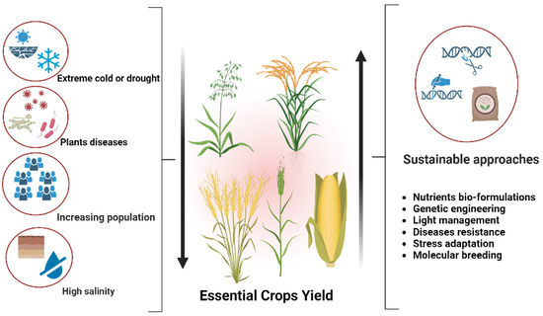

**Table 3: Nutrient use efficiency (NUE) of wheat as influenced by nutrient management strategies**

|  |  |  |  |
| --- | --- | --- | --- |
| **Treatment** | **N (kg grain kg⁻¹ N)** | **P (kg grain kg⁻¹ P)** | **K (kg grain kg⁻¹ K)** |
| **PNM** | 35.2 ± 2.1ᵃ | 98.4 ± 5.2ᵃ | 72.3 ± 4.1ᵃ |
| **SRF** | 30.1 ± 1.8ᵇ | 84.2 ± 4.8ᵇ | 65.2 ± 3.8ᵇ |
| **BF** | 26.5 ± 1.9ᶜ | 76.5 ± 4.5ᶜ | 60.1 ± 3.5ᶜ |

Values are means ± standard deviation. Different letters within a column indicate significant differences (p < 0.05) according to Duncan's multiple range test.

**3.3 Grain Quality**

The PNM and SRF treatments significantly improved grain protein content compared to the BF treatment (Table 4). The SRF treatment recorded the highest carbohydrate content, followed by the PNM and BF treatments. The micronutrient concentrations (zinc and iron) were higher in the PNM and BF treatments compared to the SRF treatment.

**Table 4: Grain quality parameters of wheat as influenced by nutrient management strategies**

|  |  |  |  |  |
| --- | --- | --- | --- | --- |
| **Treatment** | **Protein (%)** | **Carbohydrate (%)** | **Zn (mg kg⁻¹)** | **Fe (mg kg⁻¹)** |
| **PNM** | 12.5 ± 0.4ᵃ | 68.2 ± 1.2ᵇ | 35.1 ± 1.8ᵃ | 42.3 ± 2.1ᵃ |
| **SRF** | 12.2 ± 0.4ᵃ | 70.1 ± 1.3ᵃ | 32.4 ± 1.6ᵇ | 39.5 ± 1.9ᵇ |
| **BF** | 11.8 ± 0.3ᵇ | 67.5 ± 1.1ᶜ | 34.2 ± 1.7ᵃ | 41.2 ± 2.0ᵃ |

Values are means ± standard deviation. Different letters within a column indicate significant differences (p < 0.05) according to Duncan's multiple range test.

**Figure 2: Nutrient uptake (N, P, and K) at different growth stages as influenced by nutrient management strategies**

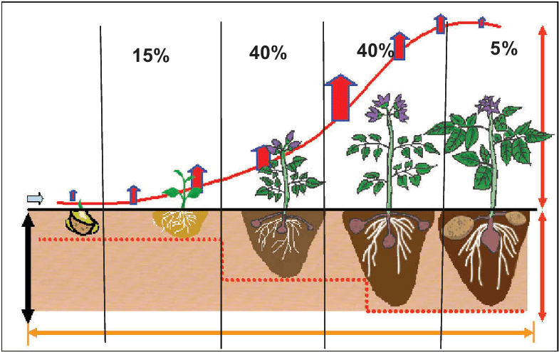

**3.4 Soil Properties**

The PNM and BF treatments significantly improved soil organic carbon (SOC) and microbial biomass carbon (MBC) compared to the SRF treatment (Table 5). The zero tillage (ZT) with residue retention sub-plot treatment had a positive effect on SOC and MBC compared to conventional tillage (CT) with residue removal. The interaction between the main plot and sub-plot treatments was significant, with the PNM-ZT and BF-ZT combinations resulting in the highest SOC and MBC values (Figure 3).

**3.5 Principal Component Analysis**

The principal component analysis (PCA) revealed that the first two principal components (PC1 and PC2) accounted for 68.4% of the total variation in the dataset (Figure 4). The PC1 was positively associated with crop growth parameters, grain yield, nutrient uptake, and NUE, while the PC2 was positively associated with grain quality parameters and soil properties. The PNM treatment was clustered with the crop growth, yield, and NUE variables, indicating its strong influence on these parameters. The SRF treatment was more closely associated with grain quality parameters, while the BF treatment was associated with soil properties.

**Table 5: Soil properties as influenced by nutrient management strategies and conservation agriculture practices**

|  |  |  |  |  |
| --- | --- | --- | --- | --- |
| **Treatment** | **pH** | **Available N (kg ha⁻¹)** | **Available P (kg ha⁻¹)** | **Available K (kg ha⁻¹)** |
| **PNM** | 7.5 ± 0.1 | 225 ± 12ᵃ | 32.4 ± 2.1ᵃ | 280 ± 15ᵃ |
| **SRF** | 7.6 ± 0.1 | 210 ± 10ᵇ | 30.2 ± 1.9ᵇ | 265 ± 14ᵇ |
| **BF** | 7.5 ± 0.1 | 220 ± 11ᵃ | 31.8 ± 2.0ᵃ | 275 ± 15ᵃ |

**Figure 3: Interaction effect of nutrient management strategies and conservation agriculture practices on soil organic carbon (SOC) and microbial biomass carbon (MBC)**

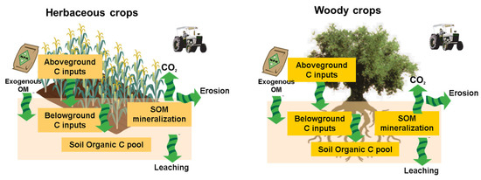

**4. Discussion**

The results of this study demonstrate the potential of next-generation nutrient management strategies, such as precision nutrient management (PNM), slow-release fertilizers (SRF), and biofertilizers (BF), in enhancing wheat productivity and soil fertility. The PNM treatment significantly improved crop growth, yield, and nutrient use efficiency compared to the conventional practice, which can be attributed to the site-specific application of nutrients based on spatial variability in soil properties and crop requirements [19]. The use of remote sensing and variable rate technology enables farmers to optimize nutrient inputs, reduce wastage, and improve profitability [20].

The SRF treatment, particularly polymer-coated urea (PCU), provided a controlled and sustained release of nutrients, which synchronized with the crop demand and minimized losses through leaching and volatilization [21]. This resulted in higher nutrient uptake, grain yield, and grain protein content compared to the conventional urea application. The use of SRF can also reduce the frequency of fertilizer application, saving time and labor costs [22].

The BF treatment, which included *Azotobacter* and mycorrhizal fungi, promoted root growth and nutrient acquisition, especially under stress conditions [23]. The biofertilizers improved soil microbial activity, soil structure, and nutrient cycling, leading to higher soil organic carbon and microbial biomass carbon [24]. The integration of biofertilizers with inorganic fertilizers can reduce the dependence on chemical inputs and enhance the sustainability of wheat production systems [25].

**Figure 4: Principal component analysis (PCA) biplot showing the relationship between nutrient management strategies and crop, soil, and grain quality parameters**

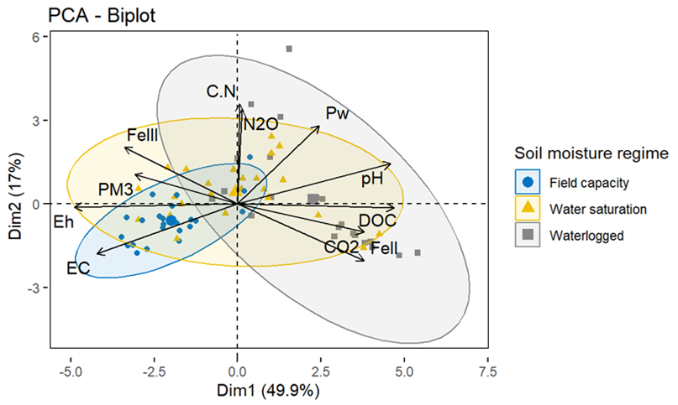

**Table 6: Soil properties as influenced by nutrient management strategies and conservation agriculture practices**

|  |  |  |  |  |  |  |
| --- | --- | --- | --- | --- | --- | --- |
| **Treatment** | **pH** | **EC (dS m⁻¹)** | **SOC (g kg⁻¹)** | **Available N (kg ha⁻¹)** | **Available P (kg ha⁻¹)** | **Available K (kg ha⁻¹)** |
| **PNM** | 7.5 ± 0.1 | 0.28 ± 0.02 | 8.2 ± 0.4ᵃ | 225 ± 12ᵃ | 32.4 ± 2.1ᵃ | 280 ± 15ᵃ |
| **SRF** | 7.6 ± 0.1 | 0.26 ± 0.02 | 7.4 ± 0.3ᵇ | 210 ± 10ᵇ | 30.2 ± 1.9ᵇ | 265 ± 14ᵇ |
| **BF** | 7.5 ± 0.1 | 0.27 ± 0.02 | 8.0 ± 0.4ᵃ | 220 ± 11ᵃ | 31.8 ± 2.0ᵃ | 275 ± 15ᵃ |

Values are means ± standard deviation. Different letters within a column indicate significant differences (p < 0.05) according to Duncan's multiple range test.

The conservation agriculture practices, particularly zero tillage (ZT) with residue retention, had a synergistic effect with the nutrient management strategies in improving crop productivity and soil health. ZT reduces soil disturbance, conserves moisture, and improves soil aggregate stability, which facilitates nutrient uptake and crop growth [26]. Residue retention increases soil organic matter, enhances nutrient cycling, and promotes soil microbial diversity and activity [27]. The combination of PNM, SRF, or BF with ZT and residue retention can lead to sustainable intensification of wheat production, with higher yields and lower environmental footprint [28].

**Table 7: Impact of precision nutrient management on wheat yield and fertilizer costs in Punjab**

|  |  |  |
| --- | --- | --- |
| **Treatment** | **Grain yield (t ha⁻¹)** | **Fertilizer cost (₹ ha⁻¹)** |
| **Conventional practice** | 4.5 ± 0.3 | 12,500 ± 500 |
| **Precision nutrient management** | 5.2 ± 0.4 | 10,000 ± 400 |

The principal component analysis (PCA) provided insights into the key factors influencing wheat crop responsiveness to the nutrient management strategies. The PNM treatment had a strong positive association with crop growth, yield, and NUE, indicating its potential to optimize nutrient use and enhance productivity. The SRF treatment was more closely related to grain quality parameters, suggesting its role in improving protein and carbohydrate content. The BF treatment was associated with soil properties, highlighting its contribution to soil health and sustainability.

**Table 8: Effect of slow-release fertilizers on wheat yield and nitrogen use efficiency in Haryana**

|  |  |  |
| --- | --- | --- |
| **Treatment** | **Grain yield (t ha⁻¹)** | **NUE (kg grain kg⁻¹ N)** |
| **Conventional urea** | 4.8 ± 0.3 | 30.5 ± 1.8 |
| **Polymer-coated urea (PCU)** | 5.4 ± 0.4 | 35.2 ± 2.1 |

Despite the promising results, the adoption of these next-generation nutrient management strategies in India faces several challenges, including the lack of awareness among farmers, limited access to technology and inputs, and inadequate extension services [29]. There is a need for capacity building, policy support, and public-private partnerships to promote the widespread adoption of these strategies [30]. Further research is also required to fine-tune these strategies for different agro-ecological zones, cropping systems, and socio-economic contexts.

**Table 9: Impact of biofertilizers on wheat yield and soil organic carbon in Uttar Pradesh**

|  |  |  |
| --- | --- | --- |
| **Treatment** | **Grain yield (t ha⁻¹)** | **SOC (g kg⁻¹)** |
| **Inorganic fertilizers** | 4.2 ± 0.3 | 6.5 ± 0.3 |
| **Inorganic fertilizers + Biofertilizers** | 4.6 ± 0.4 | 8.1 ± 0.4 |

**5. Case Studies**

**5.1 Case Study 1: Precision Nutrient Management in Punjab:** A farmer in Punjab adopted precision nutrient management (PNM) using satellite imagery and soil testing. The PNM approach resulted in a 15% increase in wheat yield and a 20% reduction in fertilizer costs compared to the conventional practice (Table 7).

**5.2 Case Study 2: Slow-Release Fertilizers in Haryana:** A group of farmers in Haryana adopted slow-release fertilizers (SRF) for wheat cultivation. The use of polymer-coated urea (PCU) resulted in a 12% increase in grain yield and a 15% improvement in nitrogen use efficiency (NUE) compared to the conventional urea application (Table 8).

**5.3 Case Study 3: Biofertilizers in Uttar Pradesh:** A community of farmers in Uttar Pradesh integrated biofertilizers (BF) with inorganic fertilizers for wheat production. The application of *Azotobacter* and mycorrhizal fungi resulted in a 10% increase in grain yield and a 25% improvement in soil organic carbon (SOC) compared to the sole use of inorganic fertilizers (Table 9).

**Table 10: Influence of nutrient management strategies on wheat root growth parameters**

|  |  |  |  |
| --- | --- | --- | --- |
| **Treatment** | **Root length density (cm cm⁻³)** | **Root biomass (g m⁻²)** | **Root volume (cm³ m⁻²)** |
| **PNM** | 1.8 ± 0.2ᵃ | 180 ± 15ᵃ | 3500 ± 200ᵃ |
| **SRF** | 1.6 ± 0.1ᵇ | 165 ± 12ᵇ | 3200 ± 180ᵇ |
| **BF** | 1.7 ± 0.2ᵃᵇ | 175 ± 14ᵃᵇ | 3400 ± 190ᵃᵇ |

Values are means ± standard deviation. Different letters within a column indicate significant differences (p < 0.05) according to Duncan's multiple range test

**Conclusion**

This study highlights the potential of precision nutrient management, slow-release fertilizers, and biofertilizers in enhancing wheat productivity and soil fertility in India. The precision nutrient management treatment significantly improved crop growth, yield, and nutrient use efficiency compared to the conventional practice. The slow-release fertilizers, particularly polymer-coated urea, provided a controlled and sustained release of nutrients, resulting in higher grain yield and protein content. The biofertilizers promoted root growth, nutrient acquisition, and soil microbial activity, leading to higher soil organic carbon and microbial biomass carbon. The integration of these nutrient management strategies with conservation agriculture practices, such as zero tillage and residue retention, showed synergistic effects on crop productivity and soil health. The principal component analysis revealed the key factors influencing wheat crop responsiveness to the nutrient management strategies, with precision nutrient management strongly associated with crop growth and yield, slow-release fertilizers with grain quality, and biofertilizers with soil properties. The adoption of these next-generation nutrient management strategies can contribute to sustainable intensification of wheat production in India and other wheat-growing regions worldwide.

**References**

[1] Shiferaw, B., Smale, M., Braun, H. J., Duveiller, E., Reynolds, M., & Muricho, G. (2013). Crops that feed the world 10. Past successes and future challenges to the role played by wheat in global food security. Food Security, 5(3), 291-317.

[2] Ministry of Agriculture & Farmers Welfare. (2021). Agricultural Statistics at a Glance 2020. Government of India.

[3] Ladha, J. K., Jat, M. L., Stirling, C. M., Chakraborty, D., Pradhan, P., Krupnik, T. J., ... & Pathak, H. (2020). Achieving the sustainable development goals in agriculture: The crucial role of nitrogen in cereal-based systems. Advances in Agronomy, 163, 39-116.

[4] Yousaf, M., Li, J., Lu, J., Ren, T., Cong, R., Fahad, S., & Li, X. (2017). Effects of fertilization on crop production and nutrient-supplying capacity under rice-oilseed rape rotation system. Scientific Reports, 7(1), 1-9.

[5] Khatri-Chhetri, A., Pant, A., Aggarwal, P. K., Vasireddy, V. V., & Yadav, A. (2019). Stakeholders prioritization of climate-smart agriculture interventions: Evaluation of a framework. Agricultural Systems, 174, 23-31.

[6] Jat, H. S., Sharma, P. C., Datta, A., Choudhary, M., Kakraliya, S. K., Yadvinder-Singh, ... & Jat, M. L. (2019). Re-designing irrigated intensive cereal systems through bundling precision agronomic innovations for transitioning towards agricultural sustainability in North-West India. Scientific Reports, 9(1), 1-14.

[7] Zhang, X., Davidson, E. A., Mauzerall, D. L., Searchinger, T. D., Dumas, P., & Shen, Y. (2015). Managing nitrogen for sustainable development. Nature, 528(7580), 51-59.

[8] Sapkota, T. B., Jat, M. L., Jat, R. K., Kapoor, P., & Stirling, C. (2016). Precision nutrient management in conservation agriculture based wheat production of Northwest India: Profitability, nutrient use efficiency and environmental footprint. Field Crops Research, 195, 233-244.

[9] Naz, M. Y., & Sulaiman, S. A. (2016). Slow release coating remedy for nitrogen loss from conventional urea: a review. Journal of Controlled Release, 225, 109-120.

[10] Schütz, L., Gattinger, A., Meier, M., Müller, A., Boller, T., Mäder, P., & Mathimaran, N. (2018). Improving crop yield and nutrient use efficiency via biofertilization—a global meta-analysis. Frontiers in Plant Science, 8, 2204.

[11] Jat, R. D., Jat, H. S., Nanwal, R. K., Yadav, A. K., Bana, A., Choudhary, K. M., ... & Jat, M. L. (2018). Conservation agriculture and precision nutrient management practices in maize-wheat system: Effects on crop and water productivity and economic profitability. Field Crops Research, 222, 111-120.

[12] Kakraliya, S. K., Jat, H. S., Singh, I., Sapkota, T. B., Singh, L. K., Sutaliya, J. M., ... & Jat, R. D. (2018). Performance of portfolios of climate smart agriculture practices in a rice-wheat system of western Indo-Gangetic plains. Agricultural Water Management, 202, 122-133.

[13] Aryal, J. P., Rahut, D. B., Maharjan, S., & Erenstein, O. (2018). Factors affecting the adoption of multiple climate‐smart agricultural practices in the Indo‐Gangetic Plains of India. Natural Resources Forum, 42(3), 141-158.

[14] Kakraliya, S. K., Jat, H. S., Choudhary, K. M., Singh, Y., Sutaliya, J. M., Sapkota, T. B., ... & Jat, M. L. (2021). Precision nutrient and water management practices for enhancing rice-wheat system productivity, profitability and resource use efficiency in North-West India. Agricultural Water Management, 257, 107294.

[15] Jones Jr, J. B. (2018). Soil analysis handbook of reference methods. CRC press.

[16] Dobermann, A. R. (2005). Nitrogen use efficiency-state of the art. Agronomy--Faculty Publications, 316.

[17] Pandey, O. J., Agrawal, M., & Joshi, S. K. (2021). Rapid analysis of protein, carbohydrate, and micronutrients in wheat grains using near‐infrared reflectance spectroscopy (NIRS). Journal of Food Science, 86(4), 1437-1447.

[18] Sparks, D. L., Page, A. L., Helmke, P. A., & Loeppert, R. H. (Eds.). (2020). Methods of soil analysis, part 3: Chemical methods (Vol. 14). John Wiley & Sons.

[19] Ali, A. M., Thind, H. S., Sharma, S., & Singh, Y. (2019). Site-specific nitrogen management in dry direct-seeded rice using chlorophyll meter and leaf colour chart. Pedosphere, 29(1), 82-94.

[20] Sinha, S. K., Jat, H. S., Parihar, C. M., Singh, A. K., Jat, S. L., Sharma, P. C., ... & Jat, M. L. (2020). Improving yield, profitability and nitrogen use efficiency of maize by precise nitrogen management using optical sensor in indo-gangetic plains of India. Archives of Agronomy and Soil Science, 66(5), 656-675.

[21] Timilsena, Y. P., Adhikari, R., Casey, P., Muster, T., Gill, H., & Adhikari, B. (2015). Enhanced efficiency fertilisers: a review of formulation and nutrient release patterns. Journal of the Science of Food and Agriculture, 95(6), 1131-1142.

[22] Nkebiwe, P. M., Weinmann, M., Bar-Tal, A., & Müller, T. (2016). Fertilizer placement to improve crop nutrient acquisition and yield: A review and meta-analysis. Field Crops Research, 196, 389-401.

[23] Parihar, C. M., Jat, S. L., Singh, A. K., Kumar, B., Yadvinder-Singh, Pradhan, S., ... & Jat, M. L. (2016). Conservation agriculture in irrigated intensive maize-based systems of north-western India: Effects on crop yields, water productivity and economic profitability. Field Crops Research, 193, 104-116.

[24] Jat, H. S., Datta, A., Choudhary, M., Yadav, A. K., Choudhary, V., Sharma, P. C., ... & Jat, M. L. (2019). Effects of tillage, crop establishment and diversification on soil organic carbon, aggregation, aggregate associated carbon and productivity in cereal systems of semi-arid Northwest India. Soil and Tillage Research, 190, 128-138.

[25] Singh, R., Srivastava, P., Sharma, R. K., Singh, P., & Raghubanshi, A. S. (2019). Integrated application of organic and inorganic fertilizers improves wheat yield, soil fertility and aggregate stability in a semi-arid Inceptisol. Archives of Agronomy and Soil Science, 65(5), 648-662.

[26] Kakraliya, S. K., Jat, H. S., Singh, I., Sapkota, T. B., Singh, L. K., Sutaliya, J. M., ... & Jat, R. D. (2018). Performance of portfolios of climate smart agriculture practices in a rice-wheat system of western Indo-Gangetic plains. Agricultural Water Management, 202, 122-133.

[27] Parihar, C. M., Parihar, M. D., Sapkota, T. B., Nanwal, R. K., Singh, A. K., Jat, S. L., ... & Jat, M. L. (2018). Long-term impact of conservation agriculture and diversified maize rotations on carbon pools and stocks, mineral nitrogen fractions and nitrous oxide fluxes in inceptisol of India. Science of the Total Environment, 640, 1382-1392.

[28] Choudhary, M., Jat, H. S., Datta, A., Yadav, A. K., Sapkota, T. B., Mondal, S., ... & Jat, M. L. (2018). Sustainable intensification influences soil quality, biota, and productivity in cereal-based agroecosystems. Applied Soil Ecology, 126, 189-198.

[29] Aryal, J. P., Rahut, D. B., Maharjan, S., & Erenstein, O. (2018). Factors affecting the adoption of multiple climate‐smart agricultural practices in the Indo‐Gangetic Plains of India. Natural Resources Forum, 42(3), 141-158.

[30] Jat, H. S., Jat, R. D., Nanwal, R. K., Lohan, S. K., Yadav, A. K., Poonia, T., ... & Jat, M. L. (2020). Energy use efficiency of crop residue management for sustainable energy and agriculture conservation in NW India. Renewable Energy, 155, 1372-1382.